Table of Contents

# 1. Sensitivity Analysis

Figure 1: Sensitivity of C_max of Raltegravir for individuals at percentiles 0.05, 0.5, 0.95 in simulation sets ‘Larson 2013 8y-18y 400mg FCT meal’, ‘Filmcoated_tablet_400mg_sd’.

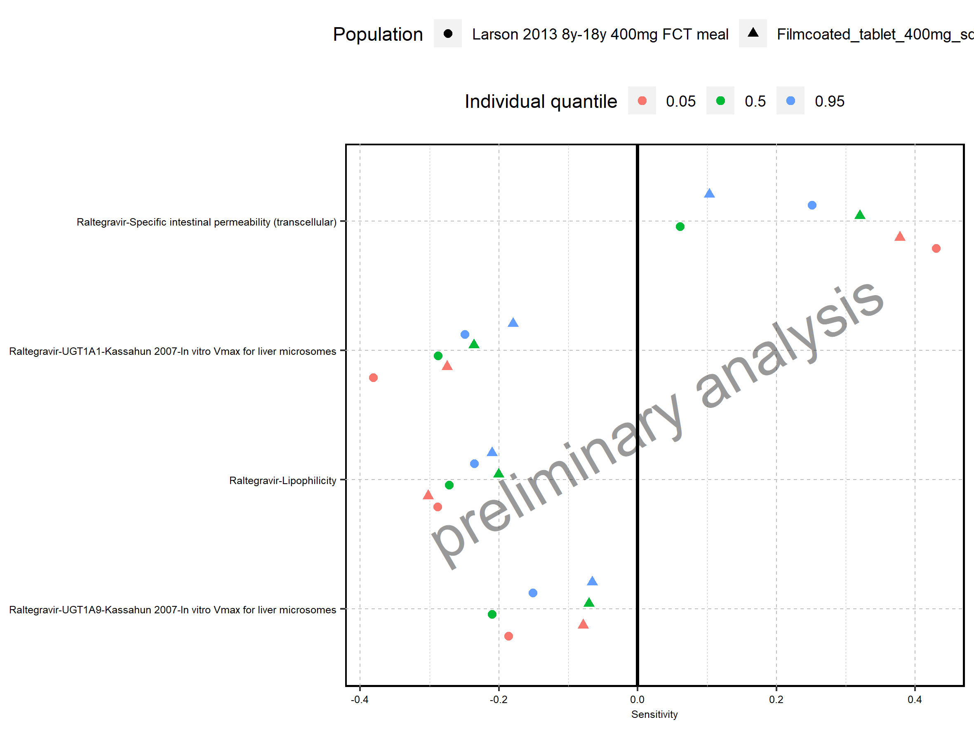

Figure 2: Sensitivity of t_max of Raltegravir for individuals at percentiles 0.05, 0.5, 0.95 in simulation sets ‘Filmcoated_tablet_400mg_sd’, ‘Larson 2013 8y-18y 400mg FCT meal’.

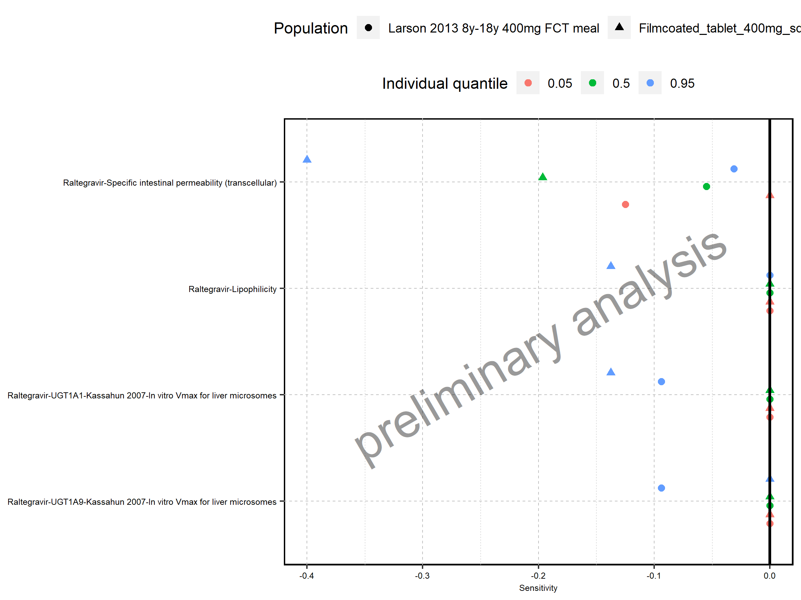

Figure 3: Sensitivity of C_tEnd of Raltegravir for individuals at percentiles 0.05, 0.5, 0.95 in simulation sets ‘Filmcoated_tablet_400mg_sd’, ‘Larson 2013 8y-18y 400mg FCT meal’.

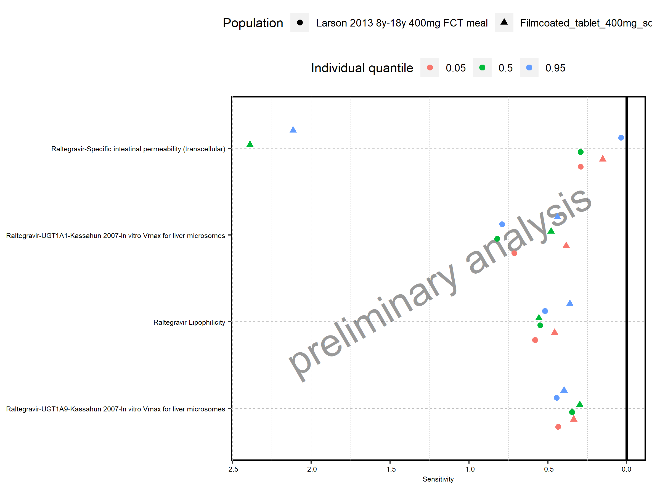

Figure 4: Sensitivity of AUC of Raltegravir for individuals at percentiles 0.05, 0.5, 0.95 in simulation sets ‘Larson 2013 8y-18y 400mg FCT meal’, ‘Filmcoated_tablet_400mg_sd’.

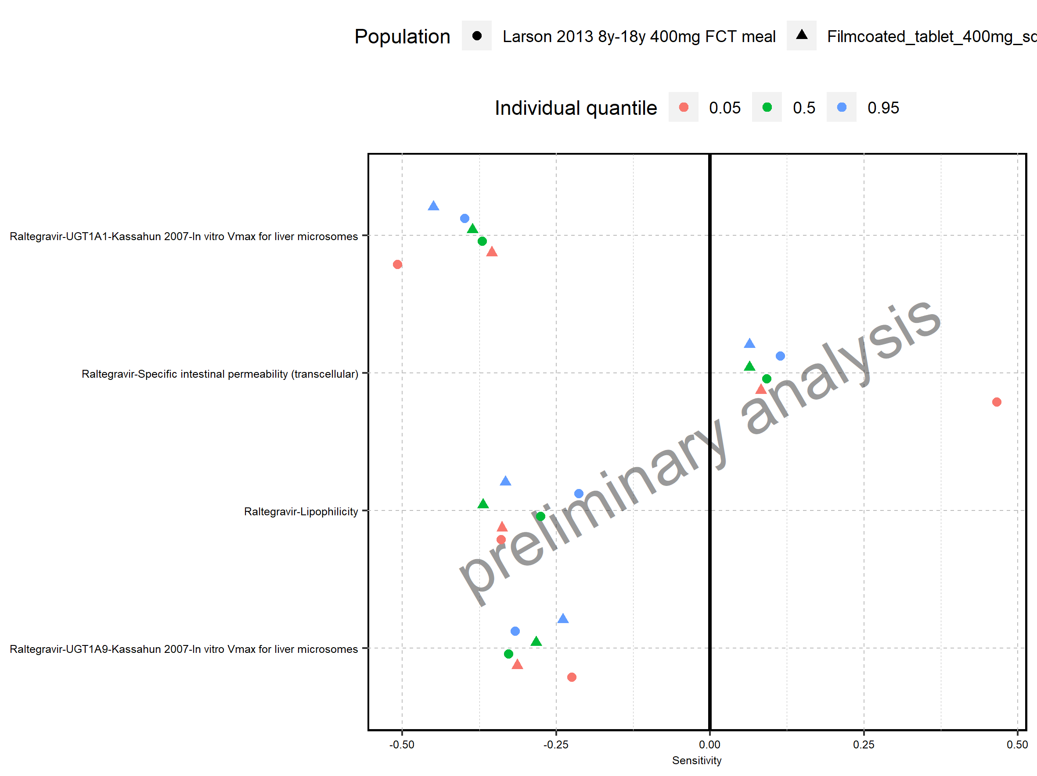

Figure 5: Sensitivity of AUC_inf of Raltegravir for individuals at percentiles 0.05, 0.5, 0.95 in simulation sets ‘Larson 2013 8y-18y 400mg FCT meal’, ‘Filmcoated_tablet_400mg_sd’.

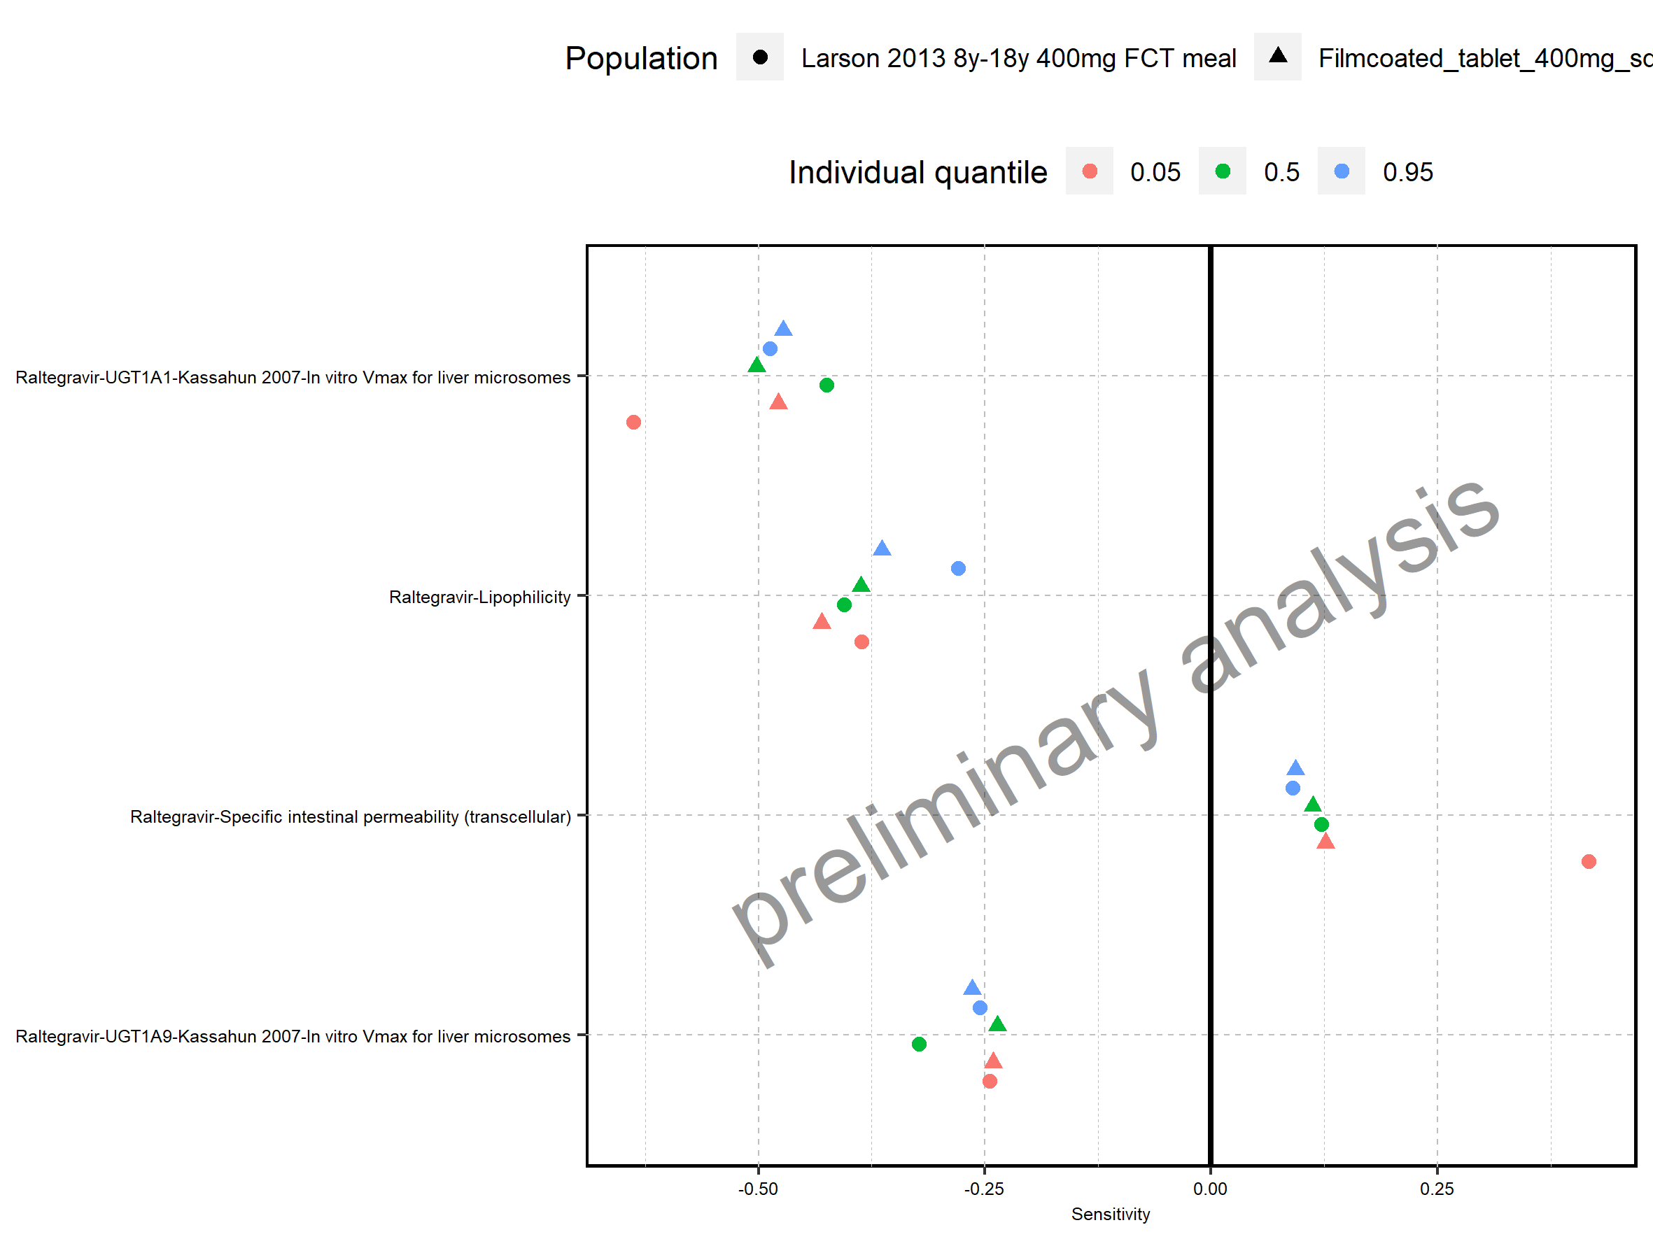

Figure 6: Sensitivity of MRT of Raltegravir for individuals at percentiles 0.05, 0.5, 0.95 in simulation sets ‘Larson 2013 8y-18y 400mg FCT meal’, ‘Filmcoated_tablet_400mg_sd’.

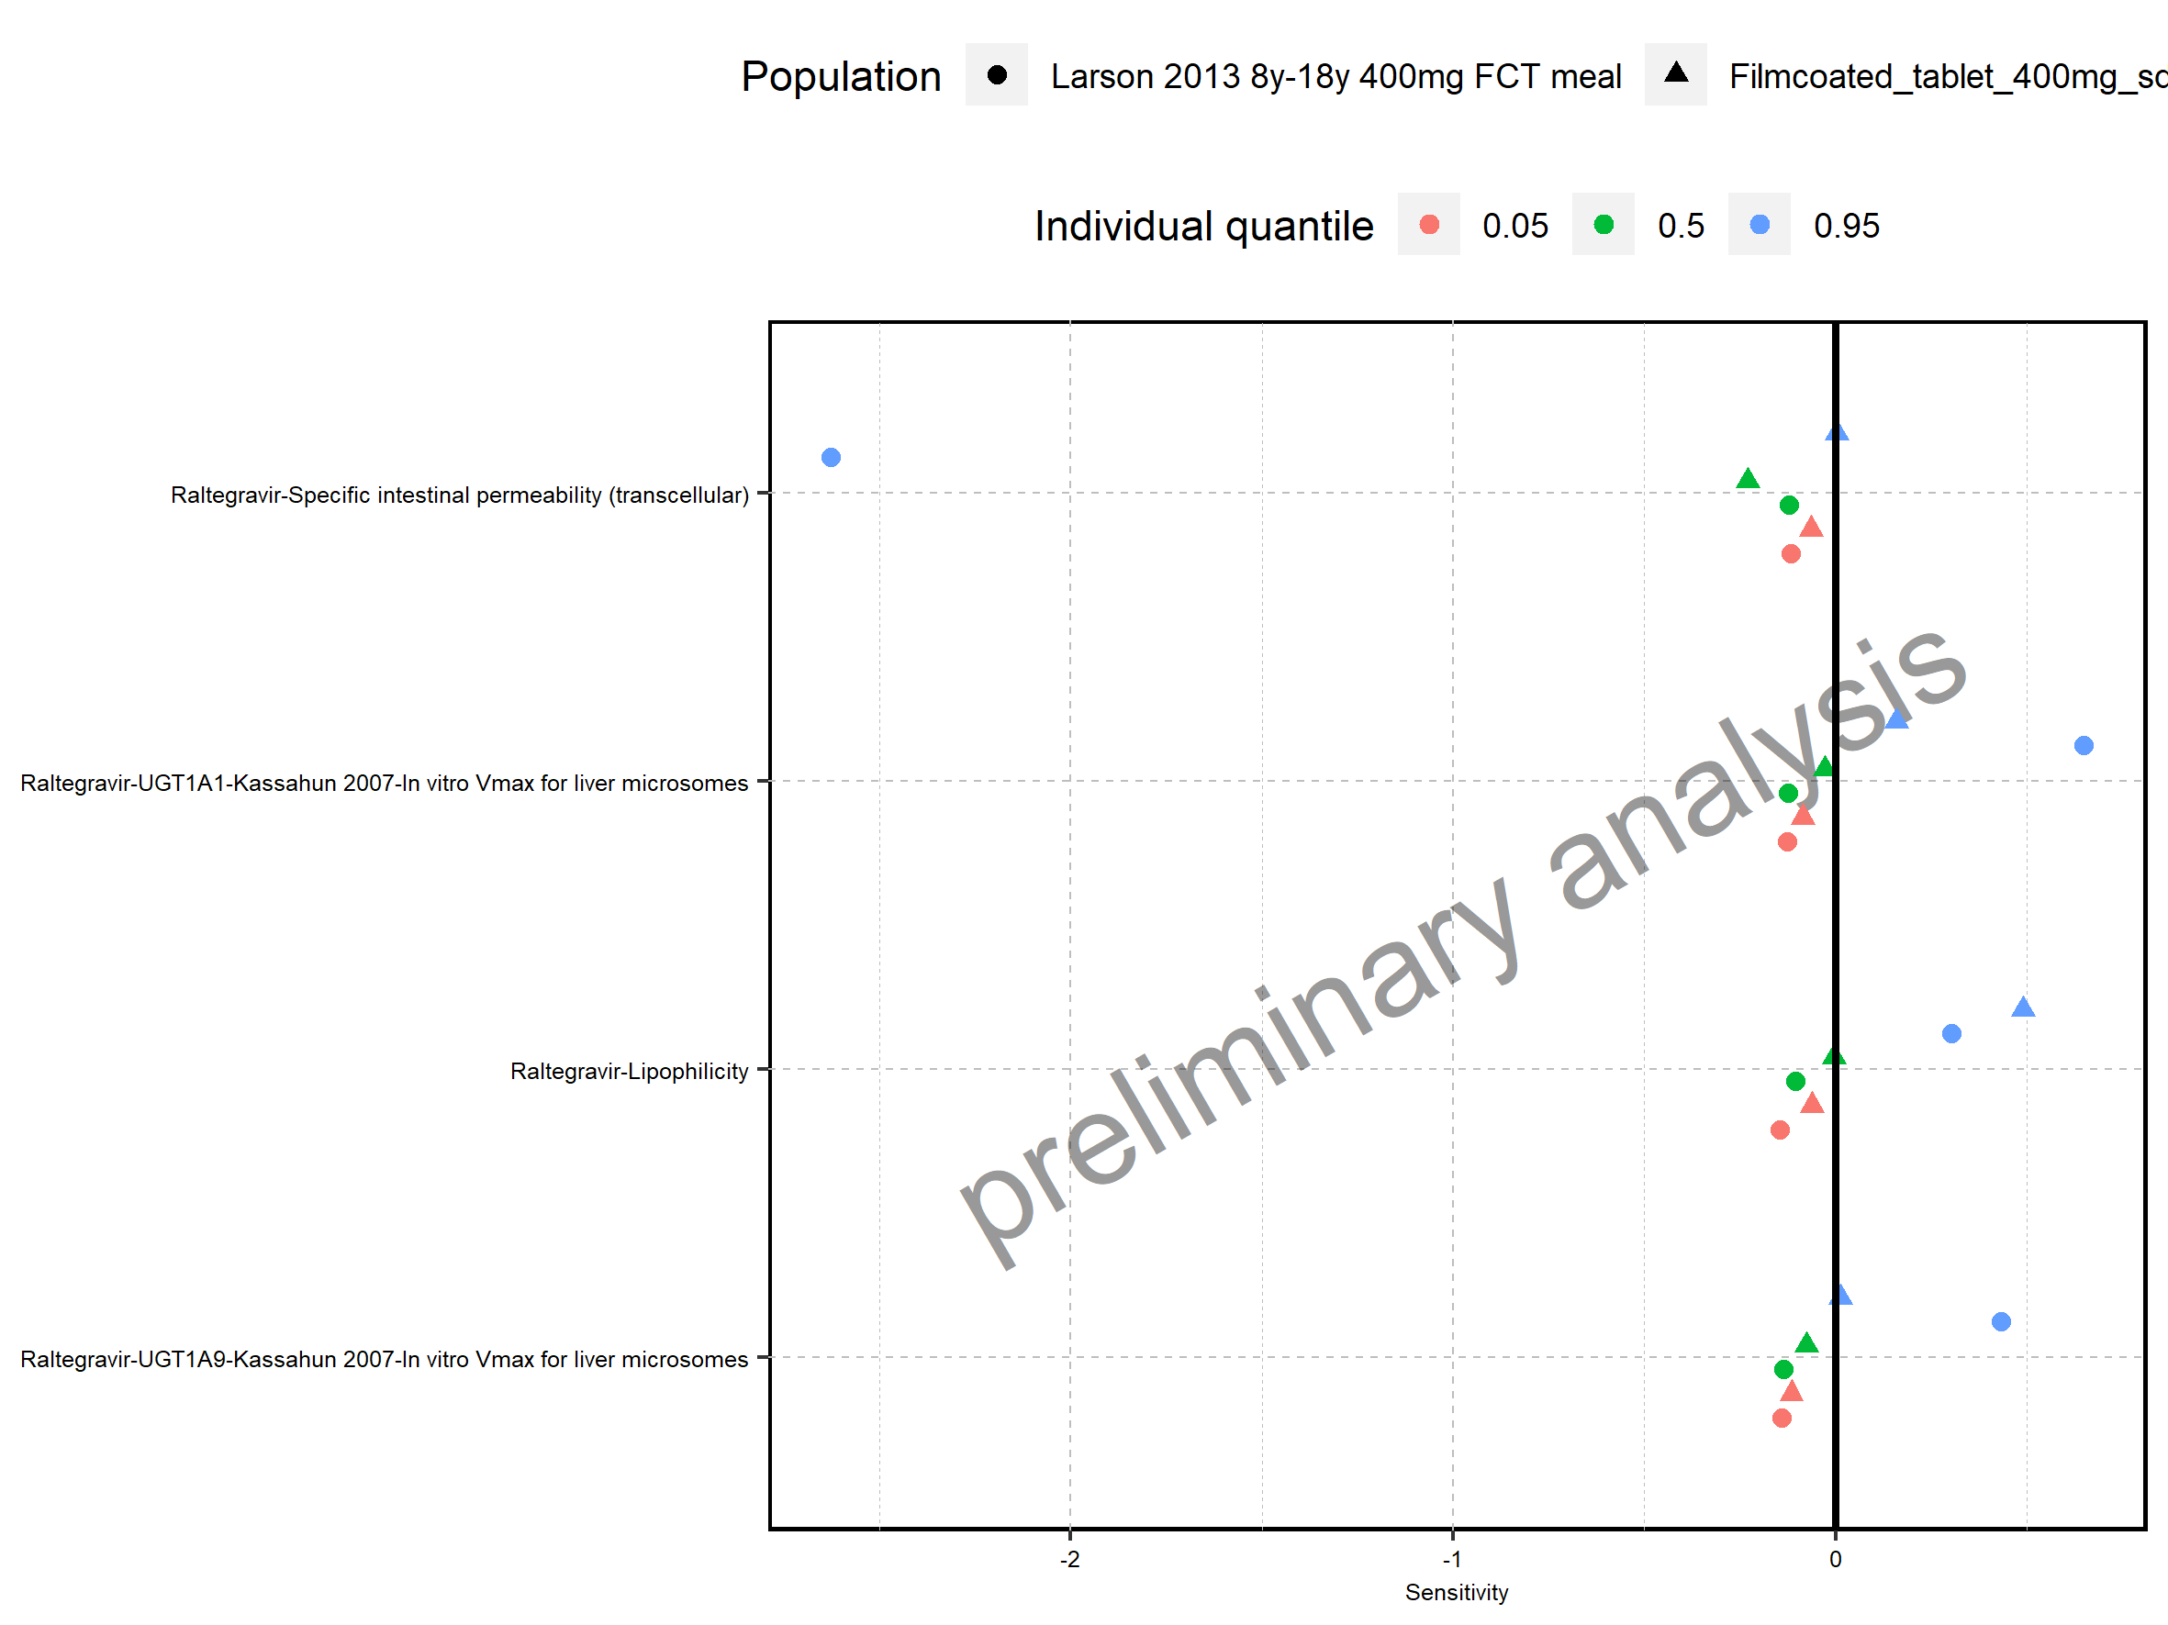

Figure 7: Sensitivity of Thalf of Raltegravir for individuals at percentiles 0.05, 0.5, 0.95 in simulation sets ‘Filmcoated_tablet_400mg_sd’, ‘Larson 2013 8y-18y 400mg FCT meal’.

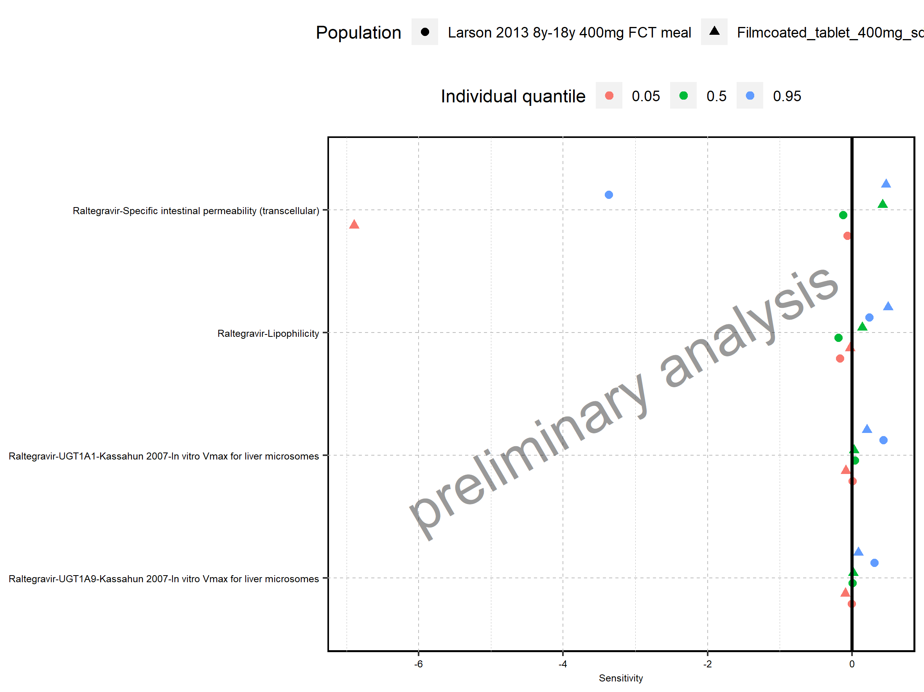

Figure 8: Sensitivity of CL of Raltegravir for individuals at percentiles 0.05, 0.5, 0.95 in simulation sets ‘Larson 2013 8y-18y 400mg FCT meal’, ‘Filmcoated_tablet_400mg_sd’.

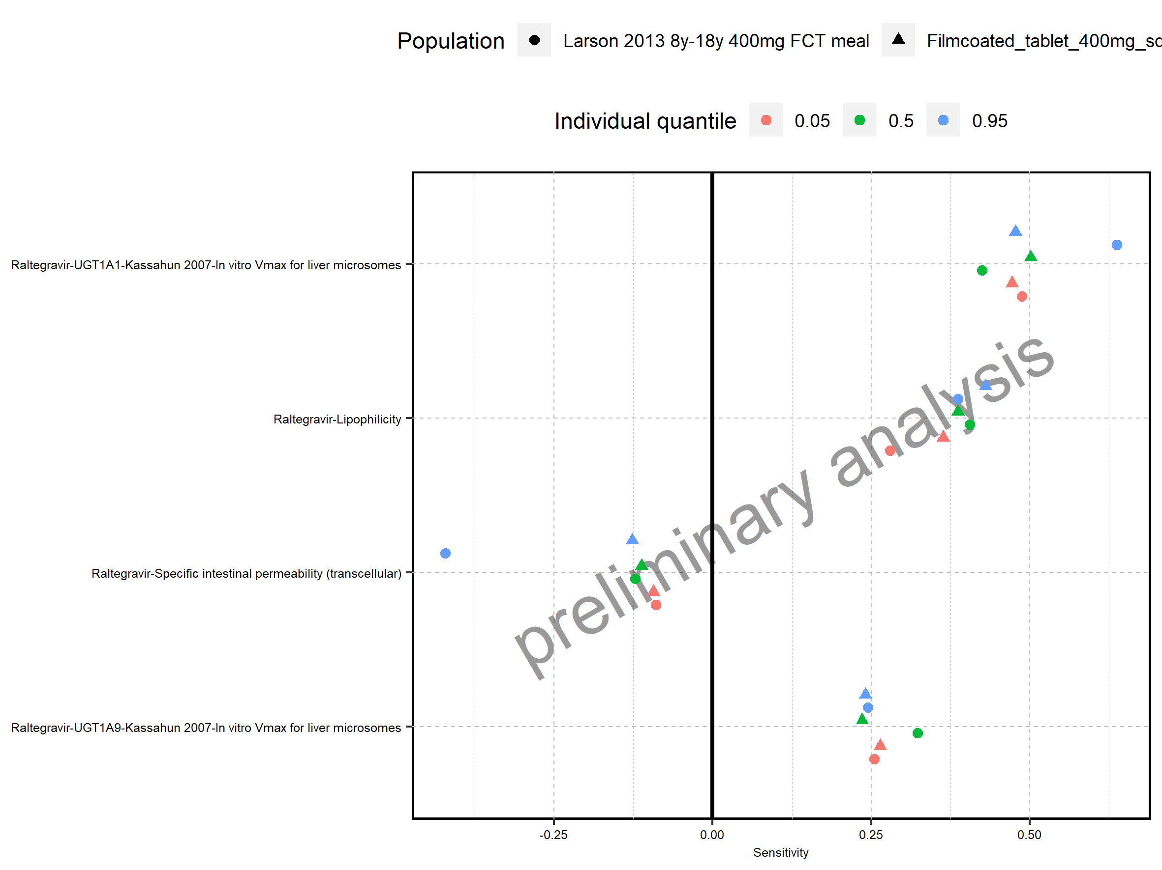

Figure 9: Sensitivity of Vss of Raltegravir for individuals at percentiles 0.05, 0.5, 0.95 in simulation sets ‘Larson 2013 8y-18y 400mg FCT meal’, ‘Filmcoated_tablet_400mg_sd’.

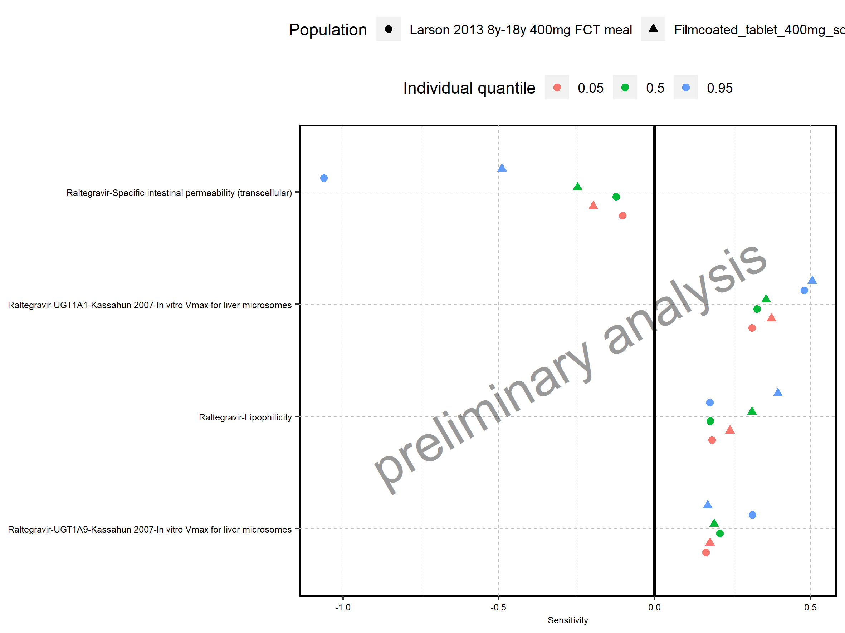

Figure 10: Sensitivity of Vd of Raltegravir for individuals at percentiles 0.05, 0.5, 0.95 in simulation sets ‘Larson 2013 8y-18y 400mg FCT meal’, ‘Filmcoated_tablet_400mg_sd’.

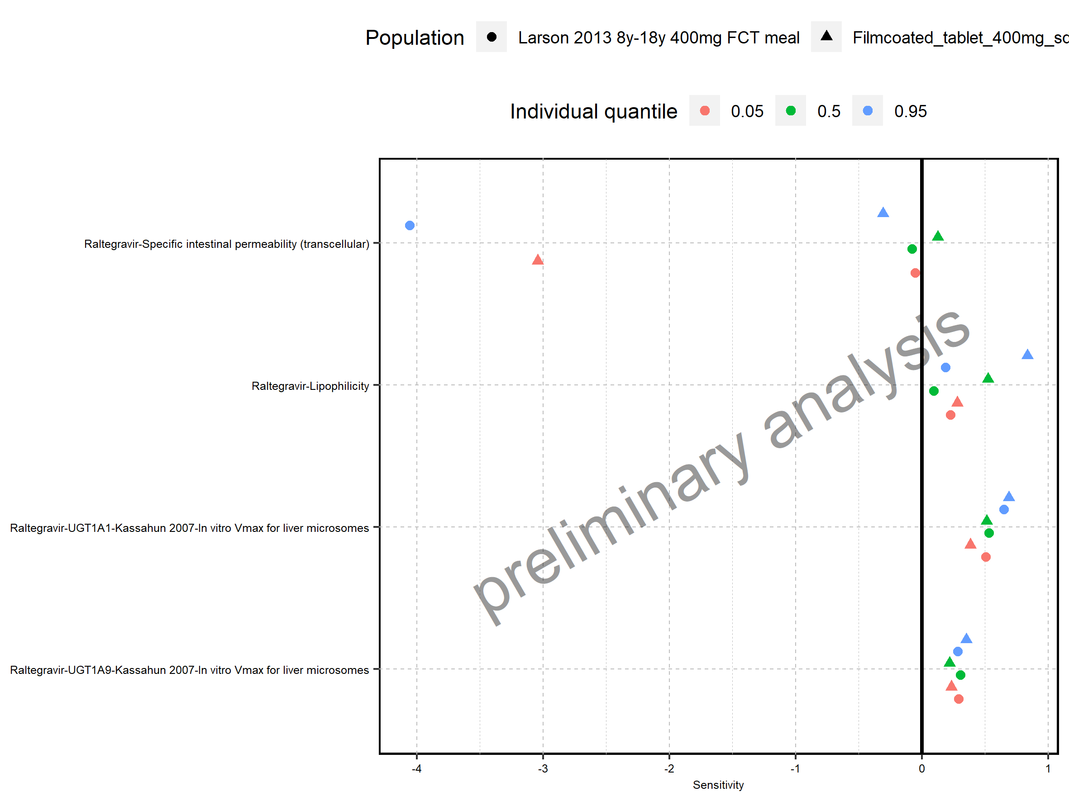

# 2. PK parameters

Figure 11: C_max of Raltegravir shown as box-whisker plot, which indicates the 5th, 25th, 50th, 75th, and 95th percentiles in linear scale.

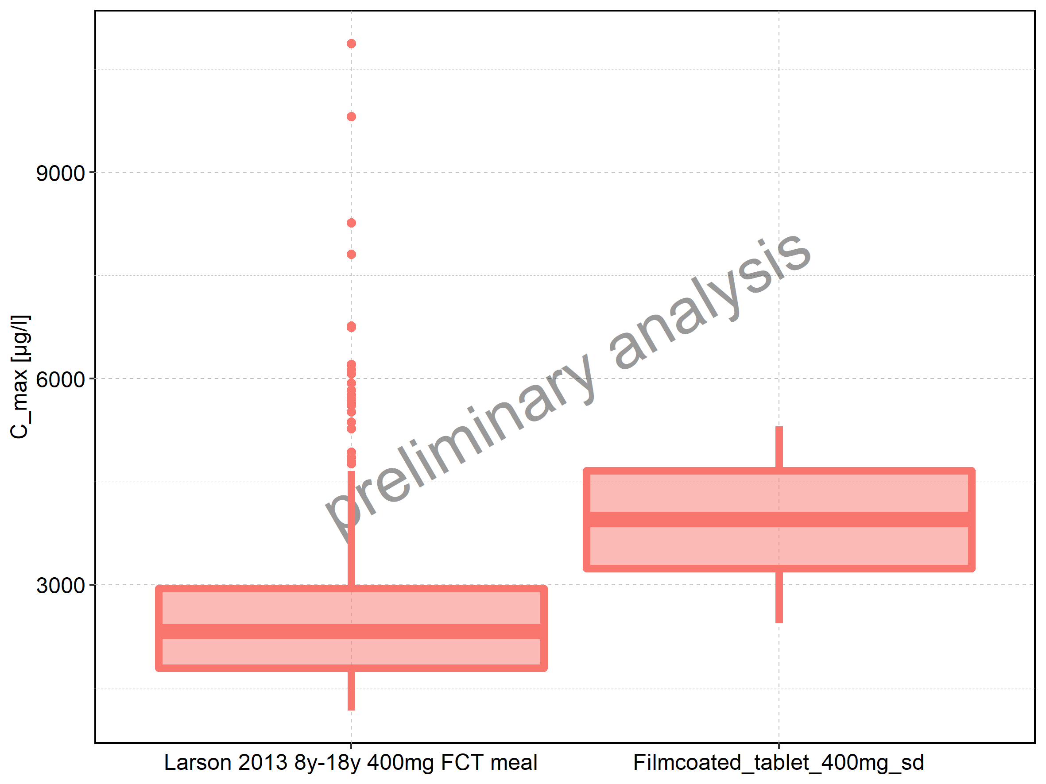

|  |  |  |  |  |  |  |  |  |  |  |
| --- | --- | --- | --- | --- | --- | --- | --- | --- | --- | --- |
| Population | N | 5th percentile | 25th percentile | 50th percentile | 75th percentile | 95th percentile | mean | standard deviation | geo mean | geo standard deviation |
| Larson 2013 8y-18y 400mg FCT meal | 500 | 1171.264 | 1784.944 | 2321.551 | 2949.242 | 4651.398 | 2549.831 | 1206.8863 | 2326.870 | 1.523041 |
| Filmcoated_tablet_400mg_sd | 100 | 2437.788 | 3236.539 | 3954.538 | 4657.555 | 5304.384 | 3940.921 | 908.8898 | 3833.698 | 1.270937 |

Figure 12: C_max of Raltegravir shown as box-whisker plot, which indicates the 5th, 25th, 50th, 75th, and 95th percentiles in logarithmic scale.

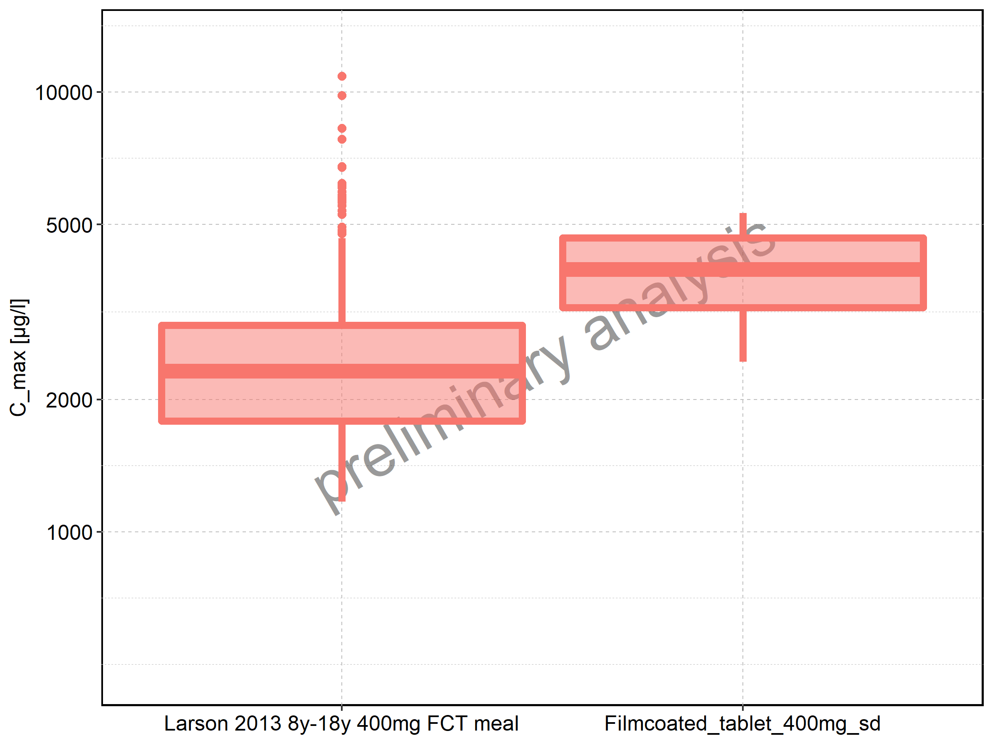

Figure 13: Age-dependence of C_max for Larson 2013 8y-18y 400mg FCT meal in comparison to Filmcoated_tablet_400mg_sd. Profiles are plotted in a linear scale.

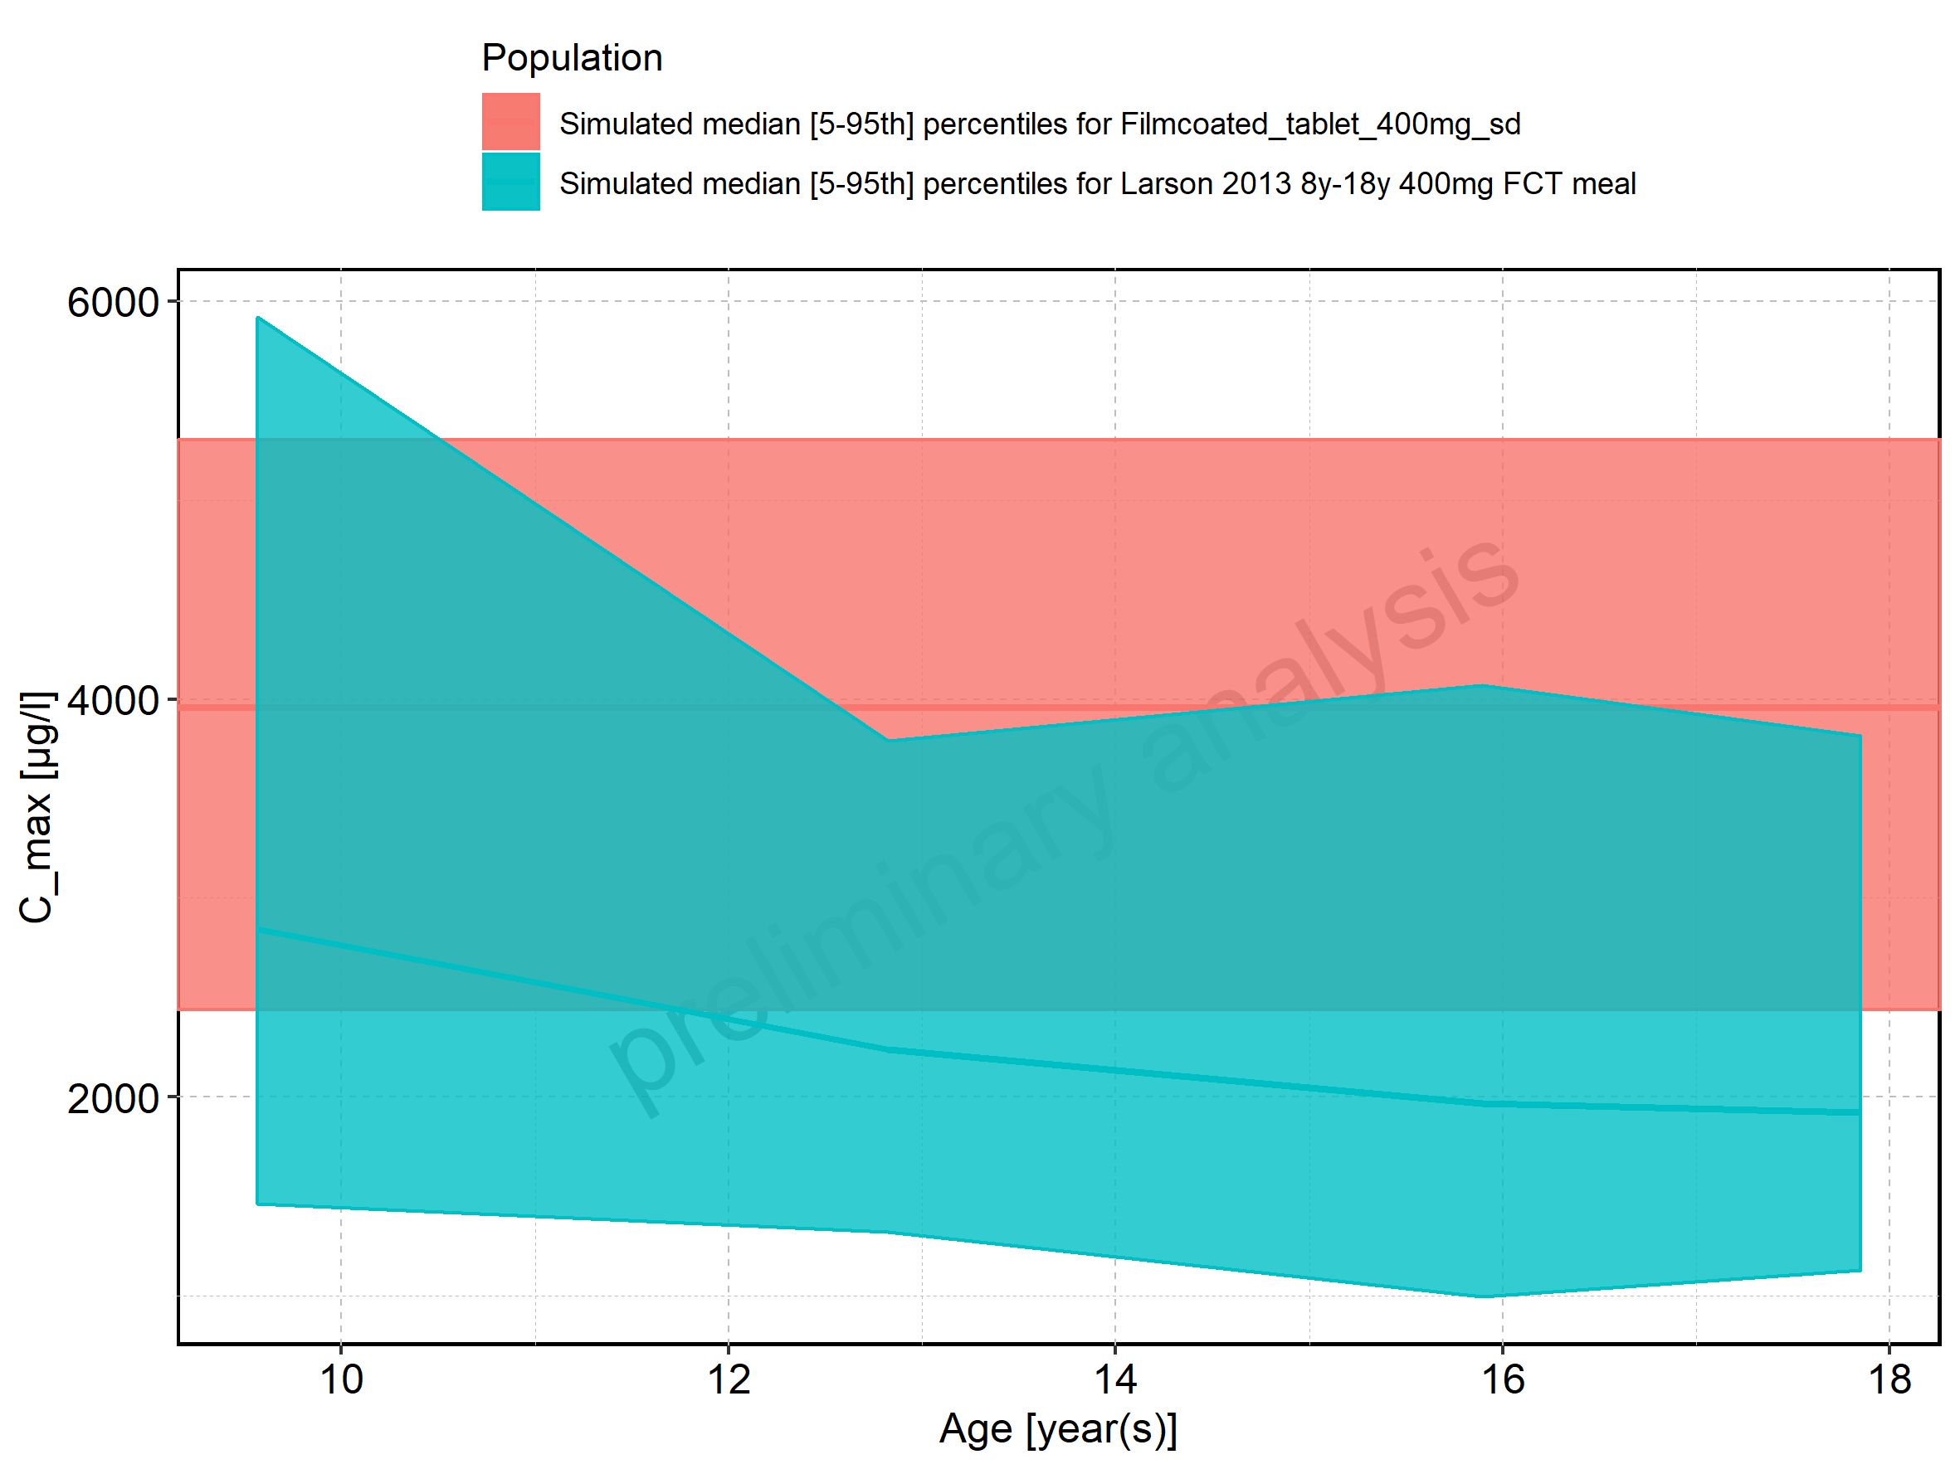

Figure 14: Age-dependence of C_max for Larson 2013 8y-18y 400mg FCT meal in comparison to Filmcoated_tablet_400mg_sd. Profiles are plotted in a logarithmic scale.

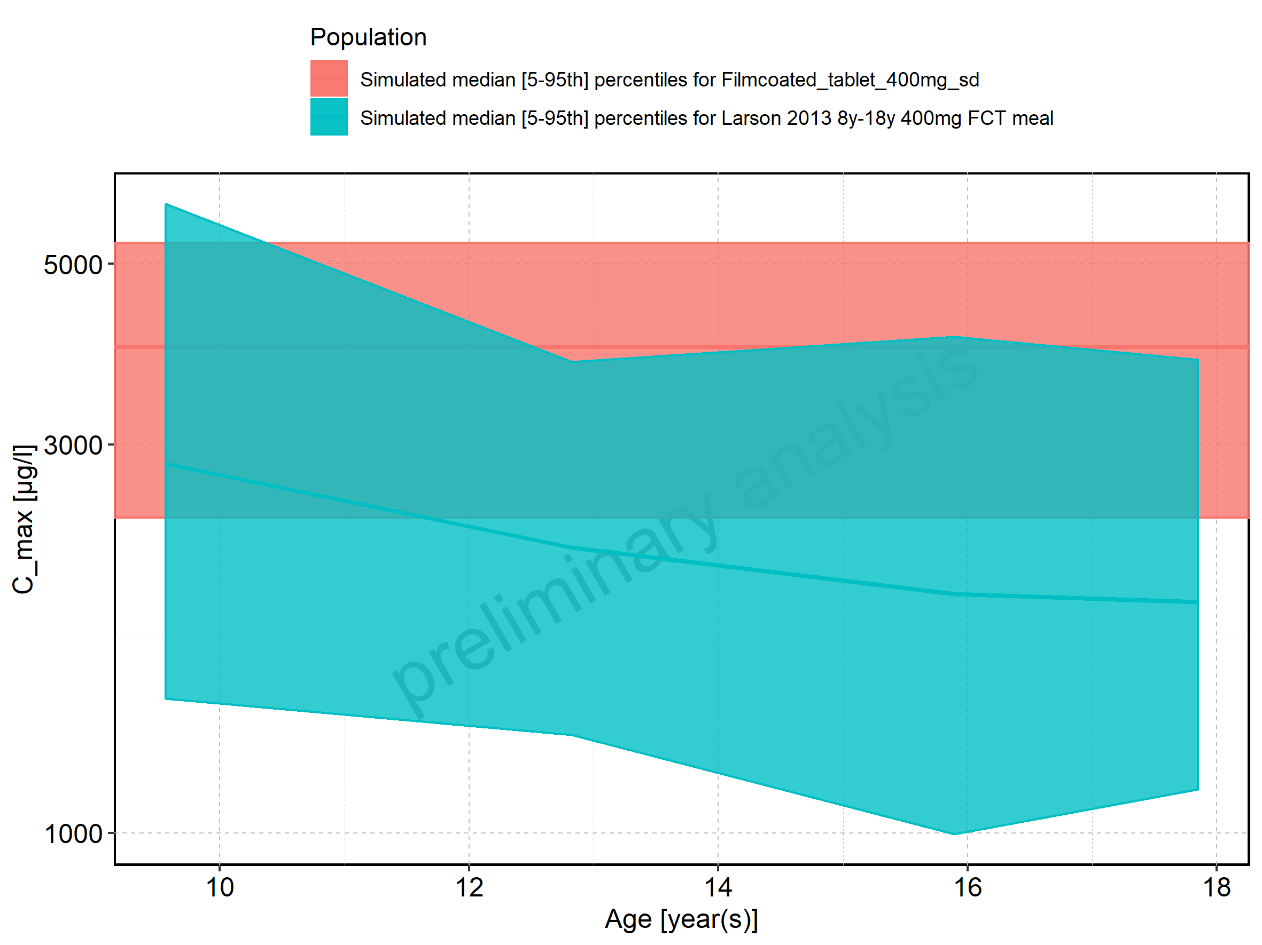

Figure 15: Age-dependence of C_max for Larson 2013 8y-18y 400mg FCT meal. Profiles are plotted in a linear scale.

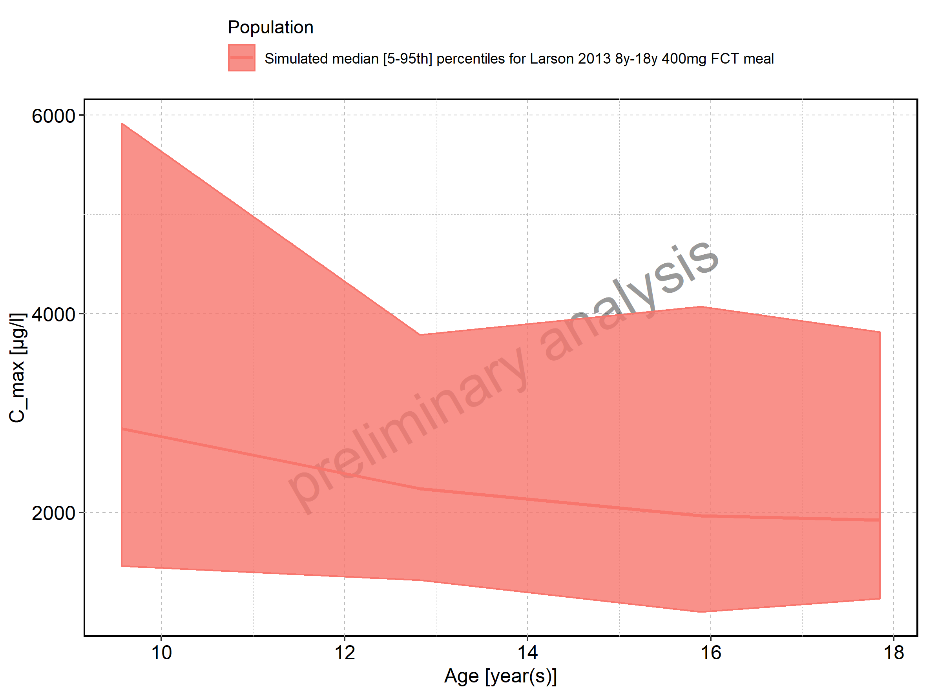

Figure 16: Age-dependence of C_max for Larson 2013 8y-18y 400mg FCT meal. Profiles are plotted in a logarithmic scale.

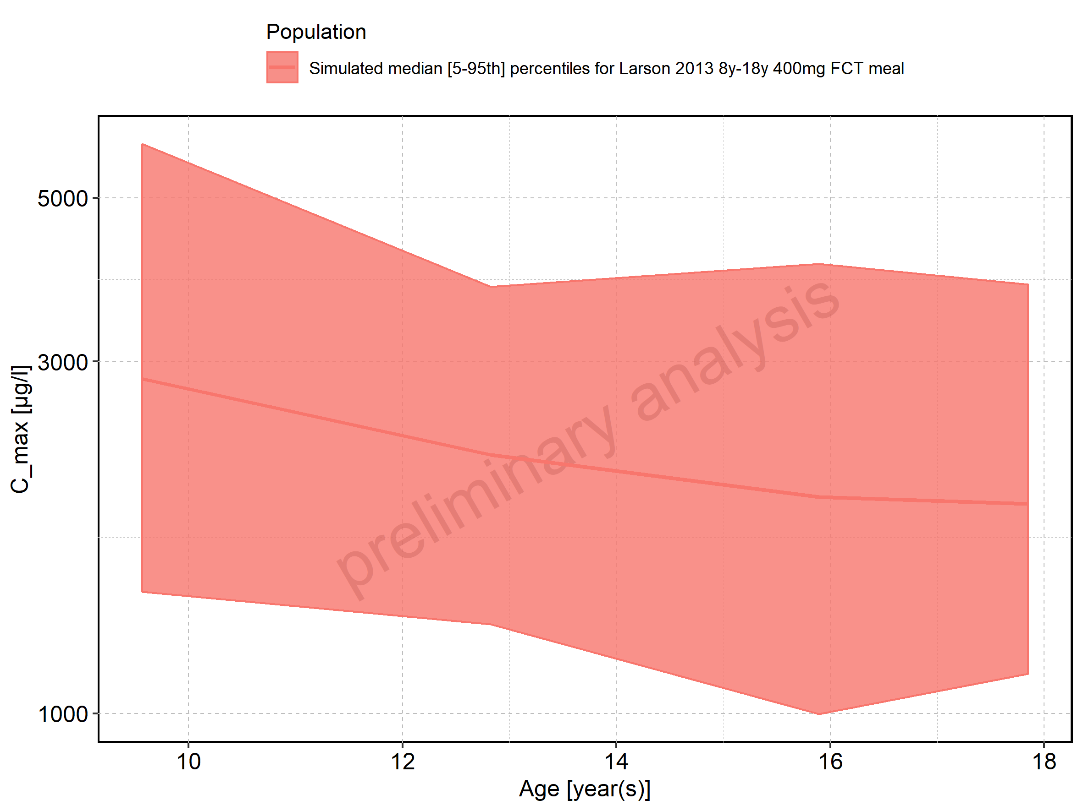

Figure 17: Age-dependence of C_max for Filmcoated_tablet_400mg_sd. Profiles are plotted in a linear scale.

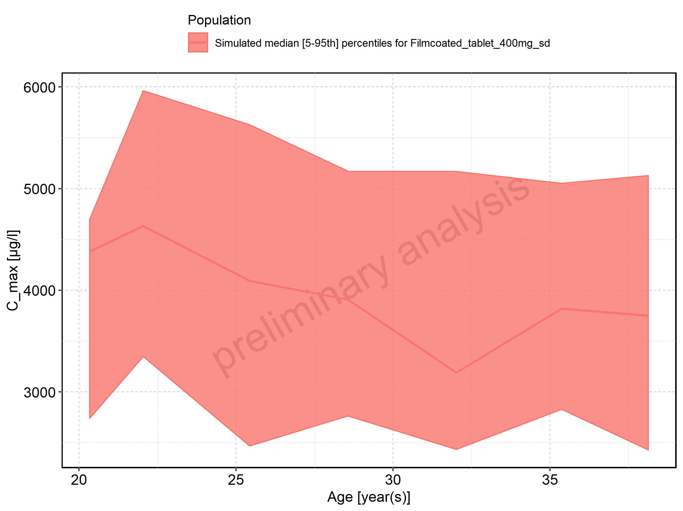

Figure 18: Age-dependence of C_max for Filmcoated_tablet_400mg_sd. Profiles are plotted in a logarithmic scale.

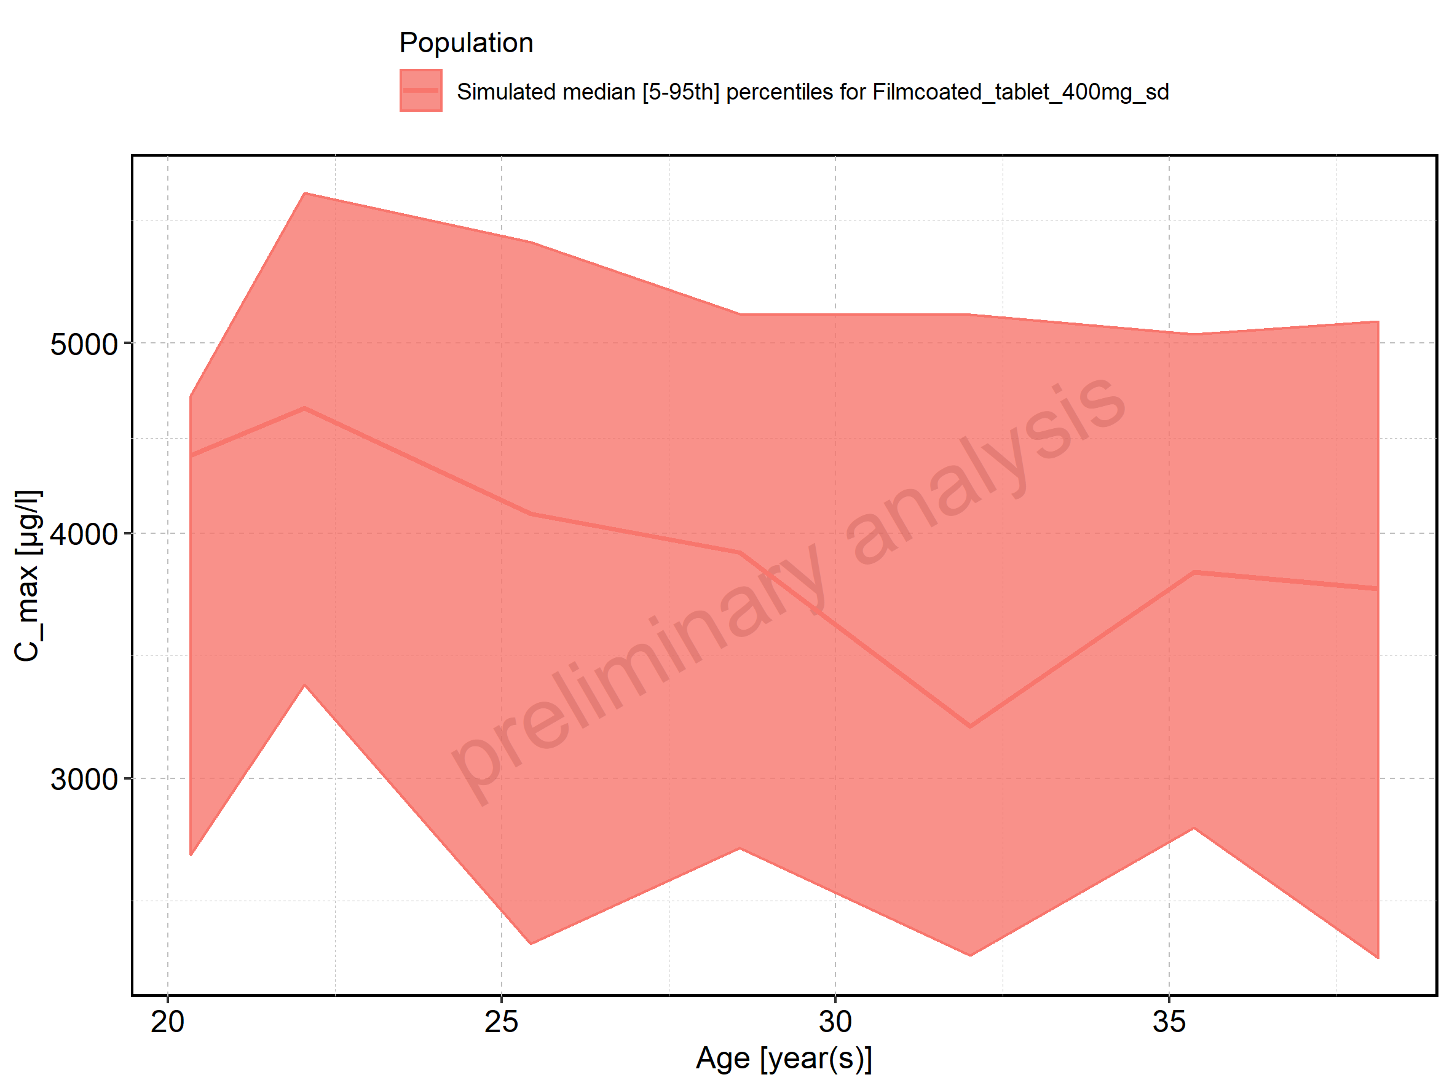

Figure 19: Height-dependence of C_max for Larson 2013 8y-18y 400mg FCT meal in comparison to Filmcoated_tablet_400mg_sd. Profiles are plotted in a linear scale.

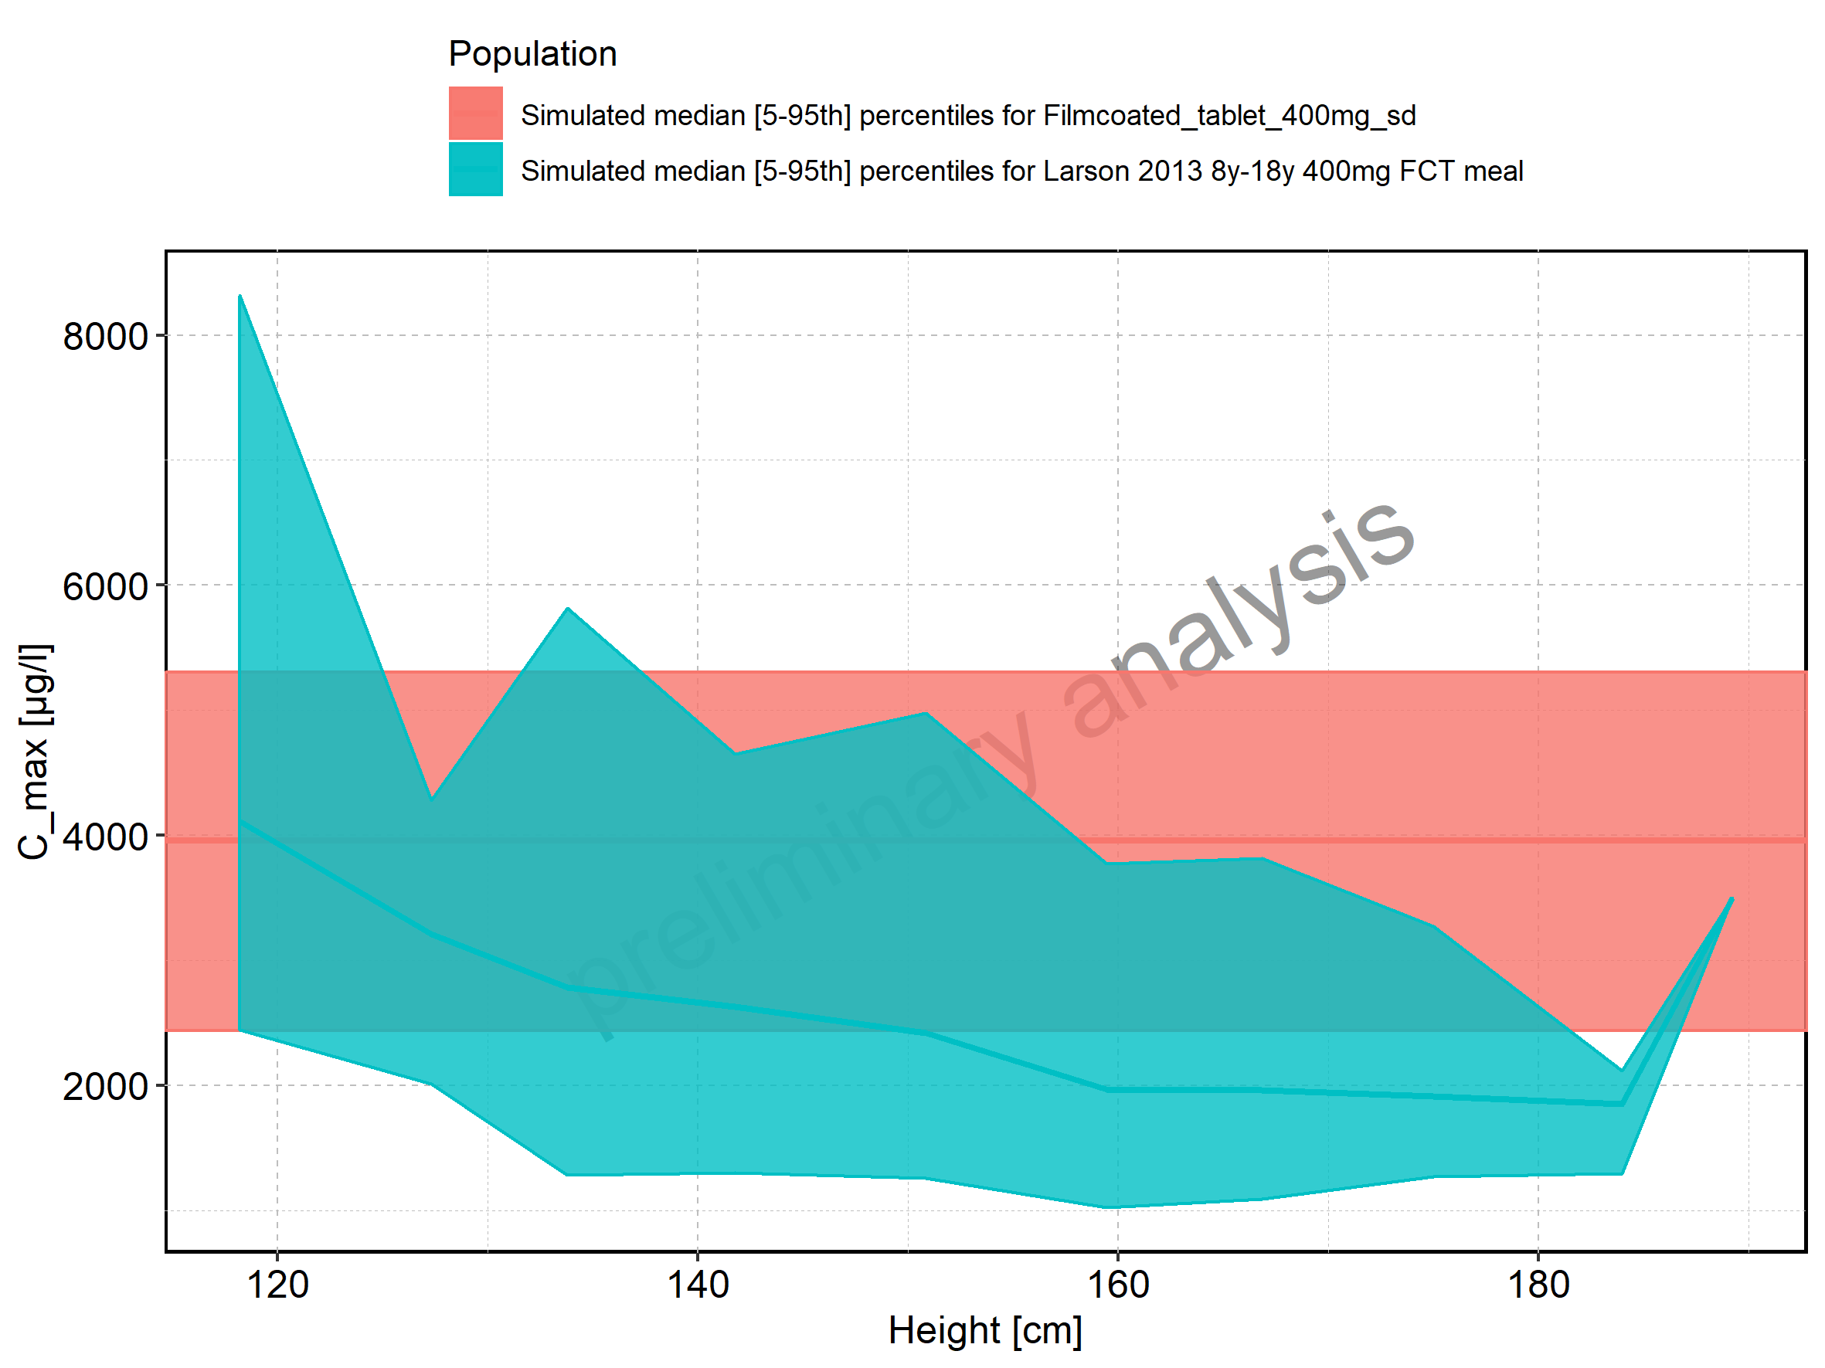

Figure 20: Height-dependence of C_max for Larson 2013 8y-18y 400mg FCT meal in comparison to Filmcoated_tablet_400mg_sd. Profiles are plotted in a logarithmic scale.

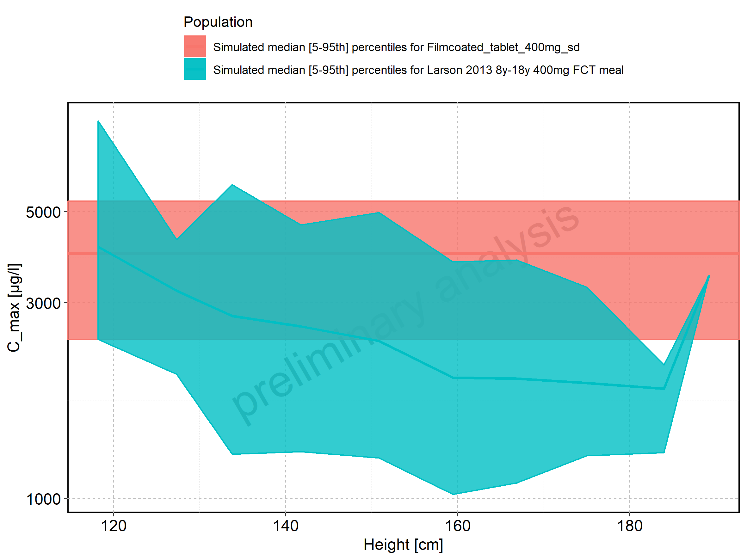

Figure 21: Height-dependence of C_max for Larson 2013 8y-18y 400mg FCT meal. Profiles are plotted in a linear scale.

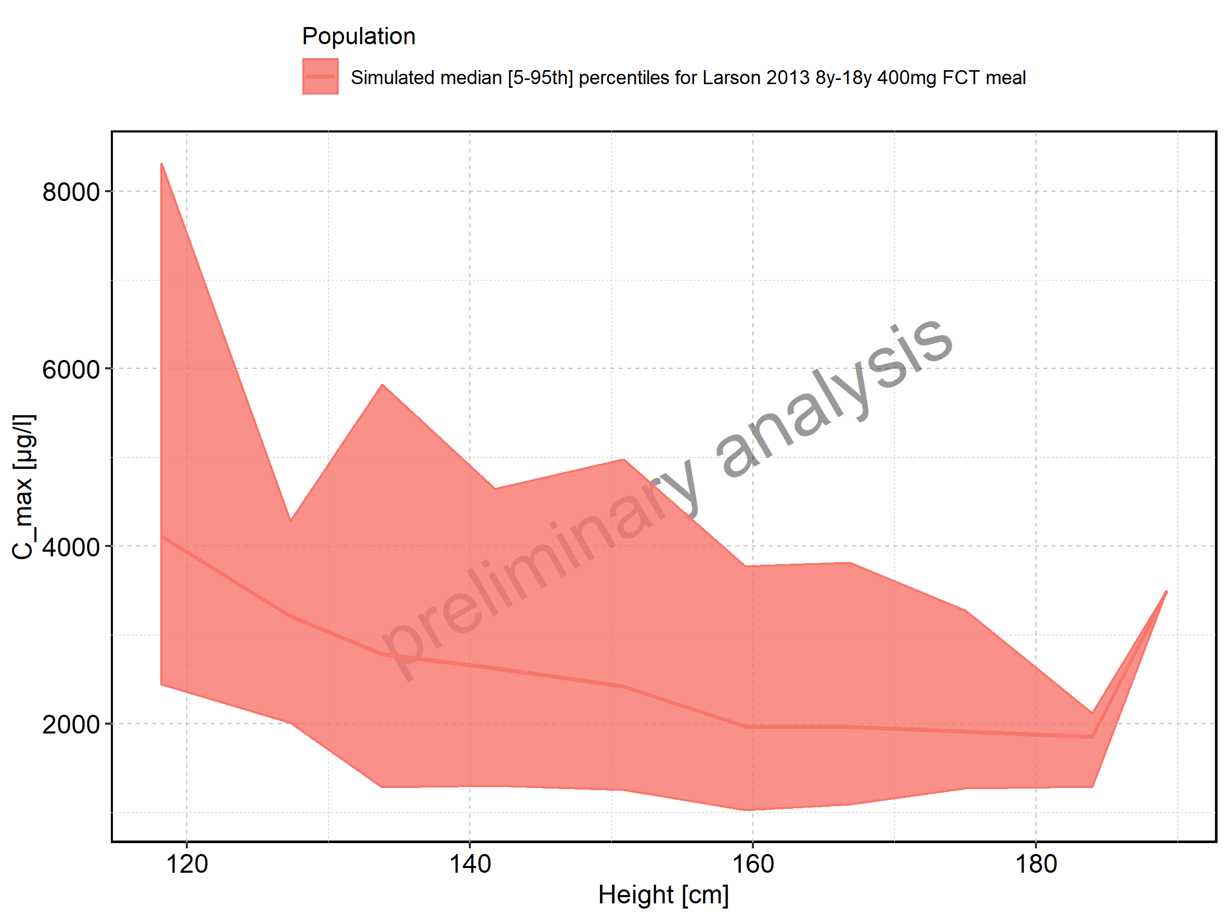

Figure 22: Height-dependence of C_max for Larson 2013 8y-18y 400mg FCT meal. Profiles are plotted in a logarithmic scale.

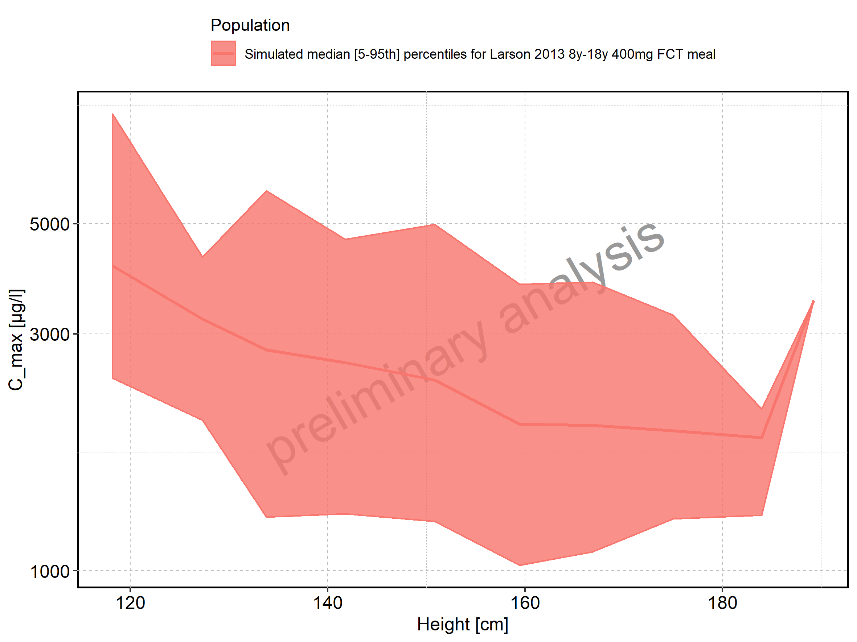

Figure 23: Height-dependence of C_max for Filmcoated_tablet_400mg_sd. Profiles are plotted in a linear scale.

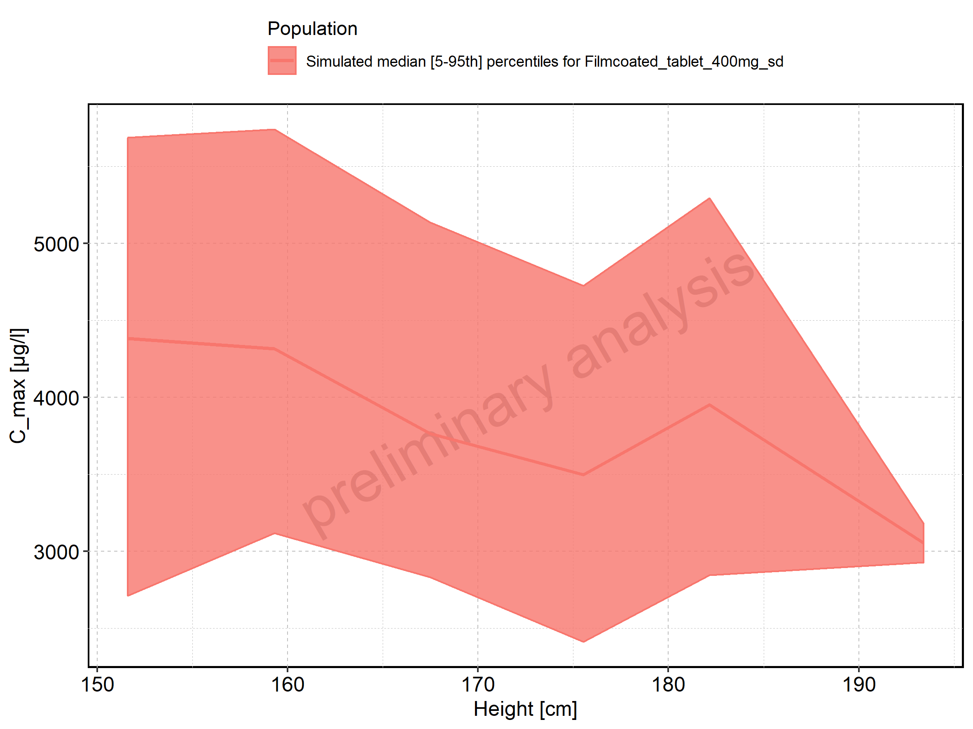

Figure 24: Height-dependence of C_max for Filmcoated_tablet_400mg_sd. Profiles are plotted in a logarithmic scale.

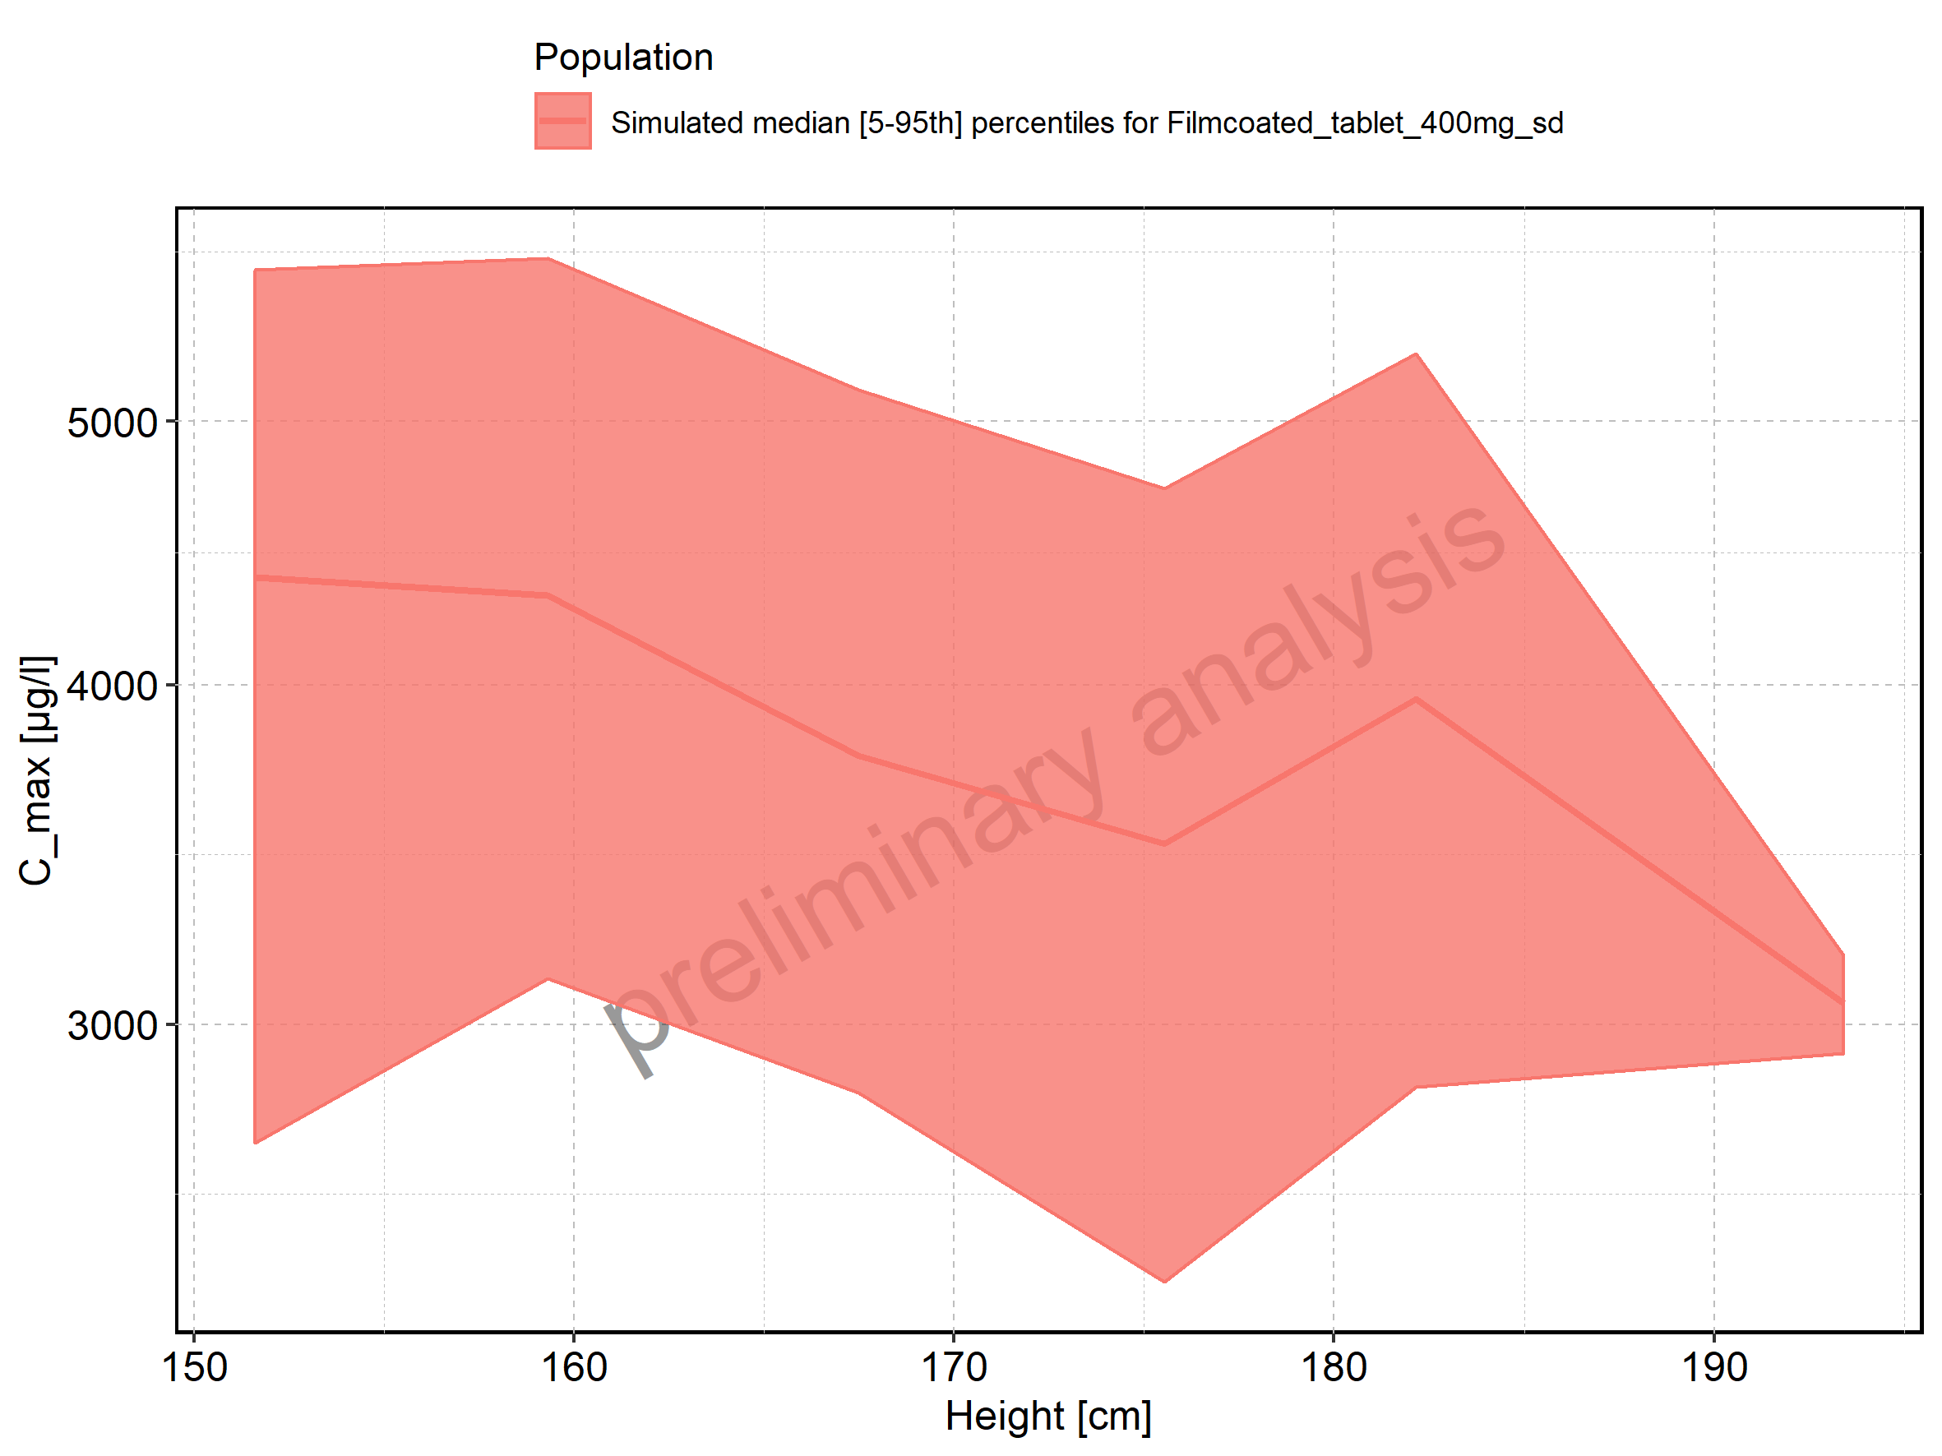

Figure 25: Weight-dependence of C_max for Larson 2013 8y-18y 400mg FCT meal in comparison to Filmcoated_tablet_400mg_sd. Profiles are plotted in a linear scale.

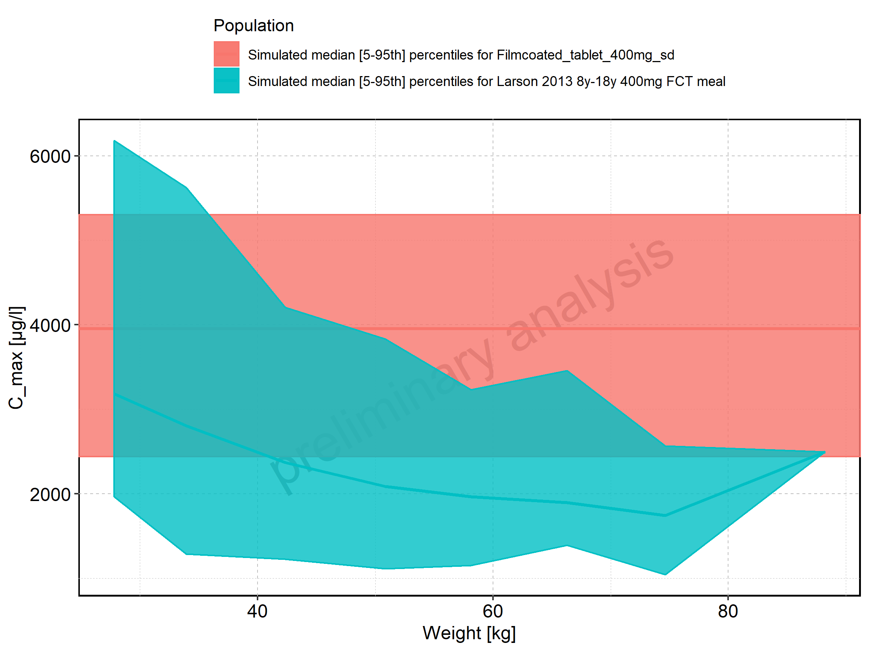

Figure 26: Weight-dependence of C_max for Larson 2013 8y-18y 400mg FCT meal in comparison to Filmcoated_tablet_400mg_sd. Profiles are plotted in a logarithmic scale.

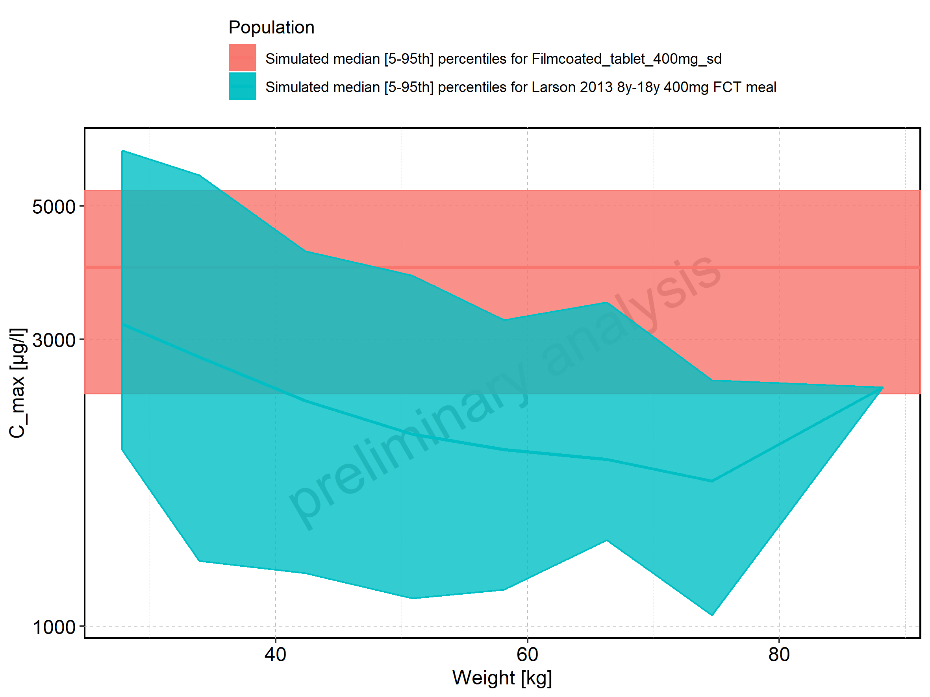

Figure 27: Weight-dependence of C_max for Larson 2013 8y-18y 400mg FCT meal. Profiles are plotted in a linear scale.

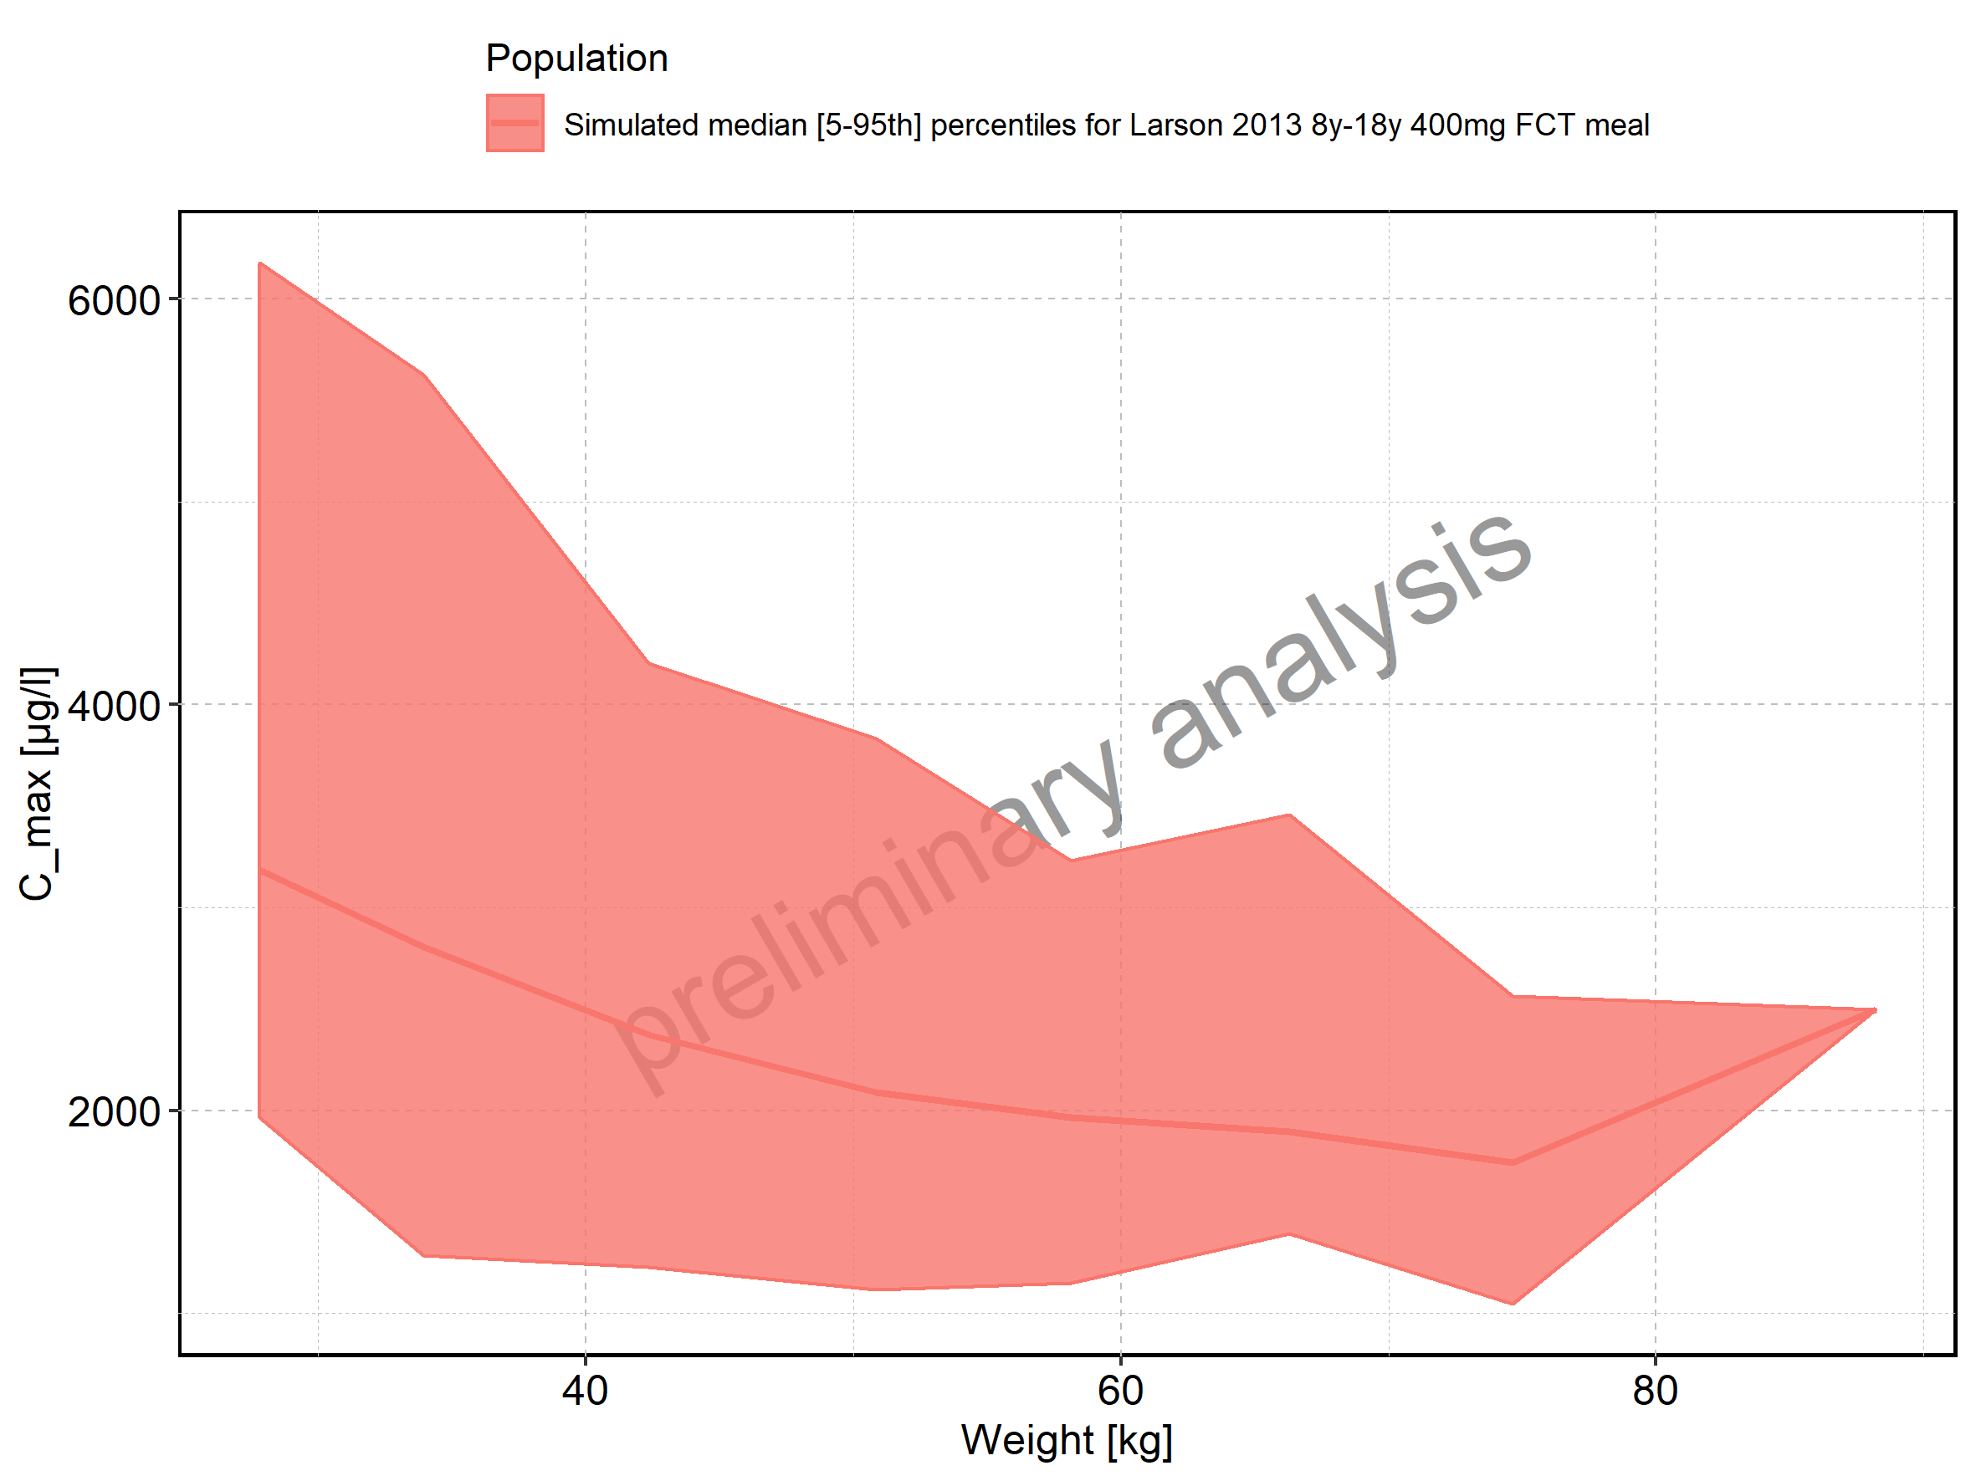

Figure 28: Weight-dependence of C_max for Larson 2013 8y-18y 400mg FCT meal. Profiles are plotted in a logarithmic scale.

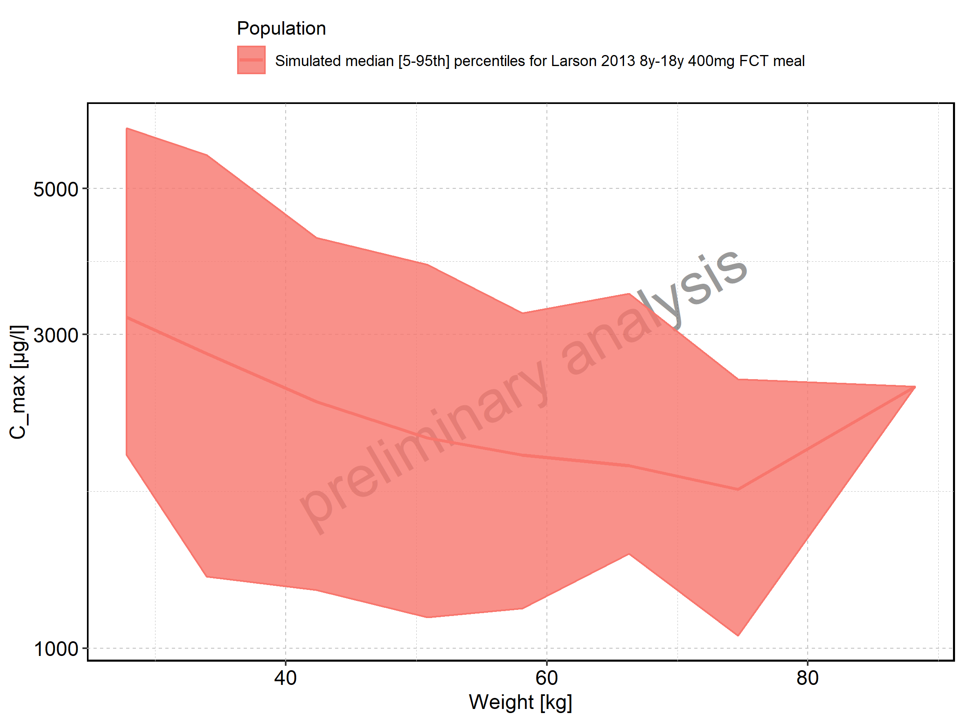

Figure 29: Weight-dependence of C_max for Filmcoated_tablet_400mg_sd. Profiles are plotted in a linear scale.

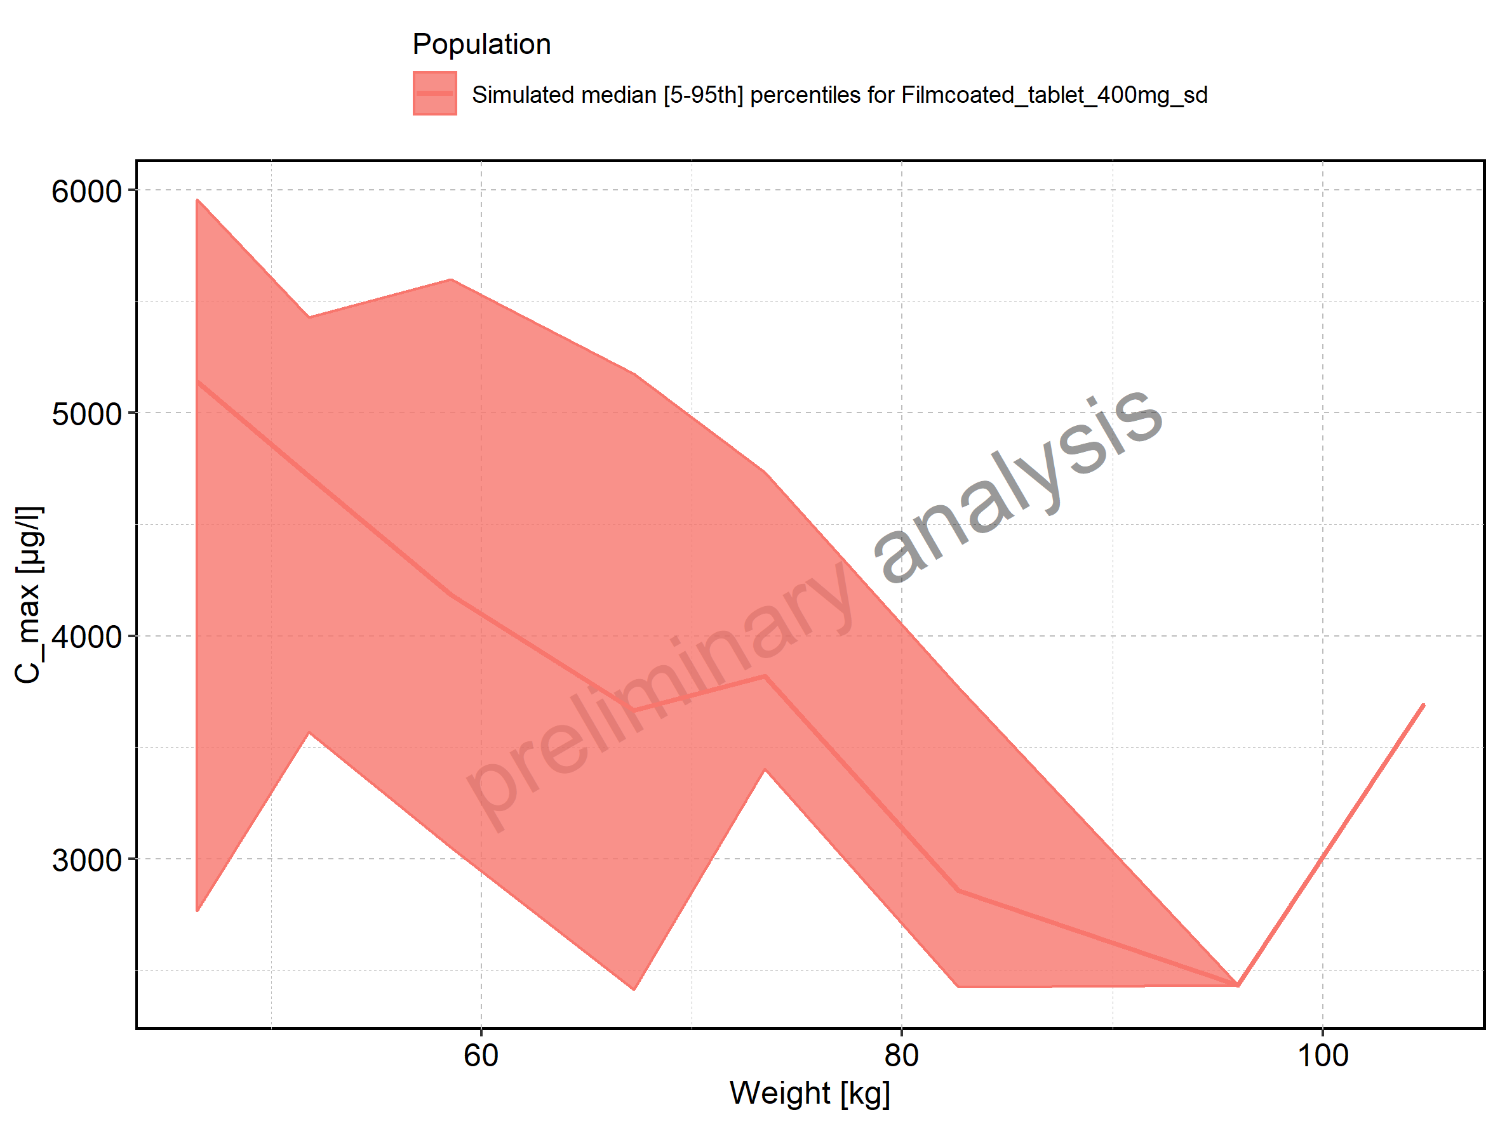

Figure 30: Weight-dependence of C_max for Filmcoated_tablet_400mg_sd. Profiles are plotted in a logarithmic scale.

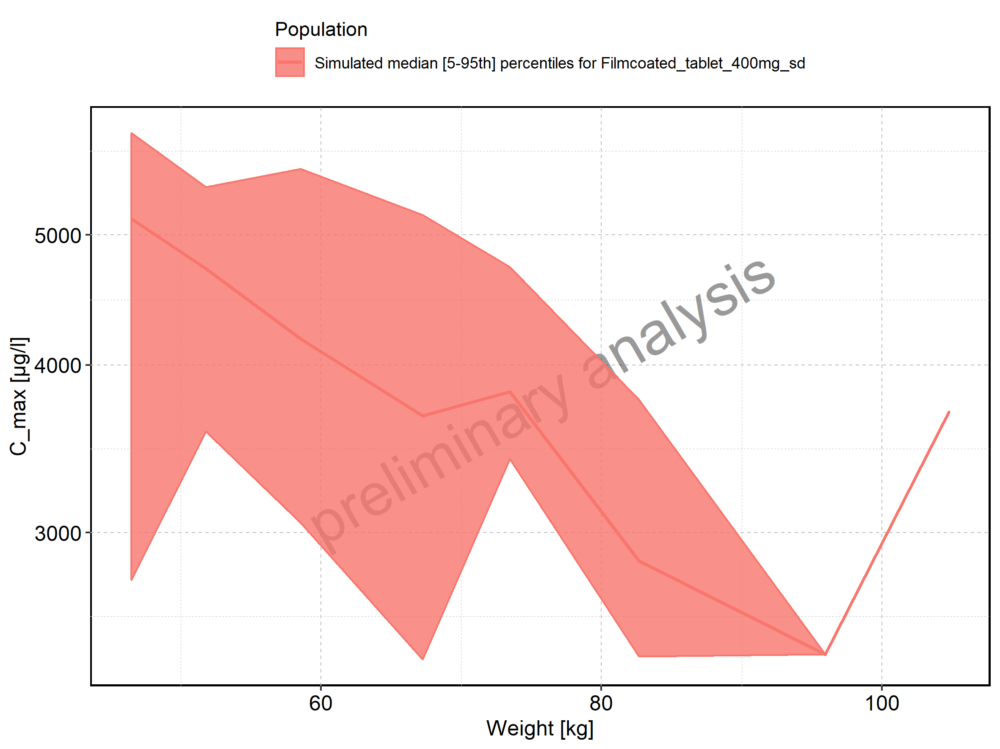

Figure 31: BMI-dependence of C_max for Larson 2013 8y-18y 400mg FCT meal in comparison to Filmcoated_tablet_400mg_sd. Profiles are plotted in a linear scale.

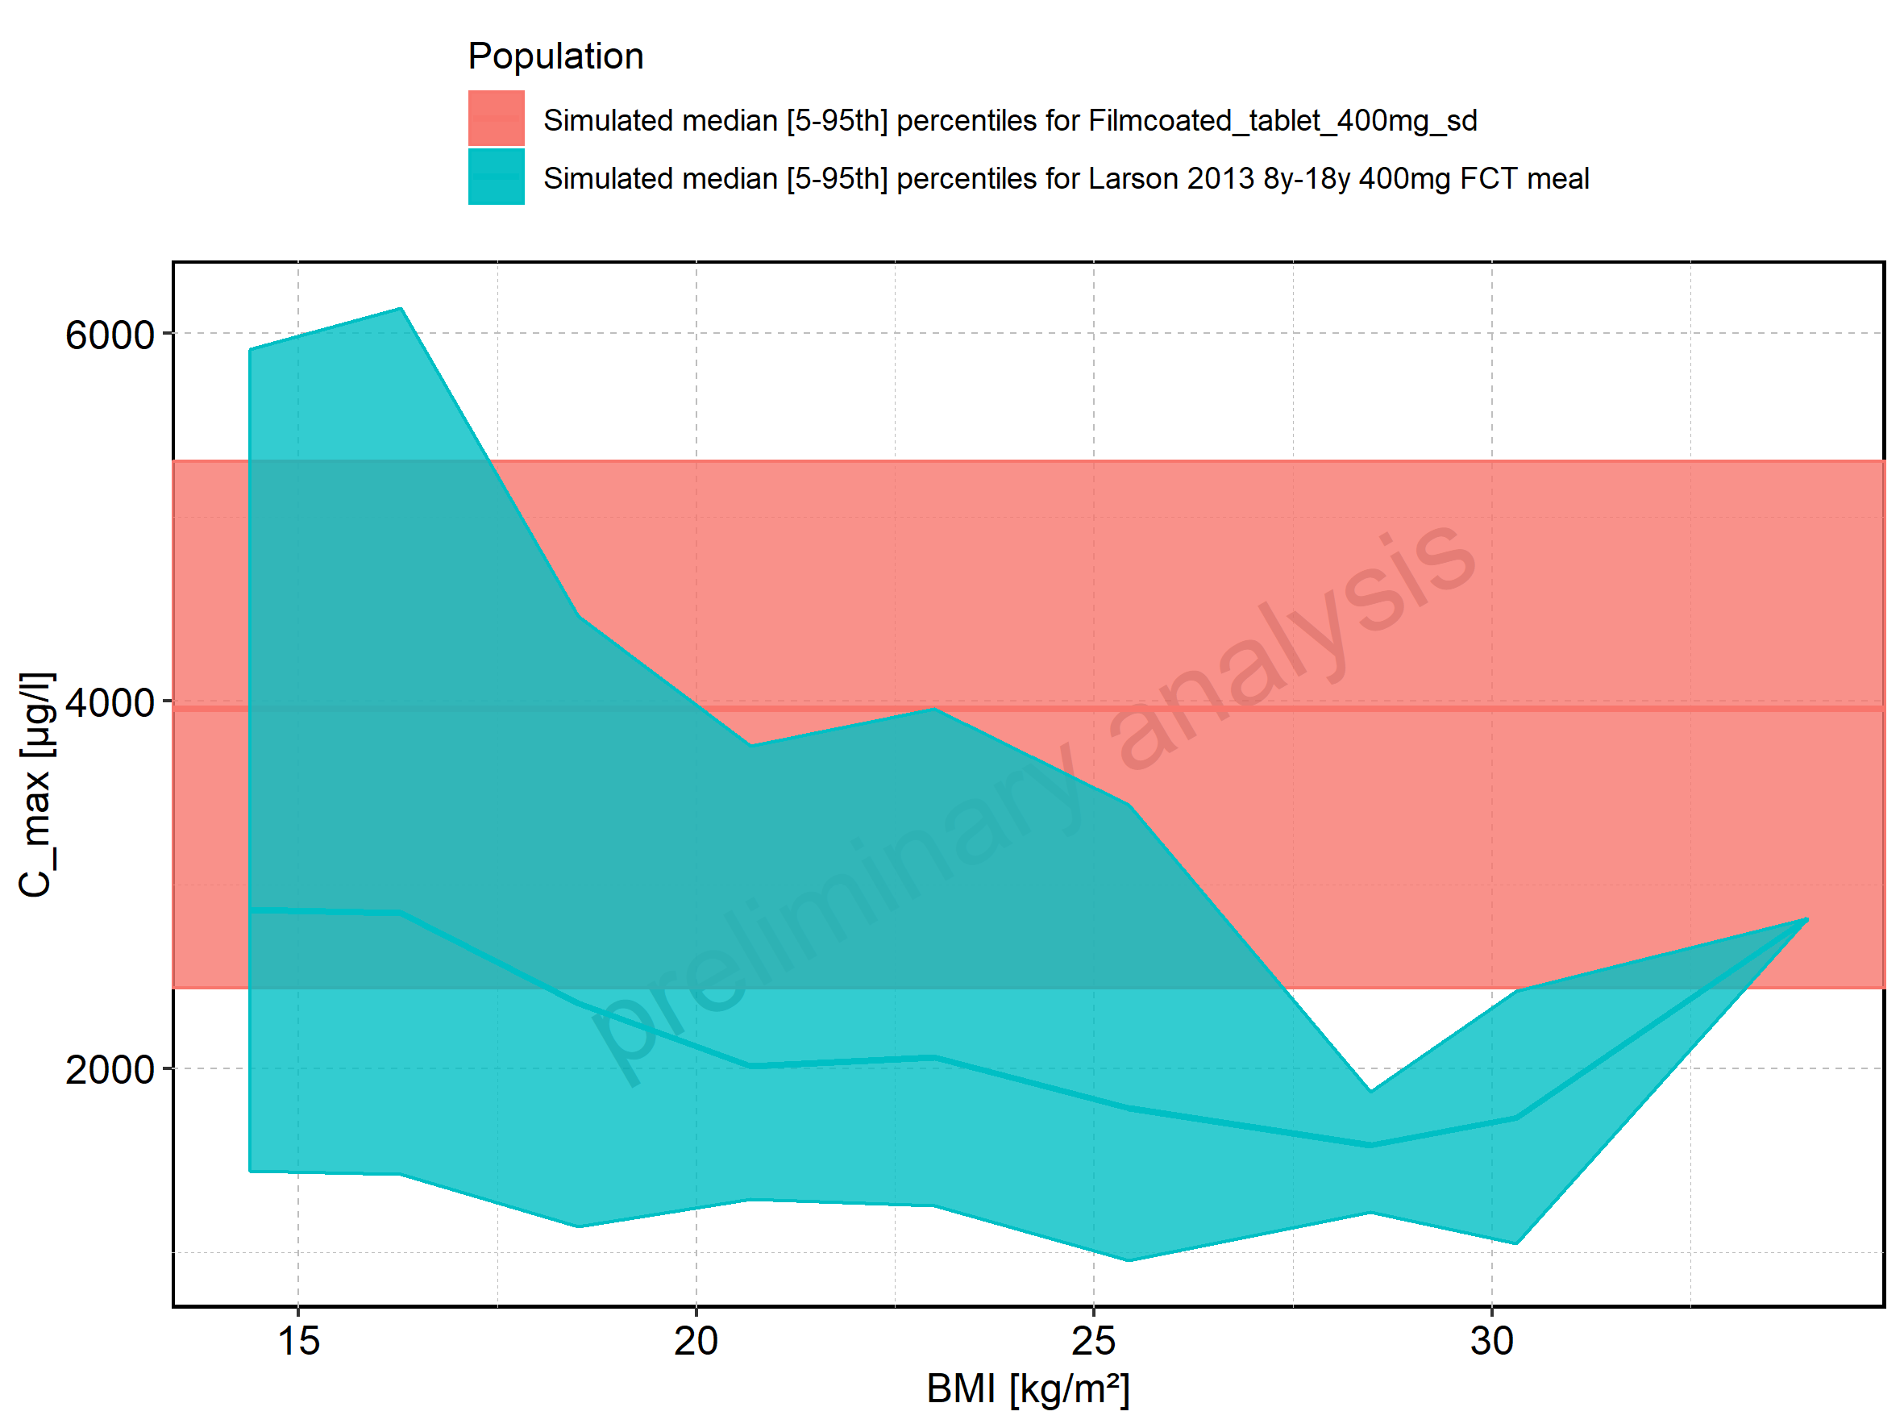

Figure 32: BMI-dependence of C_max for Larson 2013 8y-18y 400mg FCT meal in comparison to Filmcoated_tablet_400mg_sd. Profiles are plotted in a logarithmic scale.

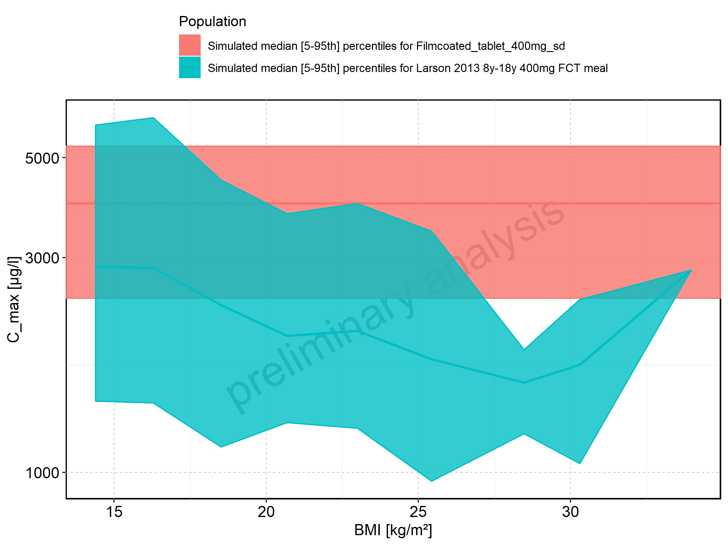

Figure 33: BMI-dependence of C_max for Larson 2013 8y-18y 400mg FCT meal. Profiles are plotted in a linear scale.

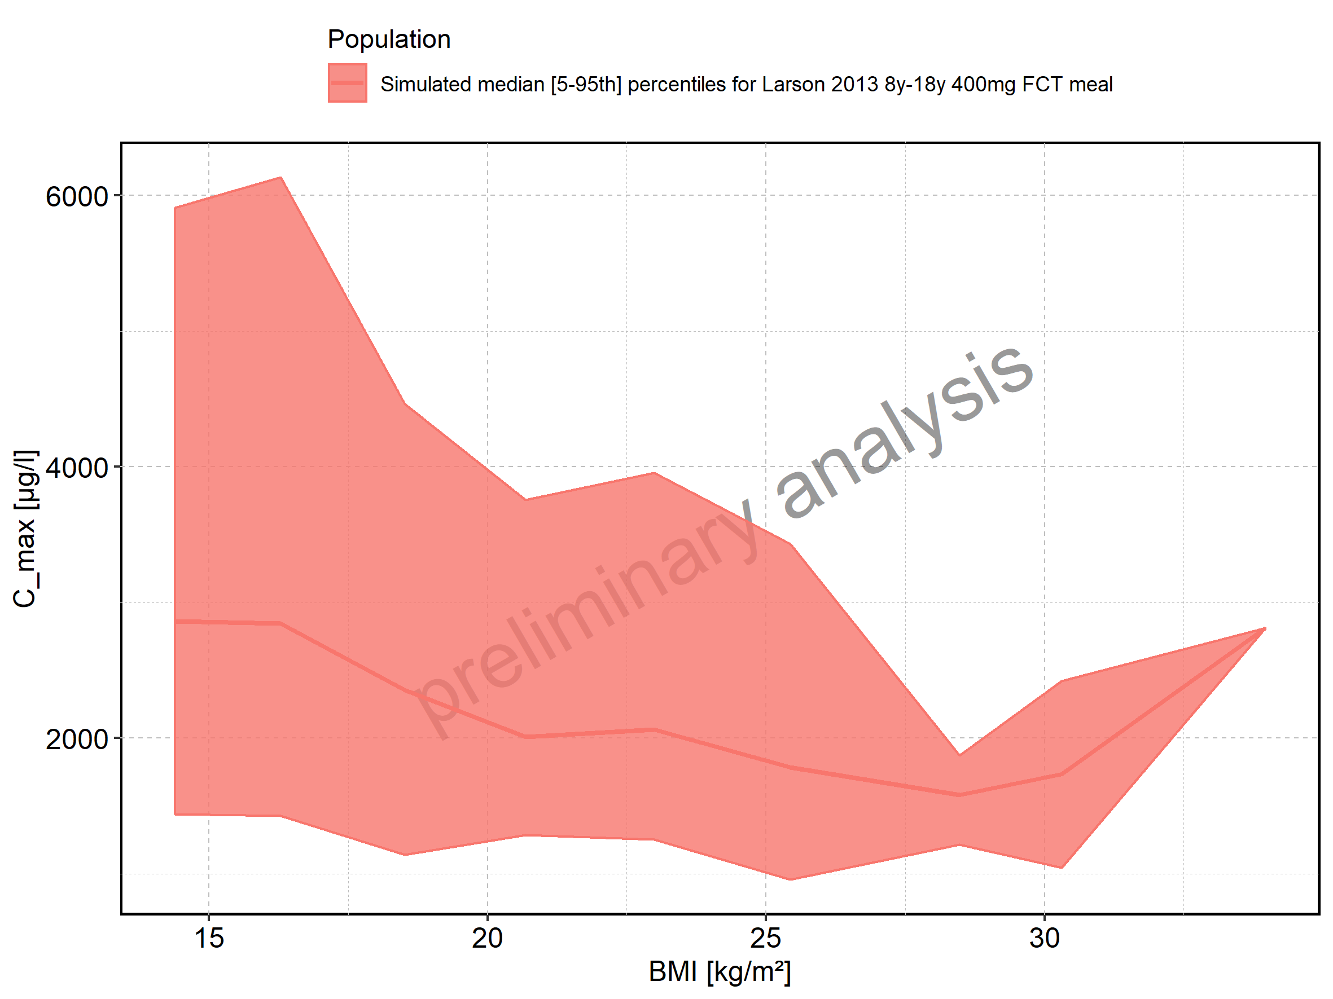

Figure 34: BMI-dependence of C_max for Larson 2013 8y-18y 400mg FCT meal. Profiles are plotted in a logarithmic scale.

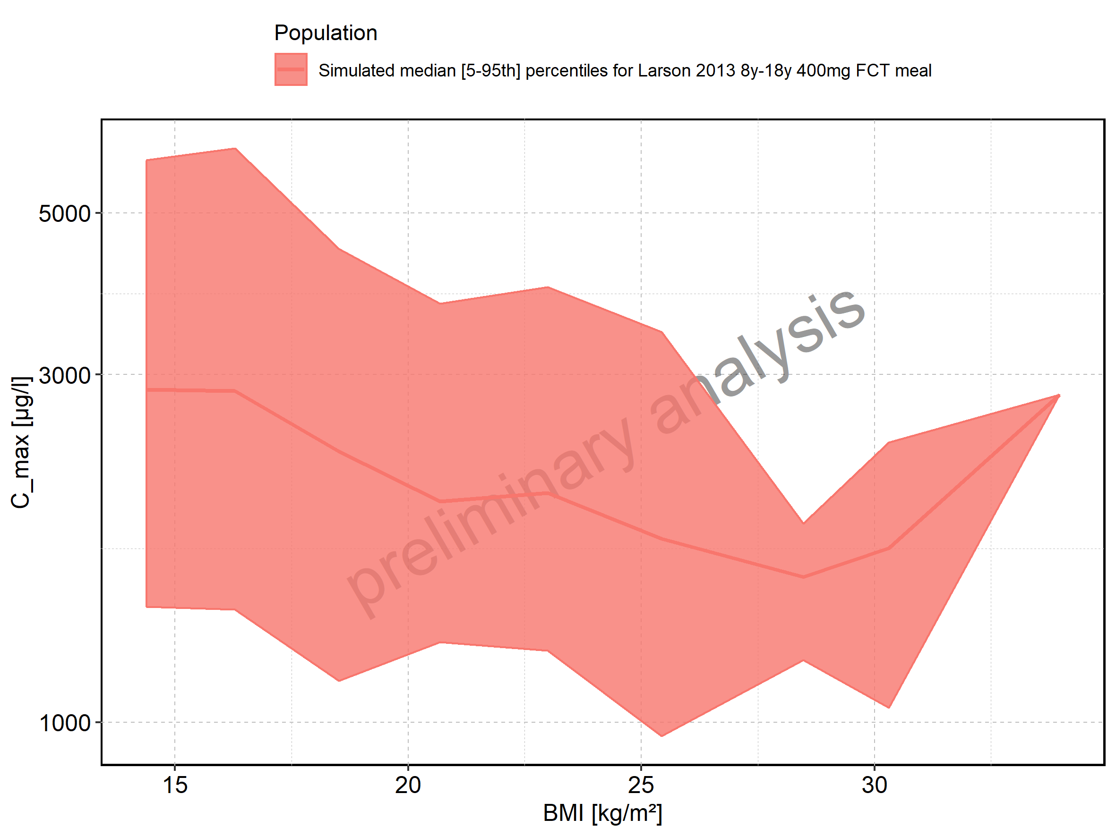

Figure 35: BMI-dependence of C_max for Filmcoated_tablet_400mg_sd. Profiles are plotted in a linear scale.

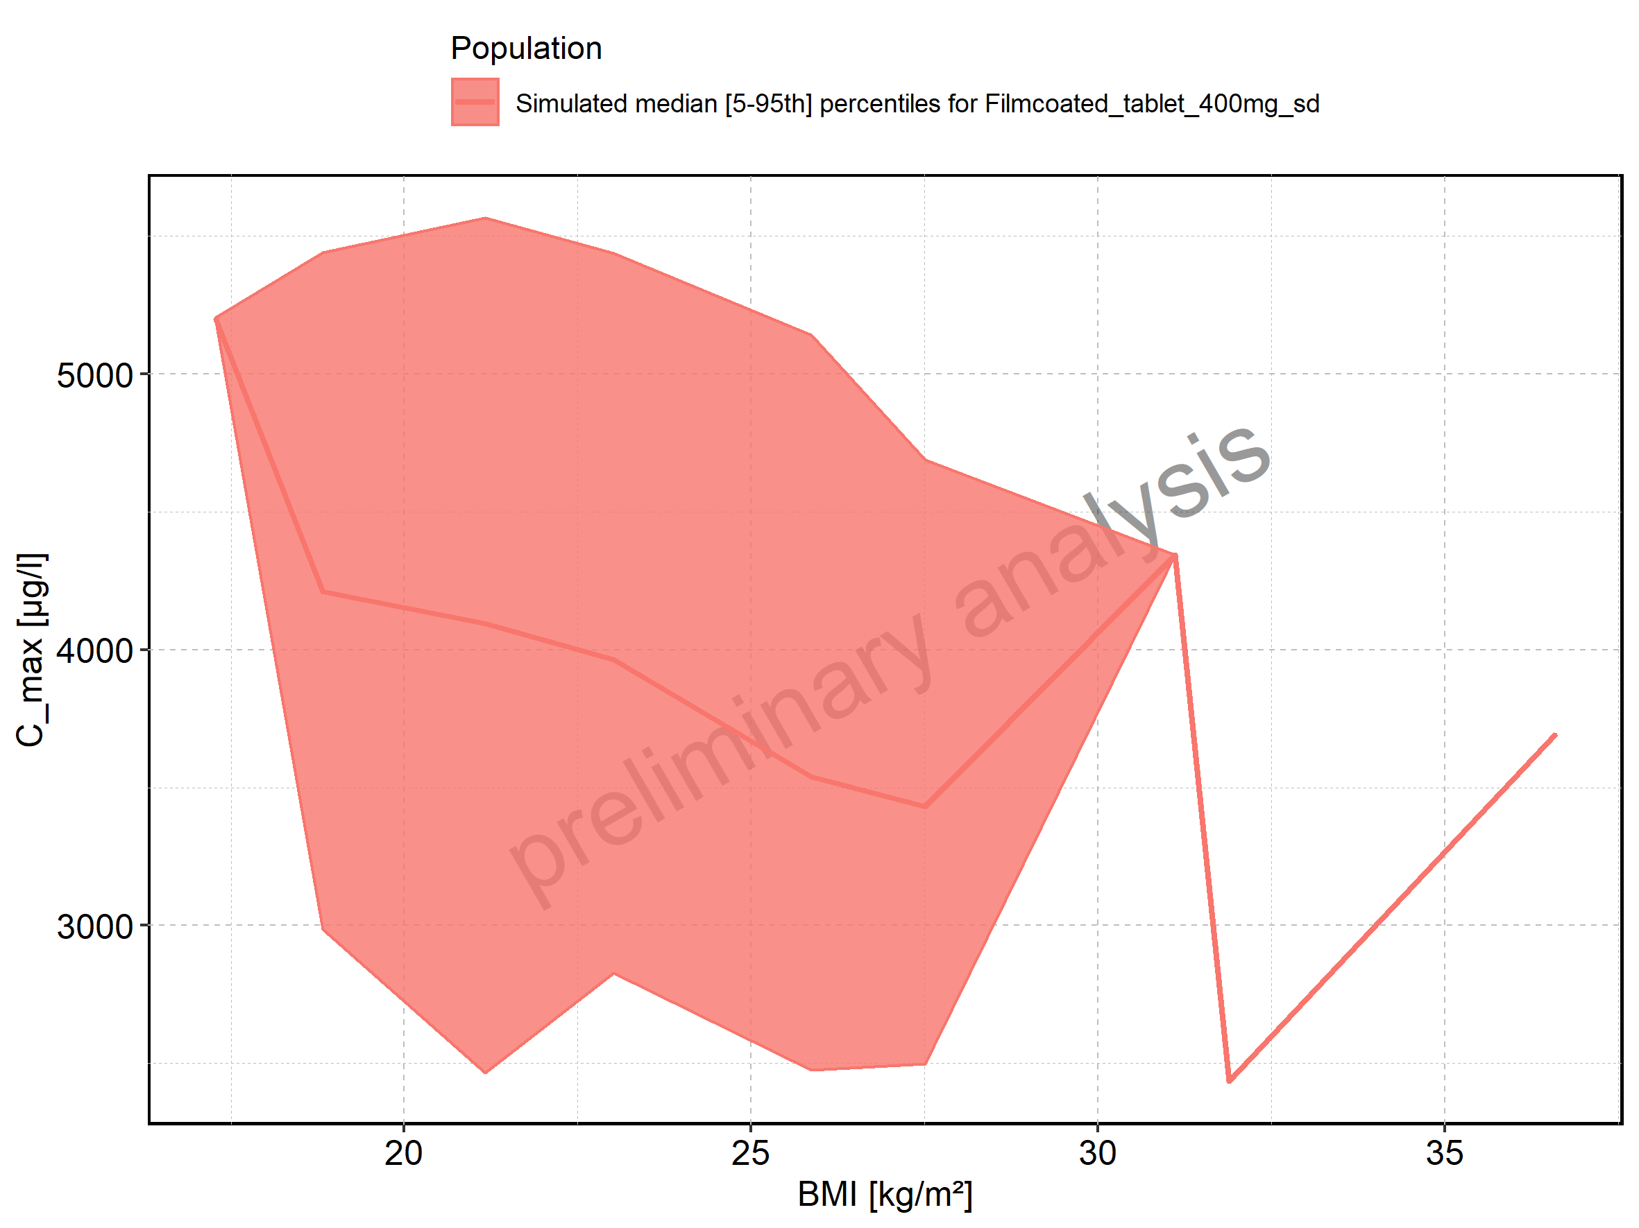

Figure 36: BMI-dependence of C_max for Filmcoated_tablet_400mg_sd. Profiles are plotted in a logarithmic scale.

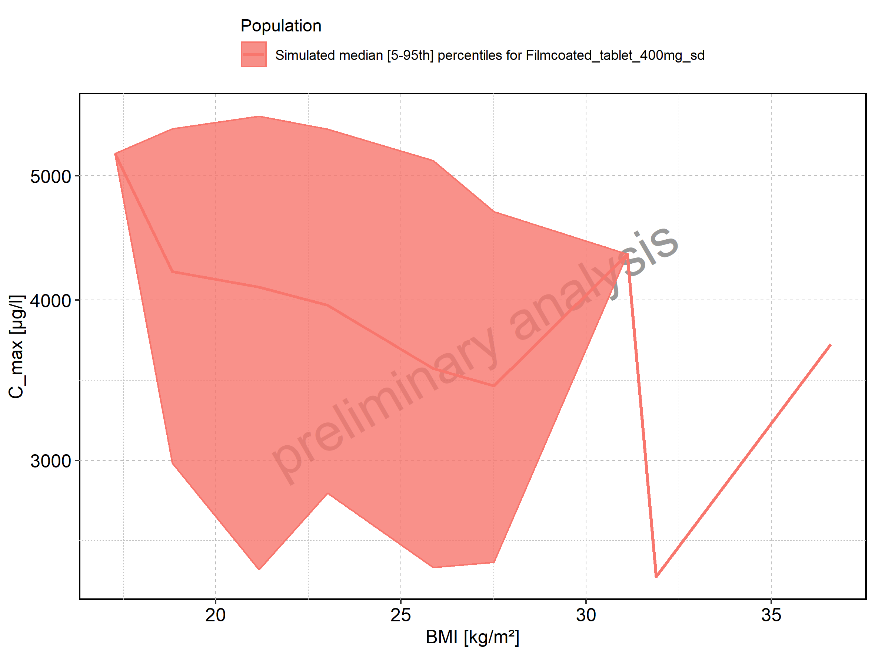

Figure 37: C_max_norm of Raltegravir shown as box-whisker plot, which indicates the 5th, 25th, 50th, 75th, and 95th percentiles in linear scale.

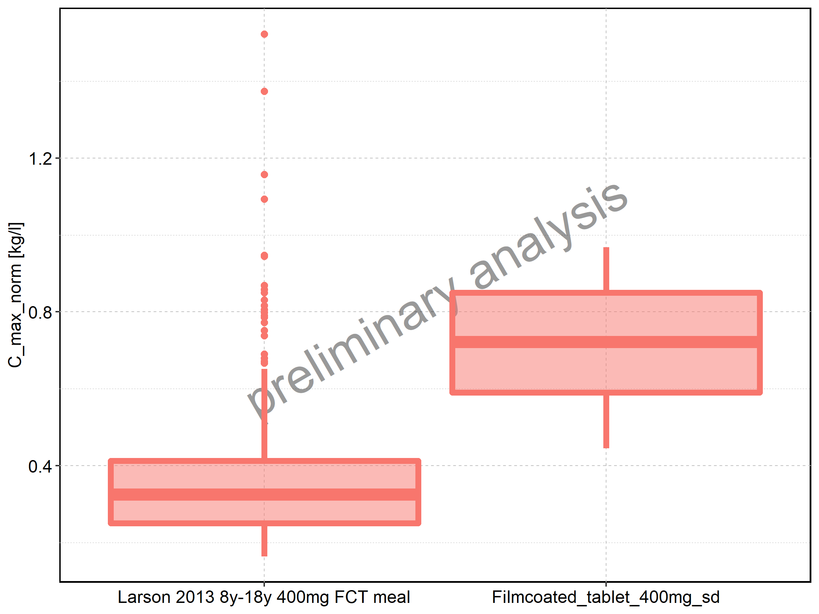

|  |  |  |  |  |  |  |  |  |  |  |
| --- | --- | --- | --- | --- | --- | --- | --- | --- | --- | --- |
| Population | N | 5th percentile | 25th percentile | 50th percentile | 75th percentile | 95th percentile | mean | standard deviation | geo mean | geo standard deviation |
| Larson 2013 8y-18y 400mg FCT meal | 500 | 0.1639770 | 0.2498922 | 0.3250171 | 0.4128938 | 0.6511956 | 0.3569764 | 0.1689641 | 0.3257618 | 1.523041 |
| Filmcoated_tablet_400mg_sd | 100 | 0.4448963 | 0.5906684 | 0.7217033 | 0.8500038 | 0.9680502 | 0.7192180 | 0.1658724 | 0.6996500 | 1.270937 |

Figure 38: C_max_norm of Raltegravir shown as box-whisker plot, which indicates the 5th, 25th, 50th, 75th, and 95th percentiles in logarithmic scale.

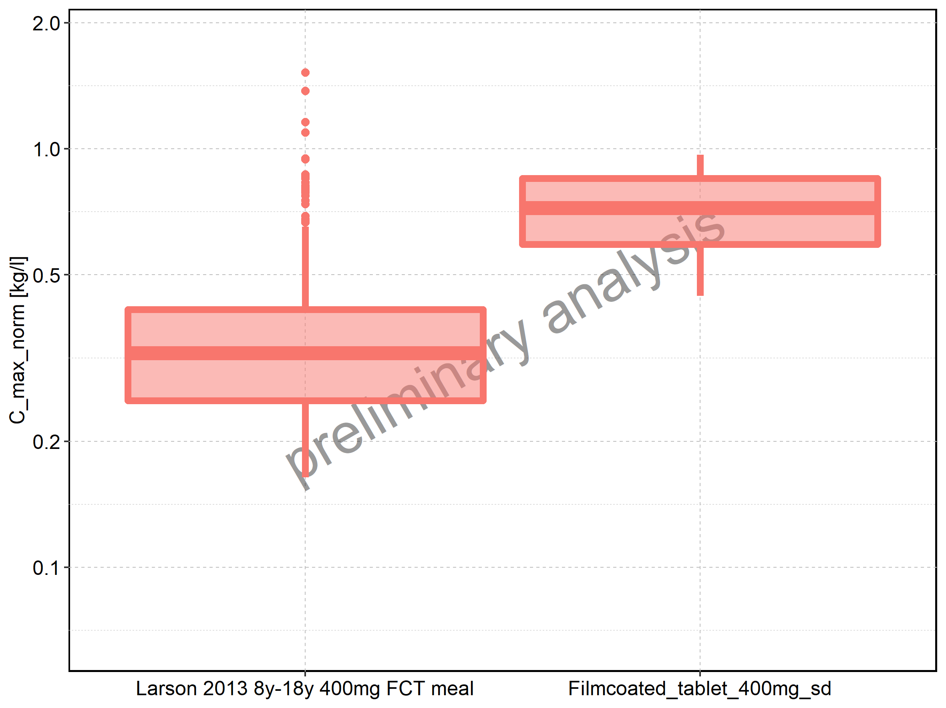

Figure 39: Age-dependence of C_max_norm for Larson 2013 8y-18y 400mg FCT meal in comparison to Filmcoated_tablet_400mg_sd. Profiles are plotted in a linear scale.

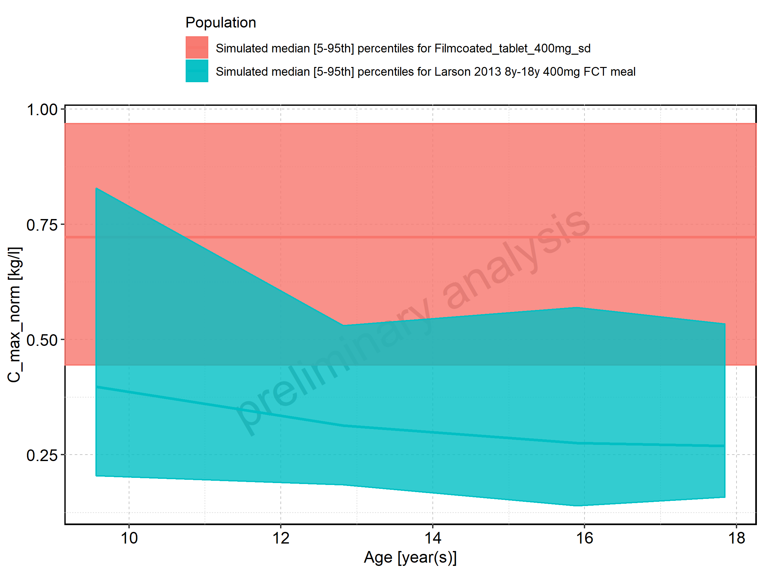

Figure 40: Age-dependence of C_max_norm for Larson 2013 8y-18y 400mg FCT meal in comparison to Filmcoated_tablet_400mg_sd. Profiles are plotted in a logarithmic scale.

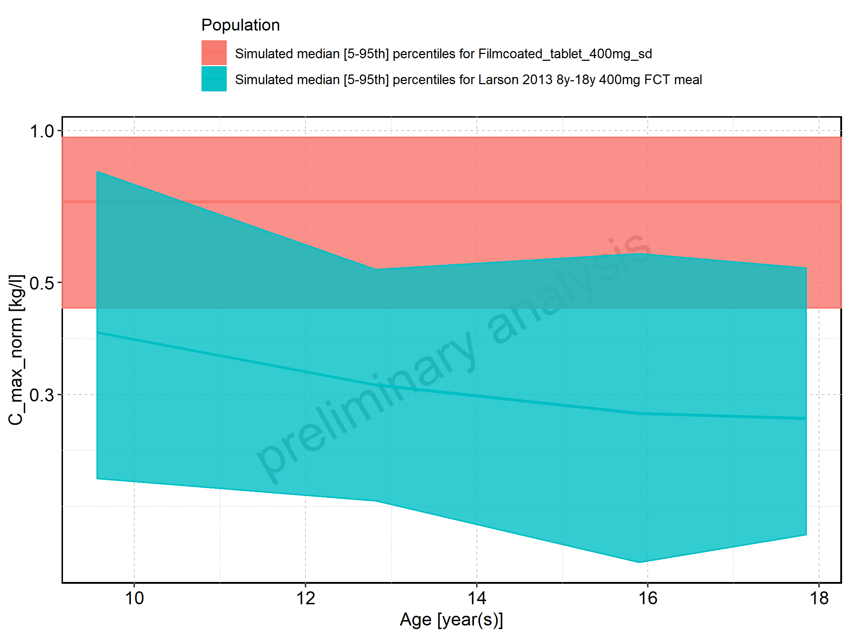

Figure 41: Age-dependence of C_max_norm for Larson 2013 8y-18y 400mg FCT meal. Profiles are plotted in a linear scale.

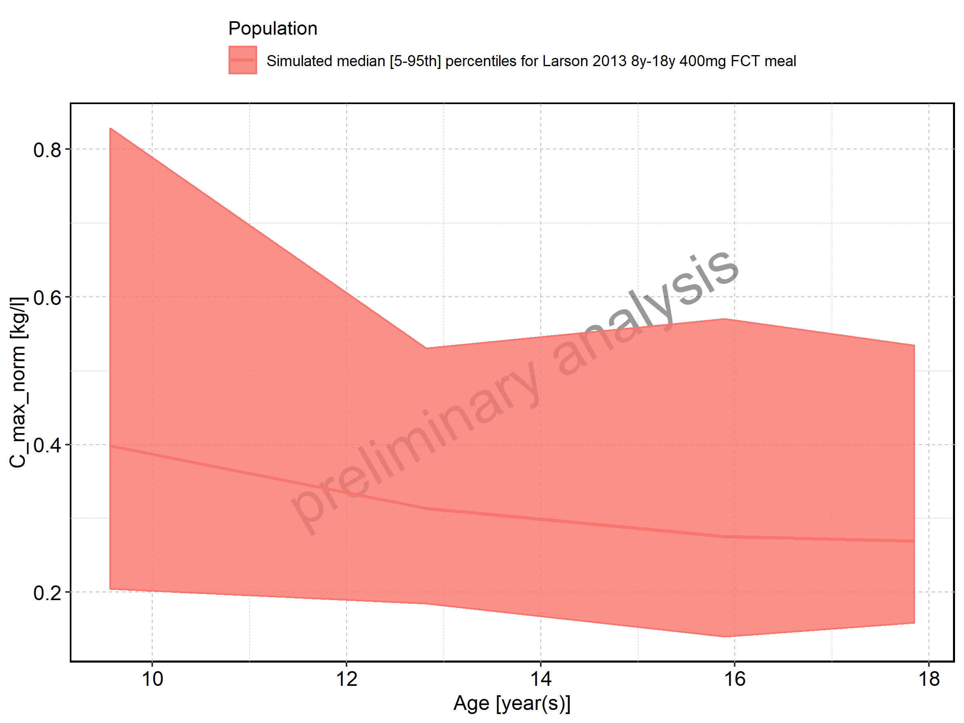

Figure 42: Age-dependence of C_max_norm for Larson 2013 8y-18y 400mg FCT meal. Profiles are plotted in a logarithmic scale.

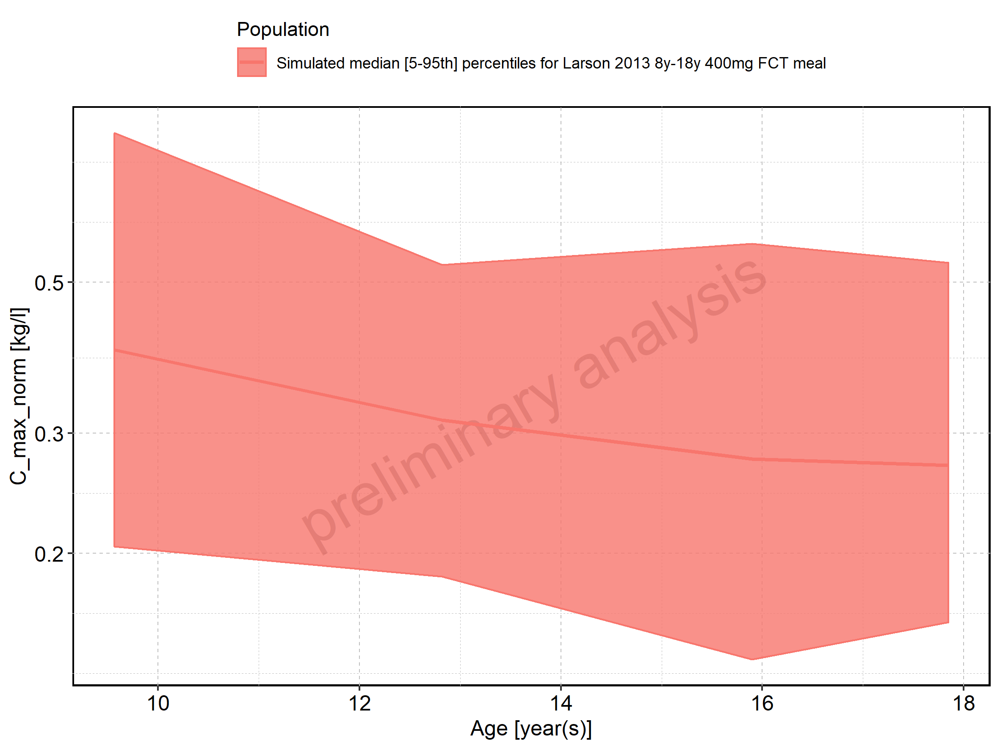

Figure 43: Age-dependence of C_max_norm for Filmcoated_tablet_400mg_sd. Profiles are plotted in a linear scale.

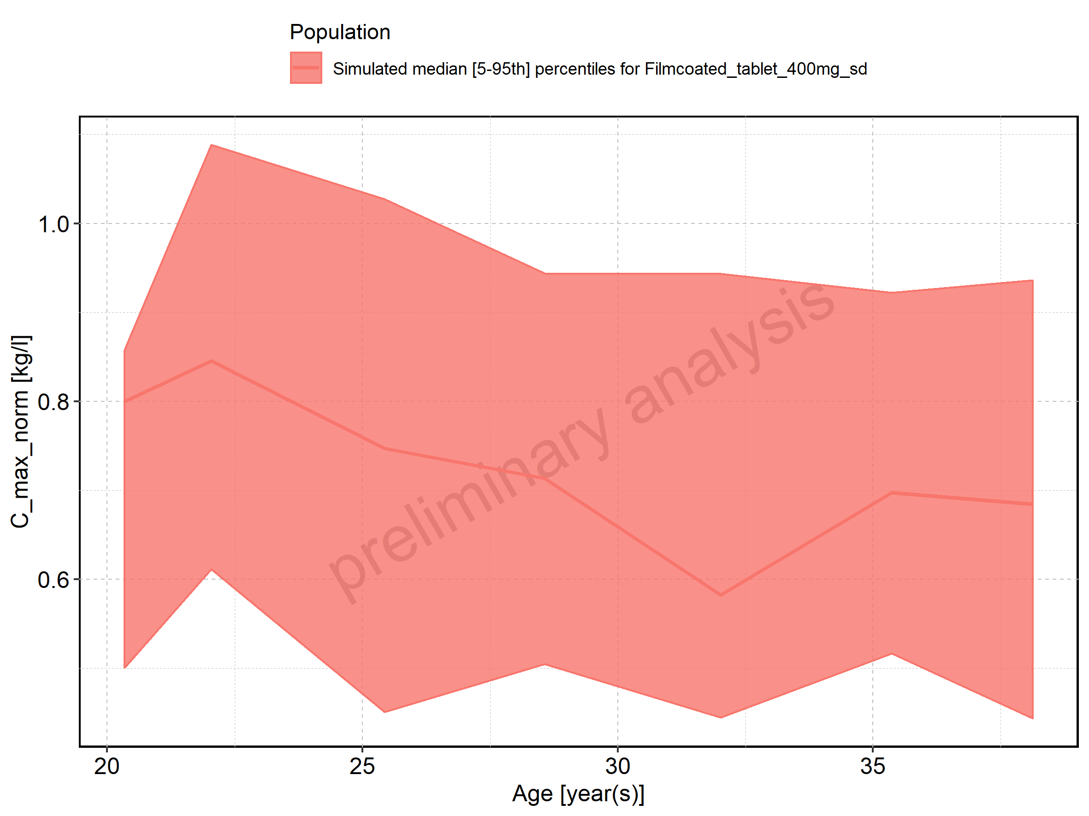

Figure 44: Age-dependence of C_max_norm for Filmcoated_tablet_400mg_sd. Profiles are plotted in a logarithmic scale.

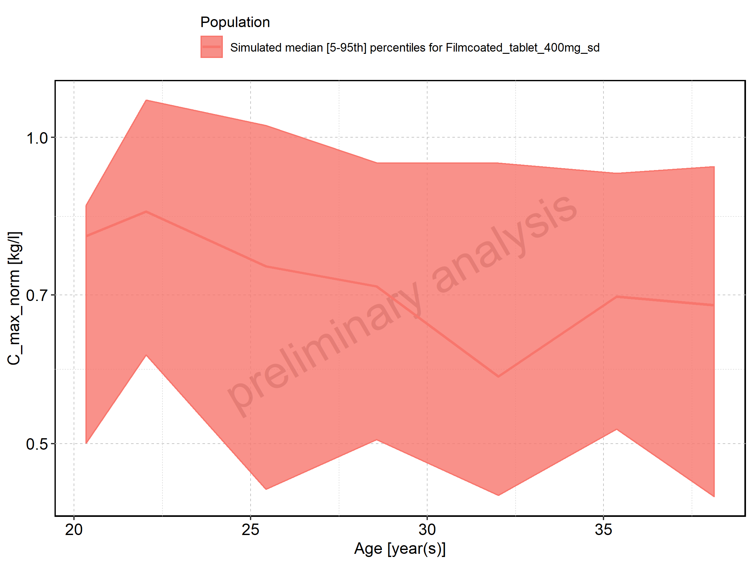

Figure 45: Height-dependence of C_max_norm for Larson 2013 8y-18y 400mg FCT meal in comparison to Filmcoated_tablet_400mg_sd. Profiles are plotted in a linear scale.

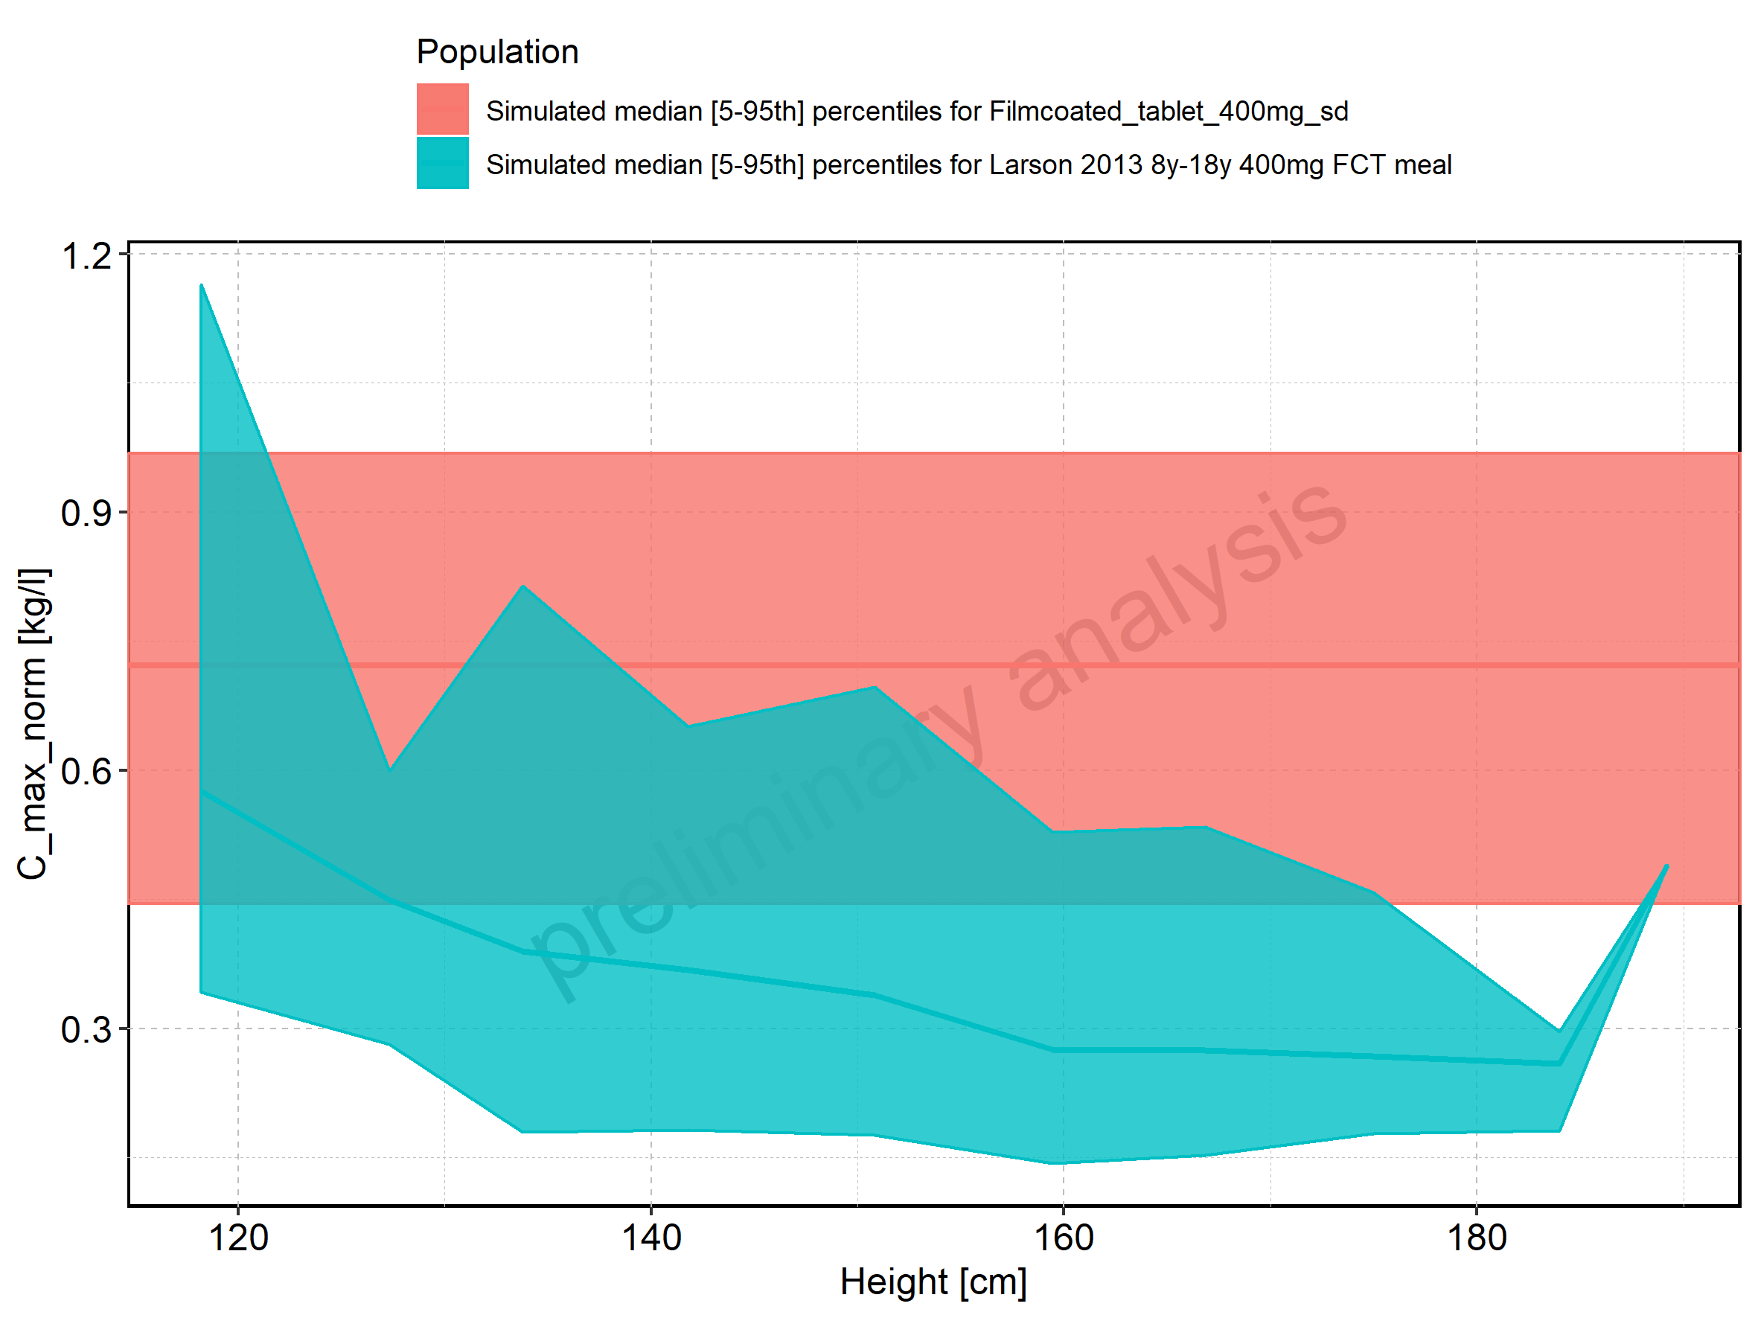

Figure 46: Height-dependence of C_max_norm for Larson 2013 8y-18y 400mg FCT meal in comparison to Filmcoated_tablet_400mg_sd. Profiles are plotted in a logarithmic scale.

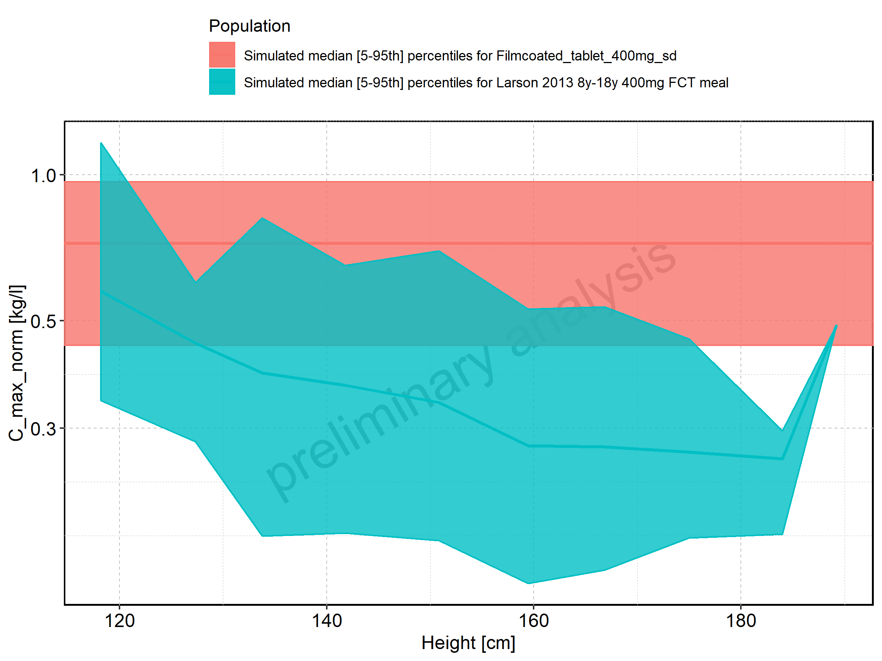

Figure 47: Height-dependence of C_max_norm for Larson 2013 8y-18y 400mg FCT meal. Profiles are plotted in a linear scale.

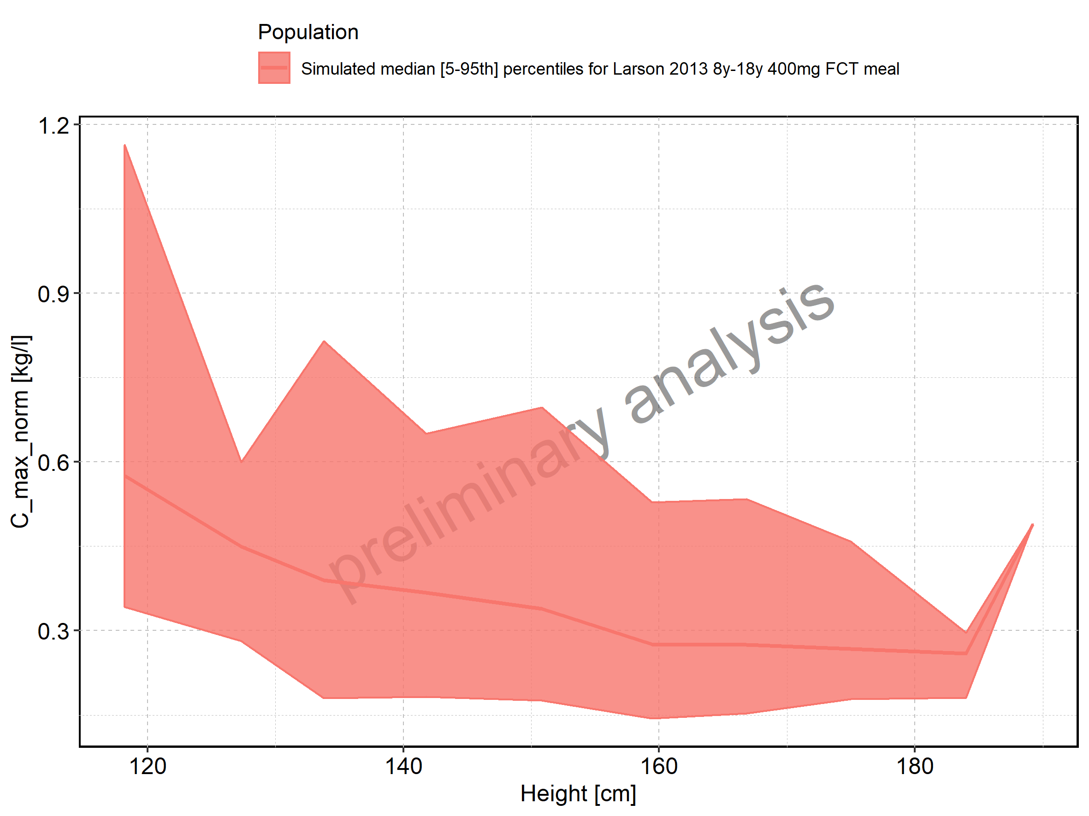

Figure 48: Height-dependence of C_max_norm for Larson 2013 8y-18y 400mg FCT meal. Profiles are plotted in a logarithmic scale.

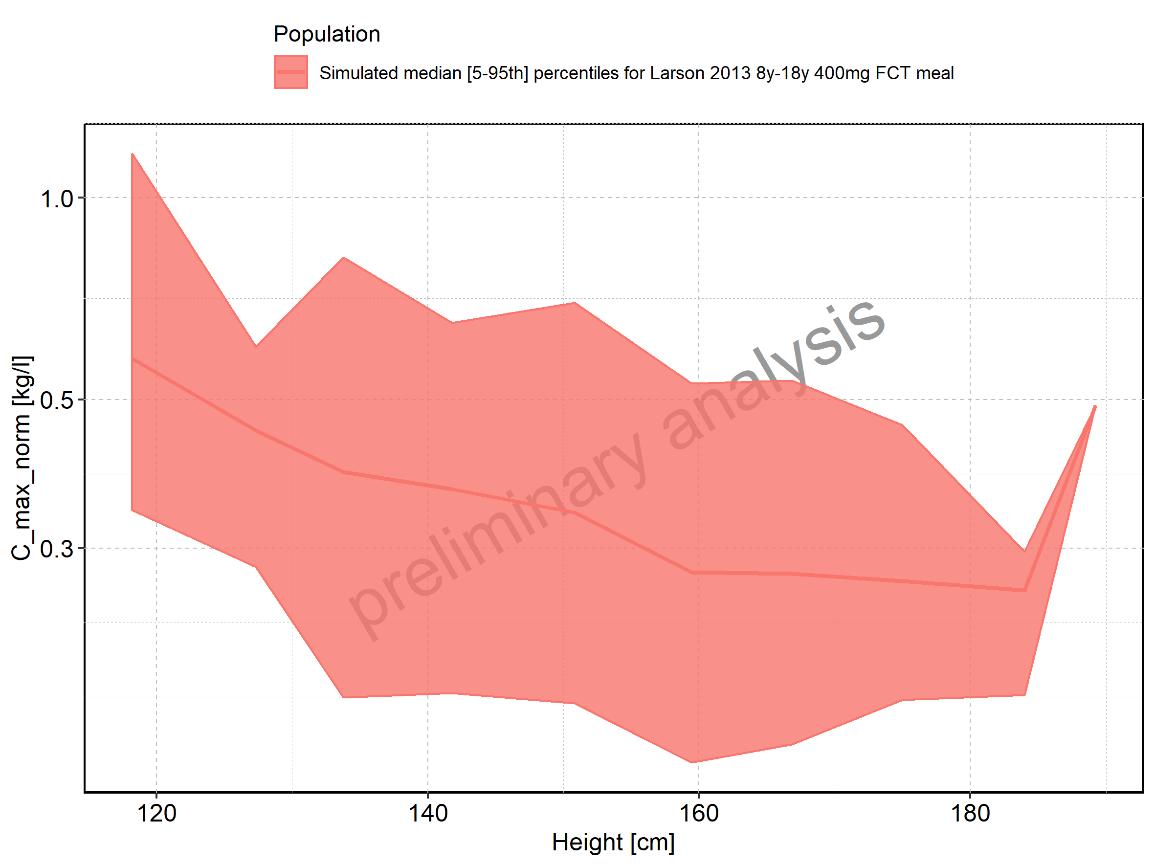

Figure 49: Height-dependence of C_max_norm for Filmcoated_tablet_400mg_sd. Profiles are plotted in a linear scale.

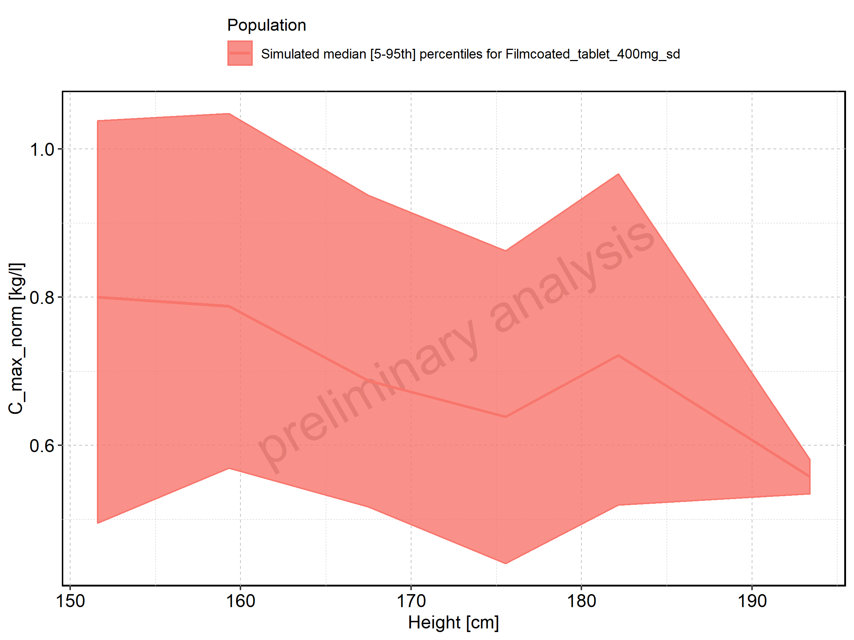

Figure 50: Height-dependence of C_max_norm for Filmcoated_tablet_400mg_sd. Profiles are plotted in a logarithmic scale.

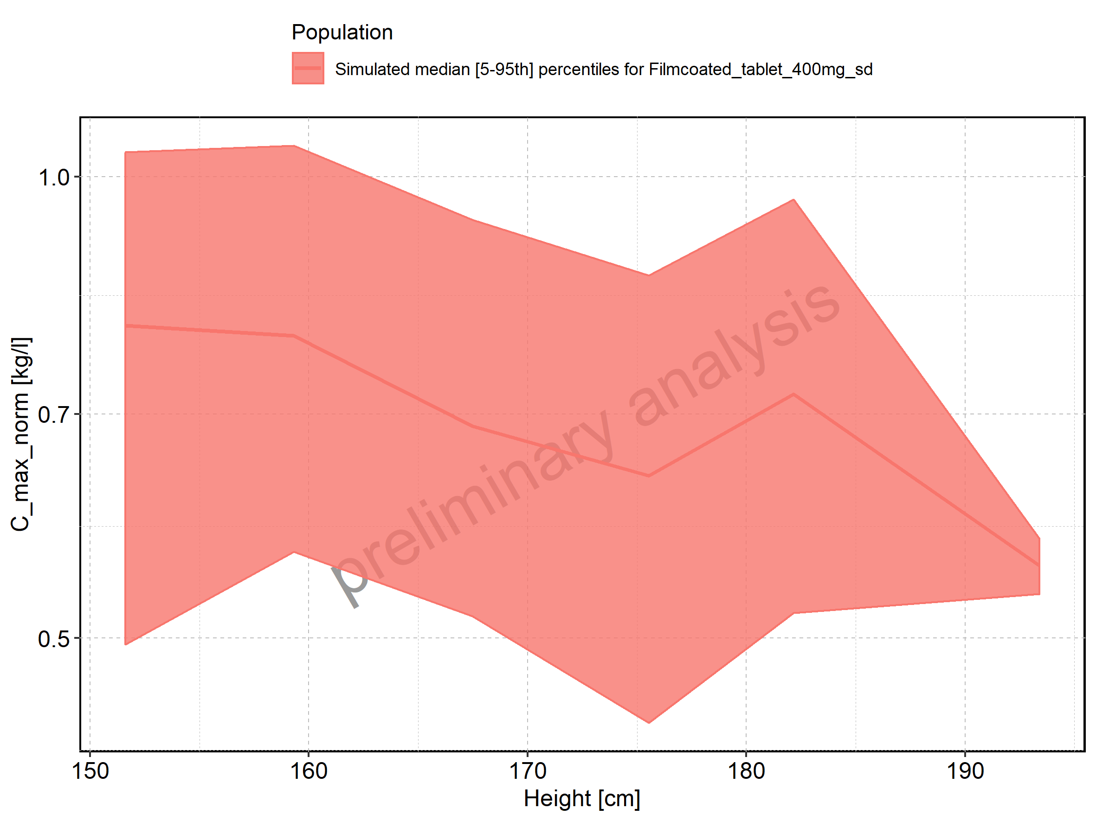

Figure 51: Weight-dependence of C_max_norm for Larson 2013 8y-18y 400mg FCT meal in comparison to Filmcoated_tablet_400mg_sd. Profiles are plotted in a linear scale.

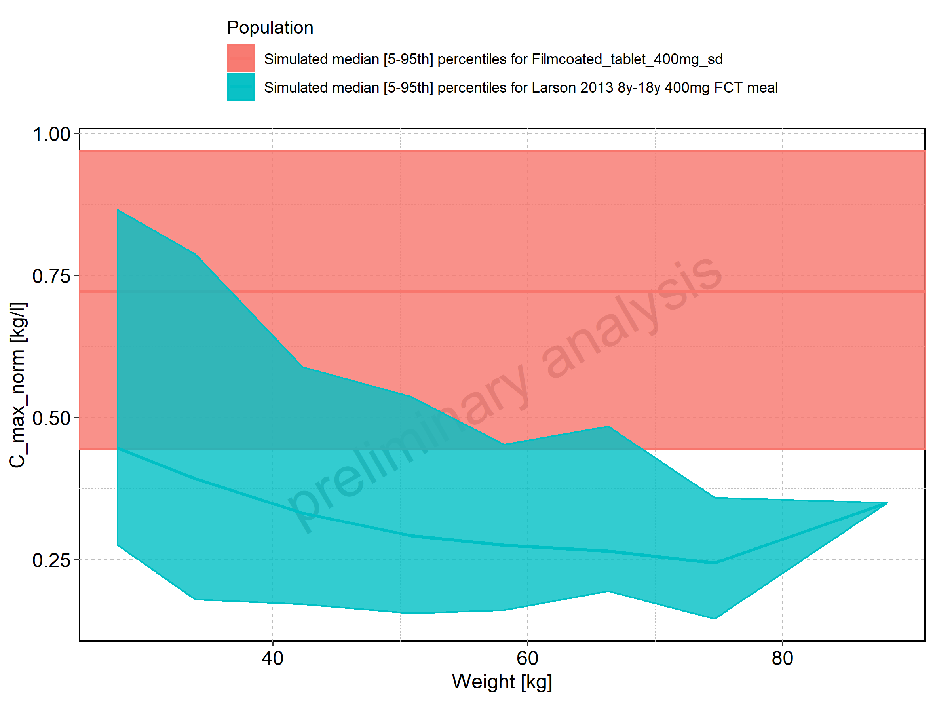

Figure 52: Weight-dependence of C_max_norm for Larson 2013 8y-18y 400mg FCT meal in comparison to Filmcoated_tablet_400mg_sd. Profiles are plotted in a logarithmic scale.

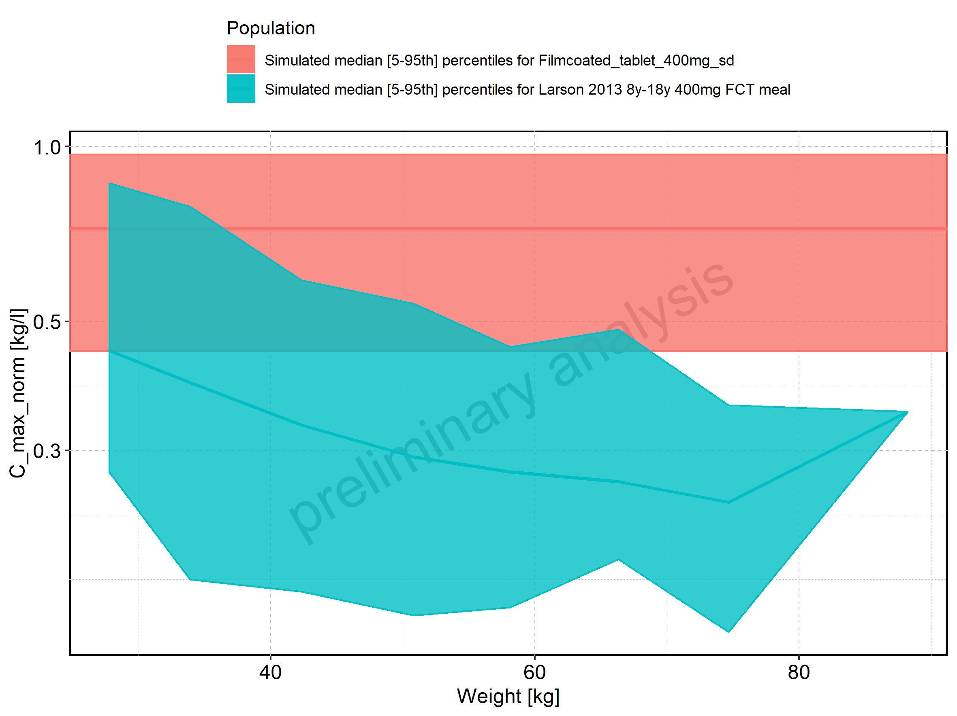

Figure 53: Weight-dependence of C_max_norm for Larson 2013 8y-18y 400mg FCT meal. Profiles are plotted in a linear scale.

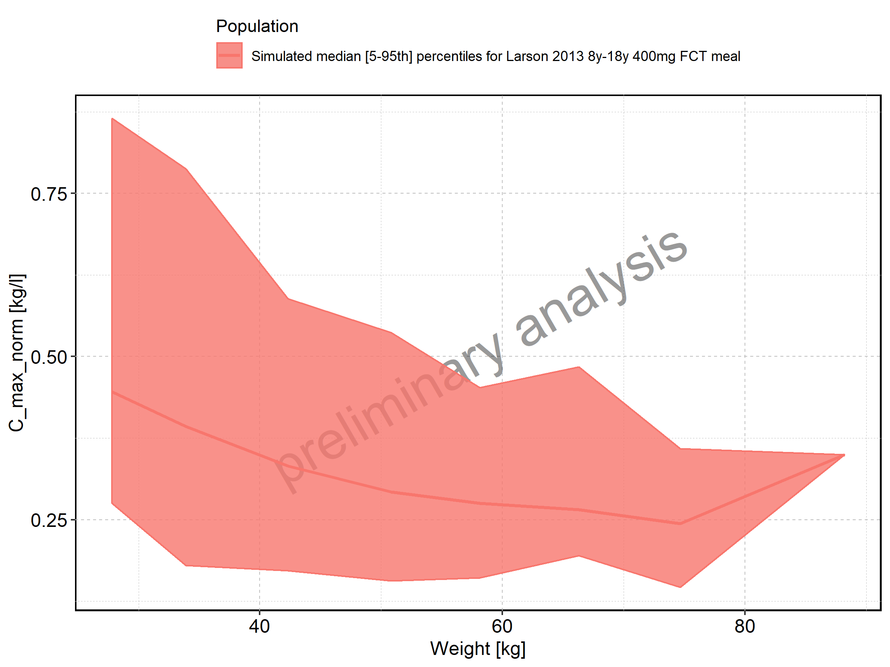

Figure 54: Weight-dependence of C_max_norm for Larson 2013 8y-18y 400mg FCT meal. Profiles are plotted in a logarithmic scale.

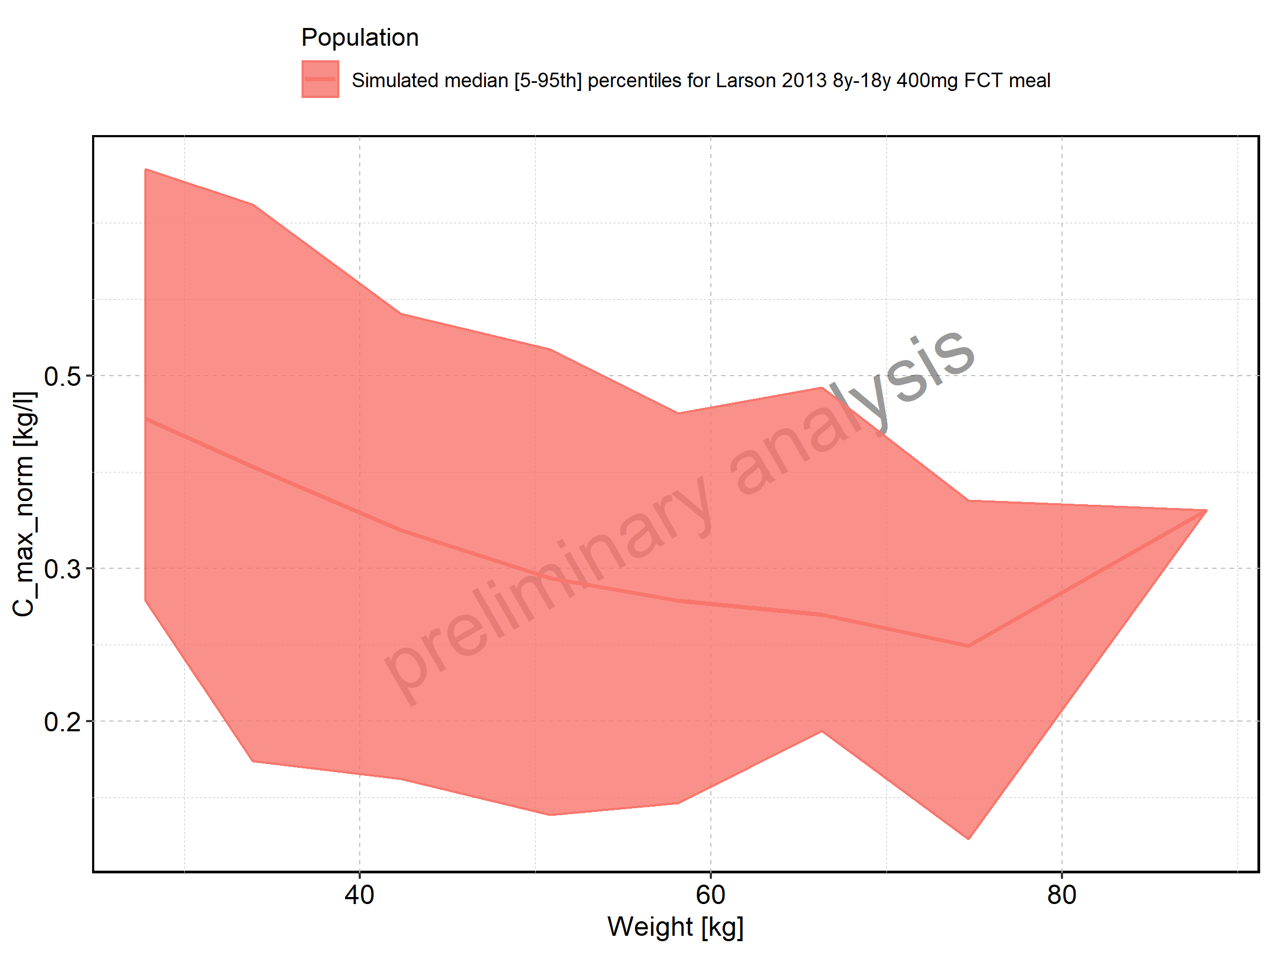

Figure 55: Weight-dependence of C_max_norm for Filmcoated_tablet_400mg_sd. Profiles are plotted in a linear scale.

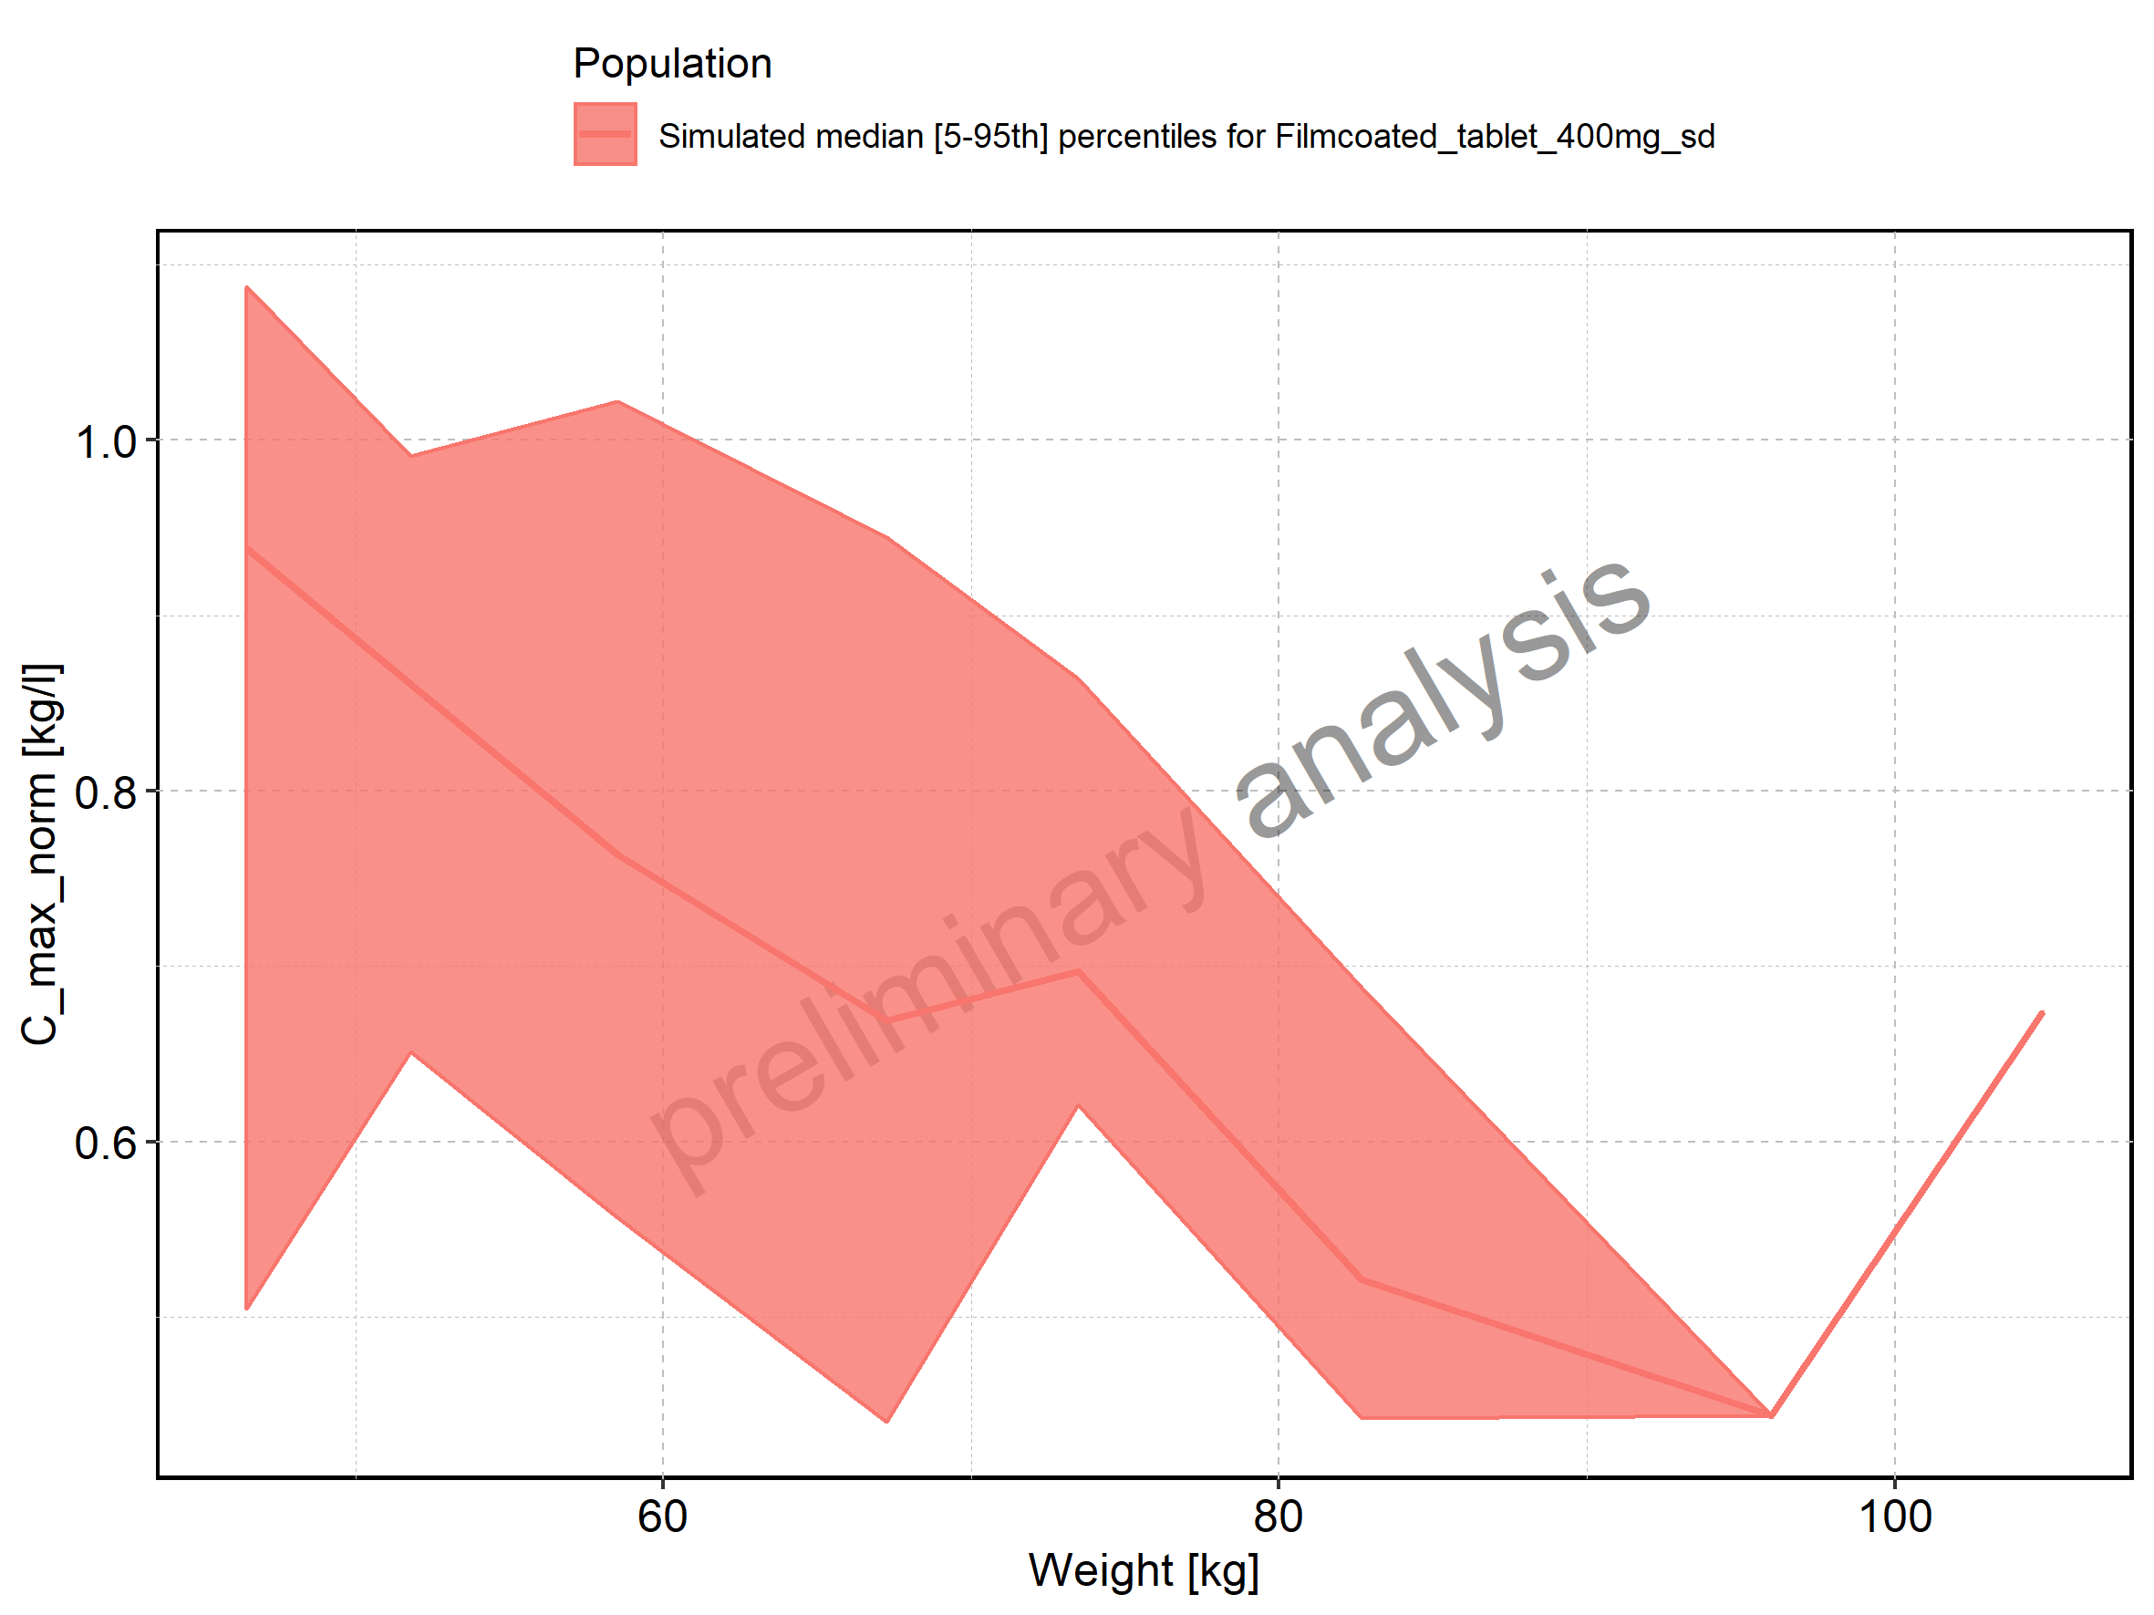

Figure 56: Weight-dependence of C_max_norm for Filmcoated_tablet_400mg_sd. Profiles are plotted in a logarithmic scale.

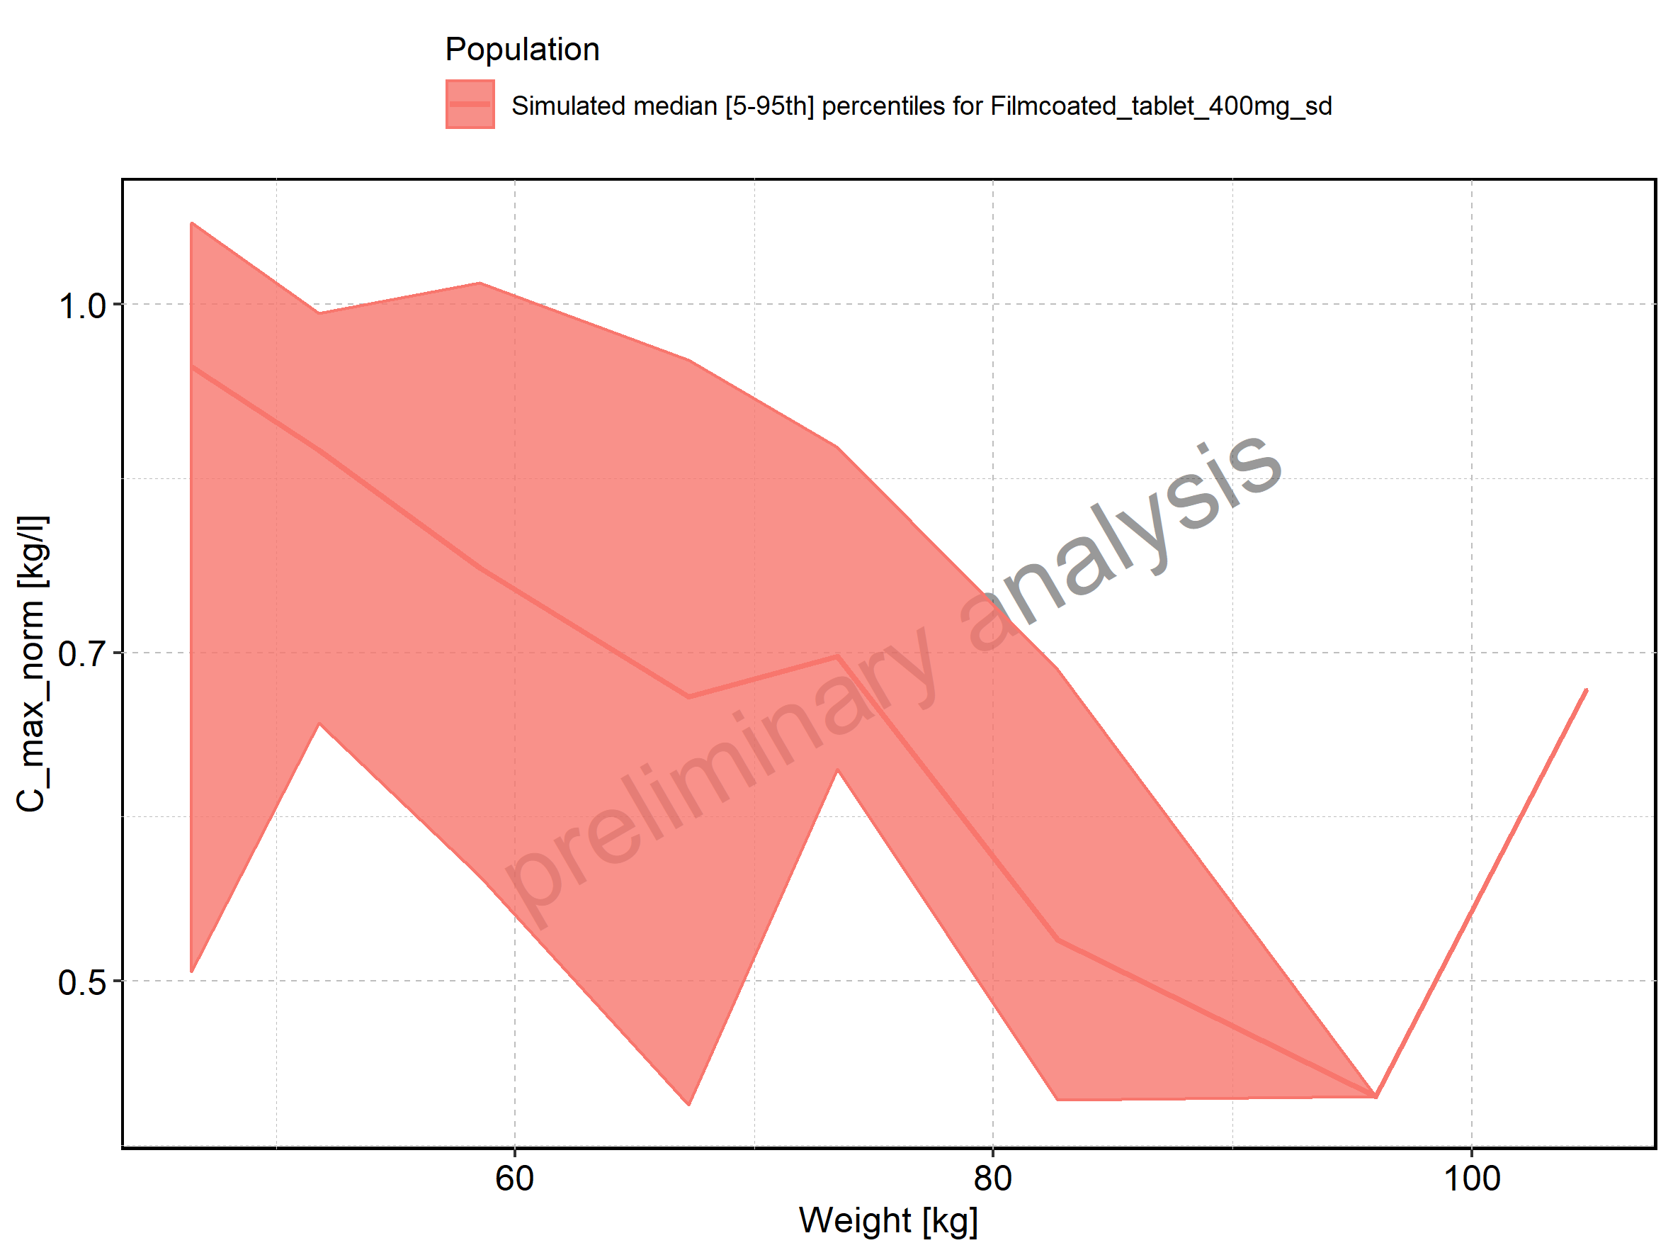

Figure 57: BMI-dependence of C_max_norm for Larson 2013 8y-18y 400mg FCT meal in comparison to Filmcoated_tablet_400mg_sd. Profiles are plotted in a linear scale.

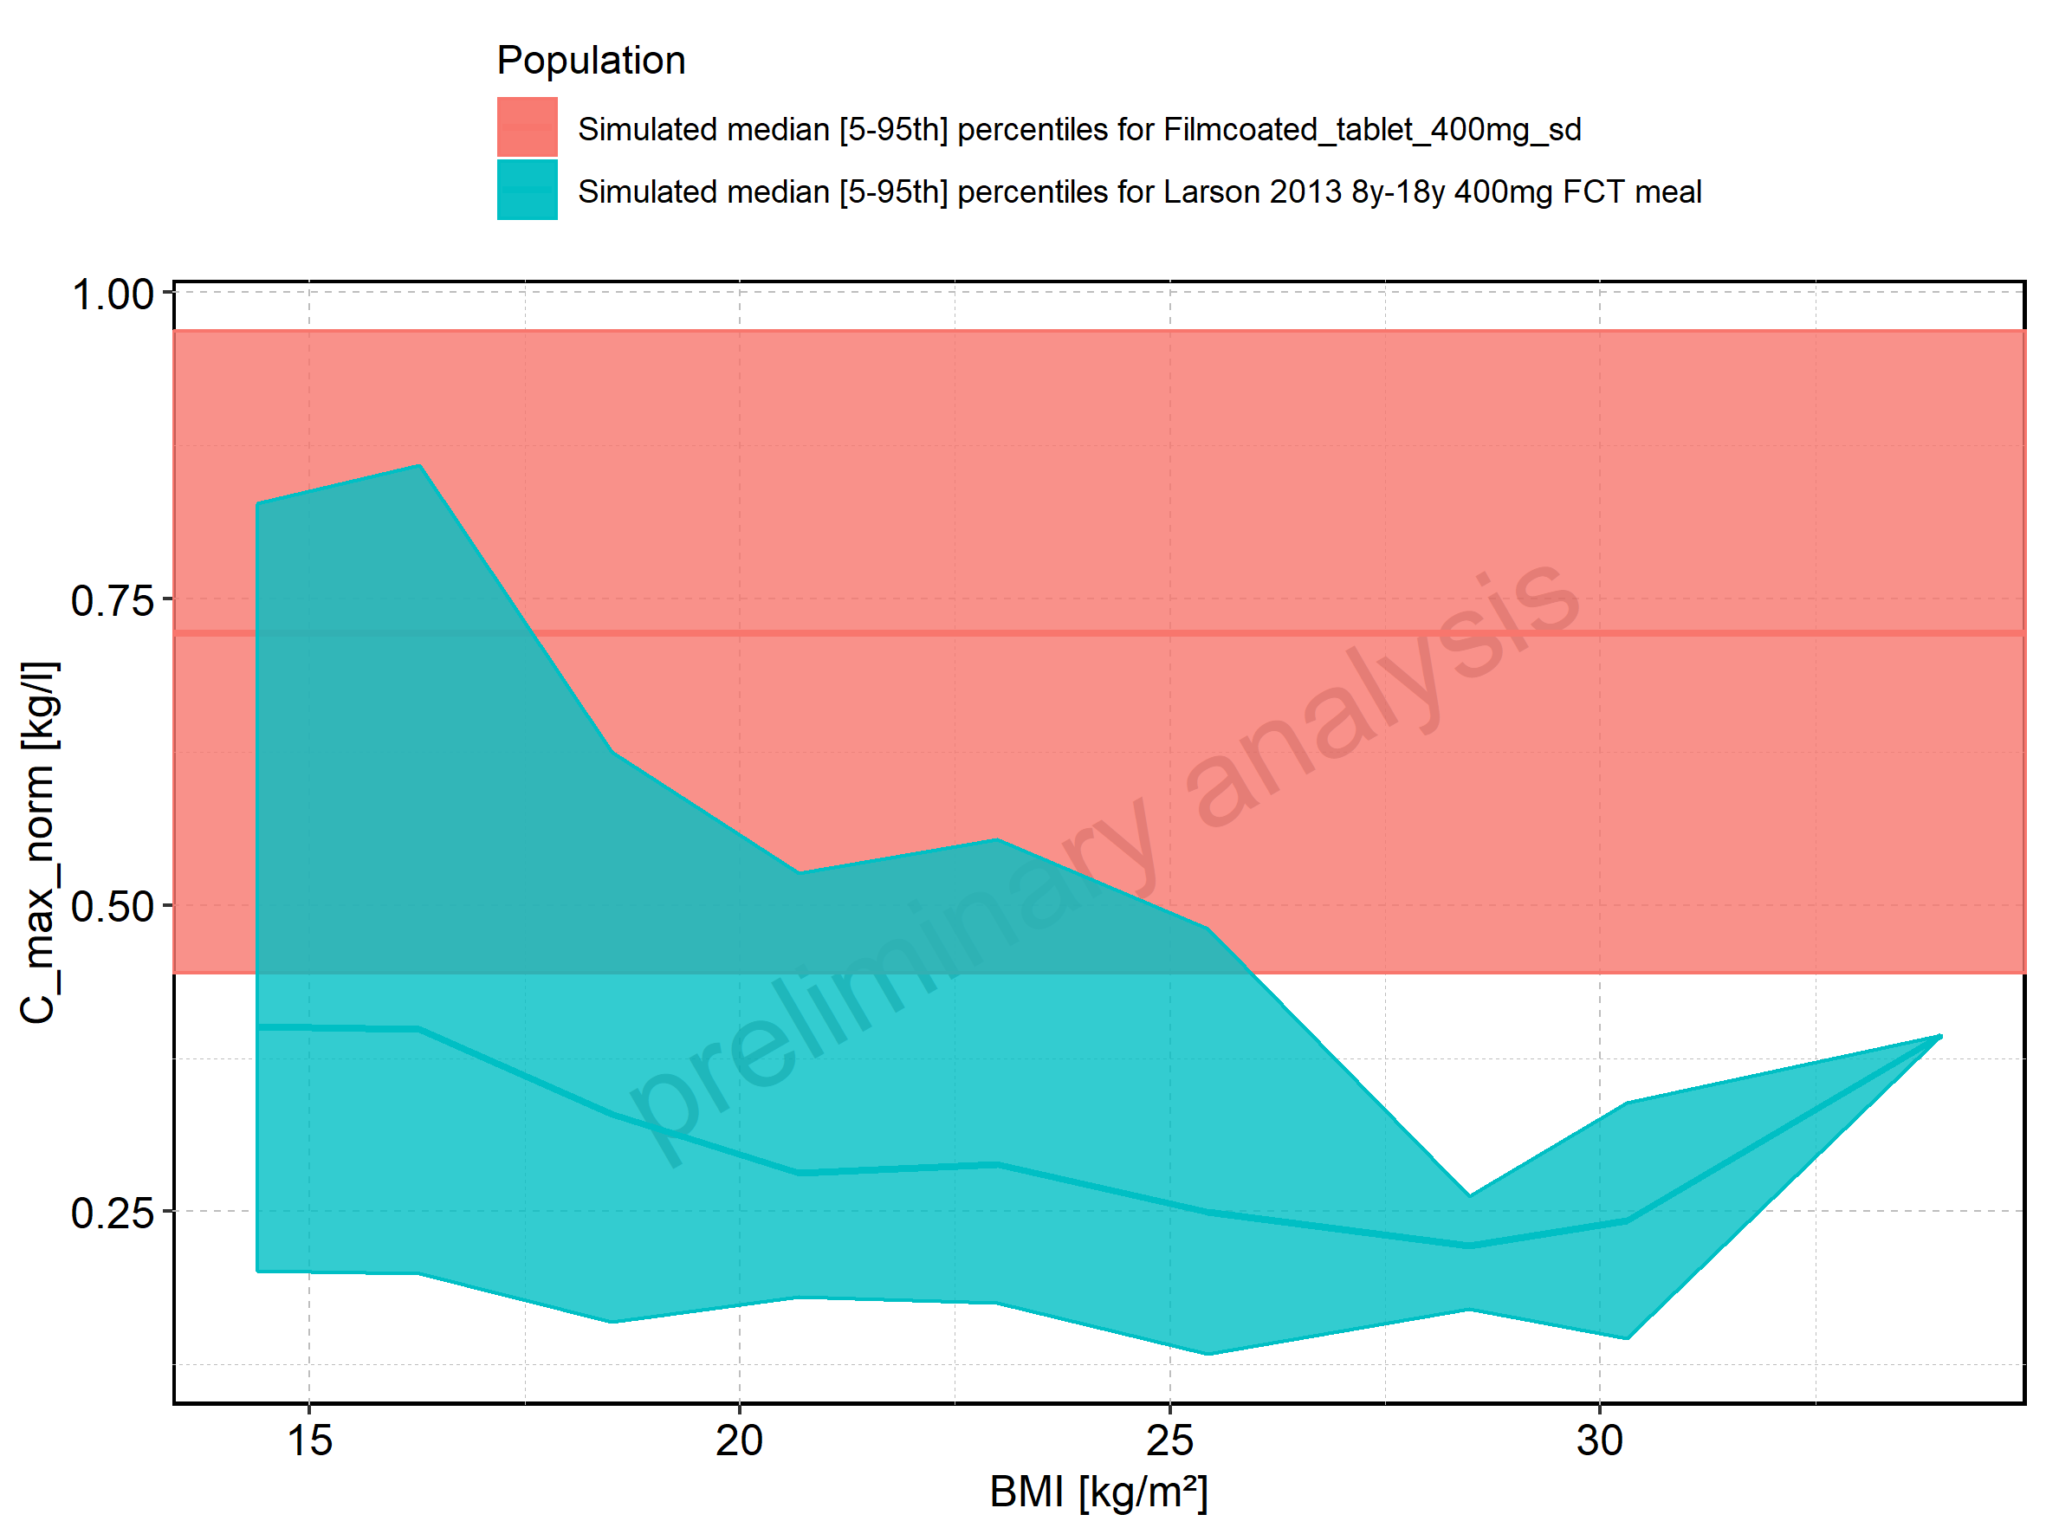

Figure 58: BMI-dependence of C_max_norm for Larson 2013 8y-18y 400mg FCT meal in comparison to Filmcoated_tablet_400mg_sd. Profiles are plotted in a logarithmic scale.

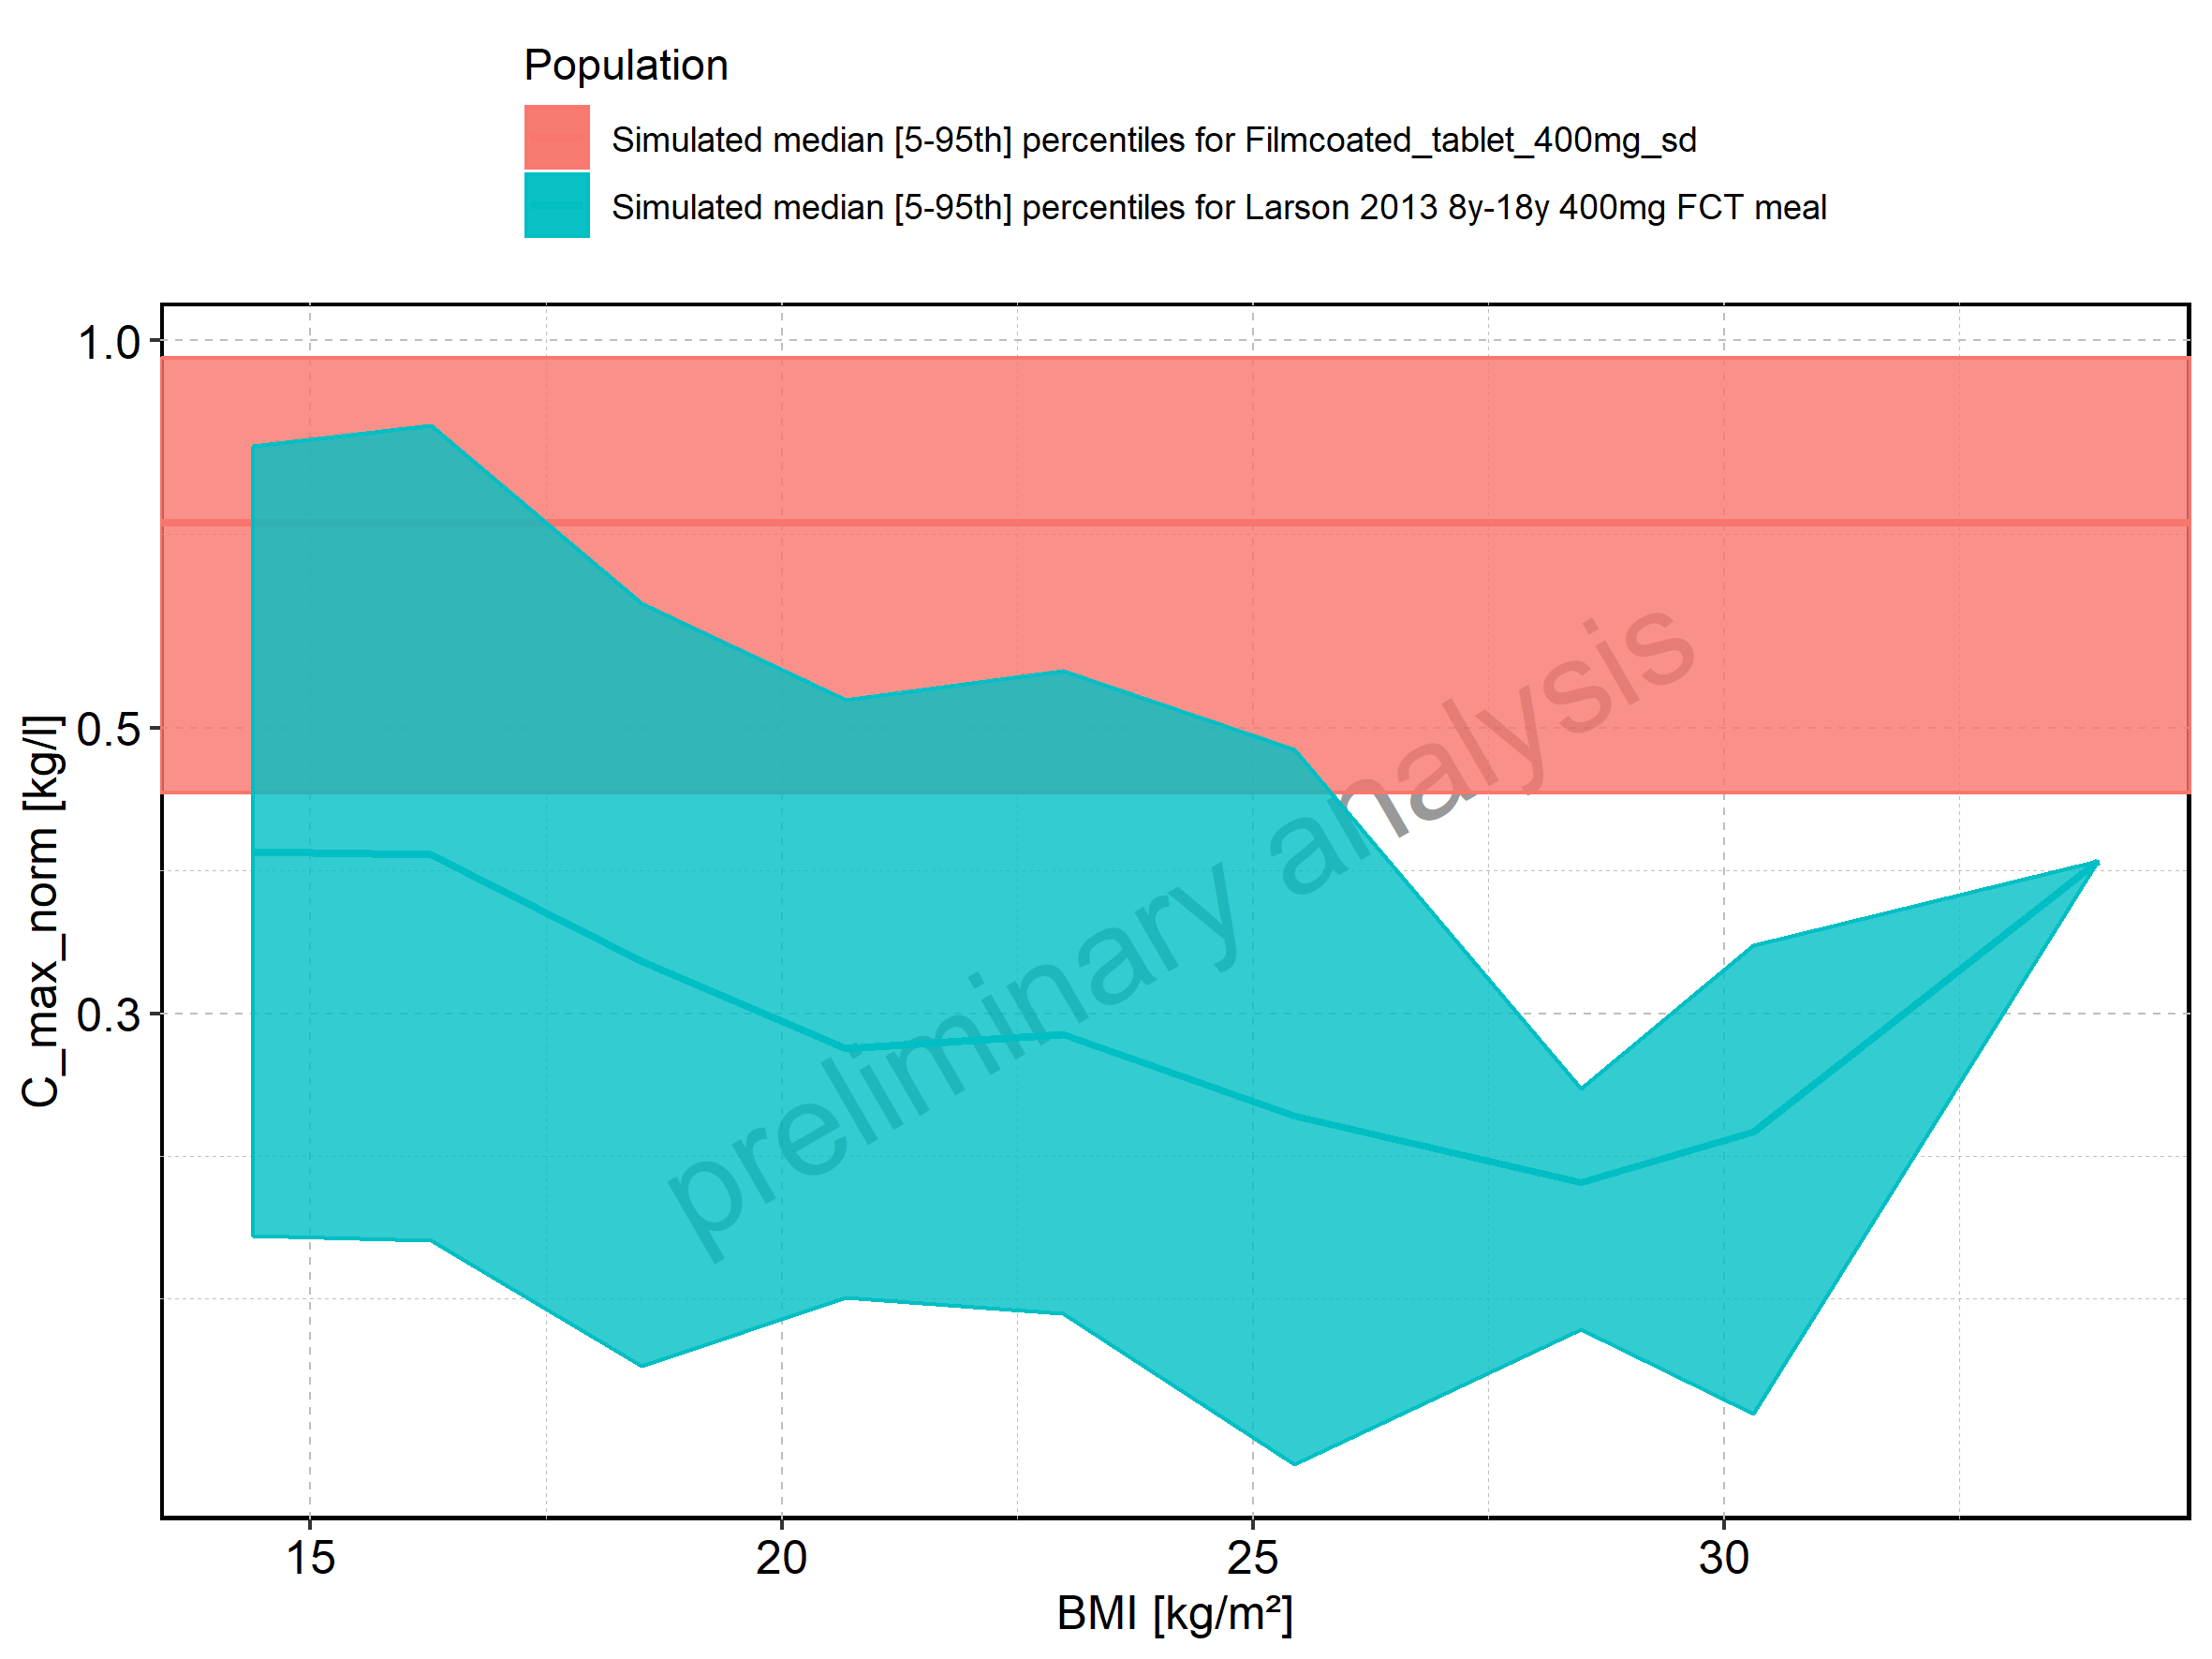

Figure 59: BMI-dependence of C_max_norm for Larson 2013 8y-18y 400mg FCT meal. Profiles are plotted in a linear scale.

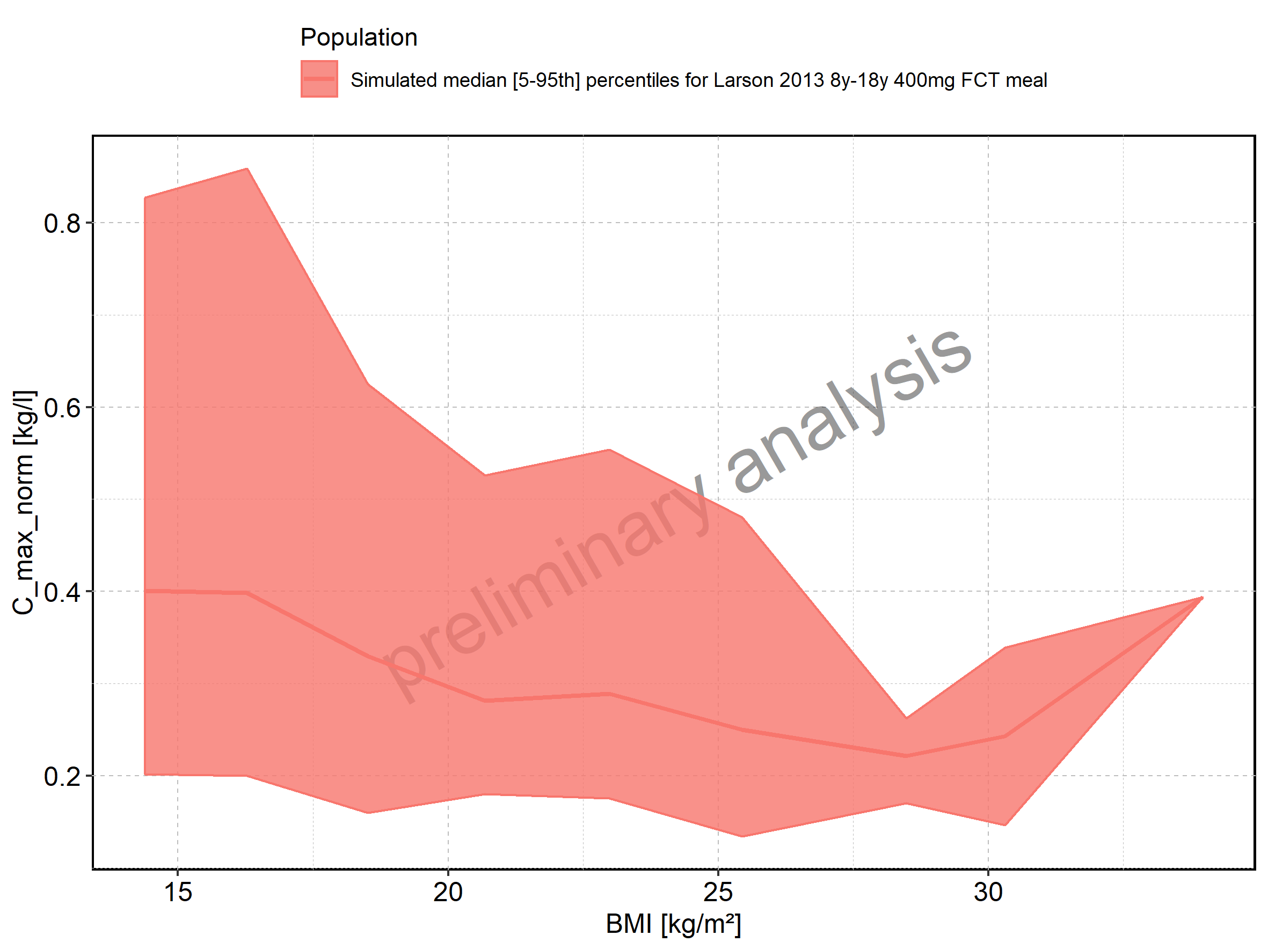

Figure 60: BMI-dependence of C_max_norm for Larson 2013 8y-18y 400mg FCT meal. Profiles are plotted in a logarithmic scale.

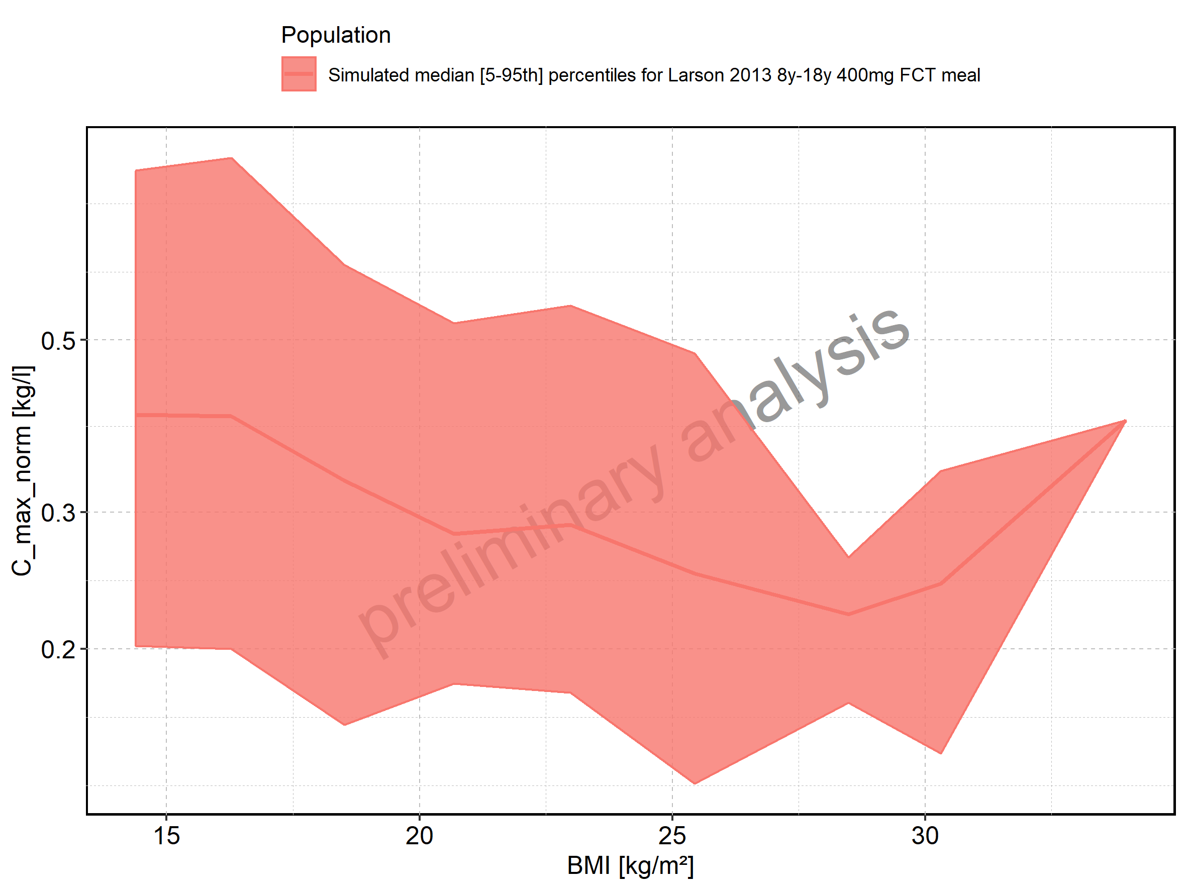

Figure 61: BMI-dependence of C_max_norm for Filmcoated_tablet_400mg_sd. Profiles are plotted in a linear scale.

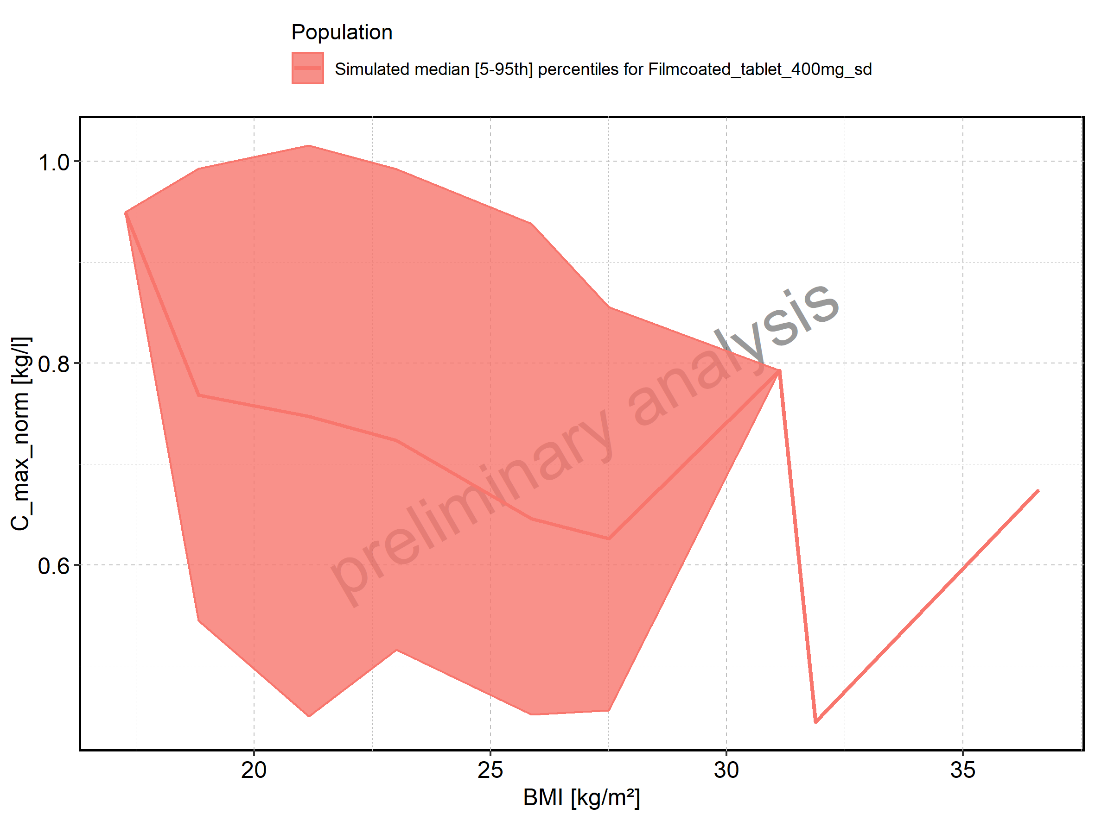

Figure 62: BMI-dependence of C_max_norm for Filmcoated_tablet_400mg_sd. Profiles are plotted in a logarithmic scale.

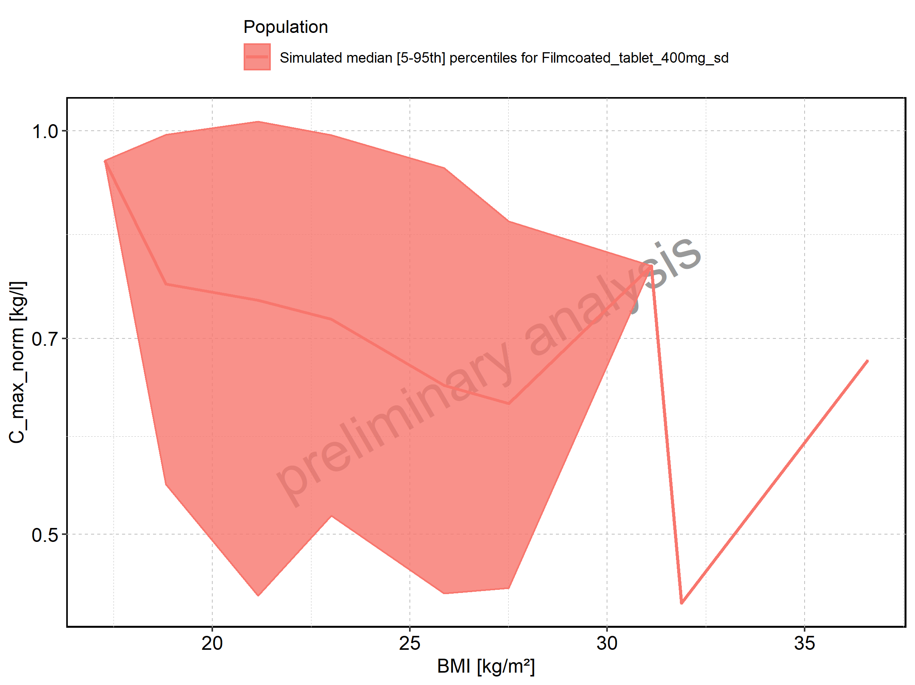

Figure 63: t_max of Raltegravir shown as box-whisker plot, which indicates the 5th, 25th, 50th, 75th, and 95th percentiles in linear scale.

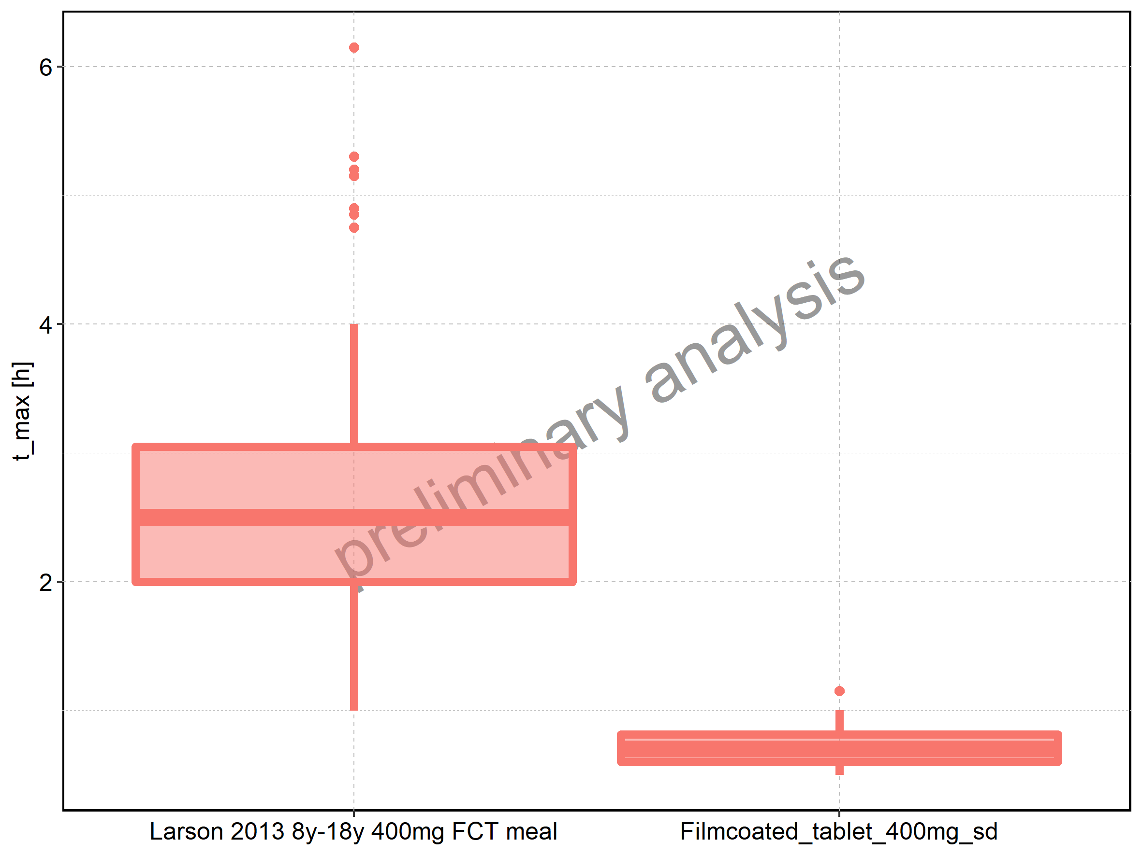

|  |  |  |  |  |  |  |  |  |  |  |
| --- | --- | --- | --- | --- | --- | --- | --- | --- | --- | --- |
| Population | N | 5th percentile | 25th percentile | 50th percentile | 75th percentile | 95th percentile | mean | standard deviation | geo mean | geo standard deviation |
| Larson 2013 8y-18y 400mg FCT meal | 500 | 0.9975 | 2.0 | 2.5 | 3.0500 | 4 | 2.5419 | 0.8782893 | 2.3720858 | 1.485027 |
| Filmcoated_tablet_400mg_sd | 100 | 0.5000 | 0.6 | 0.7 | 0.8125 | 1 | 0.7290 | 0.1516209 | 0.7135402 | 1.232465 |

Figure 64: t_max of Raltegravir shown as box-whisker plot, which indicates the 5th, 25th, 50th, 75th, and 95th percentiles in logarithmic scale.

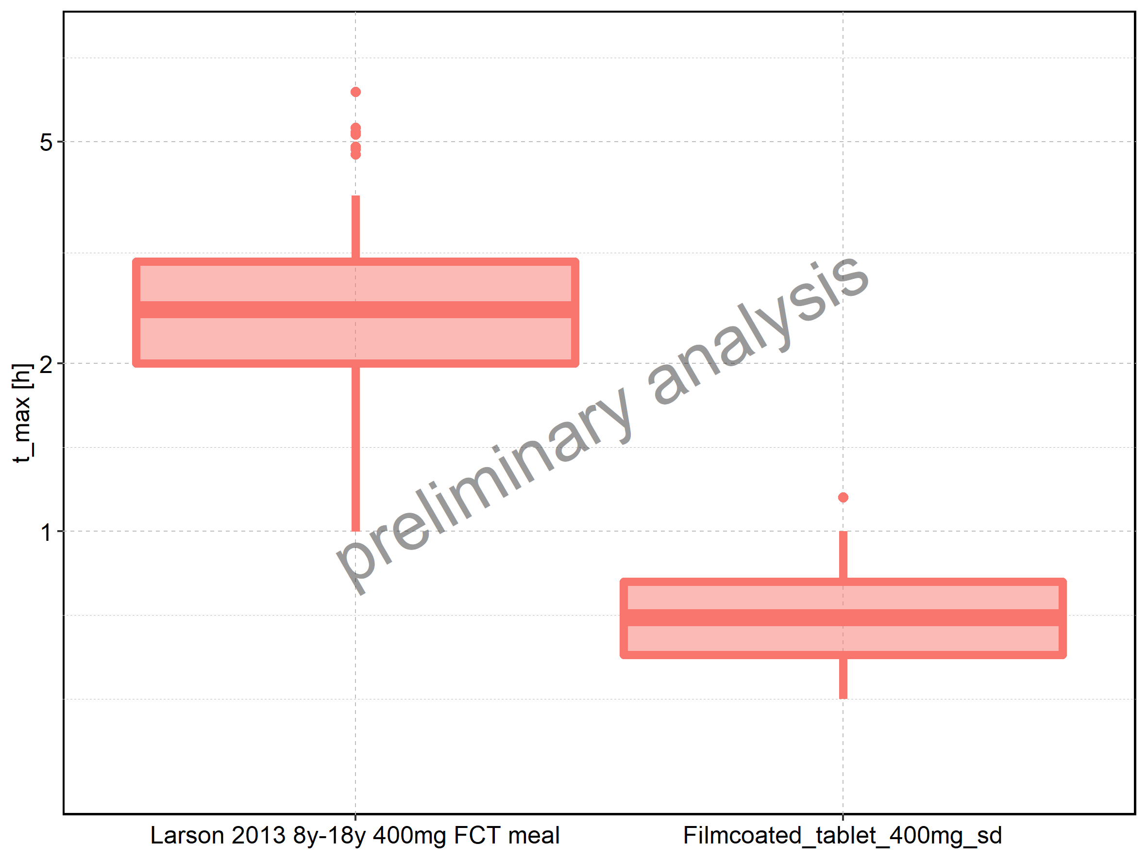

Figure 65: Age-dependence of t_max for Larson 2013 8y-18y 400mg FCT meal in comparison to Filmcoated_tablet_400mg_sd. Profiles are plotted in a linear scale.

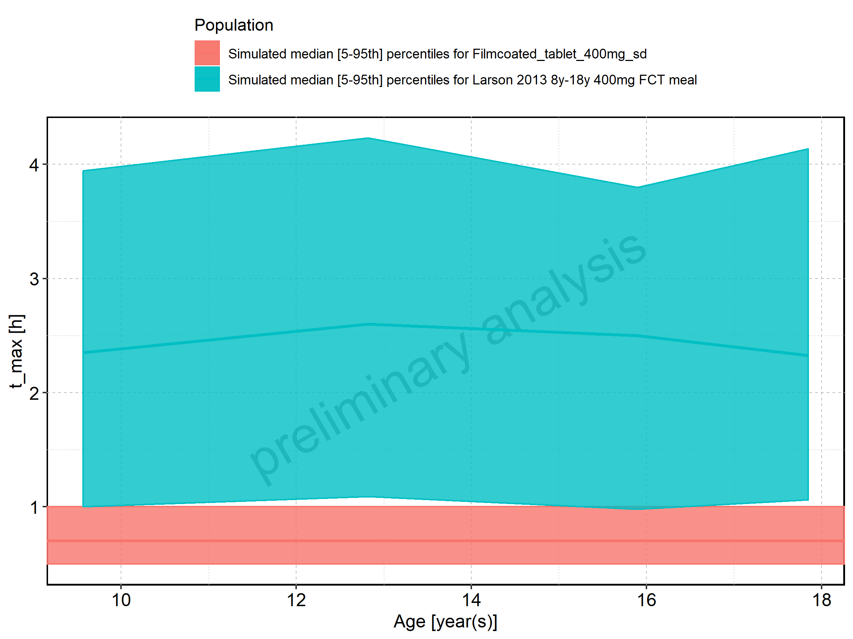

Figure 66: Age-dependence of t_max for Larson 2013 8y-18y 400mg FCT meal in comparison to Filmcoated_tablet_400mg_sd. Profiles are plotted in a logarithmic scale.

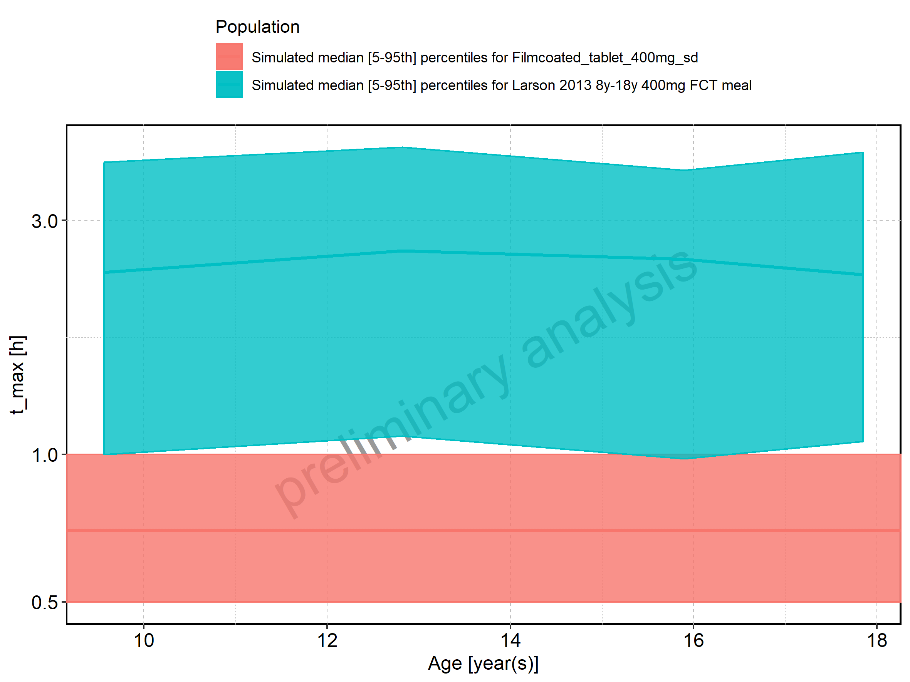

Figure 67: Age-dependence of t_max for Larson 2013 8y-18y 400mg FCT meal. Profiles are plotted in a linear scale.

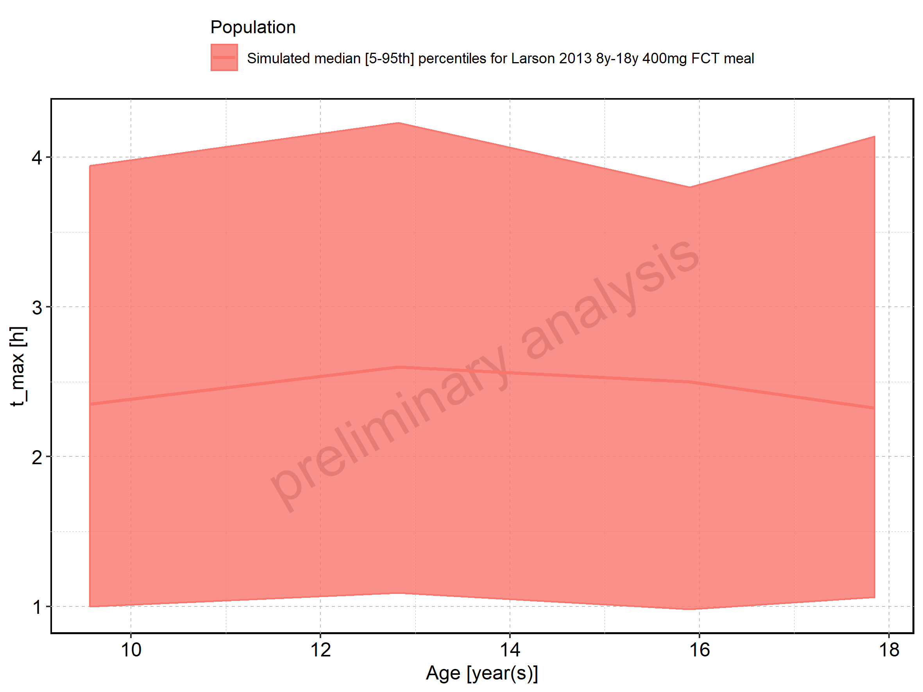

Figure 68: Age-dependence of t_max for Larson 2013 8y-18y 400mg FCT meal. Profiles are plotted in a logarithmic scale.

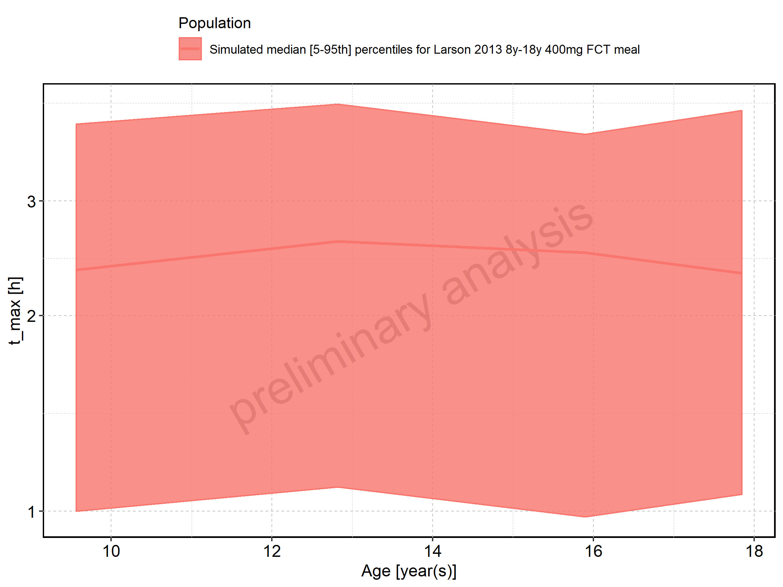

Figure 69: Age-dependence of t_max for Filmcoated_tablet_400mg_sd. Profiles are plotted in a linear scale.

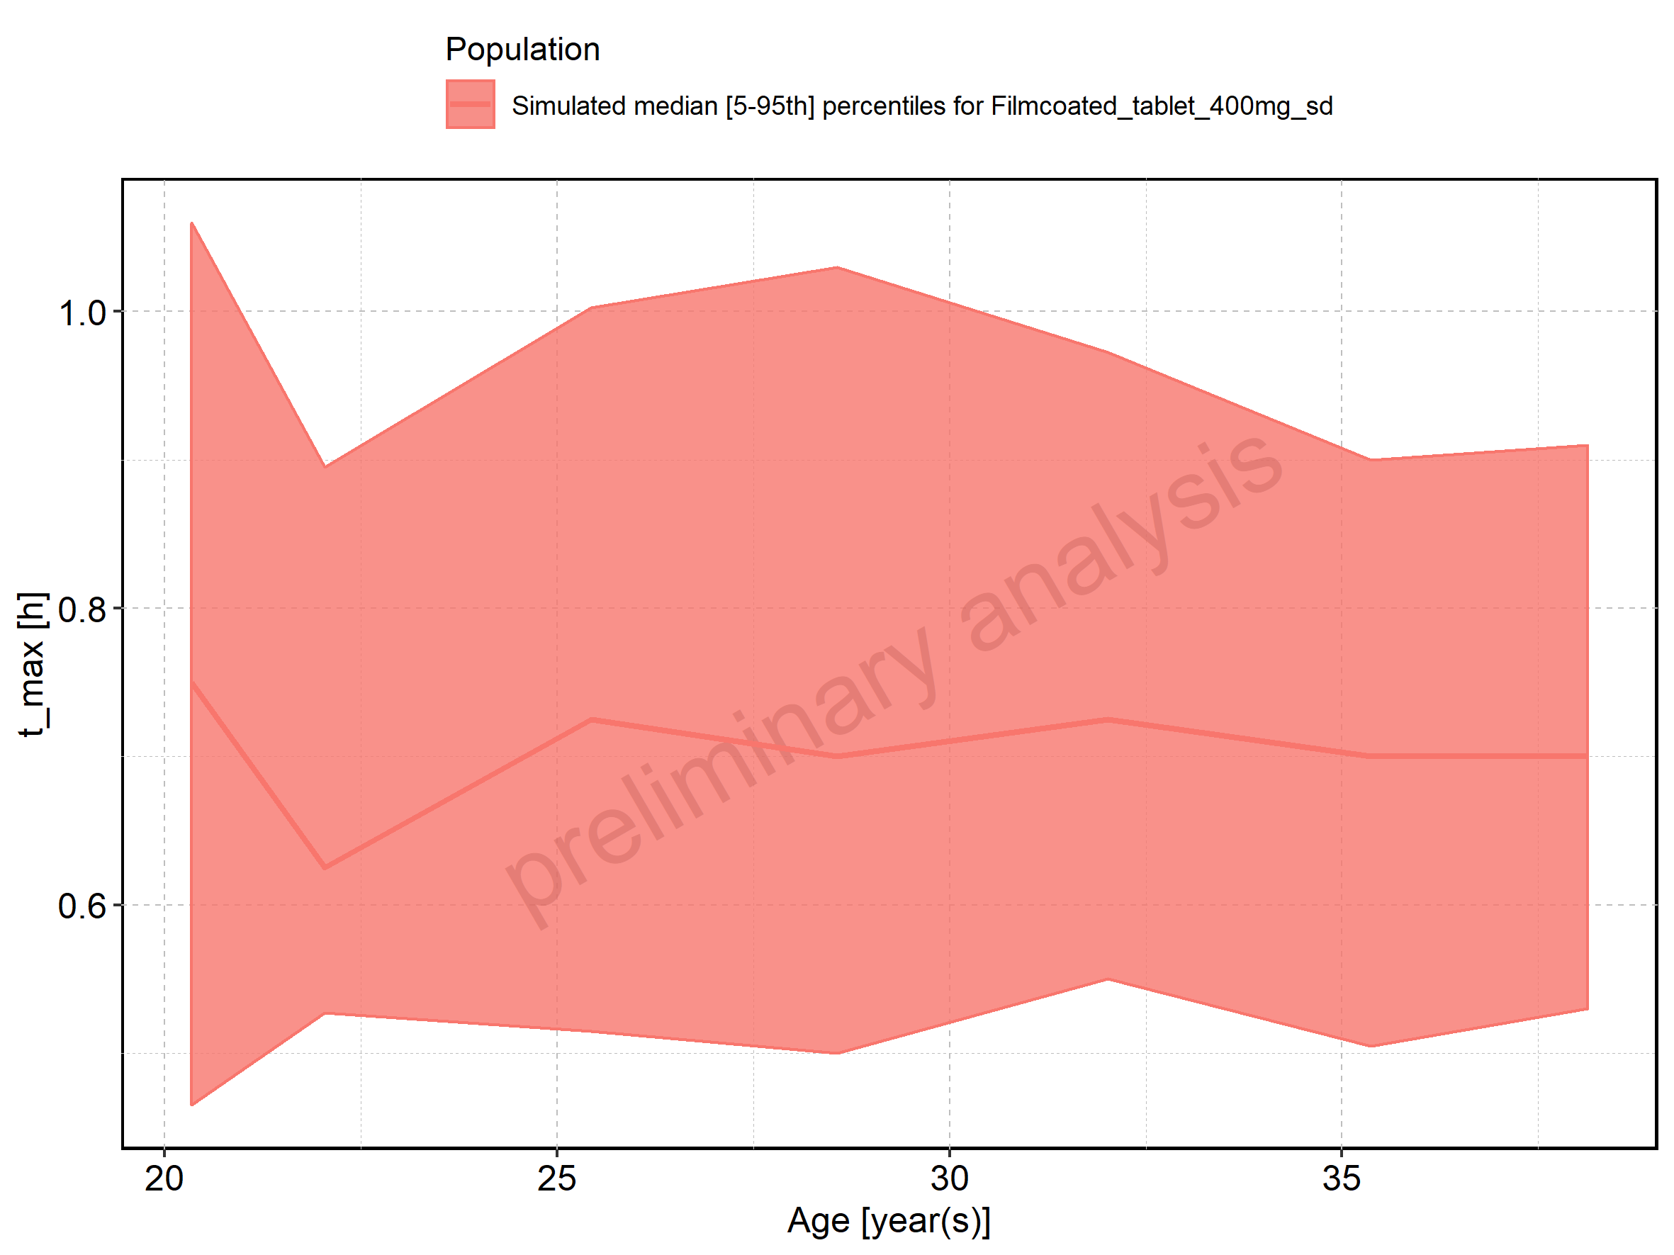

Figure 70: Age-dependence of t_max for Filmcoated_tablet_400mg_sd. Profiles are plotted in a logarithmic scale.

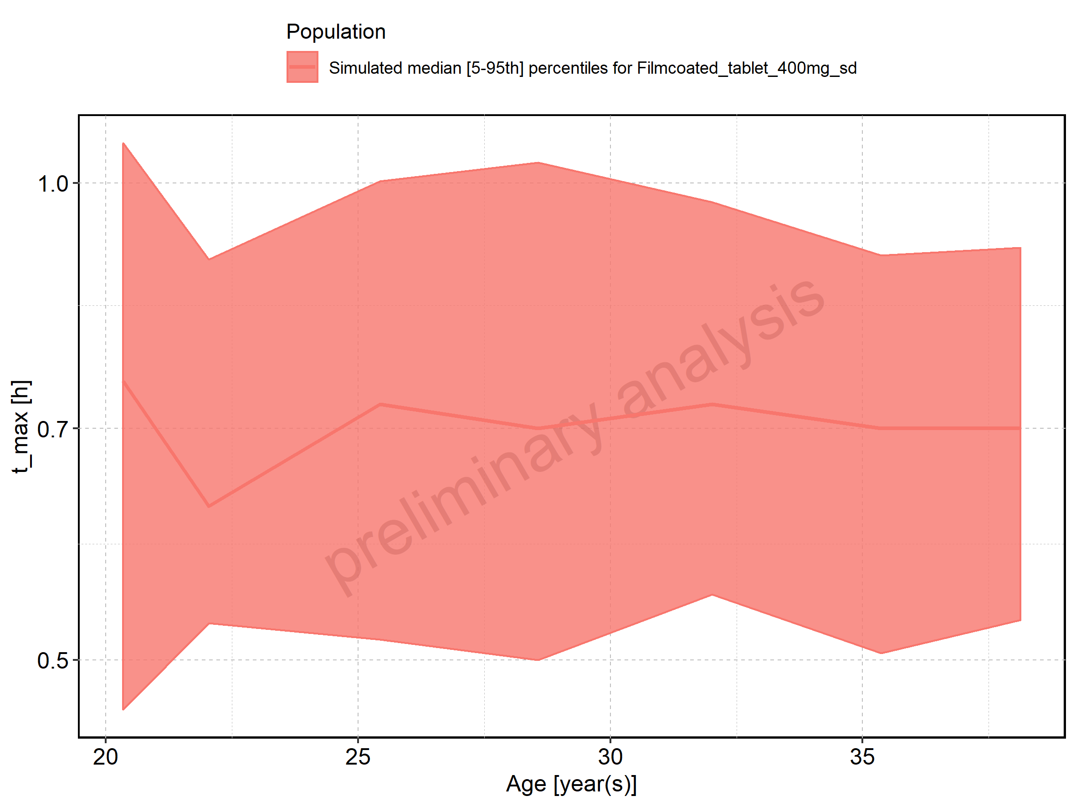

Figure 71: Height-dependence of t_max for Larson 2013 8y-18y 400mg FCT meal in comparison to Filmcoated_tablet_400mg_sd. Profiles are plotted in a linear scale.

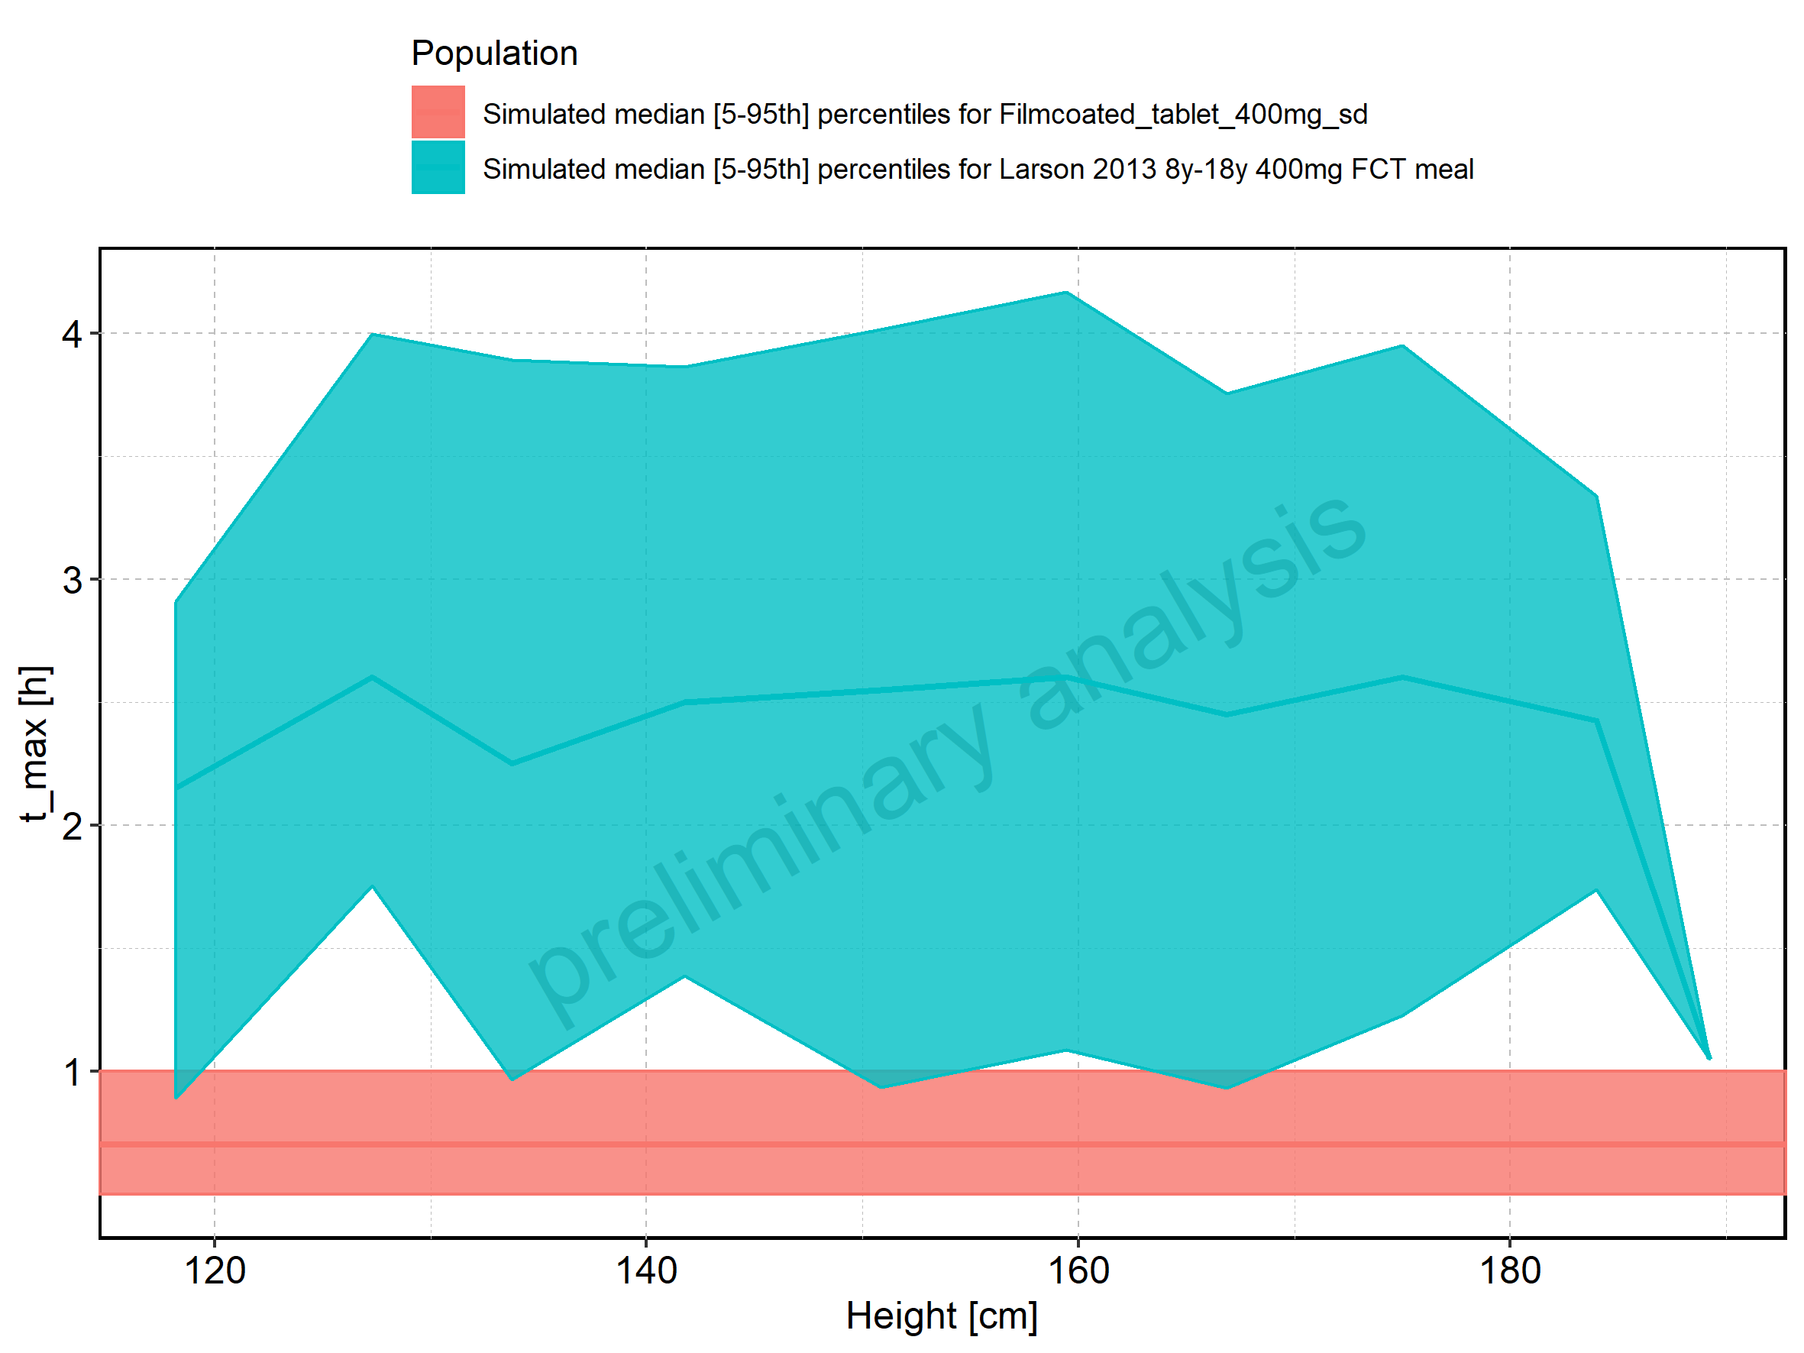

Figure 72: Height-dependence of t_max for Larson 2013 8y-18y 400mg FCT meal in comparison to Filmcoated_tablet_400mg_sd. Profiles are plotted in a logarithmic scale.

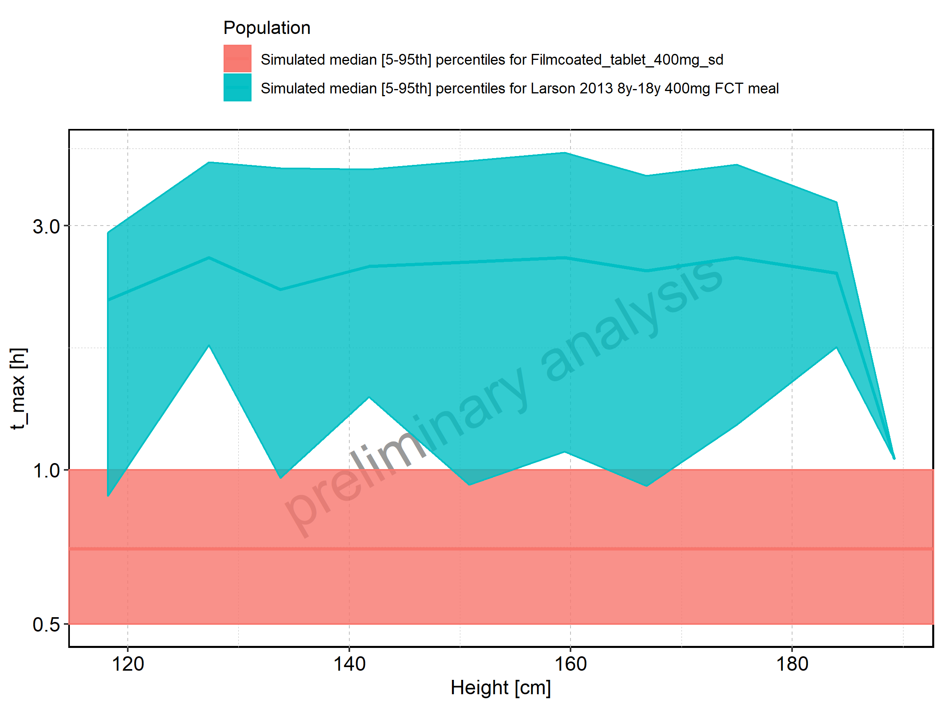

Figure 73: Height-dependence of t_max for Larson 2013 8y-18y 400mg FCT meal. Profiles are plotted in a linear scale.

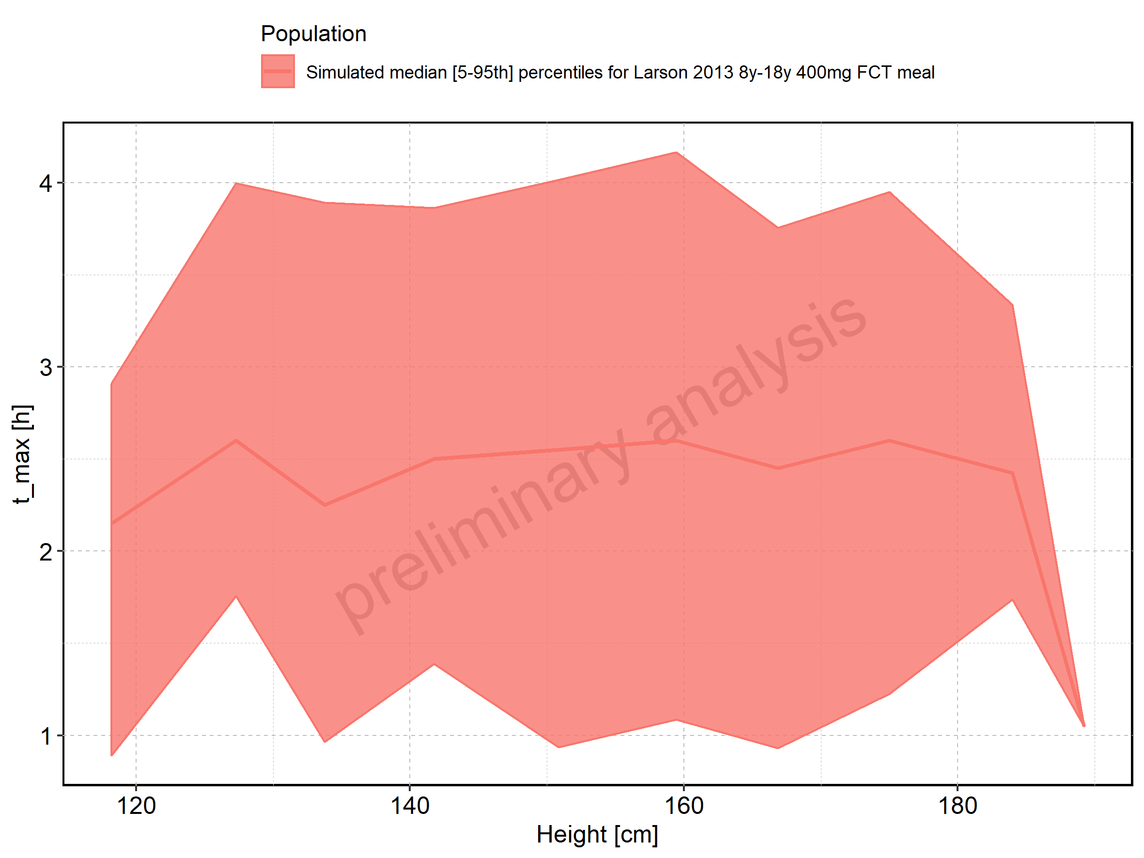

Figure 74: Height-dependence of t_max for Larson 2013 8y-18y 400mg FCT meal. Profiles are plotted in a logarithmic scale.

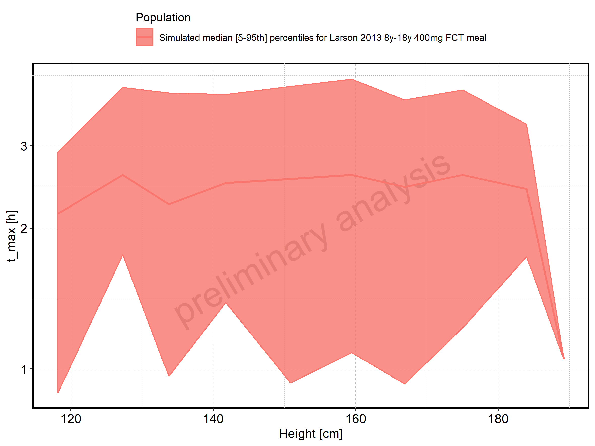

Figure 75: Height-dependence of t_max for Filmcoated_tablet_400mg_sd. Profiles are plotted in a linear scale.

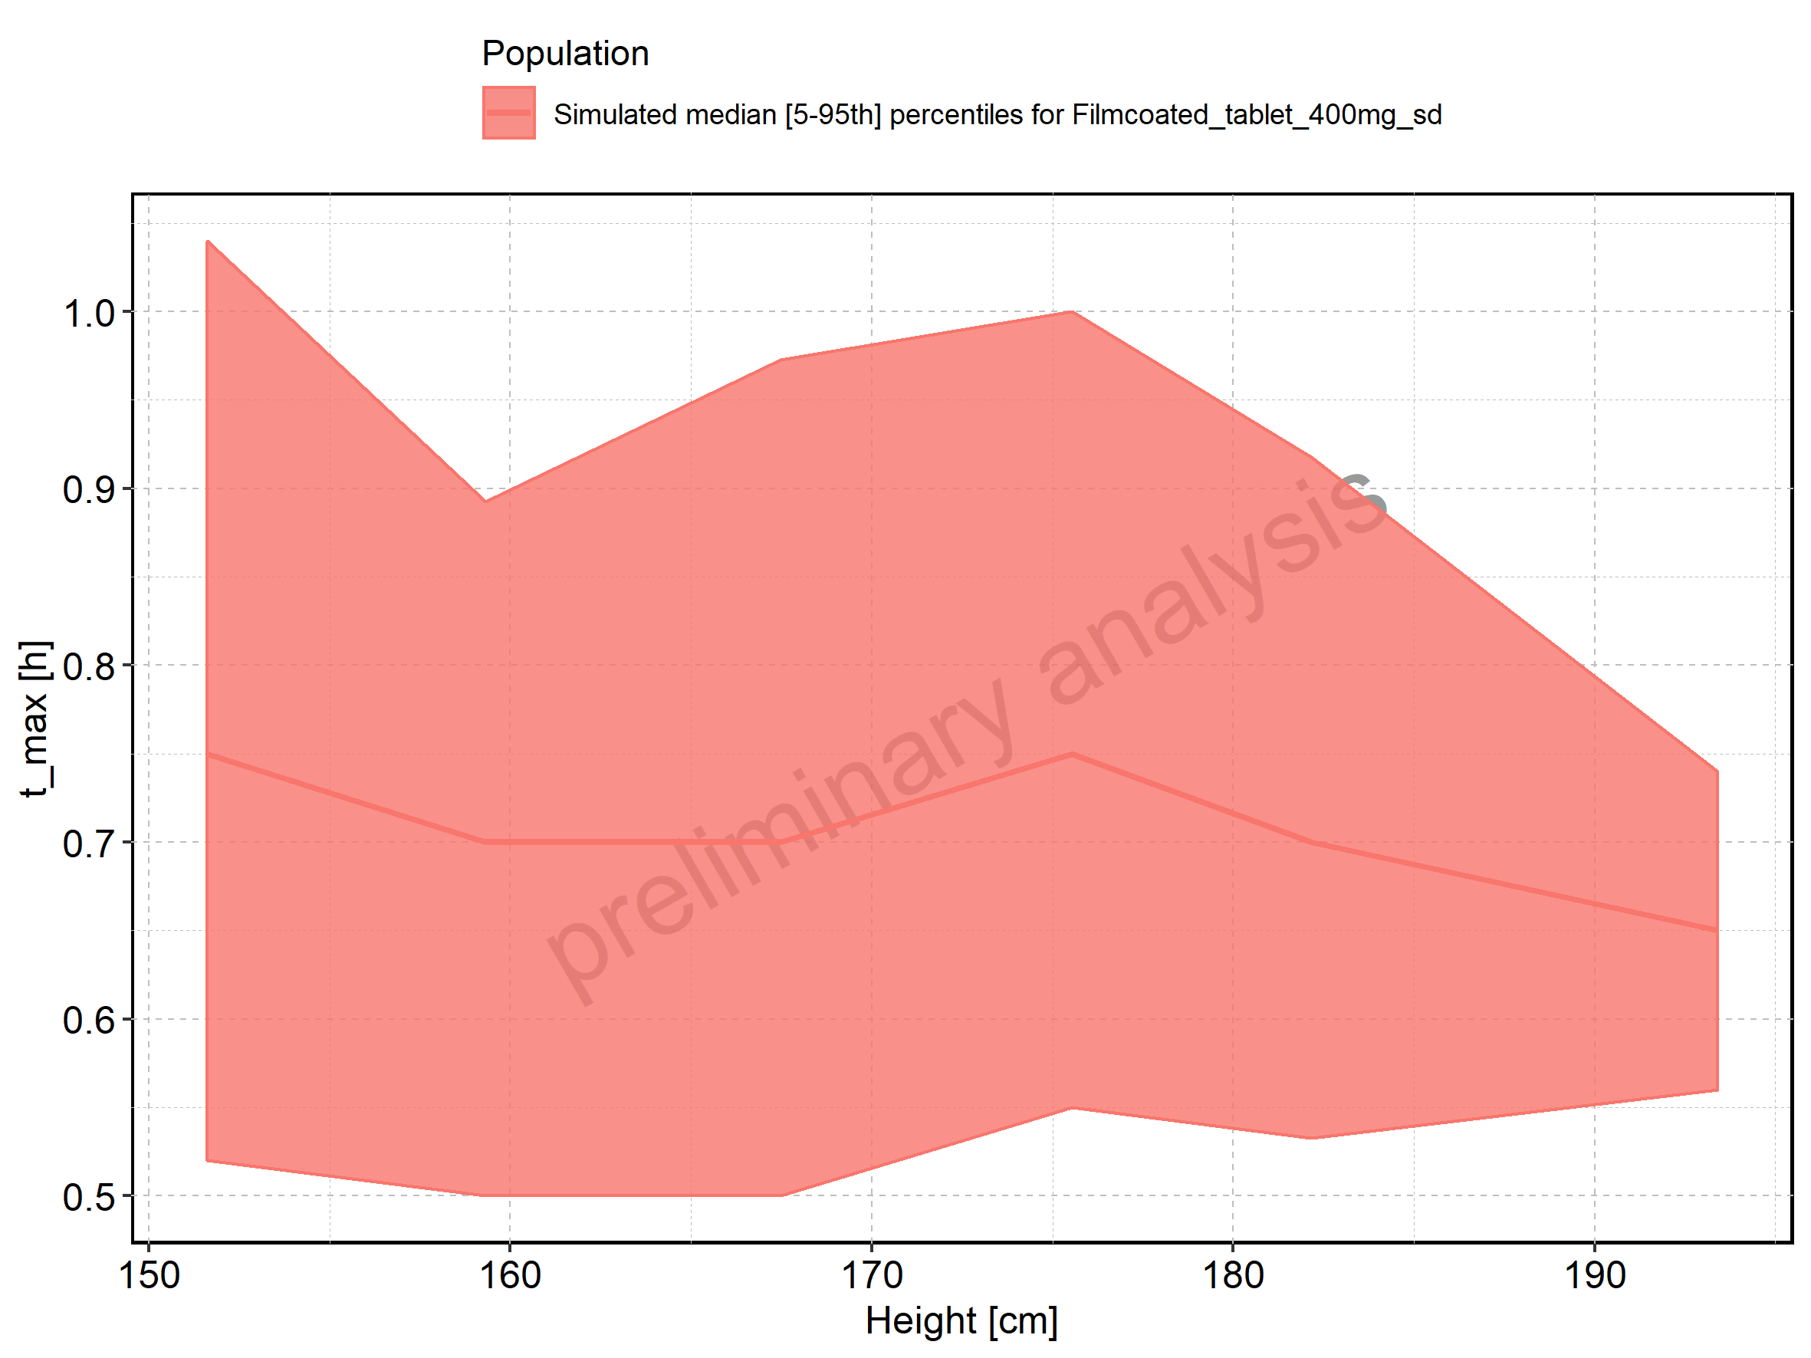

Figure 76: Height-dependence of t_max for Filmcoated_tablet_400mg_sd. Profiles are plotted in a logarithmic scale.

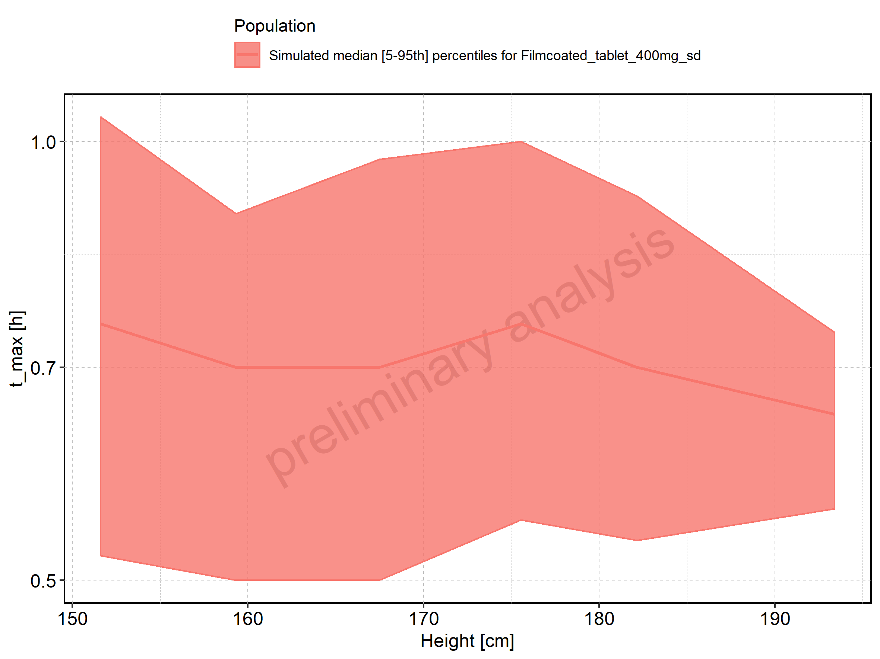

Figure 77: Weight-dependence of t_max for Larson 2013 8y-18y 400mg FCT meal in comparison to Filmcoated_tablet_400mg_sd. Profiles are plotted in a linear scale.

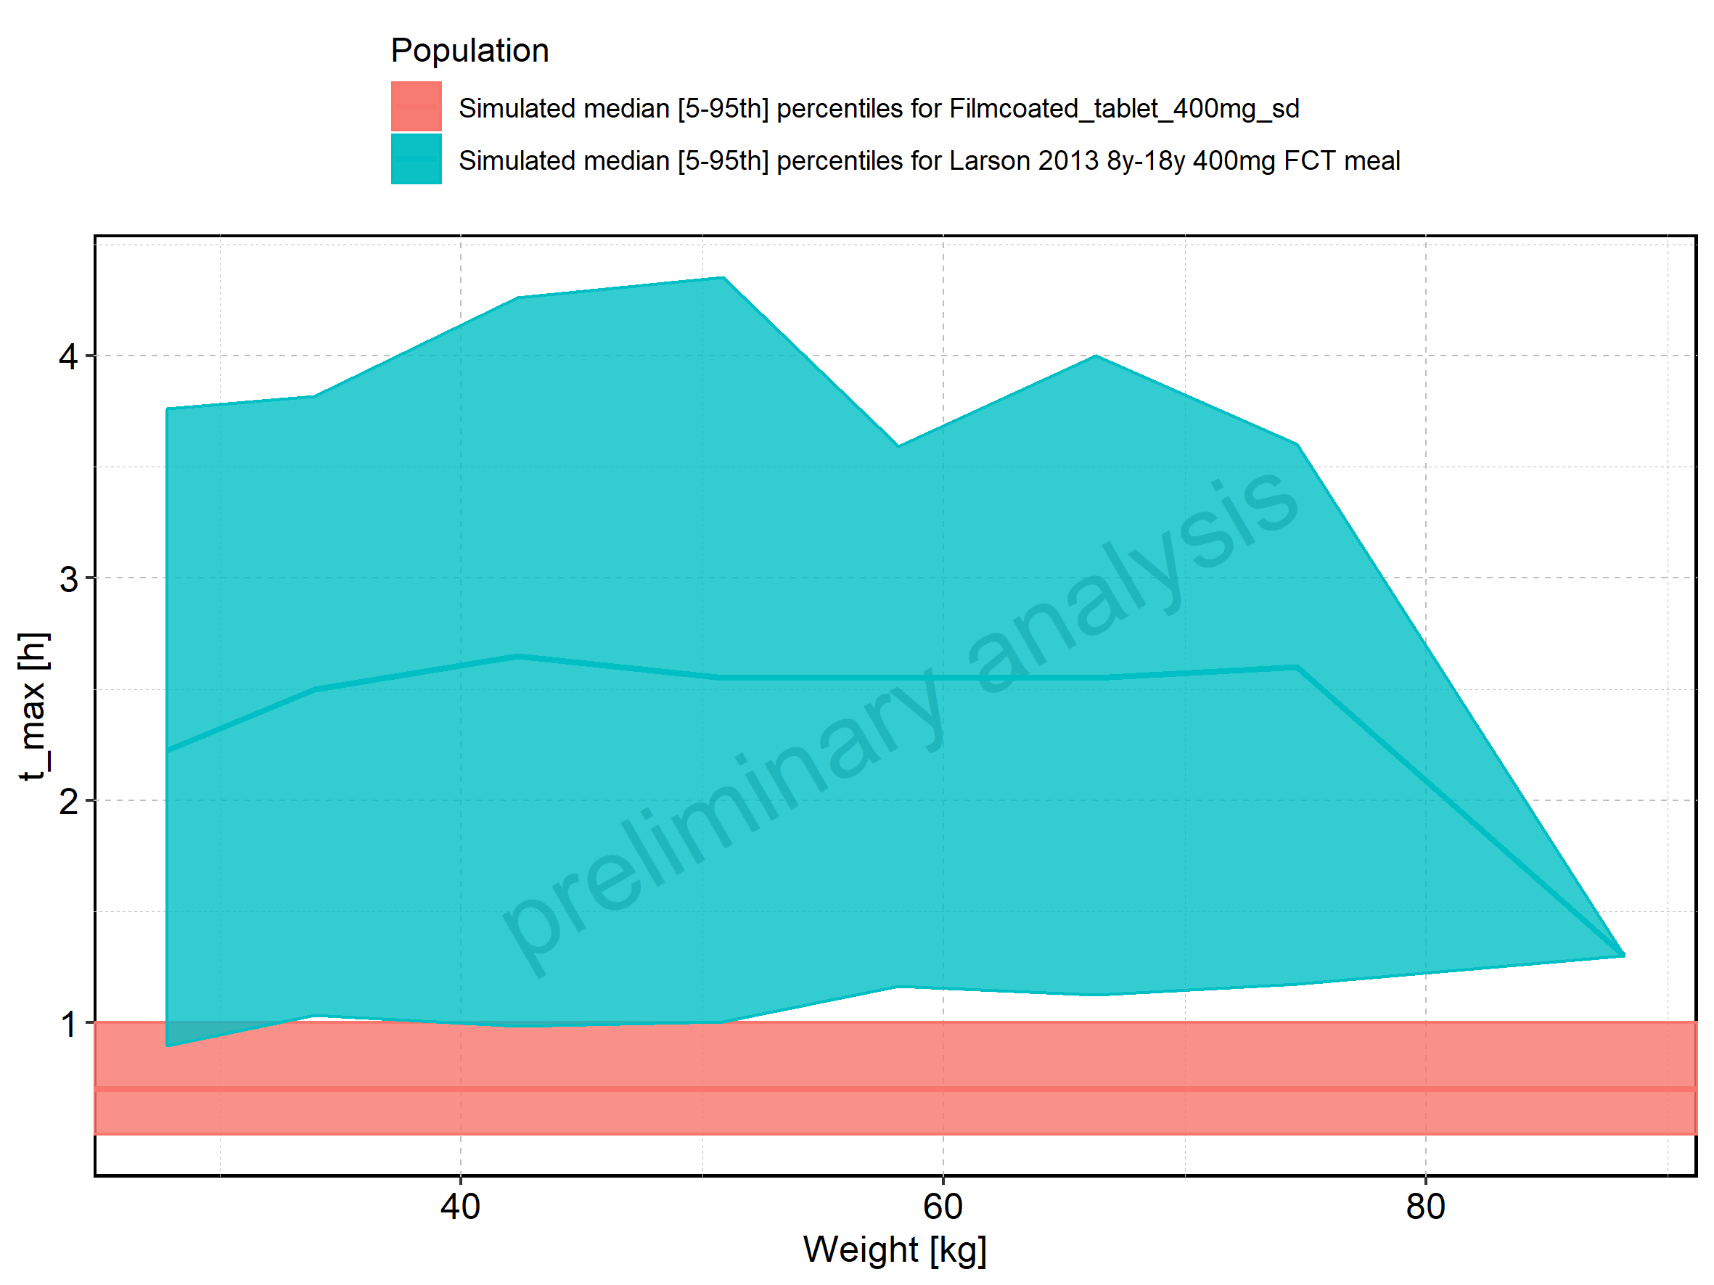

Figure 78: Weight-dependence of t_max for Larson 2013 8y-18y 400mg FCT meal in comparison to Filmcoated_tablet_400mg_sd. Profiles are plotted in a logarithmic scale.

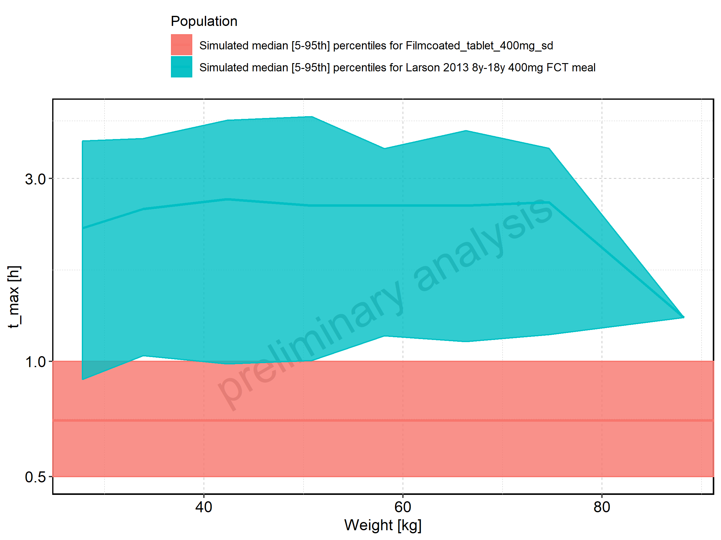

Figure 79: Weight-dependence of t_max for Larson 2013 8y-18y 400mg FCT meal. Profiles are plotted in a linear scale.

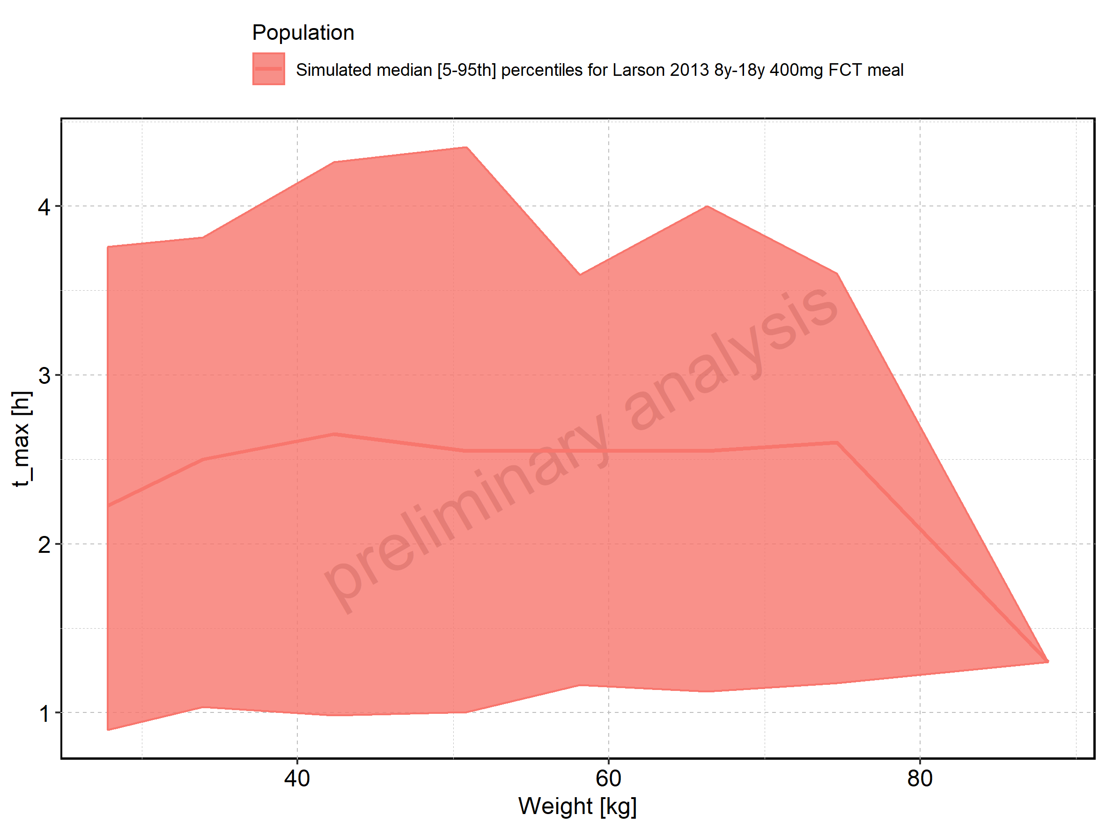

Figure 80: Weight-dependence of t_max for Larson 2013 8y-18y 400mg FCT meal. Profiles are plotted in a logarithmic scale.

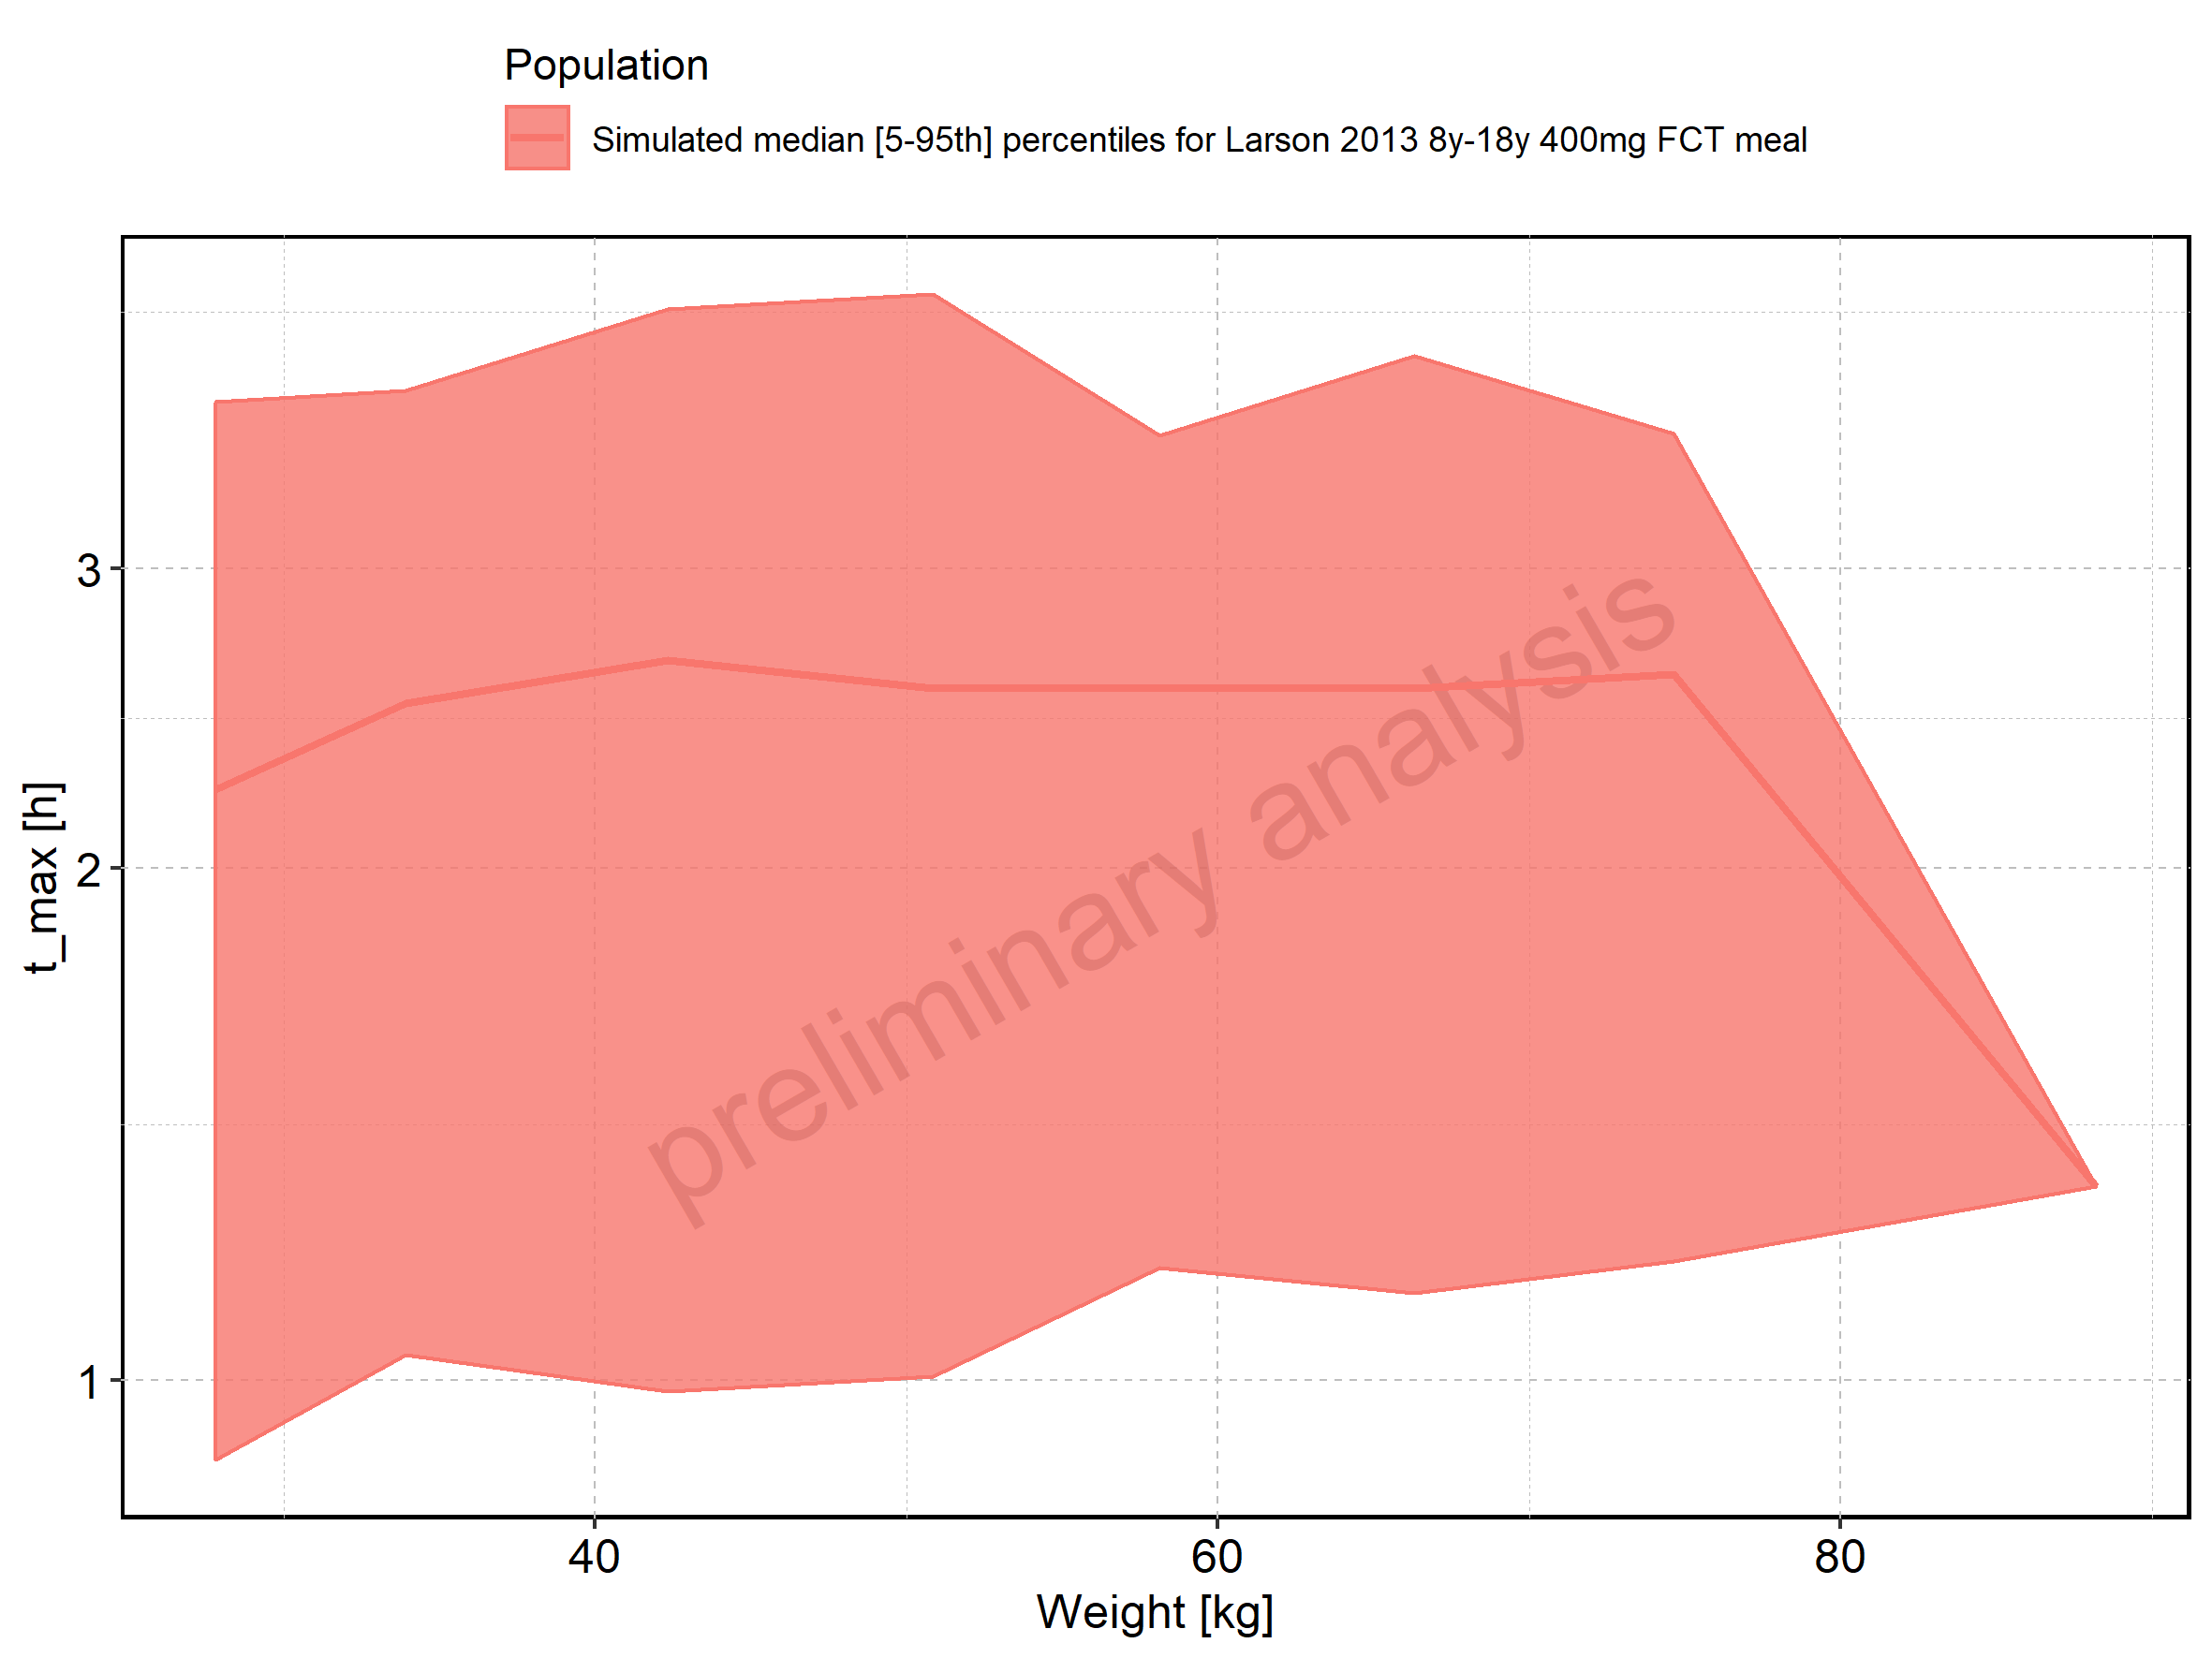

Figure 81: Weight-dependence of t_max for Filmcoated_tablet_400mg_sd. Profiles are plotted in a linear scale.

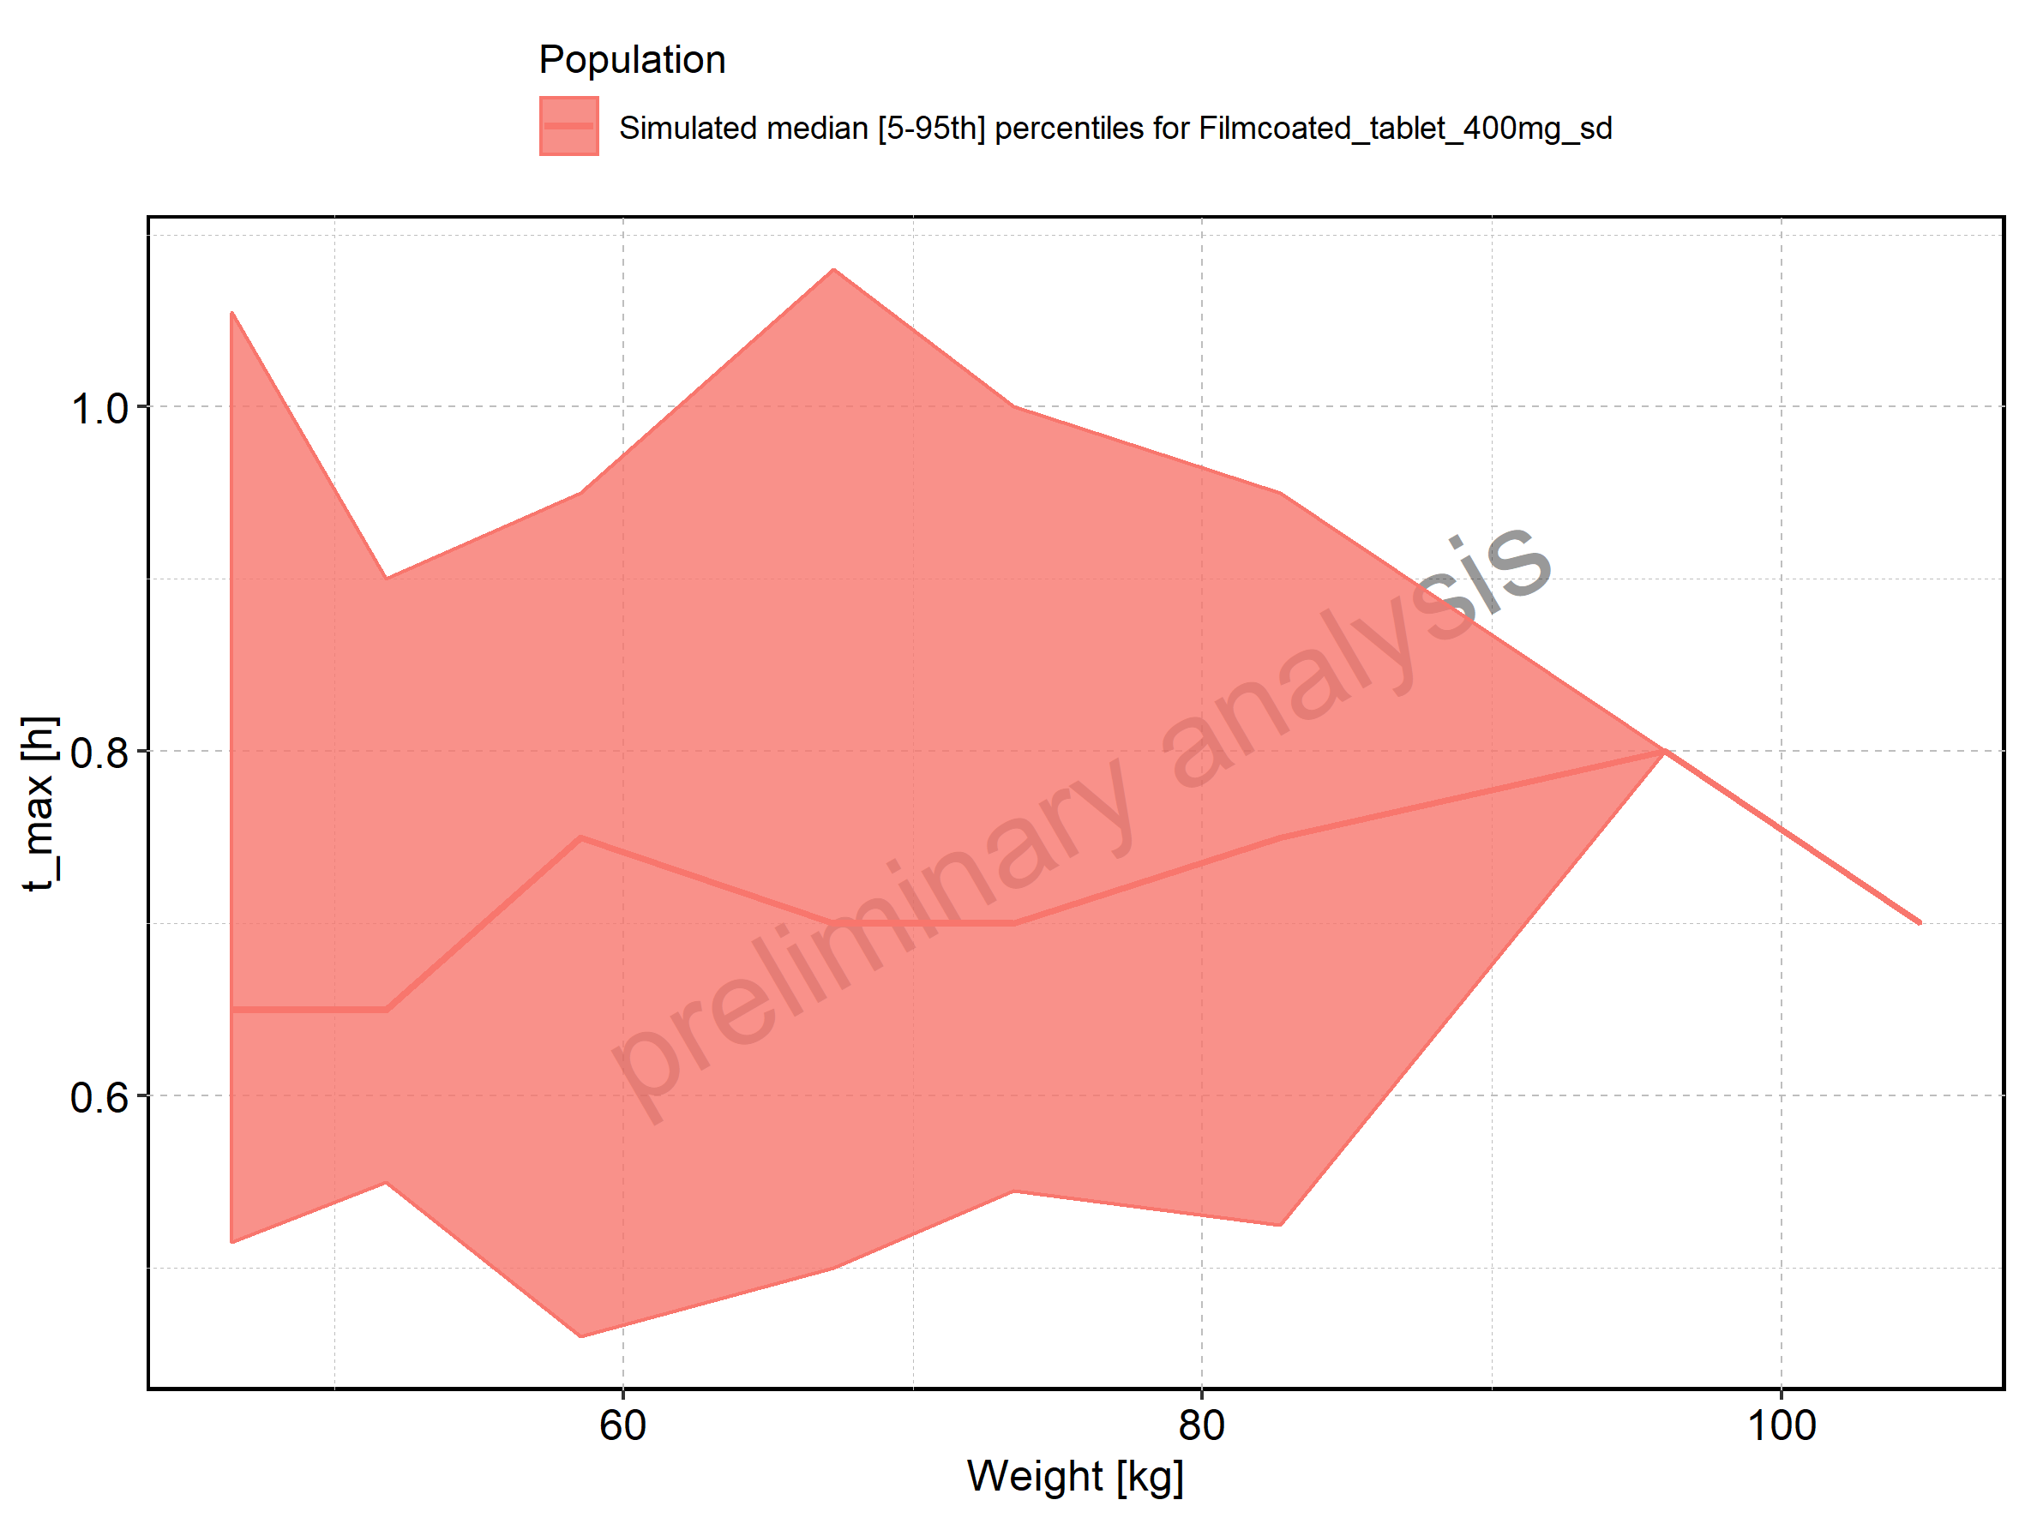

Figure 82: Weight-dependence of t_max for Filmcoated_tablet_400mg_sd. Profiles are plotted in a logarithmic scale.

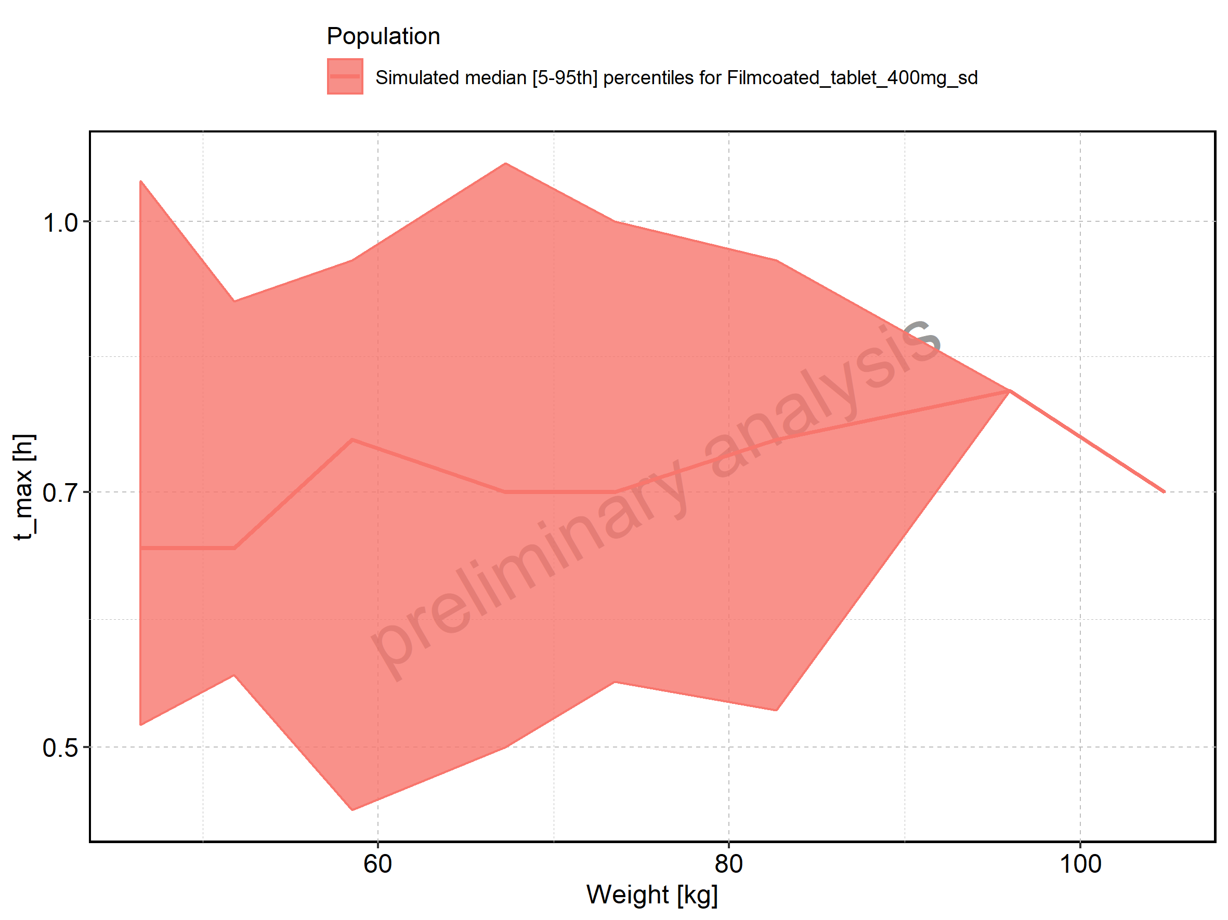

Figure 83: BMI-dependence of t_max for Larson 2013 8y-18y 400mg FCT meal in comparison to Filmcoated_tablet_400mg_sd. Profiles are plotted in a linear scale.

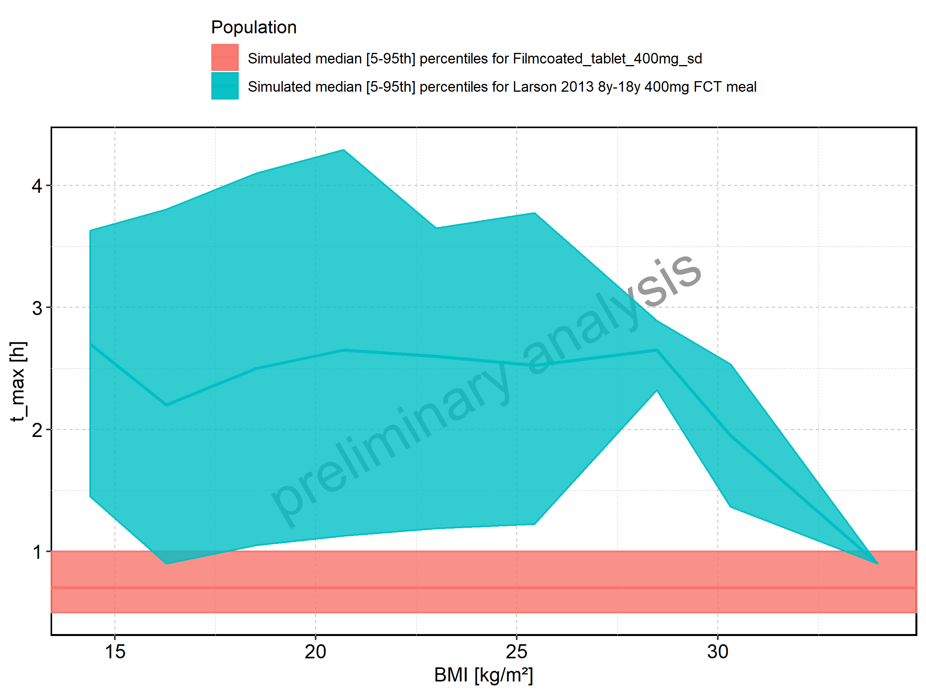

Figure 84: BMI-dependence of t_max for Larson 2013 8y-18y 400mg FCT meal in comparison to Filmcoated_tablet_400mg_sd. Profiles are plotted in a logarithmic scale.

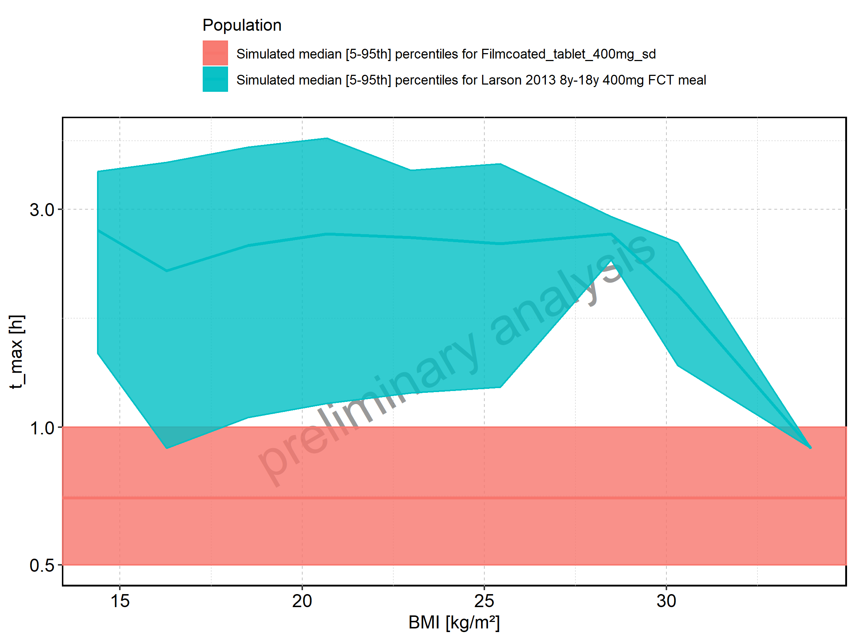

Figure 85: BMI-dependence of t_max for Larson 2013 8y-18y 400mg FCT meal. Profiles are plotted in a linear scale.

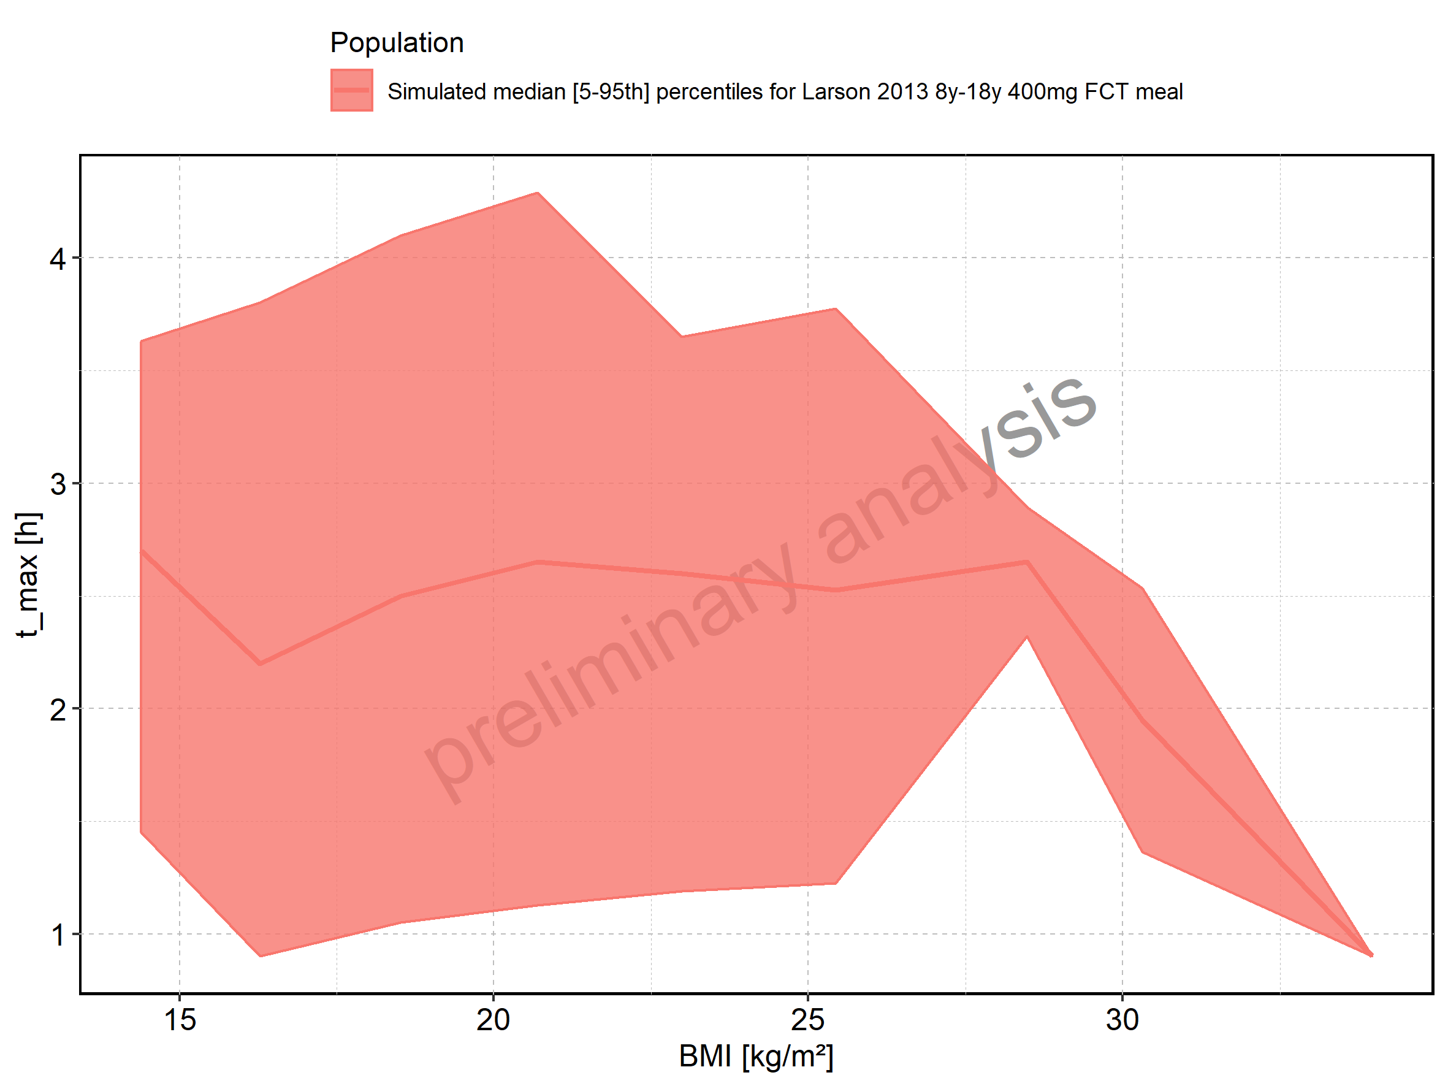

Figure 86: BMI-dependence of t_max for Larson 2013 8y-18y 400mg FCT meal. Profiles are plotted in a logarithmic scale.

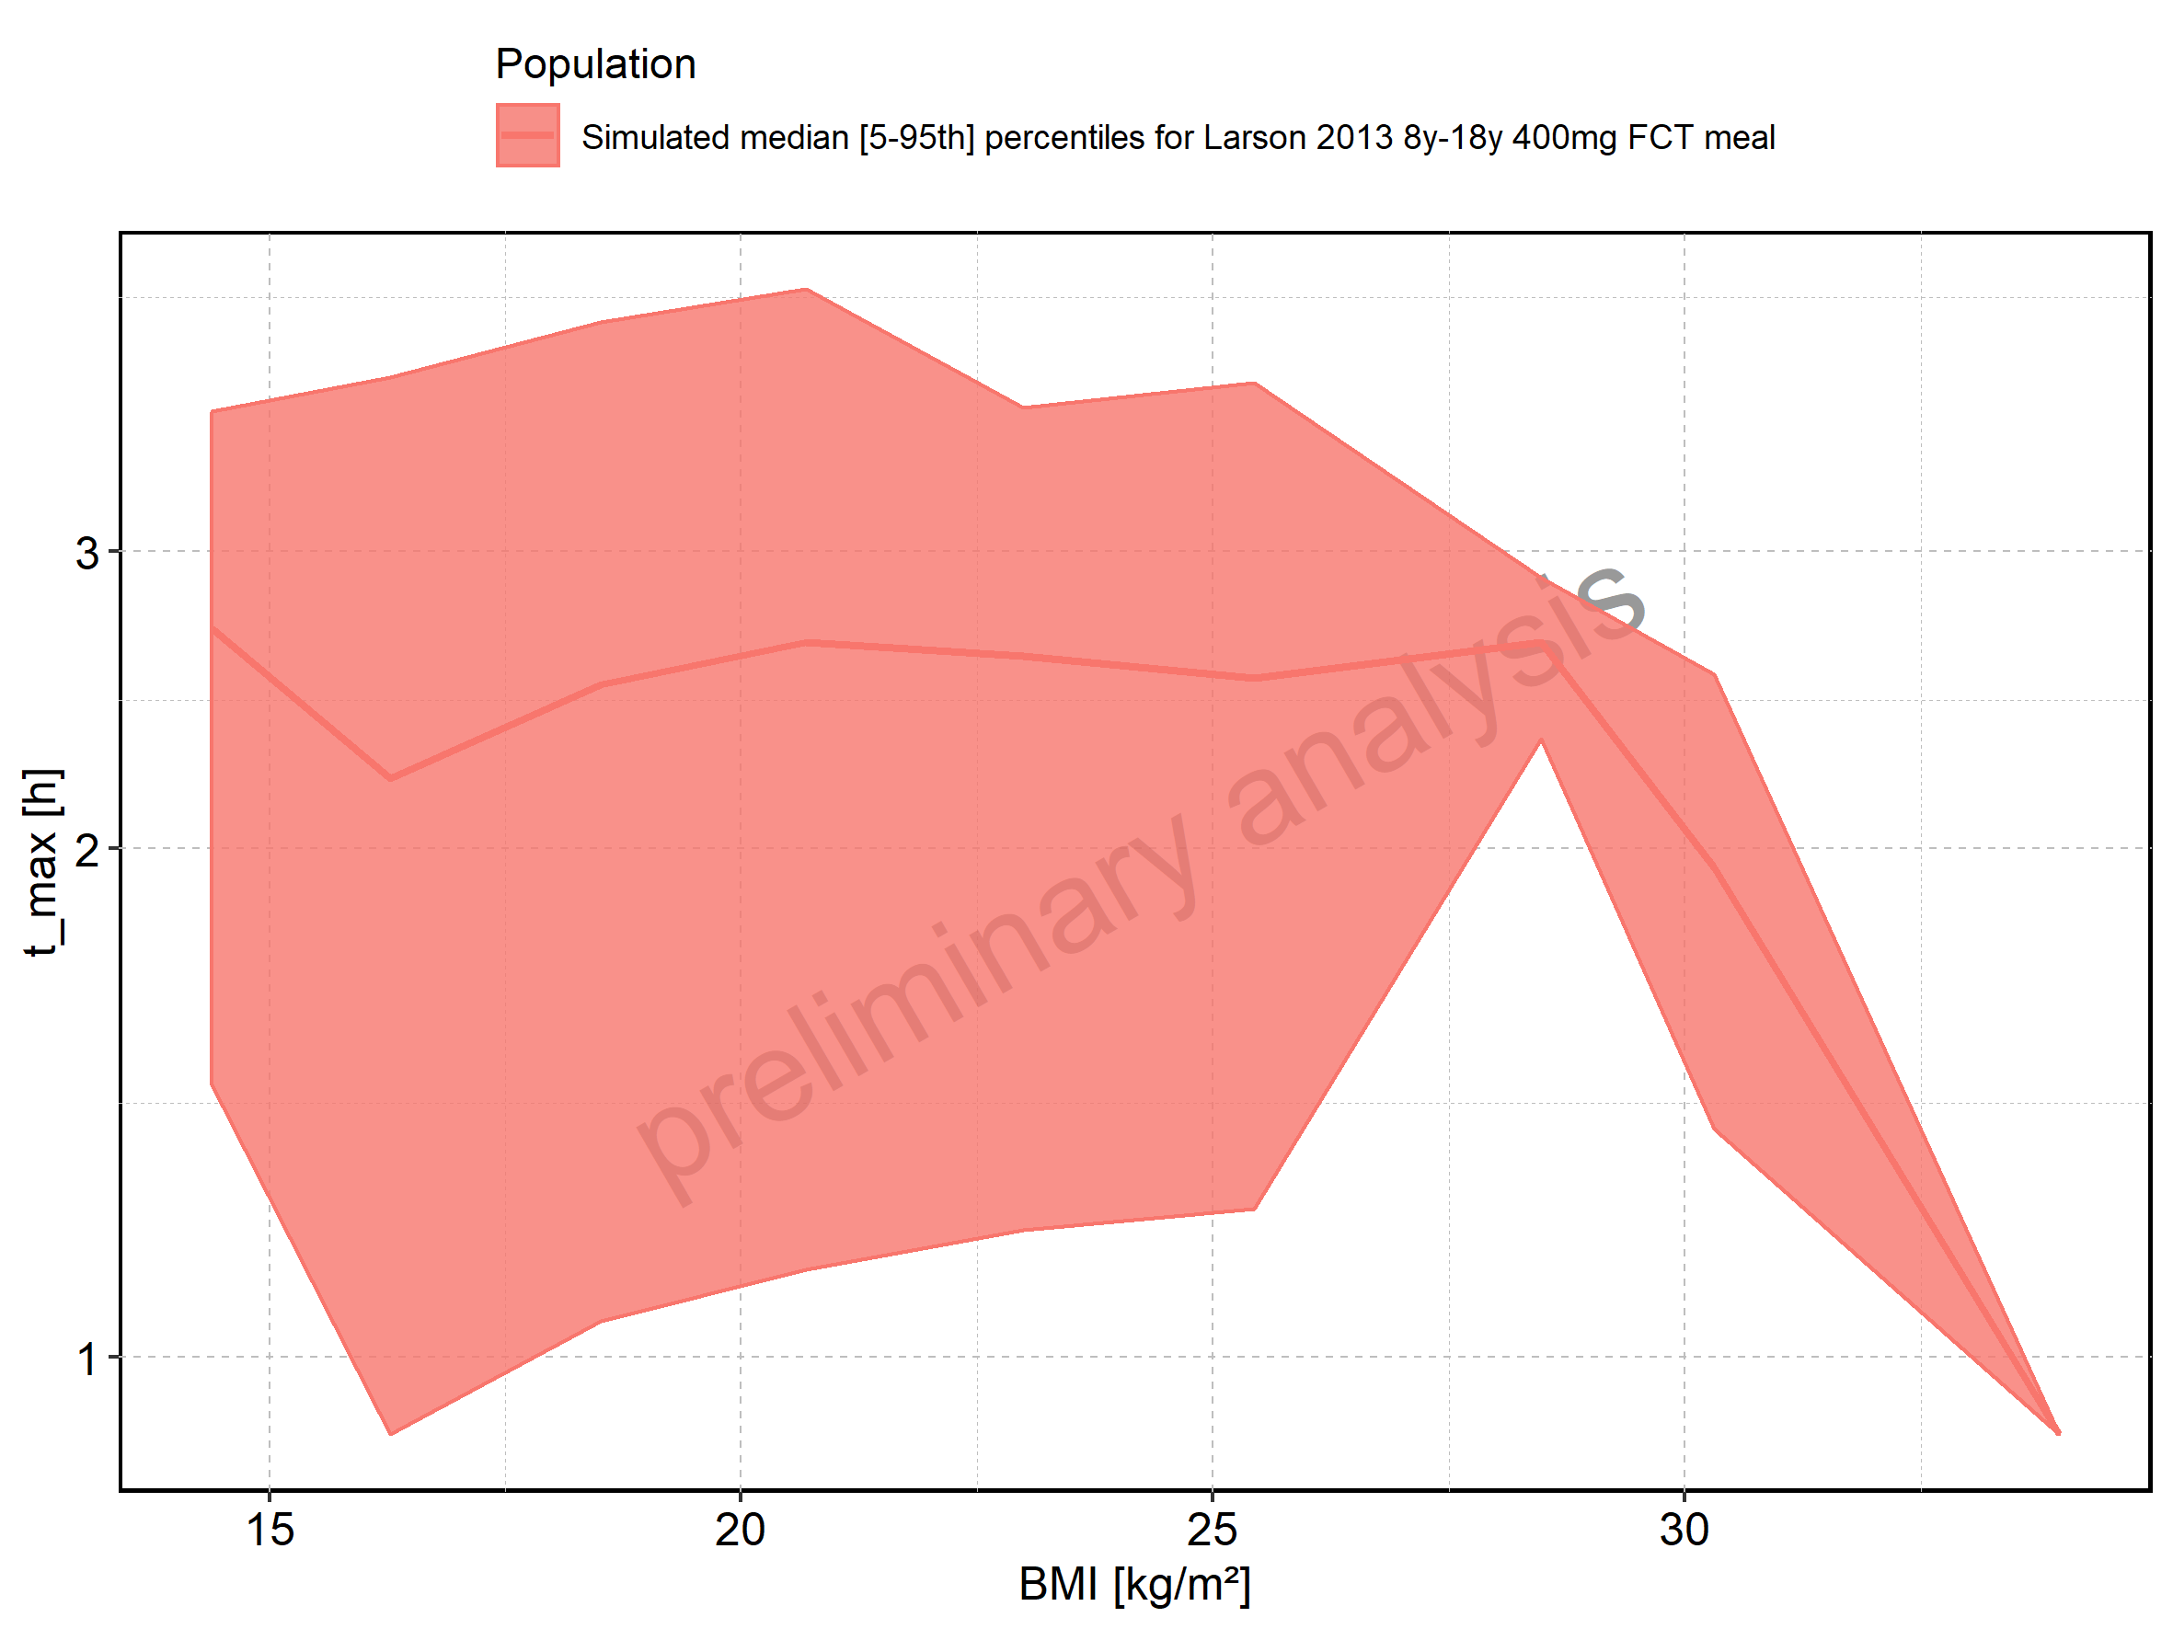

Figure 87: BMI-dependence of t_max for Filmcoated_tablet_400mg_sd. Profiles are plotted in a linear scale.

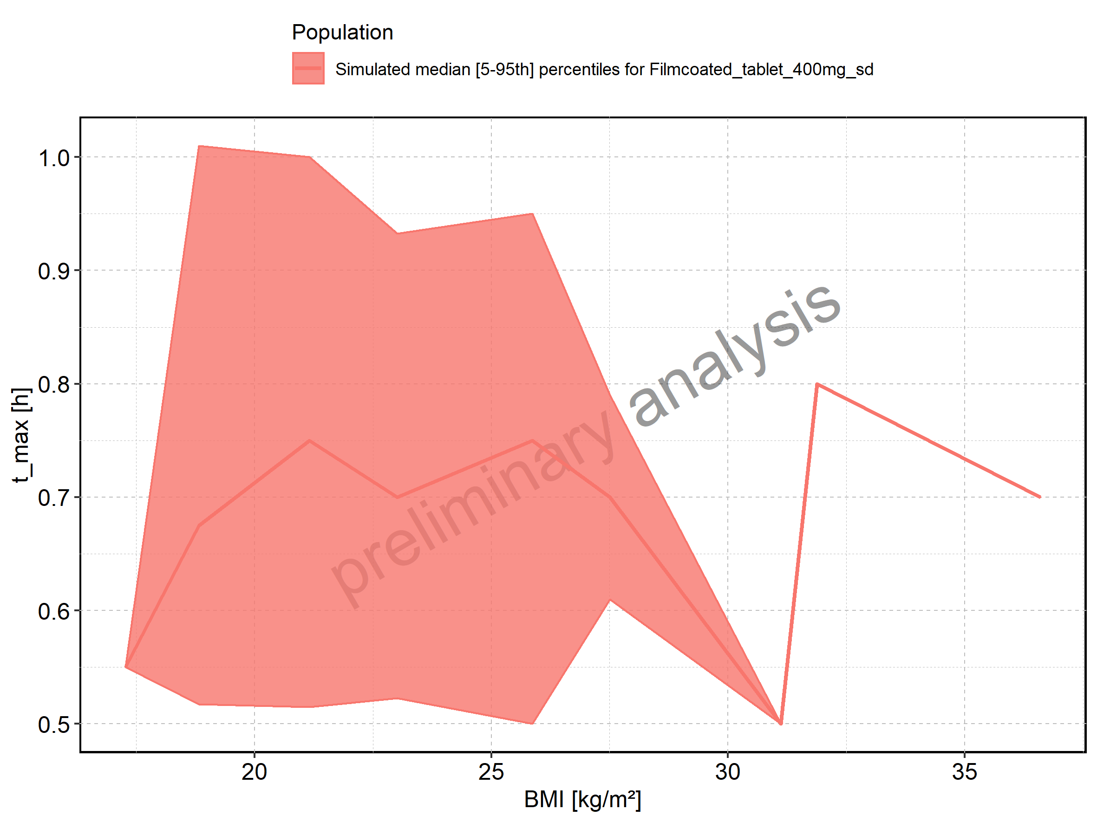

Figure 88: BMI-dependence of t_max for Filmcoated_tablet_400mg_sd. Profiles are plotted in a logarithmic scale.

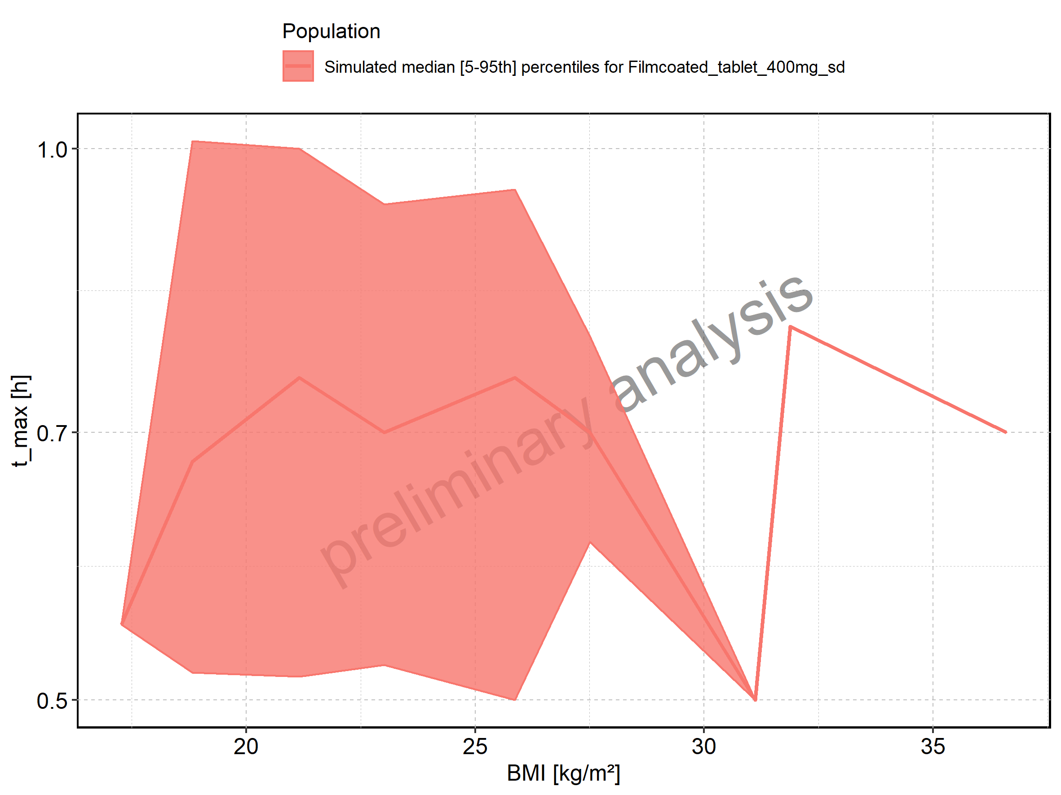

Figure 89: C_tEnd of Raltegravir shown as box-whisker plot, which indicates the 5th, 25th, 50th, 75th, and 95th percentiles in linear scale.

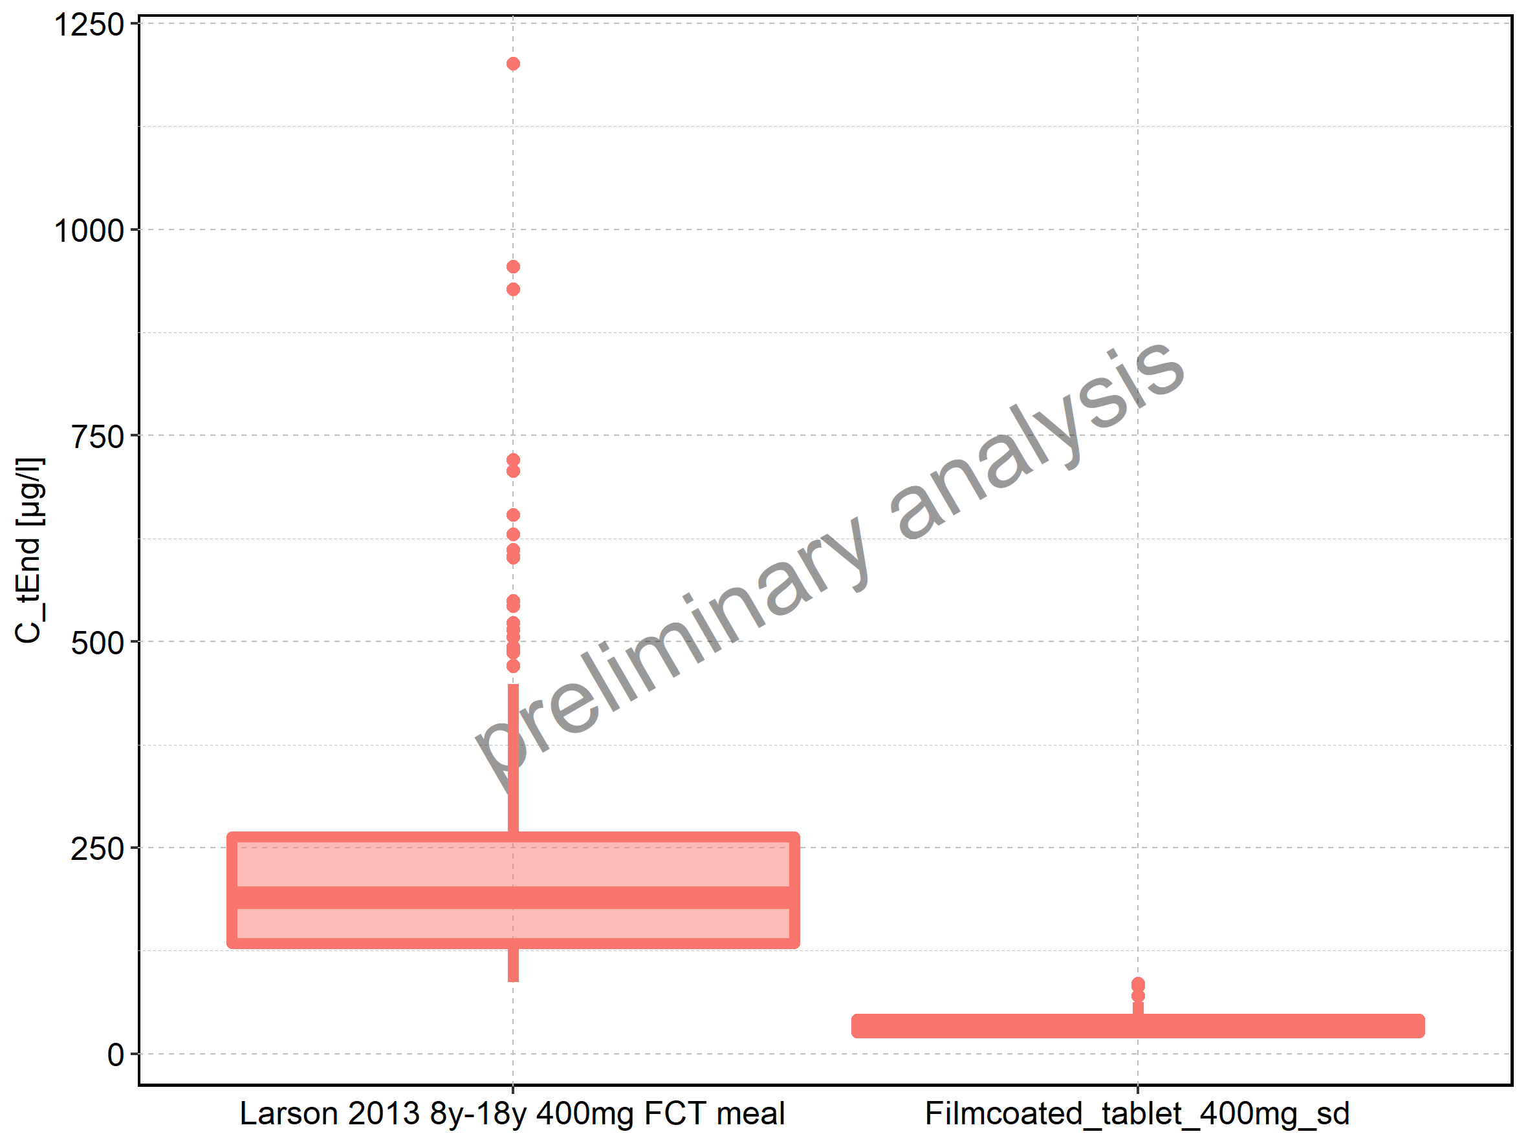

|  |  |  |  |  |  |  |  |  |  |  |
| --- | --- | --- | --- | --- | --- | --- | --- | --- | --- | --- |
| Population | N | 5th percentile | 25th percentile | 50th percentile | 75th percentile | 95th percentile | mean | standard deviation | geo mean | geo standard deviation |
| Larson 2013 8y-18y 400mg FCT meal | 500 | 86.63046 | 133.65437 | 189.56204 | 263.51260 | 448.02293 | 218.90336 | 129.11620 | 191.12211 | 1.666367 |
| Filmcoated_tablet_400mg_sd | 100 | 19.57484 | 25.79622 | 32.34815 | 41.91365 | 62.67601 | 35.38577 | 14.20645 | 33.01047 | 1.444113 |

Figure 90: C_tEnd of Raltegravir shown as box-whisker plot, which indicates the 5th, 25th, 50th, 75th, and 95th percentiles in logarithmic scale.

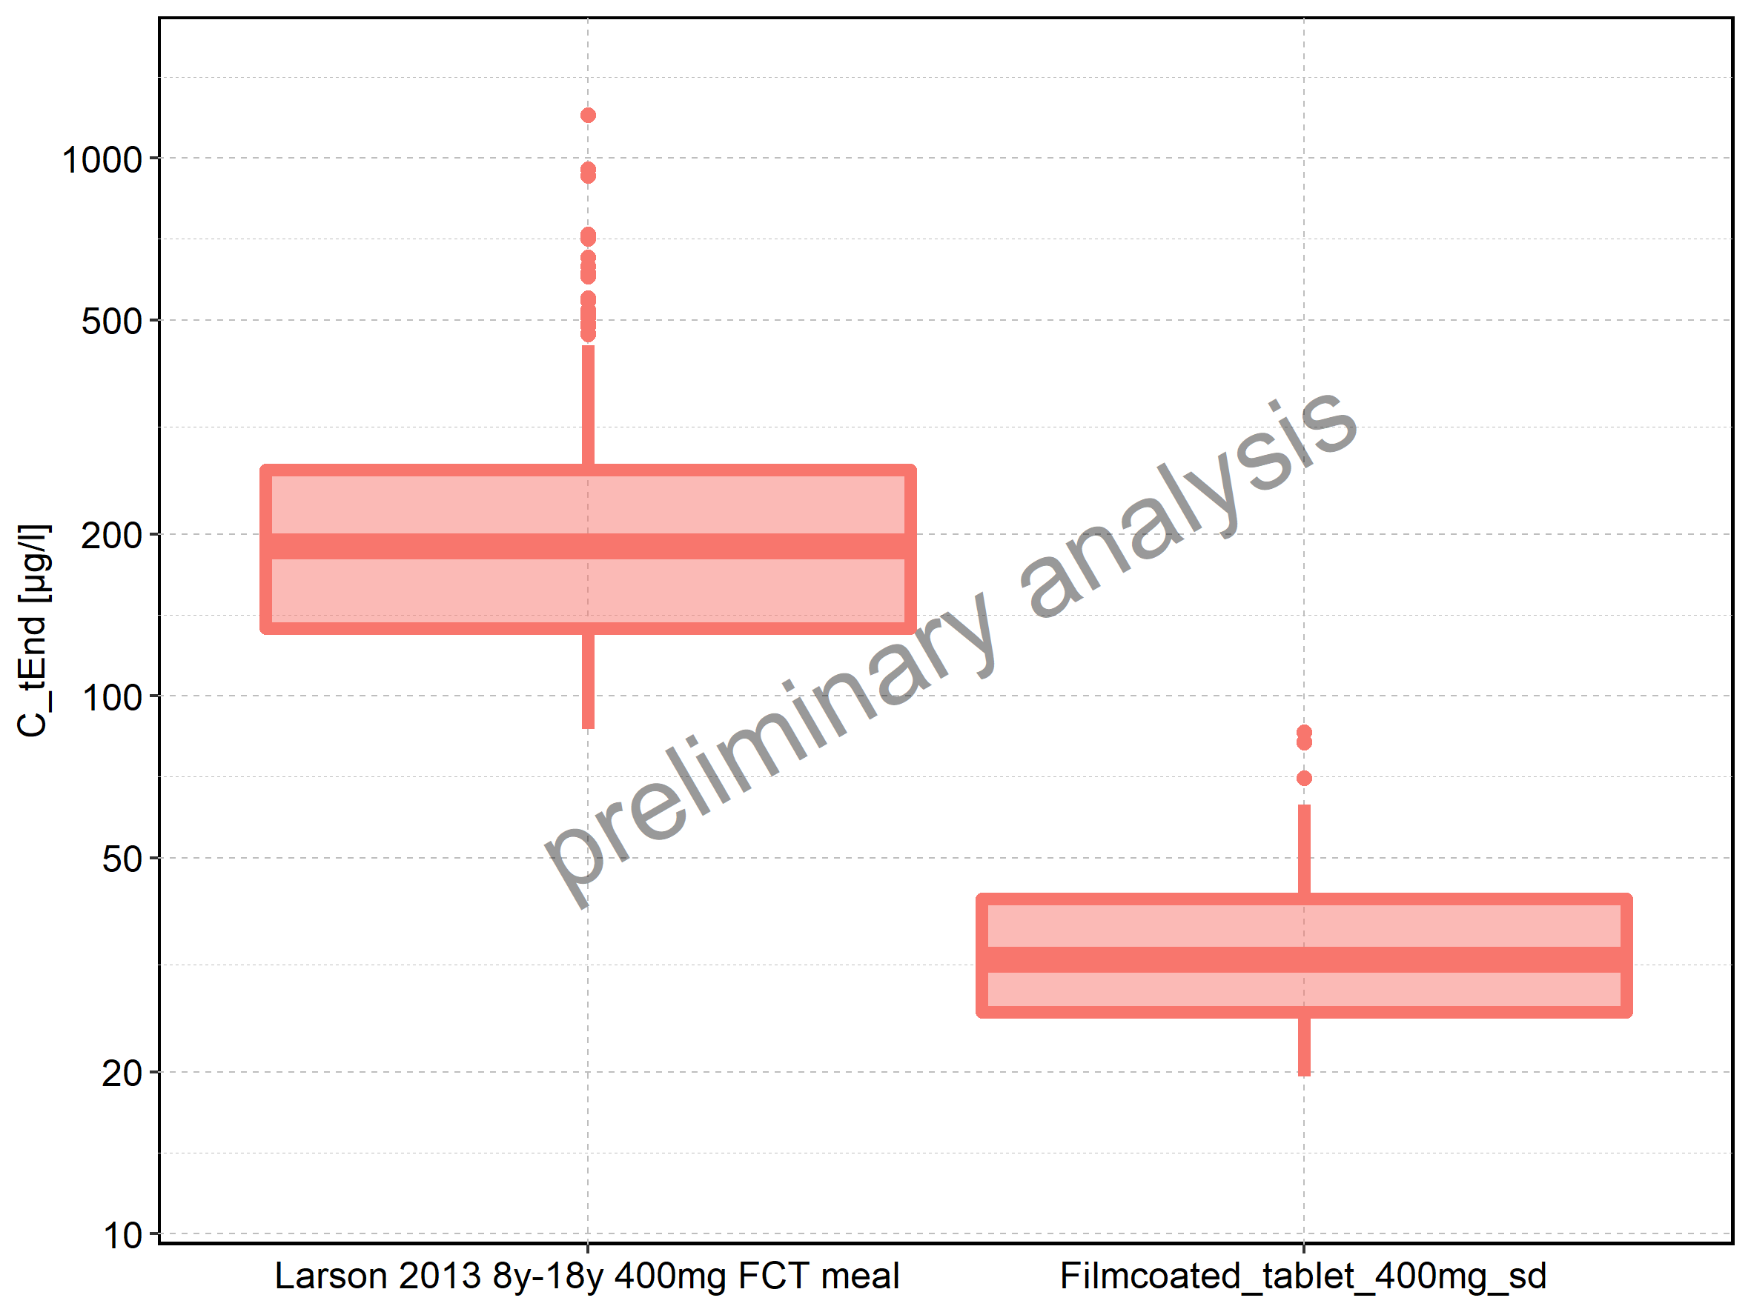

Figure 91: Age-dependence of C_tEnd for Larson 2013 8y-18y 400mg FCT meal in comparison to Filmcoated_tablet_400mg_sd. Profiles are plotted in a linear scale.

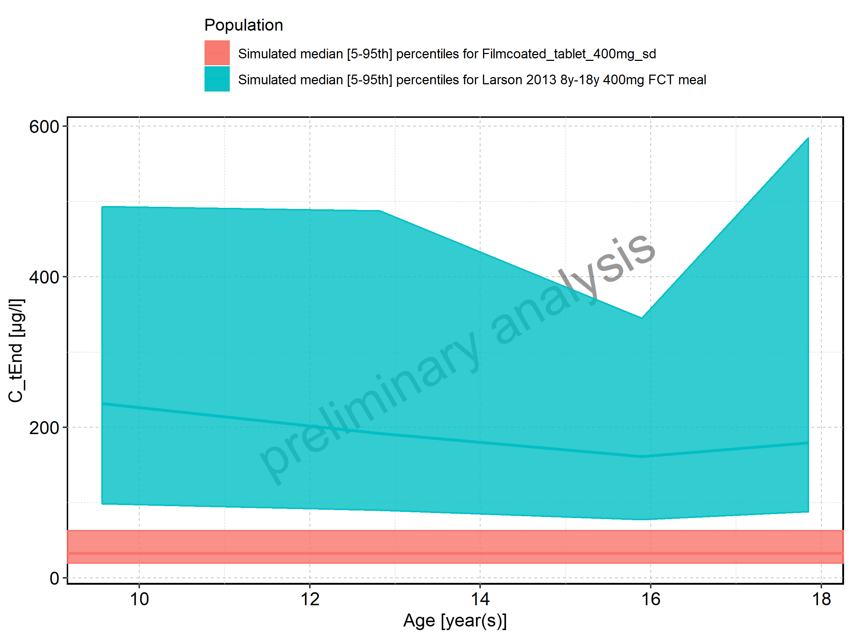

Figure 92: Age-dependence of C_tEnd for Larson 2013 8y-18y 400mg FCT meal in comparison to Filmcoated_tablet_400mg_sd. Profiles are plotted in a logarithmic scale.

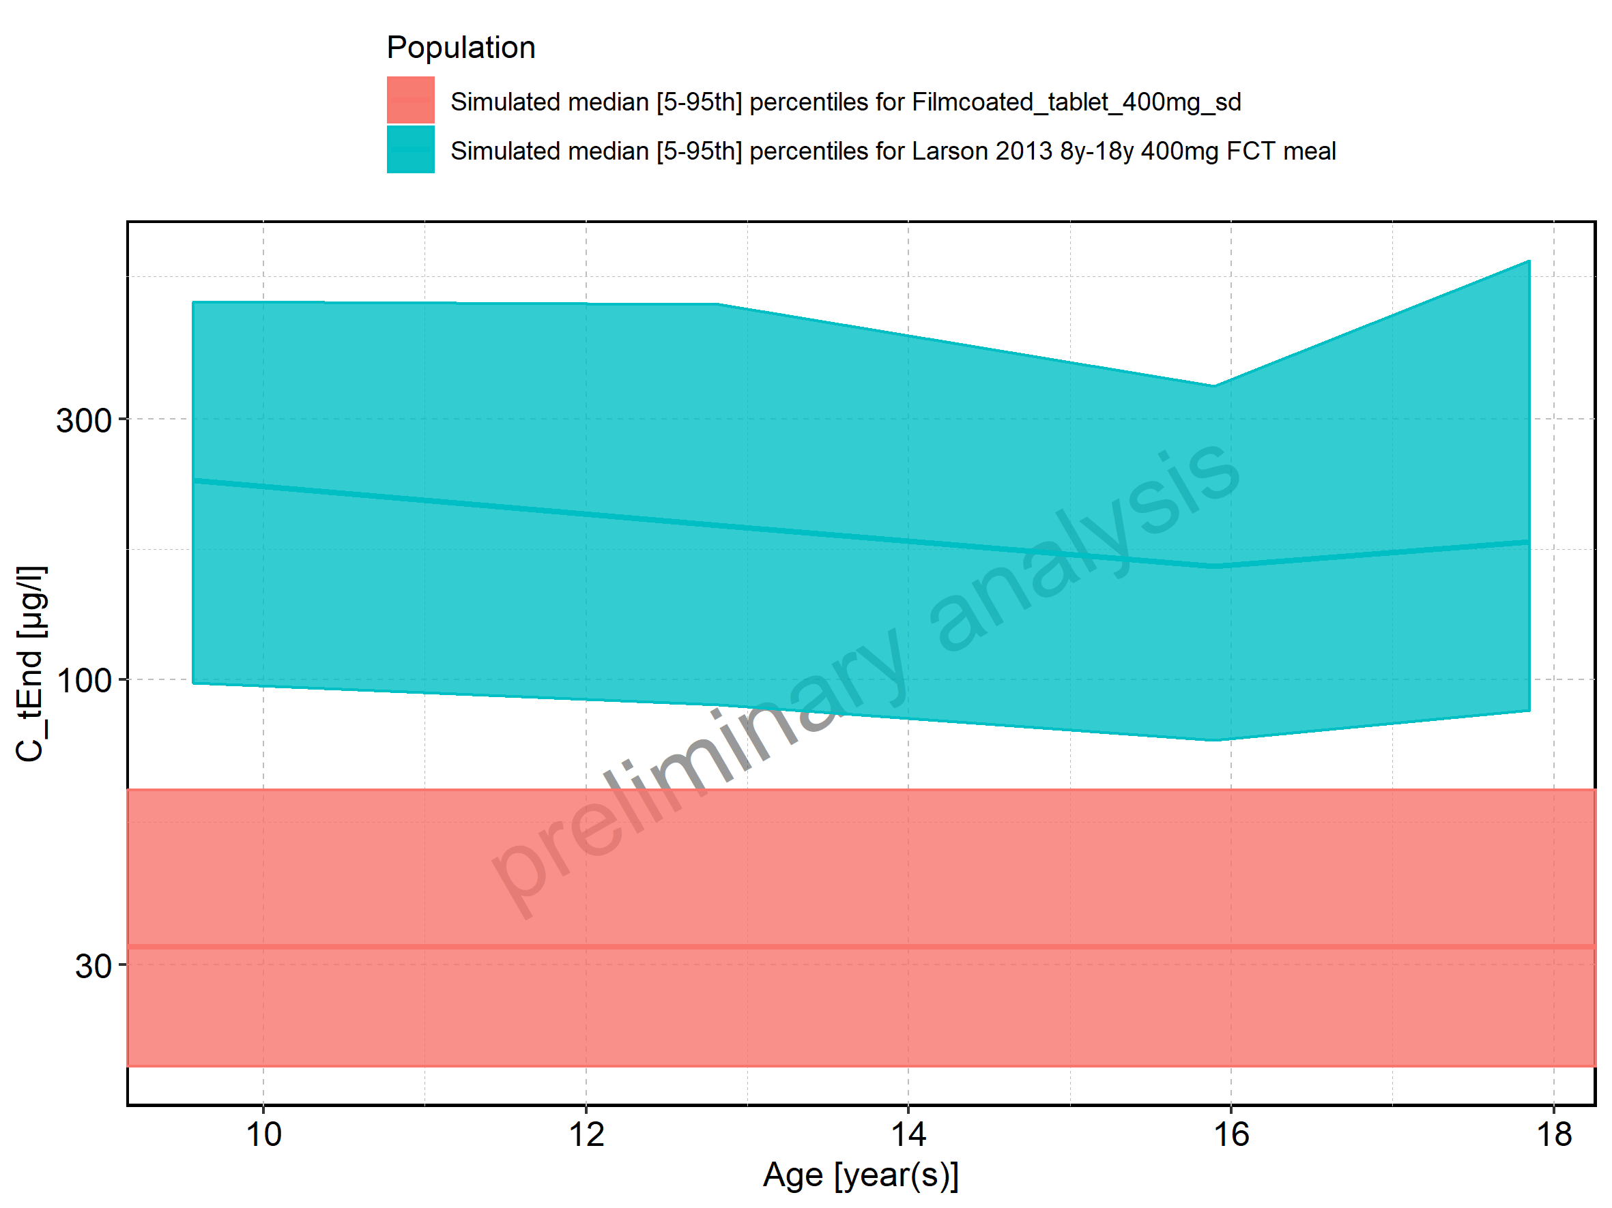

Figure 93: Age-dependence of C_tEnd for Larson 2013 8y-18y 400mg FCT meal. Profiles are plotted in a linear scale.

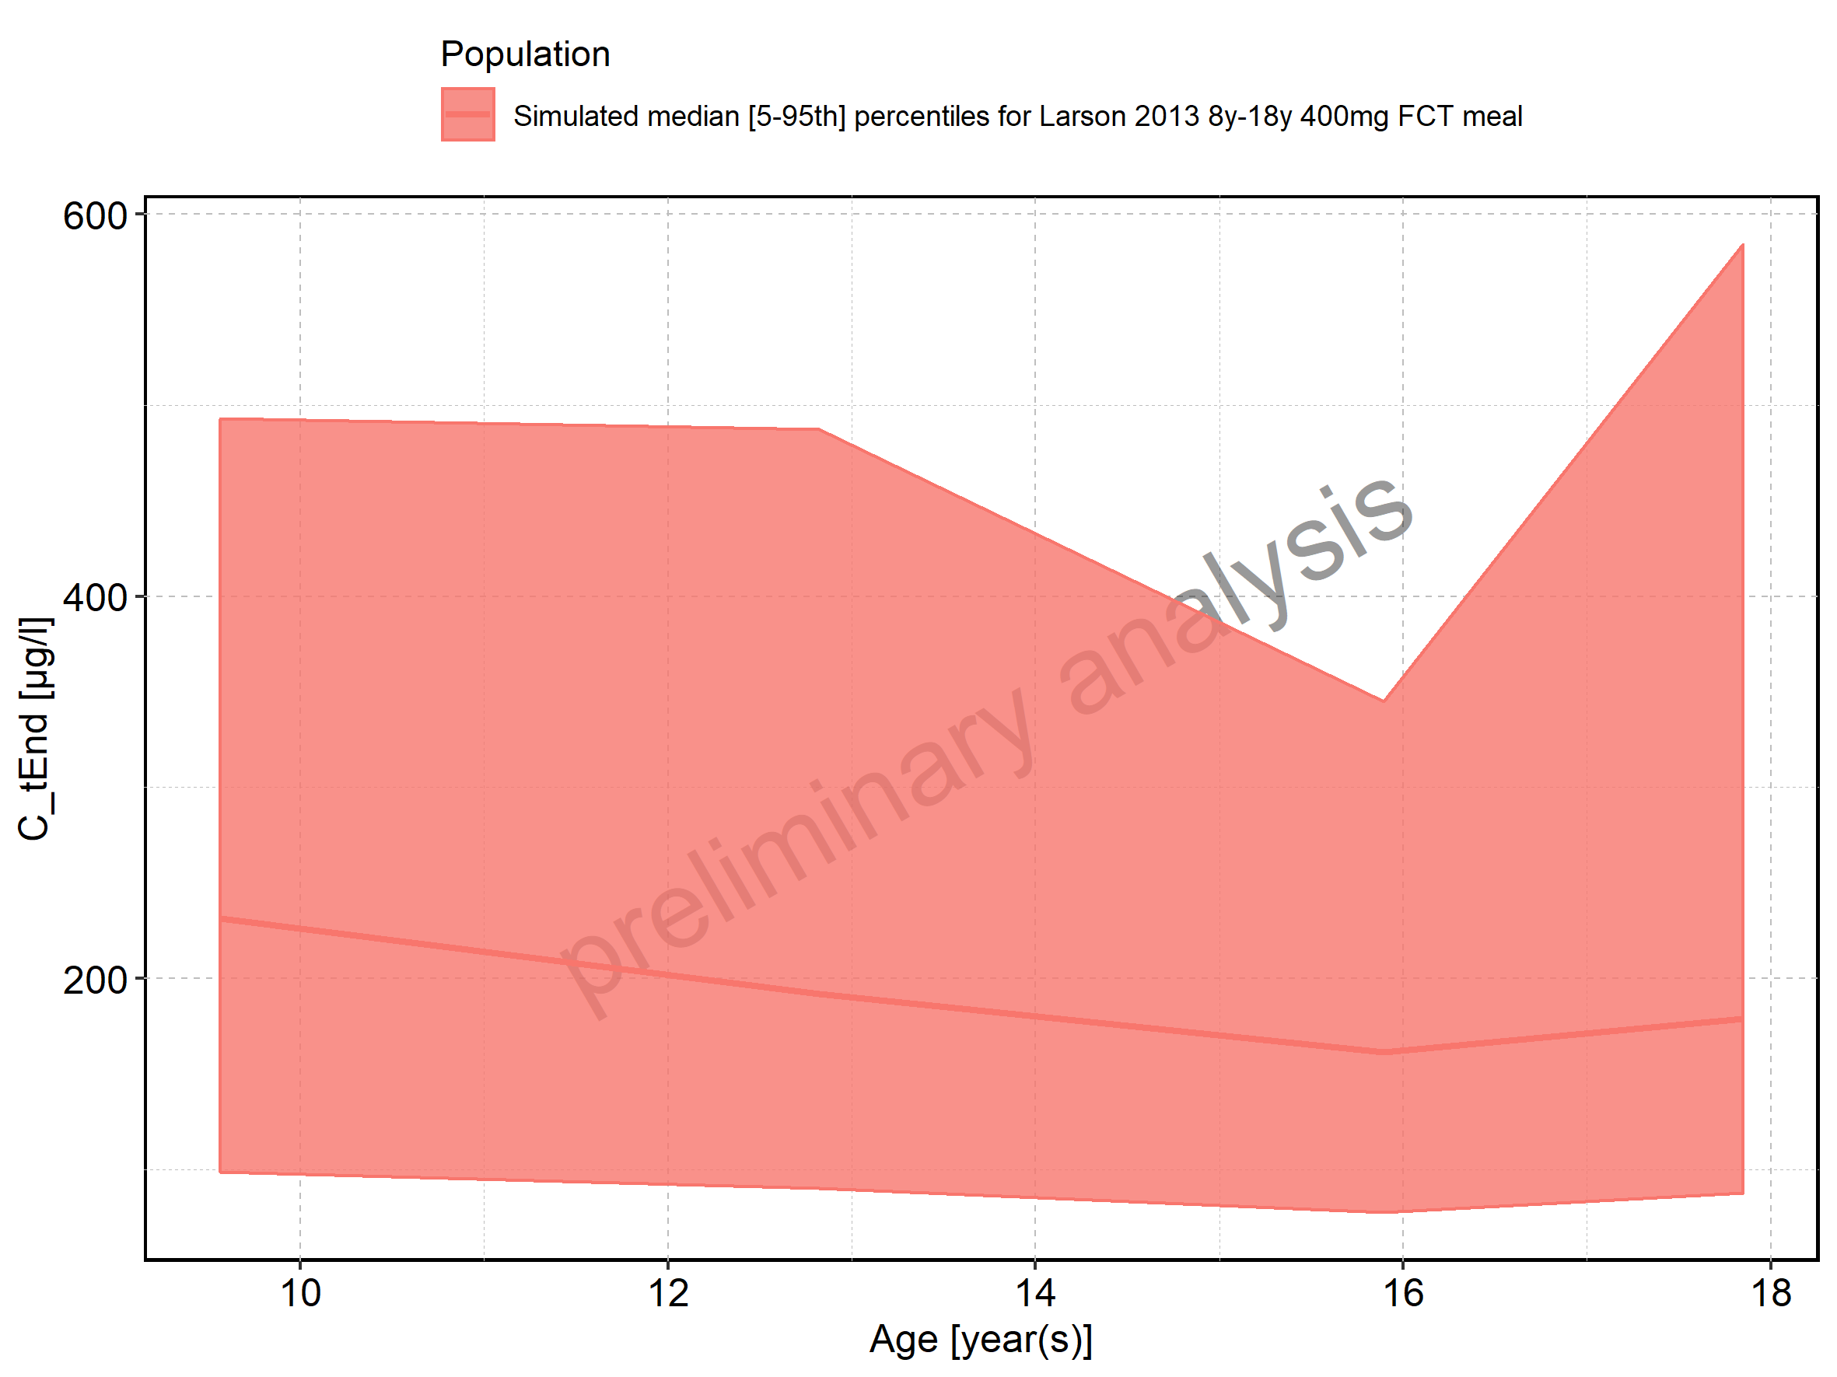

Figure 94: Age-dependence of C_tEnd for Larson 2013 8y-18y 400mg FCT meal. Profiles are plotted in a logarithmic scale.

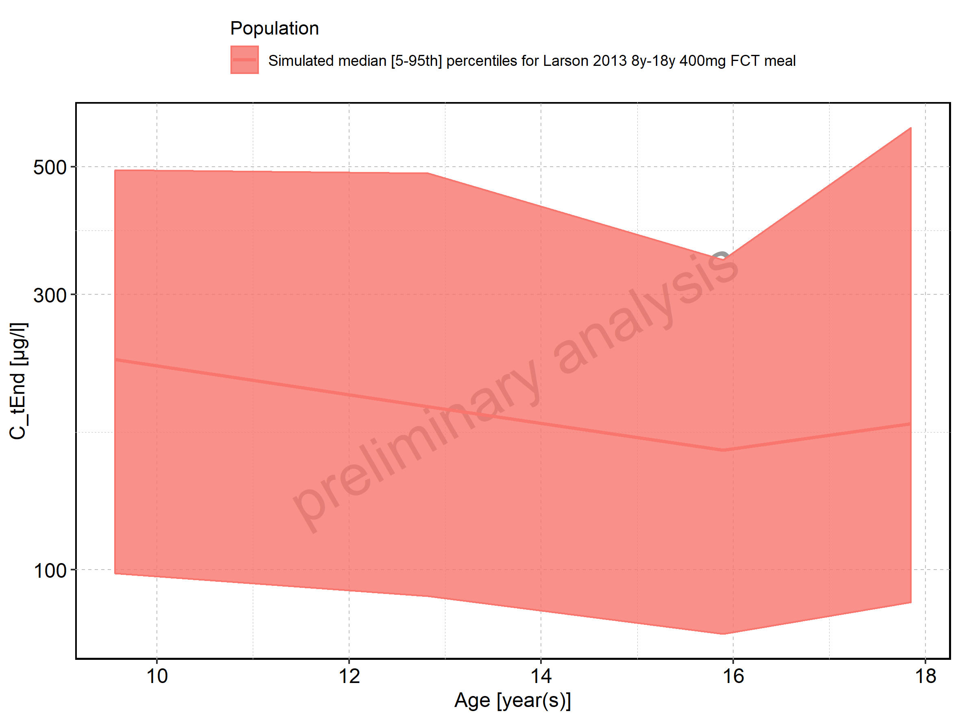

Figure 95: Age-dependence of C_tEnd for Filmcoated_tablet_400mg_sd. Profiles are plotted in a linear scale.

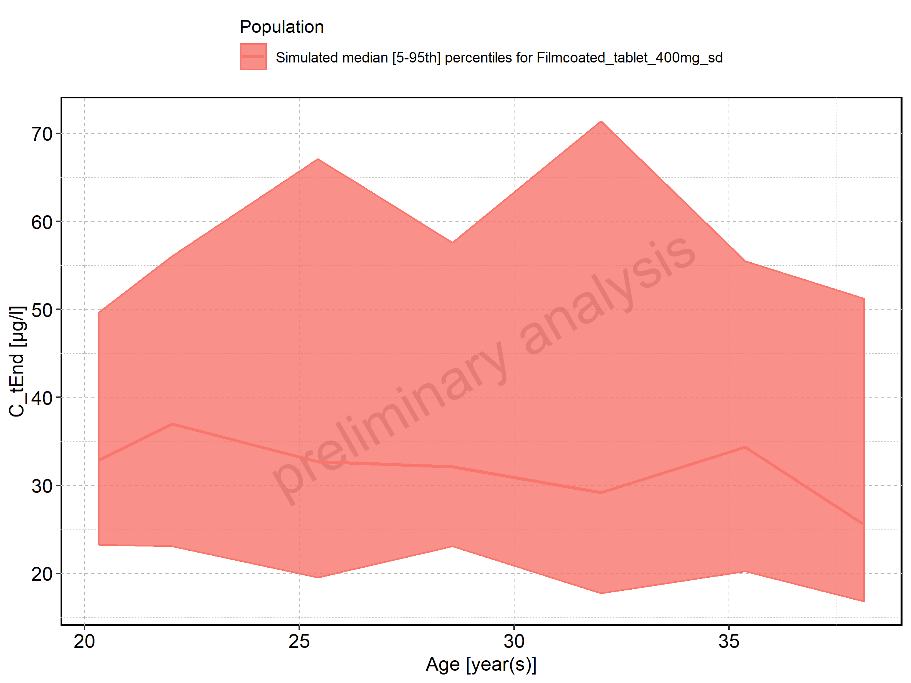

Figure 96: Age-dependence of C_tEnd for Filmcoated_tablet_400mg_sd. Profiles are plotted in a logarithmic scale.

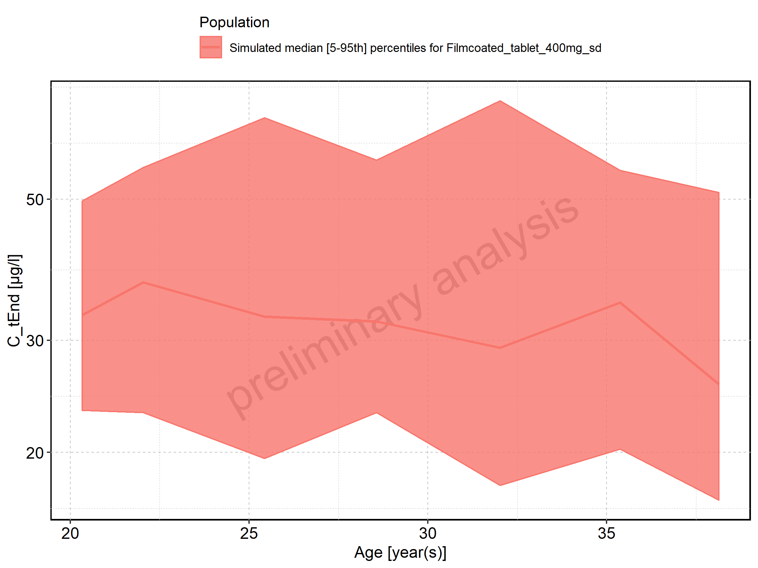

Figure 97: Height-dependence of C_tEnd for Larson 2013 8y-18y 400mg FCT meal in comparison to Filmcoated_tablet_400mg_sd. Profiles are plotted in a linear scale.

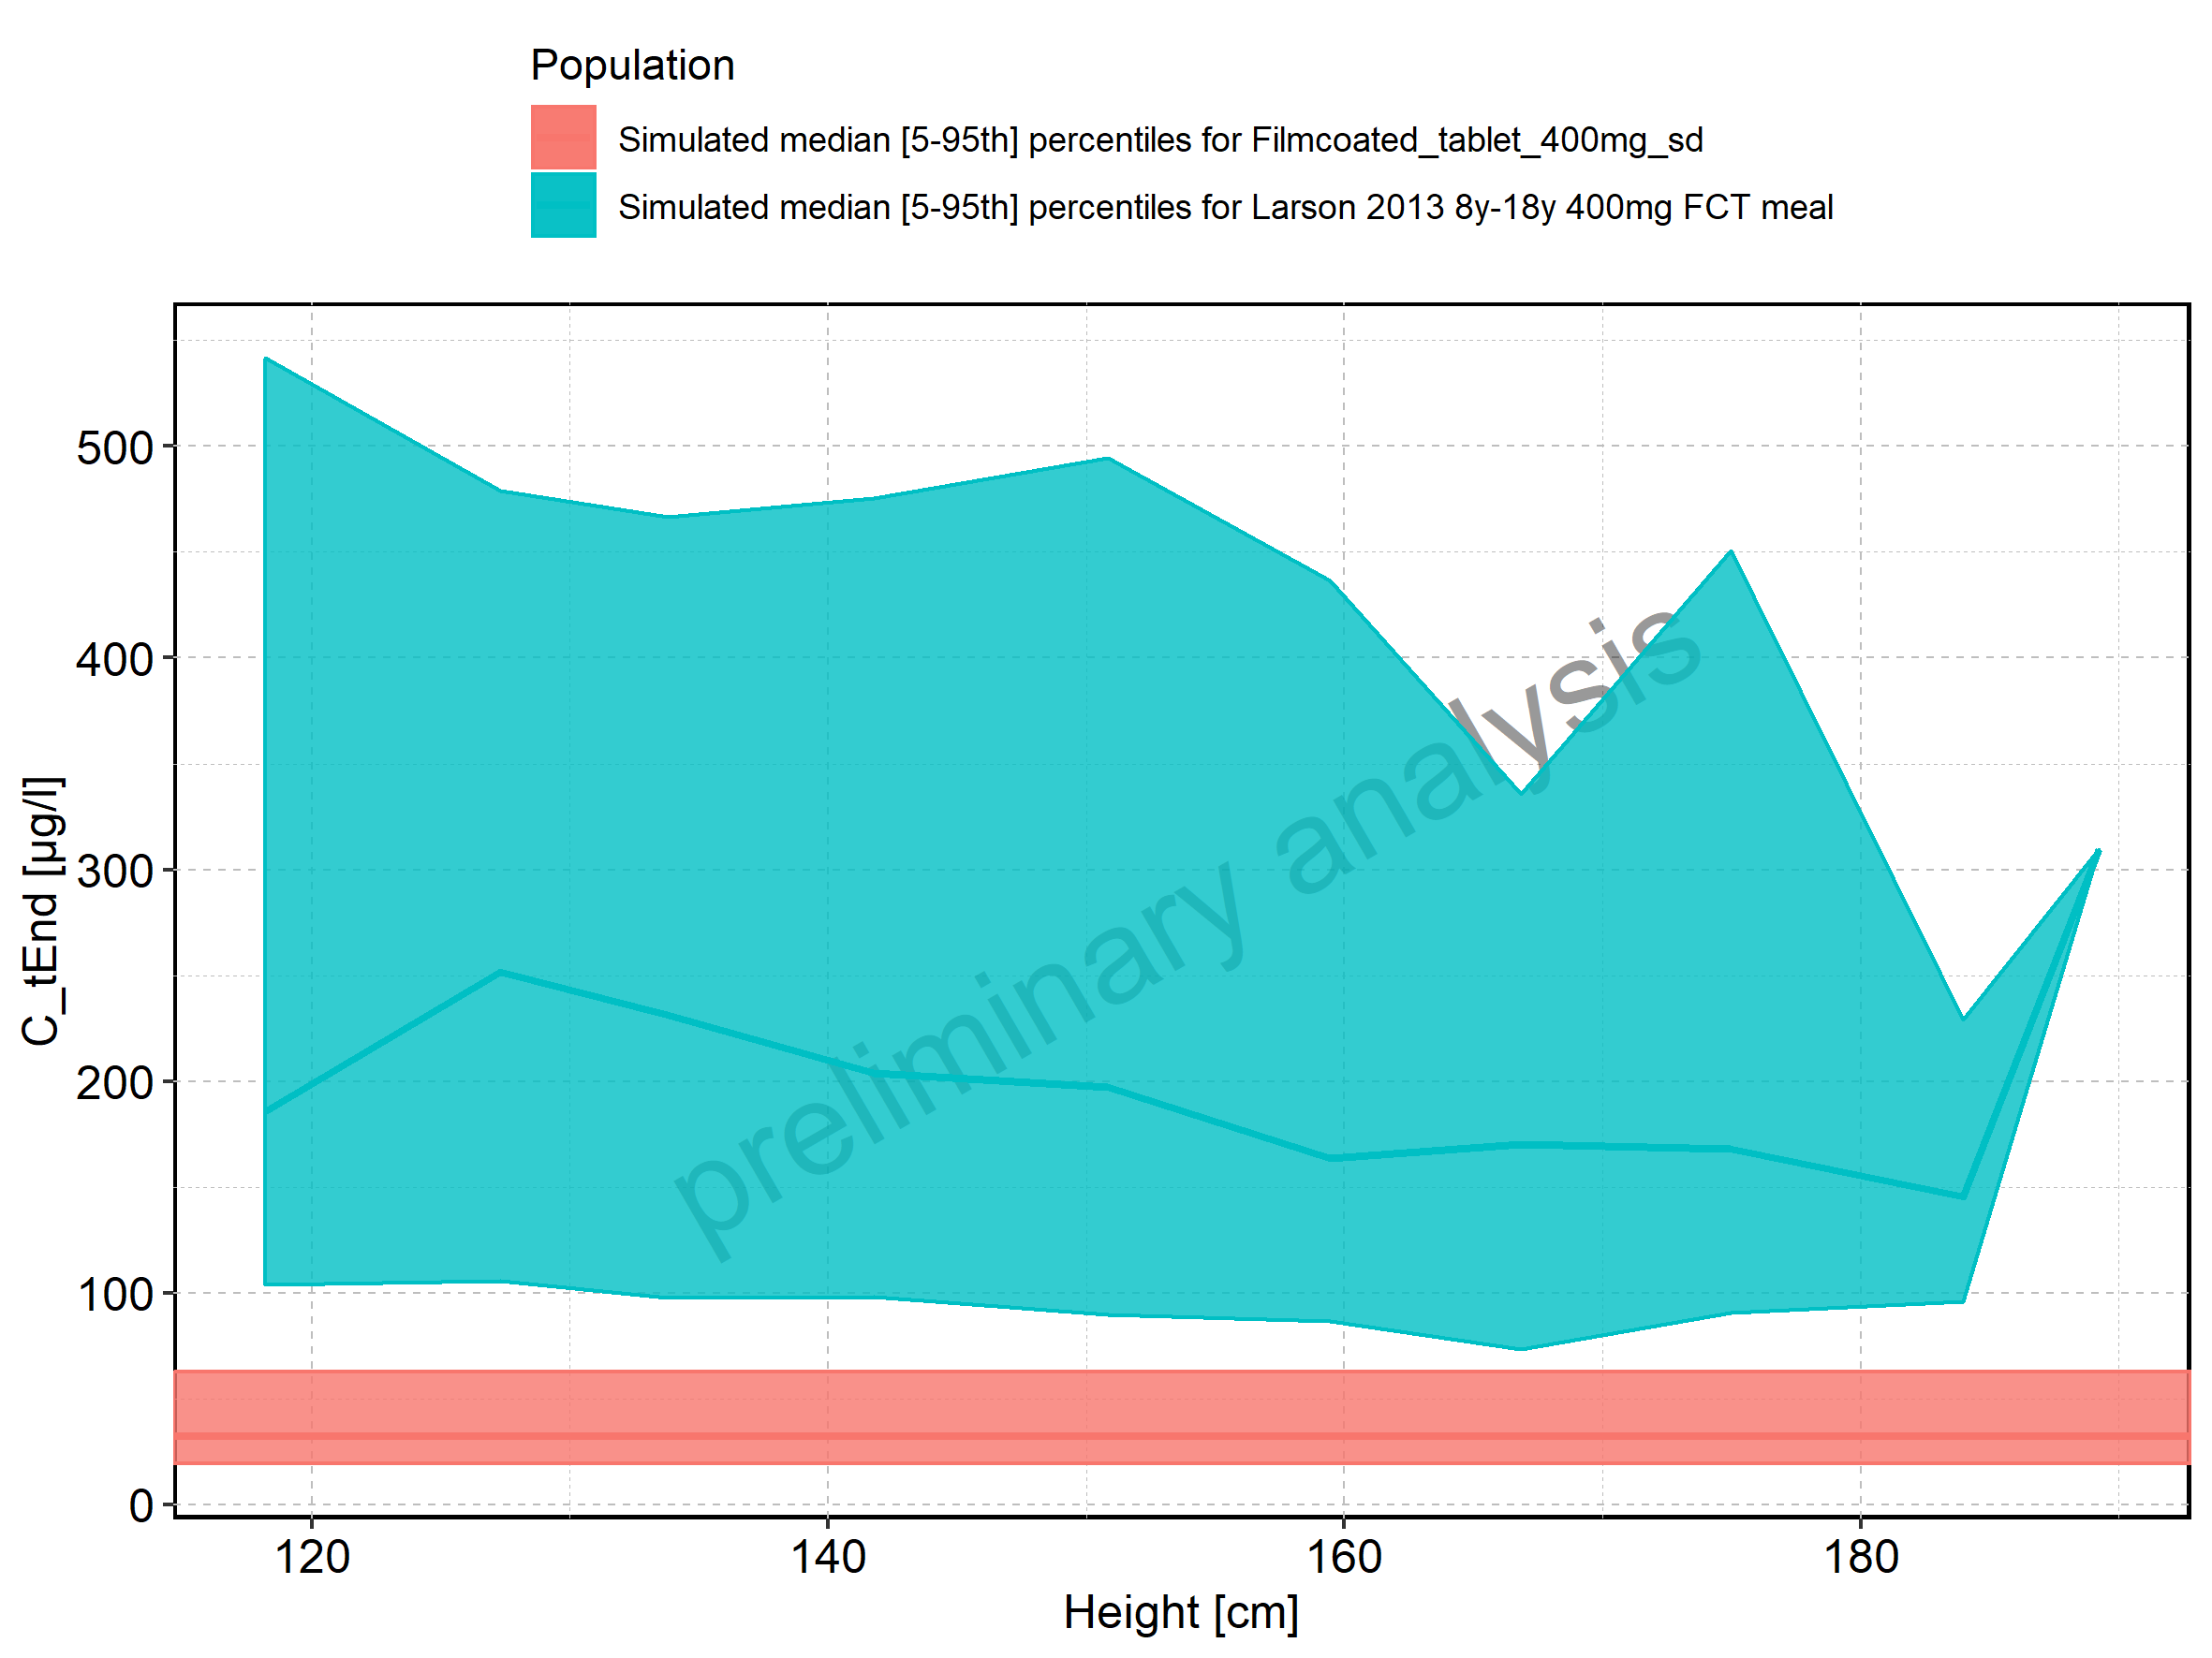

Figure 98: Height-dependence of C_tEnd for Larson 2013 8y-18y 400mg FCT meal in comparison to Filmcoated_tablet_400mg_sd. Profiles are plotted in a logarithmic scale.

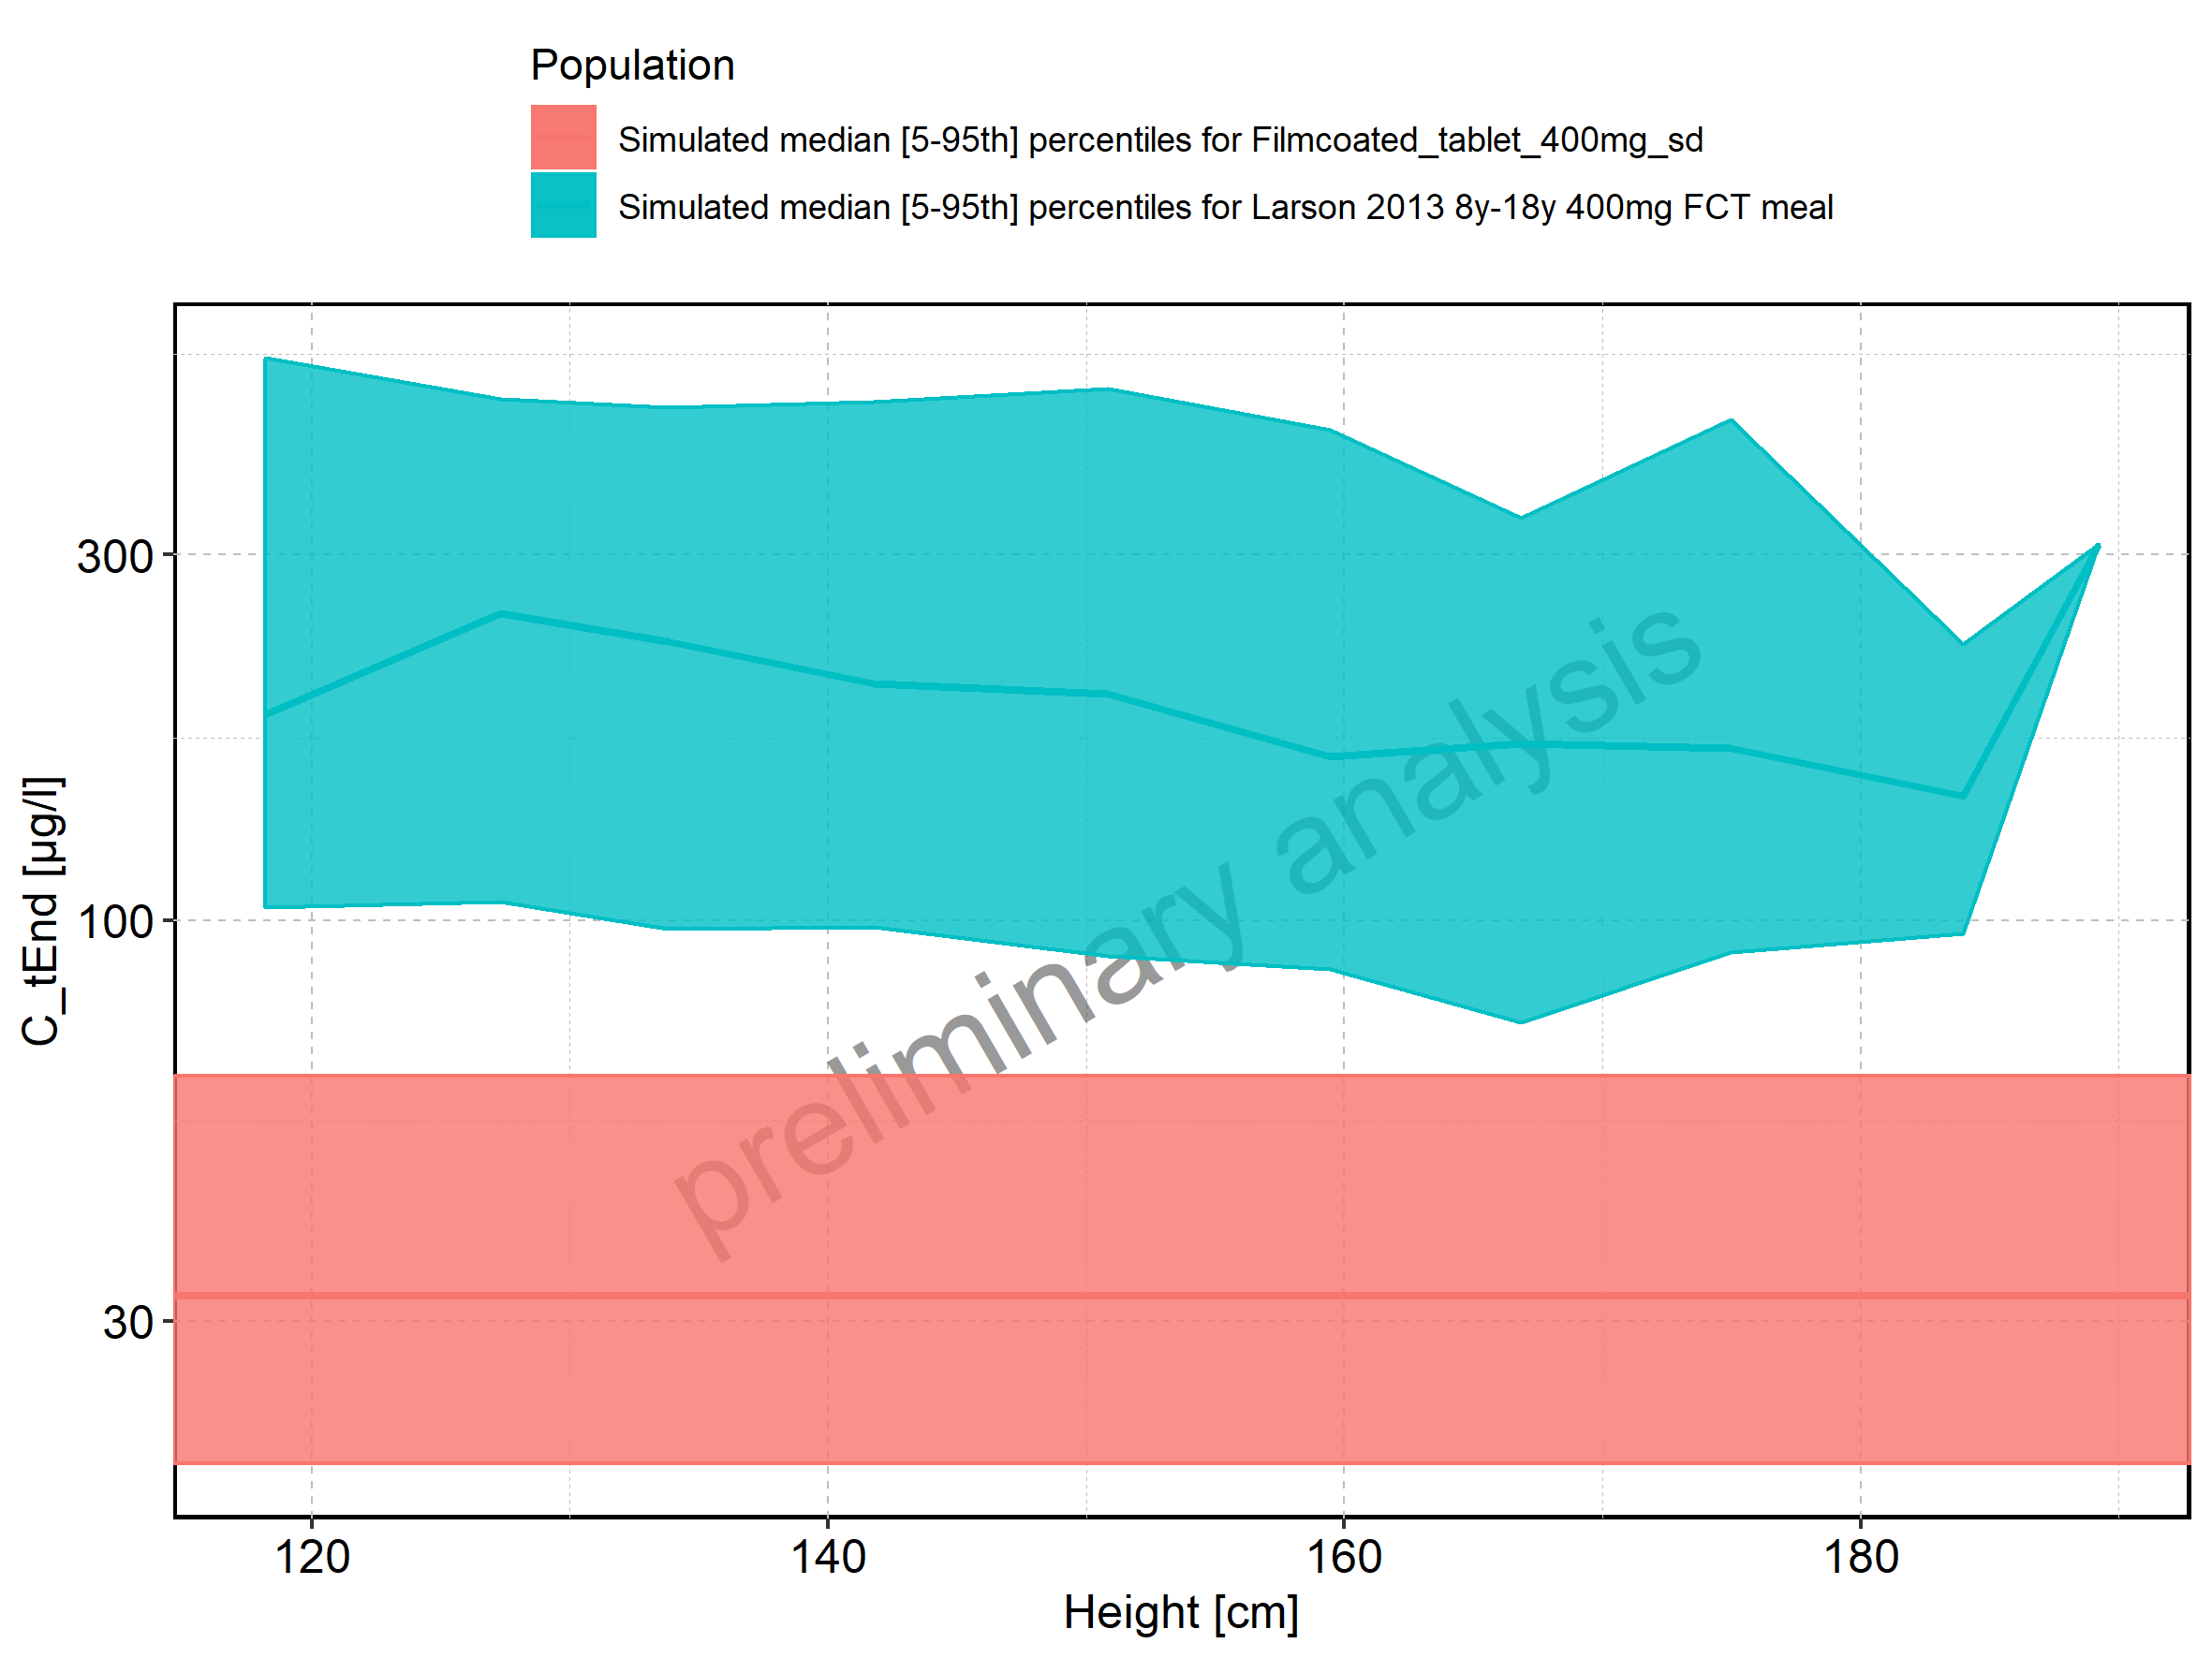

Figure 99: Height-dependence of C_tEnd for Larson 2013 8y-18y 400mg FCT meal. Profiles are plotted in a linear scale.

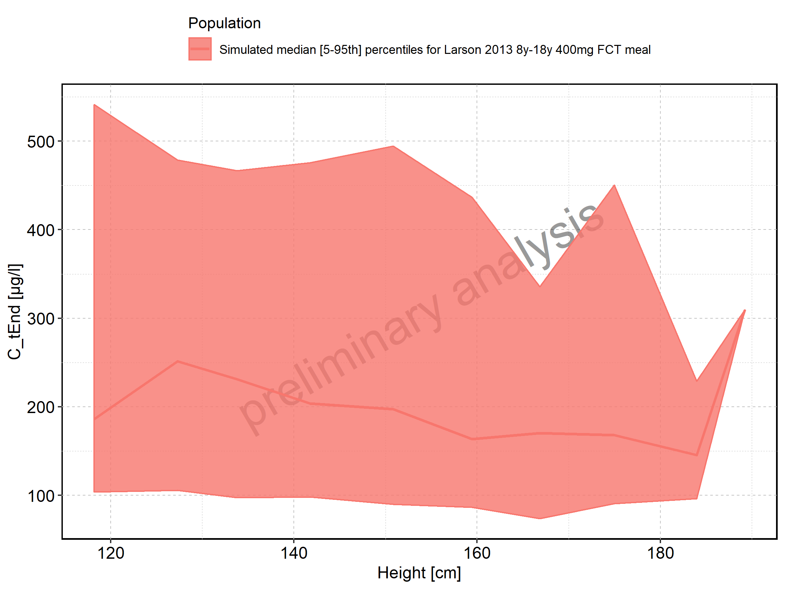

Figure 100: Height-dependence of C_tEnd for Larson 2013 8y-18y 400mg FCT meal. Profiles are plotted in a logarithmic scale.

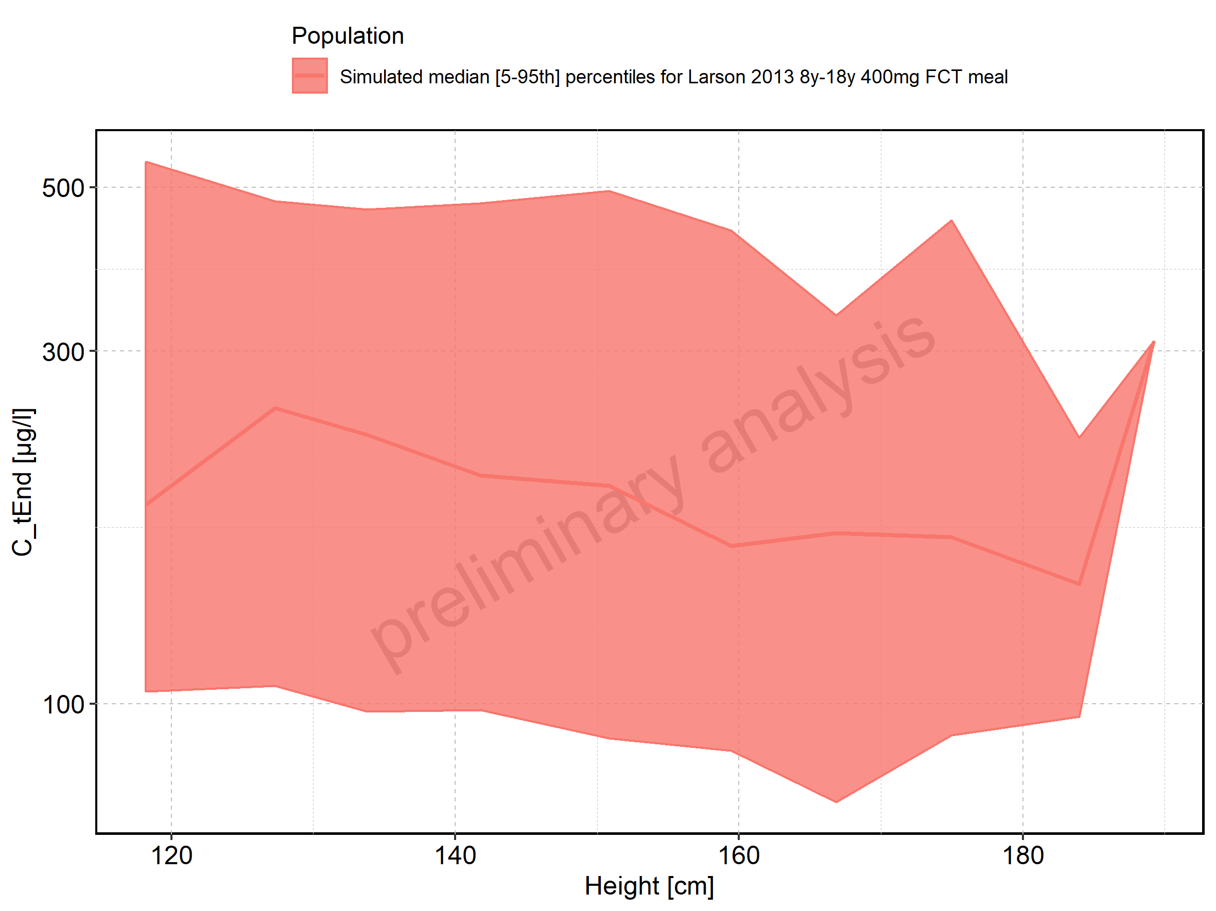

Figure 101: Height-dependence of C_tEnd for Filmcoated_tablet_400mg_sd. Profiles are plotted in a linear scale.

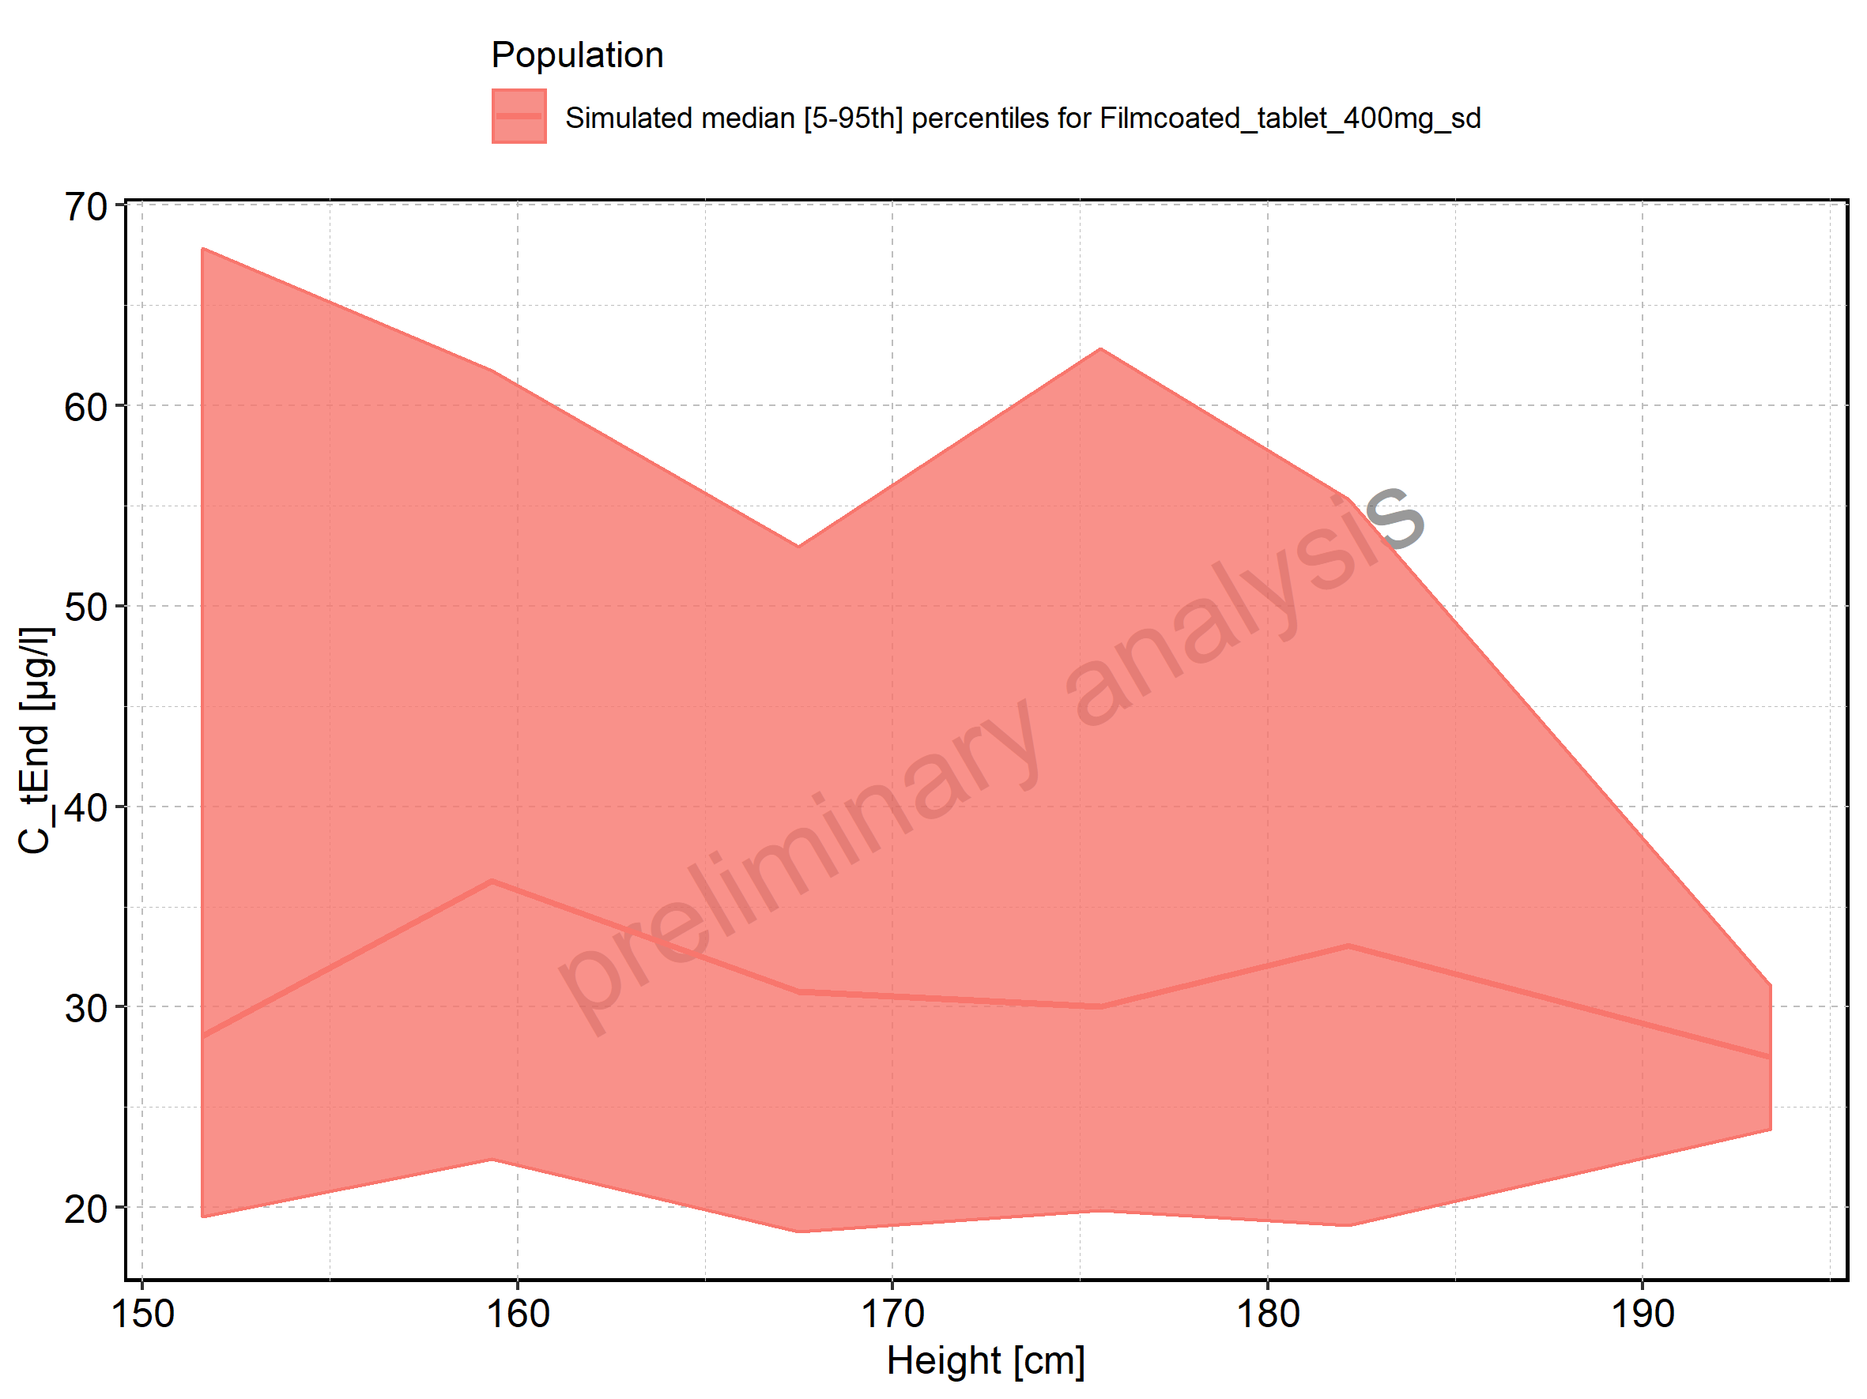

Figure 102: Height-dependence of C_tEnd for Filmcoated_tablet_400mg_sd. Profiles are plotted in a logarithmic scale.

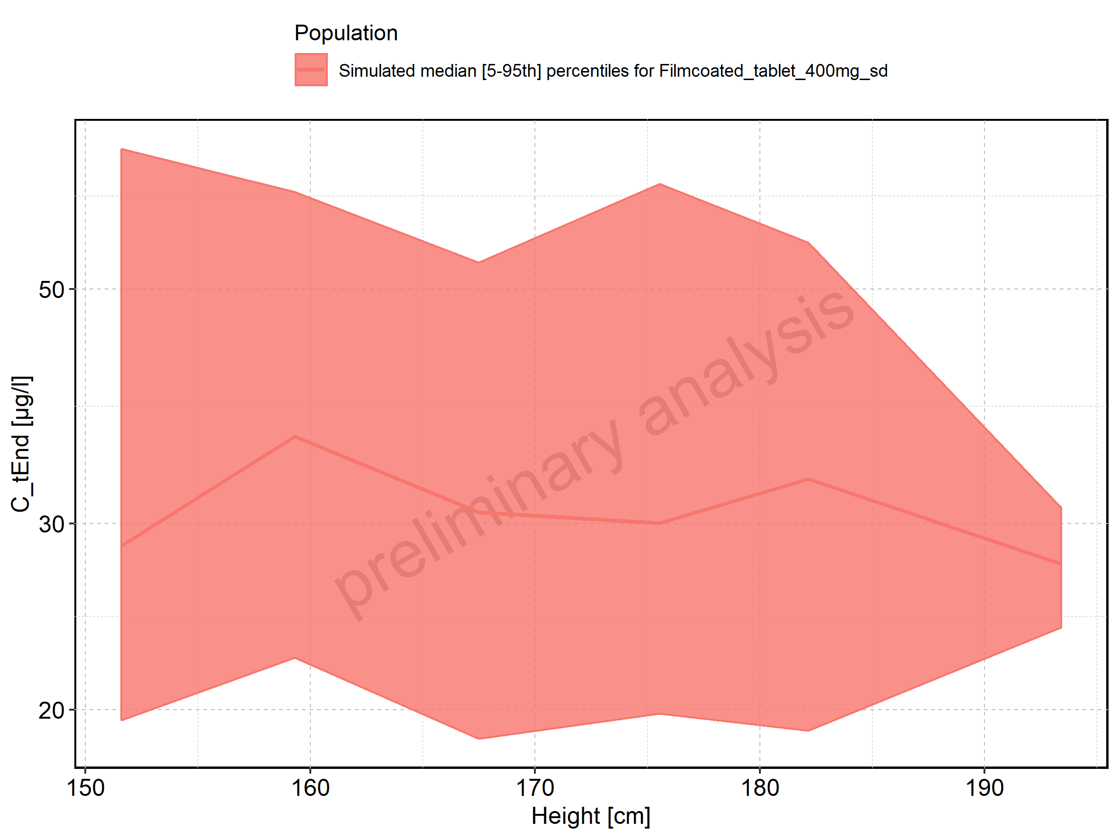

Figure 103: Weight-dependence of C_tEnd for Larson 2013 8y-18y 400mg FCT meal in comparison to Filmcoated_tablet_400mg_sd. Profiles are plotted in a linear scale.

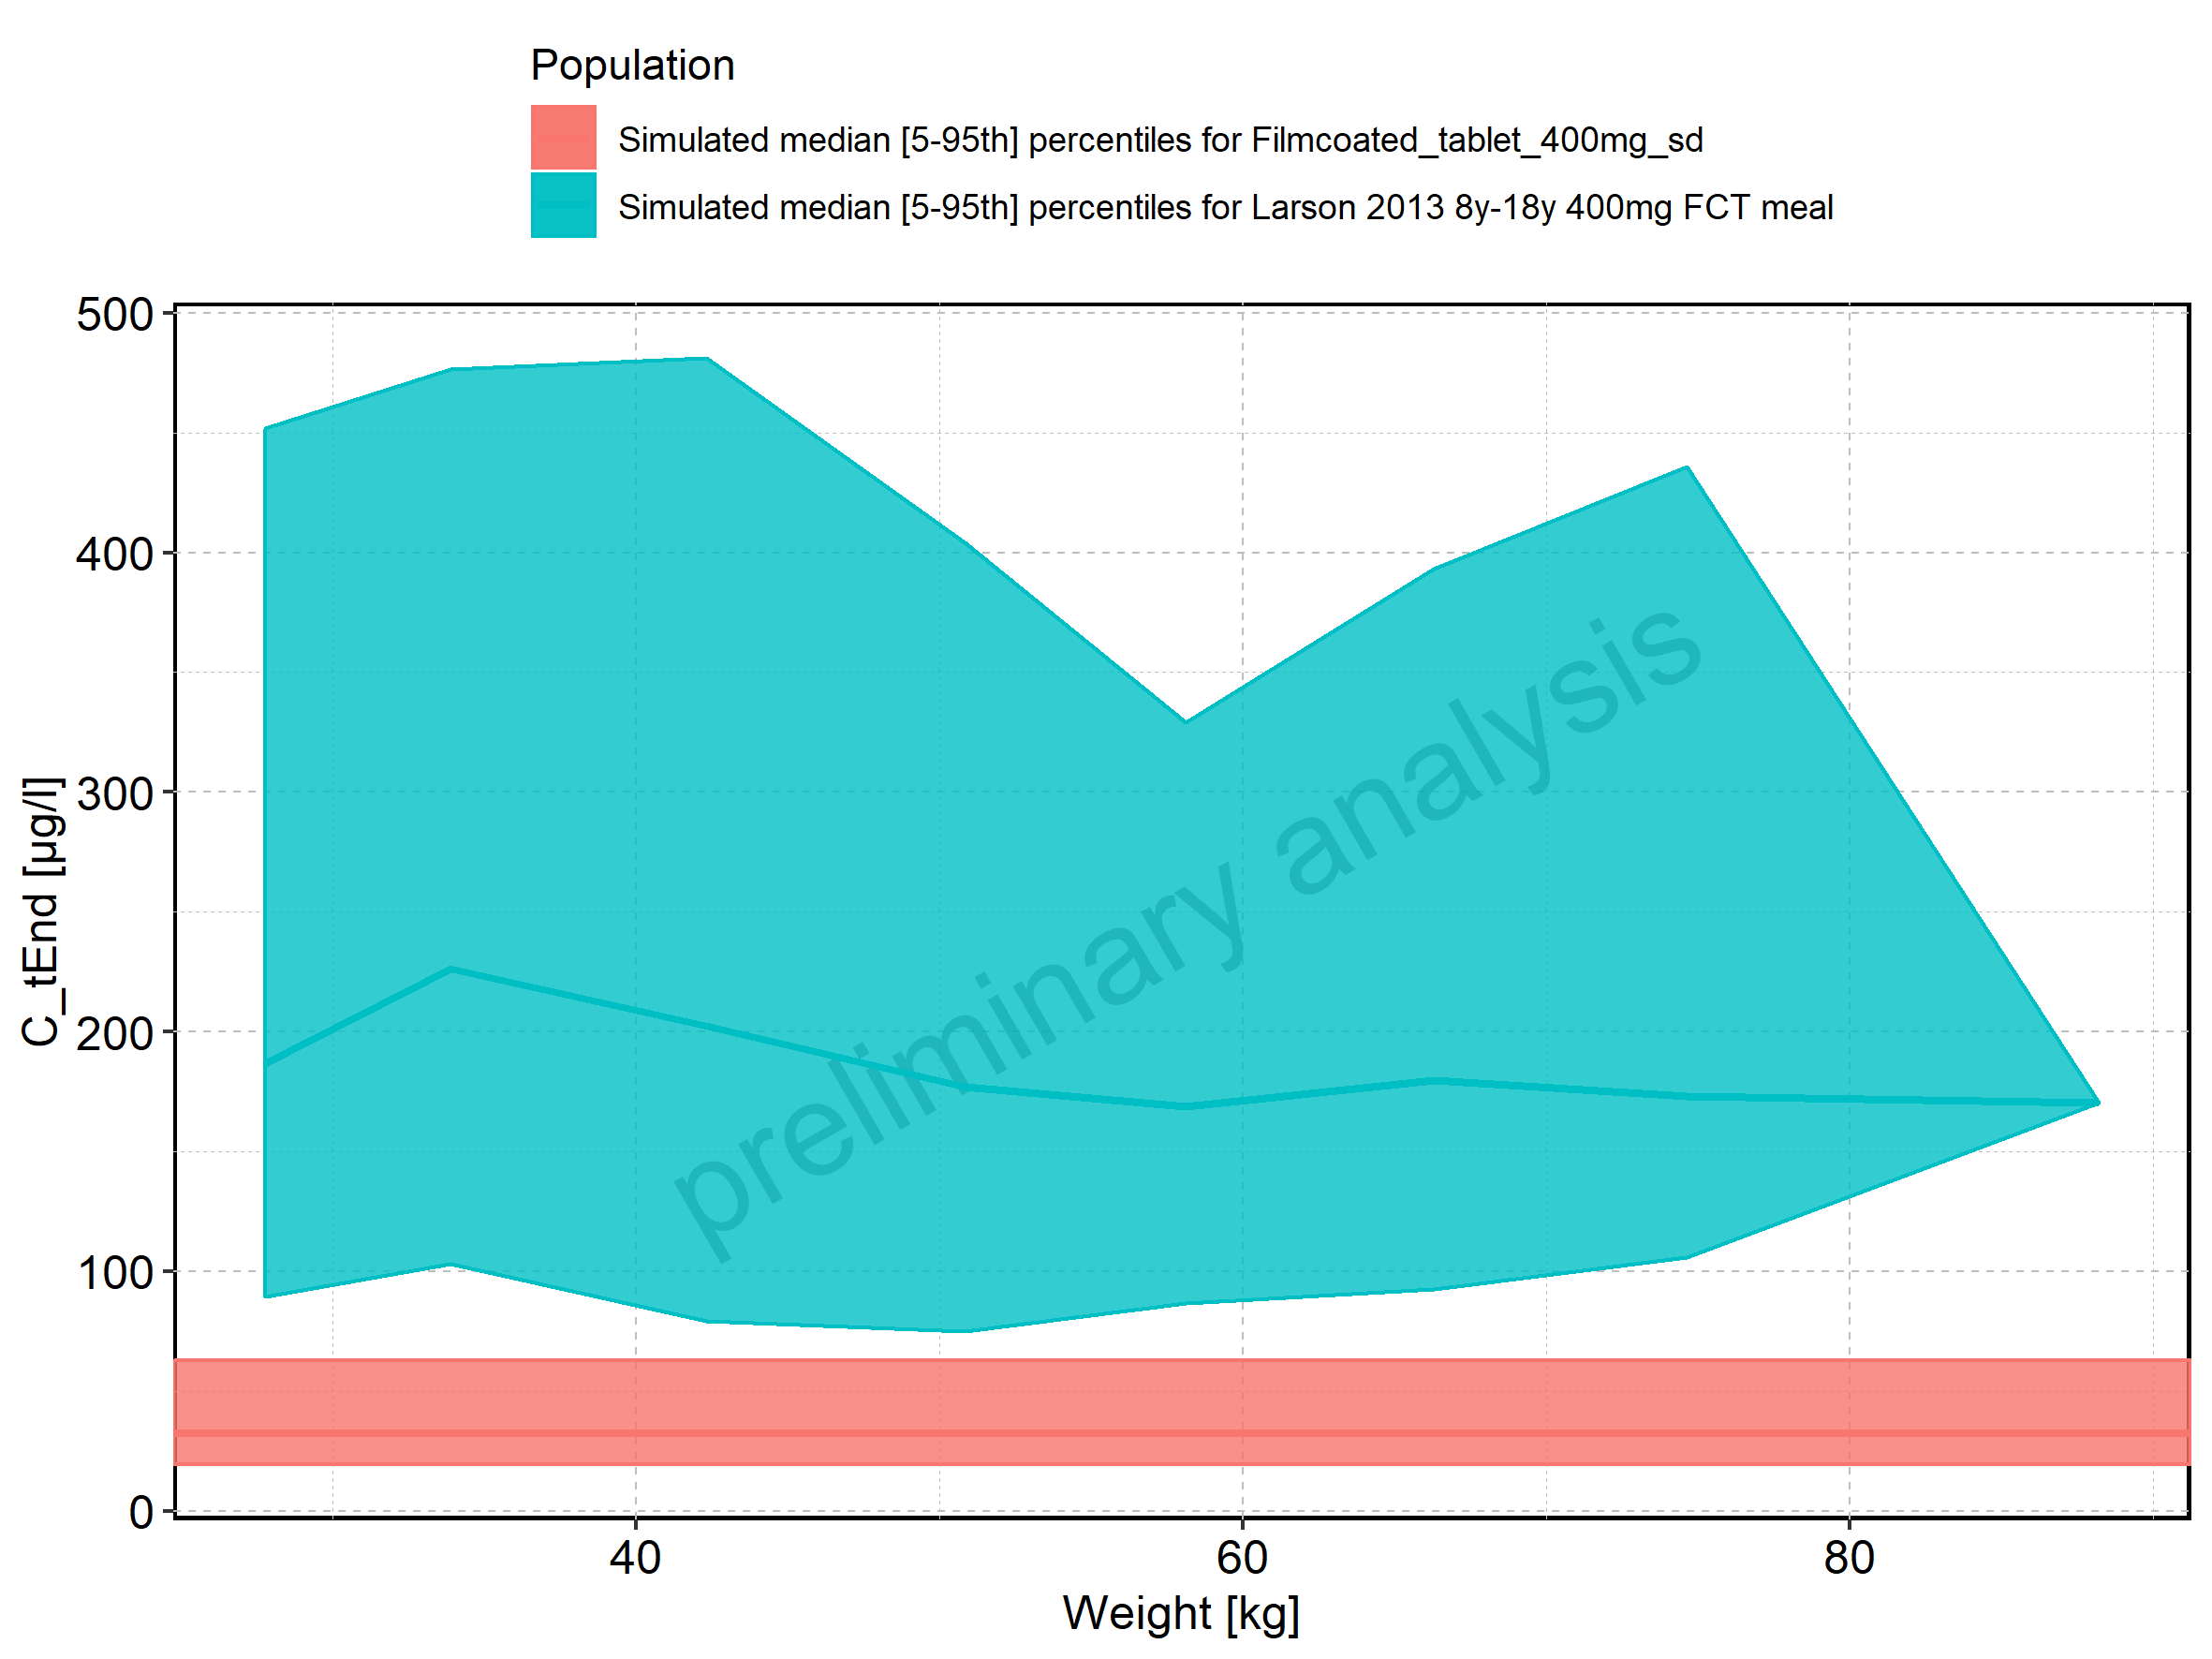

Figure 104: Weight-dependence of C_tEnd for Larson 2013 8y-18y 400mg FCT meal in comparison to Filmcoated_tablet_400mg_sd. Profiles are plotted in a logarithmic scale.

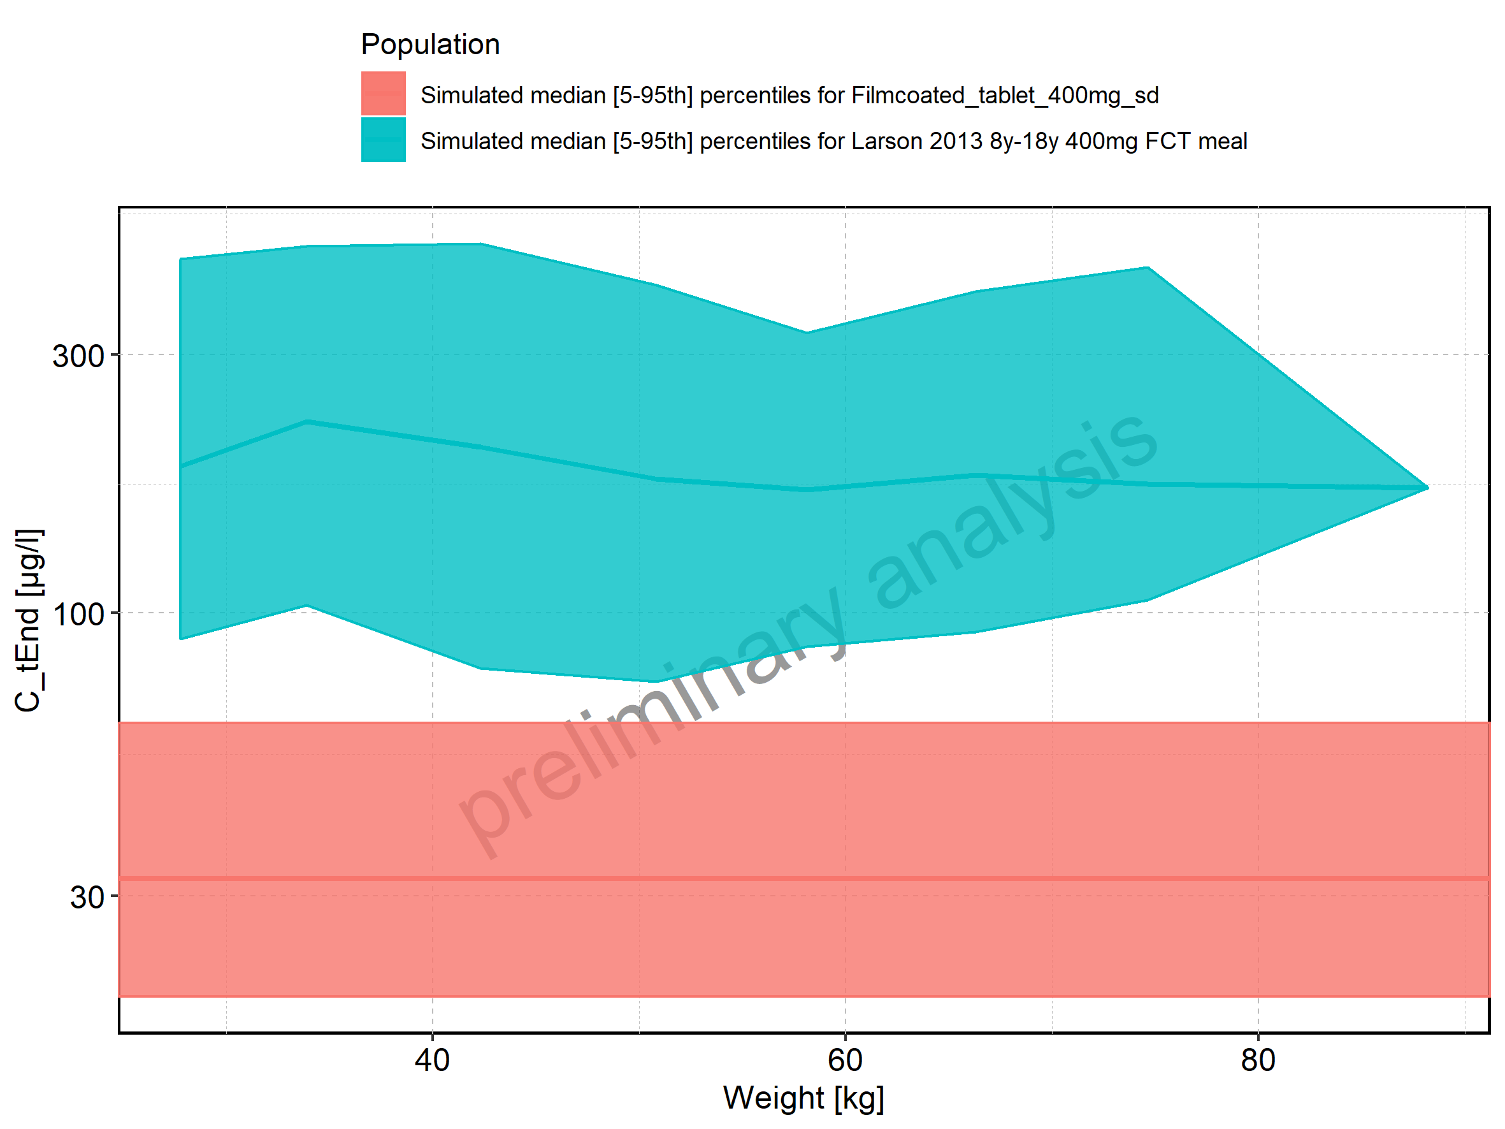

Figure 105: Weight-dependence of C_tEnd for Larson 2013 8y-18y 400mg FCT meal. Profiles are plotted in a linear scale.

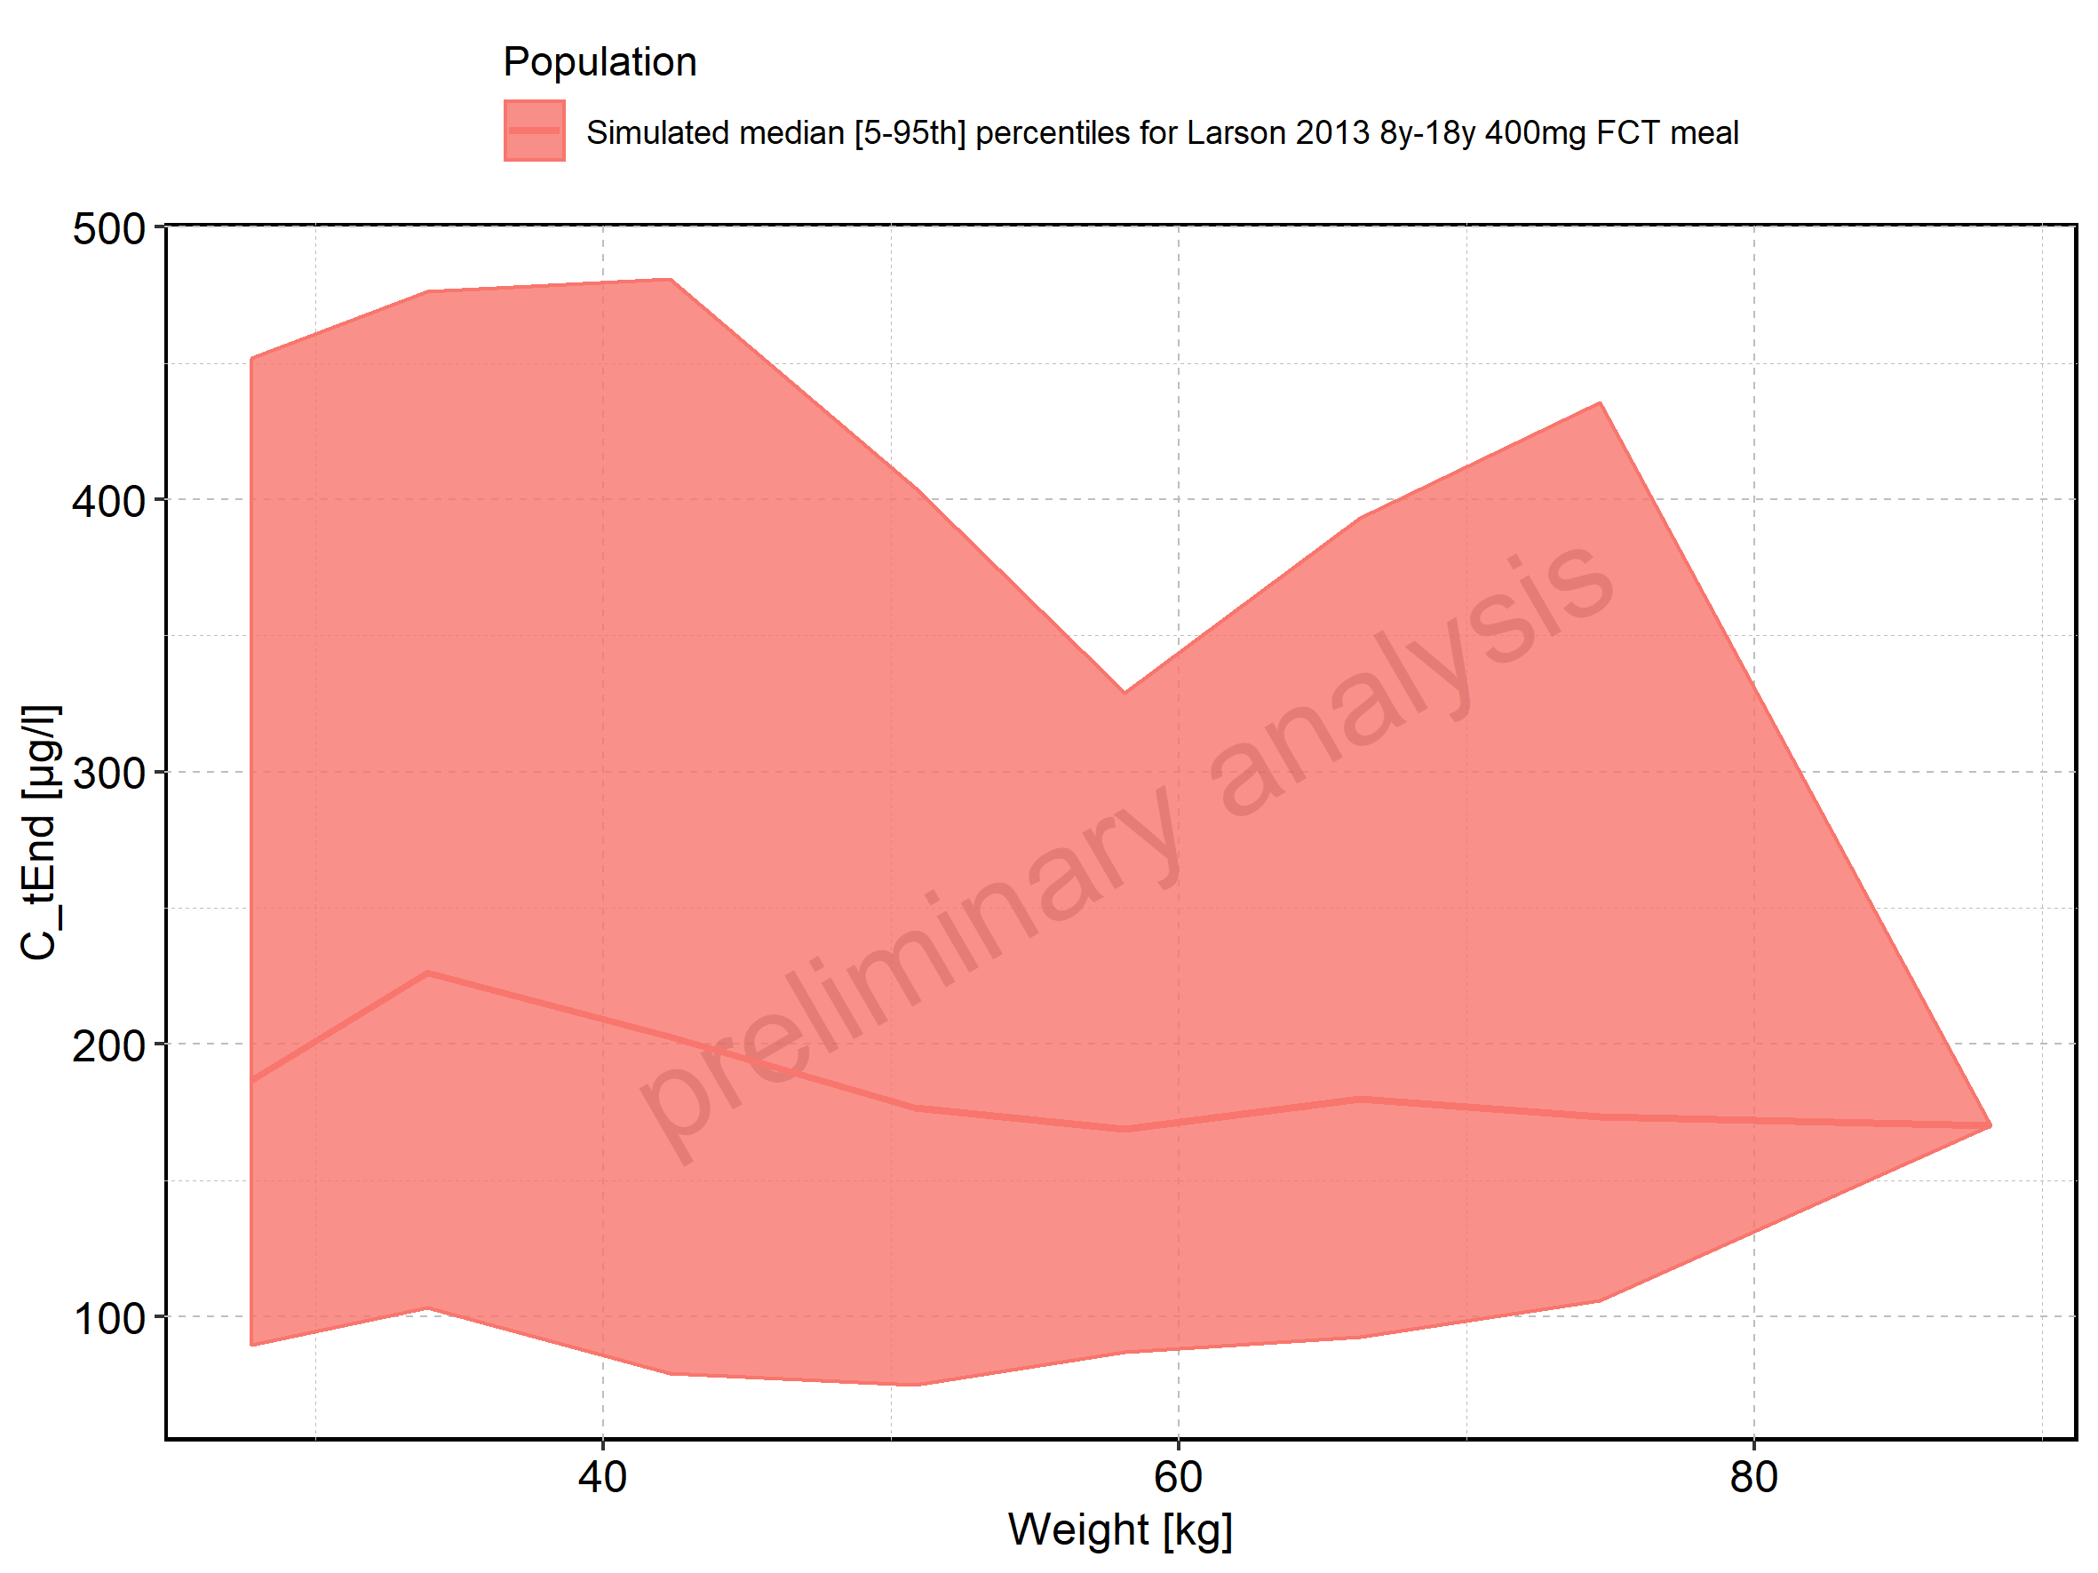

Figure 106: Weight-dependence of C_tEnd for Larson 2013 8y-18y 400mg FCT meal. Profiles are plotted in a logarithmic scale.

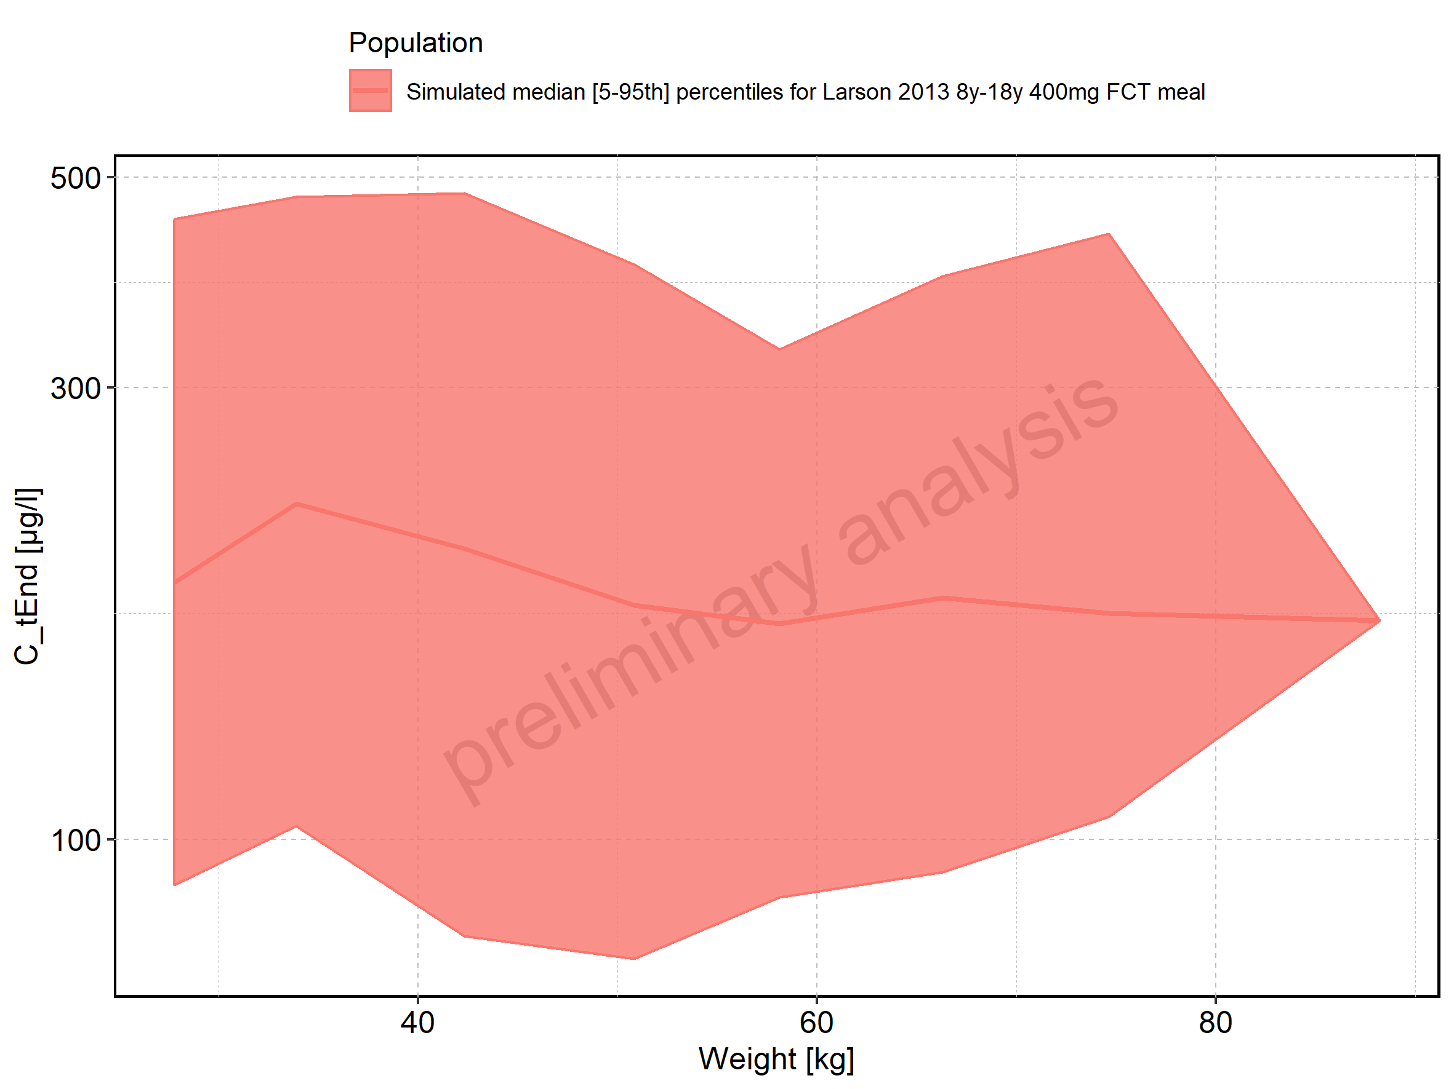

Figure 107: Weight-dependence of C_tEnd for Filmcoated_tablet_400mg_sd. Profiles are plotted in a linear scale.

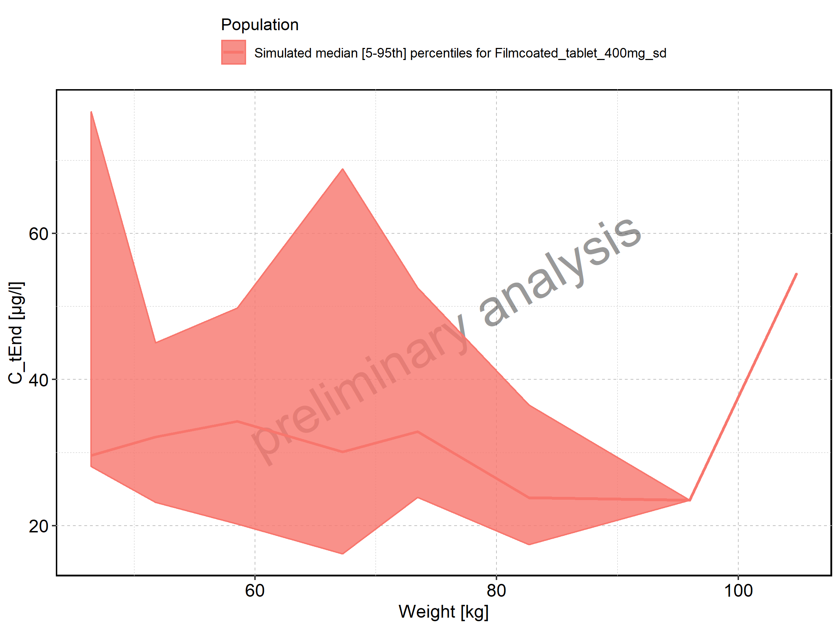

Figure 108: Weight-dependence of C_tEnd for Filmcoated_tablet_400mg_sd. Profiles are plotted in a logarithmic scale.

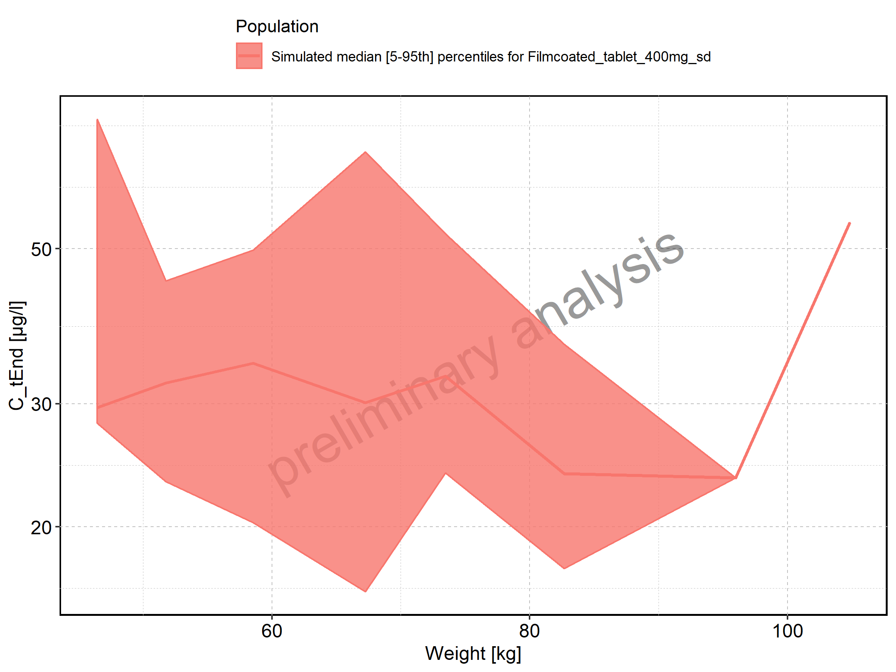

Figure 109: BMI-dependence of C_tEnd for Larson 2013 8y-18y 400mg FCT meal in comparison to Filmcoated_tablet_400mg_sd. Profiles are plotted in a linear scale.

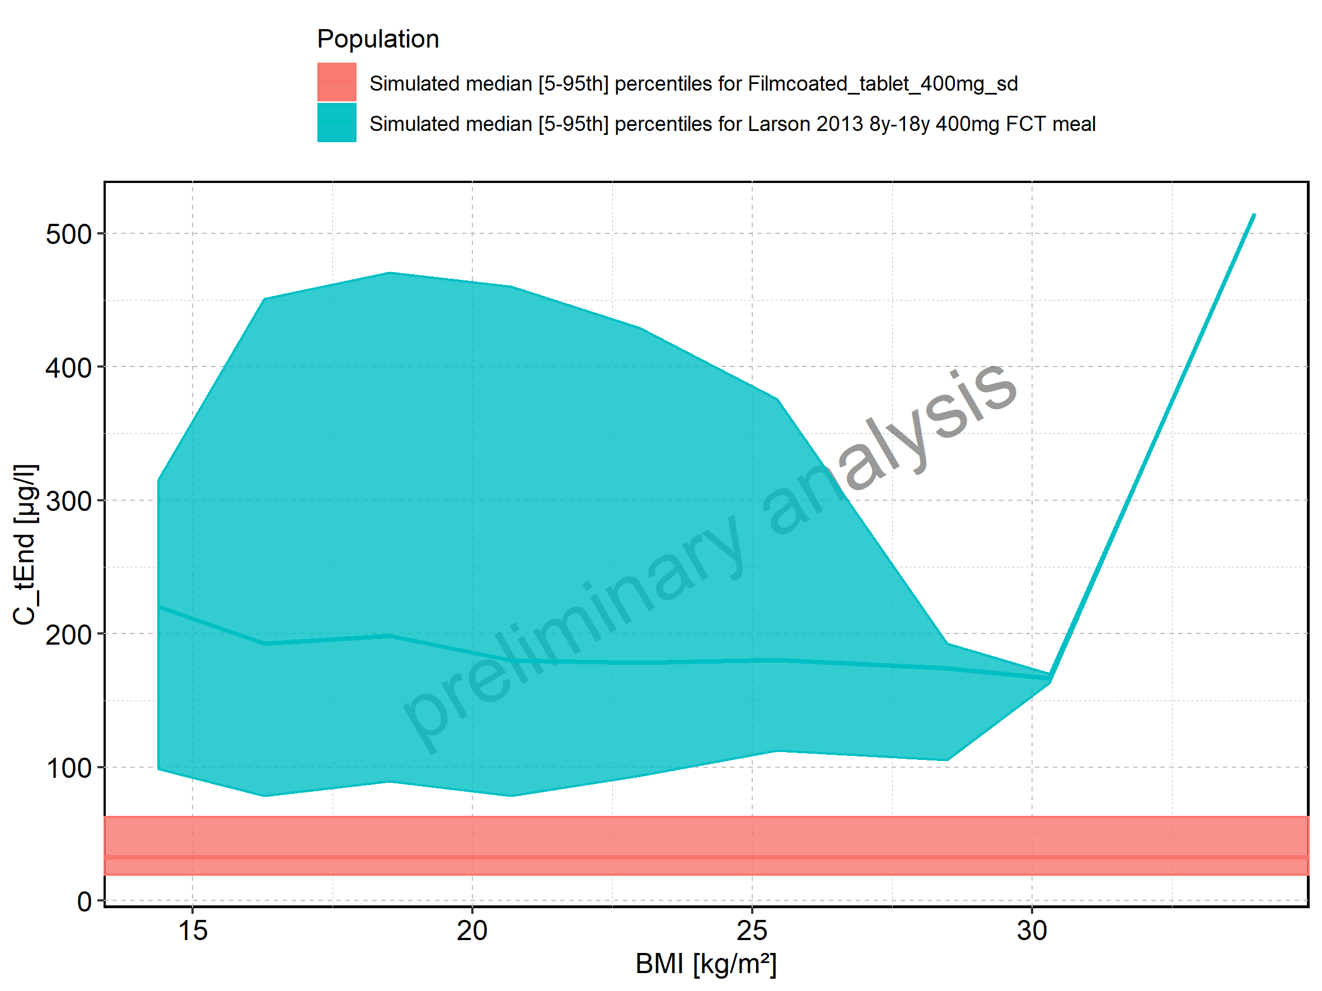

Figure 110: BMI-dependence of C_tEnd for Larson 2013 8y-18y 400mg FCT meal in comparison to Filmcoated_tablet_400mg_sd. Profiles are plotted in a logarithmic scale.

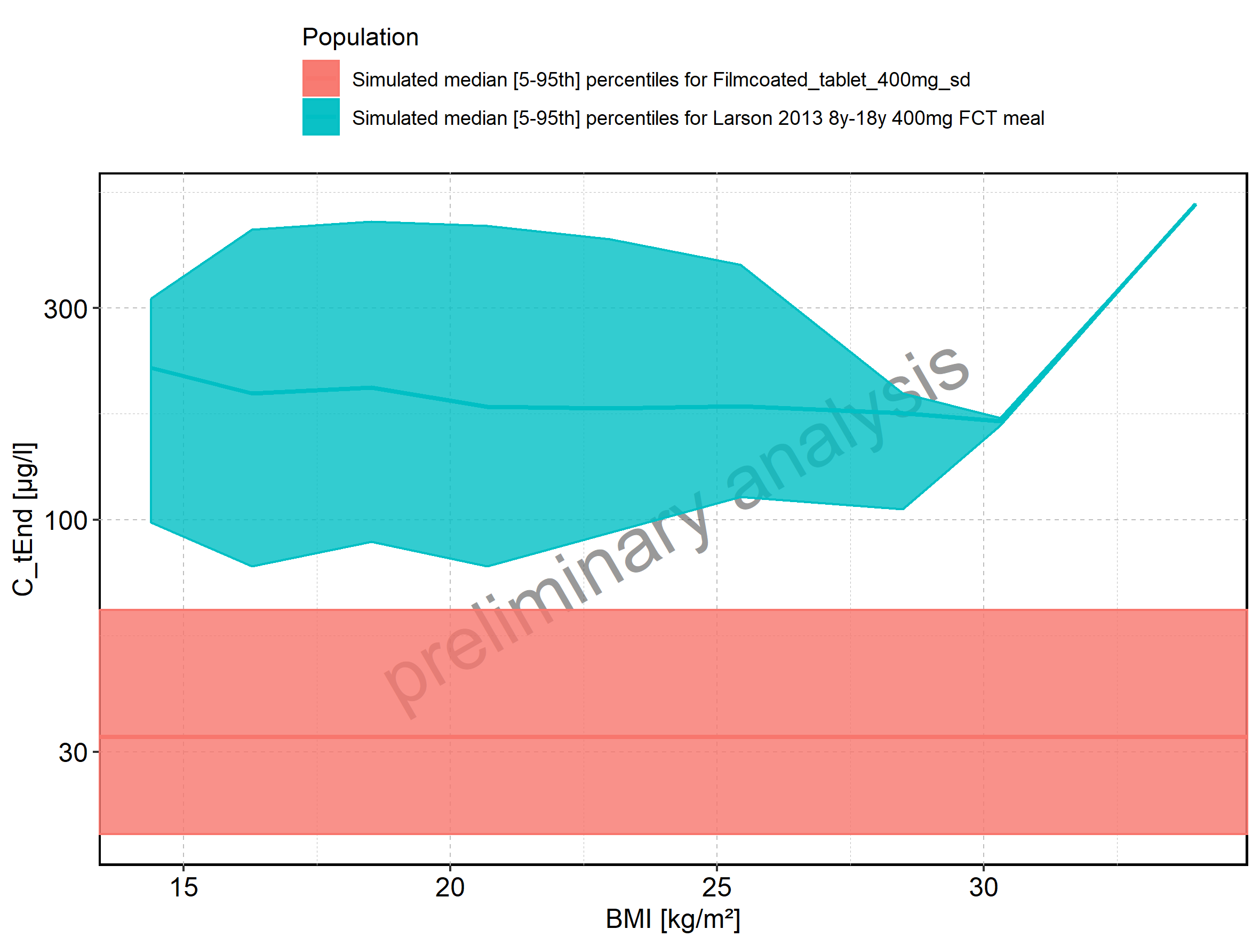

Figure 111: BMI-dependence of C_tEnd for Larson 2013 8y-18y 400mg FCT meal. Profiles are plotted in a linear scale.

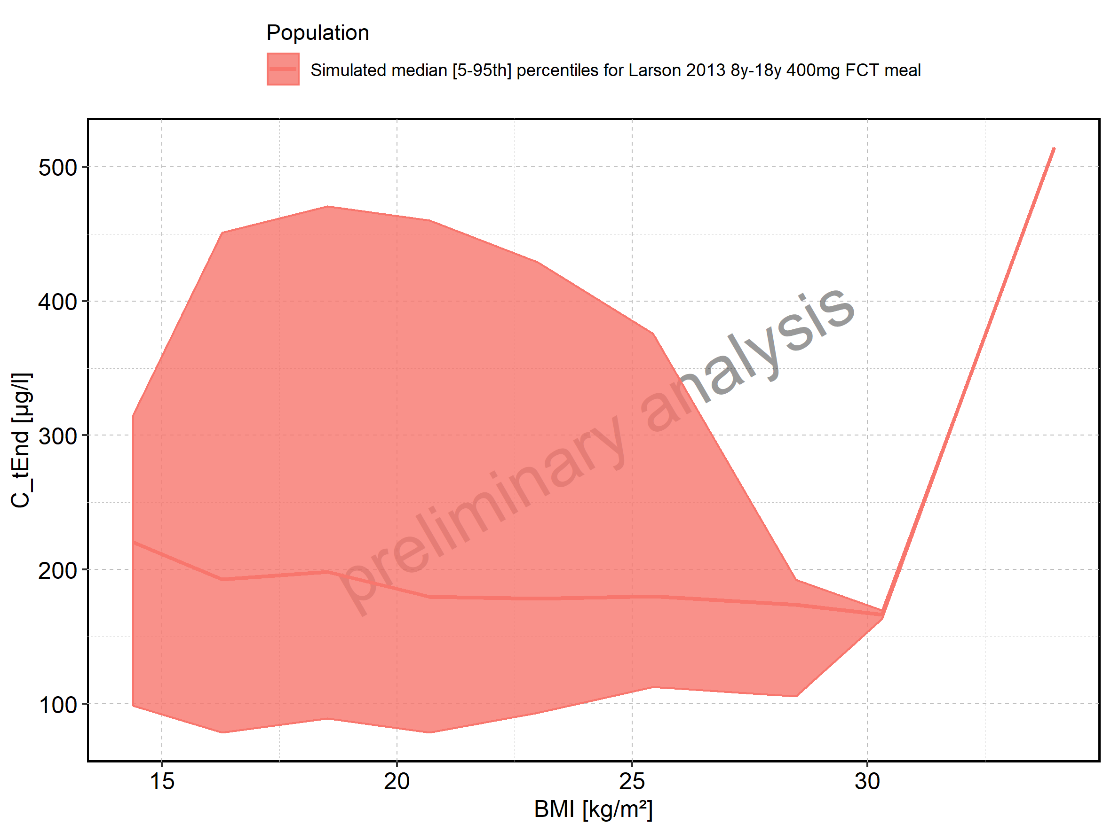

Figure 112: BMI-dependence of C_tEnd for Larson 2013 8y-18y 400mg FCT meal. Profiles are plotted in a logarithmic scale.

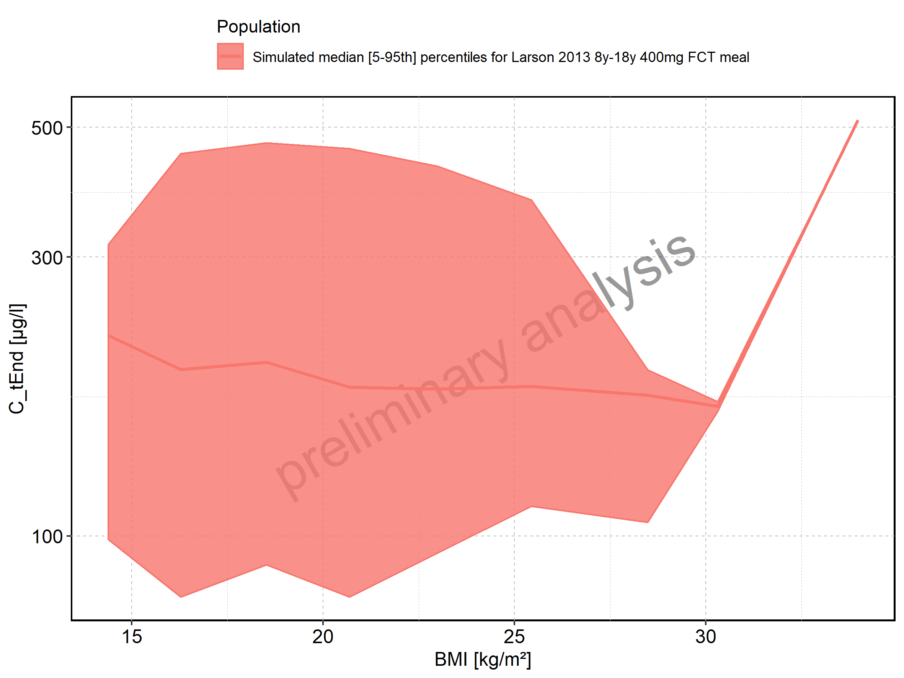

Figure 113: BMI-dependence of C_tEnd for Filmcoated_tablet_400mg_sd. Profiles are plotted in a linear scale.

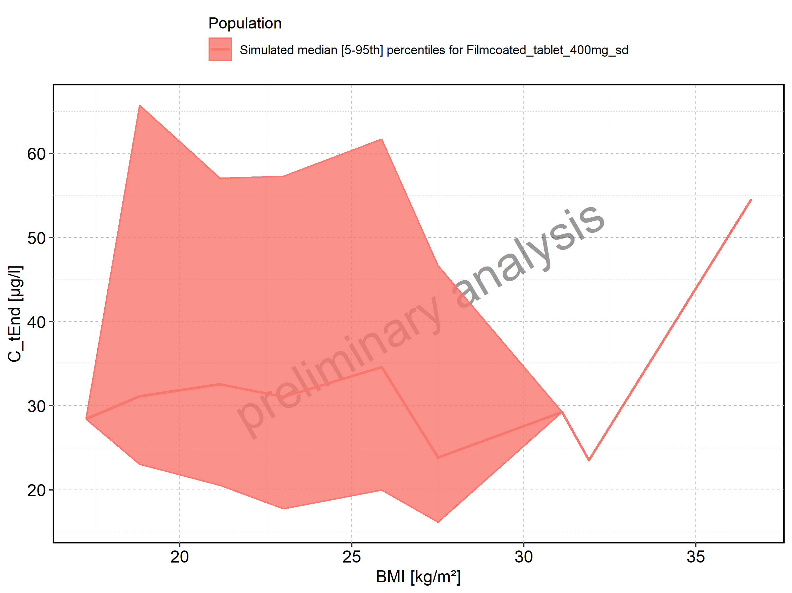

Figure 114: BMI-dependence of C_tEnd for Filmcoated_tablet_400mg_sd. Profiles are plotted in a logarithmic scale.

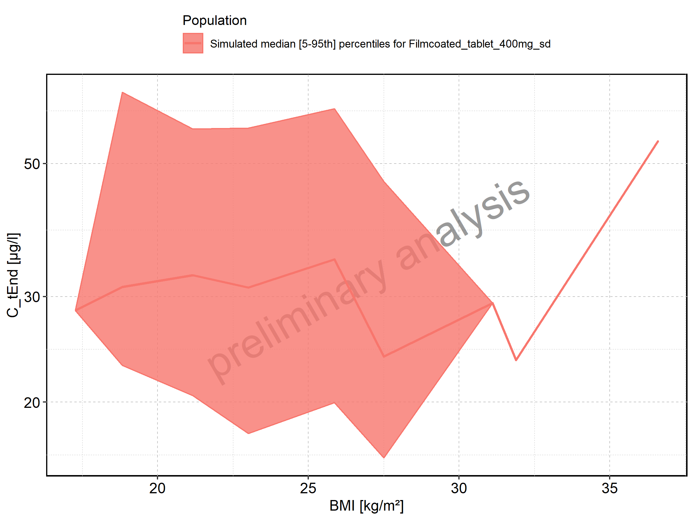

Figure 115: AUC of Raltegravir shown as box-whisker plot, which indicates the 5th, 25th, 50th, 75th, and 95th percentiles in linear scale.

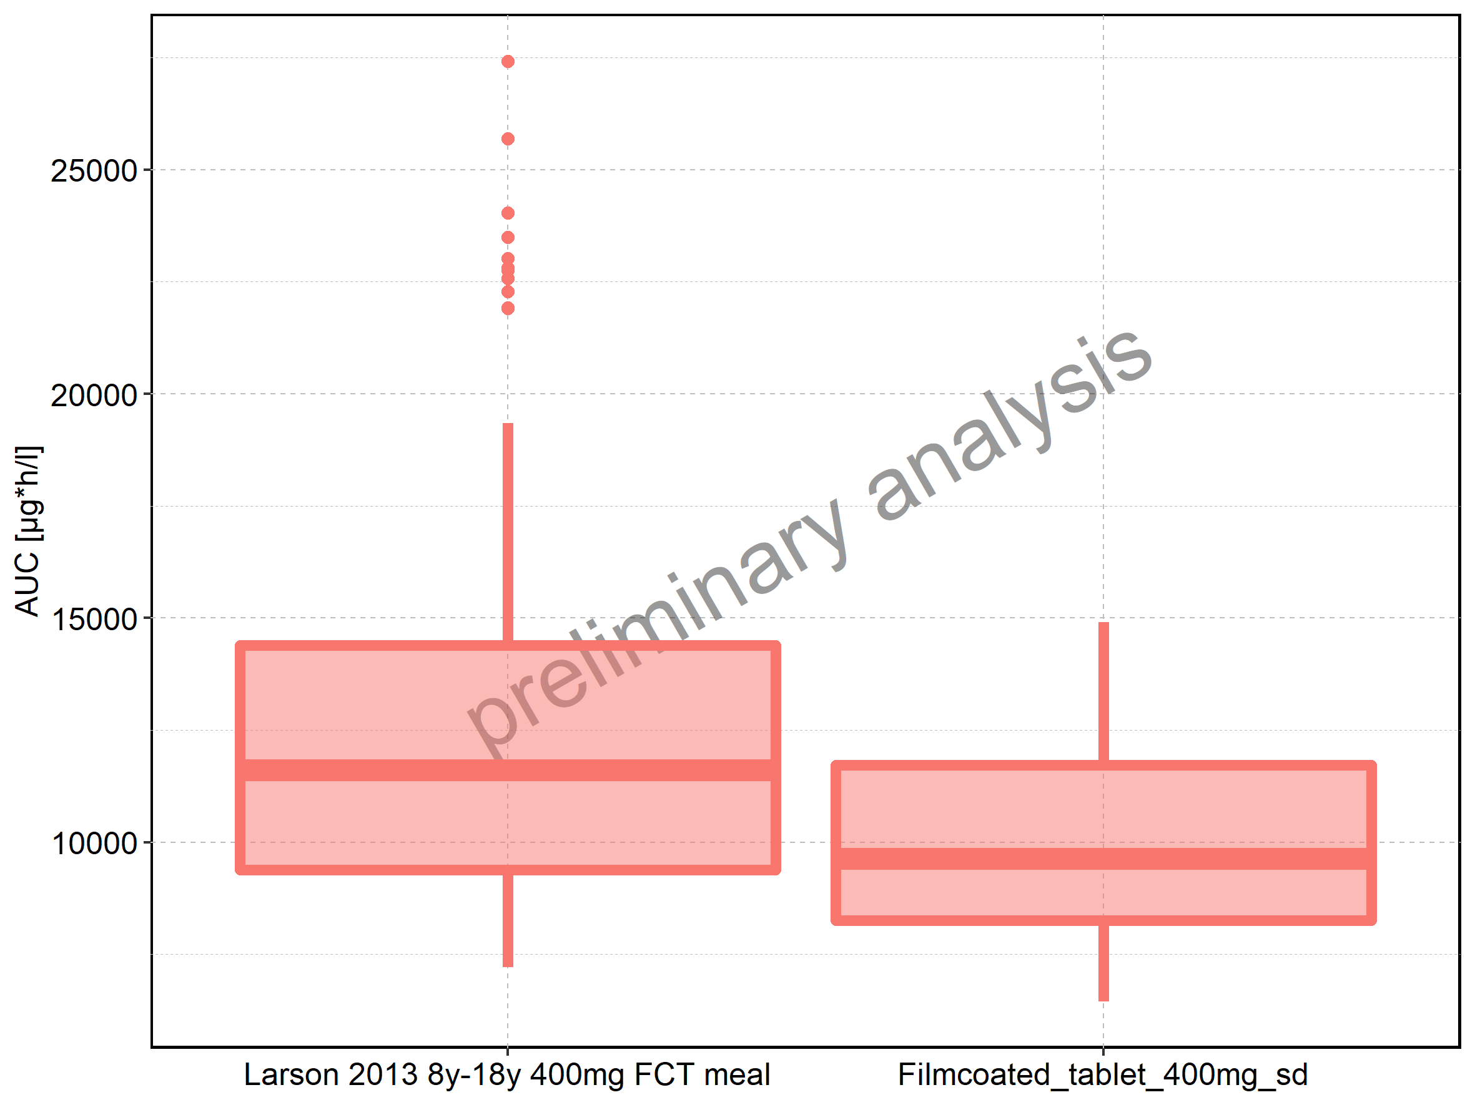

|  |  |  |  |  |  |  |  |  |  |  |
| --- | --- | --- | --- | --- | --- | --- | --- | --- | --- | --- |
| Population | N | 5th percentile | 25th percentile | 50th percentile | 75th percentile | 95th percentile | mean | standard deviation | geo mean | geo standard deviation |
| Larson 2013 8y-18y 400mg FCT meal | 500 | 7207.278 | 9378.917 | 11615.203 | 14388.95 | 19343.09 | 12199.86 | 3756.553 | 11656.084 | 1.353277 |
| Filmcoated_tablet_400mg_sd | 100 | 6449.274 | 8248.740 | 9637.507 | 11717.01 | 14901.11 | 10129.70 | 2672.292 | 9784.558 | 1.305605 |

Figure 116: AUC of Raltegravir shown as box-whisker plot, which indicates the 5th, 25th, 50th, 75th, and 95th percentiles in logarithmic scale.

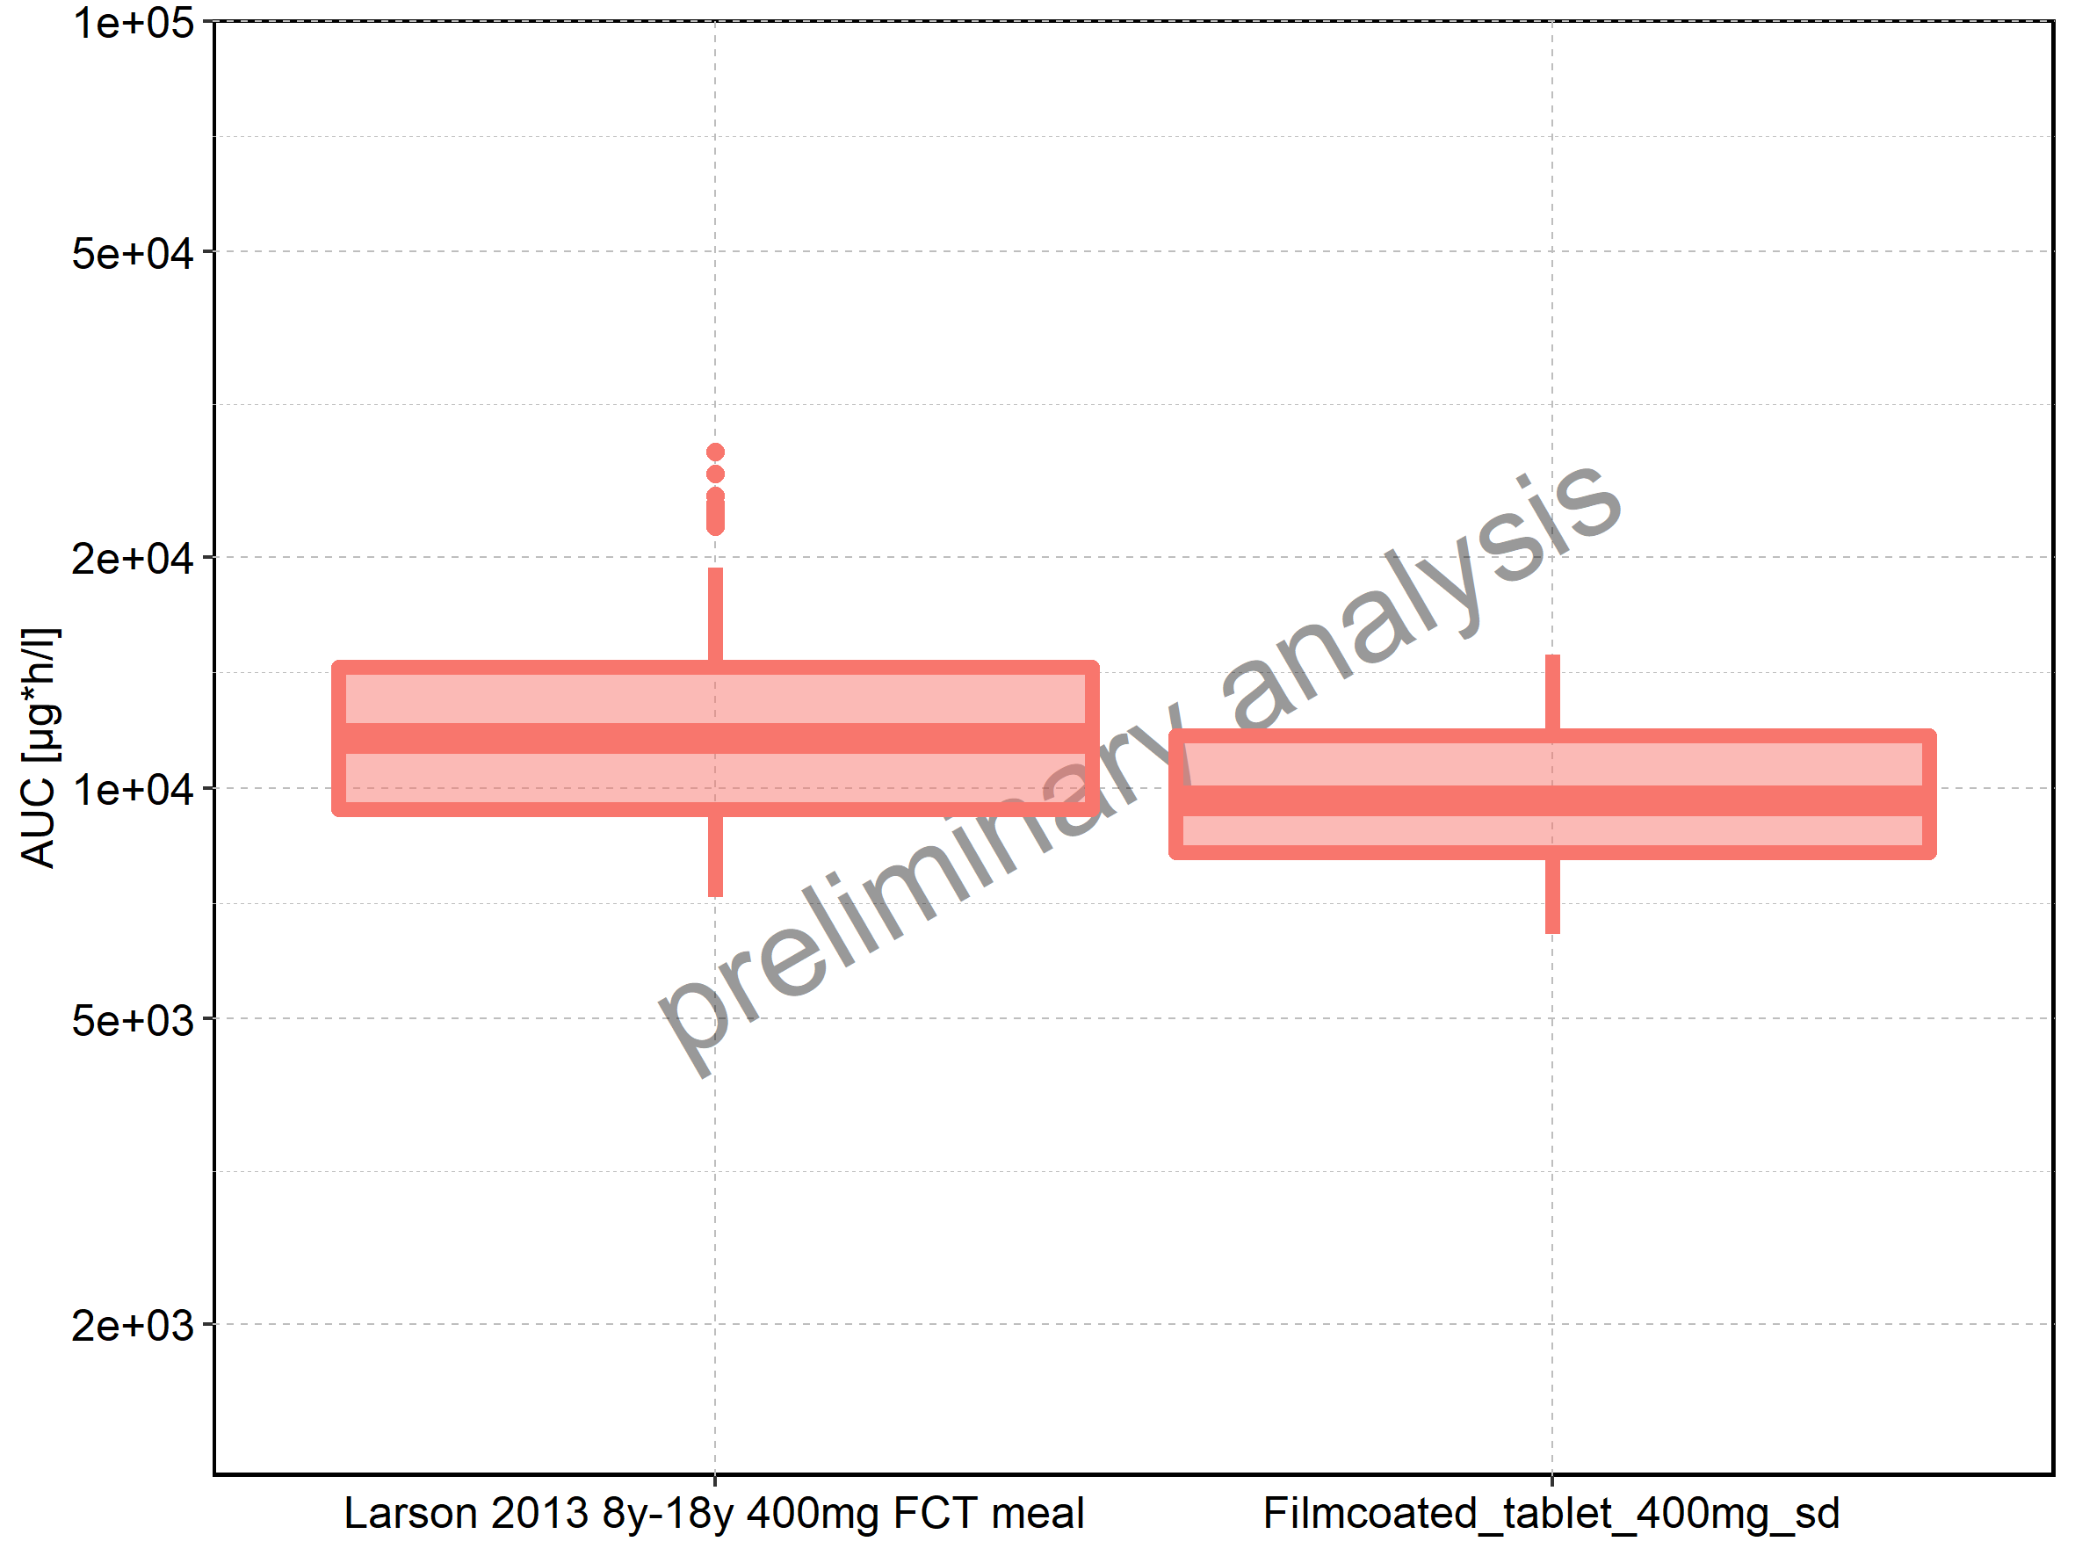

Figure 117: Age-dependence of AUC for Larson 2013 8y-18y 400mg FCT meal in comparison to Filmcoated_tablet_400mg_sd. Profiles are plotted in a linear scale.

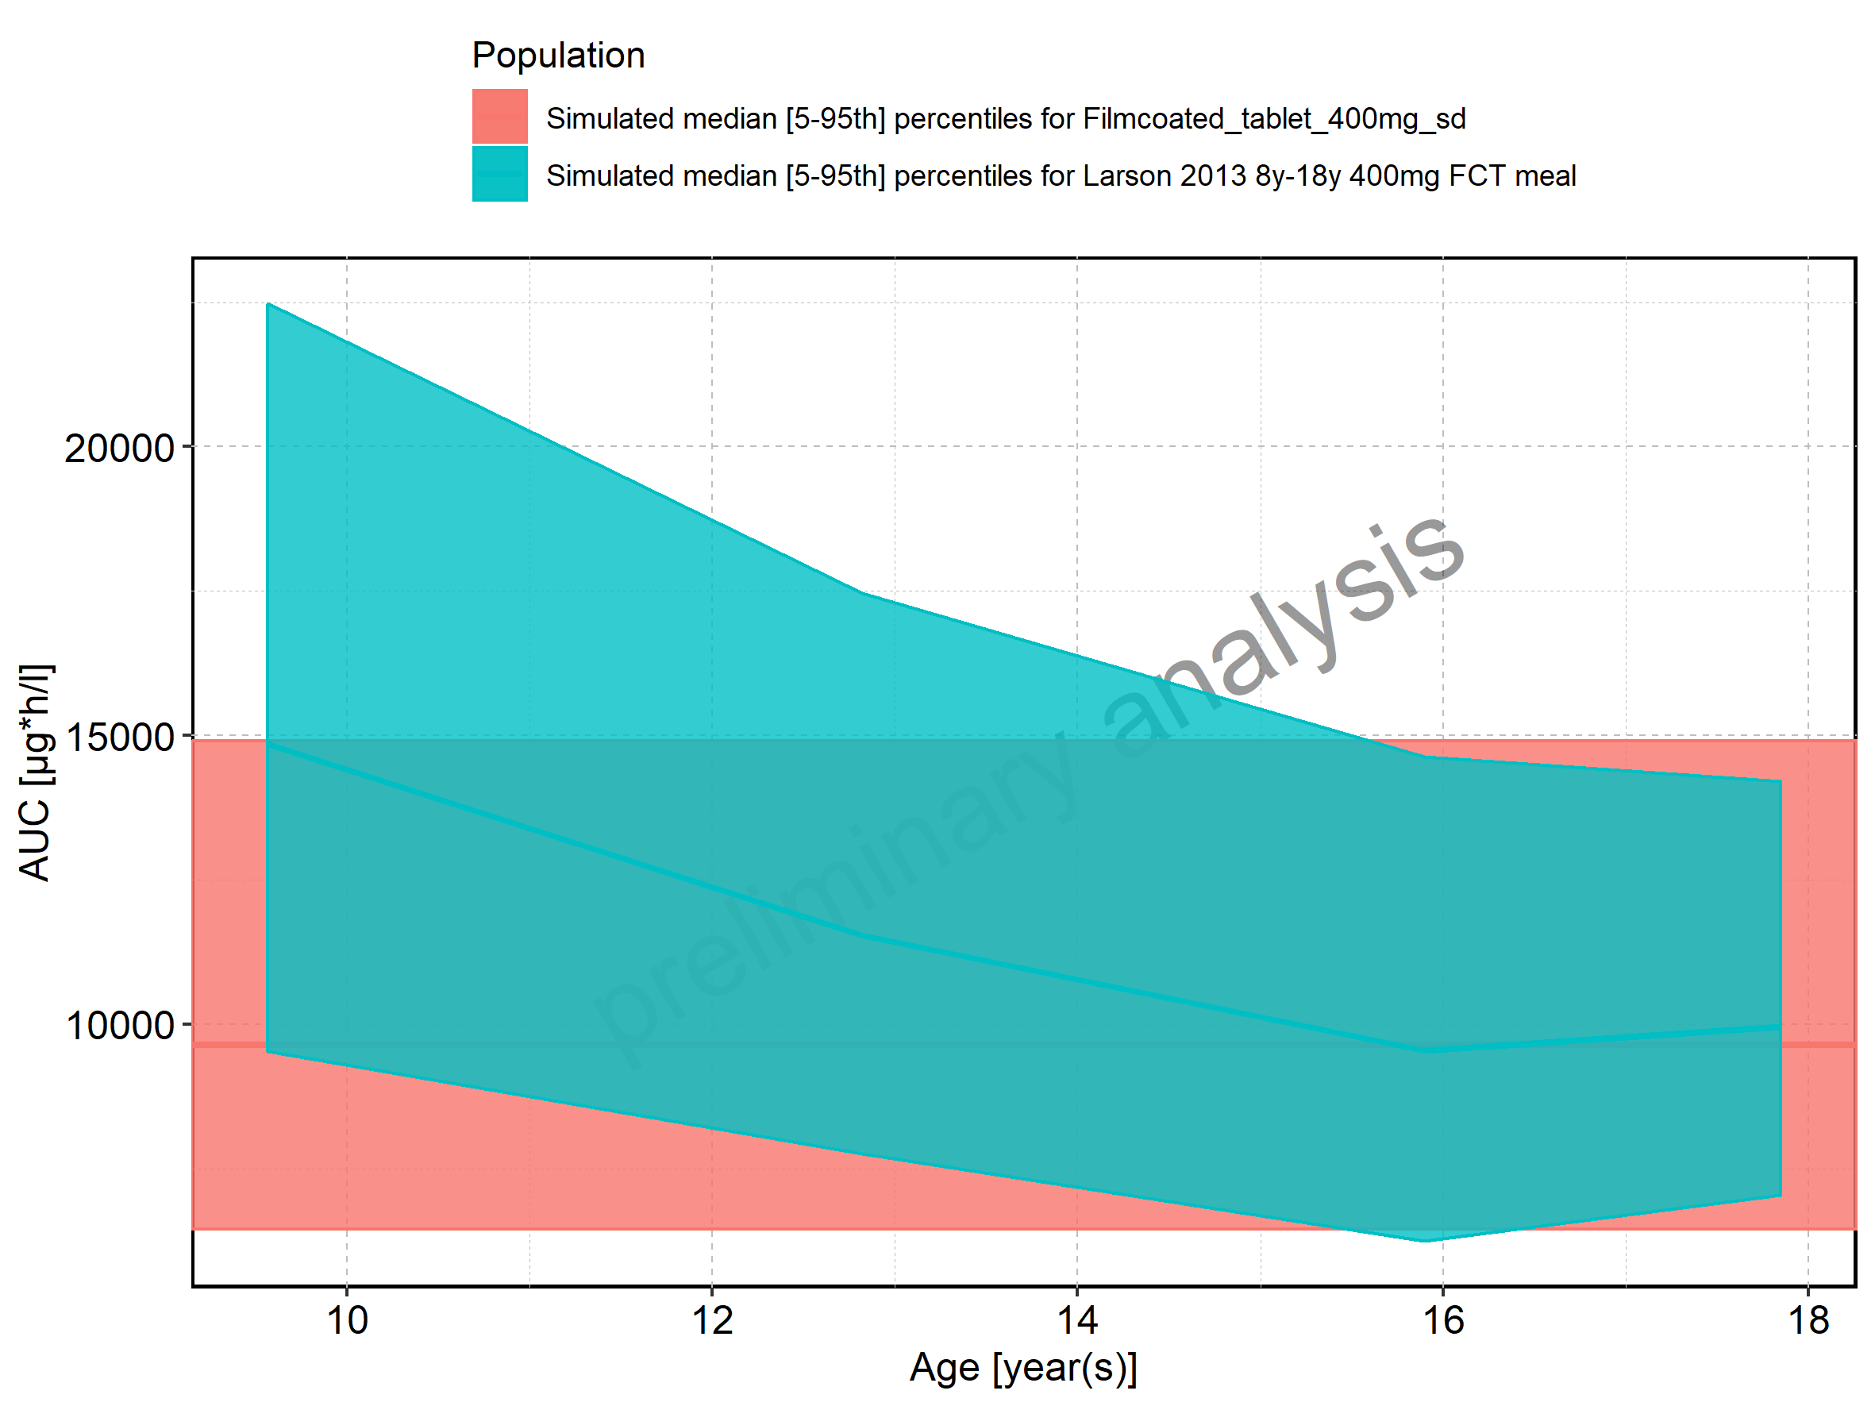

Figure 118: Age-dependence of AUC for Larson 2013 8y-18y 400mg FCT meal in comparison to Filmcoated_tablet_400mg_sd. Profiles are plotted in a logarithmic scale.

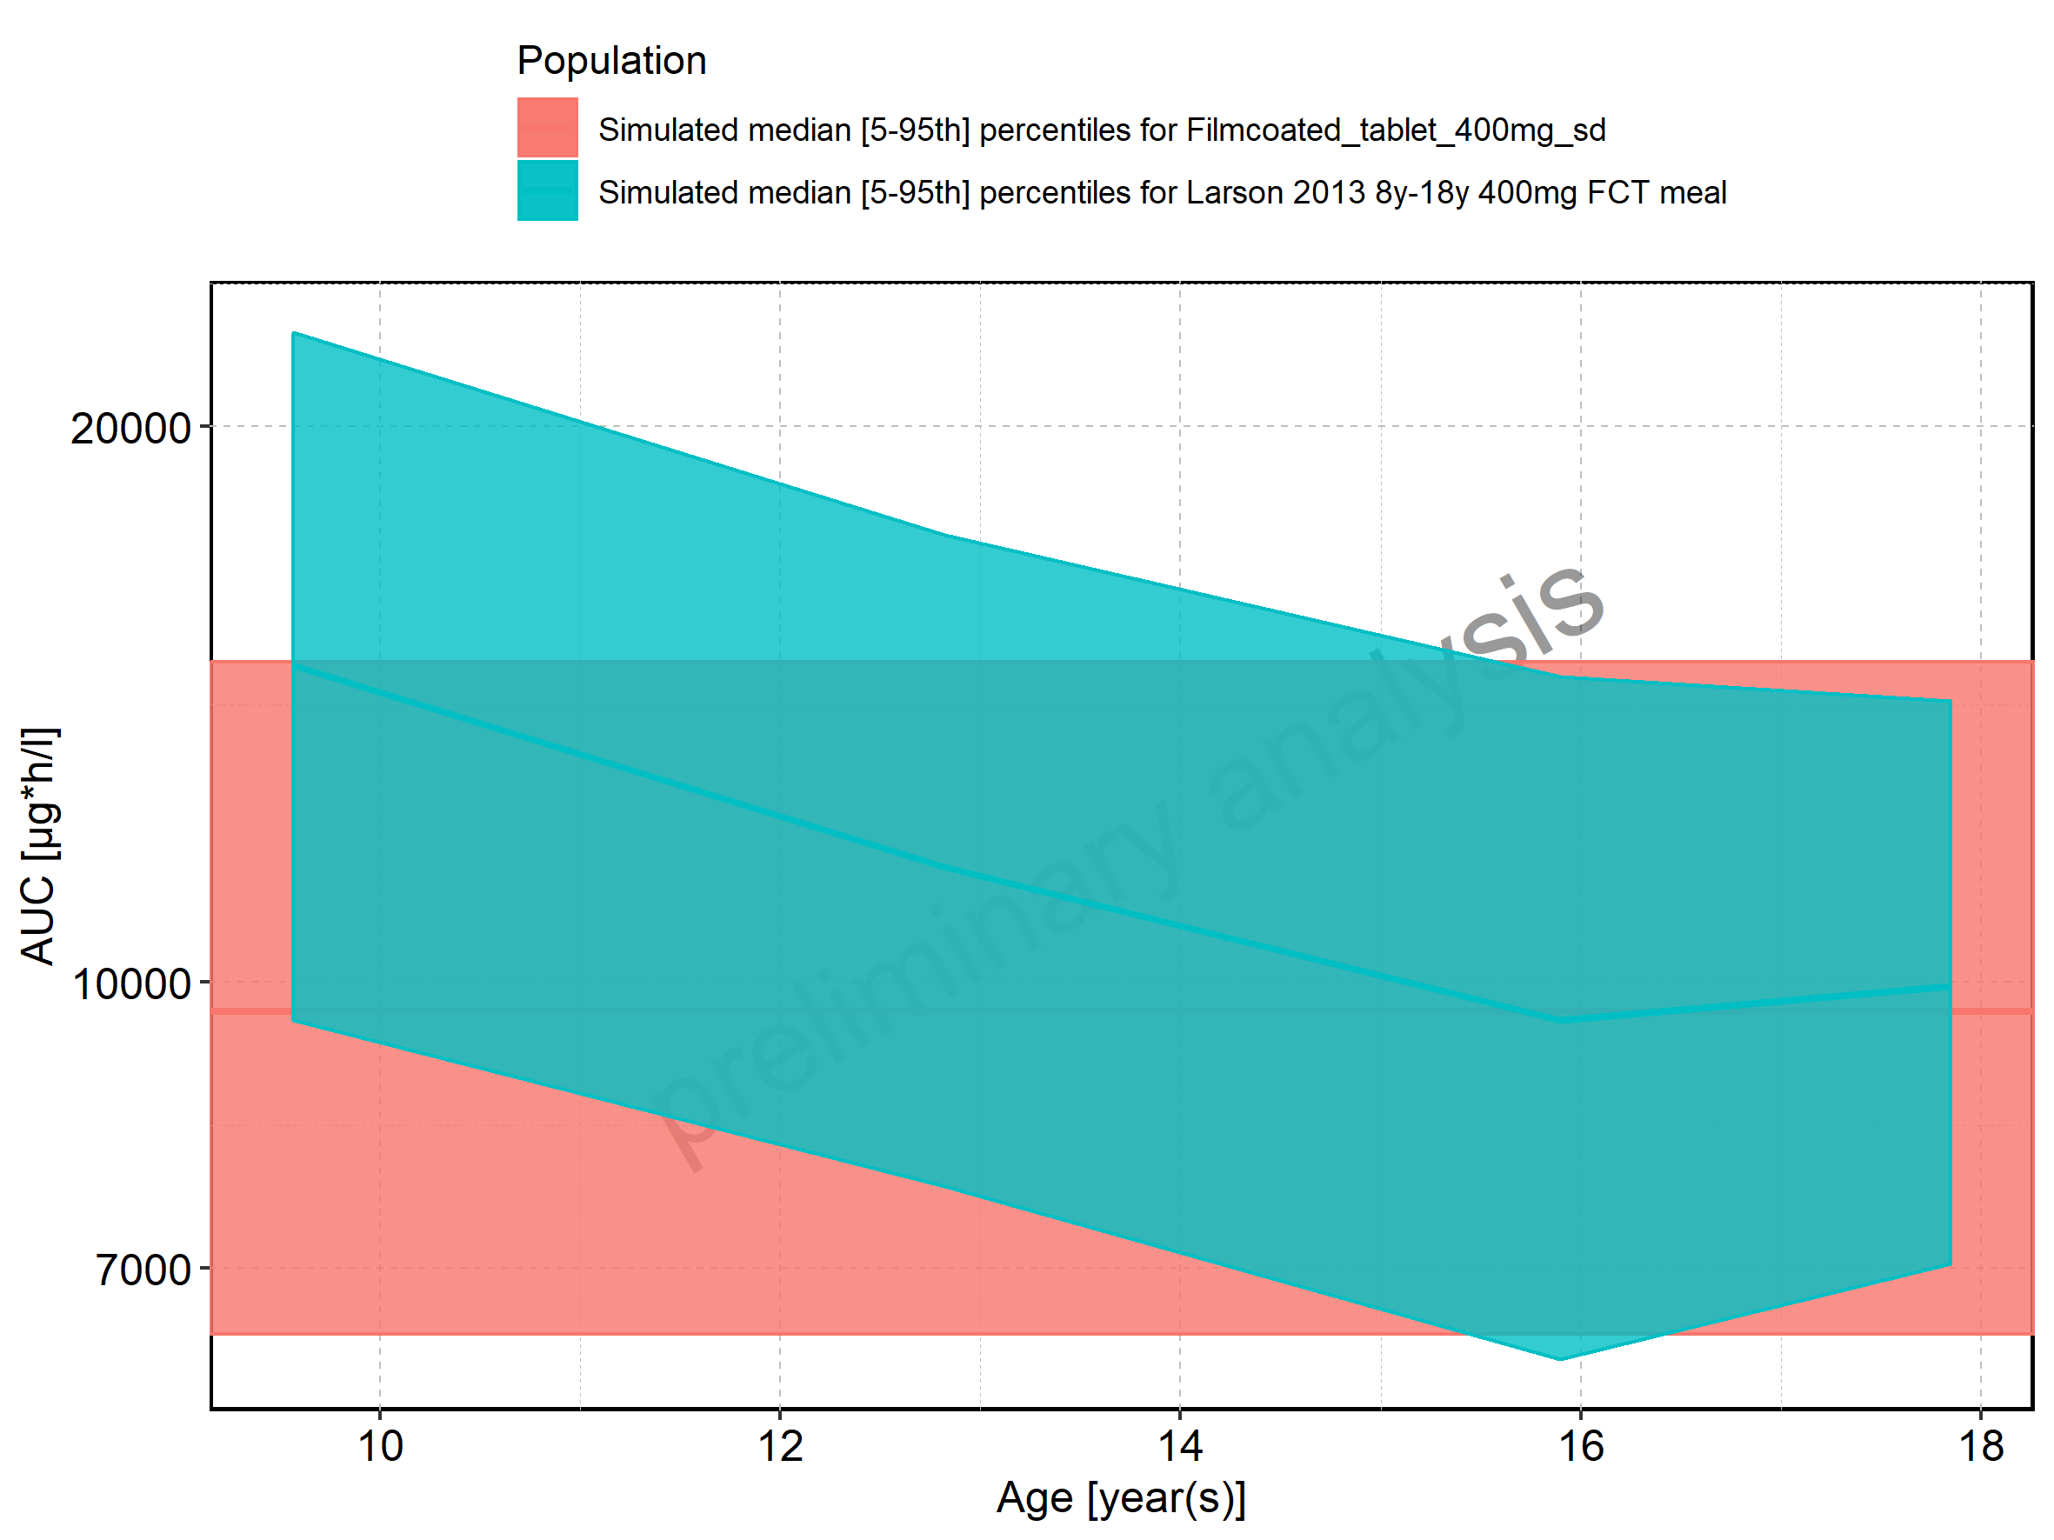

Figure 119: Age-dependence of AUC for Larson 2013 8y-18y 400mg FCT meal. Profiles are plotted in a linear scale.

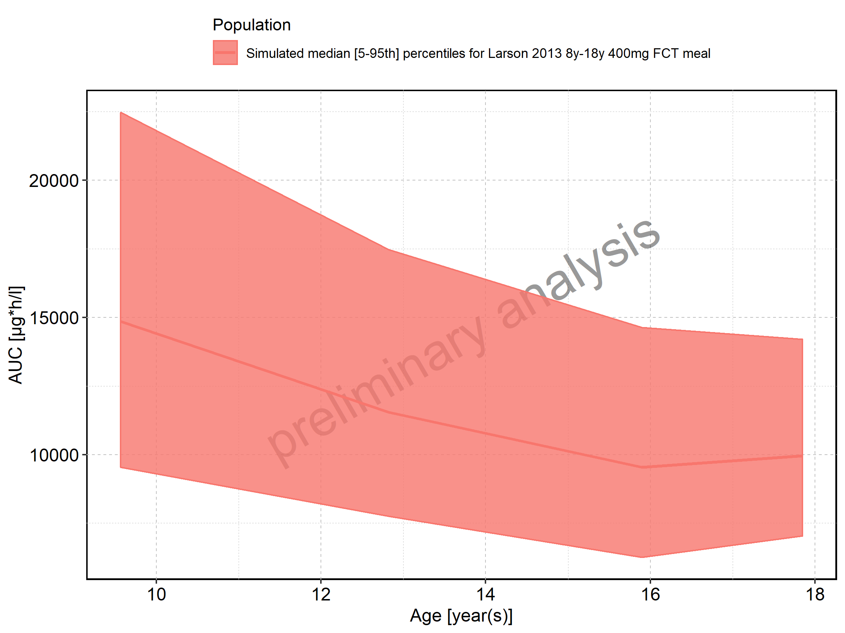

Figure 120: Age-dependence of AUC for Larson 2013 8y-18y 400mg FCT meal. Profiles are plotted in a logarithmic scale.

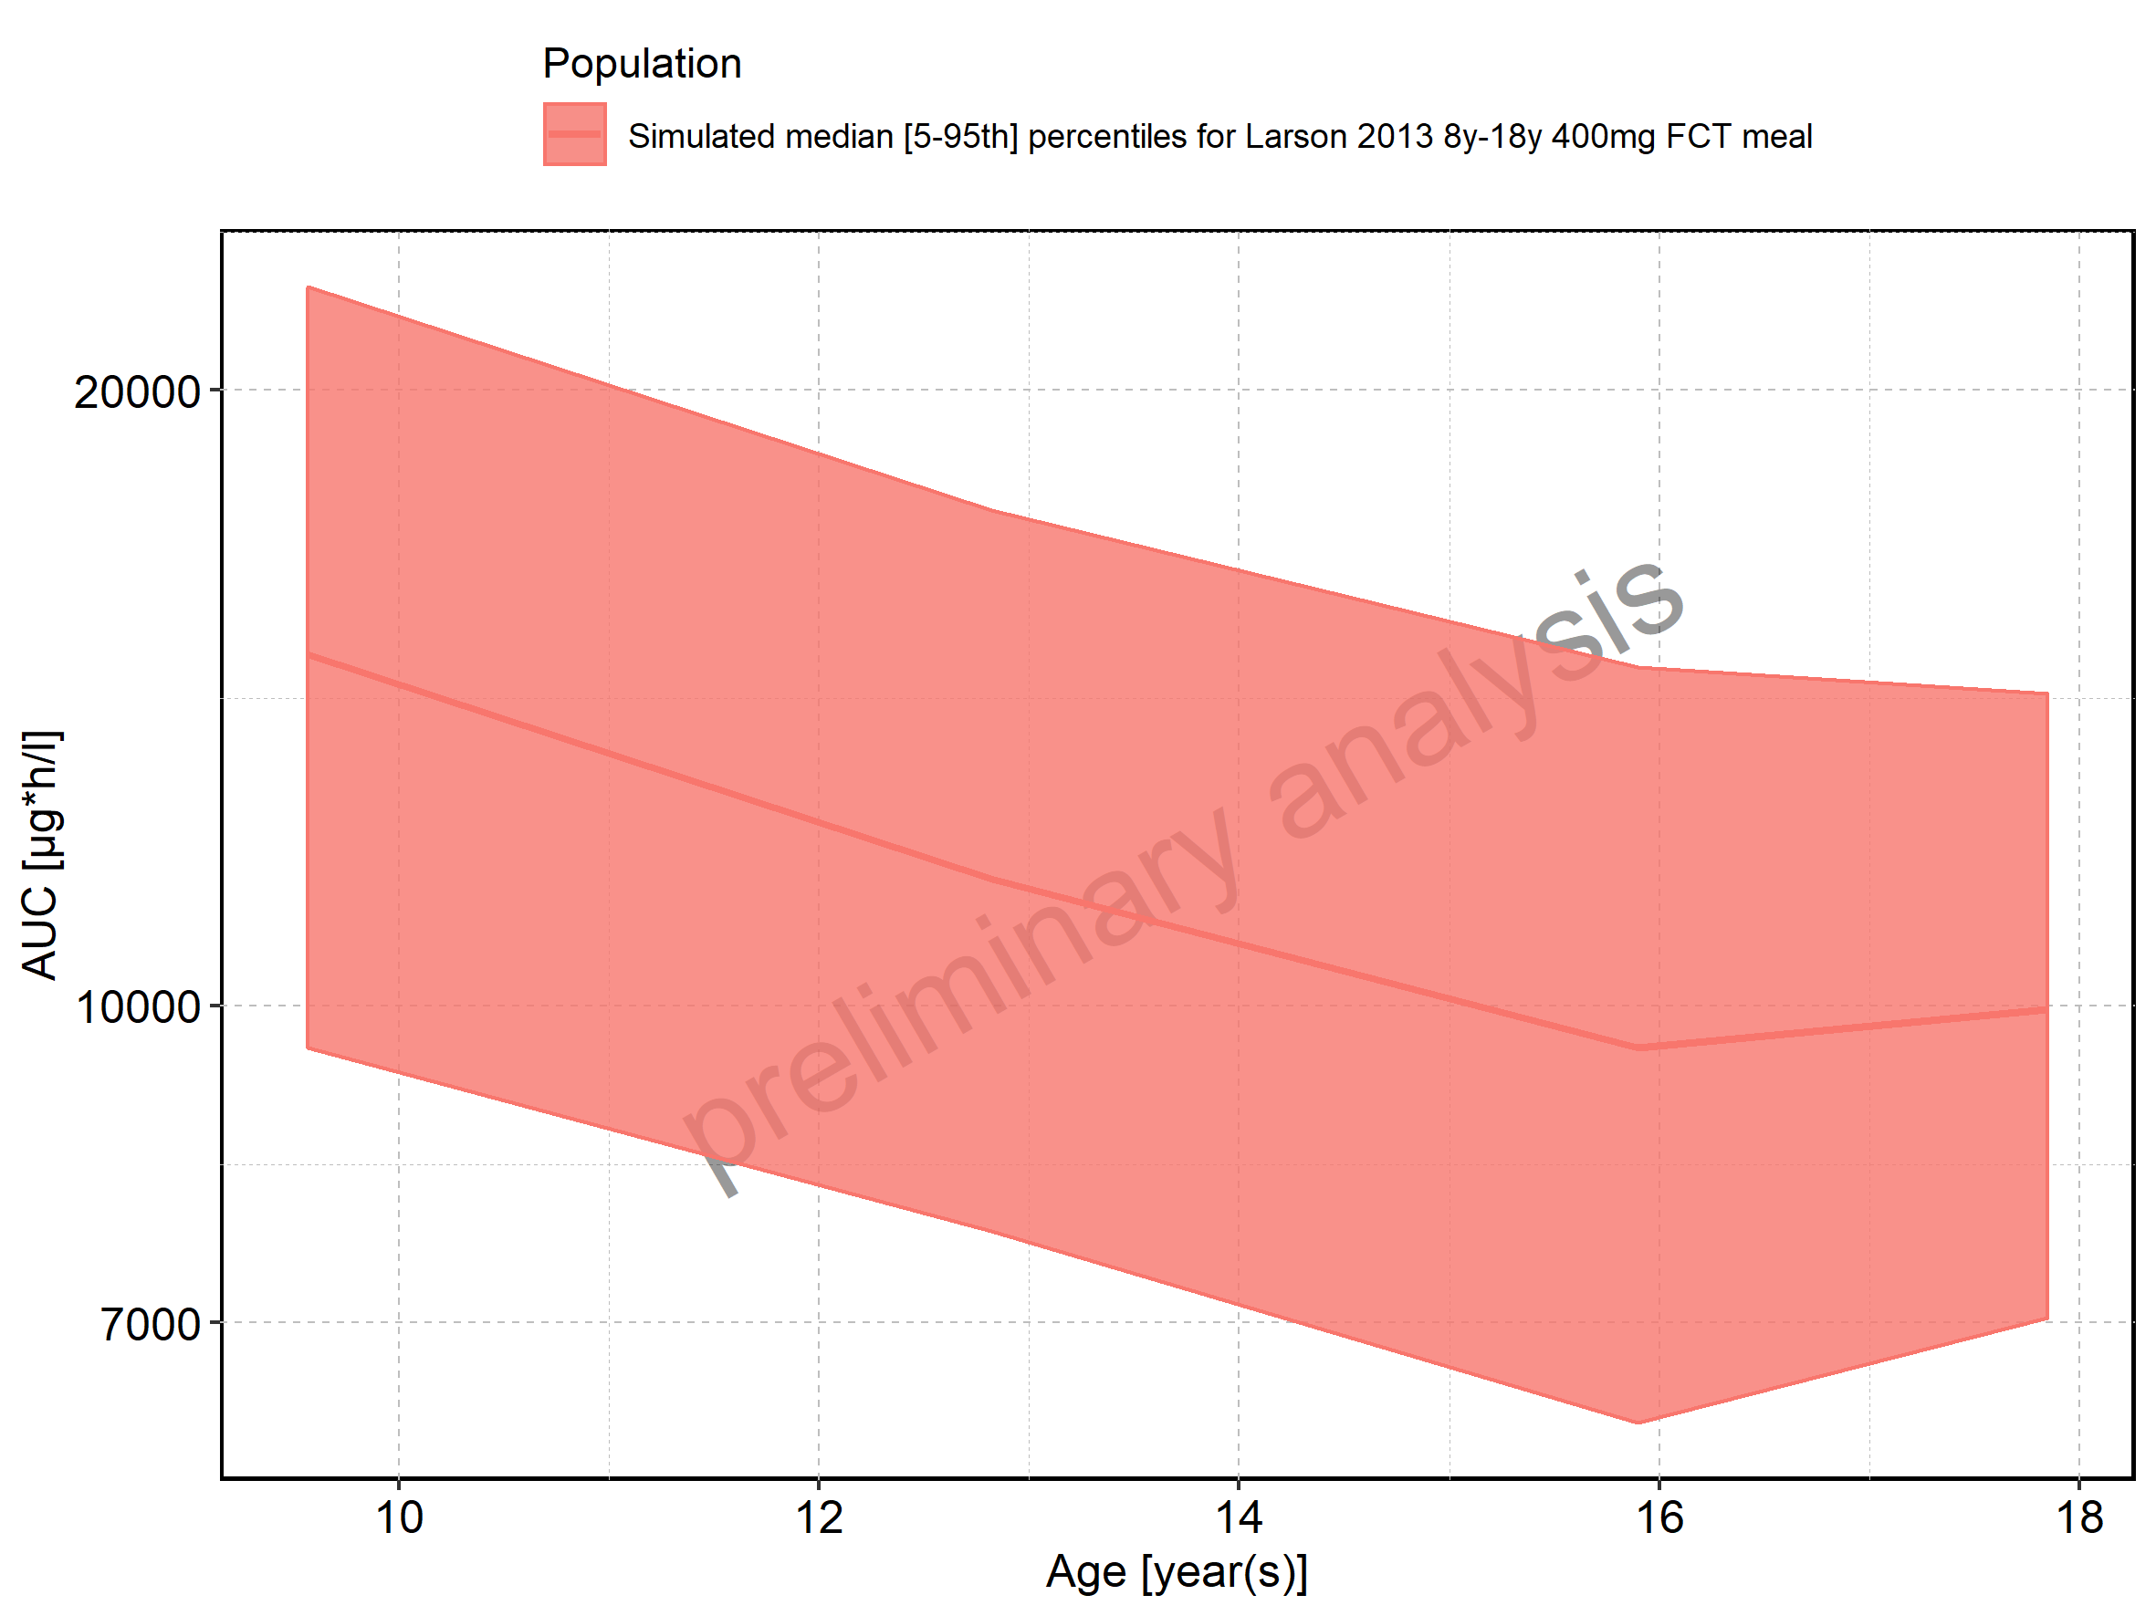

Figure 121: Age-dependence of AUC for Filmcoated_tablet_400mg_sd. Profiles are plotted in a linear scale.

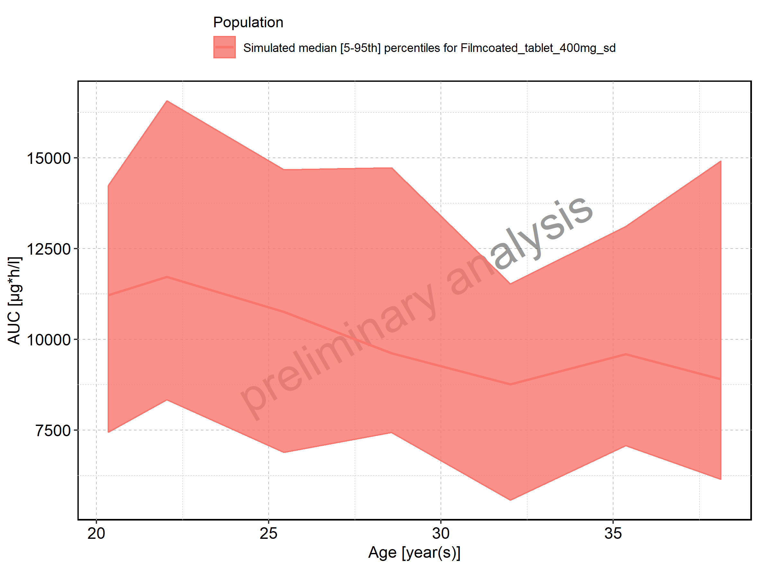

Figure 122: Age-dependence of AUC for Filmcoated_tablet_400mg_sd. Profiles are plotted in a logarithmic scale.

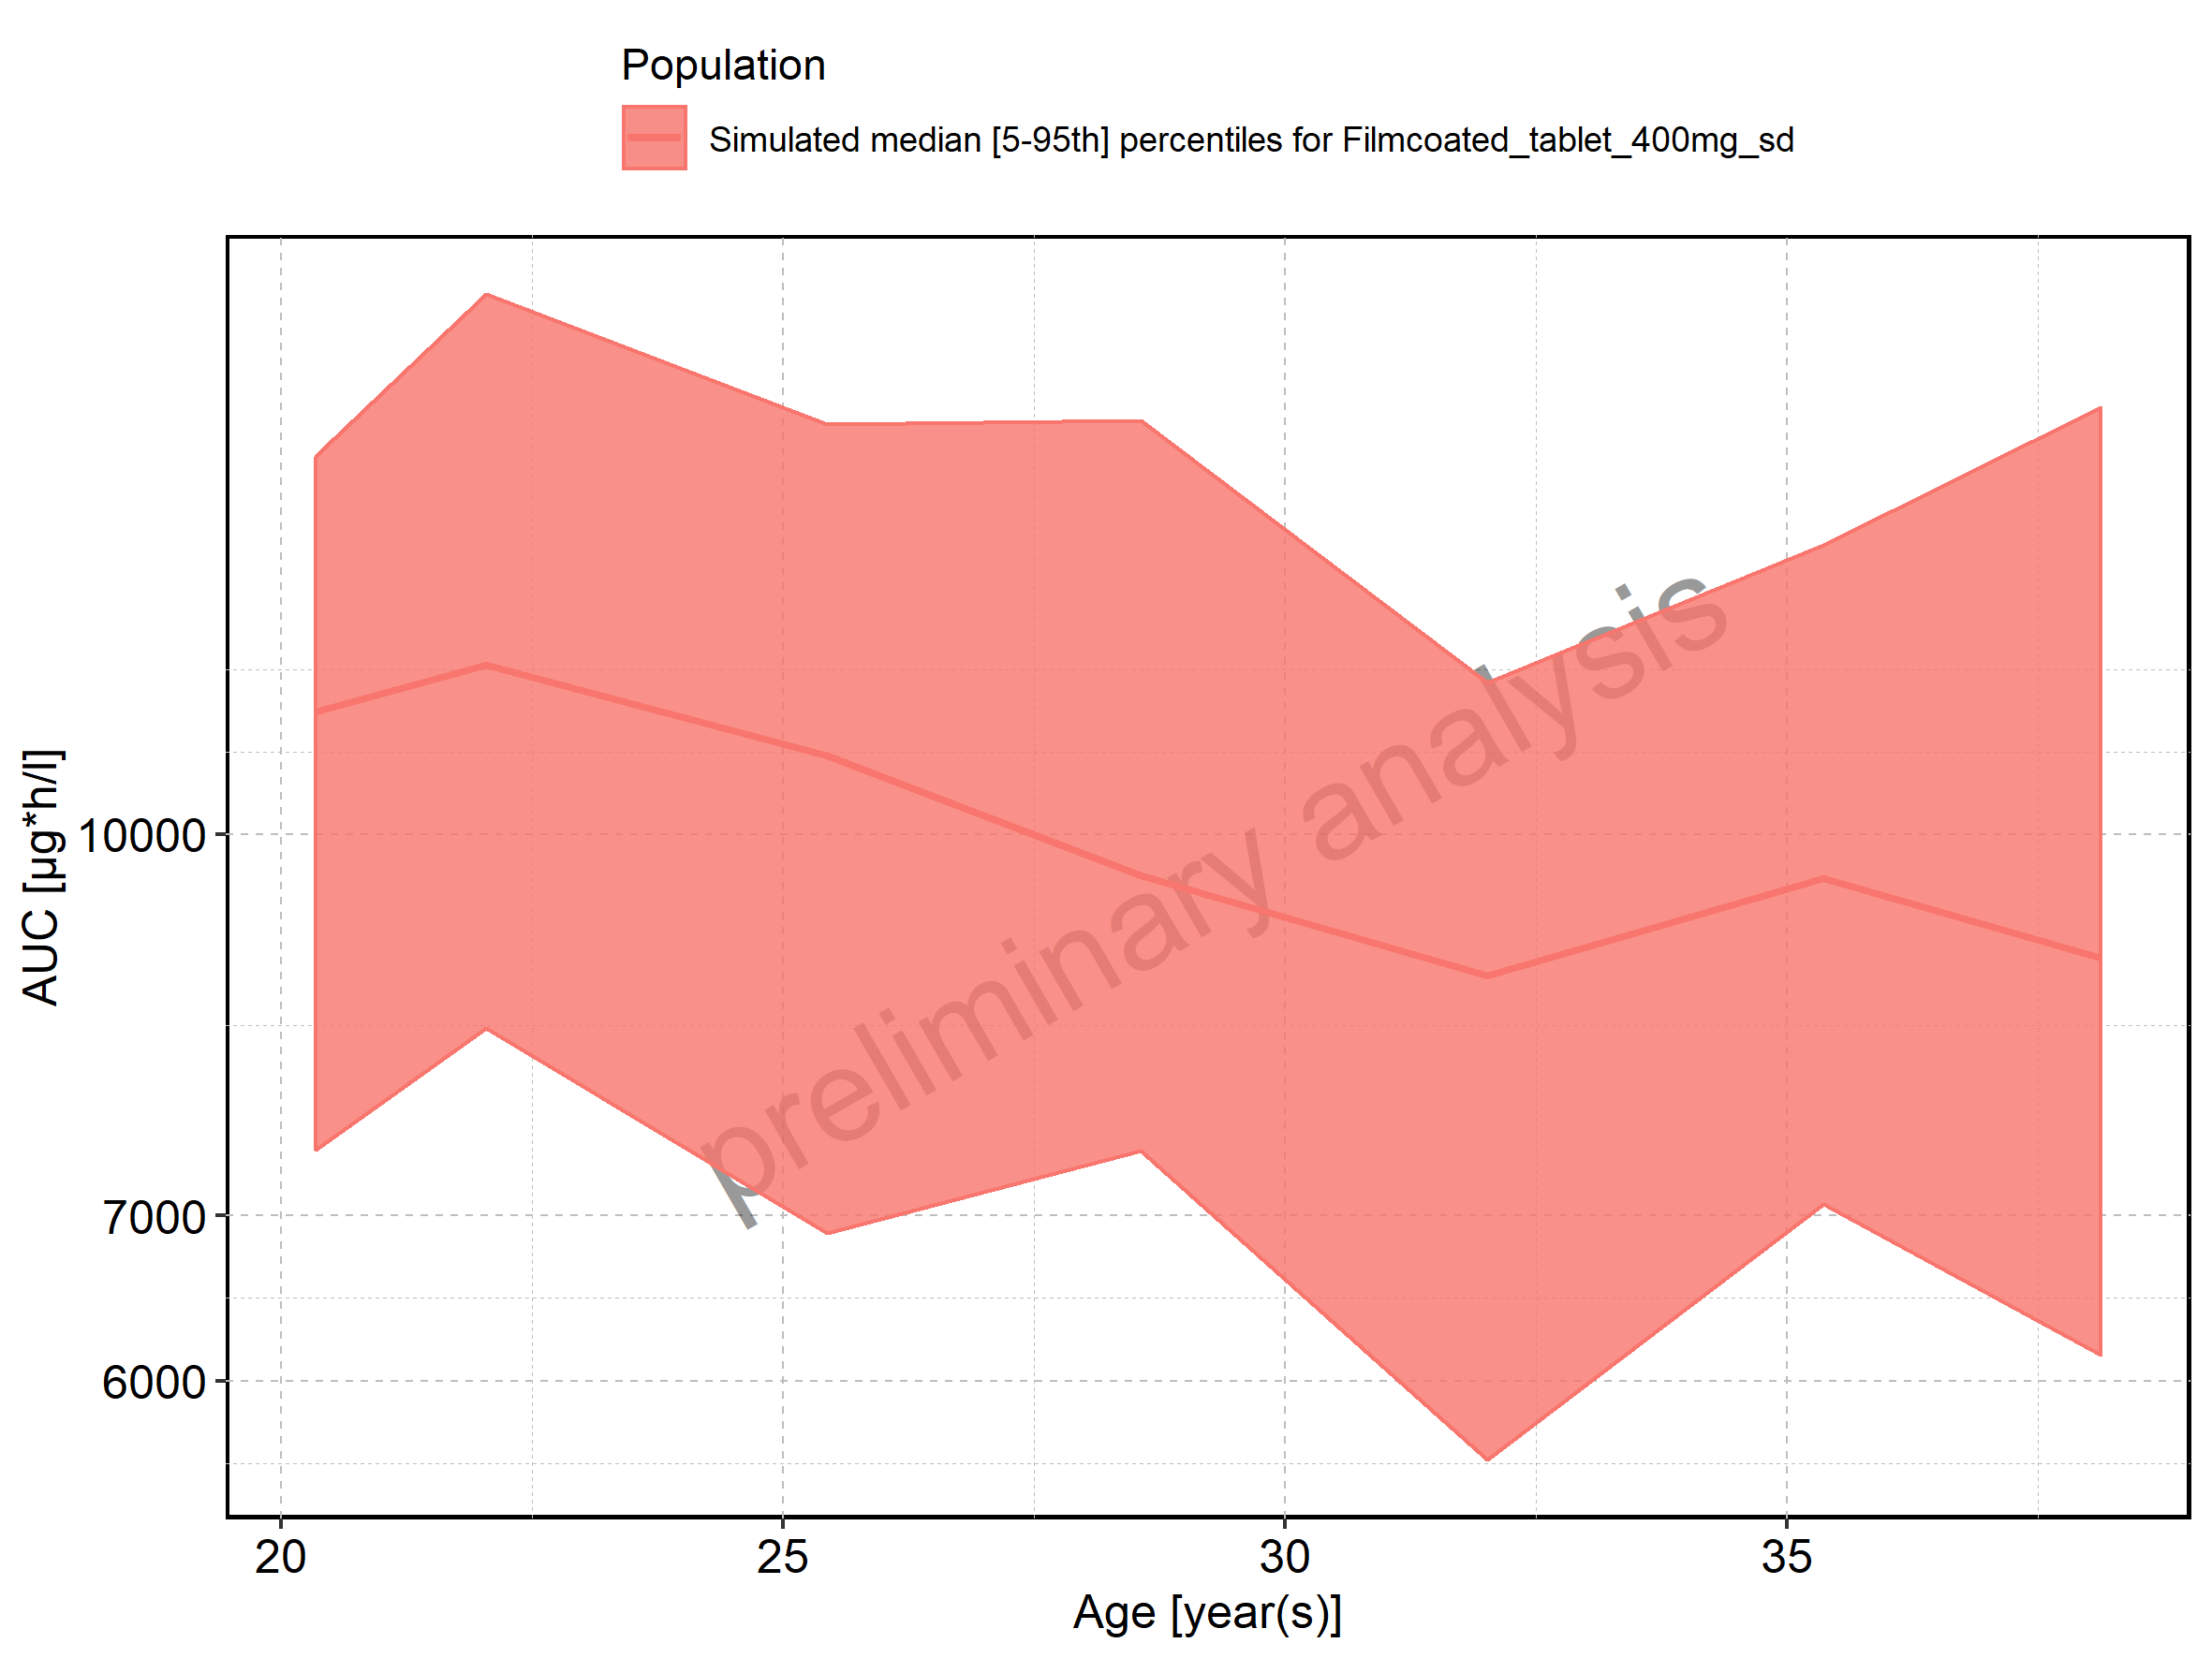

Figure 123: Height-dependence of AUC for Larson 2013 8y-18y 400mg FCT meal in comparison to Filmcoated_tablet_400mg_sd. Profiles are plotted in a linear scale.

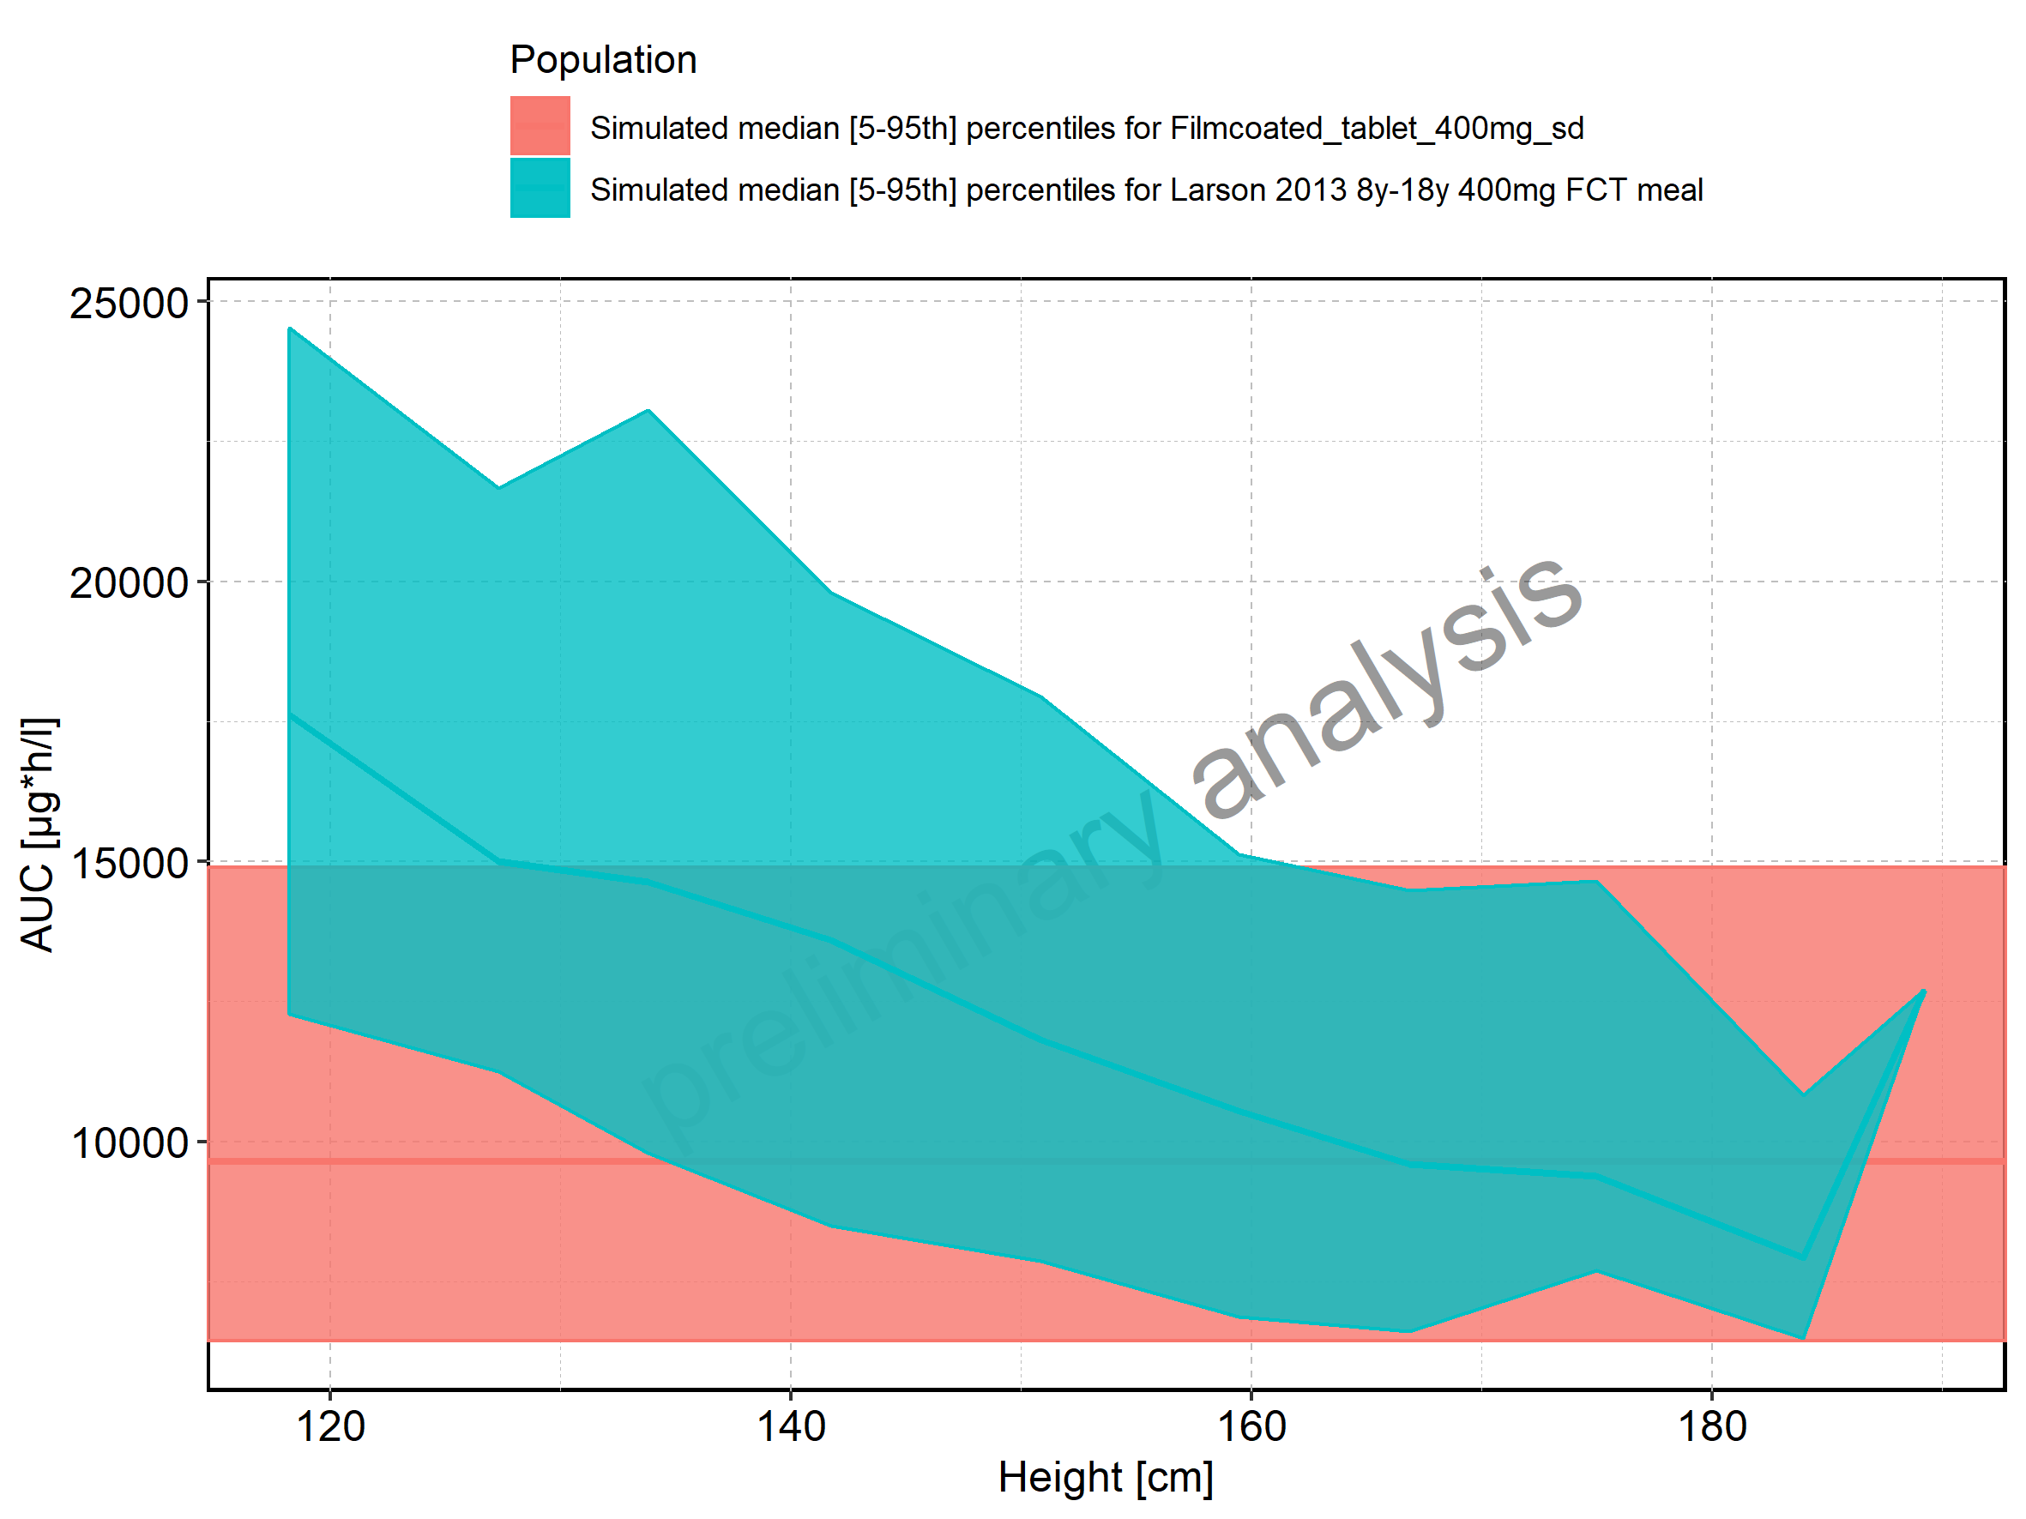

Figure 124: Height-dependence of AUC for Larson 2013 8y-18y 400mg FCT meal in comparison to Filmcoated_tablet_400mg_sd. Profiles are plotted in a logarithmic scale.

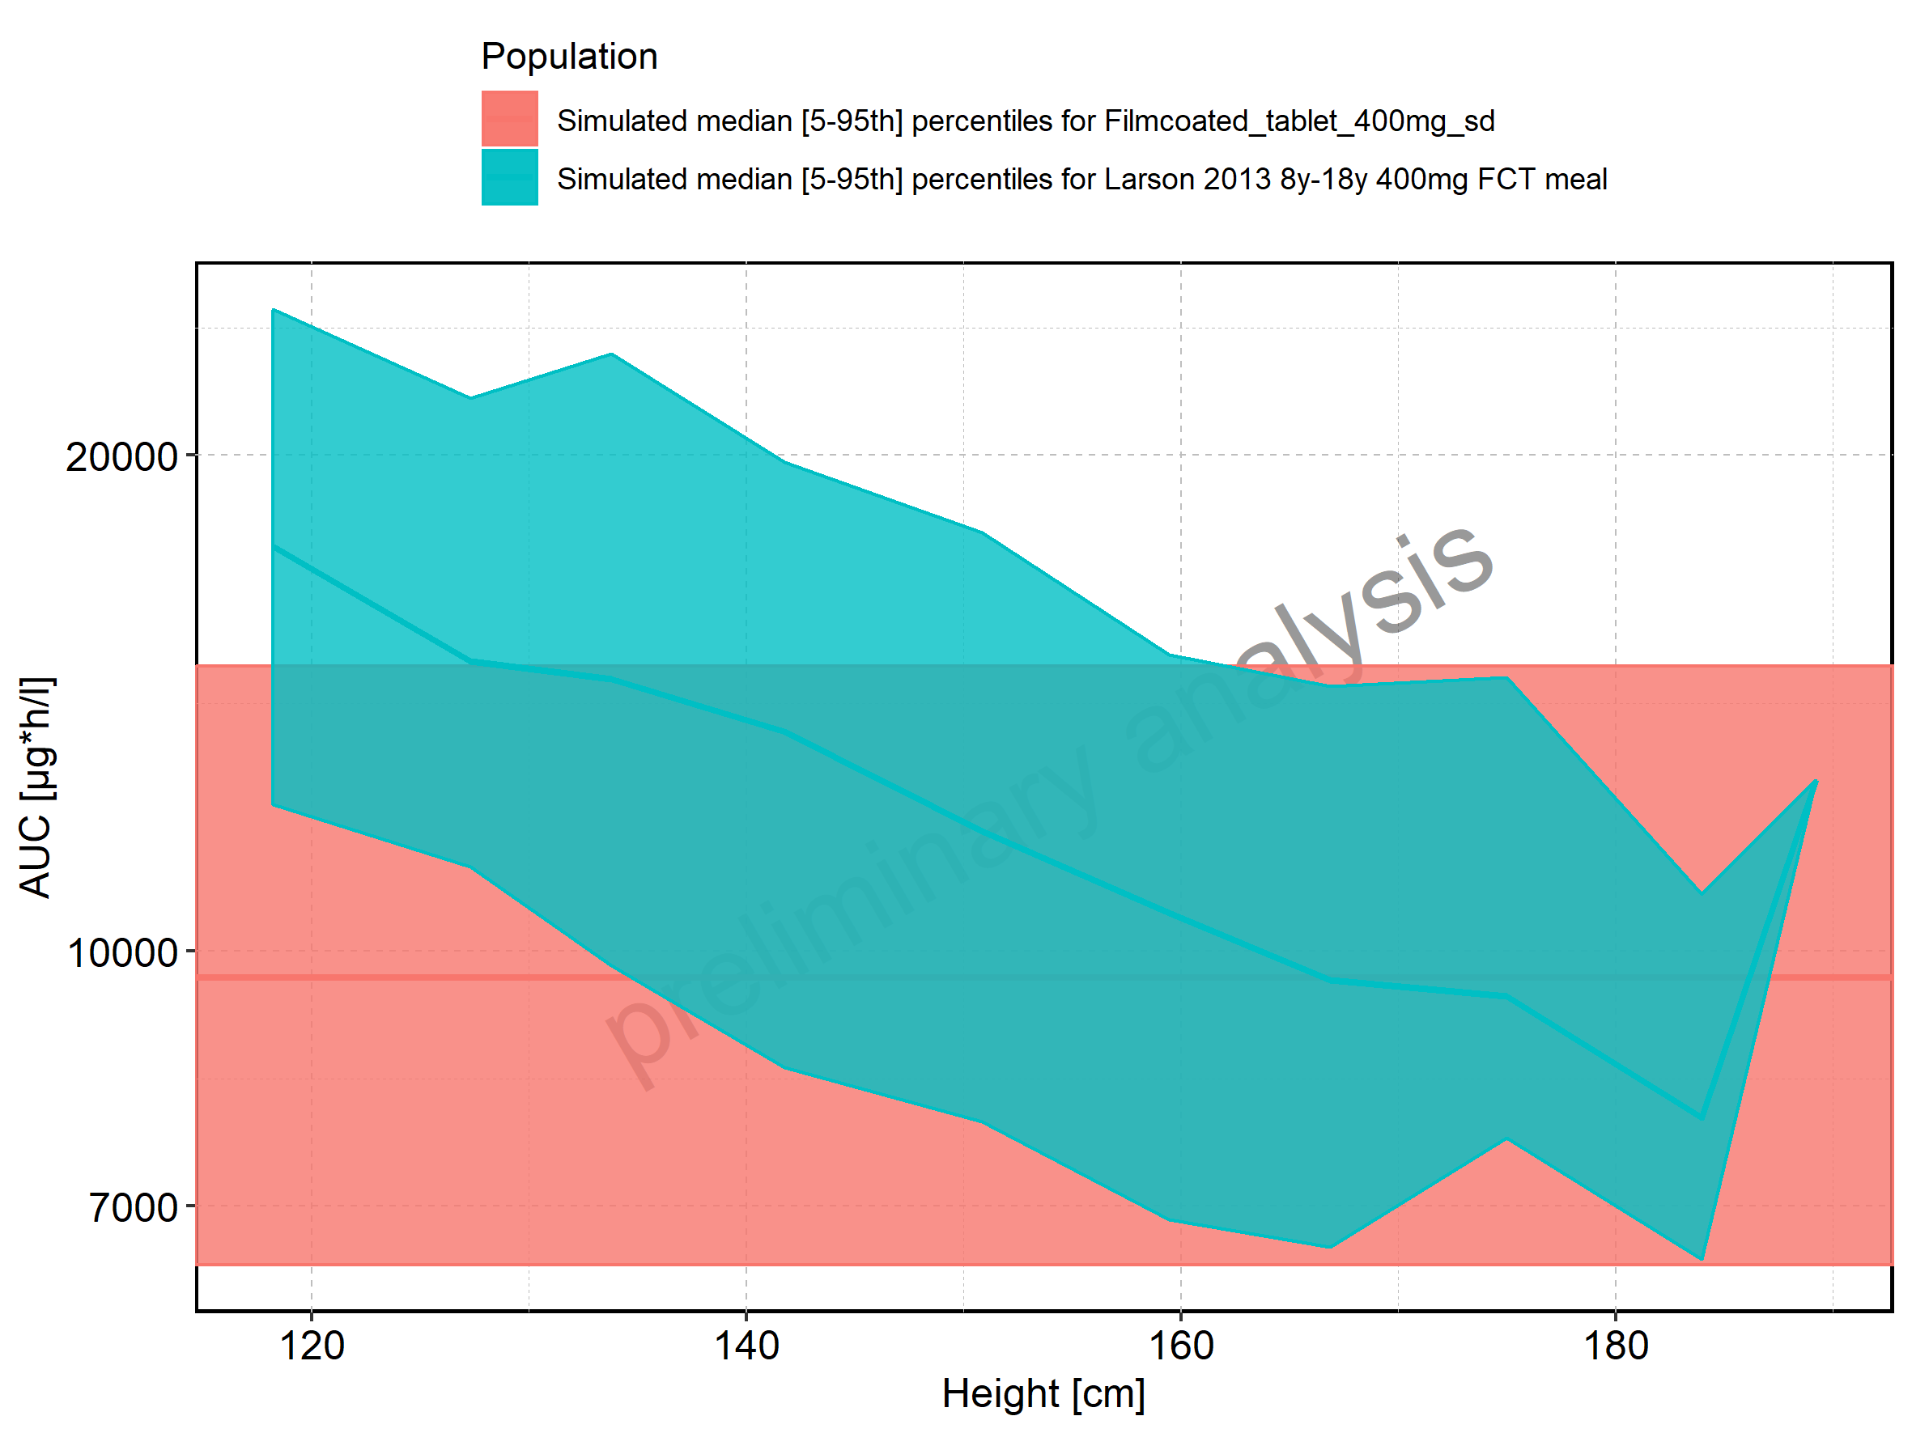

Figure 125: Height-dependence of AUC for Larson 2013 8y-18y 400mg FCT meal. Profiles are plotted in a linear scale.

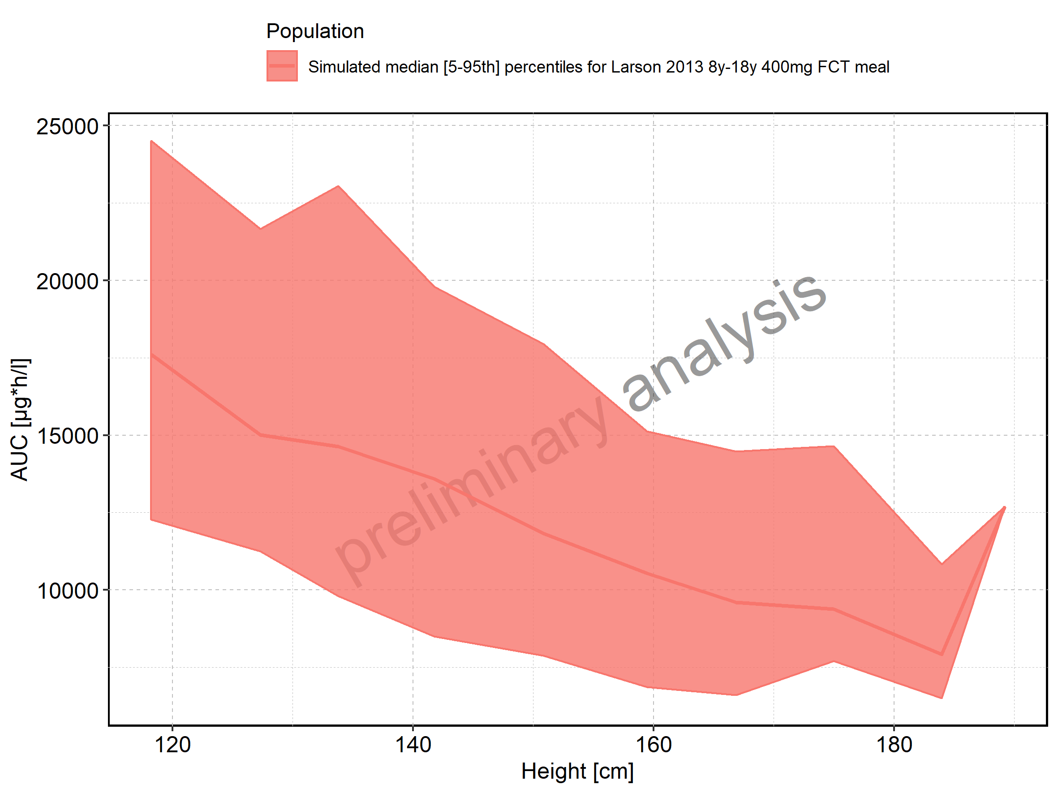

Figure 126: Height-dependence of AUC for Larson 2013 8y-18y 400mg FCT meal. Profiles are plotted in a logarithmic scale.

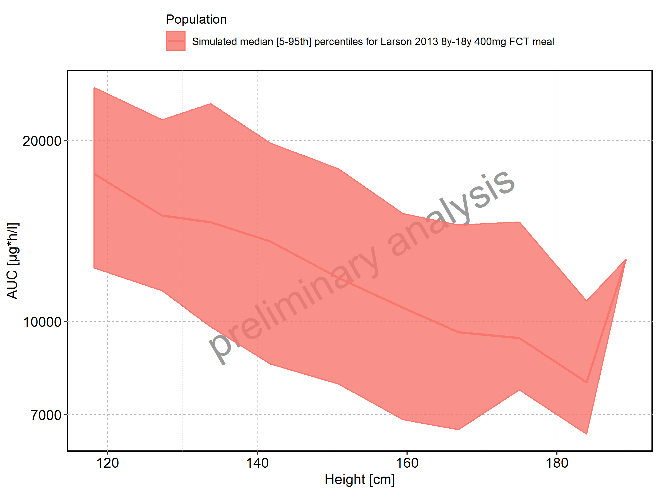

Figure 127: Height-dependence of AUC for Filmcoated_tablet_400mg_sd. Profiles are plotted in a linear scale.

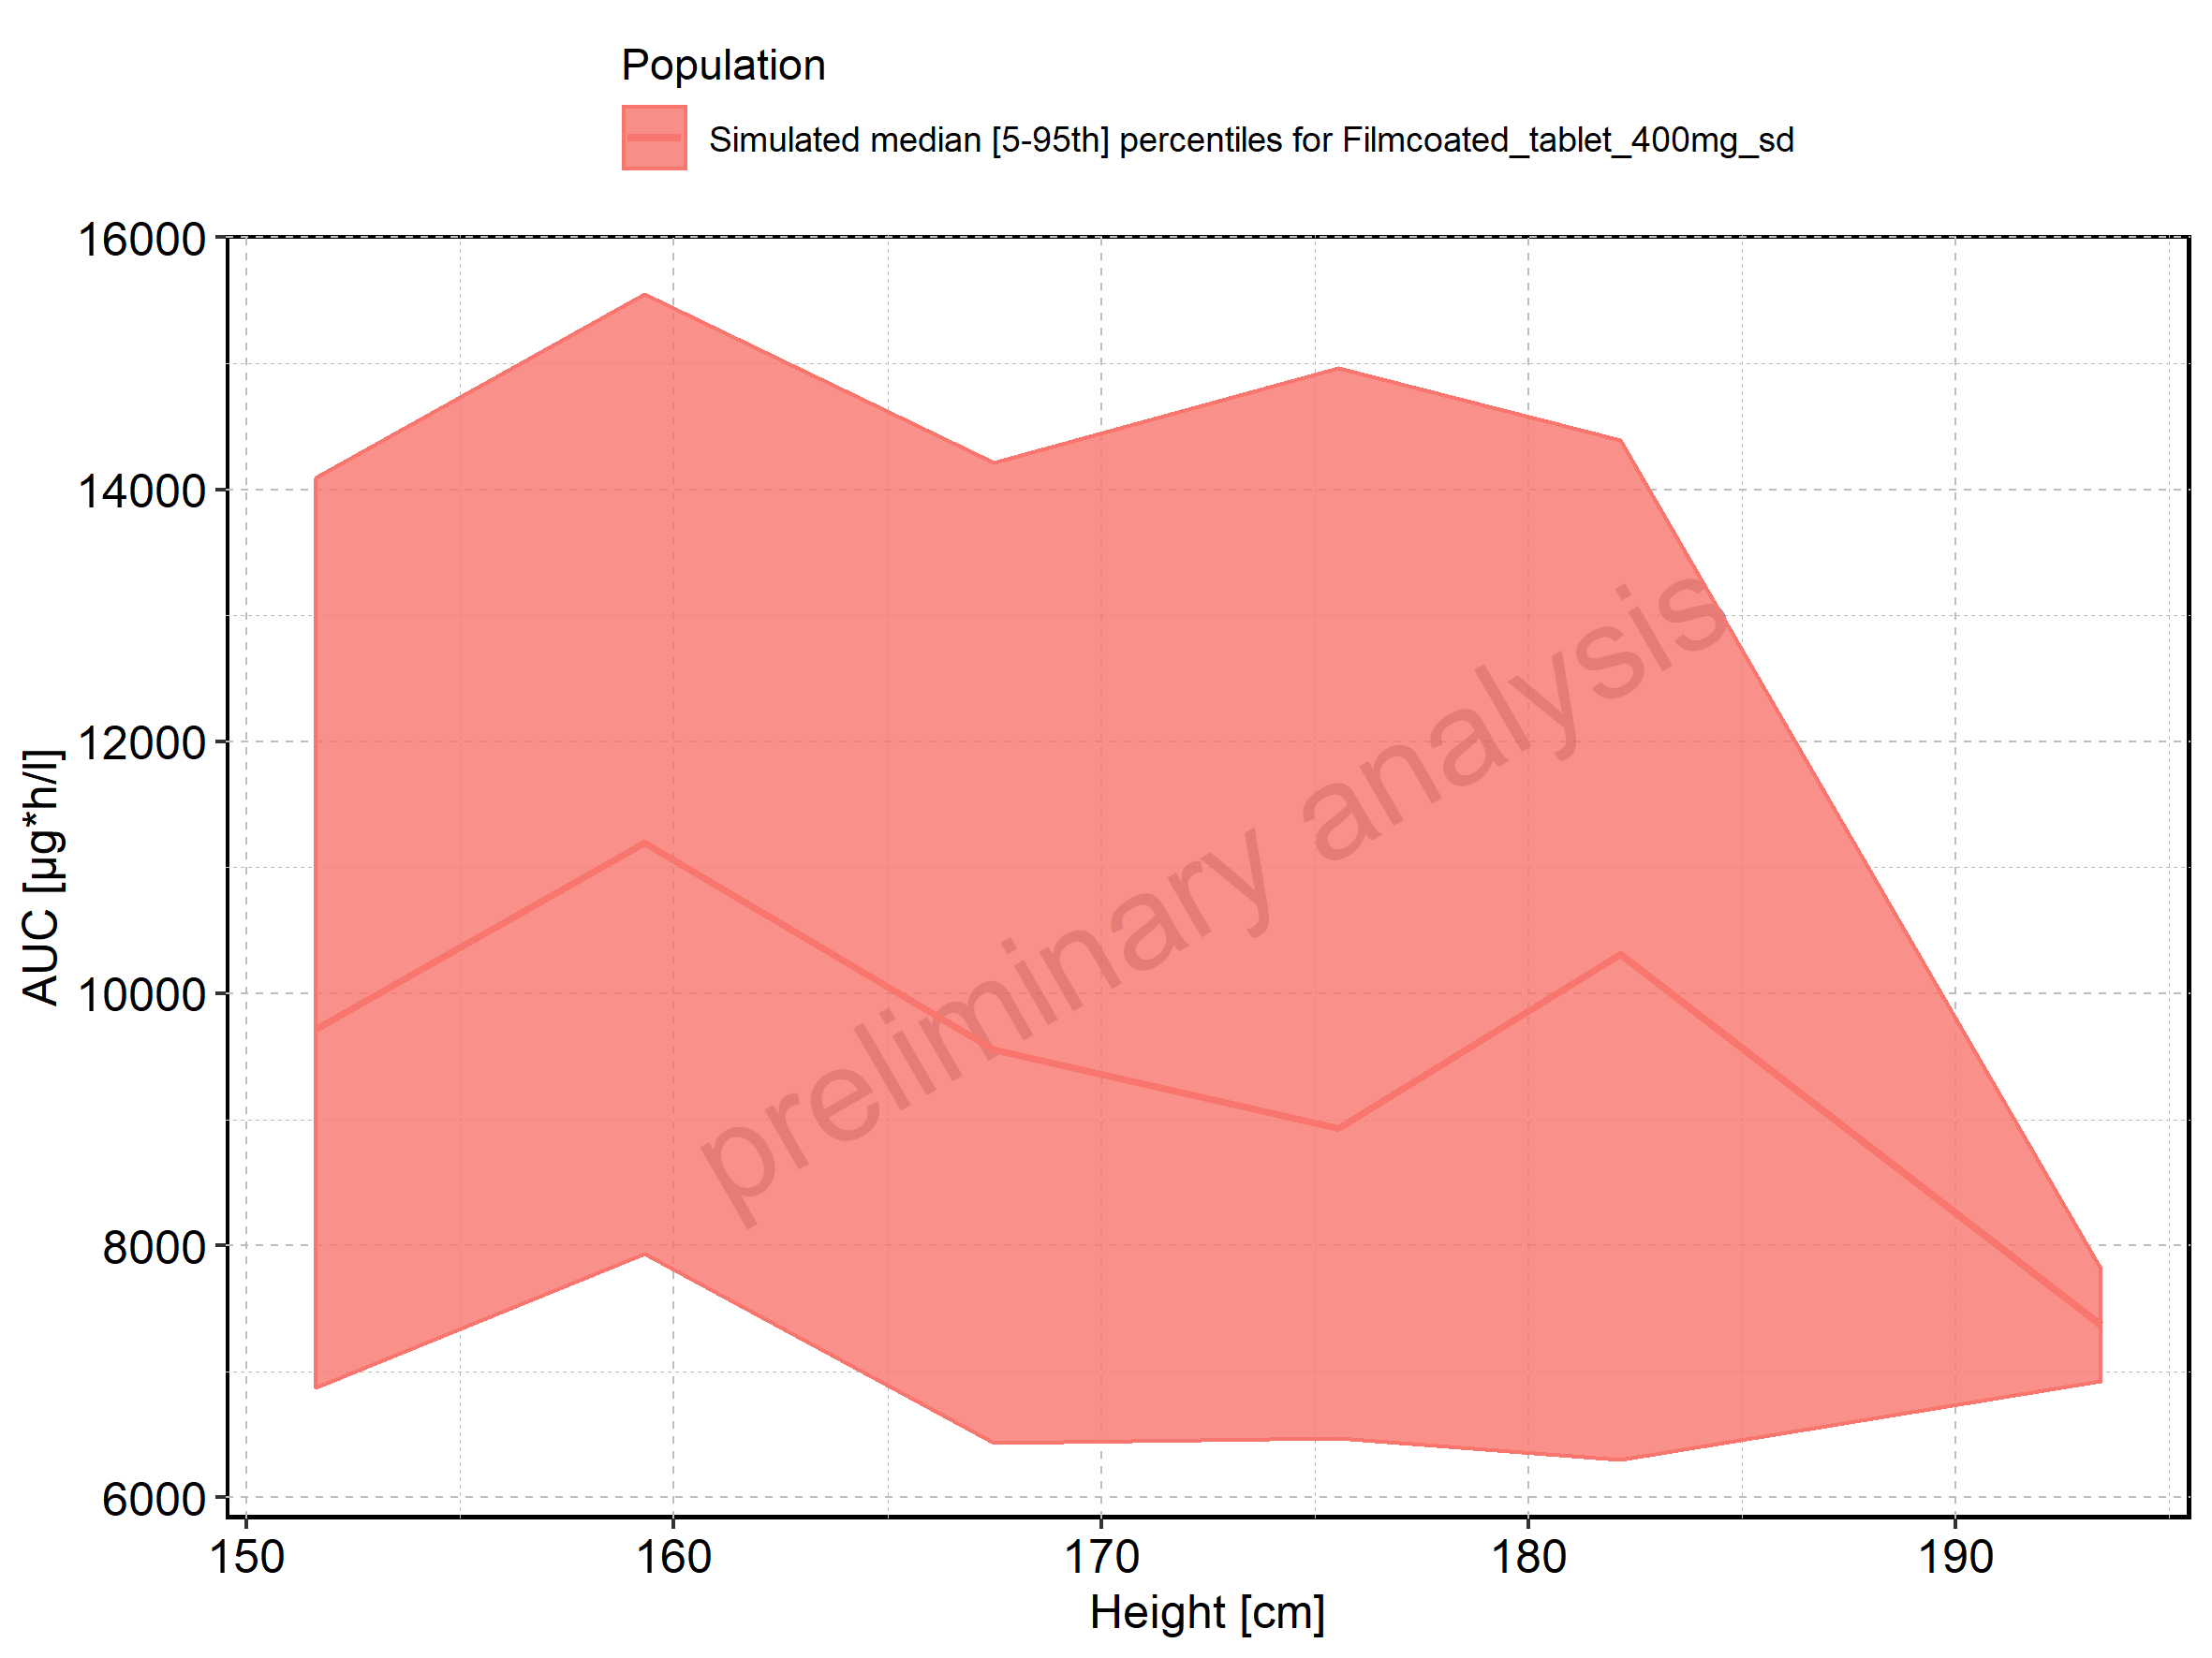

Figure 128: Height-dependence of AUC for Filmcoated_tablet_400mg_sd. Profiles are plotted in a logarithmic scale.

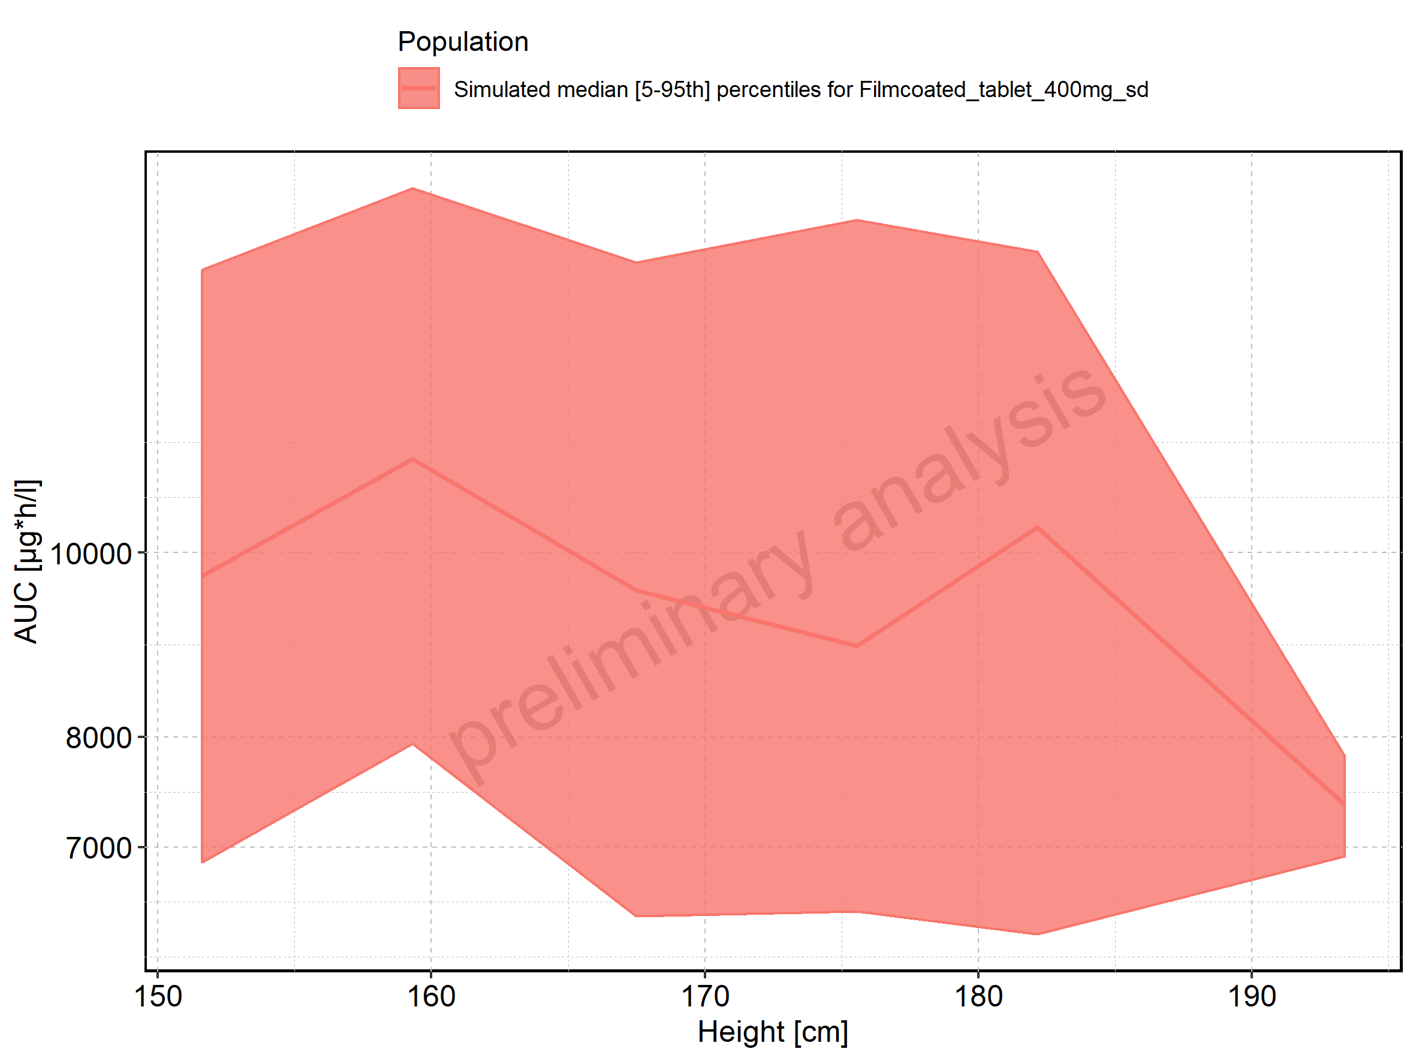

Figure 129: Weight-dependence of AUC for Larson 2013 8y-18y 400mg FCT meal in comparison to Filmcoated_tablet_400mg_sd. Profiles are plotted in a linear scale.

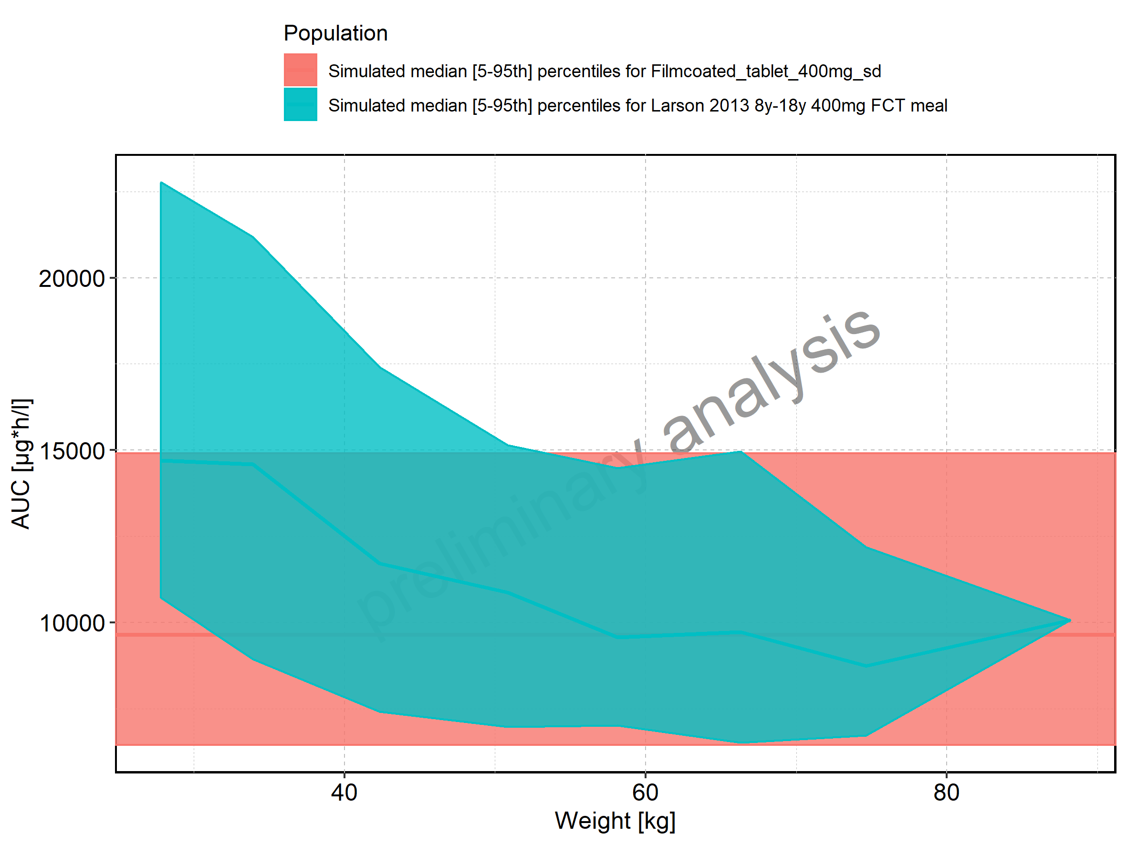

Figure 130: Weight-dependence of AUC for Larson 2013 8y-18y 400mg FCT meal in comparison to Filmcoated_tablet_400mg_sd. Profiles are plotted in a logarithmic scale.

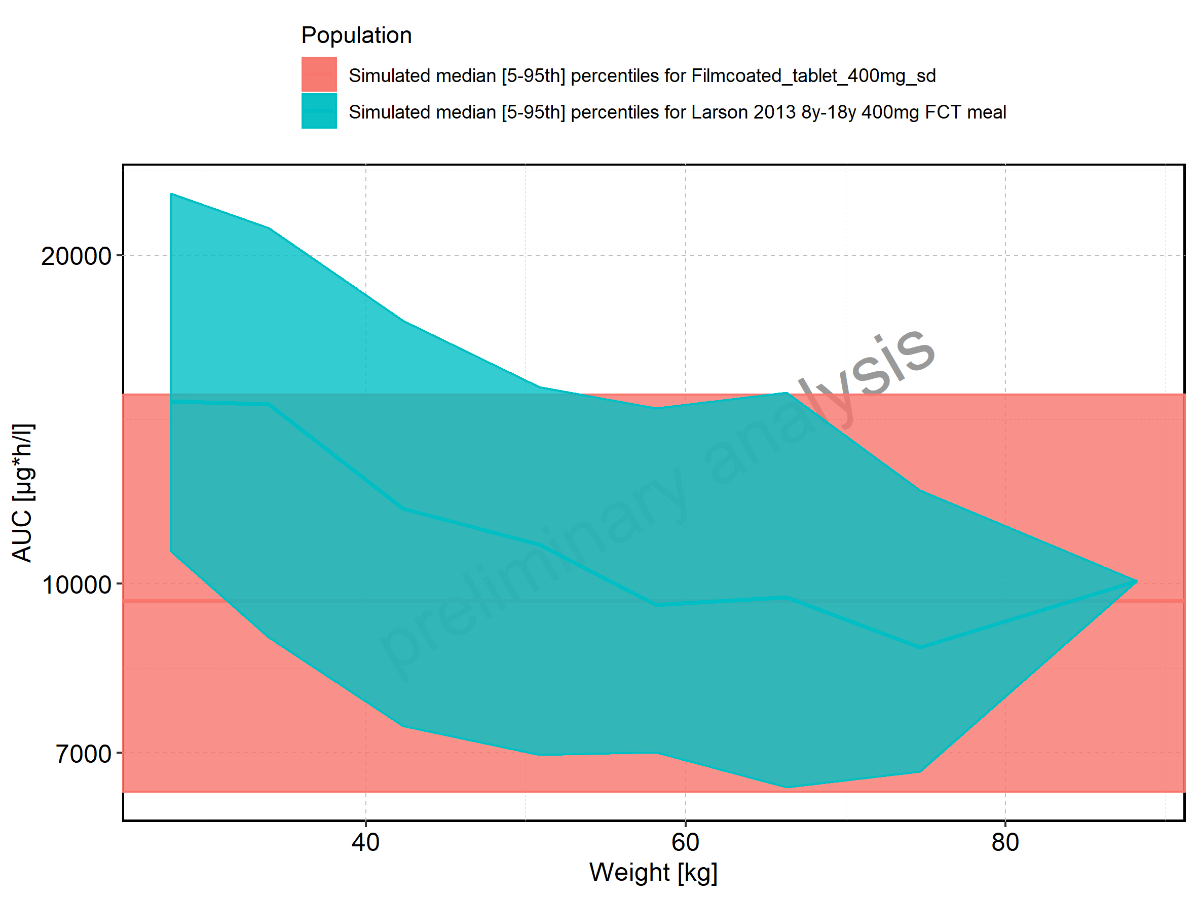

Figure 131: Weight-dependence of AUC for Larson 2013 8y-18y 400mg FCT meal. Profiles are plotted in a linear scale.

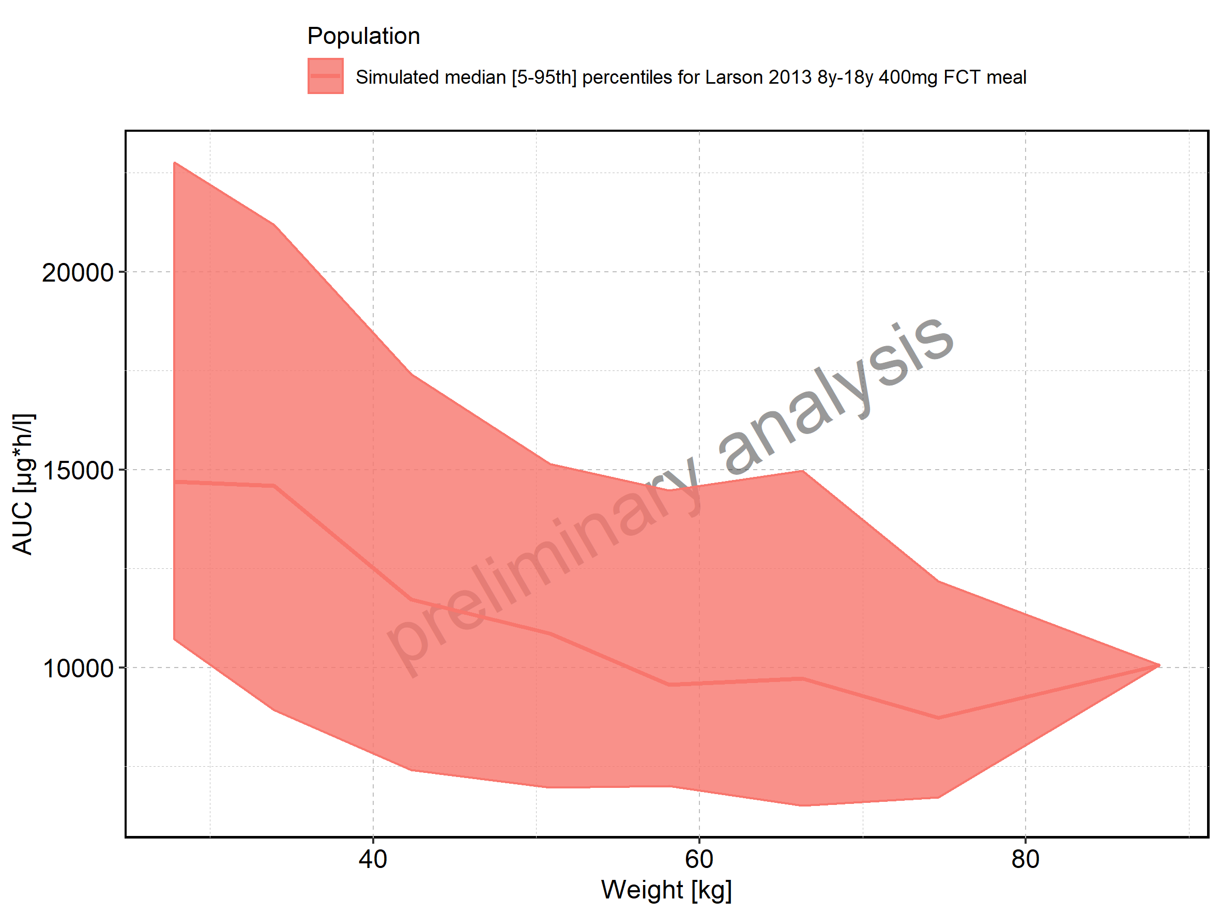

Figure 132: Weight-dependence of AUC for Larson 2013 8y-18y 400mg FCT meal. Profiles are plotted in a logarithmic scale.

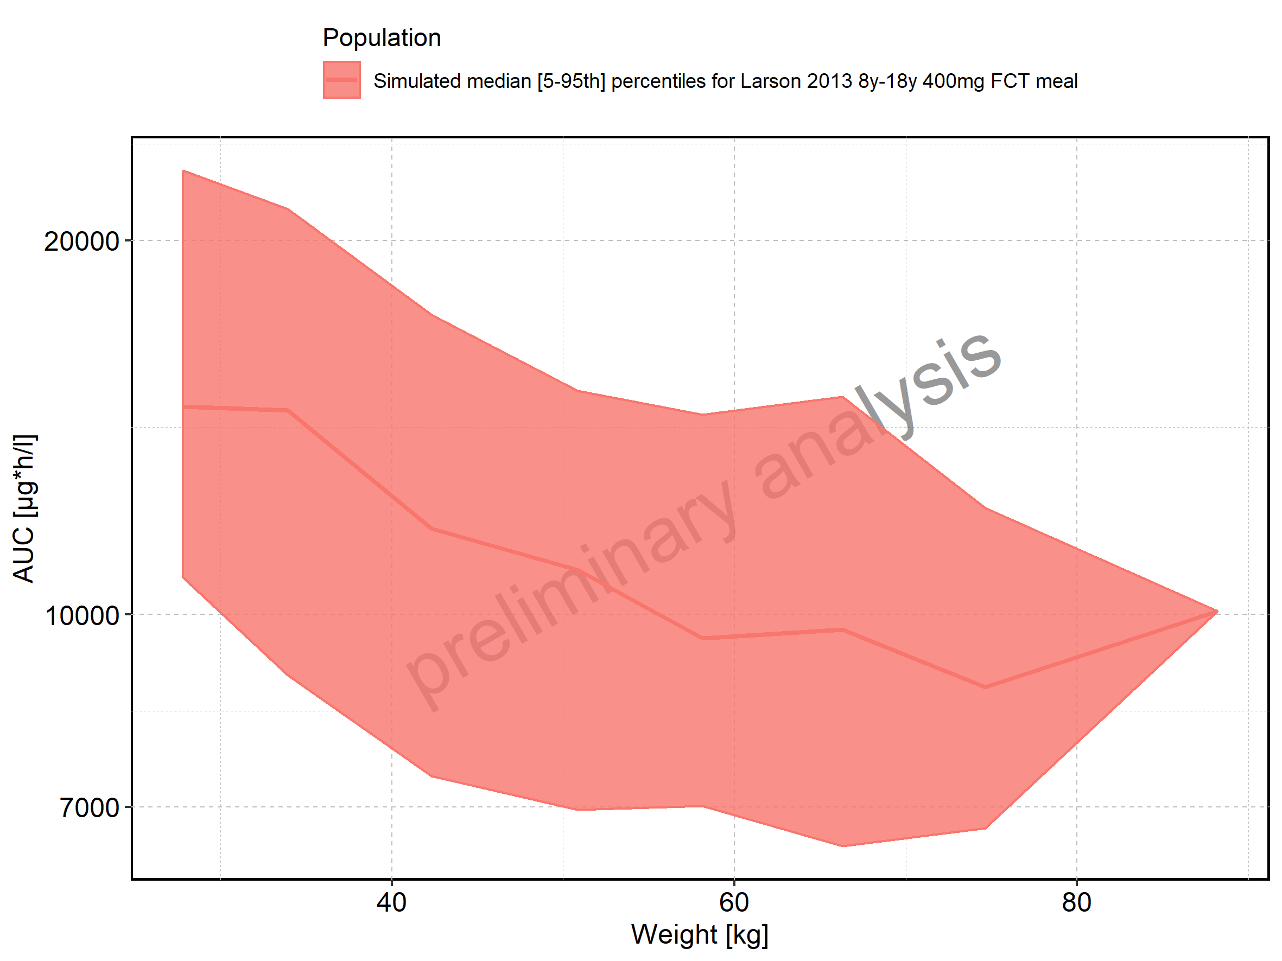

Figure 133: Weight-dependence of AUC for Filmcoated_tablet_400mg_sd. Profiles are plotted in a linear scale.

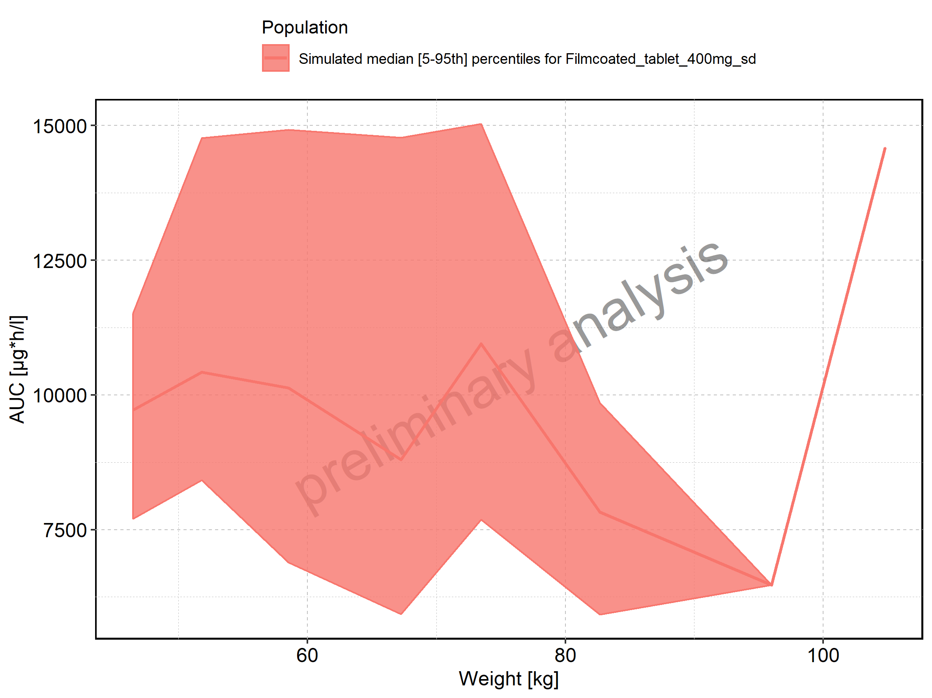

Figure 134: Weight-dependence of AUC for Filmcoated_tablet_400mg_sd. Profiles are plotted in a logarithmic scale.

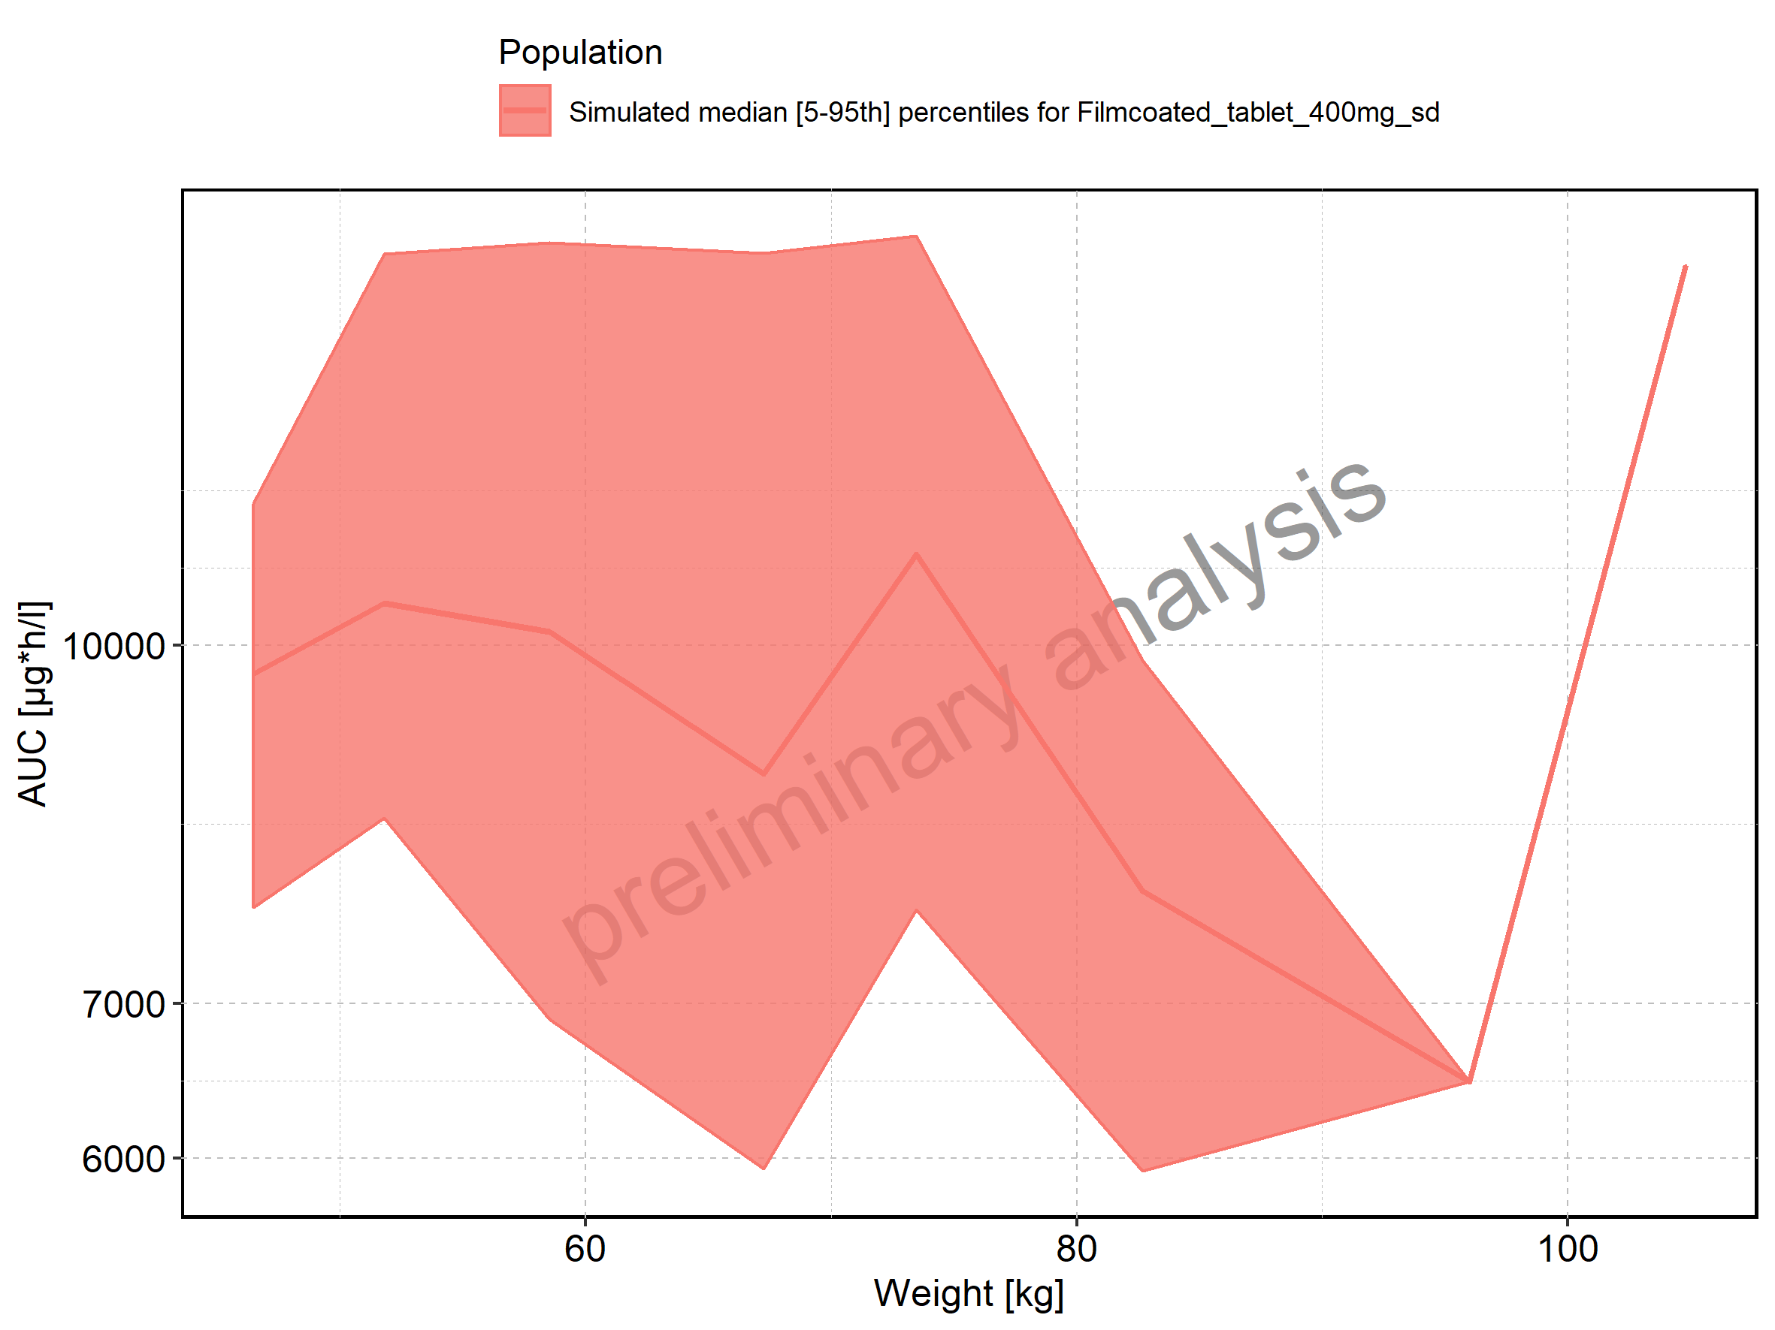

Figure 135: BMI-dependence of AUC for Larson 2013 8y-18y 400mg FCT meal in comparison to Filmcoated_tablet_400mg_sd. Profiles are plotted in a linear scale.

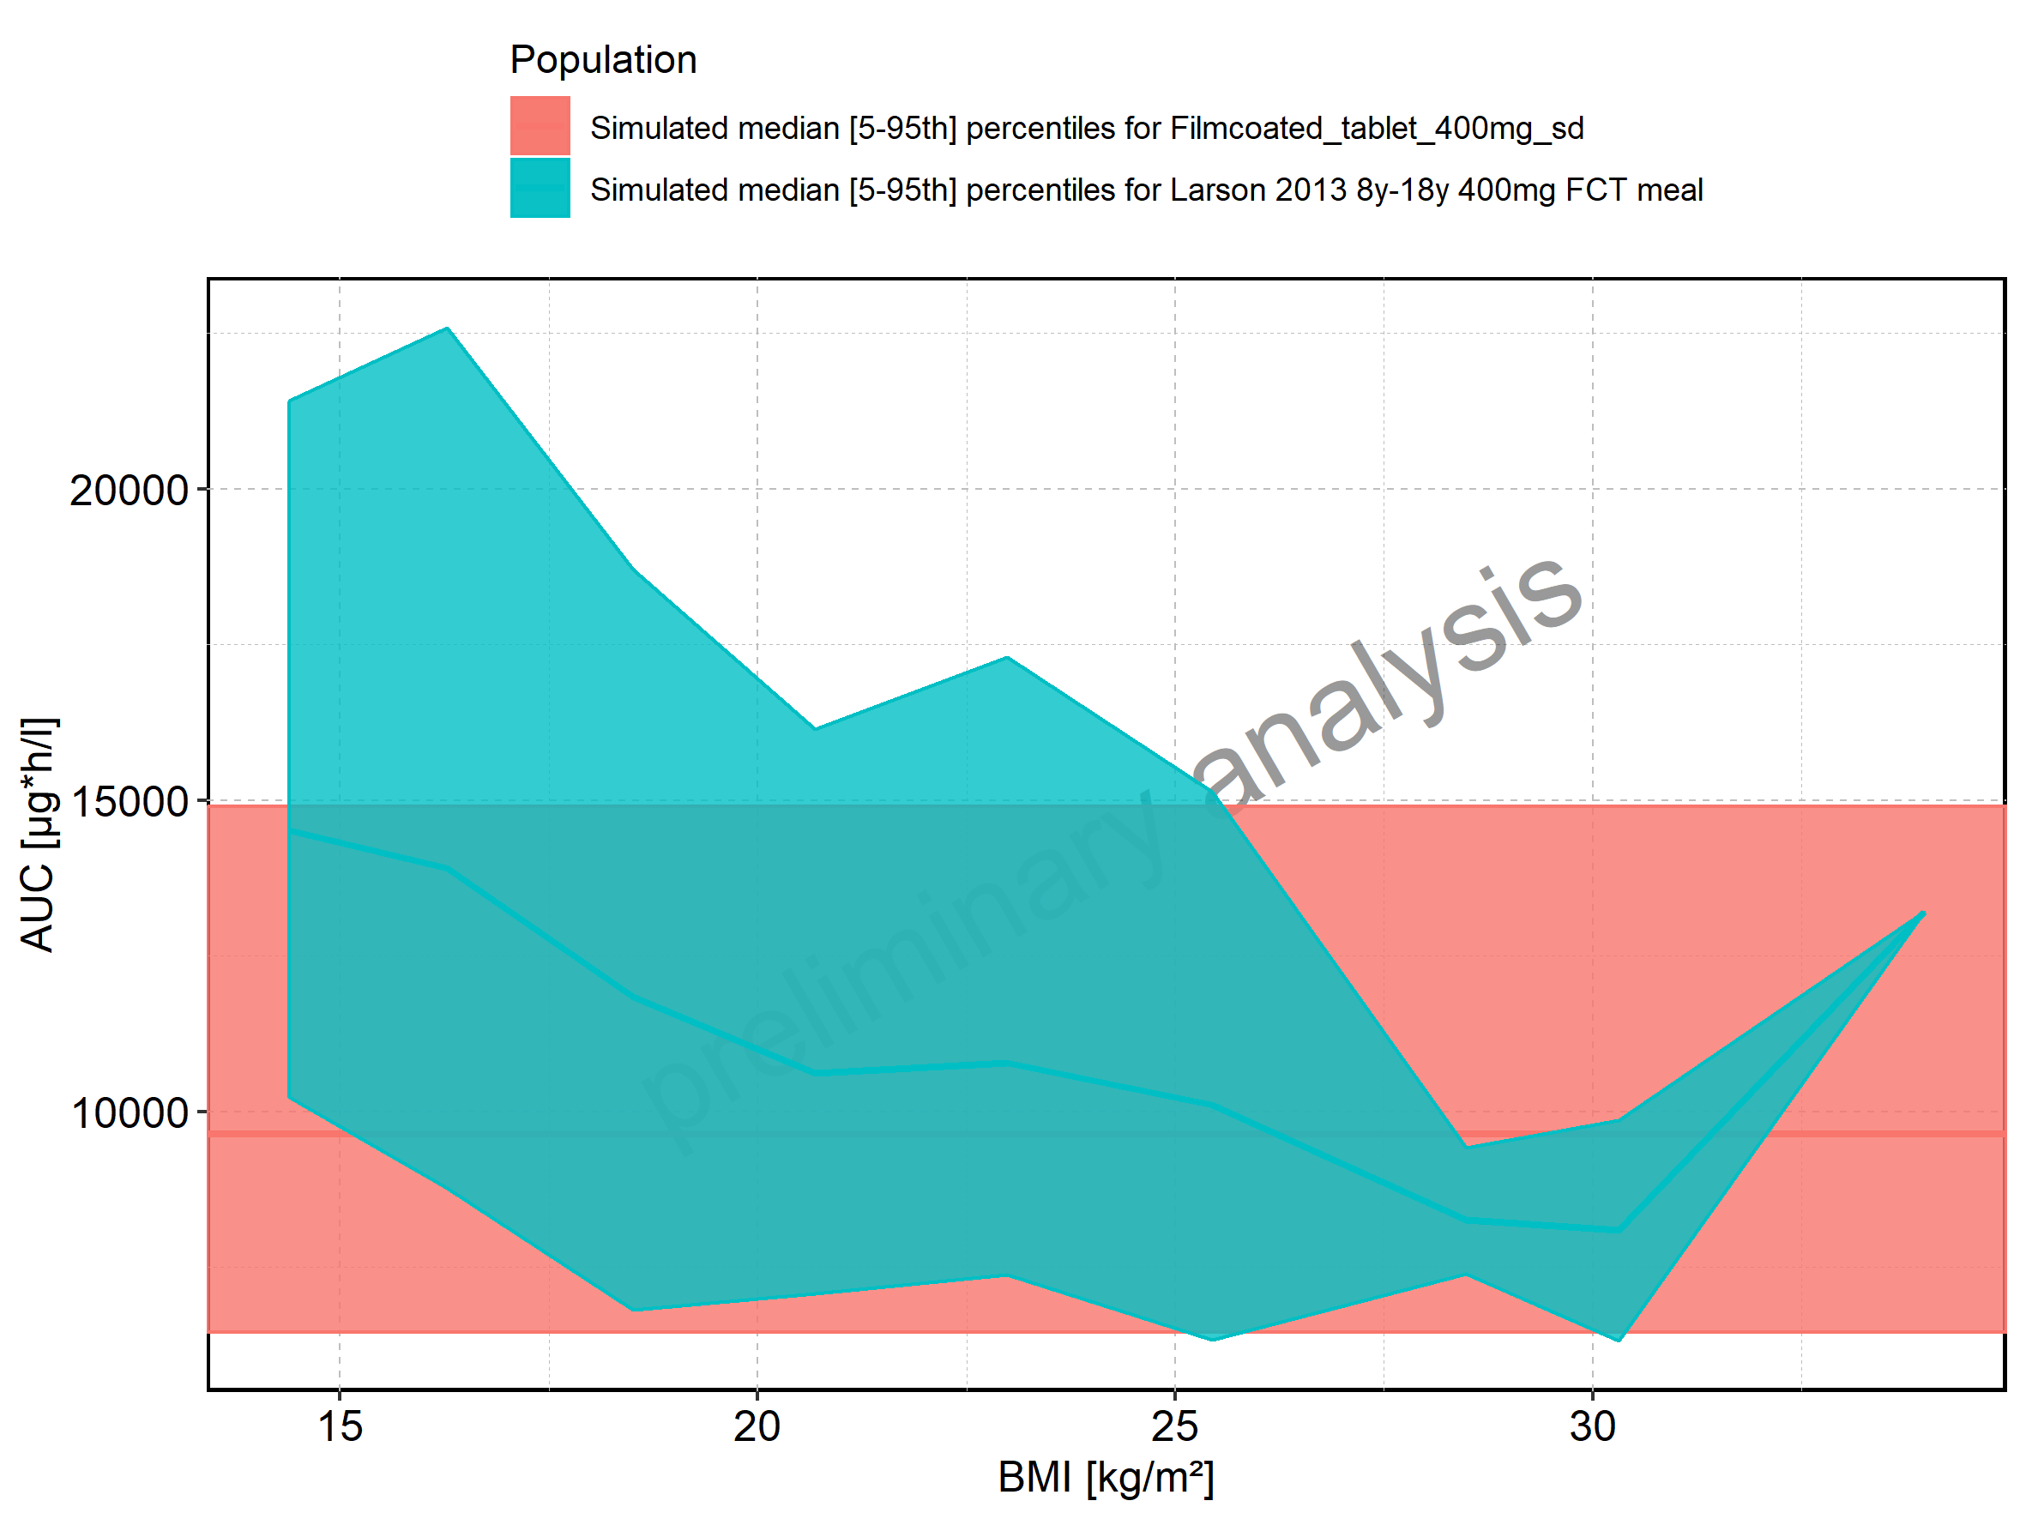

Figure 136: BMI-dependence of AUC for Larson 2013 8y-18y 400mg FCT meal in comparison to Filmcoated_tablet_400mg_sd. Profiles are plotted in a logarithmic scale.

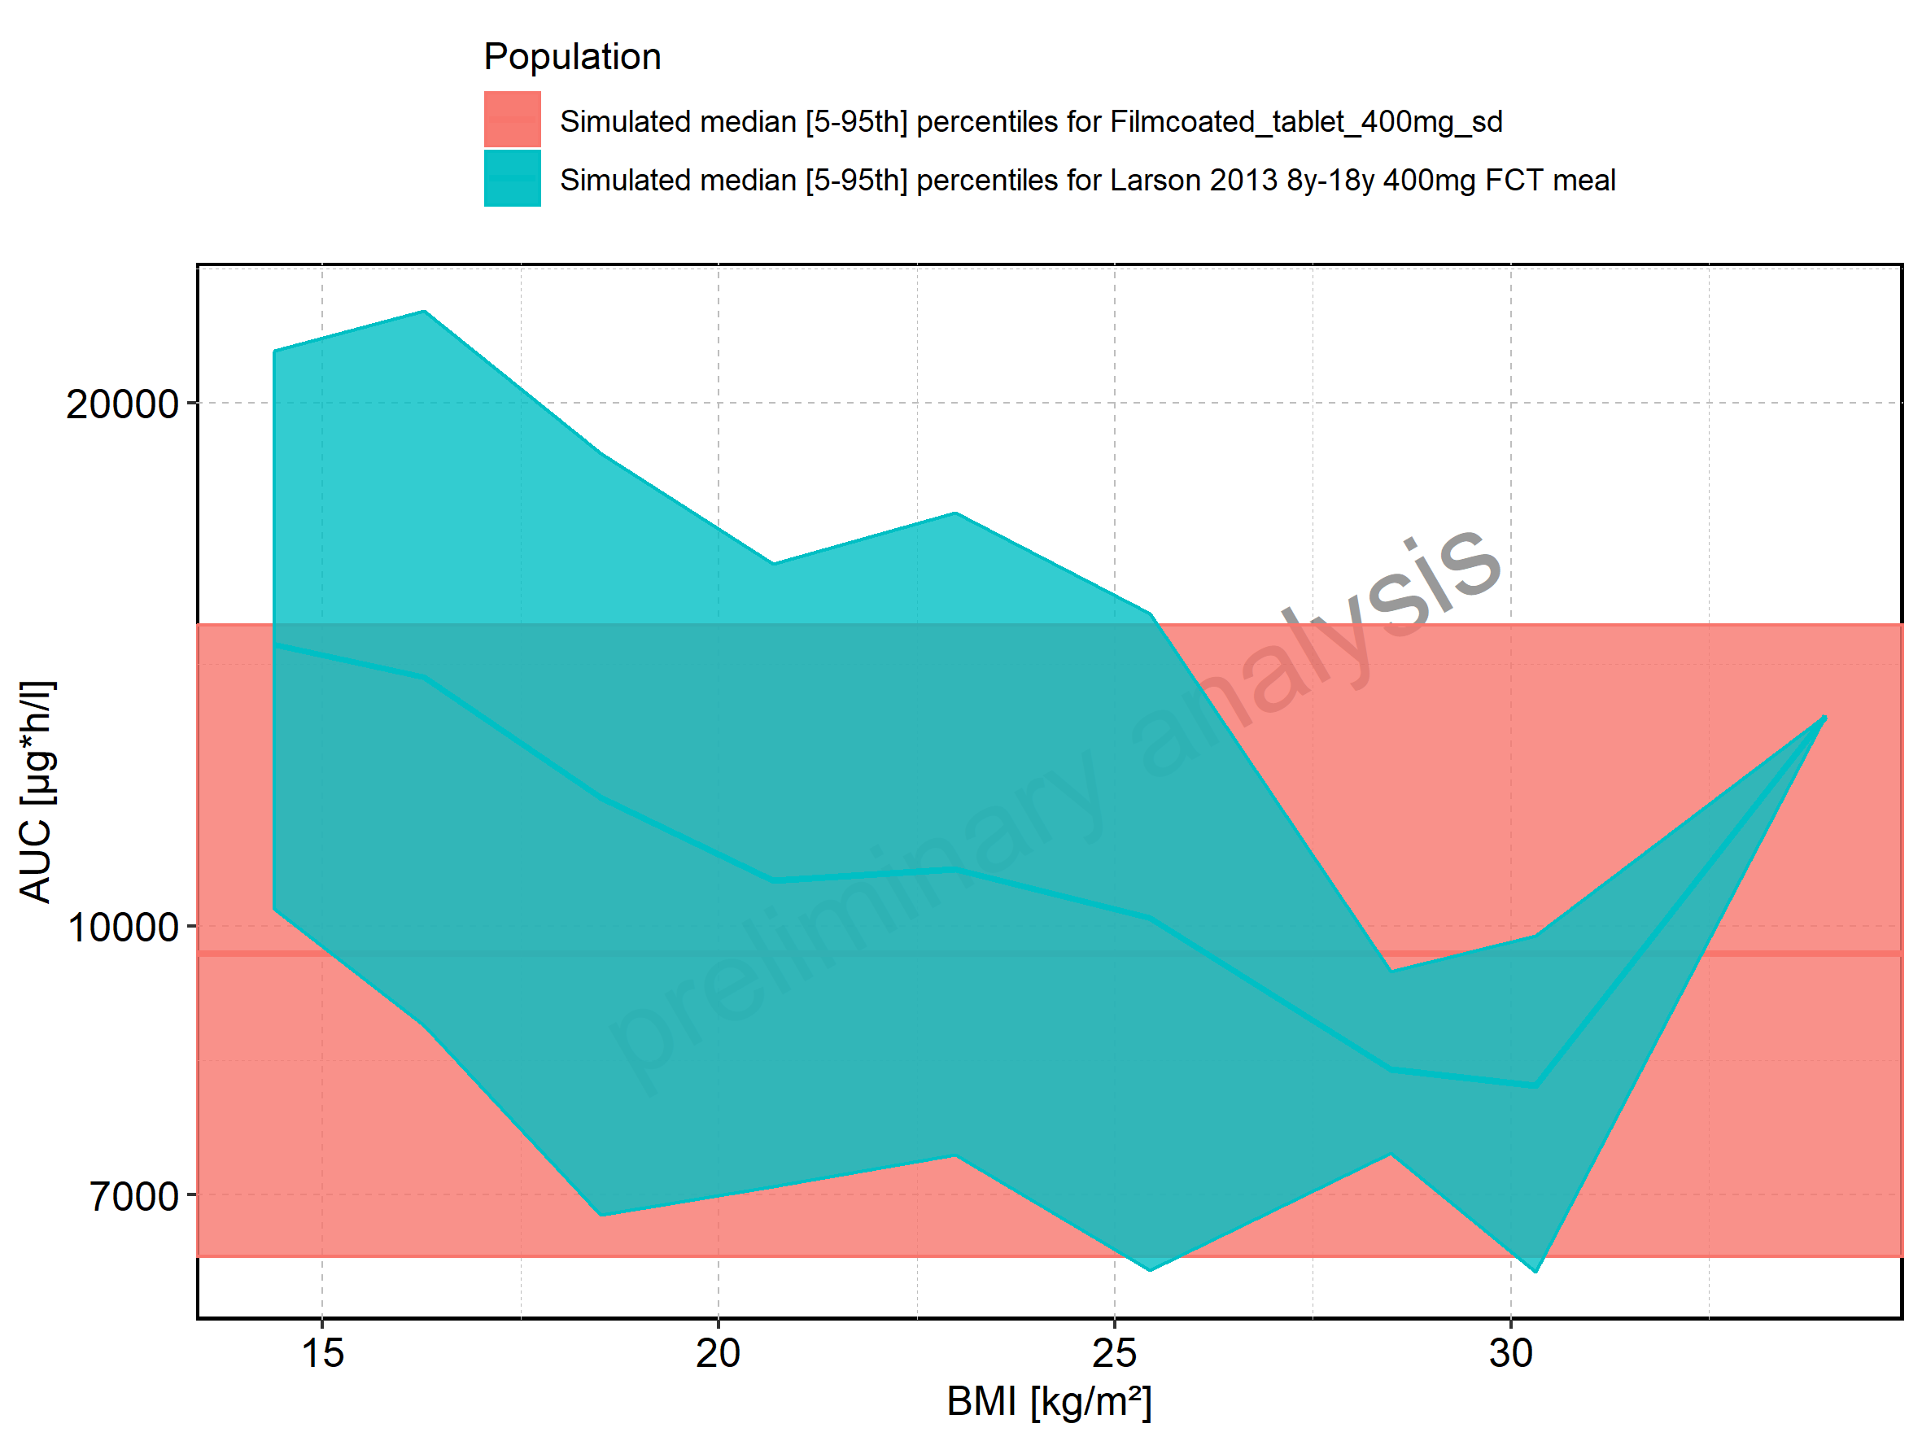

Figure 137: BMI-dependence of AUC for Larson 2013 8y-18y 400mg FCT meal. Profiles are plotted in a linear scale.

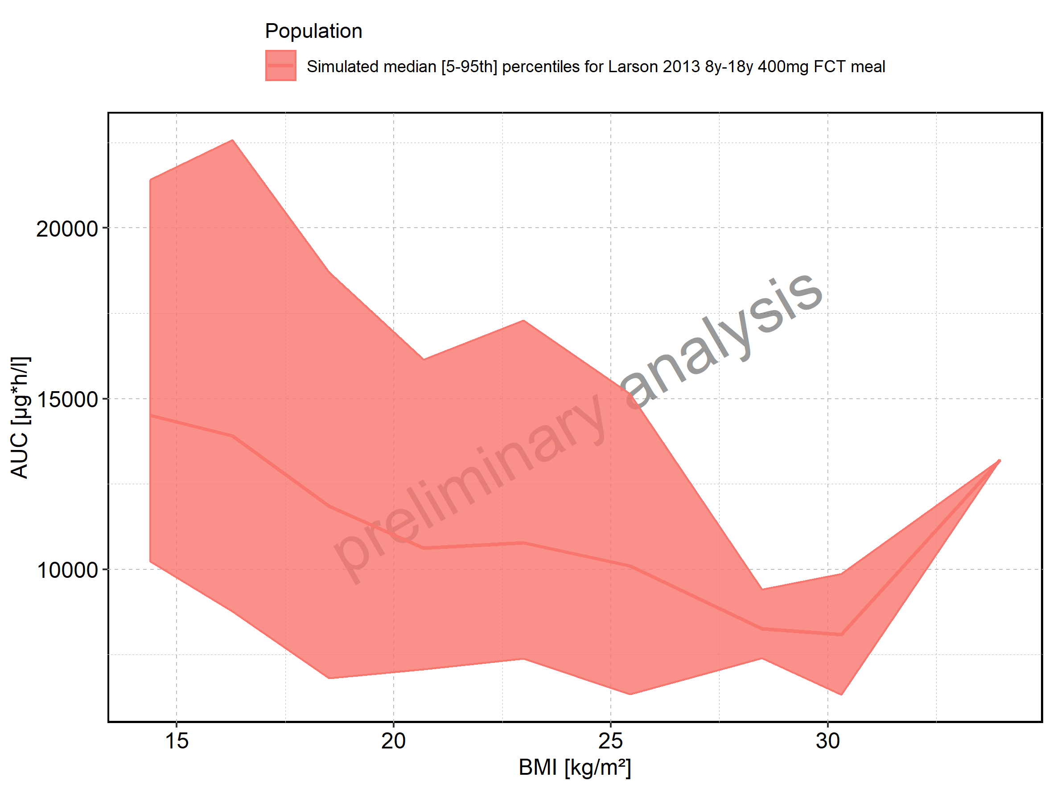

Figure 138: BMI-dependence of AUC for Larson 2013 8y-18y 400mg FCT meal. Profiles are plotted in a logarithmic scale.

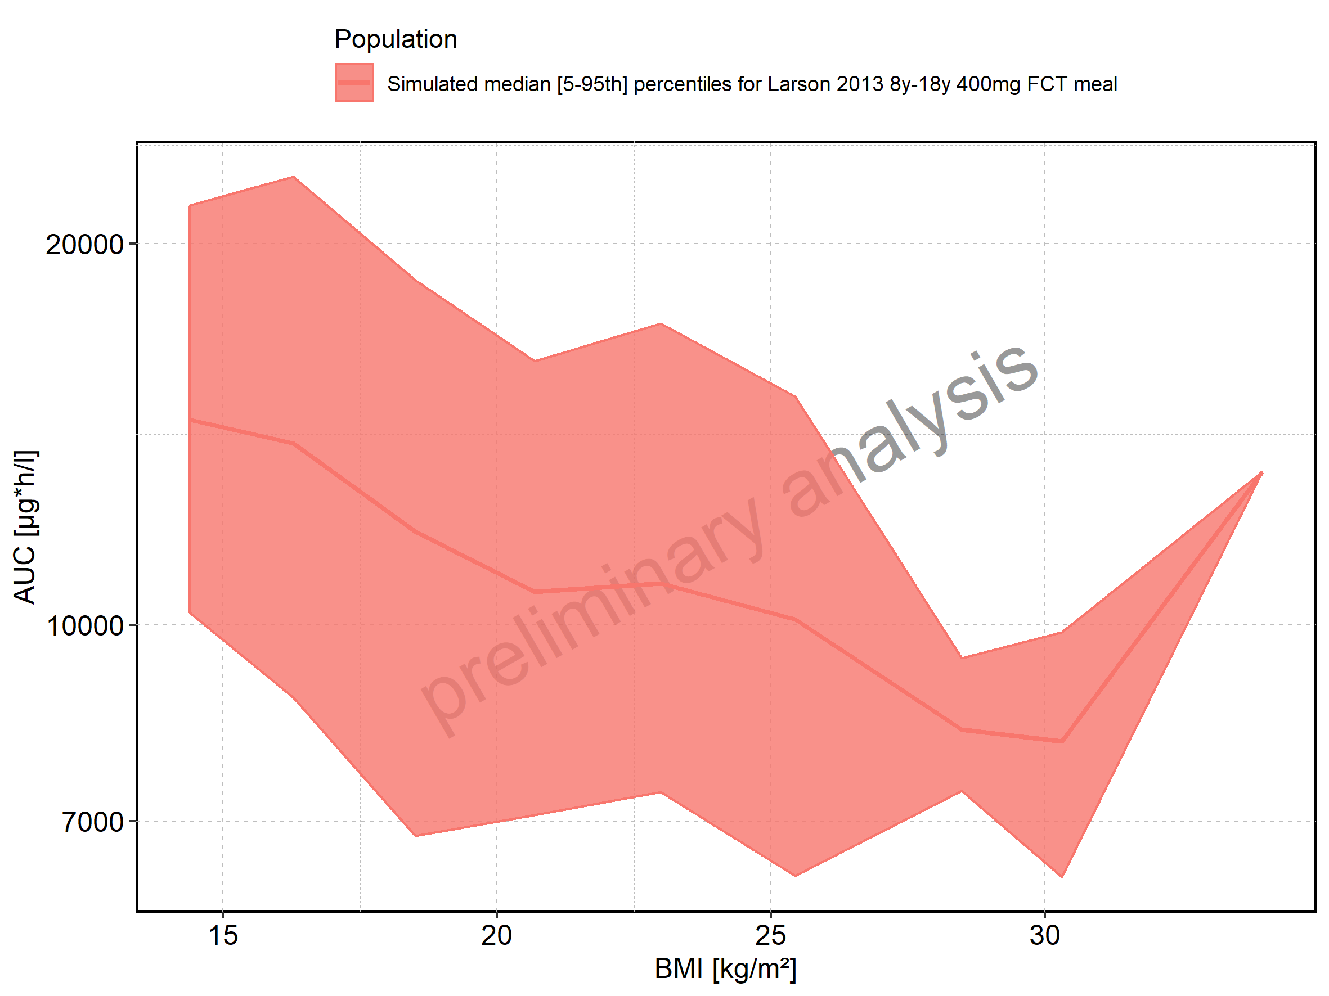

Figure 139: BMI-dependence of AUC for Filmcoated_tablet_400mg_sd. Profiles are plotted in a linear scale.

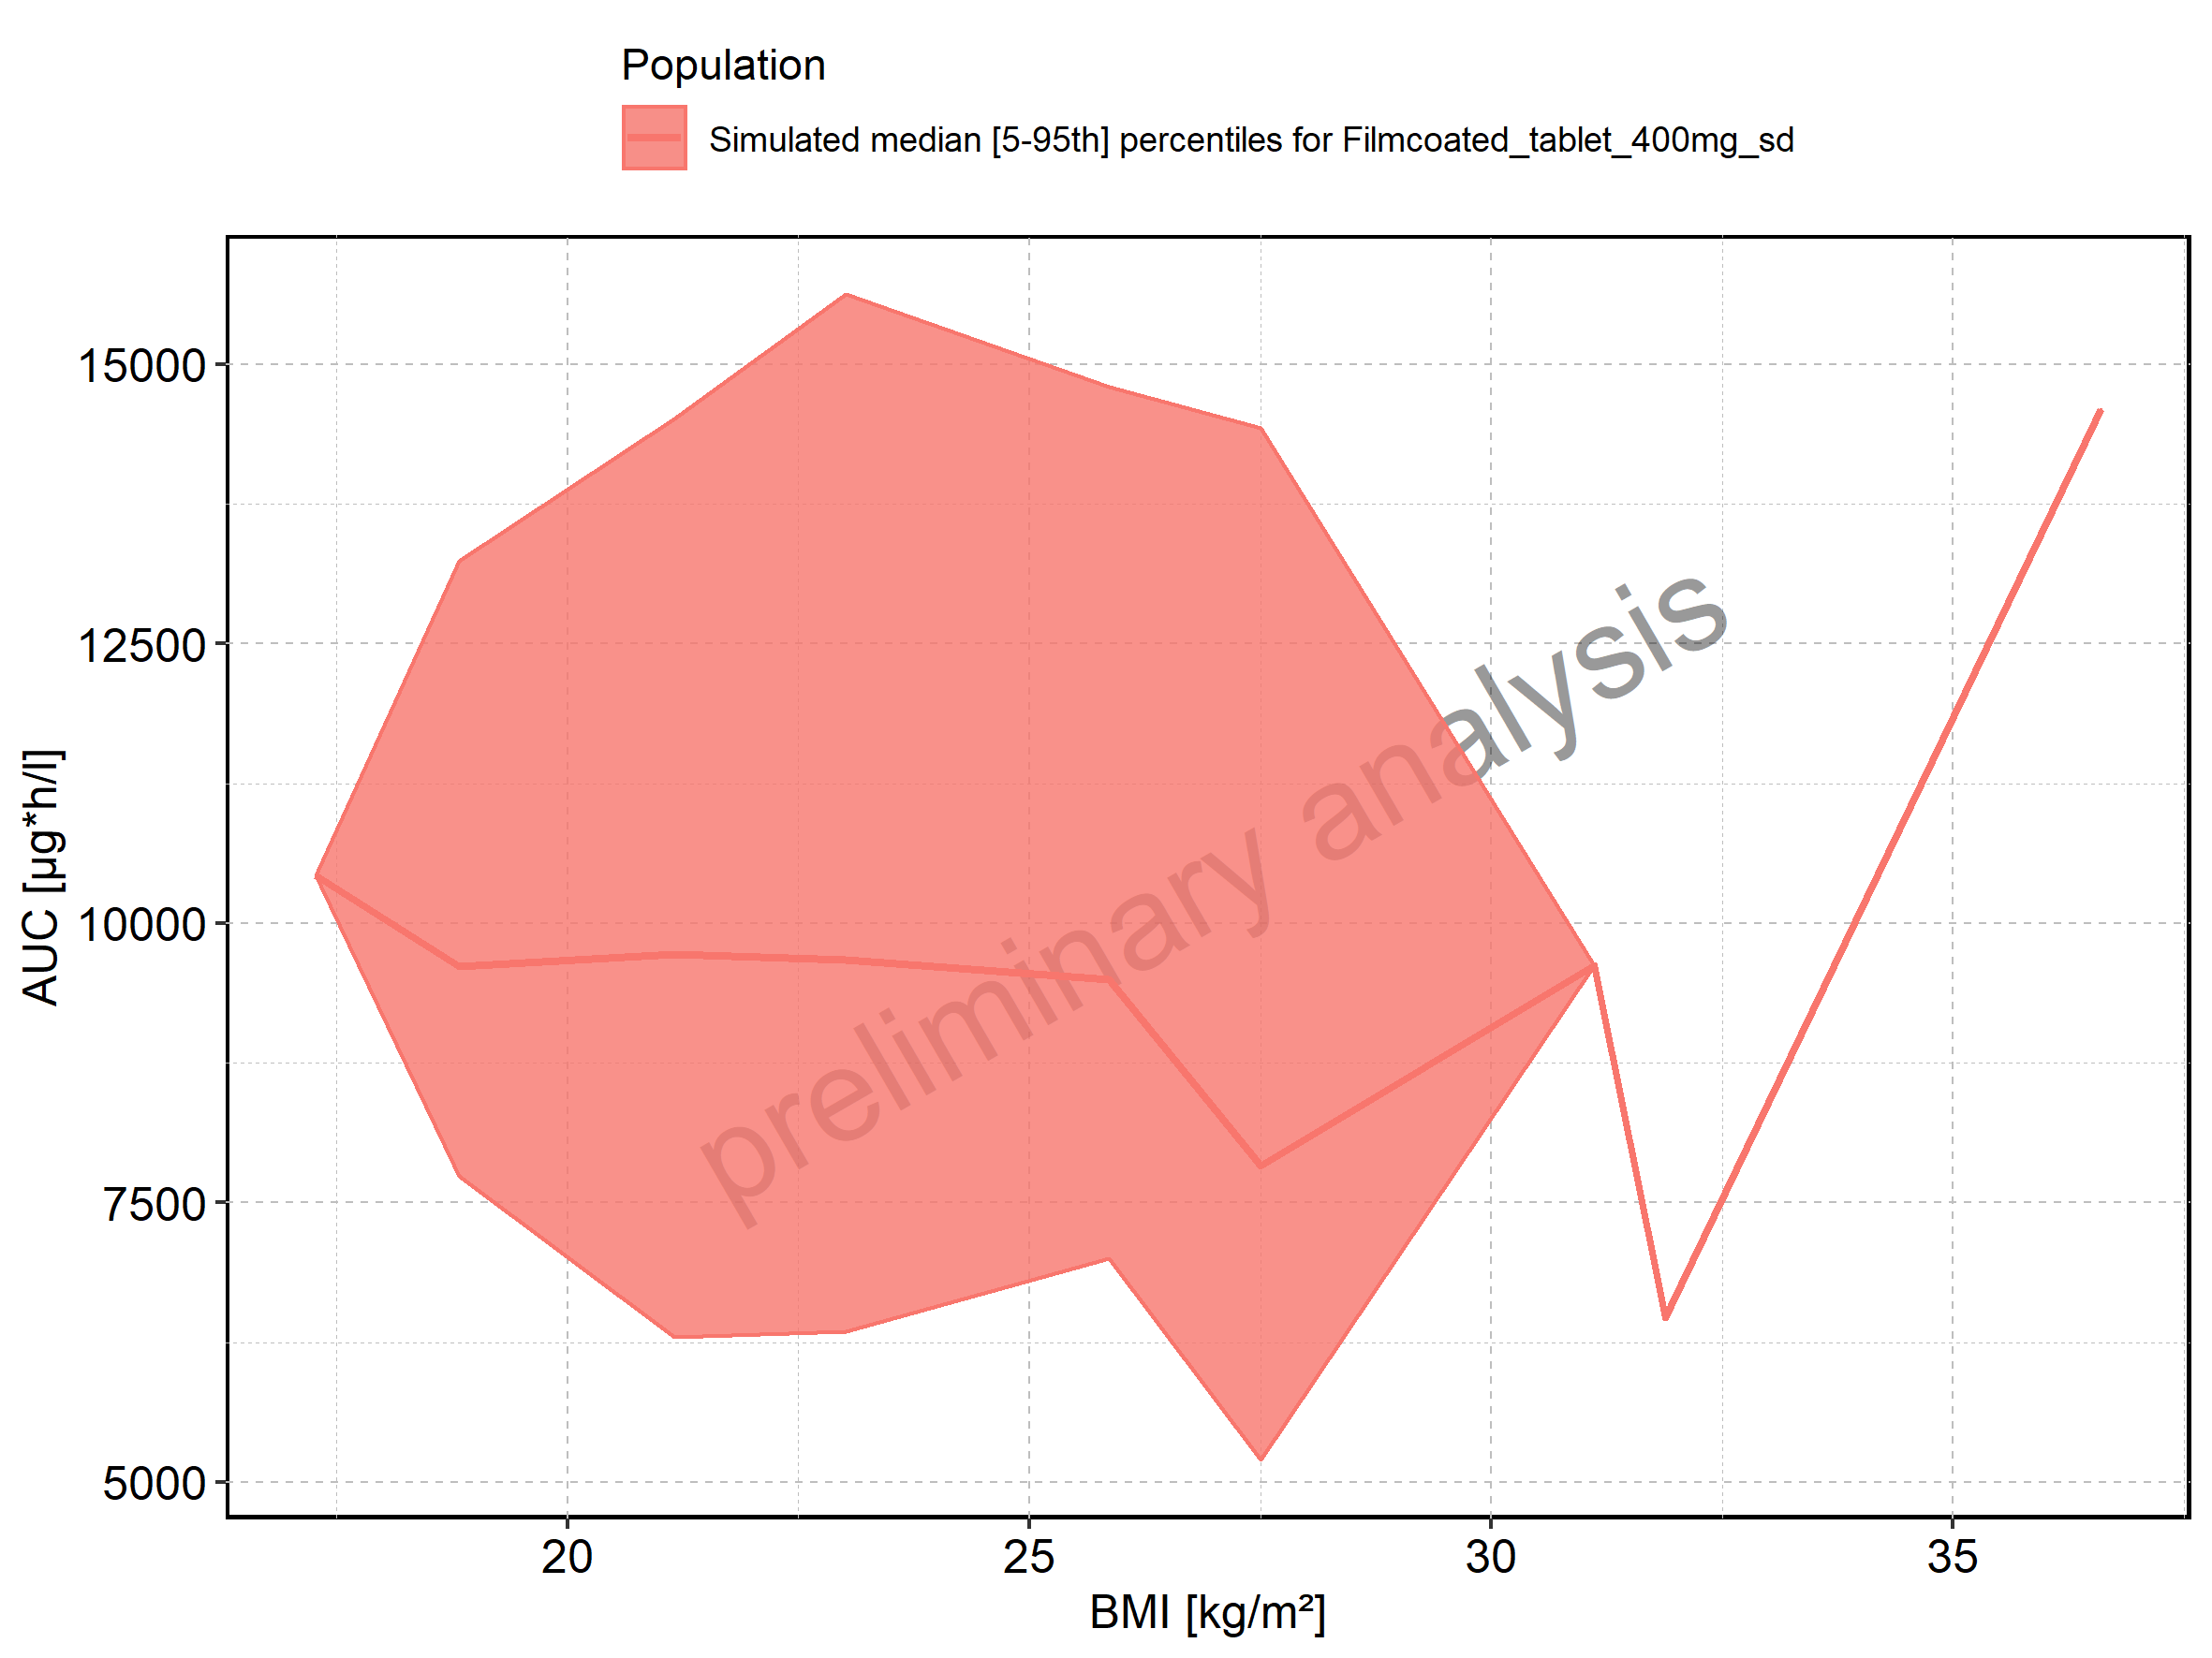

Figure 140: BMI-dependence of AUC for Filmcoated_tablet_400mg_sd. Profiles are plotted in a logarithmic scale.

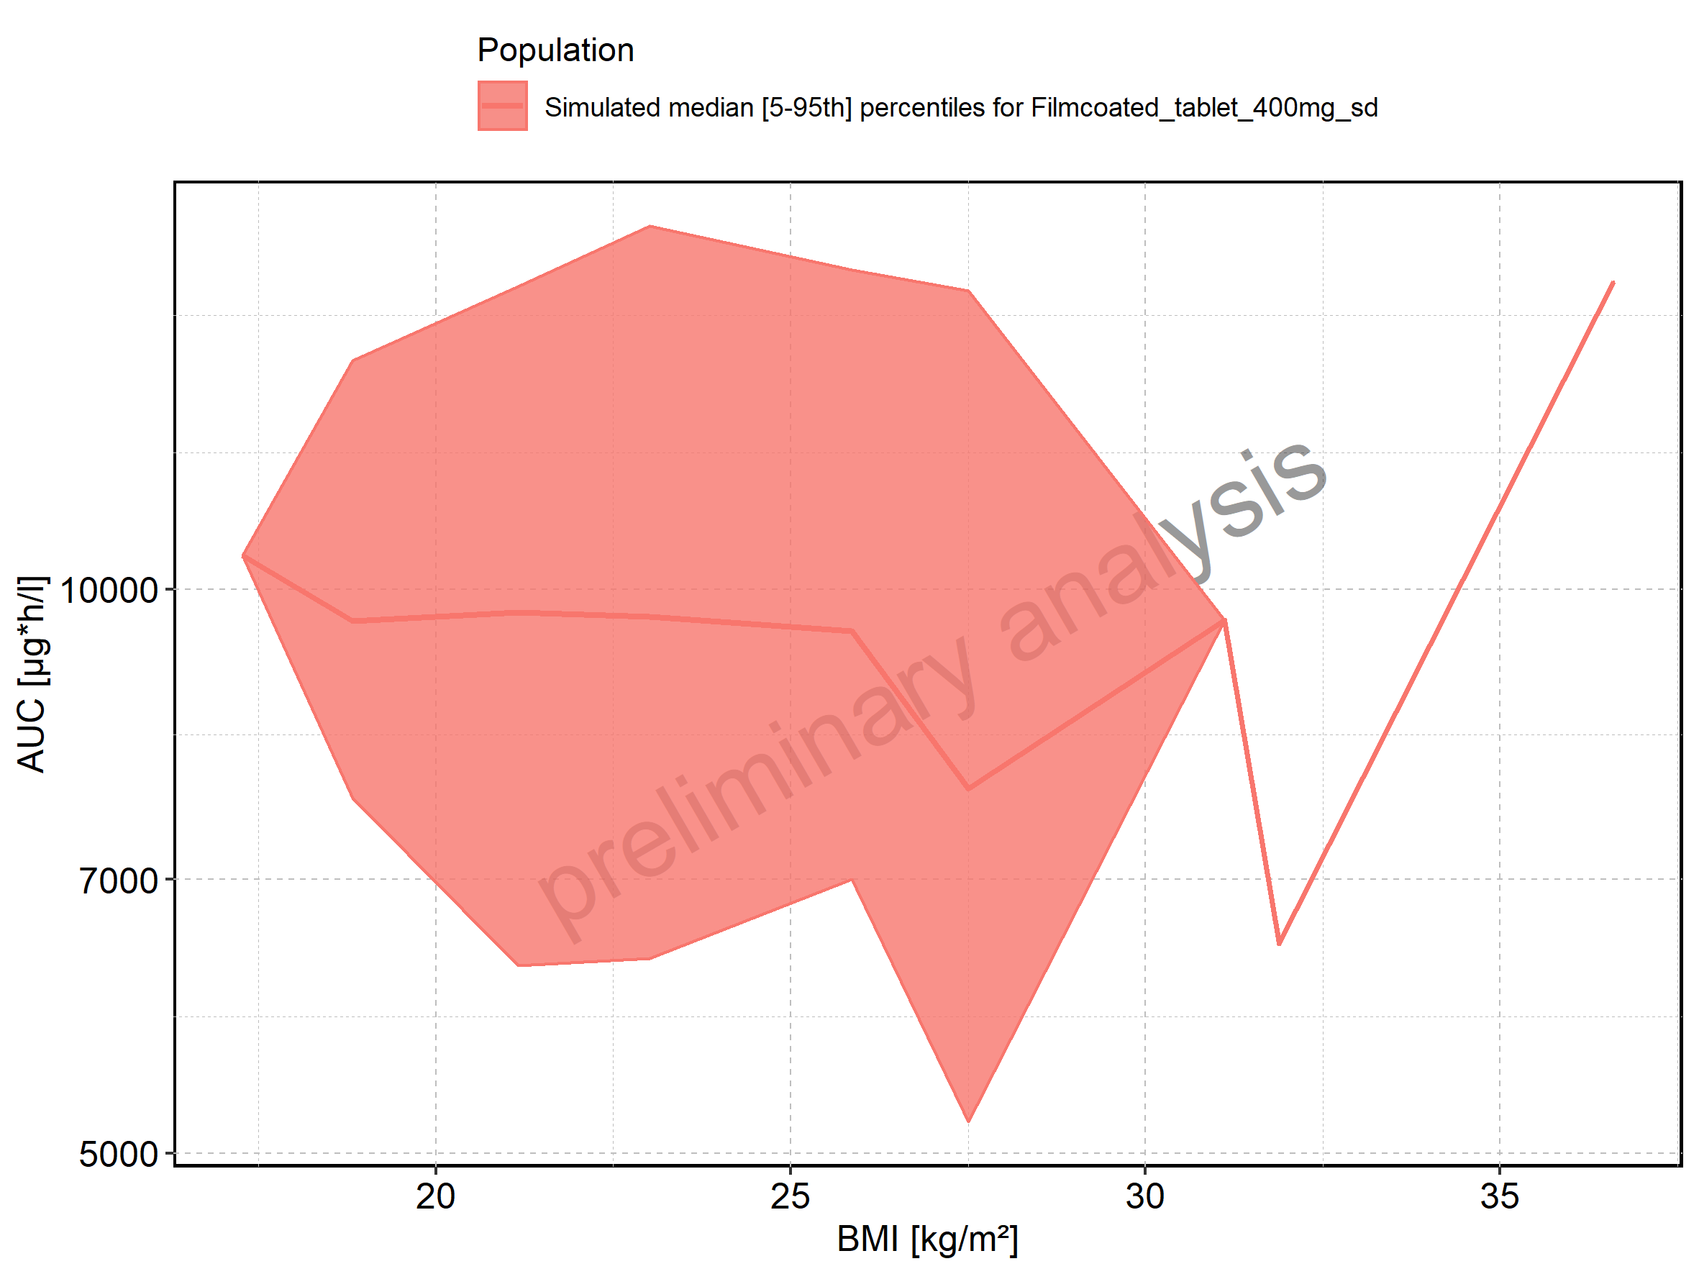

Figure 141: AUC_norm of Raltegravir shown as box-whisker plot, which indicates the 5th, 25th, 50th, 75th, and 95th percentiles in linear scale.

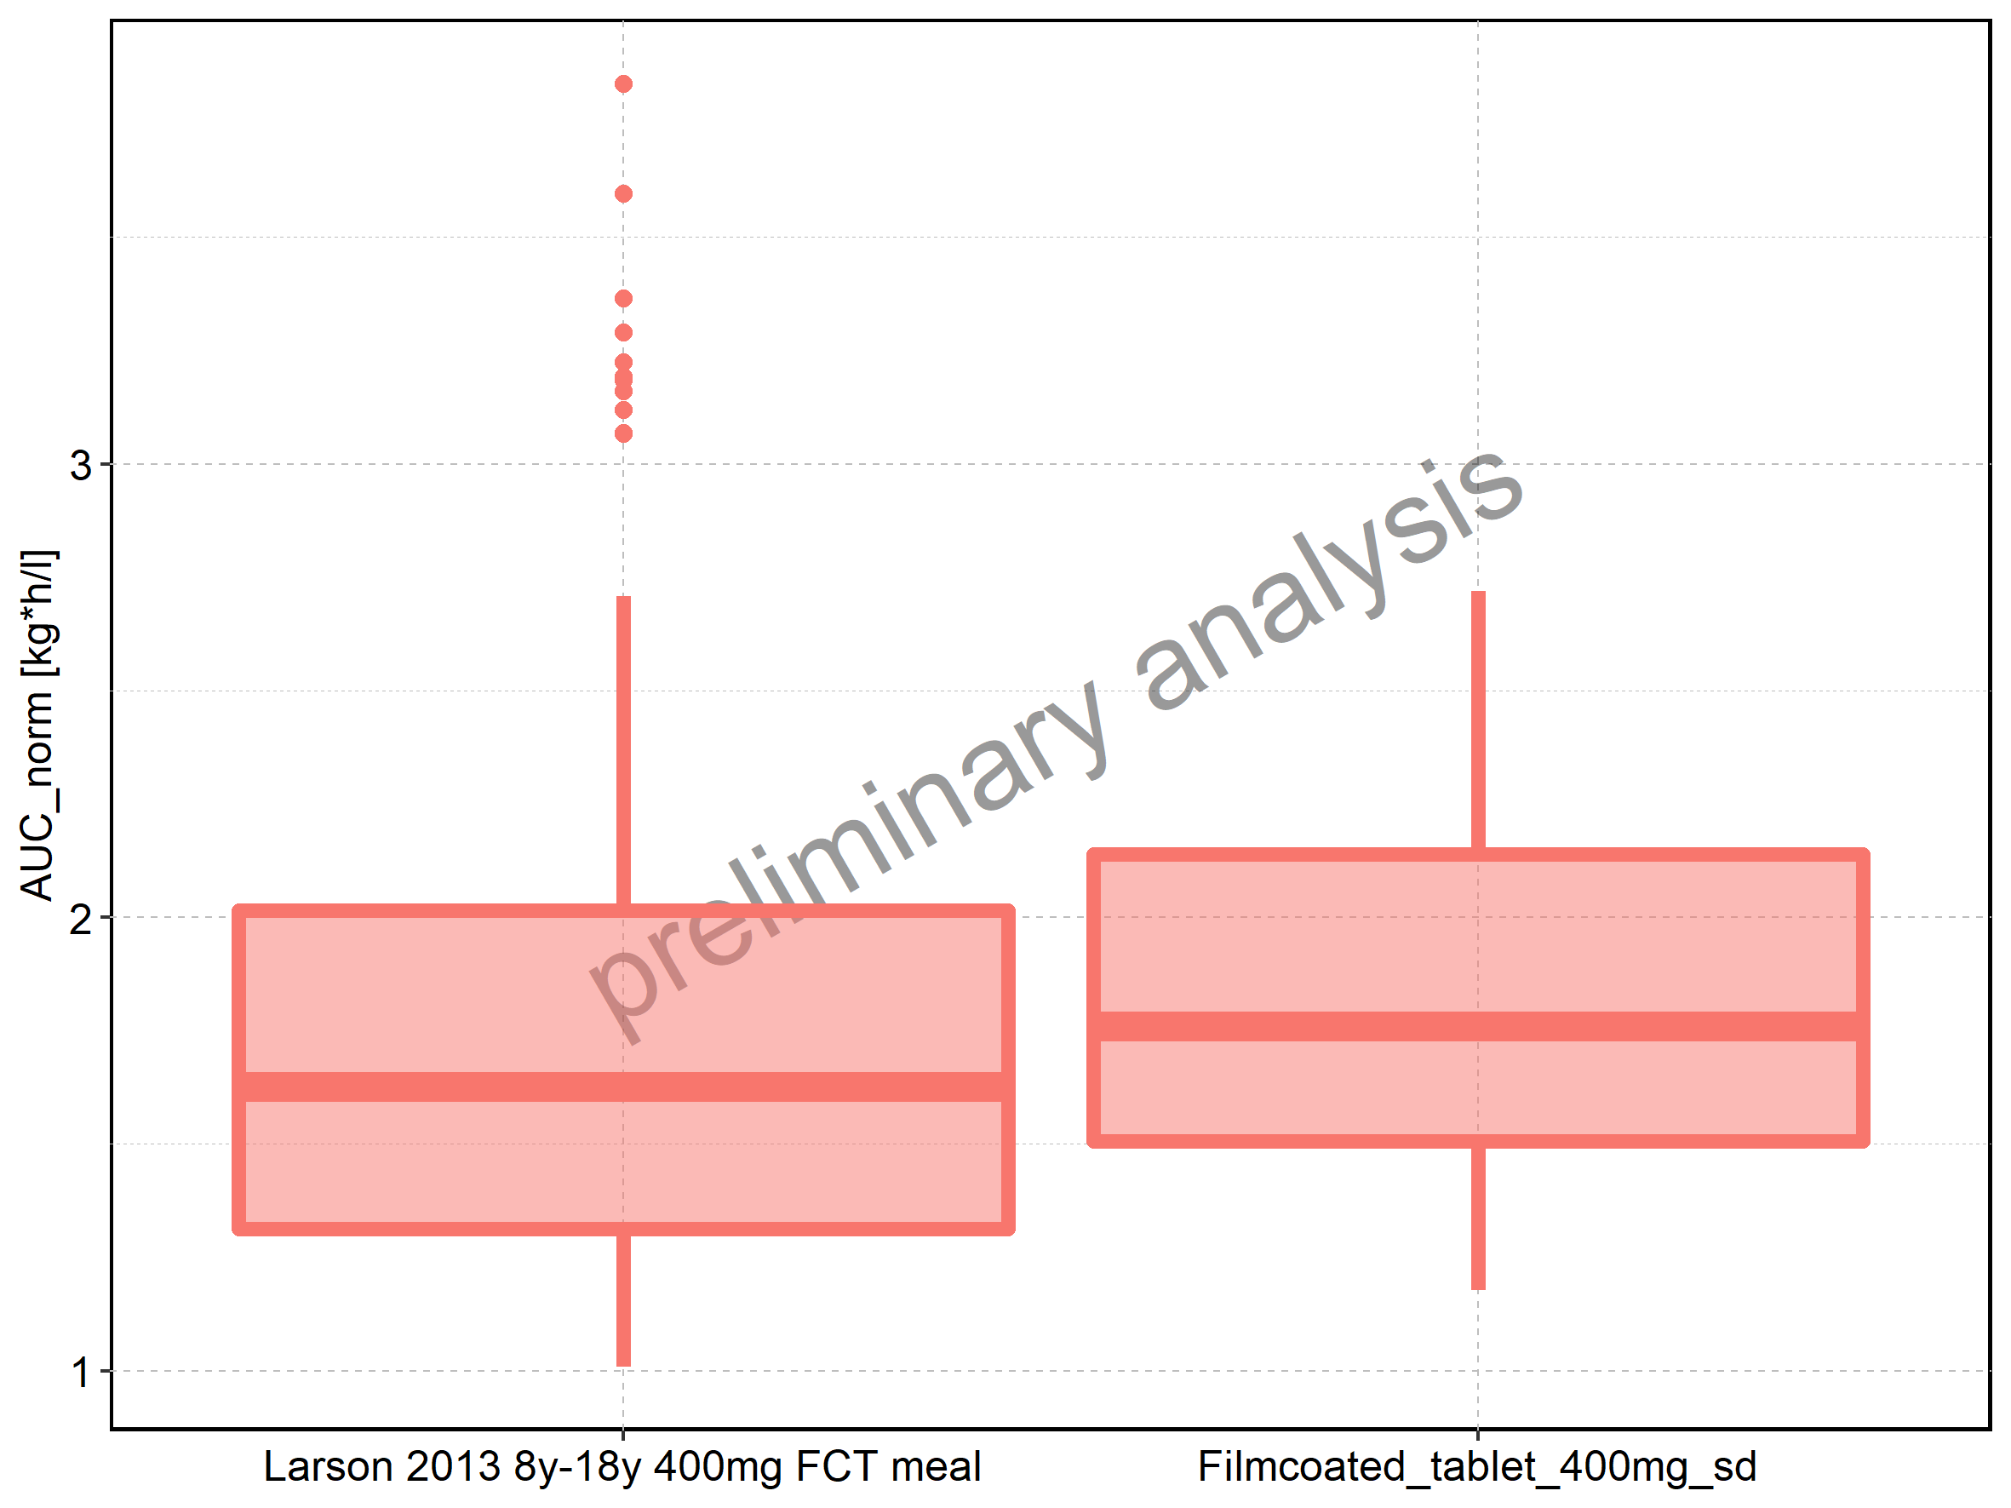

|  |  |  |  |  |  |  |  |  |  |  |
| --- | --- | --- | --- | --- | --- | --- | --- | --- | --- | --- |
| Population | N | 5th percentile | 25th percentile | 50th percentile | 75th percentile | 95th percentile | mean | standard deviation | geo mean | geo standard deviation |
| Larson 2013 8y-18y 400mg FCT meal | 500 | 1.009019 | 1.313048 | 1.626128 | 2.014453 | 2.708033 | 1.707981 | 0.5259174 | 1.631852 | 1.353277 |
| Filmcoated_tablet_400mg_sd | 100 | 1.176993 | 1.505395 | 1.758845 | 2.138354 | 2.719452 | 1.848670 | 0.4876933 | 1.785682 | 1.305605 |

Figure 142: AUC_norm of Raltegravir shown as box-whisker plot, which indicates the 5th, 25th, 50th, 75th, and 95th percentiles in logarithmic scale.

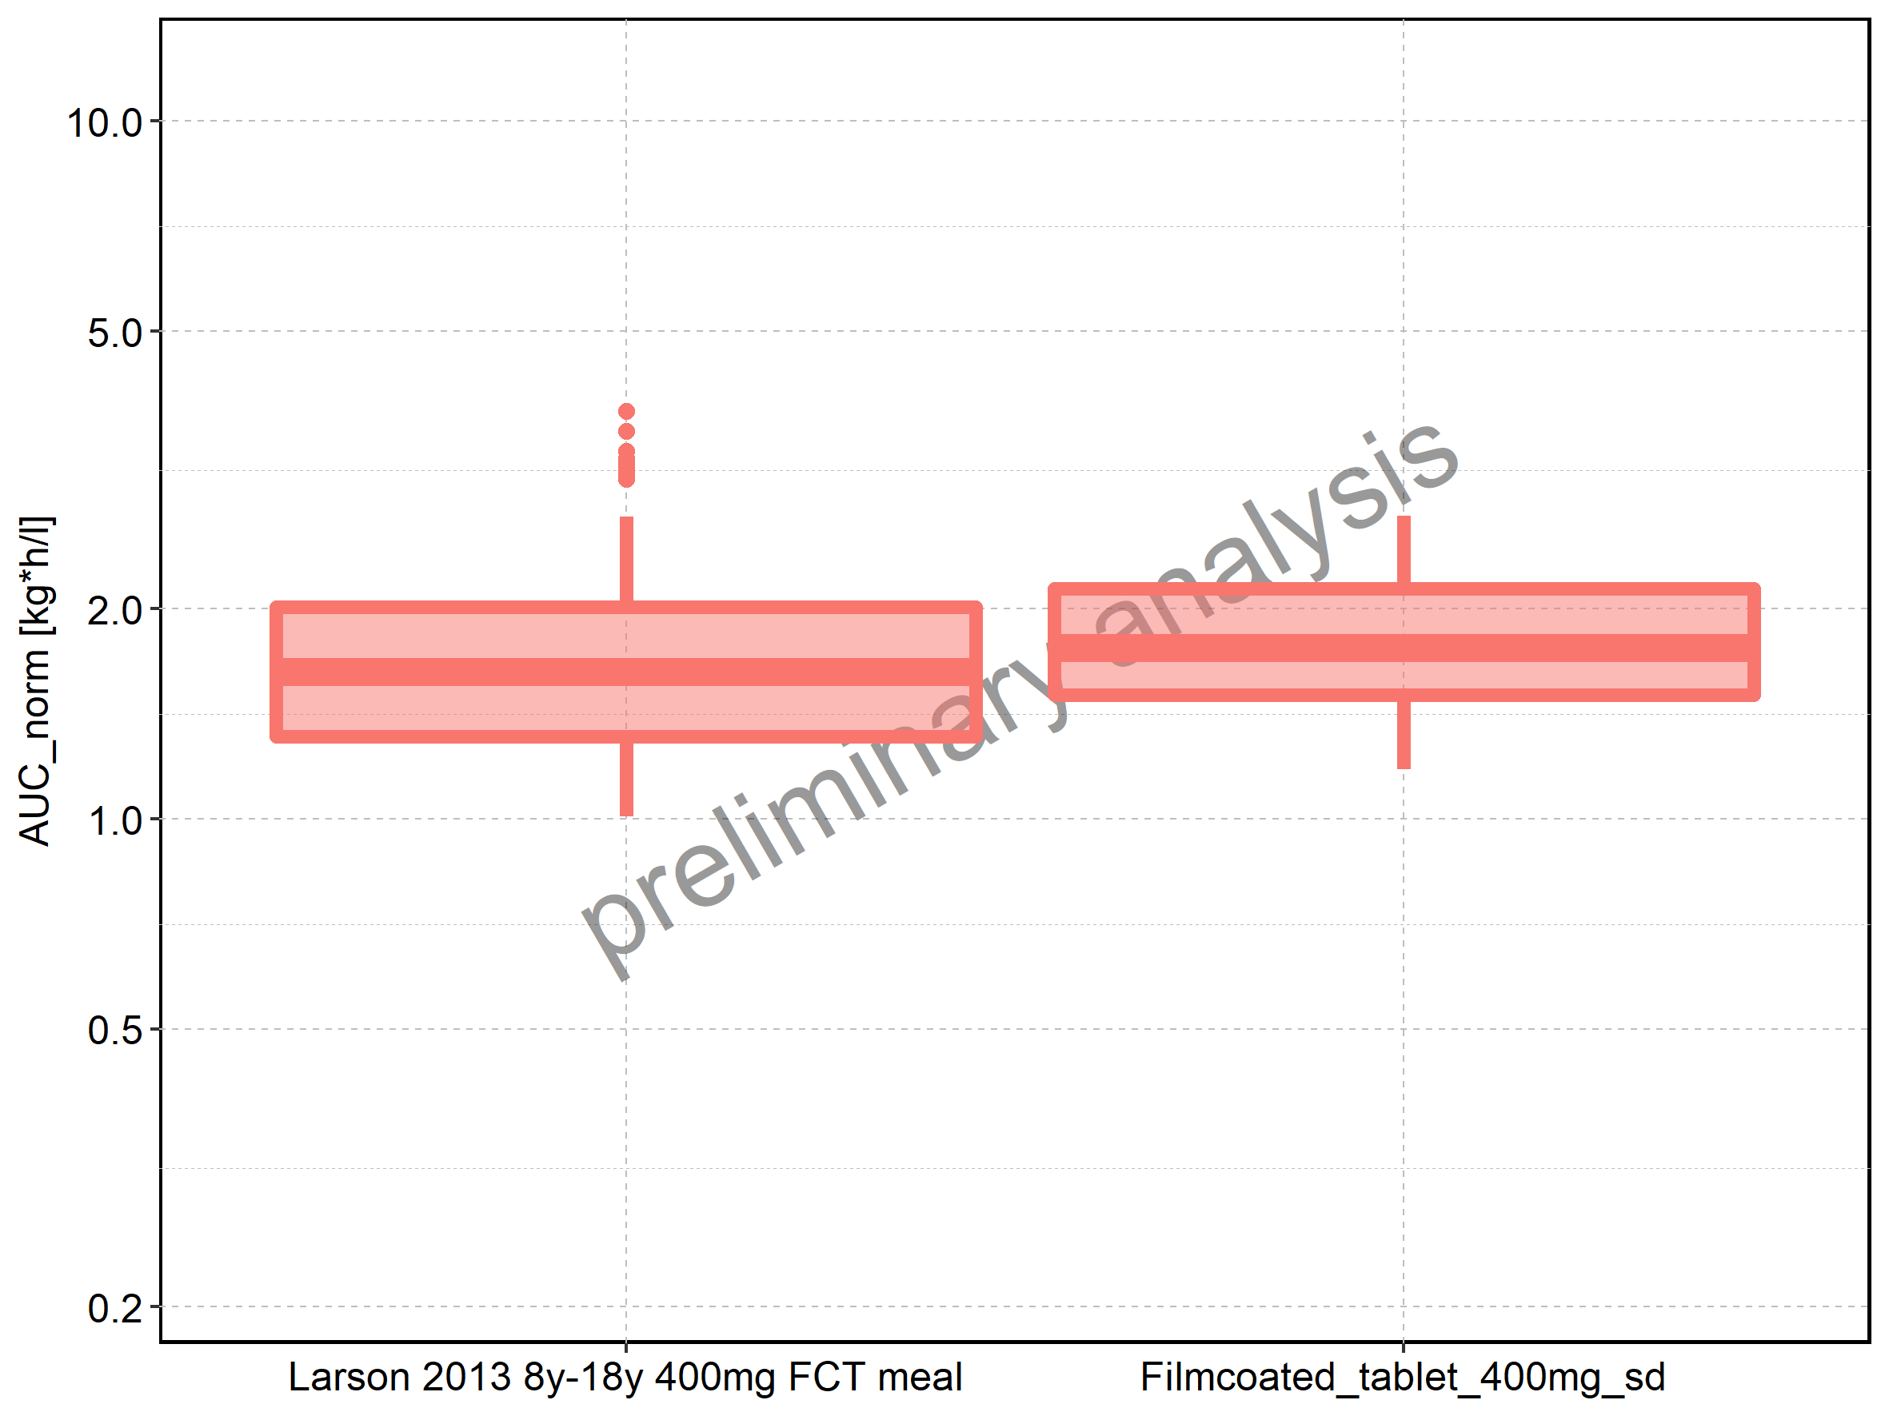

Figure 143: Age-dependence of AUC_norm for Larson 2013 8y-18y 400mg FCT meal in comparison to Filmcoated_tablet_400mg_sd. Profiles are plotted in a linear scale.

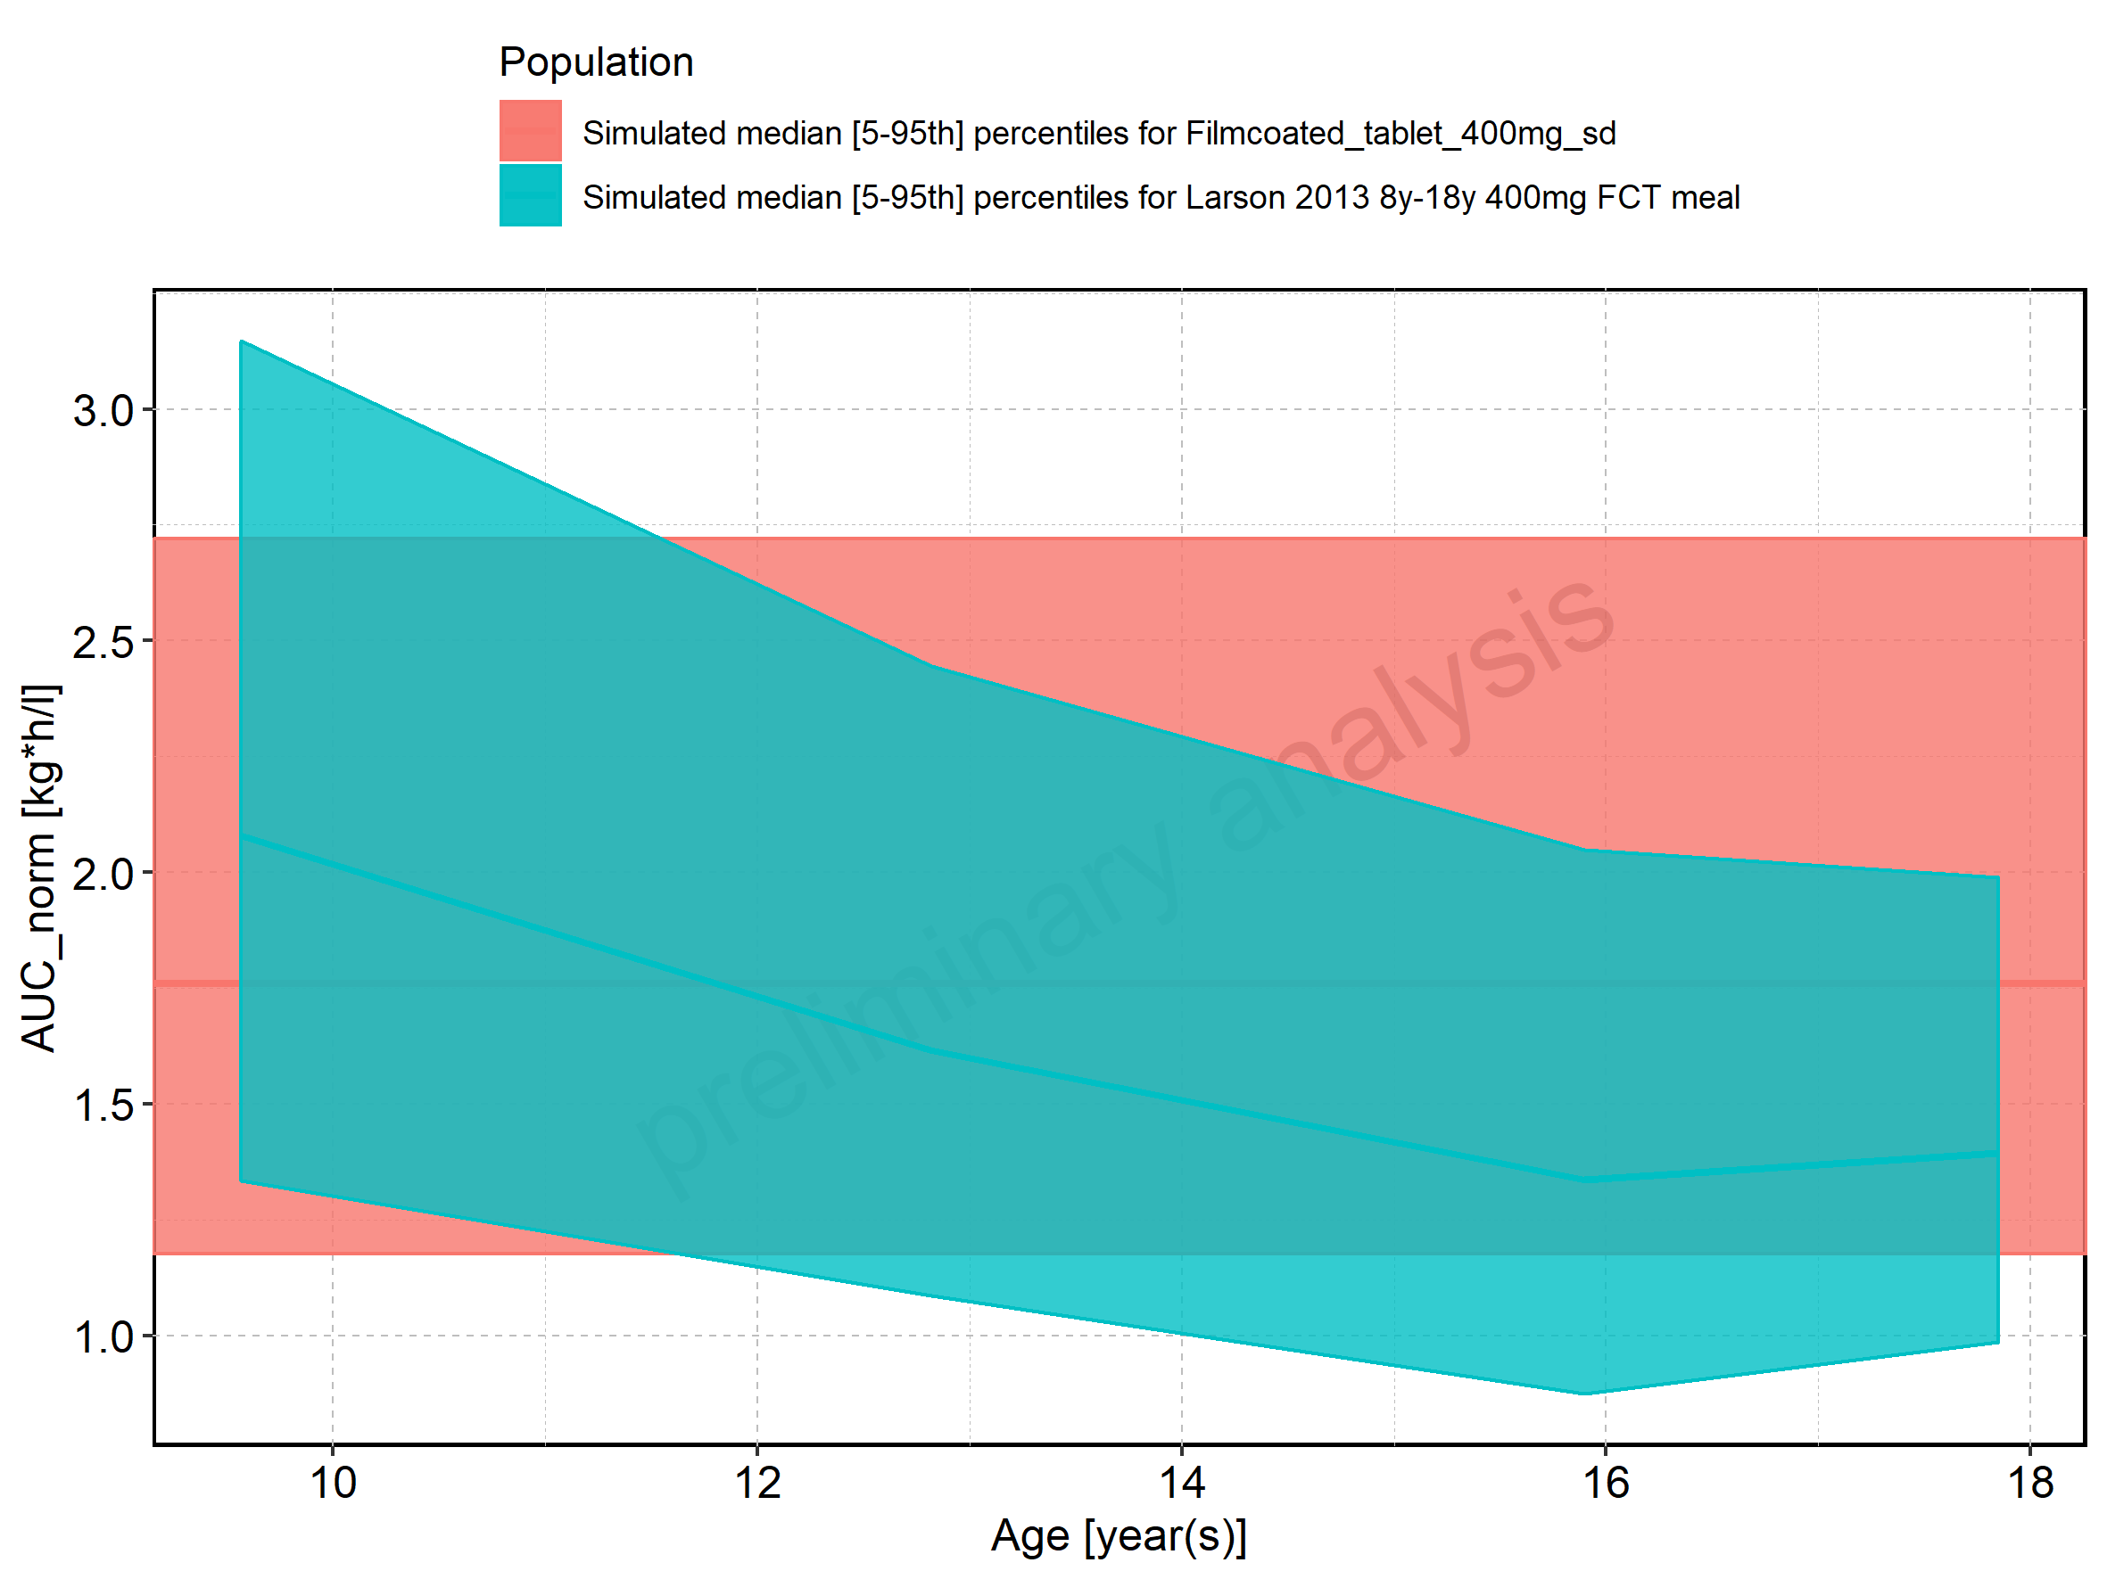

Figure 144: Age-dependence of AUC_norm for Larson 2013 8y-18y 400mg FCT meal in comparison to Filmcoated_tablet_400mg_sd. Profiles are plotted in a logarithmic scale.

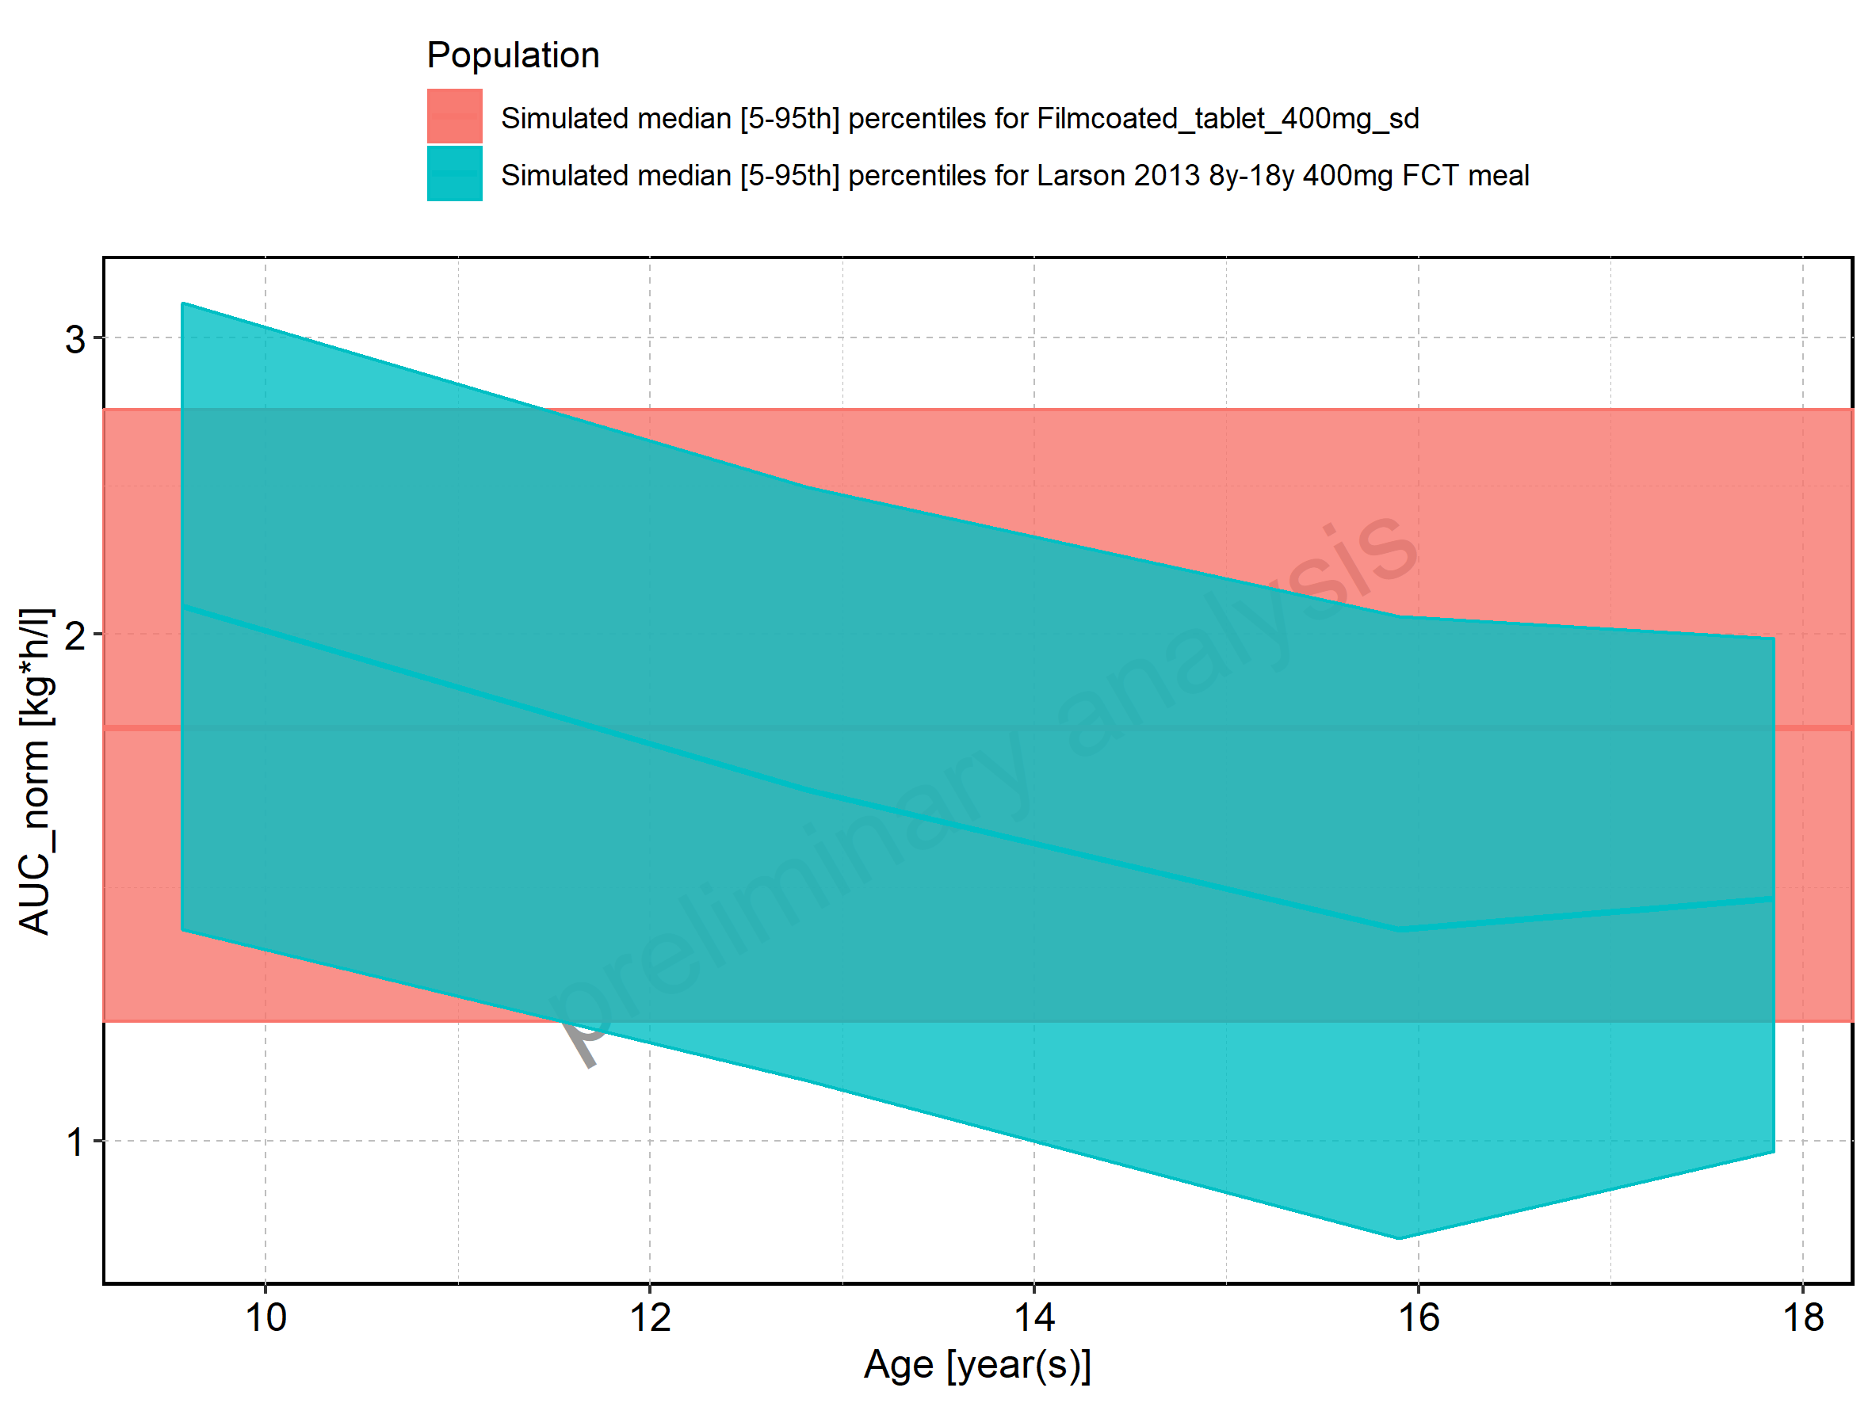

Figure 145: Age-dependence of AUC_norm for Larson 2013 8y-18y 400mg FCT meal. Profiles are plotted in a linear scale.

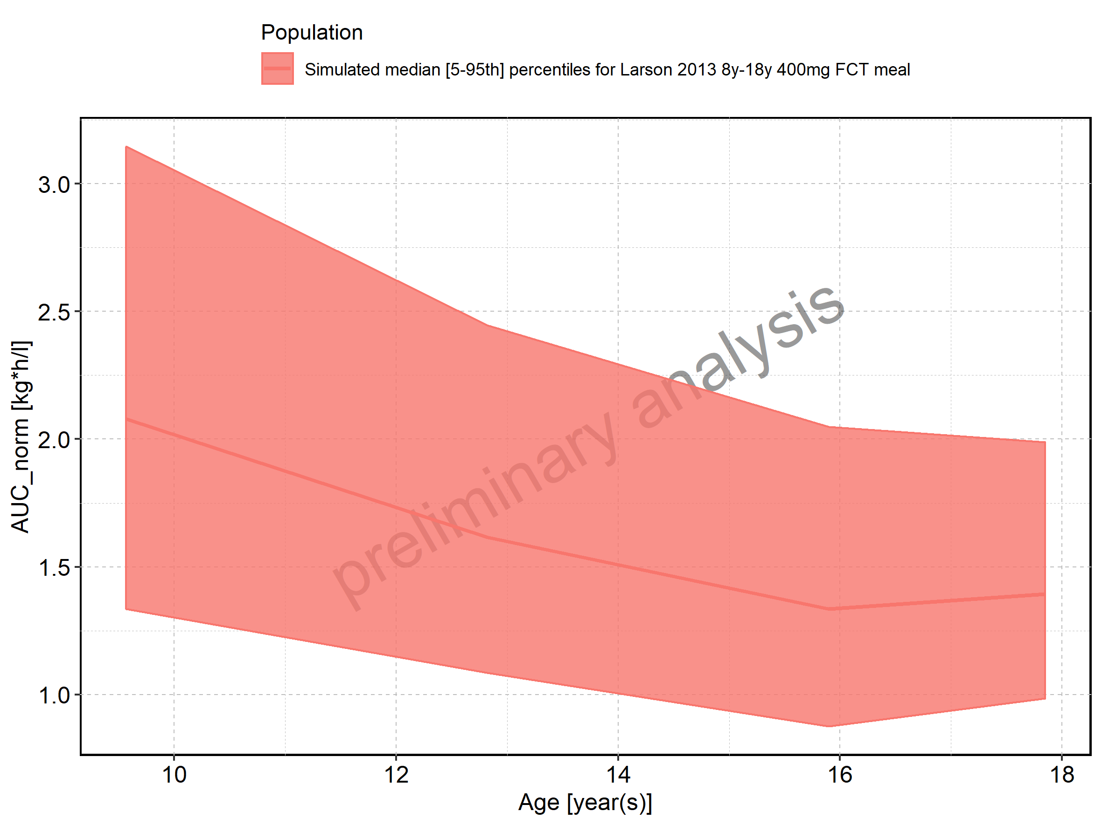

Figure 146: Age-dependence of AUC_norm for Larson 2013 8y-18y 400mg FCT meal. Profiles are plotted in a logarithmic scale.

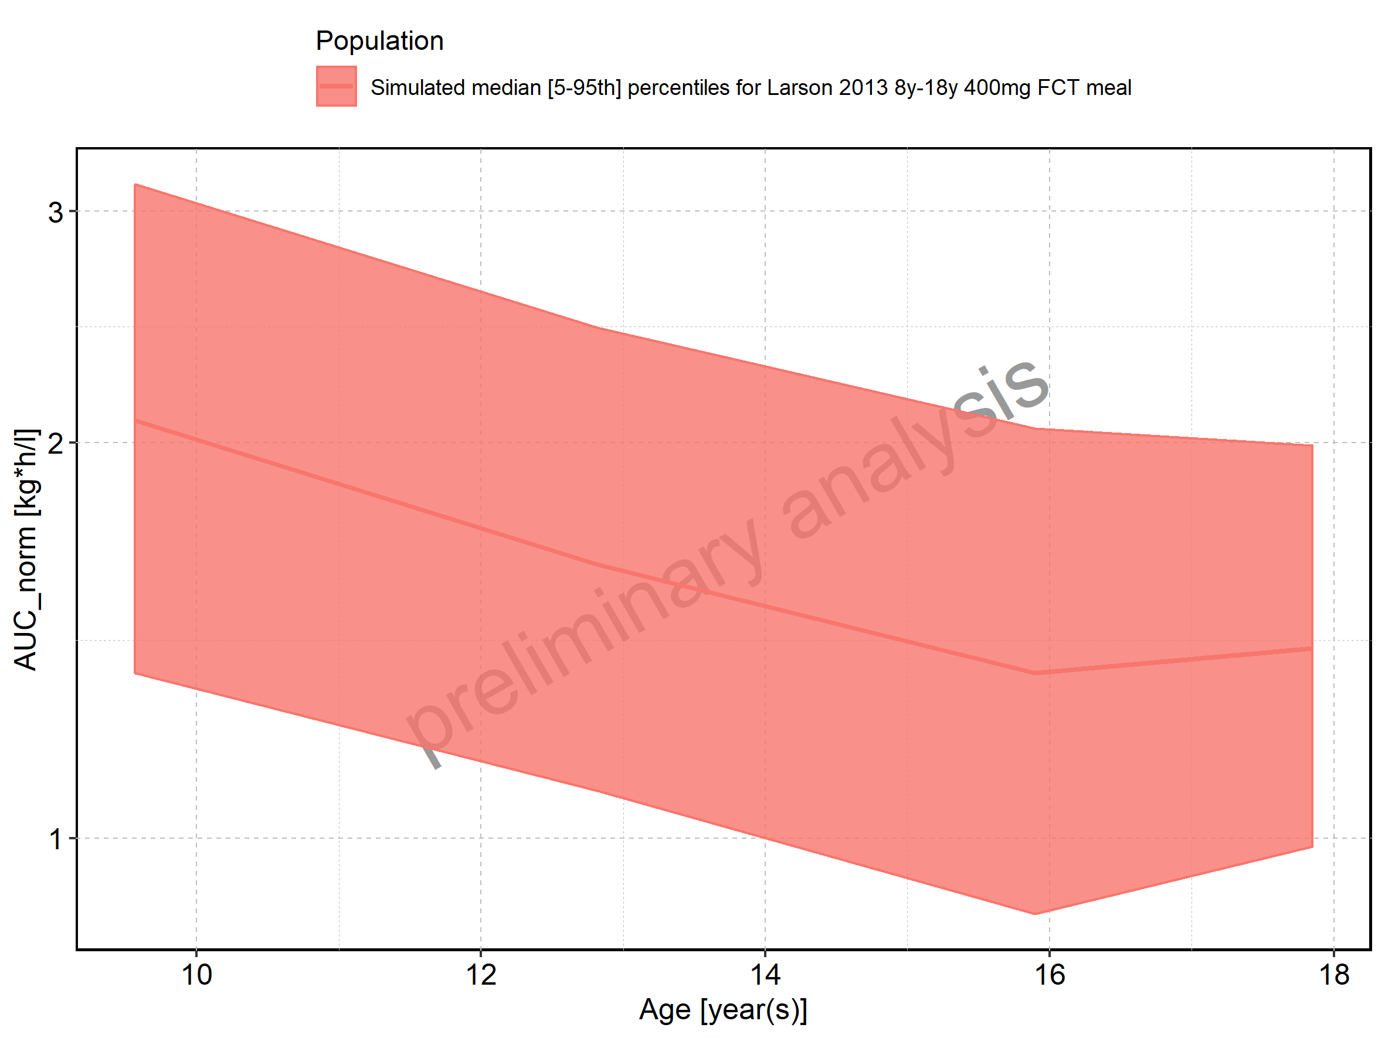

Figure 147: Age-dependence of AUC_norm for Filmcoated_tablet_400mg_sd. Profiles are plotted in a linear scale.

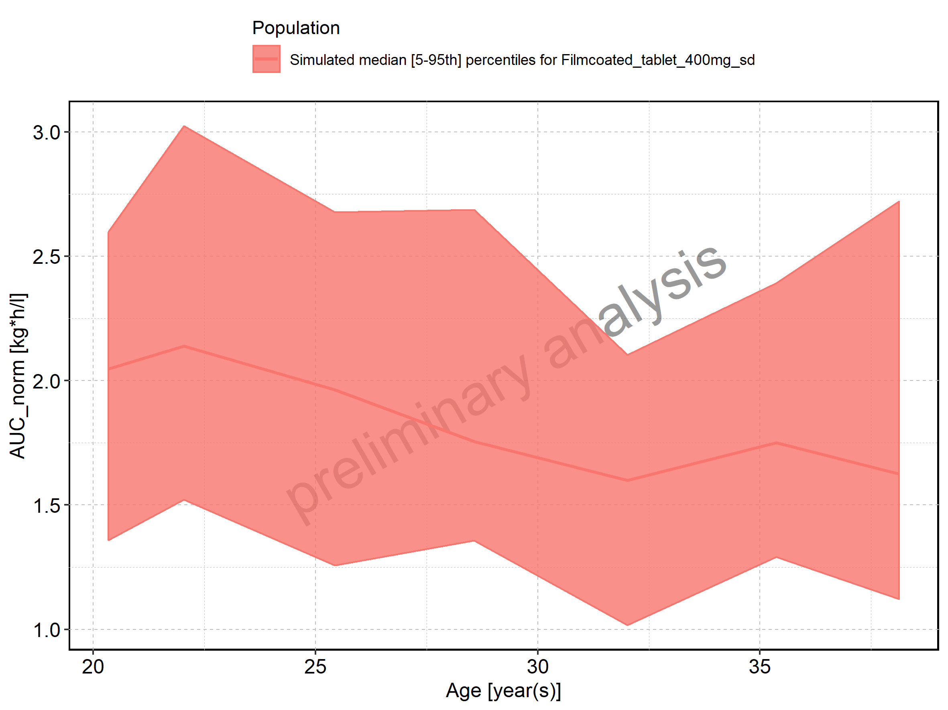

Figure 148: Age-dependence of AUC_norm for Filmcoated_tablet_400mg_sd. Profiles are plotted in a logarithmic scale.

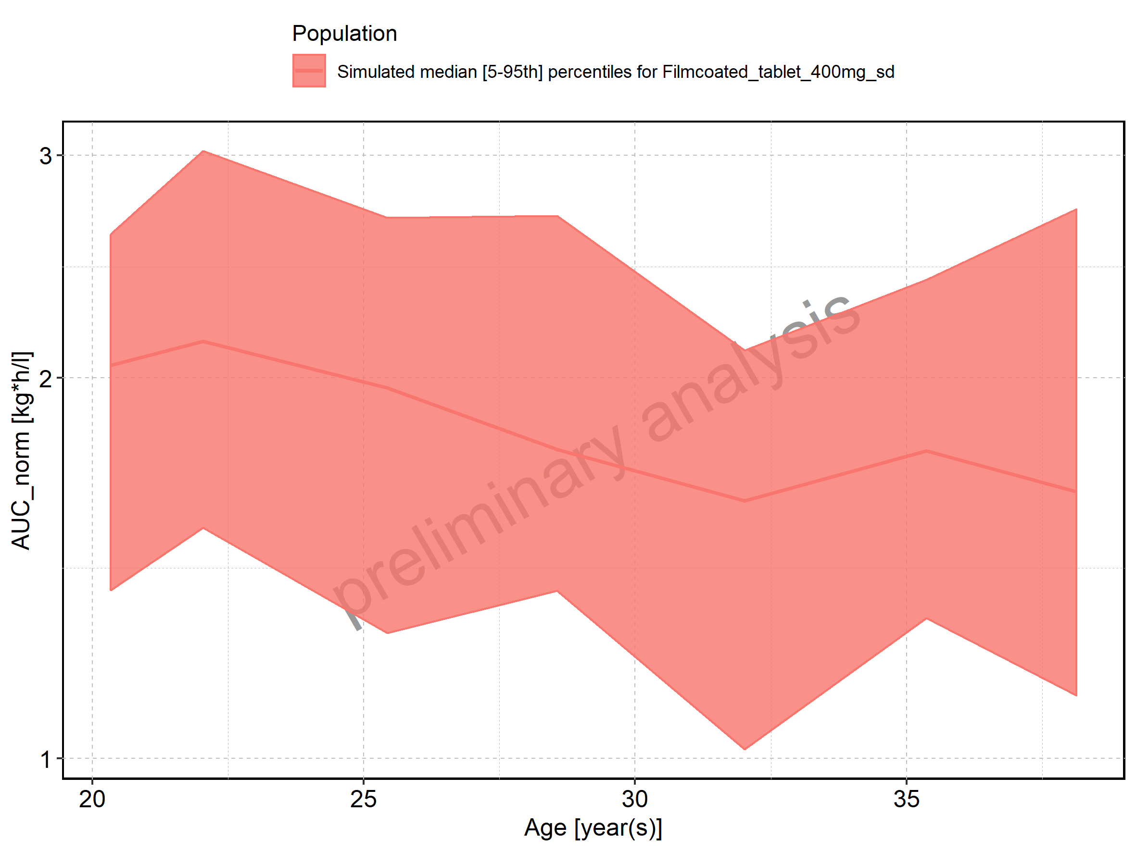

Figure 149: Height-dependence of AUC_norm for Larson 2013 8y-18y 400mg FCT meal in comparison to Filmcoated_tablet_400mg_sd. Profiles are plotted in a linear scale.

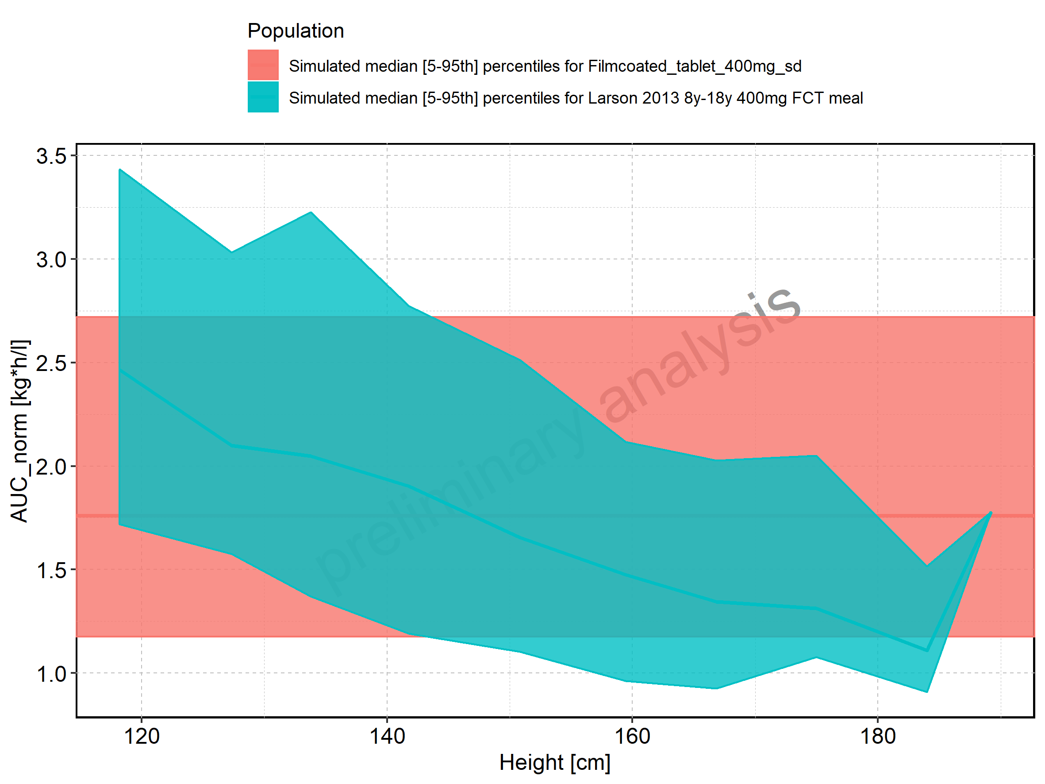

Figure 150: Height-dependence of AUC_norm for Larson 2013 8y-18y 400mg FCT meal in comparison to Filmcoated_tablet_400mg_sd. Profiles are plotted in a logarithmic scale.

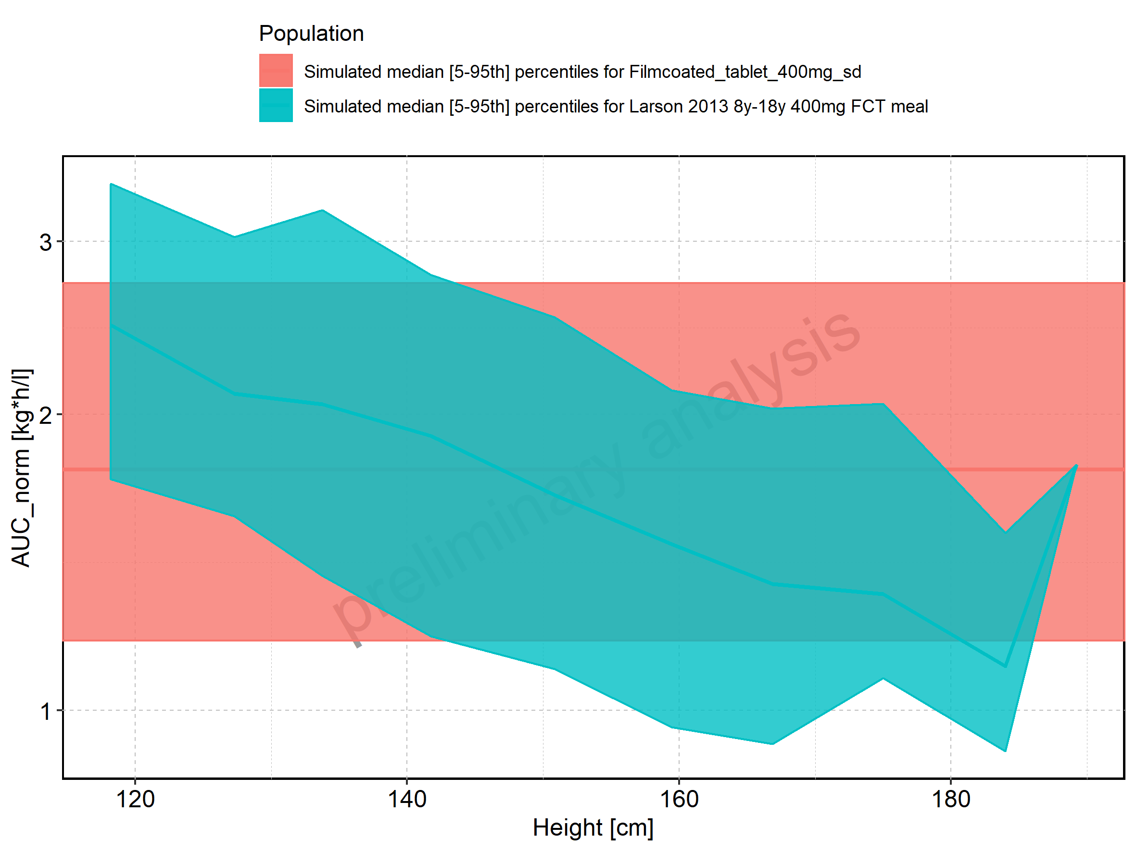

Figure 151: Height-dependence of AUC_norm for Larson 2013 8y-18y 400mg FCT meal. Profiles are plotted in a linear scale.

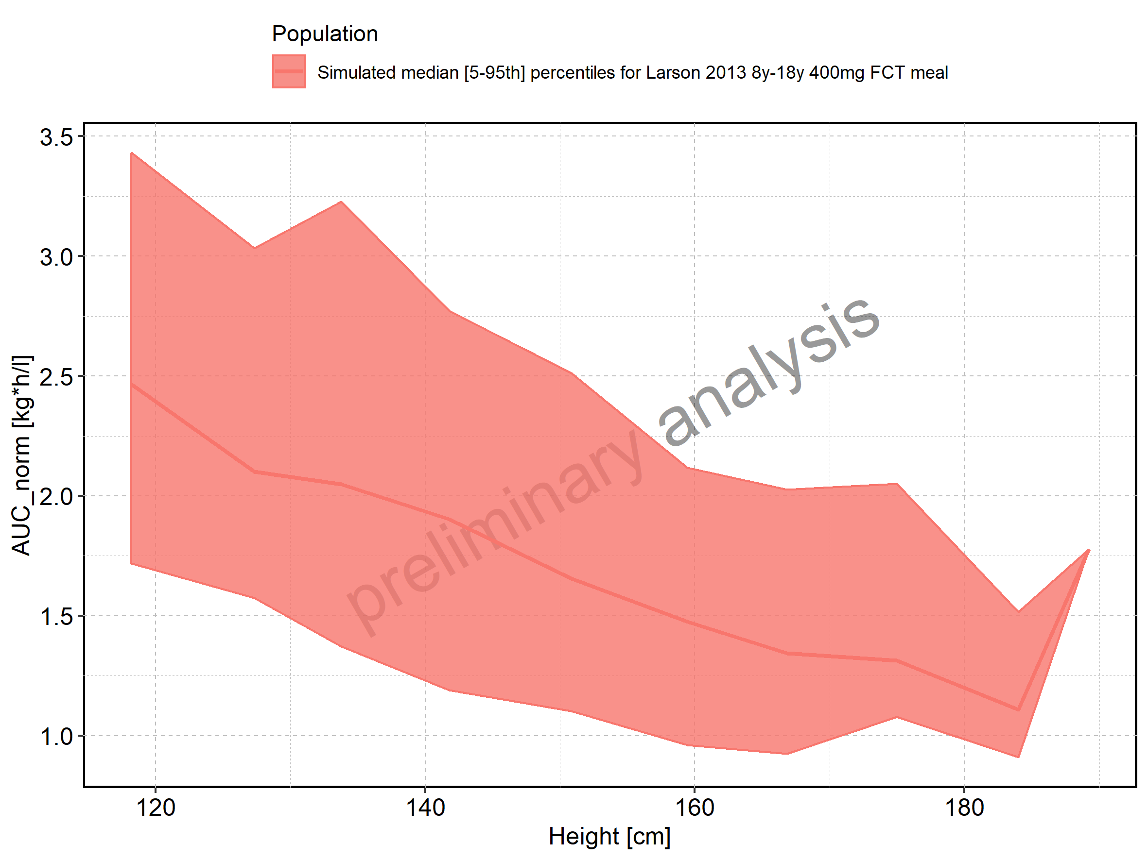

Figure 152: Height-dependence of AUC_norm for Larson 2013 8y-18y 400mg FCT meal. Profiles are plotted in a logarithmic scale.

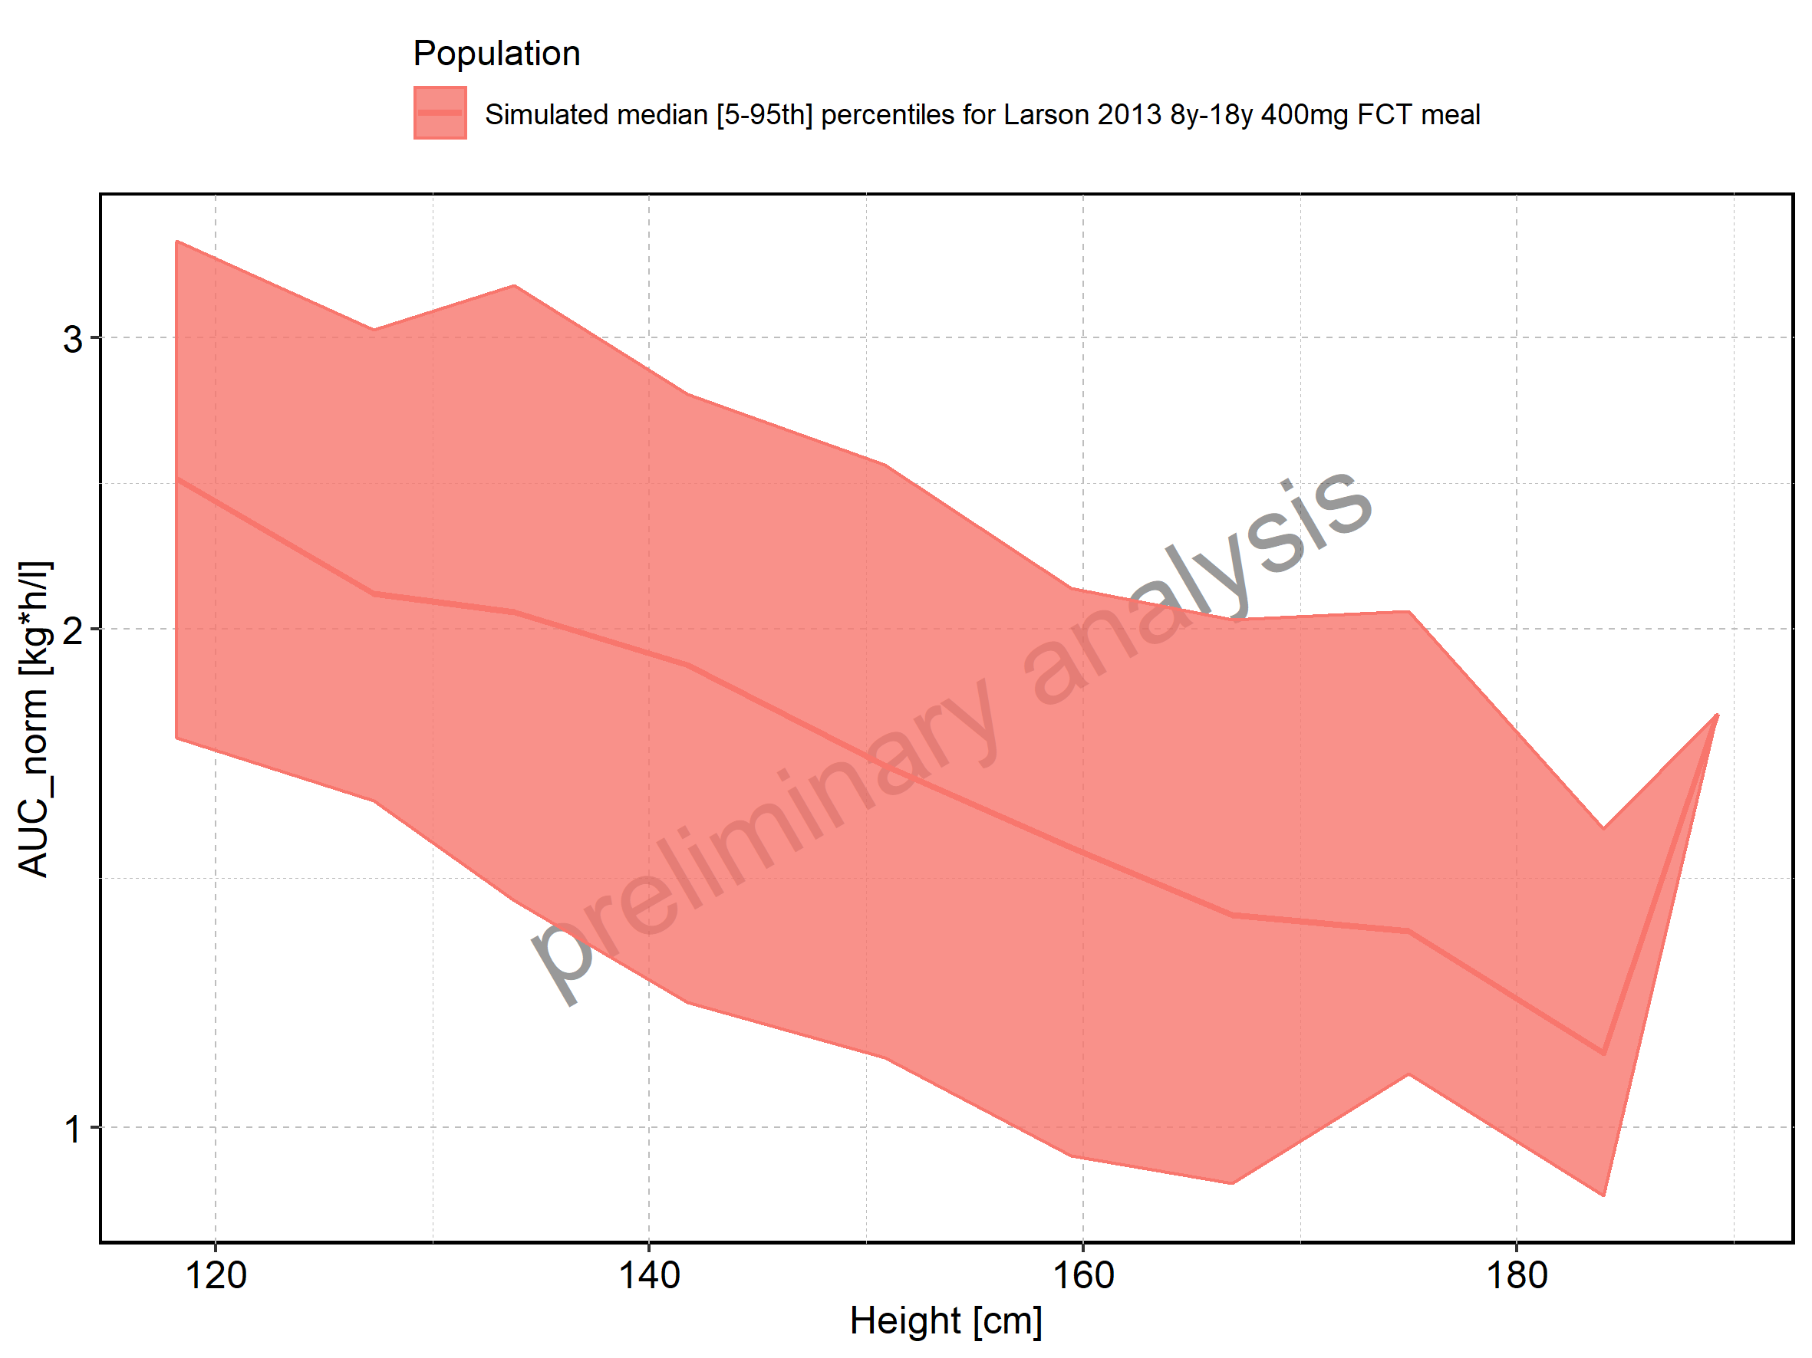

Figure 153: Height-dependence of AUC_norm for Filmcoated_tablet_400mg_sd. Profiles are plotted in a linear scale.

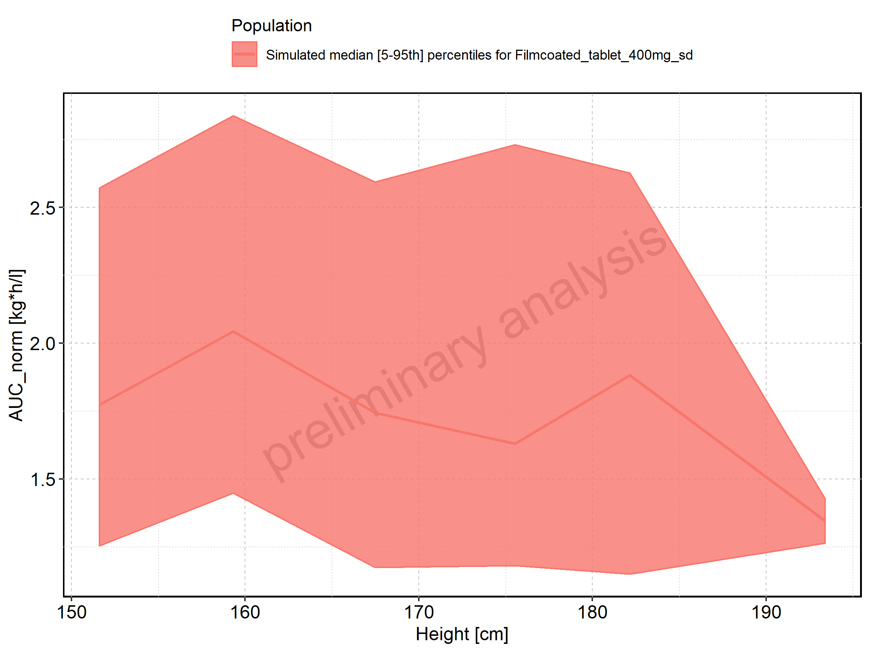

Figure 154: Height-dependence of AUC_norm for Filmcoated_tablet_400mg_sd. Profiles are plotted in a logarithmic scale.

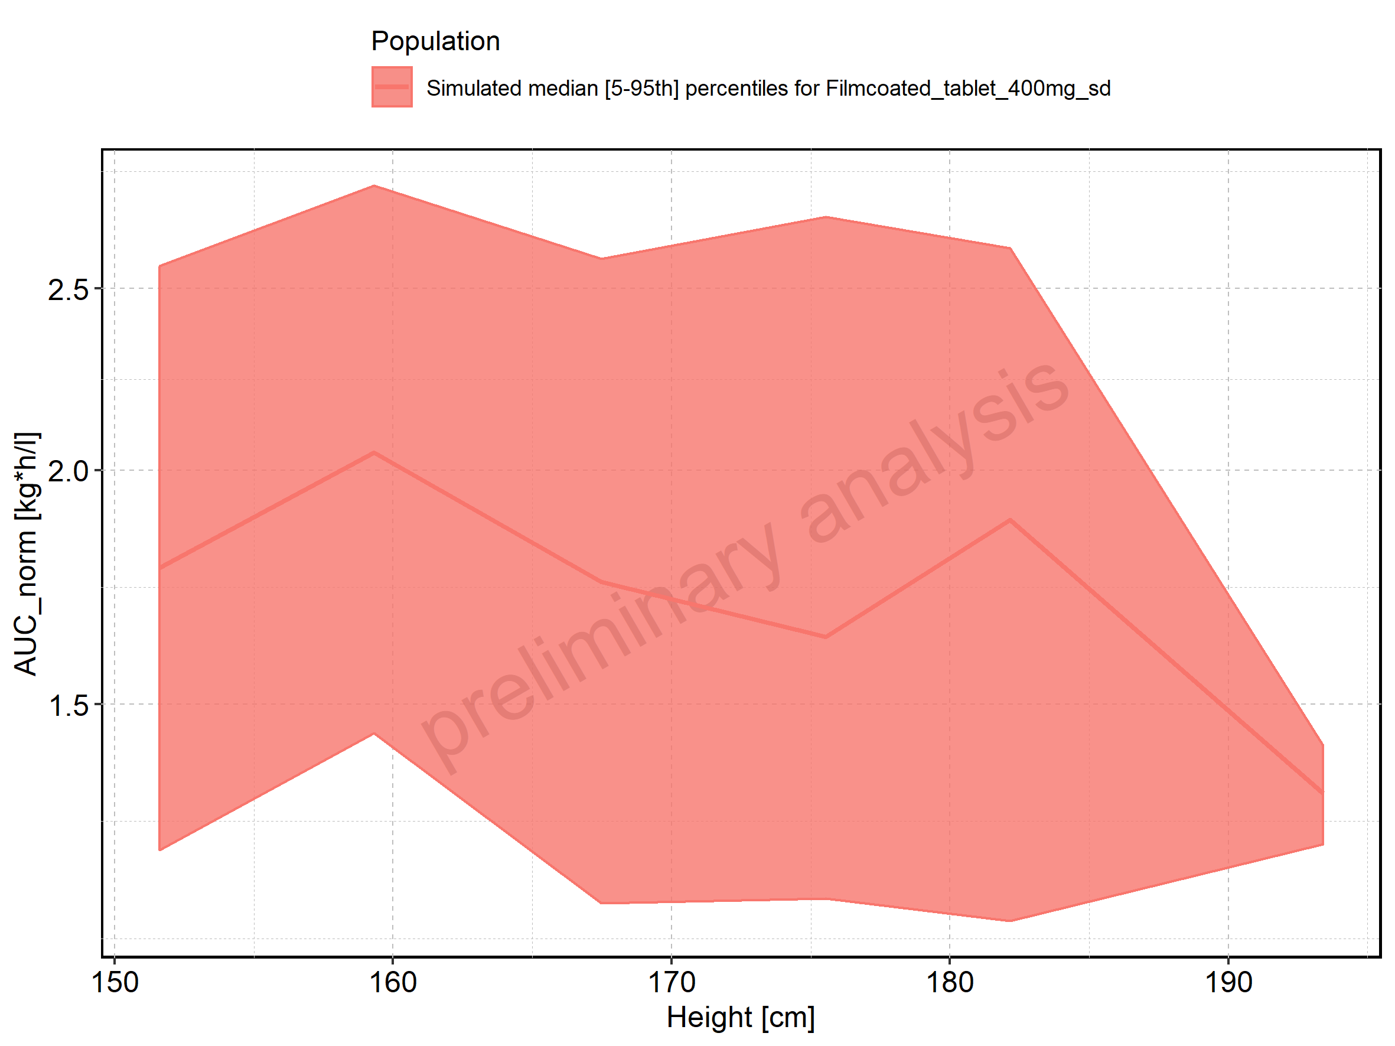

Figure 155: Weight-dependence of AUC_norm for Larson 2013 8y-18y 400mg FCT meal in comparison to Filmcoated_tablet_400mg_sd. Profiles are plotted in a linear scale.

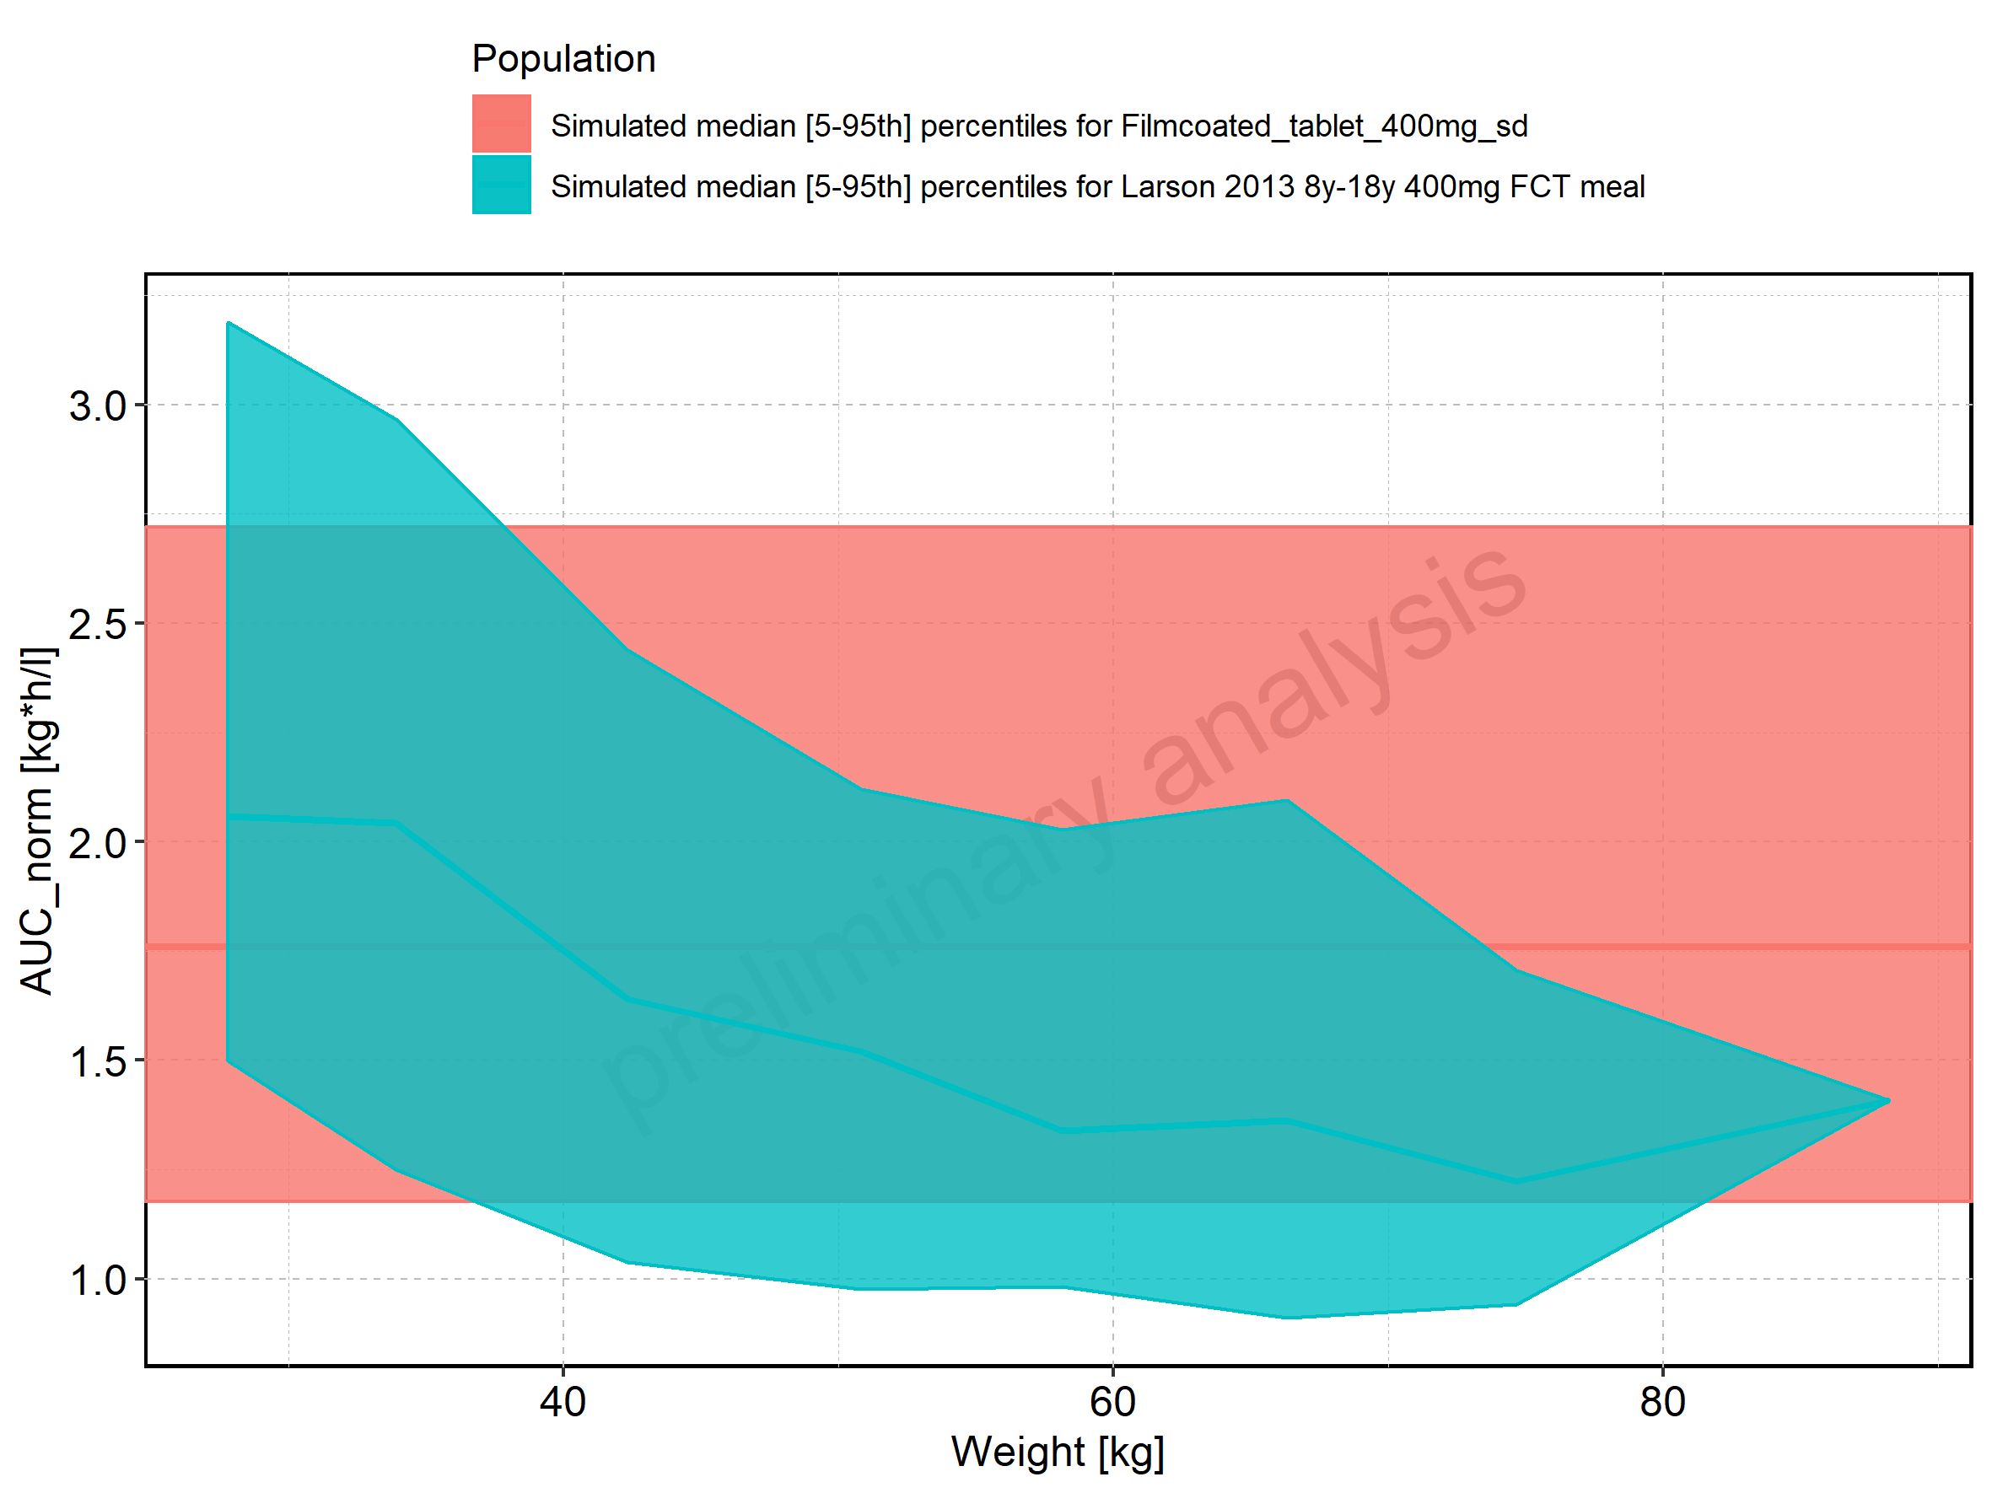

Figure 156: Weight-dependence of AUC_norm for Larson 2013 8y-18y 400mg FCT meal in comparison to Filmcoated_tablet_400mg_sd. Profiles are plotted in a logarithmic scale.

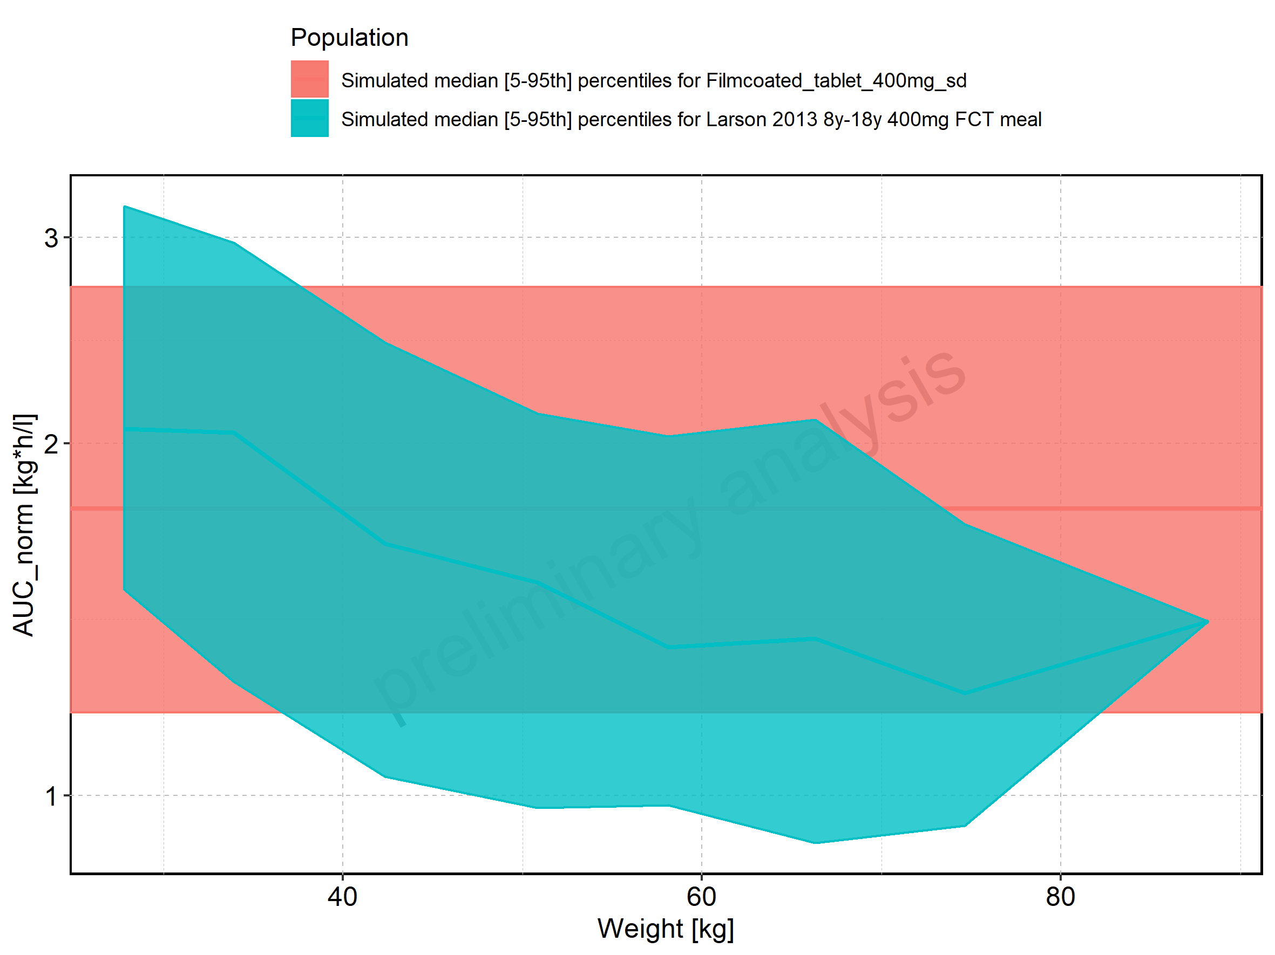

Figure 157: Weight-dependence of AUC_norm for Larson 2013 8y-18y 400mg FCT meal. Profiles are plotted in a linear scale.

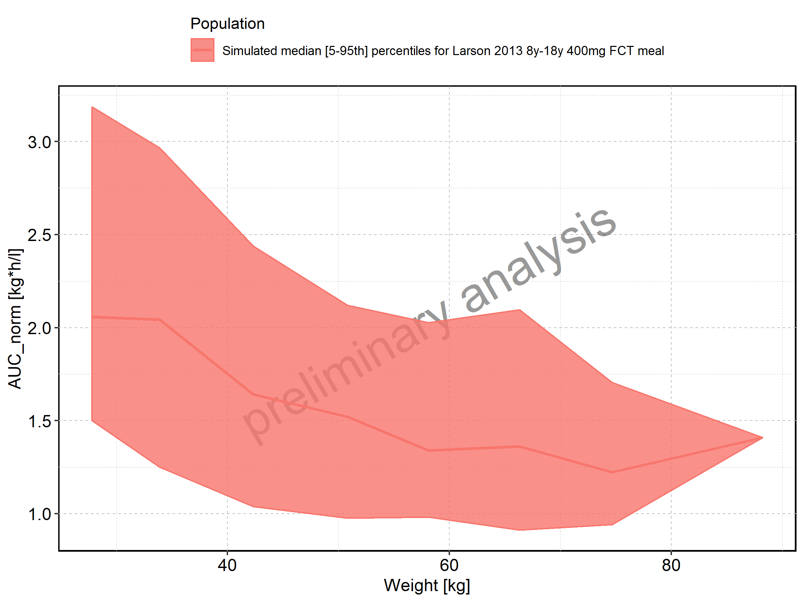

Figure 158: Weight-dependence of AUC_norm for Larson 2013 8y-18y 400mg FCT meal. Profiles are plotted in a logarithmic scale.

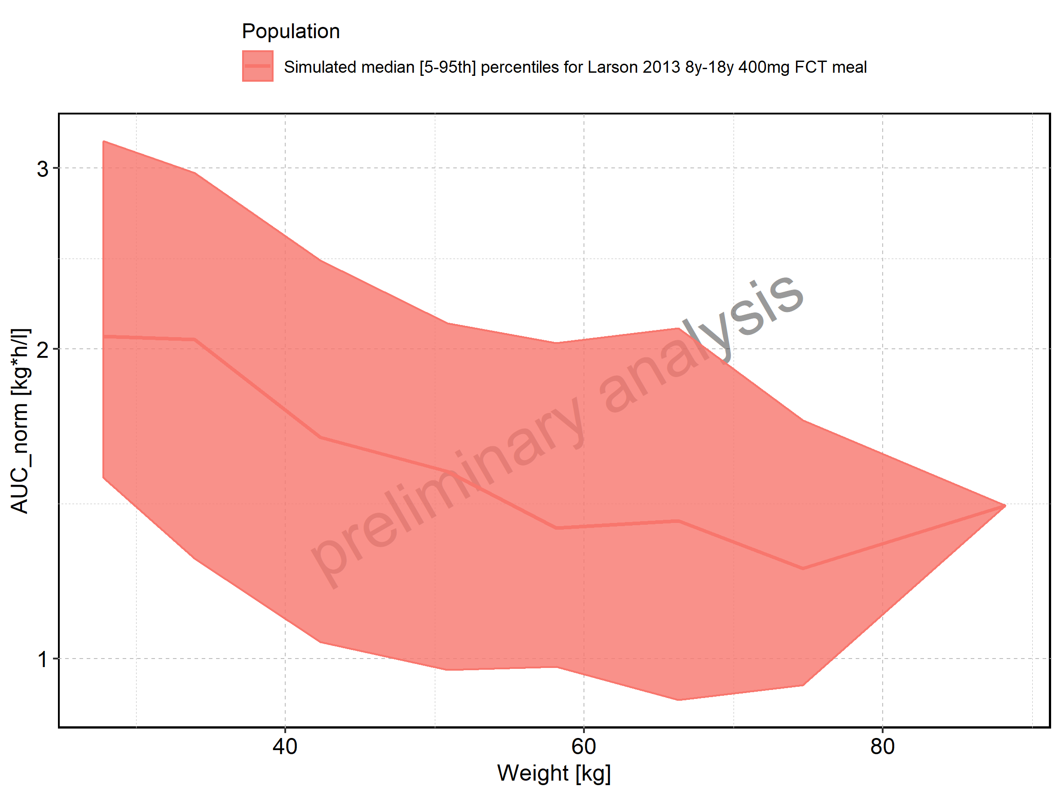

Figure 159: Weight-dependence of AUC_norm for Filmcoated_tablet_400mg_sd. Profiles are plotted in a linear scale.

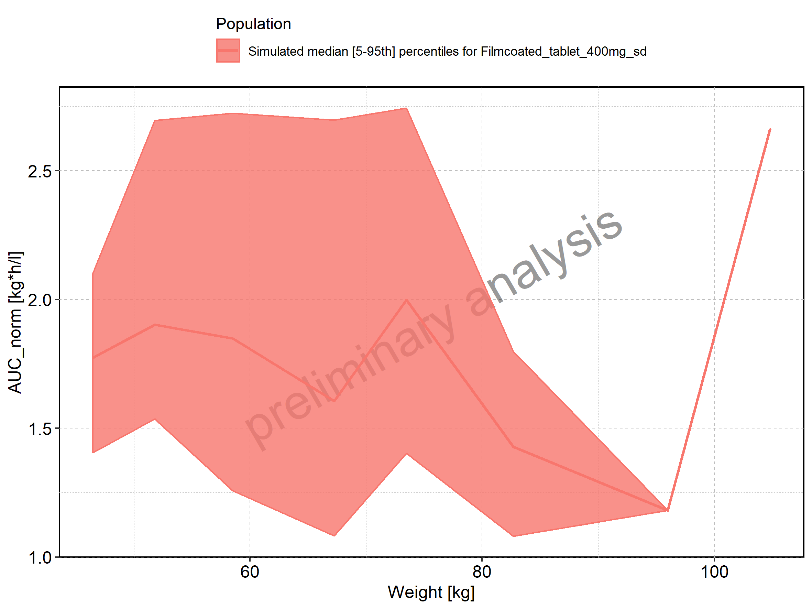

Figure 160: Weight-dependence of AUC_norm for Filmcoated_tablet_400mg_sd. Profiles are plotted in a logarithmic scale.

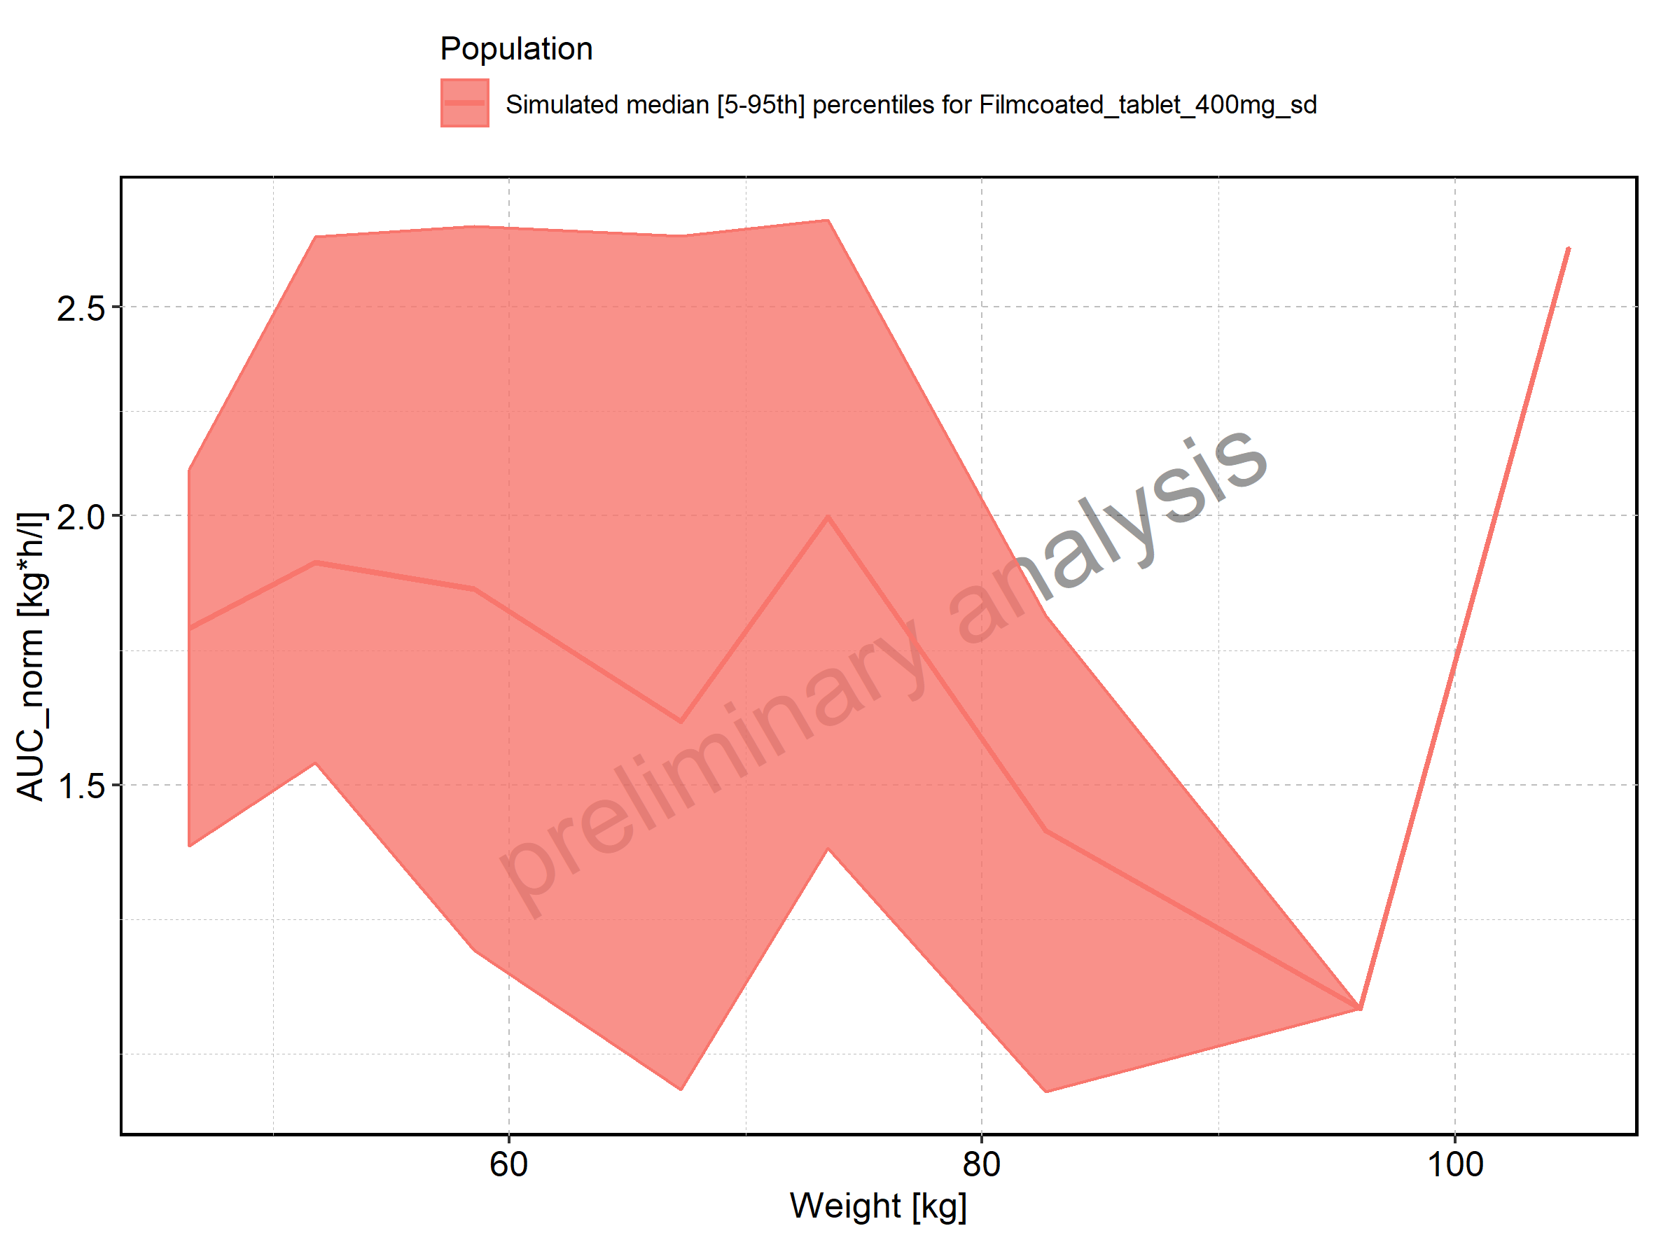

Figure 161: BMI-dependence of AUC_norm for Larson 2013 8y-18y 400mg FCT meal in comparison to Filmcoated_tablet_400mg_sd. Profiles are plotted in a linear scale.

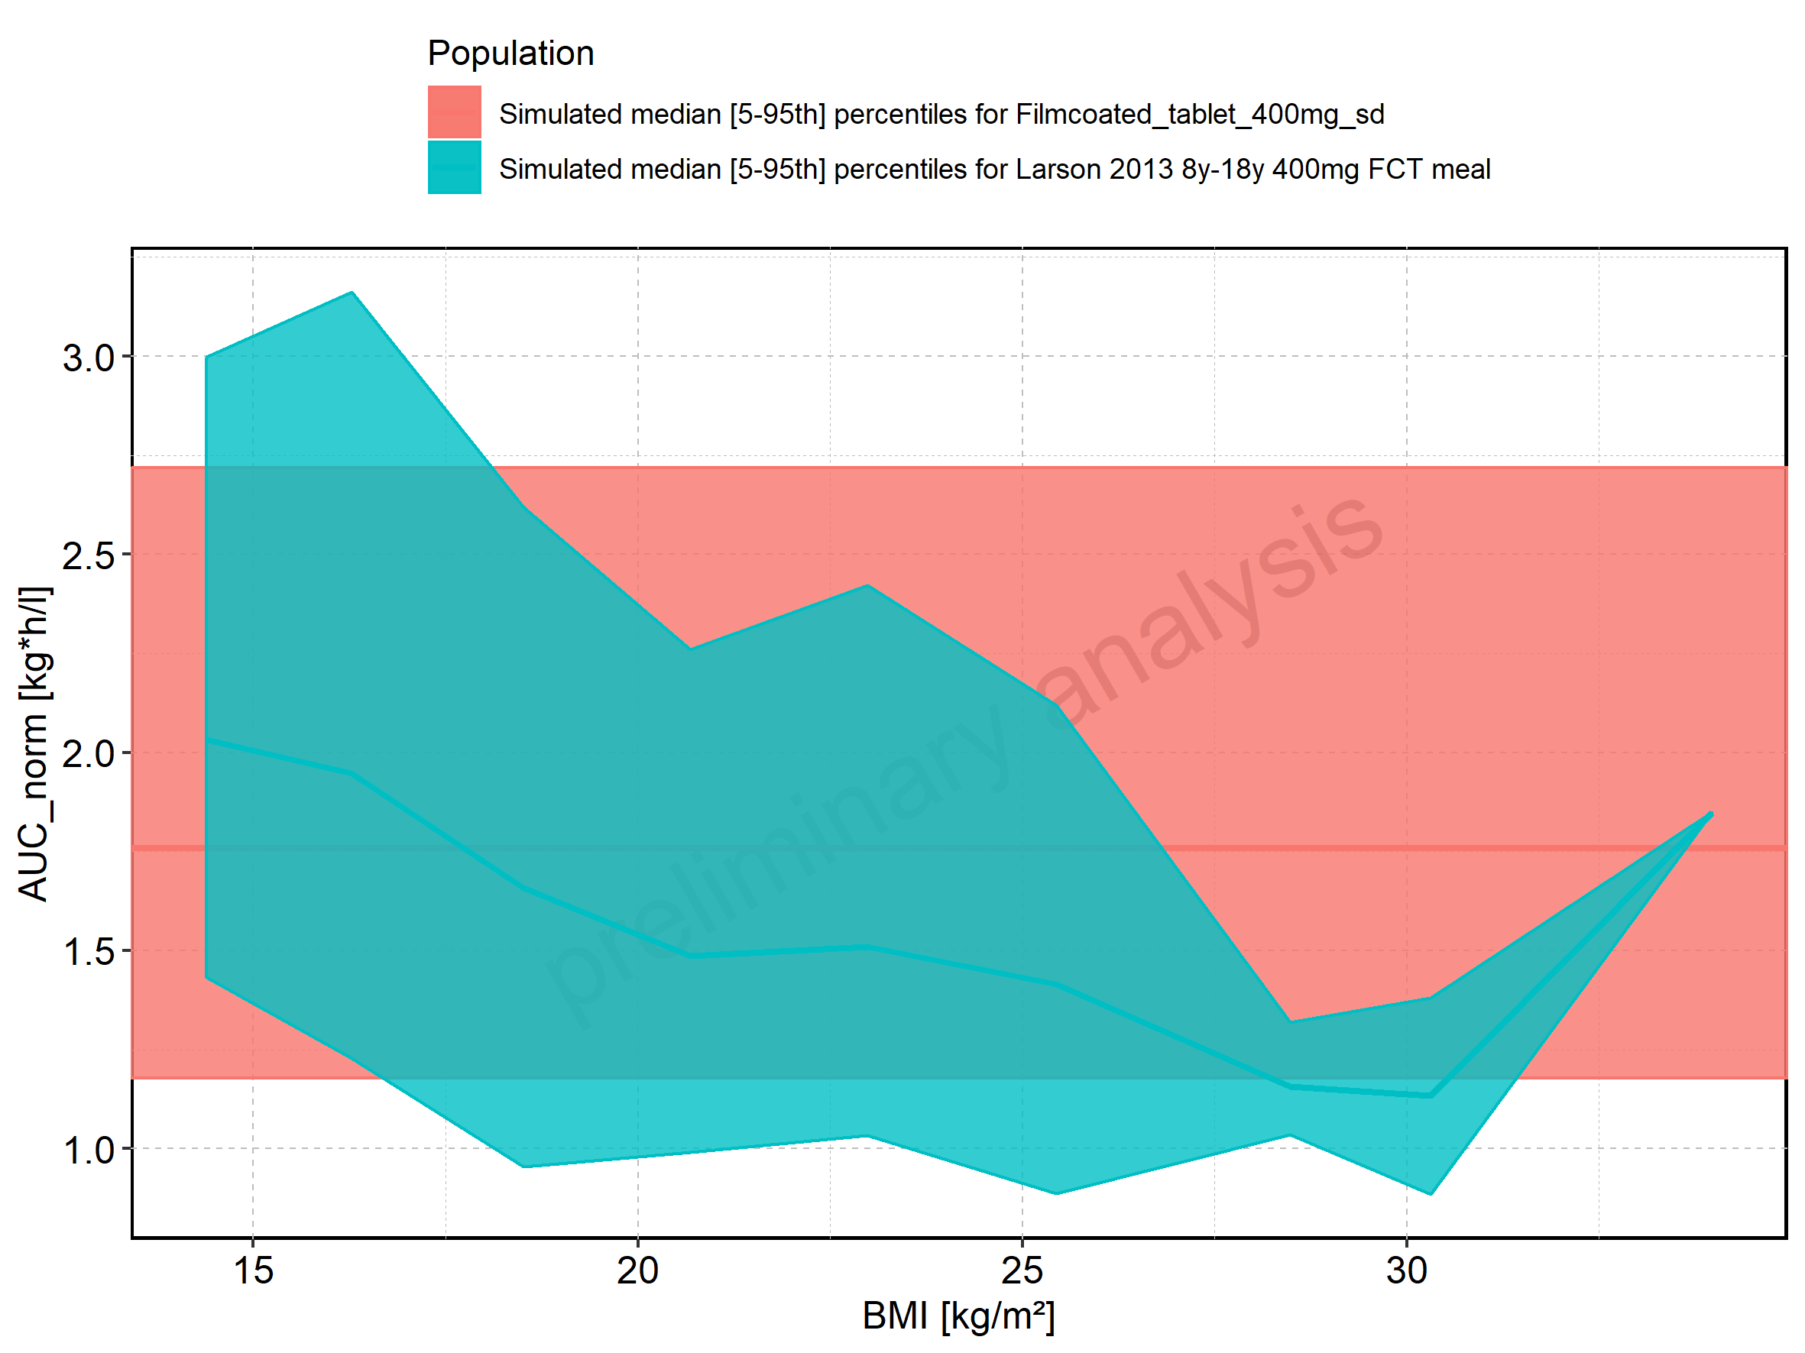

Figure 162: BMI-dependence of AUC_norm for Larson 2013 8y-18y 400mg FCT meal in comparison to Filmcoated_tablet_400mg_sd. Profiles are plotted in a logarithmic scale.

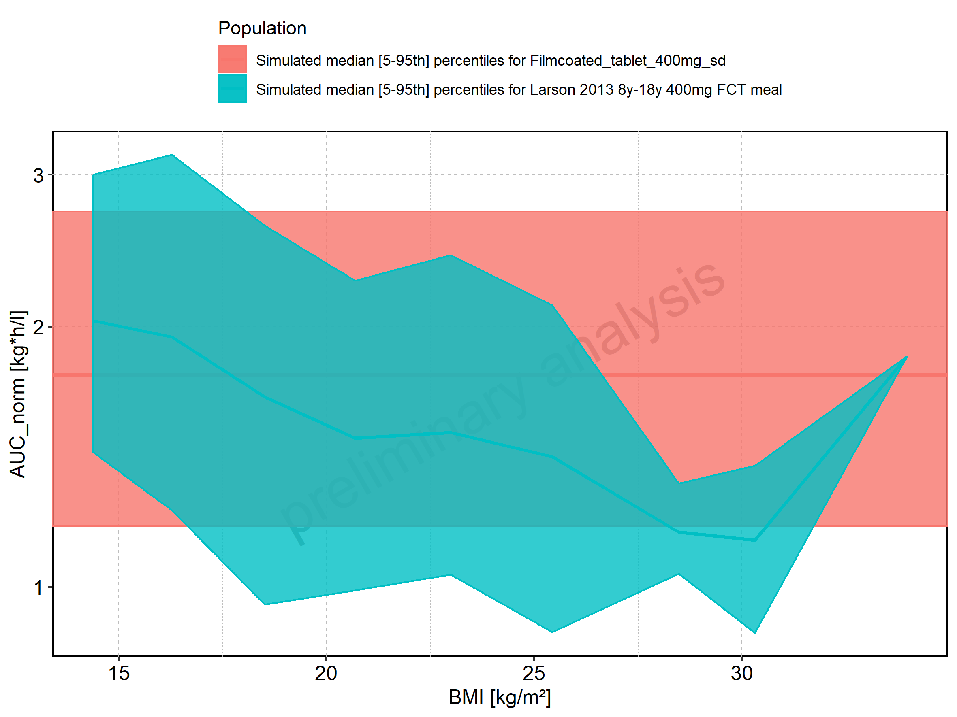

Figure 163: BMI-dependence of AUC_norm for Larson 2013 8y-18y 400mg FCT meal. Profiles are plotted in a linear scale.

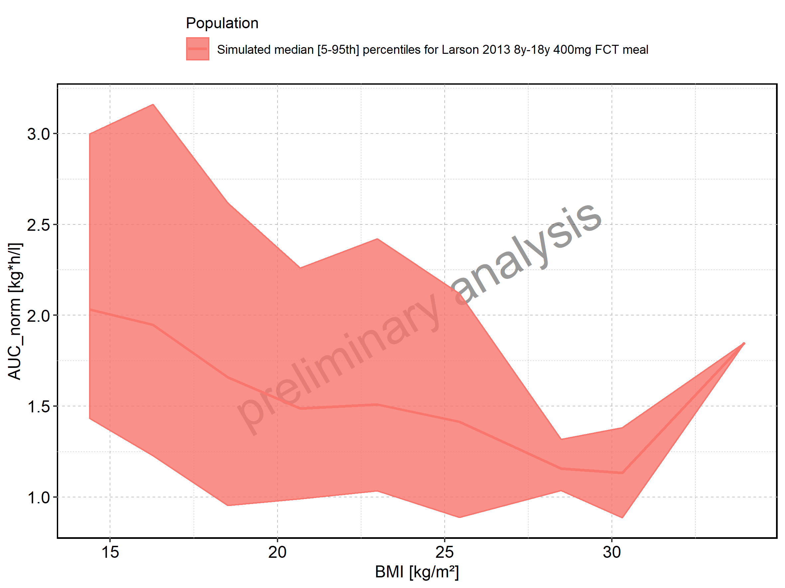

Figure 164: BMI-dependence of AUC_norm for Larson 2013 8y-18y 400mg FCT meal. Profiles are plotted in a logarithmic scale.

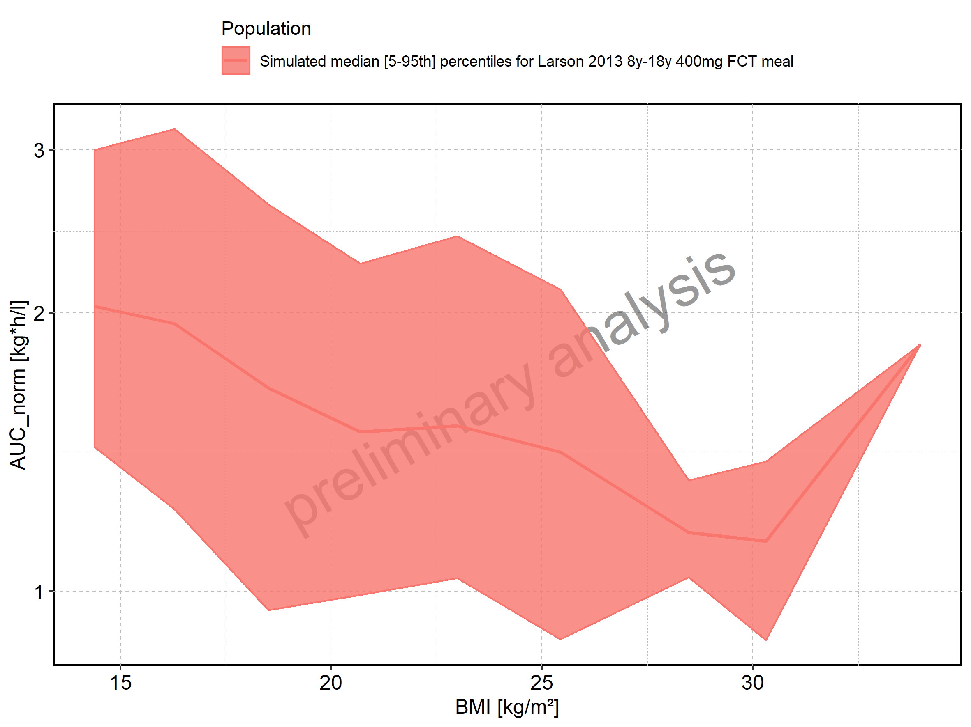

Figure 165: BMI-dependence of AUC_norm for Filmcoated_tablet_400mg_sd. Profiles are plotted in a linear scale.

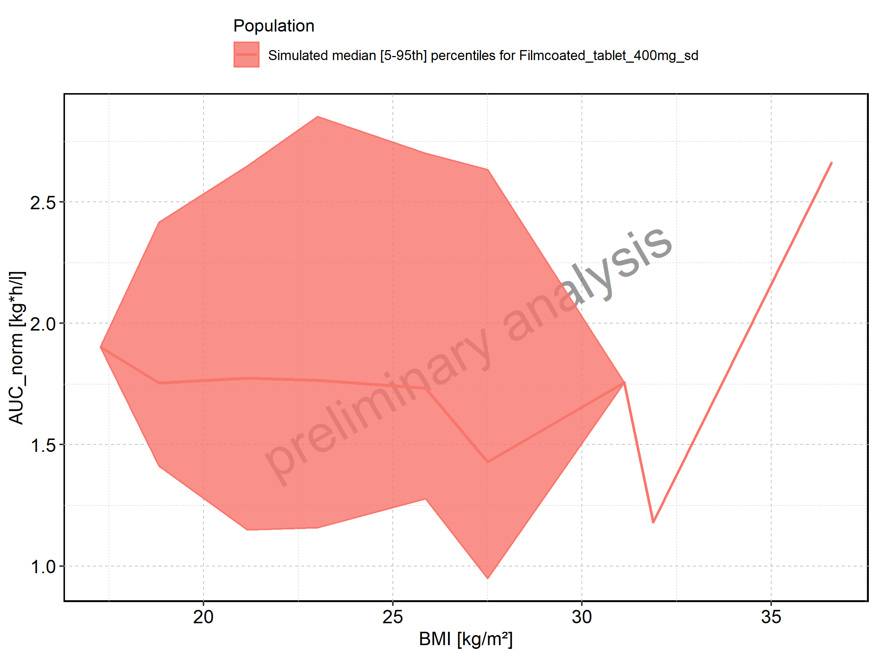

Figure 166: BMI-dependence of AUC_norm for Filmcoated_tablet_400mg_sd. Profiles are plotted in a logarithmic scale.

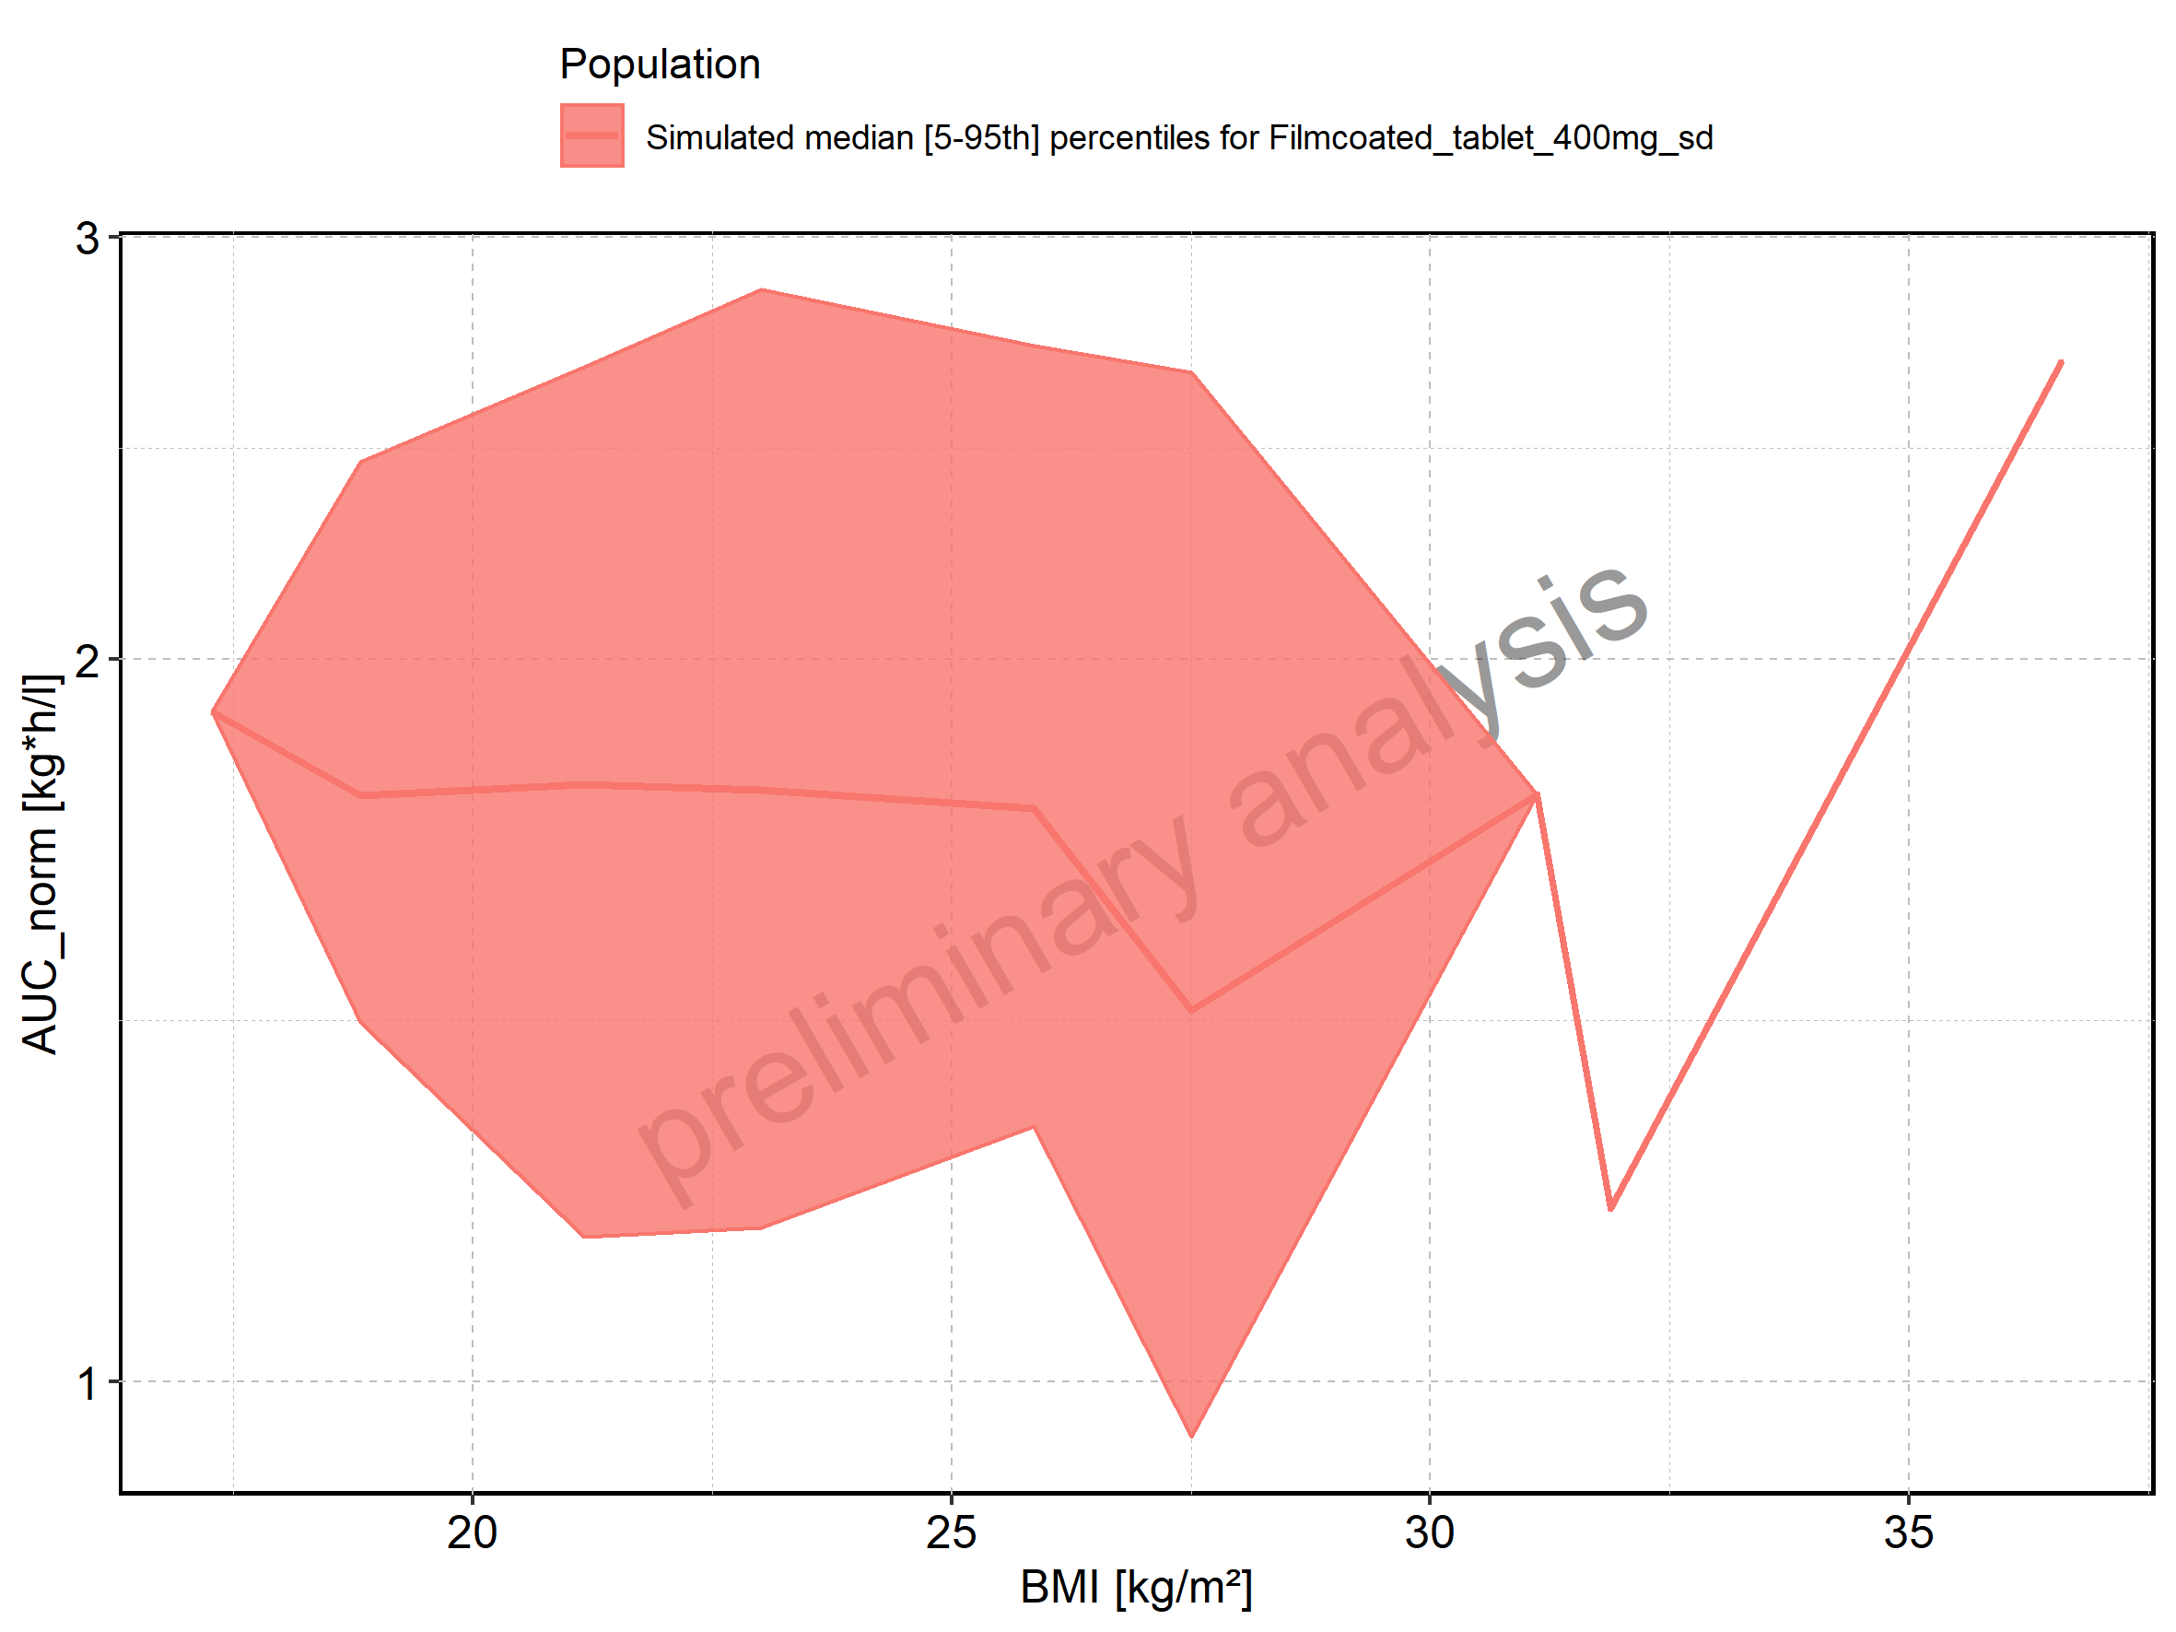

Figure 167: AUC_inf of Raltegravir shown as box-whisker plot, which indicates the 5th, 25th, 50th, 75th, and 95th percentiles in linear scale.

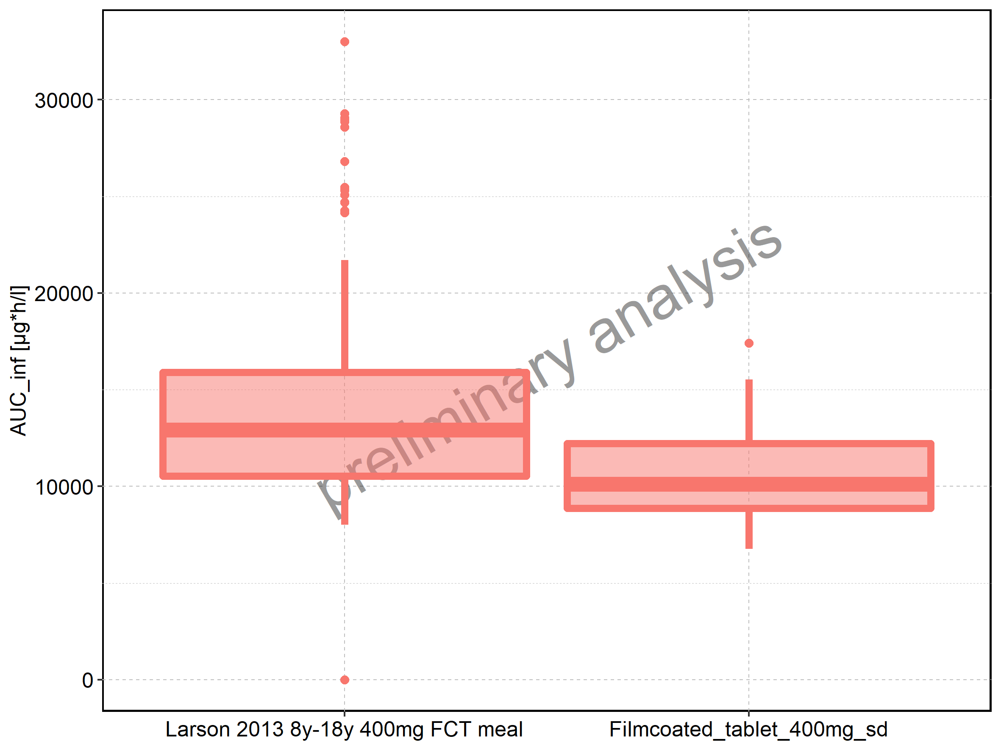

|  |  |  |  |  |  |  |  |  |  |  |
| --- | --- | --- | --- | --- | --- | --- | --- | --- | --- | --- |
| Population | N | 5th percentile | 25th percentile | 50th percentile | 75th percentile | 95th percentile | mean | standard deviation | geo mean | geo standard deviation |
| Larson 2013 8y-18y 400mg FCT meal | 500 | 8017.563 | 10533.549 | 12921.04 | 15892.62 | 21707.95 | 13652.18 | 4460.216 | 0.00 | NA |
| Filmcoated_tablet_400mg_sd | 100 | 6771.970 | 8875.702 | 10112.32 | 12229.14 | 15523.15 | 10626.71 | 2757.612 | 10275.45 | 1.300506 |

Figure 168: AUC_inf of Raltegravir shown as box-whisker plot, which indicates the 5th, 25th, 50th, 75th, and 95th percentiles in logarithmic scale.

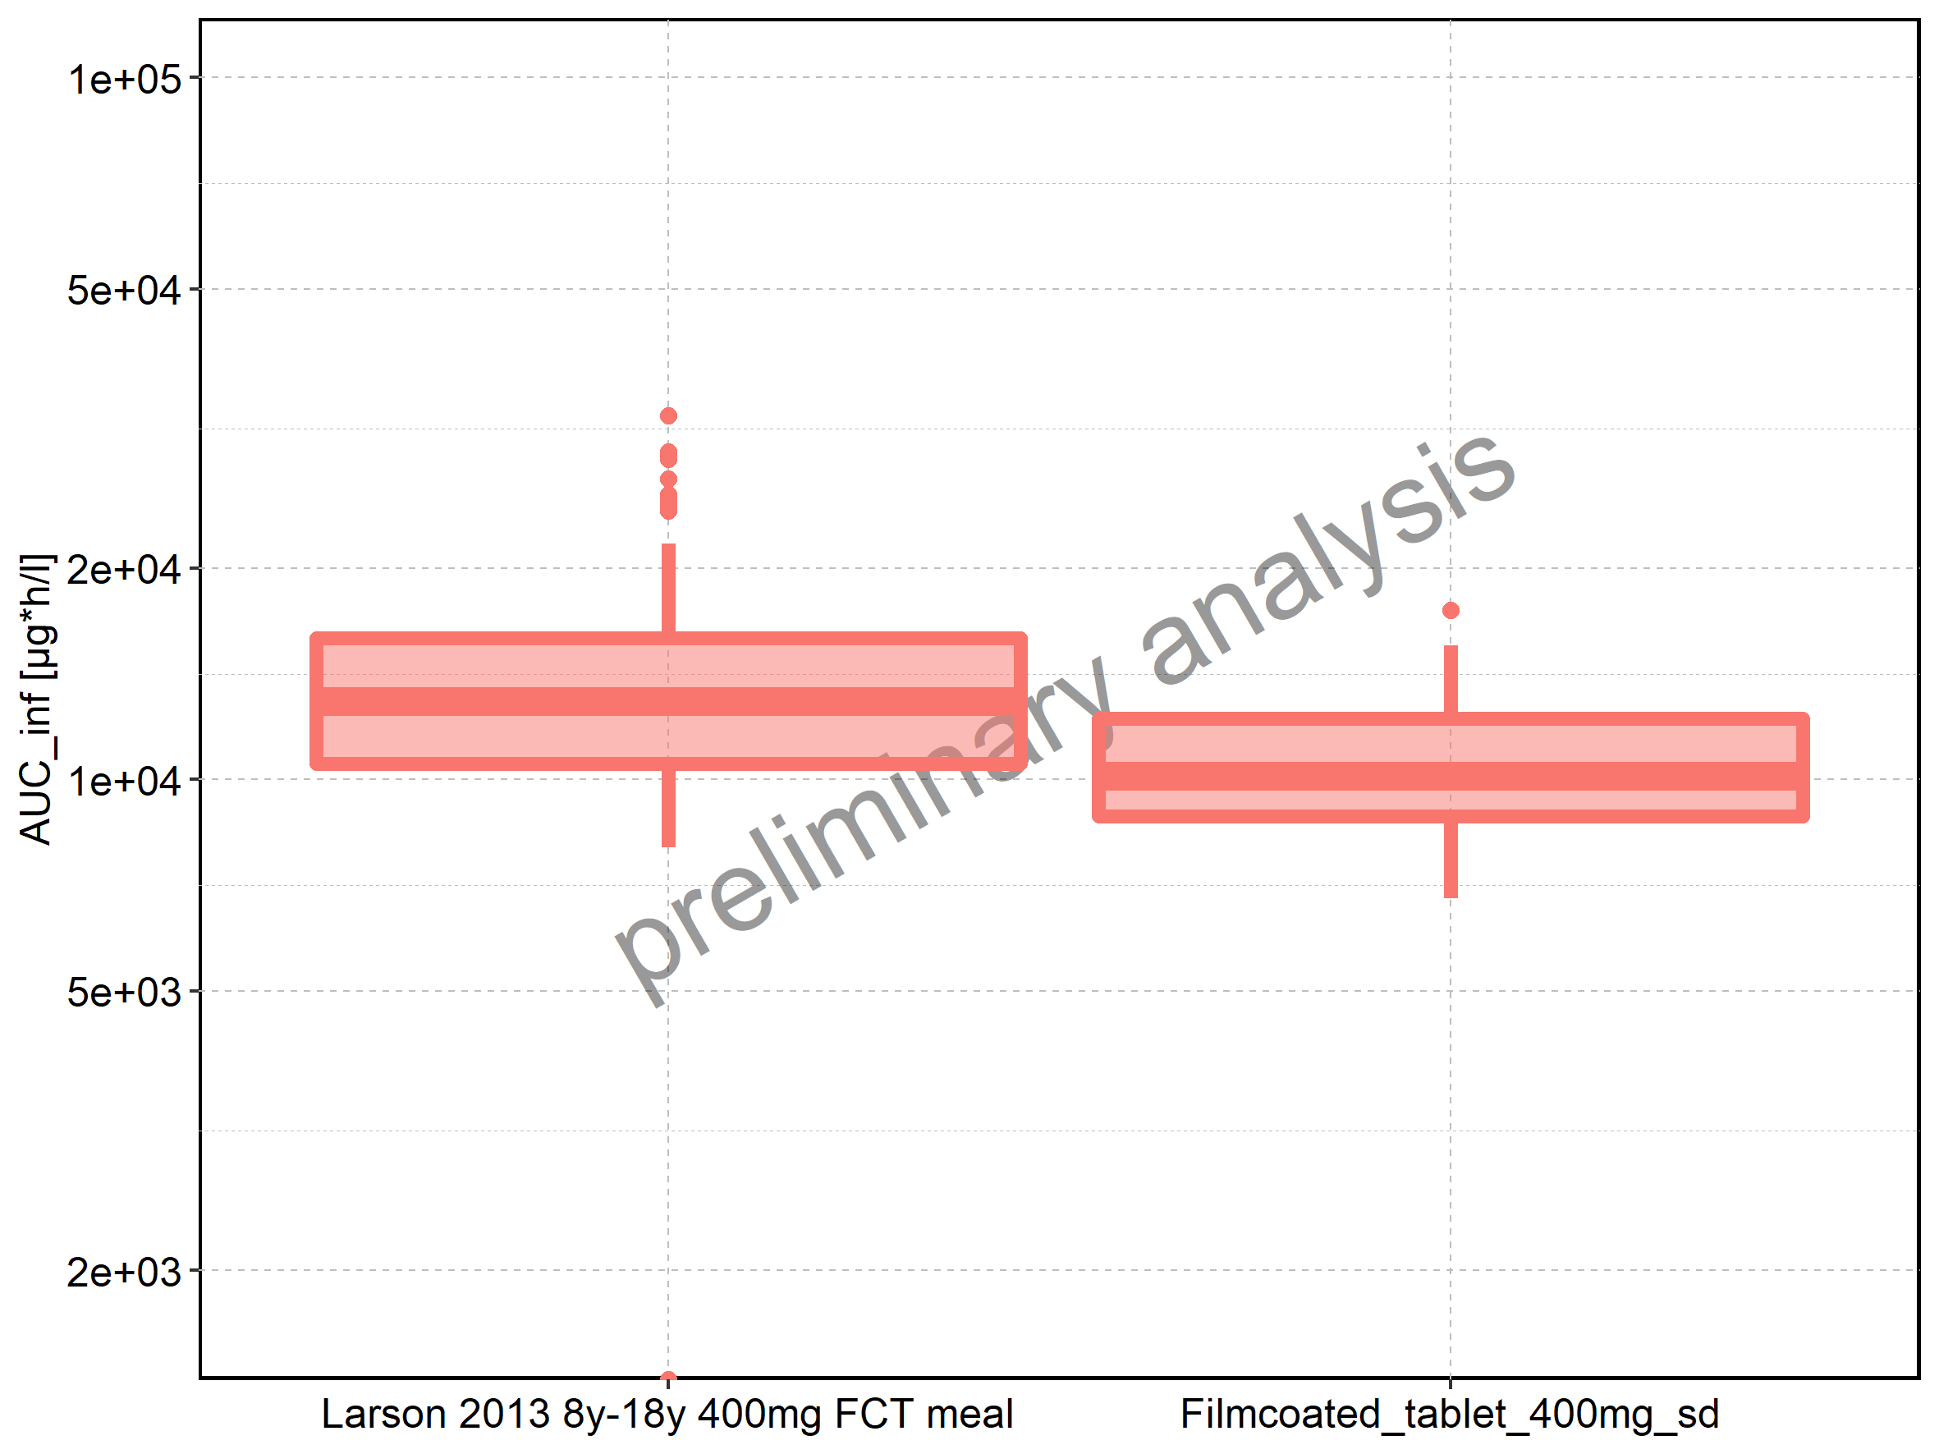

Figure 169: Age-dependence of AUC_inf for Larson 2013 8y-18y 400mg FCT meal in comparison to Filmcoated_tablet_400mg_sd. Profiles are plotted in a linear scale.

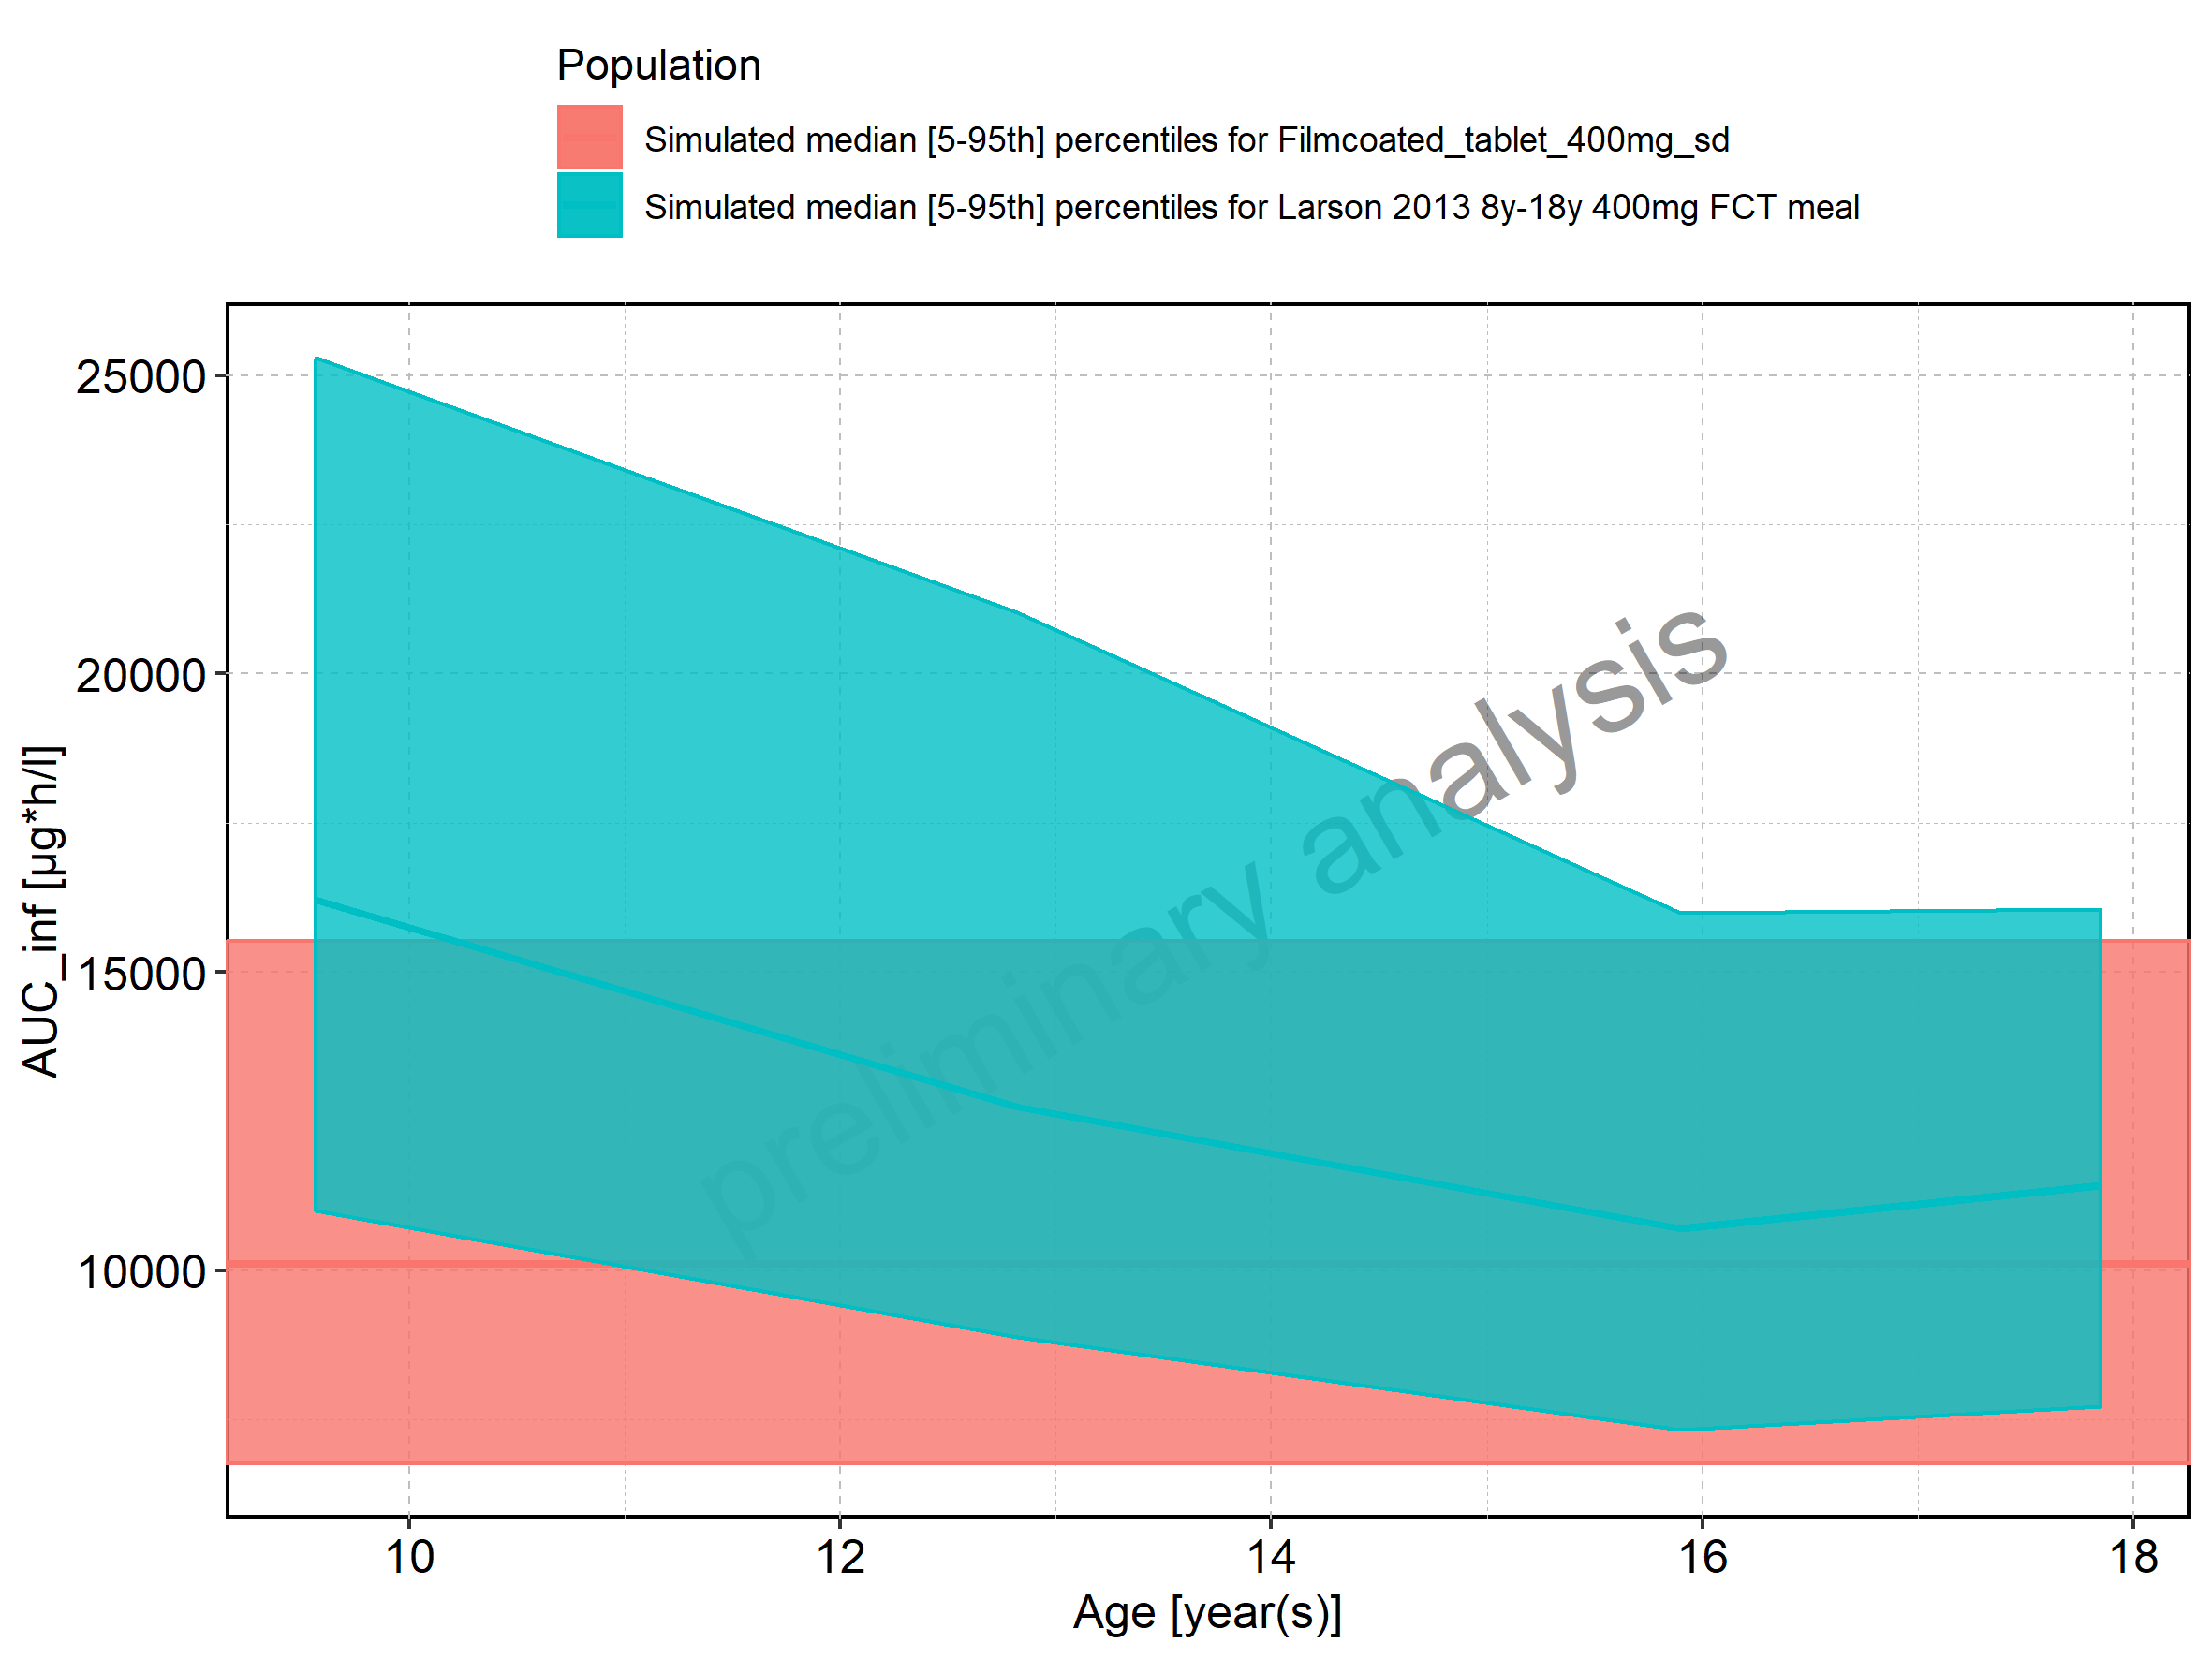

Figure 170: Age-dependence of AUC_inf for Larson 2013 8y-18y 400mg FCT meal in comparison to Filmcoated_tablet_400mg_sd. Profiles are plotted in a logarithmic scale.

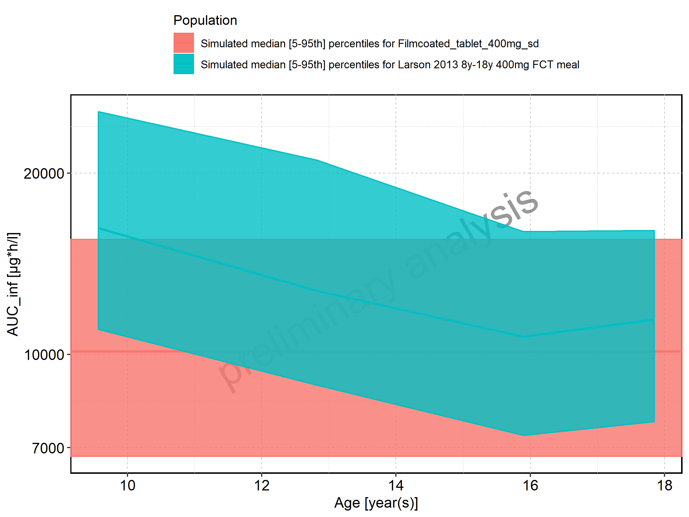

Figure 171: Age-dependence of AUC_inf for Larson 2013 8y-18y 400mg FCT meal. Profiles are plotted in a linear scale.

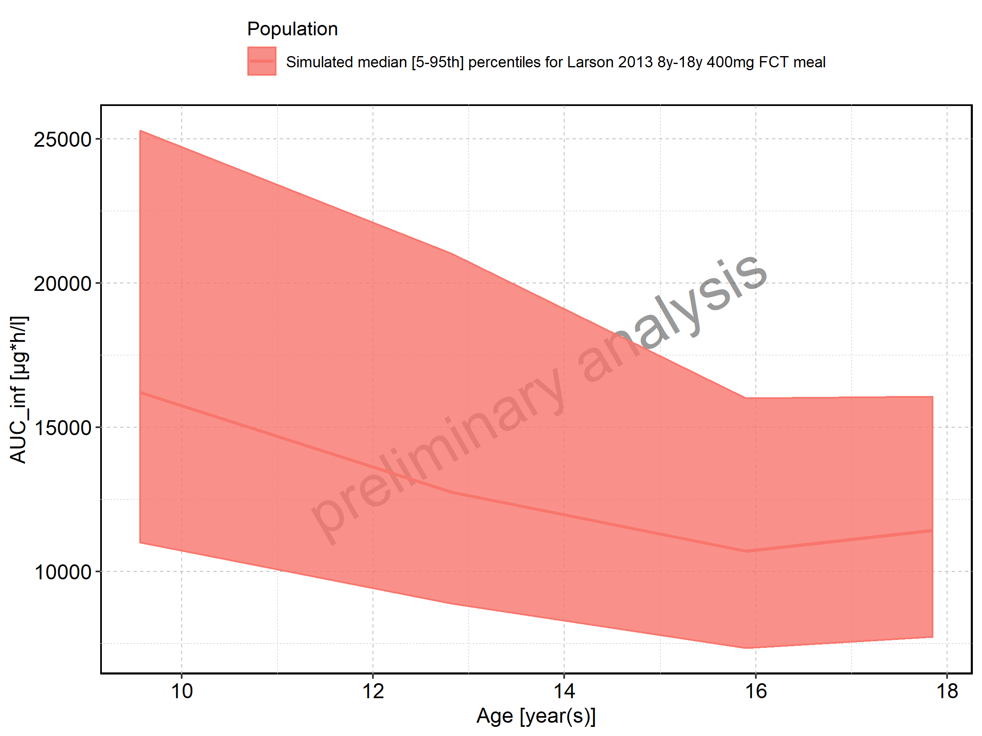

Figure 172: Age-dependence of AUC_inf for Larson 2013 8y-18y 400mg FCT meal. Profiles are plotted in a logarithmic scale.

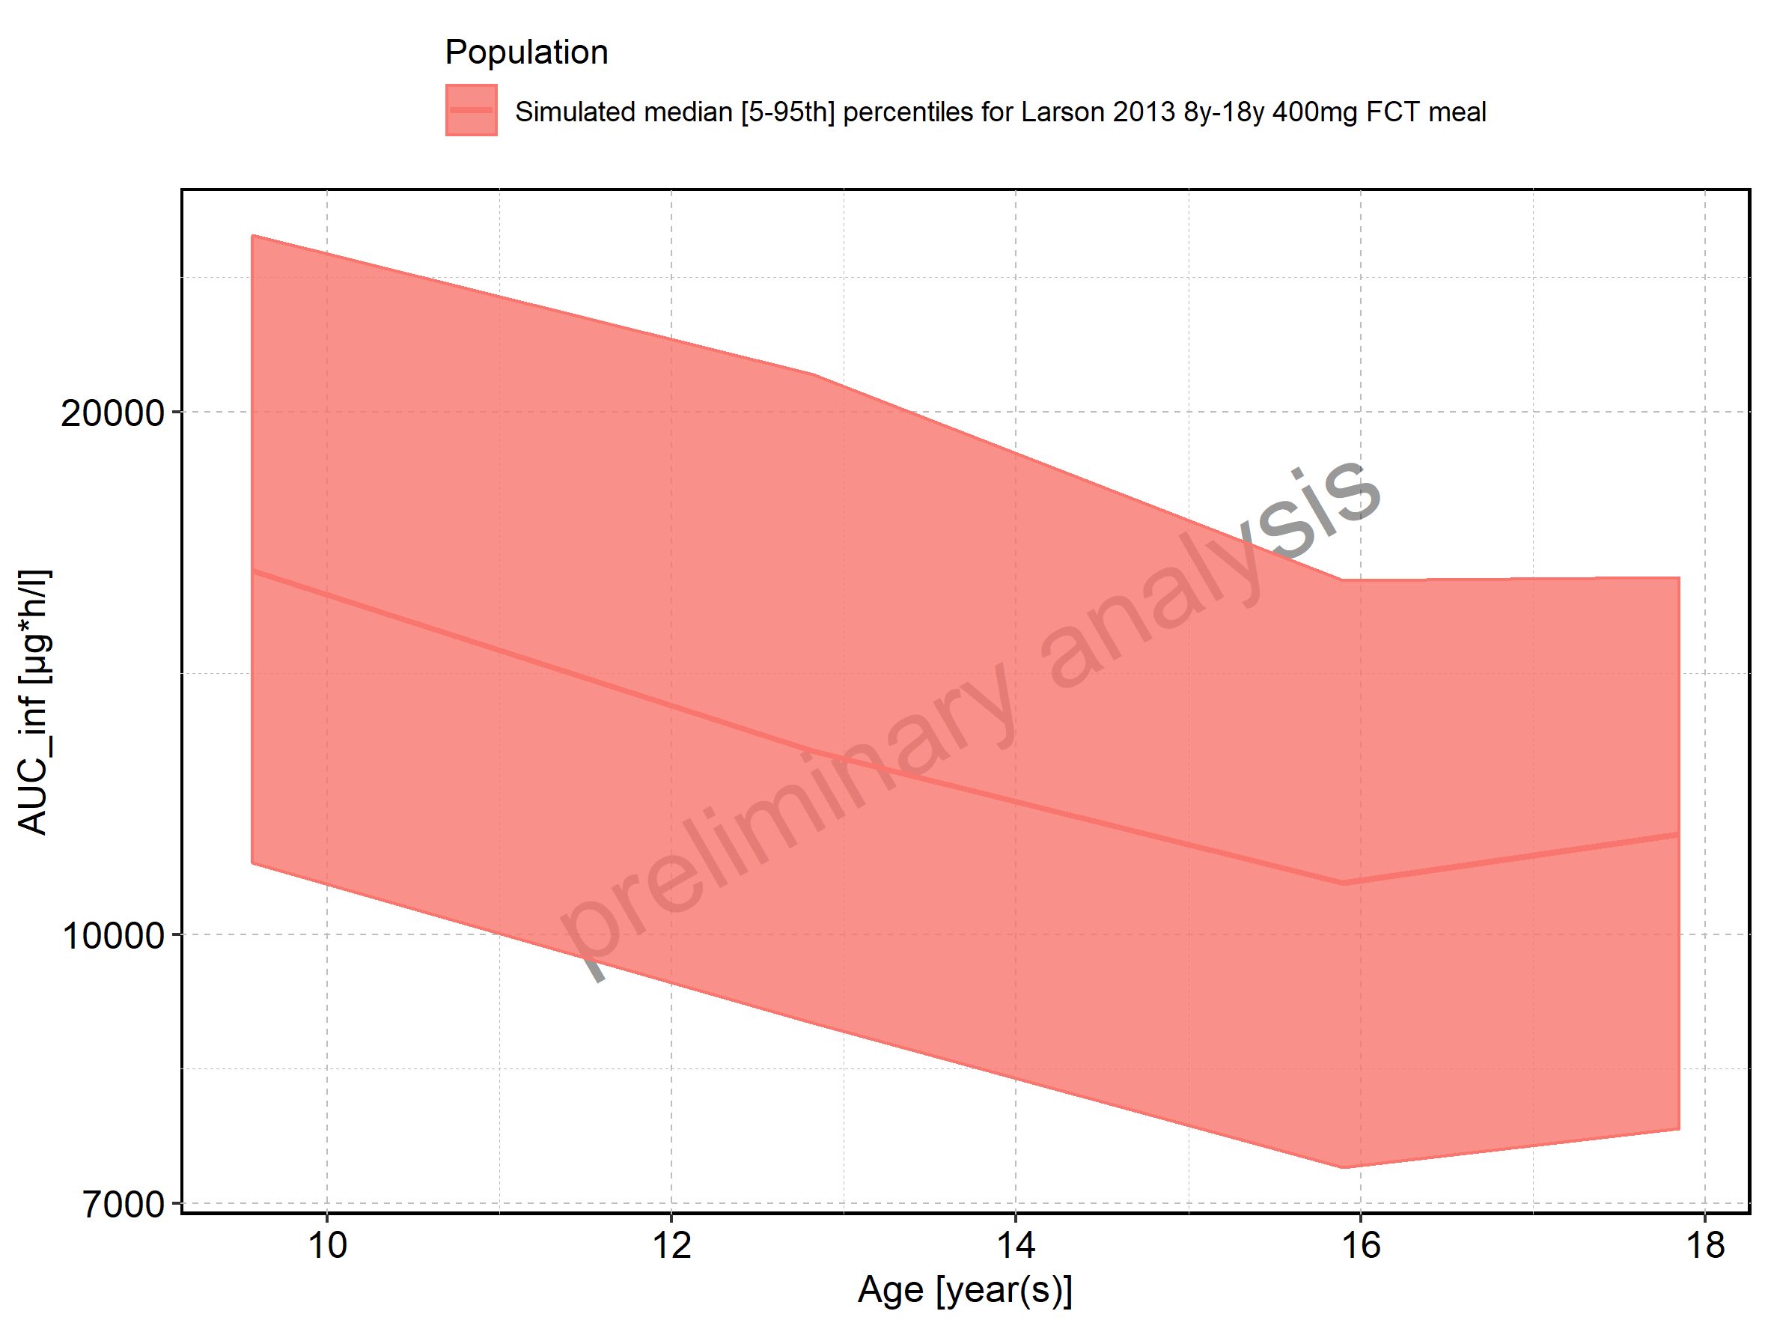

Figure 173: Age-dependence of AUC_inf for Filmcoated_tablet_400mg_sd. Profiles are plotted in a linear scale.

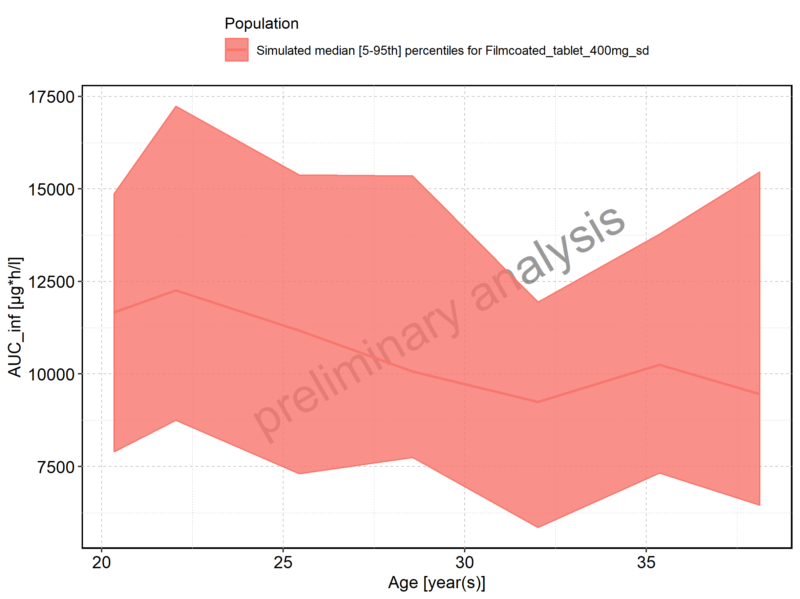

Figure 174: Age-dependence of AUC_inf for Filmcoated_tablet_400mg_sd. Profiles are plotted in a logarithmic scale.

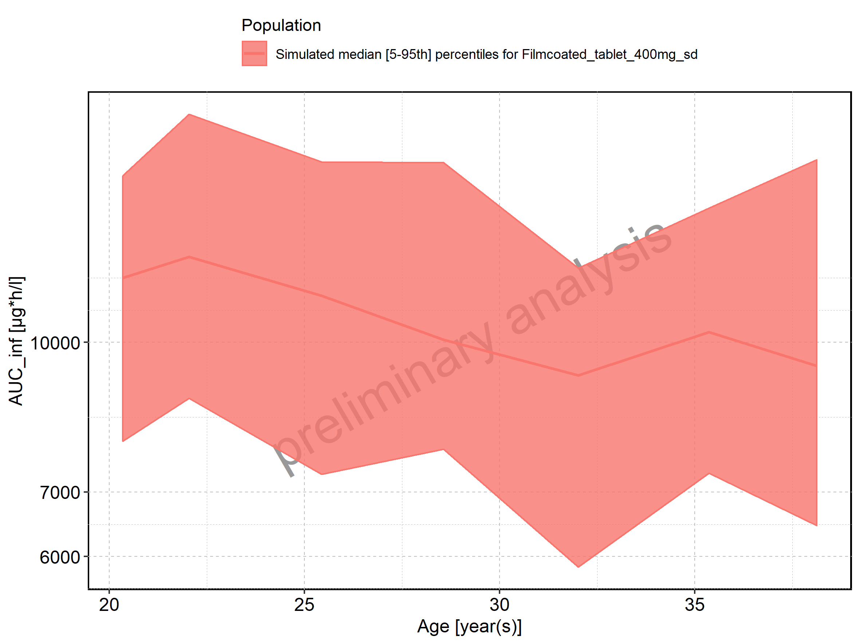

Figure 175: Height-dependence of AUC_inf for Larson 2013 8y-18y 400mg FCT meal in comparison to Filmcoated_tablet_400mg_sd. Profiles are plotted in a linear scale.

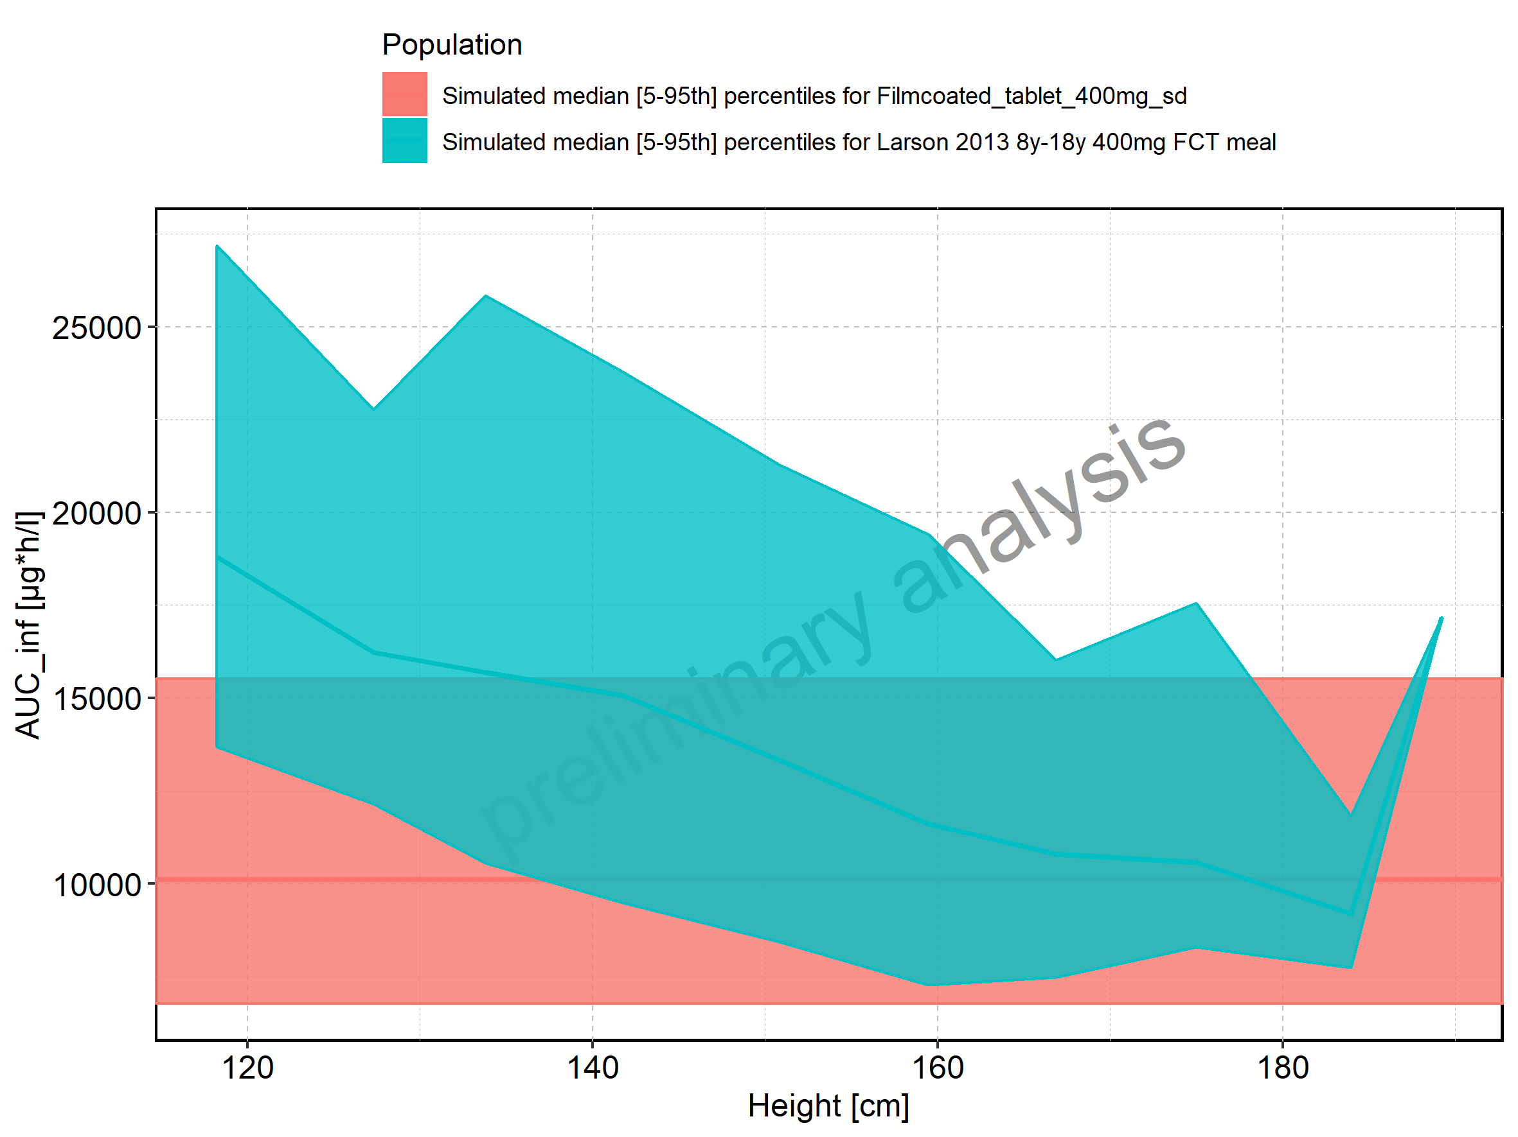

Figure 176: Height-dependence of AUC_inf for Larson 2013 8y-18y 400mg FCT meal in comparison to Filmcoated_tablet_400mg_sd. Profiles are plotted in a logarithmic scale.

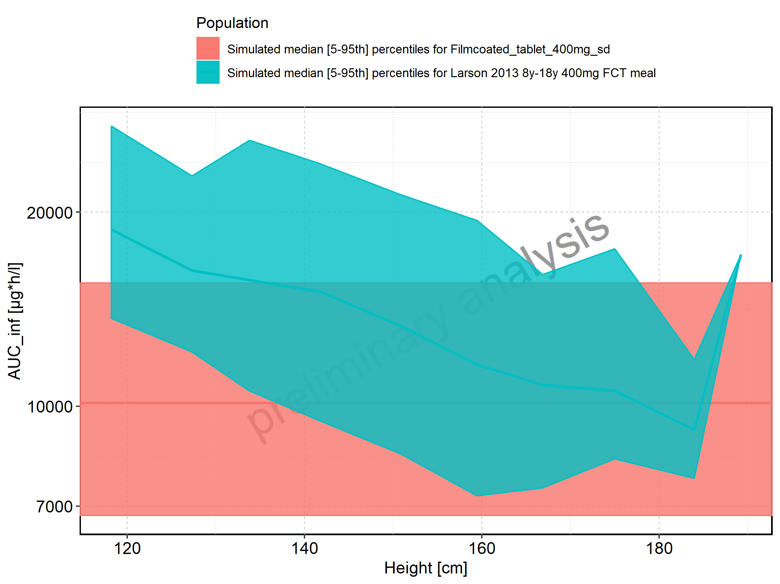

Figure 177: Height-dependence of AUC_inf for Larson 2013 8y-18y 400mg FCT meal. Profiles are plotted in a linear scale.

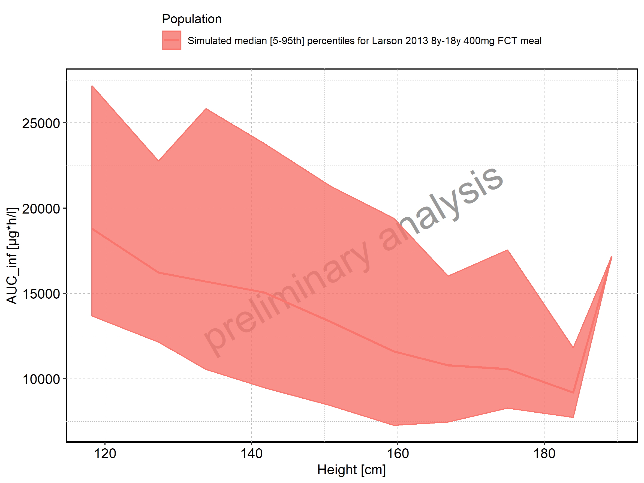

Figure 178: Height-dependence of AUC_inf for Larson 2013 8y-18y 400mg FCT meal. Profiles are plotted in a logarithmic scale.

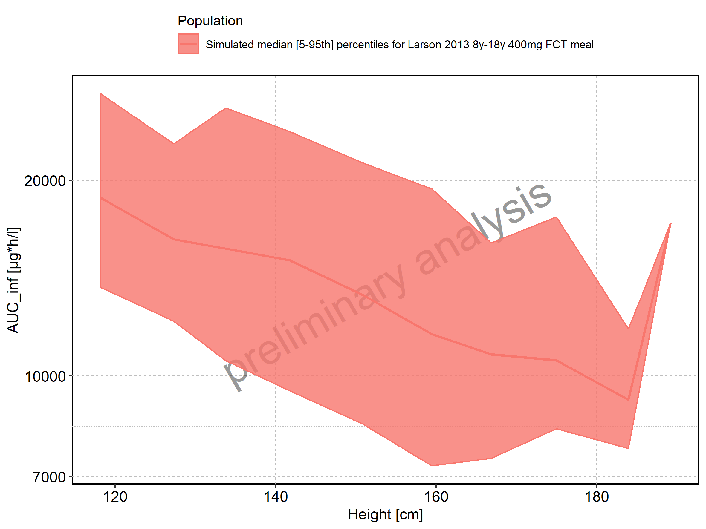

Figure 179: Height-dependence of AUC_inf for Filmcoated_tablet_400mg_sd. Profiles are plotted in a linear scale.

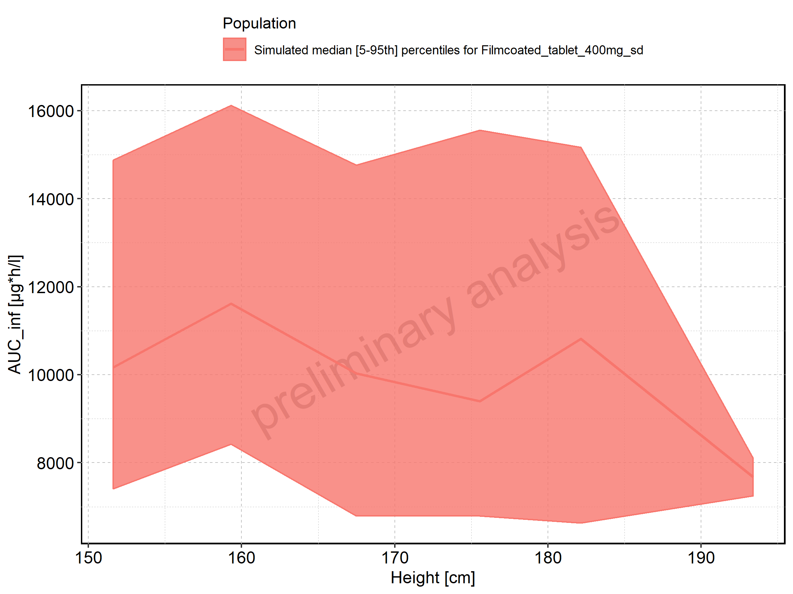

Figure 180: Height-dependence of AUC_inf for Filmcoated_tablet_400mg_sd. Profiles are plotted in a logarithmic scale.

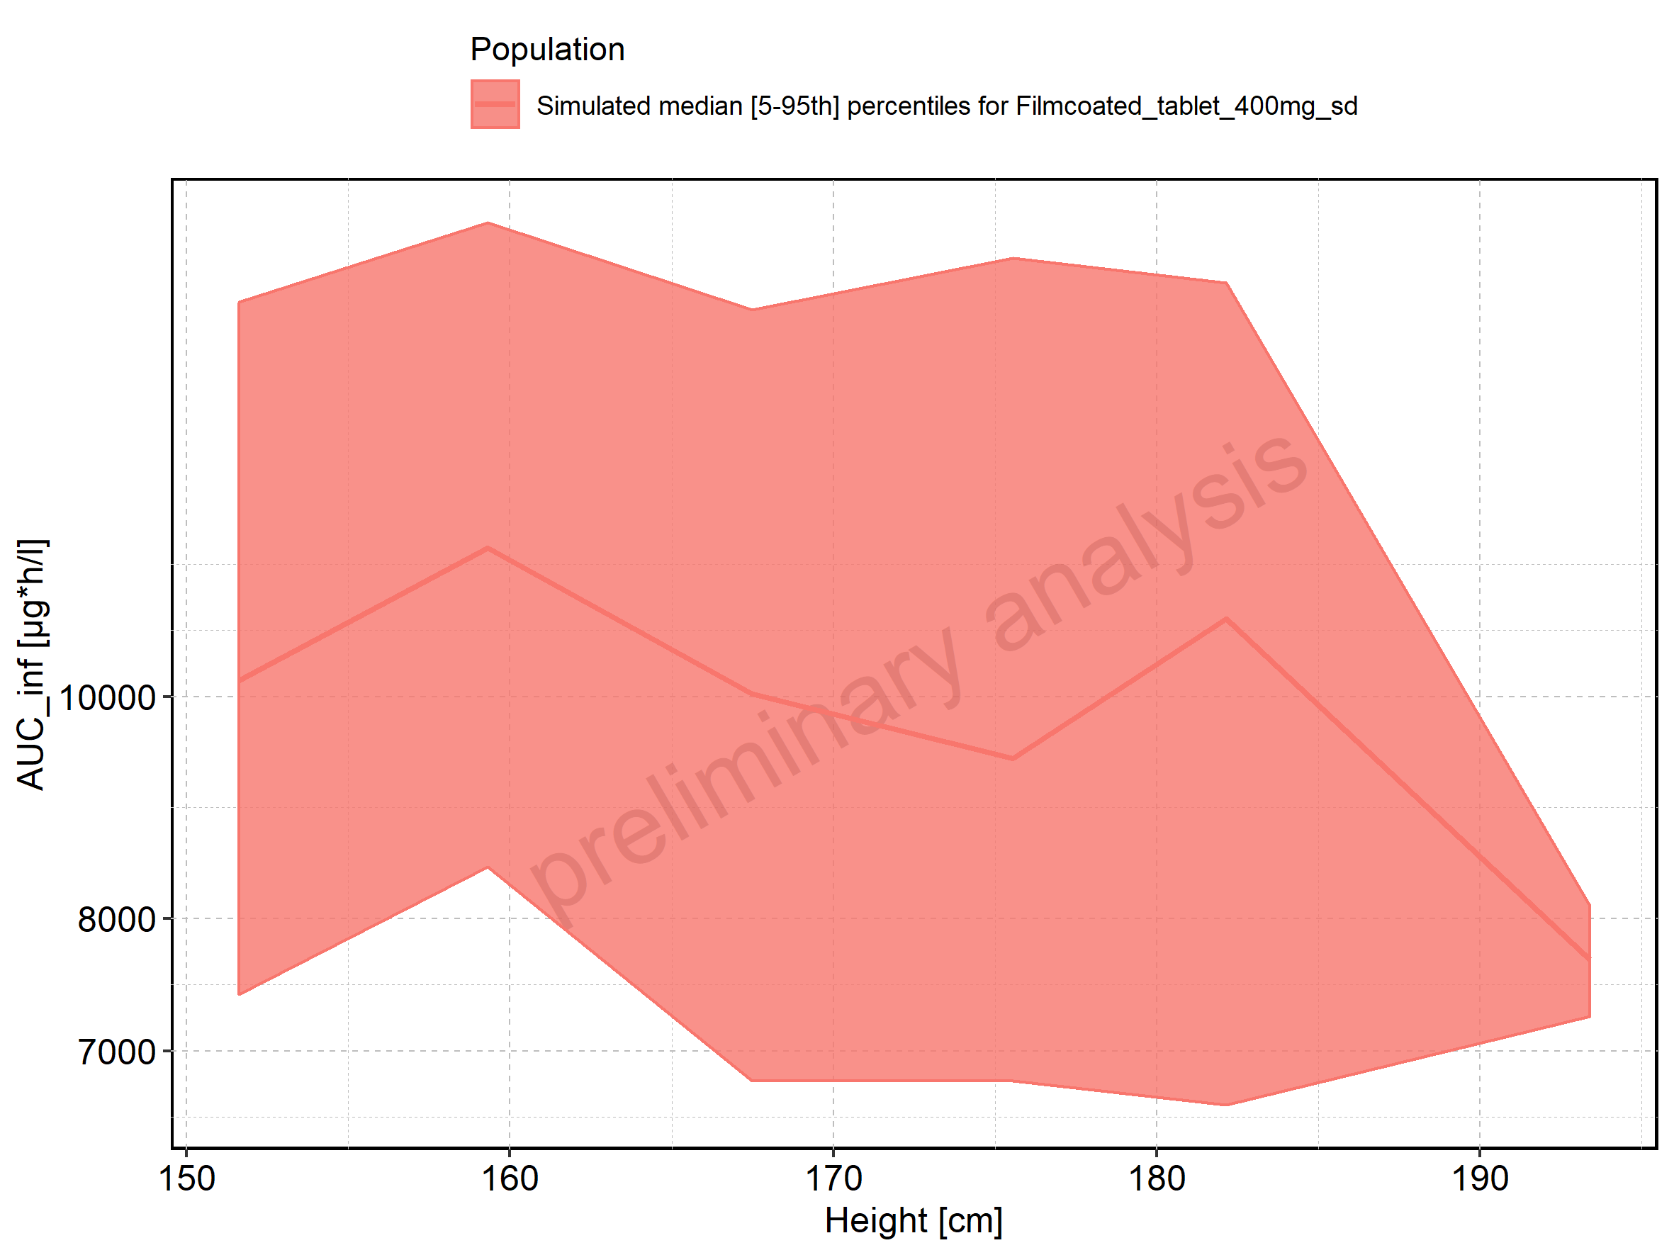

Figure 181: Weight-dependence of AUC_inf for Larson 2013 8y-18y 400mg FCT meal in comparison to Filmcoated_tablet_400mg_sd. Profiles are plotted in a linear scale.

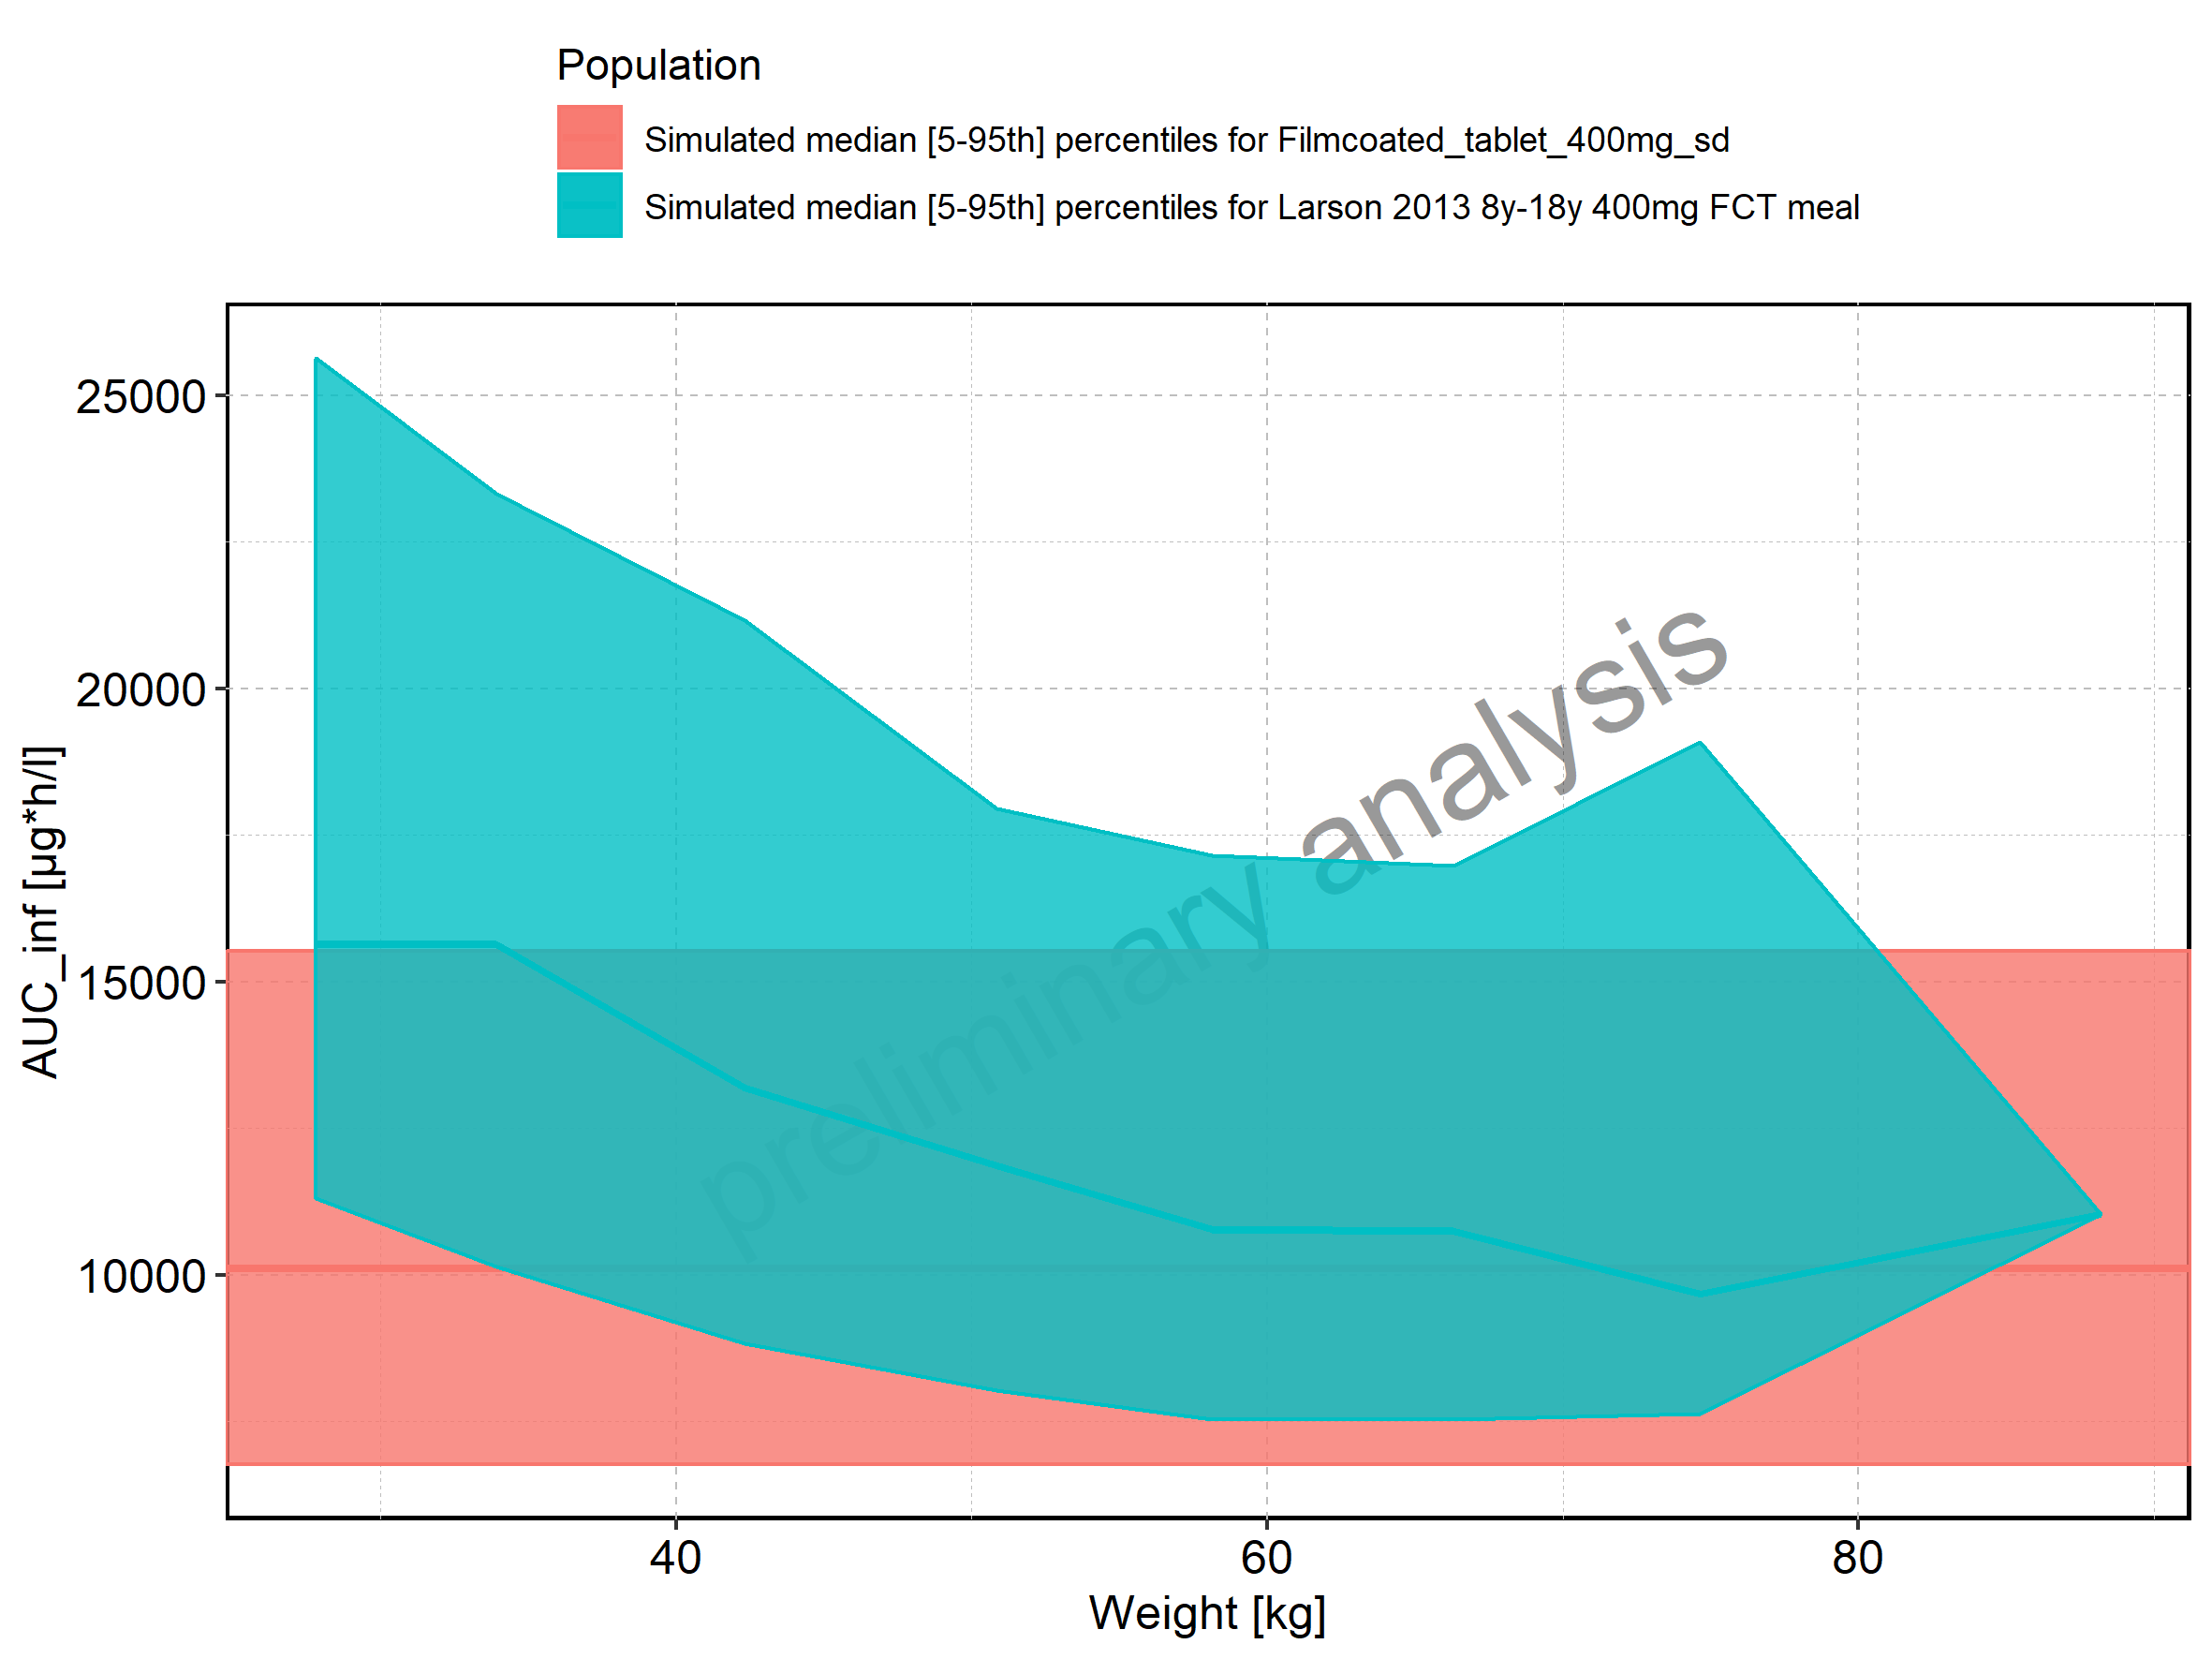

Figure 182: Weight-dependence of AUC_inf for Larson 2013 8y-18y 400mg FCT meal in comparison to Filmcoated_tablet_400mg_sd. Profiles are plotted in a logarithmic scale.

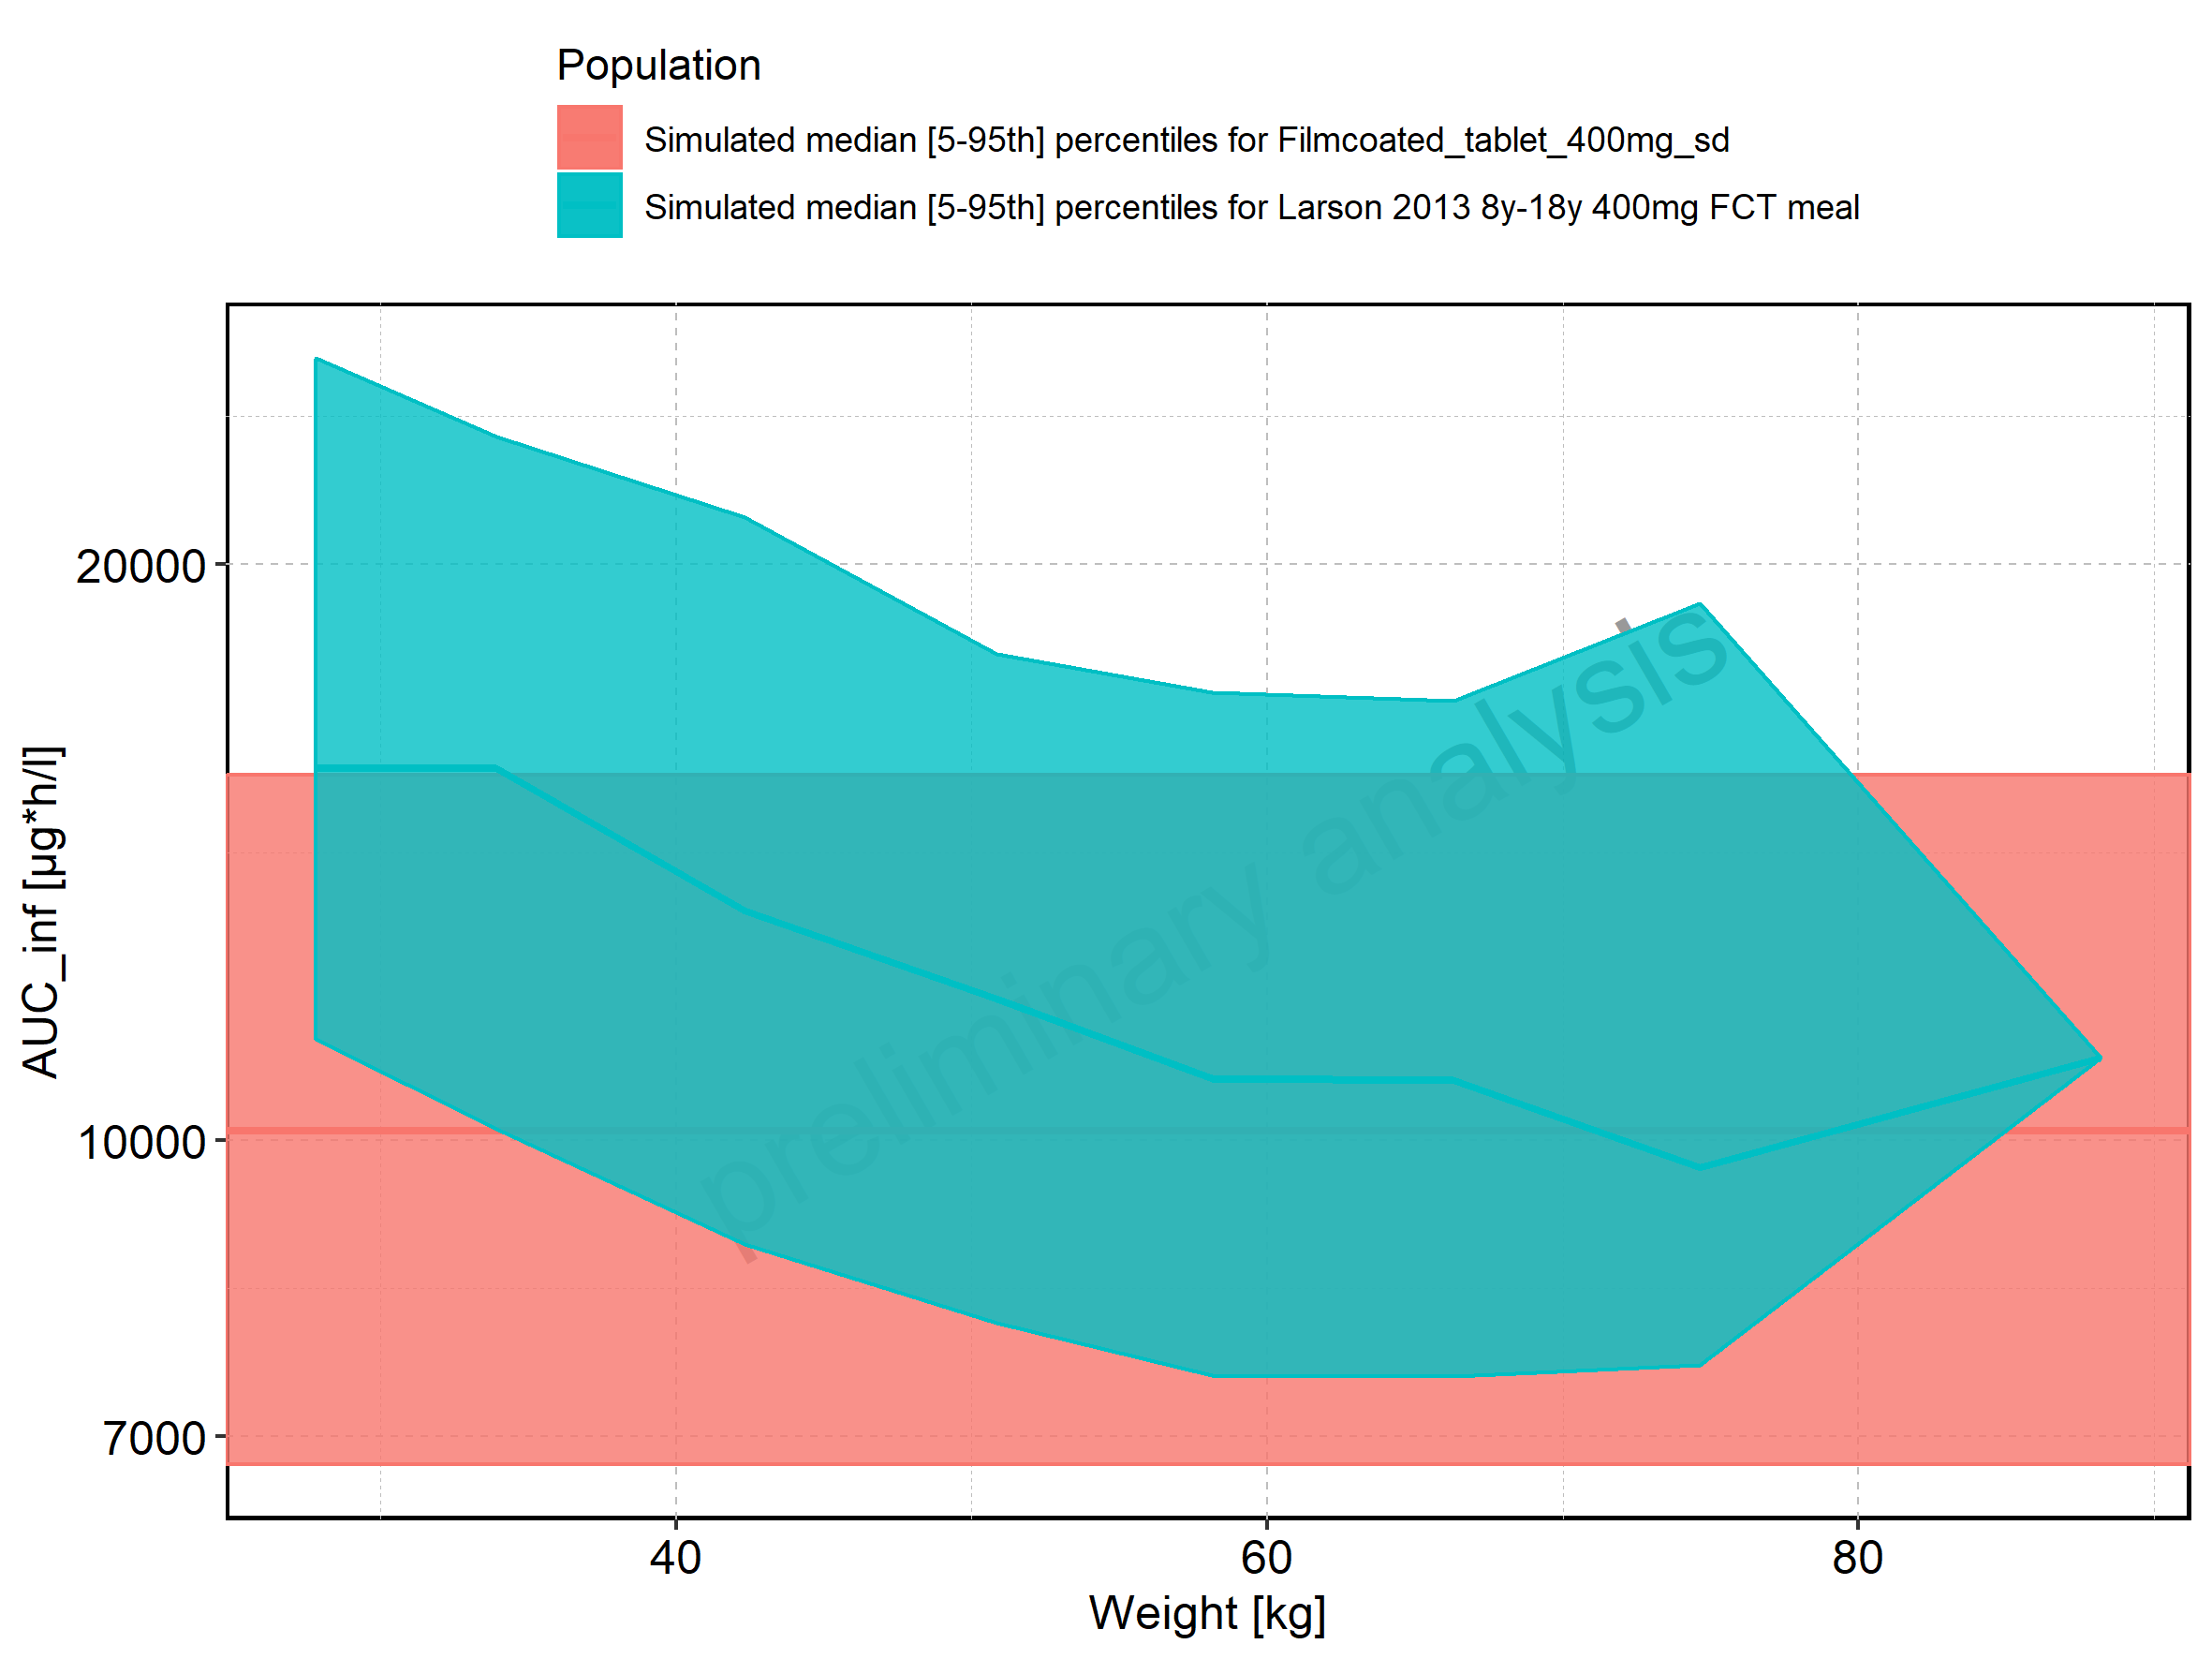

Figure 183: Weight-dependence of AUC_inf for Larson 2013 8y-18y 400mg FCT meal. Profiles are plotted in a linear scale.

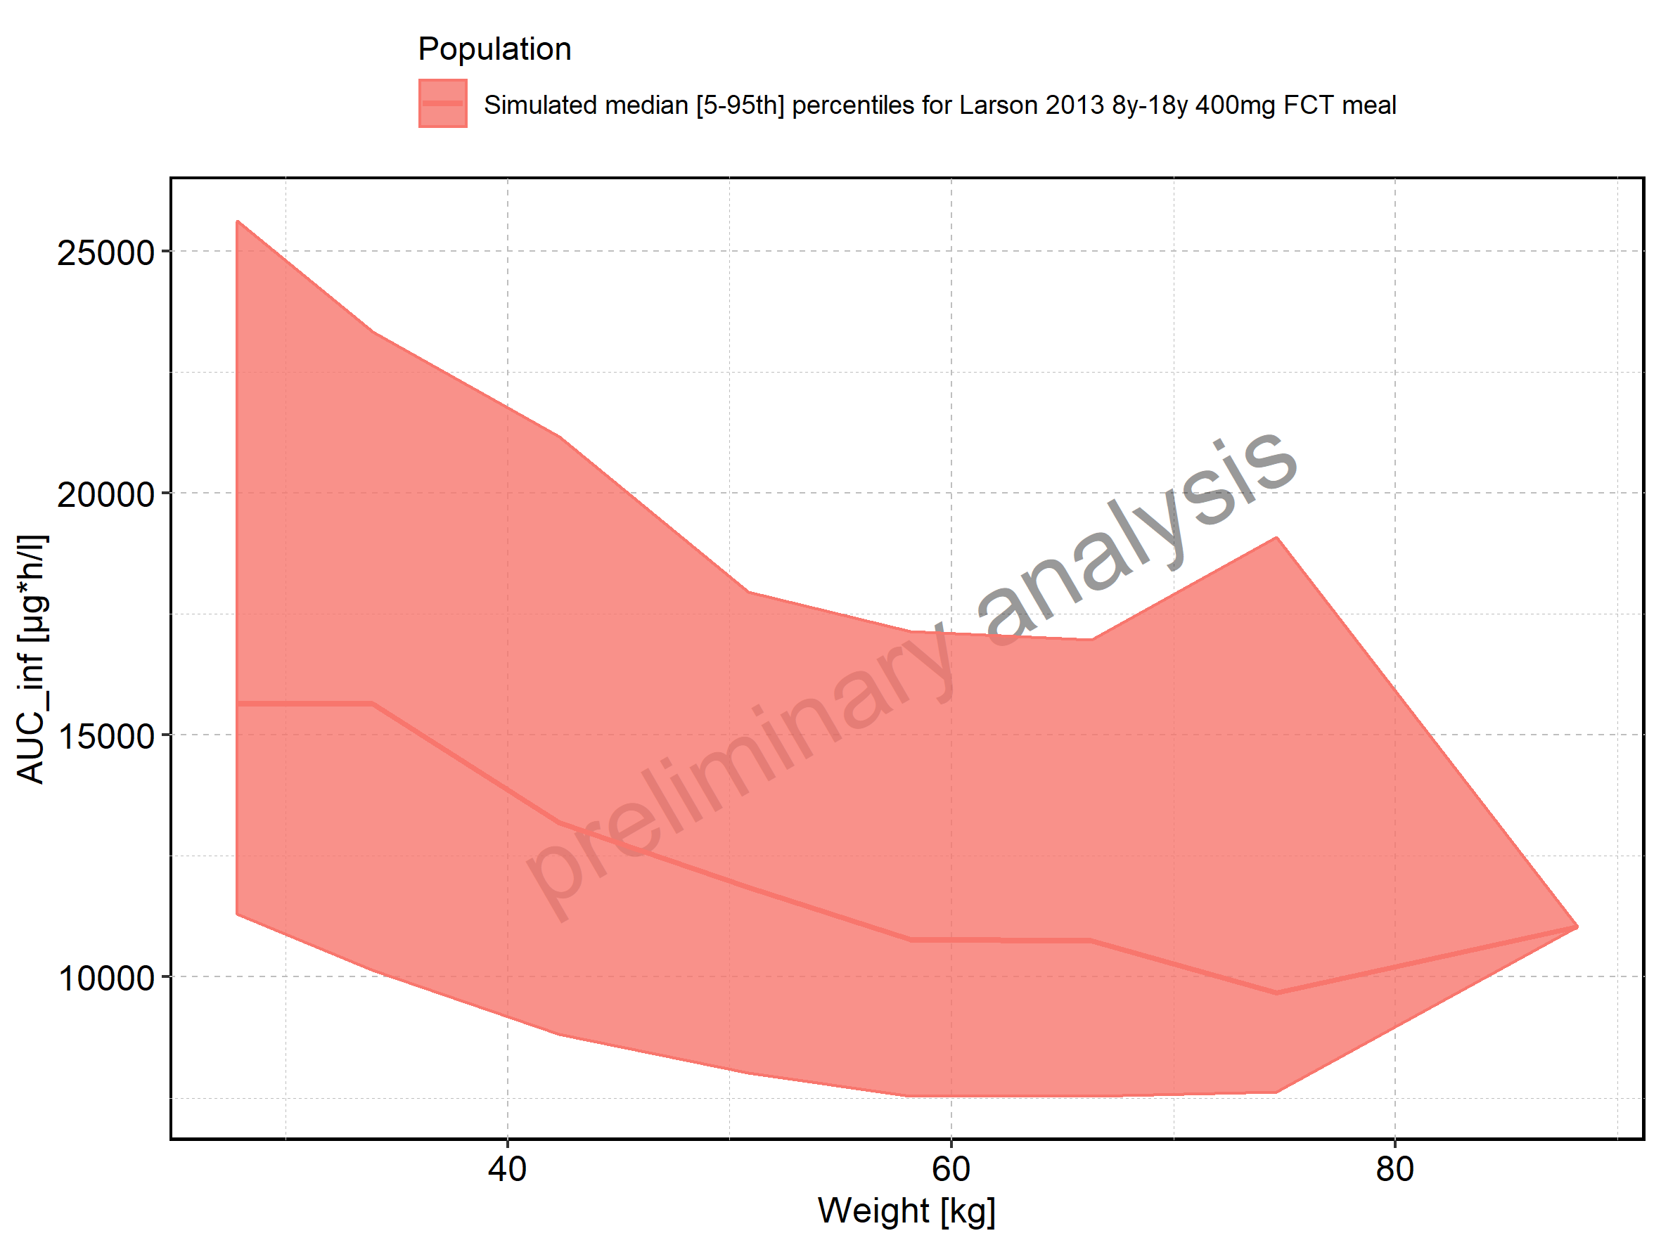

Figure 184: Weight-dependence of AUC_inf for Larson 2013 8y-18y 400mg FCT meal. Profiles are plotted in a logarithmic scale.

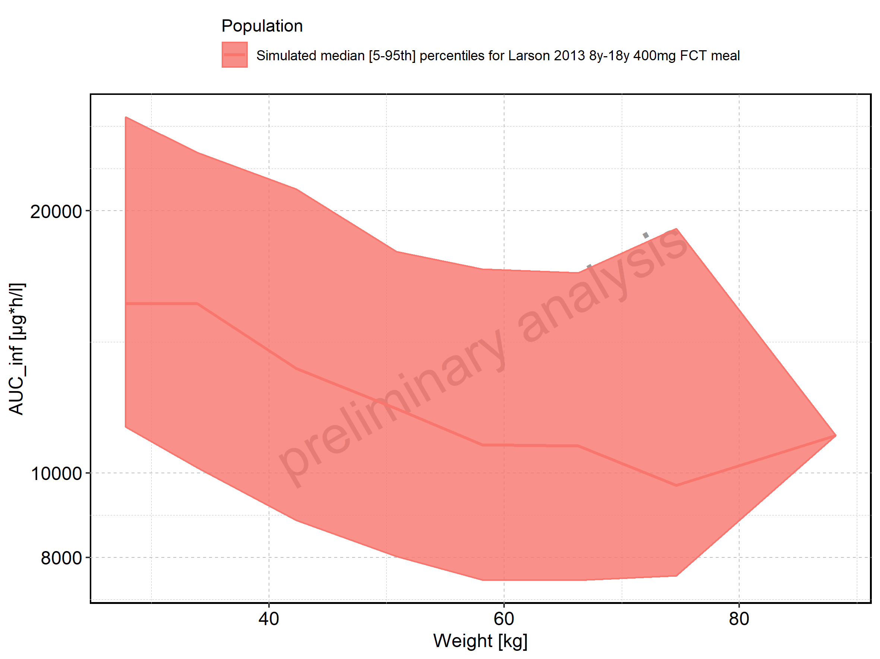

Figure 185: Weight-dependence of AUC_inf for Filmcoated_tablet_400mg_sd. Profiles are plotted in a linear scale.

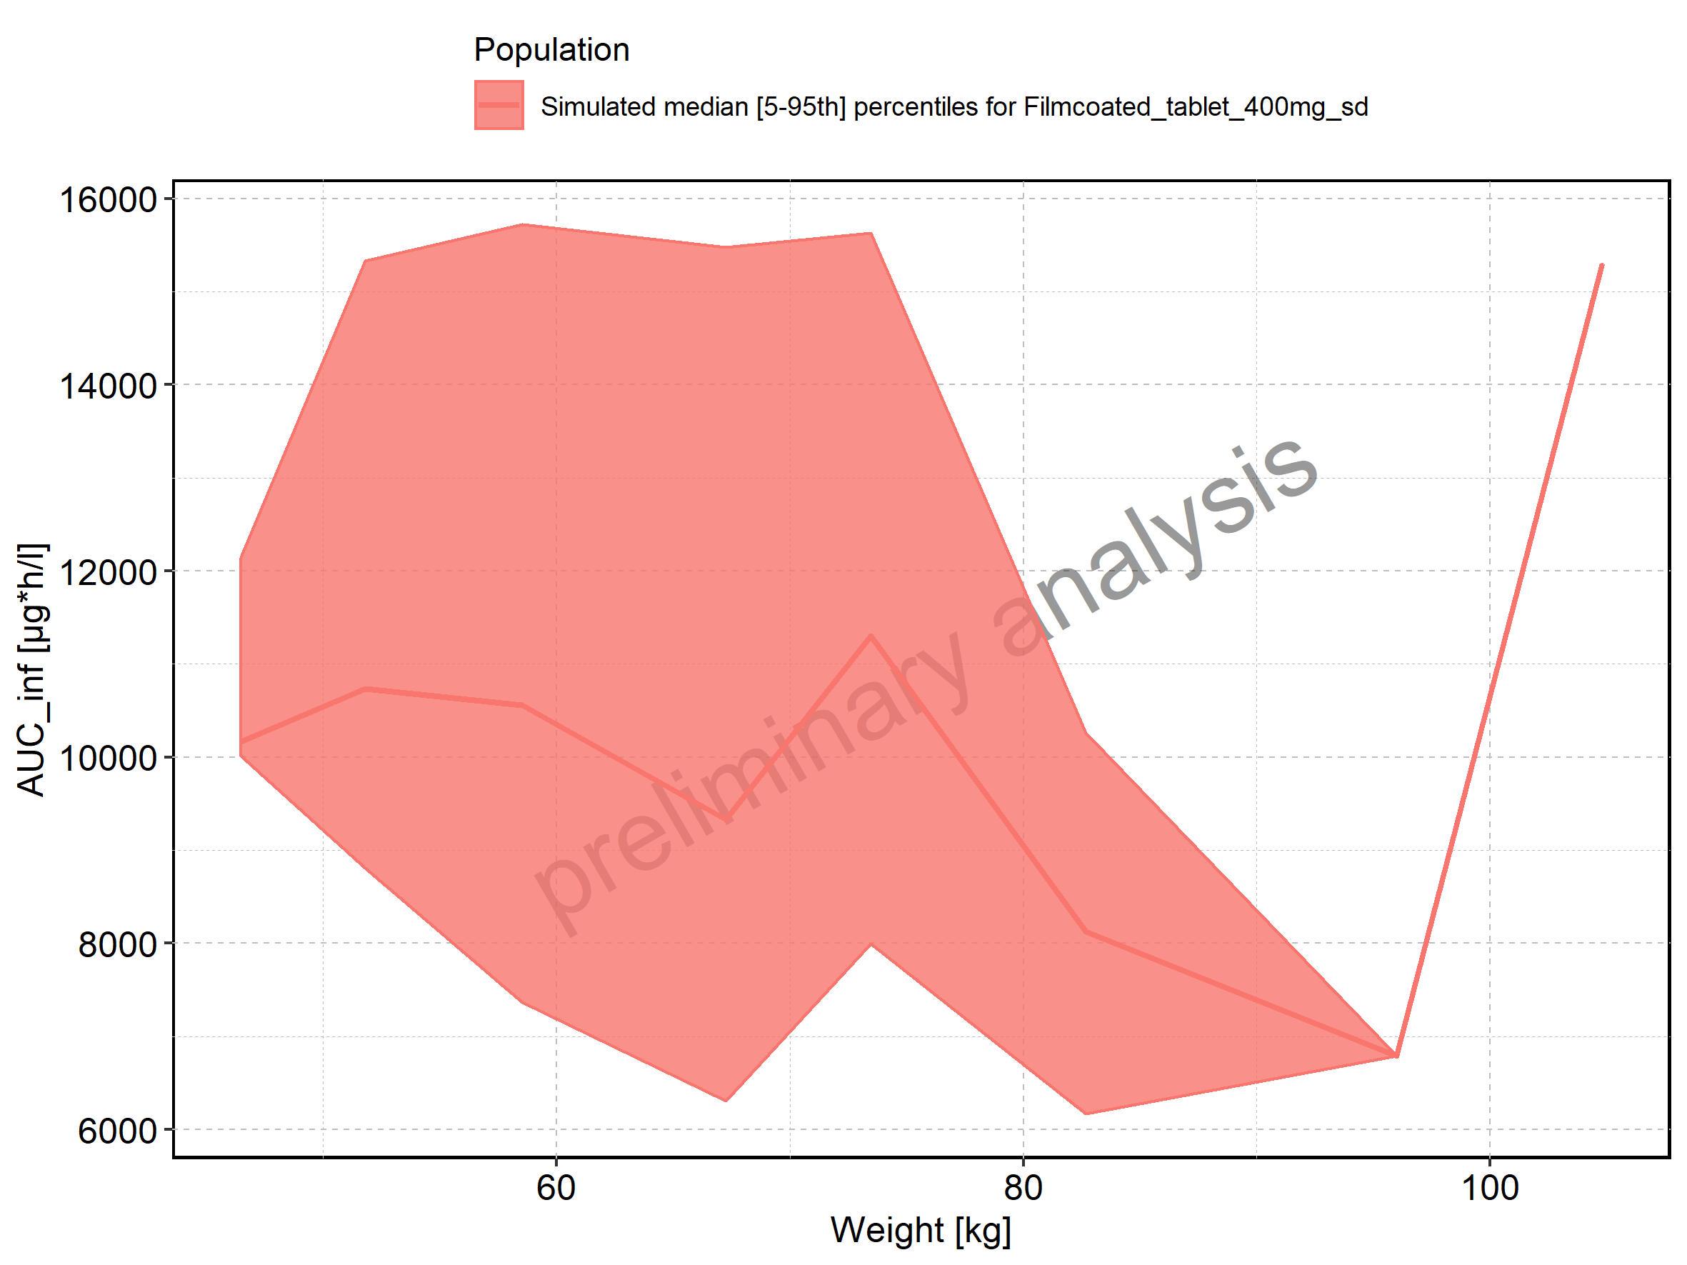

Figure 186: Weight-dependence of AUC_inf for Filmcoated_tablet_400mg_sd. Profiles are plotted in a logarithmic scale.

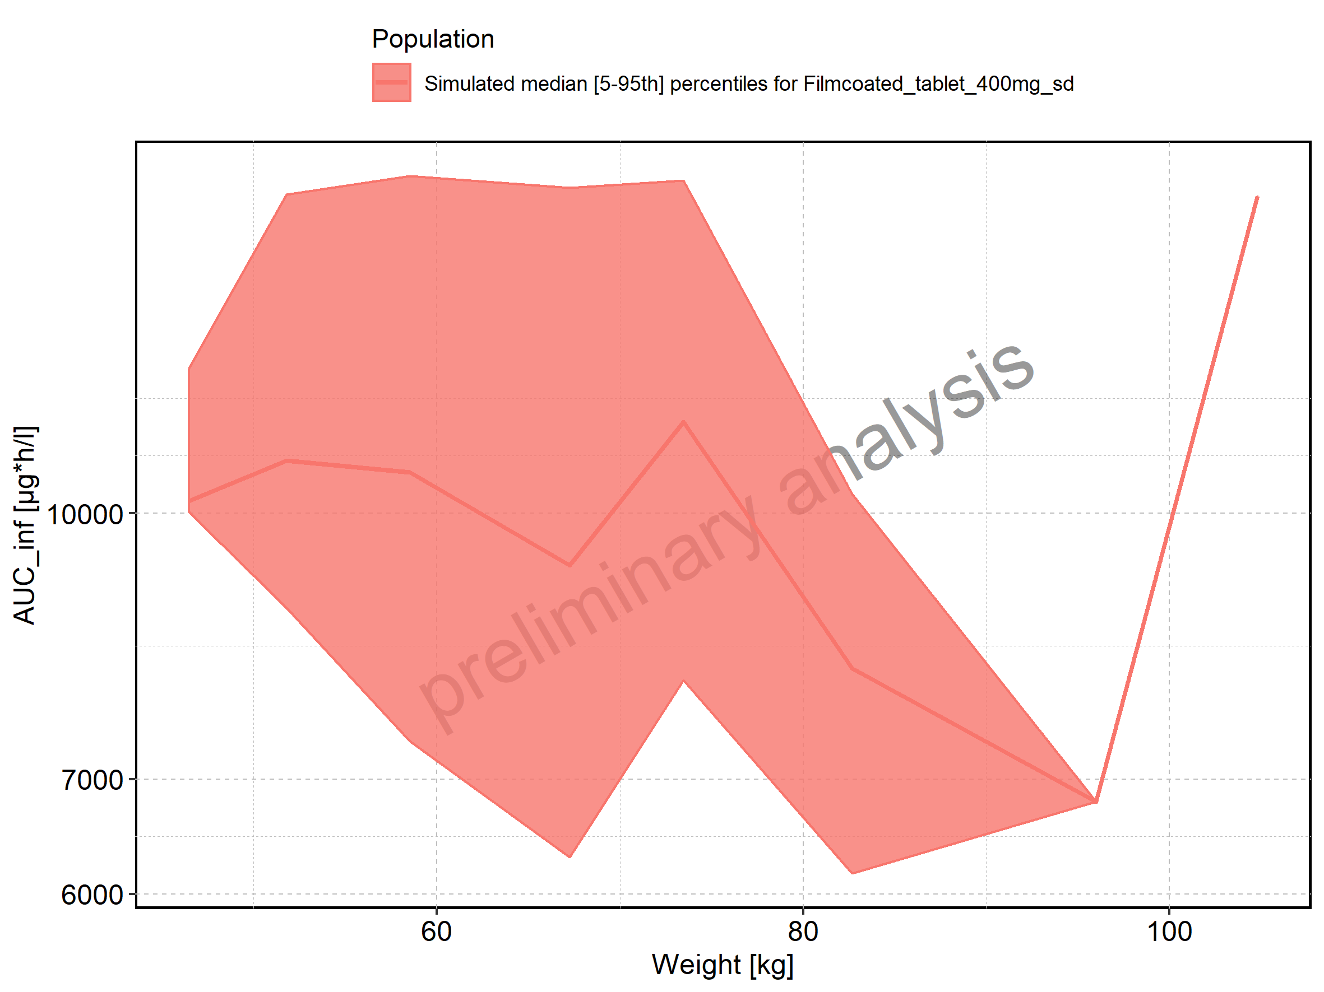

Figure 187: BMI-dependence of AUC_inf for Larson 2013 8y-18y 400mg FCT meal in comparison to Filmcoated_tablet_400mg_sd. Profiles are plotted in a linear scale.

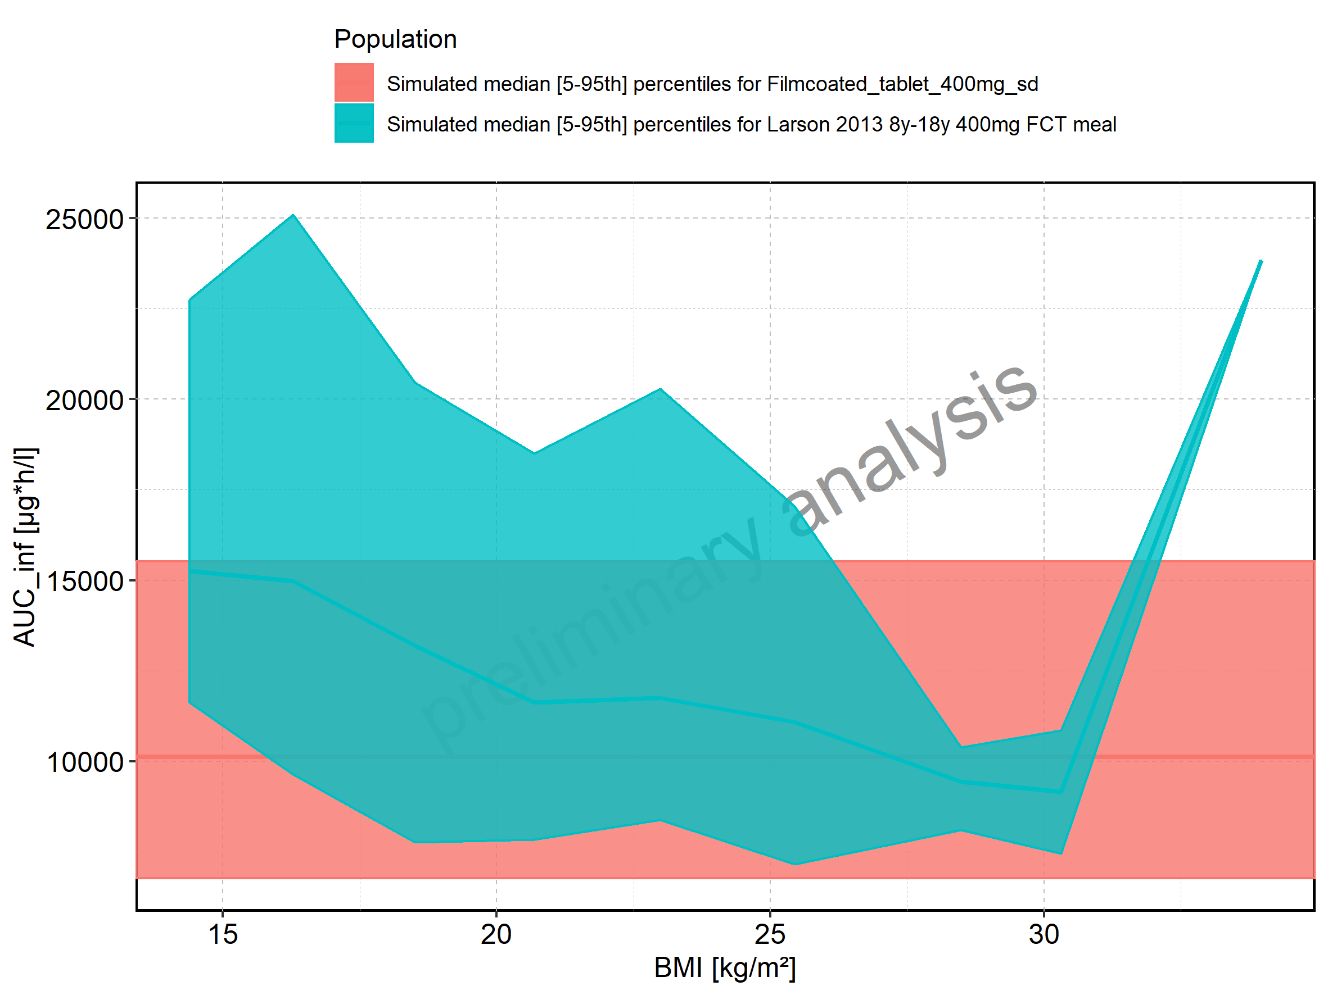

Figure 188: BMI-dependence of AUC_inf for Larson 2013 8y-18y 400mg FCT meal in comparison to Filmcoated_tablet_400mg_sd. Profiles are plotted in a logarithmic scale.

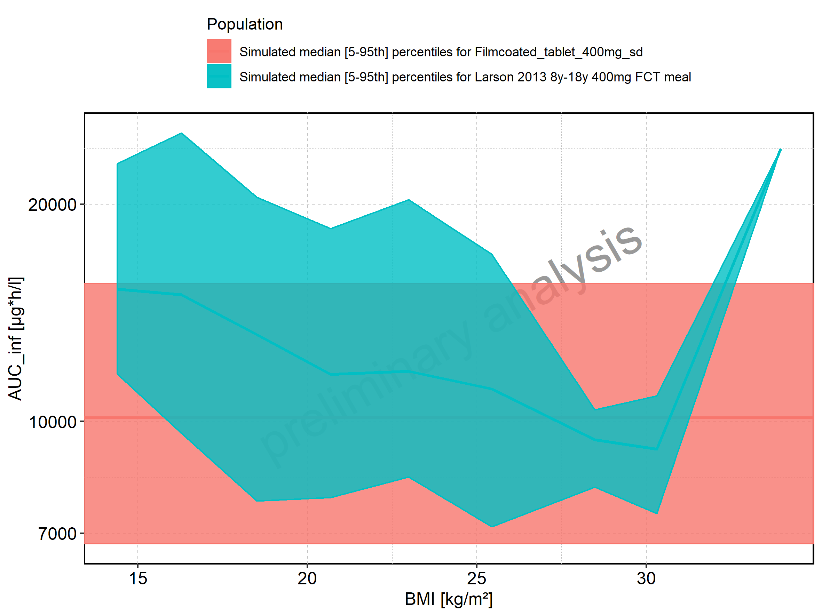

Figure 189: BMI-dependence of AUC_inf for Larson 2013 8y-18y 400mg FCT meal. Profiles are plotted in a linear scale.

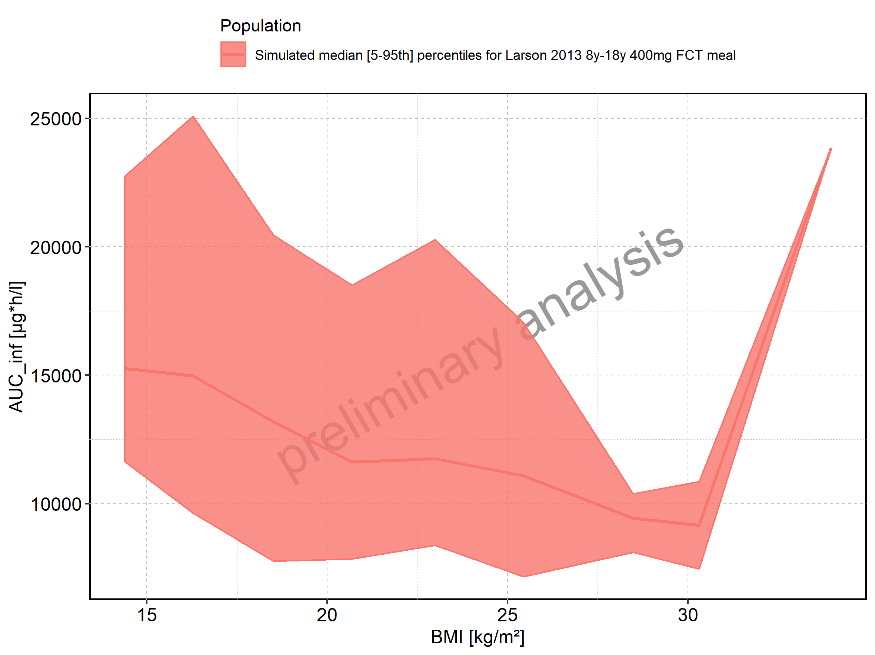

Figure 190: BMI-dependence of AUC_inf for Larson 2013 8y-18y 400mg FCT meal. Profiles are plotted in a logarithmic scale.

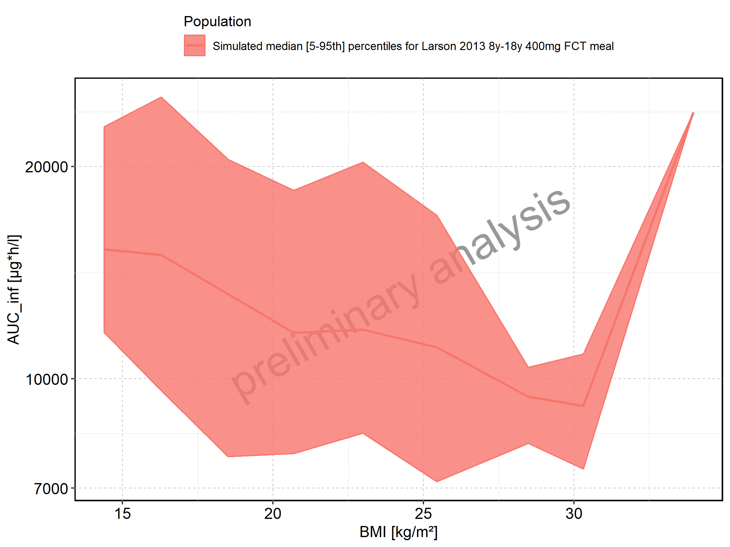

Figure 191: BMI-dependence of AUC_inf for Filmcoated_tablet_400mg_sd. Profiles are plotted in a linear scale.

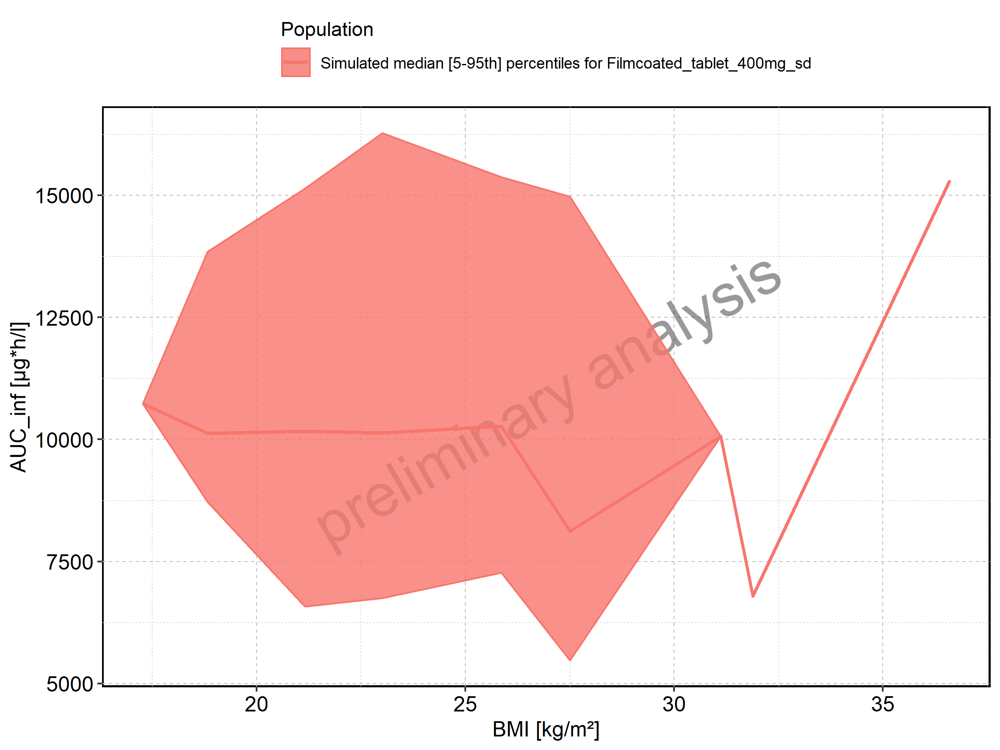

Figure 192: BMI-dependence of AUC_inf for Filmcoated_tablet_400mg_sd. Profiles are plotted in a logarithmic scale.

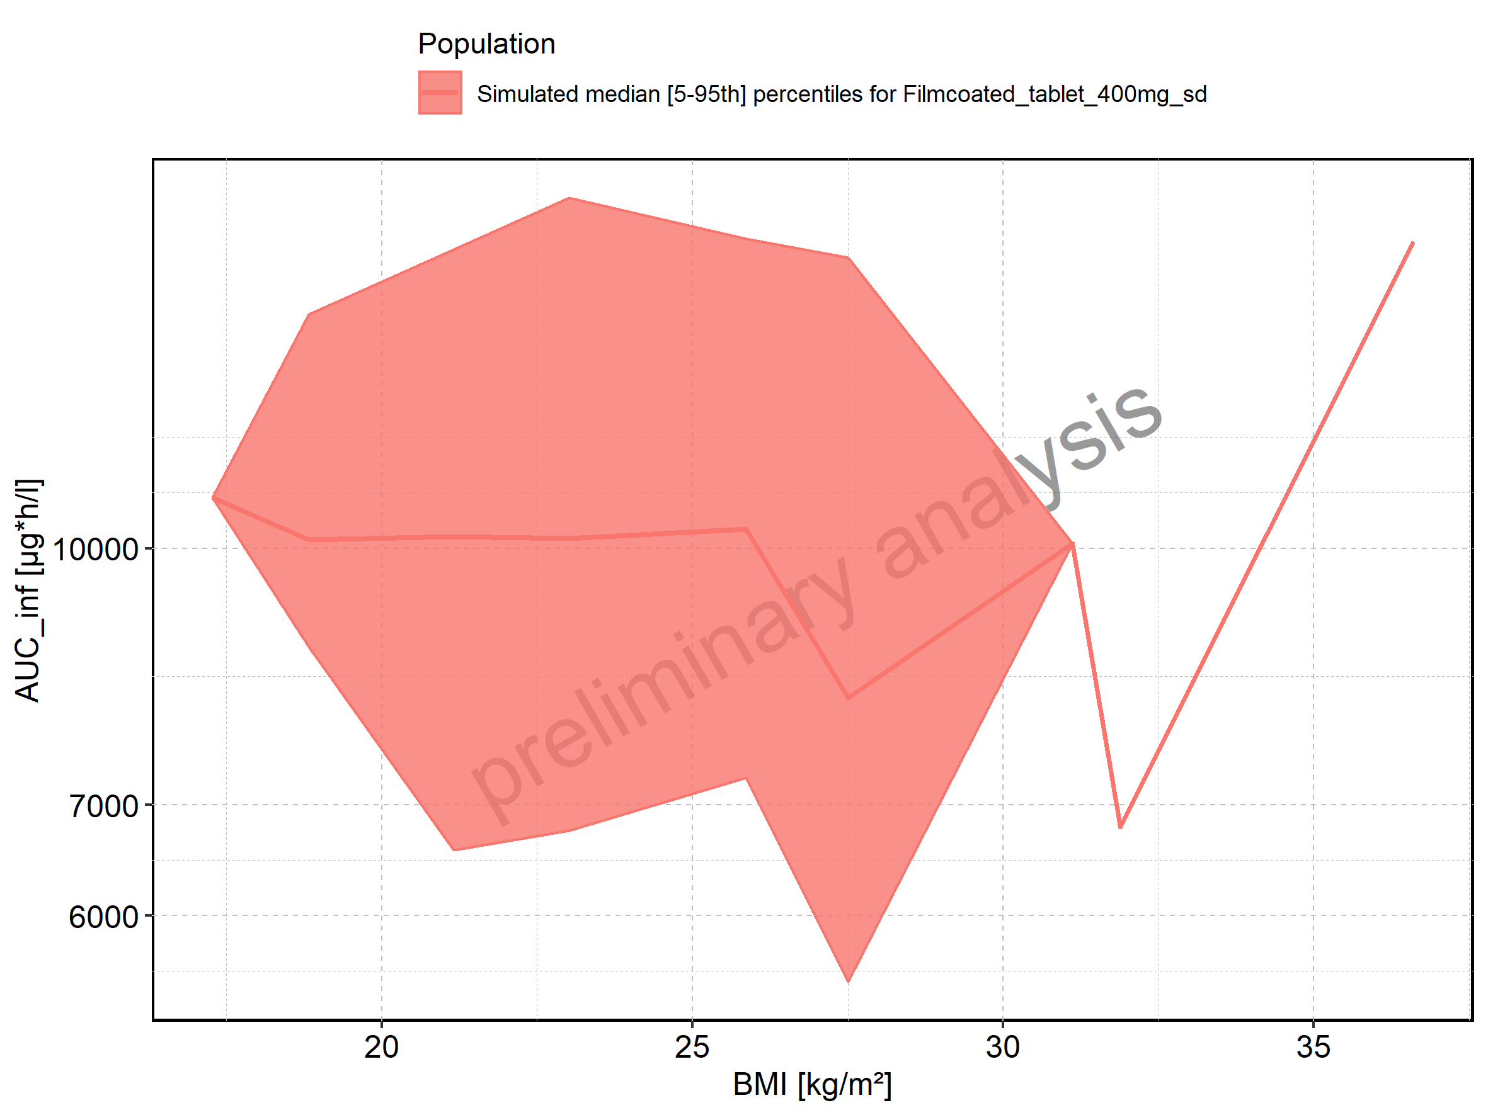

Figure 193: AUC_inf_norm of Raltegravir shown as box-whisker plot, which indicates the 5th, 25th, 50th, 75th, and 95th percentiles in linear scale.

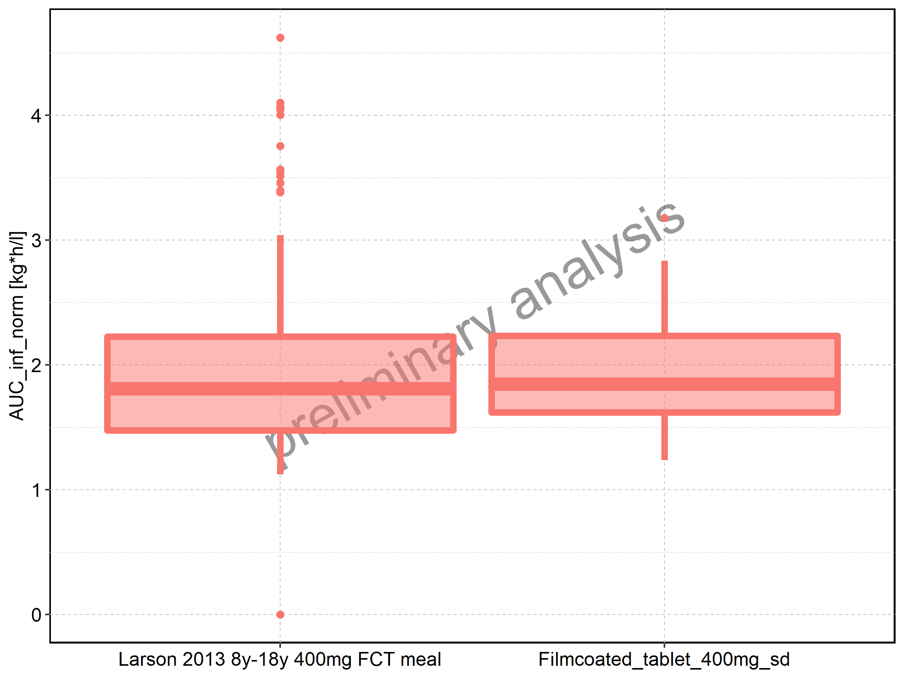

|  |  |  |  |  |  |  |  |  |  |  |
| --- | --- | --- | --- | --- | --- | --- | --- | --- | --- | --- |
| Population | N | 5th percentile | 25th percentile | 50th percentile | 75th percentile | 95th percentile | mean | standard deviation | geo mean | geo standard deviation |
| Larson 2013 8y-18y 400mg FCT meal | 500 | 1.122459 | 1.474697 | 1.808946 | 2.224966 | 3.039113 | 1.911306 | 0.6244302 | 0.000000 | NA |
| Filmcoated_tablet_400mg_sd | 100 | 1.235885 | 1.619816 | 1.845499 | 2.231818 | 2.832975 | 1.939375 | 0.5032642 | 1.875269 | 1.300506 |

Figure 194: AUC_inf_norm of Raltegravir shown as box-whisker plot, which indicates the 5th, 25th, 50th, 75th, and 95th percentiles in logarithmic scale.

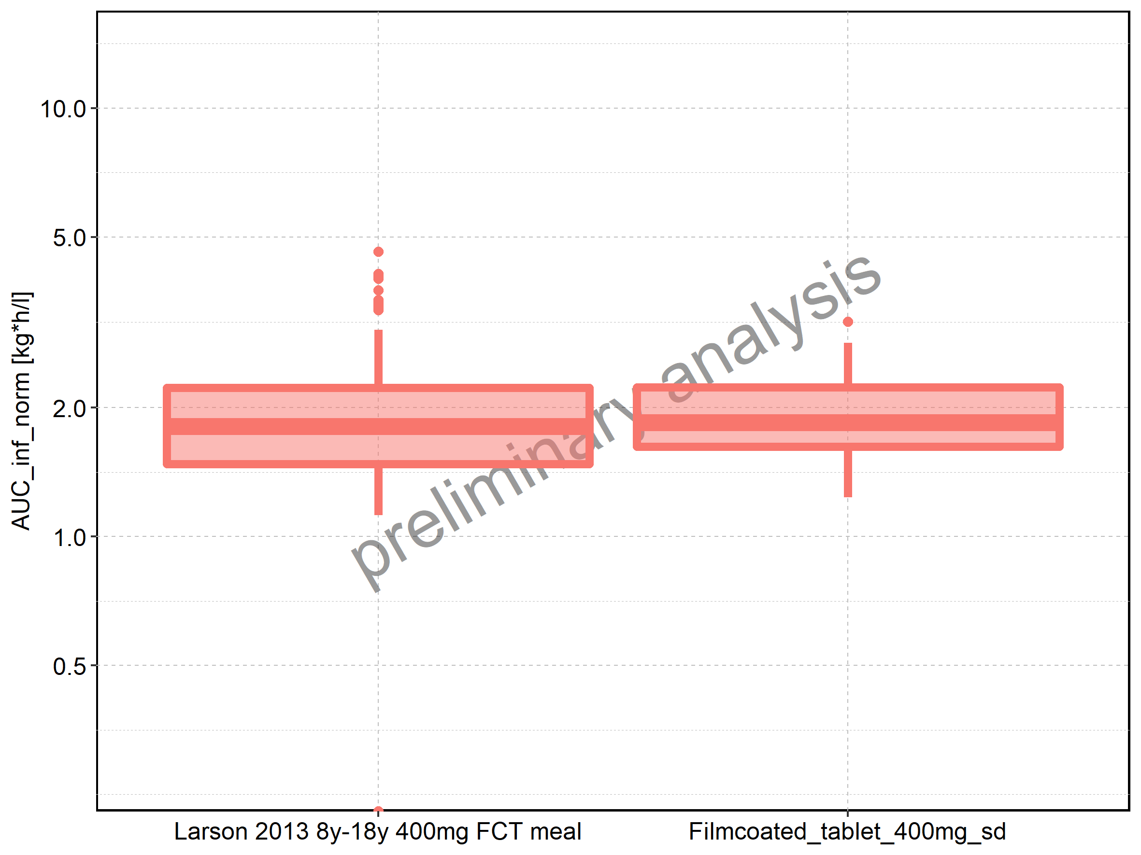

Figure 195: Age-dependence of AUC_inf_norm for Larson 2013 8y-18y 400mg FCT meal in comparison to Filmcoated_tablet_400mg_sd. Profiles are plotted in a linear scale.

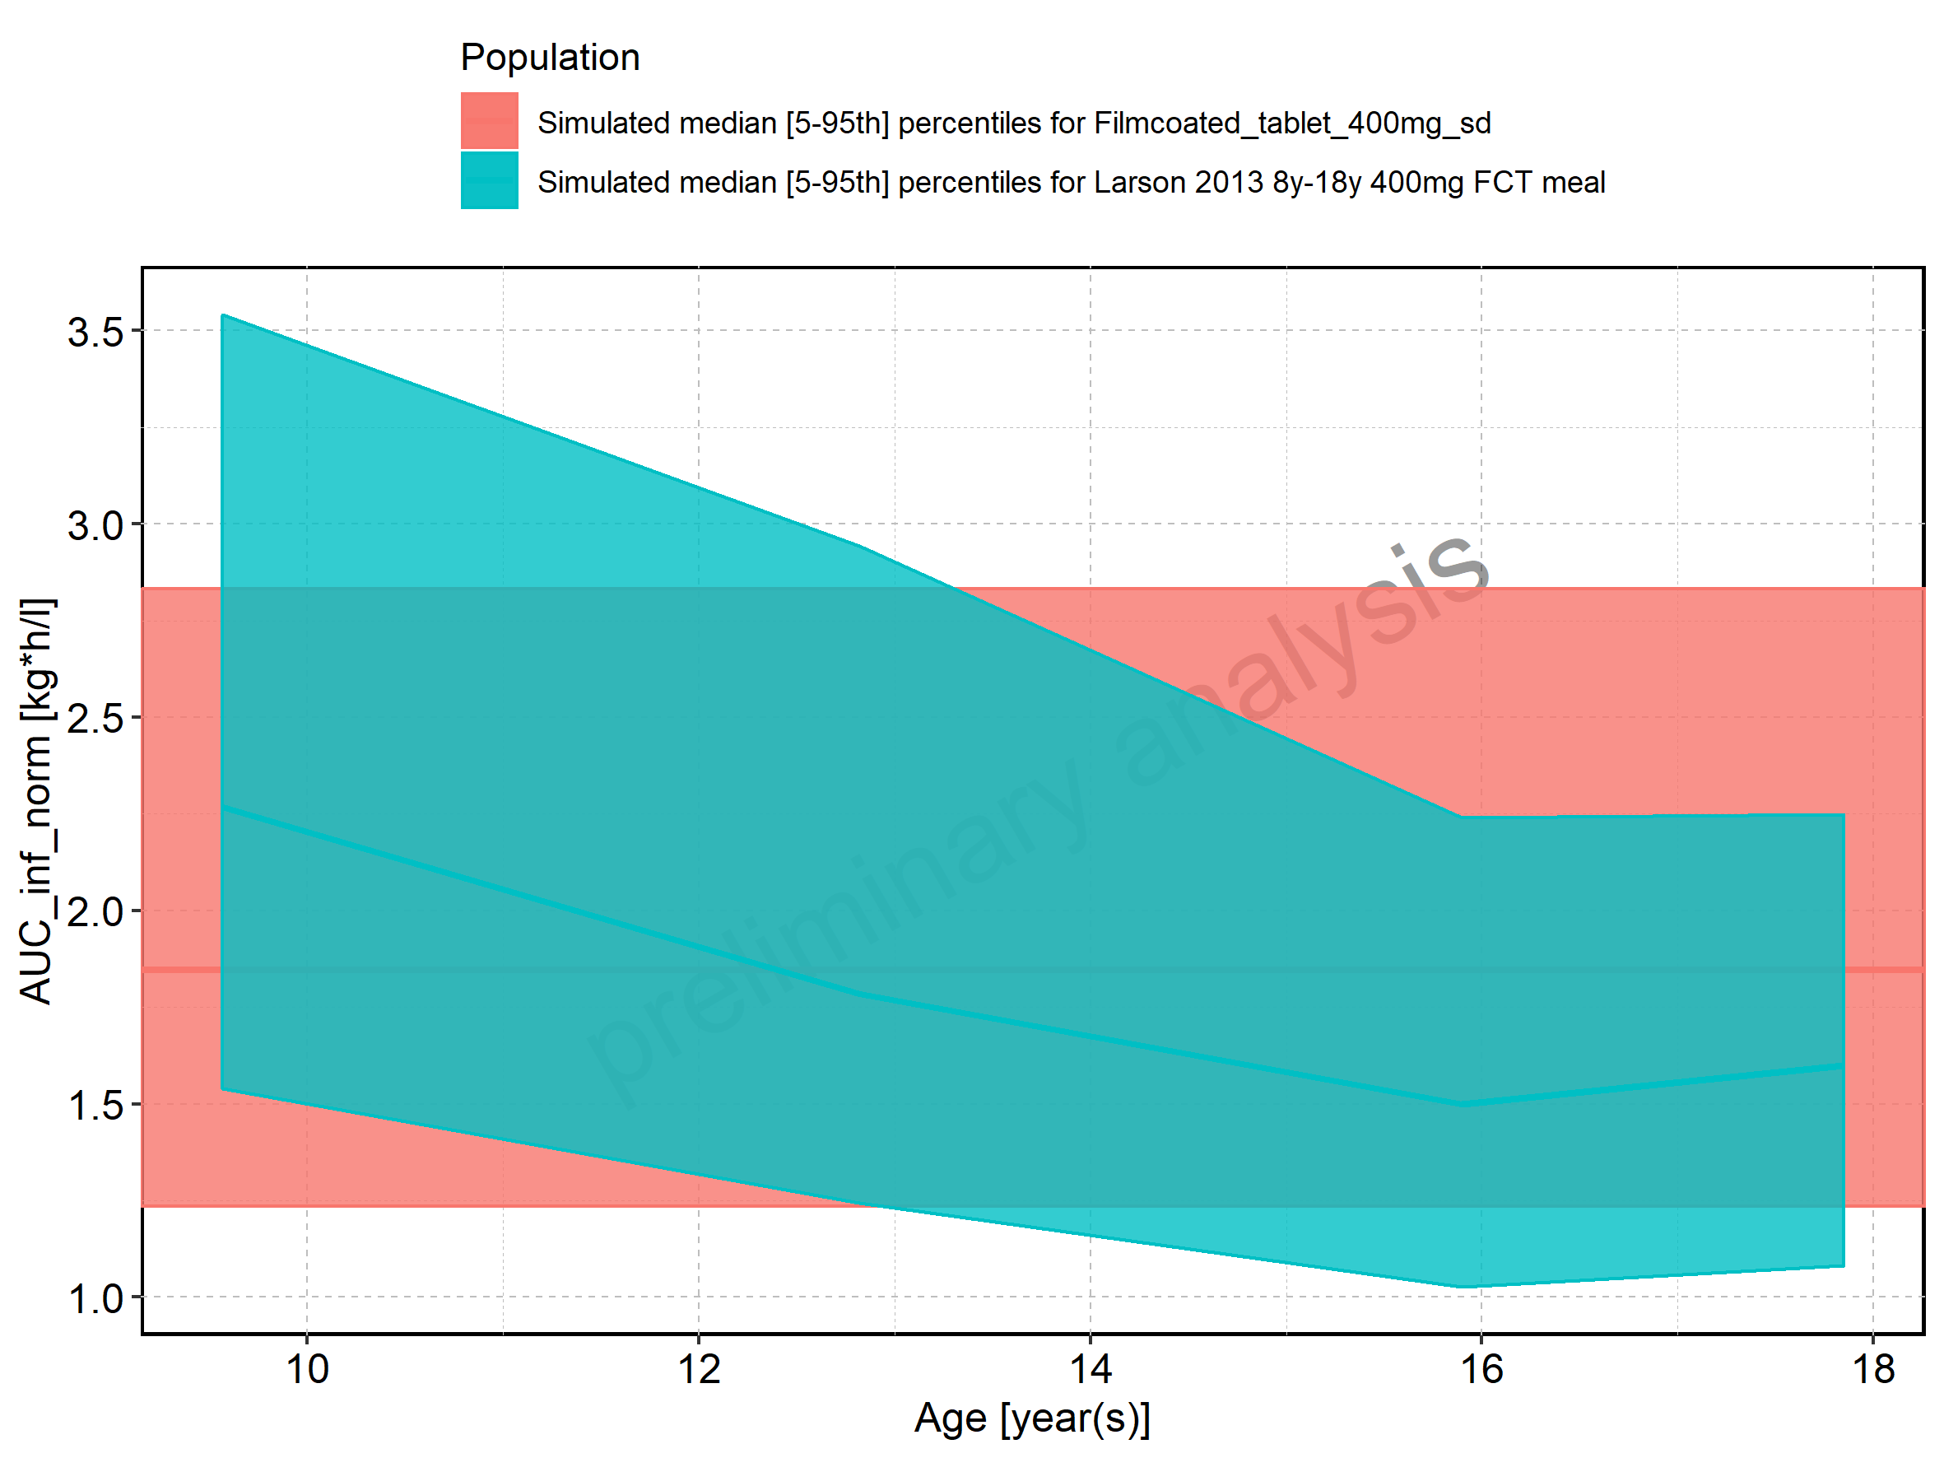

Figure 196: Age-dependence of AUC_inf_norm for Larson 2013 8y-18y 400mg FCT meal in comparison to Filmcoated_tablet_400mg_sd. Profiles are plotted in a logarithmic scale.

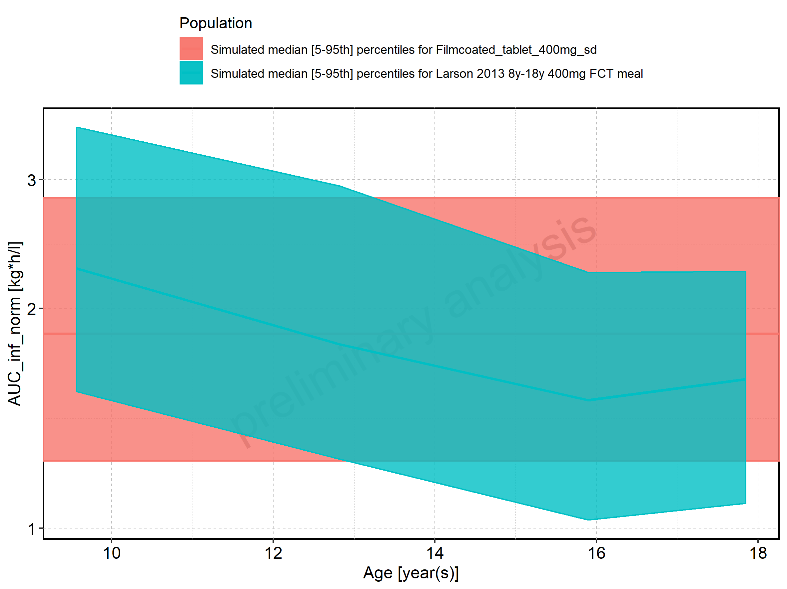

Figure 197: Age-dependence of AUC_inf_norm for Larson 2013 8y-18y 400mg FCT meal. Profiles are plotted in a linear scale.

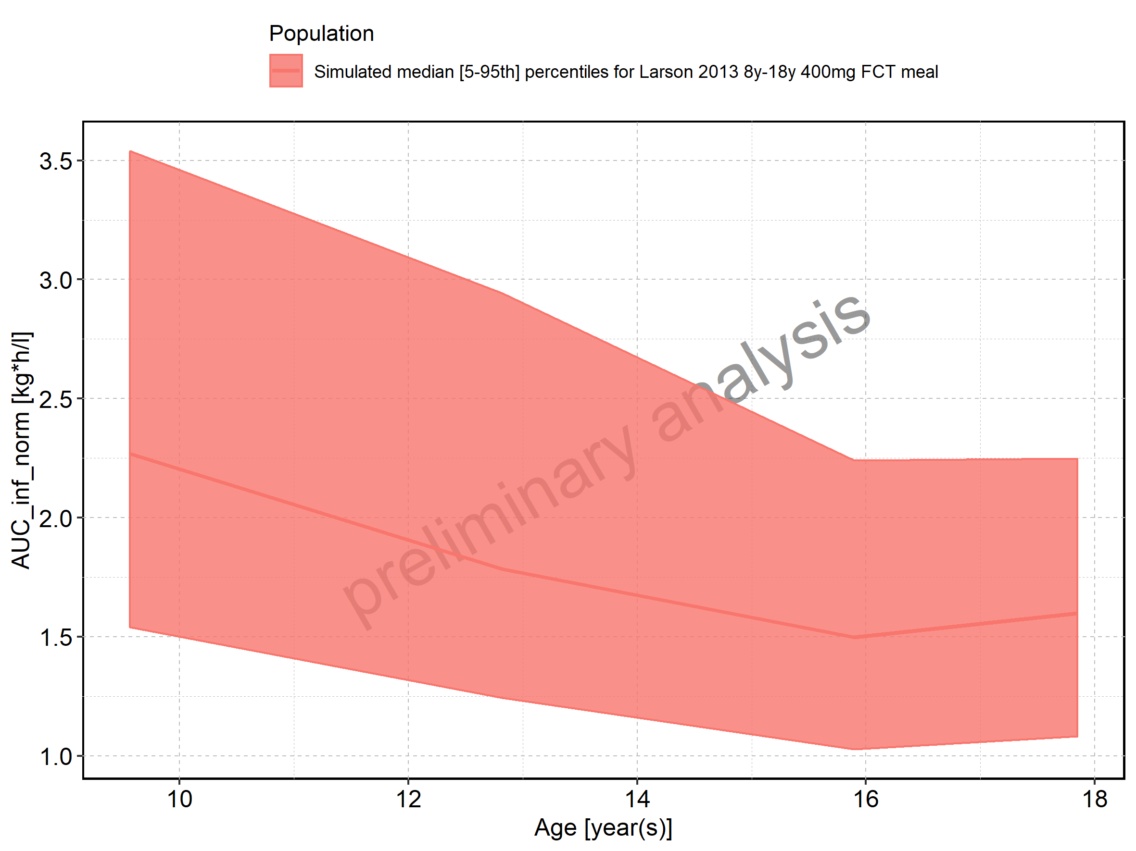

Figure 198: Age-dependence of AUC_inf_norm for Larson 2013 8y-18y 400mg FCT meal. Profiles are plotted in a logarithmic scale.

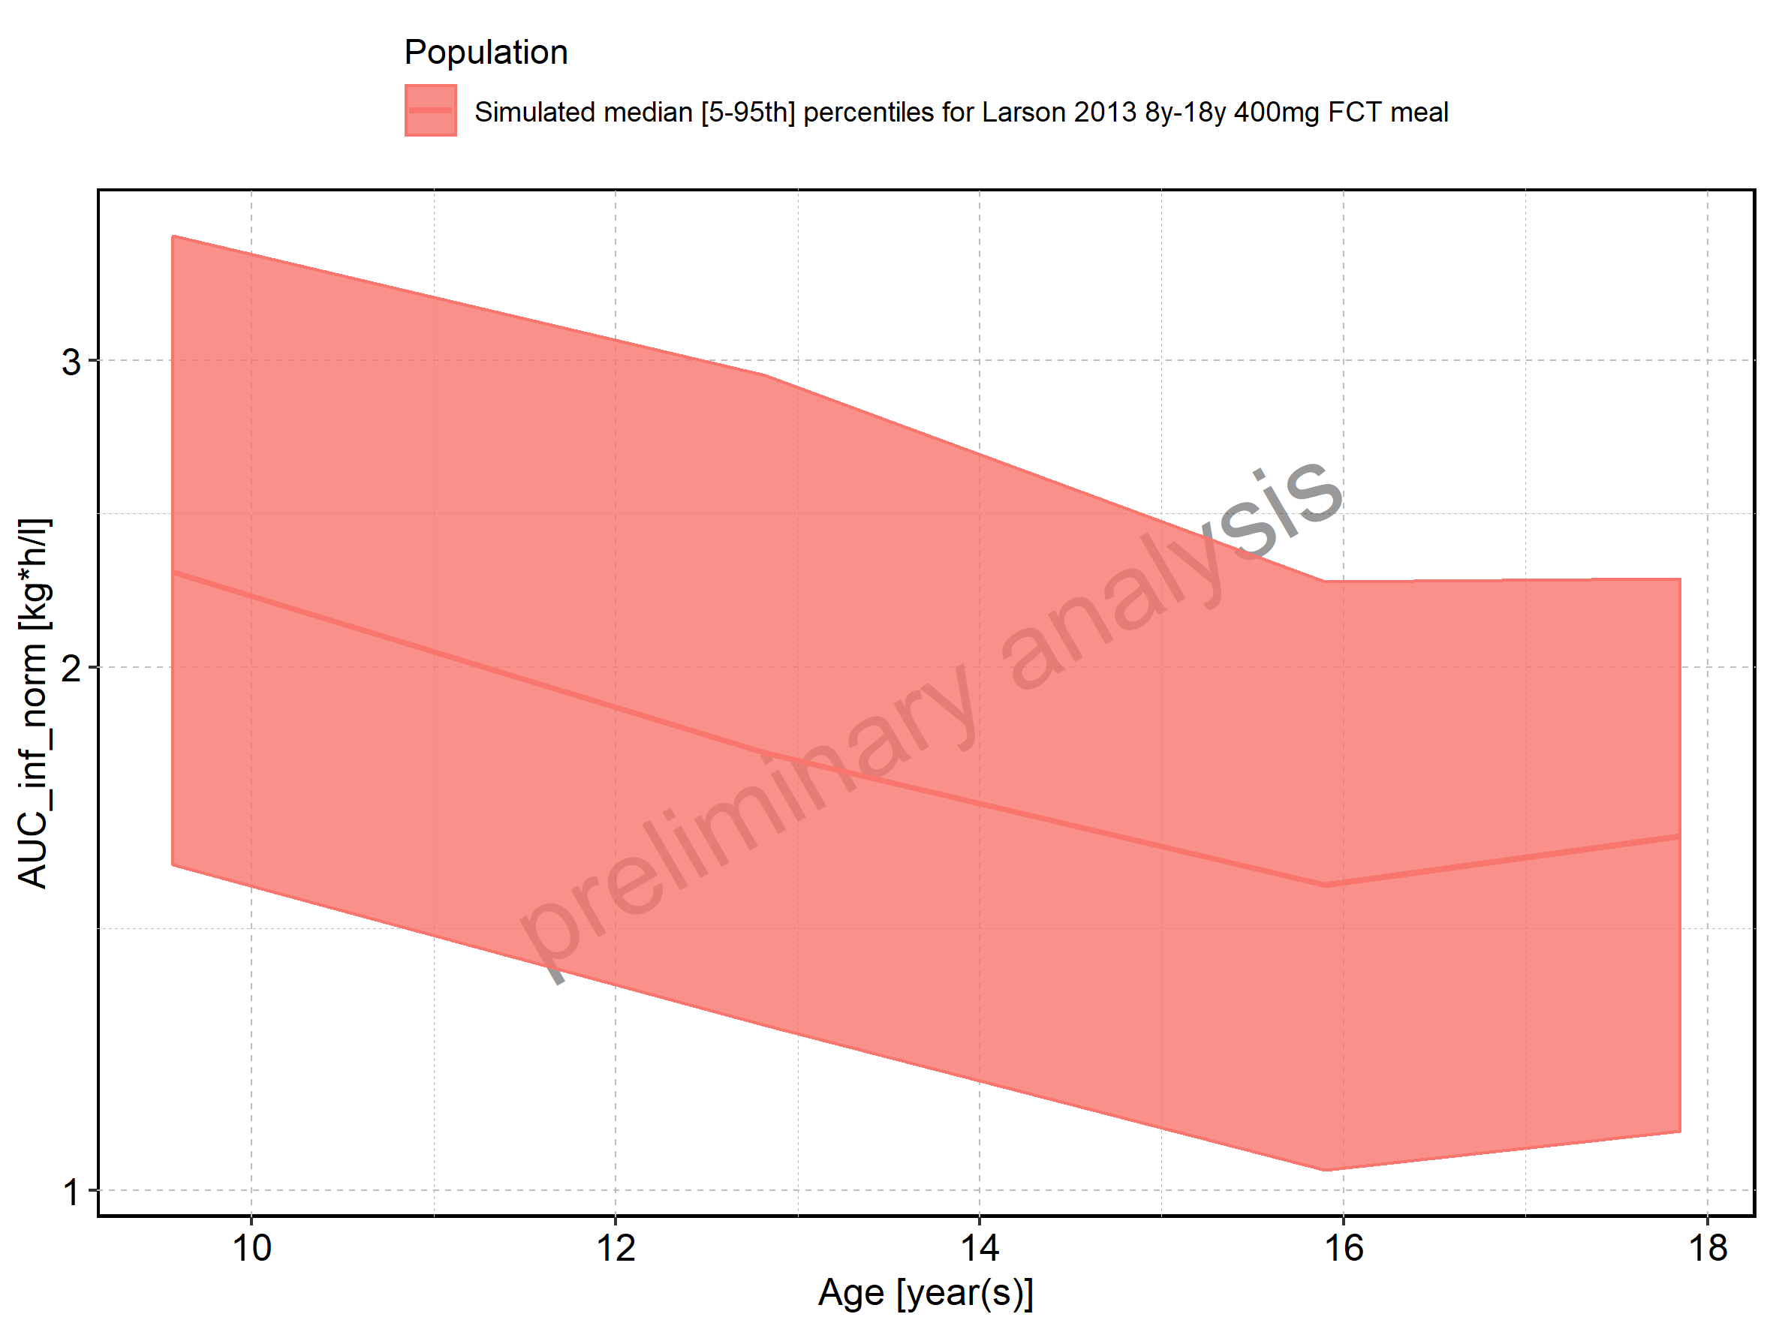

Figure 199: Age-dependence of AUC_inf_norm for Filmcoated_tablet_400mg_sd. Profiles are plotted in a linear scale.

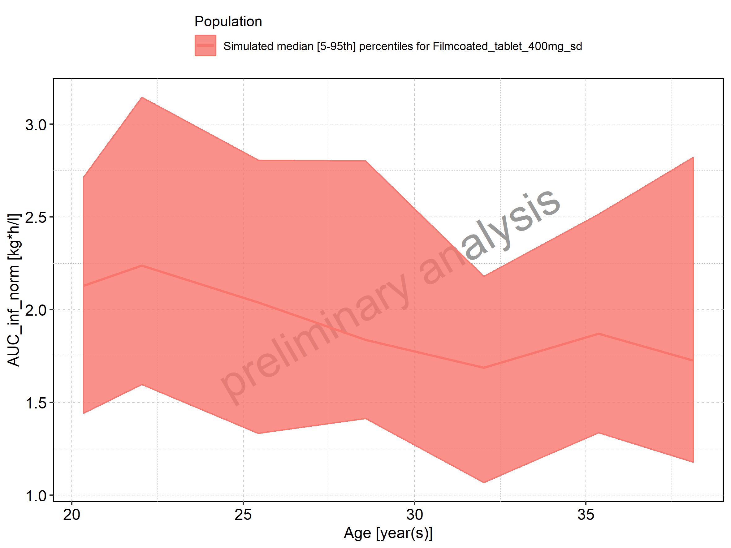

Figure 200: Age-dependence of AUC_inf_norm for Filmcoated_tablet_400mg_sd. Profiles are plotted in a logarithmic scale.

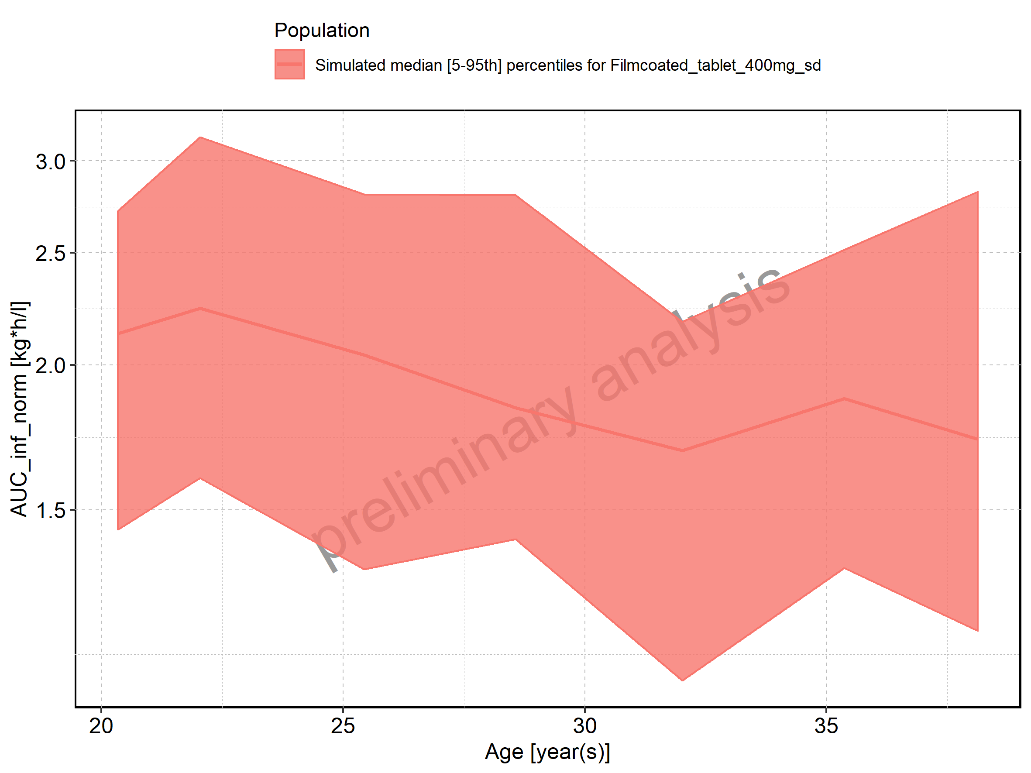

Figure 201: Height-dependence of AUC_inf_norm for Larson 2013 8y-18y 400mg FCT meal in comparison to Filmcoated_tablet_400mg_sd. Profiles are plotted in a linear scale.

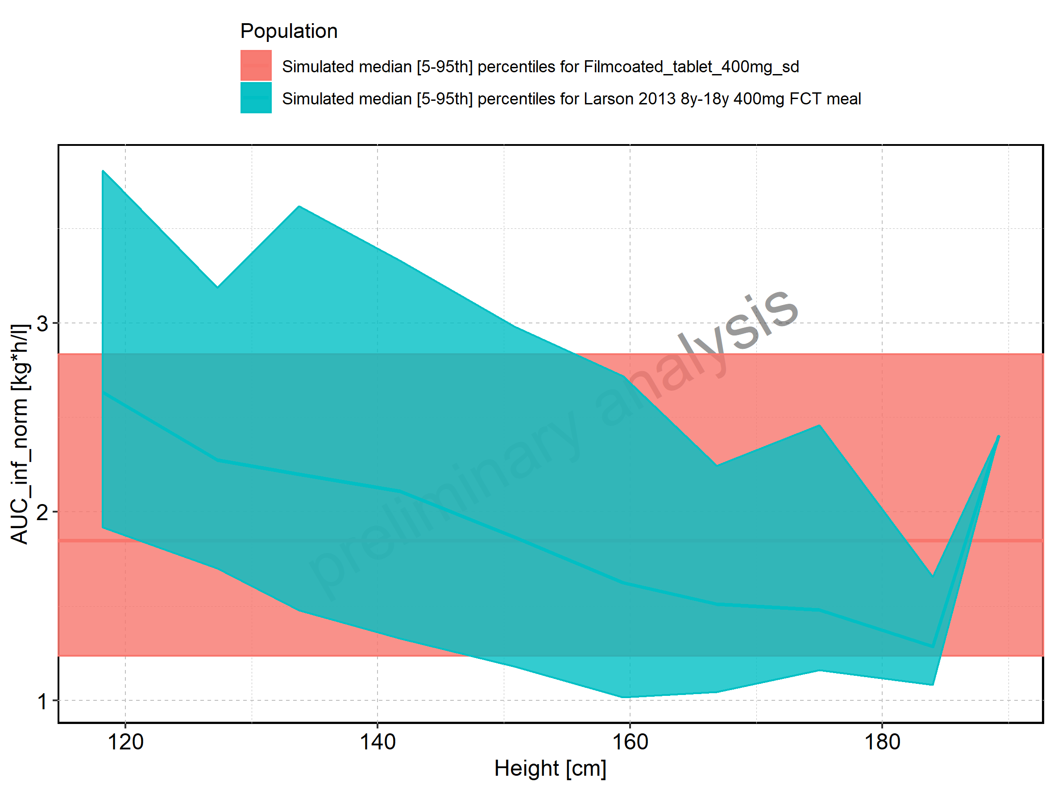

Figure 202: Height-dependence of AUC_inf_norm for Larson 2013 8y-18y 400mg FCT meal in comparison to Filmcoated_tablet_400mg_sd. Profiles are plotted in a logarithmic scale.

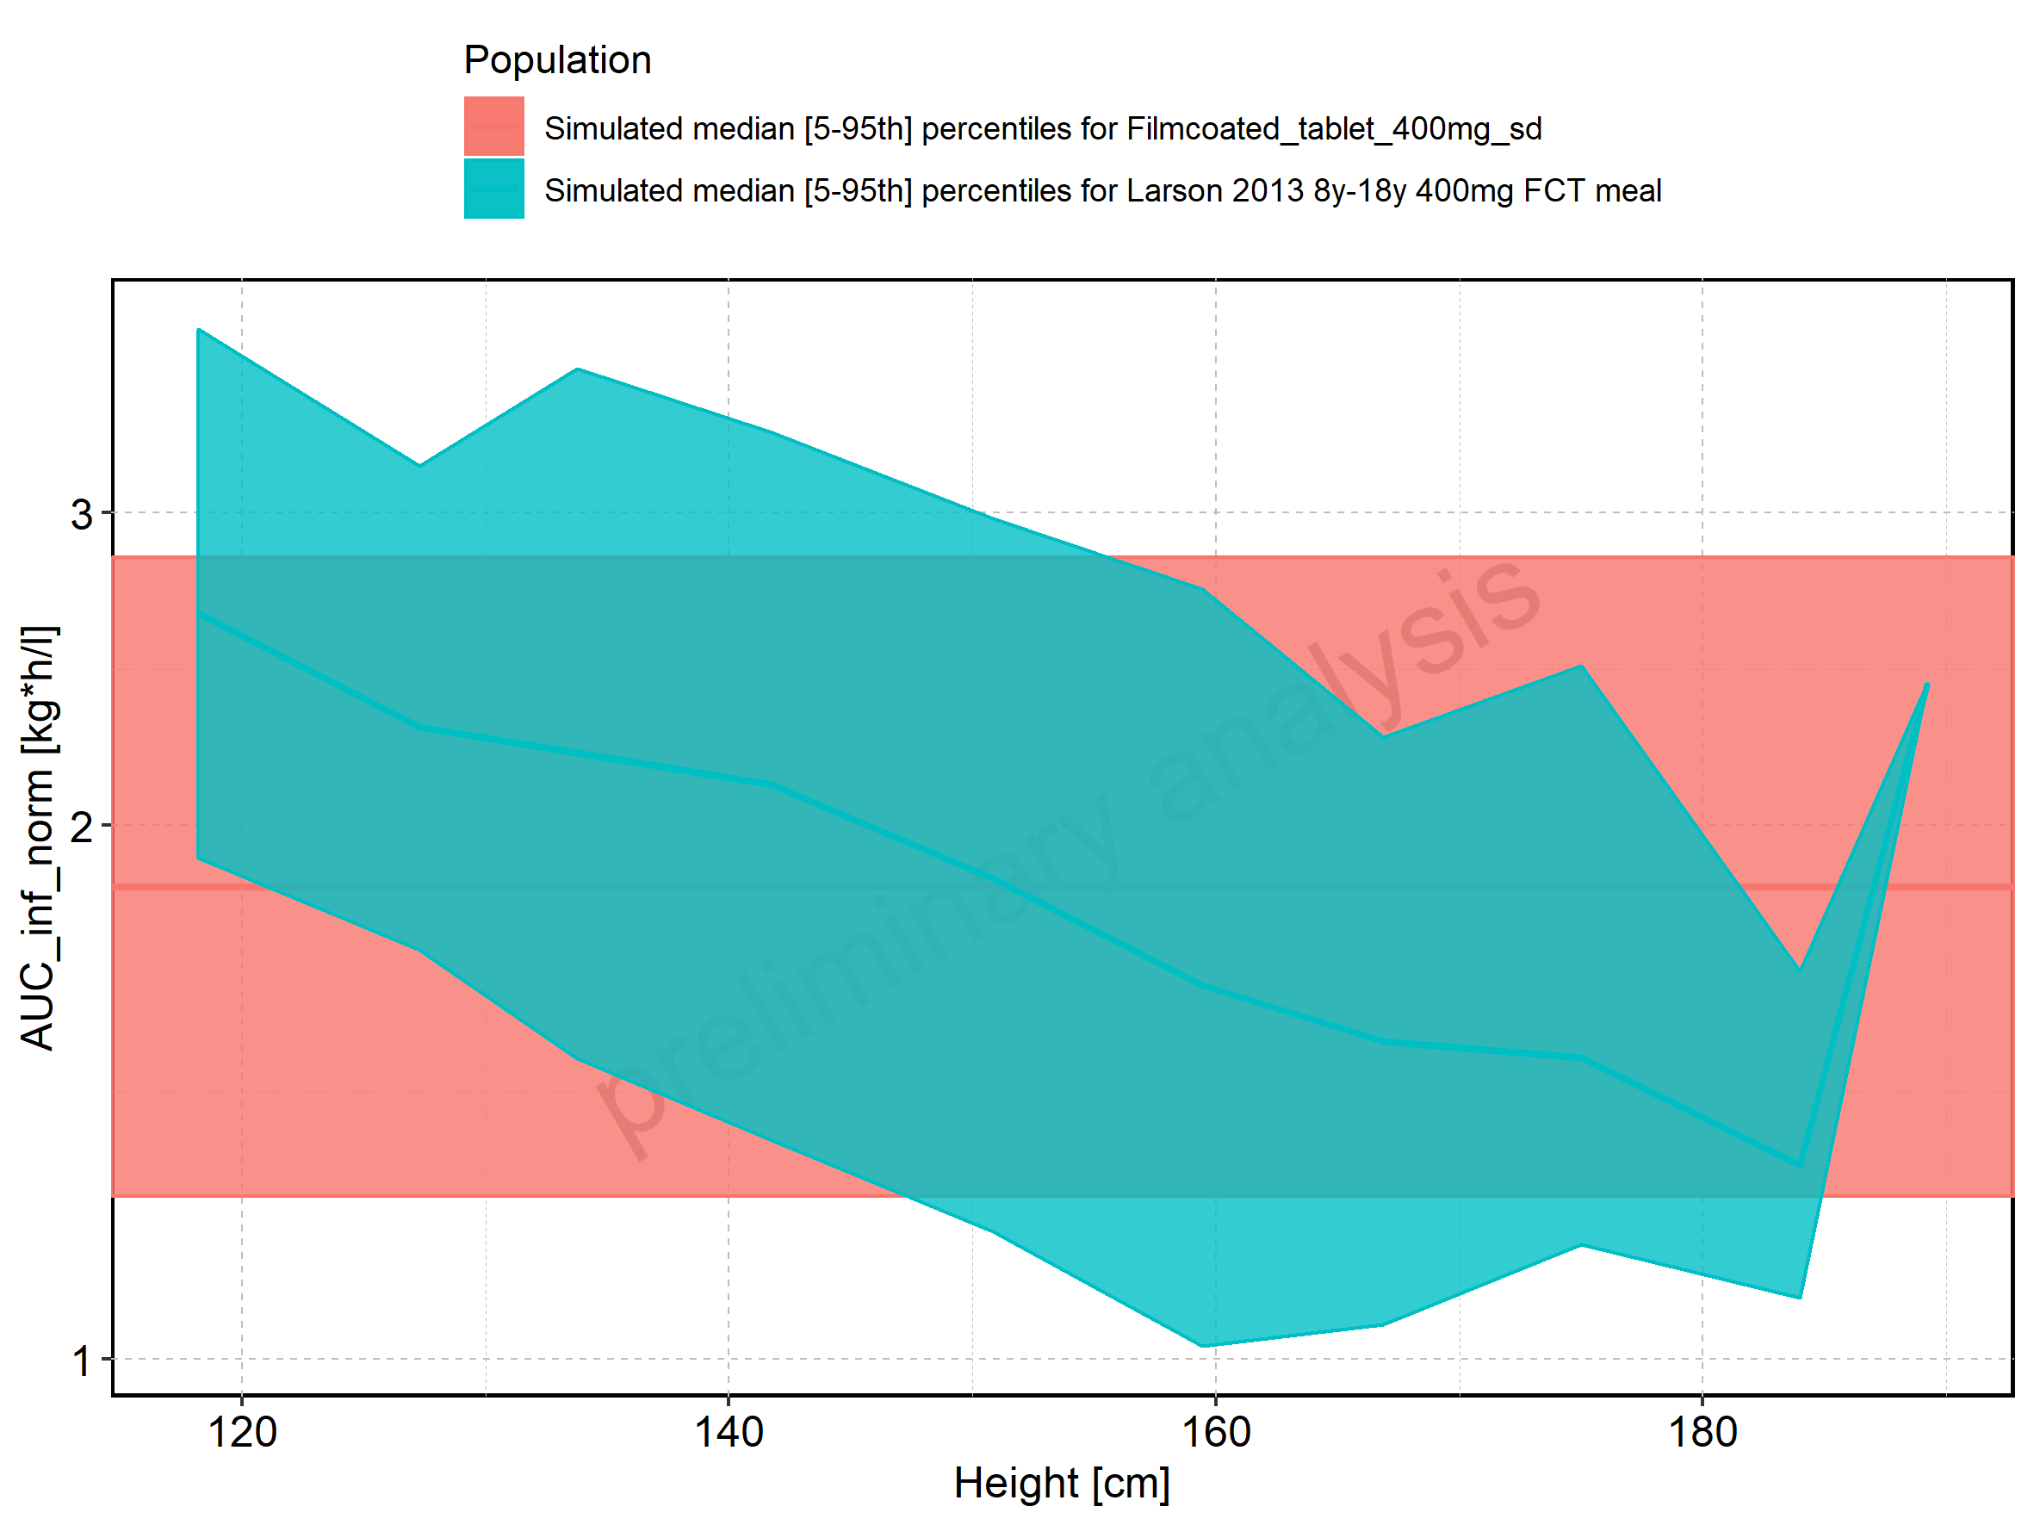

Figure 203: Height-dependence of AUC_inf_norm for Larson 2013 8y-18y 400mg FCT meal. Profiles are plotted in a linear scale.

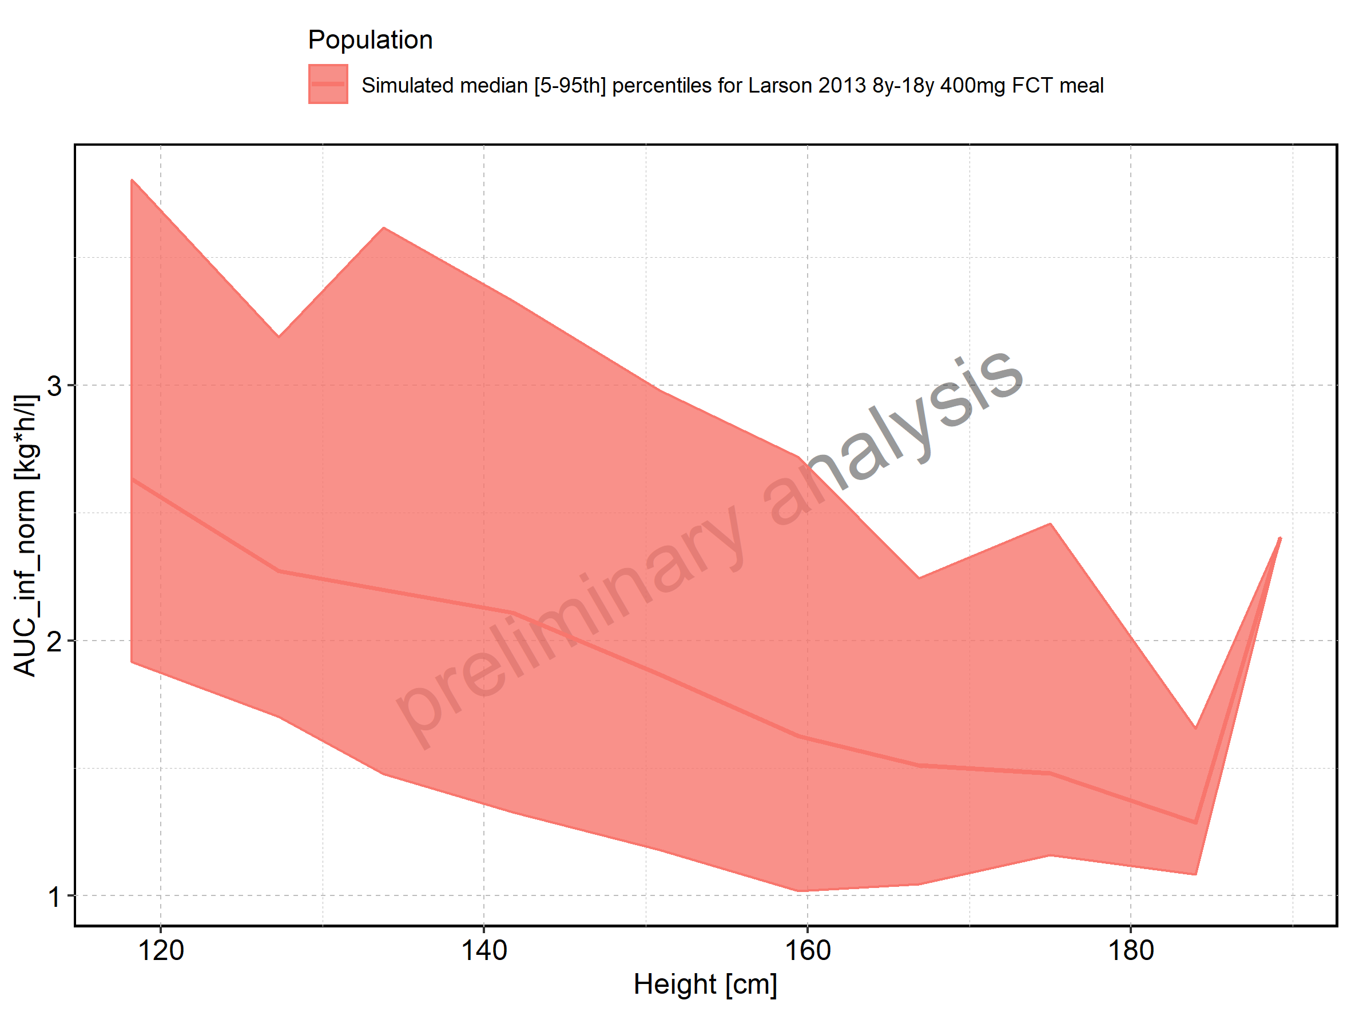

Figure 204: Height-dependence of AUC_inf_norm for Larson 2013 8y-18y 400mg FCT meal. Profiles are plotted in a logarithmic scale.

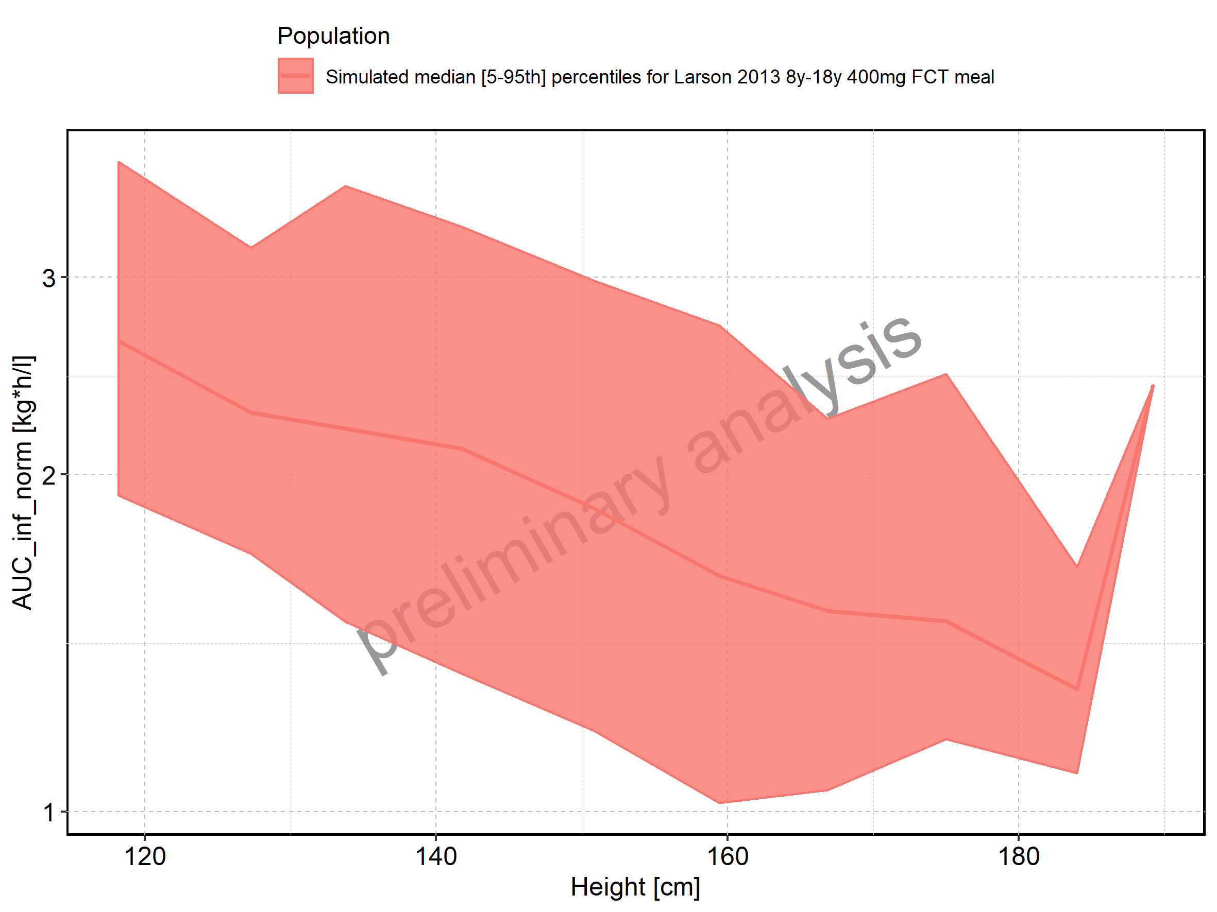

Figure 205: Height-dependence of AUC_inf_norm for Filmcoated_tablet_400mg_sd. Profiles are plotted in a linear scale.

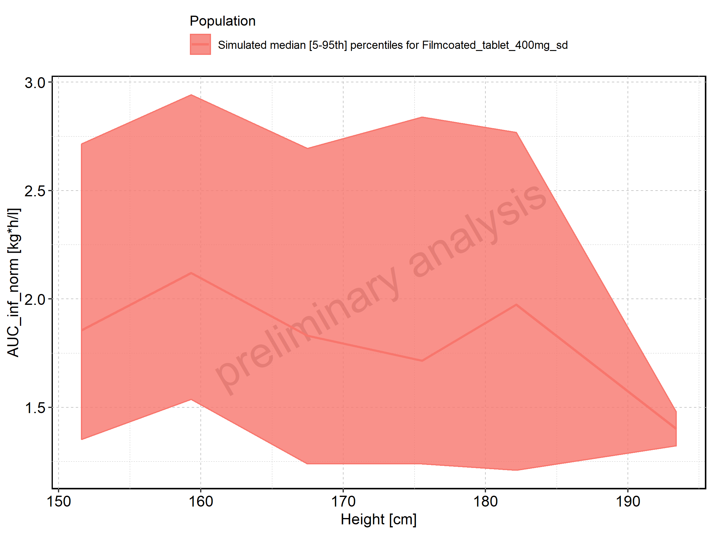

Figure 206: Height-dependence of AUC_inf_norm for Filmcoated_tablet_400mg_sd. Profiles are plotted in a logarithmic scale.

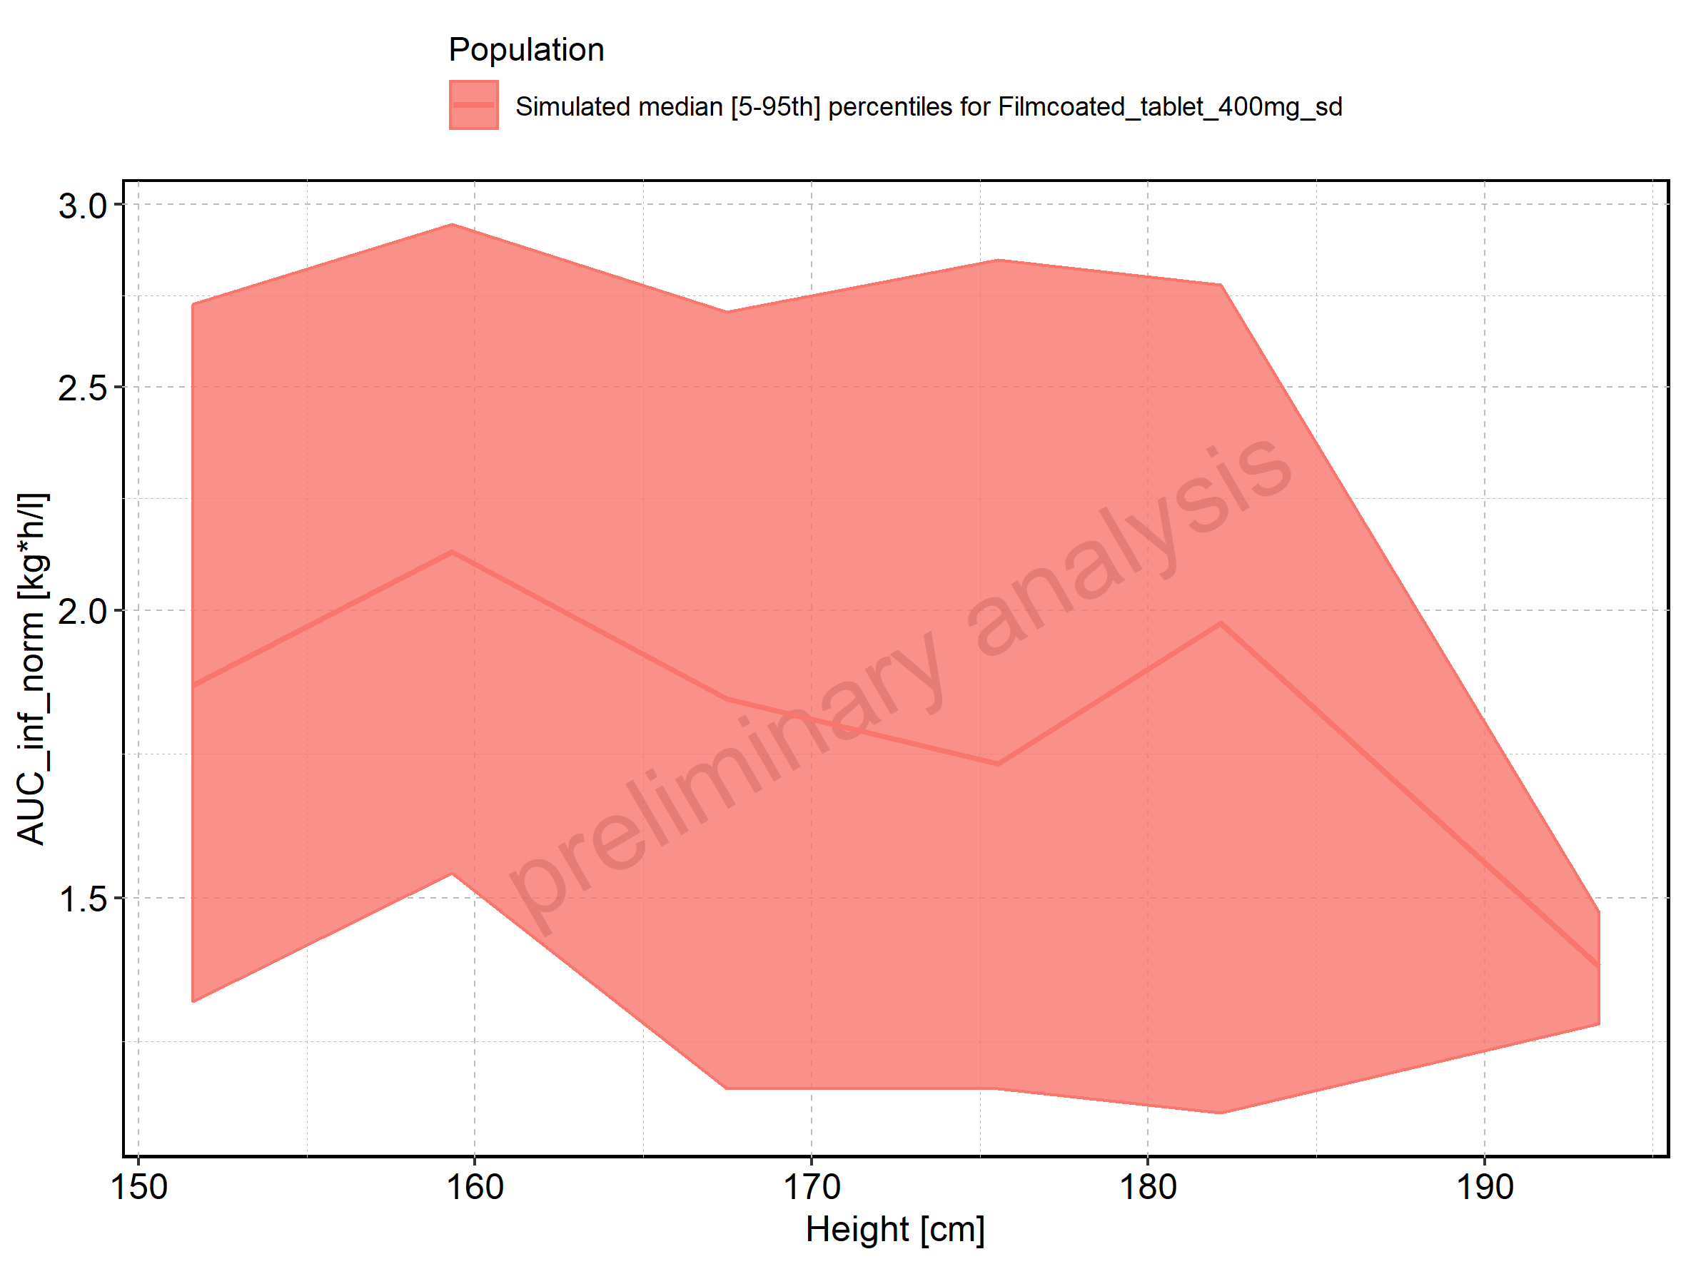

Figure 207: Weight-dependence of AUC_inf_norm for Larson 2013 8y-18y 400mg FCT meal in comparison to Filmcoated_tablet_400mg_sd. Profiles are plotted in a linear scale.

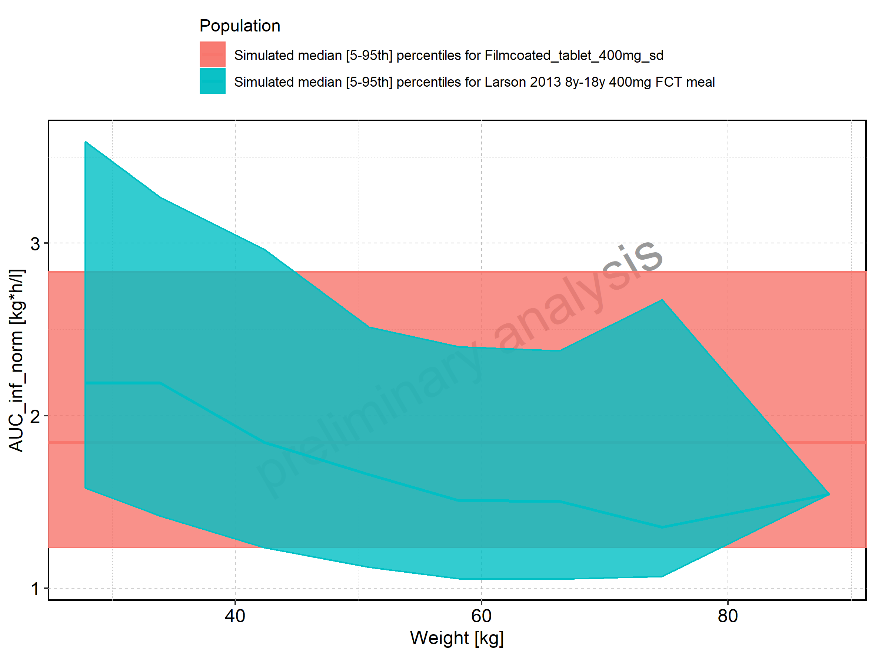

Figure 208: Weight-dependence of AUC_inf_norm for Larson 2013 8y-18y 400mg FCT meal in comparison to Filmcoated_tablet_400mg_sd. Profiles are plotted in a logarithmic scale.

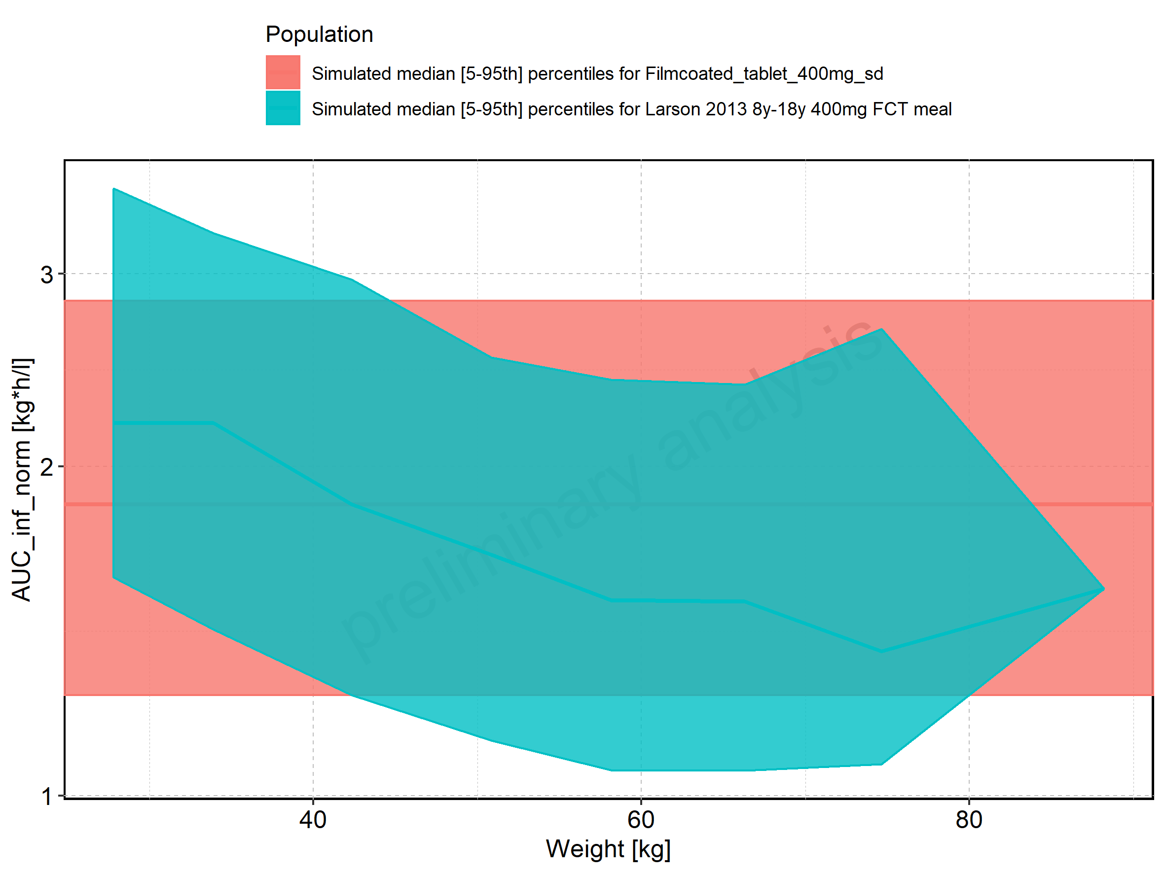

Figure 209: Weight-dependence of AUC_inf_norm for Larson 2013 8y-18y 400mg FCT meal. Profiles are plotted in a linear scale.

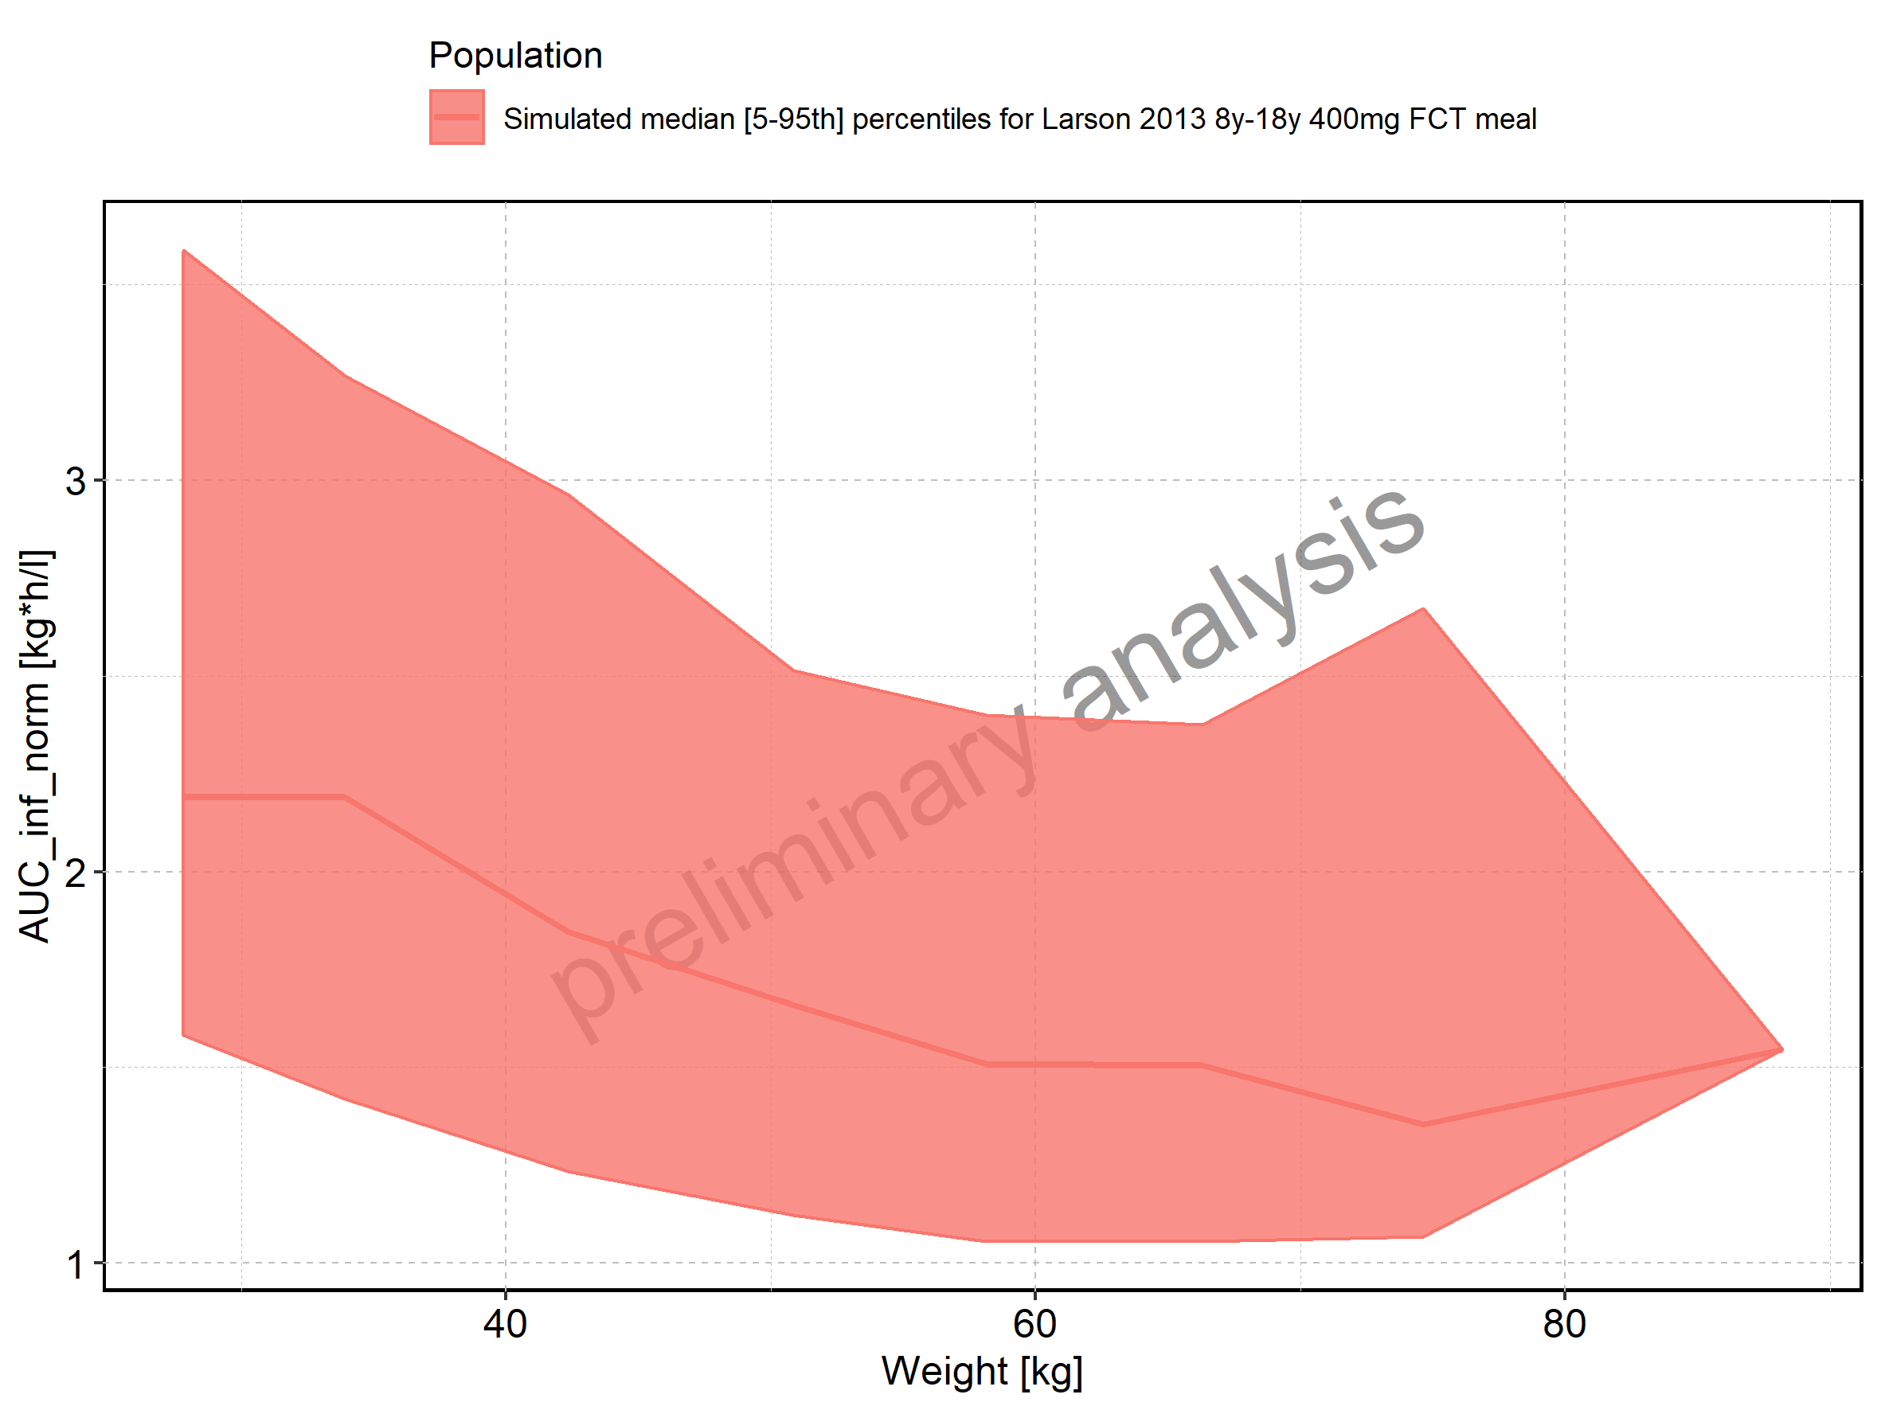

Figure 210: Weight-dependence of AUC_inf_norm for Larson 2013 8y-18y 400mg FCT meal. Profiles are plotted in a logarithmic scale.

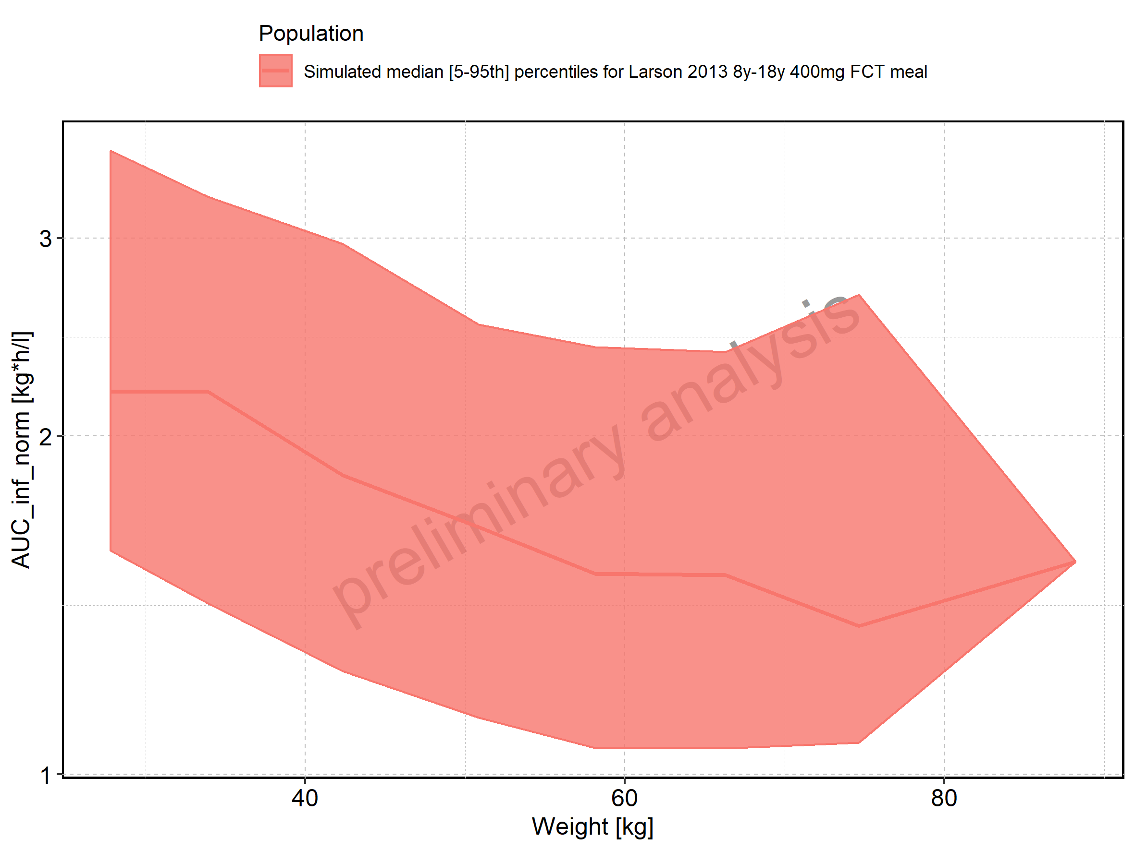

Figure 211: Weight-dependence of AUC_inf_norm for Filmcoated_tablet_400mg_sd. Profiles are plotted in a linear scale.

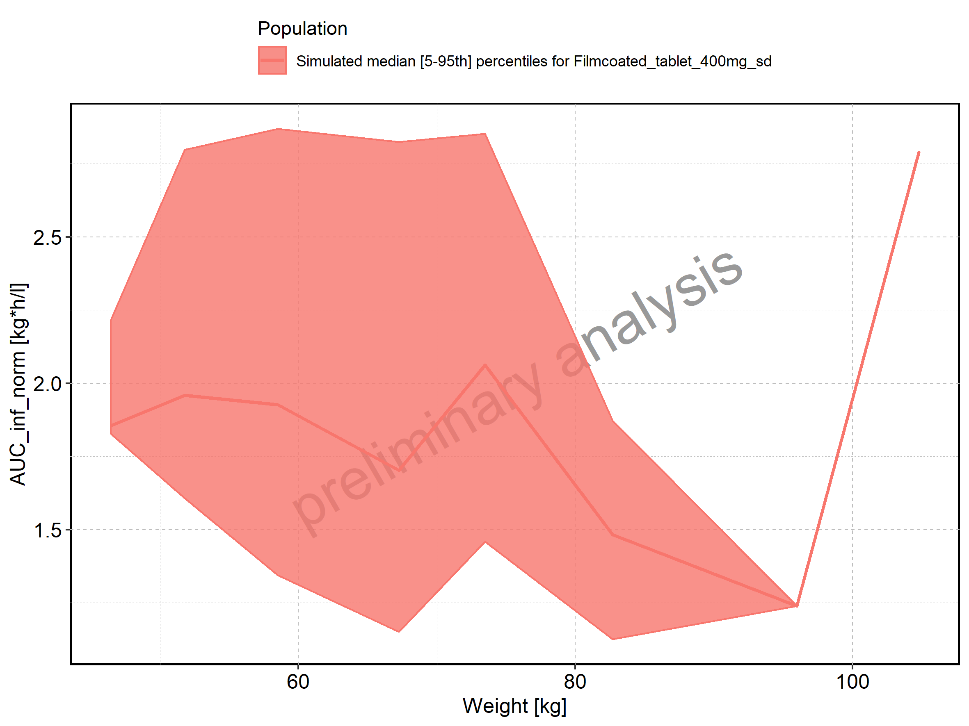

Figure 212: Weight-dependence of AUC_inf_norm for Filmcoated_tablet_400mg_sd. Profiles are plotted in a logarithmic scale.

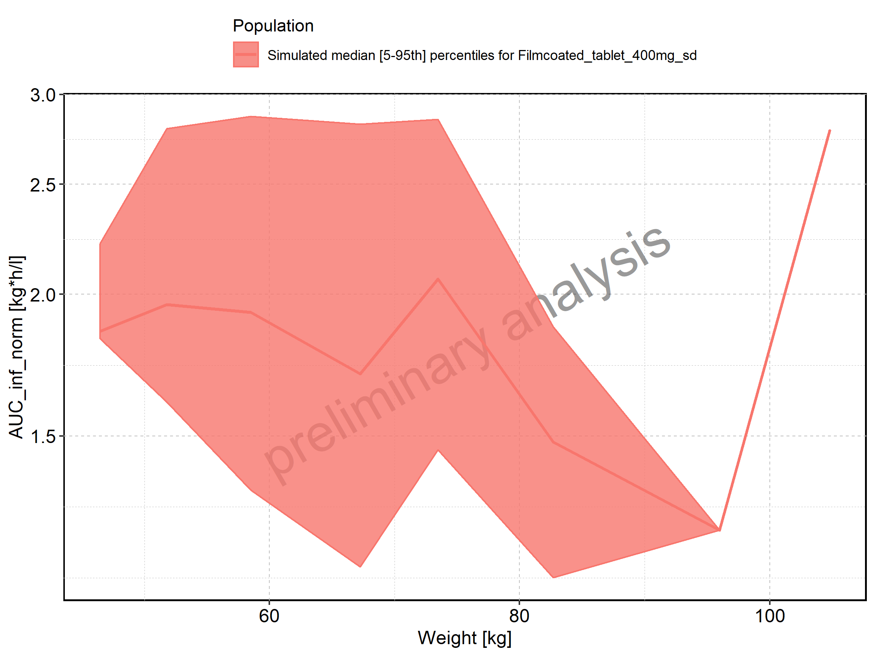

Figure 213: BMI-dependence of AUC_inf_norm for Larson 2013 8y-18y 400mg FCT meal in comparison to Filmcoated_tablet_400mg_sd. Profiles are plotted in a linear scale.

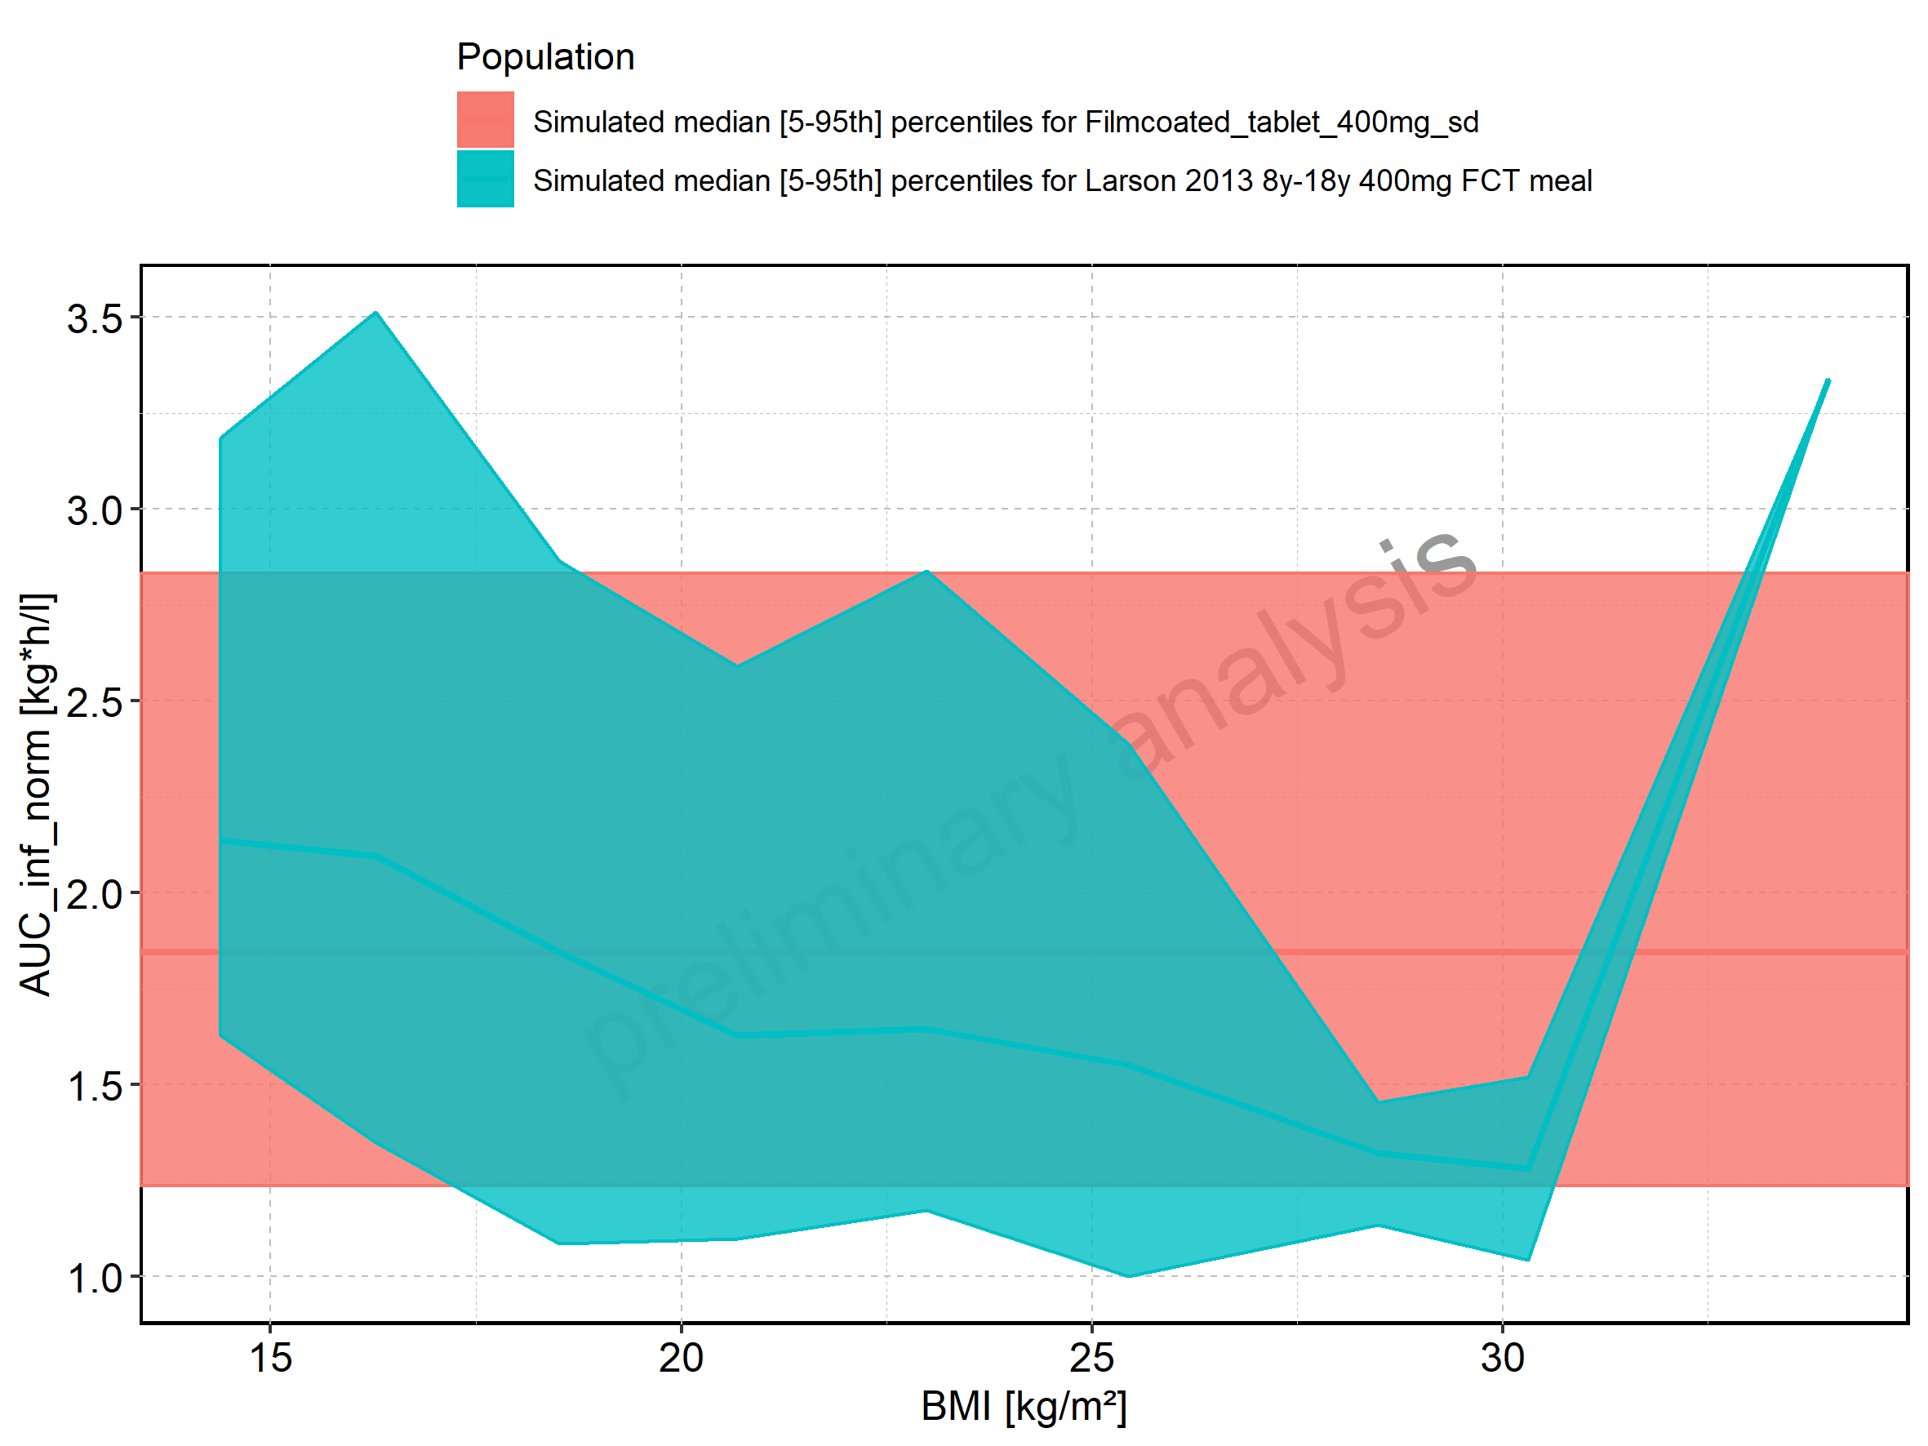

Figure 214: BMI-dependence of AUC_inf_norm for Larson 2013 8y-18y 400mg FCT meal in comparison to Filmcoated_tablet_400mg_sd. Profiles are plotted in a logarithmic scale.

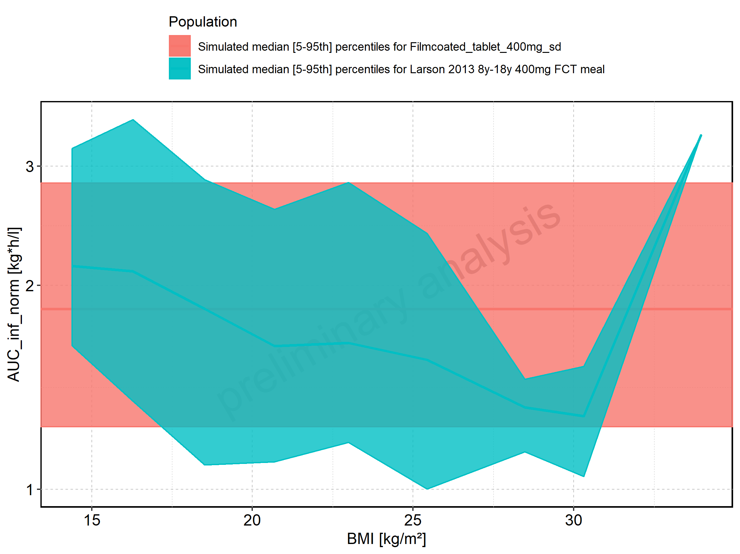

Figure 215: BMI-dependence of AUC_inf_norm for Larson 2013 8y-18y 400mg FCT meal. Profiles are plotted in a linear scale.

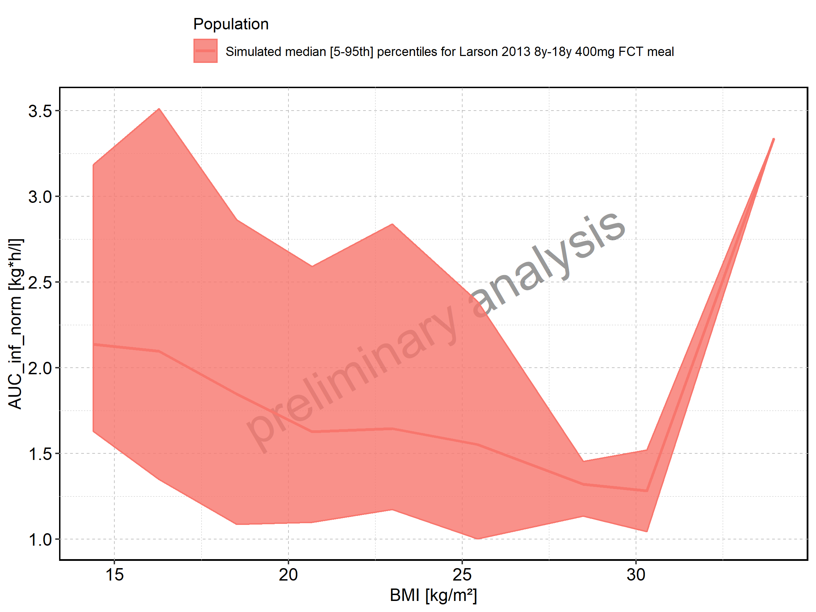

Figure 216: BMI-dependence of AUC_inf_norm for Larson 2013 8y-18y 400mg FCT meal. Profiles are plotted in a logarithmic scale.

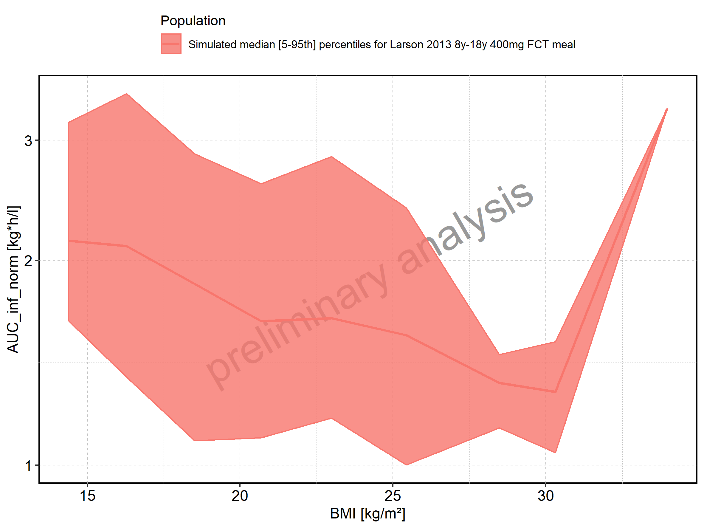

Figure 217: BMI-dependence of AUC_inf_norm for Filmcoated_tablet_400mg_sd. Profiles are plotted in a linear scale.

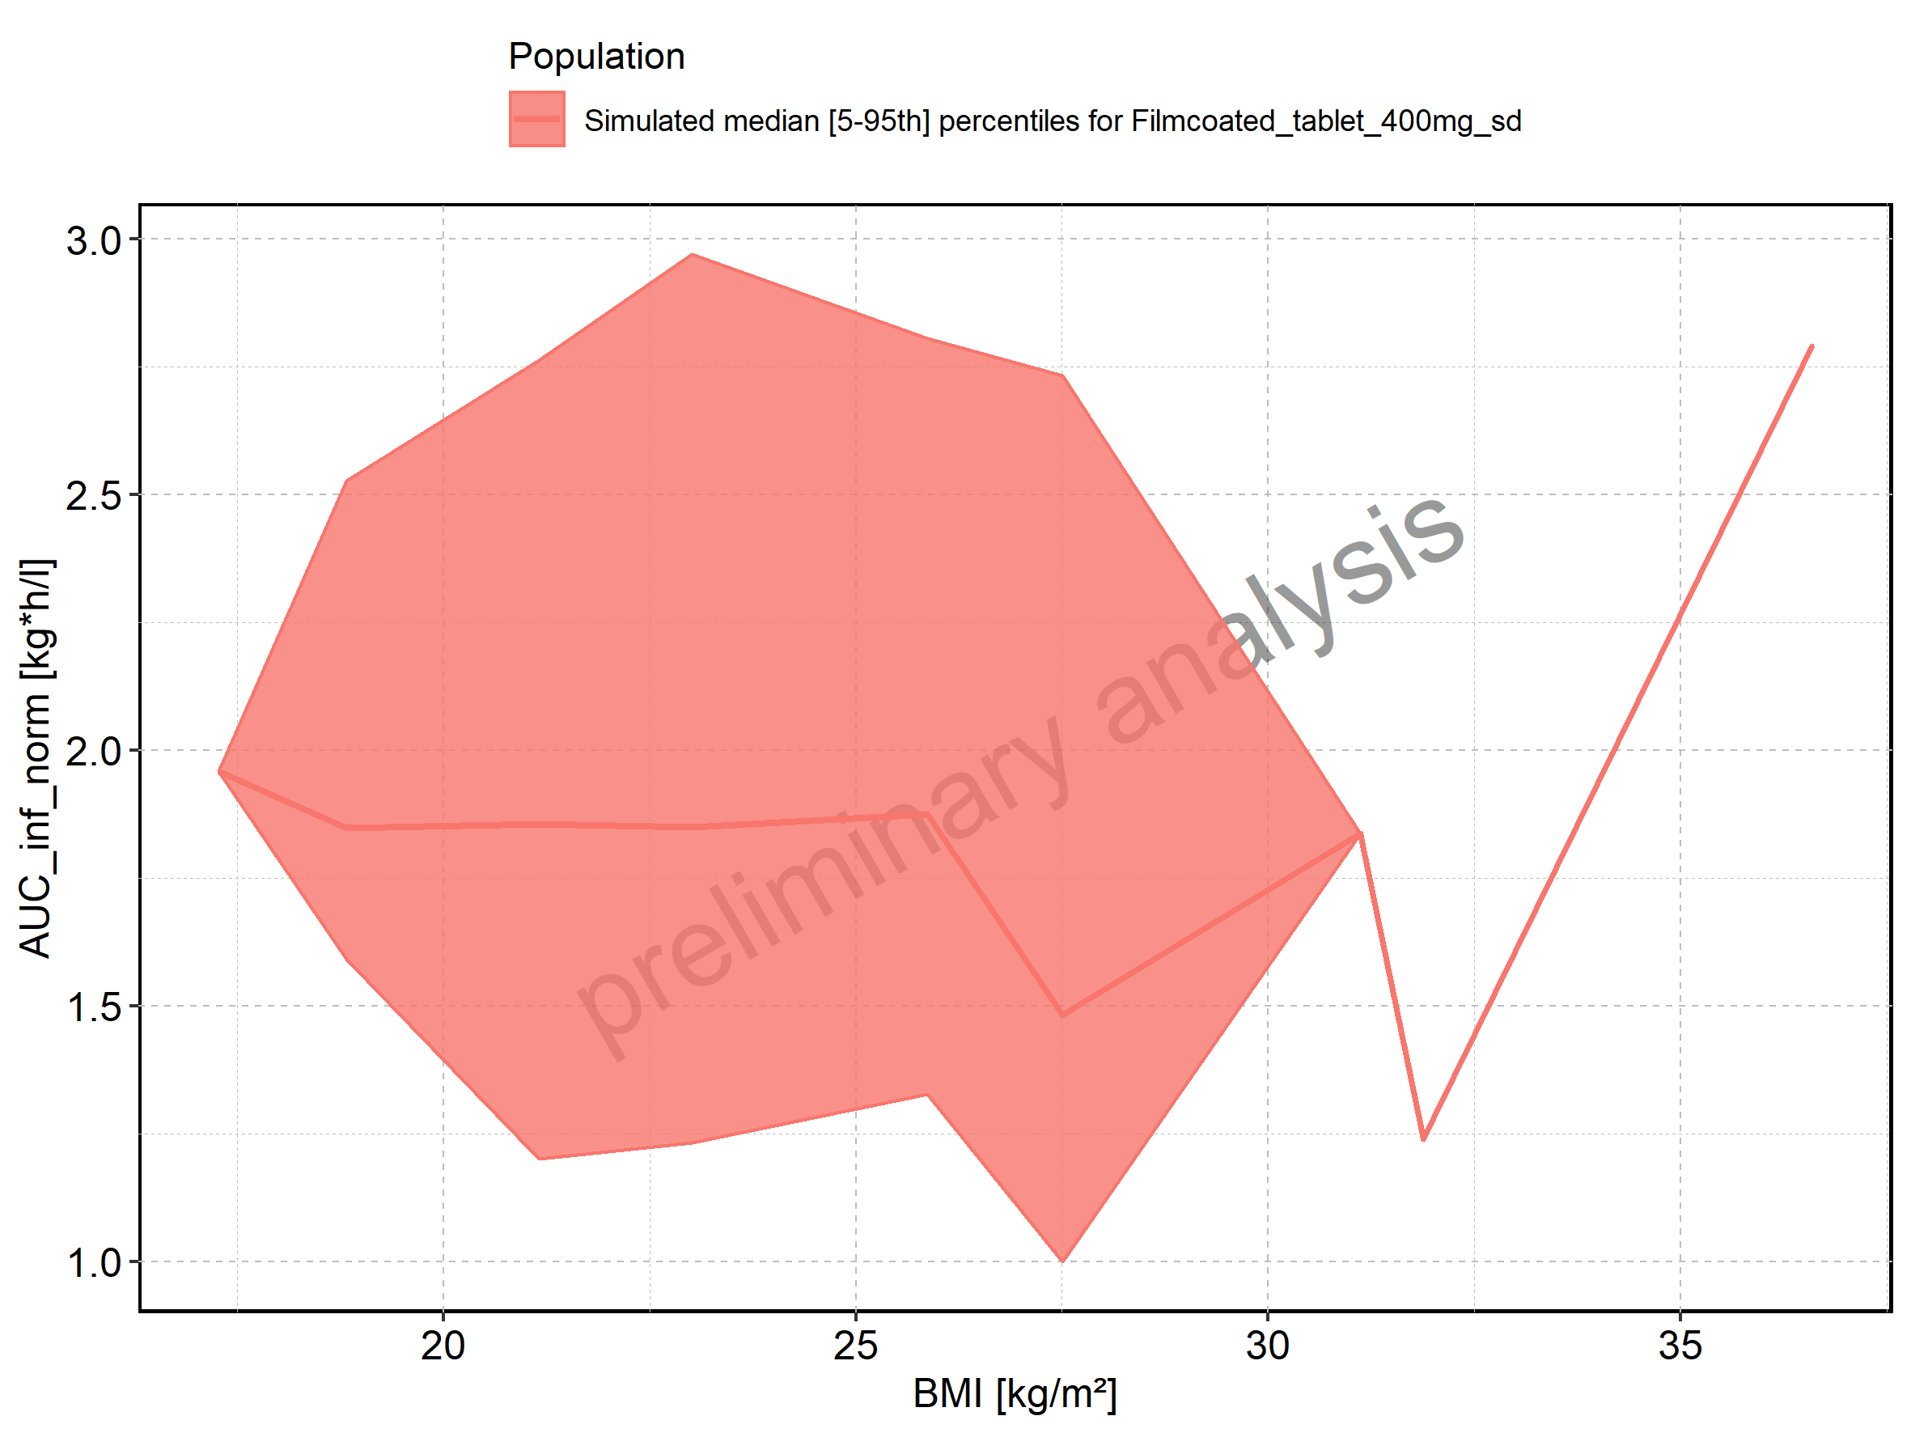

Figure 218: BMI-dependence of AUC_inf_norm for Filmcoated_tablet_400mg_sd. Profiles are plotted in a logarithmic scale.

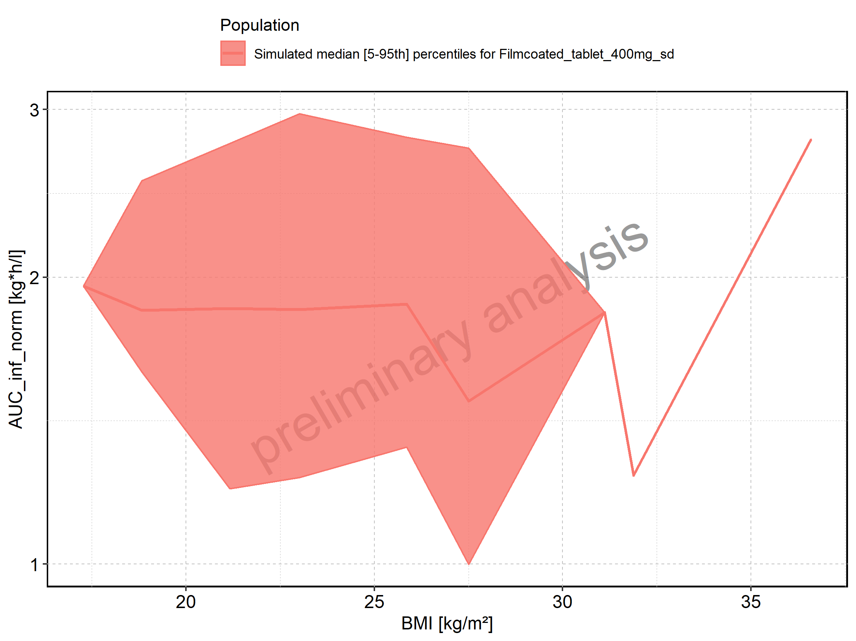

Figure 219: MRT of Raltegravir shown as box-whisker plot, which indicates the 5th, 25th, 50th, 75th, and 95th percentiles in linear scale.

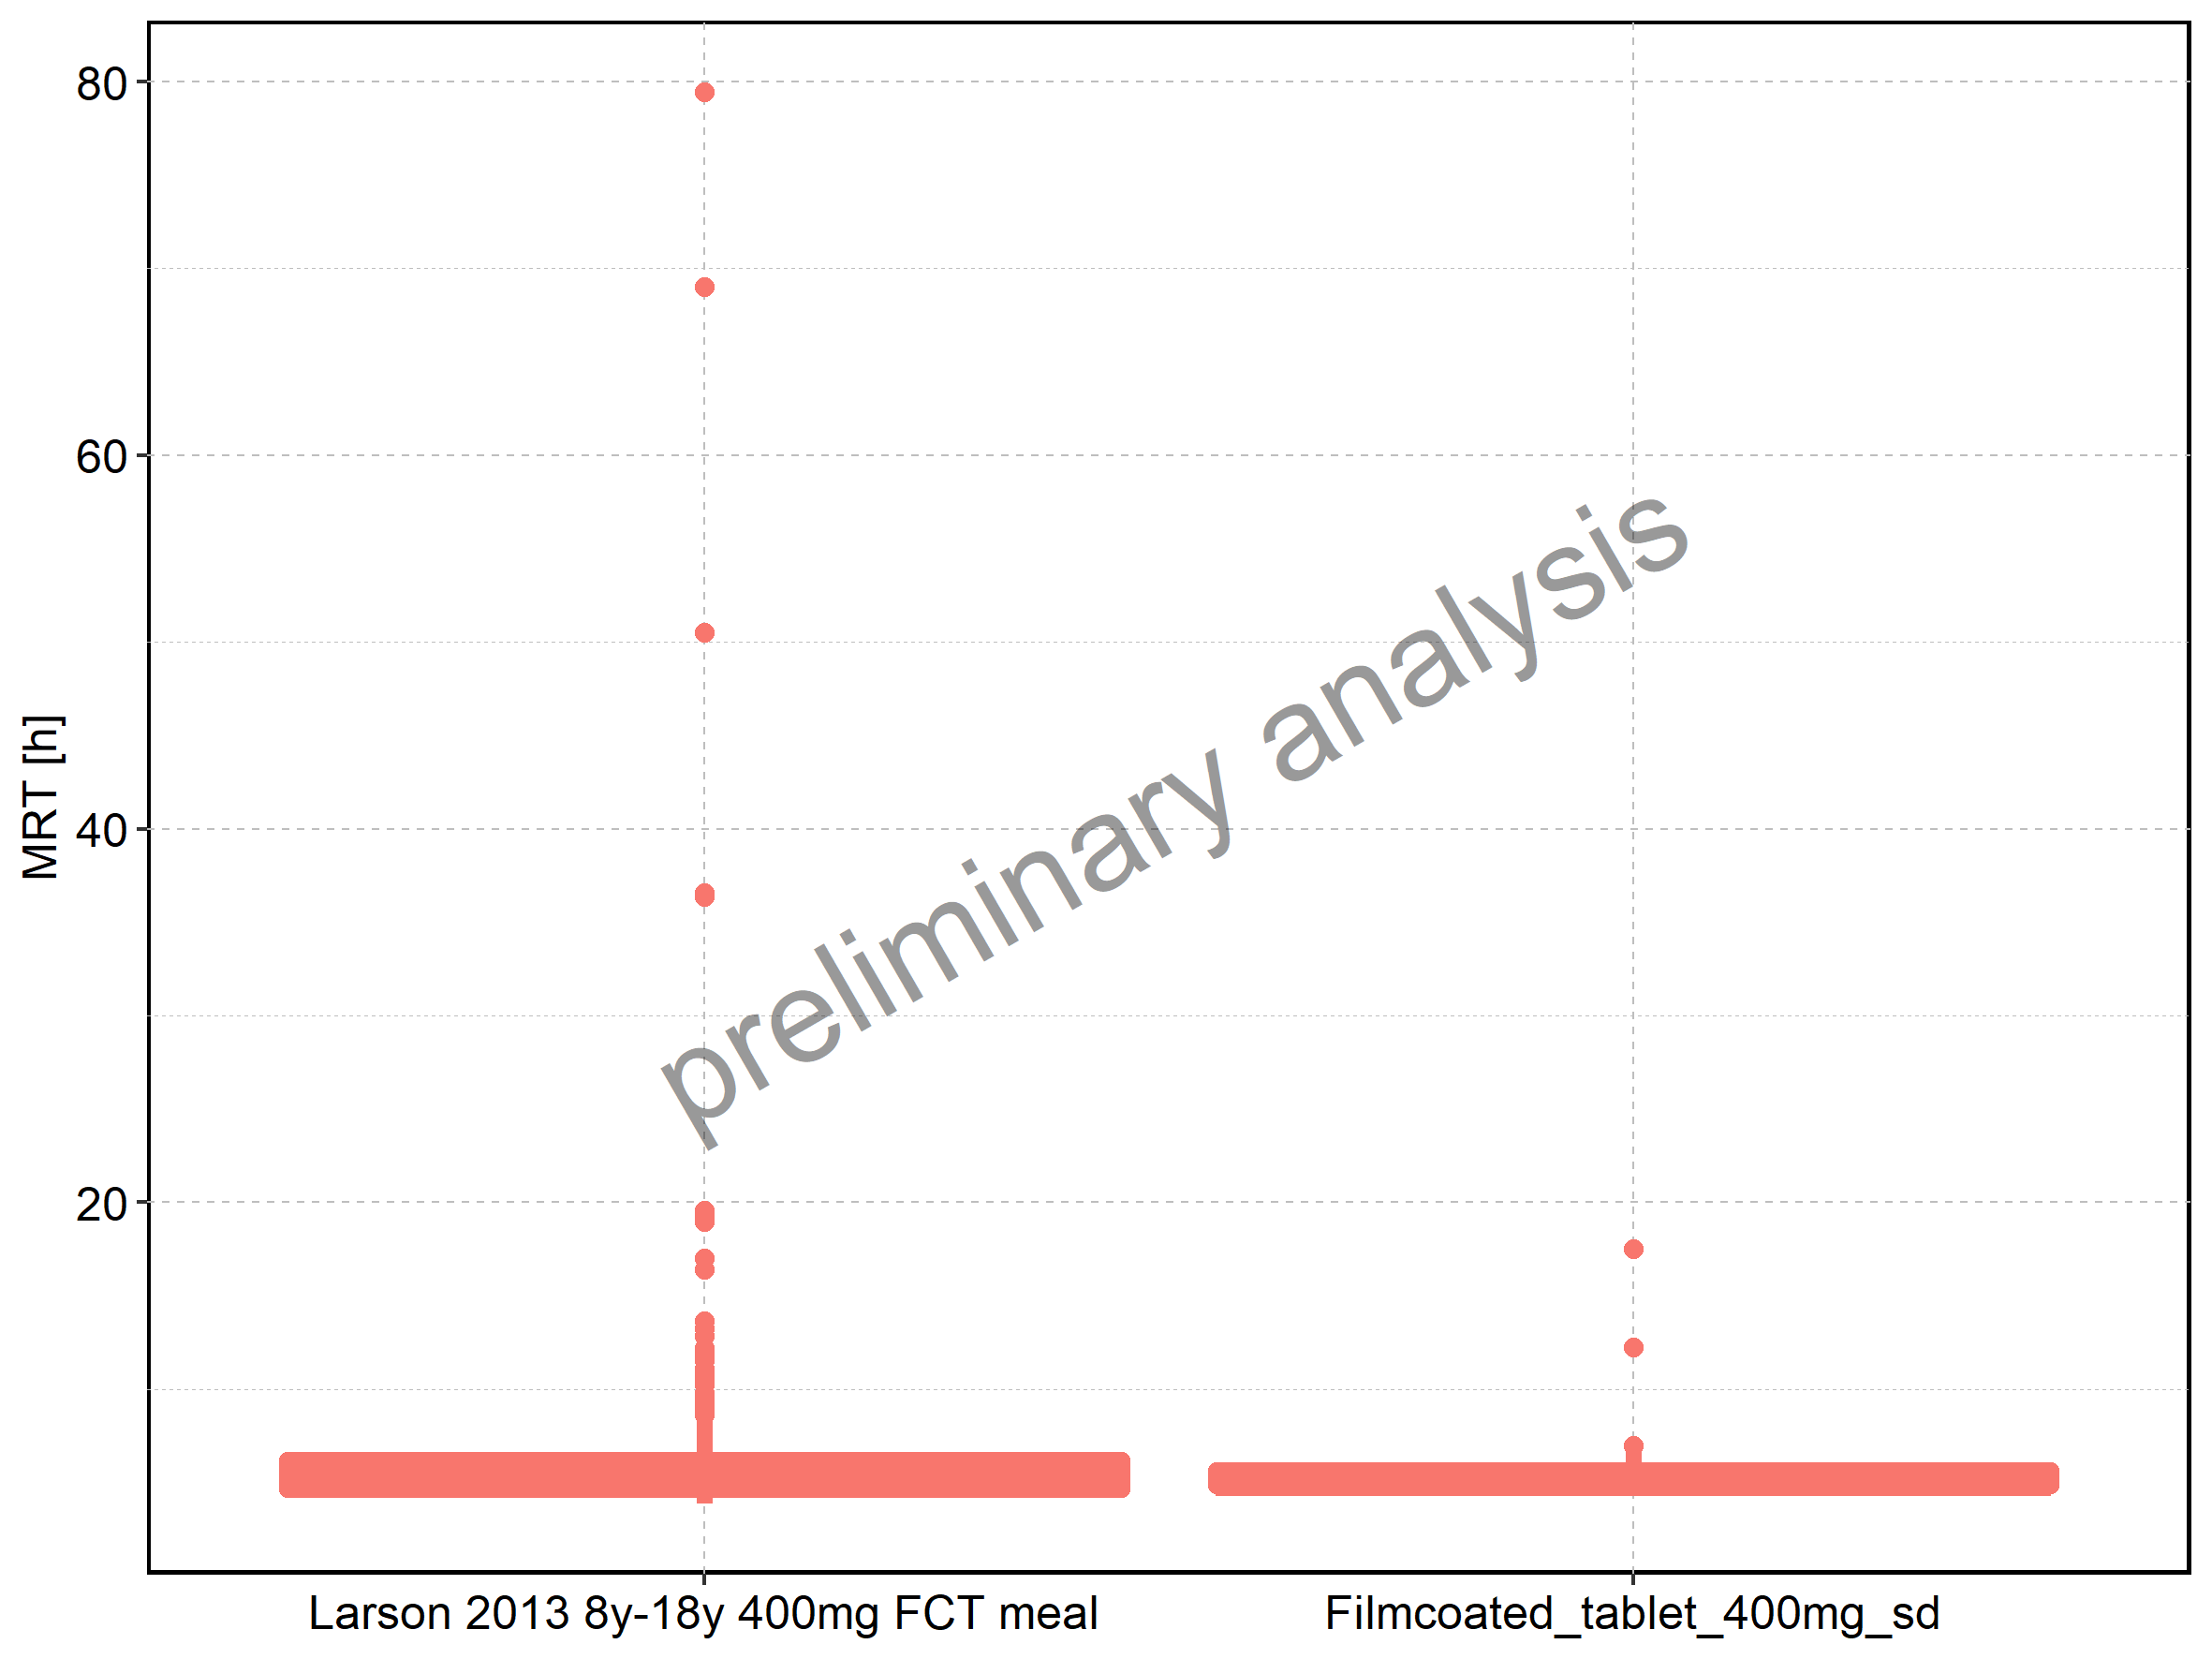

|  |  |  |  |  |  |  |  |  |  |  |
| --- | --- | --- | --- | --- | --- | --- | --- | --- | --- | --- |
| Population | N | 5th percentile | 25th percentile | 50th percentile | 75th percentile | 95th percentile | mean | standard deviation | geo mean | geo standard deviation |
| Larson 2013 8y-18y 400mg FCT meal | 497 | 3.883445 | 4.609144 | 5.323850 | 6.221885 | 10.309280 | 6.263007 | 5.564381 | 5.638136 | 1.436888 |
| Filmcoated_tablet_400mg_sd | 100 | 4.431076 | 4.803071 | 5.199119 | 5.682457 | 6.697588 | 5.438420 | 1.539076 | 5.318614 | 1.206249 |

Figure 220: MRT of Raltegravir shown as box-whisker plot, which indicates the 5th, 25th, 50th, 75th, and 95th percentiles in logarithmic scale.

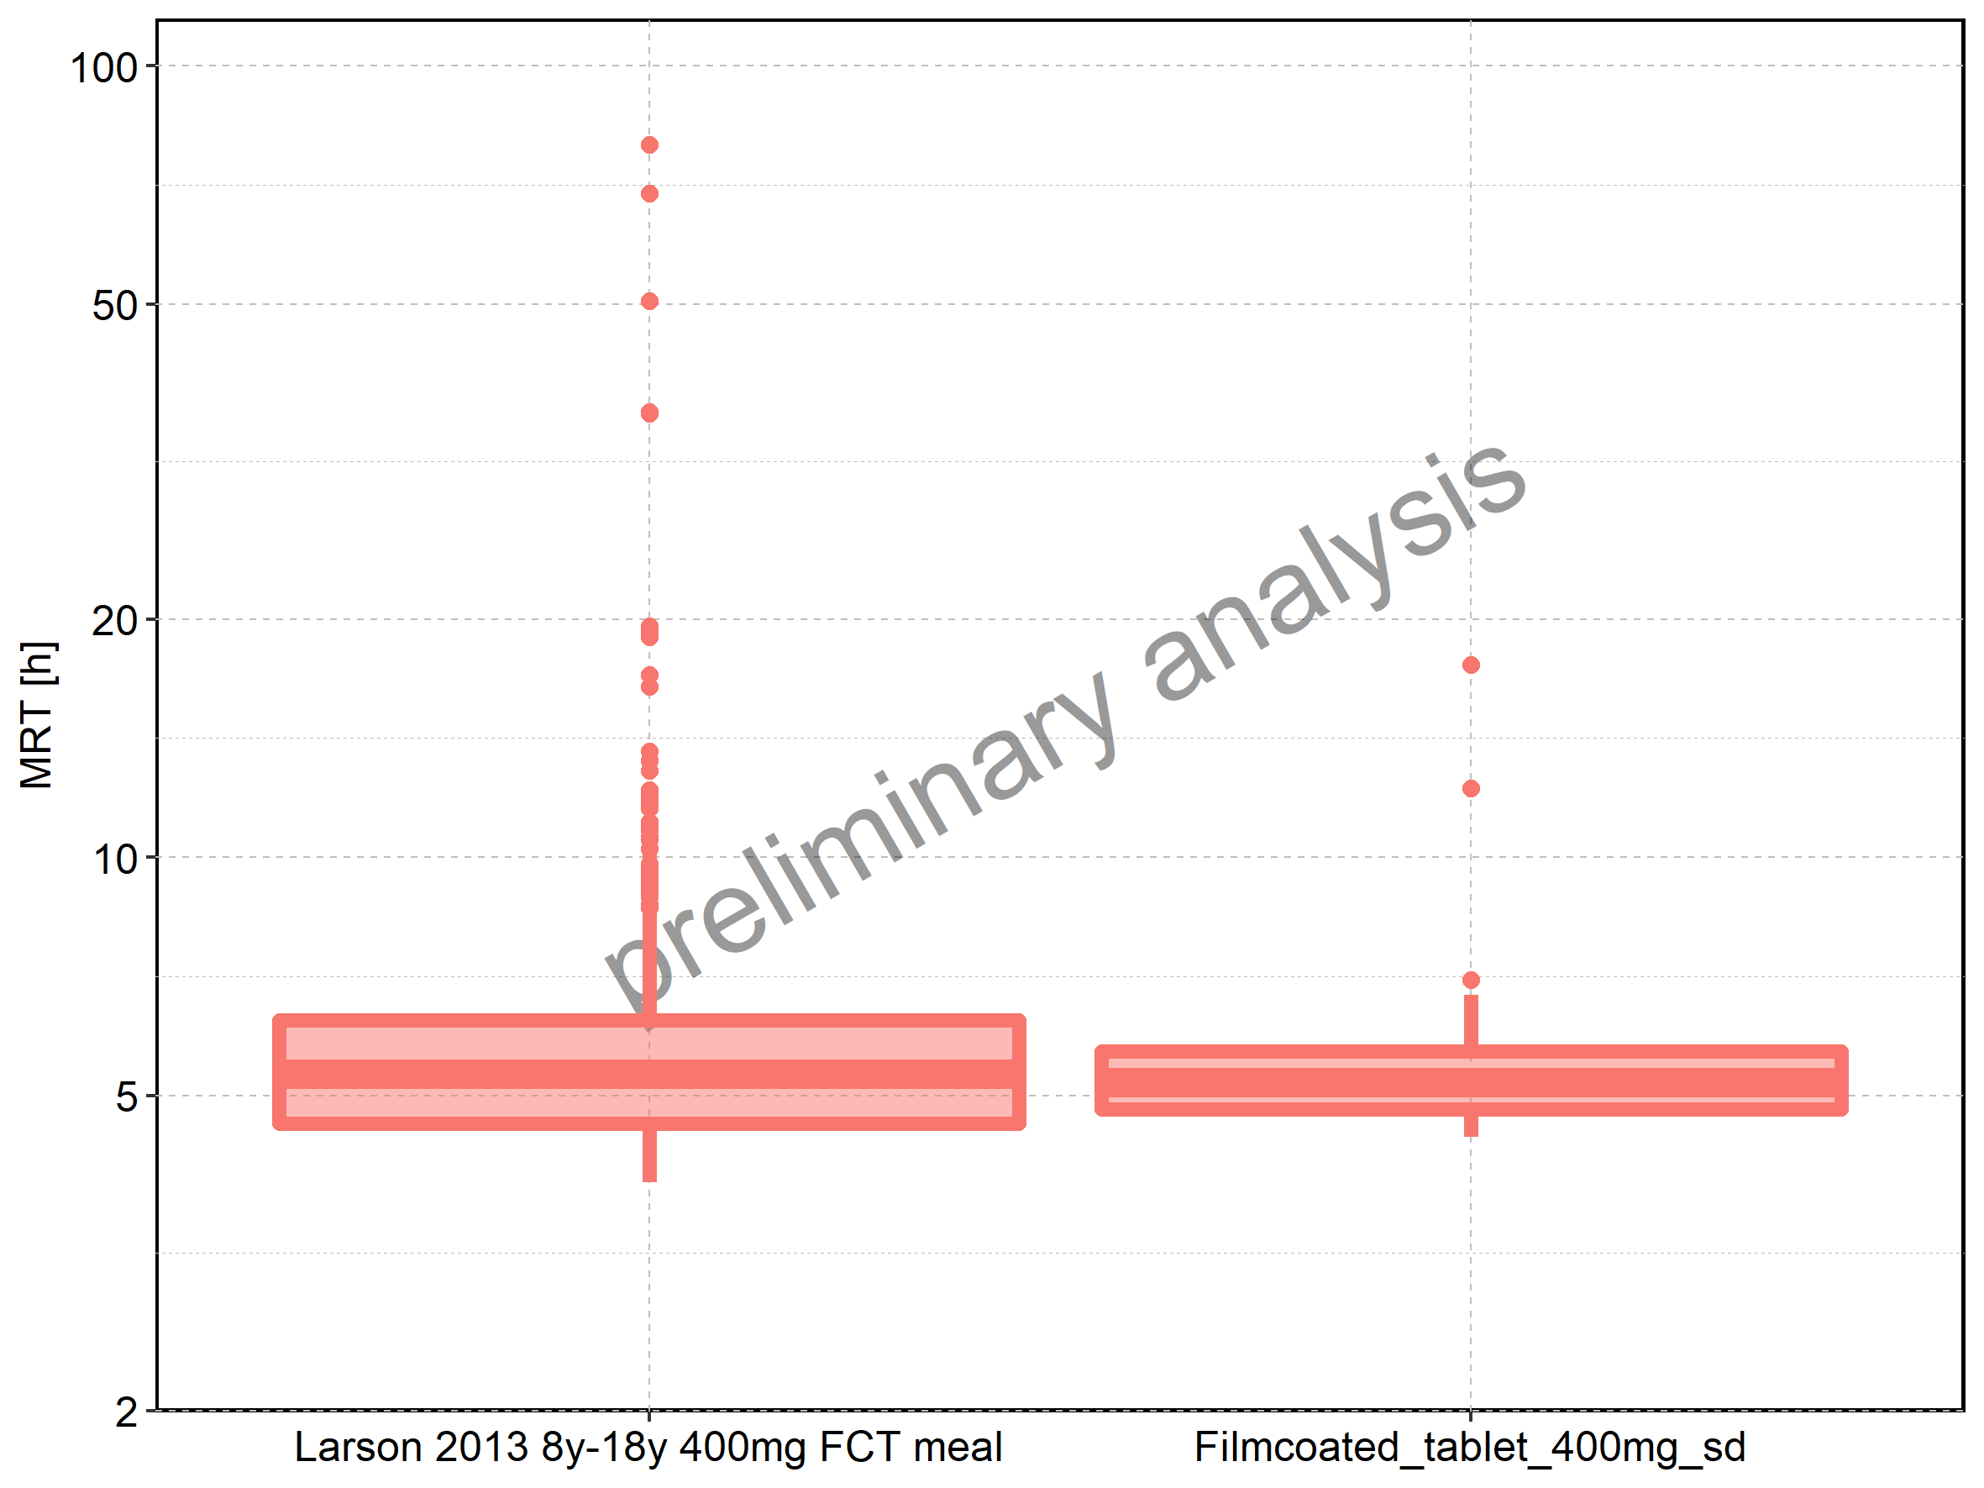

Figure 221: Age-dependence of MRT for Larson 2013 8y-18y 400mg FCT meal in comparison to Filmcoated_tablet_400mg_sd. Profiles are plotted in a linear scale.

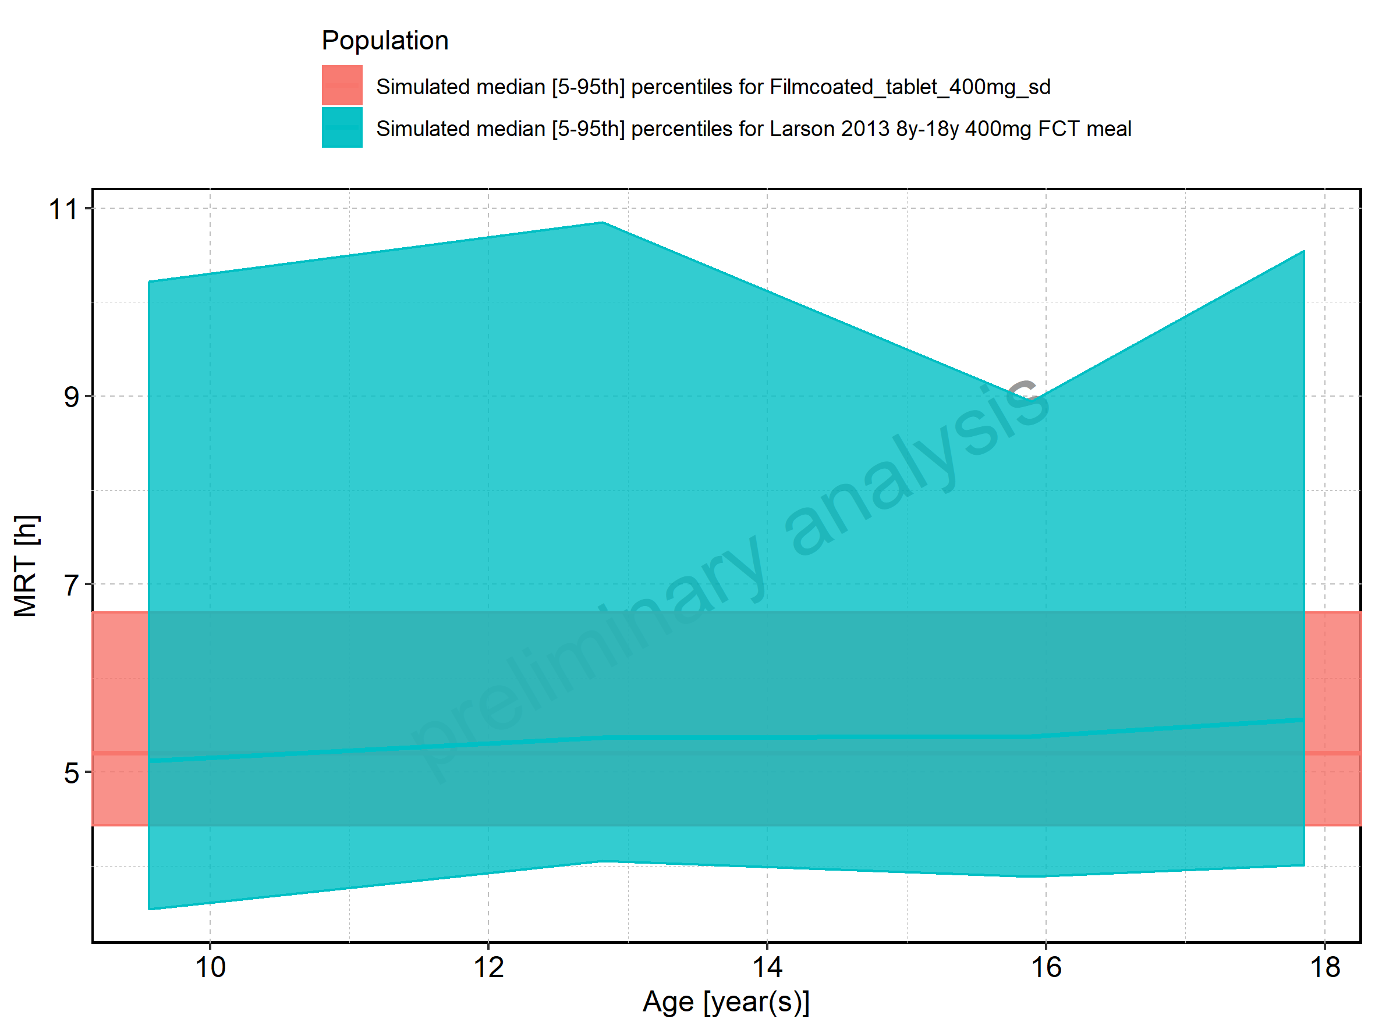

Figure 222: Age-dependence of MRT for Larson 2013 8y-18y 400mg FCT meal in comparison to Filmcoated_tablet_400mg_sd. Profiles are plotted in a logarithmic scale.

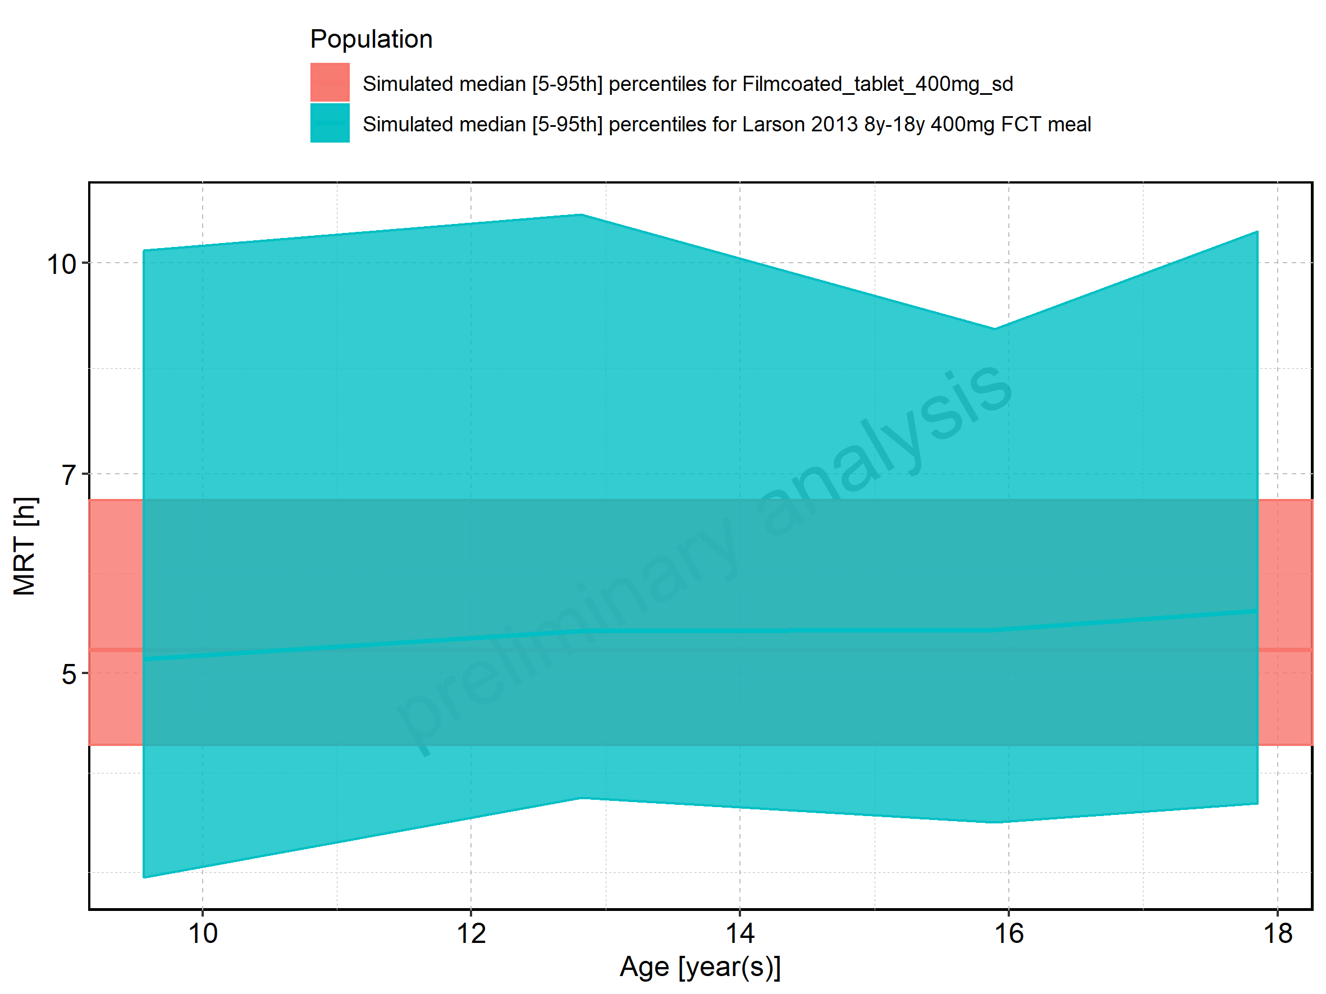

Figure 223: Age-dependence of MRT for Larson 2013 8y-18y 400mg FCT meal. Profiles are plotted in a linear scale.

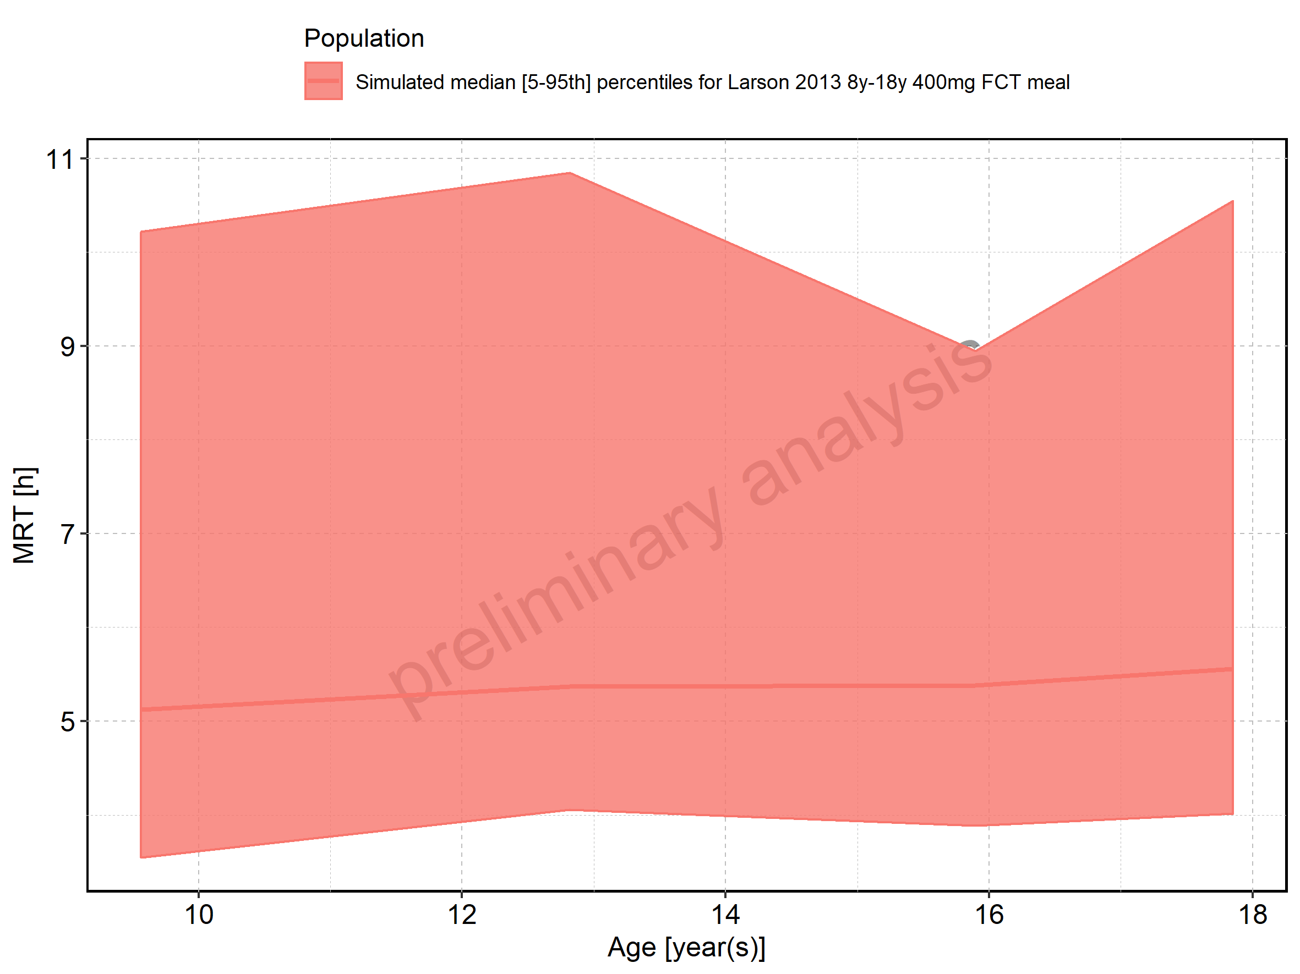

Figure 224: Age-dependence of MRT for Larson 2013 8y-18y 400mg FCT meal. Profiles are plotted in a logarithmic scale.

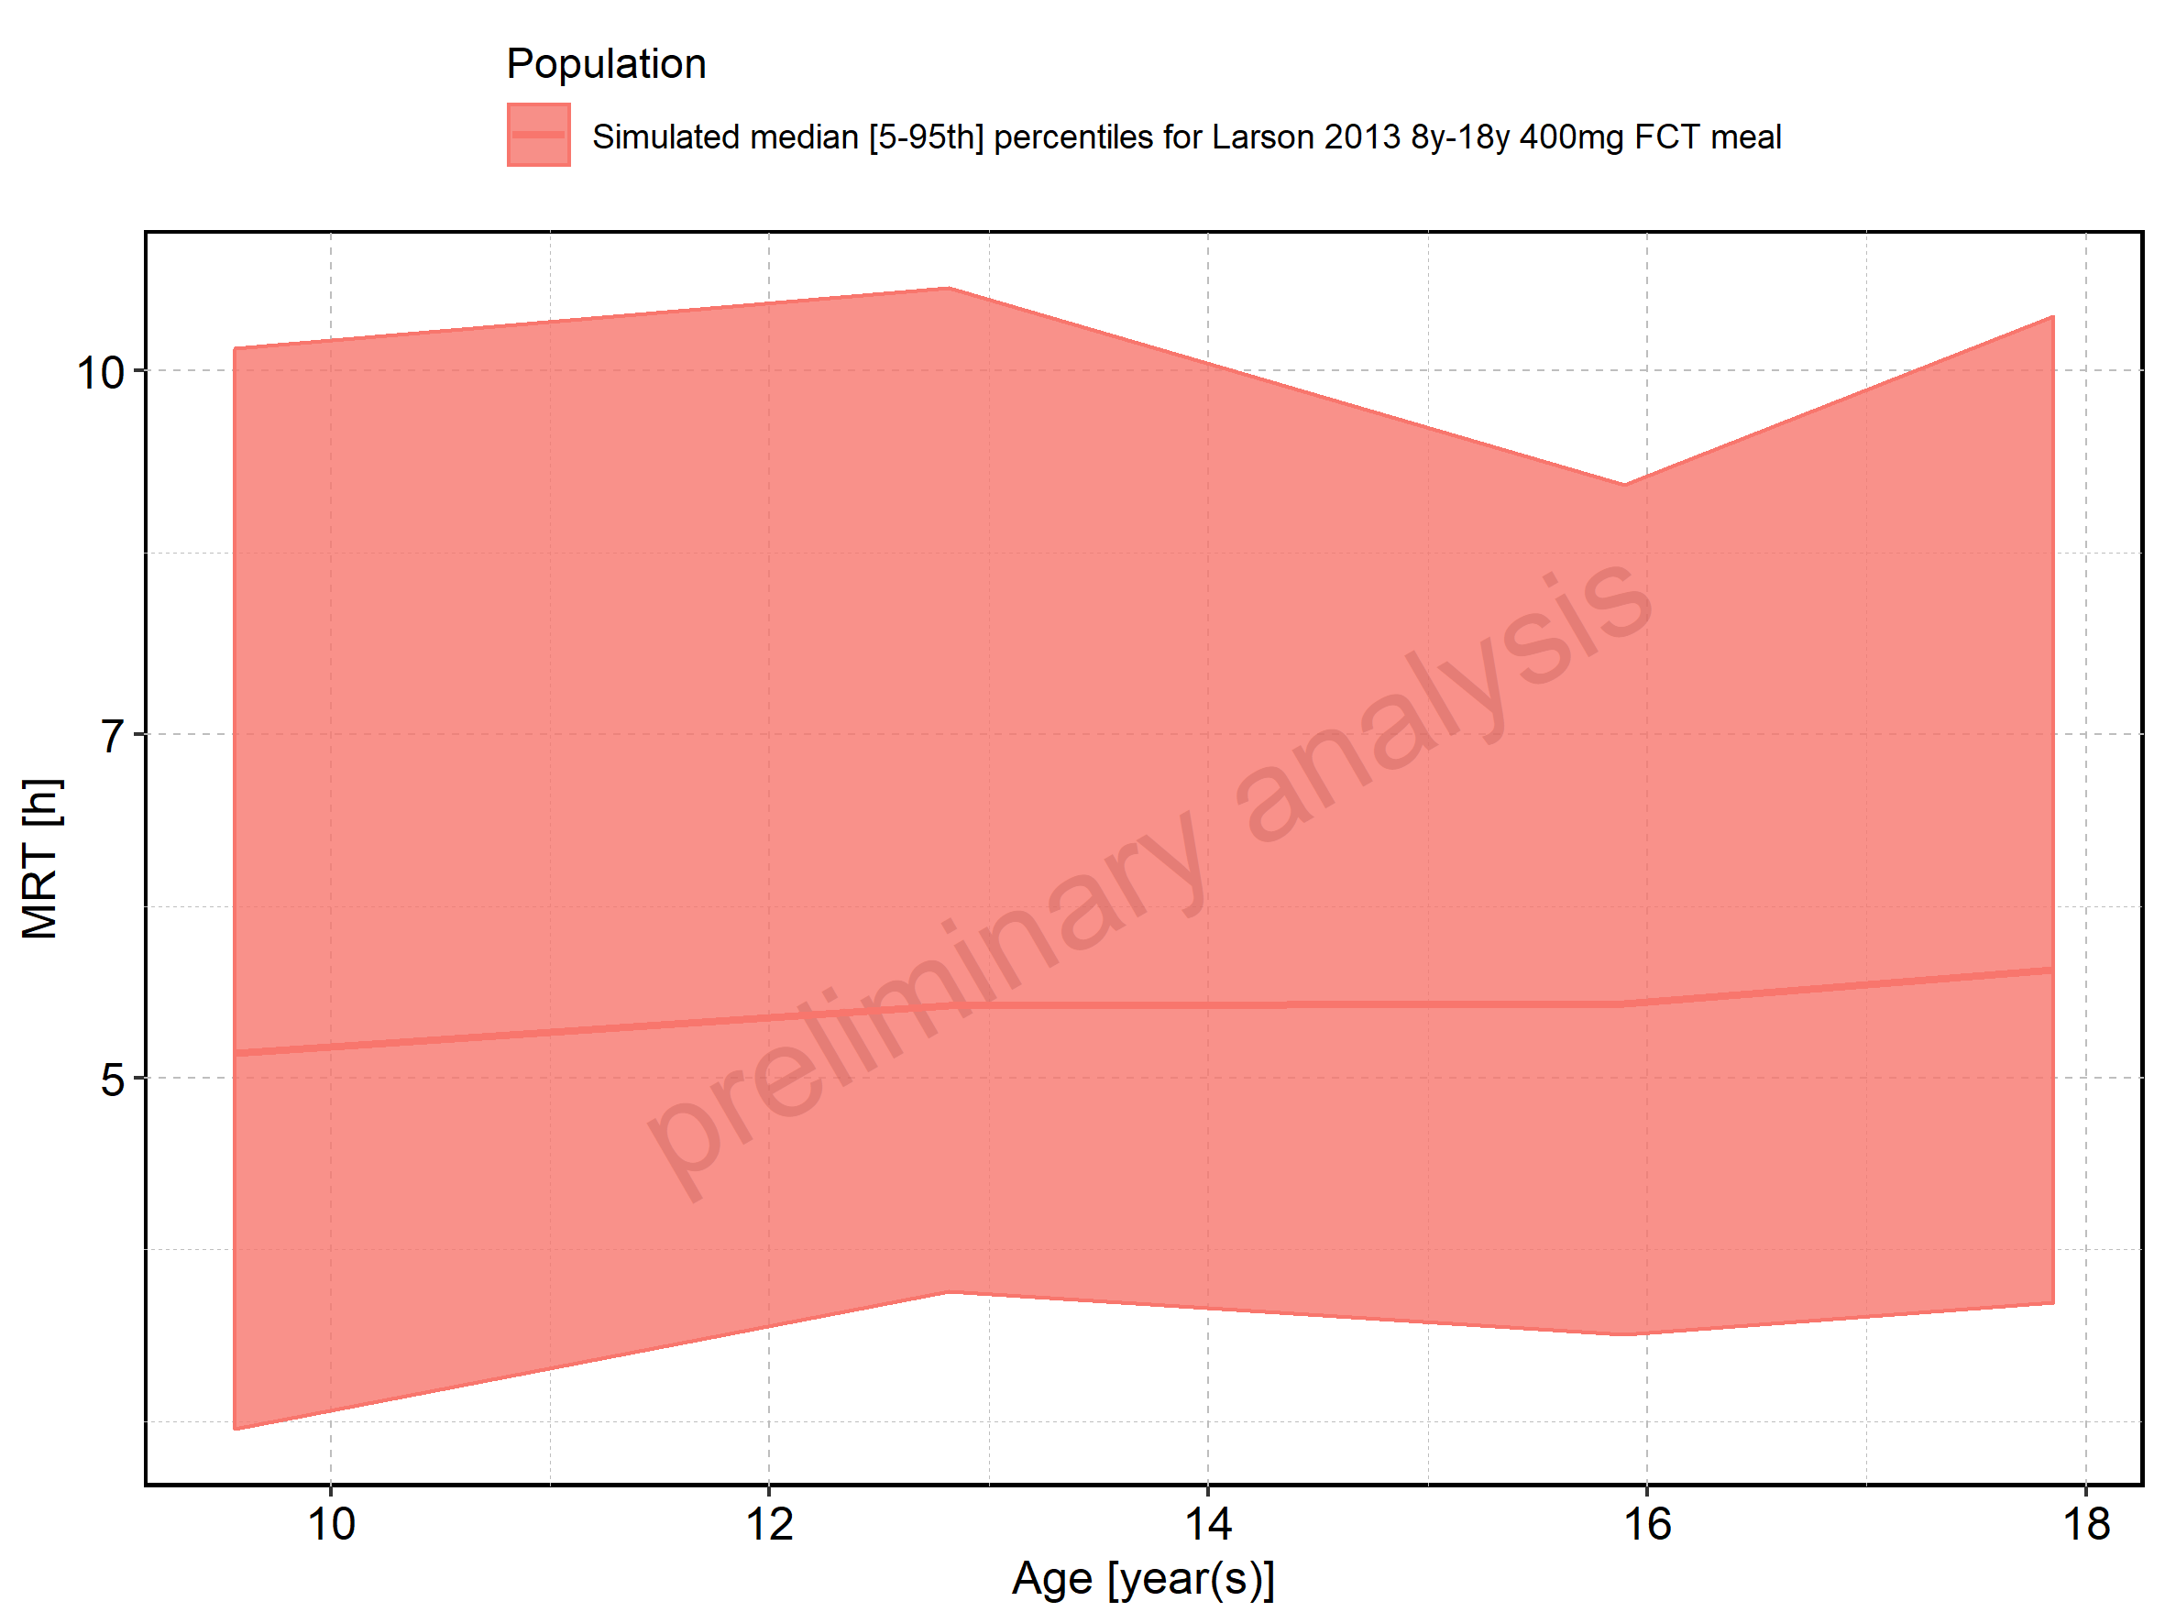

Figure 225: Age-dependence of MRT for Filmcoated_tablet_400mg_sd. Profiles are plotted in a linear scale.

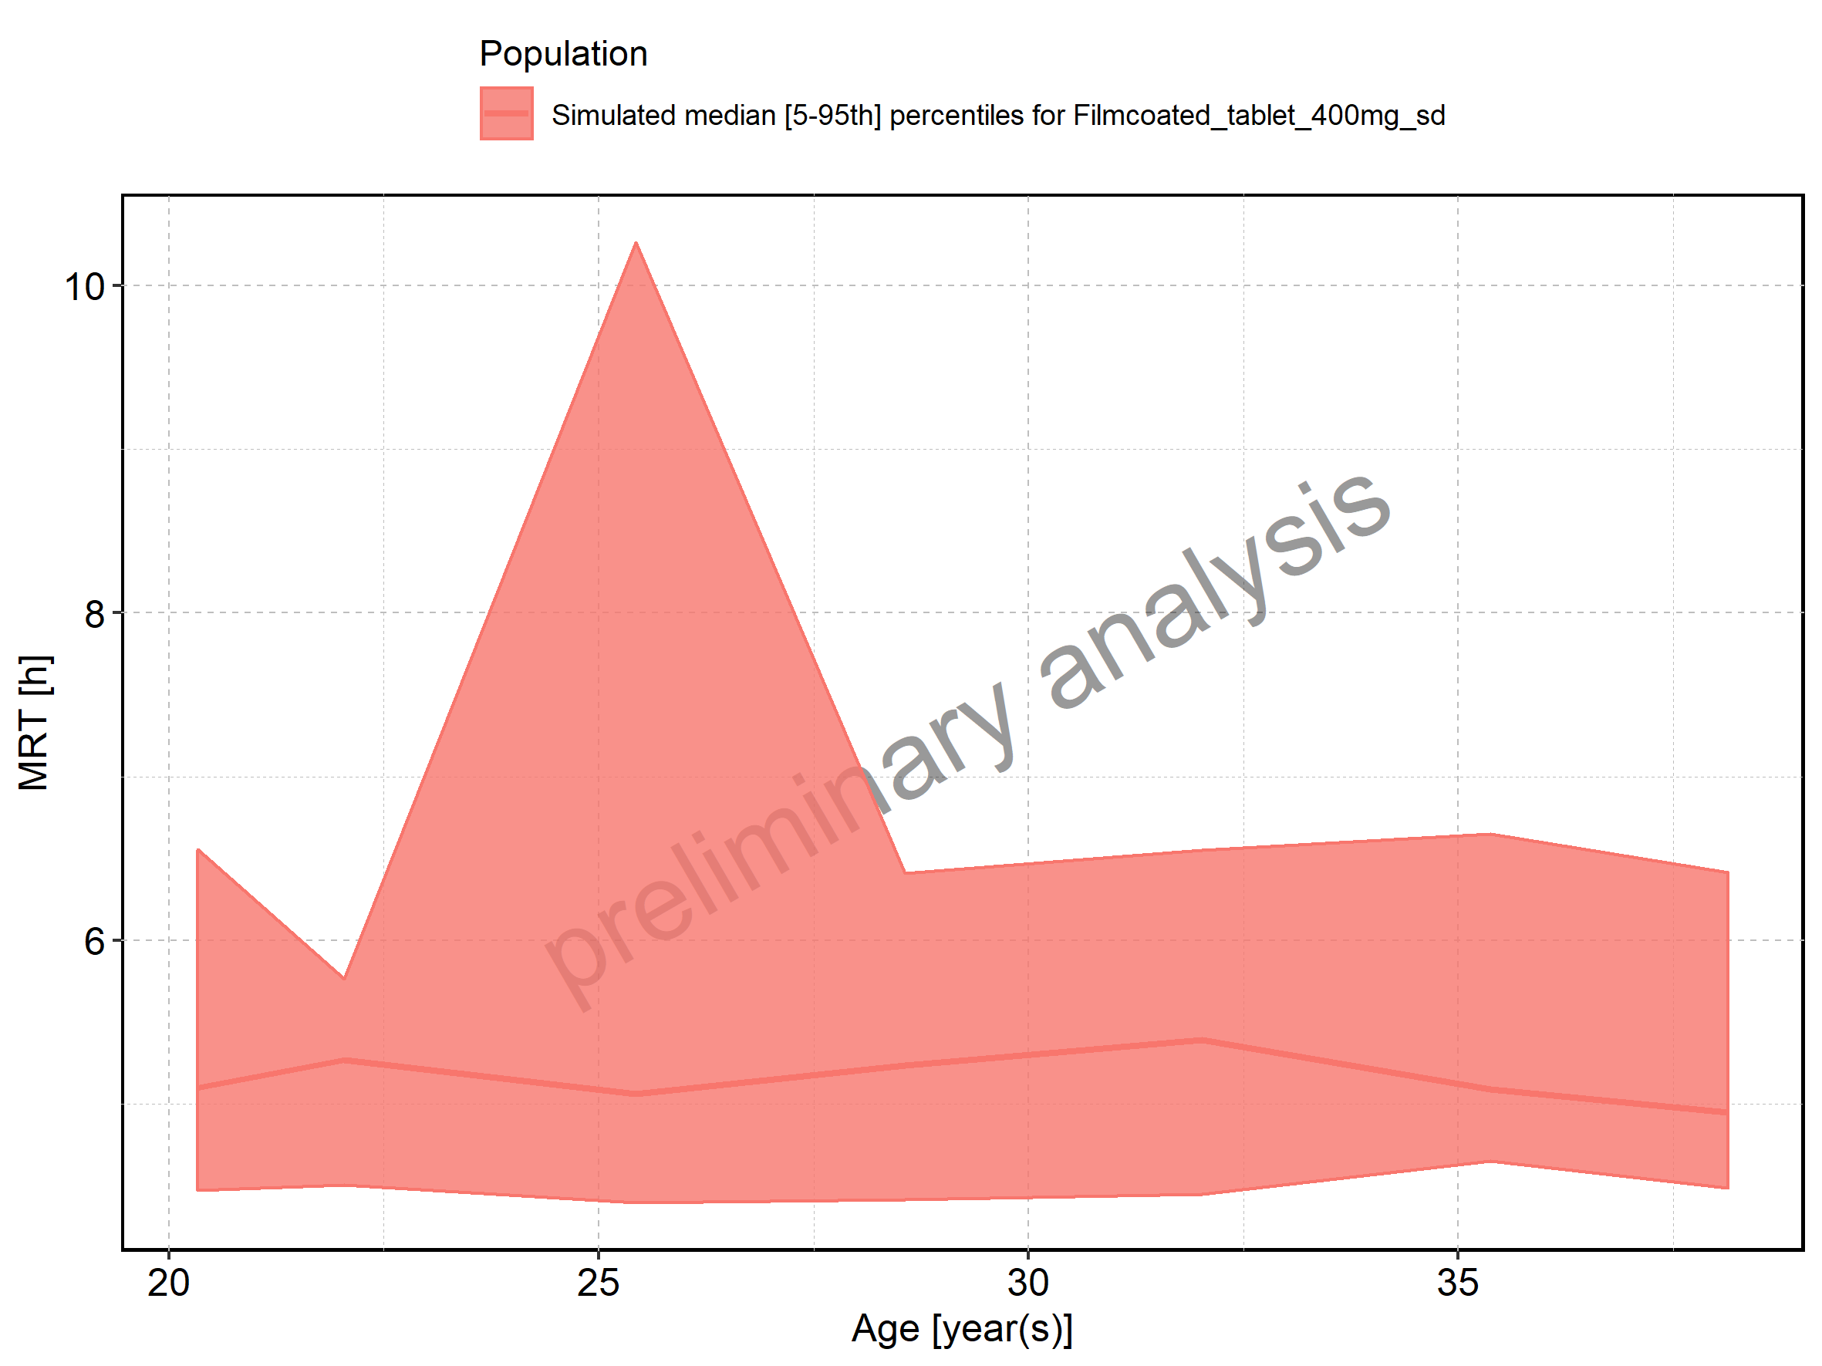

Figure 226: Age-dependence of MRT for Filmcoated_tablet_400mg_sd. Profiles are plotted in a logarithmic scale.

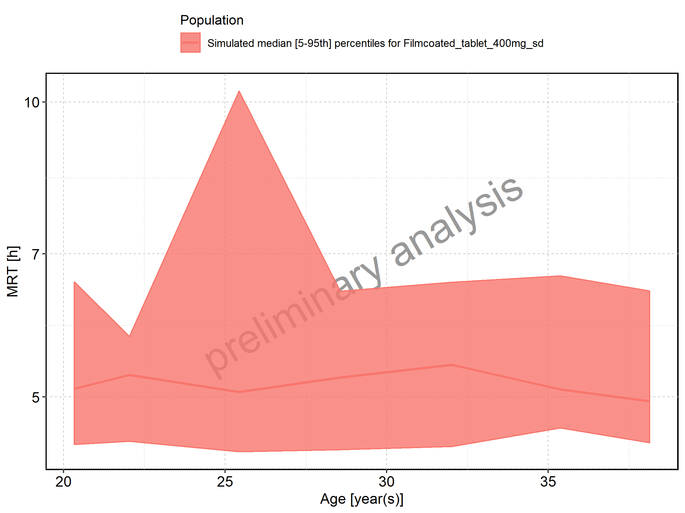

Figure 227: Height-dependence of MRT for Larson 2013 8y-18y 400mg FCT meal in comparison to Filmcoated_tablet_400mg_sd. Profiles are plotted in a linear scale.

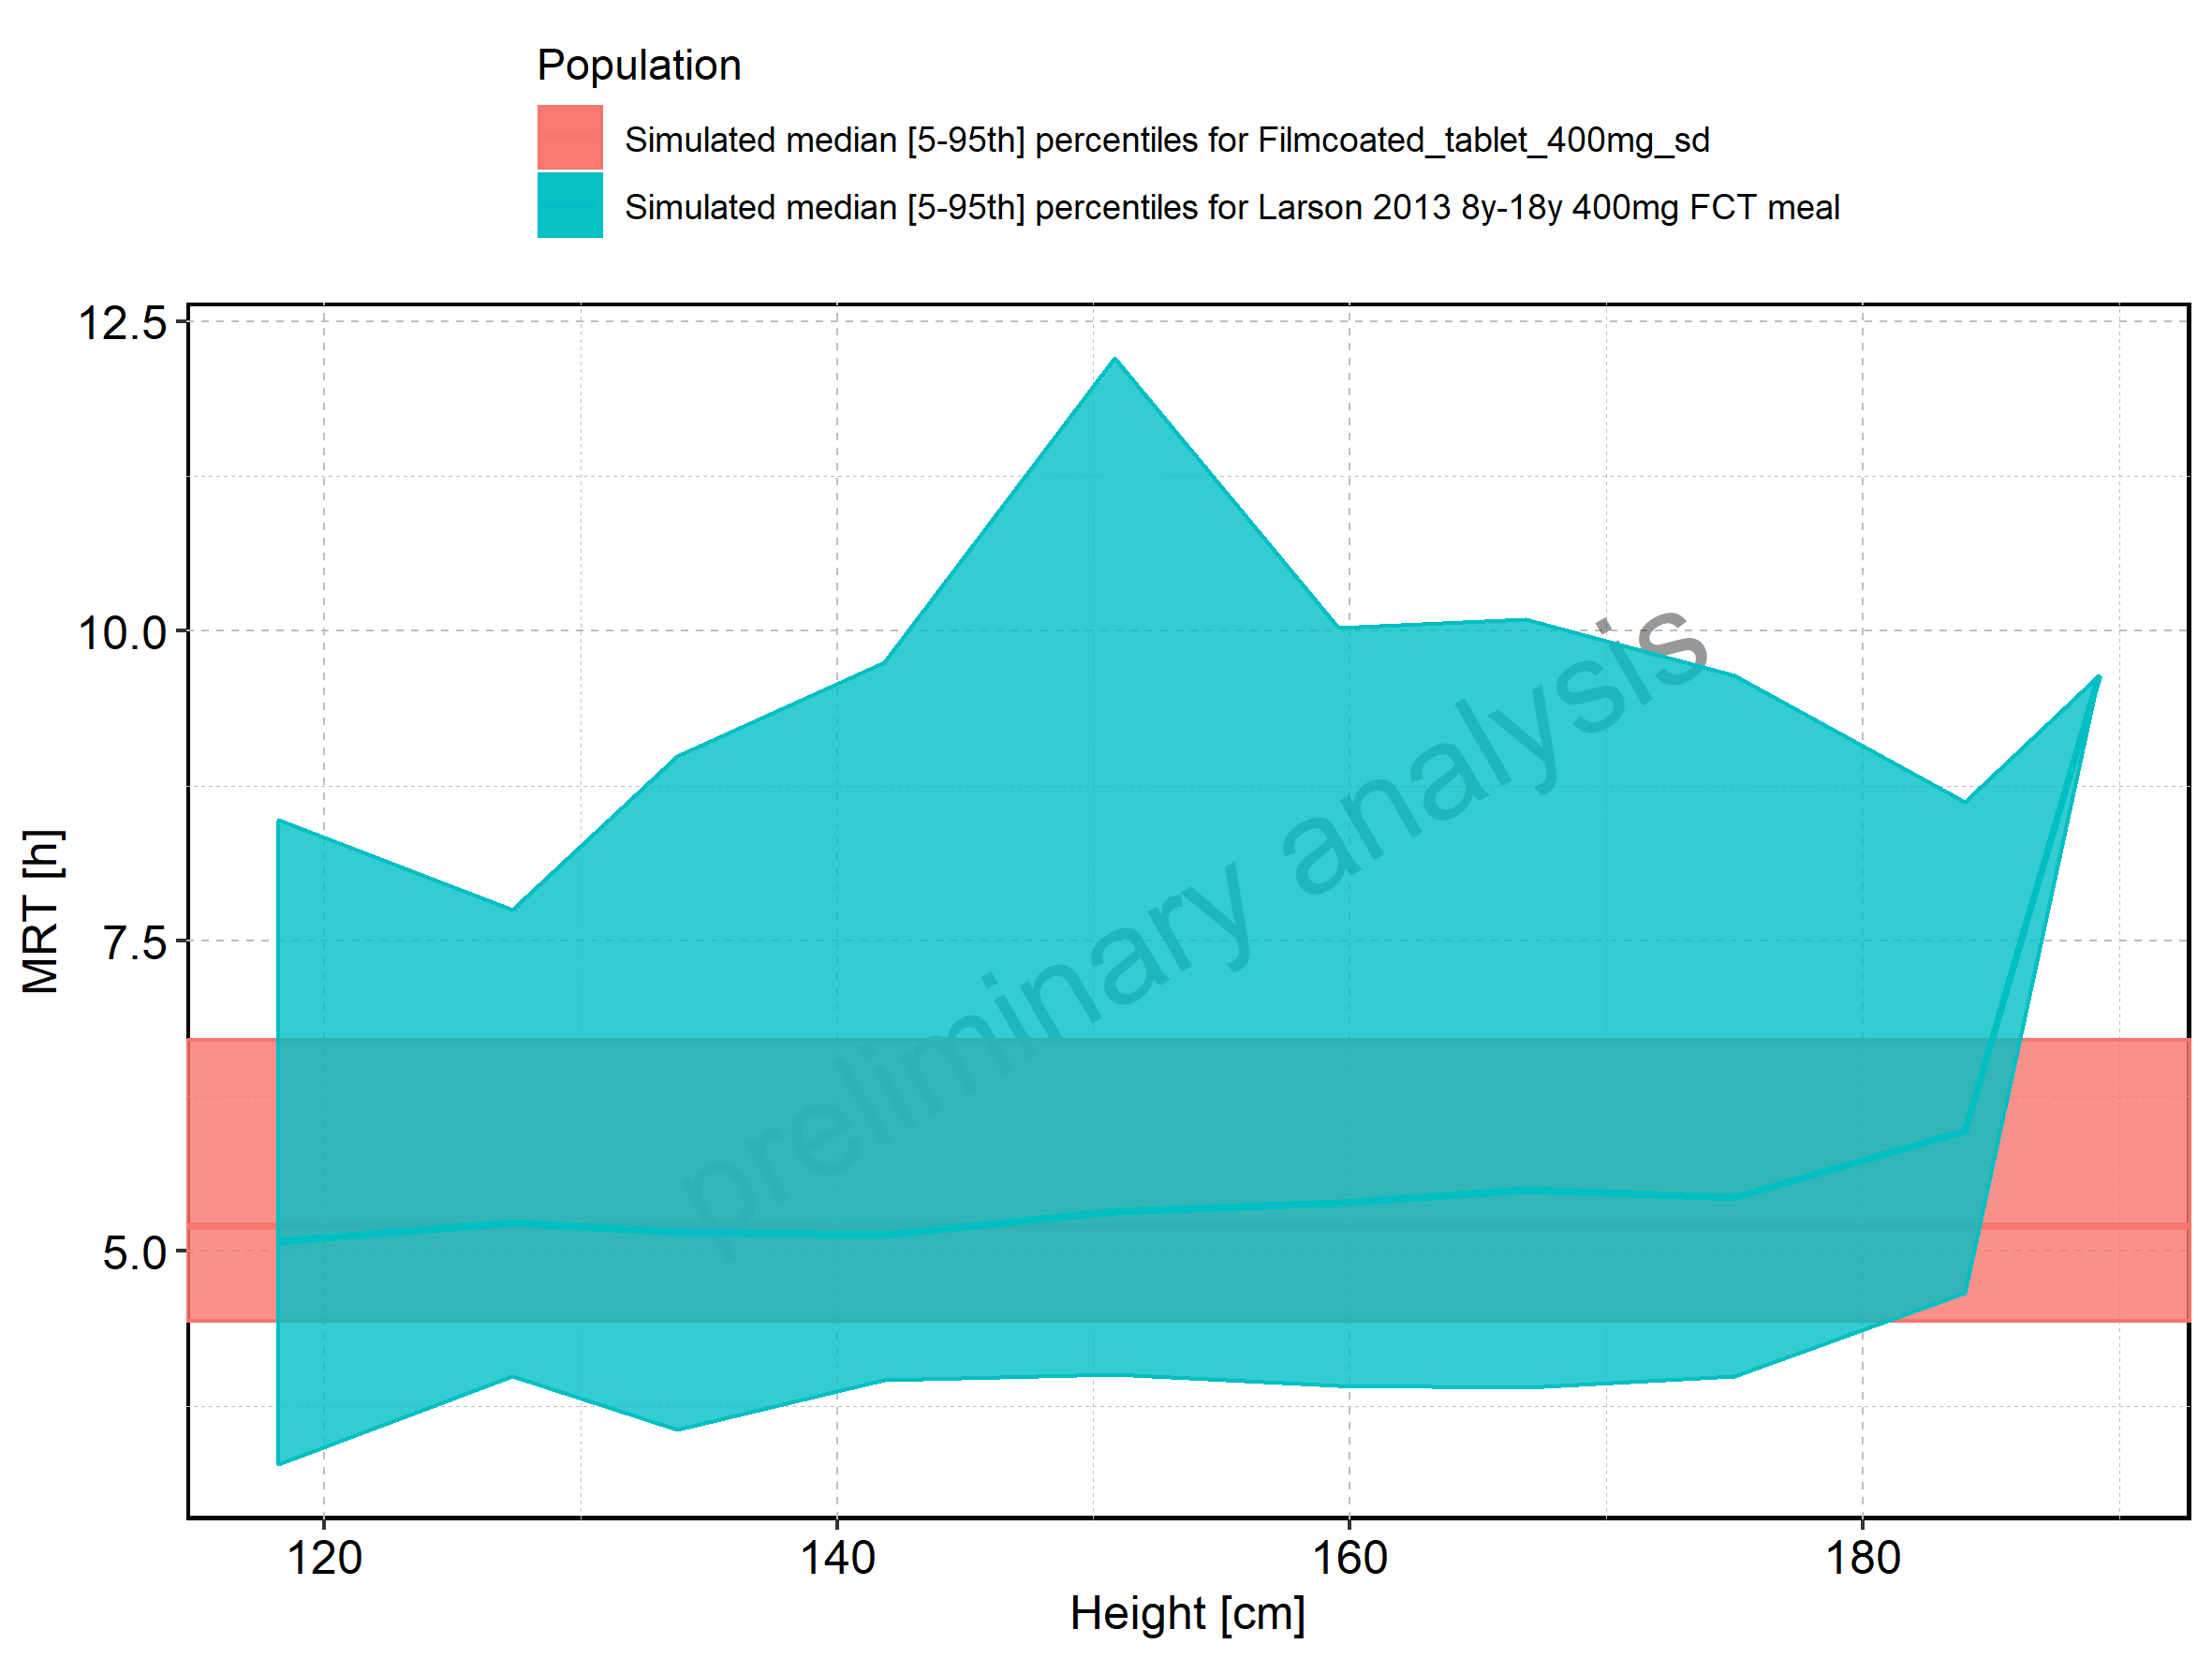

Figure 228: Height-dependence of MRT for Larson 2013 8y-18y 400mg FCT meal in comparison to Filmcoated_tablet_400mg_sd. Profiles are plotted in a logarithmic scale.

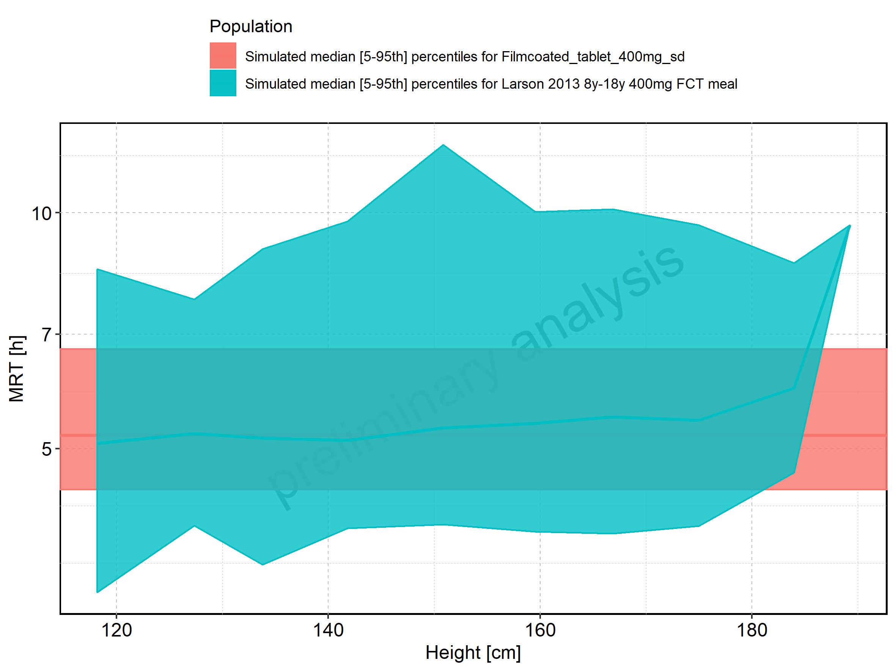

Figure 229: Height-dependence of MRT for Larson 2013 8y-18y 400mg FCT meal. Profiles are plotted in a linear scale.

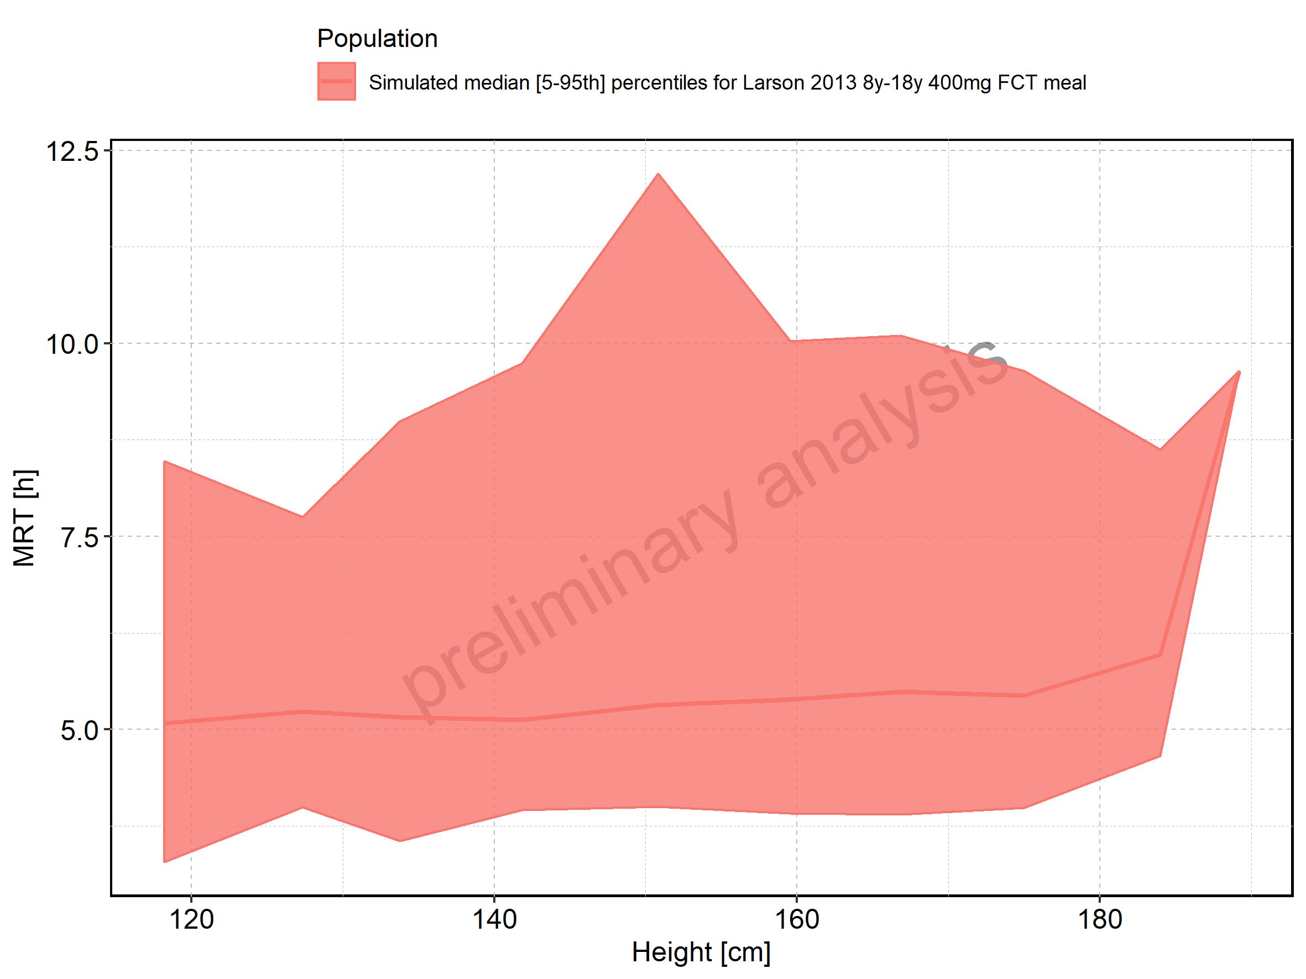

Figure 230: Height-dependence of MRT for Larson 2013 8y-18y 400mg FCT meal. Profiles are plotted in a logarithmic scale.

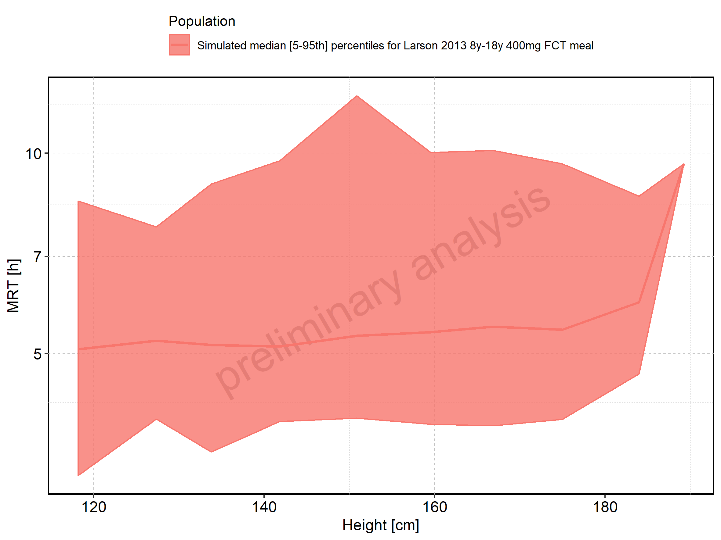

Figure 231: Height-dependence of MRT for Filmcoated_tablet_400mg_sd. Profiles are plotted in a linear scale.

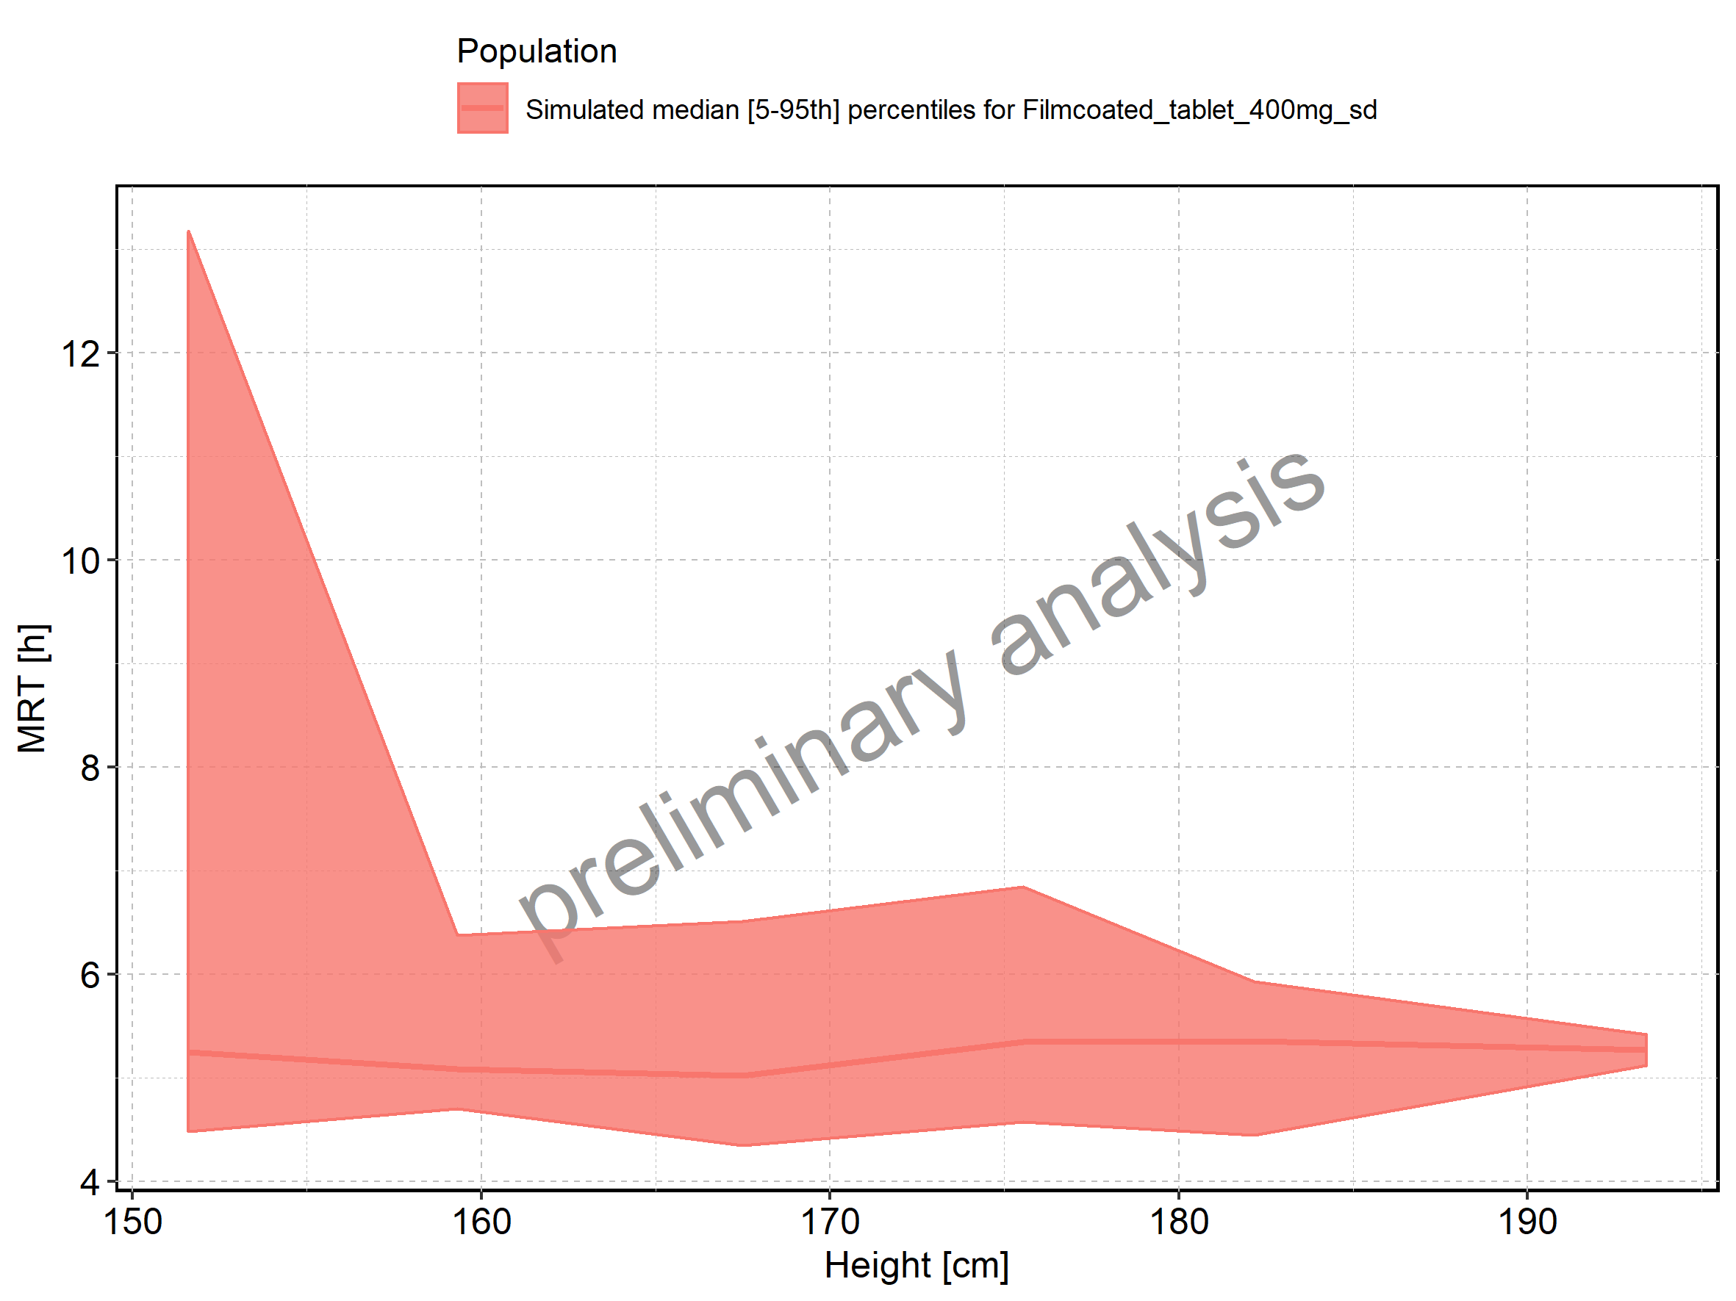

Figure 232: Height-dependence of MRT for Filmcoated_tablet_400mg_sd. Profiles are plotted in a logarithmic scale.

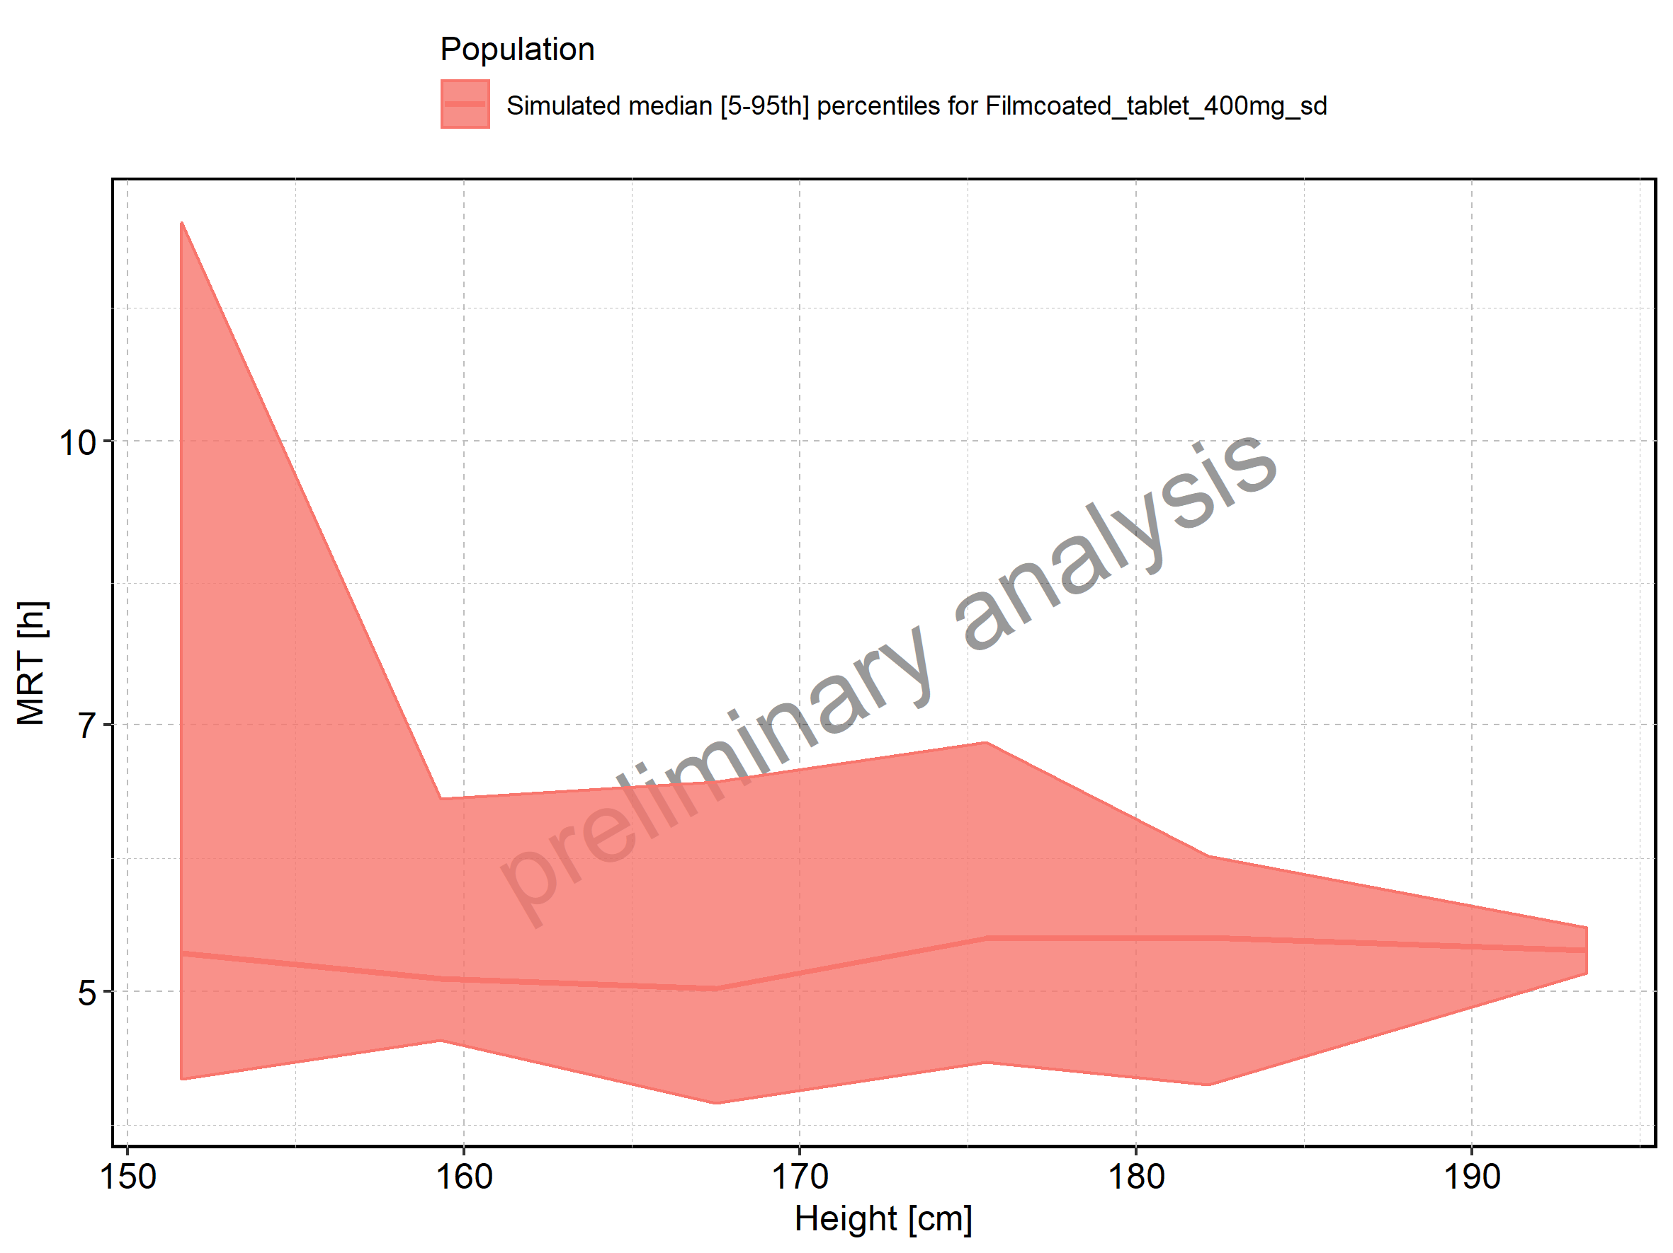

Figure 233: Weight-dependence of MRT for Larson 2013 8y-18y 400mg FCT meal in comparison to Filmcoated_tablet_400mg_sd. Profiles are plotted in a linear scale.

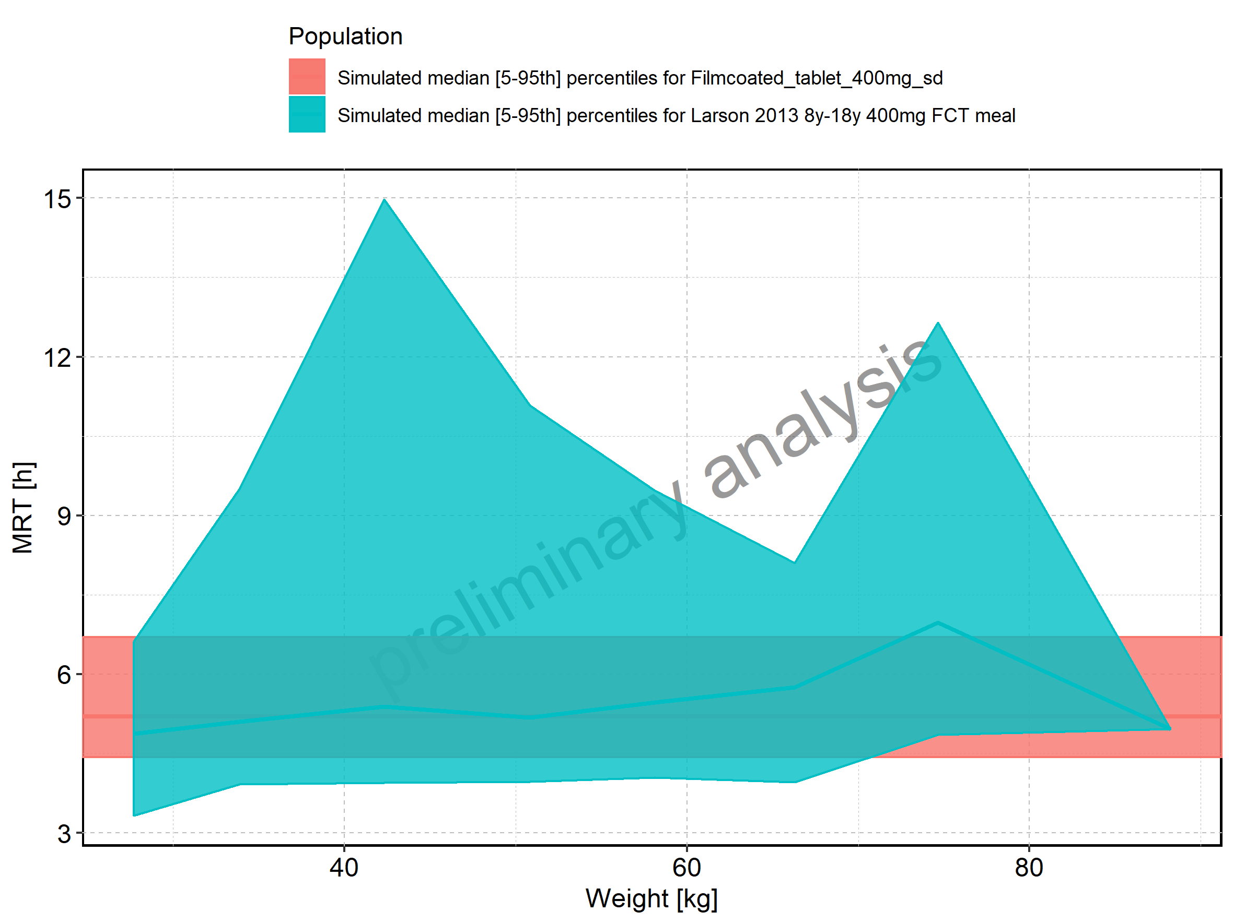

Figure 234: Weight-dependence of MRT for Larson 2013 8y-18y 400mg FCT meal in comparison to Filmcoated_tablet_400mg_sd. Profiles are plotted in a logarithmic scale.

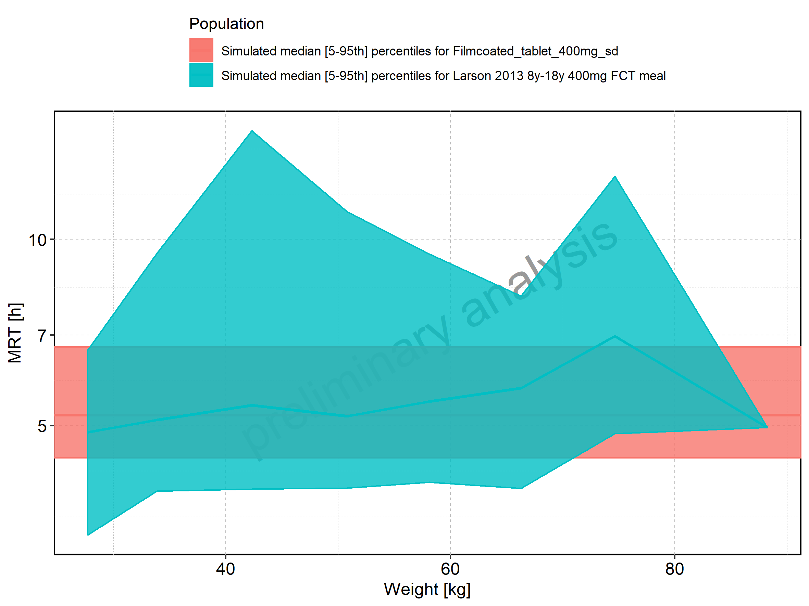

Figure 235: Weight-dependence of MRT for Larson 2013 8y-18y 400mg FCT meal. Profiles are plotted in a linear scale.

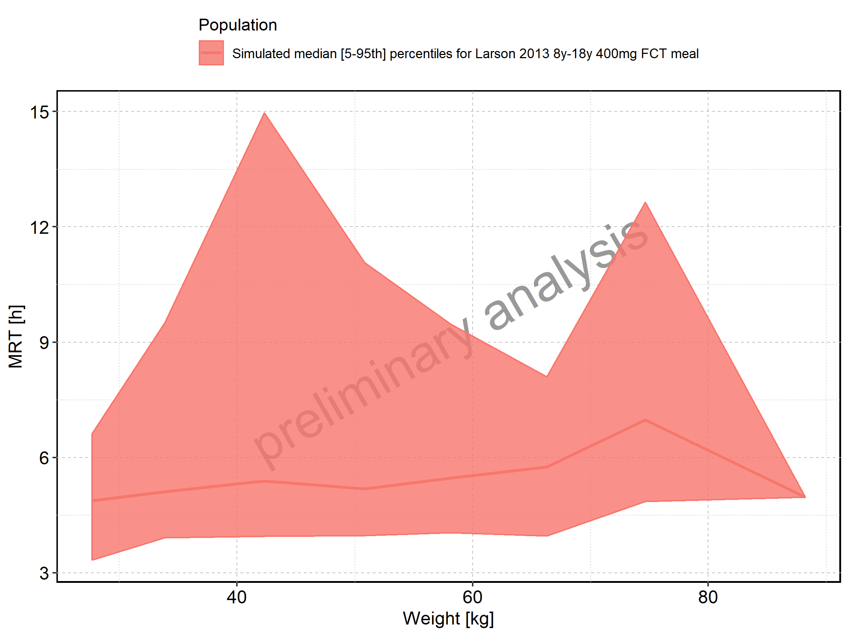

Figure 236: Weight-dependence of MRT for Larson 2013 8y-18y 400mg FCT meal. Profiles are plotted in a logarithmic scale.

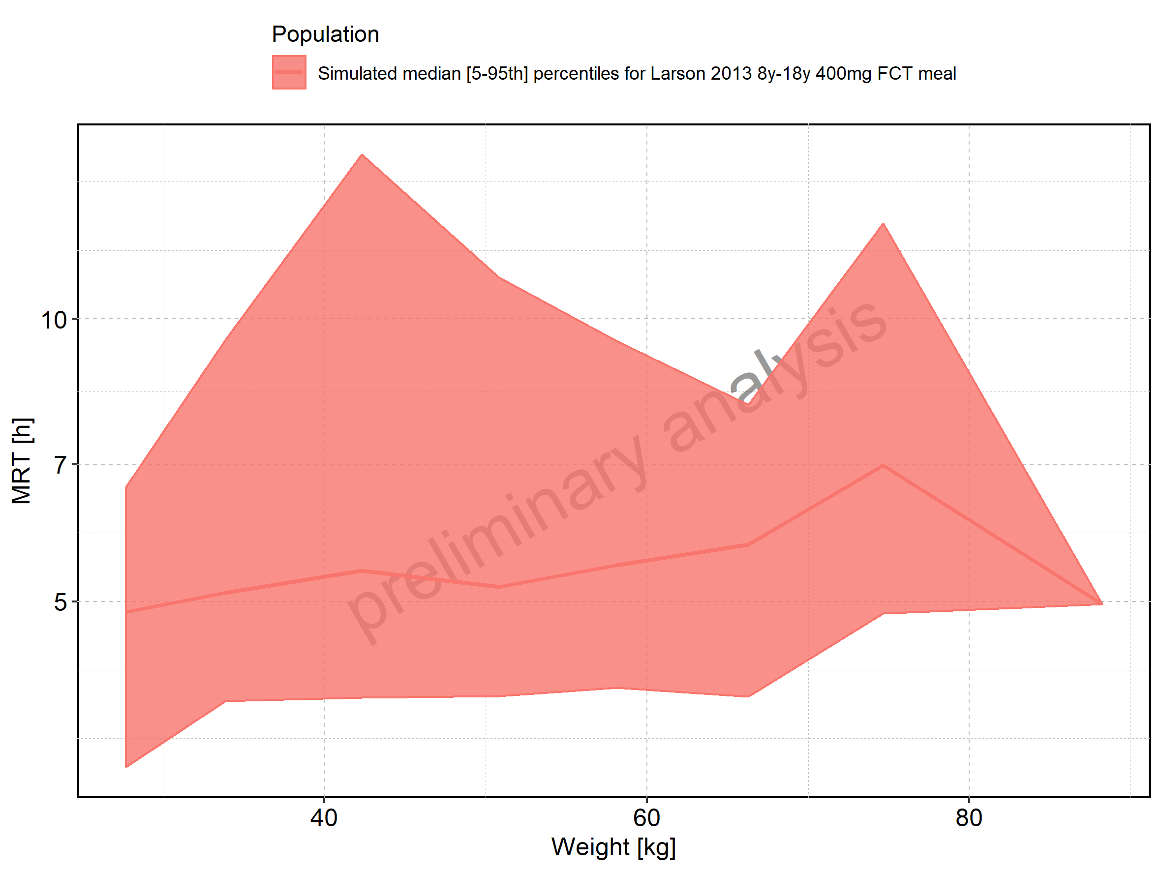

Figure 237: Weight-dependence of MRT for Filmcoated_tablet_400mg_sd. Profiles are plotted in a linear scale.

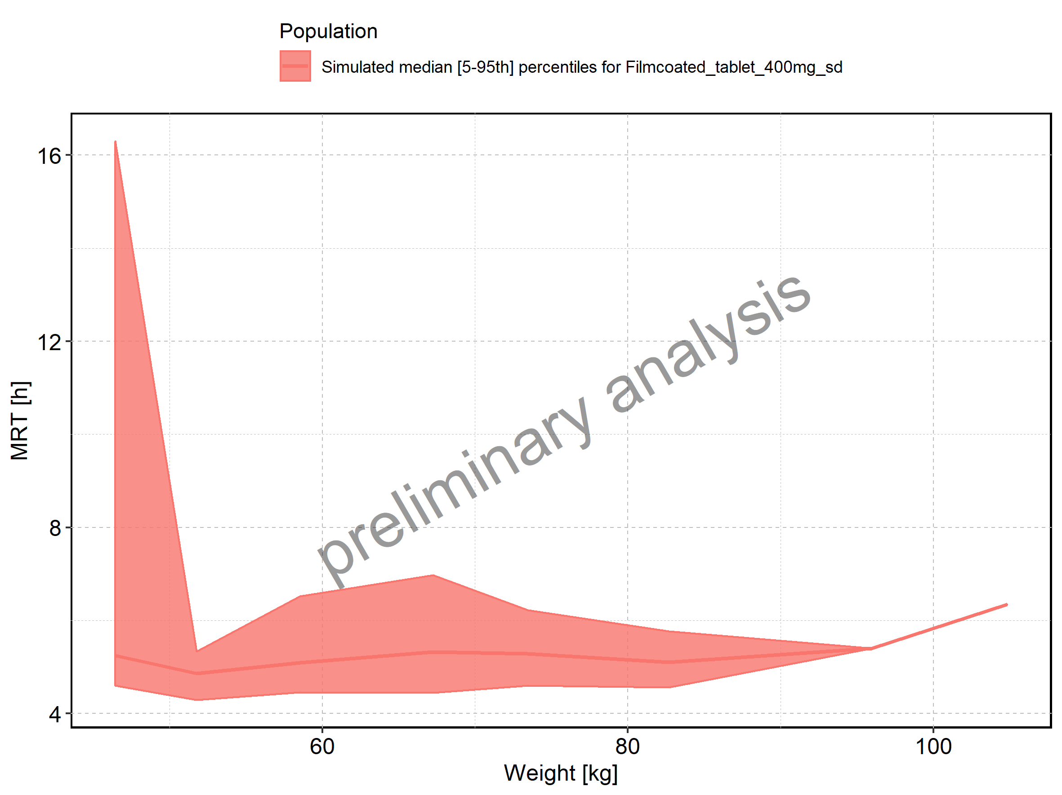

Figure 238: Weight-dependence of MRT for Filmcoated_tablet_400mg_sd. Profiles are plotted in a logarithmic scale.

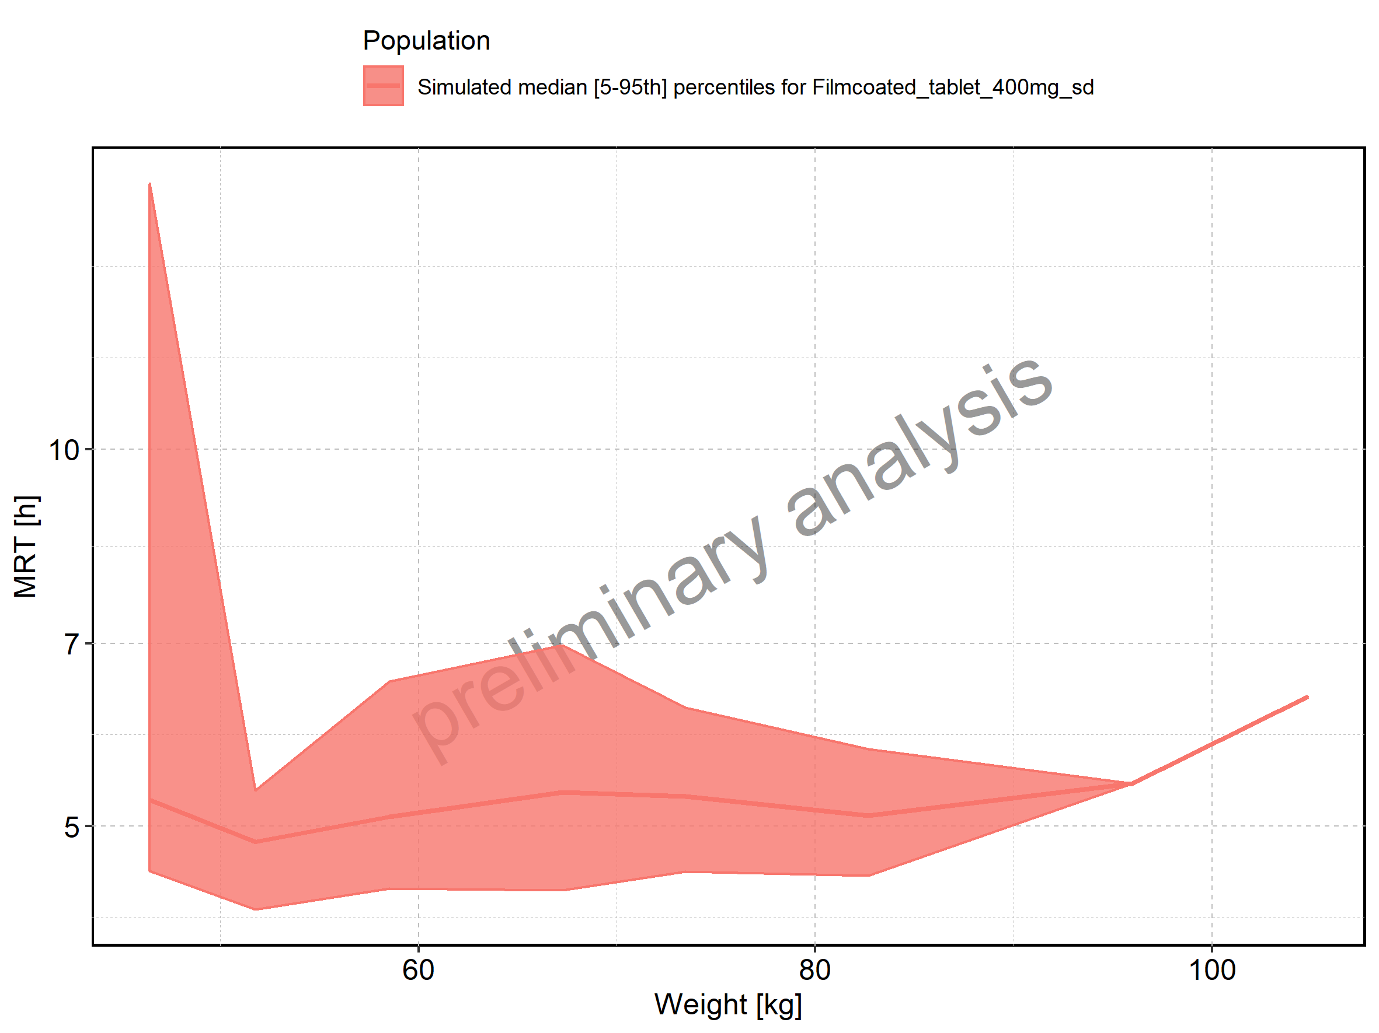

Figure 239: BMI-dependence of MRT for Larson 2013 8y-18y 400mg FCT meal in comparison to Filmcoated_tablet_400mg_sd. Profiles are plotted in a linear scale.

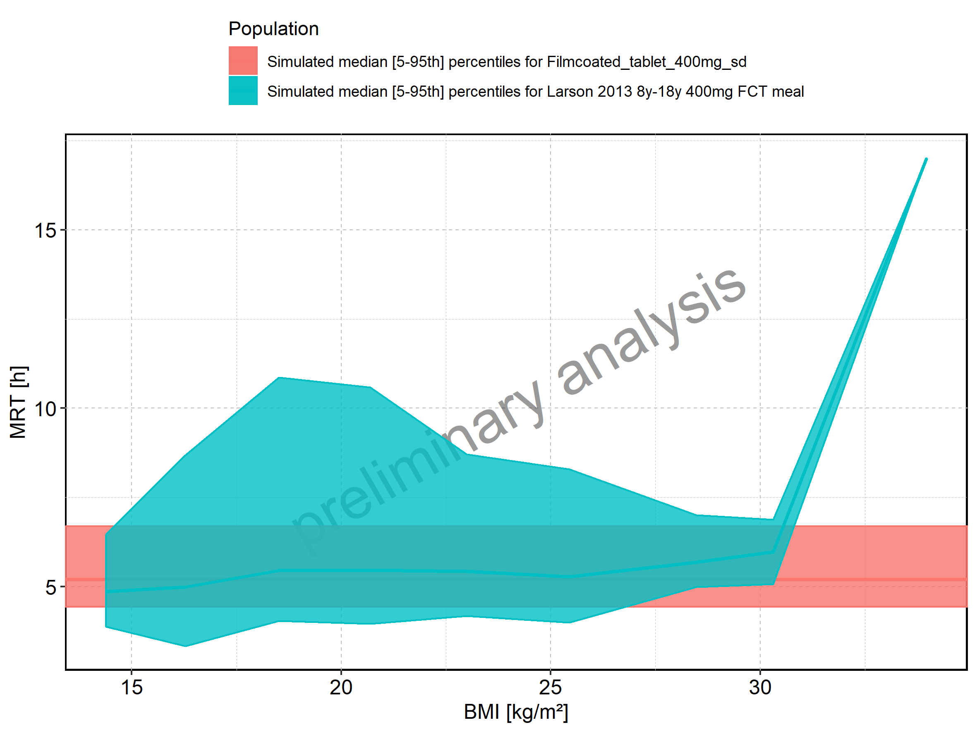

Figure 240: BMI-dependence of MRT for Larson 2013 8y-18y 400mg FCT meal in comparison to Filmcoated_tablet_400mg_sd. Profiles are plotted in a logarithmic scale.

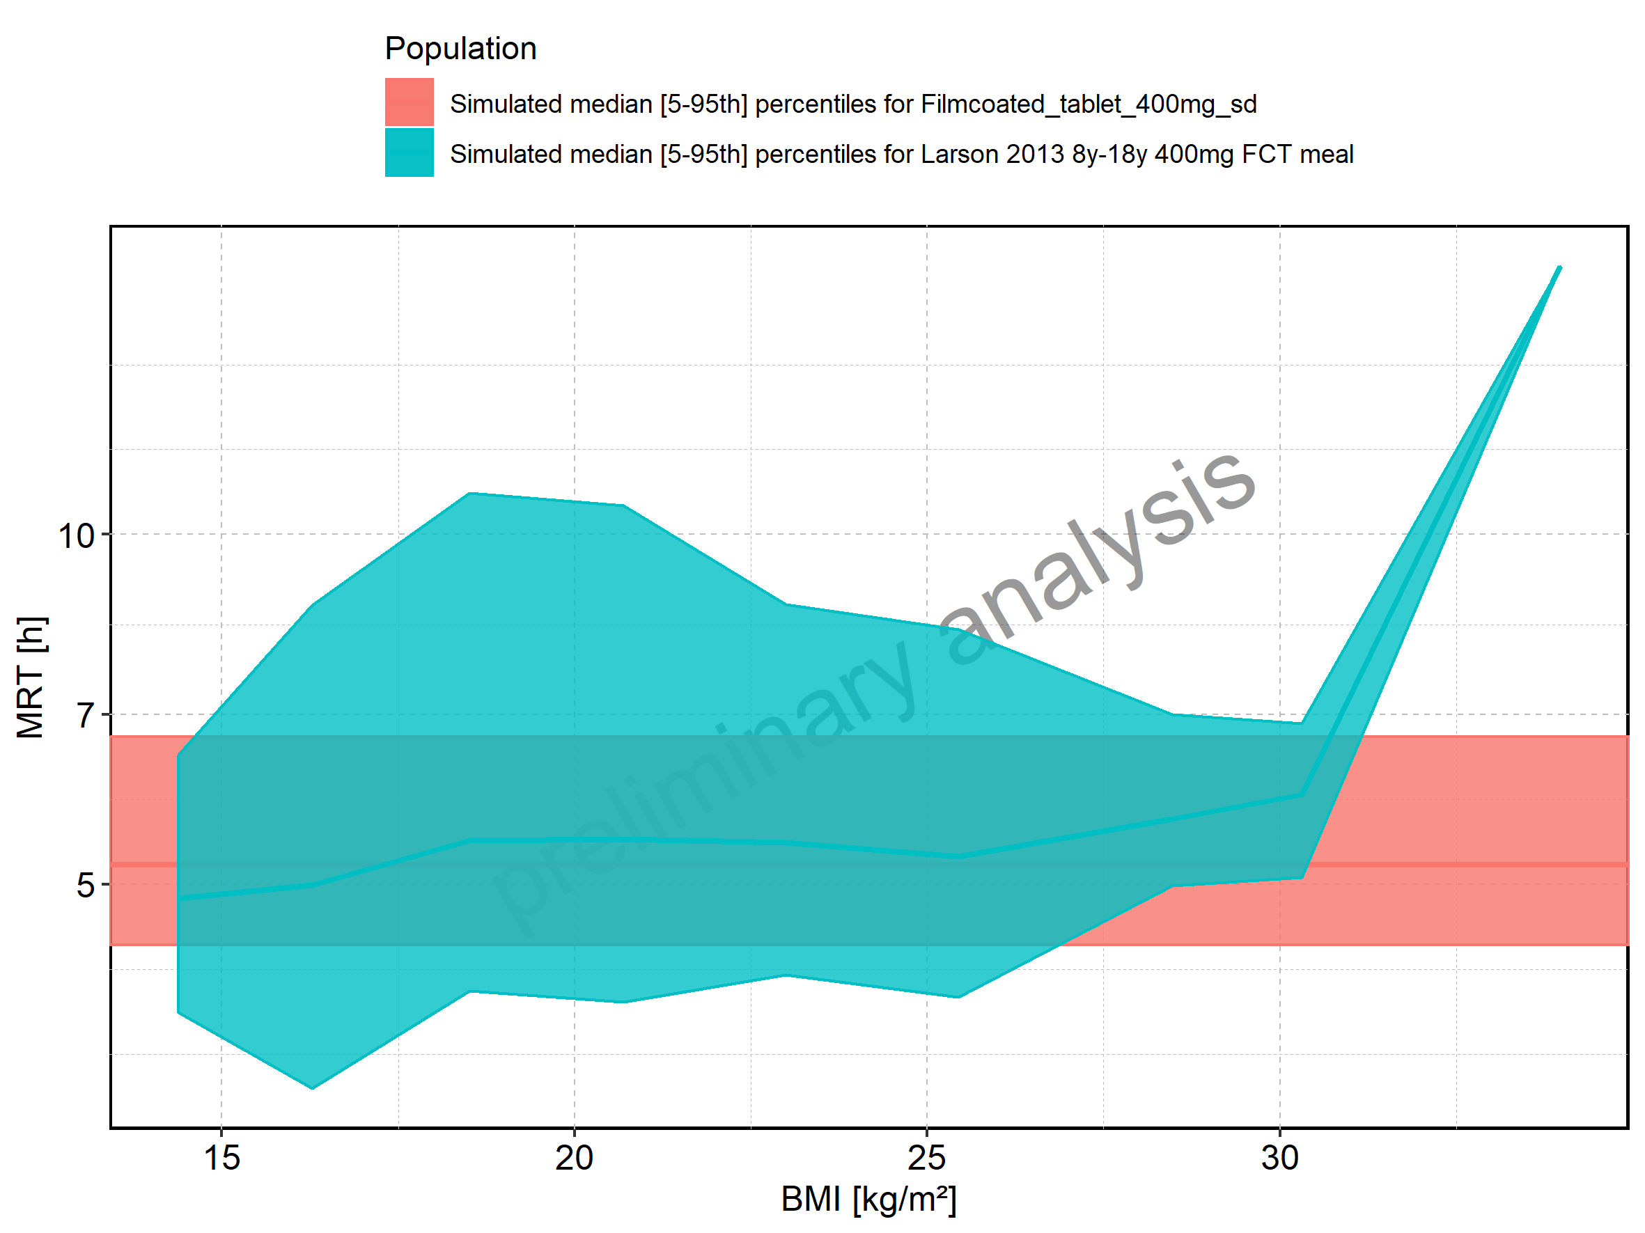

Figure 241: BMI-dependence of MRT for Larson 2013 8y-18y 400mg FCT meal. Profiles are plotted in a linear scale.

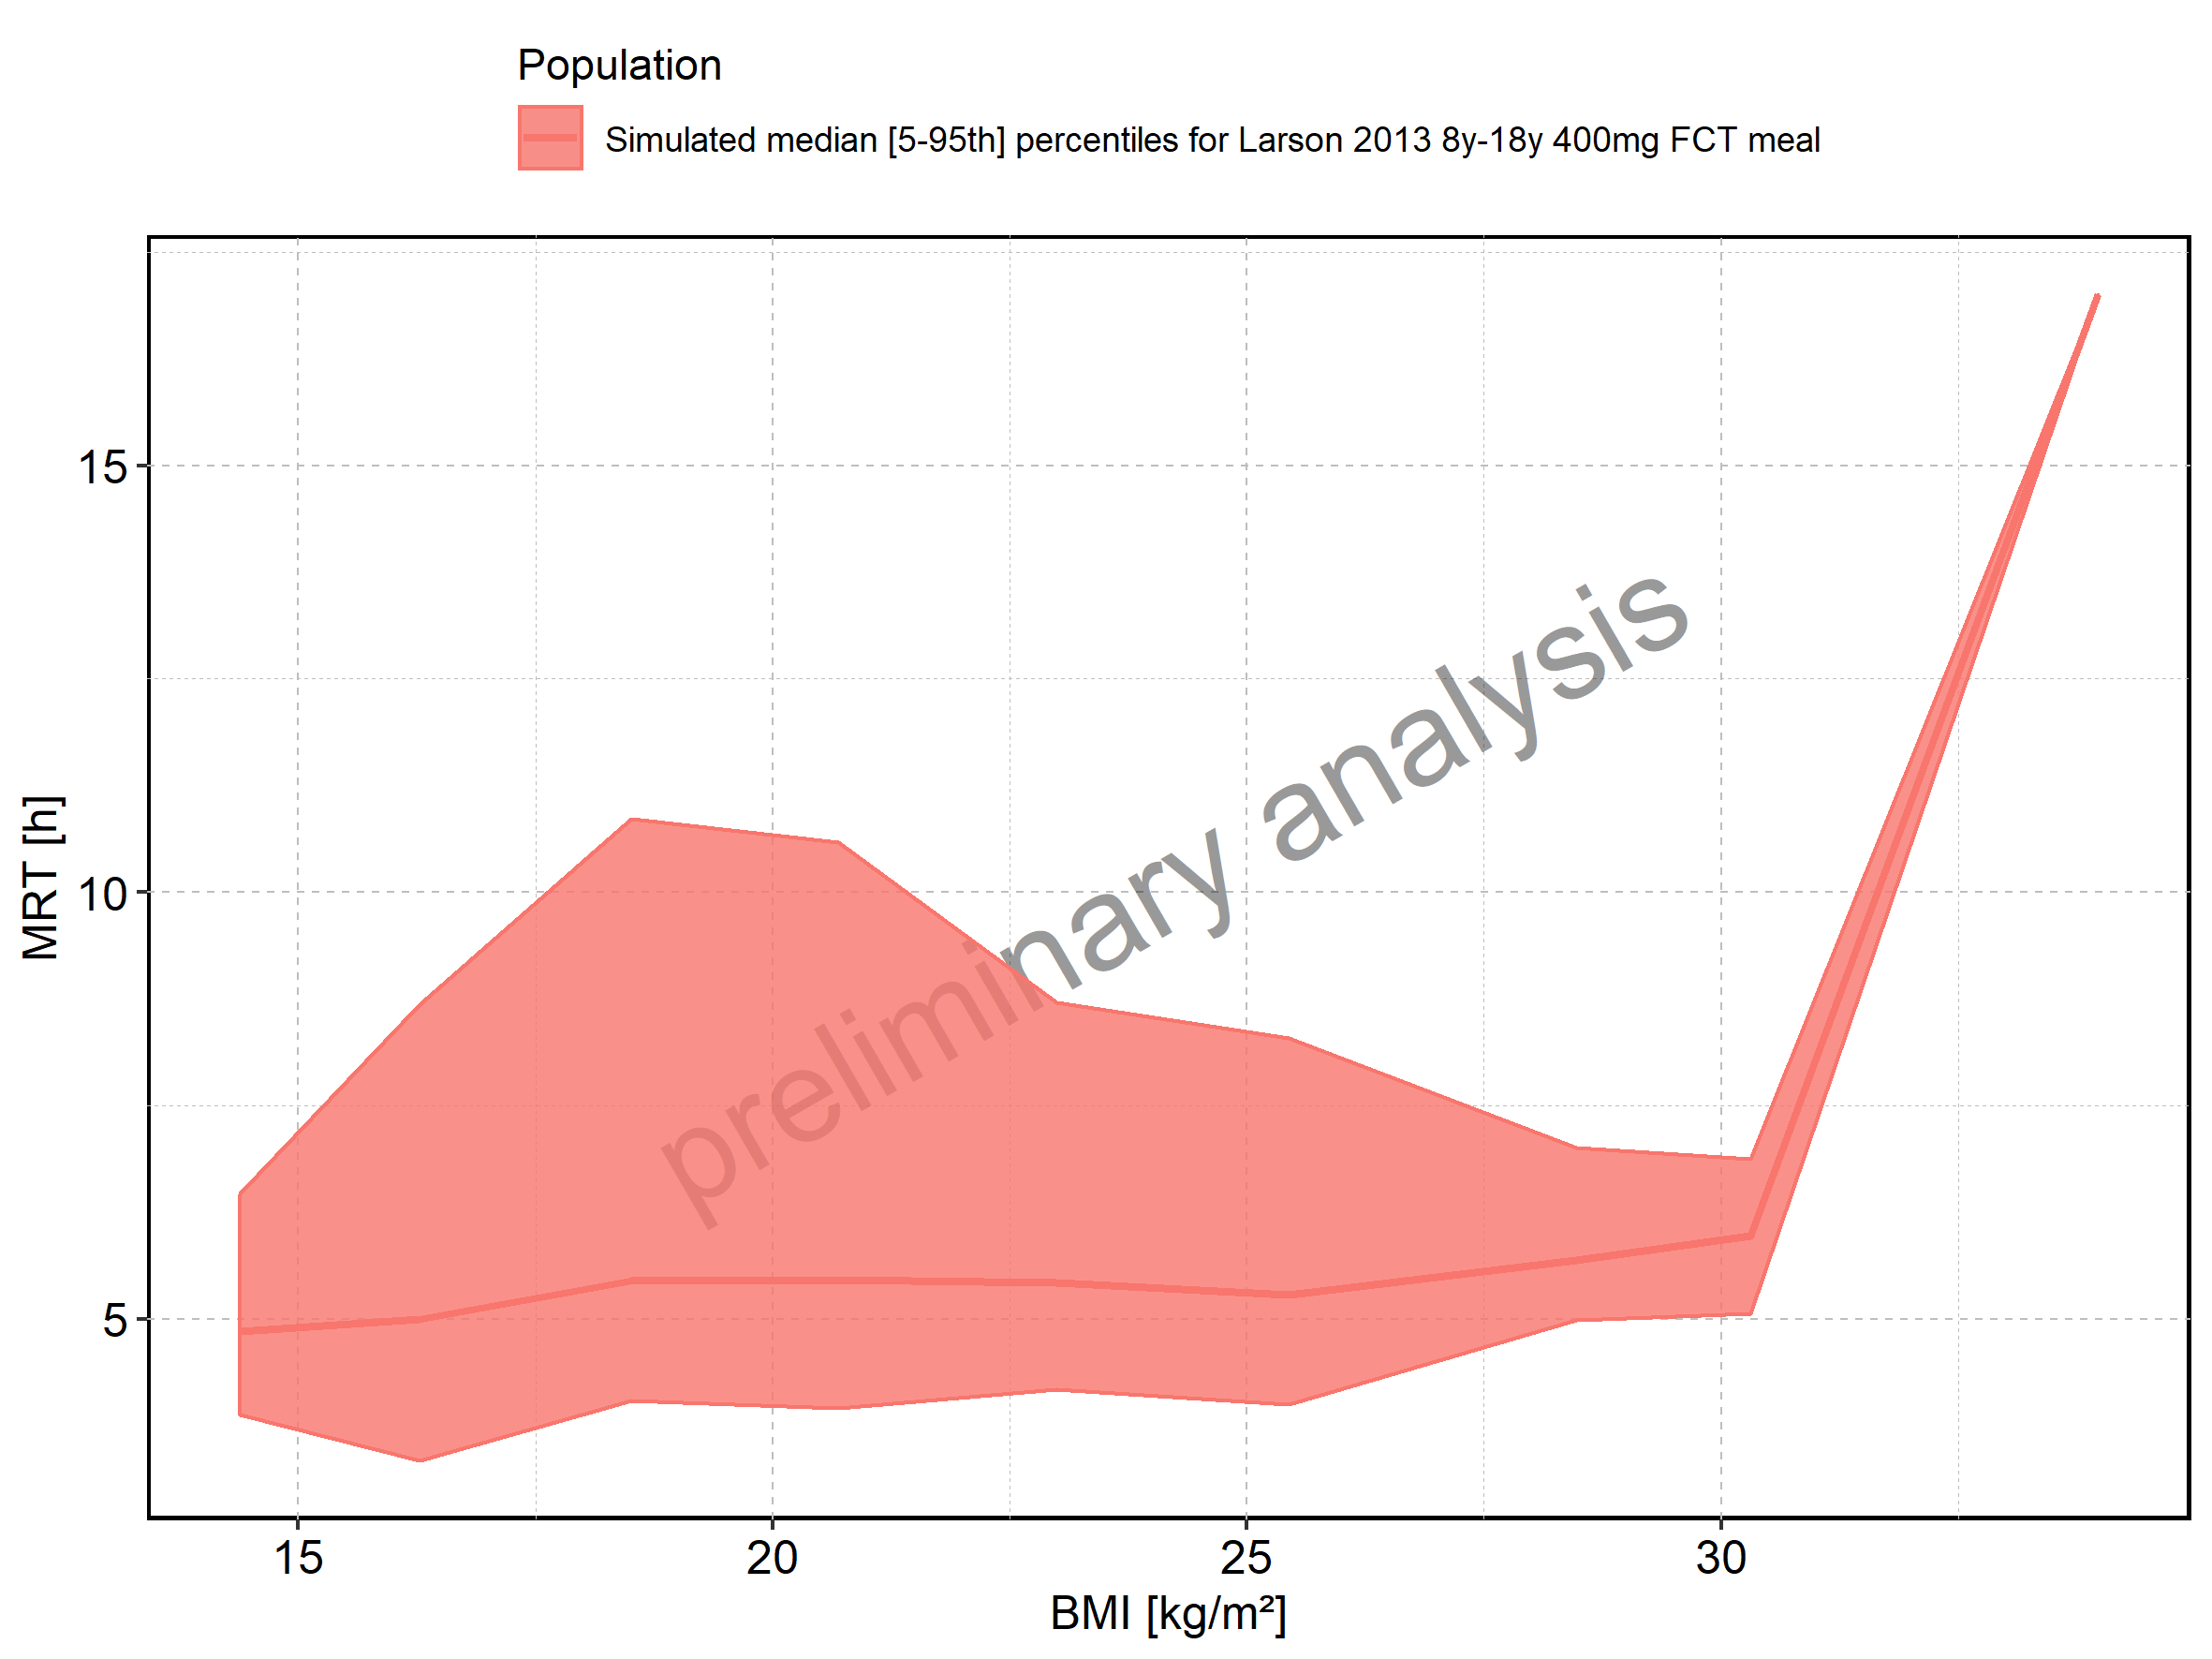

Figure 242: BMI-dependence of MRT for Larson 2013 8y-18y 400mg FCT meal. Profiles are plotted in a logarithmic scale.

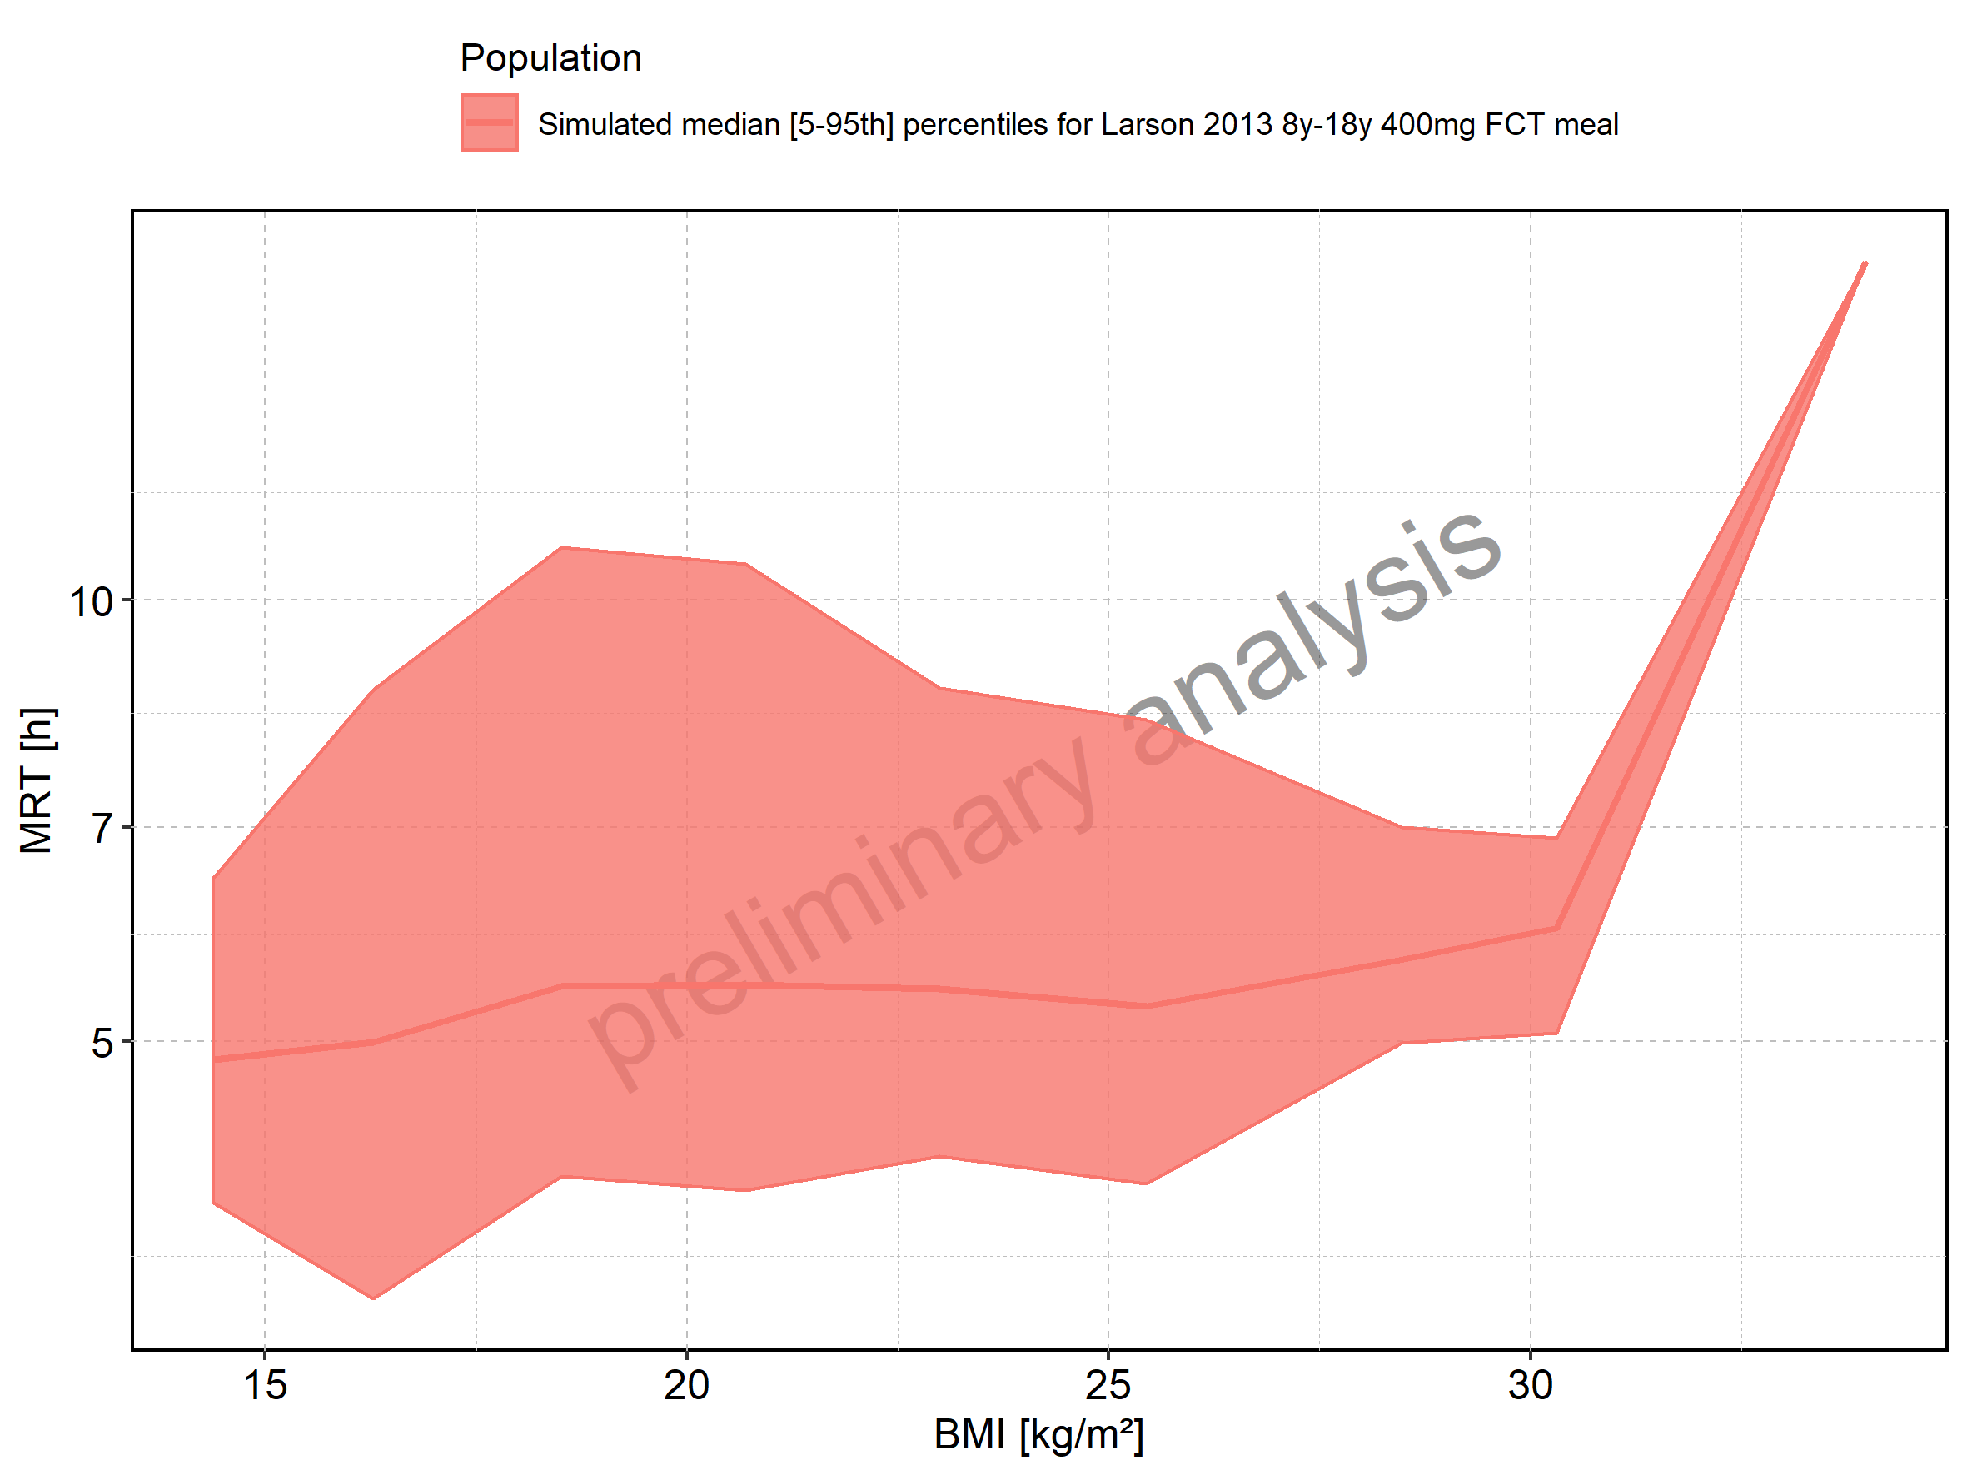

Figure 243: BMI-dependence of MRT for Filmcoated_tablet_400mg_sd. Profiles are plotted in a linear scale.

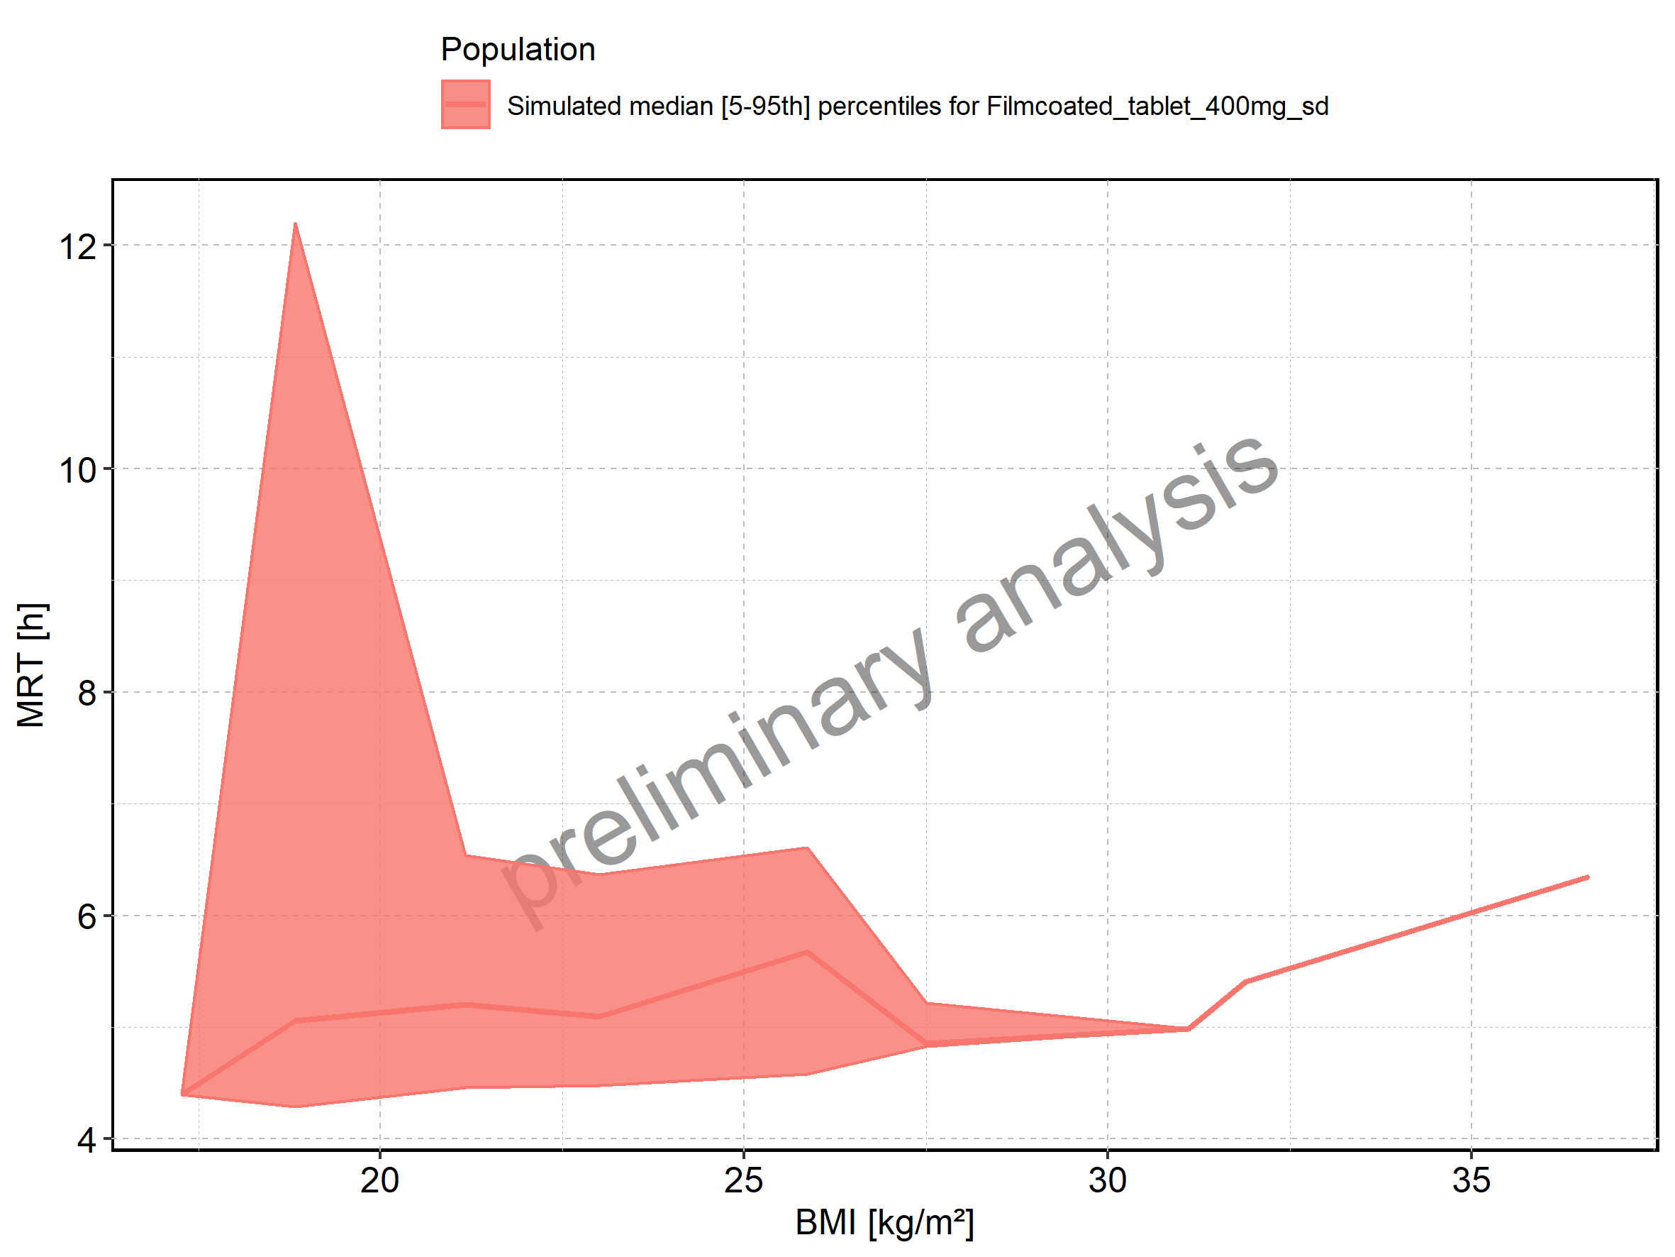

Figure 244: BMI-dependence of MRT for Filmcoated_tablet_400mg_sd. Profiles are plotted in a logarithmic scale.

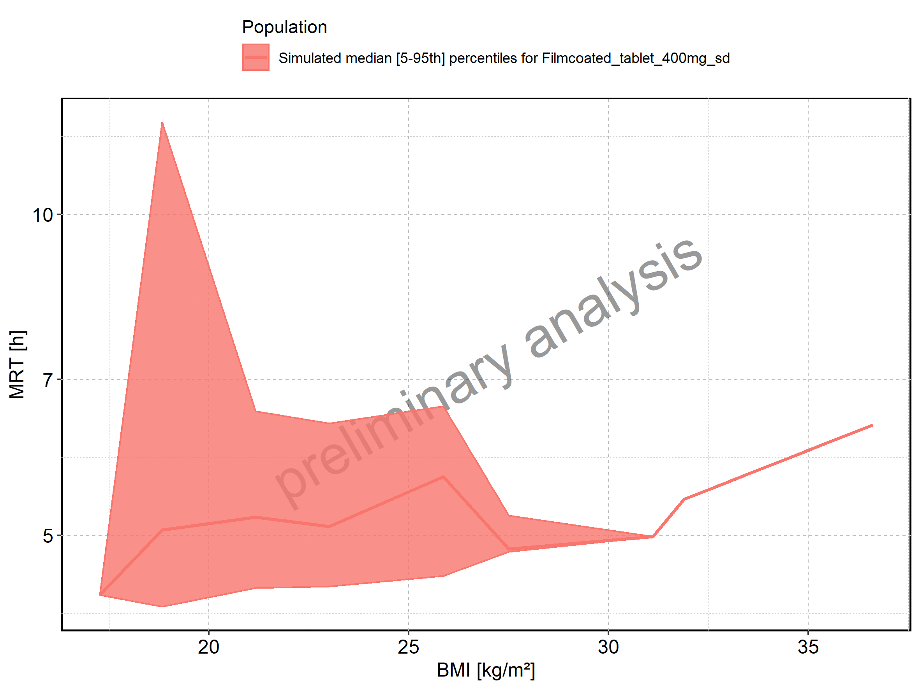

Figure 245: Thalf of Raltegravir shown as box-whisker plot, which indicates the 5th, 25th, 50th, 75th, and 95th percentiles in linear scale.

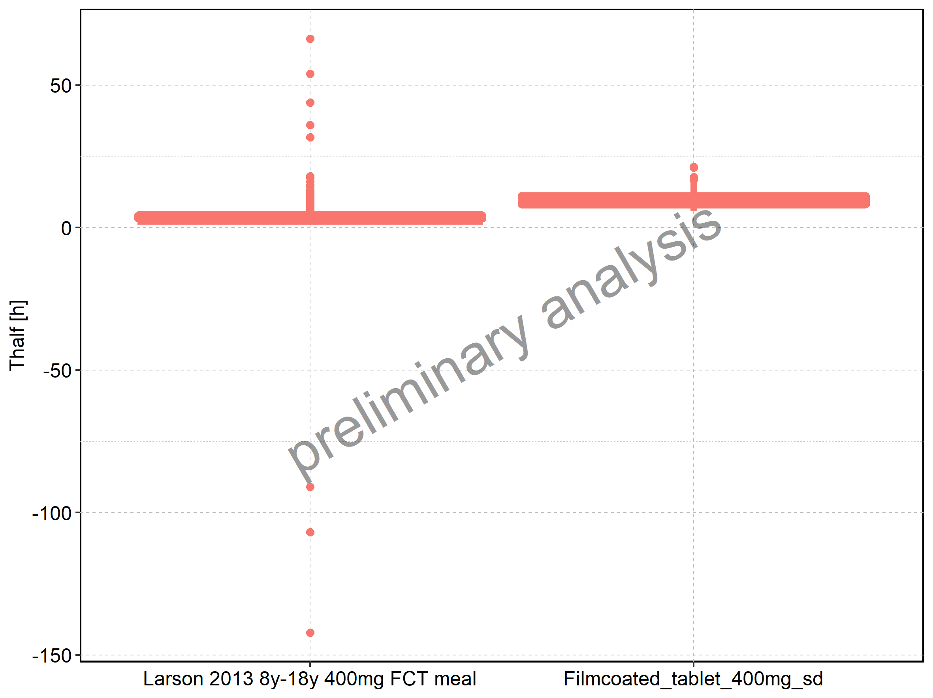

|  |  |  |  |  |  |  |  |  |  |  |
| --- | --- | --- | --- | --- | --- | --- | --- | --- | --- | --- |
| Population | N | 5th percentile | 25th percentile | 50th percentile | 75th percentile | 95th percentile | mean | standard deviation | geo mean | geo standard deviation |
| Larson 2013 8y-18y 400mg FCT meal | 500 | 2.549721 | 3.014632 | 3.492033 | 4.299532 | 9.428484 | 3.895486 | 10.49435 | NA | NA |
| Filmcoated_tablet_400mg_sd | 100 | 5.739979 | 8.084065 | 9.195944 | 11.176013 | 16.813811 | 9.987299 | 3.18254 | 9.545373 | 1.348088 |

Figure 246: Thalf of Raltegravir shown as box-whisker plot, which indicates the 5th, 25th, 50th, 75th, and 95th percentiles in logarithmic scale.

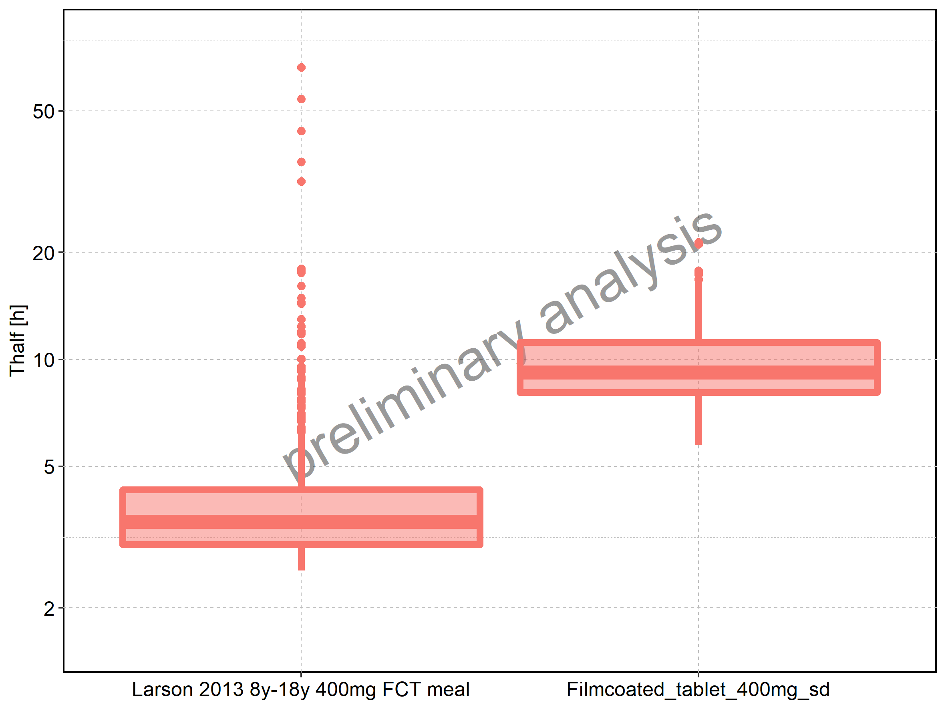

Figure 247: Age-dependence of Thalf for Larson 2013 8y-18y 400mg FCT meal in comparison to Filmcoated_tablet_400mg_sd. Profiles are plotted in a linear scale.

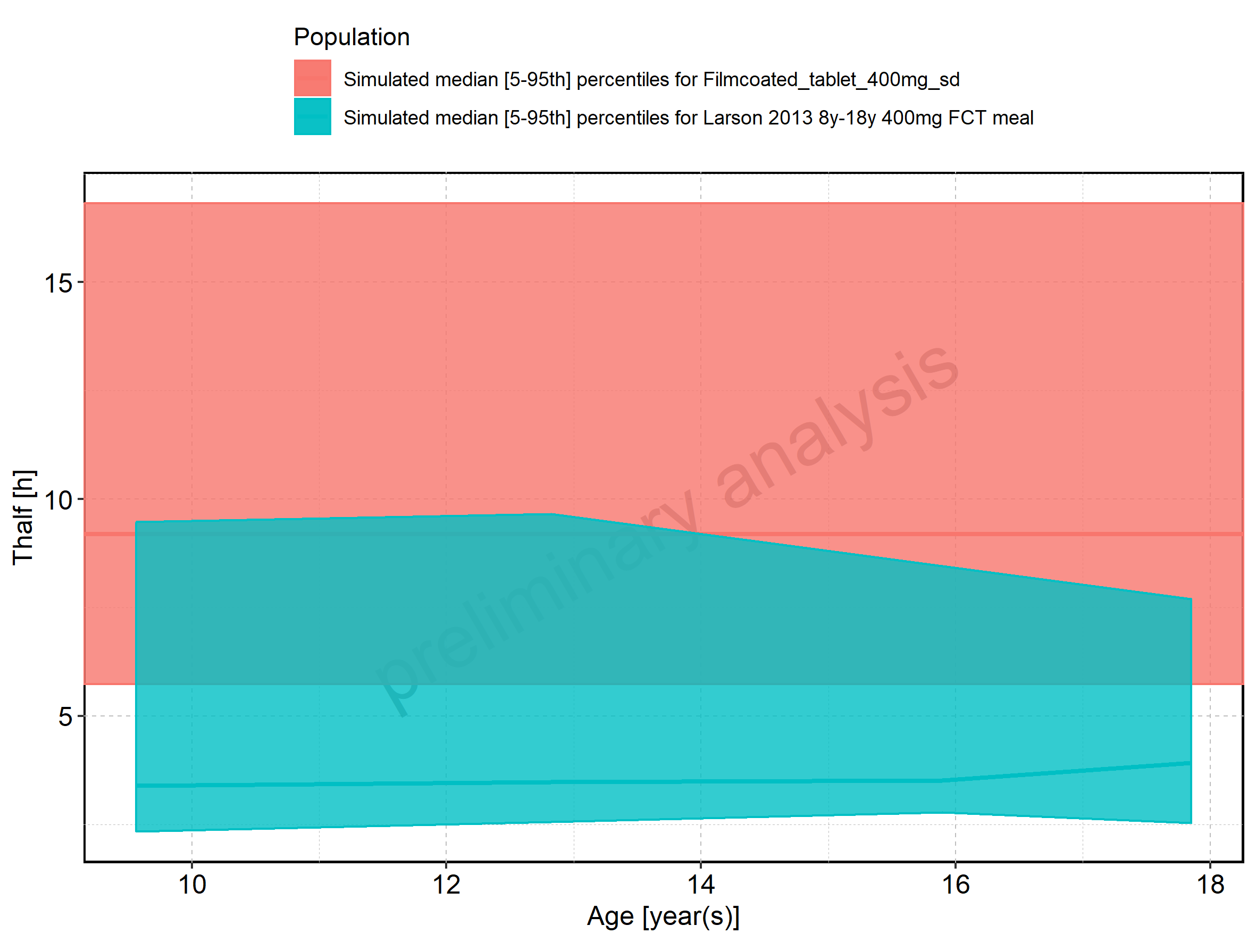

Figure 248: Age-dependence of Thalf for Larson 2013 8y-18y 400mg FCT meal in comparison to Filmcoated_tablet_400mg_sd. Profiles are plotted in a logarithmic scale.

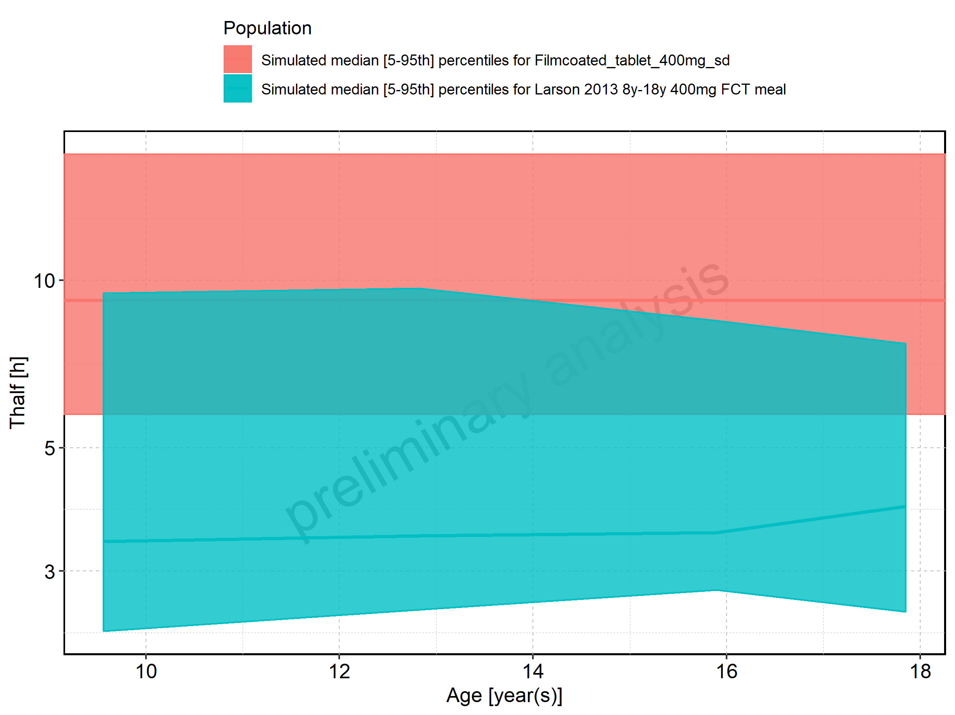

Figure 249: Age-dependence of Thalf for Larson 2013 8y-18y 400mg FCT meal. Profiles are plotted in a linear scale.

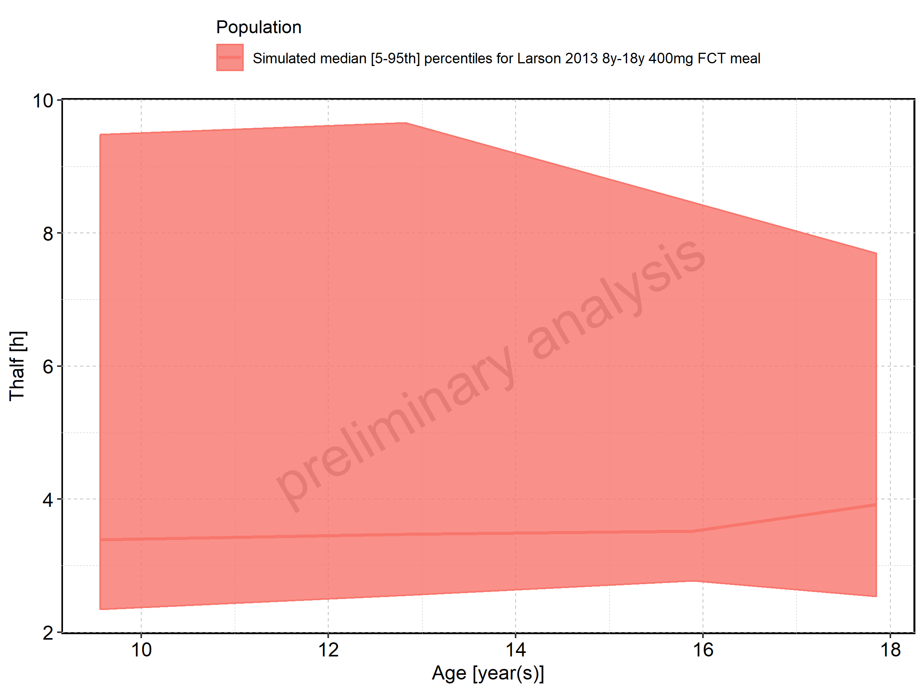

Figure 250: Age-dependence of Thalf for Larson 2013 8y-18y 400mg FCT meal. Profiles are plotted in a logarithmic scale.

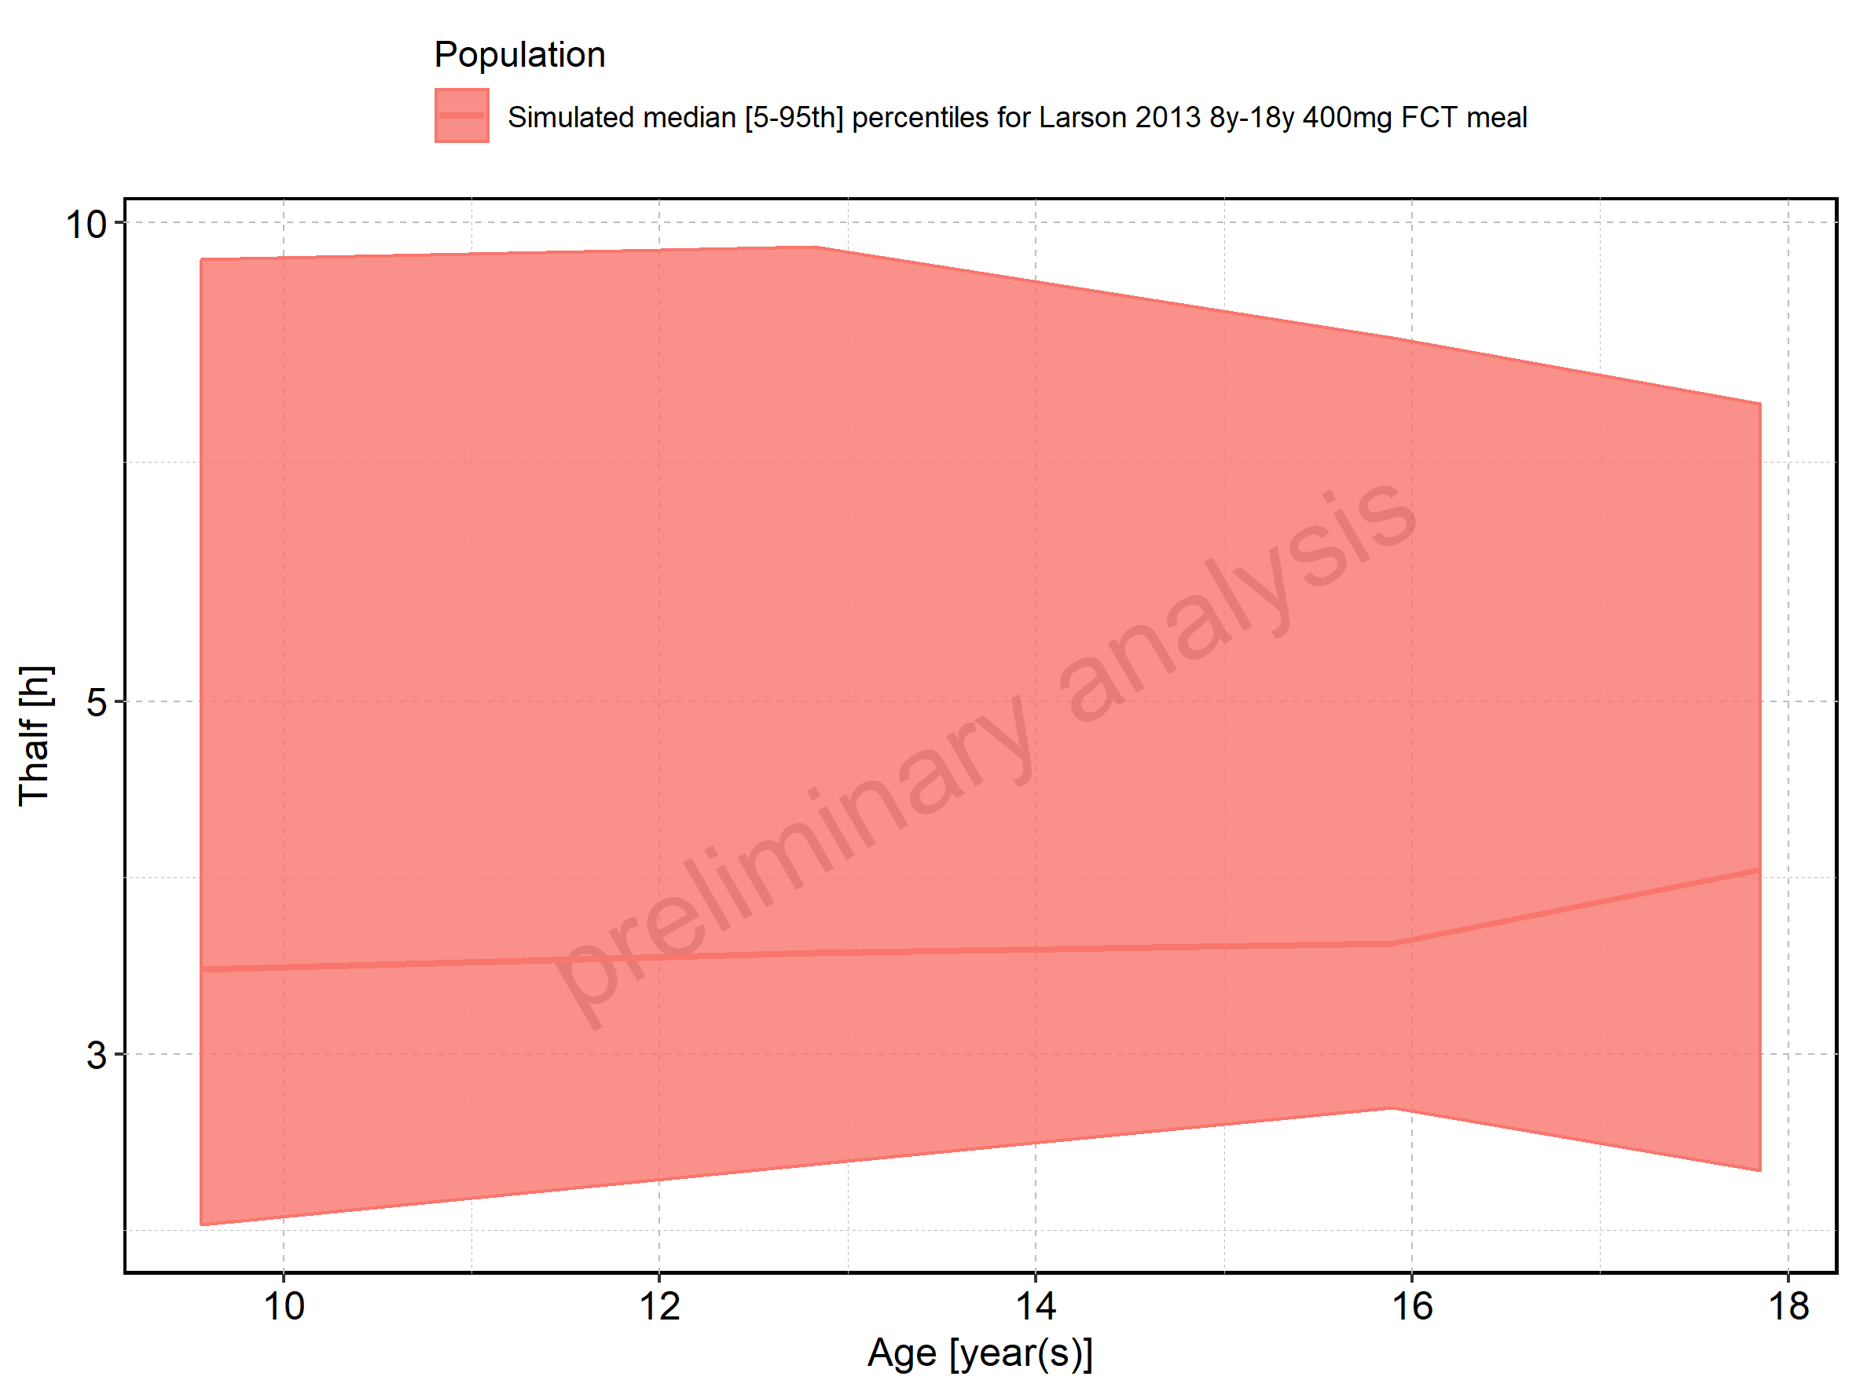

Figure 251: Age-dependence of Thalf for Filmcoated_tablet_400mg_sd. Profiles are plotted in a linear scale.

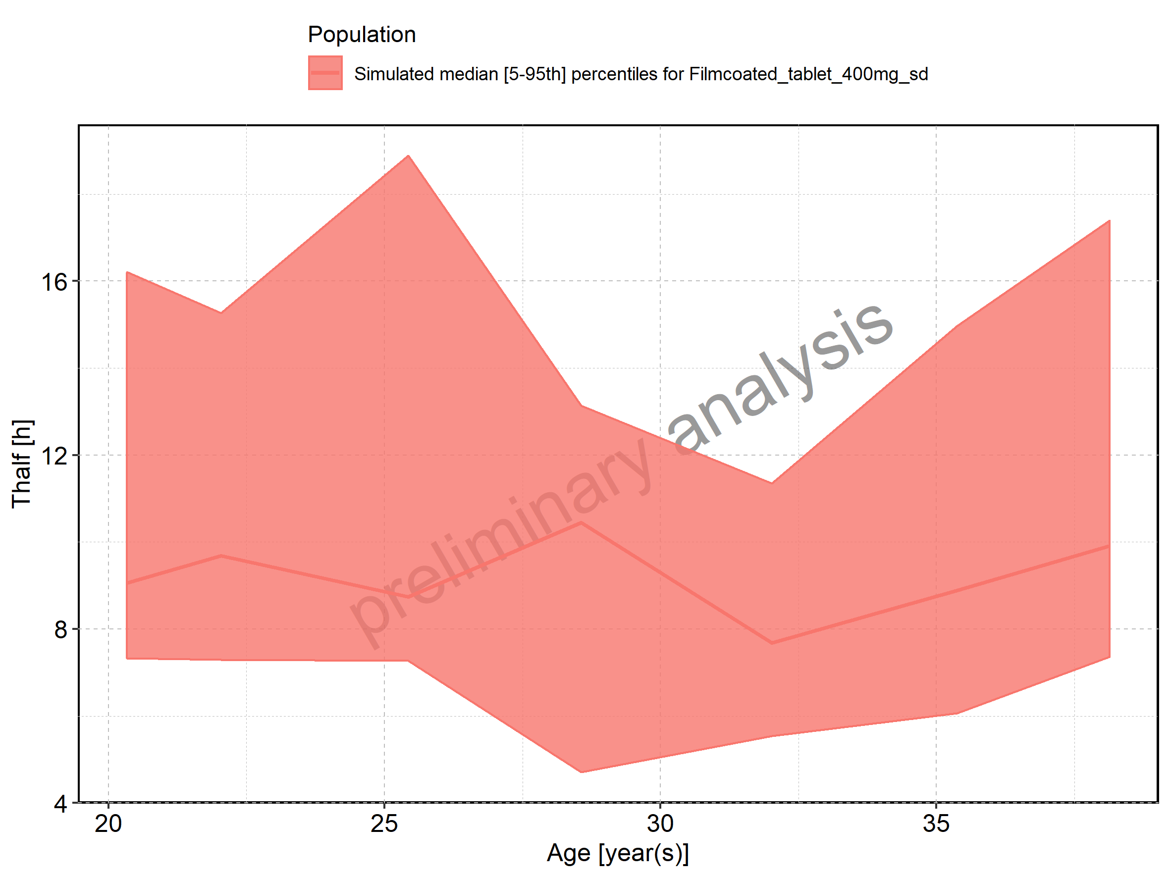

Figure 252: Age-dependence of Thalf for Filmcoated_tablet_400mg_sd. Profiles are plotted in a logarithmic scale.

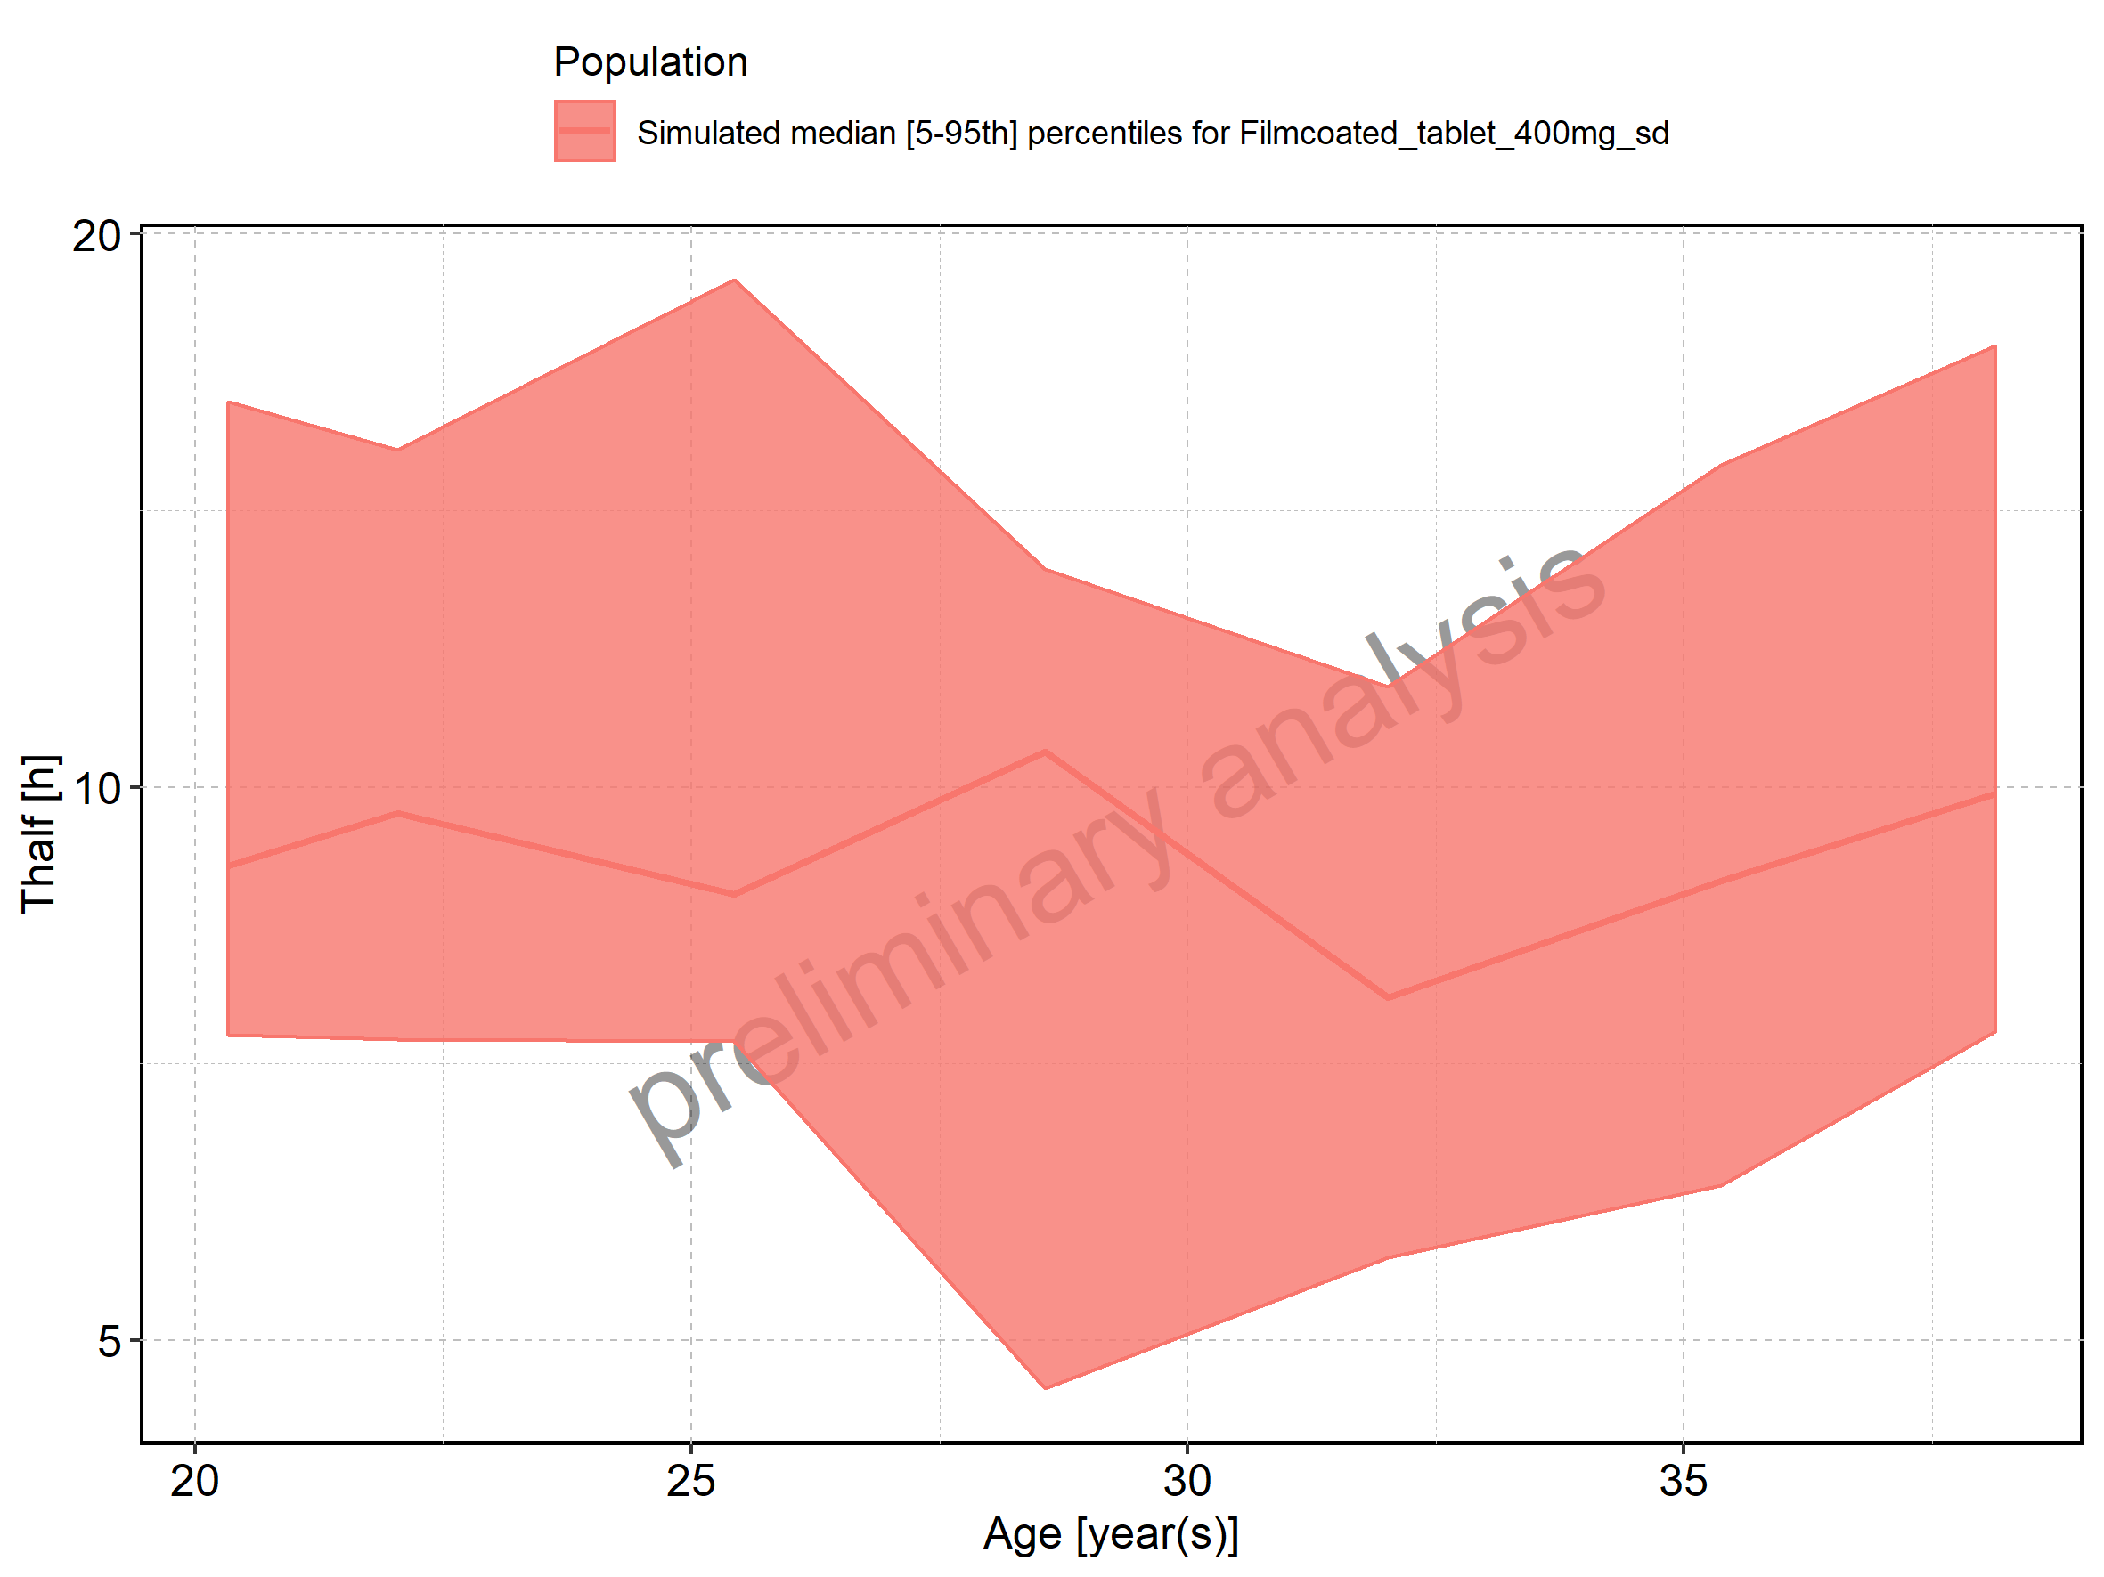

Figure 253: Height-dependence of Thalf for Larson 2013 8y-18y 400mg FCT meal in comparison to Filmcoated_tablet_400mg_sd. Profiles are plotted in a linear scale.

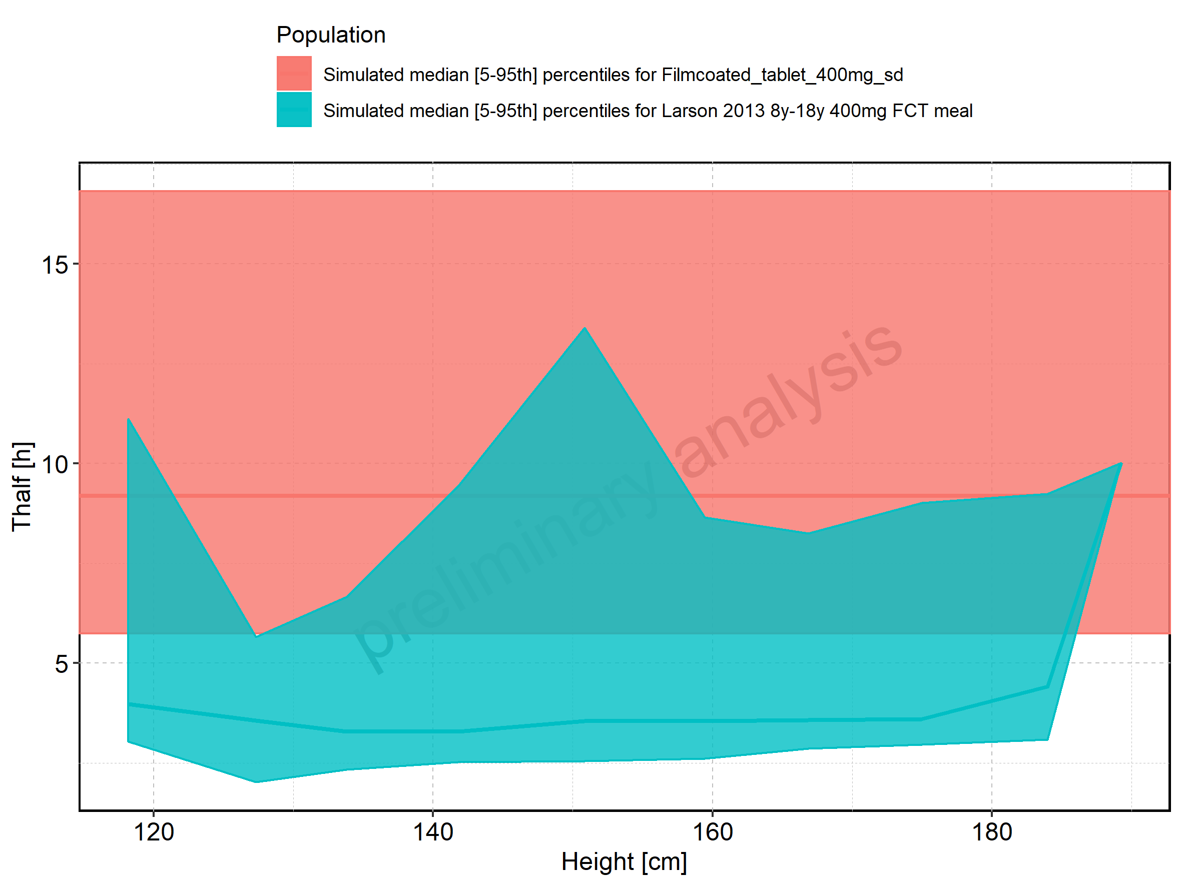

Figure 254: Height-dependence of Thalf for Larson 2013 8y-18y 400mg FCT meal in comparison to Filmcoated_tablet_400mg_sd. Profiles are plotted in a logarithmic scale.

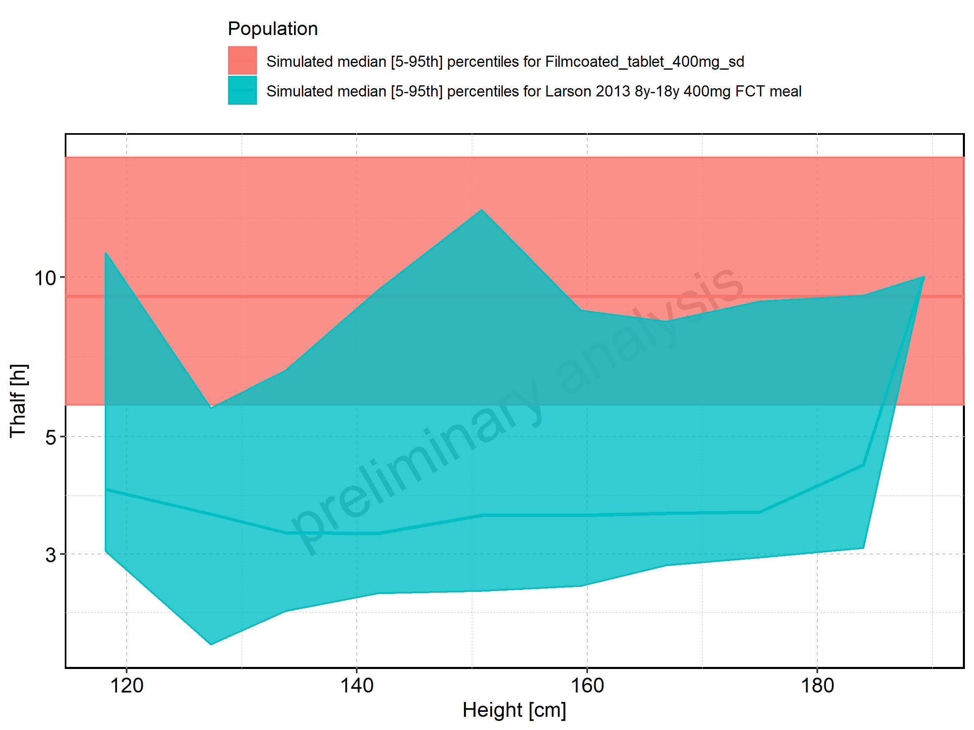

Figure 255: Height-dependence of Thalf for Larson 2013 8y-18y 400mg FCT meal. Profiles are plotted in a linear scale.

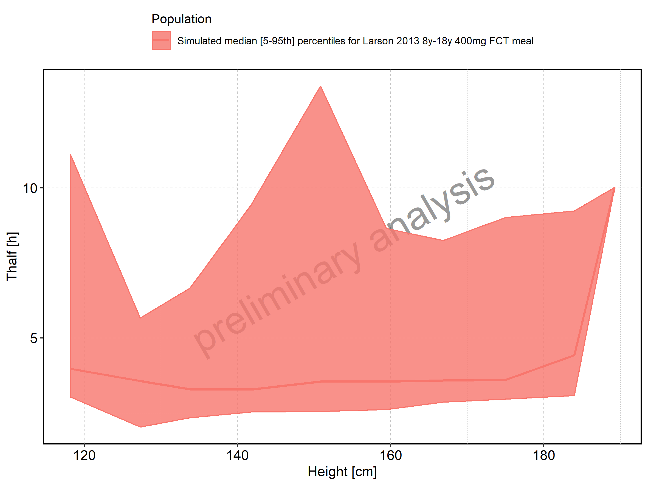

Figure 256: Height-dependence of Thalf for Larson 2013 8y-18y 400mg FCT meal. Profiles are plotted in a logarithmic scale.

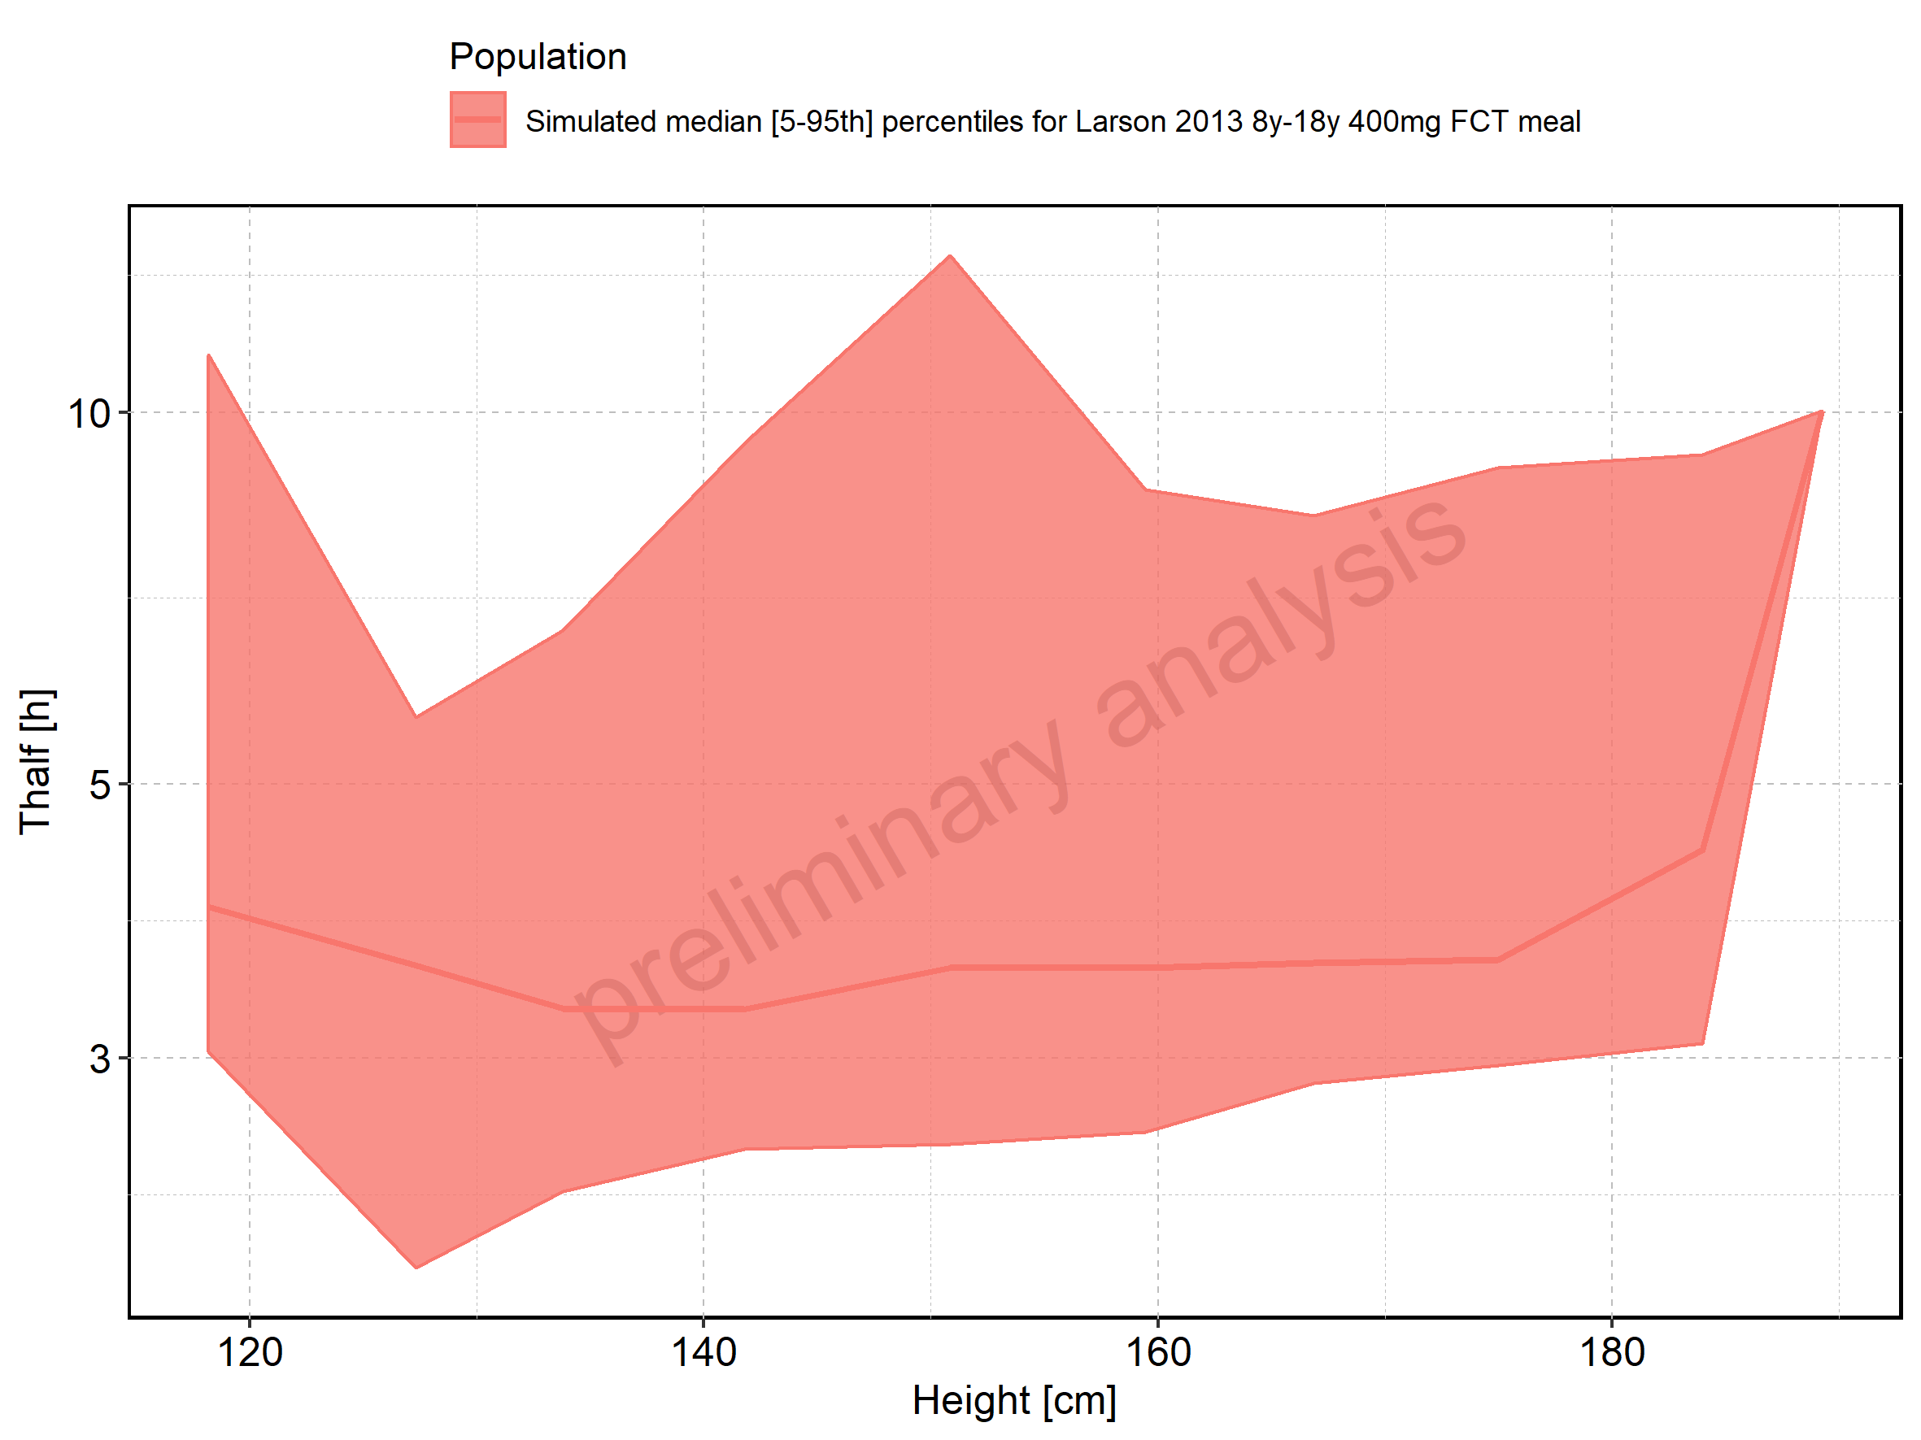

Figure 257: Height-dependence of Thalf for Filmcoated_tablet_400mg_sd. Profiles are plotted in a linear scale.

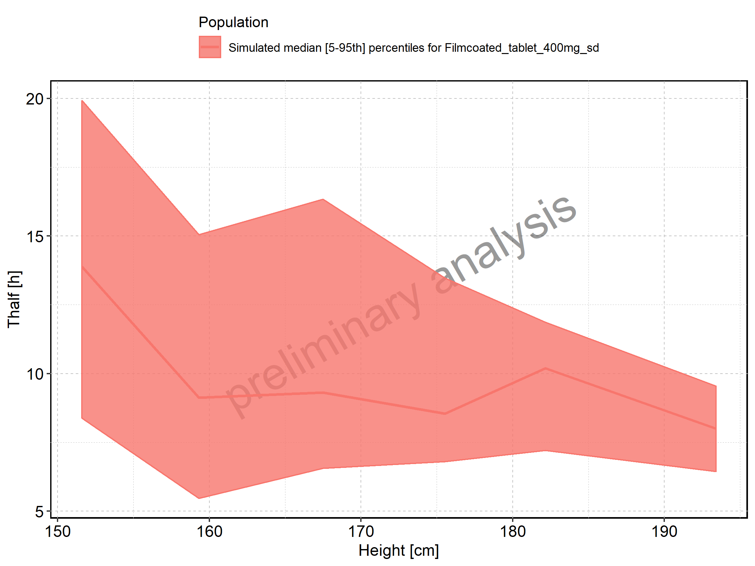

Figure 258: Height-dependence of Thalf for Filmcoated_tablet_400mg_sd. Profiles are plotted in a logarithmic scale.

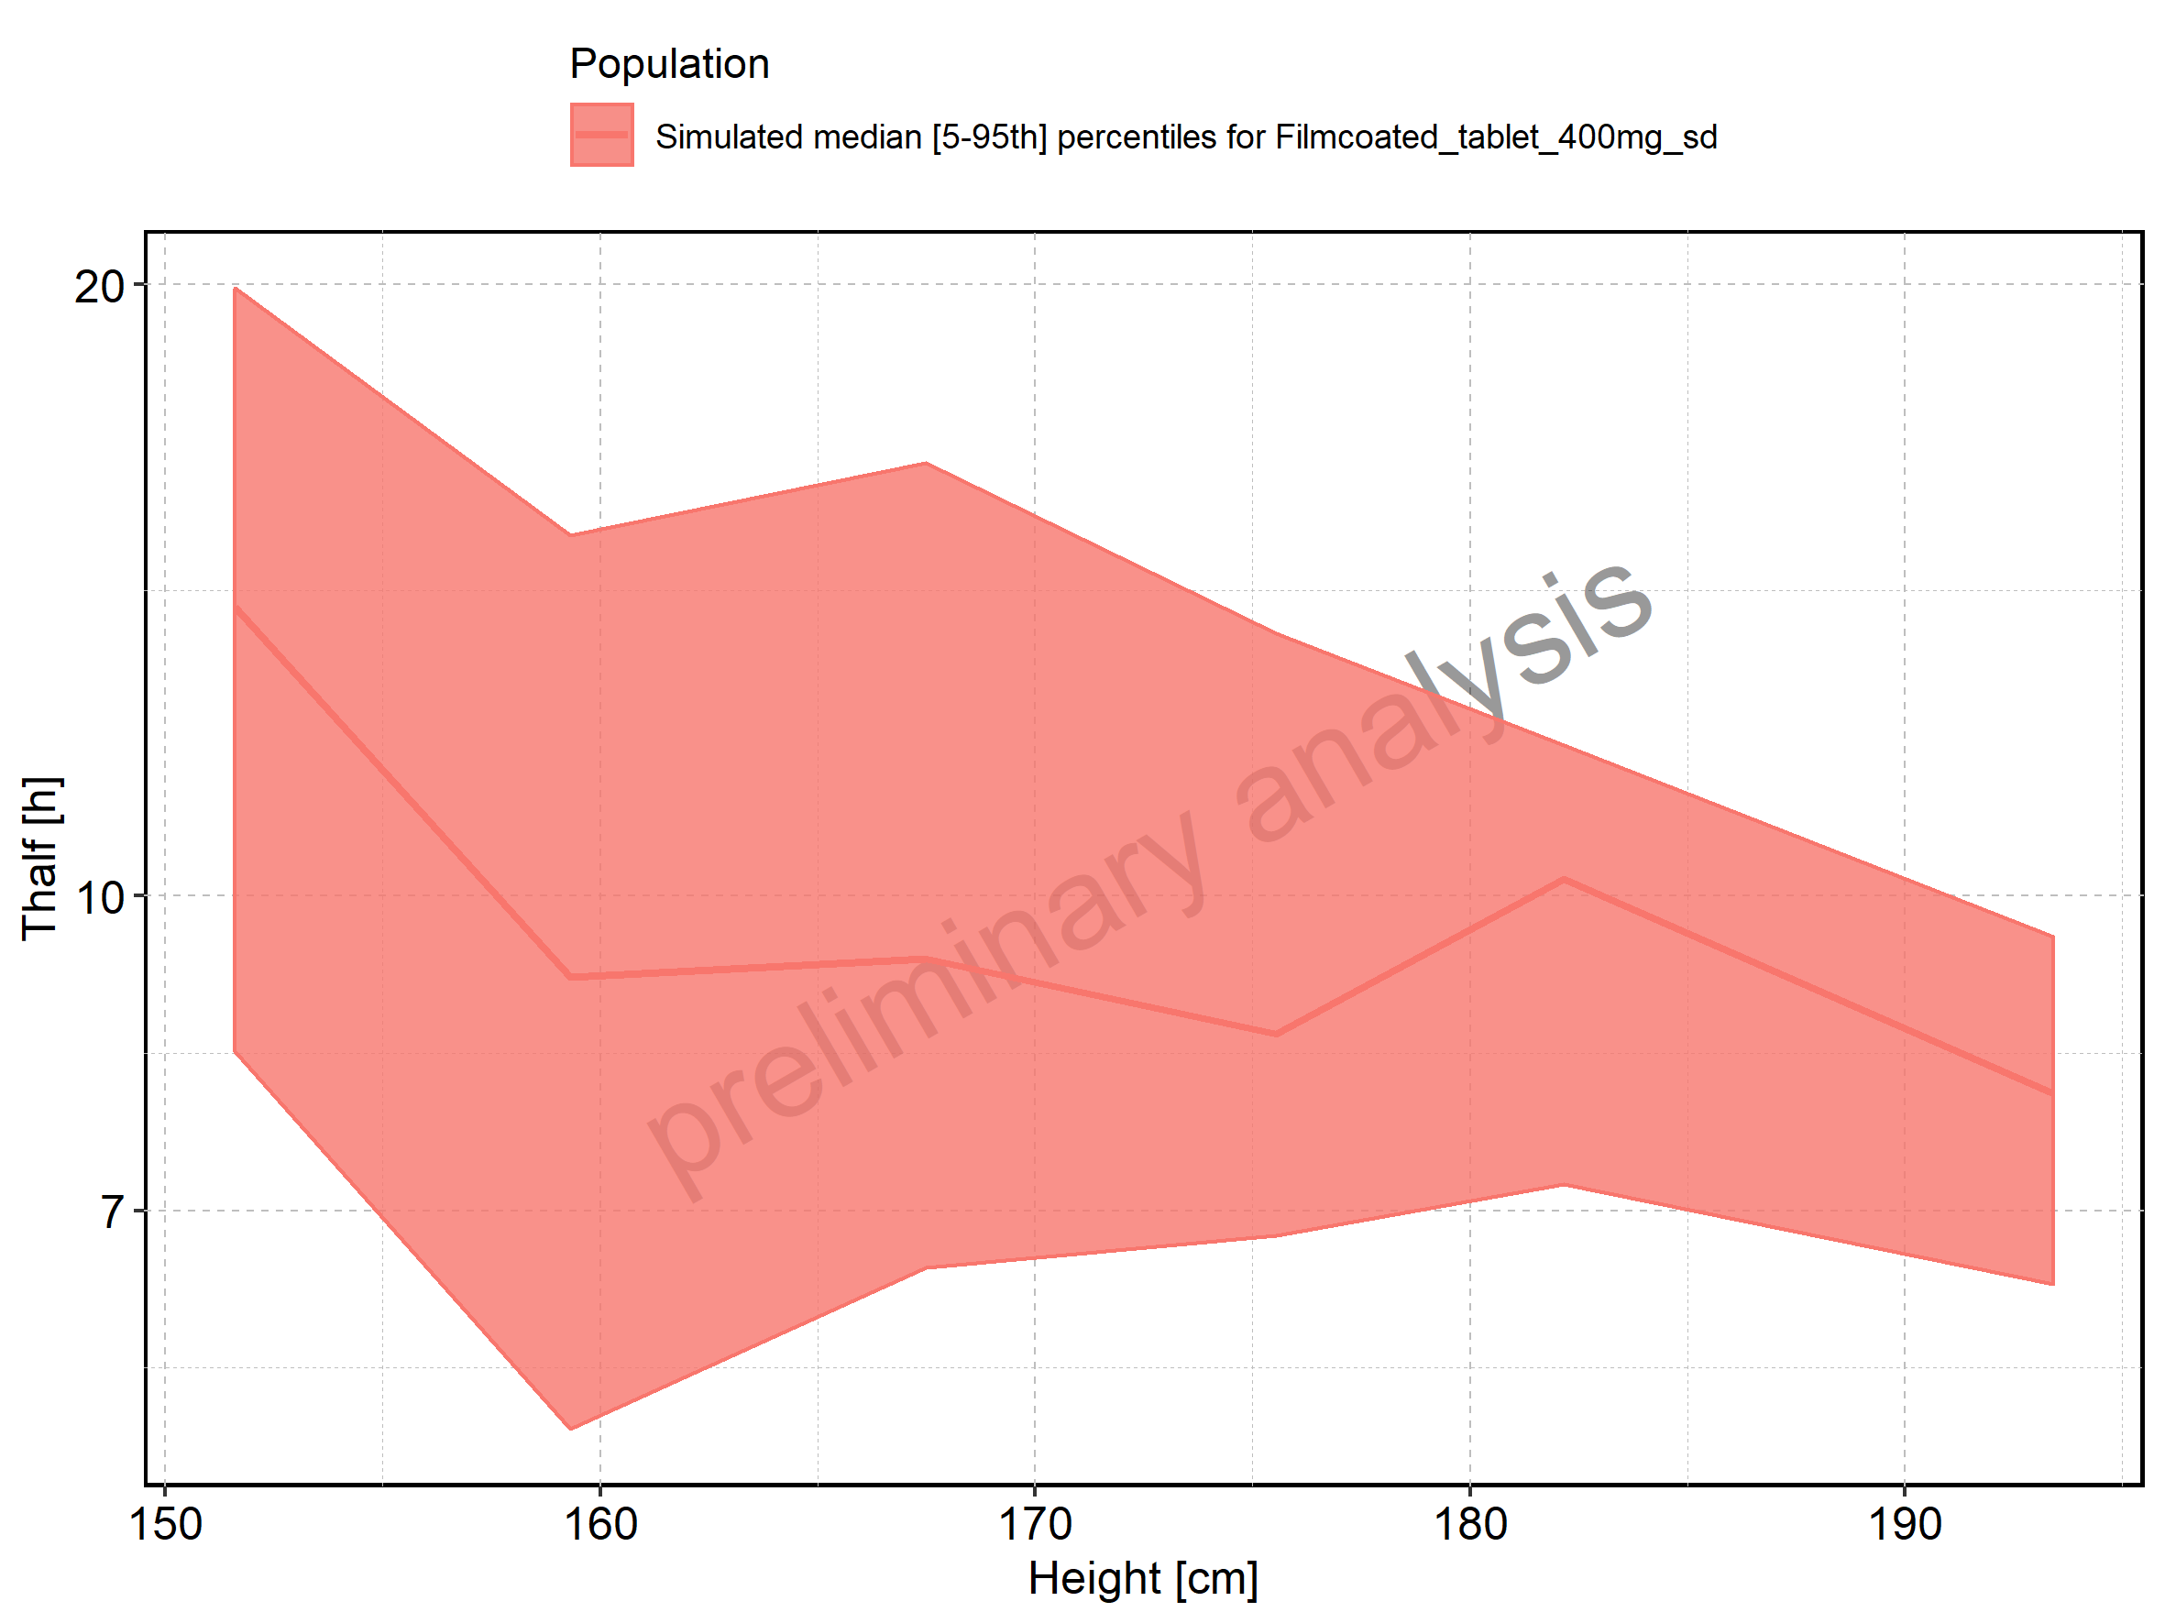

Figure 259: Weight-dependence of Thalf for Larson 2013 8y-18y 400mg FCT meal in comparison to Filmcoated_tablet_400mg_sd. Profiles are plotted in a linear scale.

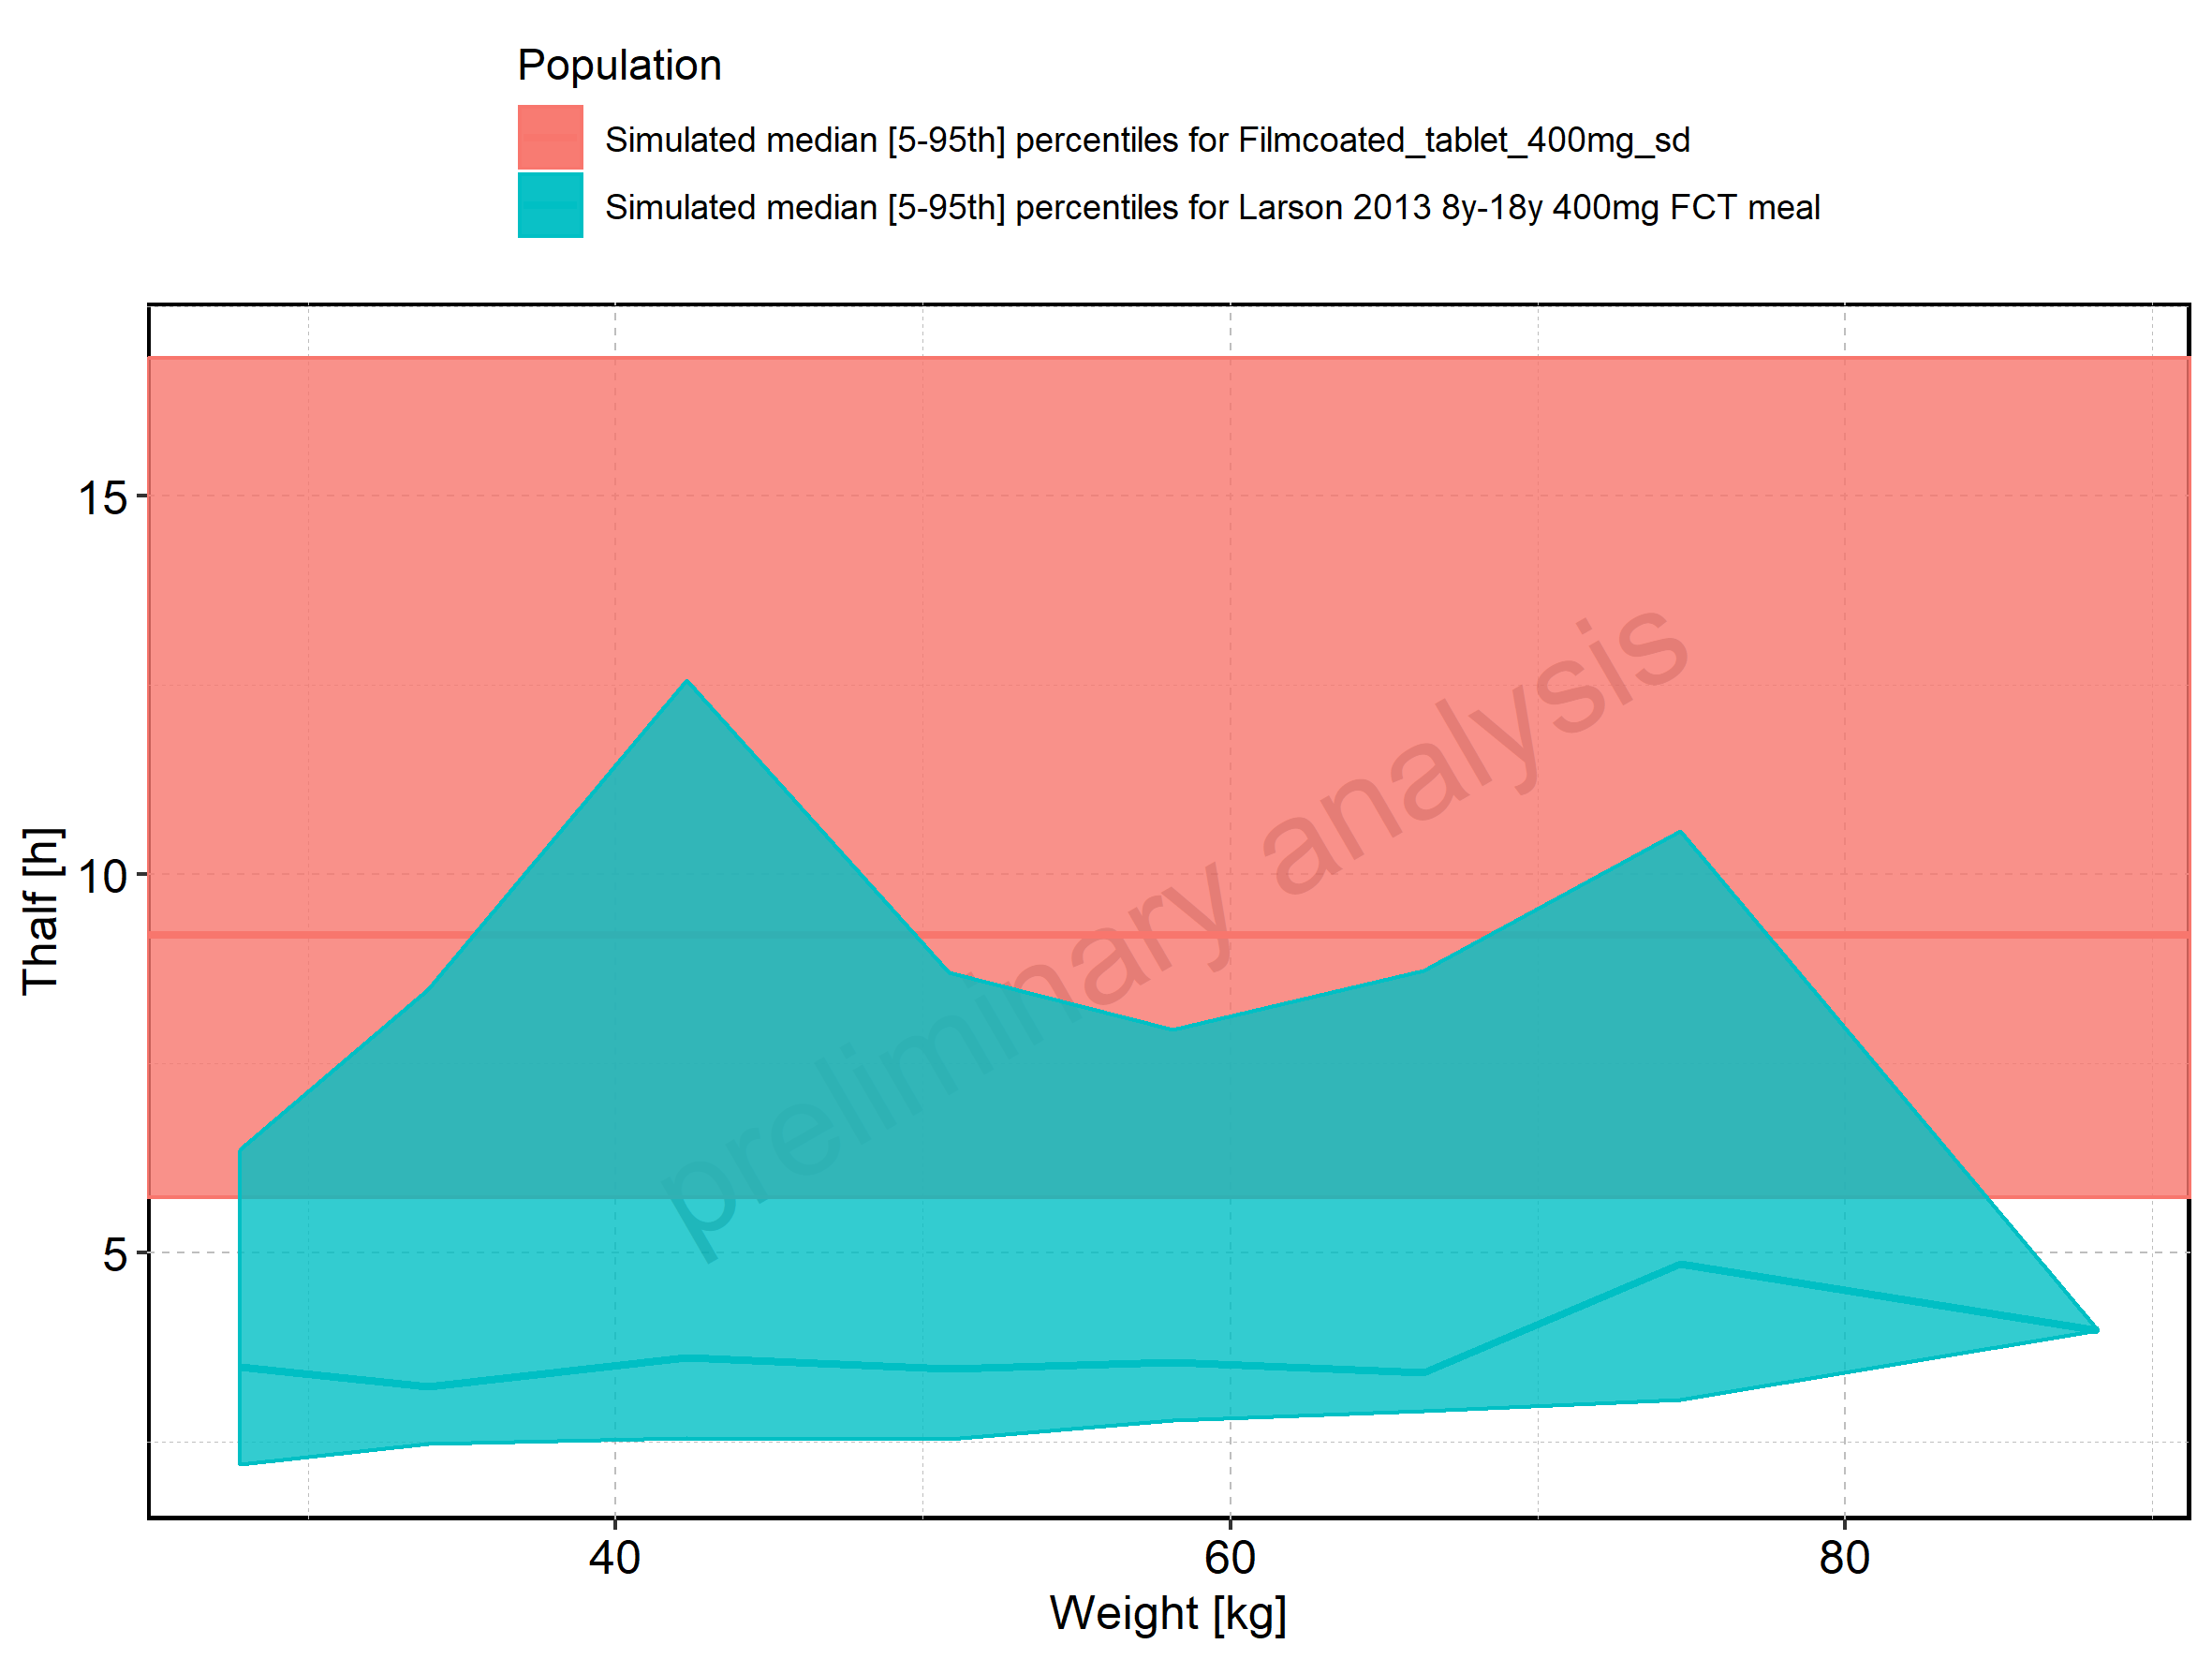

Figure 260: Weight-dependence of Thalf for Larson 2013 8y-18y 400mg FCT meal in comparison to Filmcoated_tablet_400mg_sd. Profiles are plotted in a logarithmic scale.

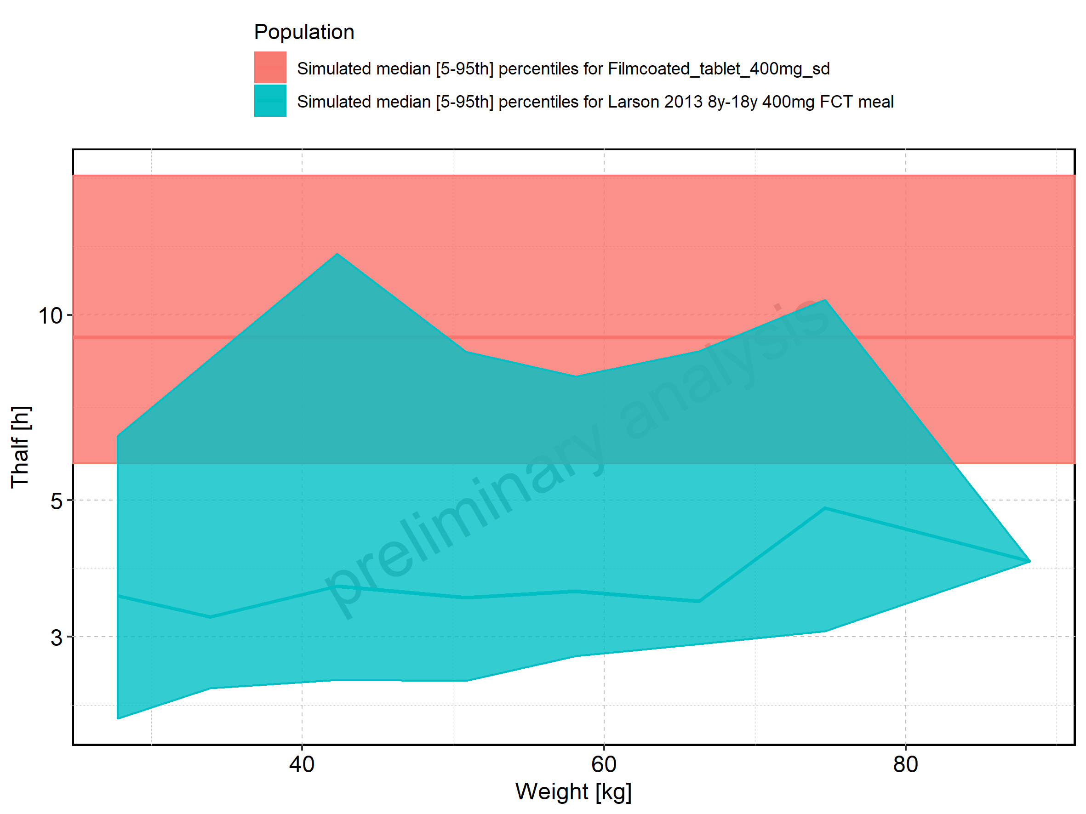

Figure 261: Weight-dependence of Thalf for Larson 2013 8y-18y 400mg FCT meal. Profiles are plotted in a linear scale.

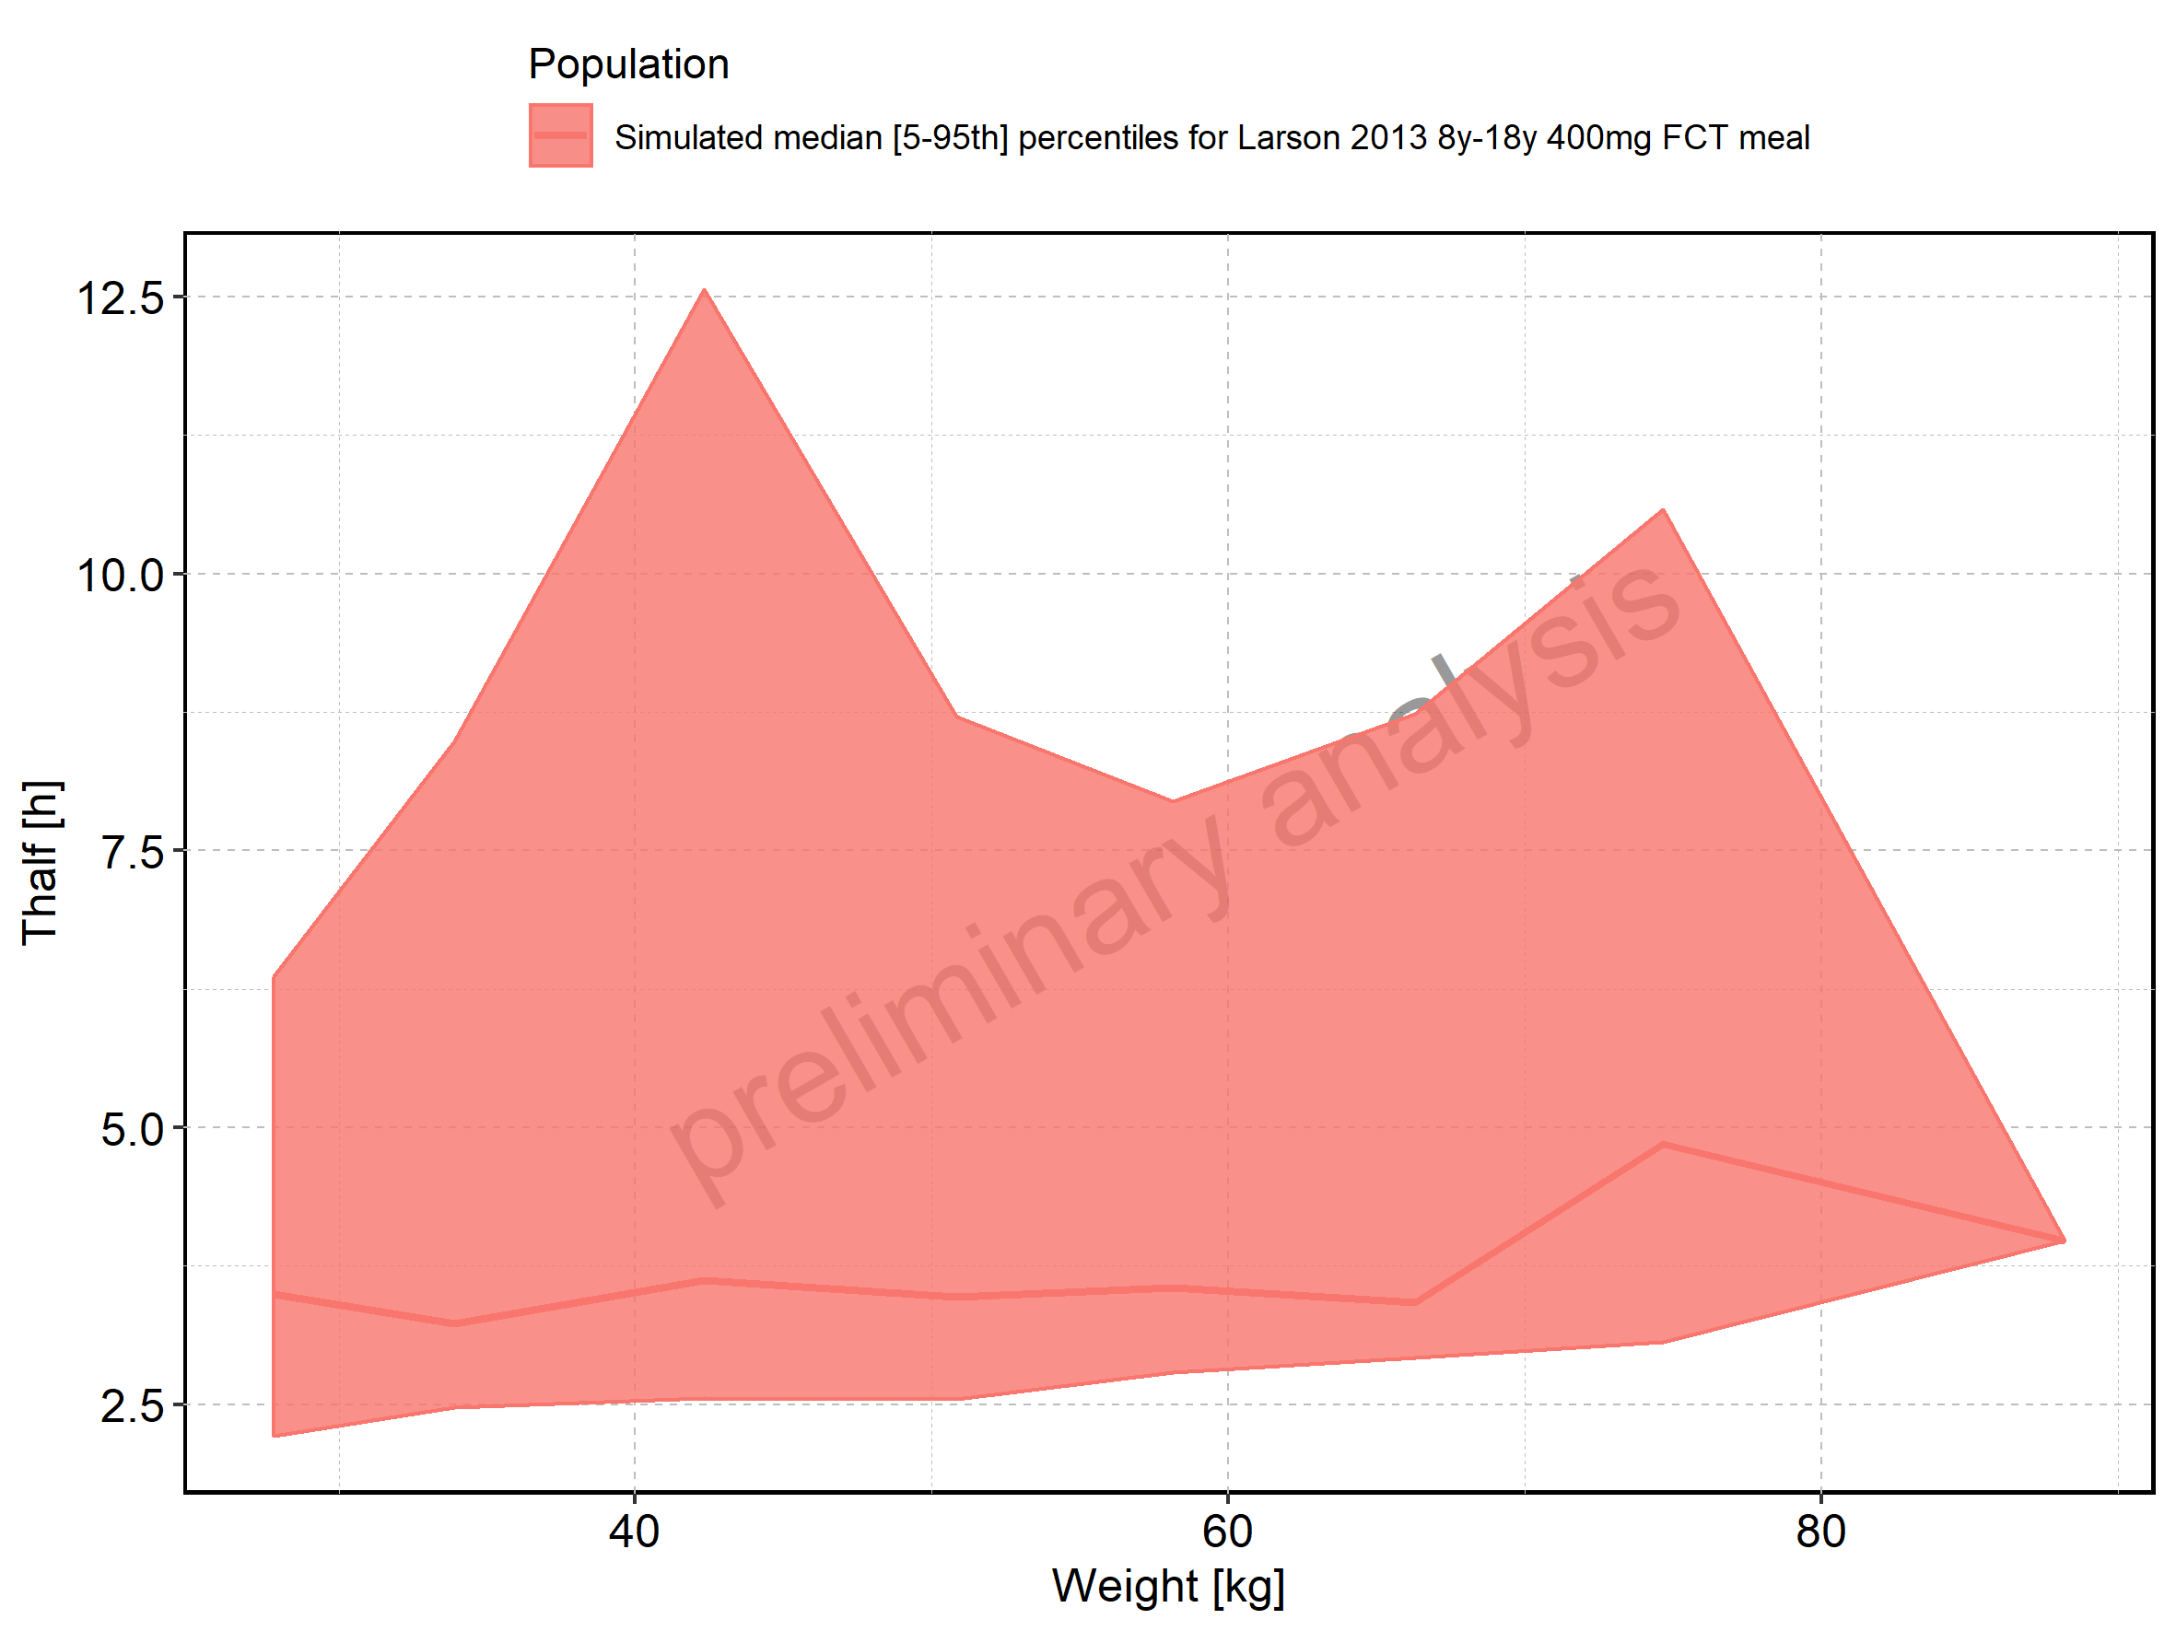

Figure 262: Weight-dependence of Thalf for Larson 2013 8y-18y 400mg FCT meal. Profiles are plotted in a logarithmic scale.

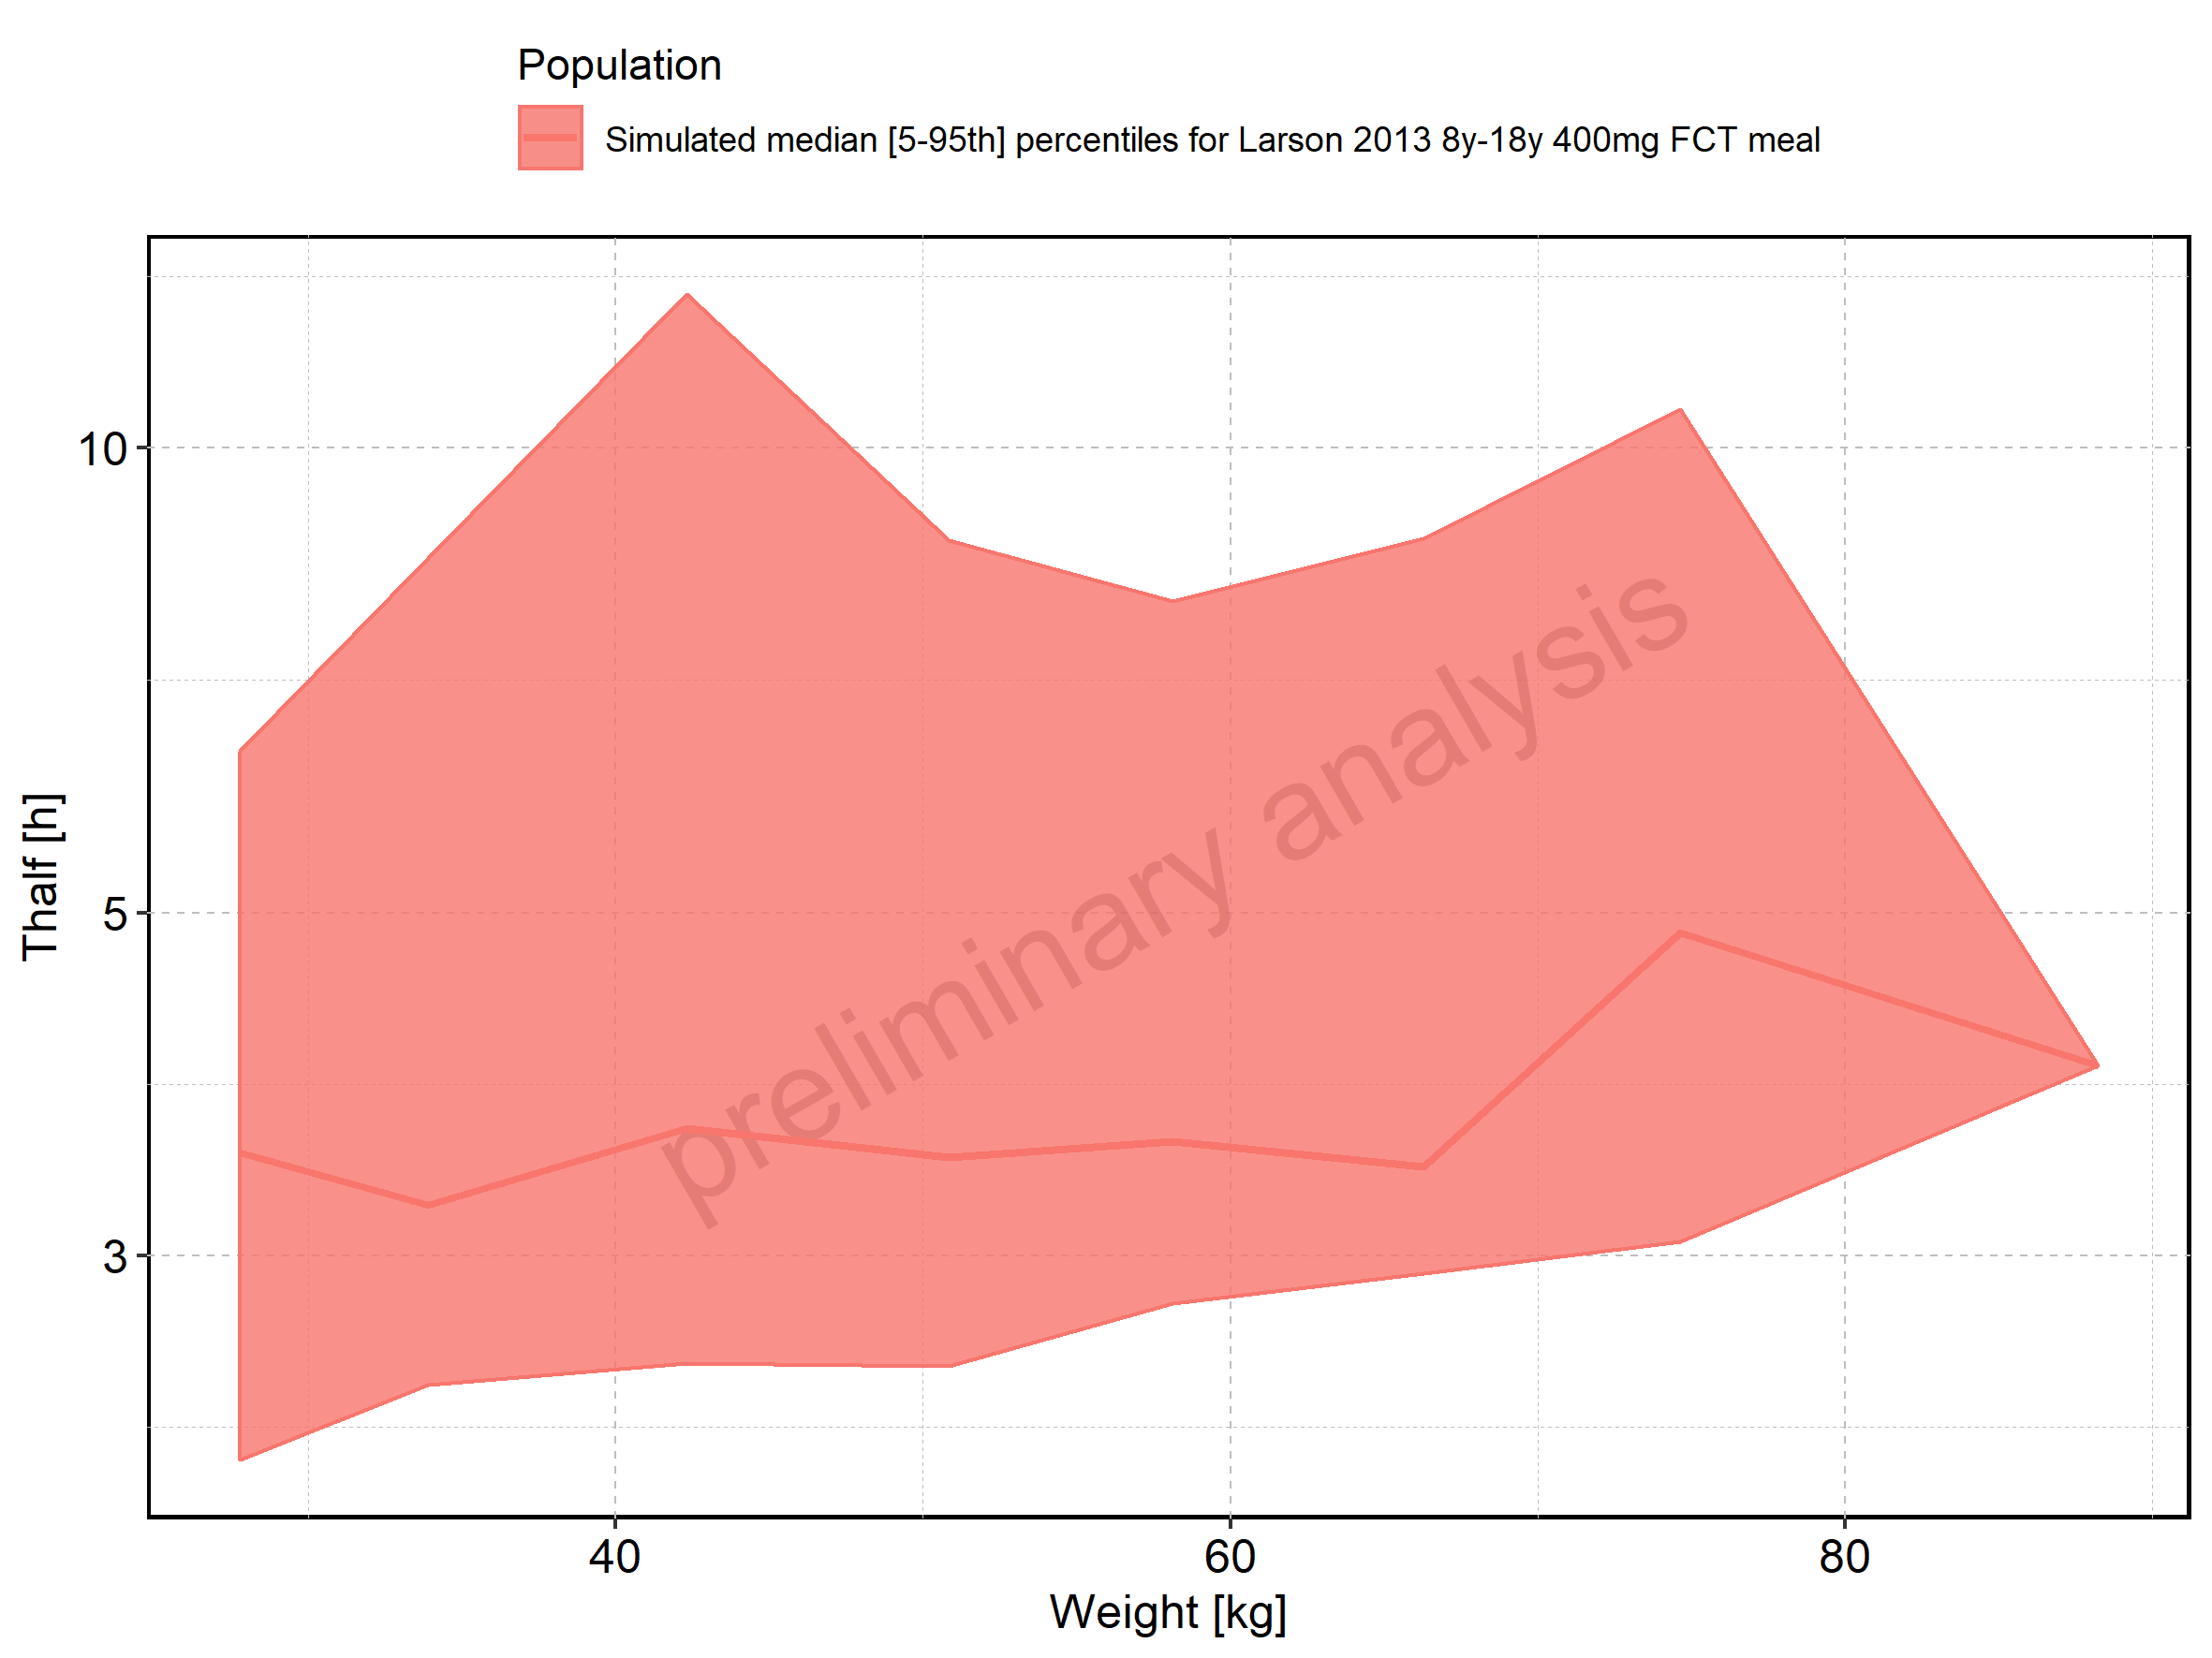

Figure 263: Weight-dependence of Thalf for Filmcoated_tablet_400mg_sd. Profiles are plotted in a linear scale.

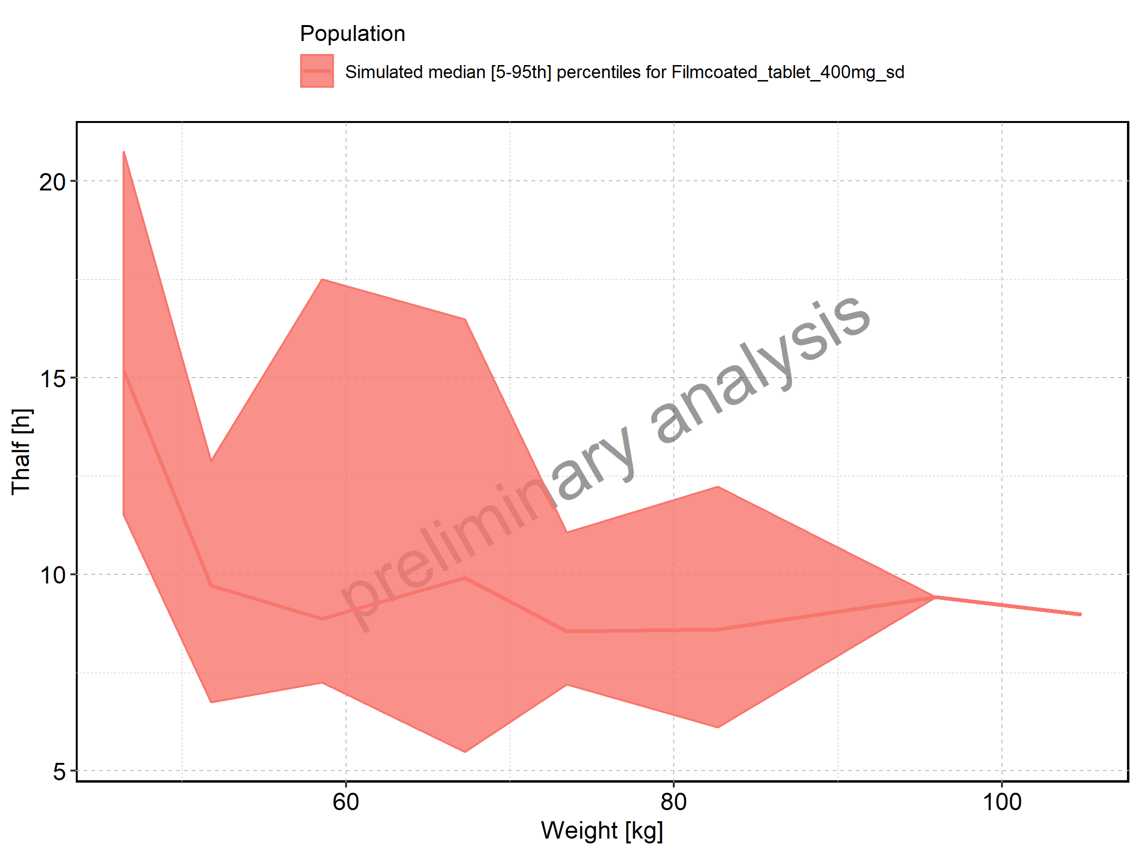

Figure 264: Weight-dependence of Thalf for Filmcoated_tablet_400mg_sd. Profiles are plotted in a logarithmic scale.

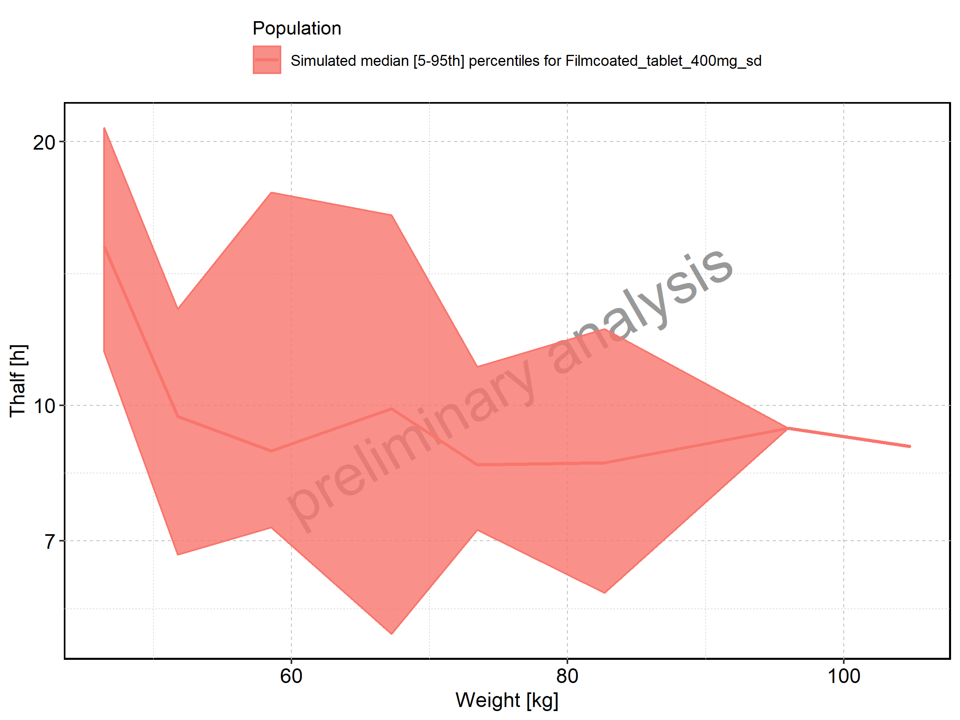

Figure 265: BMI-dependence of Thalf for Larson 2013 8y-18y 400mg FCT meal in comparison to Filmcoated_tablet_400mg_sd. Profiles are plotted in a linear scale.

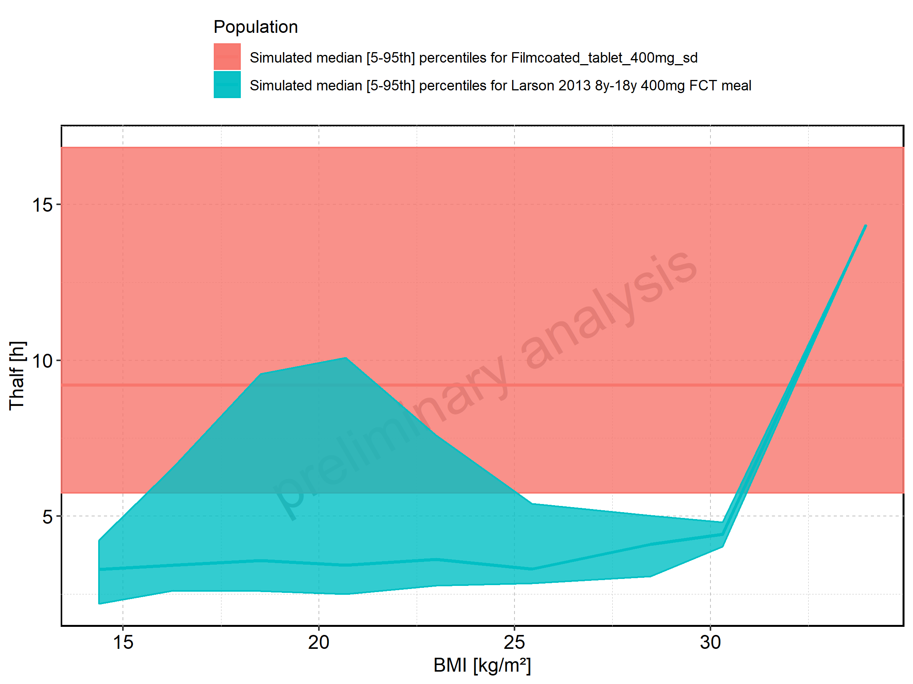

Figure 266: BMI-dependence of Thalf for Larson 2013 8y-18y 400mg FCT meal in comparison to Filmcoated_tablet_400mg_sd. Profiles are plotted in a logarithmic scale.

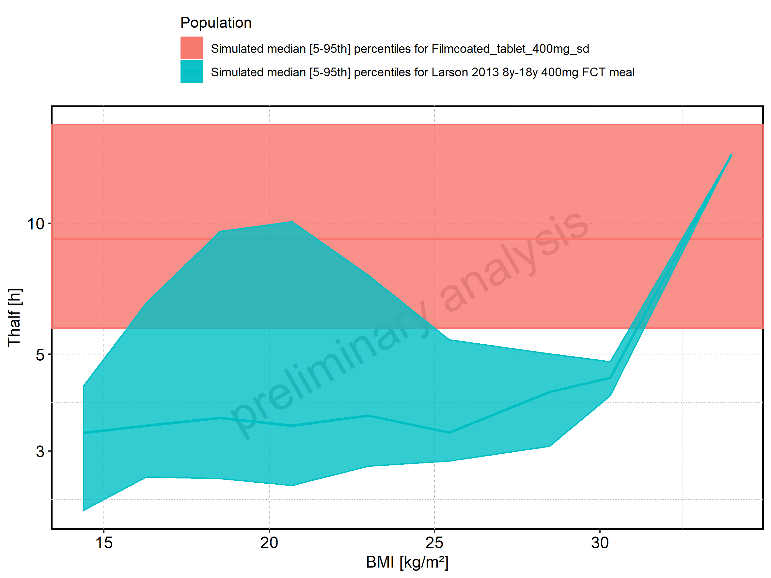

Figure 267: BMI-dependence of Thalf for Larson 2013 8y-18y 400mg FCT meal. Profiles are plotted in a linear scale.

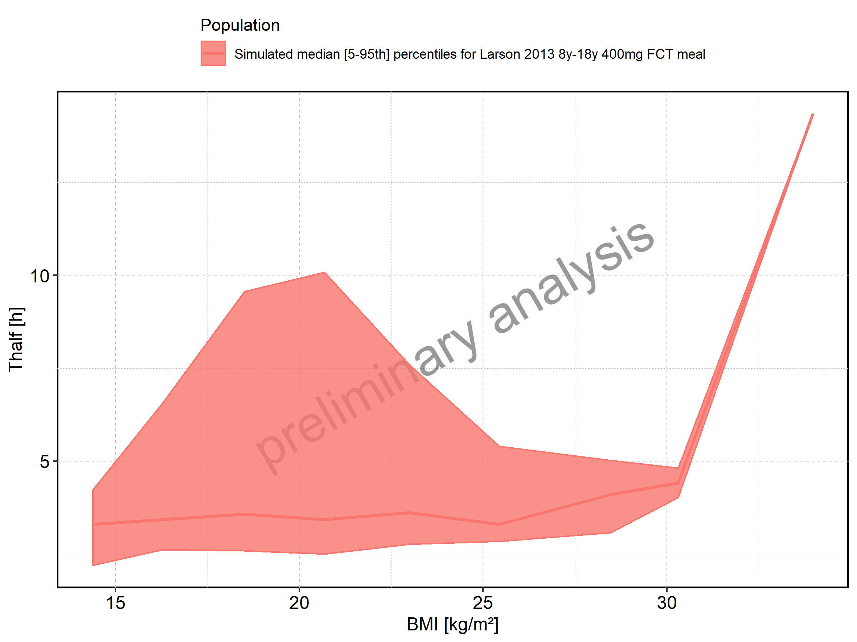

Figure 268: BMI-dependence of Thalf for Larson 2013 8y-18y 400mg FCT meal. Profiles are plotted in a logarithmic scale.

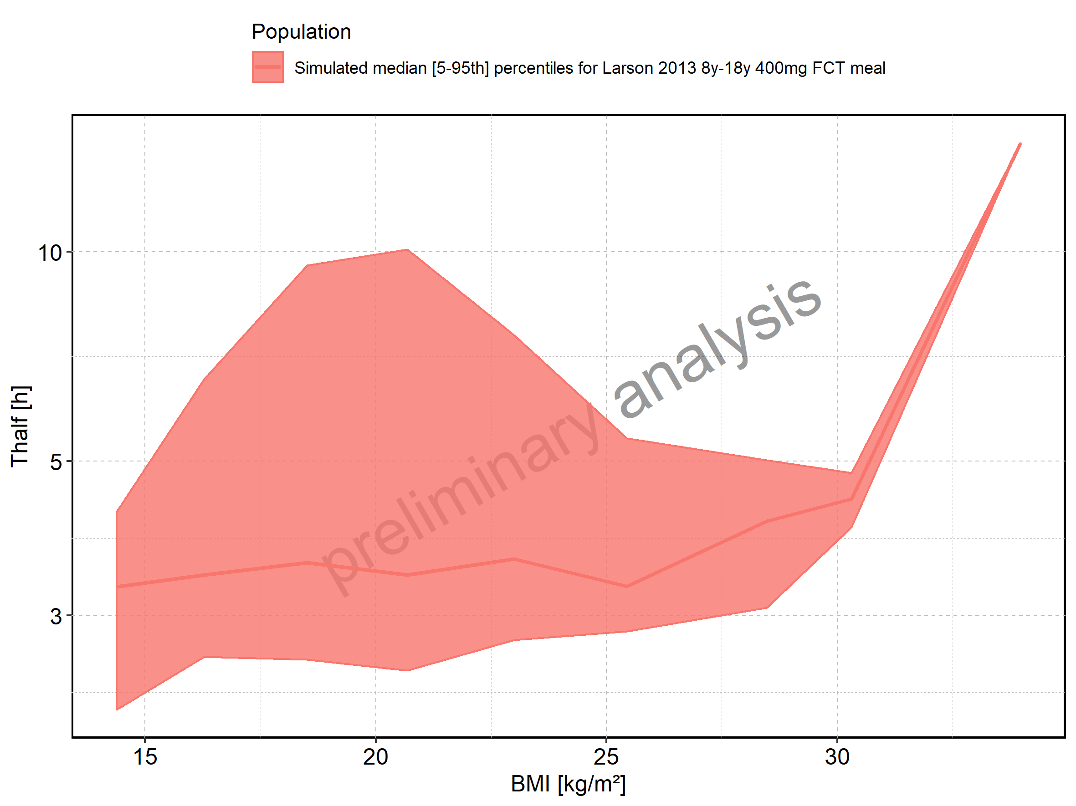

Figure 269: BMI-dependence of Thalf for Filmcoated_tablet_400mg_sd. Profiles are plotted in a linear scale.

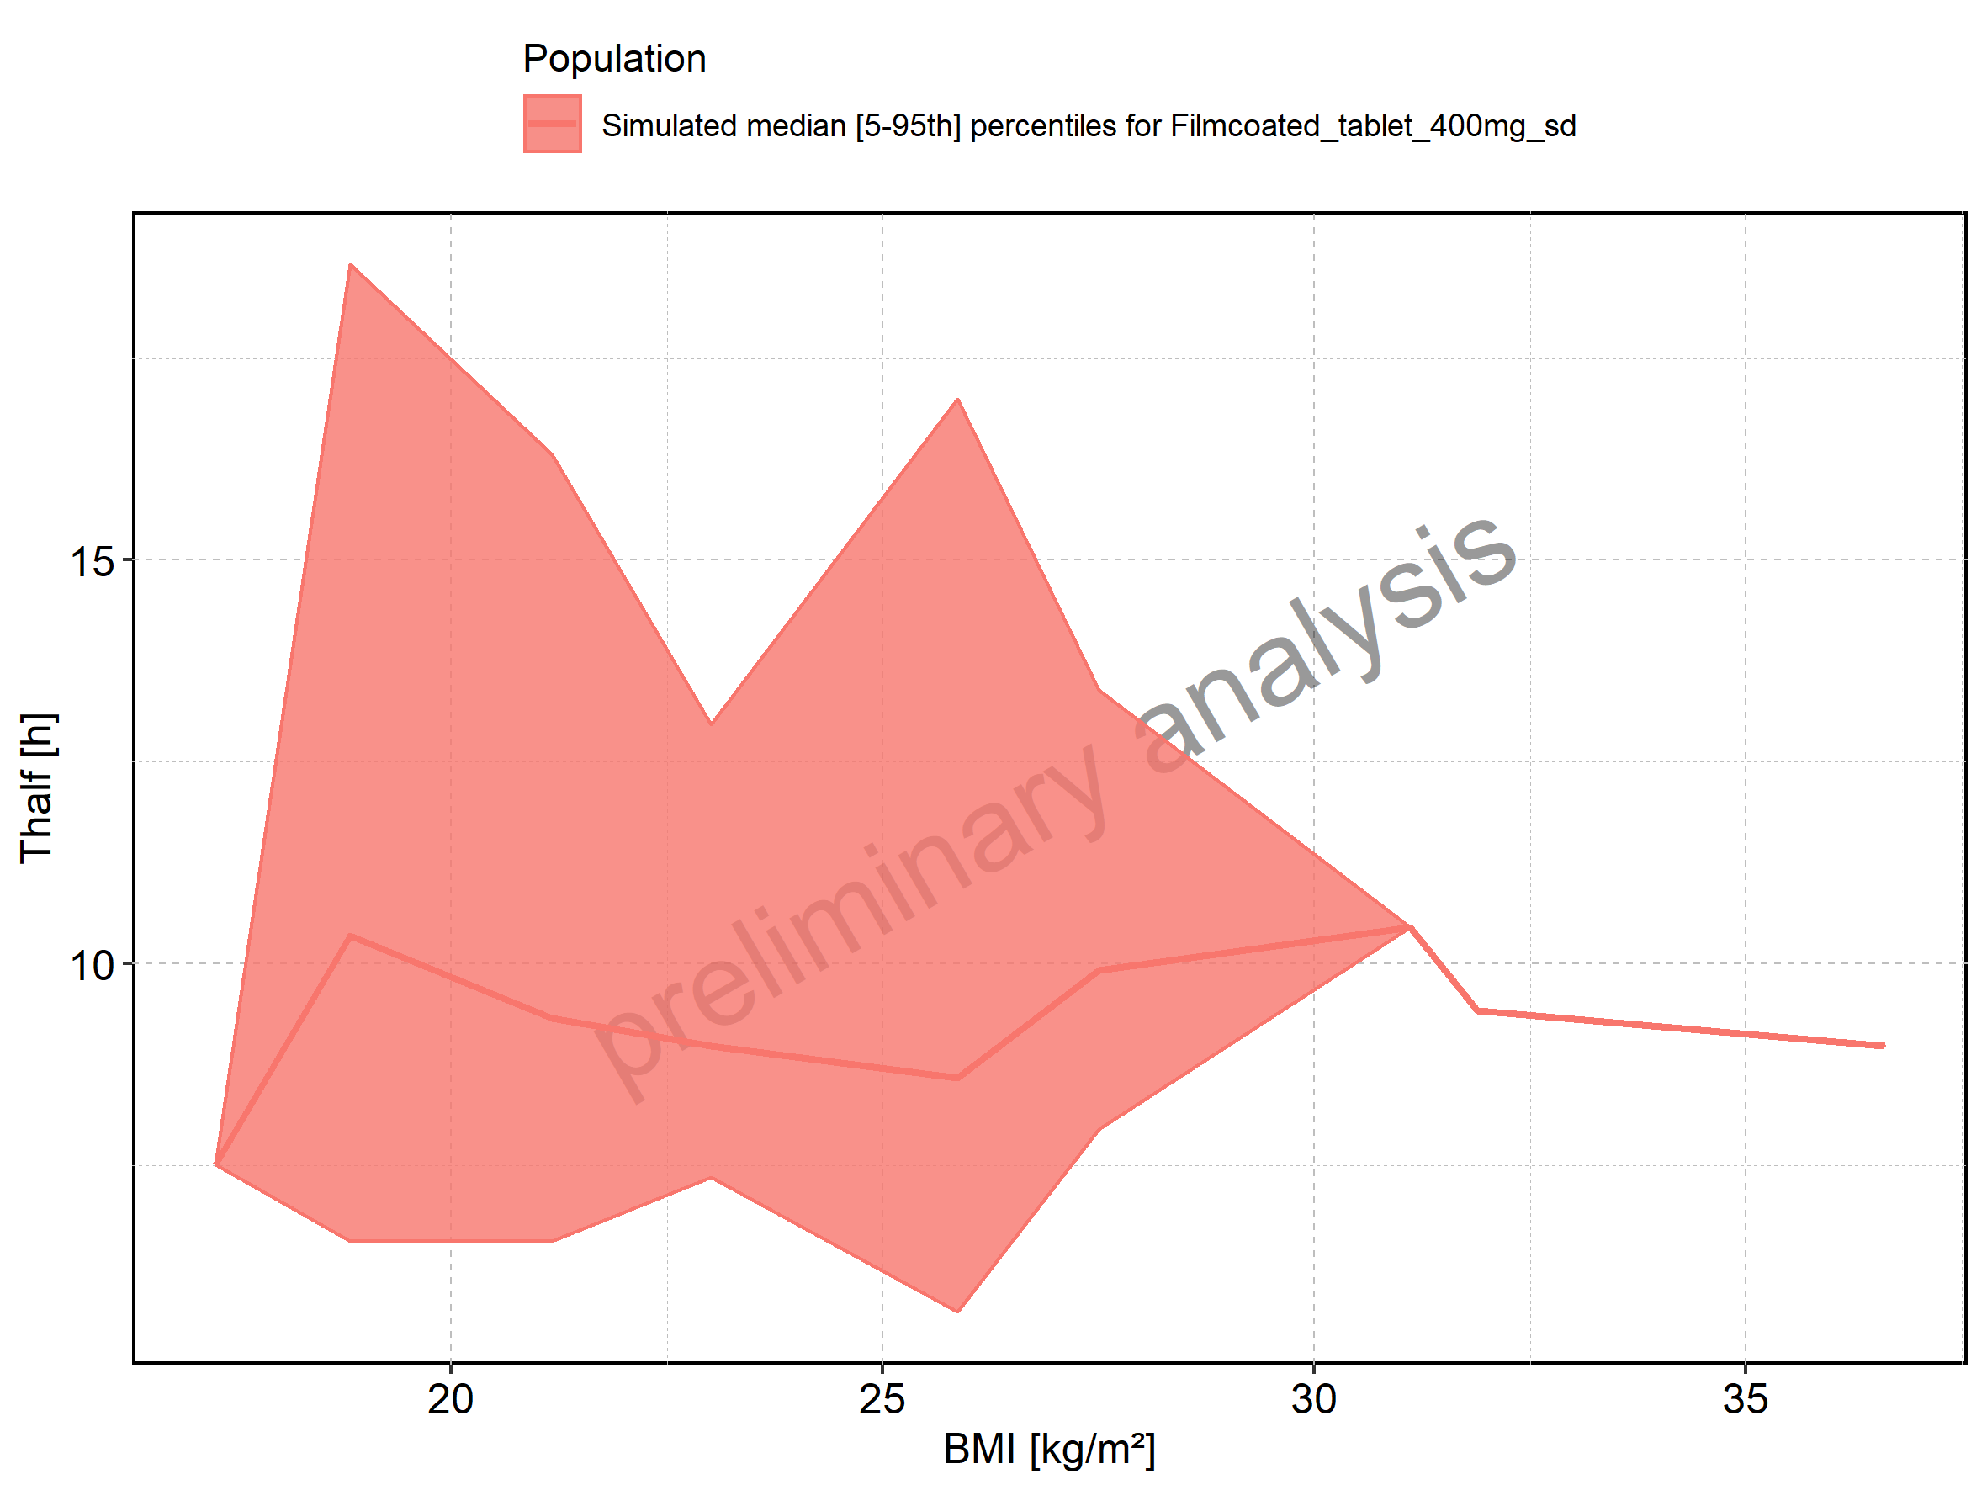

Figure 270: BMI-dependence of Thalf for Filmcoated_tablet_400mg_sd. Profiles are plotted in a logarithmic scale.

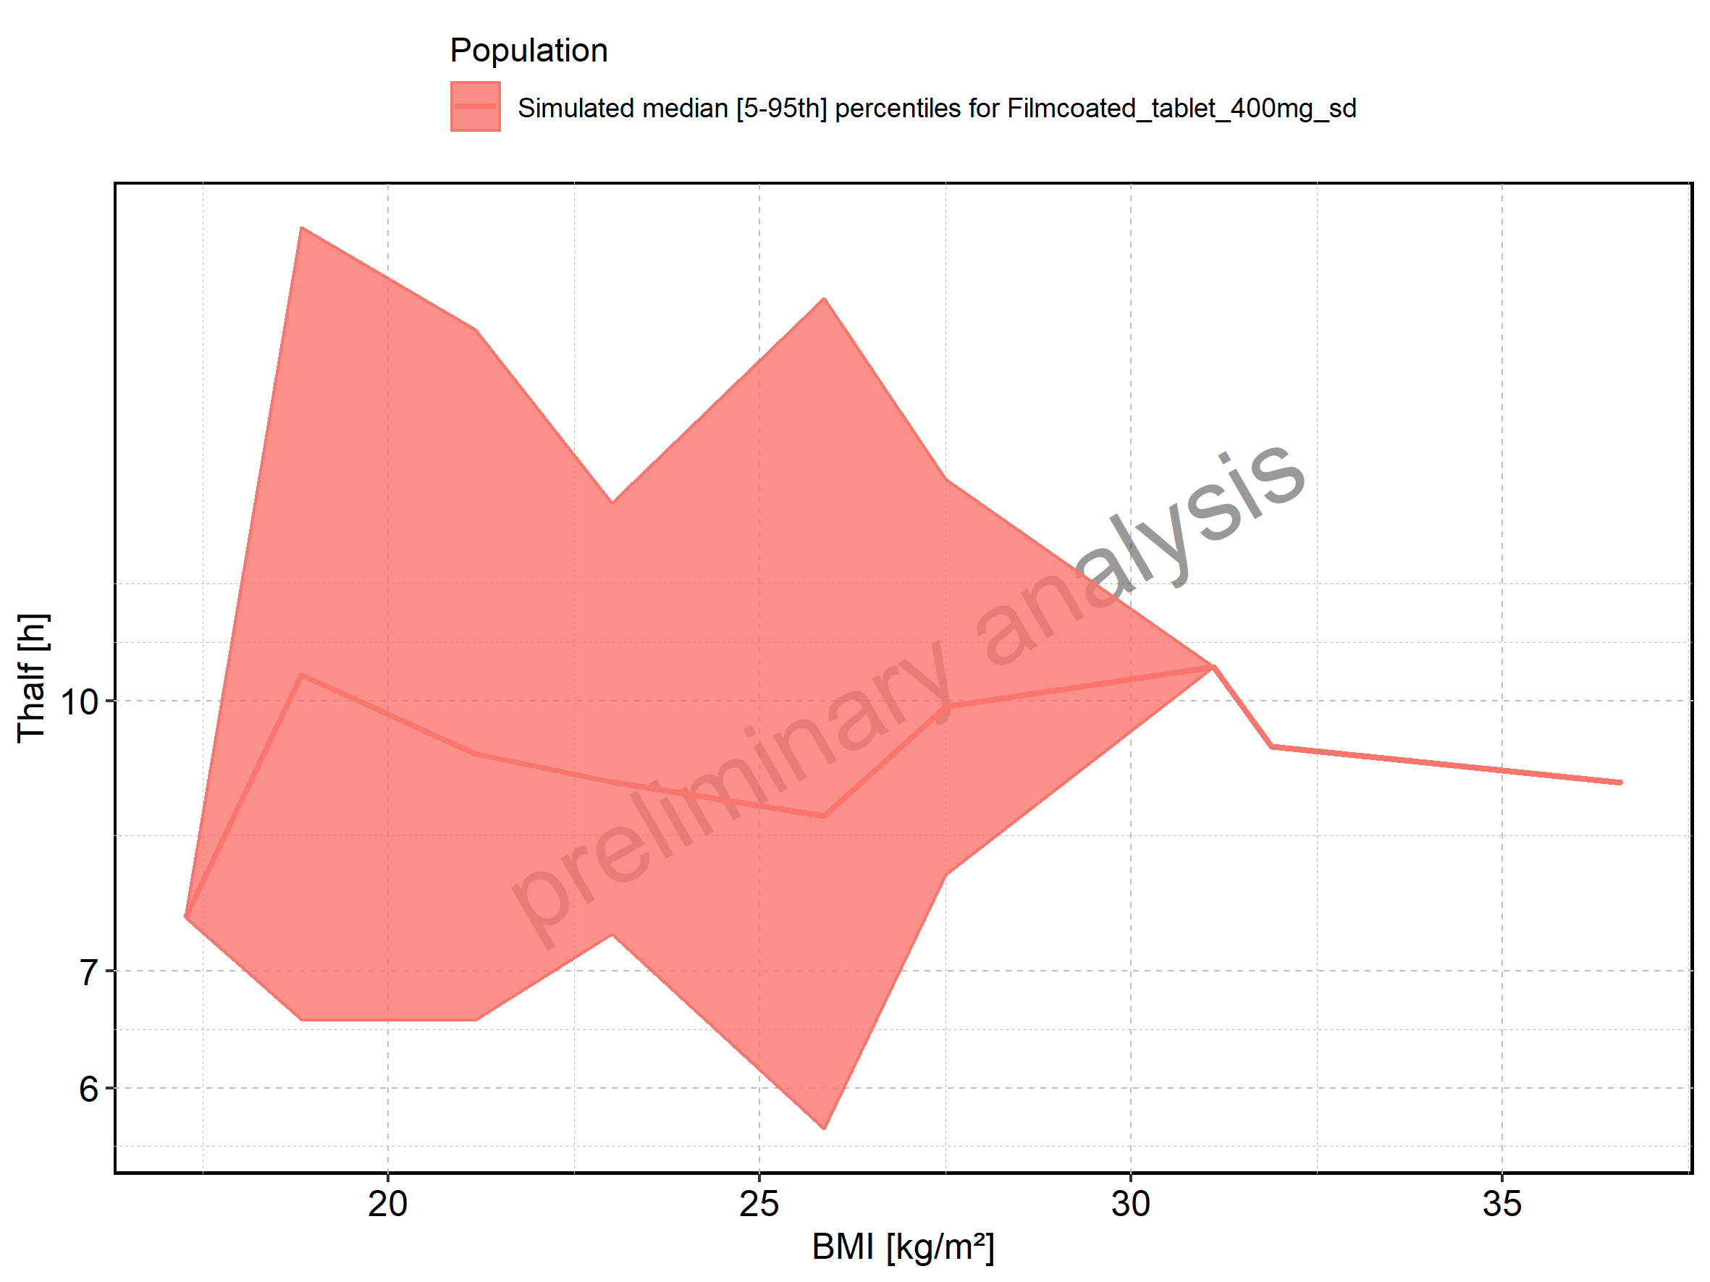

Figure 271: CL of Raltegravir shown as box-whisker plot, which indicates the 5th, 25th, 50th, 75th, and 95th percentiles in linear scale.

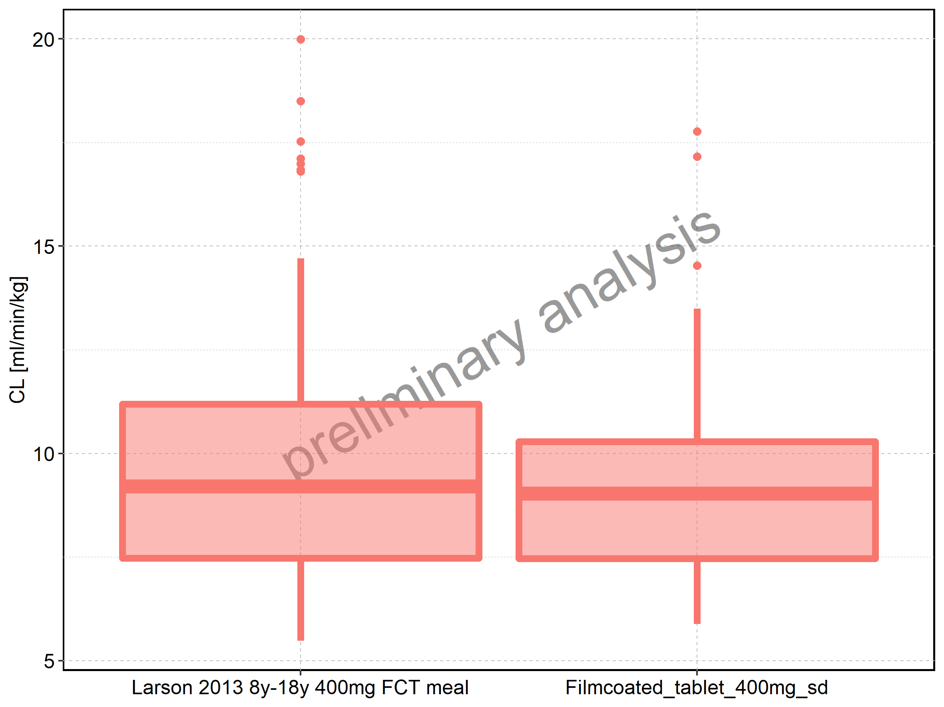

|  |  |  |  |  |  |  |  |  |  |  |
| --- | --- | --- | --- | --- | --- | --- | --- | --- | --- | --- |
| Population | N | 5th percentile | 25th percentile | 50th percentile | 75th percentile | 95th percentile | mean | standard deviation | geo mean | geo standard deviation |
| Larson 2013 8y-18y 400mg FCT meal | 497 | 5.482107 | 7.474607 | 9.202990 | 11.19313 | 14.70885 | 9.494905 | 2.837542 | 9.079491 | 1.353166 |
| Filmcoated_tablet_400mg_sd | 100 | 5.883098 | 7.467935 | 9.030982 | 10.28982 | 13.48808 | 9.200767 | 2.501942 | 8.887614 | 1.300506 |

Figure 272: CL of Raltegravir shown as box-whisker plot, which indicates the 5th, 25th, 50th, 75th, and 95th percentiles in logarithmic scale.

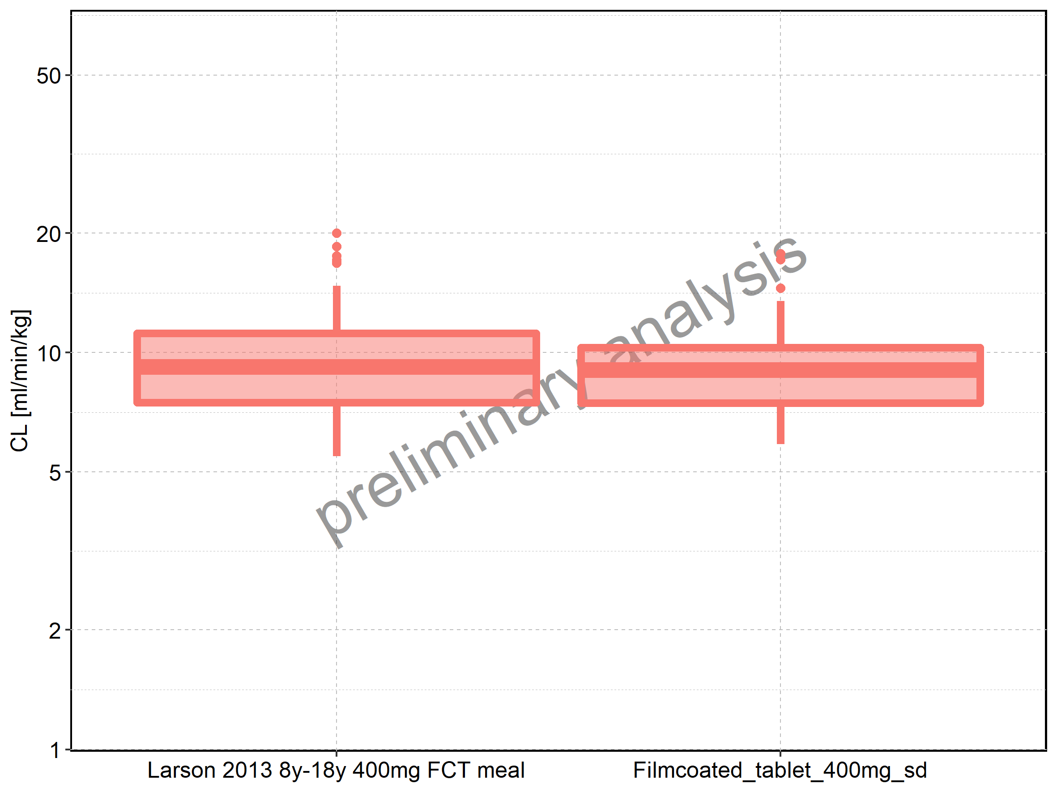

Figure 273: Age-dependence of CL for Larson 2013 8y-18y 400mg FCT meal in comparison to Filmcoated_tablet_400mg_sd. Profiles are plotted in a linear scale.

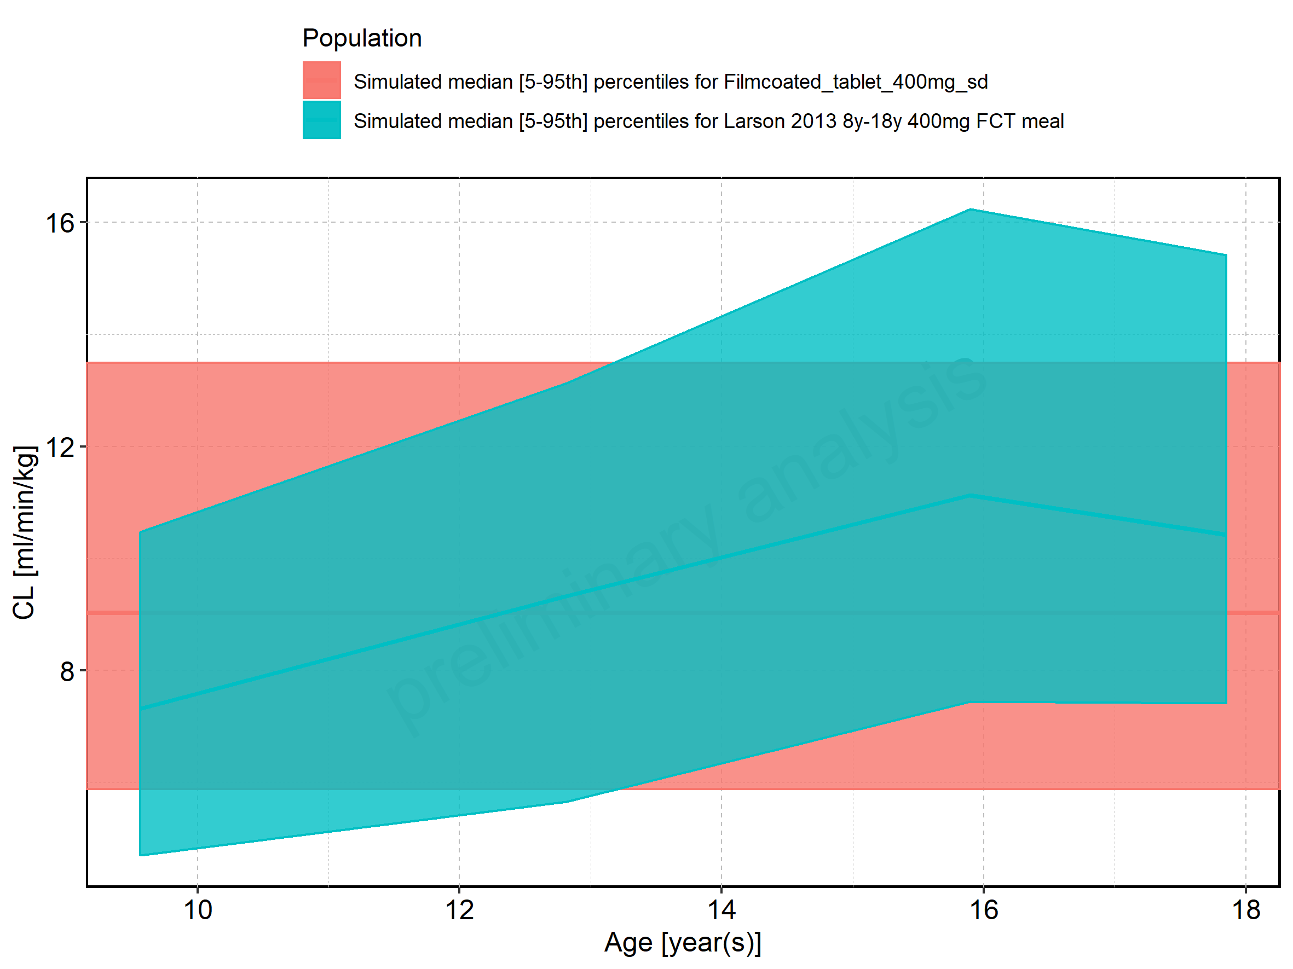

Figure 274: Age-dependence of CL for Larson 2013 8y-18y 400mg FCT meal in comparison to Filmcoated_tablet_400mg_sd. Profiles are plotted in a logarithmic scale.

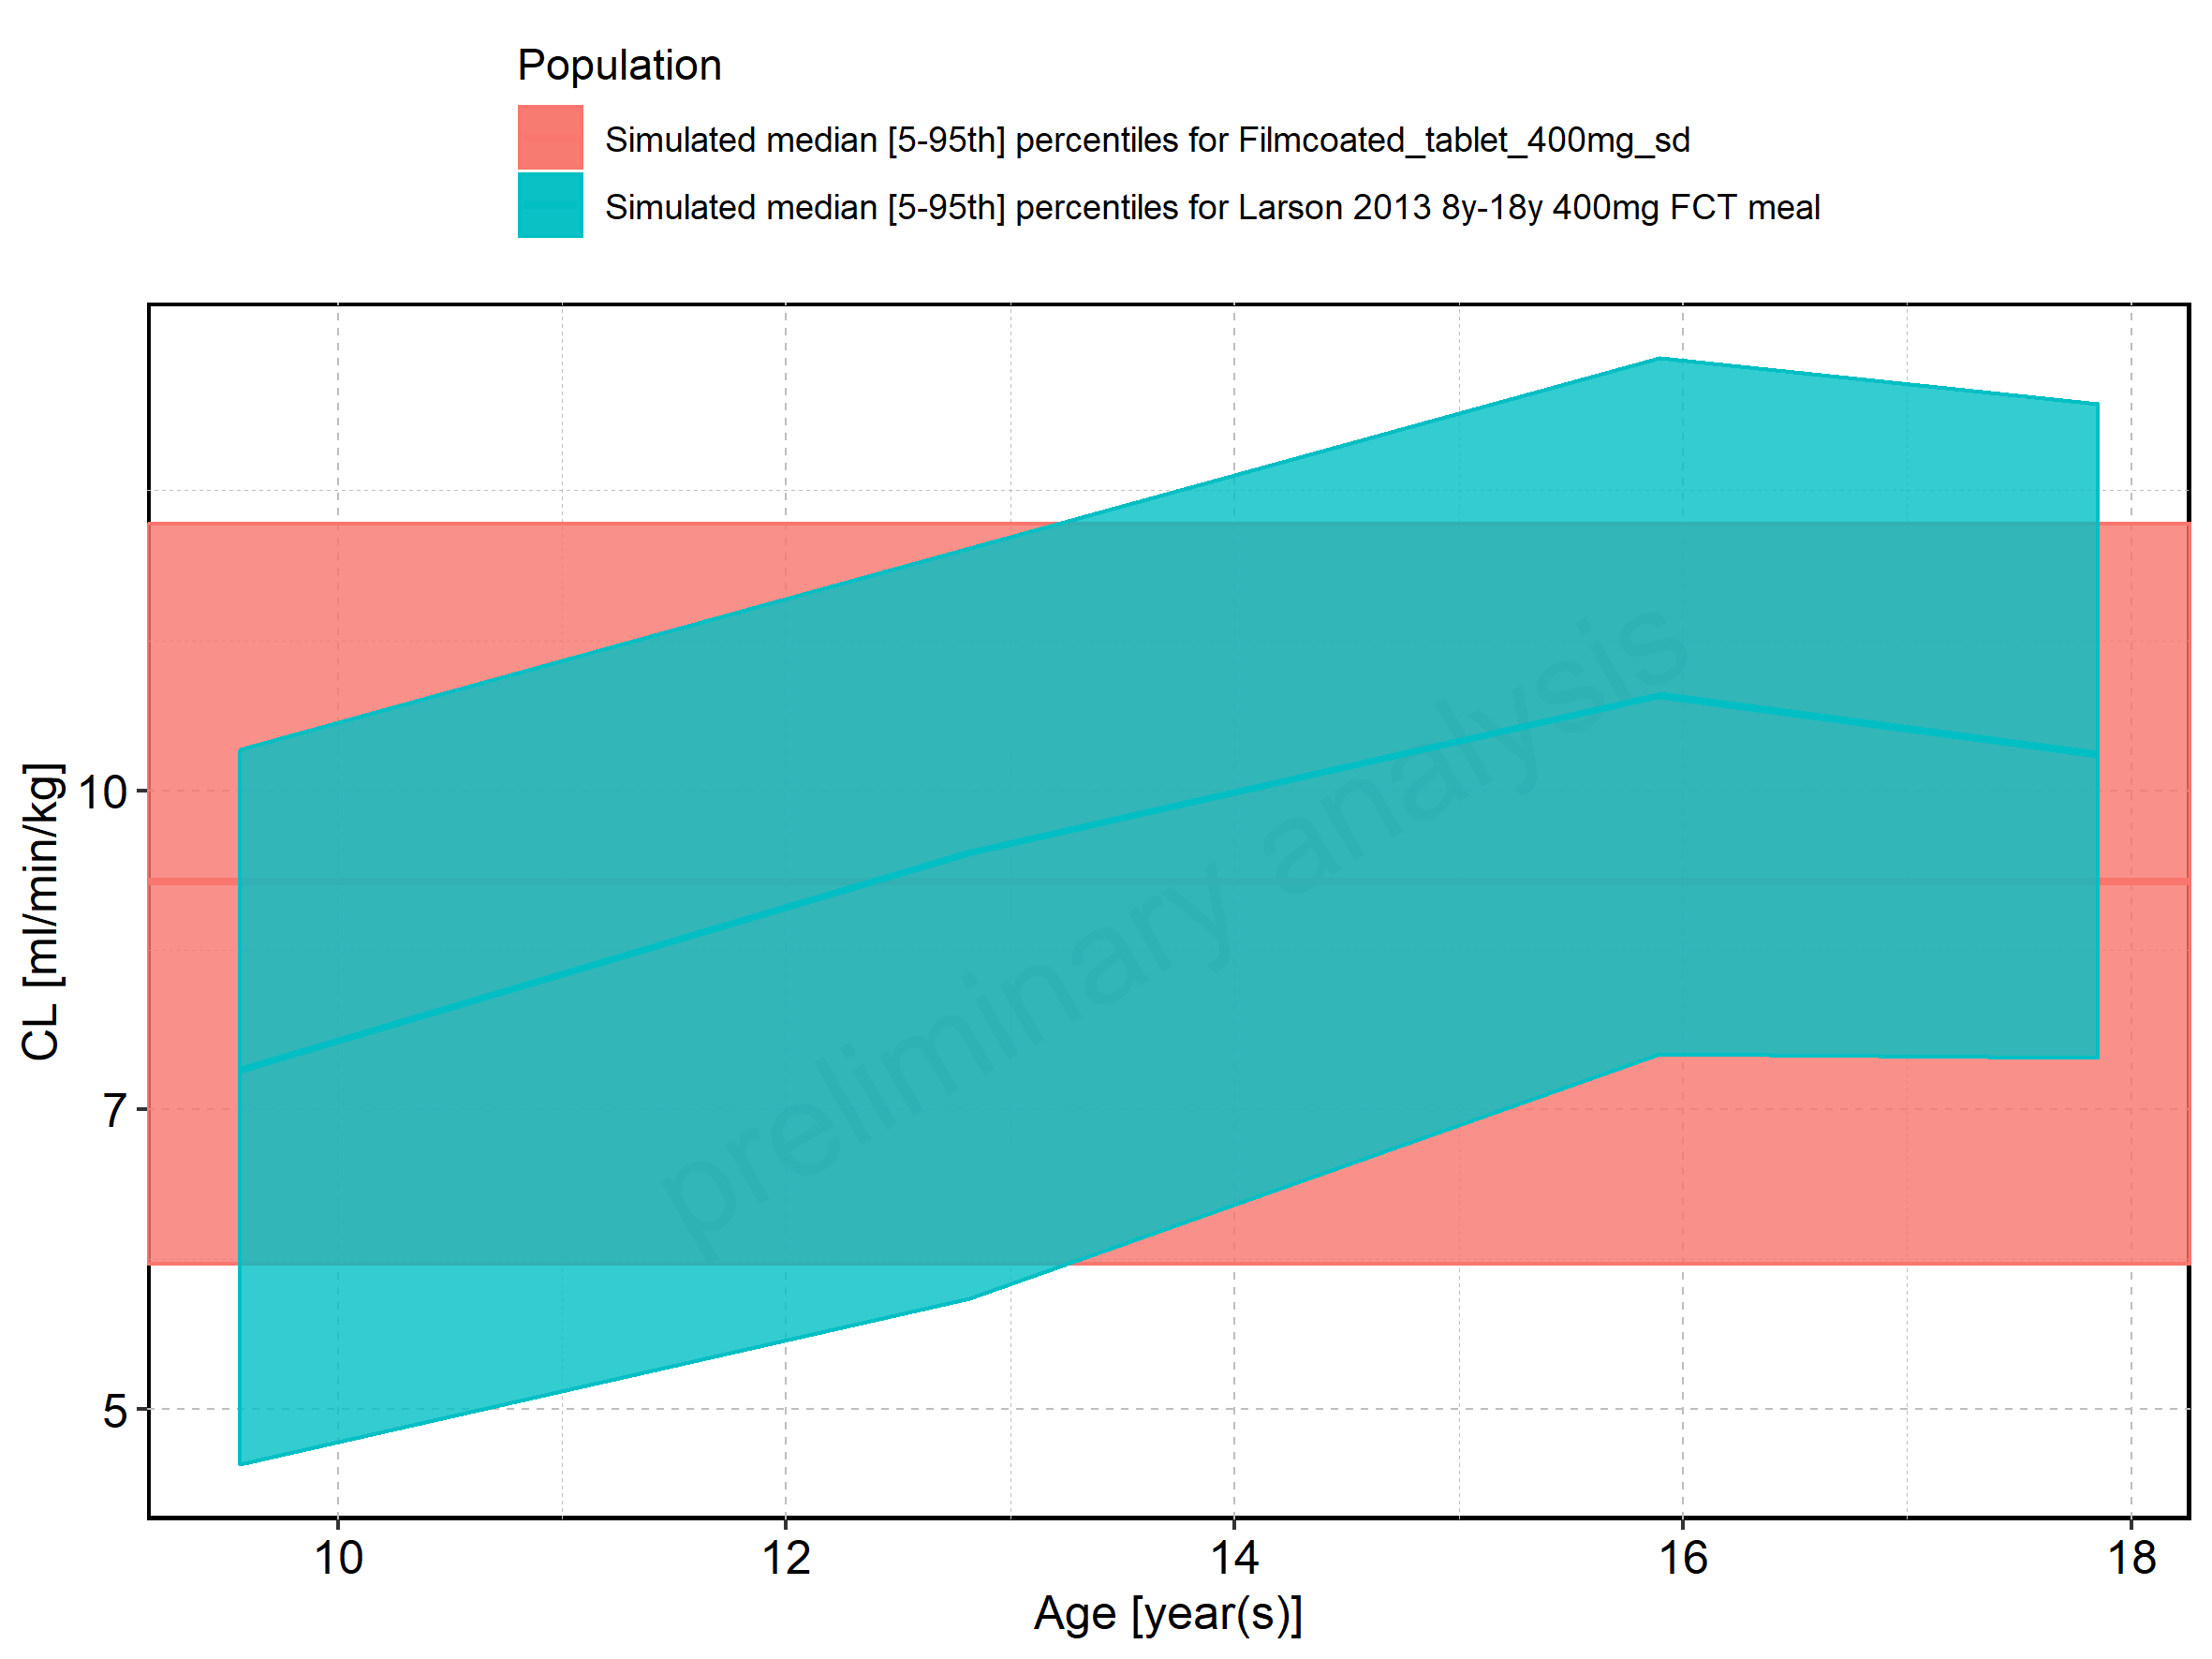

Figure 275: Age-dependence of CL for Larson 2013 8y-18y 400mg FCT meal. Profiles are plotted in a linear scale.

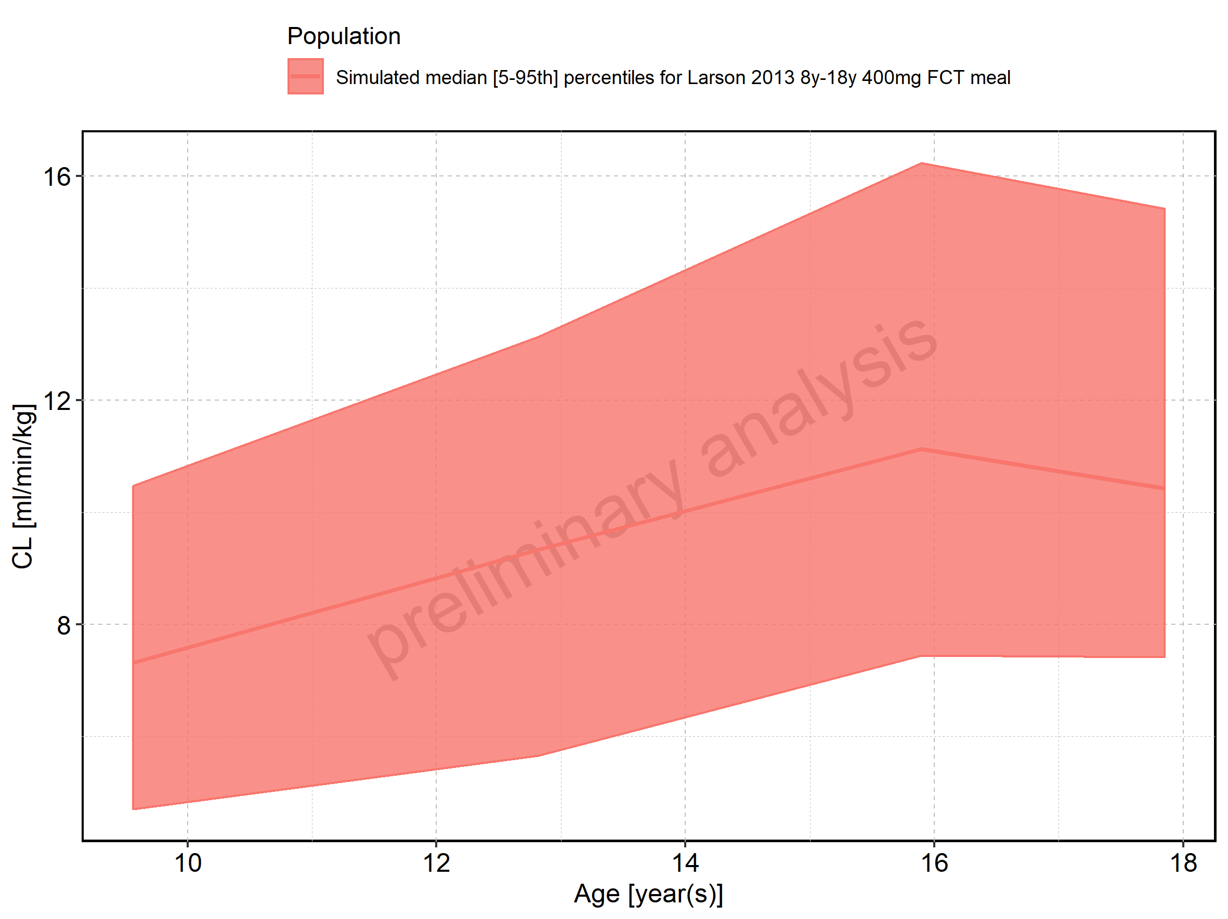

Figure 276: Age-dependence of CL for Larson 2013 8y-18y 400mg FCT meal. Profiles are plotted in a logarithmic scale.

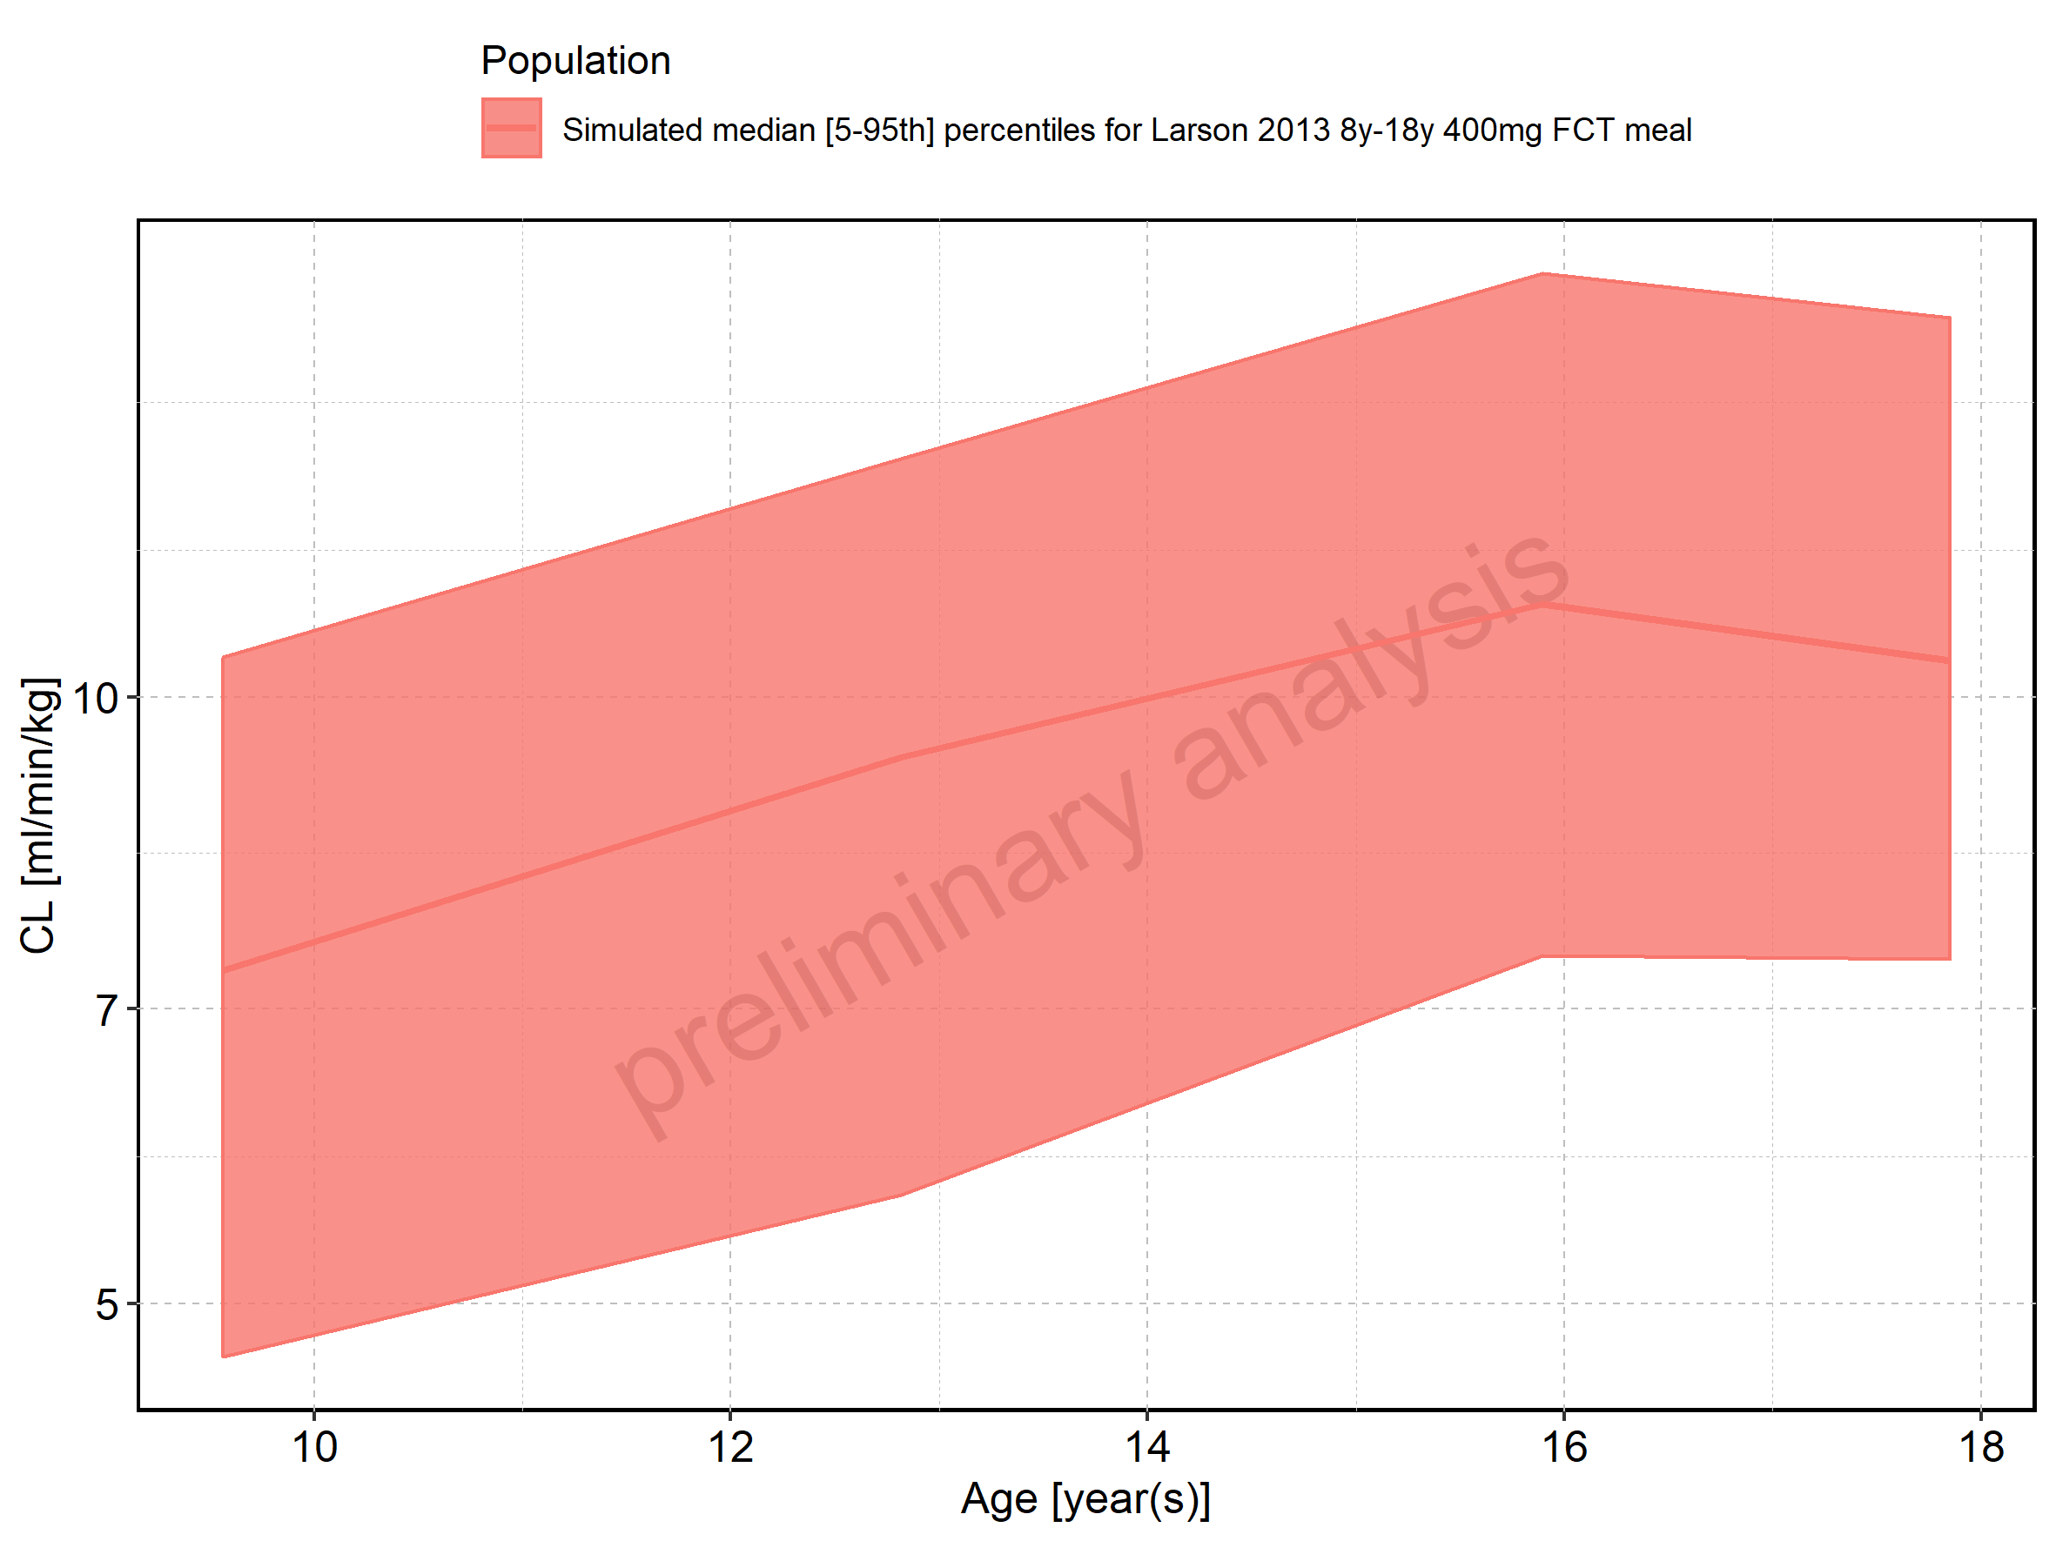

Figure 277: Age-dependence of CL for Filmcoated_tablet_400mg_sd. Profiles are plotted in a linear scale.

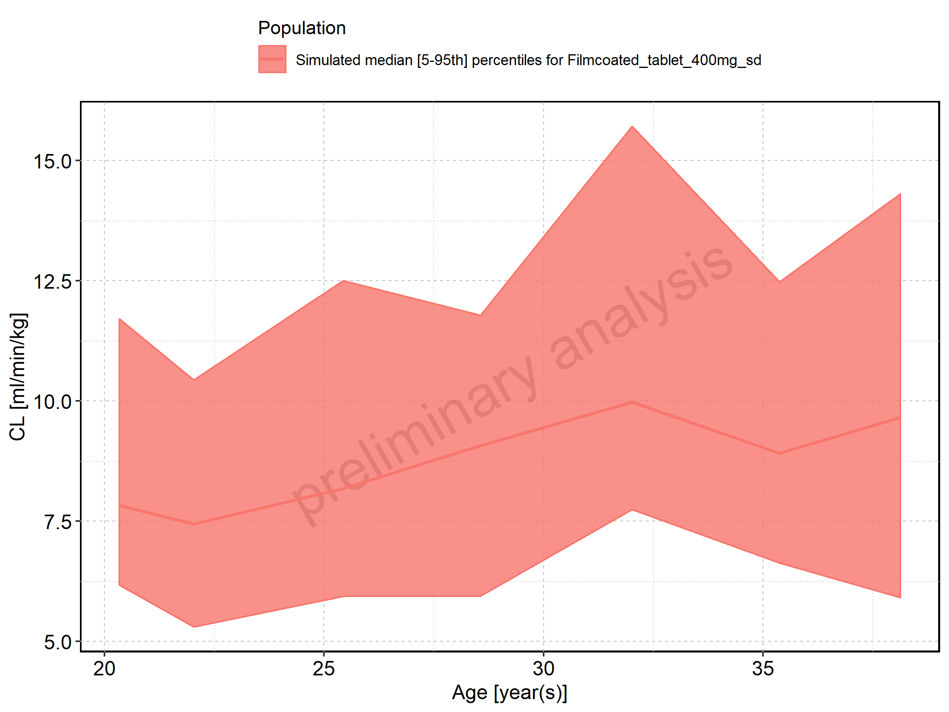

Figure 278: Age-dependence of CL for Filmcoated_tablet_400mg_sd. Profiles are plotted in a logarithmic scale.

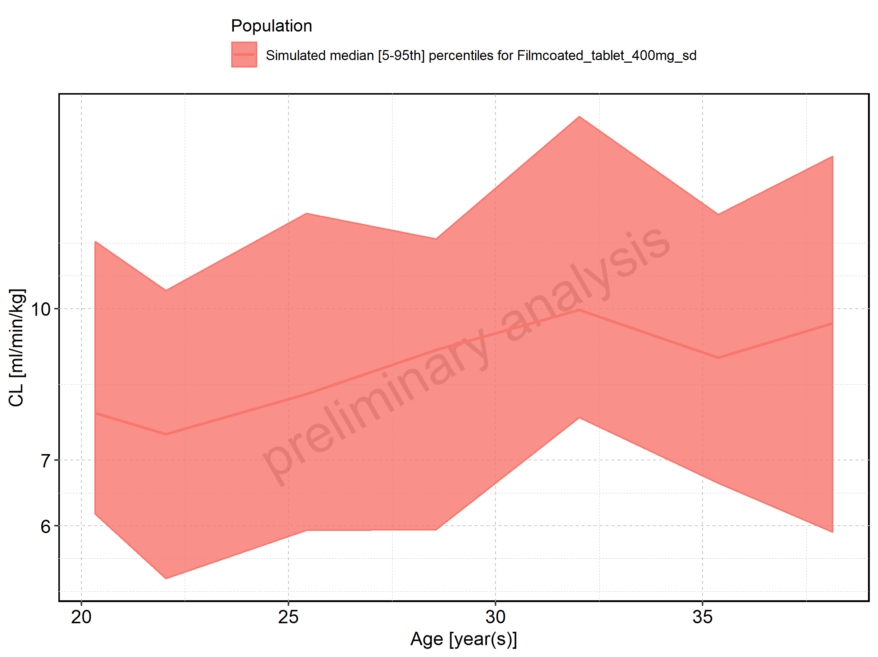

Figure 279: Height-dependence of CL for Larson 2013 8y-18y 400mg FCT meal in comparison to Filmcoated_tablet_400mg_sd. Profiles are plotted in a linear scale.

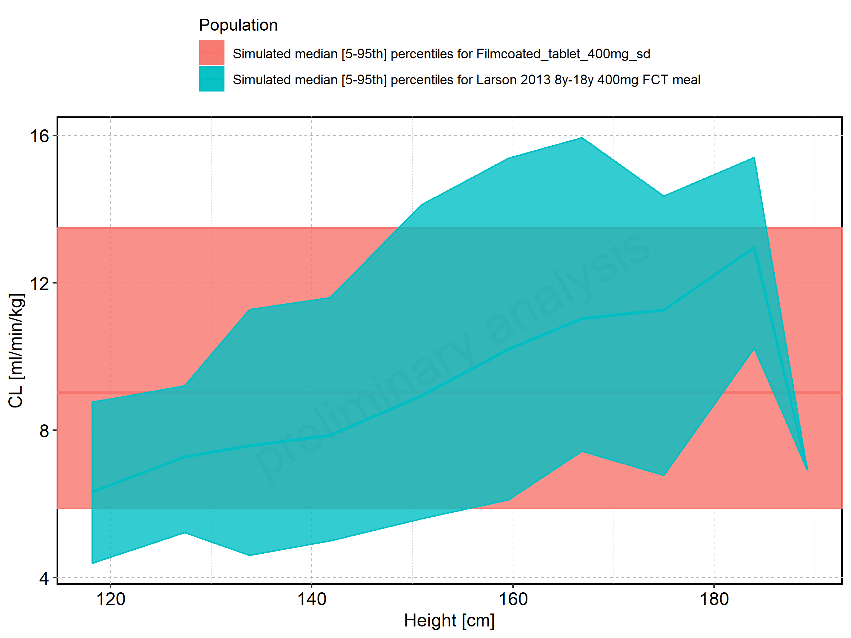

Figure 280: Height-dependence of CL for Larson 2013 8y-18y 400mg FCT meal in comparison to Filmcoated_tablet_400mg_sd. Profiles are plotted in a logarithmic scale.

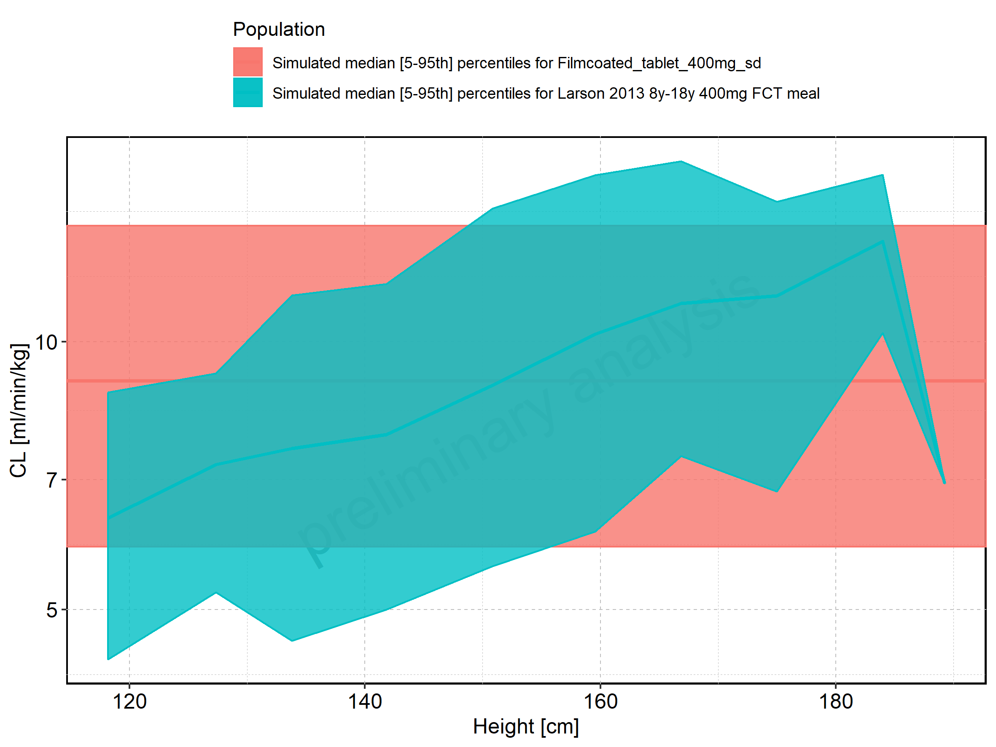

Figure 281: Height-dependence of CL for Larson 2013 8y-18y 400mg FCT meal. Profiles are plotted in a linear scale.

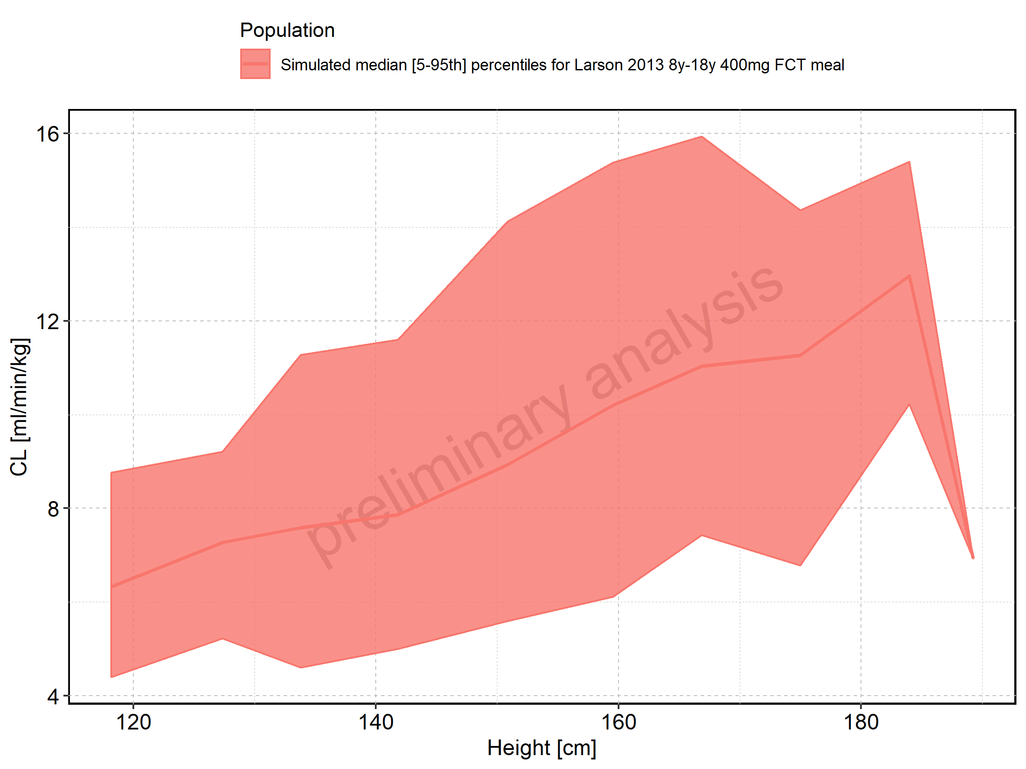

Figure 282: Height-dependence of CL for Larson 2013 8y-18y 400mg FCT meal. Profiles are plotted in a logarithmic scale.

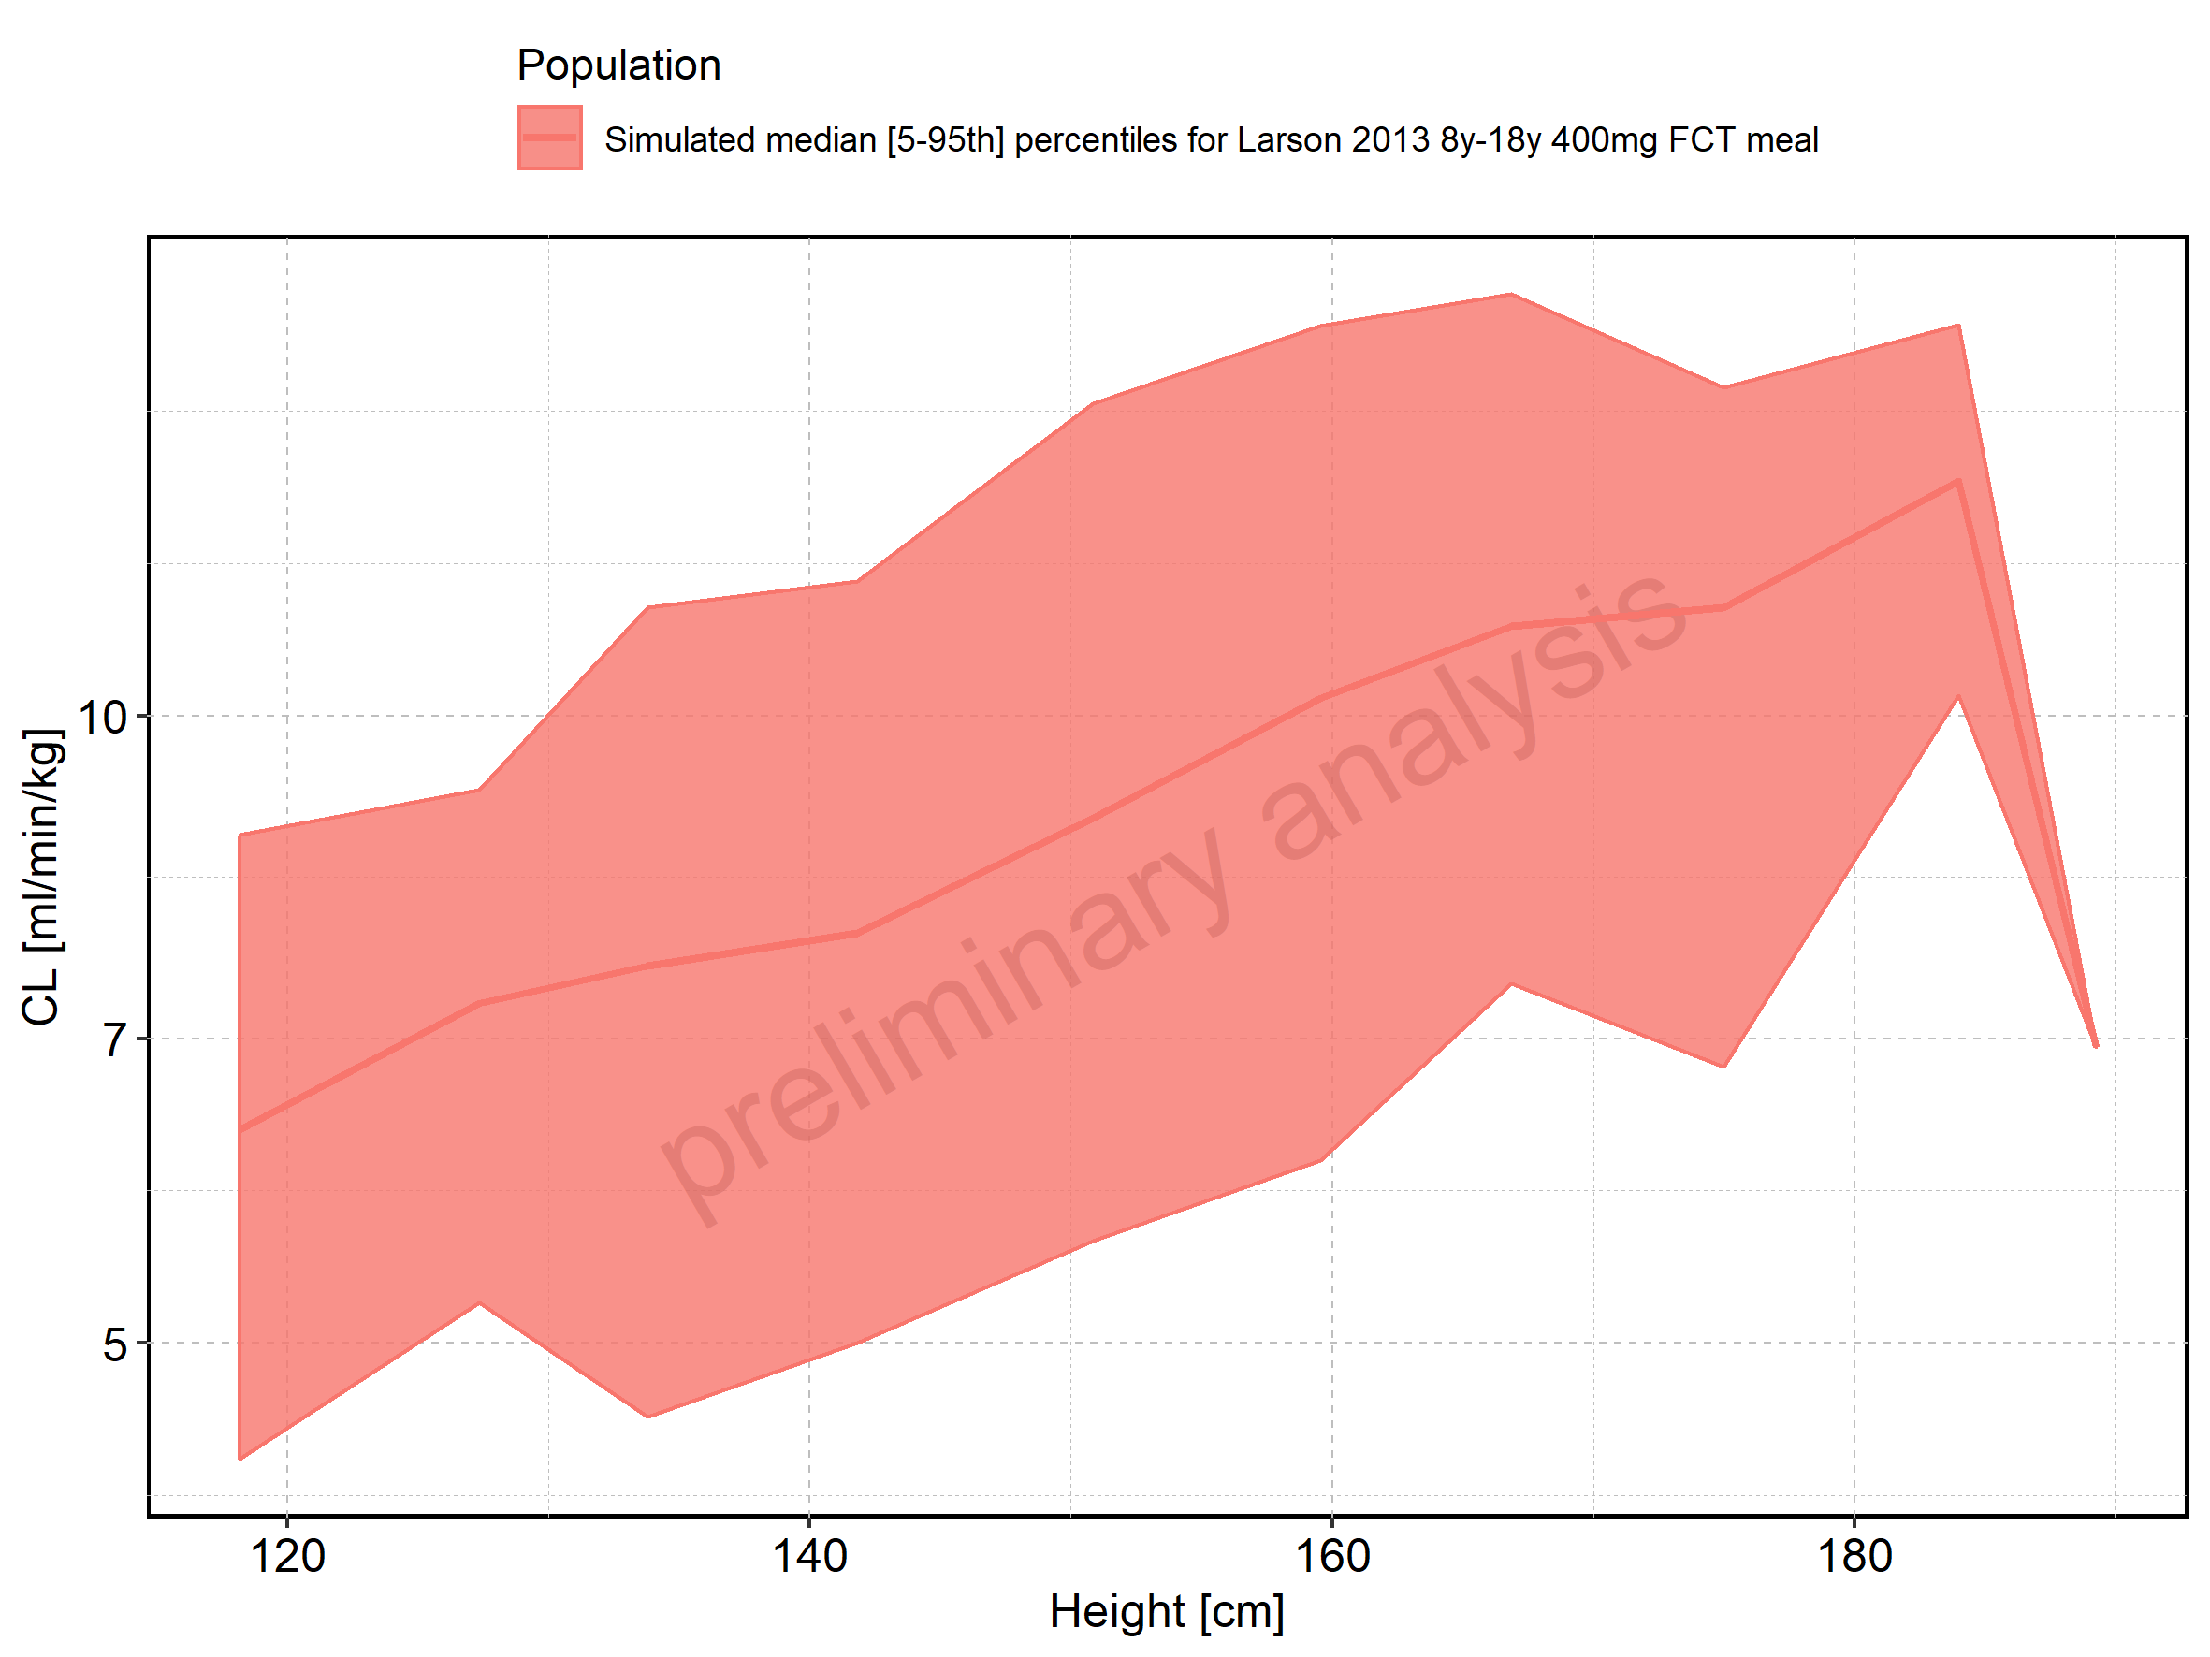

Figure 283: Height-dependence of CL for Filmcoated_tablet_400mg_sd. Profiles are plotted in a linear scale.

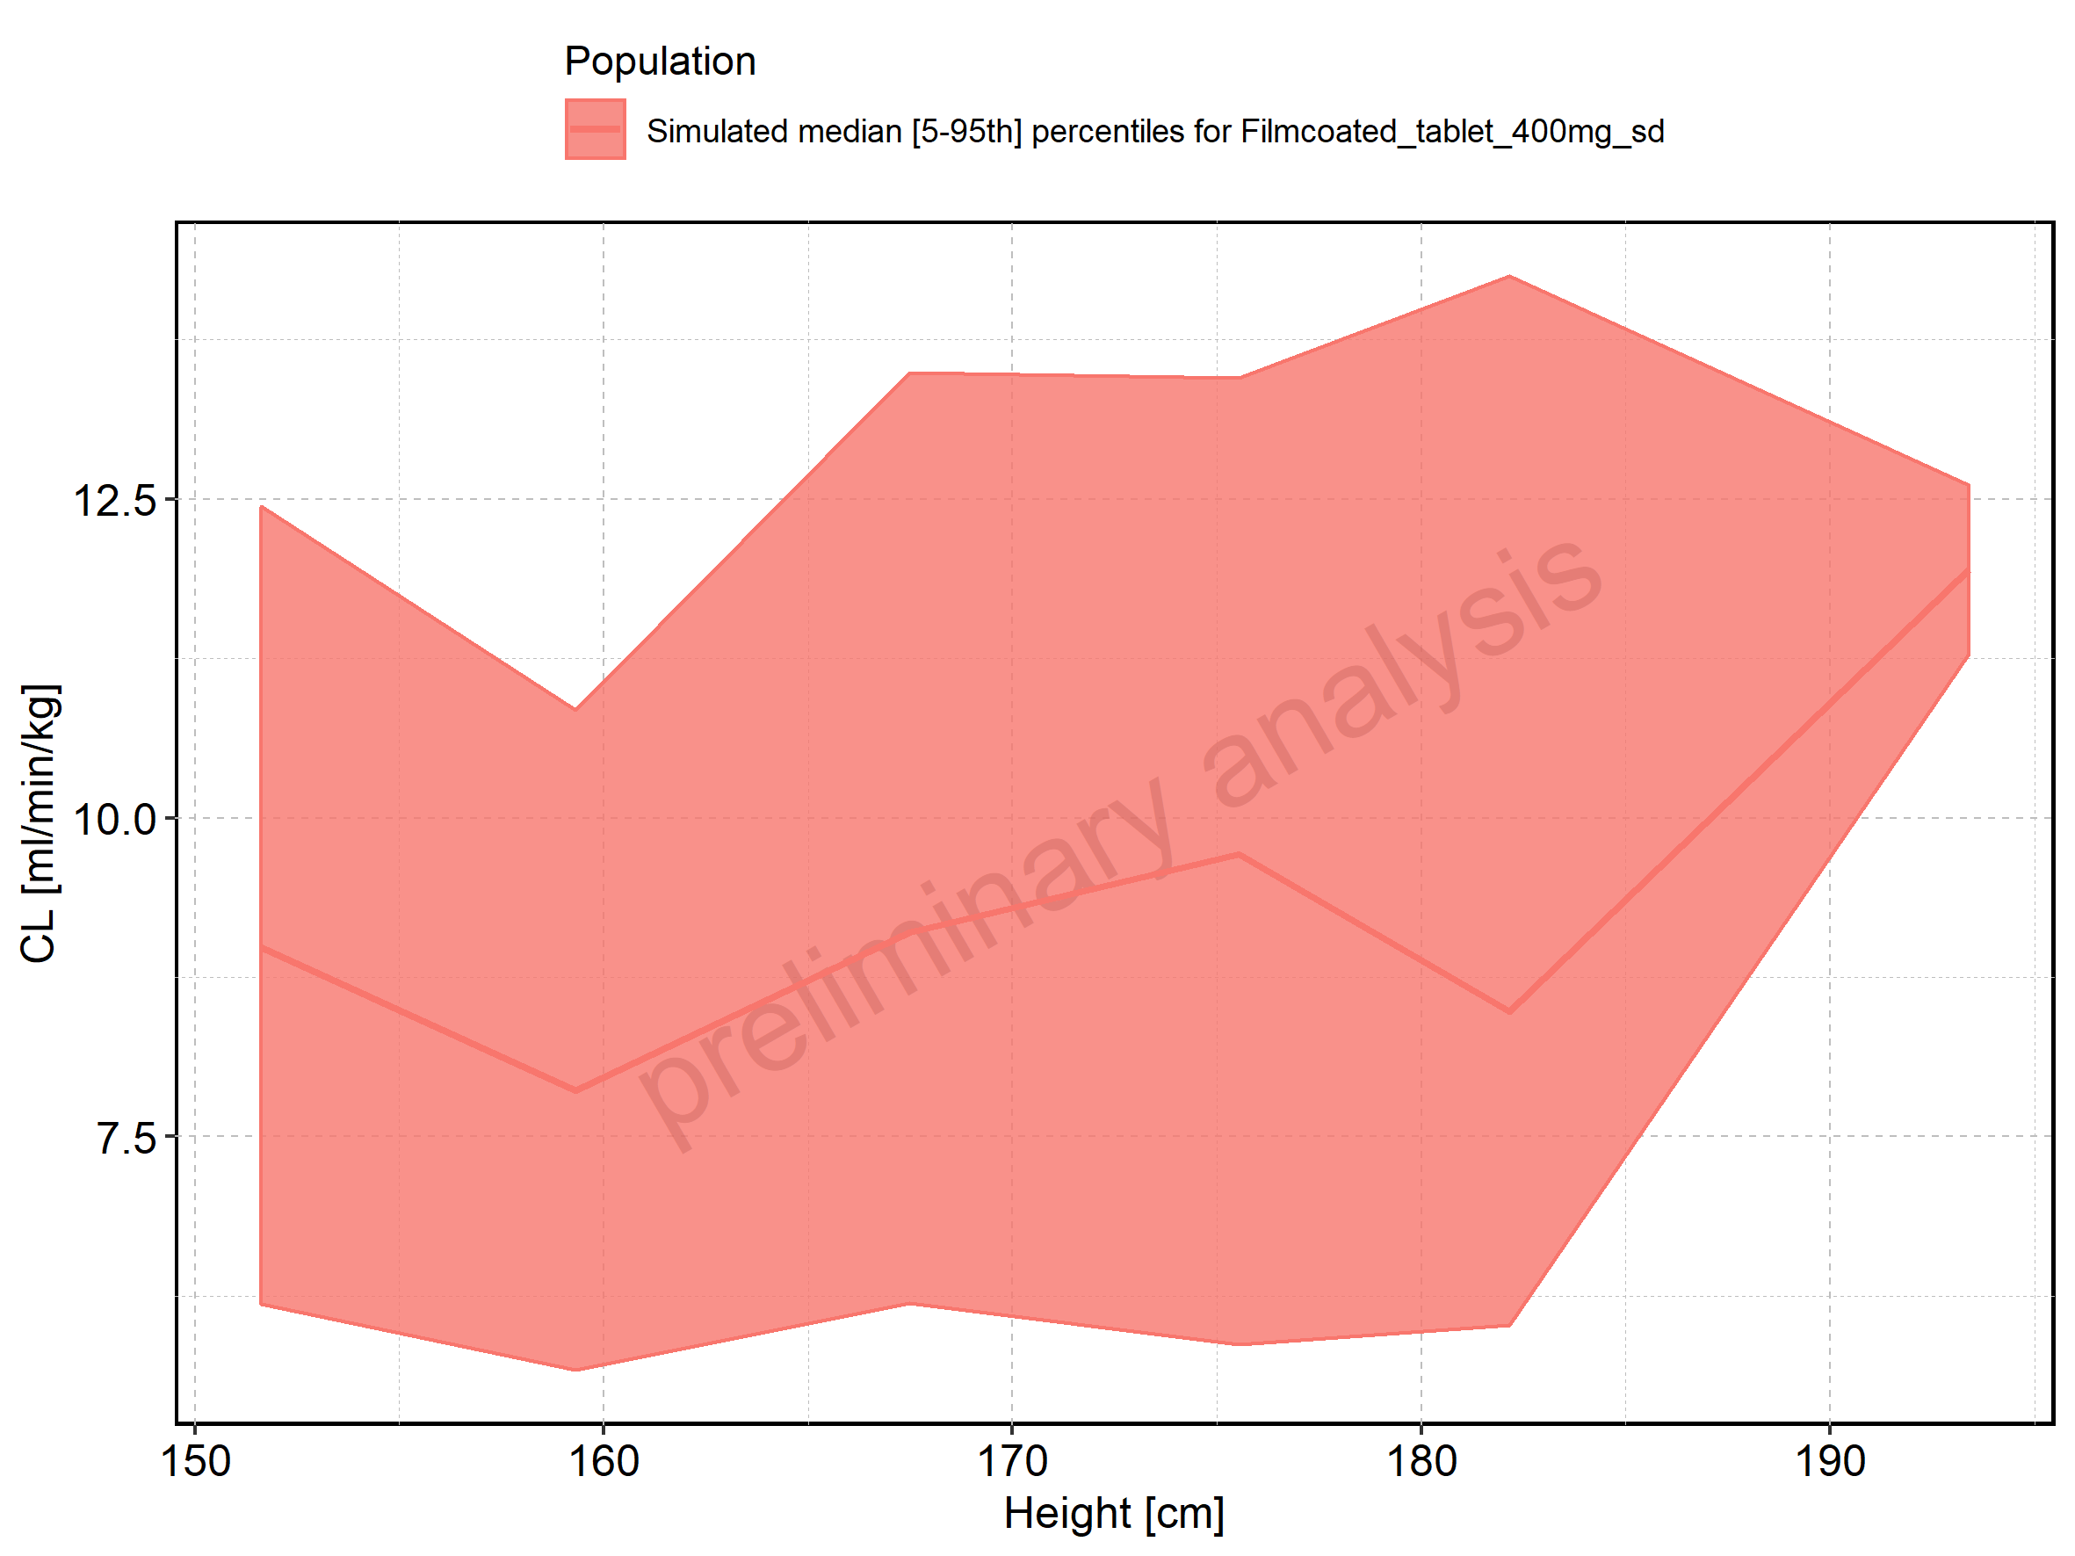

Figure 284: Height-dependence of CL for Filmcoated_tablet_400mg_sd. Profiles are plotted in a logarithmic scale.

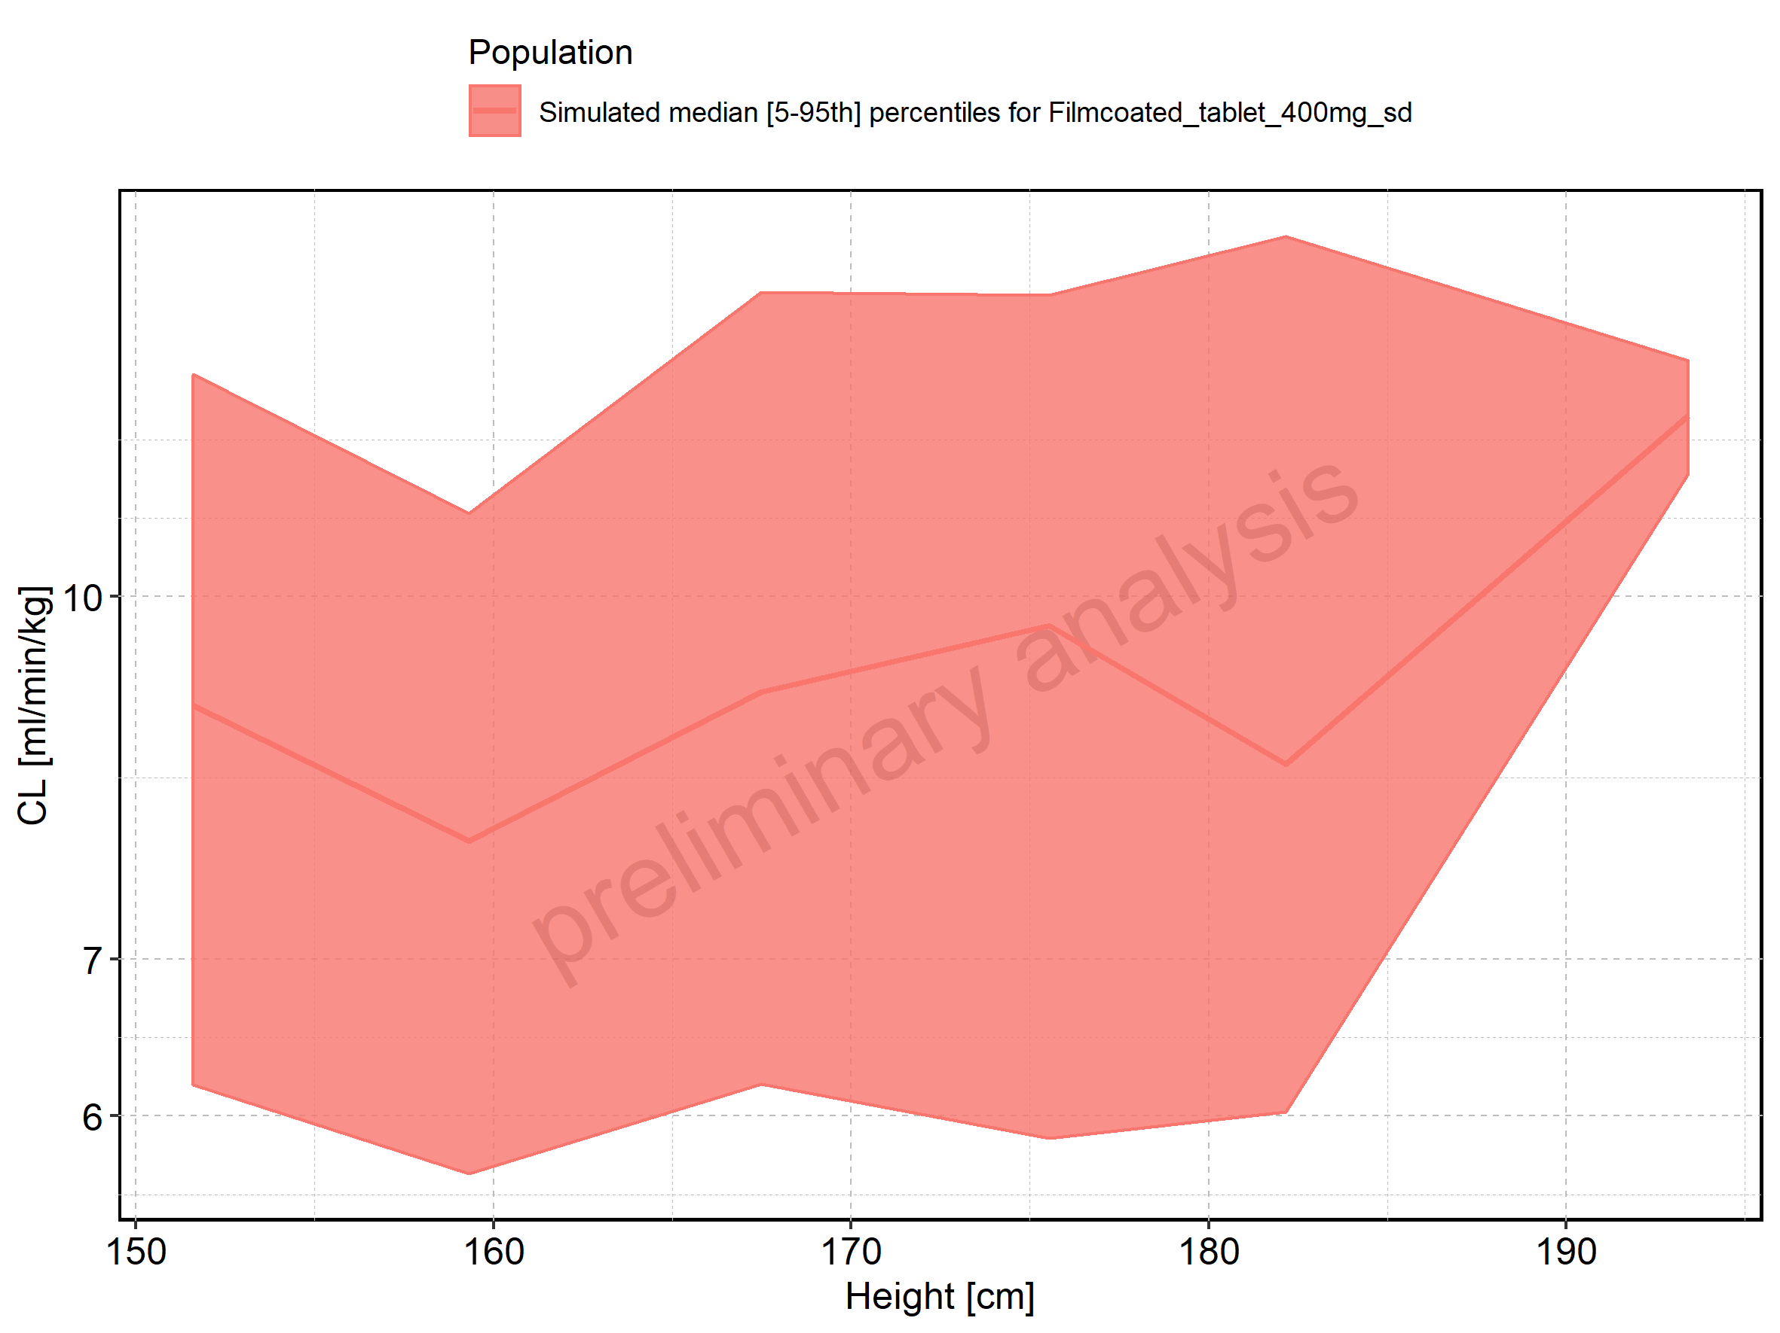

Figure 285: Weight-dependence of CL for Larson 2013 8y-18y 400mg FCT meal in comparison to Filmcoated_tablet_400mg_sd. Profiles are plotted in a linear scale.

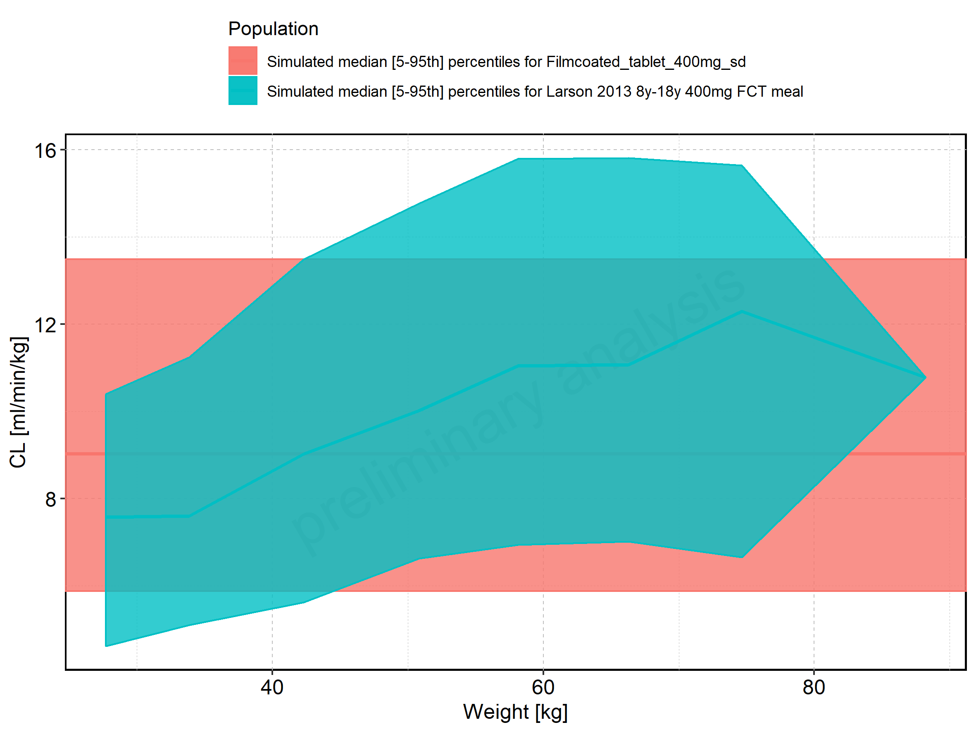

Figure 286: Weight-dependence of CL for Larson 2013 8y-18y 400mg FCT meal in comparison to Filmcoated_tablet_400mg_sd. Profiles are plotted in a logarithmic scale.

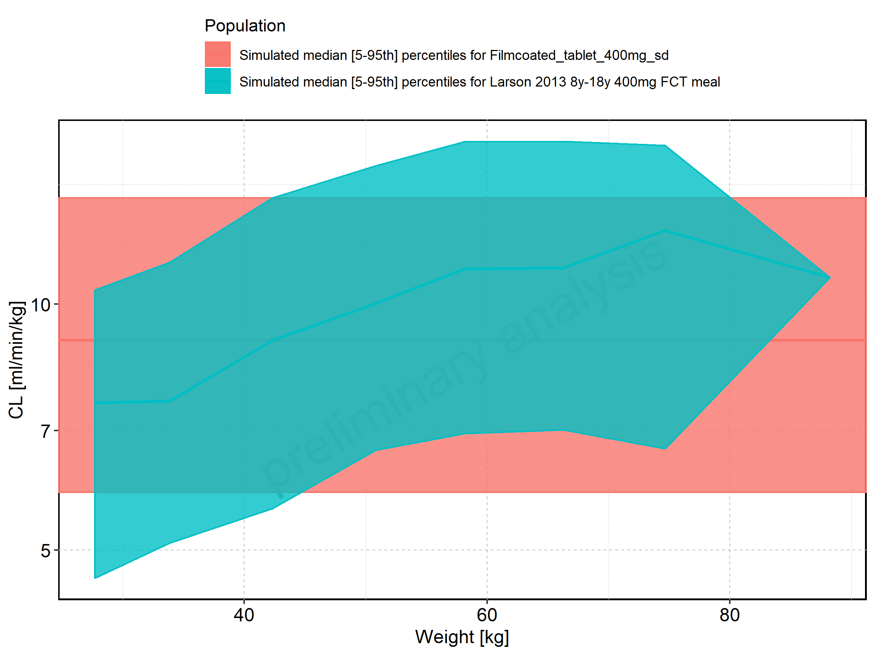

Figure 287: Weight-dependence of CL for Larson 2013 8y-18y 400mg FCT meal. Profiles are plotted in a linear scale.

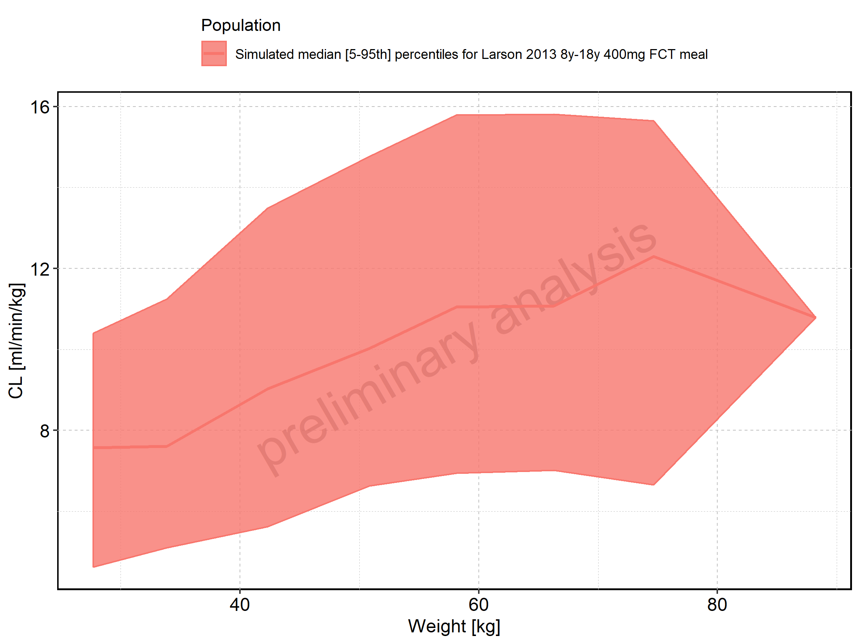

Figure 288: Weight-dependence of CL for Larson 2013 8y-18y 400mg FCT meal. Profiles are plotted in a logarithmic scale.

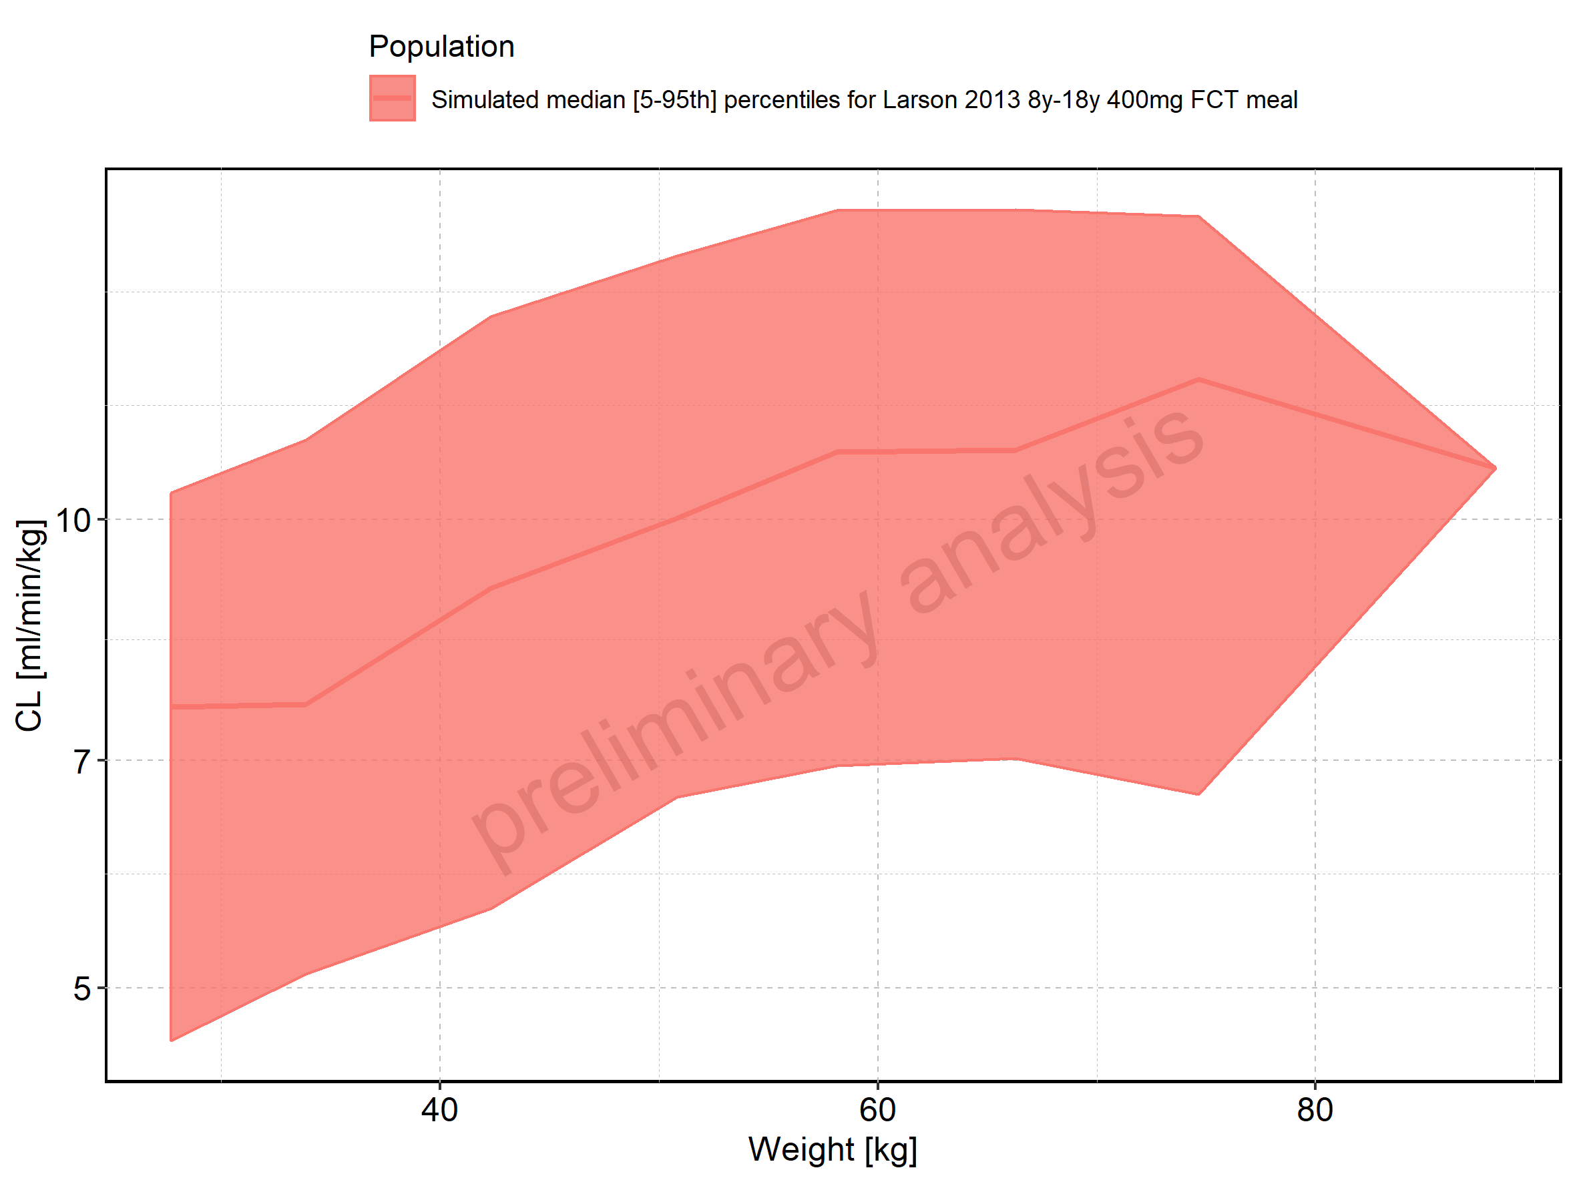

Figure 289: Weight-dependence of CL for Filmcoated_tablet_400mg_sd. Profiles are plotted in a linear scale.

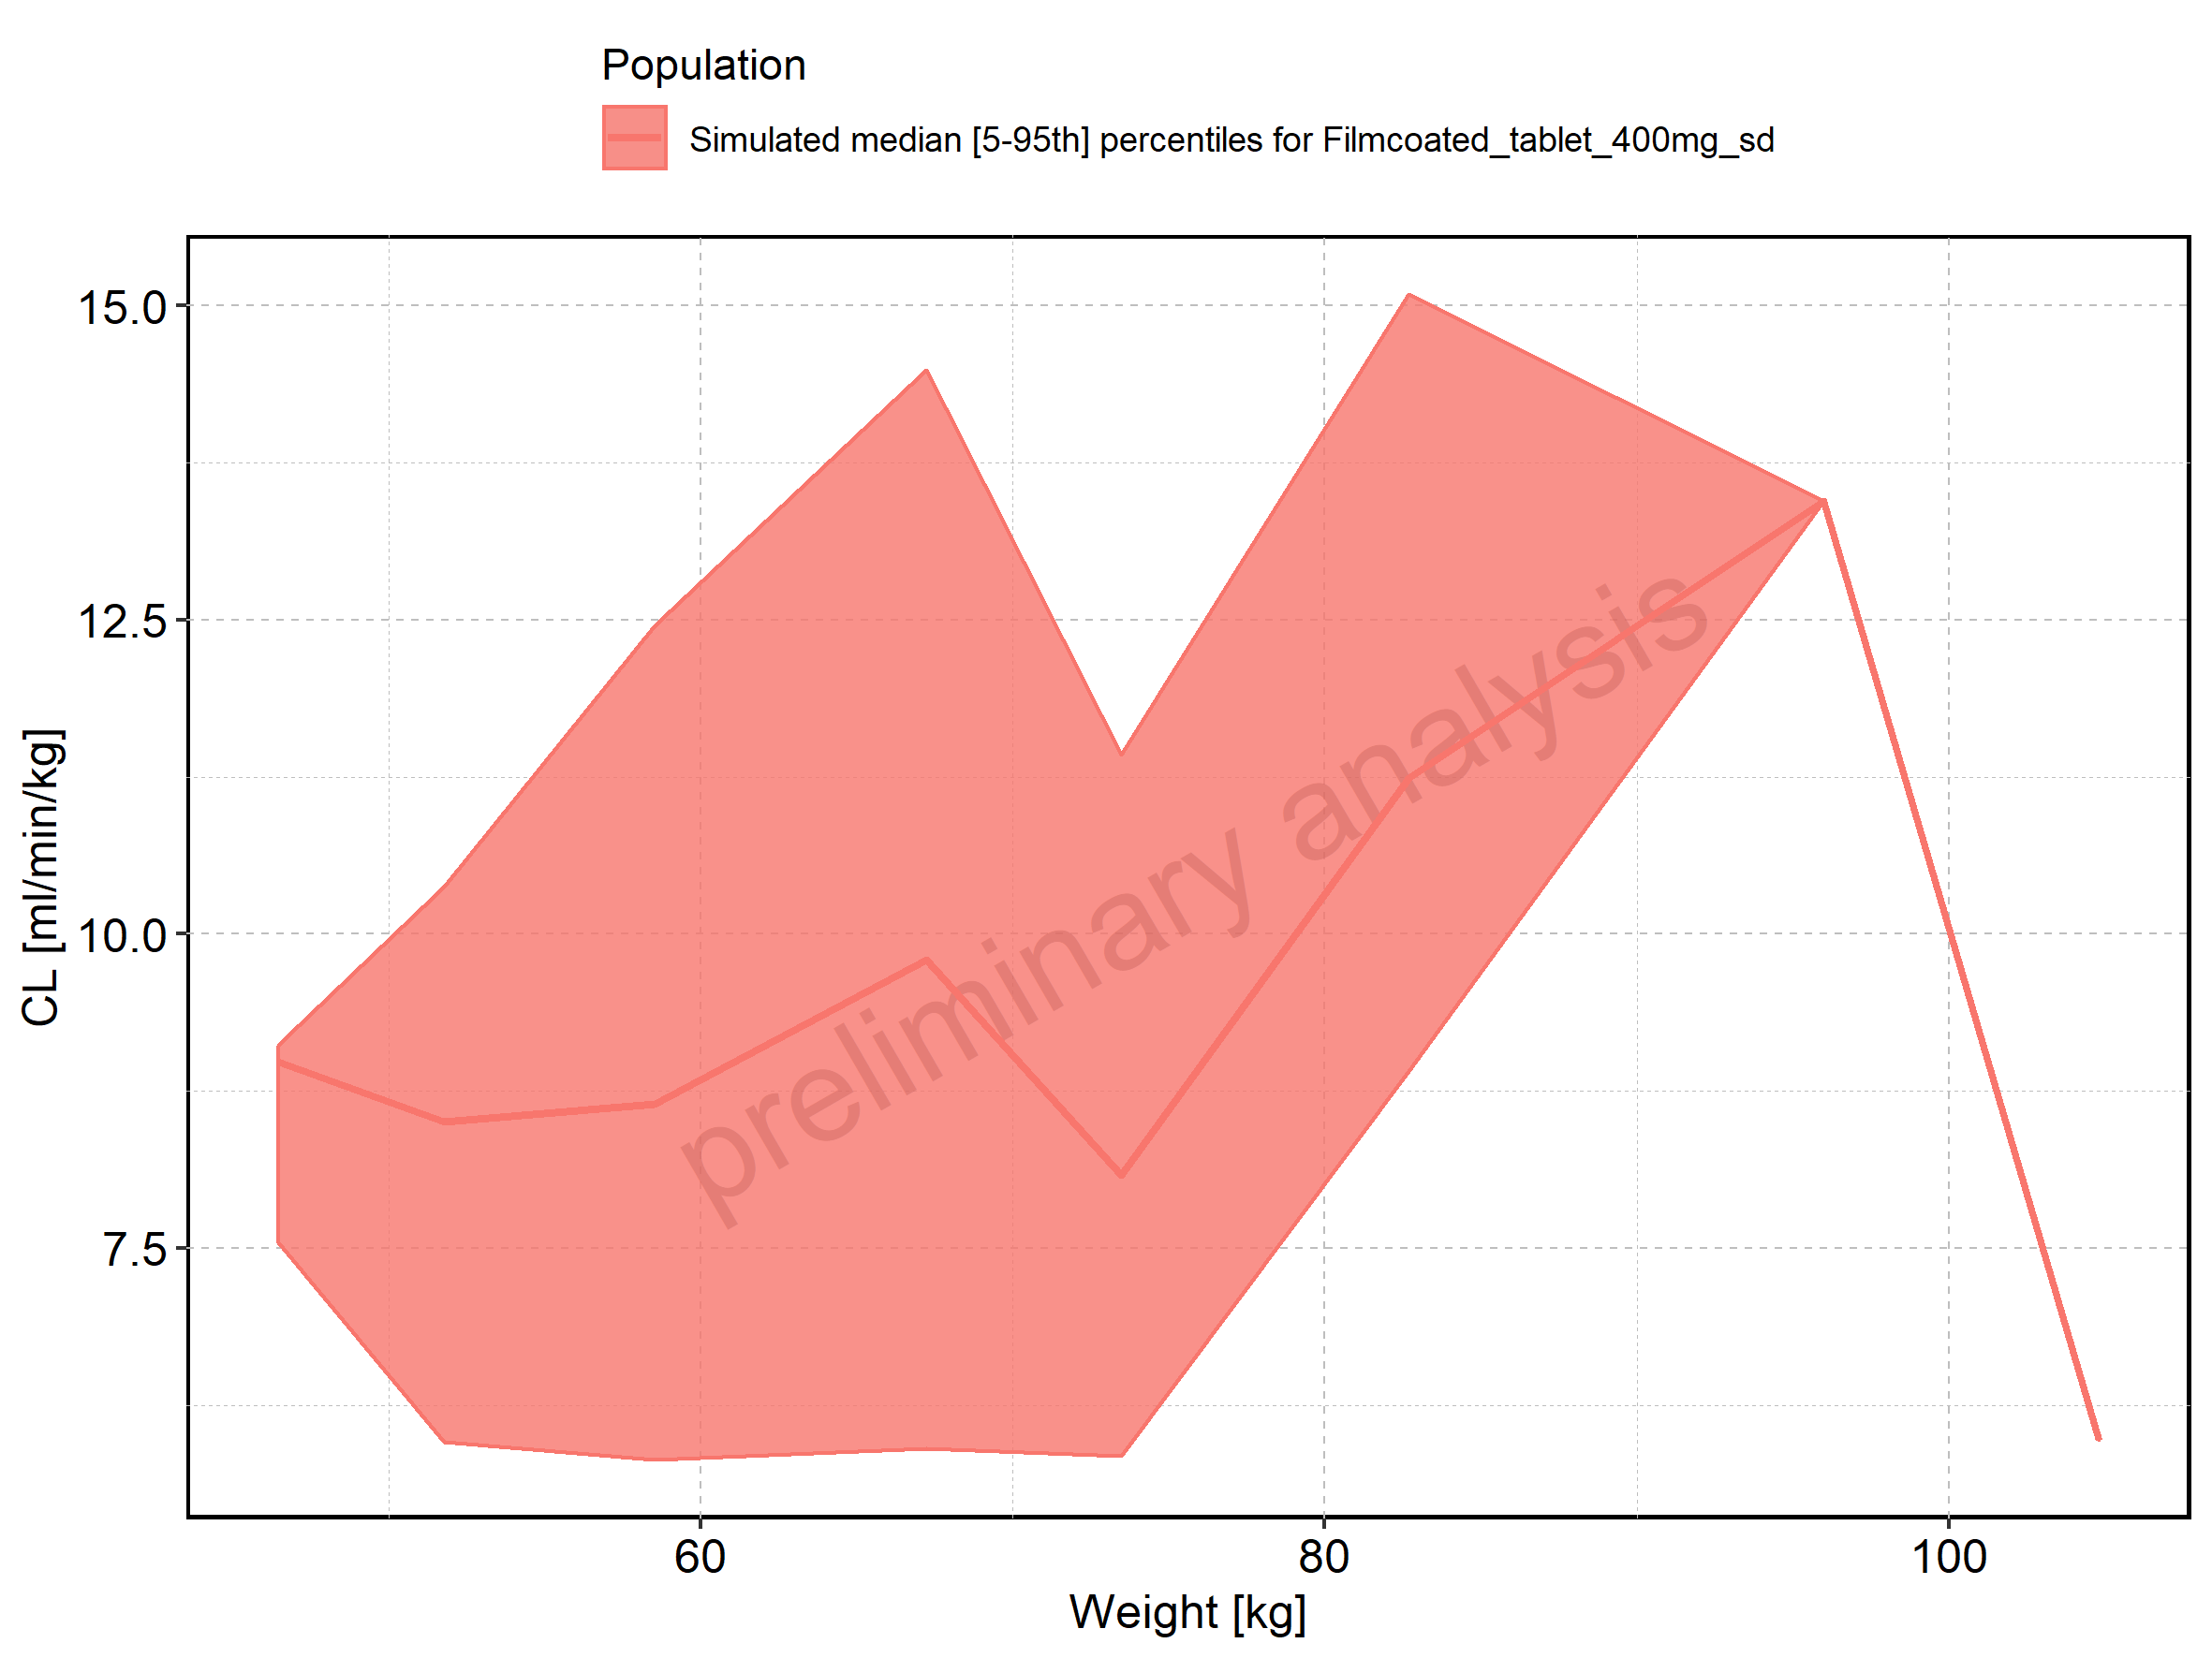

Figure 290: Weight-dependence of CL for Filmcoated_tablet_400mg_sd. Profiles are plotted in a logarithmic scale.

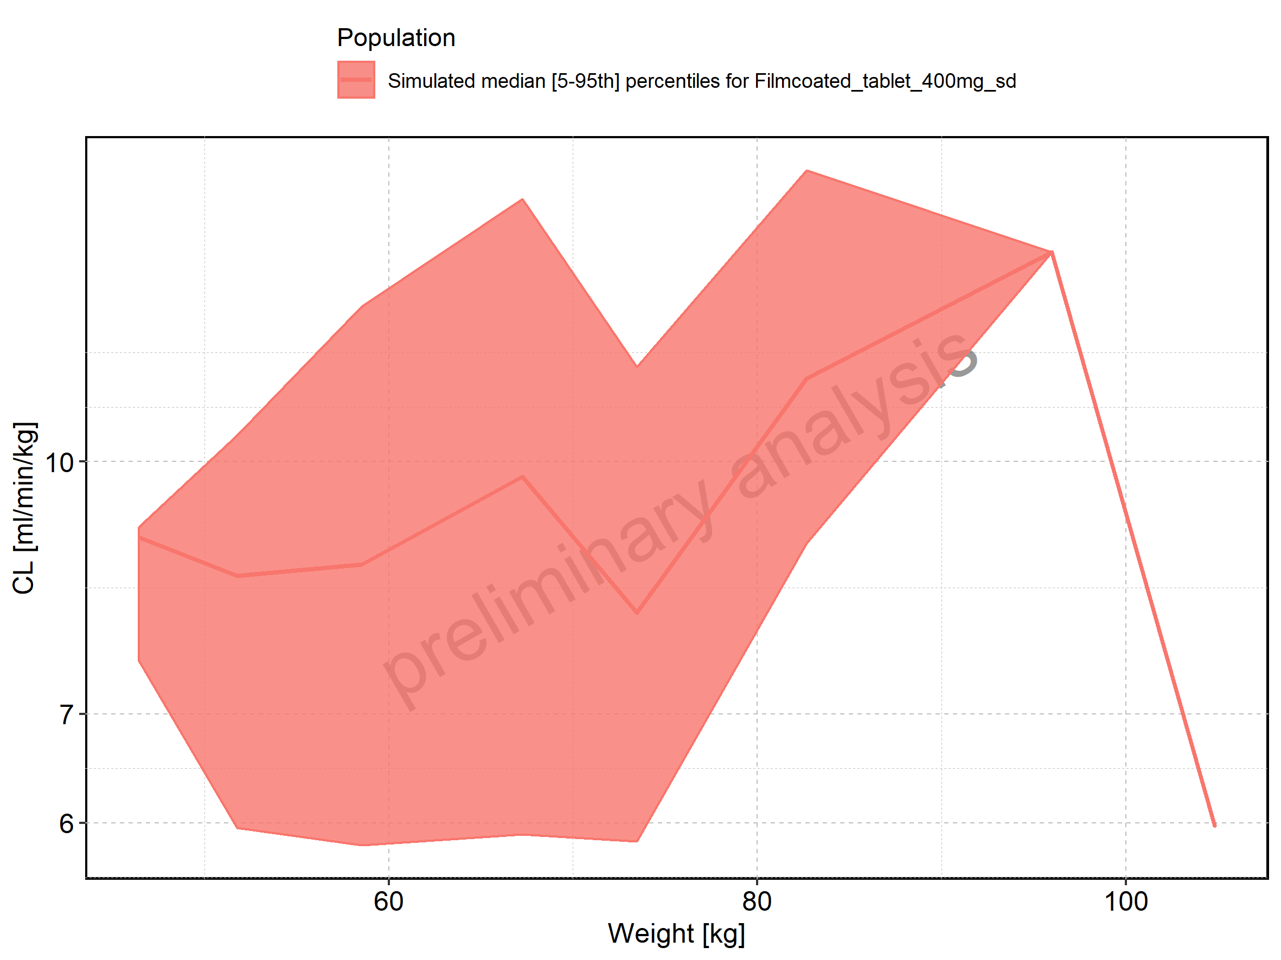

Figure 291: BMI-dependence of CL for Larson 2013 8y-18y 400mg FCT meal in comparison to Filmcoated_tablet_400mg_sd. Profiles are plotted in a linear scale.

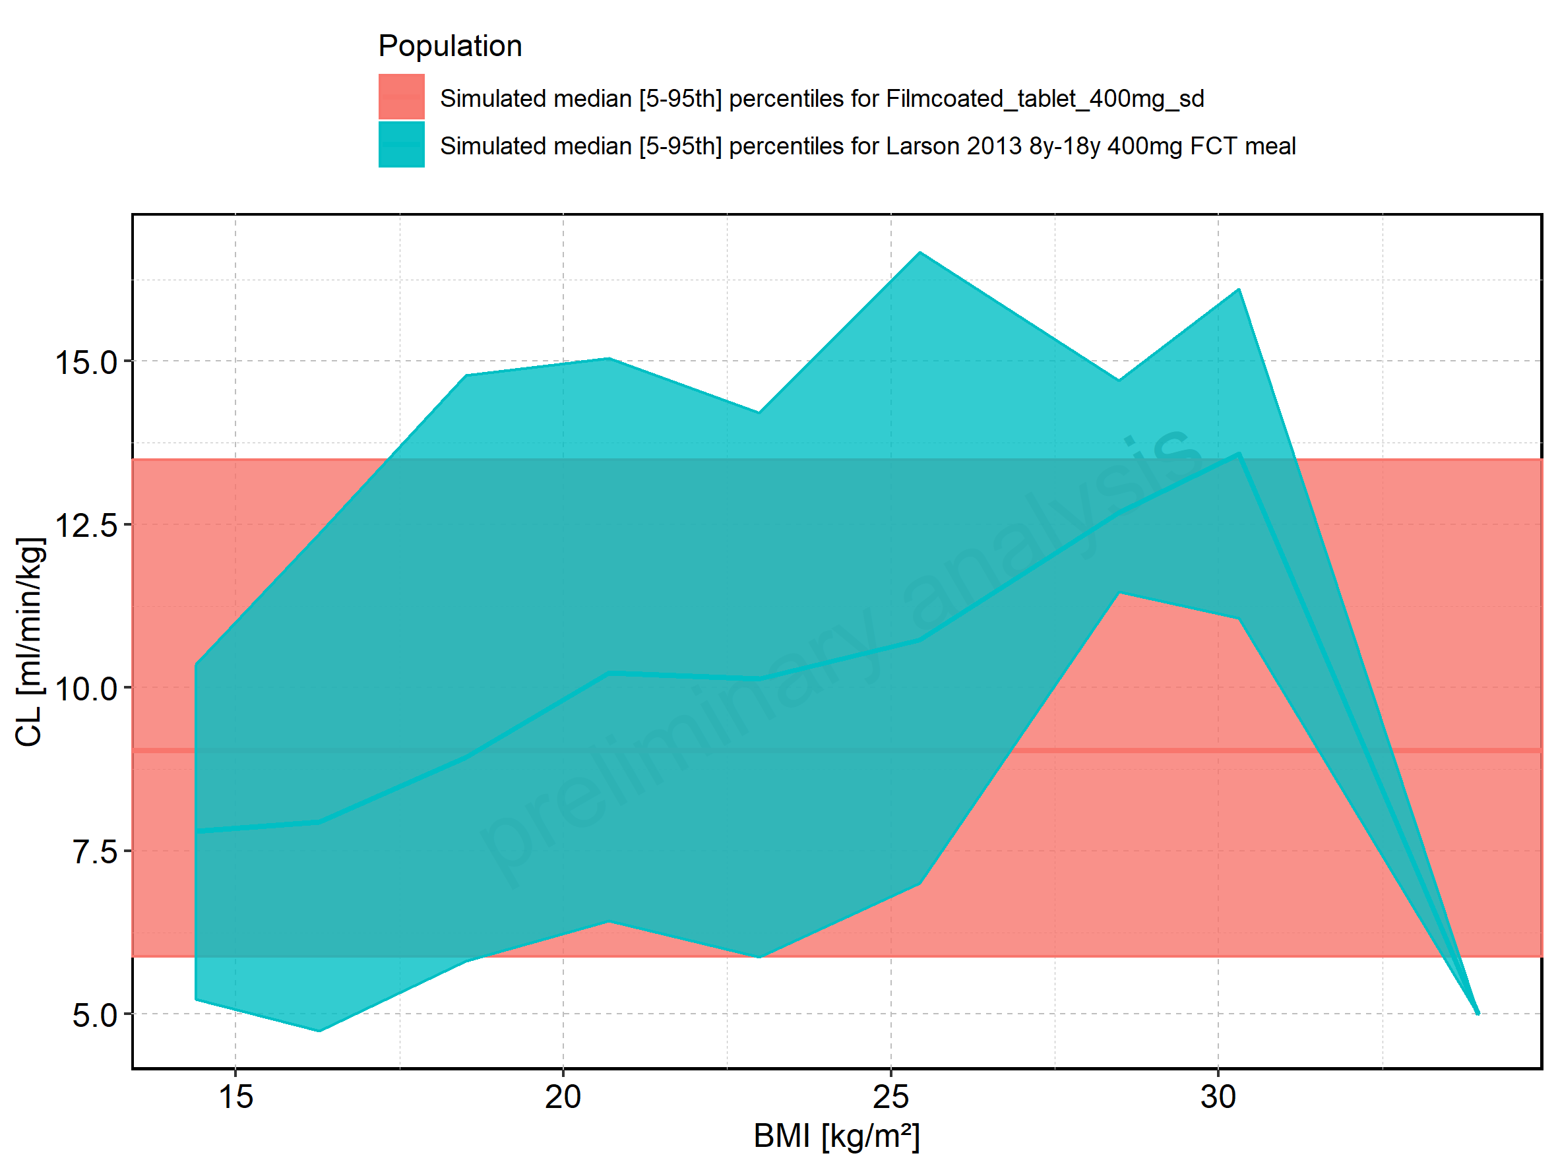

Figure 292: BMI-dependence of CL for Larson 2013 8y-18y 400mg FCT meal in comparison to Filmcoated_tablet_400mg_sd. Profiles are plotted in a logarithmic scale.

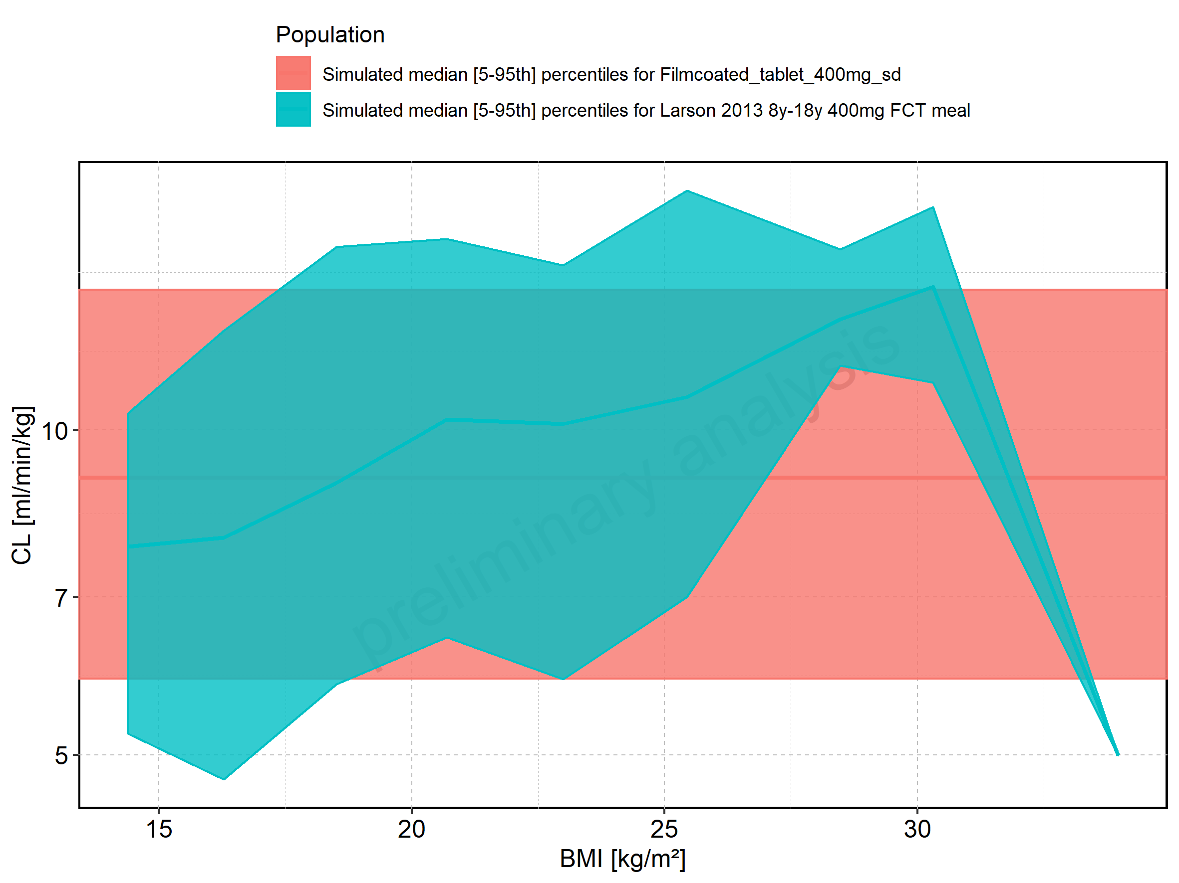

Figure 293: BMI-dependence of CL for Larson 2013 8y-18y 400mg FCT meal. Profiles are plotted in a linear scale.

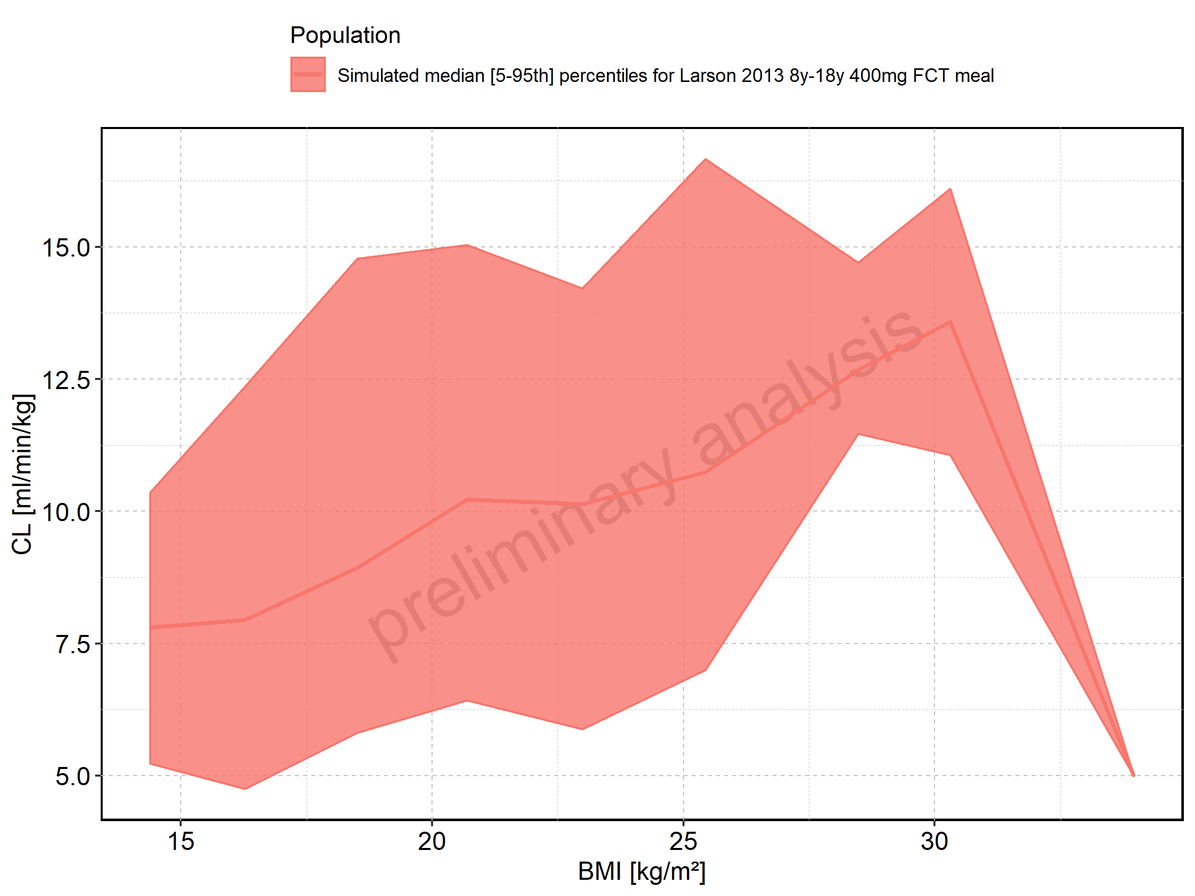

Figure 294: BMI-dependence of CL for Larson 2013 8y-18y 400mg FCT meal. Profiles are plotted in a logarithmic scale.

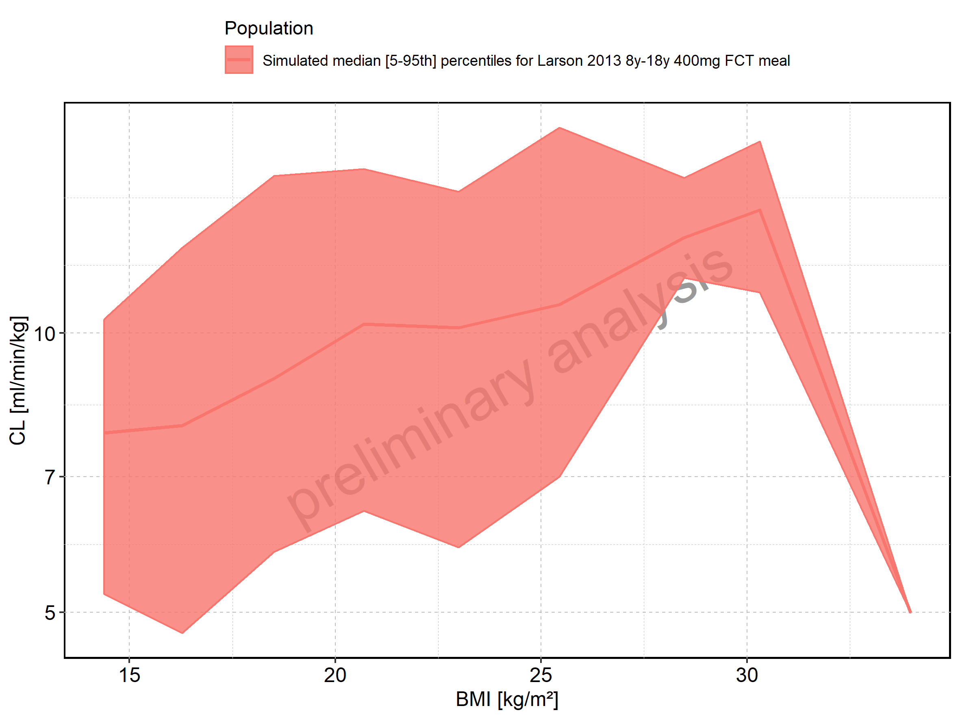

Figure 295: BMI-dependence of CL for Filmcoated_tablet_400mg_sd. Profiles are plotted in a linear scale.

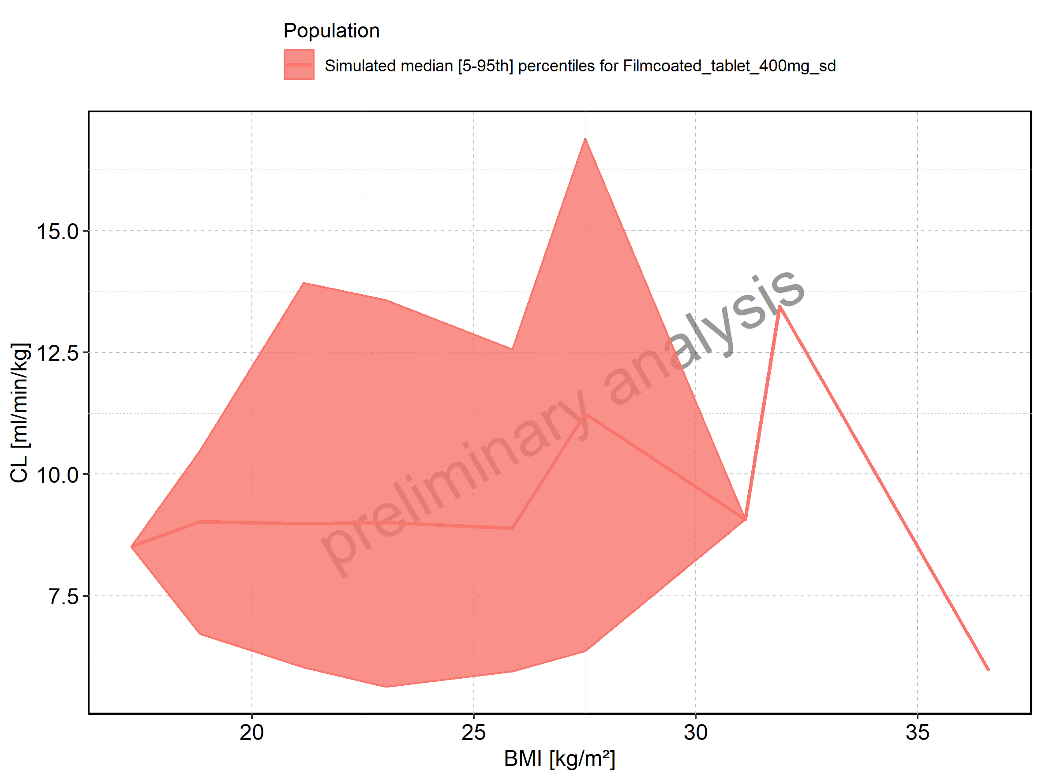

Figure 296: BMI-dependence of CL for Filmcoated_tablet_400mg_sd. Profiles are plotted in a logarithmic scale.

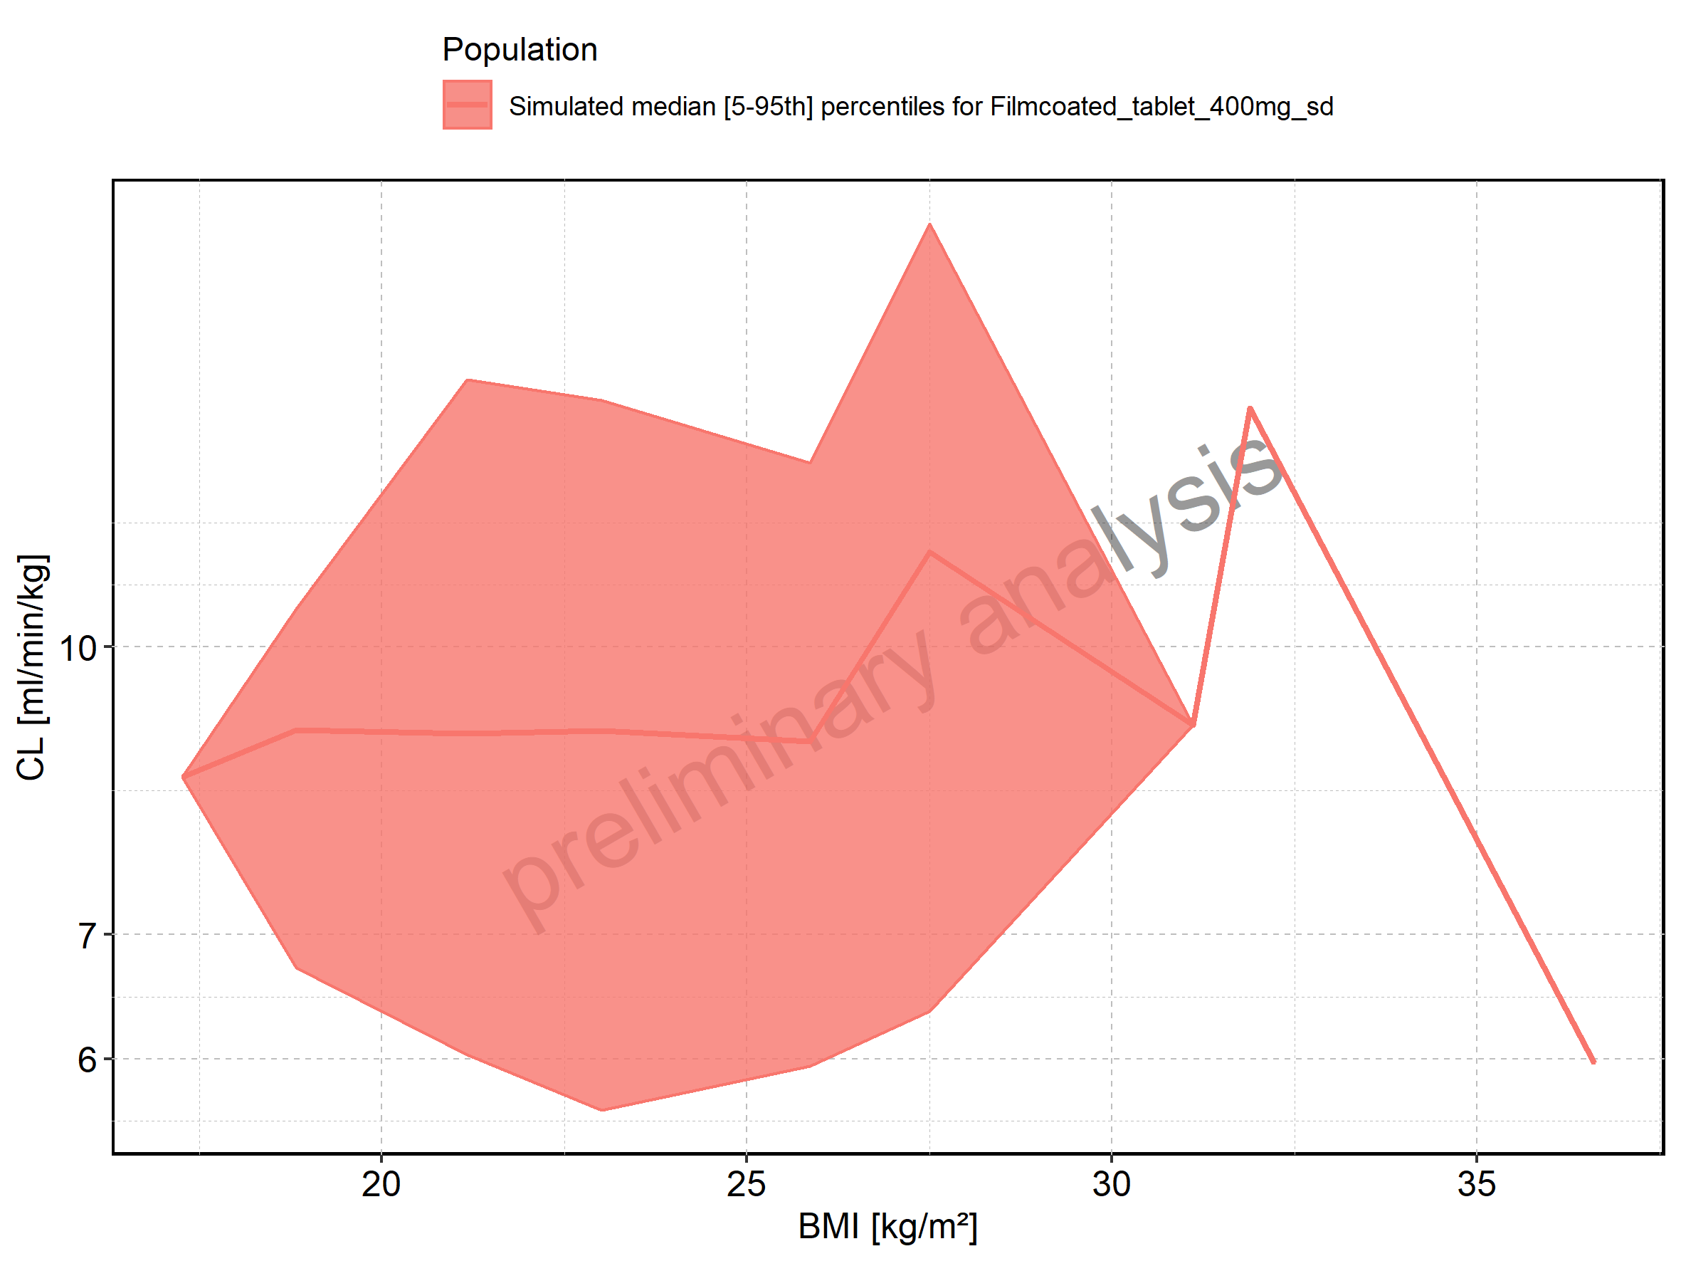

Figure 297: Vss of Raltegravir shown as box-whisker plot, which indicates the 5th, 25th, 50th, 75th, and 95th percentiles in linear scale.

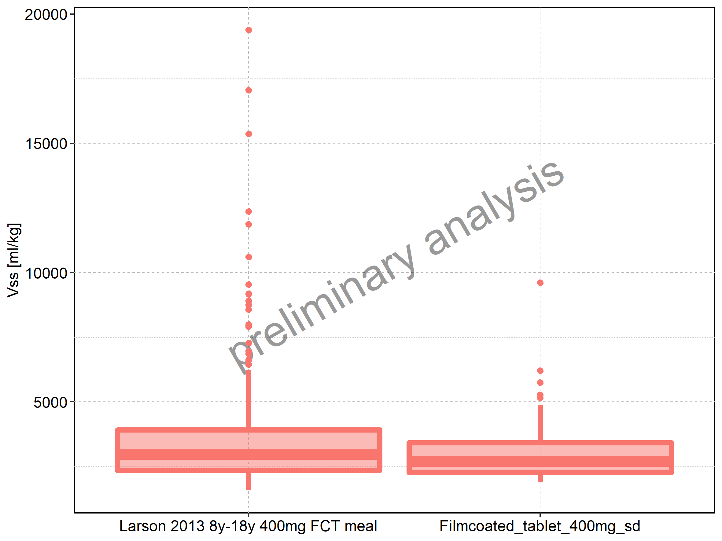

|  |  |  |  |  |  |  |  |  |  |  |
| --- | --- | --- | --- | --- | --- | --- | --- | --- | --- | --- |
| Population | N | 5th percentile | 25th percentile | 50th percentile | 75th percentile | 95th percentile | mean | standard deviation | geo mean | geo standard deviation |
| Larson 2013 8y-18y 400mg FCT meal | 497 | 1581.086 | 2341.616 | 2968.180 | 3917.840 | 6249.022 | 3396.631 | 1880.065 | 3071.484 | 1.528280 |
| Filmcoated_tablet_400mg_sd | 100 | 1880.267 | 2263.552 | 2695.832 | 3418.902 | 4890.574 | 2993.695 | 1138.953 | 2836.187 | 1.369004 |

Figure 298: Vss of Raltegravir shown as box-whisker plot, which indicates the 5th, 25th, 50th, 75th, and 95th percentiles in logarithmic scale.

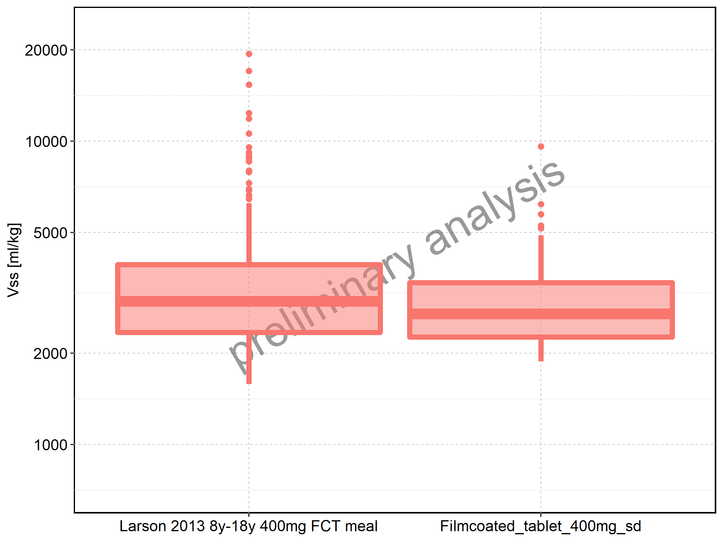

Figure 299: Age-dependence of Vss for Larson 2013 8y-18y 400mg FCT meal in comparison to Filmcoated_tablet_400mg_sd. Profiles are plotted in a linear scale.

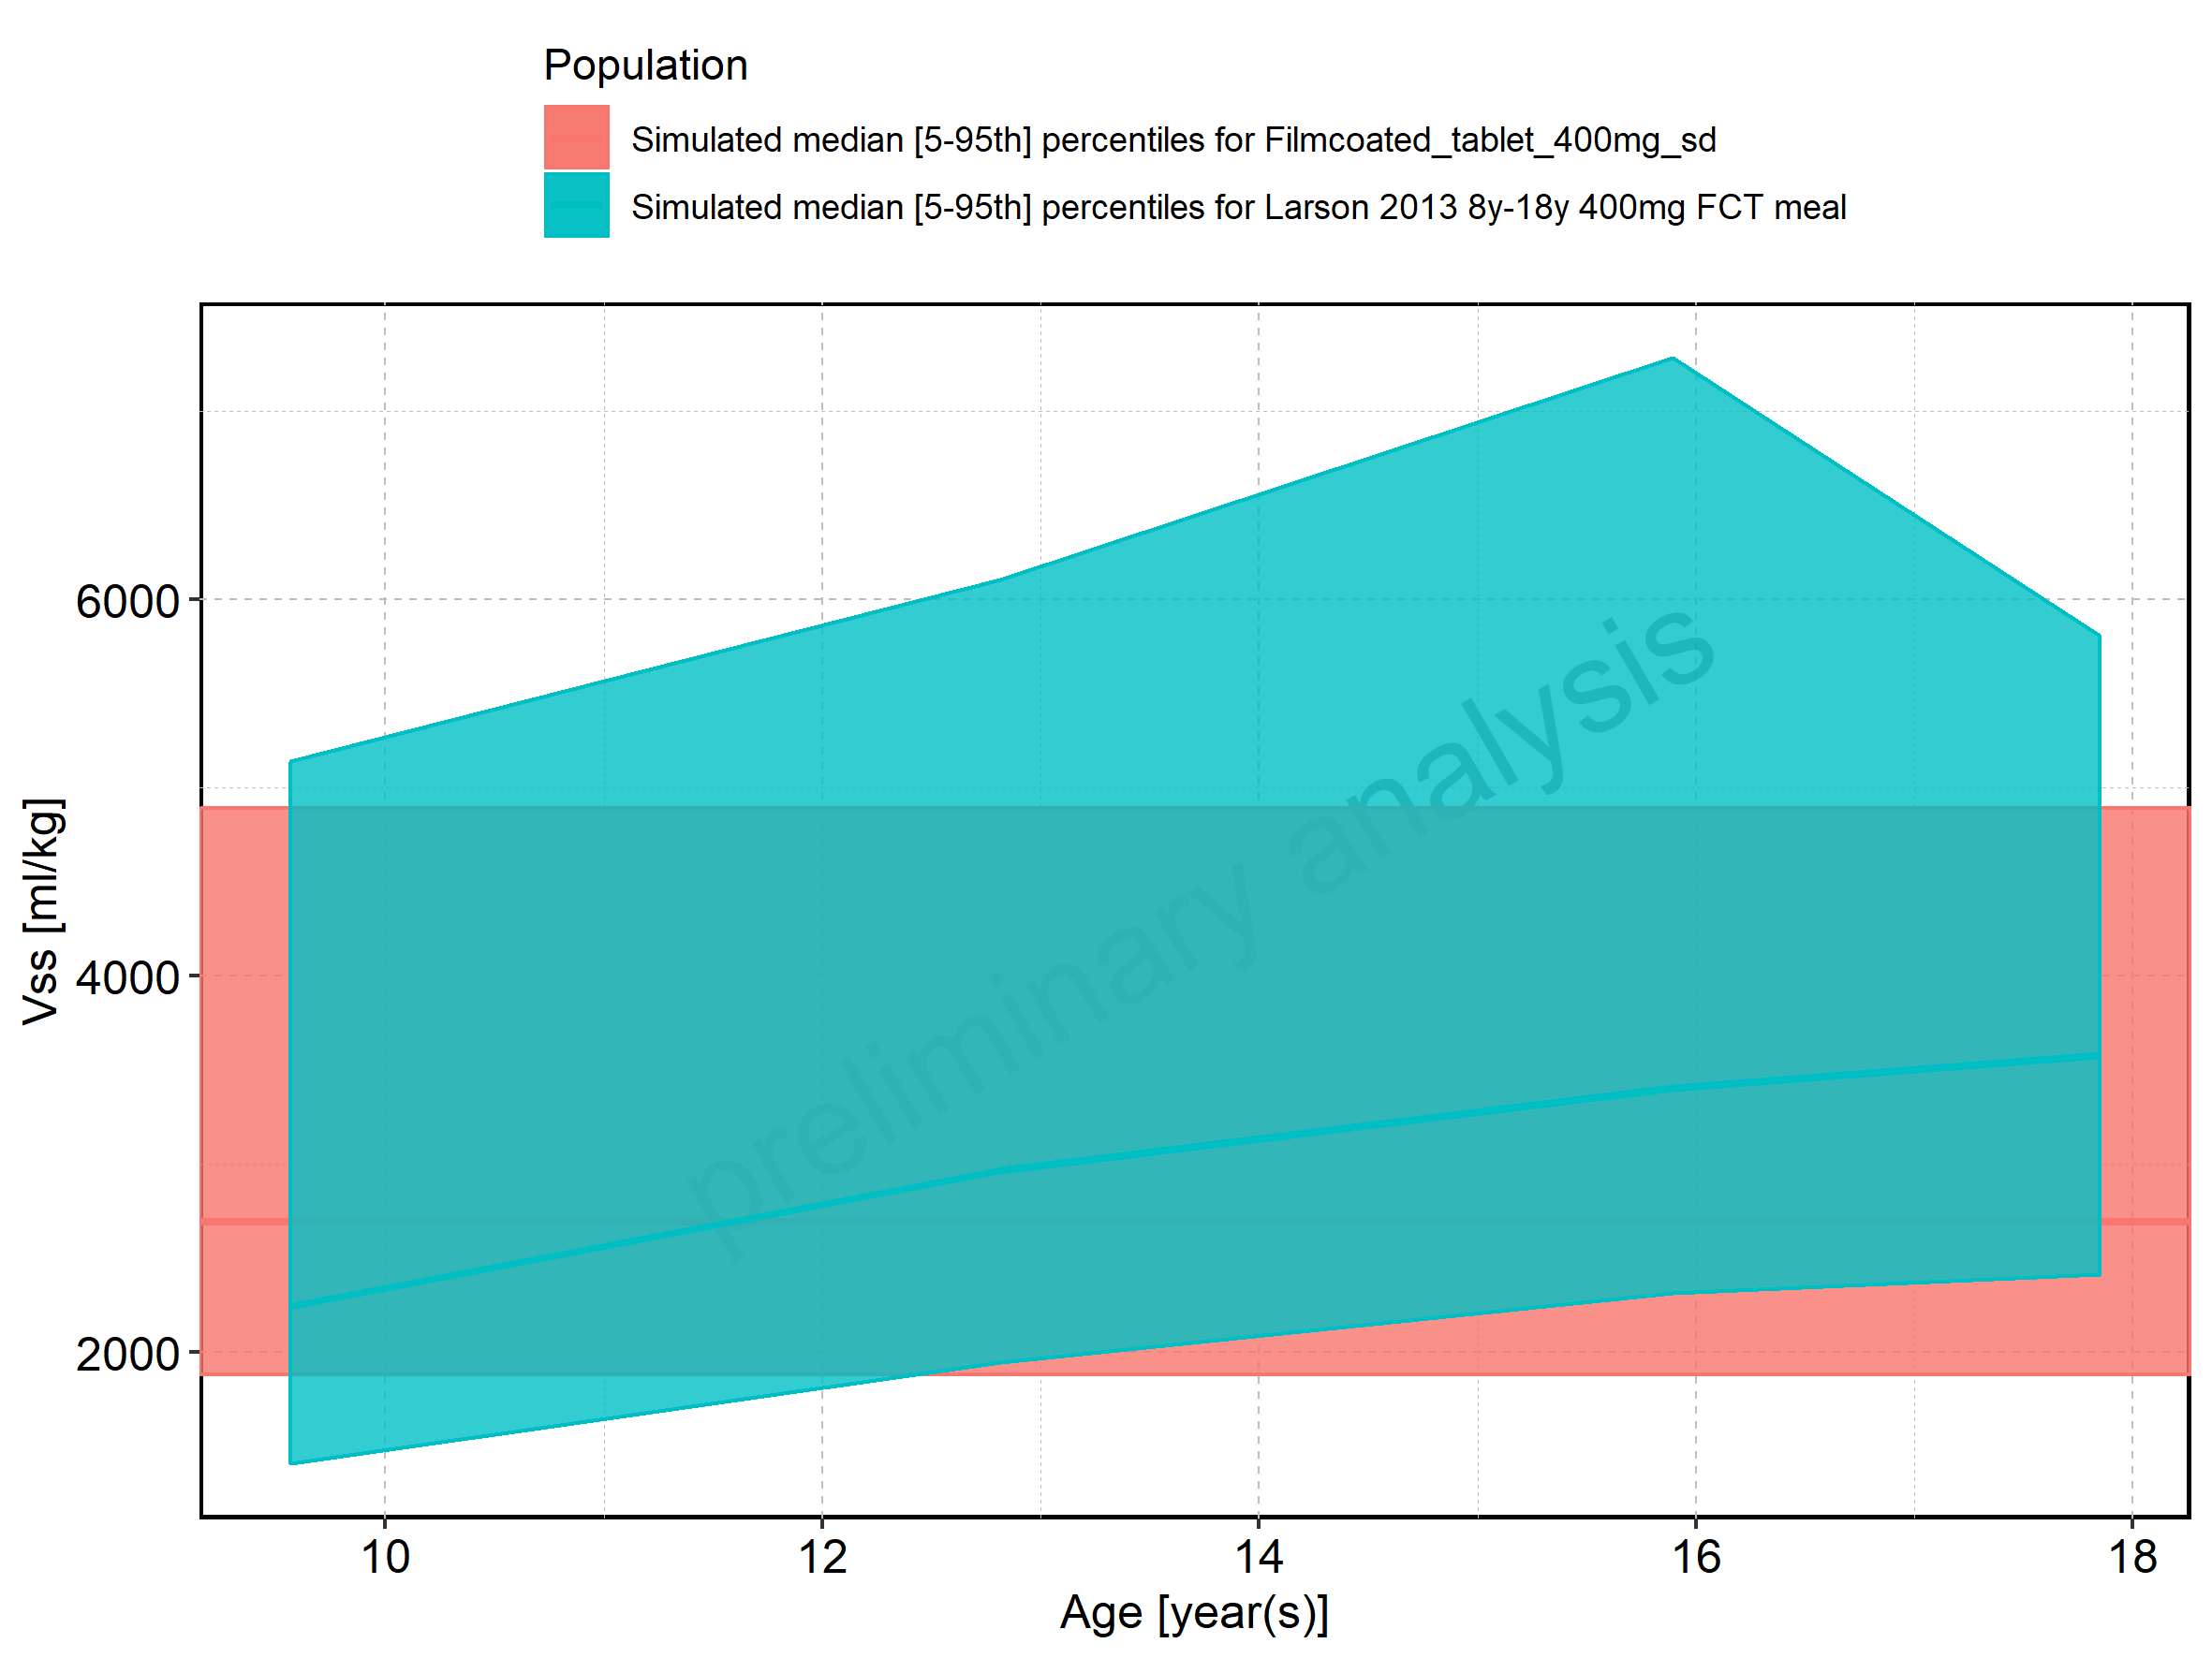

Figure 300: Age-dependence of Vss for Larson 2013 8y-18y 400mg FCT meal in comparison to Filmcoated_tablet_400mg_sd. Profiles are plotted in a logarithmic scale.

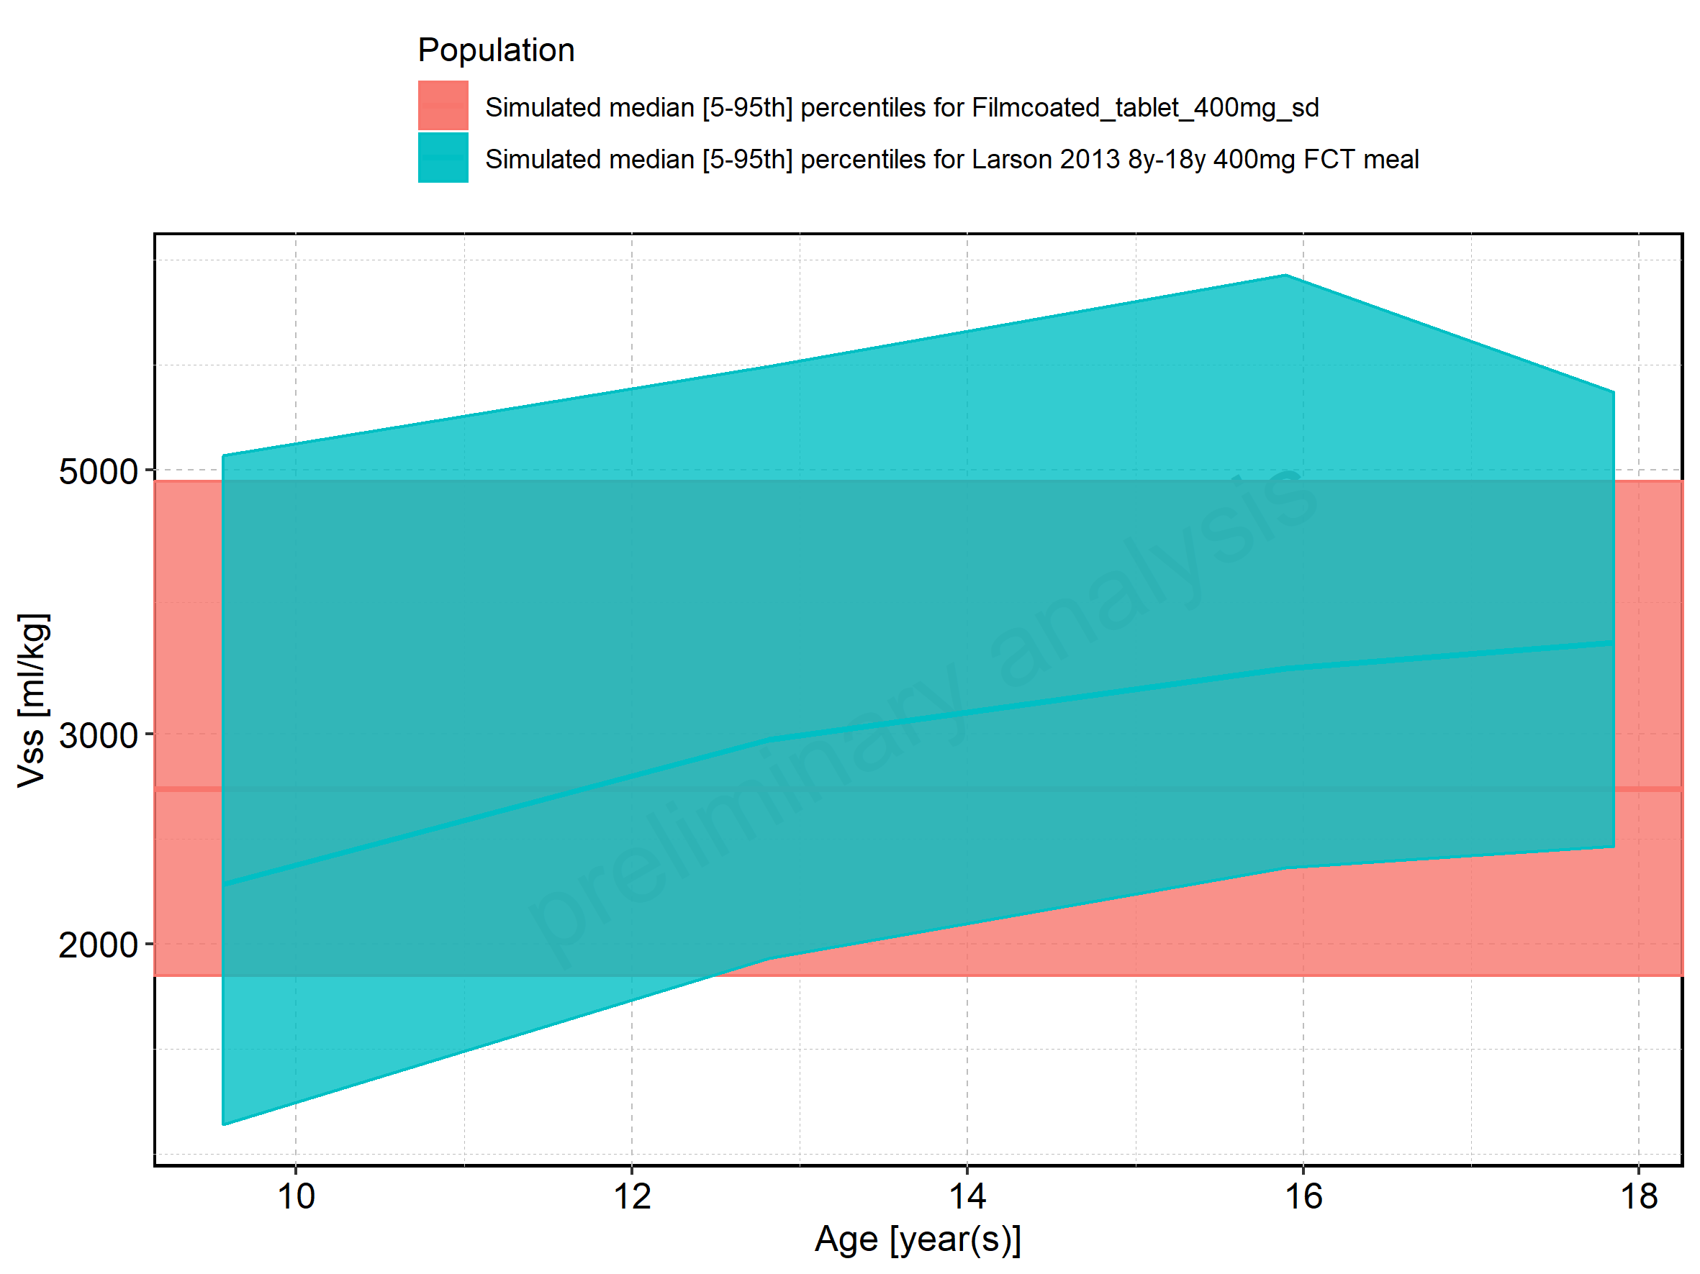

Figure 301: Age-dependence of Vss for Larson 2013 8y-18y 400mg FCT meal. Profiles are plotted in a linear scale.

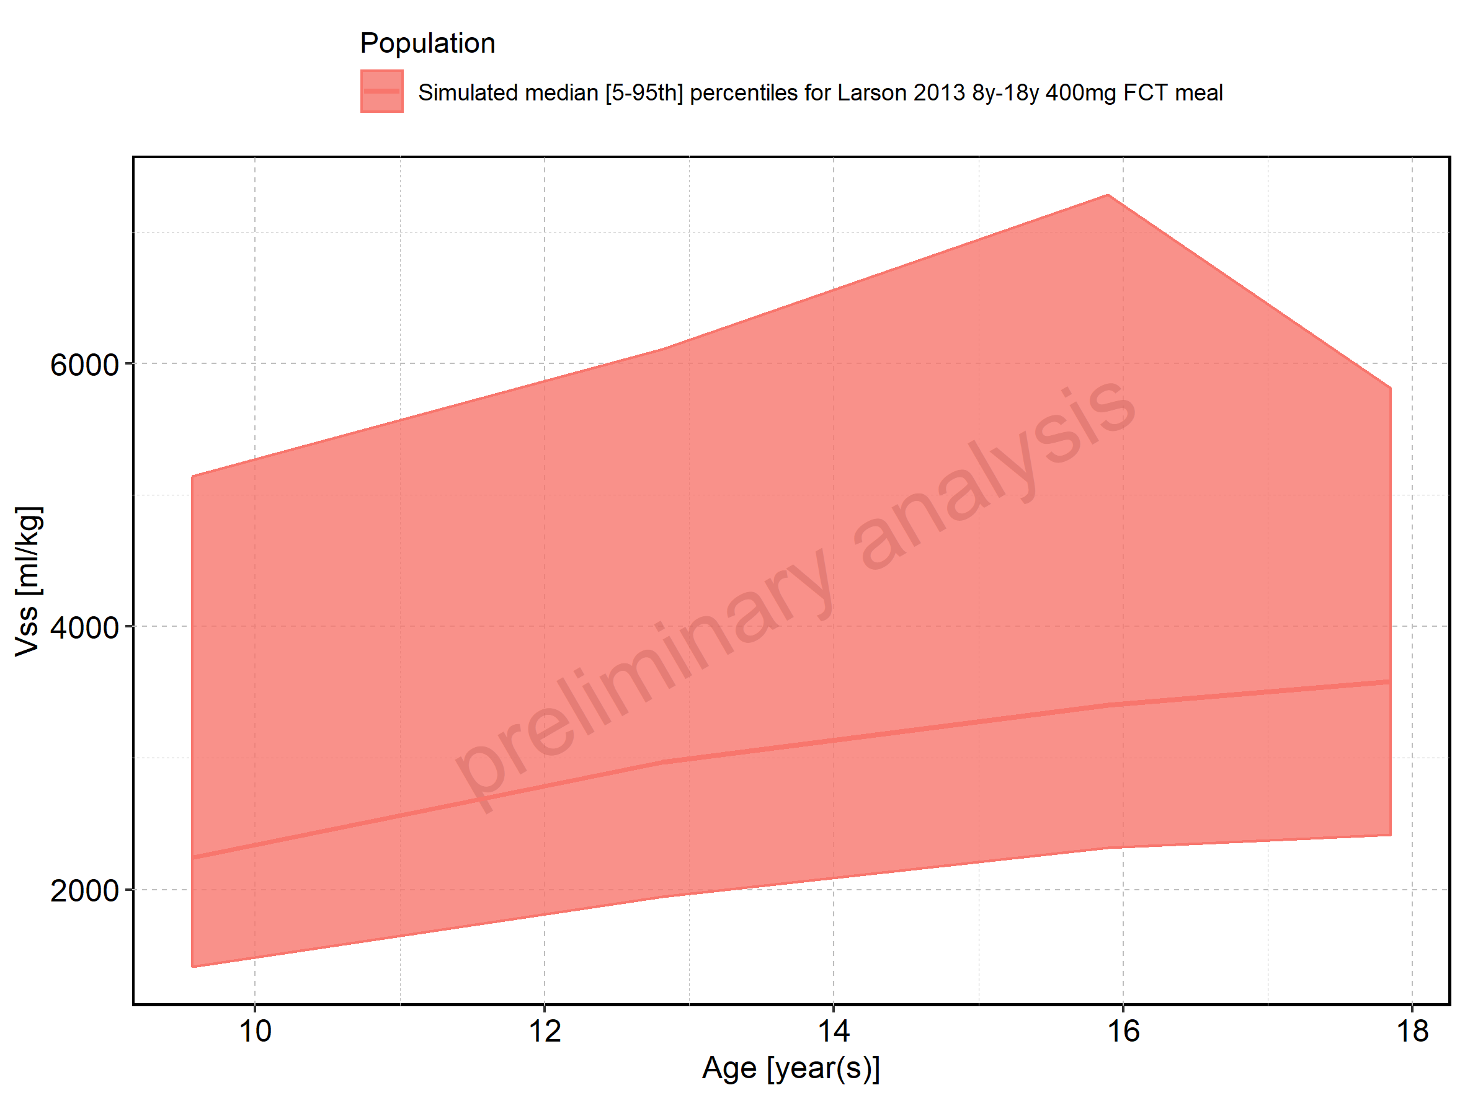

Figure 302: Age-dependence of Vss for Larson 2013 8y-18y 400mg FCT meal. Profiles are plotted in a logarithmic scale.

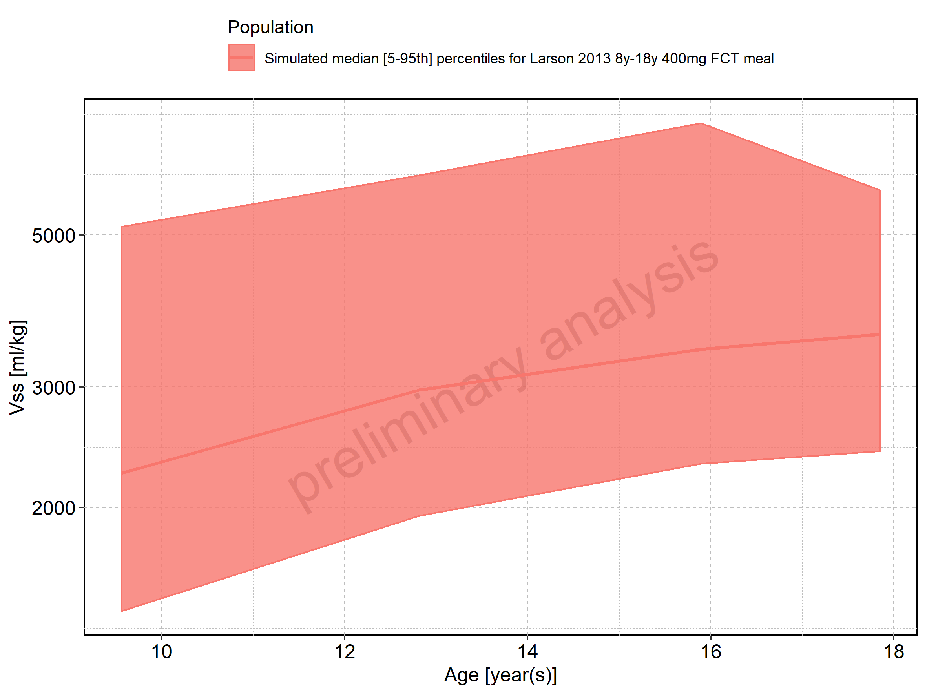

Figure 303: Age-dependence of Vss for Filmcoated_tablet_400mg_sd. Profiles are plotted in a linear scale.

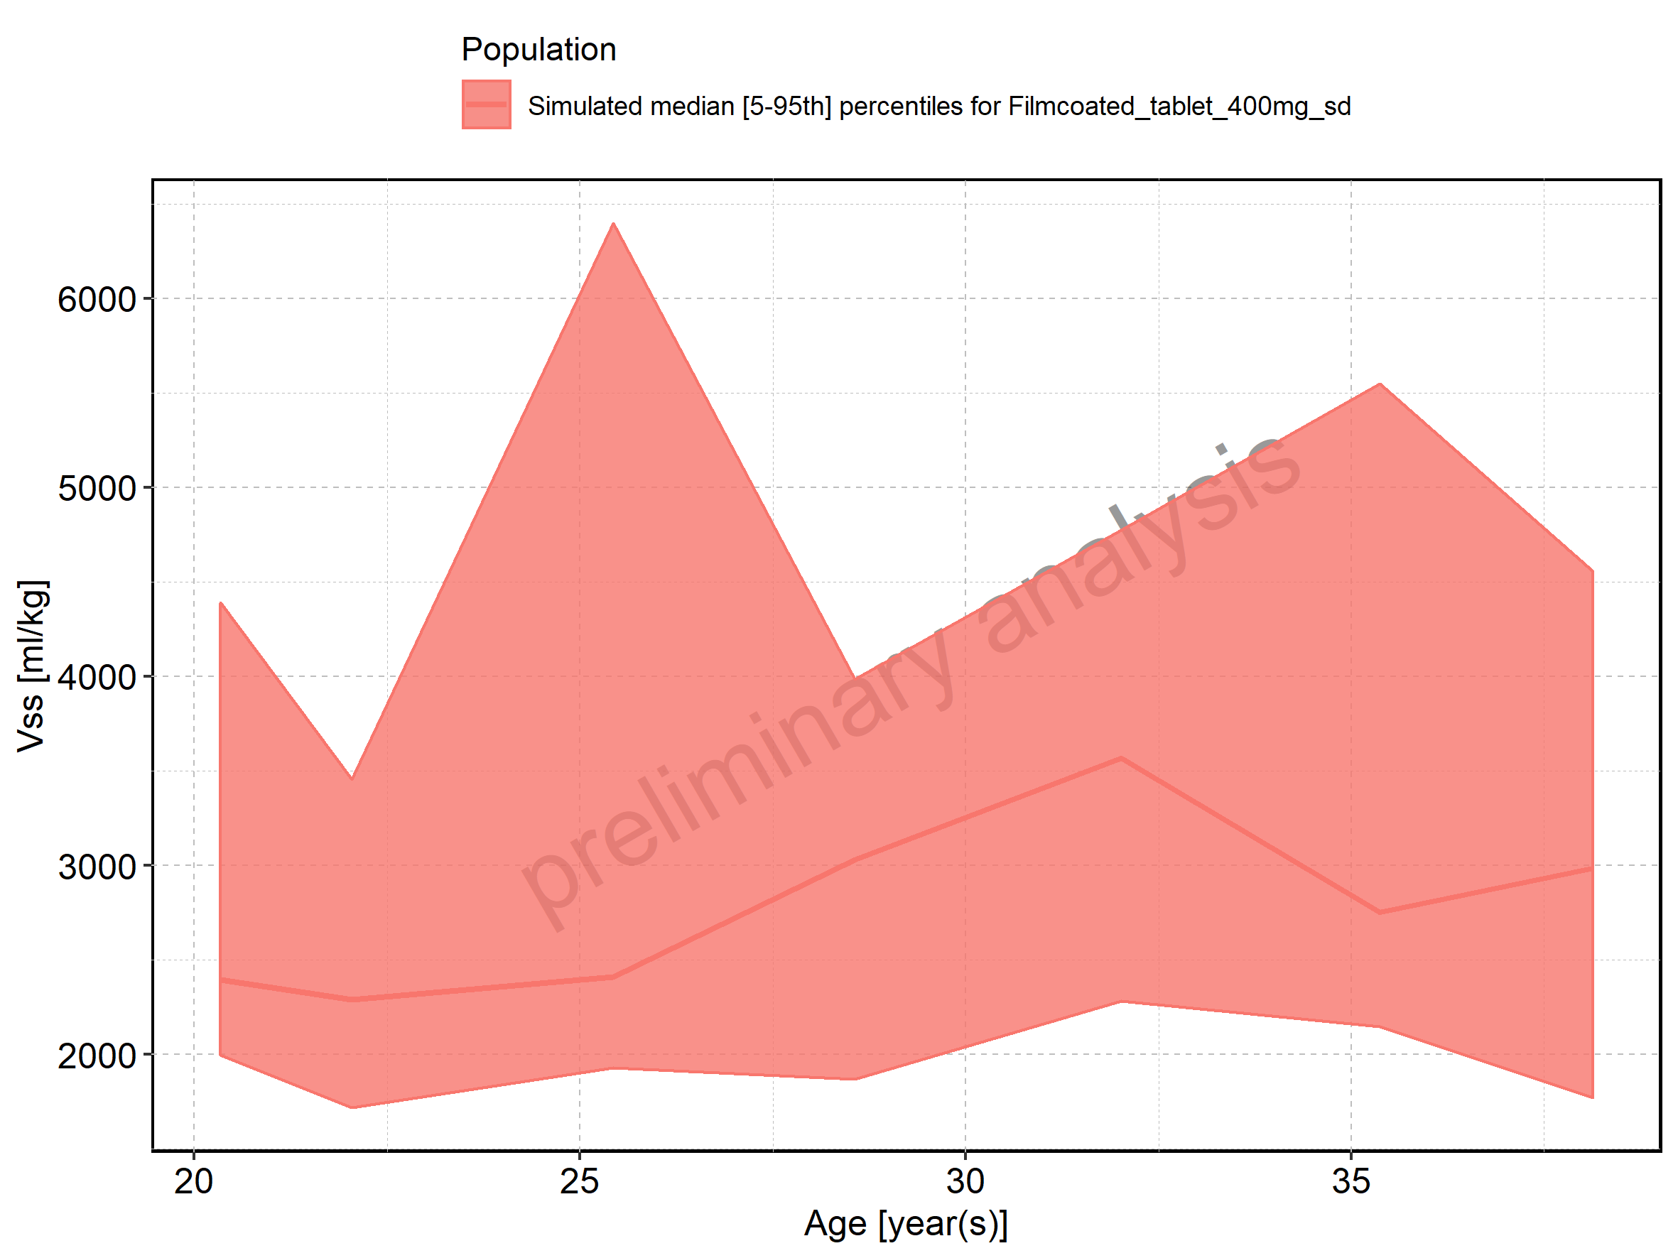

Figure 304: Age-dependence of Vss for Filmcoated_tablet_400mg_sd. Profiles are plotted in a logarithmic scale.

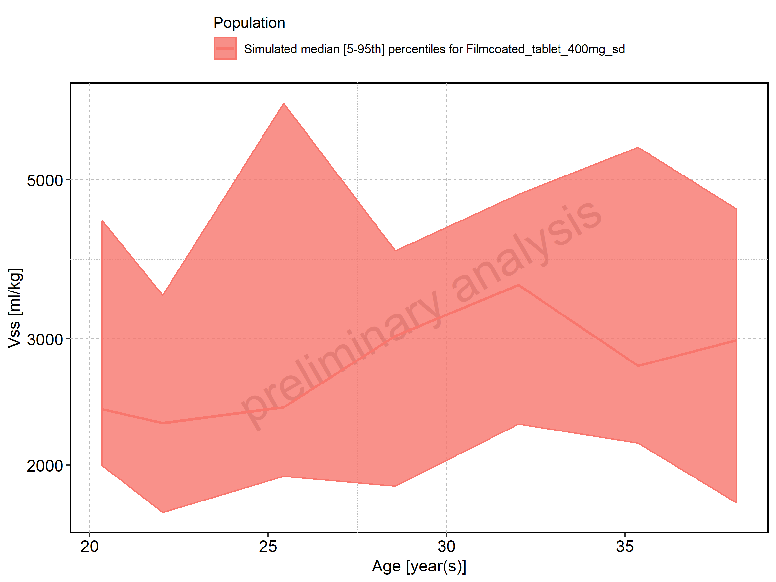

Figure 305: Height-dependence of Vss for Larson 2013 8y-18y 400mg FCT meal in comparison to Filmcoated_tablet_400mg_sd. Profiles are plotted in a linear scale.

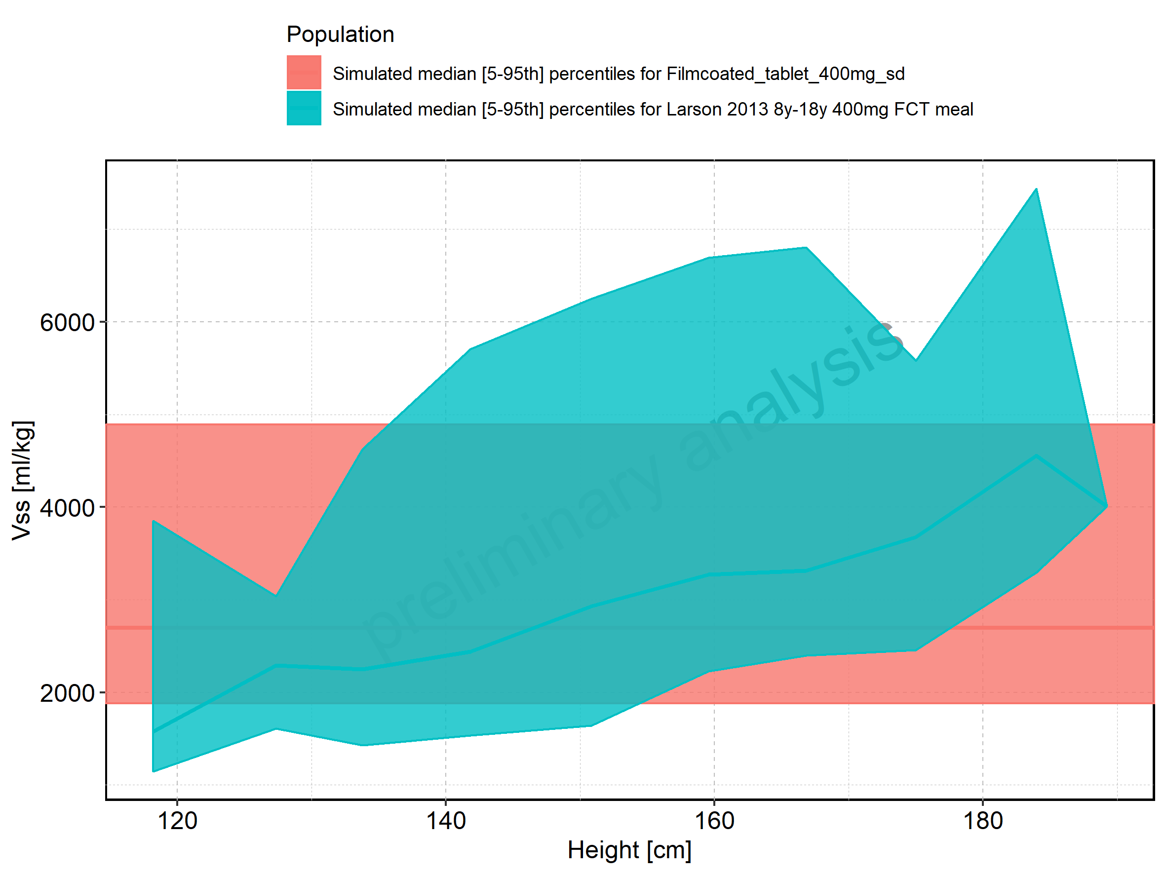

Figure 306: Height-dependence of Vss for Larson 2013 8y-18y 400mg FCT meal in comparison to Filmcoated_tablet_400mg_sd. Profiles are plotted in a logarithmic scale.

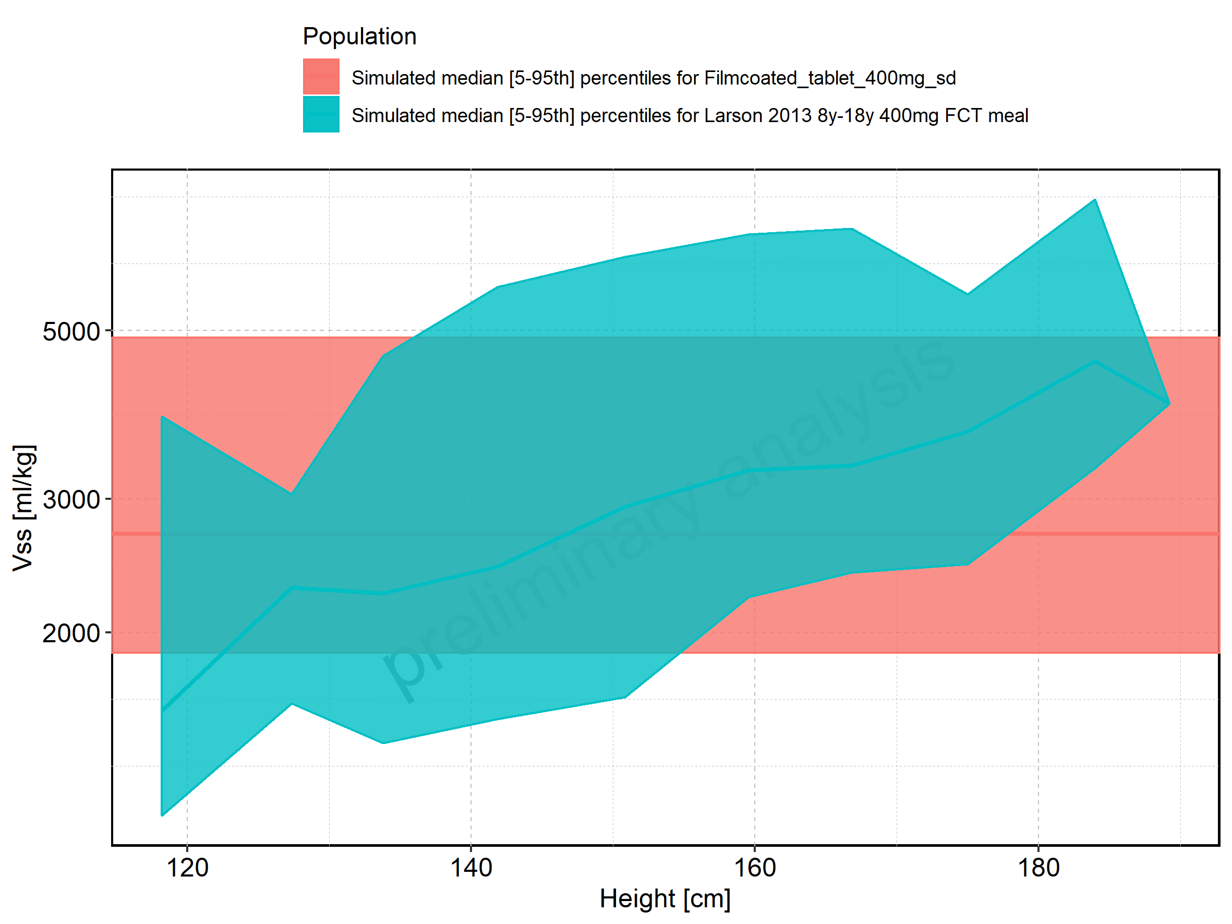

Figure 307: Height-dependence of Vss for Larson 2013 8y-18y 400mg FCT meal. Profiles are plotted in a linear scale.

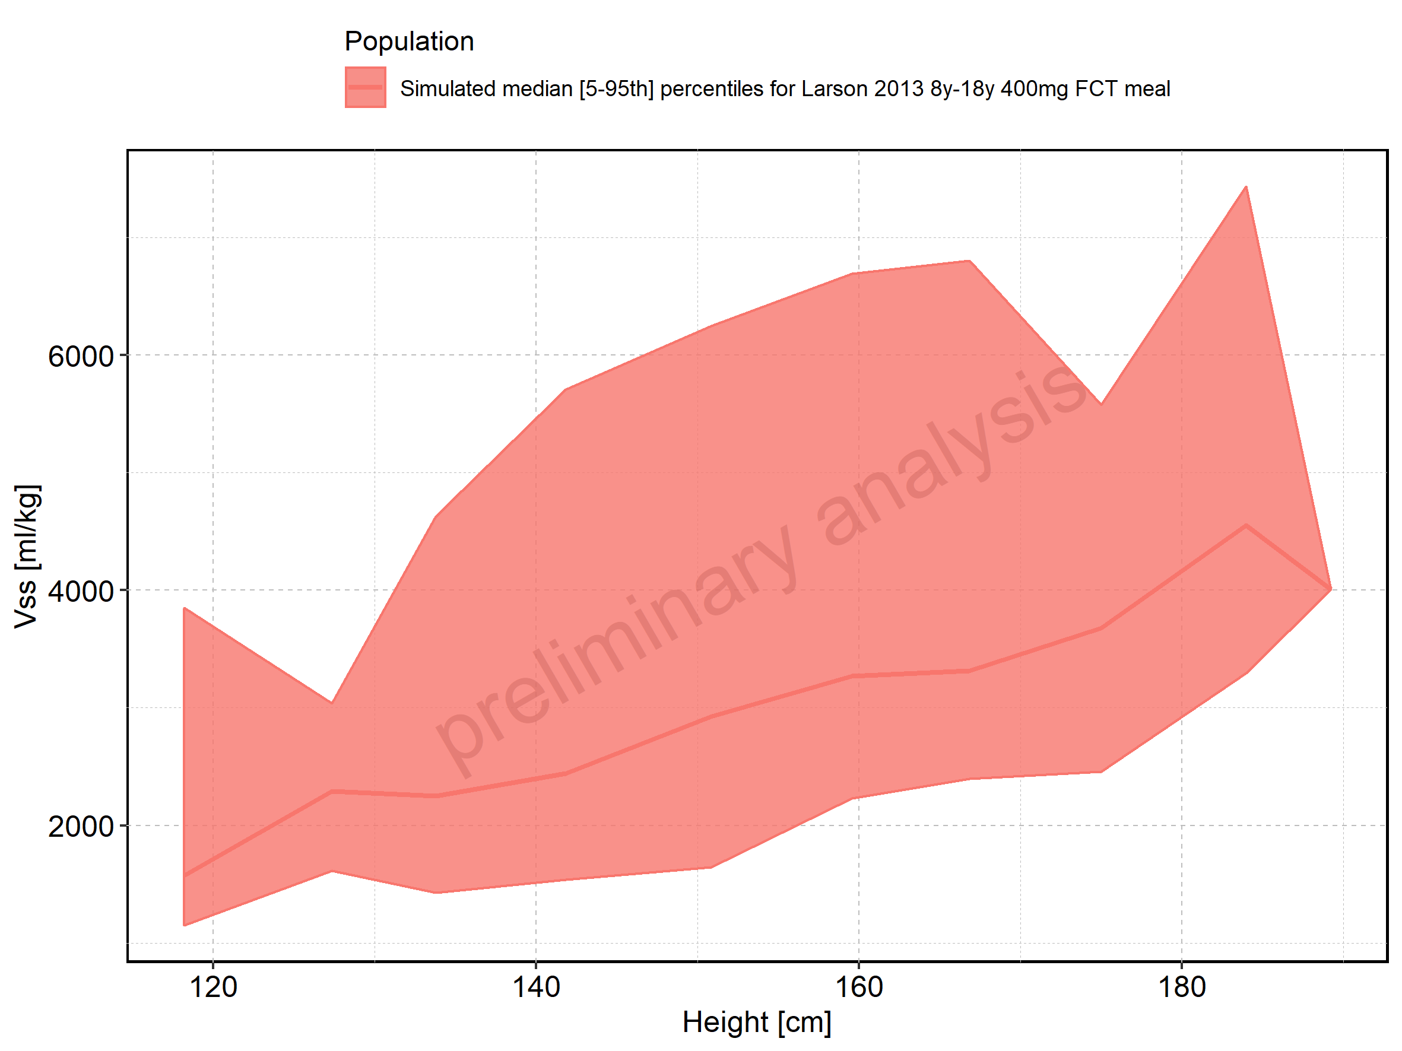

Figure 308: Height-dependence of Vss for Larson 2013 8y-18y 400mg FCT meal. Profiles are plotted in a logarithmic scale.

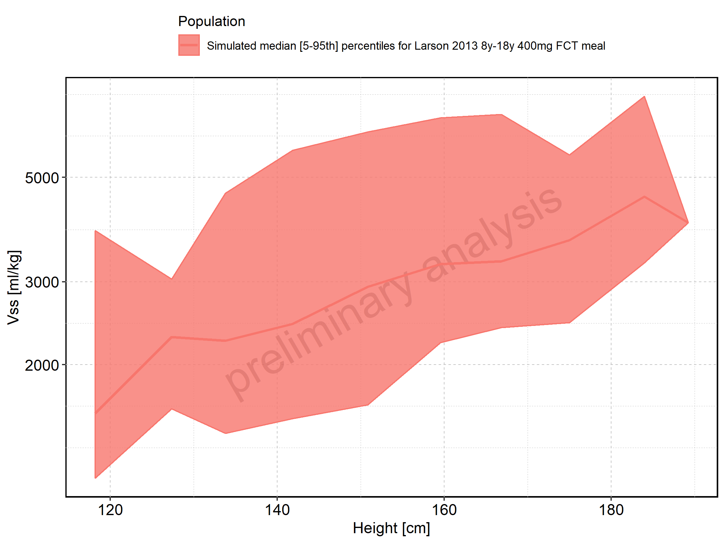

Figure 309: Height-dependence of Vss for Filmcoated_tablet_400mg_sd. Profiles are plotted in a linear scale.

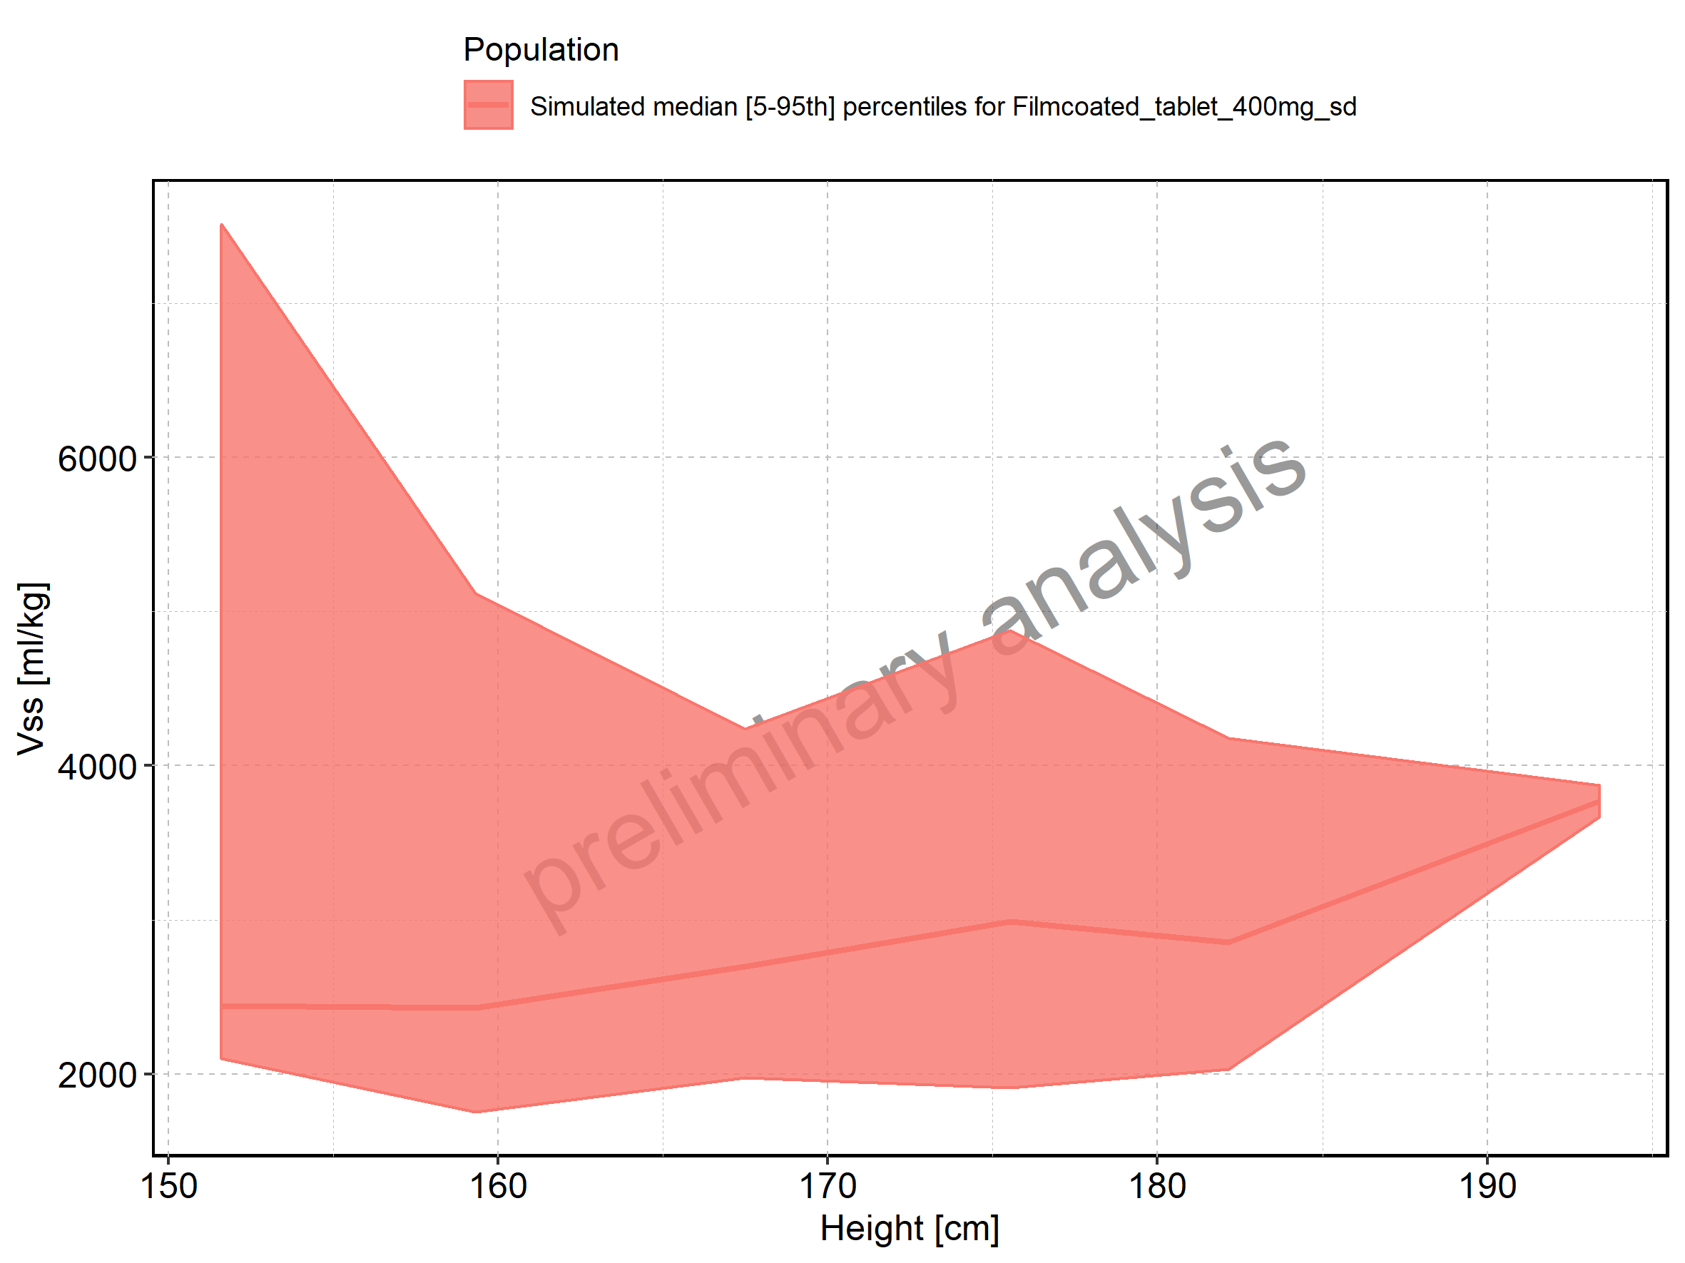

Figure 310: Height-dependence of Vss for Filmcoated_tablet_400mg_sd. Profiles are plotted in a logarithmic scale.

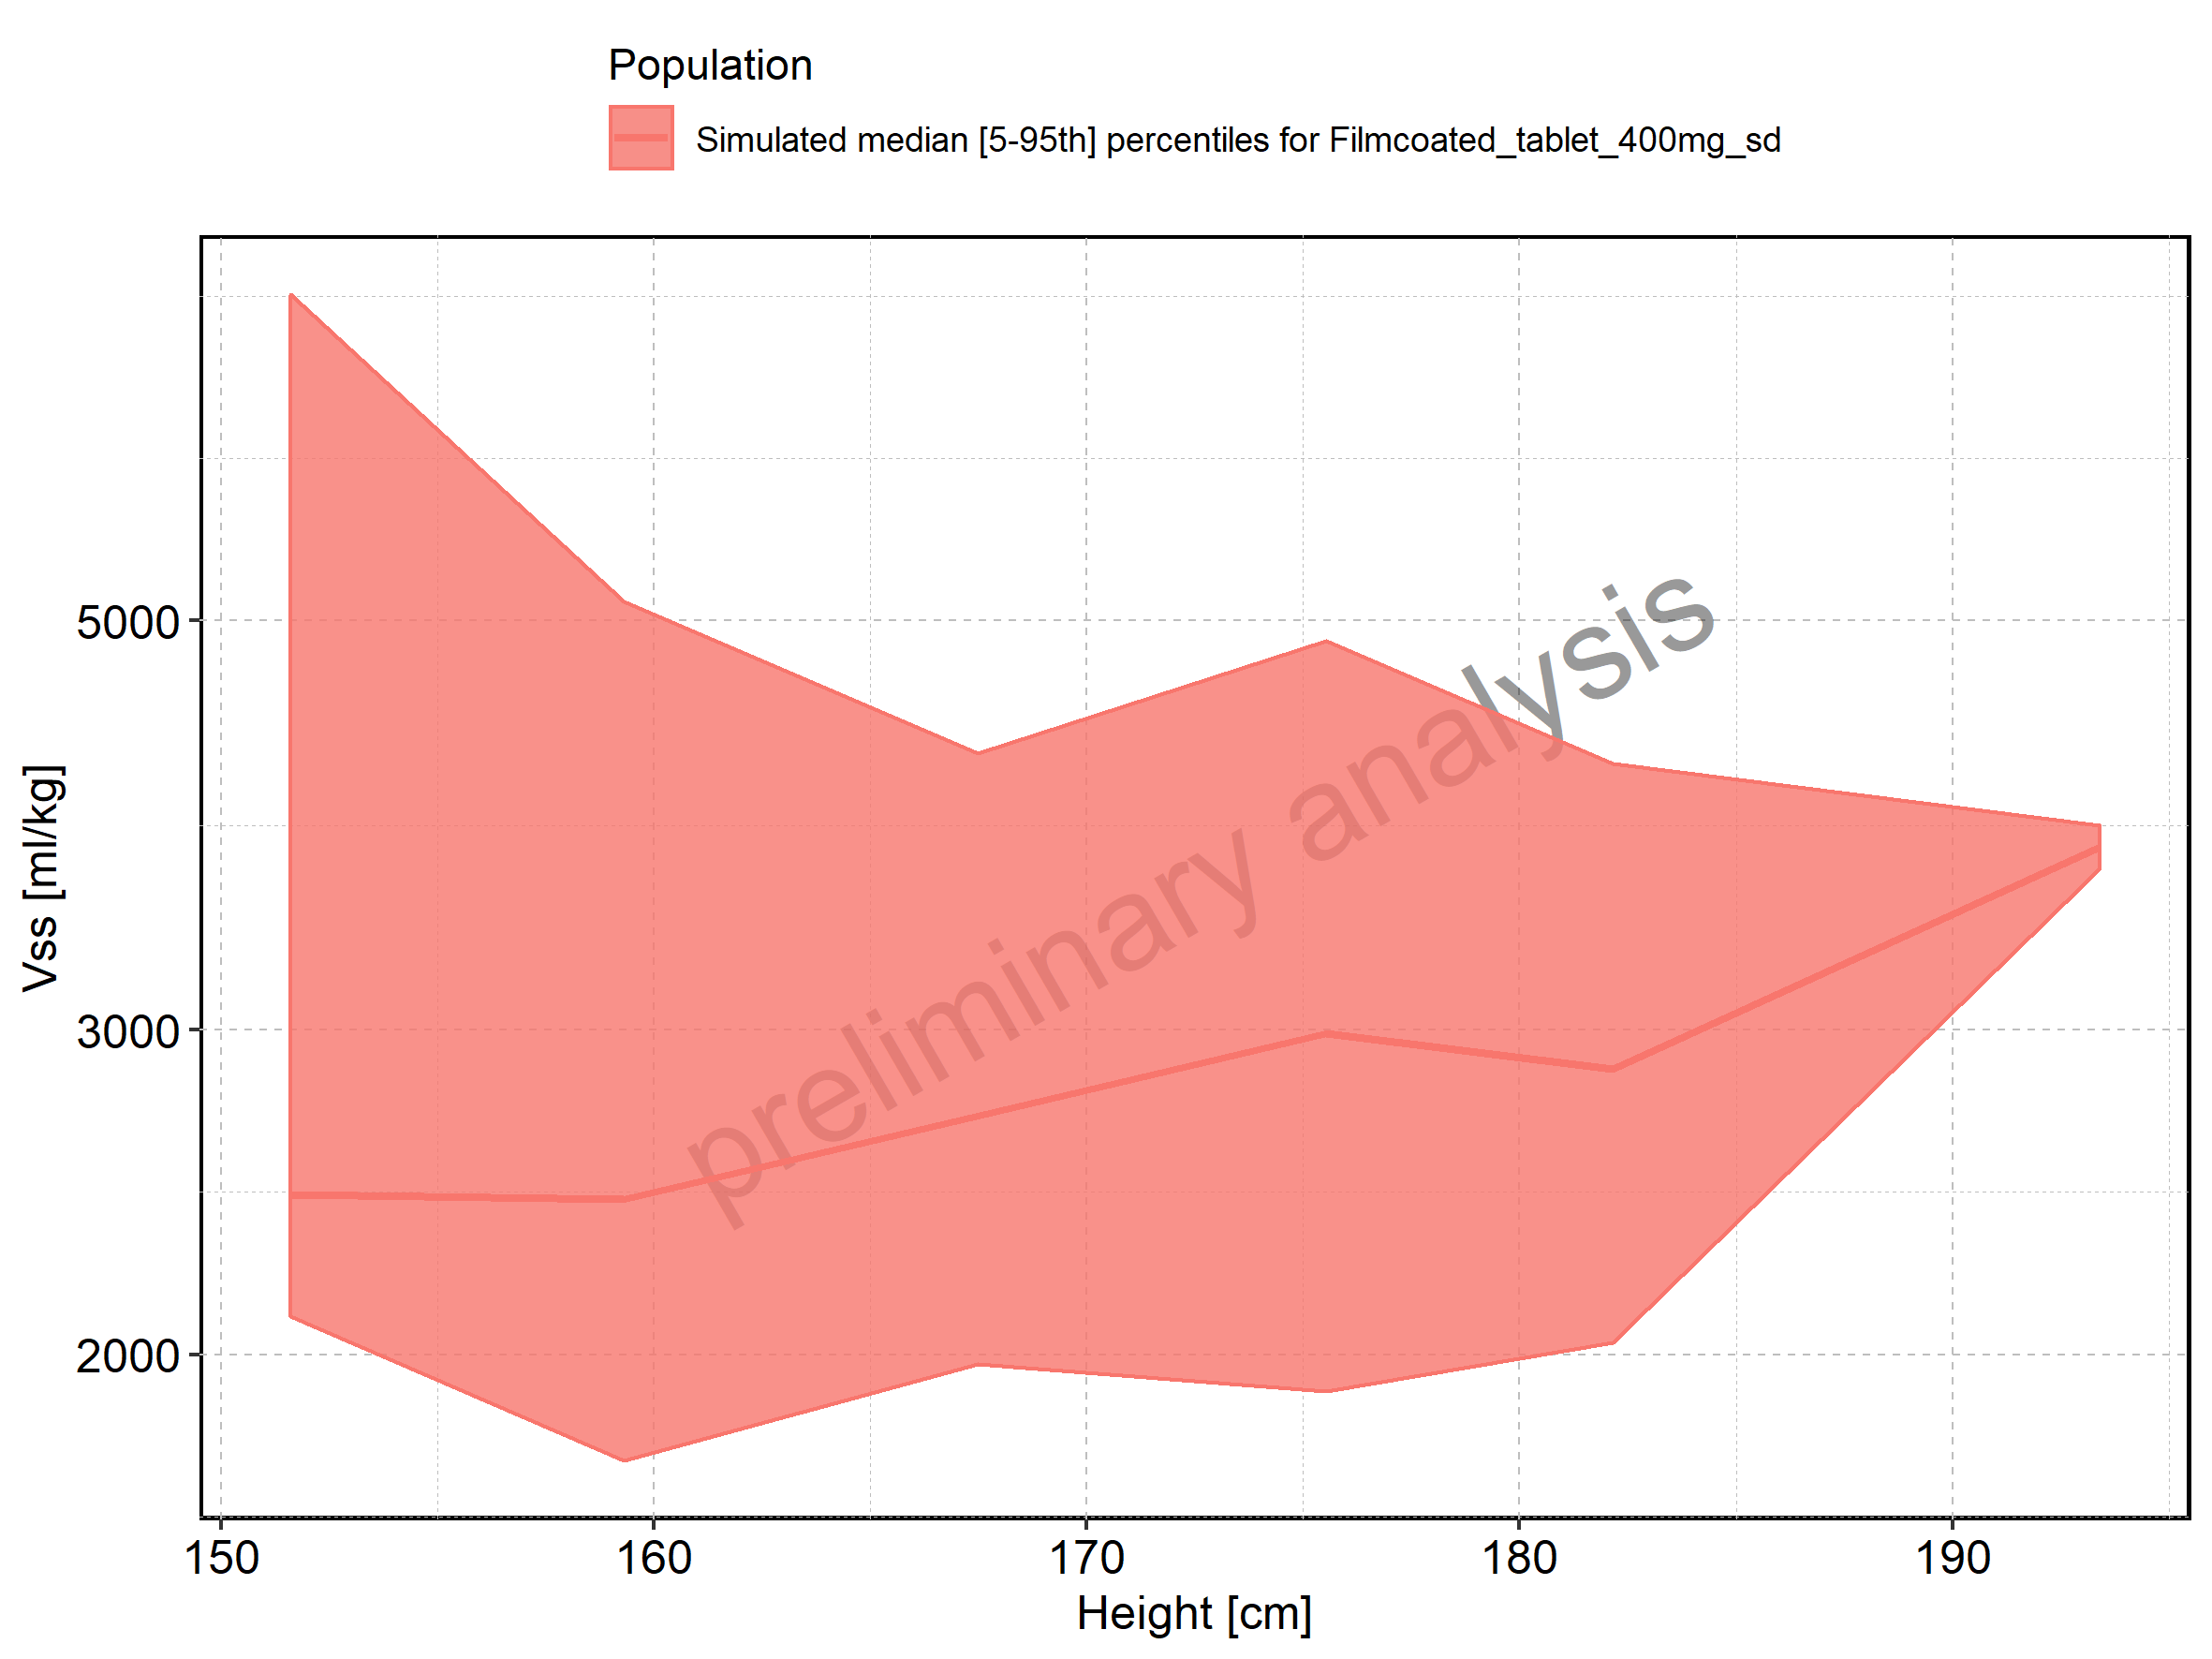

Figure 311: Weight-dependence of Vss for Larson 2013 8y-18y 400mg FCT meal in comparison to Filmcoated_tablet_400mg_sd. Profiles are plotted in a linear scale.

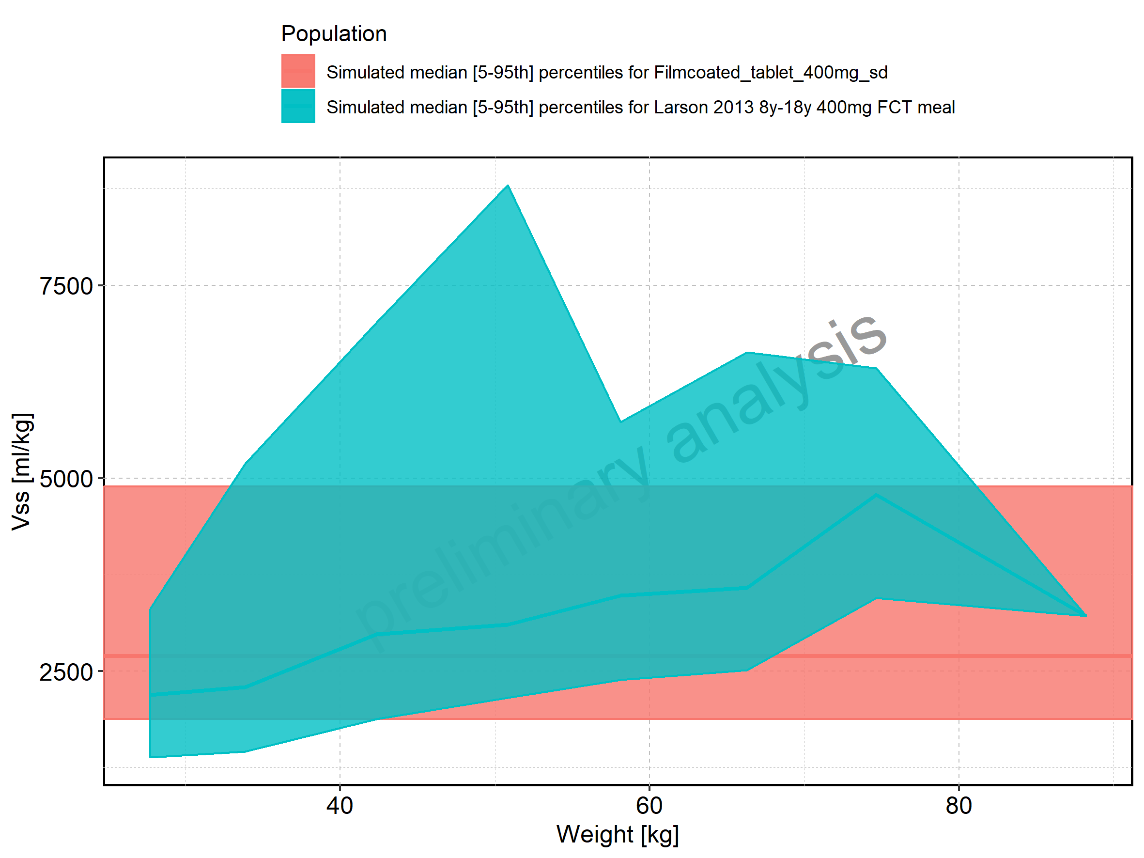

Figure 312: Weight-dependence of Vss for Larson 2013 8y-18y 400mg FCT meal in comparison to Filmcoated_tablet_400mg_sd. Profiles are plotted in a logarithmic scale.

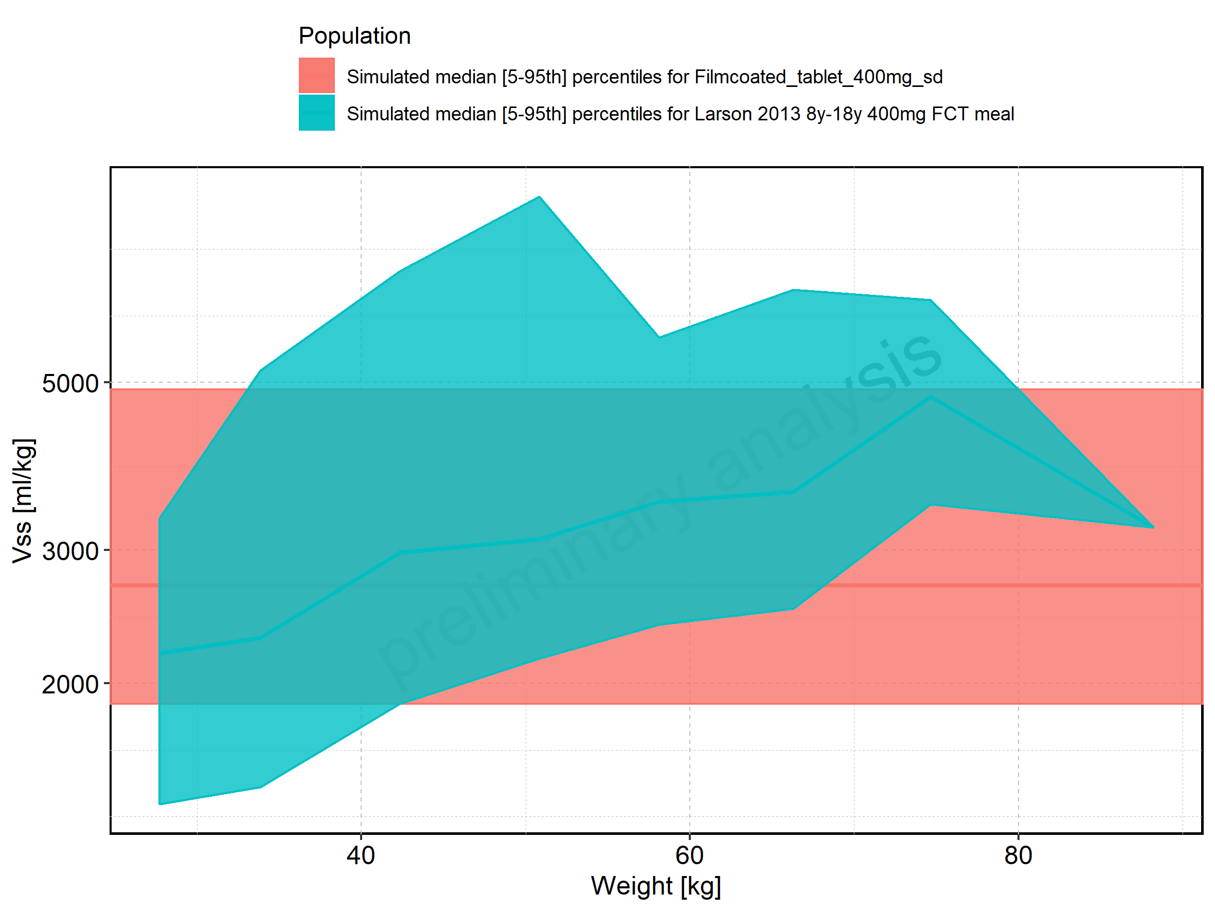

Figure 313: Weight-dependence of Vss for Larson 2013 8y-18y 400mg FCT meal. Profiles are plotted in a linear scale.

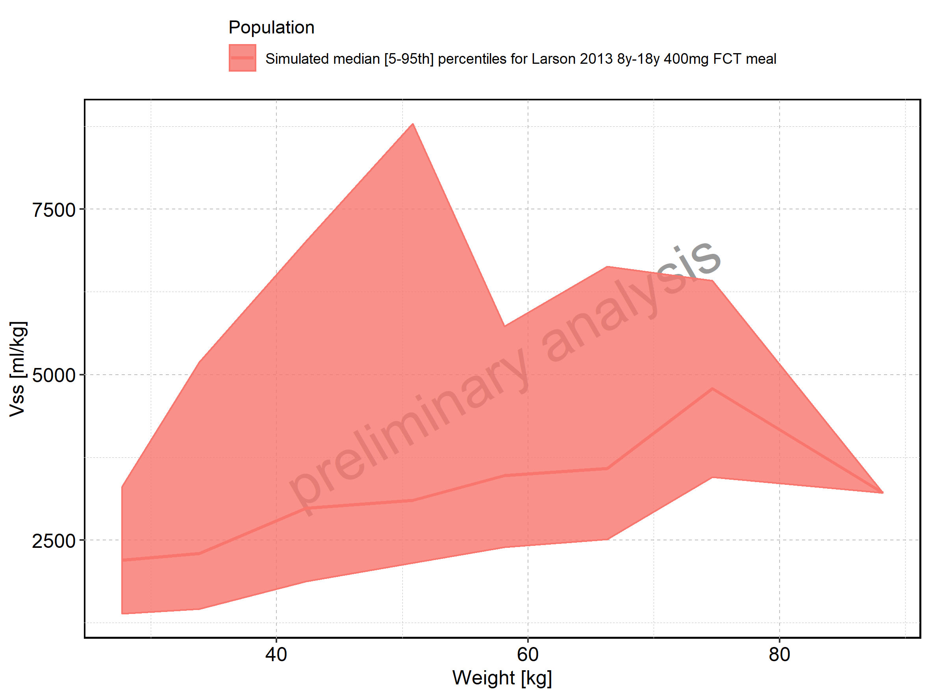

Figure 314: Weight-dependence of Vss for Larson 2013 8y-18y 400mg FCT meal. Profiles are plotted in a logarithmic scale.

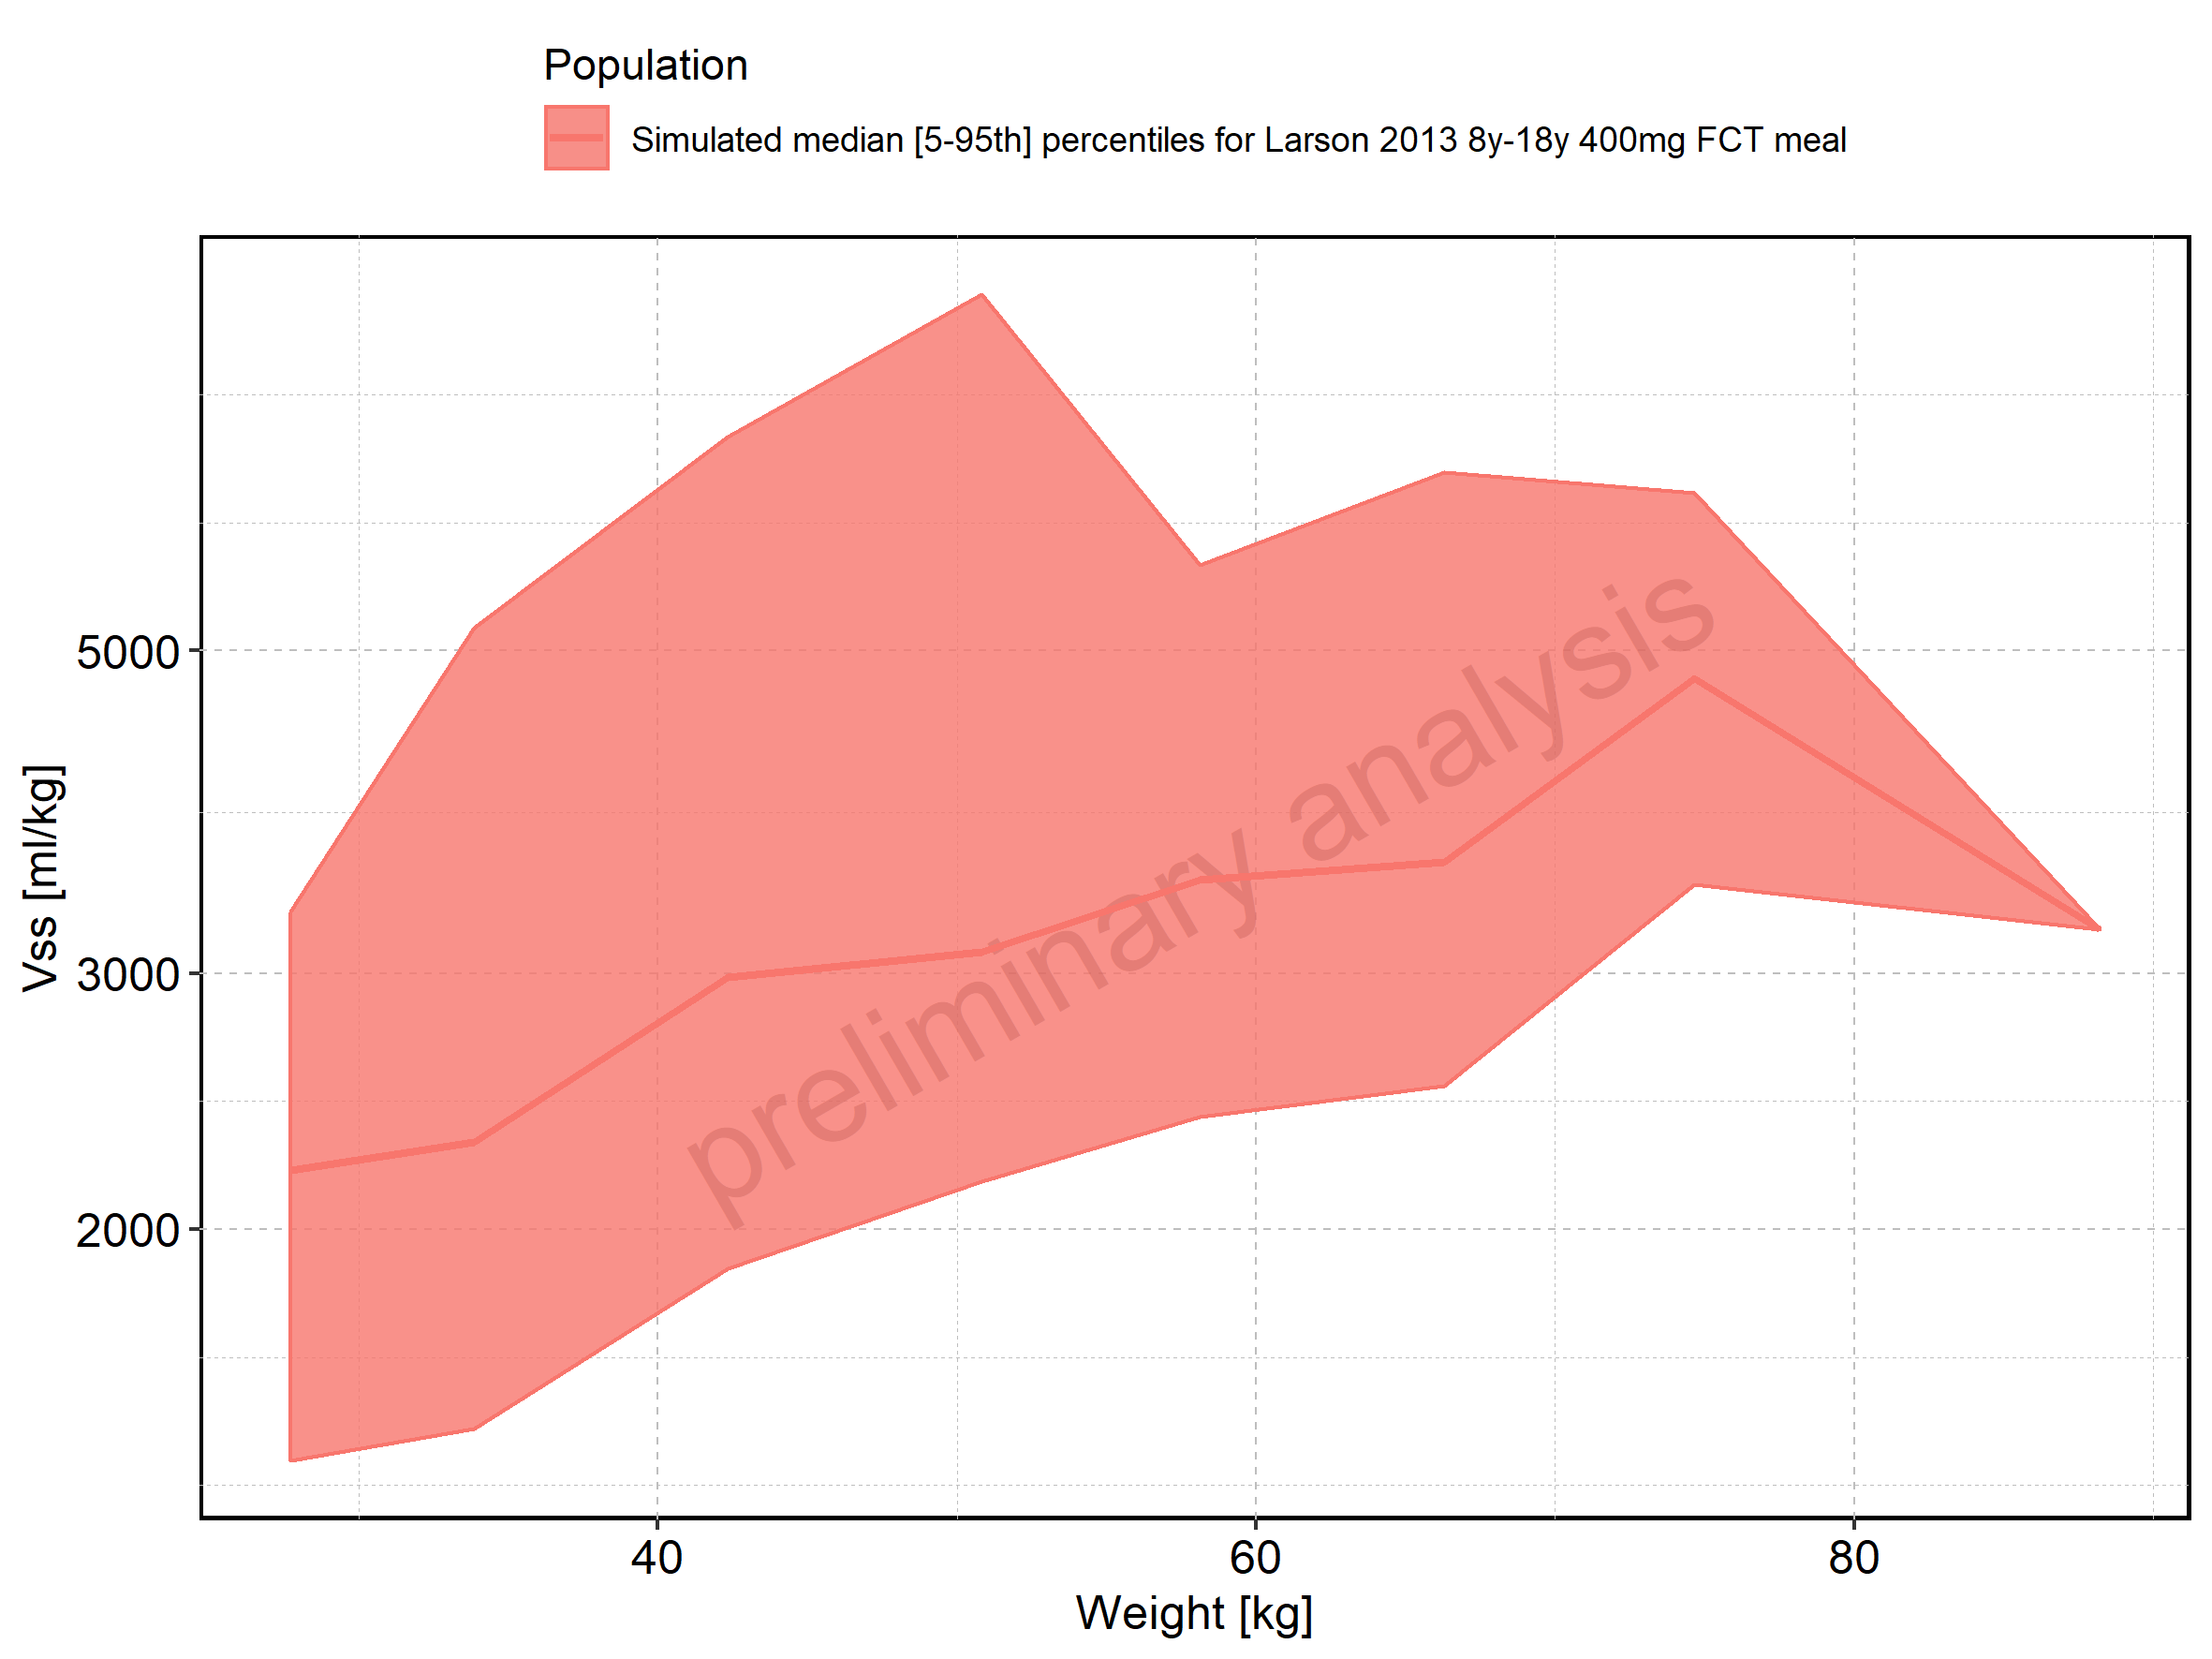

Figure 315: Weight-dependence of Vss for Filmcoated_tablet_400mg_sd. Profiles are plotted in a linear scale.

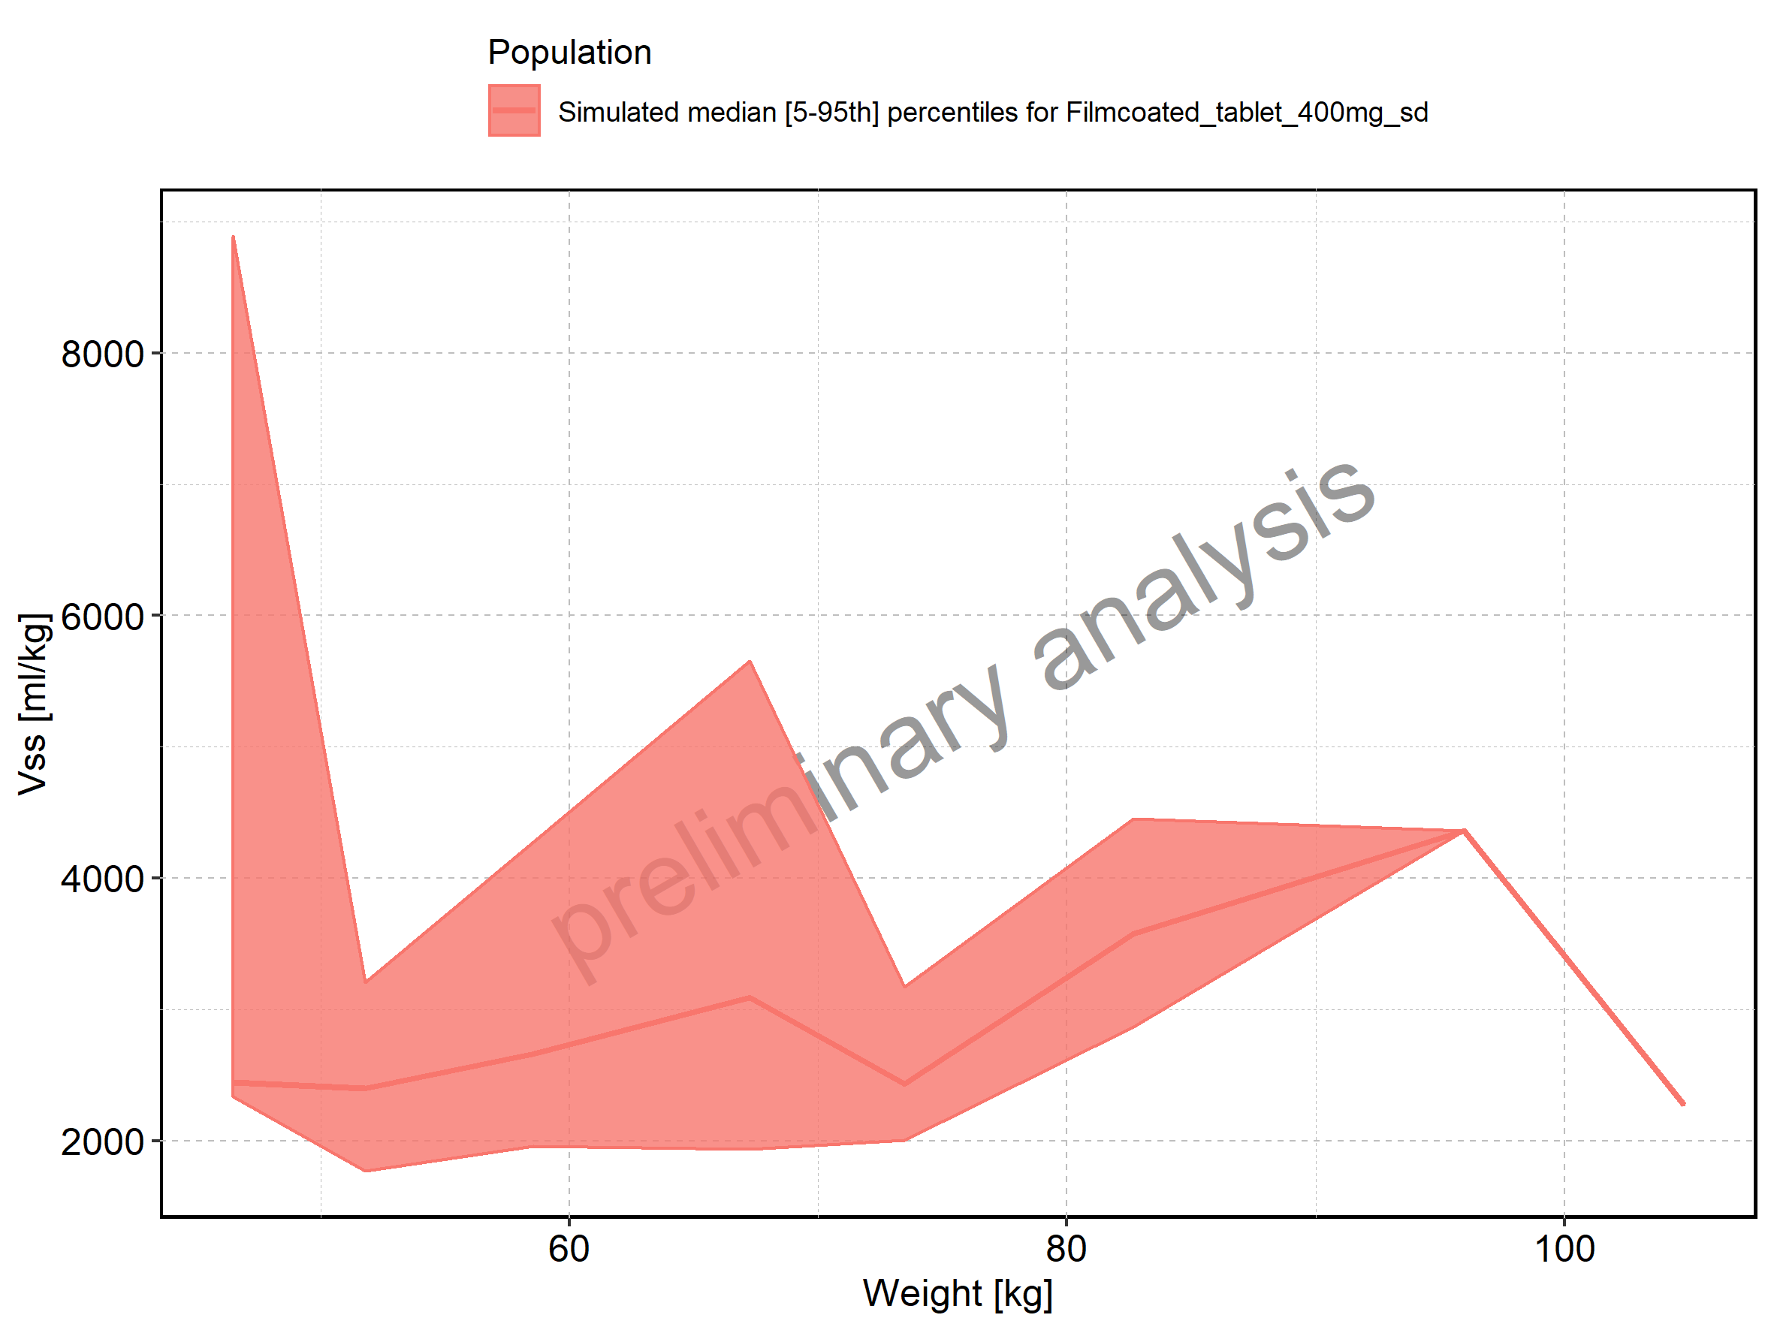

Figure 316: Weight-dependence of Vss for Filmcoated_tablet_400mg_sd. Profiles are plotted in a logarithmic scale.

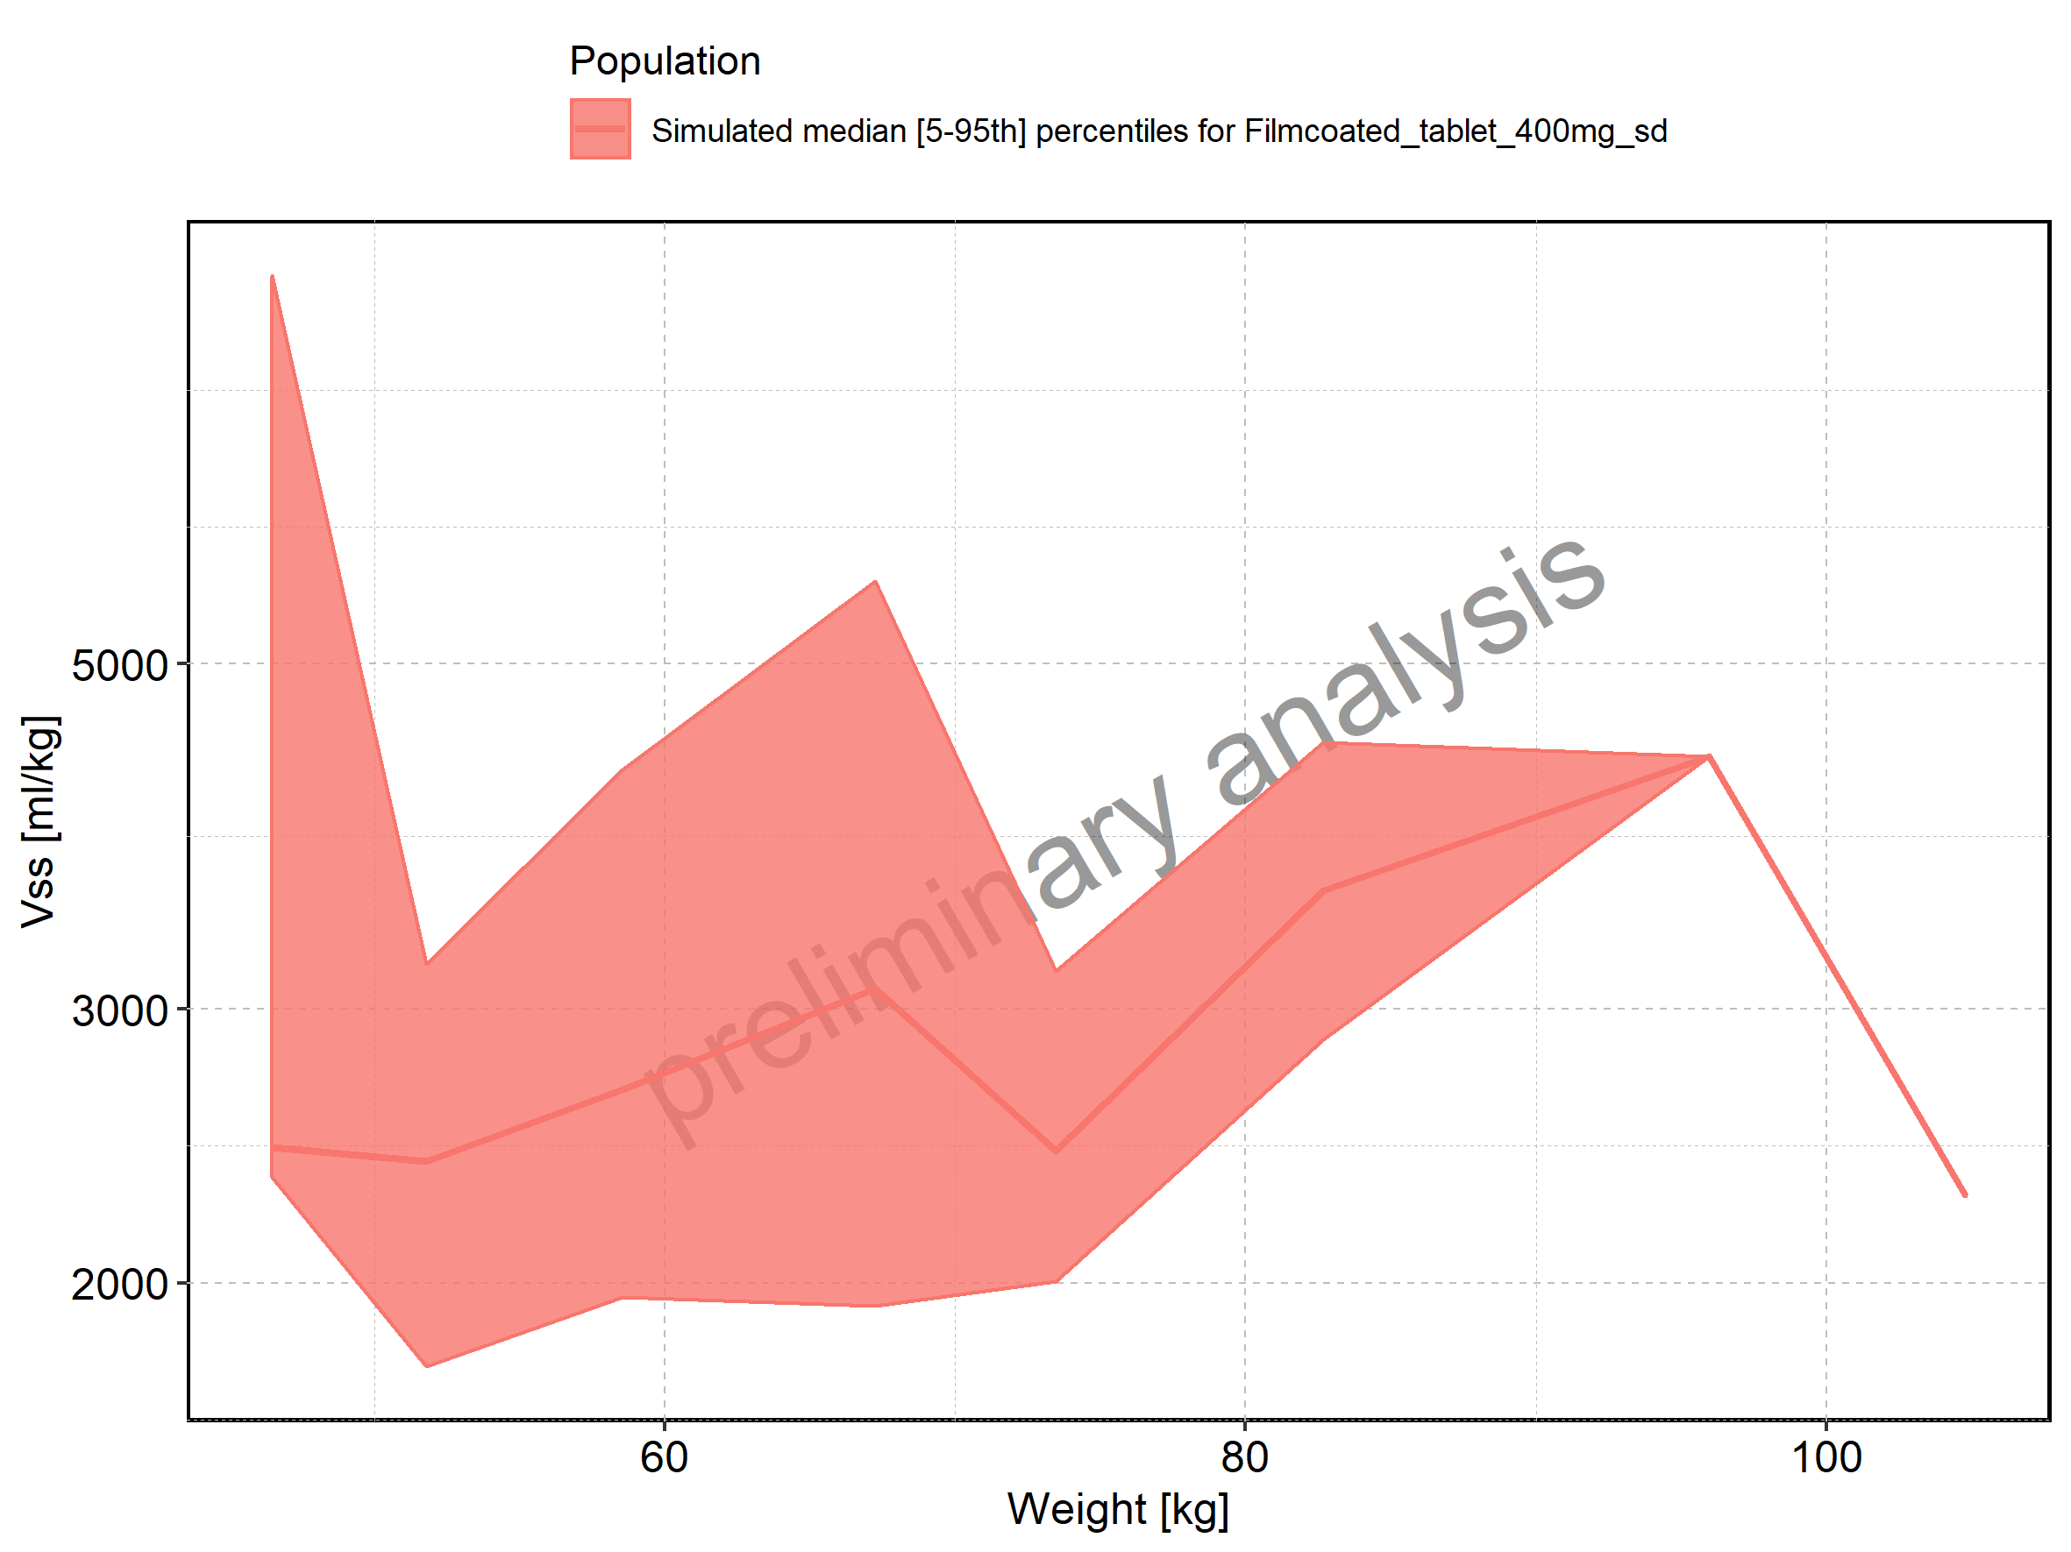

Figure 317: BMI-dependence of Vss for Larson 2013 8y-18y 400mg FCT meal in comparison to Filmcoated_tablet_400mg_sd. Profiles are plotted in a linear scale.

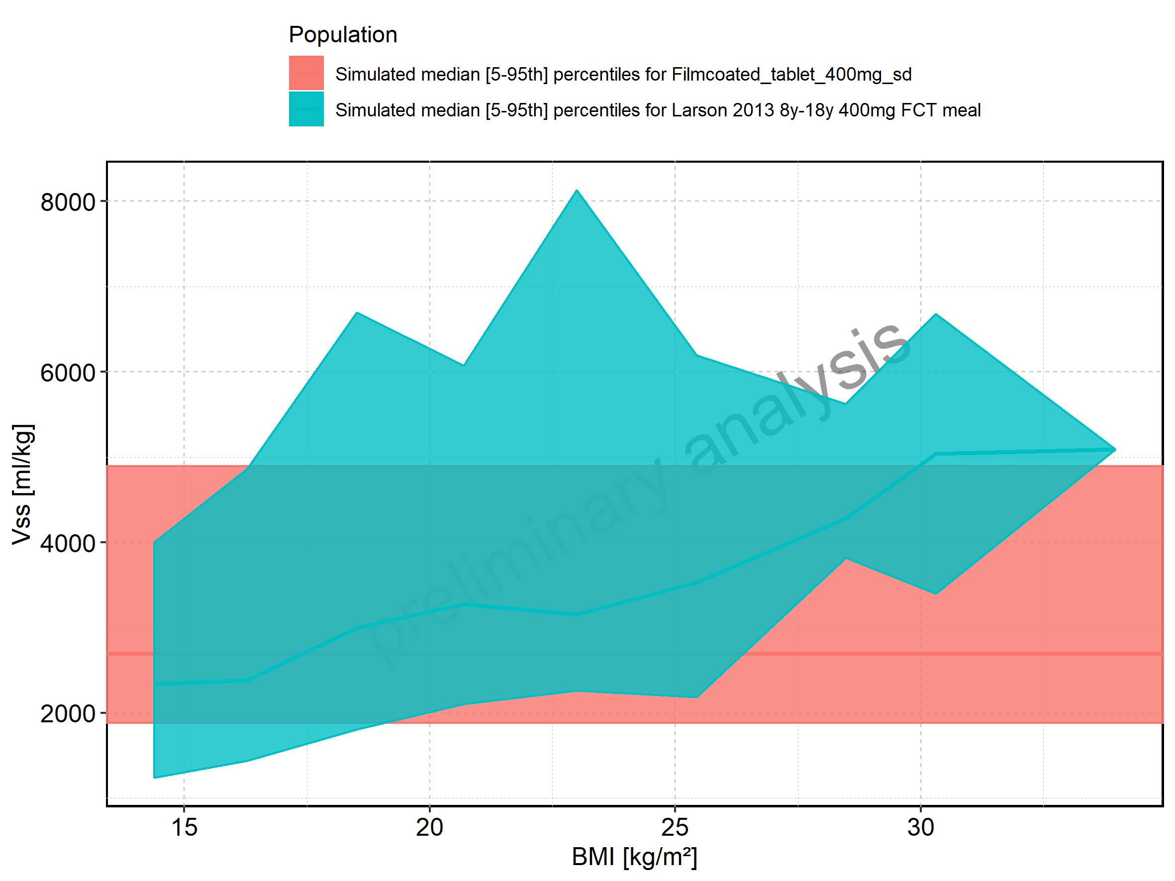

Figure 318: BMI-dependence of Vss for Larson 2013 8y-18y 400mg FCT meal in comparison to Filmcoated_tablet_400mg_sd. Profiles are plotted in a logarithmic scale.

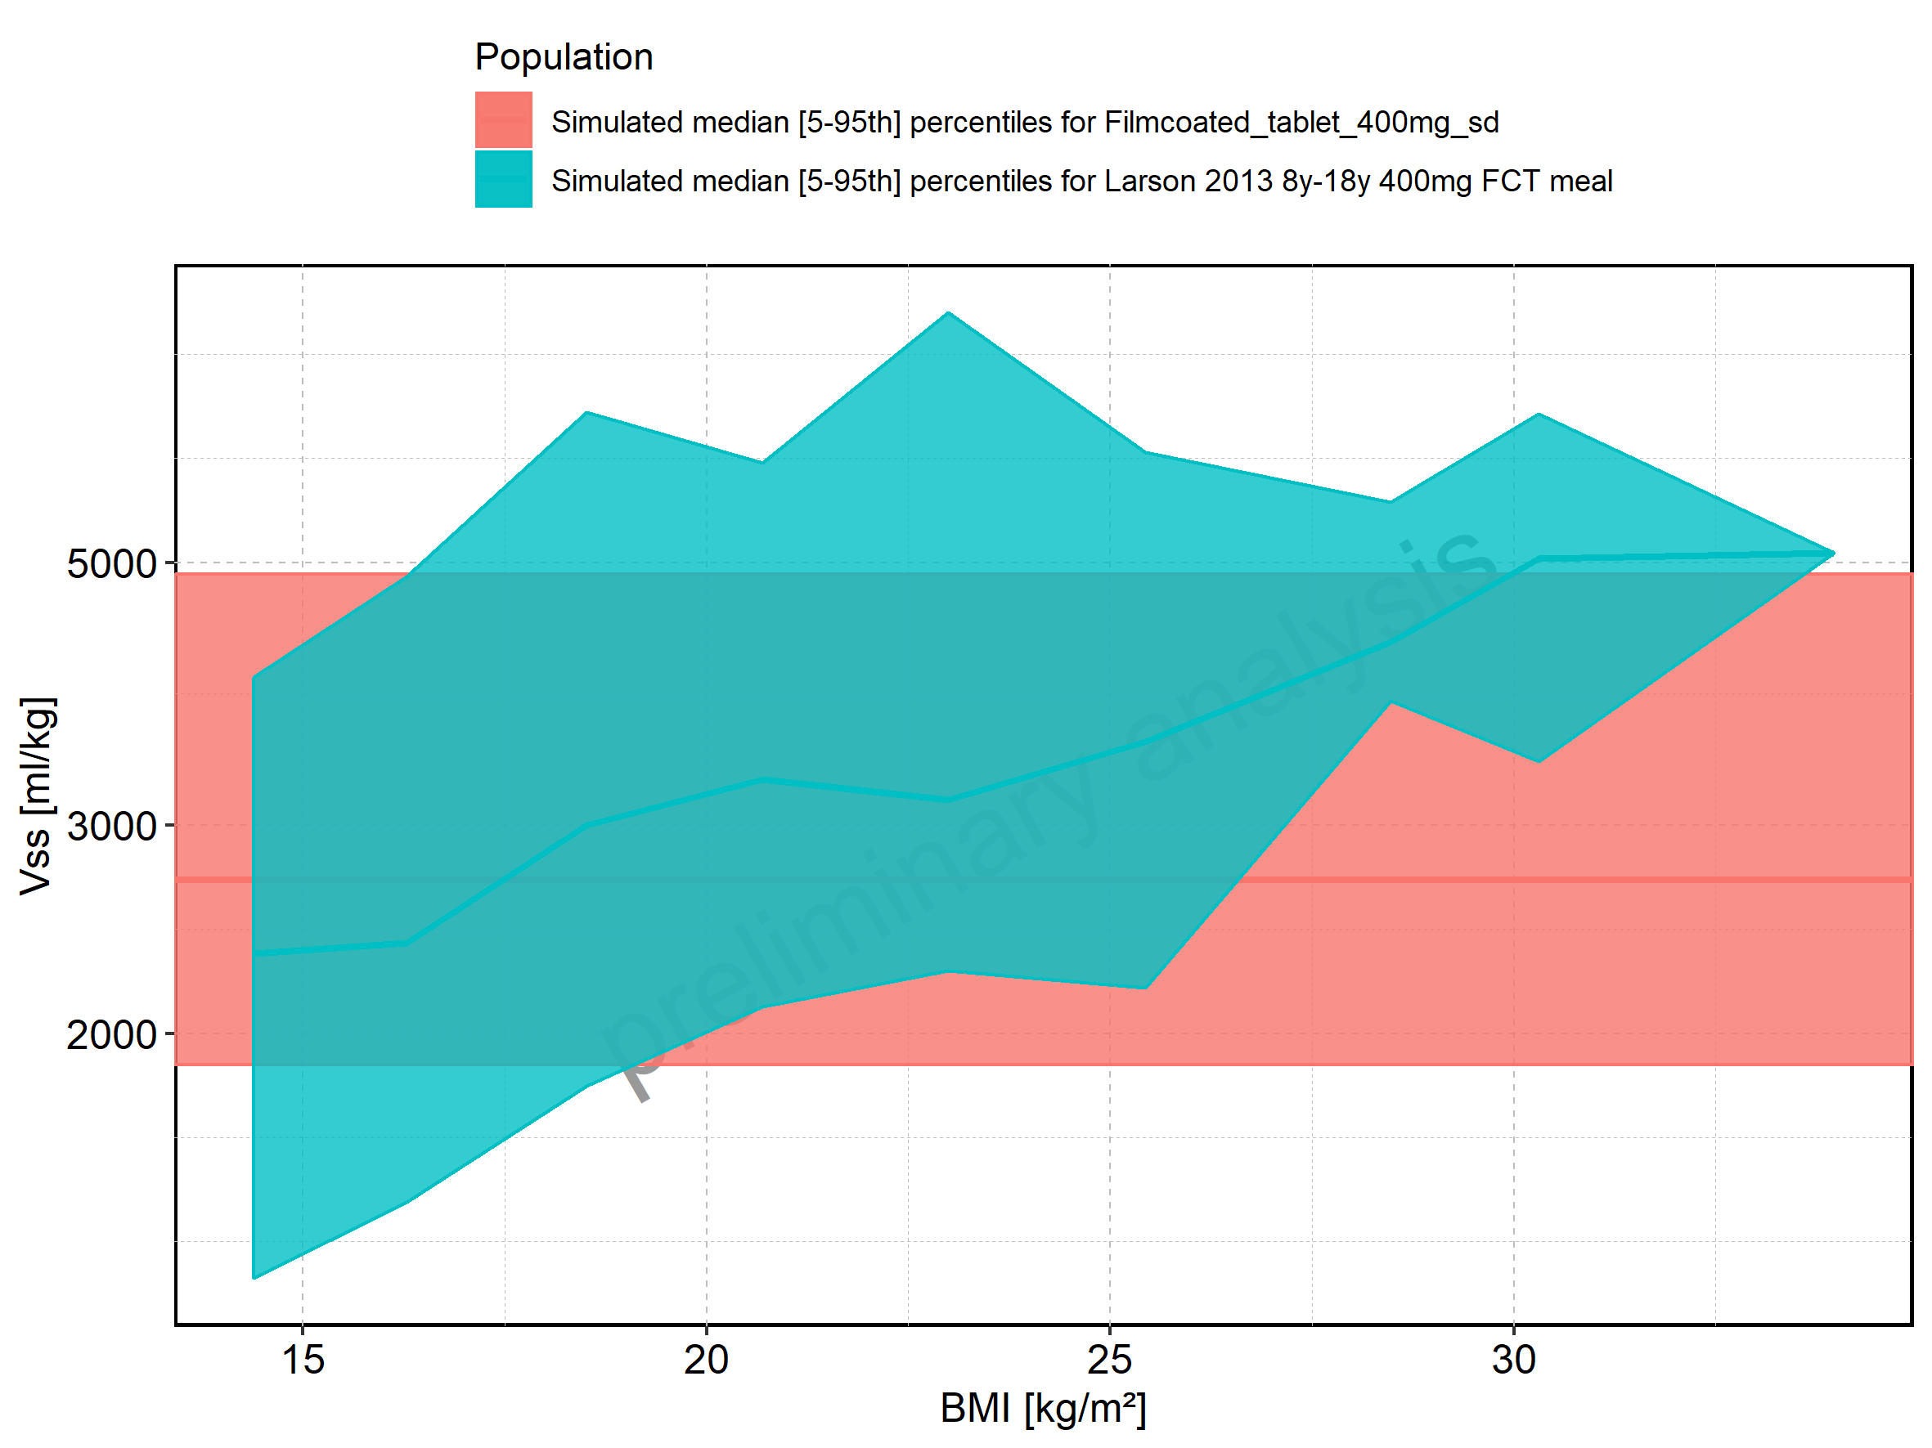

Figure 319: BMI-dependence of Vss for Larson 2013 8y-18y 400mg FCT meal. Profiles are plotted in a linear scale.

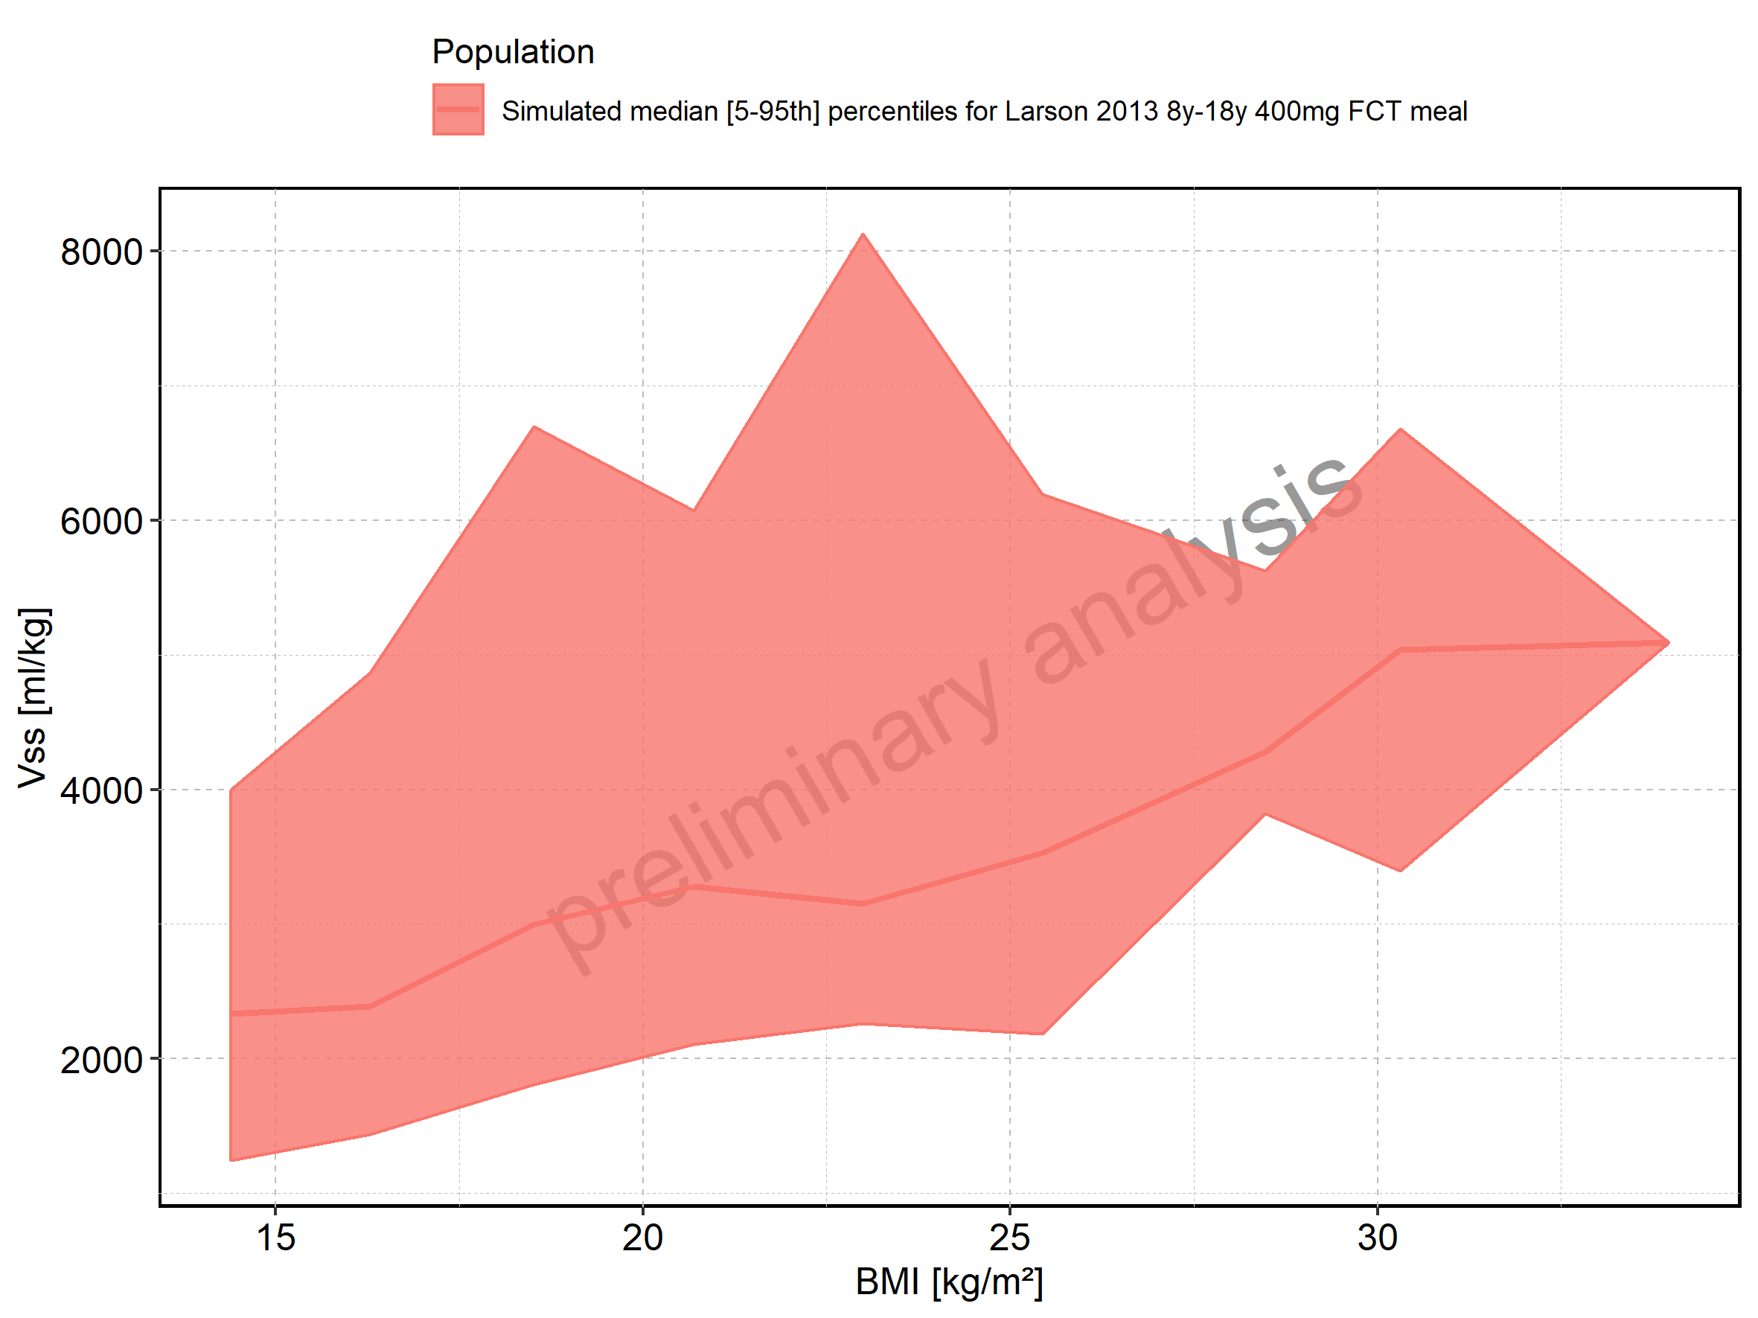

Figure 320: BMI-dependence of Vss for Larson 2013 8y-18y 400mg FCT meal. Profiles are plotted in a logarithmic scale.

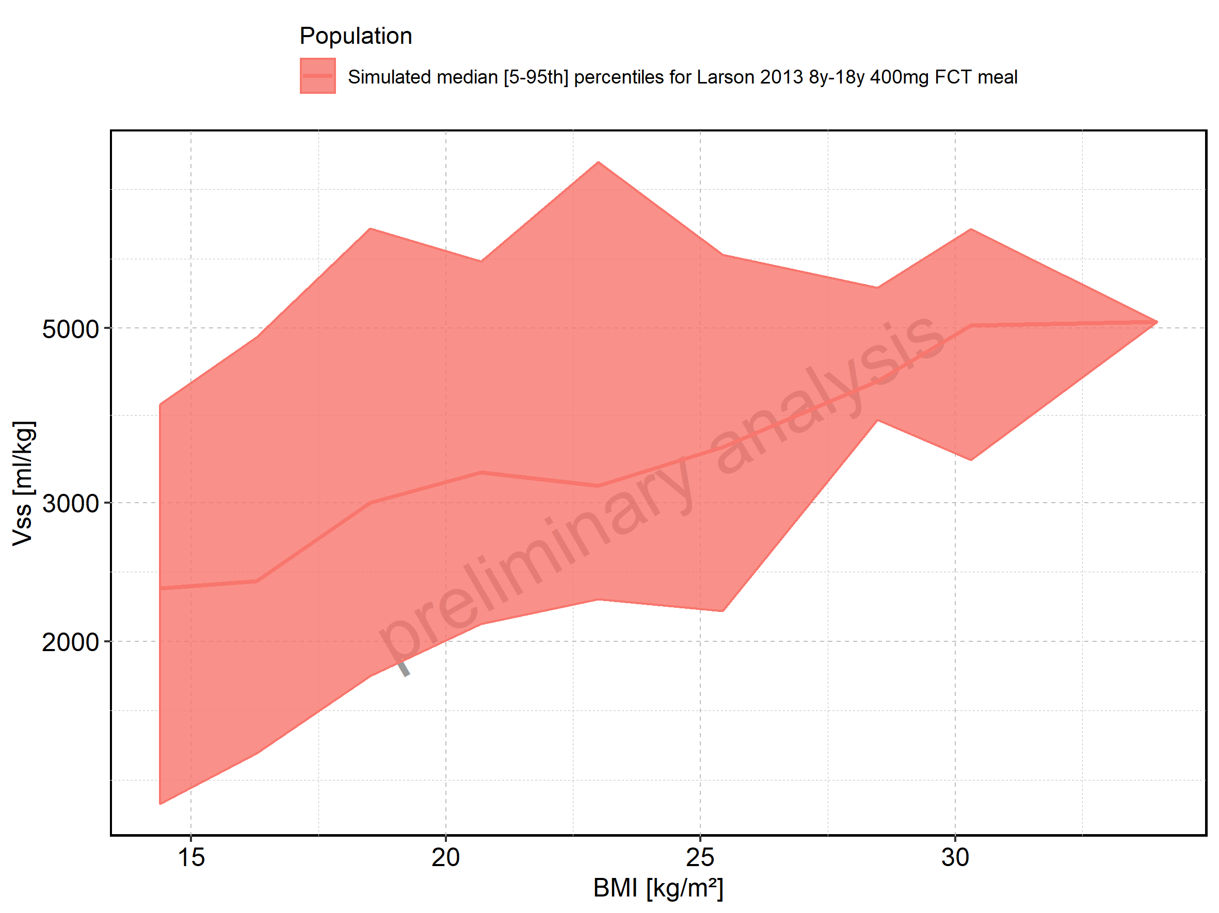

Figure 321: BMI-dependence of Vss for Filmcoated_tablet_400mg_sd. Profiles are plotted in a linear scale.

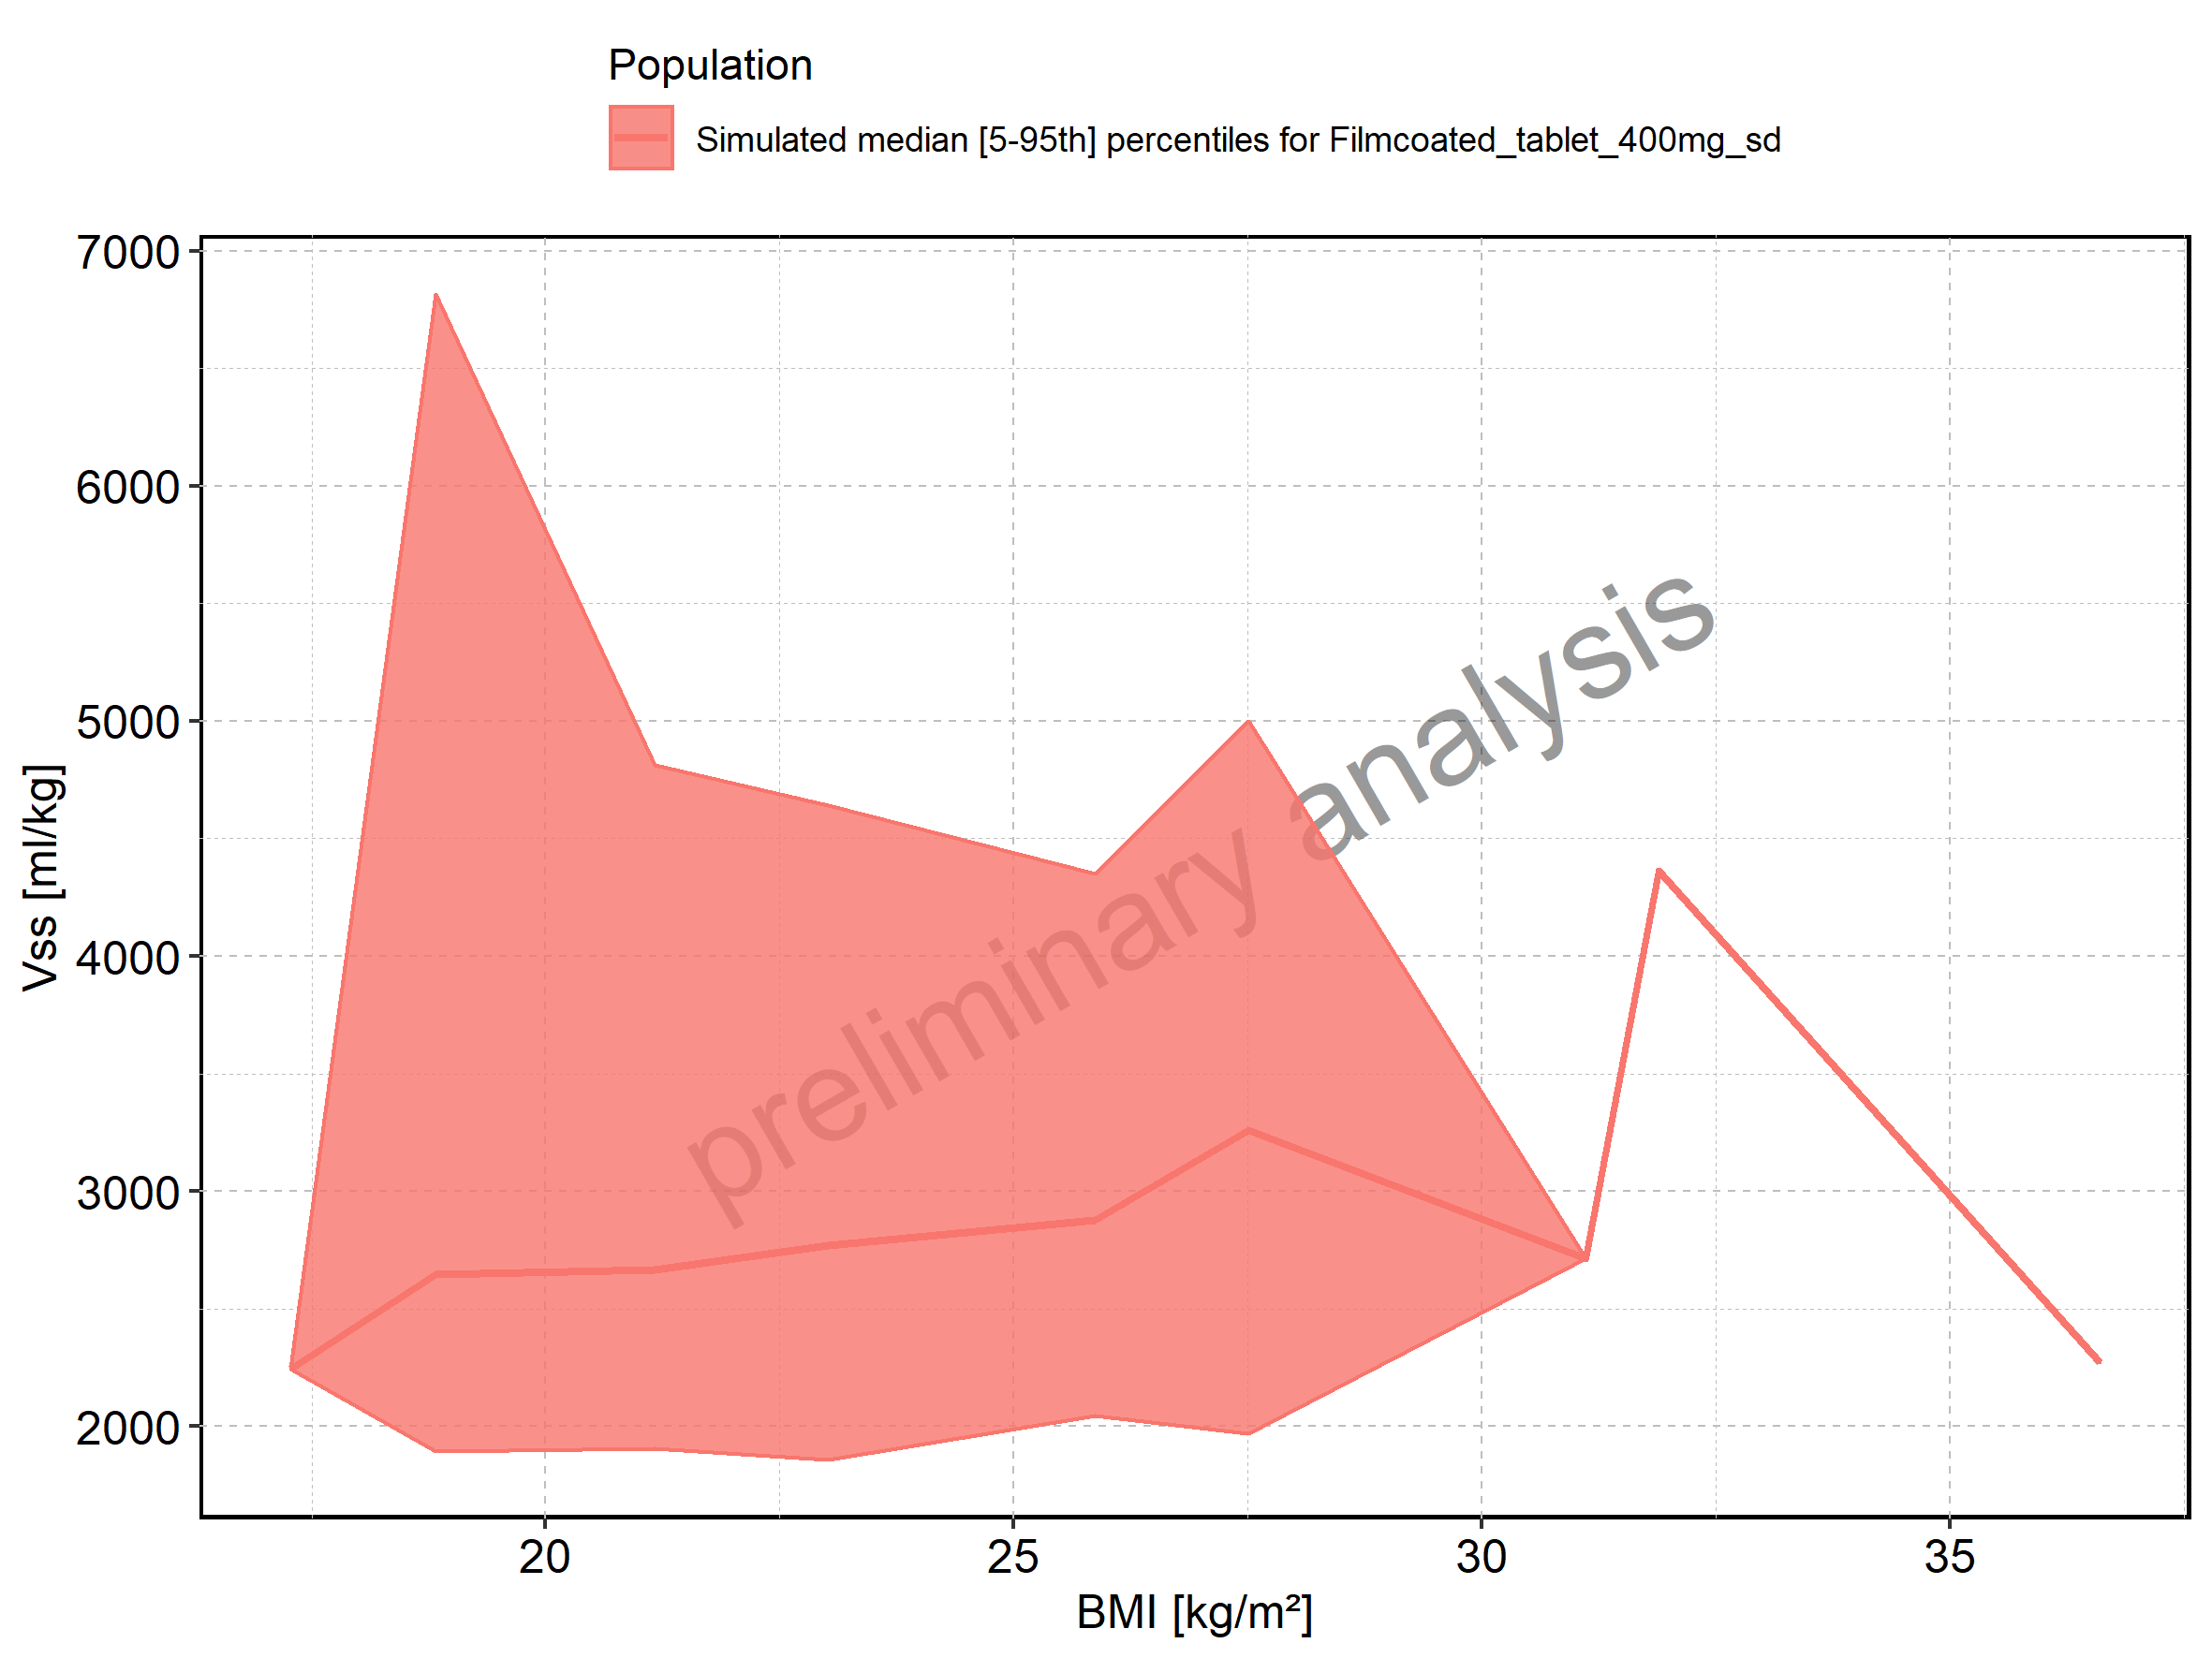

Figure 322: BMI-dependence of Vss for Filmcoated_tablet_400mg_sd. Profiles are plotted in a logarithmic scale.

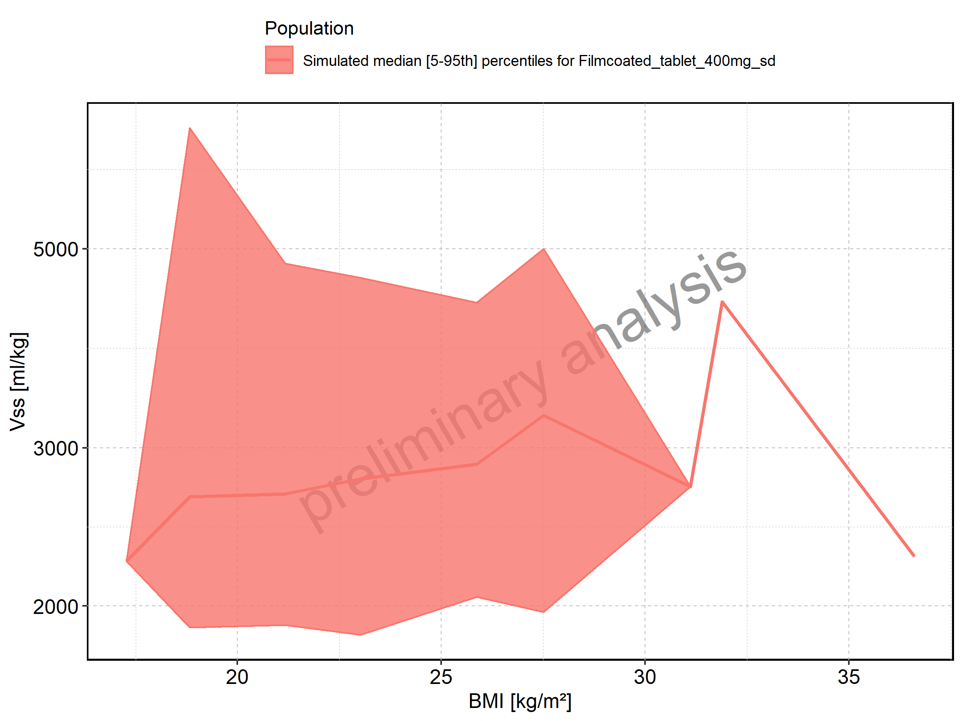

Figure 323: Vd of Raltegravir shown as box-whisker plot, which indicates the 5th, 25th, 50th, 75th, and 95th percentiles in linear scale.

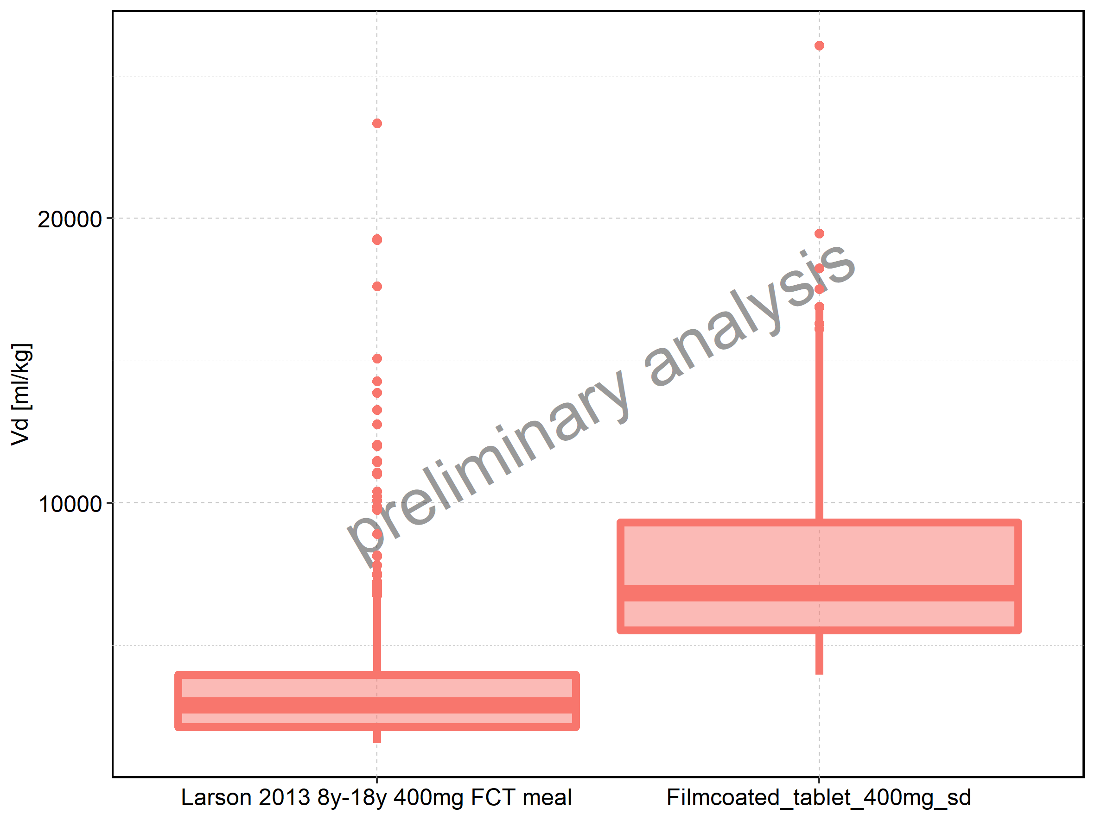

|  |  |  |  |  |  |  |  |  |  |  |
| --- | --- | --- | --- | --- | --- | --- | --- | --- | --- | --- |
| Population | N | 5th percentile | 25th percentile | 50th percentile | 75th percentile | 95th percentile | mean | standard deviation | geo mean | geo standard deviation |
| Larson 2013 8y-18y 400mg FCT meal | 497 | 1564.173 | 2133.960 | 2893.518 | 3971.826 | 7809.583 | 3610.039 | 2601.900 | 3089.071 | 1.670646 |
| Filmcoated_tablet_400mg_sd | 100 | 3961.869 | 5531.167 | 6823.958 | 9325.515 | 16886.072 | 8090.422 | 4000.153 | 7343.514 | 1.531150 |

Figure 324: Vd of Raltegravir shown as box-whisker plot, which indicates the 5th, 25th, 50th, 75th, and 95th percentiles in logarithmic scale.

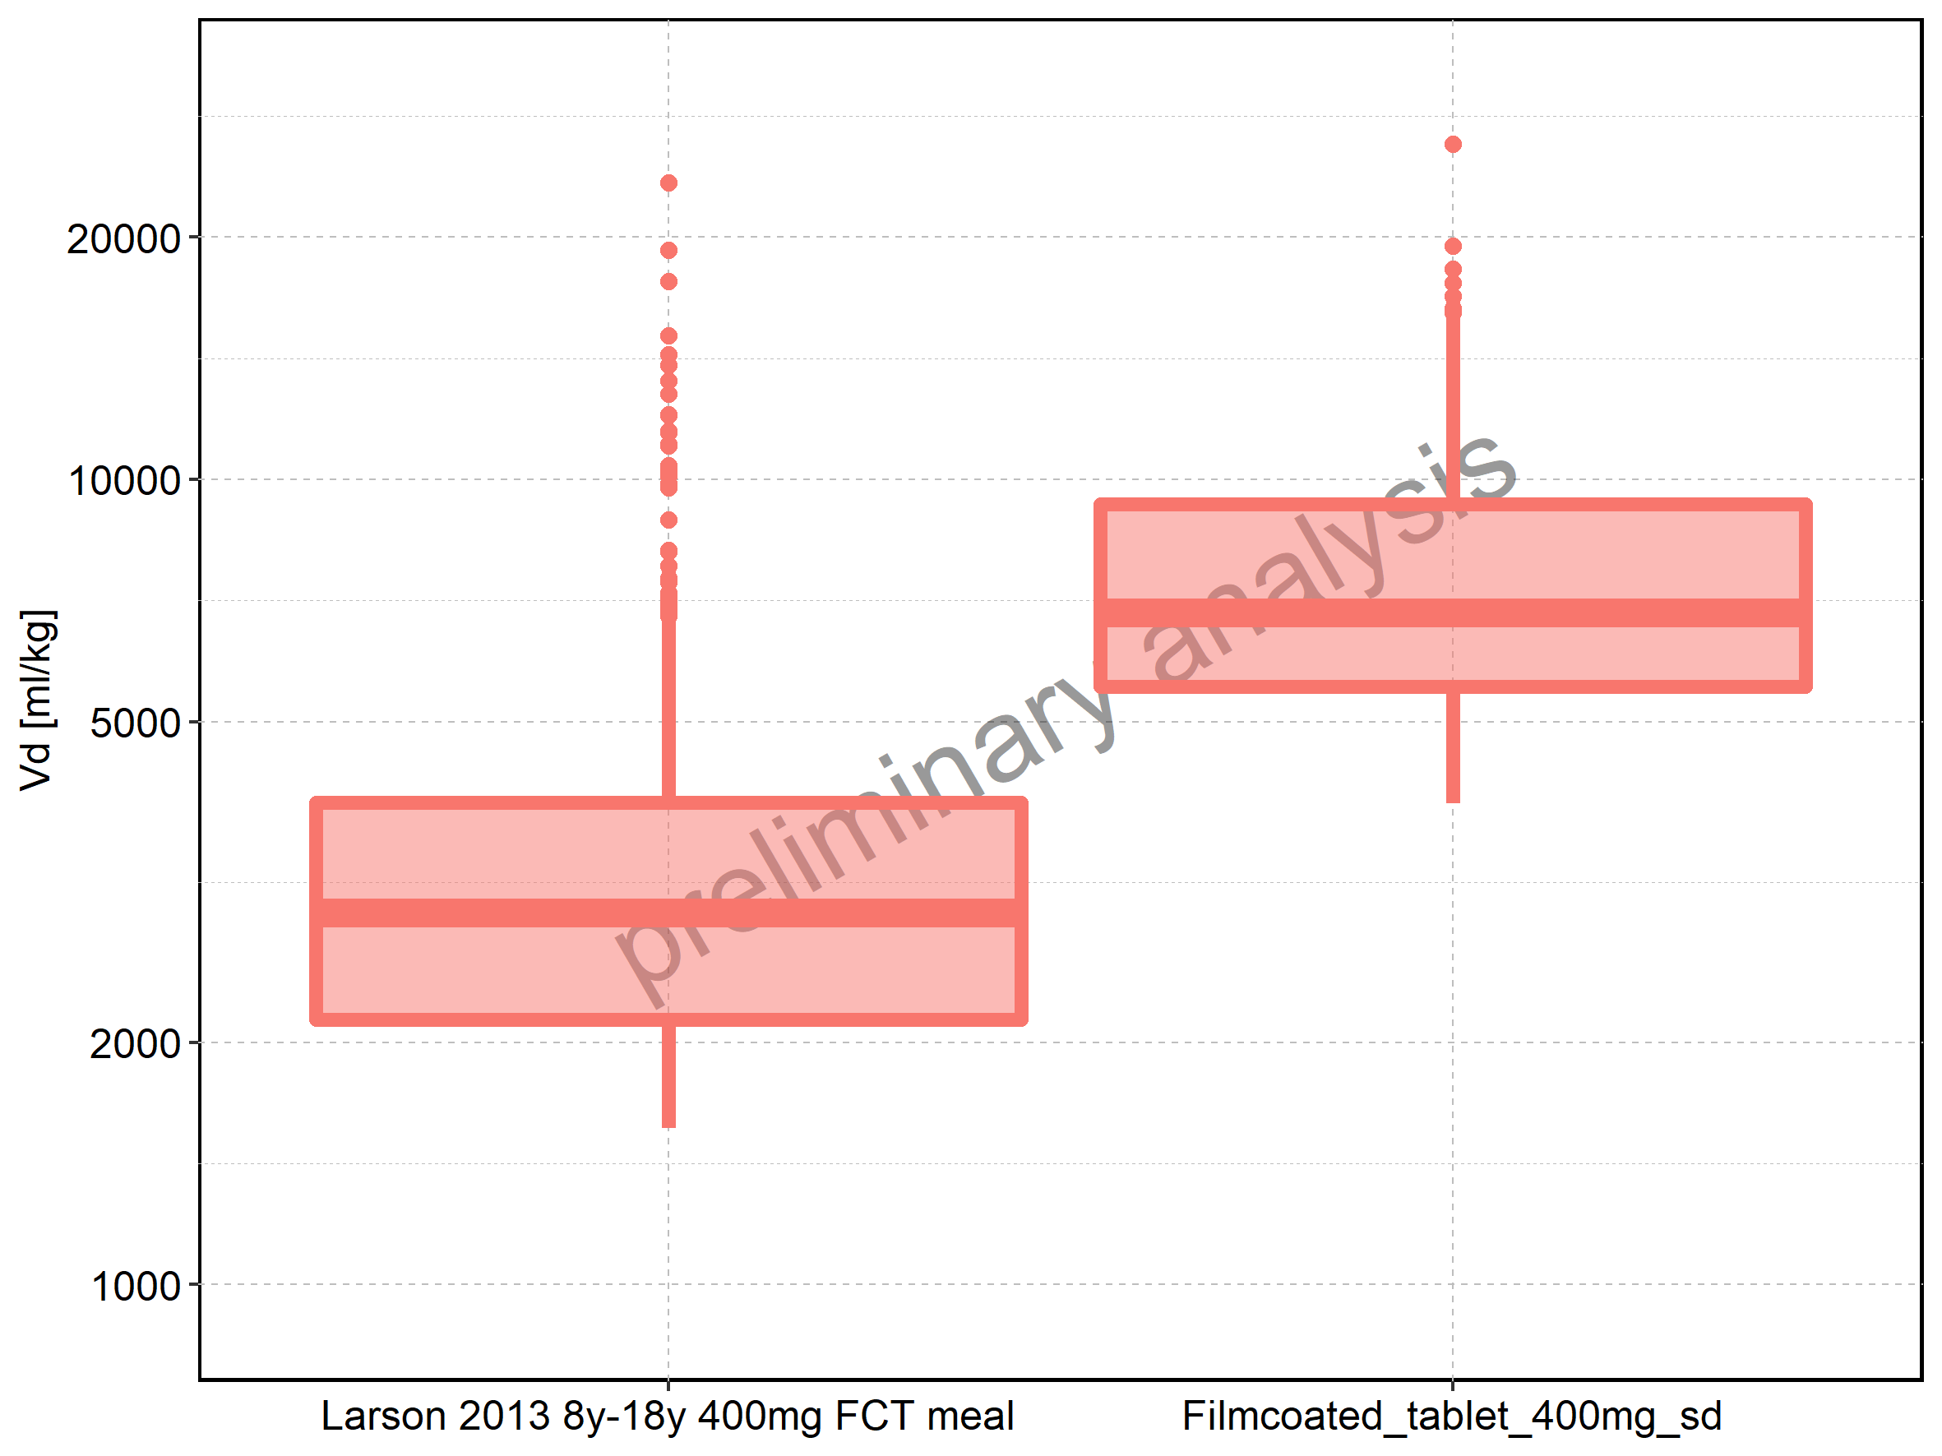

Figure 325: Age-dependence of Vd for Larson 2013 8y-18y 400mg FCT meal in comparison to Filmcoated_tablet_400mg_sd. Profiles are plotted in a linear scale.

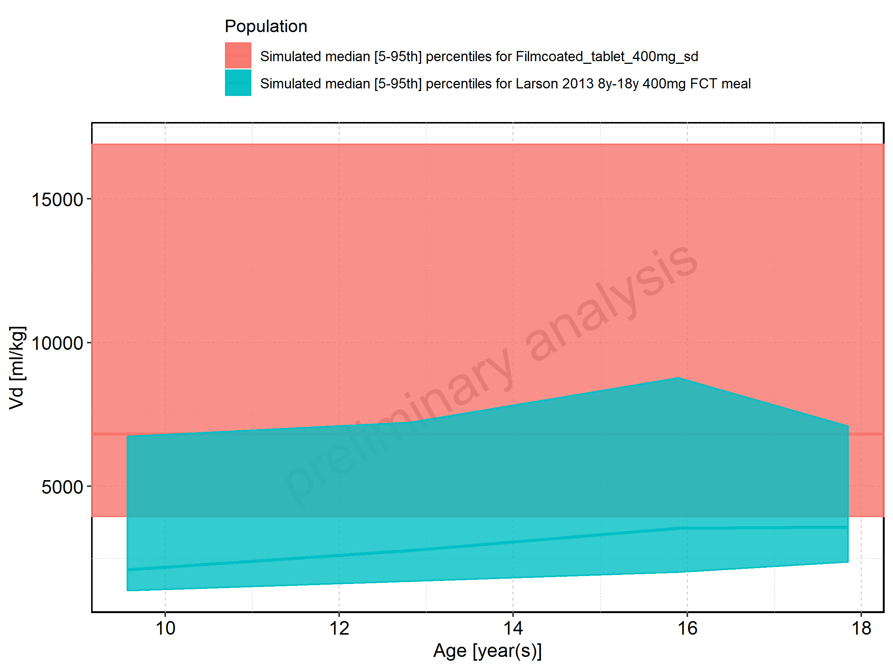

Figure 326: Age-dependence of Vd for Larson 2013 8y-18y 400mg FCT meal in comparison to Filmcoated_tablet_400mg_sd. Profiles are plotted in a logarithmic scale.

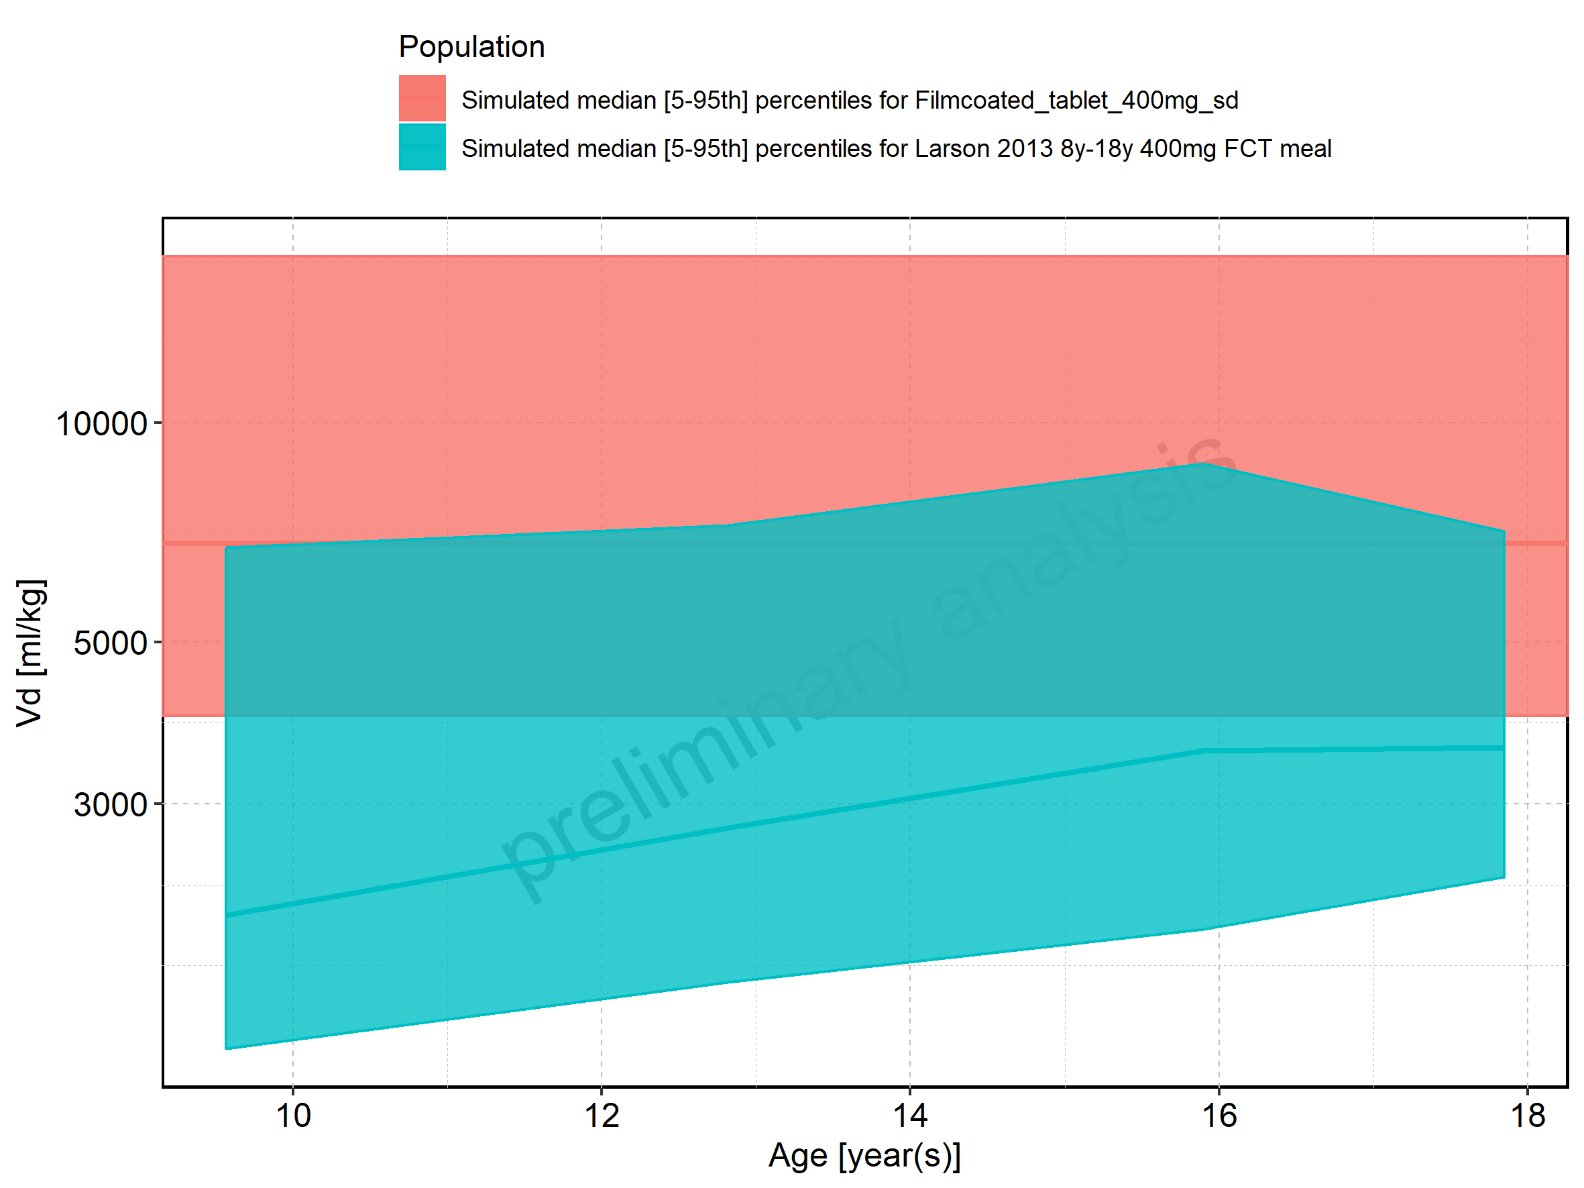

Figure 327: Age-dependence of Vd for Larson 2013 8y-18y 400mg FCT meal. Profiles are plotted in a linear scale.

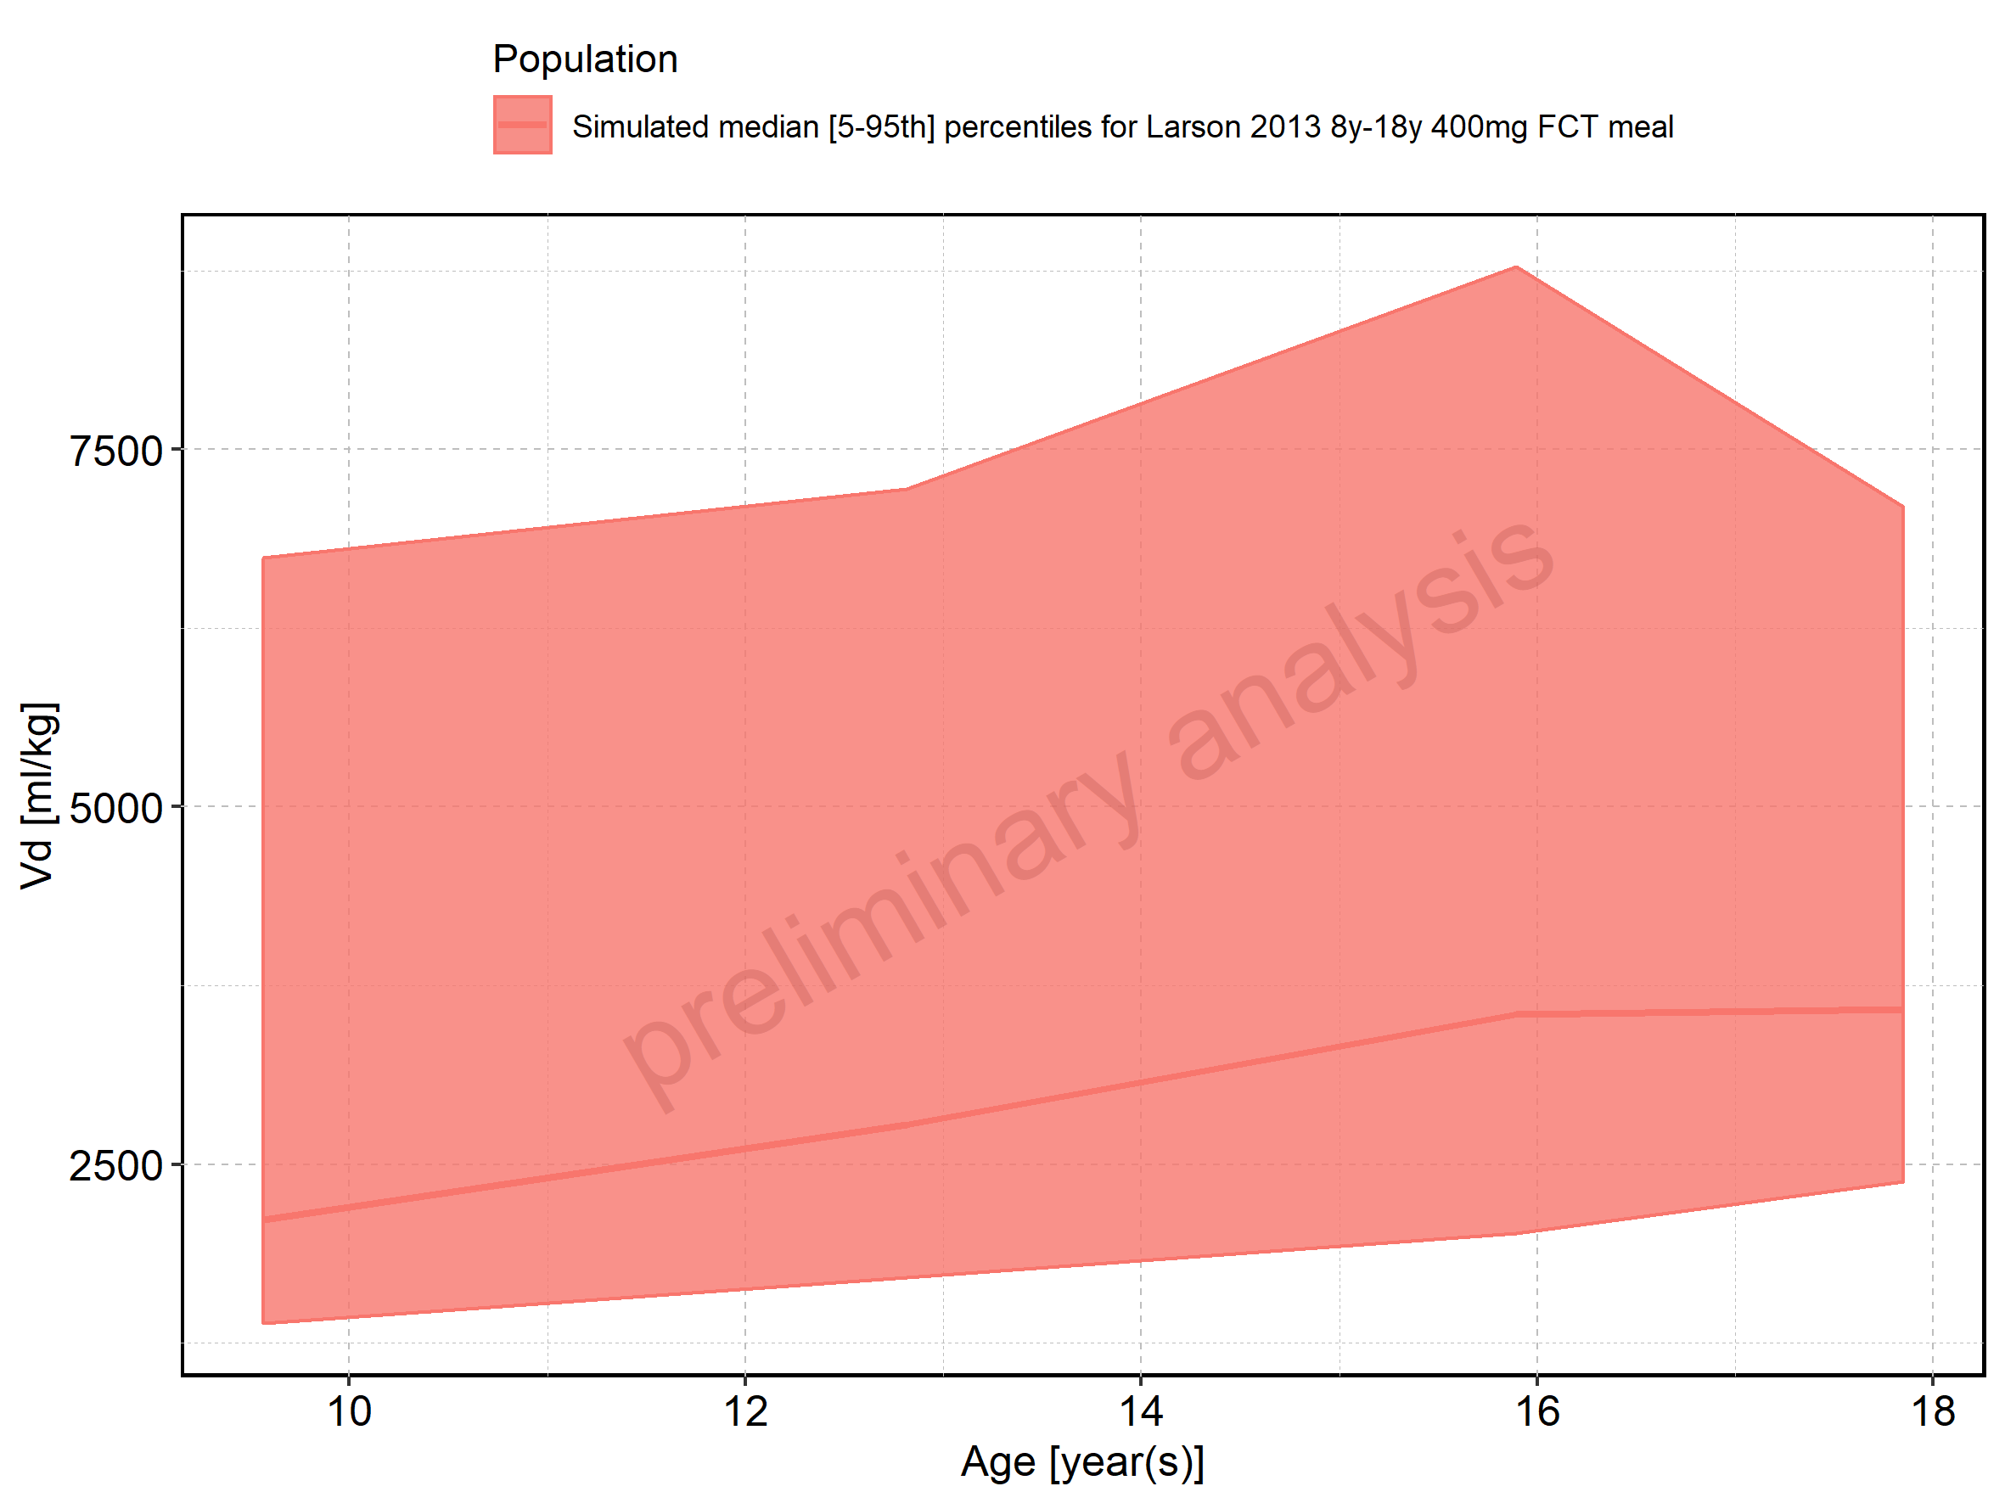

Figure 328: Age-dependence of Vd for Larson 2013 8y-18y 400mg FCT meal. Profiles are plotted in a logarithmic scale.

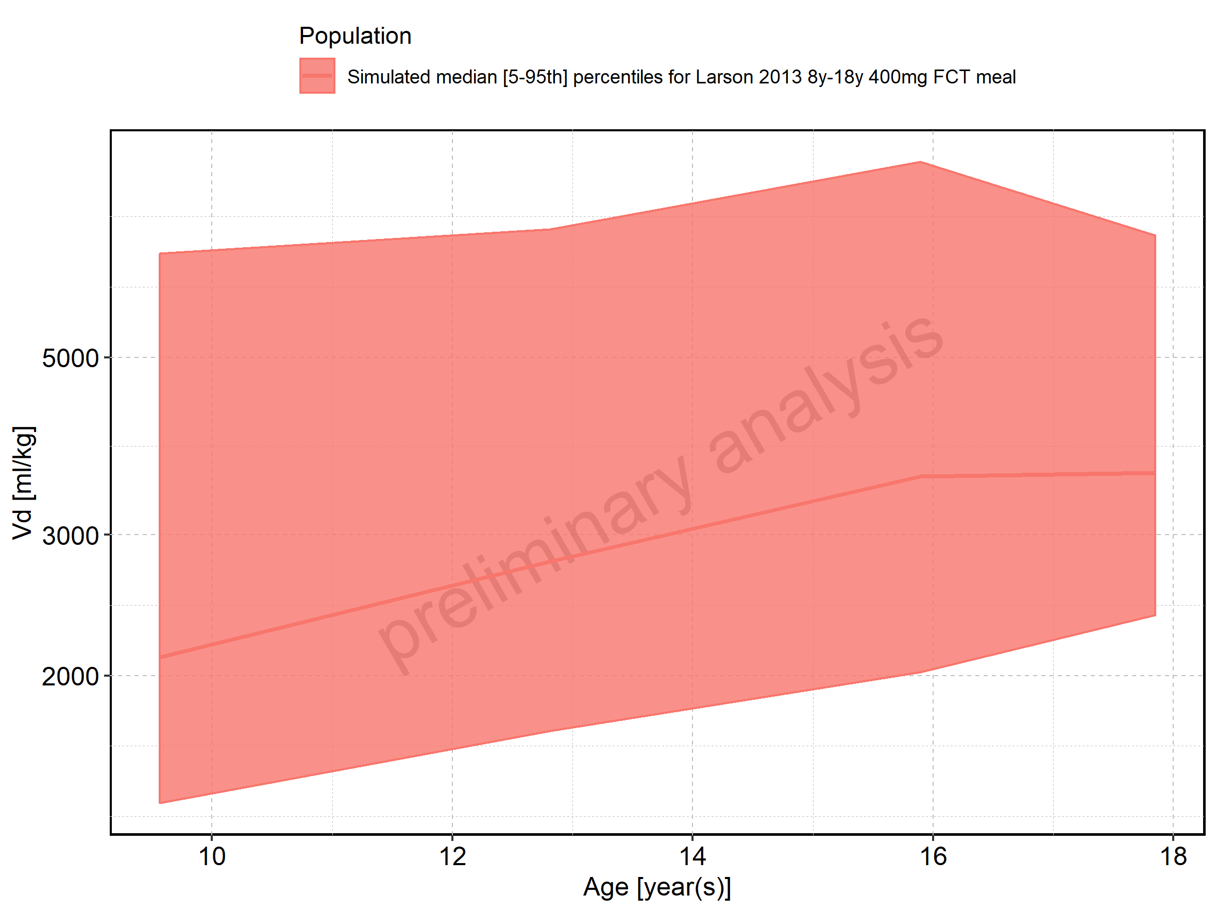

Figure 329: Age-dependence of Vd for Filmcoated_tablet_400mg_sd. Profiles are plotted in a linear scale.

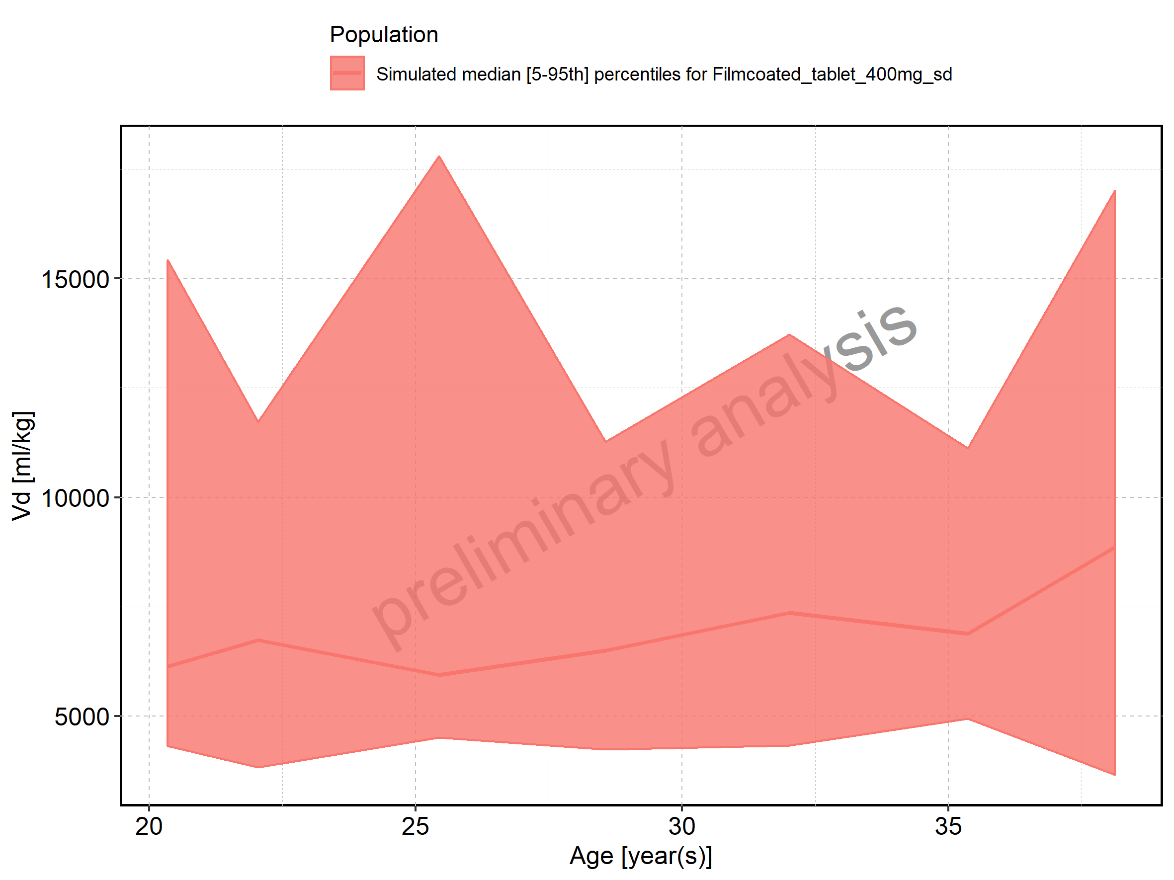

Figure 330: Age-dependence of Vd for Filmcoated_tablet_400mg_sd. Profiles are plotted in a logarithmic scale.

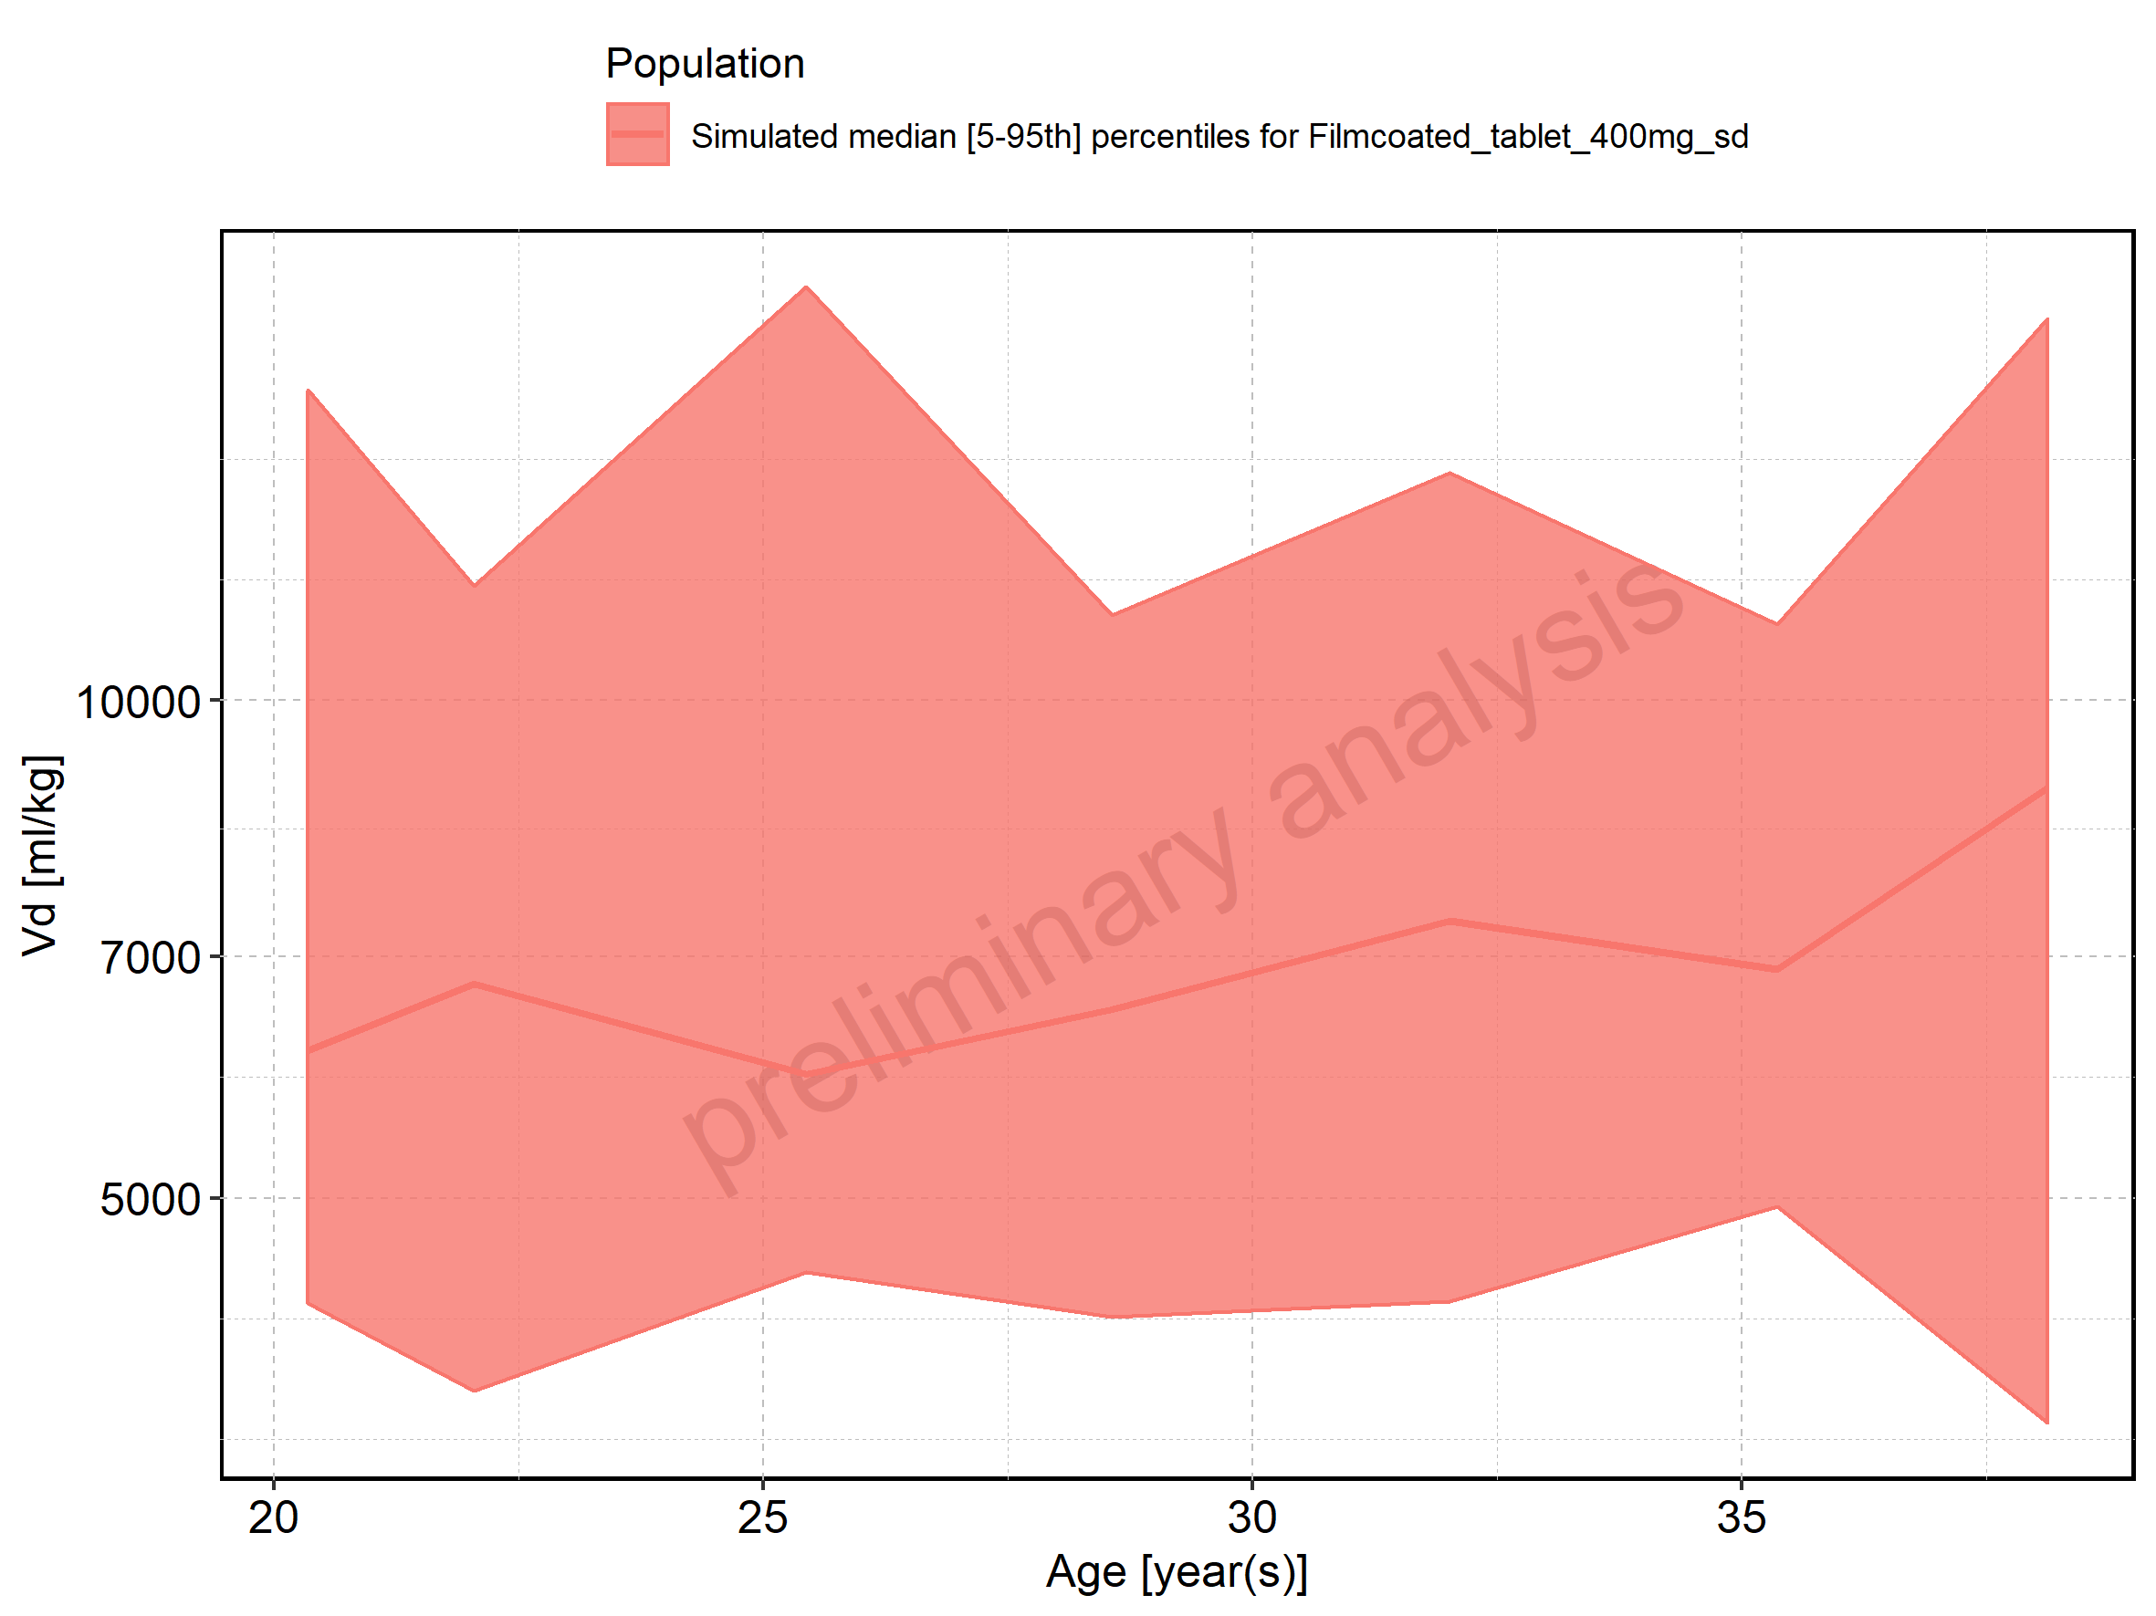

Figure 331: Height-dependence of Vd for Larson 2013 8y-18y 400mg FCT meal in comparison to Filmcoated_tablet_400mg_sd. Profiles are plotted in a linear scale.

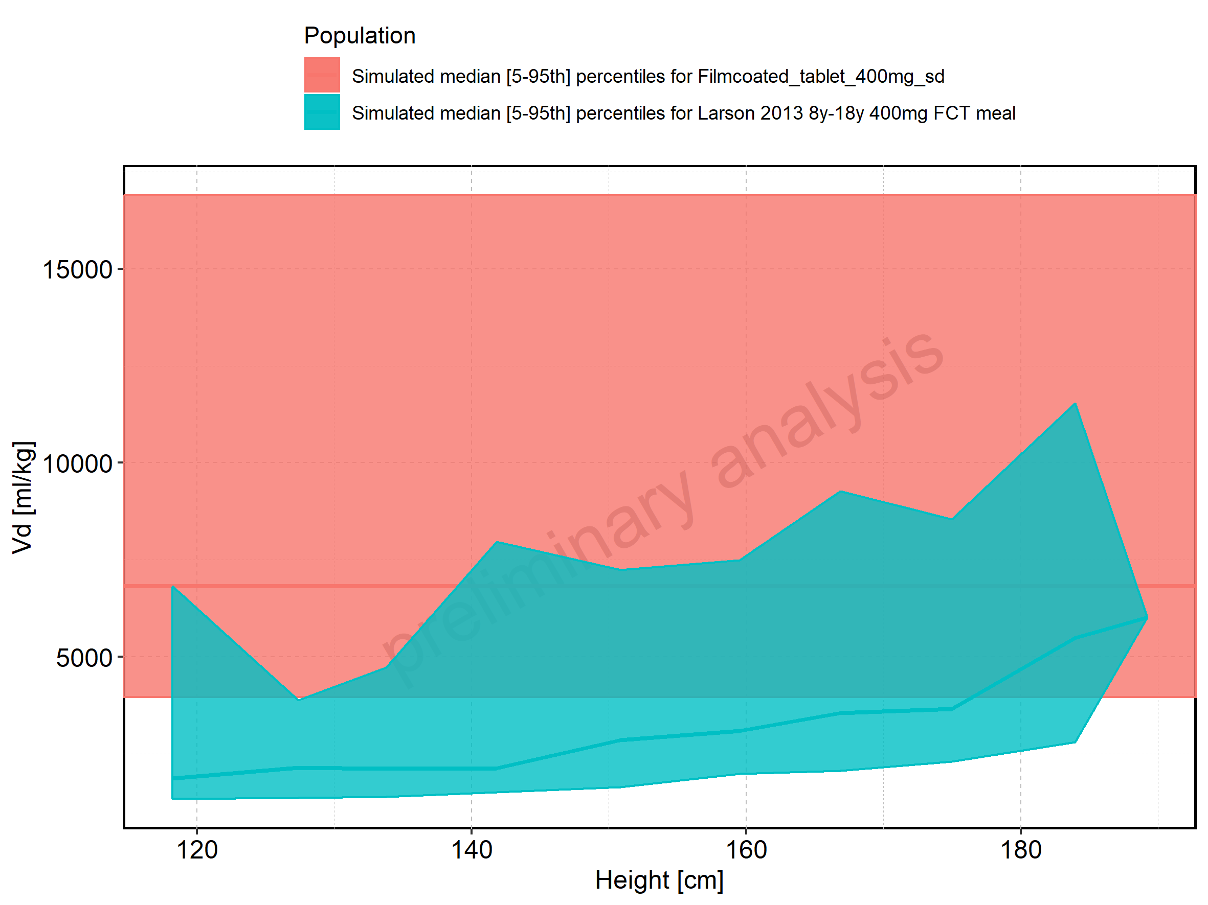

Figure 332: Height-dependence of Vd for Larson 2013 8y-18y 400mg FCT meal in comparison to Filmcoated_tablet_400mg_sd. Profiles are plotted in a logarithmic scale.

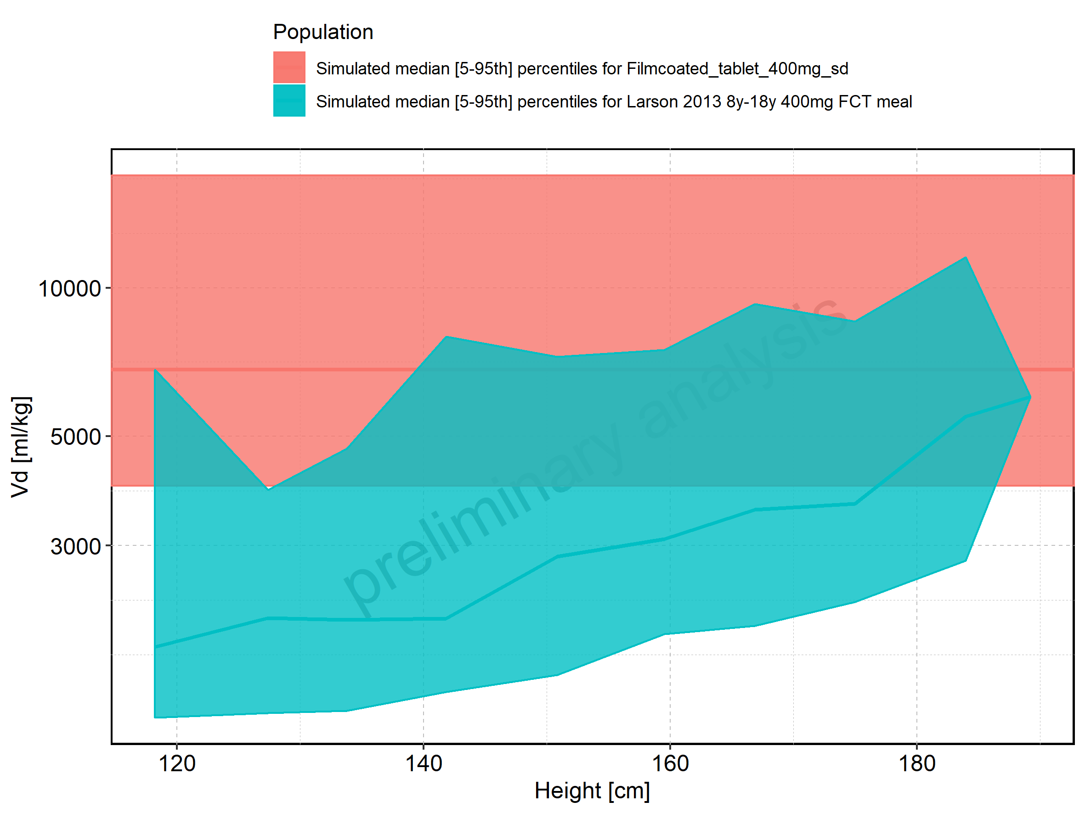

Figure 333: Height-dependence of Vd for Larson 2013 8y-18y 400mg FCT meal. Profiles are plotted in a linear scale.

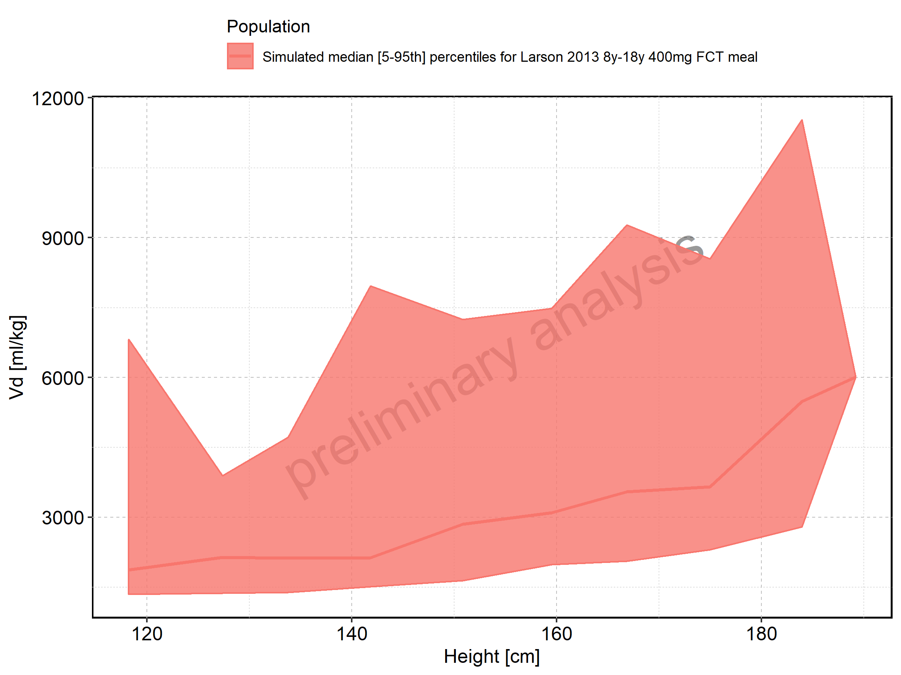

Figure 334: Height-dependence of Vd for Larson 2013 8y-18y 400mg FCT meal. Profiles are plotted in a logarithmic scale.

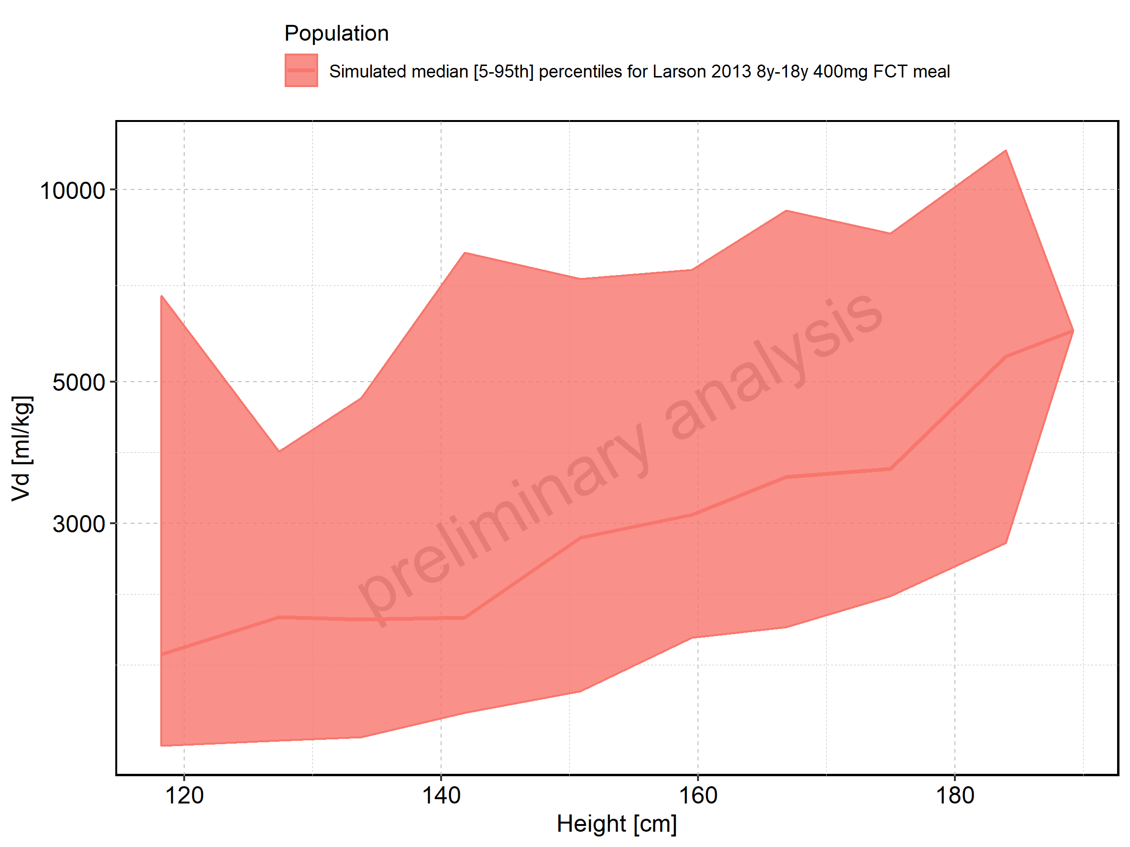

Figure 335: Height-dependence of Vd for Filmcoated_tablet_400mg_sd. Profiles are plotted in a linear scale.

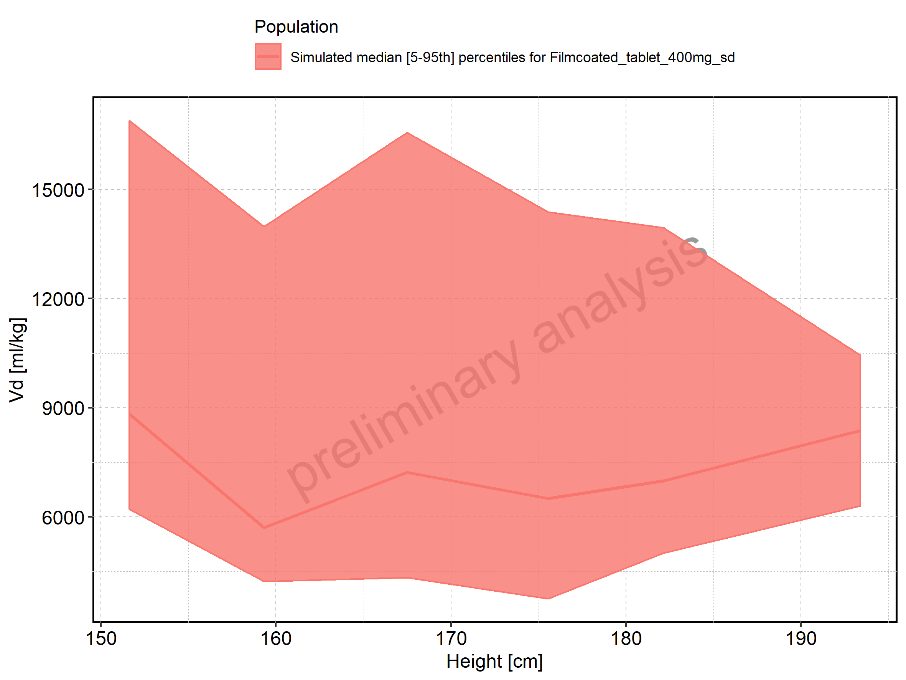

Figure 336: Height-dependence of Vd for Filmcoated_tablet_400mg_sd. Profiles are plotted in a logarithmic scale.

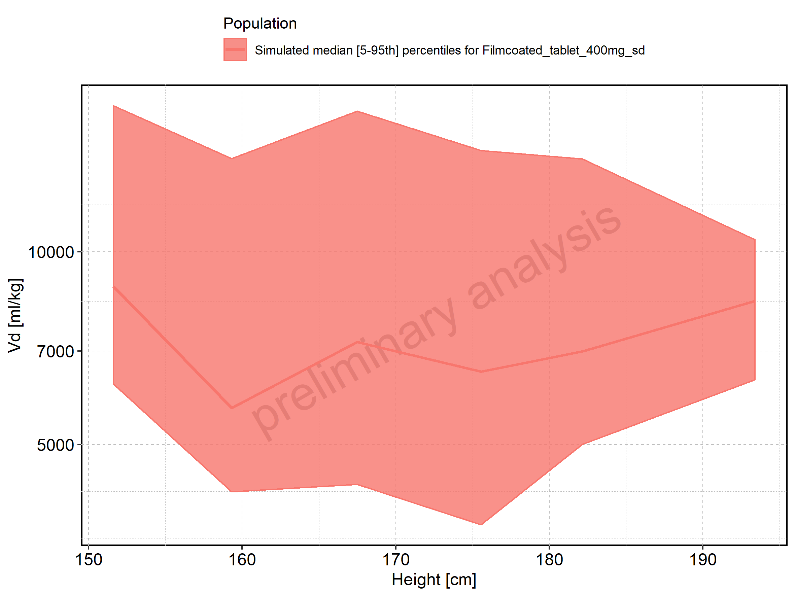

Figure 337: Weight-dependence of Vd for Larson 2013 8y-18y 400mg FCT meal in comparison to Filmcoated_tablet_400mg_sd. Profiles are plotted in a linear scale.

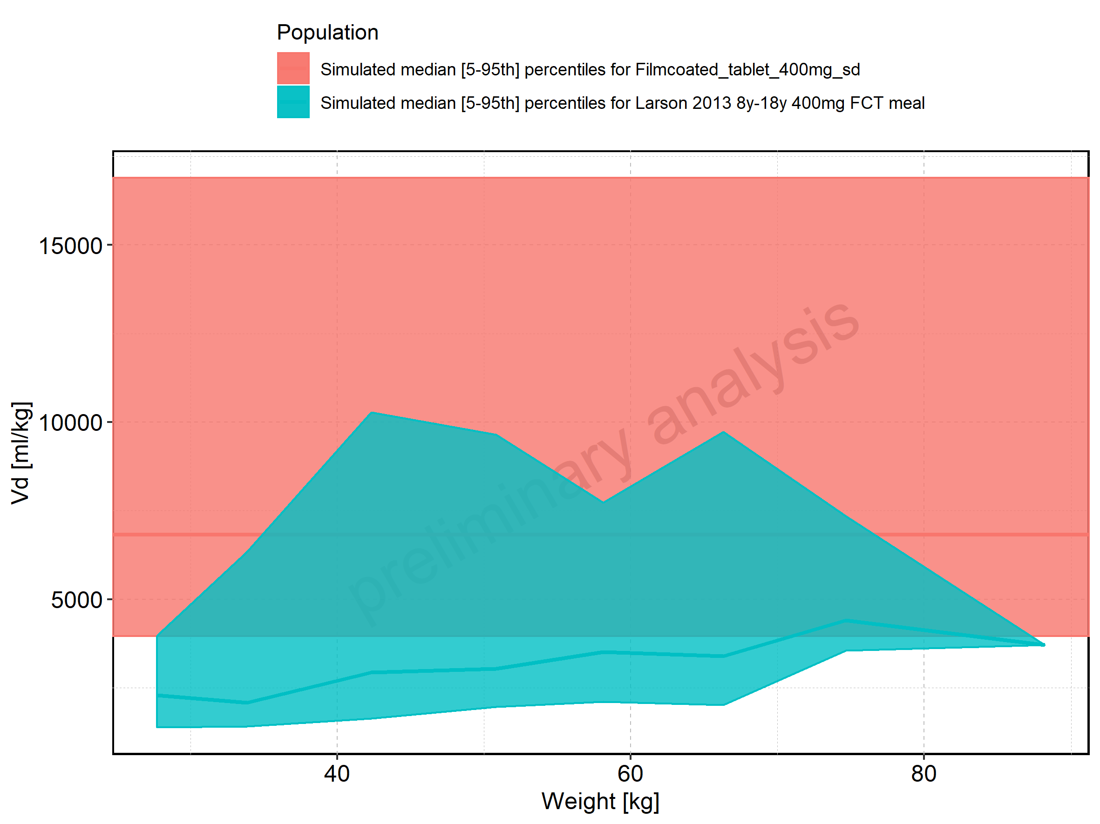

Figure 338: Weight-dependence of Vd for Larson 2013 8y-18y 400mg FCT meal in comparison to Filmcoated_tablet_400mg_sd. Profiles are plotted in a logarithmic scale.

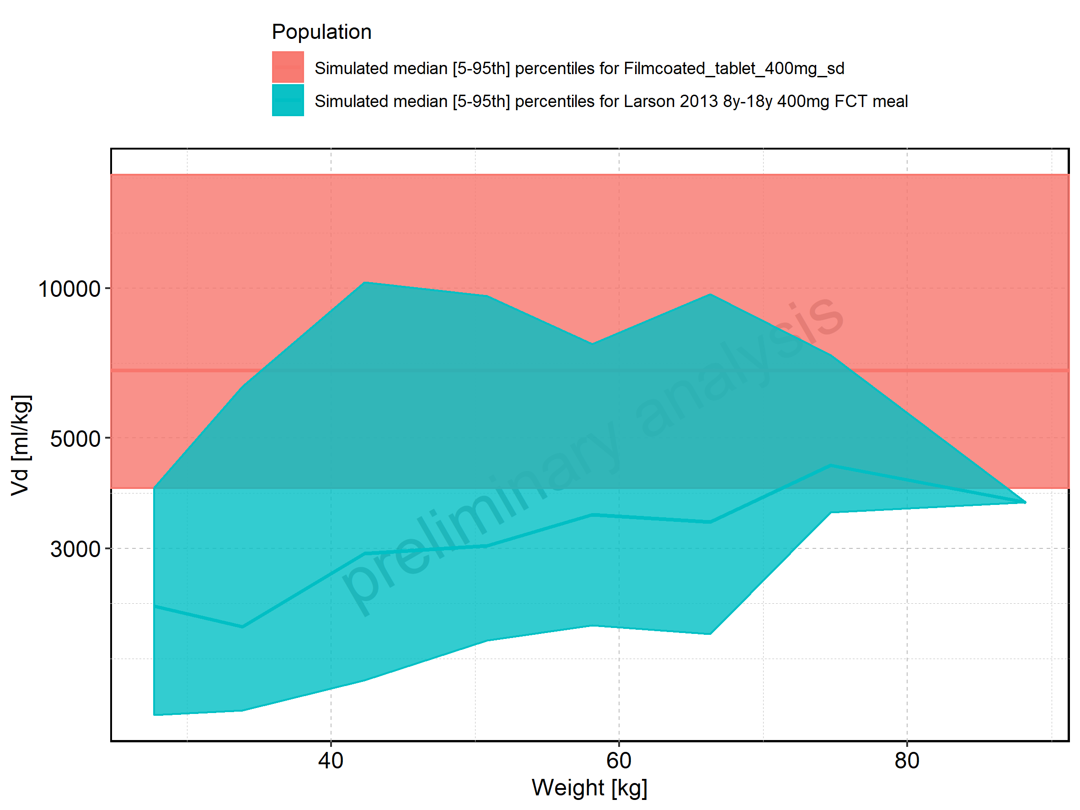

Figure 339: Weight-dependence of Vd for Larson 2013 8y-18y 400mg FCT meal. Profiles are plotted in a linear scale.

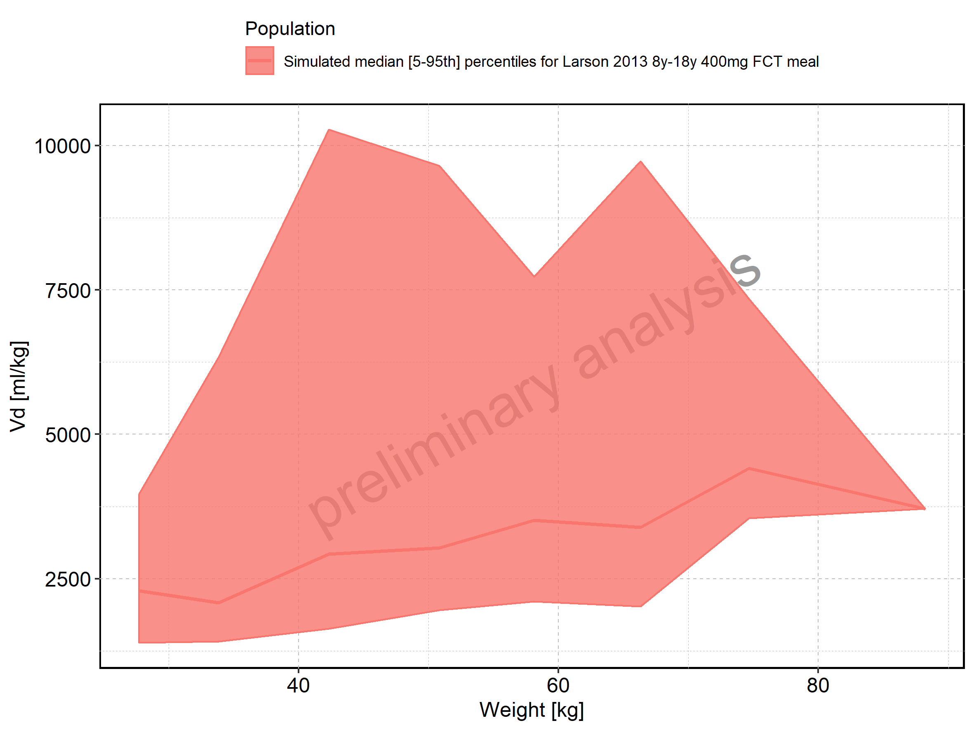

Figure 340: Weight-dependence of Vd for Larson 2013 8y-18y 400mg FCT meal. Profiles are plotted in a logarithmic scale.

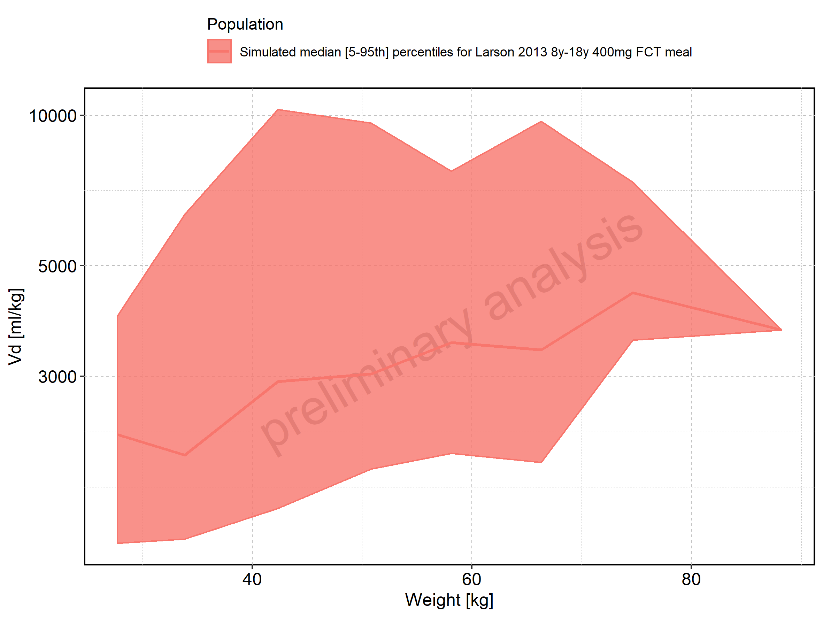

Figure 341: Weight-dependence of Vd for Filmcoated_tablet_400mg_sd. Profiles are plotted in a linear scale.

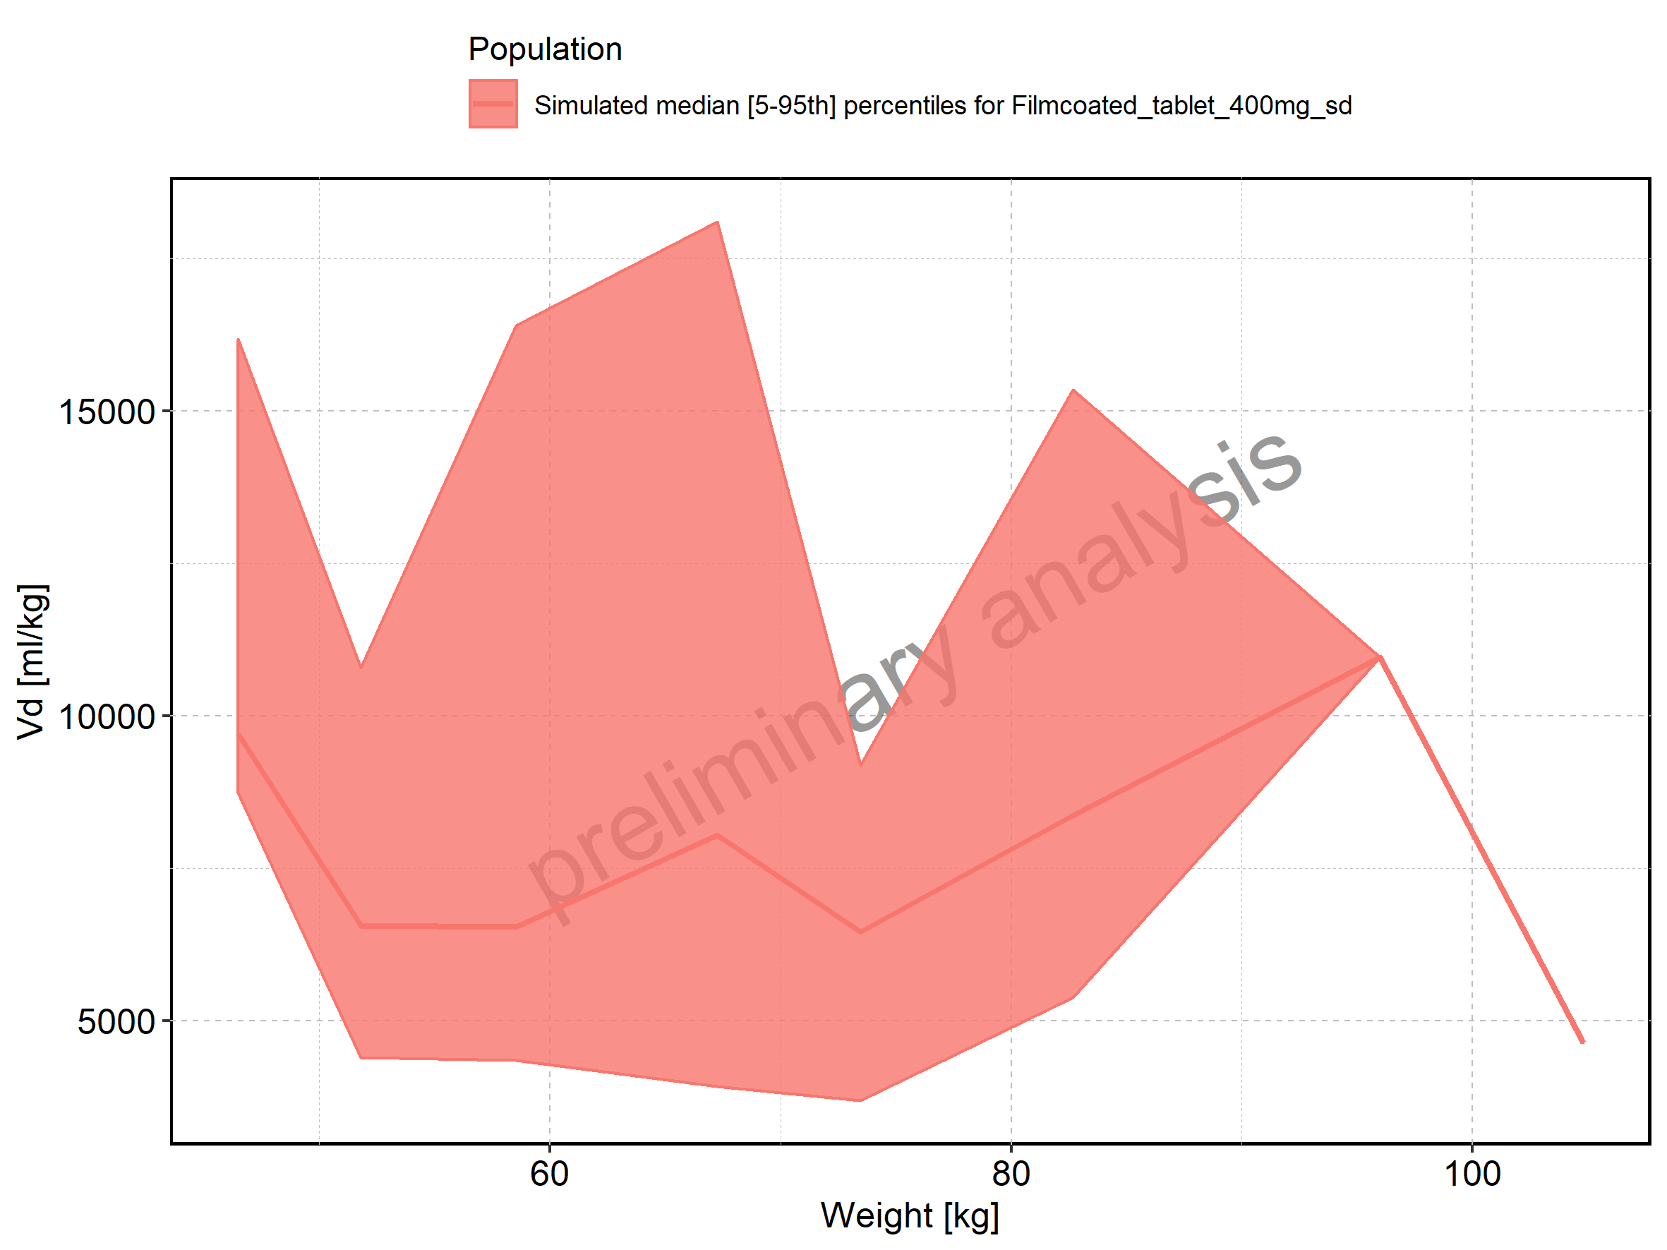

Figure 342: Weight-dependence of Vd for Filmcoated_tablet_400mg_sd. Profiles are plotted in a logarithmic scale.

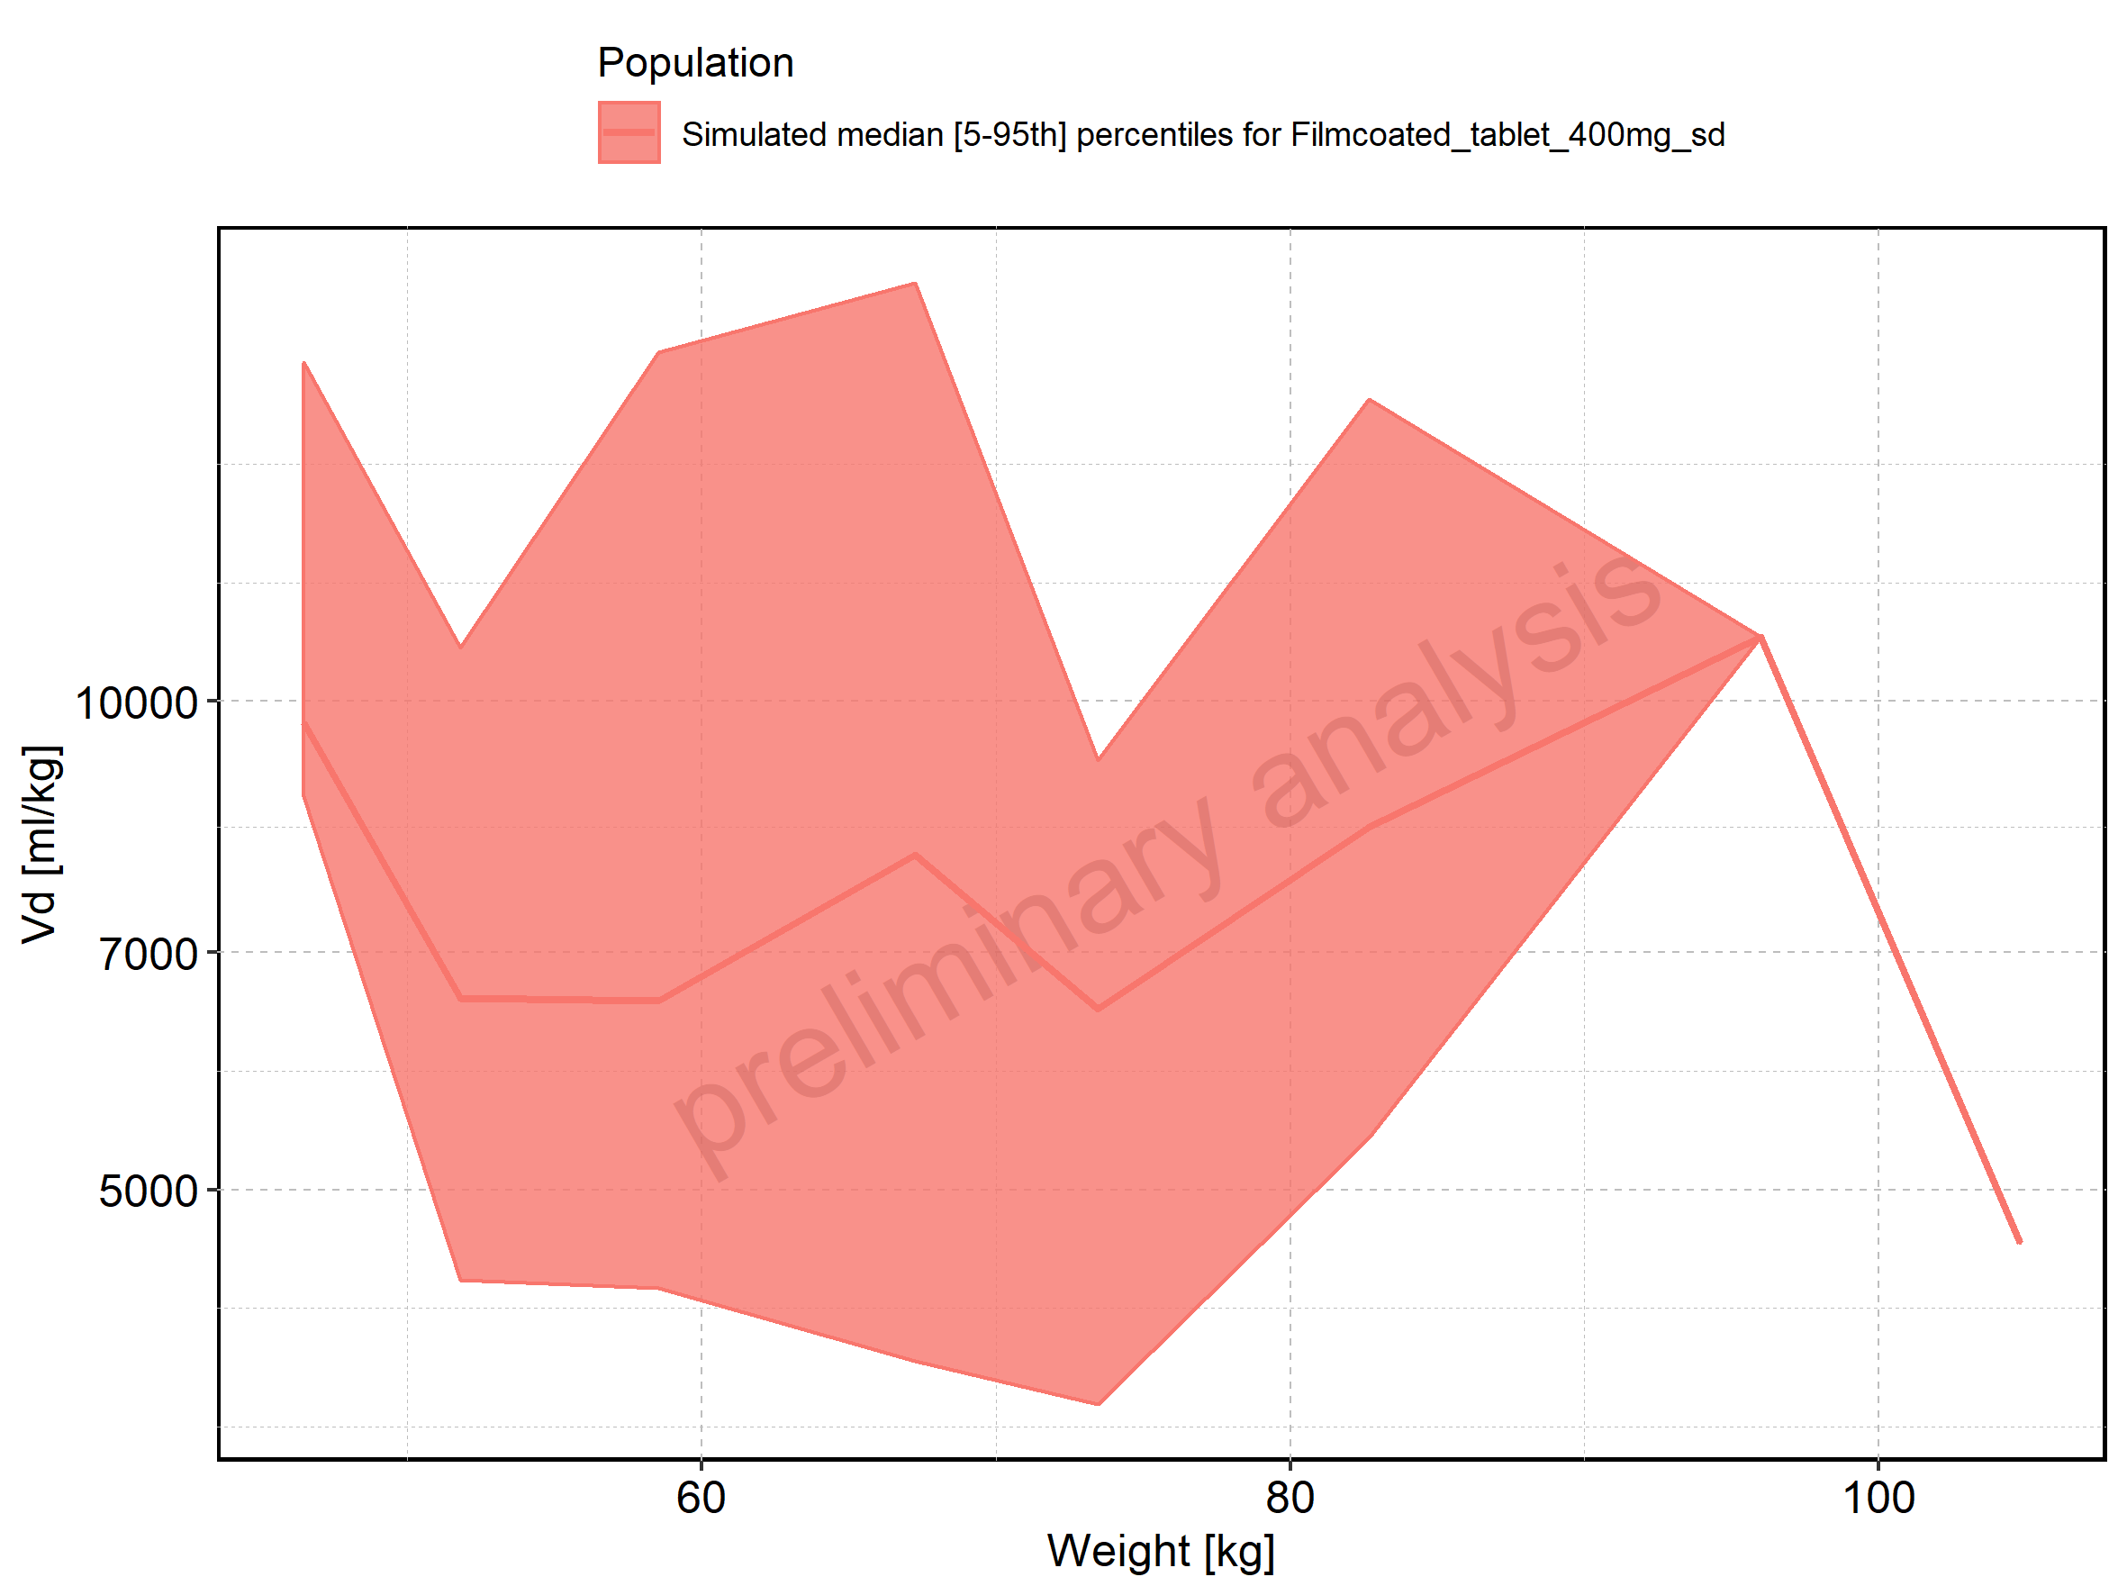

Figure 343: BMI-dependence of Vd for Larson 2013 8y-18y 400mg FCT meal in comparison to Filmcoated_tablet_400mg_sd. Profiles are plotted in a linear scale.

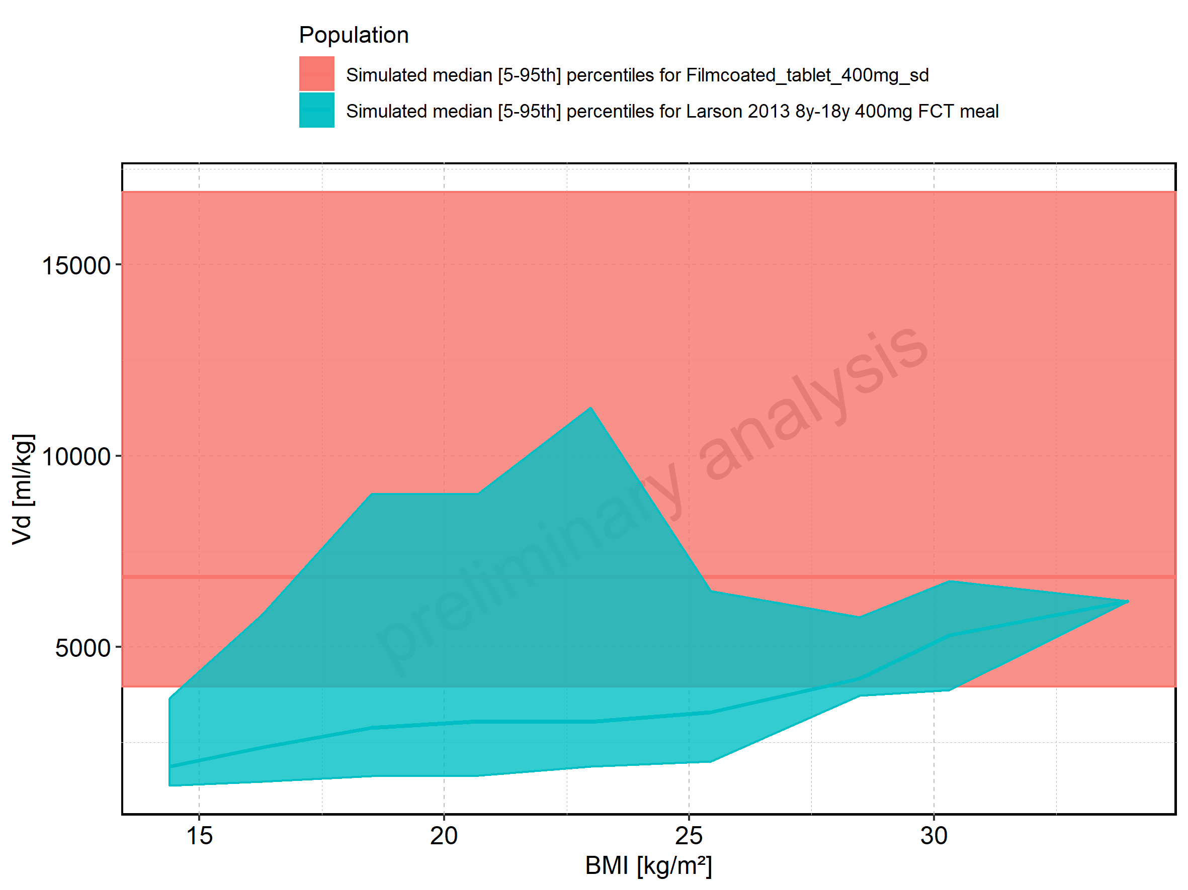

Figure 344: BMI-dependence of Vd for Larson 2013 8y-18y 400mg FCT meal in comparison to Filmcoated_tablet_400mg_sd. Profiles are plotted in a logarithmic scale.

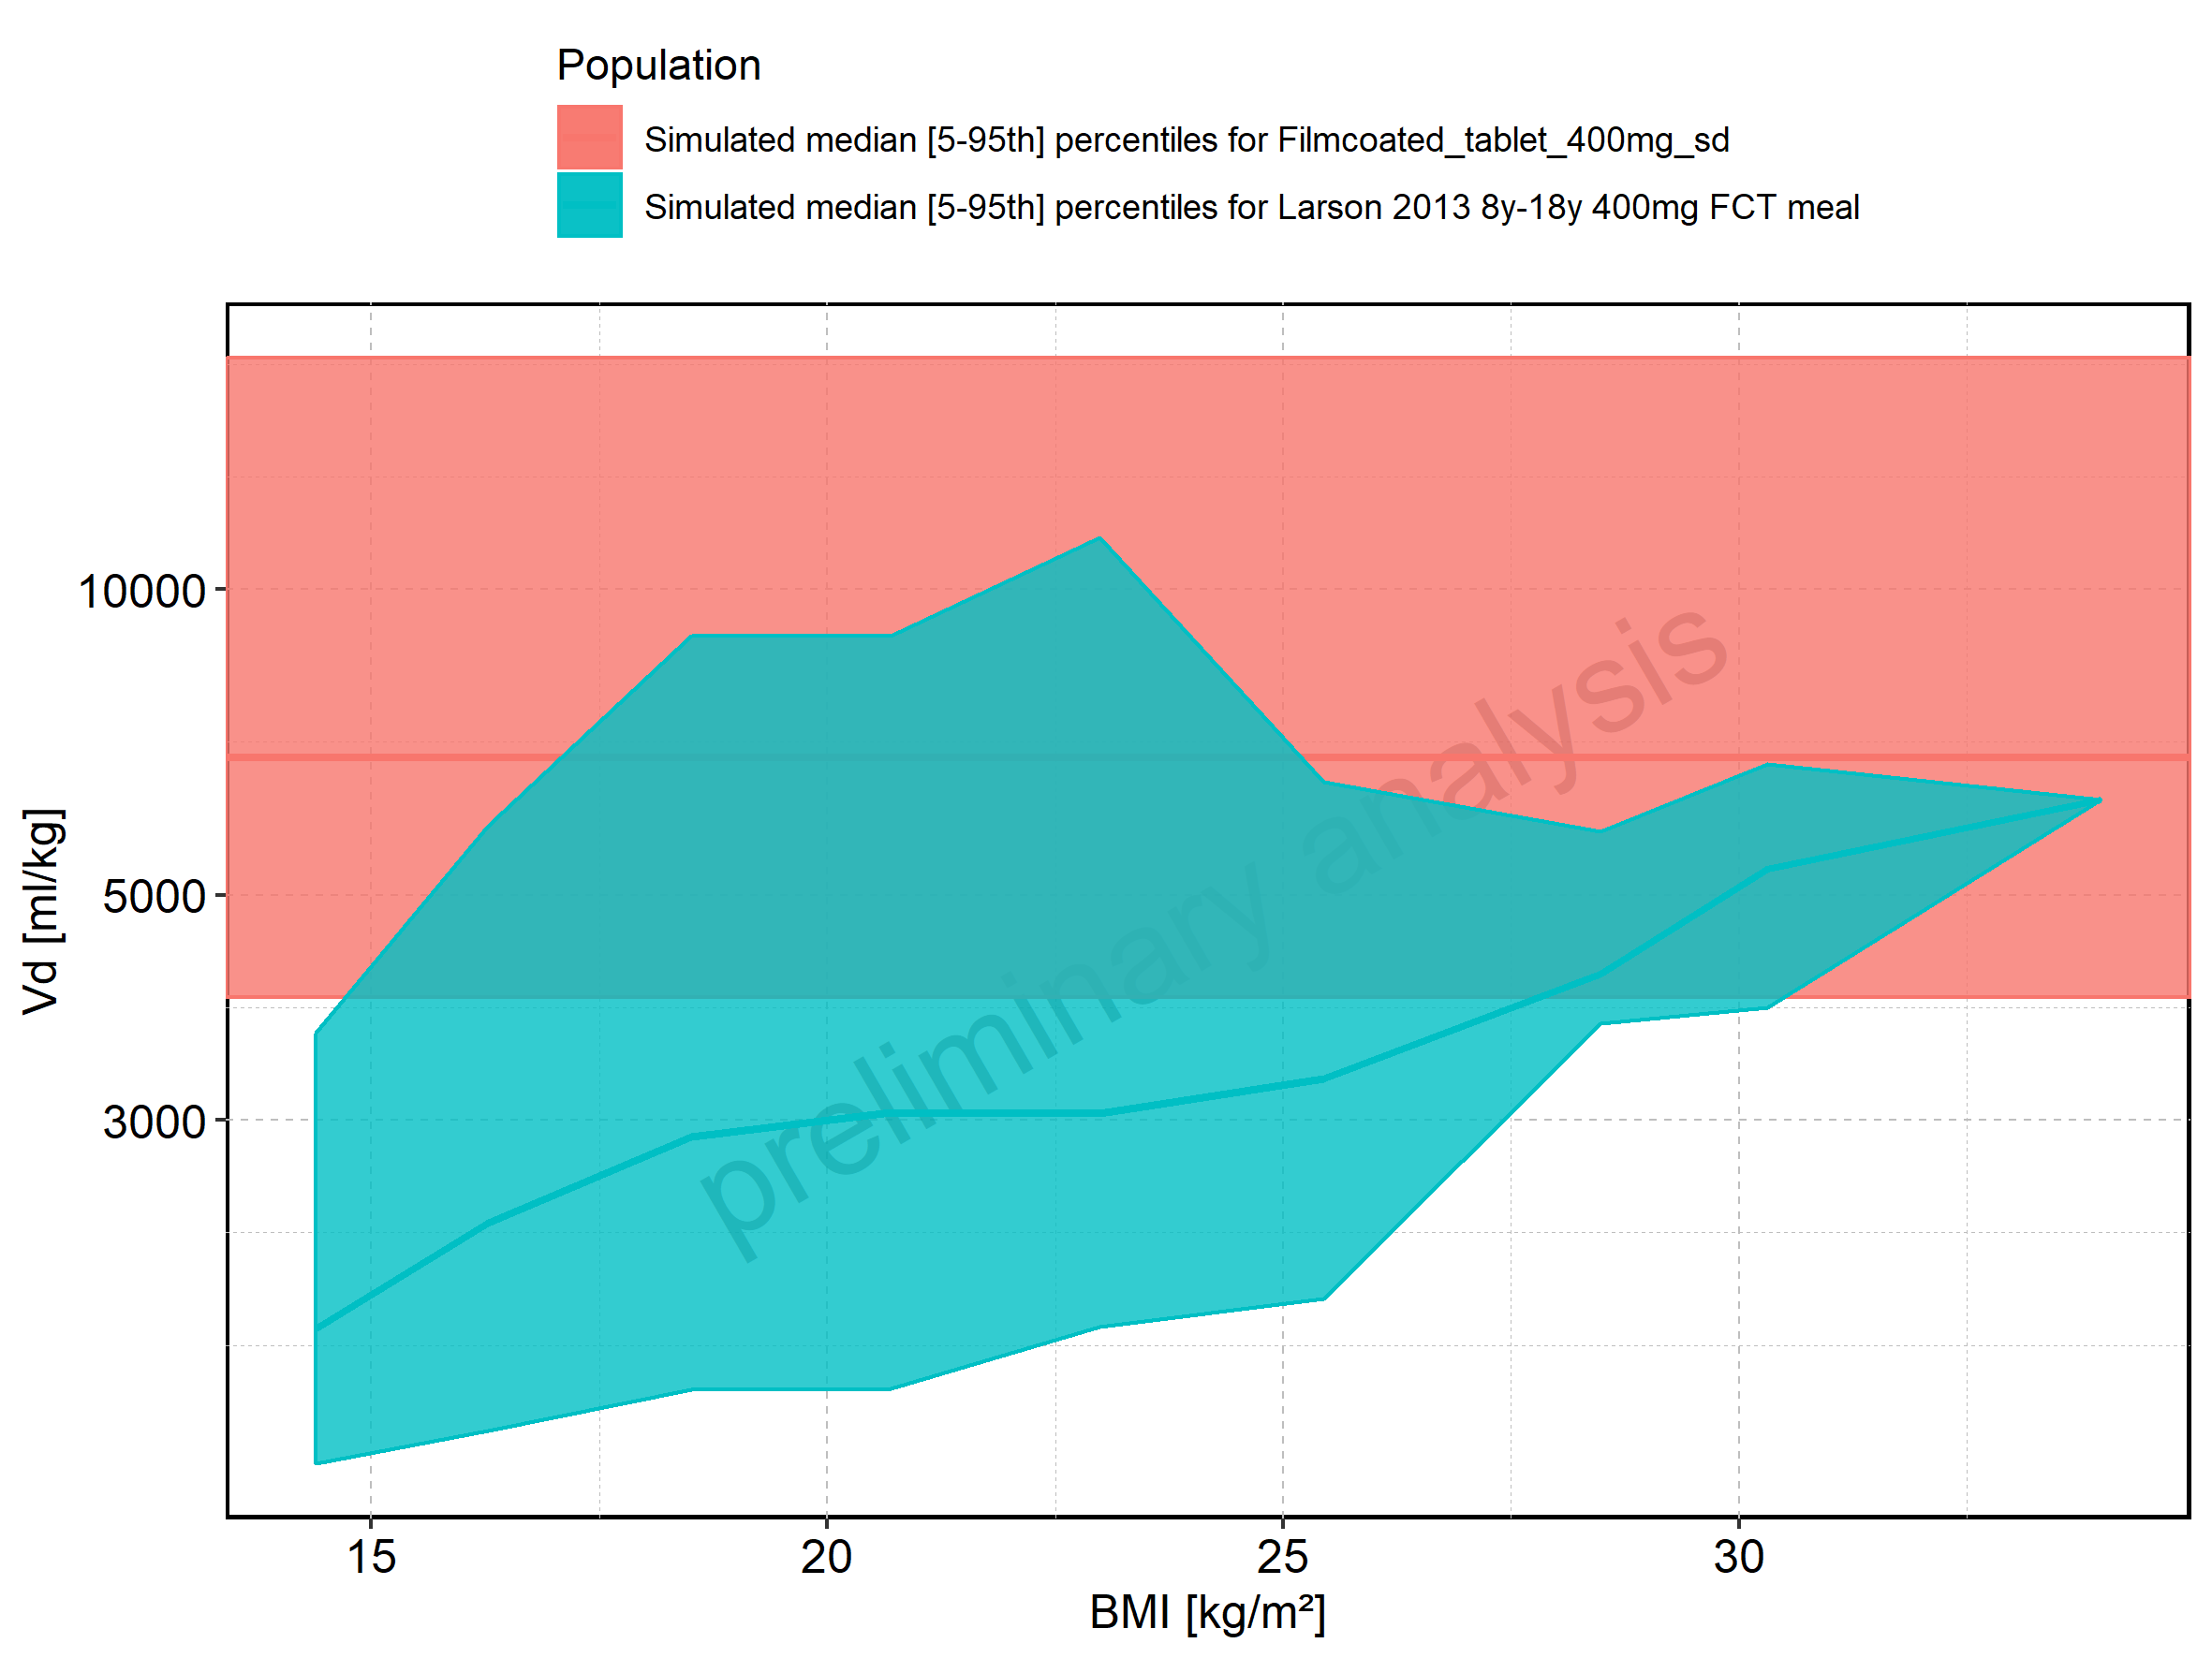

Figure 345: BMI-dependence of Vd for Larson 2013 8y-18y 400mg FCT meal. Profiles are plotted in a linear scale.

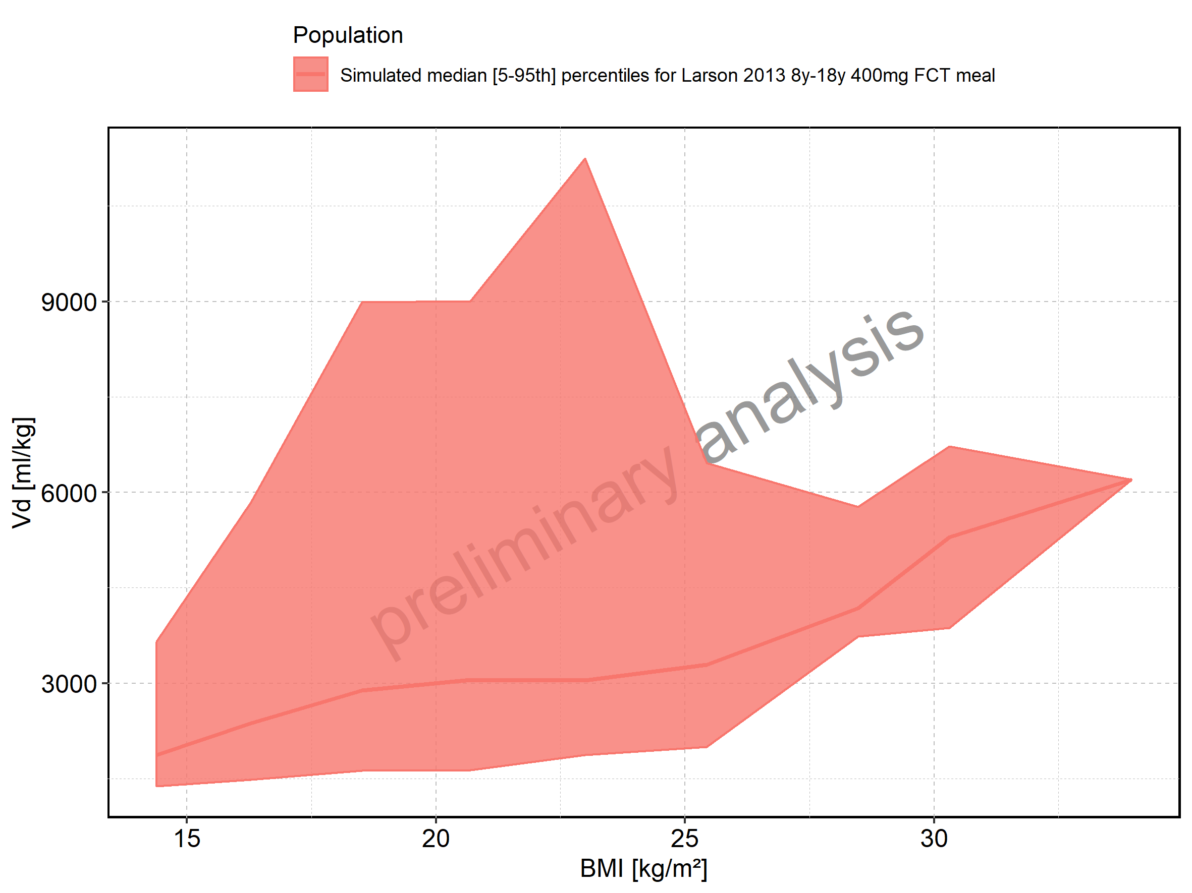

Figure 346: BMI-dependence of Vd for Larson 2013 8y-18y 400mg FCT meal. Profiles are plotted in a logarithmic scale.

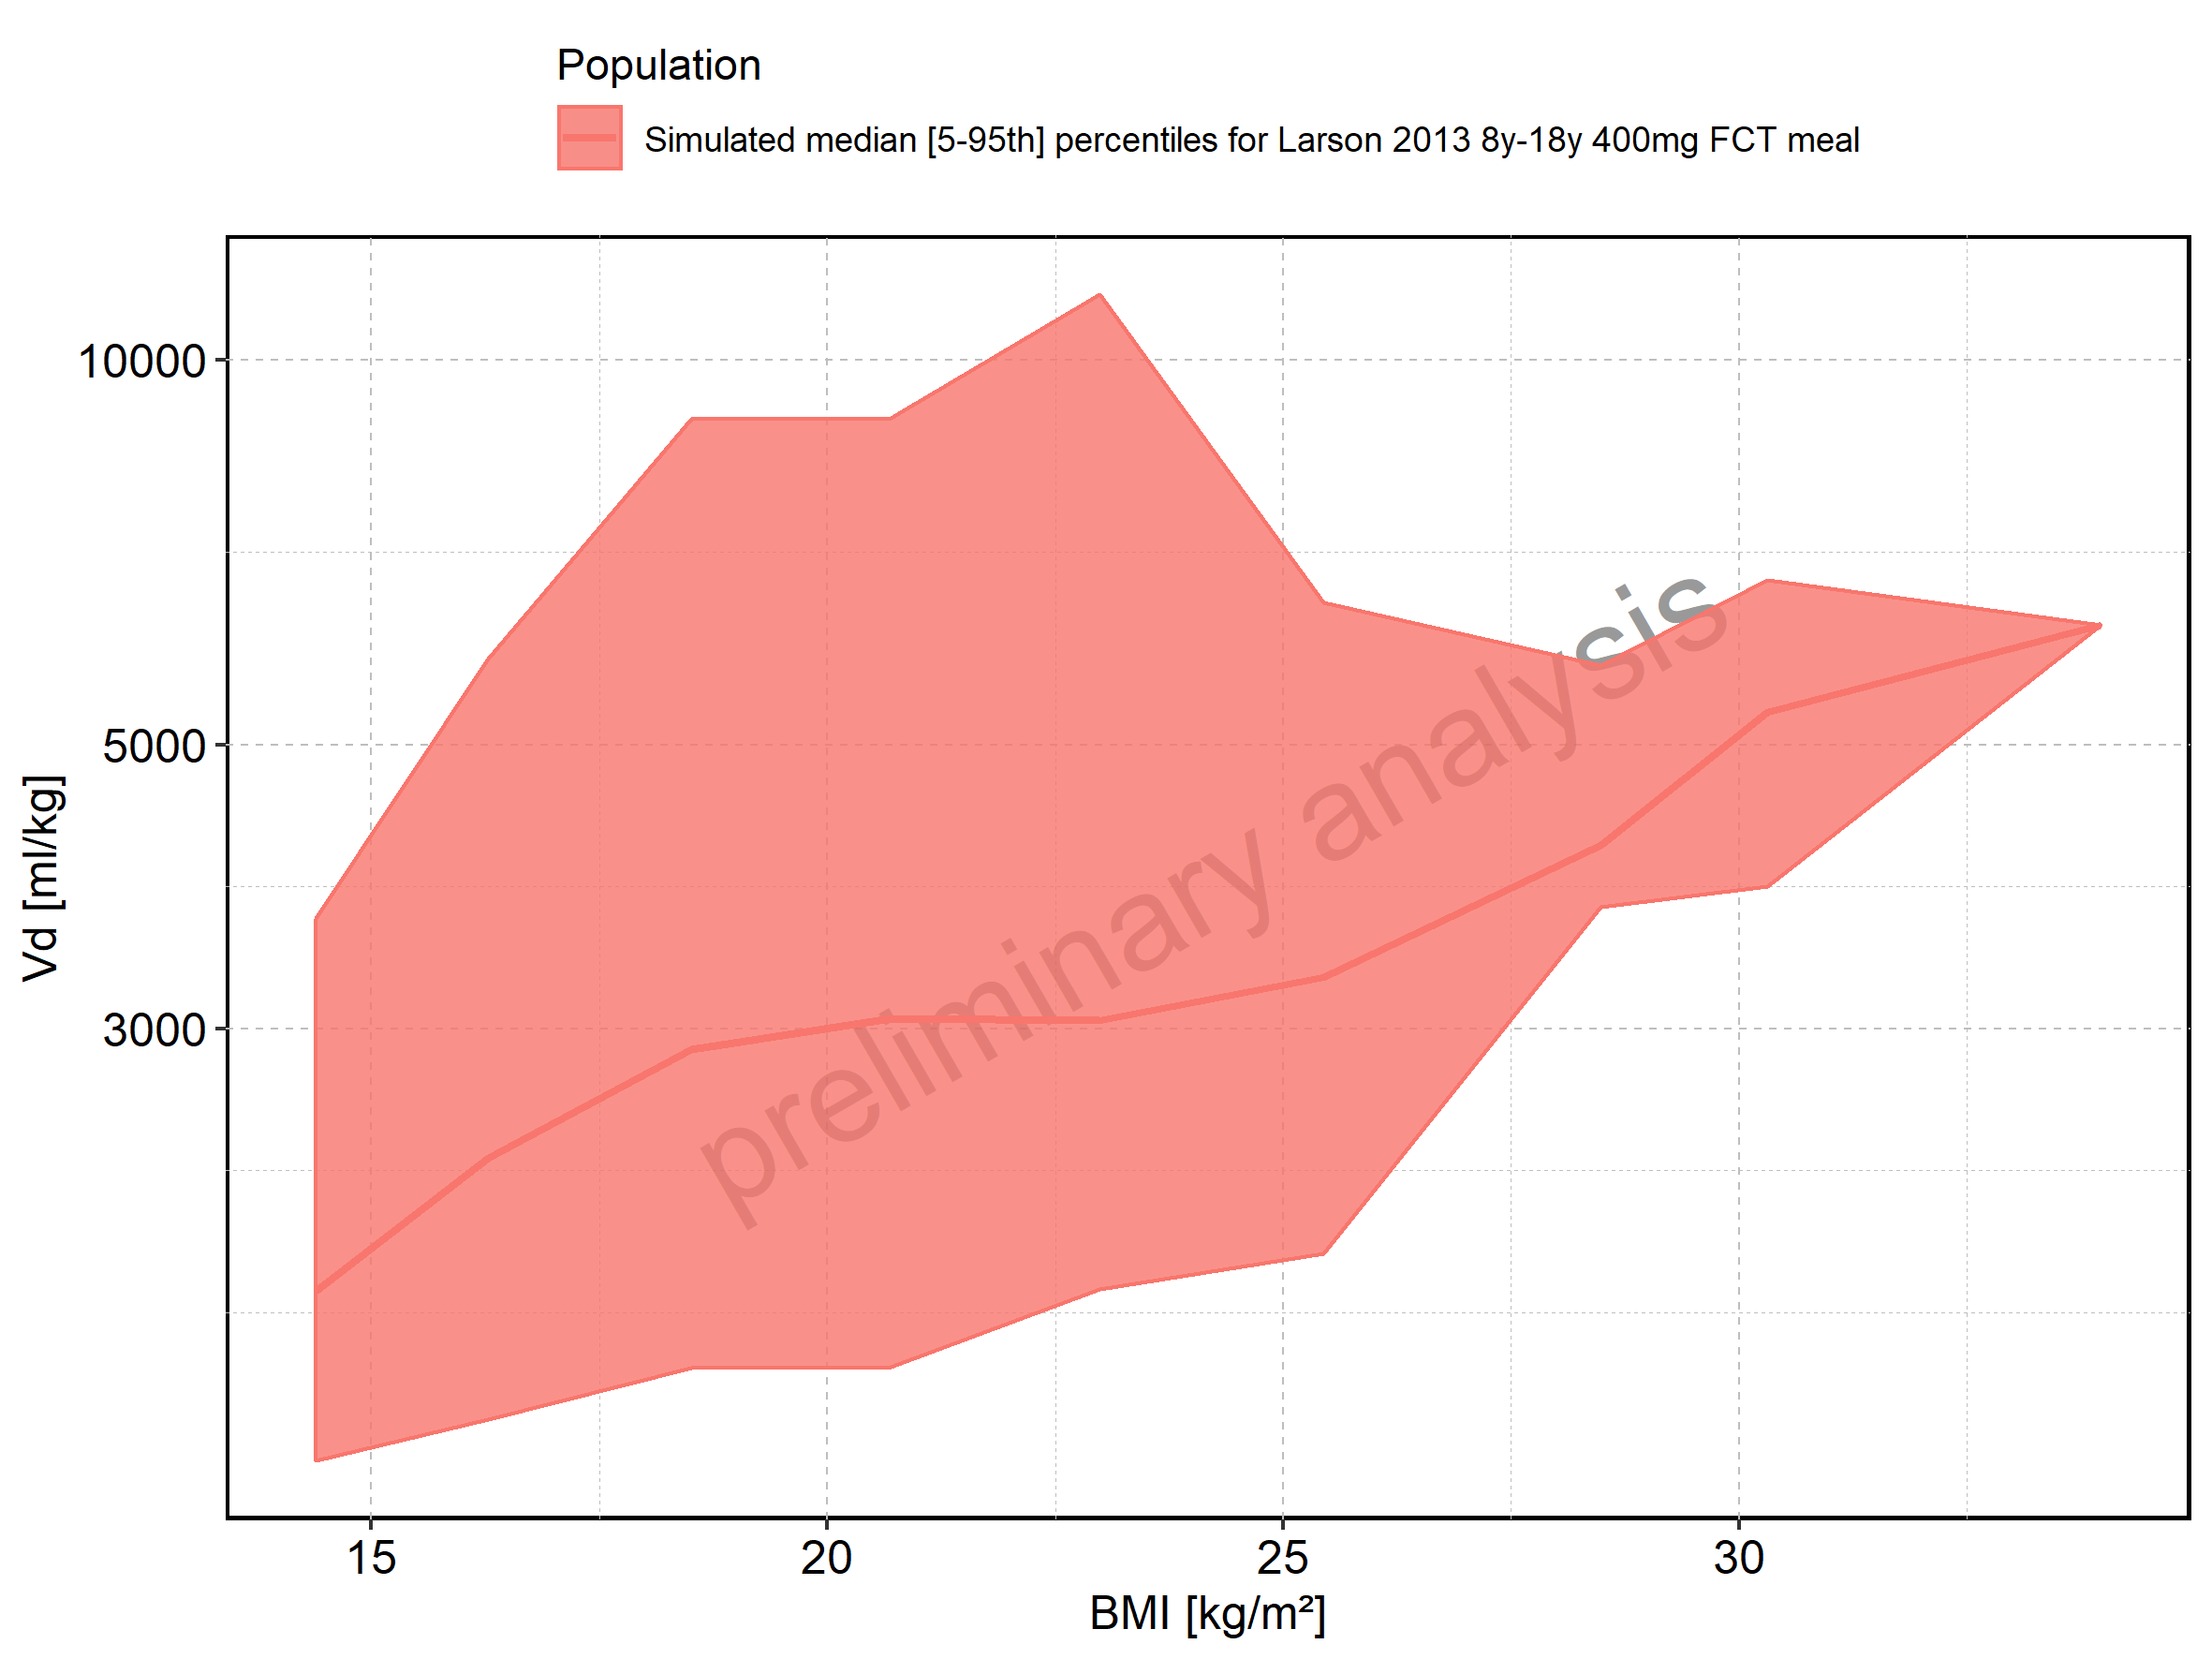

Figure 347: BMI-dependence of Vd for Filmcoated_tablet_400mg_sd. Profiles are plotted in a linear scale.

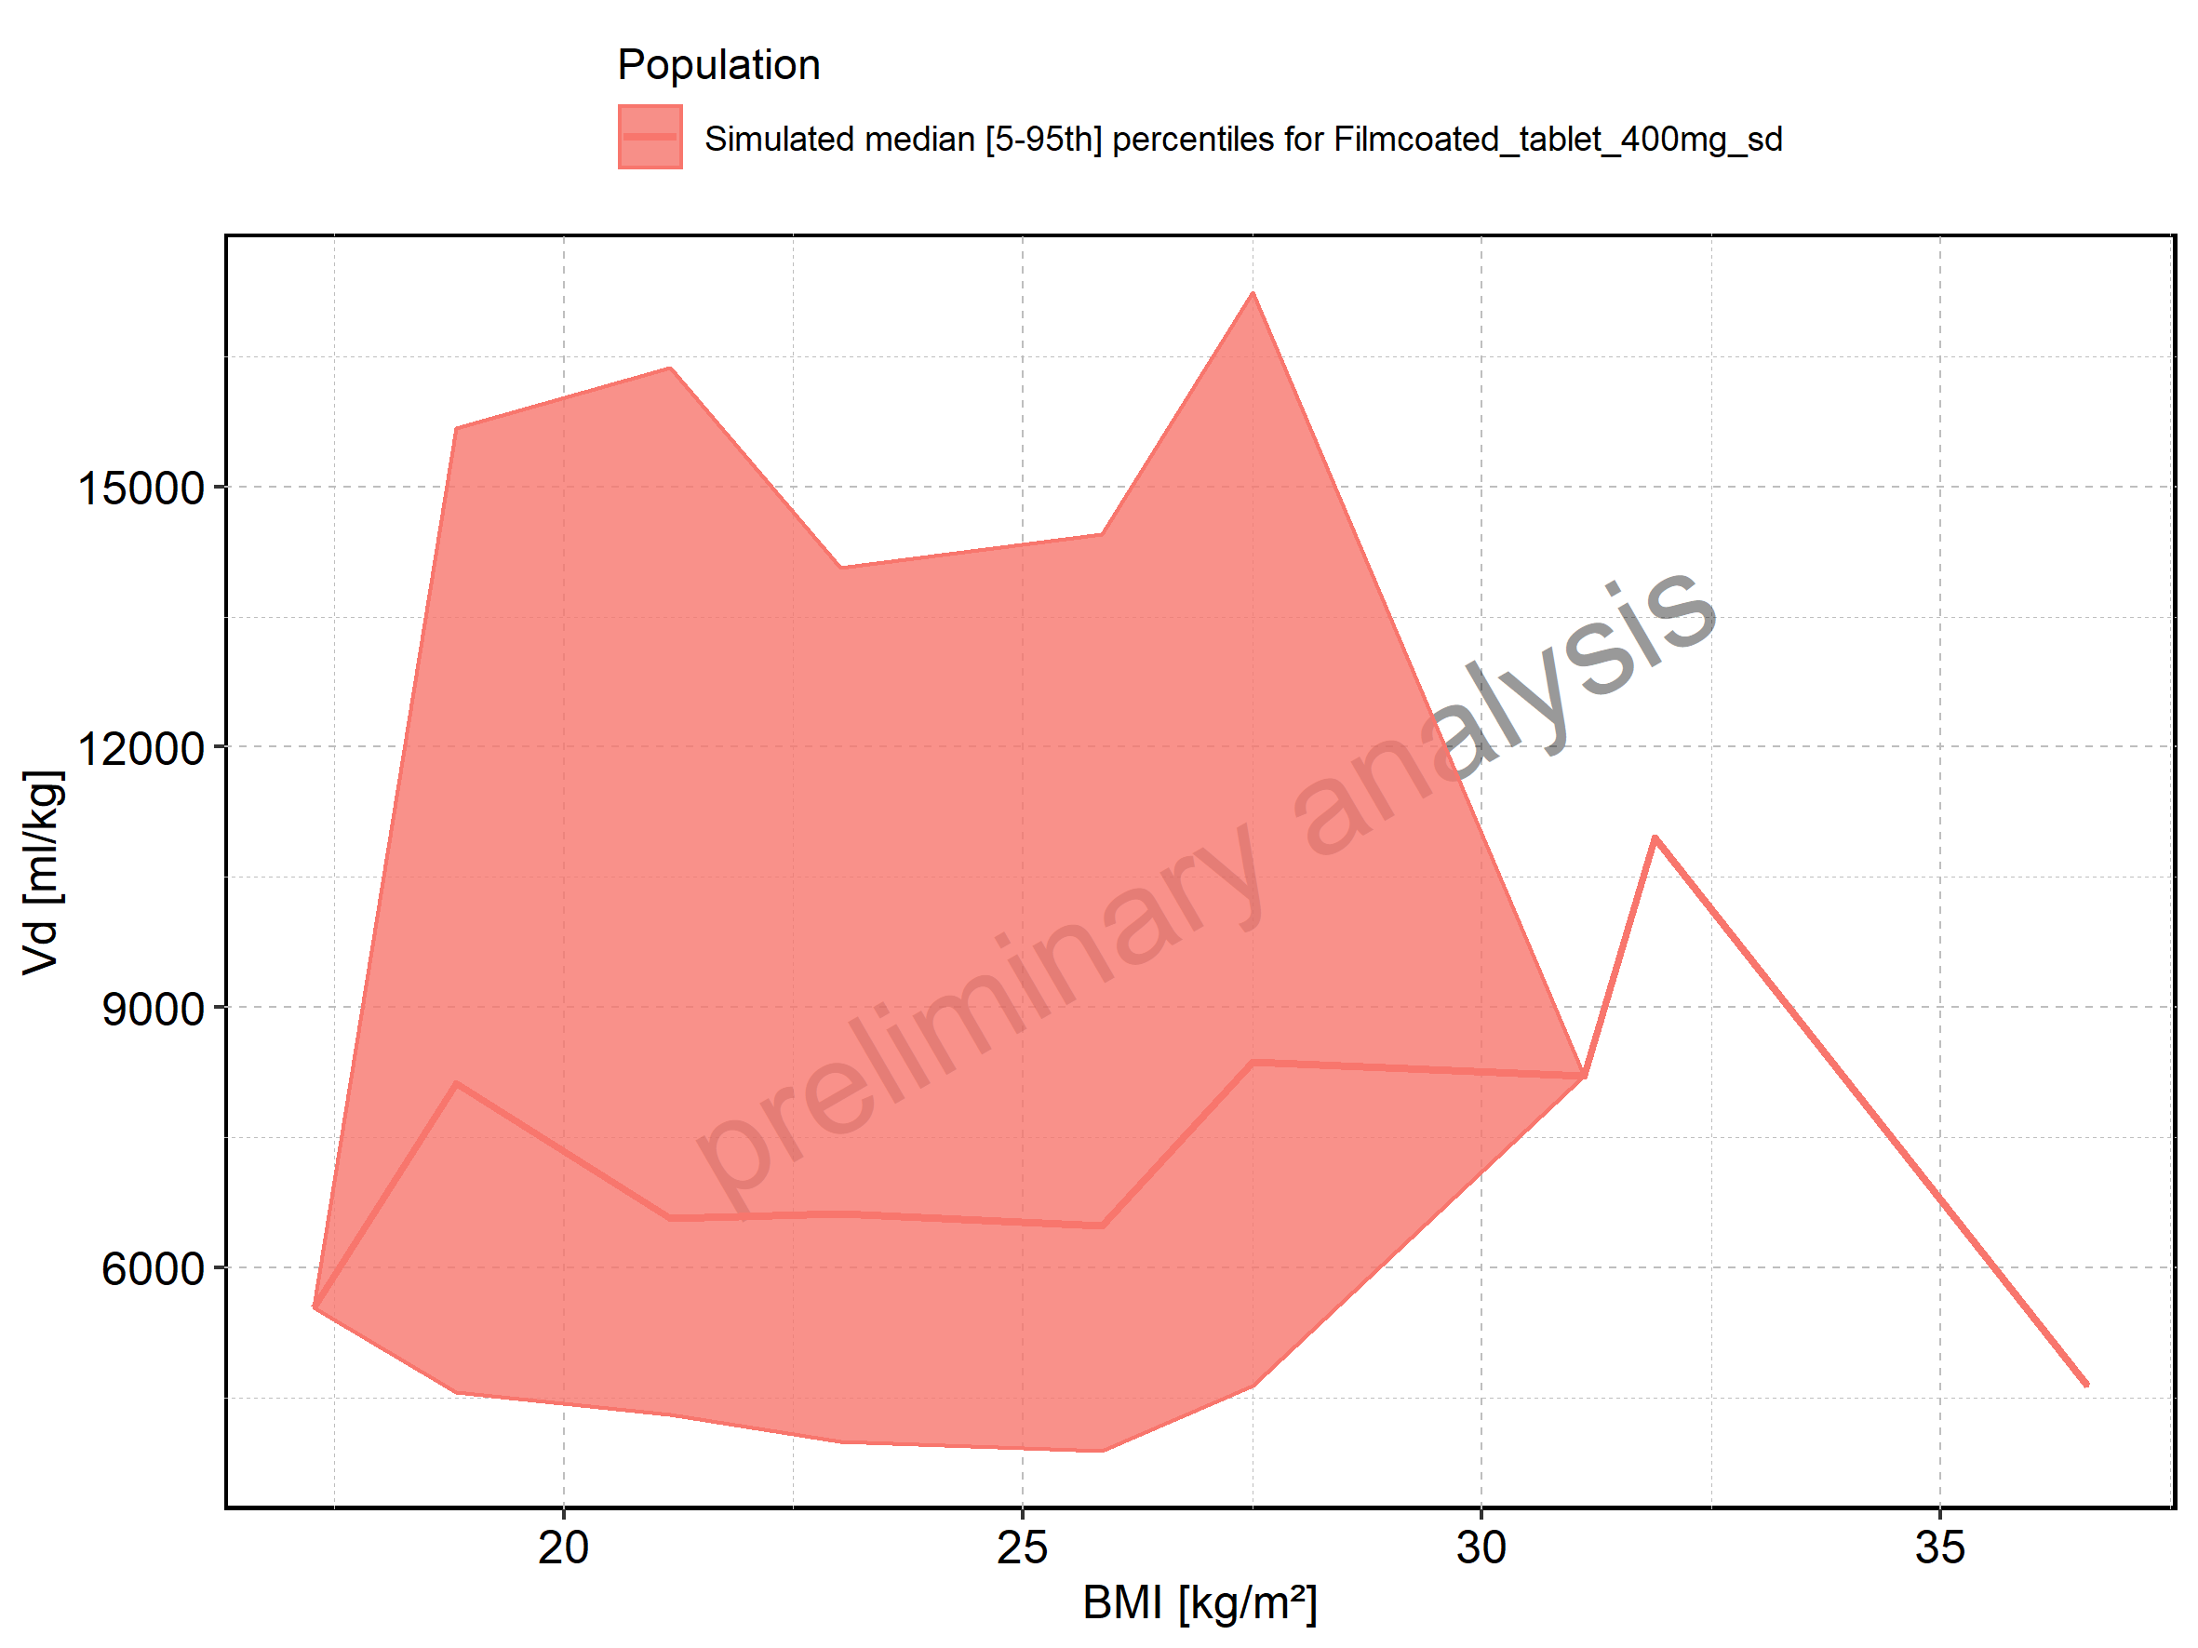

Figure 348: BMI-dependence of Vd for Filmcoated_tablet_400mg_sd. Profiles are plotted in a logarithmic scale.

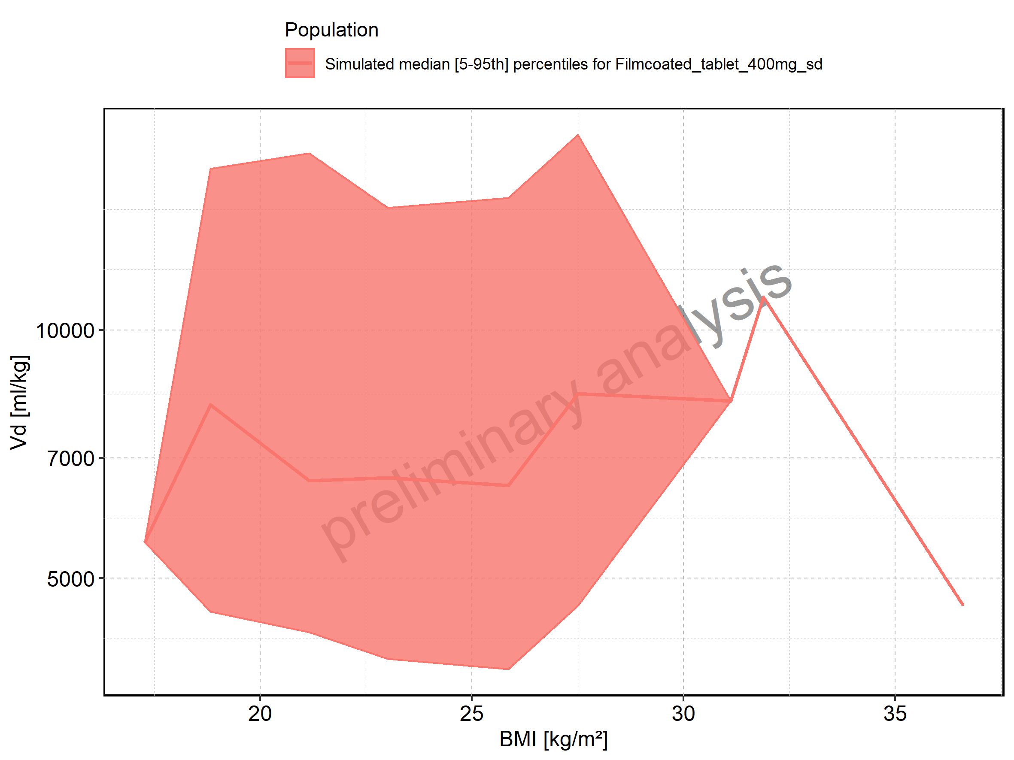

# 3. Time profiles and residual plots

## 3.1. Time profiles and residual plots for Larson 2013 8y-18y 400mg FCT meal

Figure 349: Time profiles of Larson 2013 8y-18y 400mg FCT meal for Larson 2013 8-18y meal. Data source: Data/Raltegravir_PK.txt. Time profiles are plotted in a linear scale.

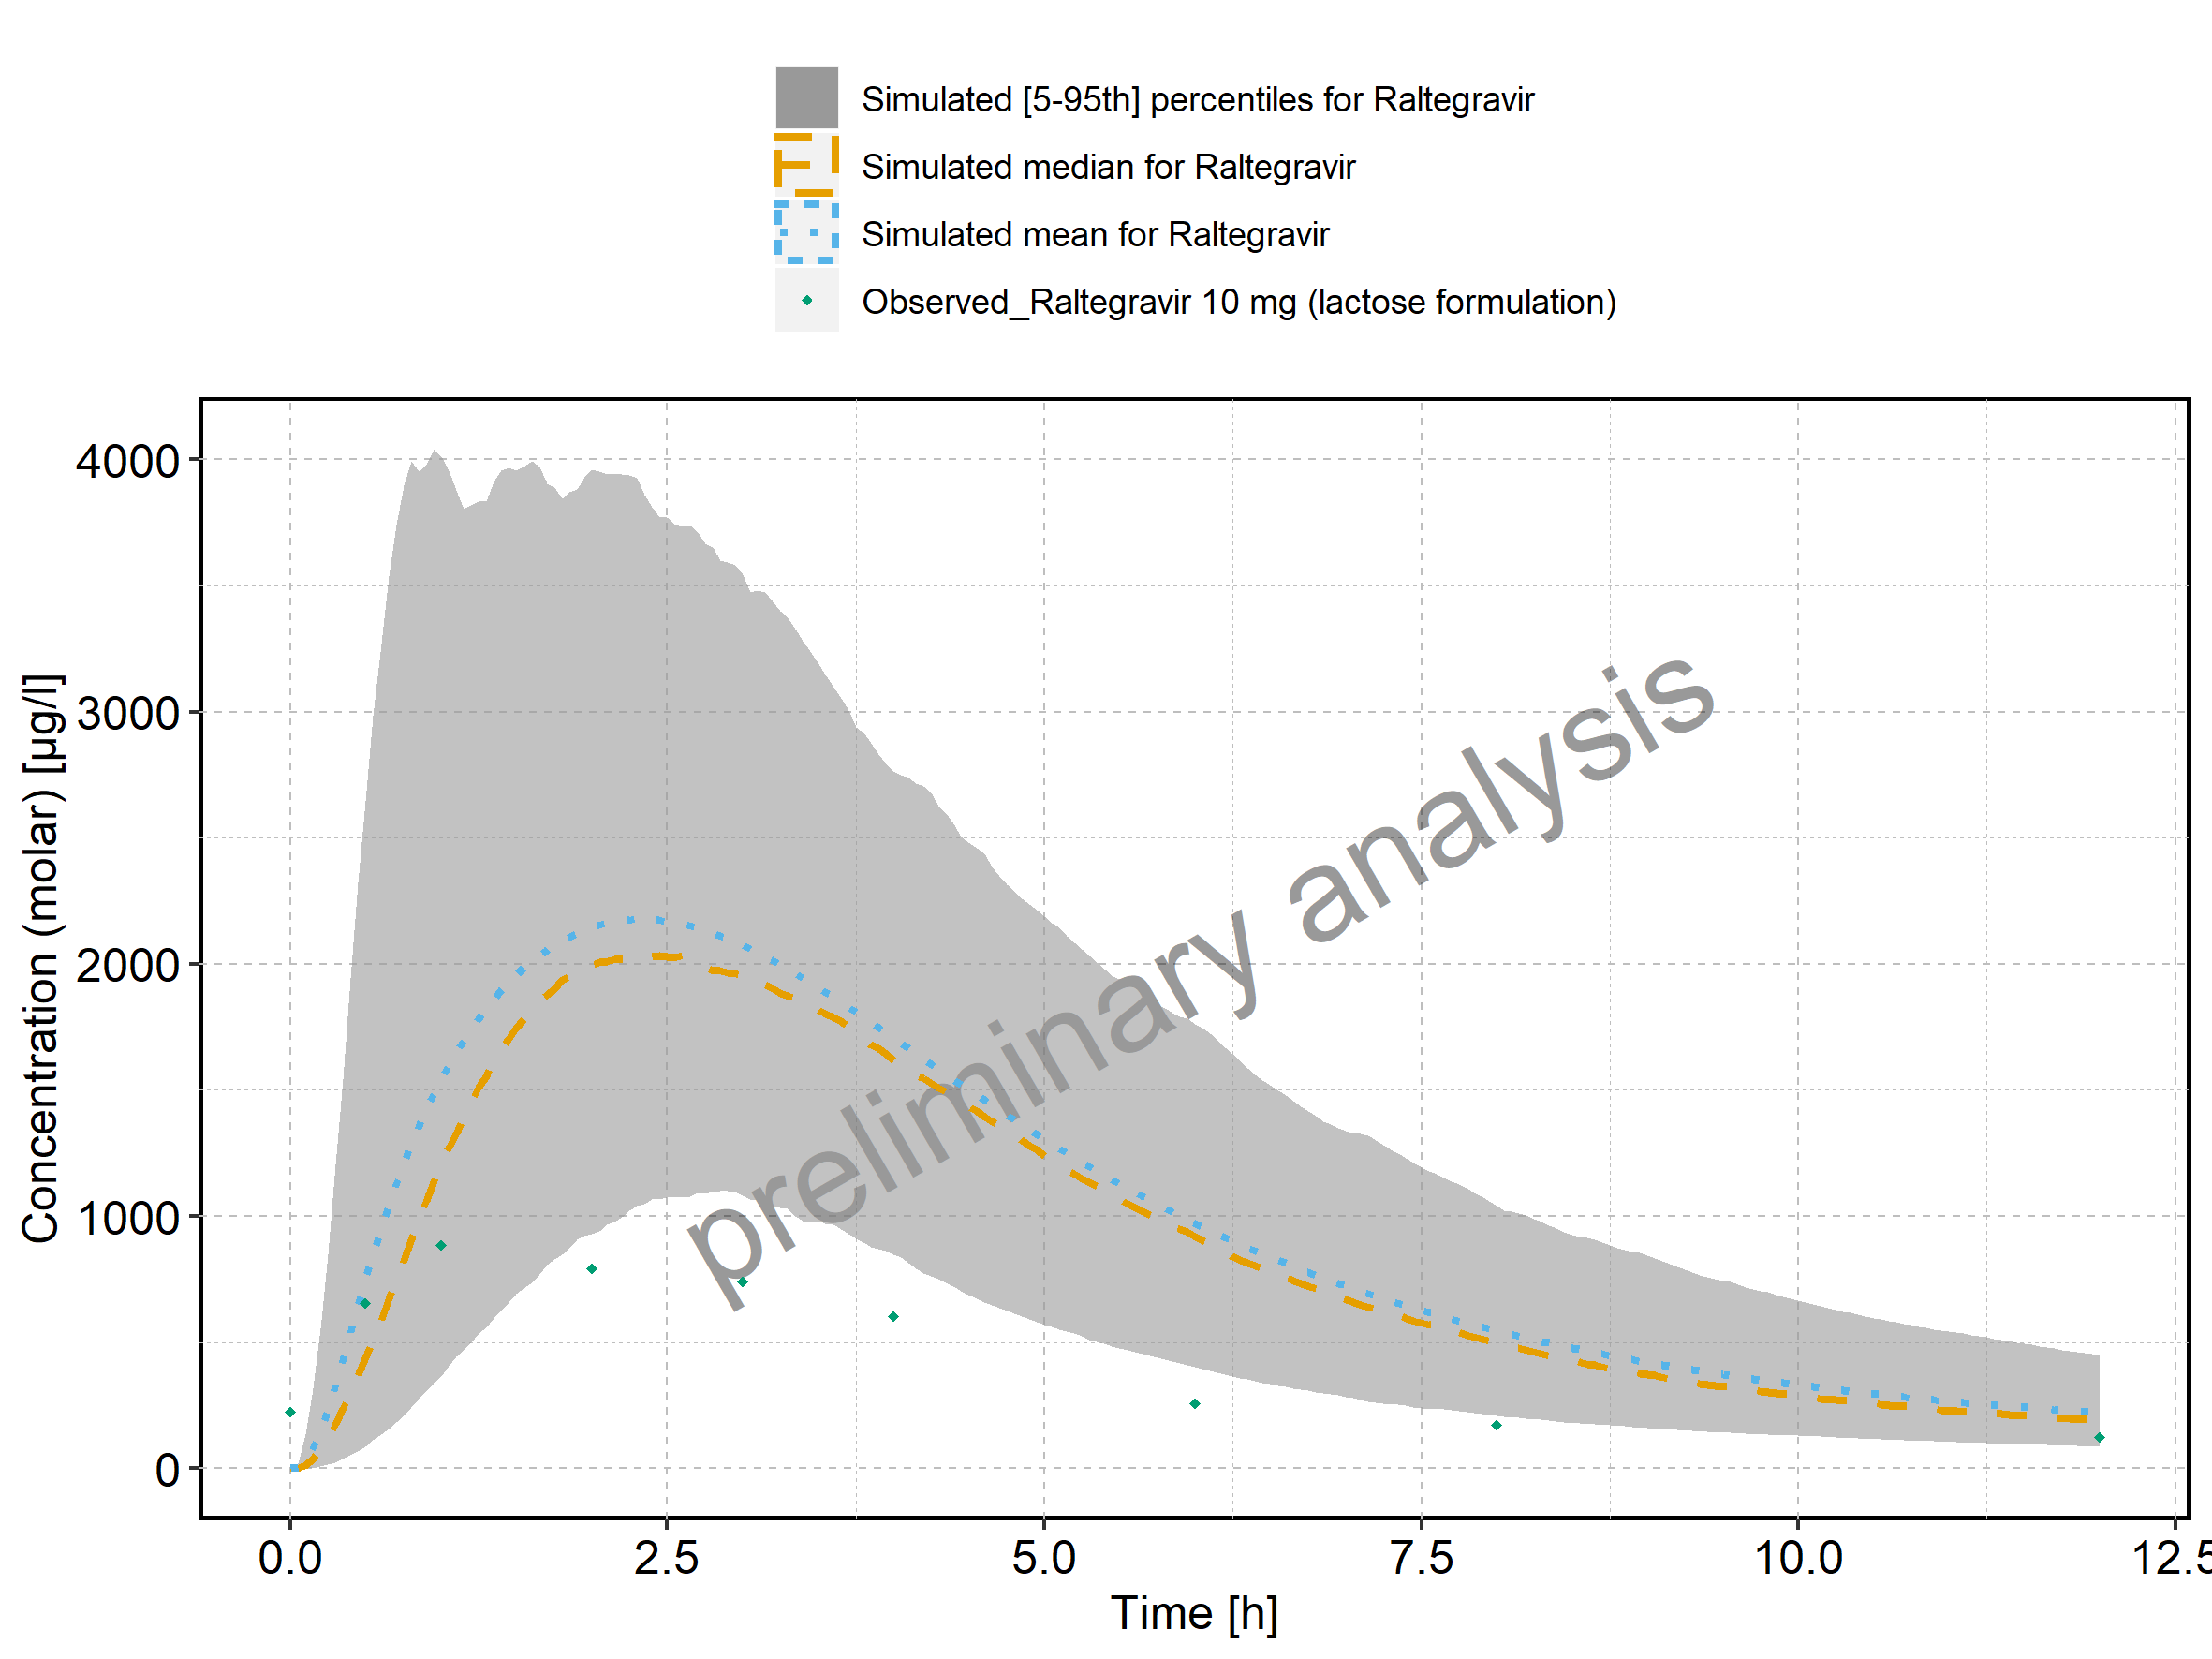

Figure 350: Time profiles of Larson 2013 8y-18y 400mg FCT meal for Larson 2013 8-18y meal. Data source: Data/Raltegravir_PK.txt. Time profiles are plotted in a logarithmic scale.

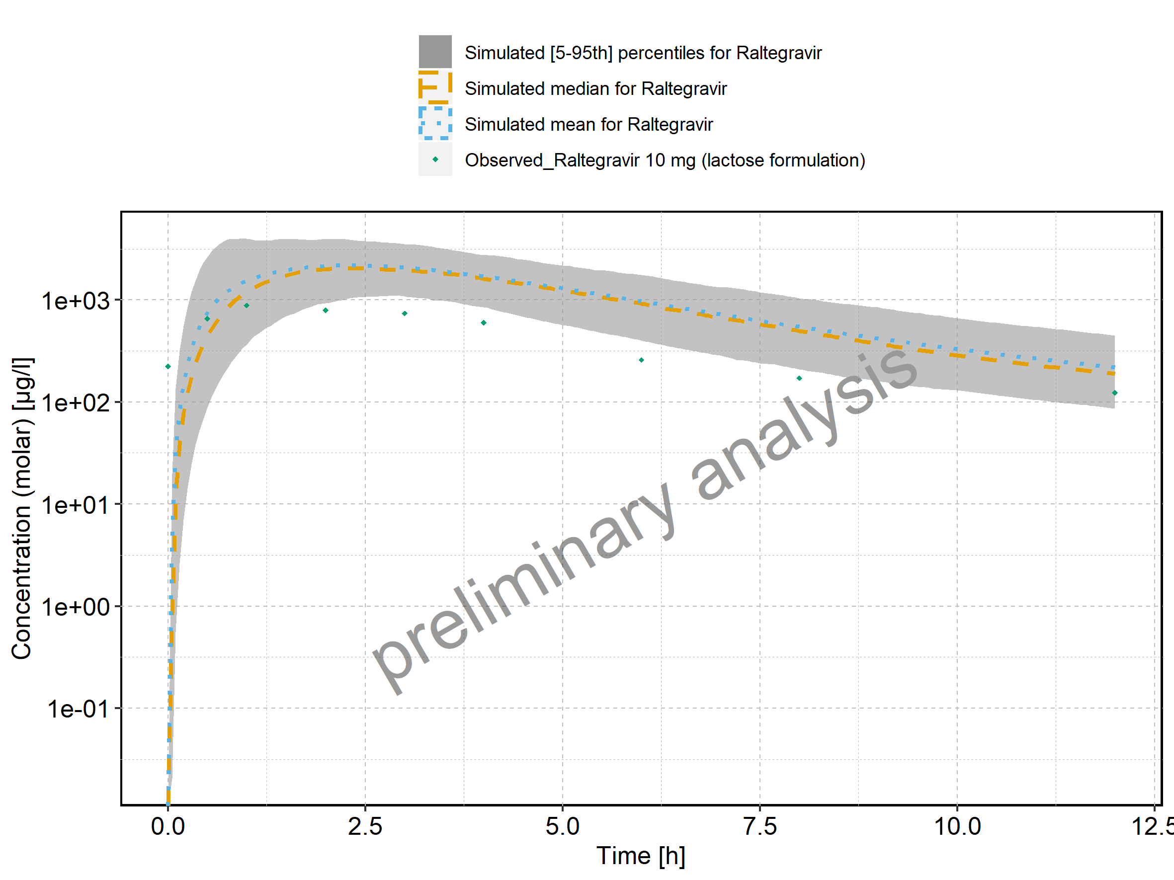

Figure 351: Predicted vs observed of Larson 2013 8y-18y 400mg FCT meal for Larson 2013 8-18y meal. Data source: Data/Raltegravir_PK.txt. Predictions and observations are plotted in a linear scale.

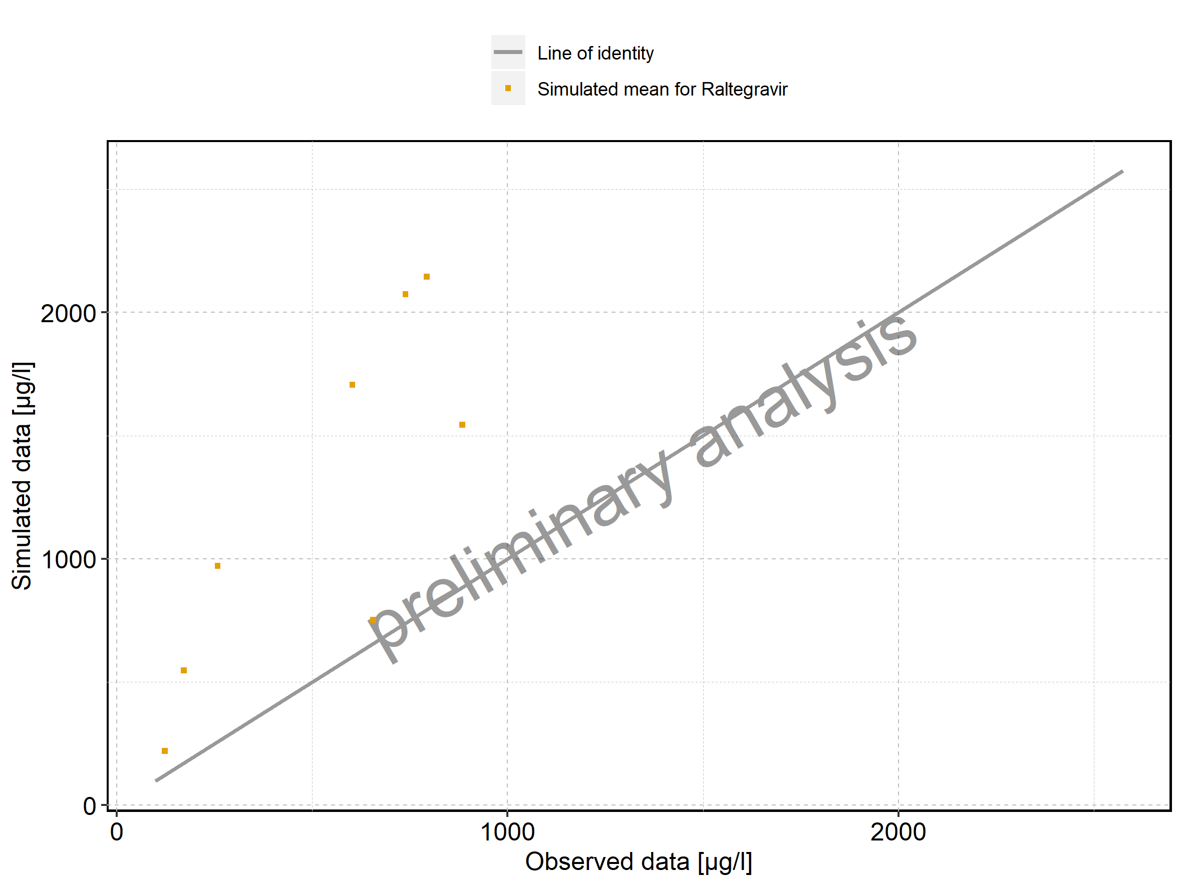

Figure 352: Predicted vs observed of Larson 2013 8y-18y 400mg FCT meal for Larson 2013 8-18y meal. Data source: Data/Raltegravir_PK.txt. Predictions and observations are plotted in a logarithmic scale.

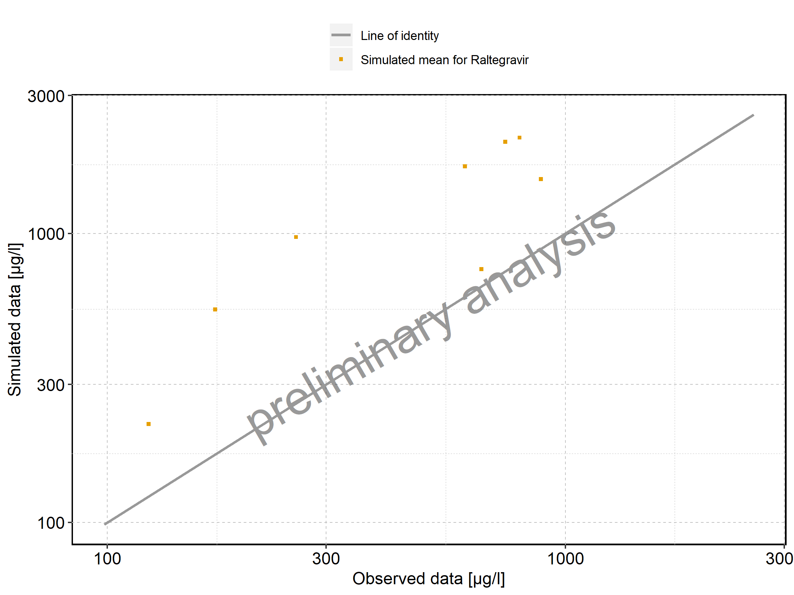

Figure 353: Logarithmic residuals vs predicted values of Larson 2013 8y-18y 400mg FCT meal for Larson 2013 8-18y meal. Data source: Data/Raltegravir_PK.txt.

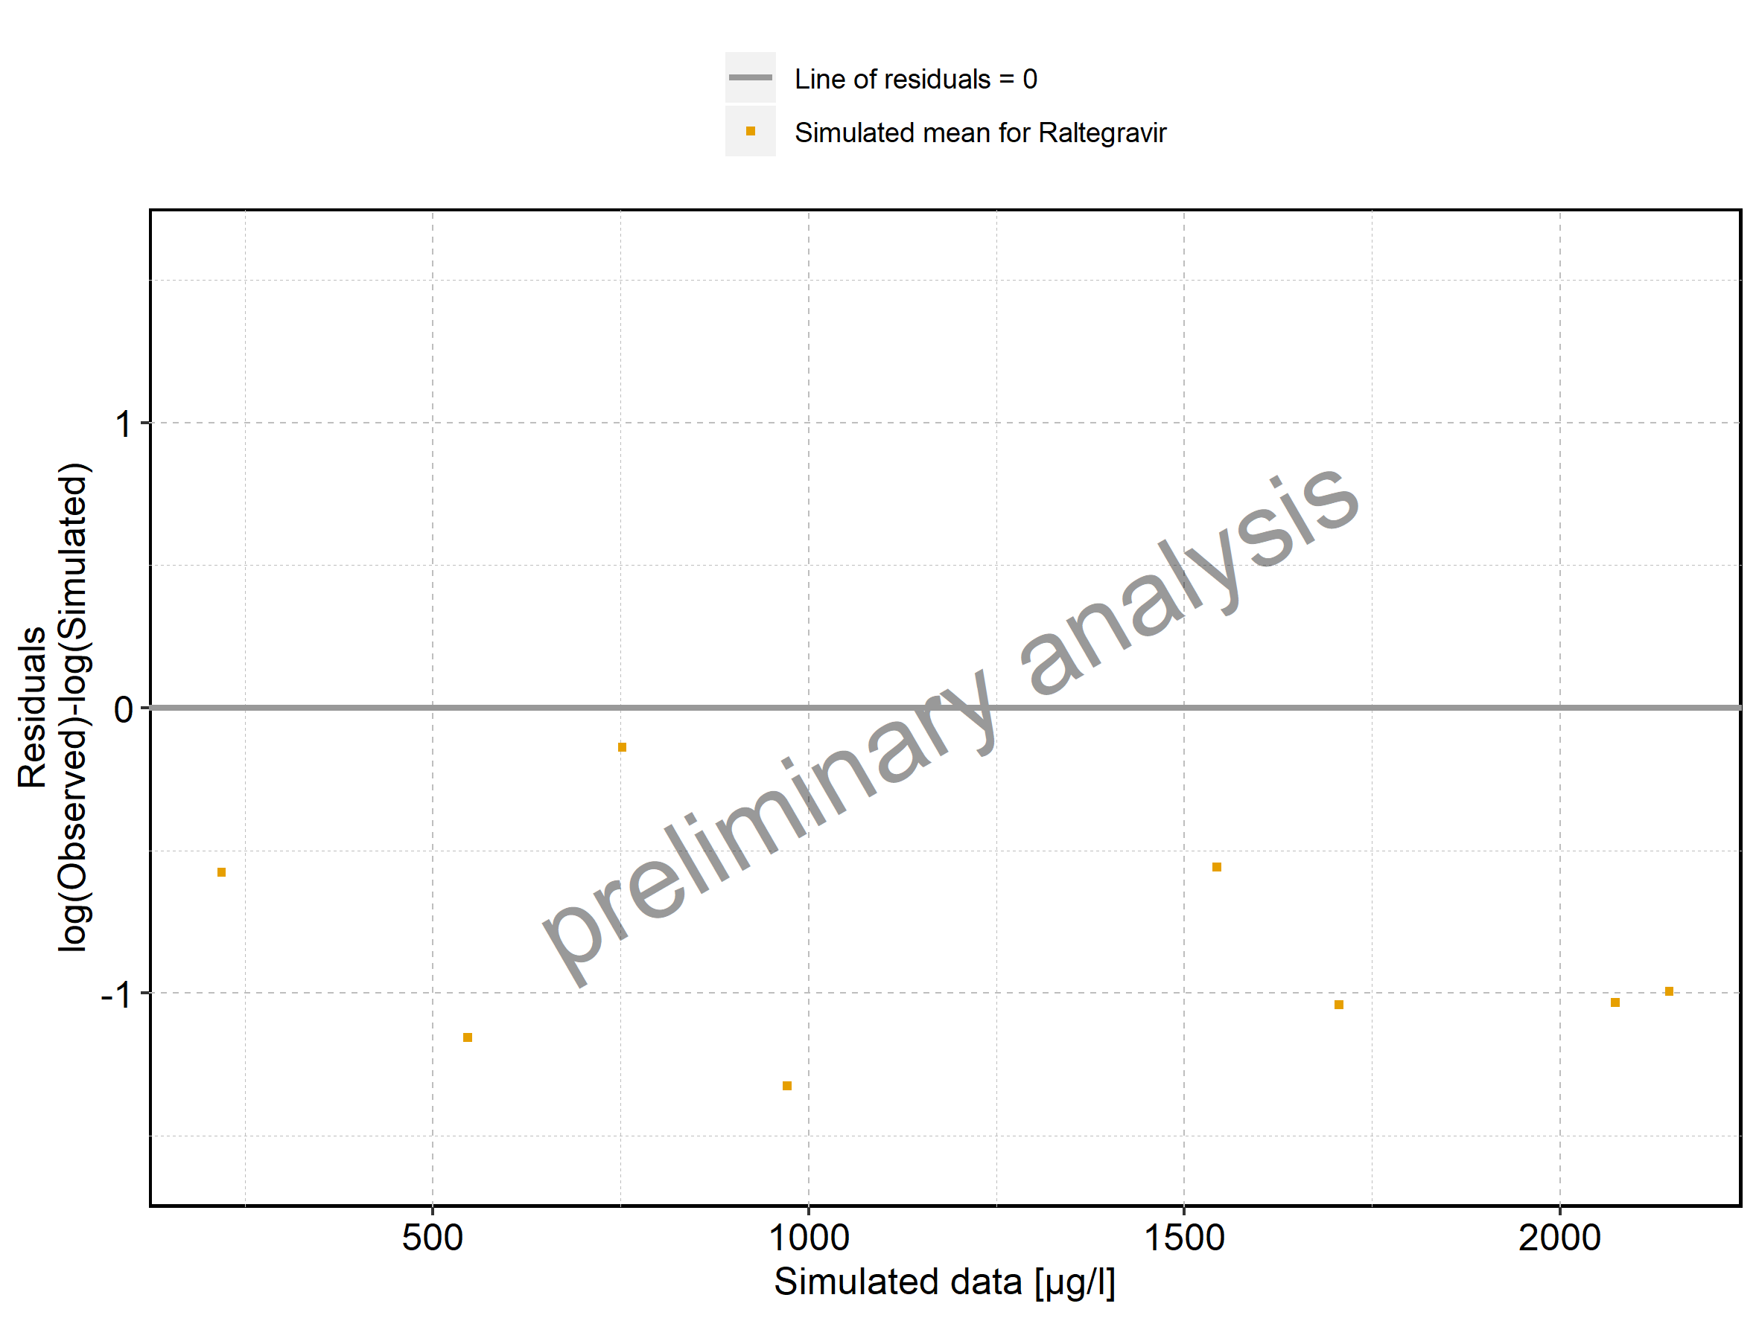

Figure 354: Logarithmic residuals vs time of Larson 2013 8y-18y 400mg FCT meal for Larson 2013 8-18y meal. Data source: Data/Raltegravir_PK.txt.

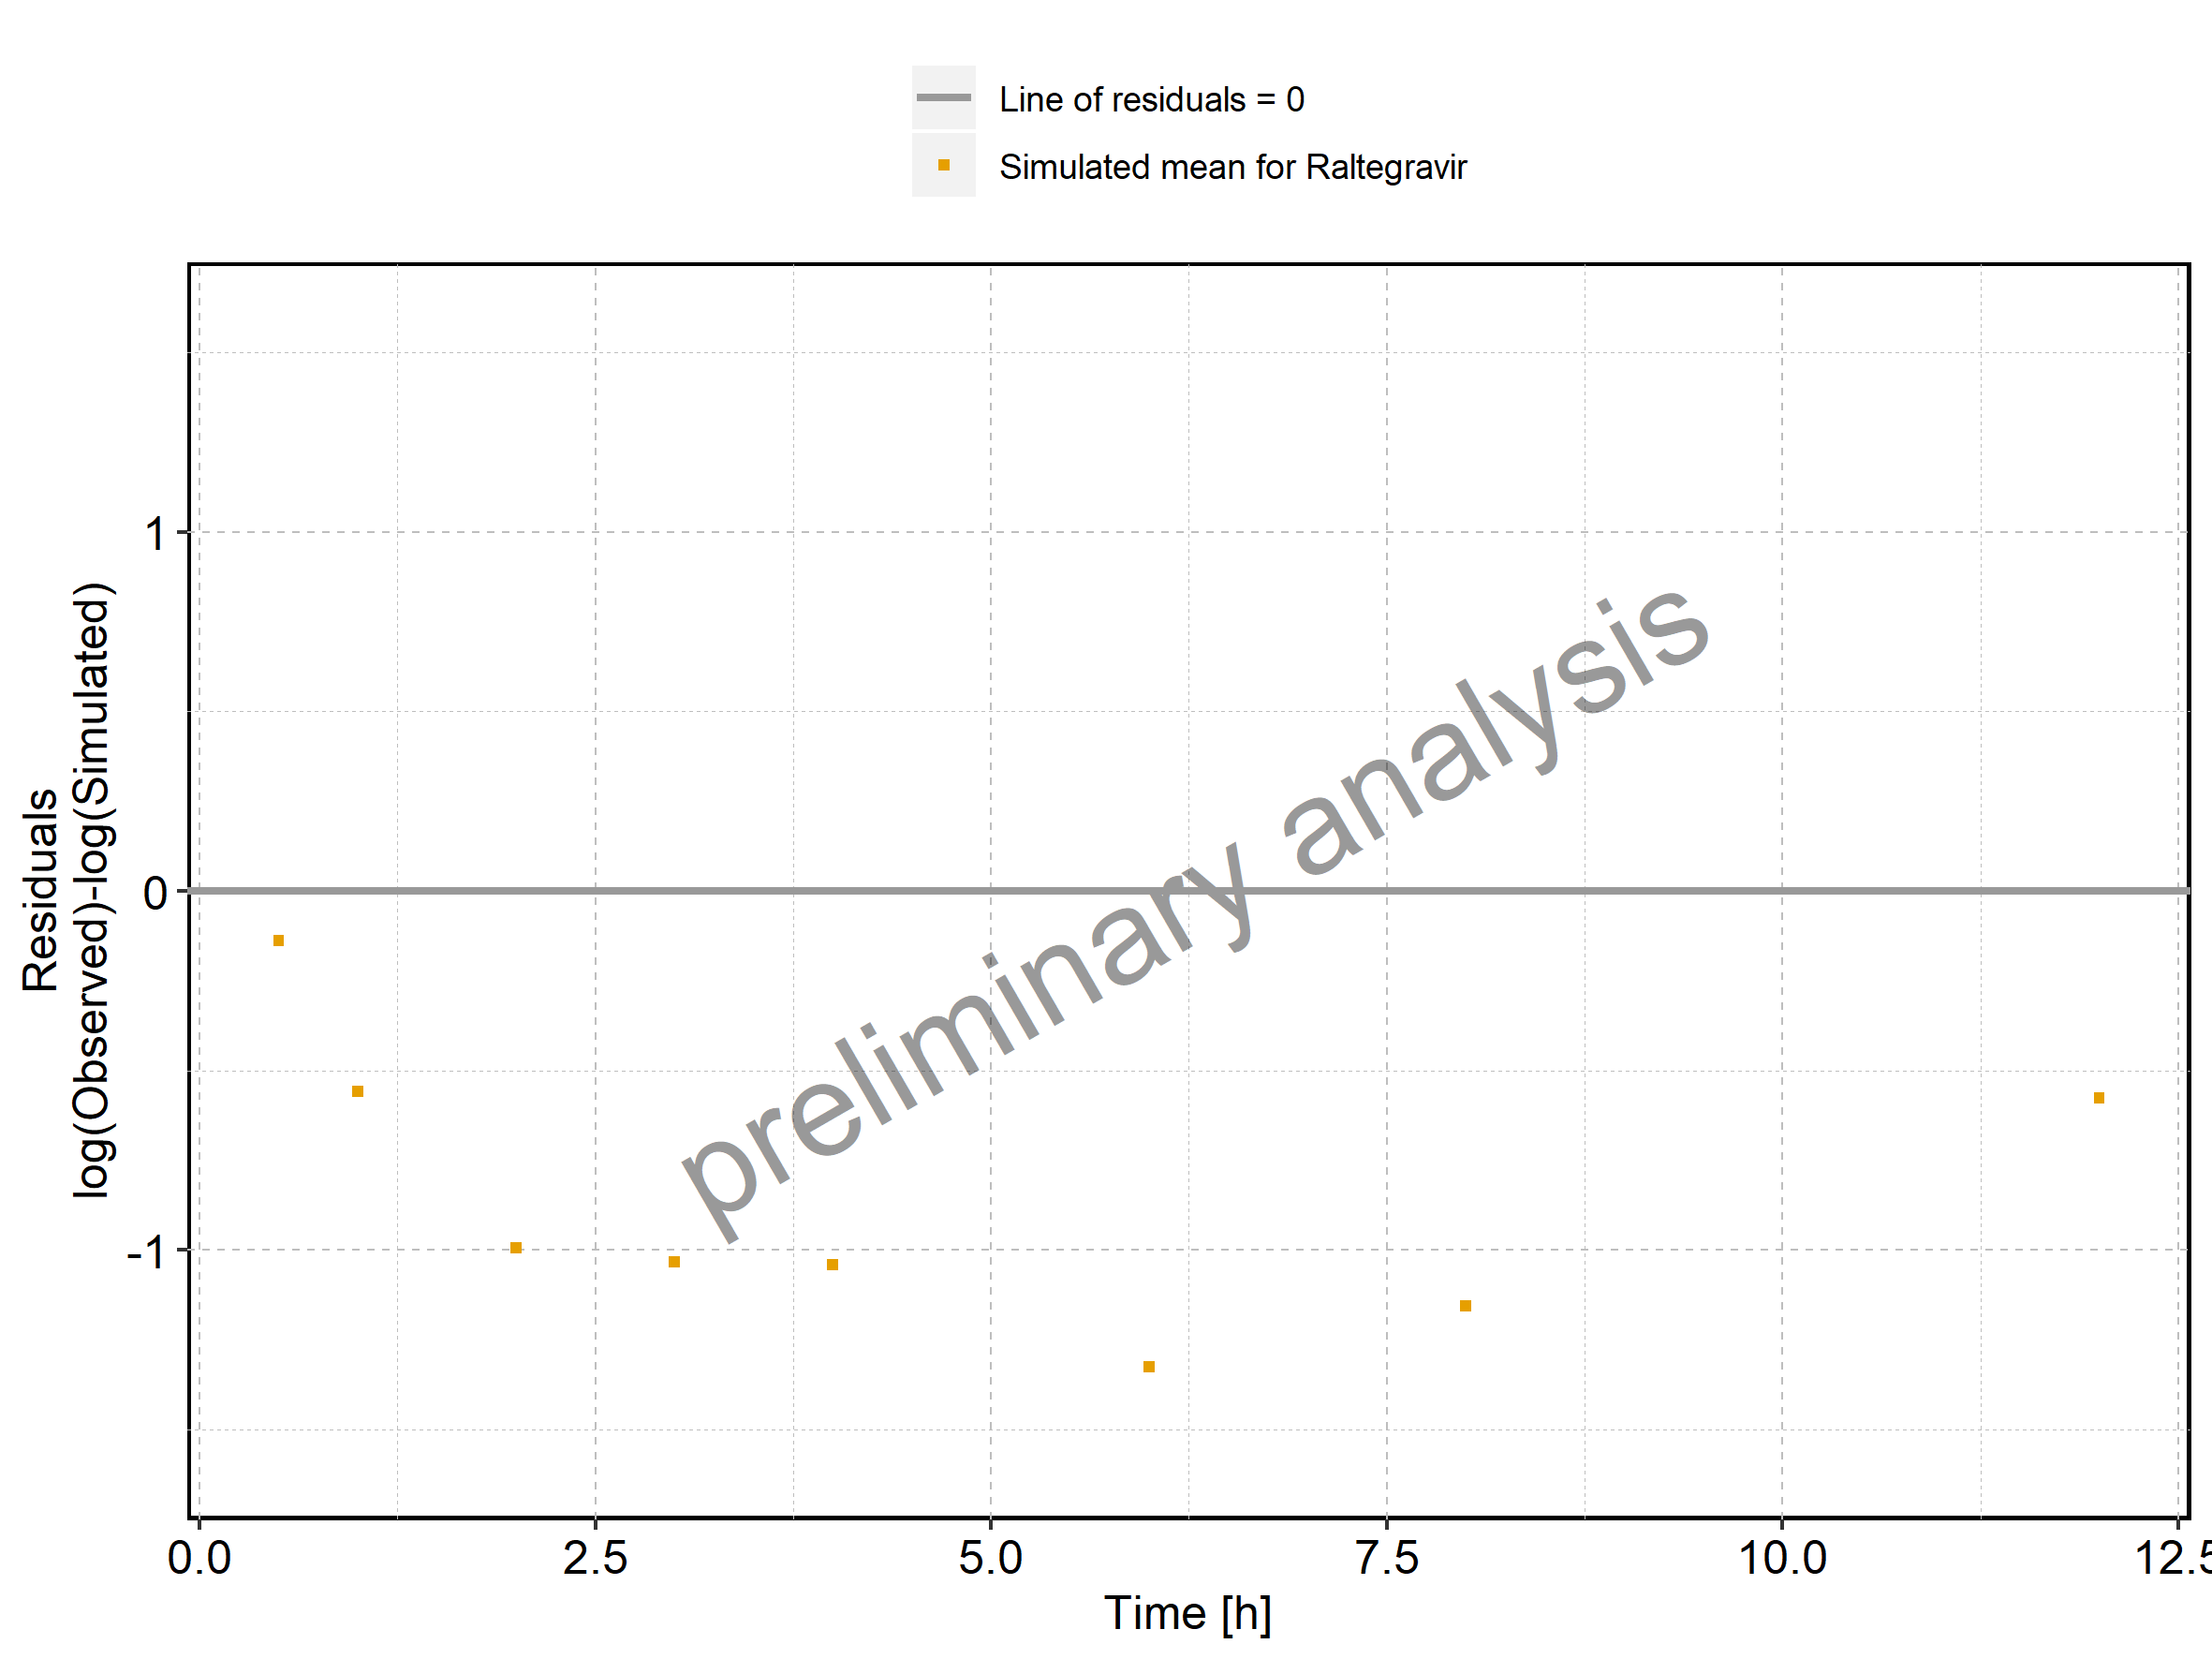

Figure 355: Logarithmic residuals distribution of Larson 2013 8y-18y 400mg FCT meal for Larson 2013 8-18y meal. Data source: Data/Raltegravir_PK.txt.

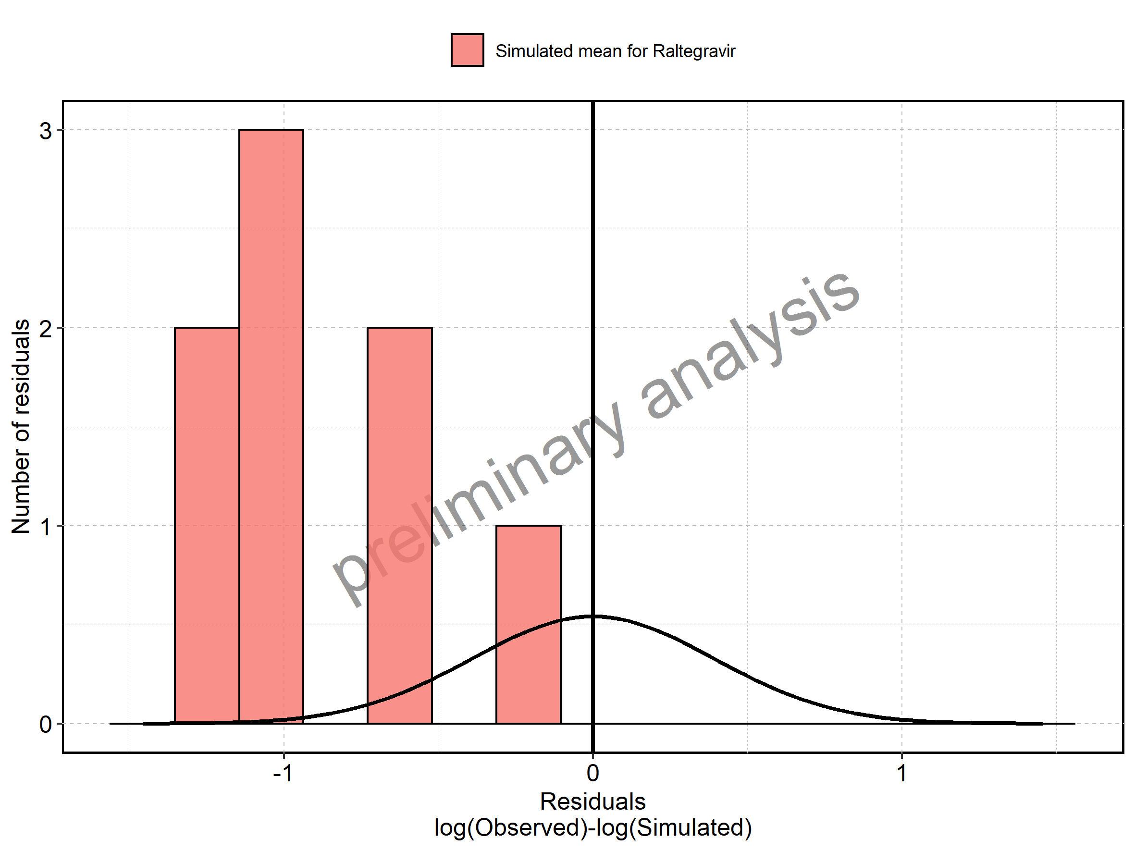

Figure 356: Logarithmic residuals of Larson 2013 8y-18y 400mg FCT meal for Larson 2013 8-18y meal as quantile-quantile plot. Data source: Data/Raltegravir_PK.txt.

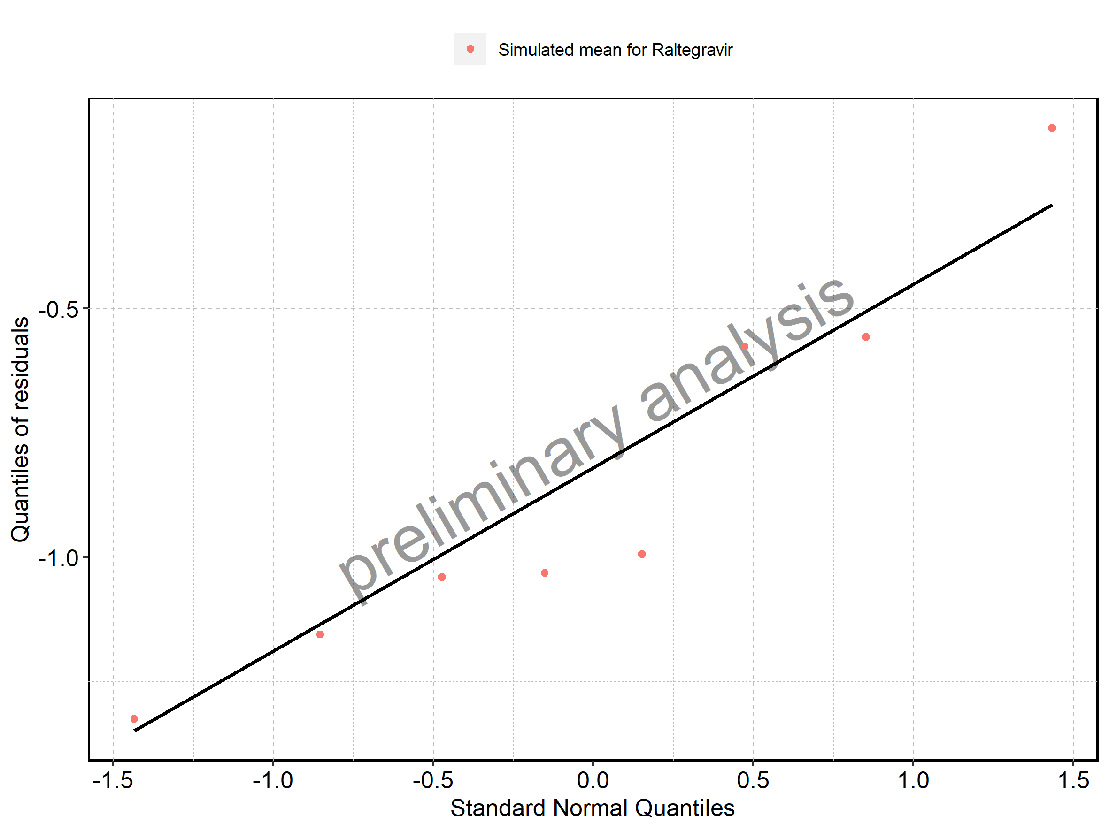

## 3.2. Time profiles and residual plots for Filmcoated_tablet_400mg_sd

Figure 357: Time profiles of Filmcoated_tablet_400mg_sd for Raltegravir 400mg filmcoated tablet. Data source: Data/Raltegravir_PK.txt. Time profiles are plotted in a linear scale.

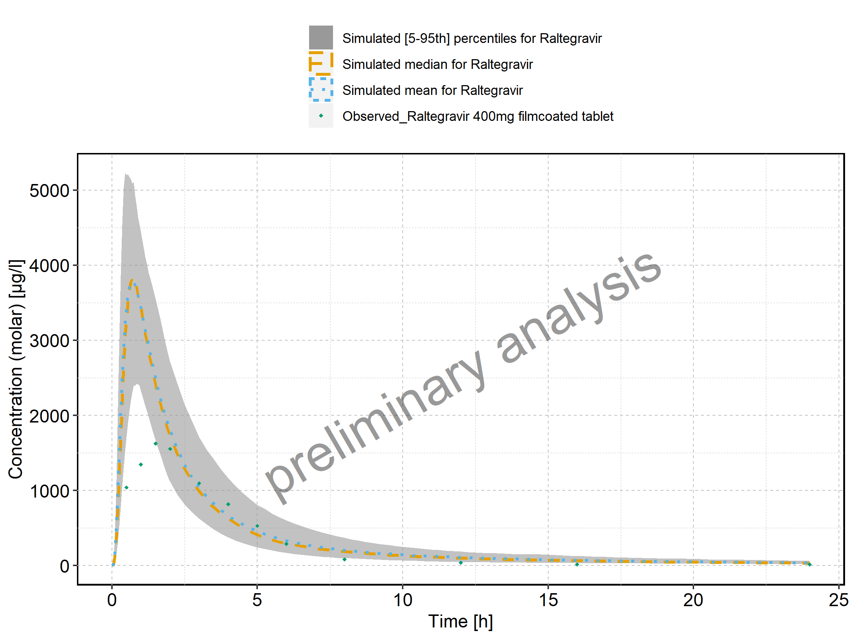

Figure 358: Time profiles of Filmcoated_tablet_400mg_sd for Raltegravir 400mg filmcoated tablet. Data source: Data/Raltegravir_PK.txt. Time profiles are plotted in a logarithmic scale.

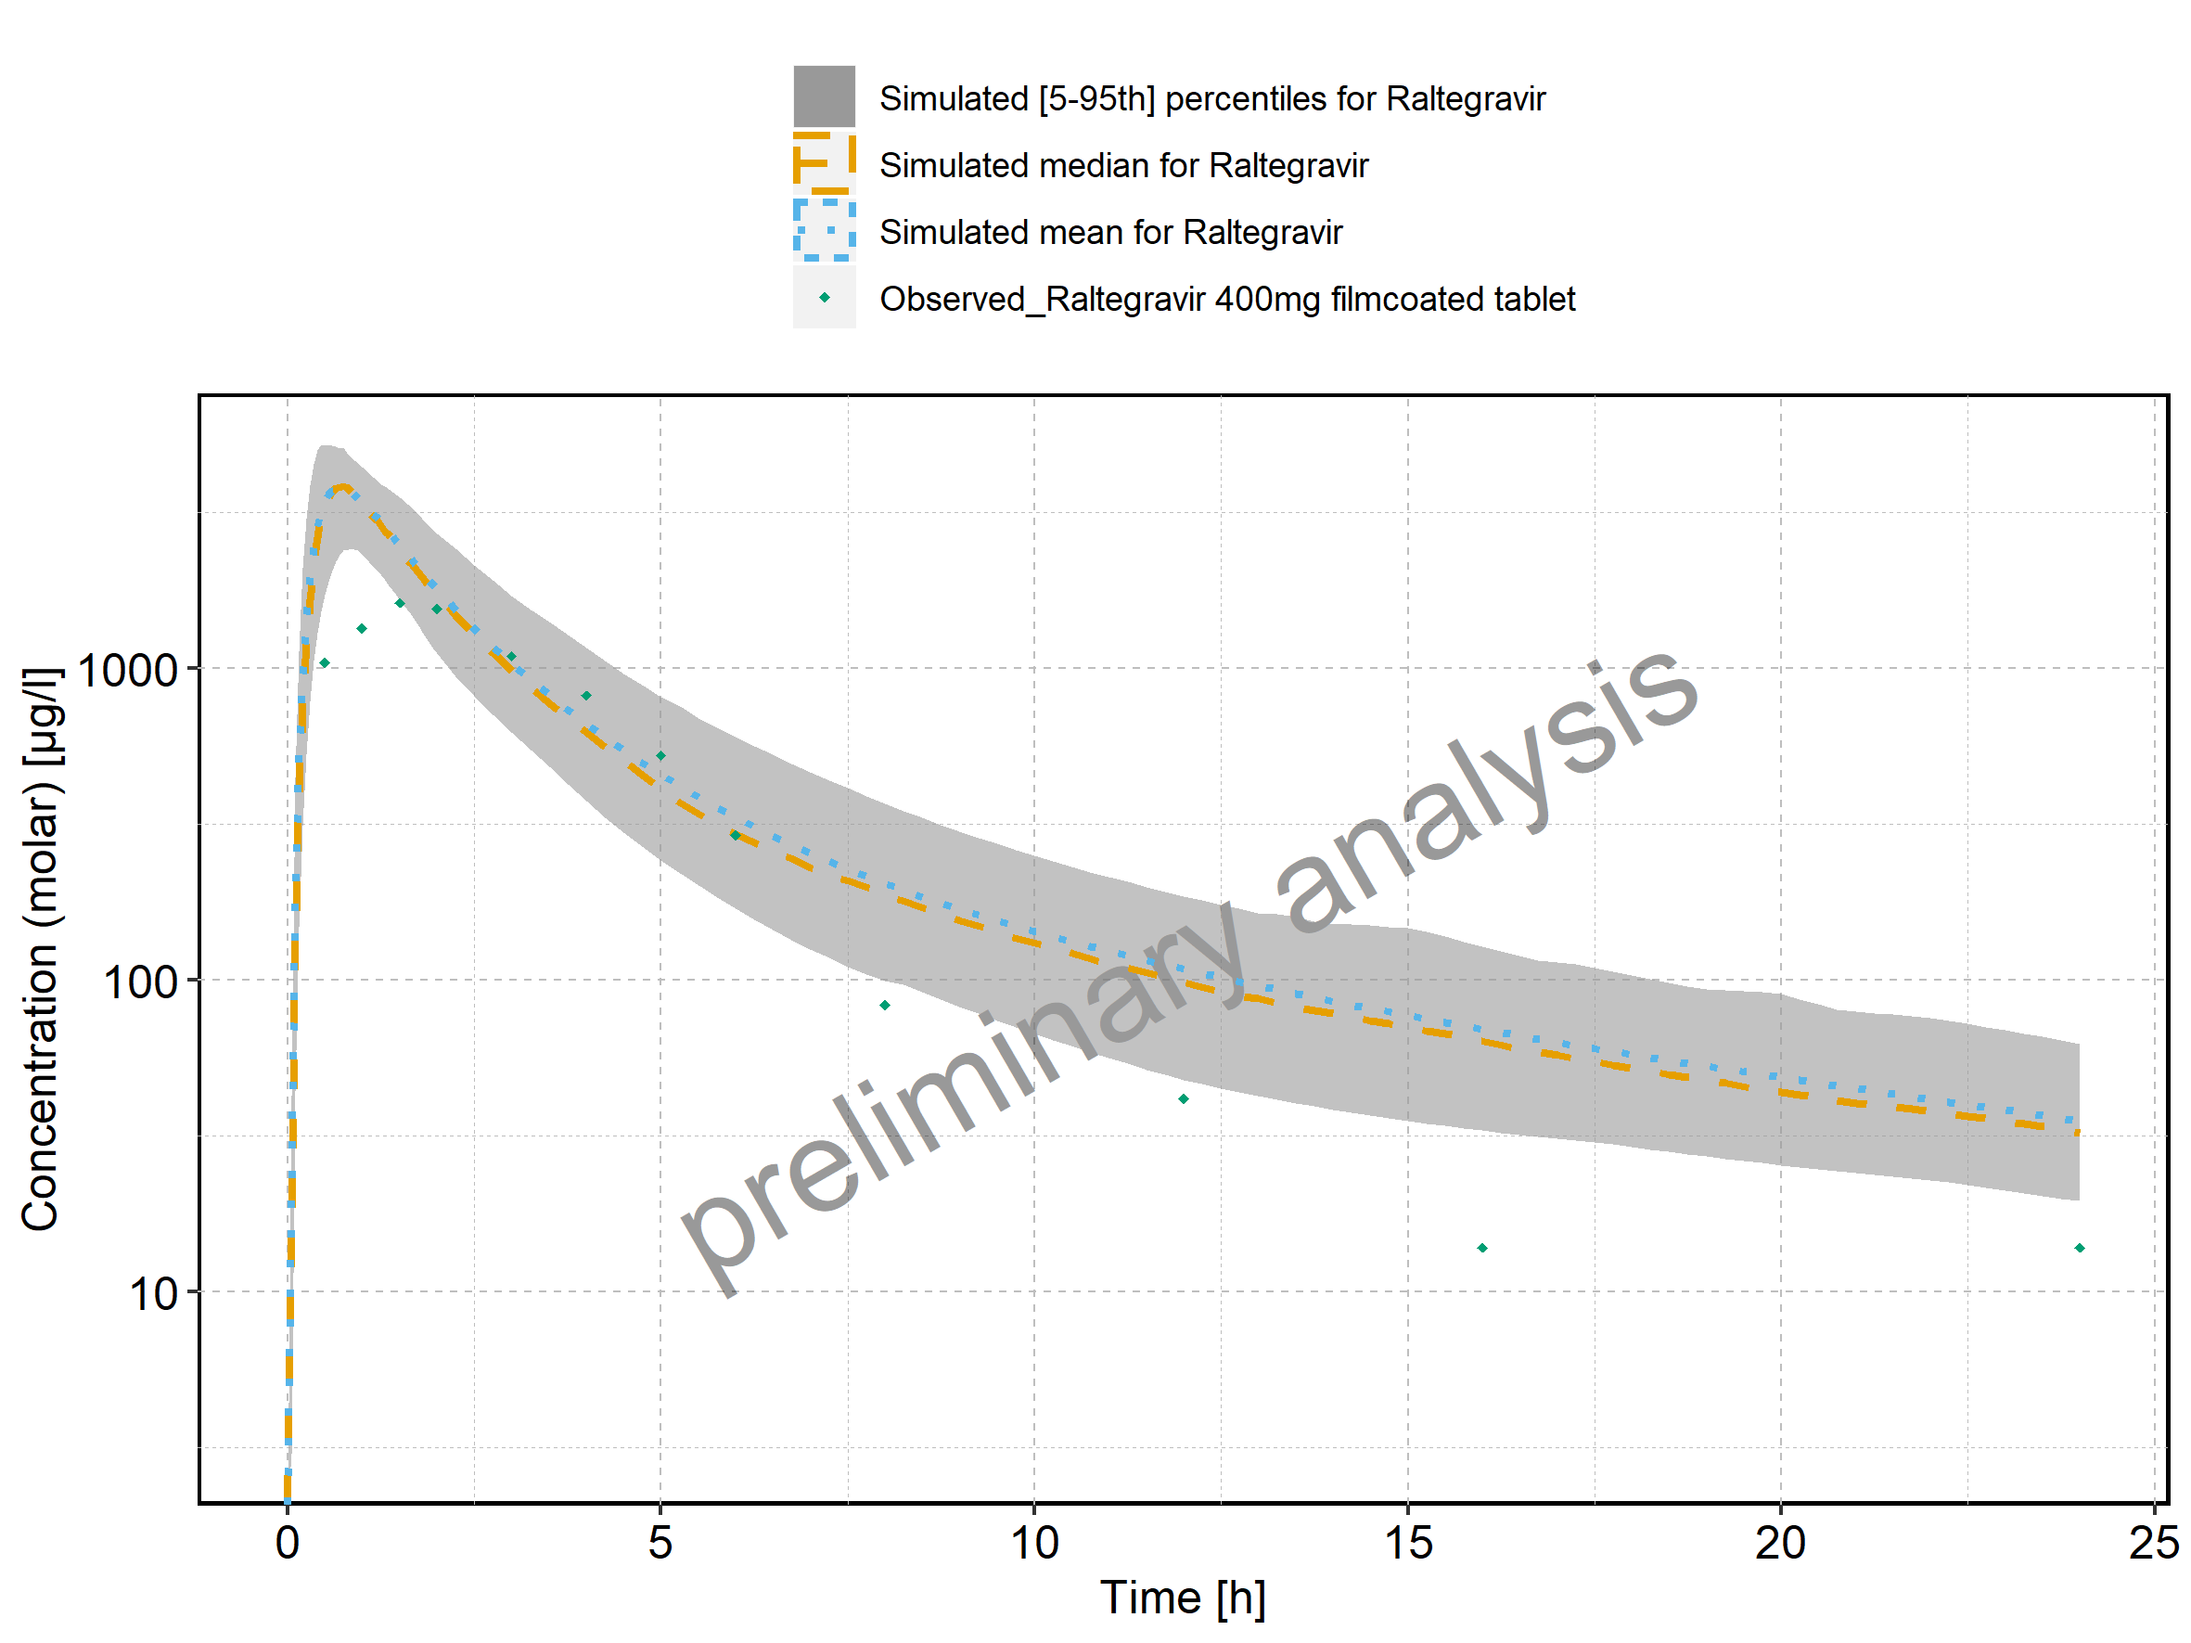

Figure 359: Predicted vs observed of Filmcoated_tablet_400mg_sd for Raltegravir 400mg filmcoated tablet. Data source: Data/Raltegravir_PK.txt. Predictions and observations are plotted in a linear scale.

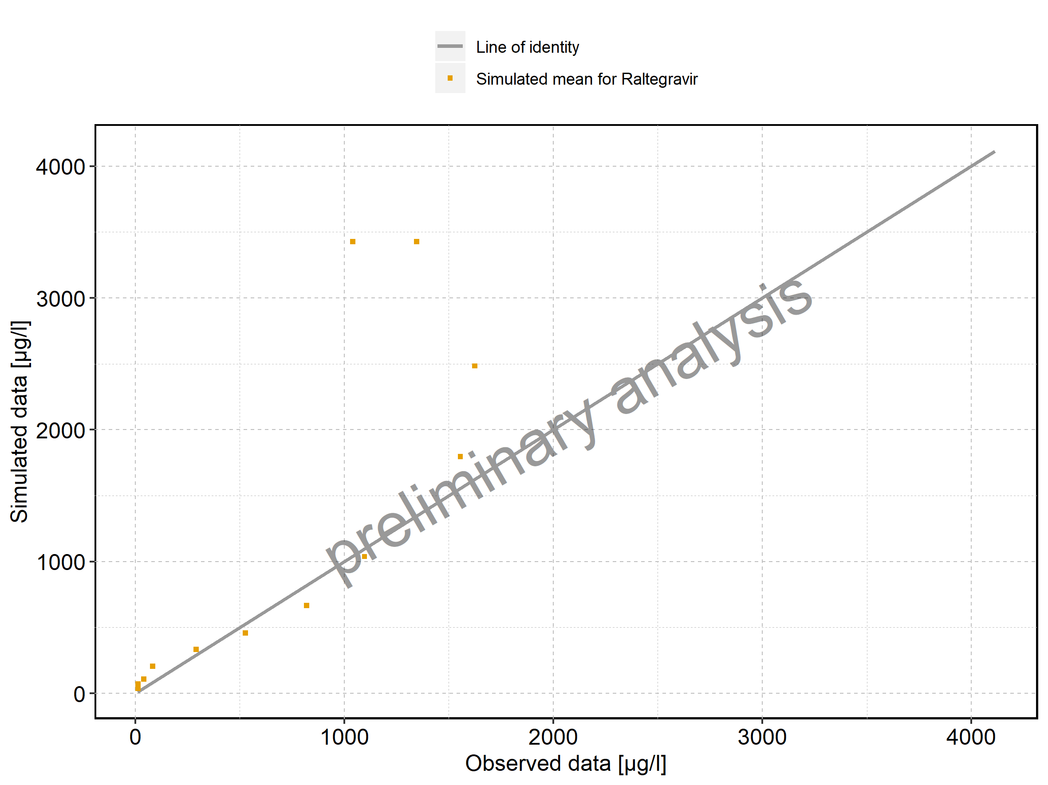

Figure 360: Predicted vs observed of Filmcoated_tablet_400mg_sd for Raltegravir 400mg filmcoated tablet. Data source: Data/Raltegravir_PK.txt. Predictions and observations are plotted in a logarithmic scale.

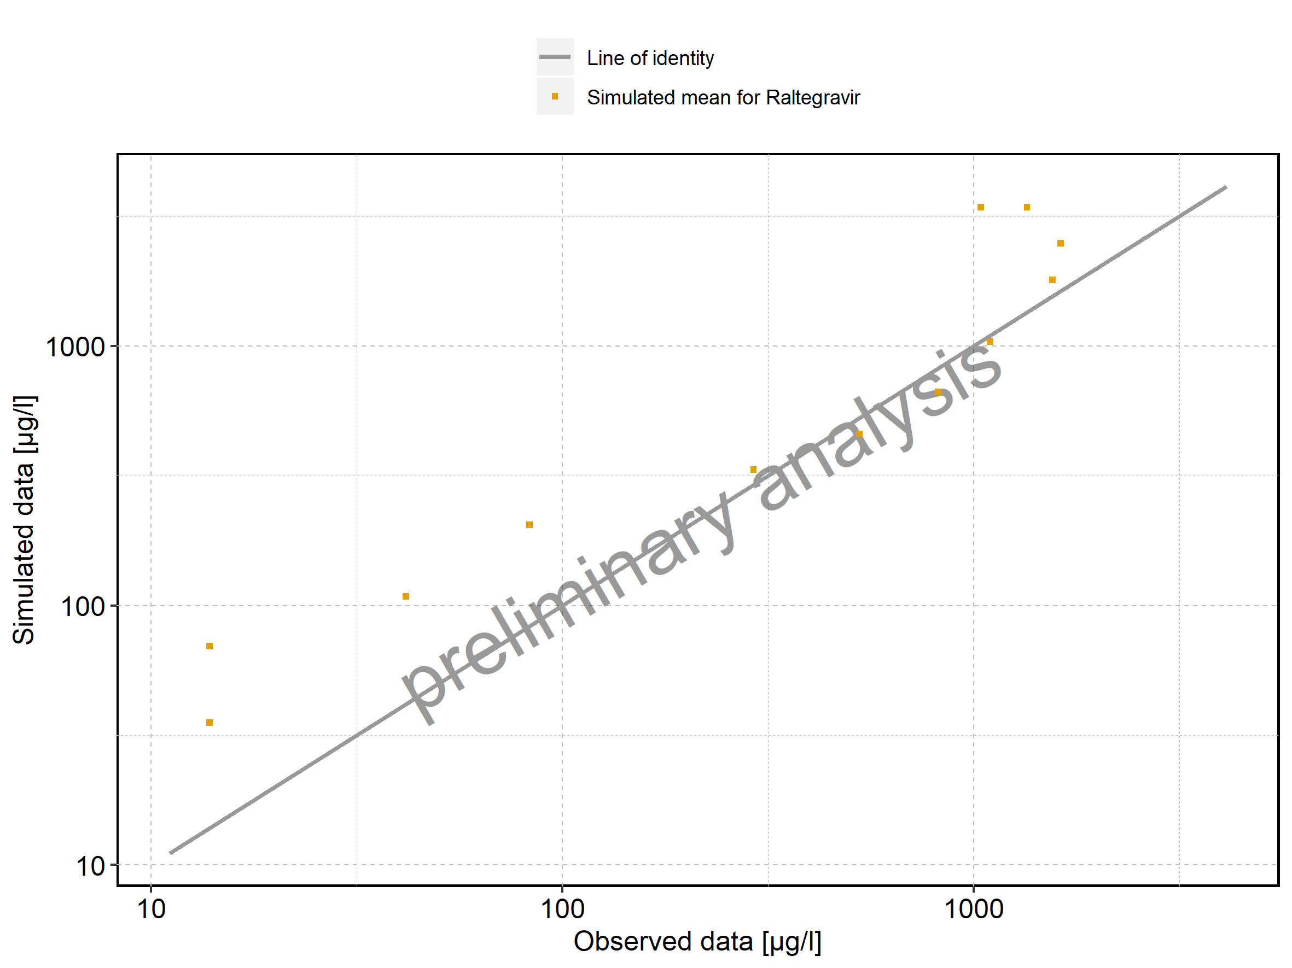

Figure 361: Logarithmic residuals vs predicted values of Filmcoated_tablet_400mg_sd for Raltegravir 400mg filmcoated tablet. Data source: Data/Raltegravir_PK.txt.

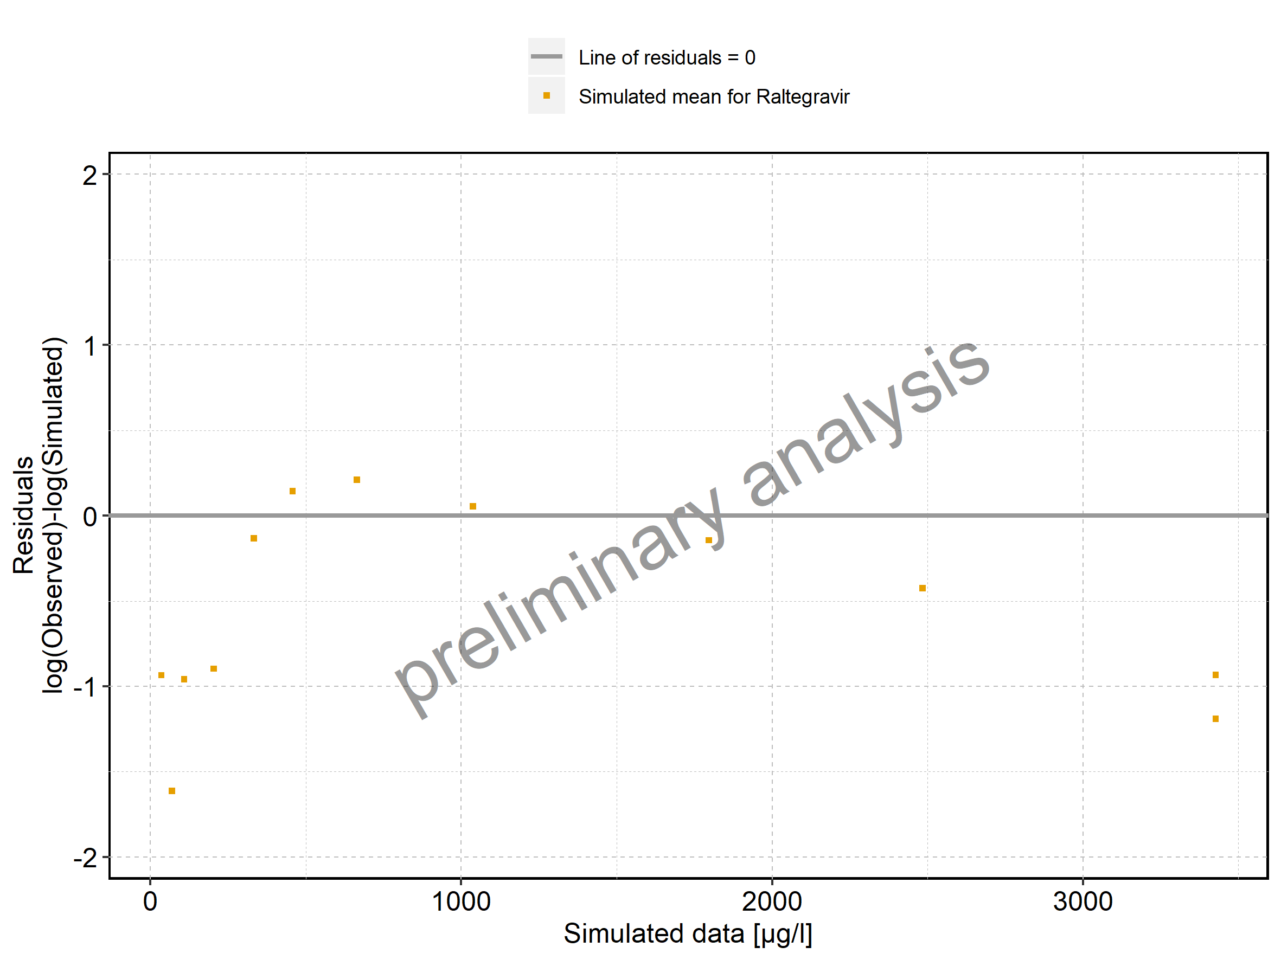

Figure 362: Logarithmic residuals vs time of Filmcoated_tablet_400mg_sd for Raltegravir 400mg filmcoated tablet. Data source: Data/Raltegravir_PK.txt.

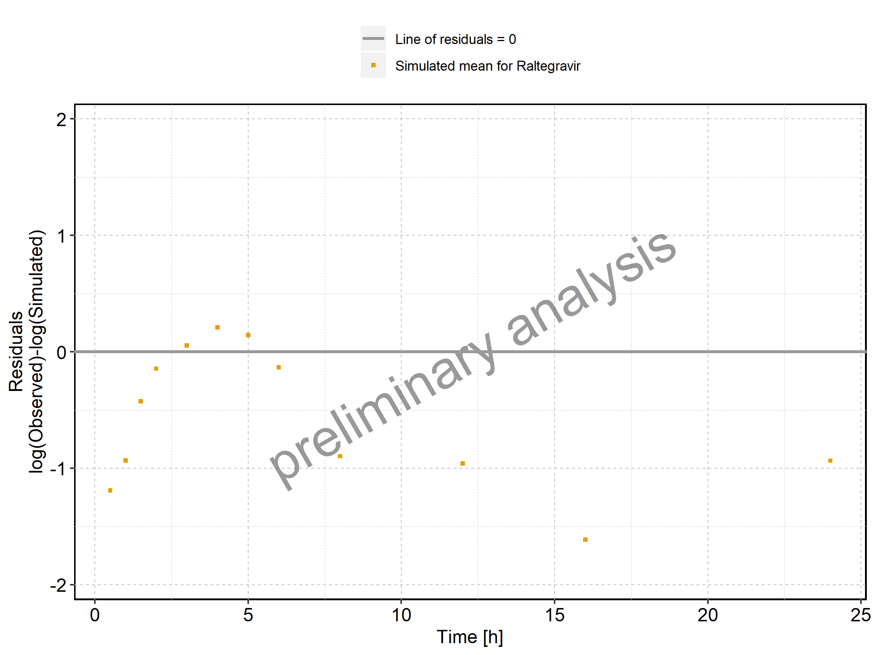

Figure 363: Logarithmic residuals distribution of Filmcoated_tablet_400mg_sd for Raltegravir 400mg filmcoated tablet. Data source: Data/Raltegravir_PK.txt.

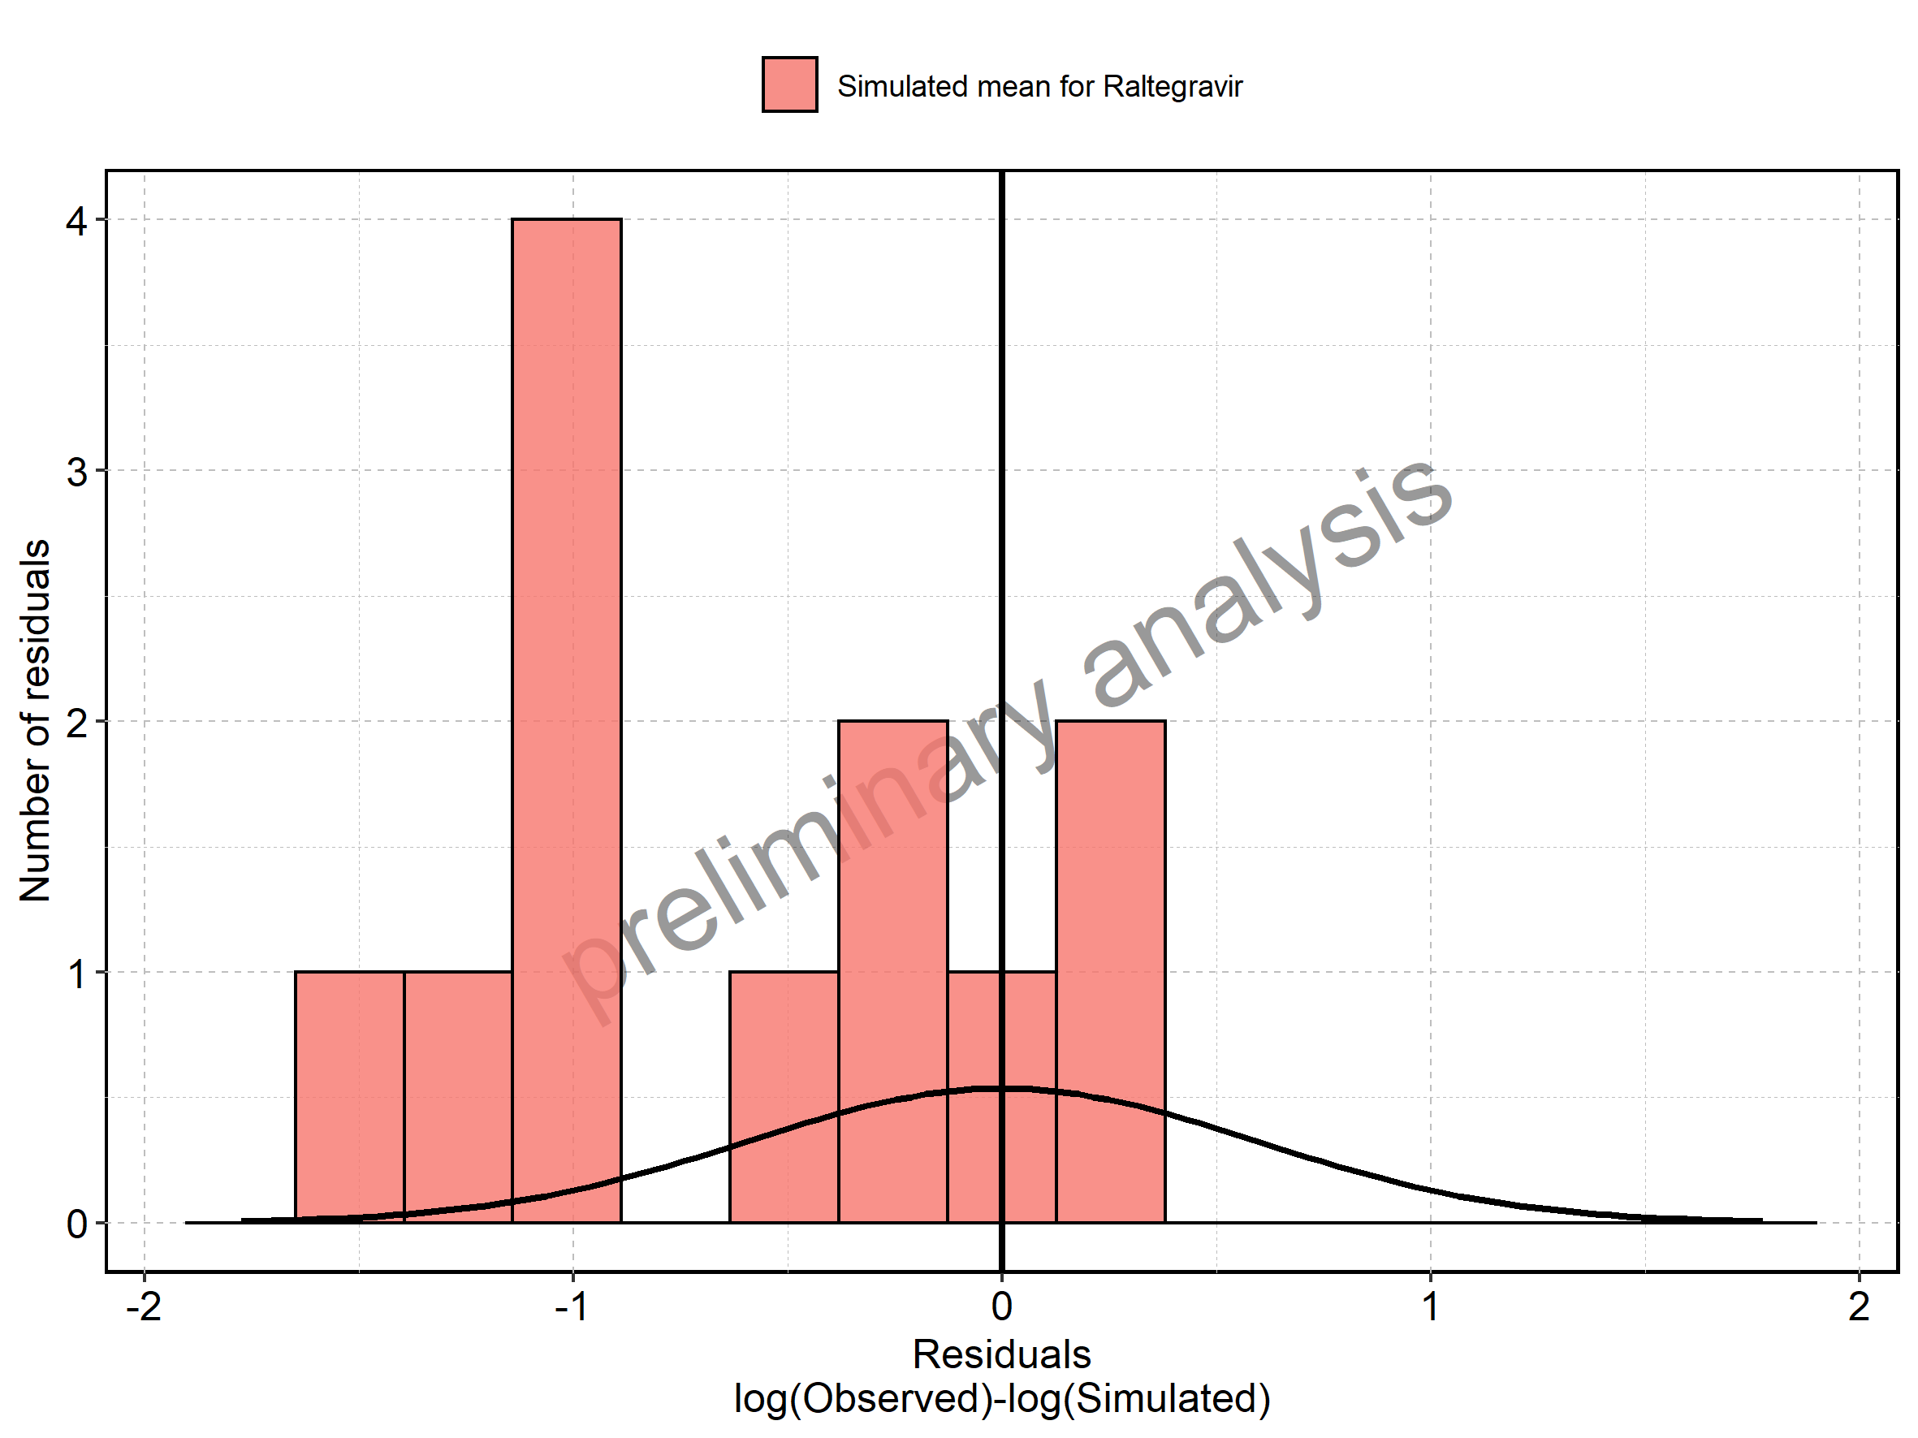

Figure 364: Logarithmic residuals of Filmcoated_tablet_400mg_sd for Raltegravir 400mg filmcoated tablet as quantile-quantile plot. Data source: Data/Raltegravir_PK.txt.

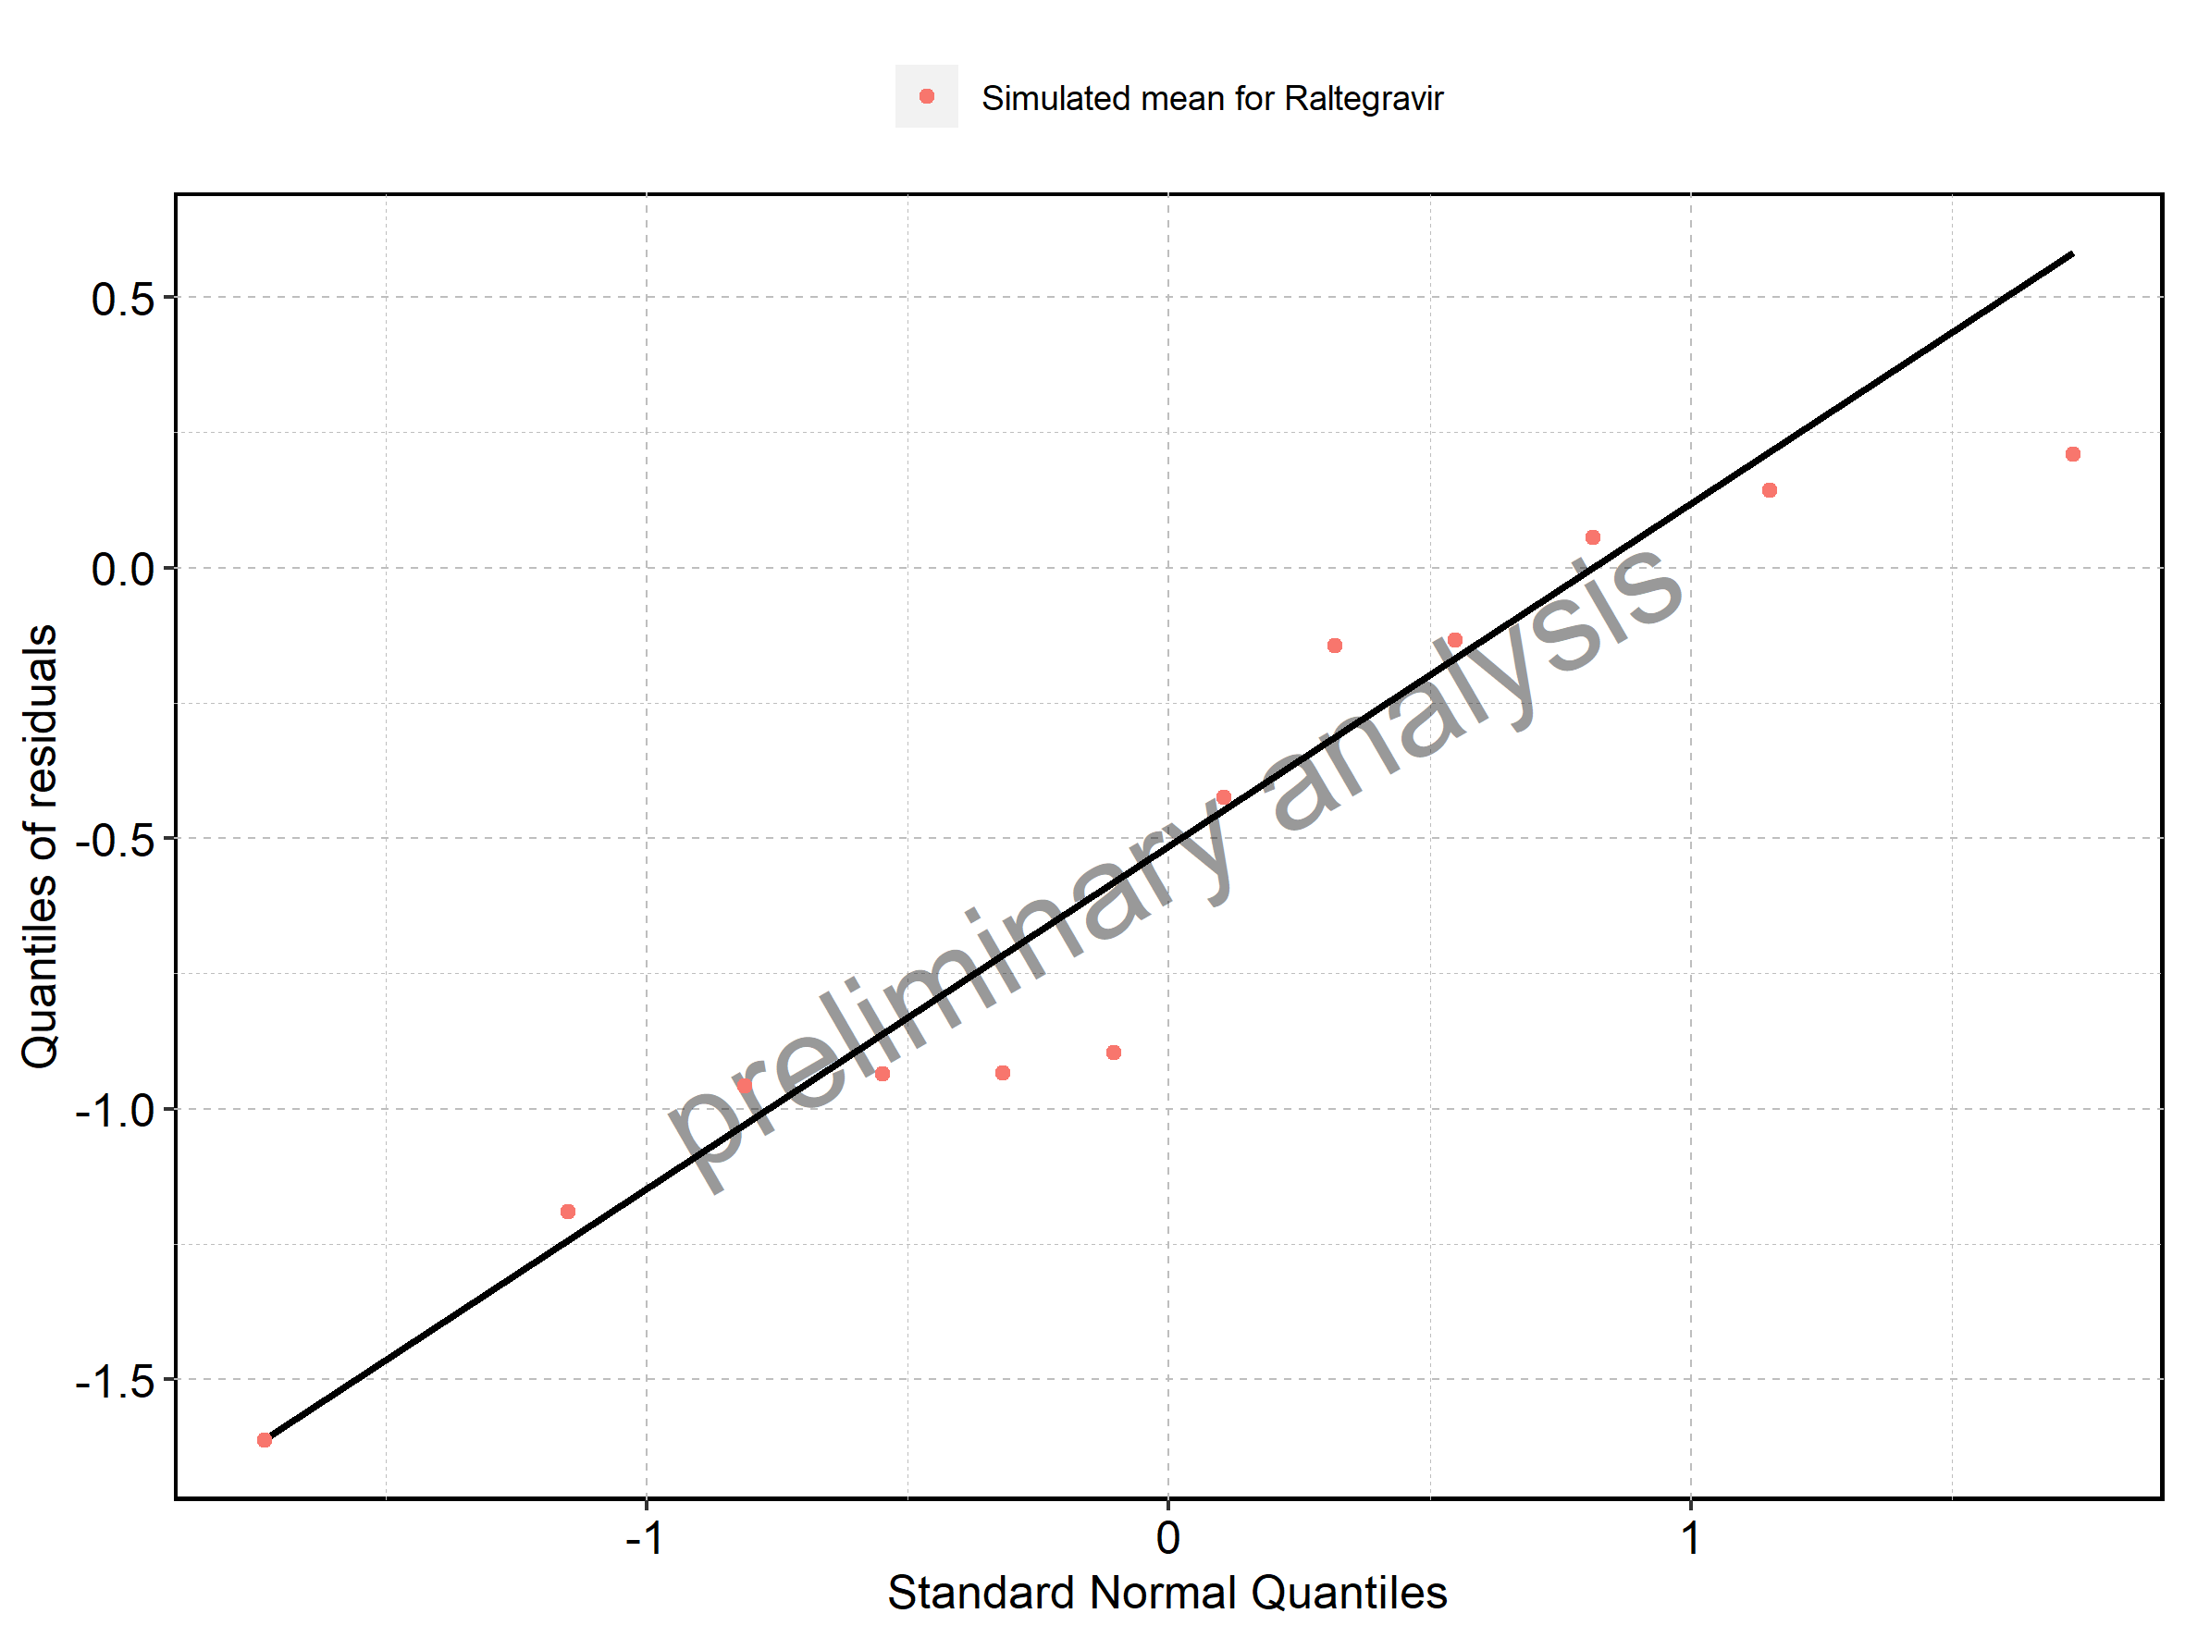

## 3.3. Residuals across all simulations

Figure 365: Distribution of residuals for Larson 2013 8y-18y 400mg FCT meal, Filmcoated_tablet_400mg_sd

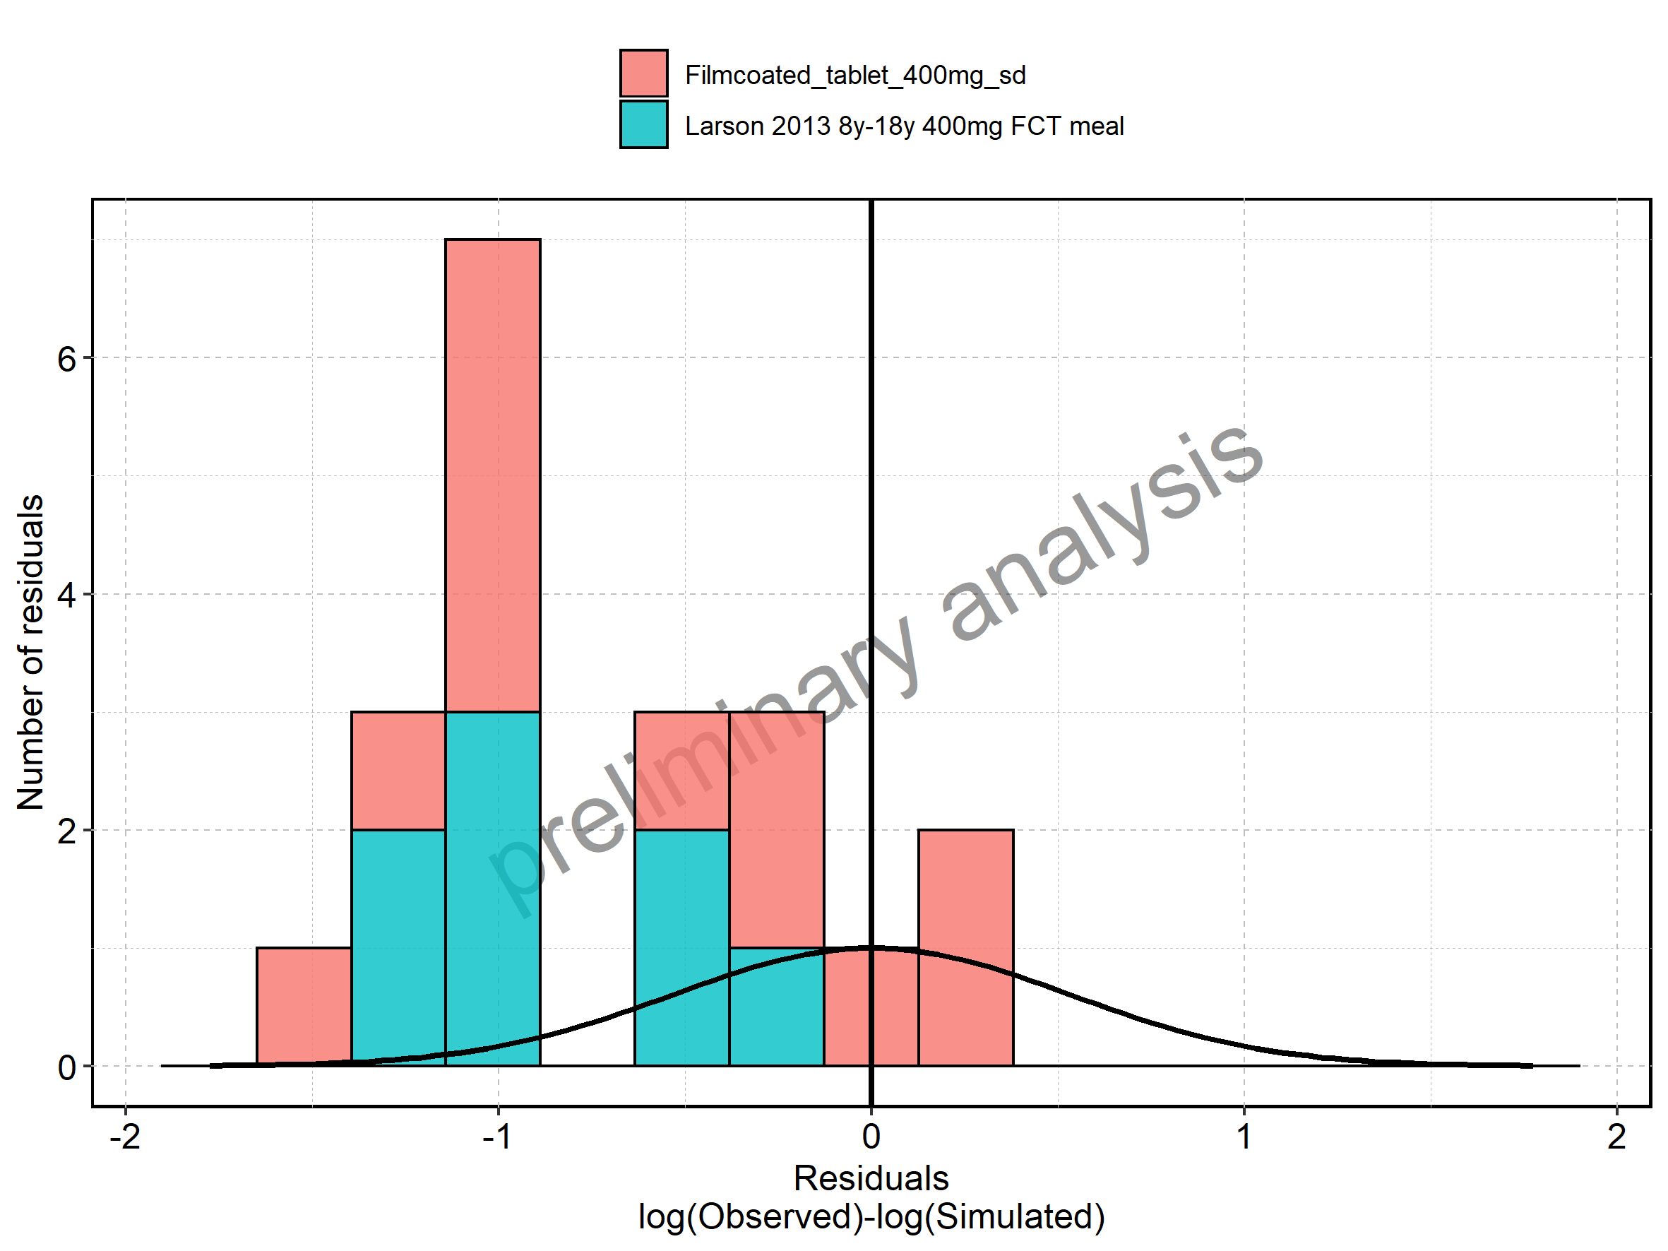

Figure 366: Residuals for Larson 2013 8y-18y 400mg FCT meal, Filmcoated_tablet_400mg_sd as quantile-quantile plot.

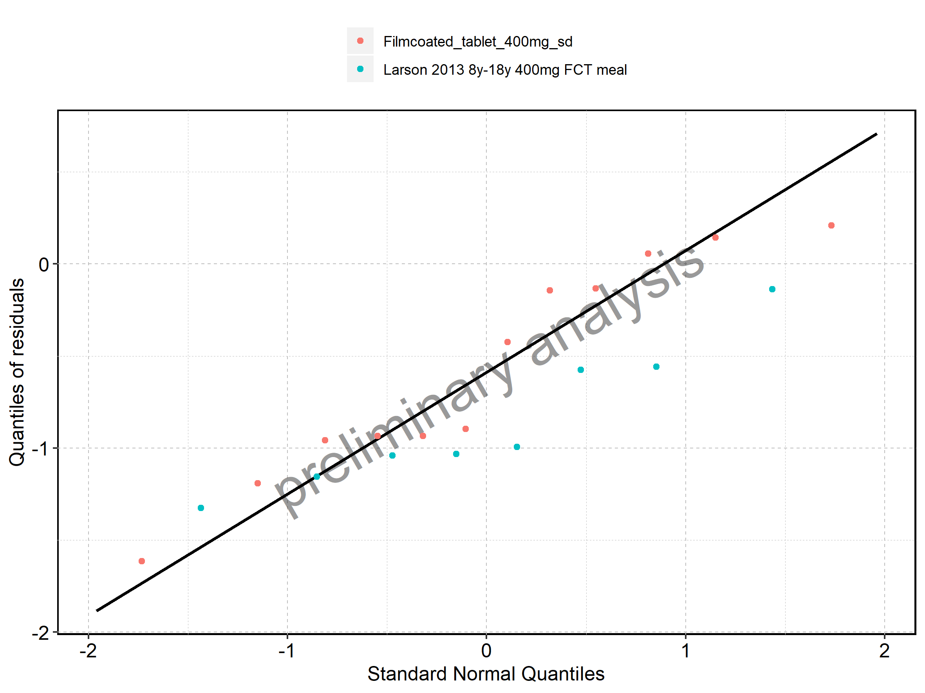

# 4. Demography

Figure 367: Age-dependence of Height for Larson 2013 8y-18y 400mg FCT meal in comparison to Filmcoated_tablet_400mg_sd. Profiles are plotted in a linear scale.

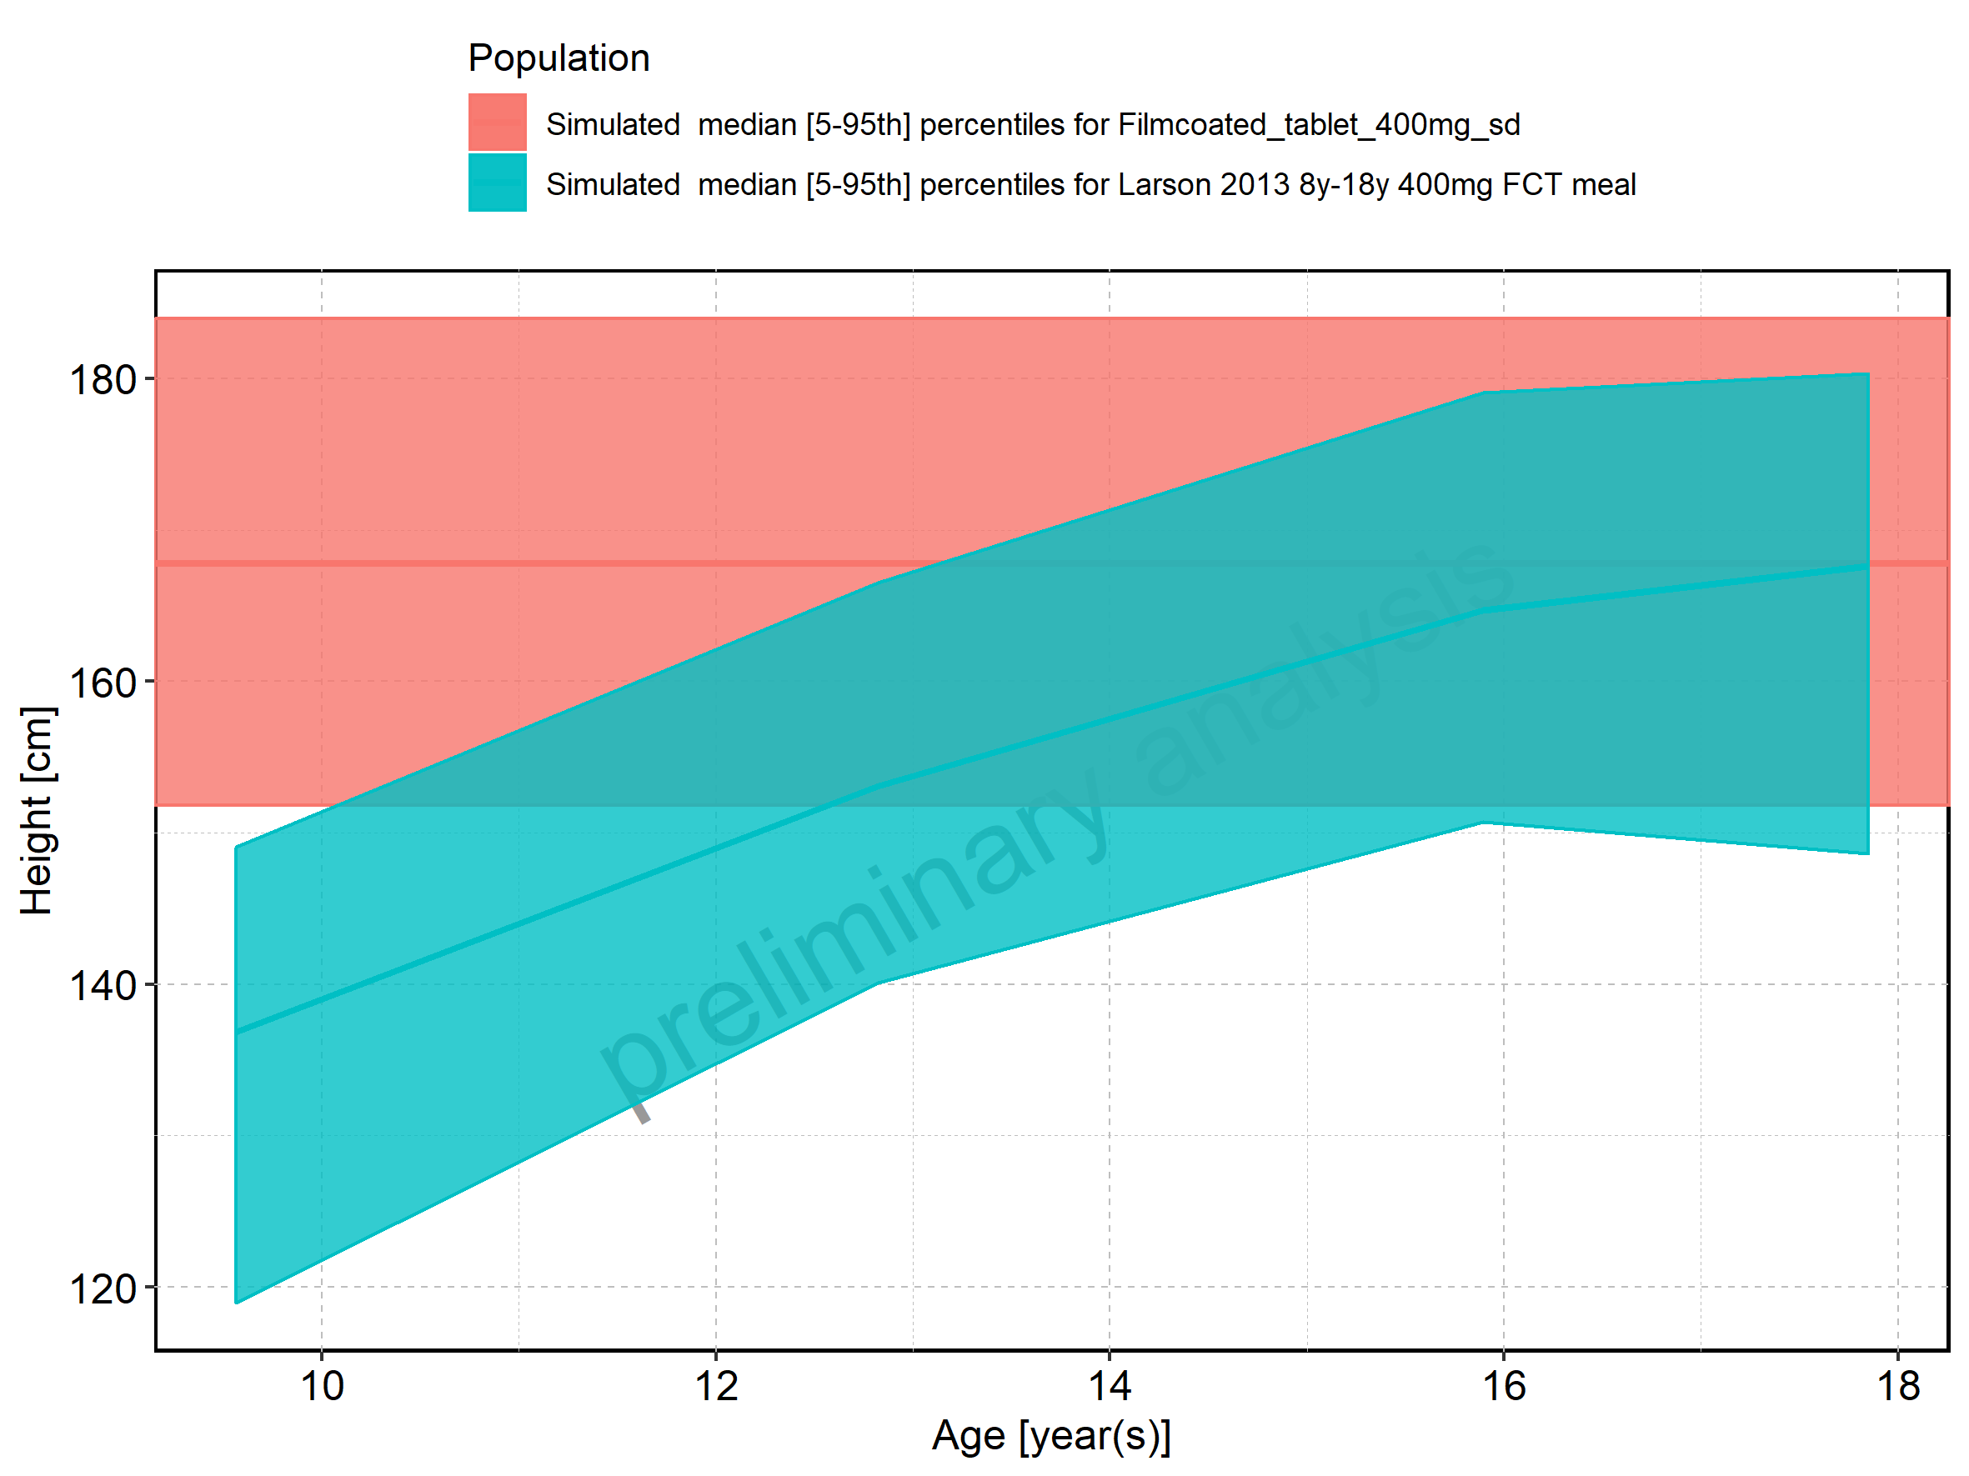

Figure 368: Age-dependence of Height for Larson 2013 8y-18y 400mg FCT meal in comparison to Filmcoated_tablet_400mg_sd. Profiles are plotted in a logarithmic scale.

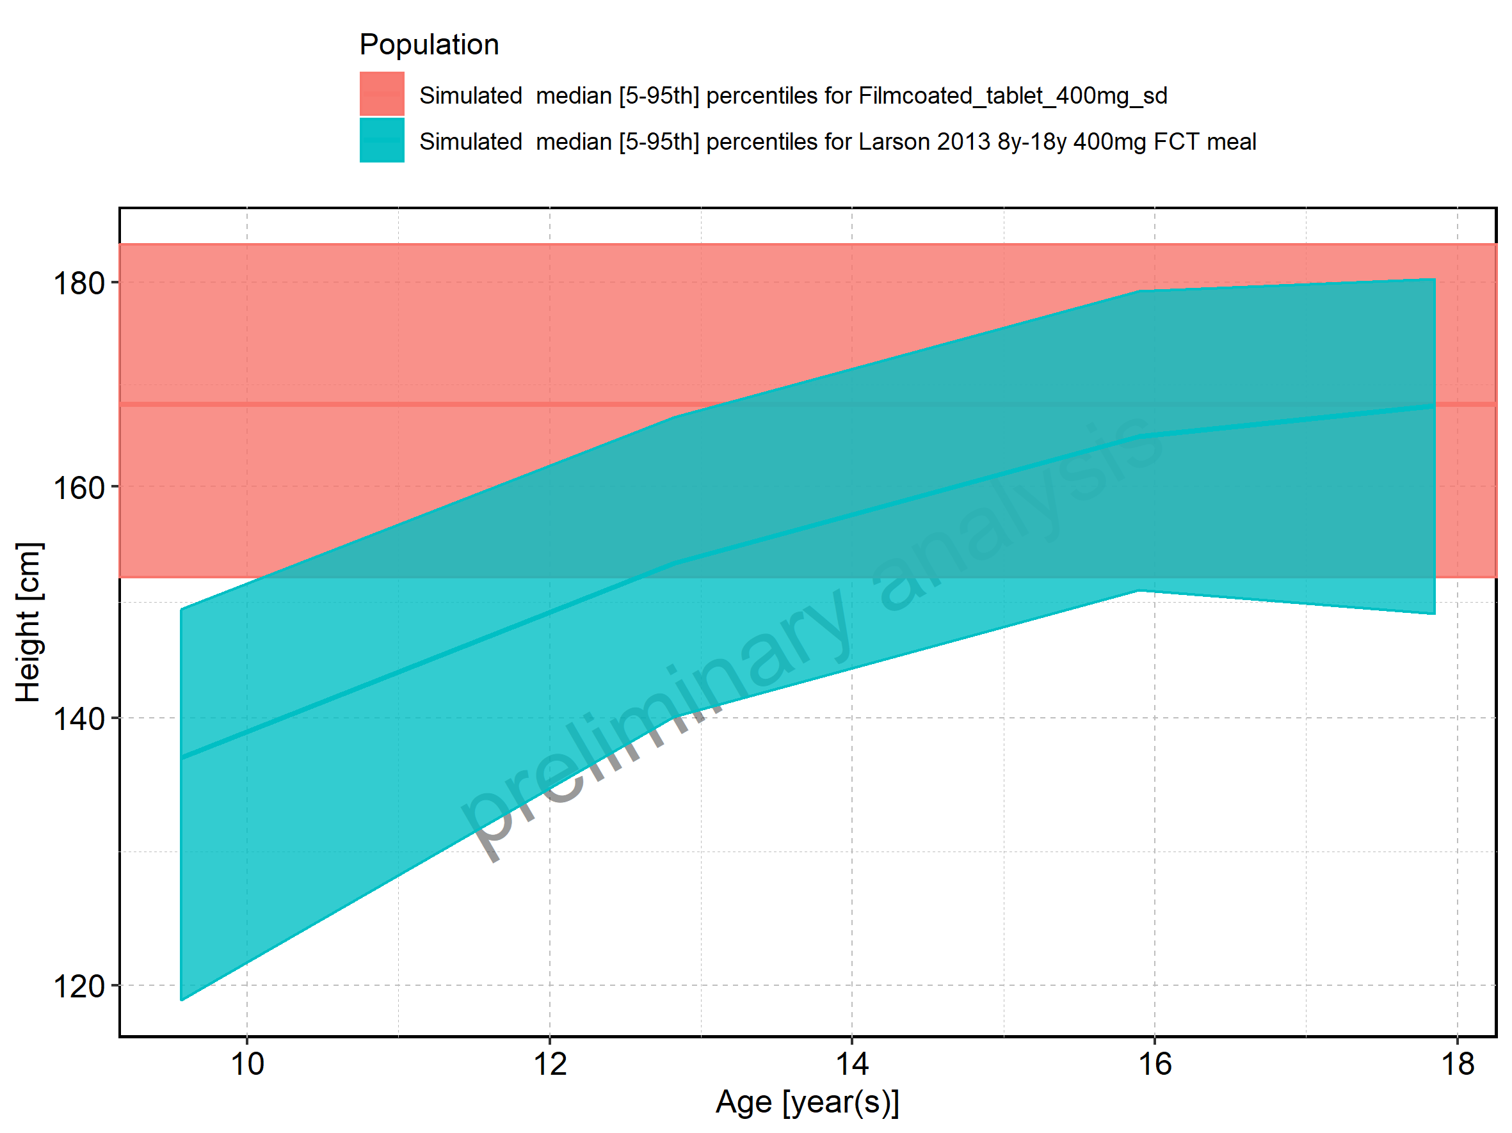

Figure 369: Age-dependence of Height for Larson 2013 8y-18y 400mg FCT meal. Profiles are plotted in a linear scale.

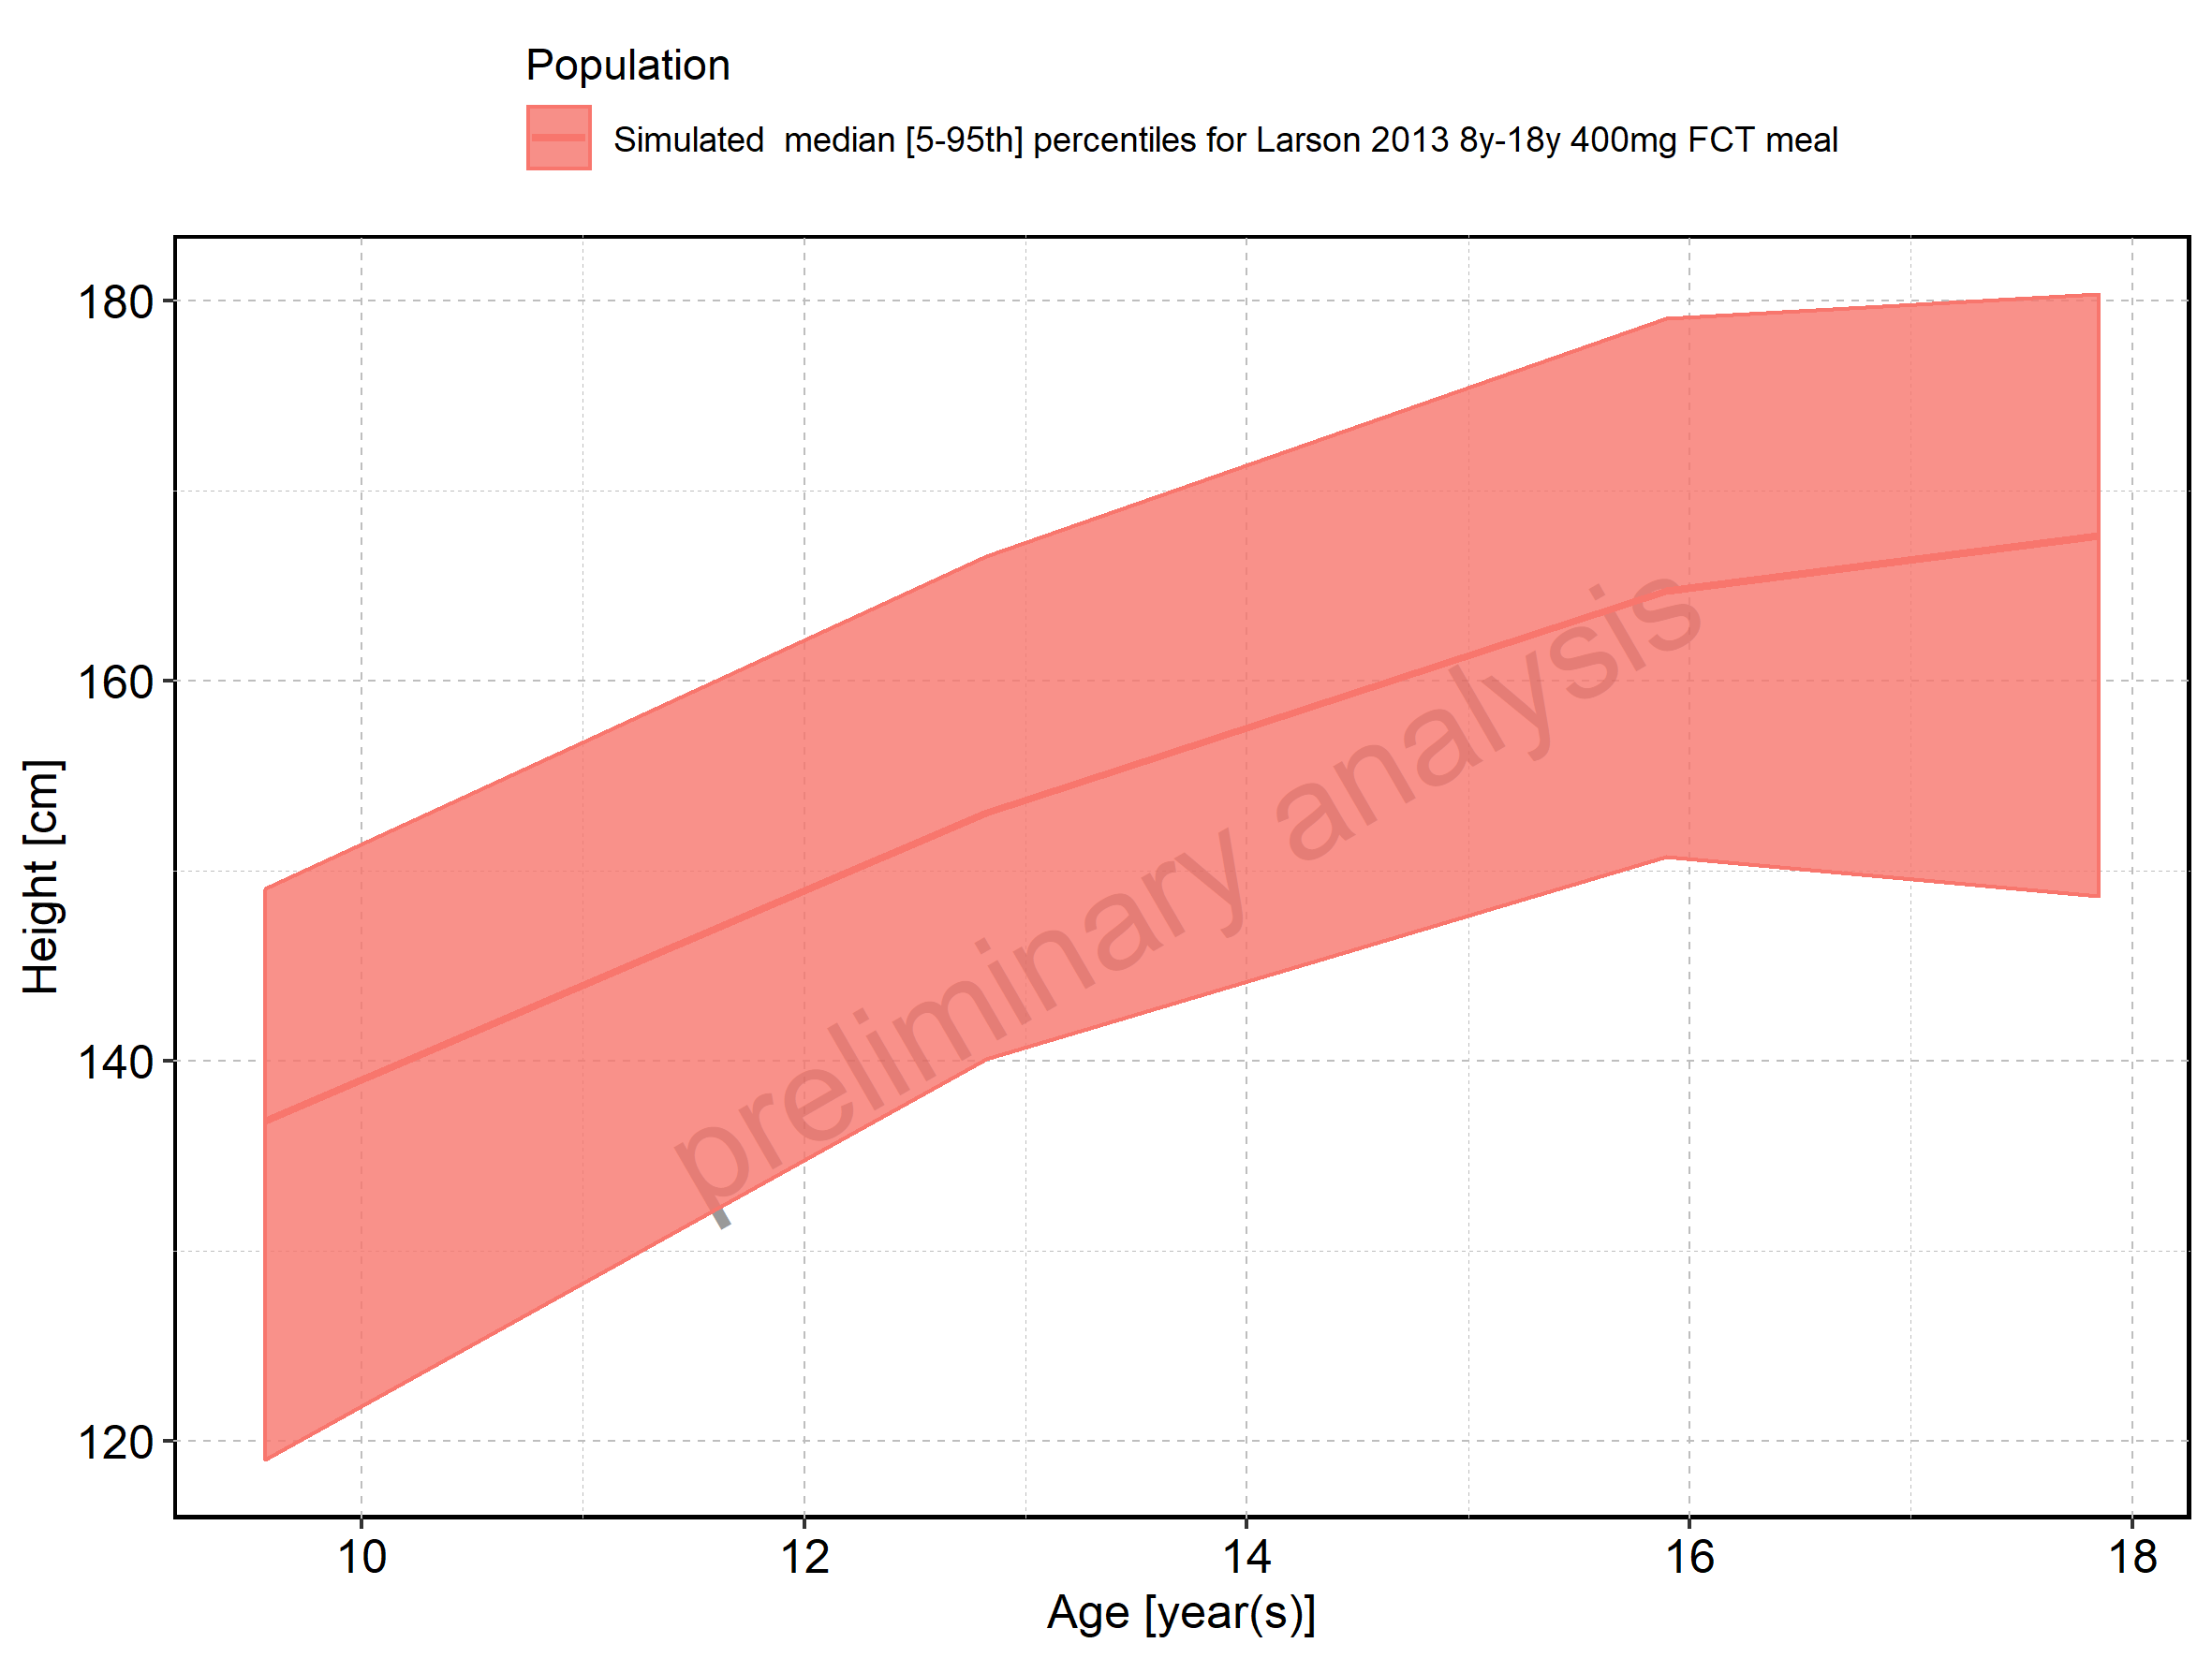

Figure 370: Age-dependence of Height for Larson 2013 8y-18y 400mg FCT meal. Profiles are plotted in a logarithmic scale.

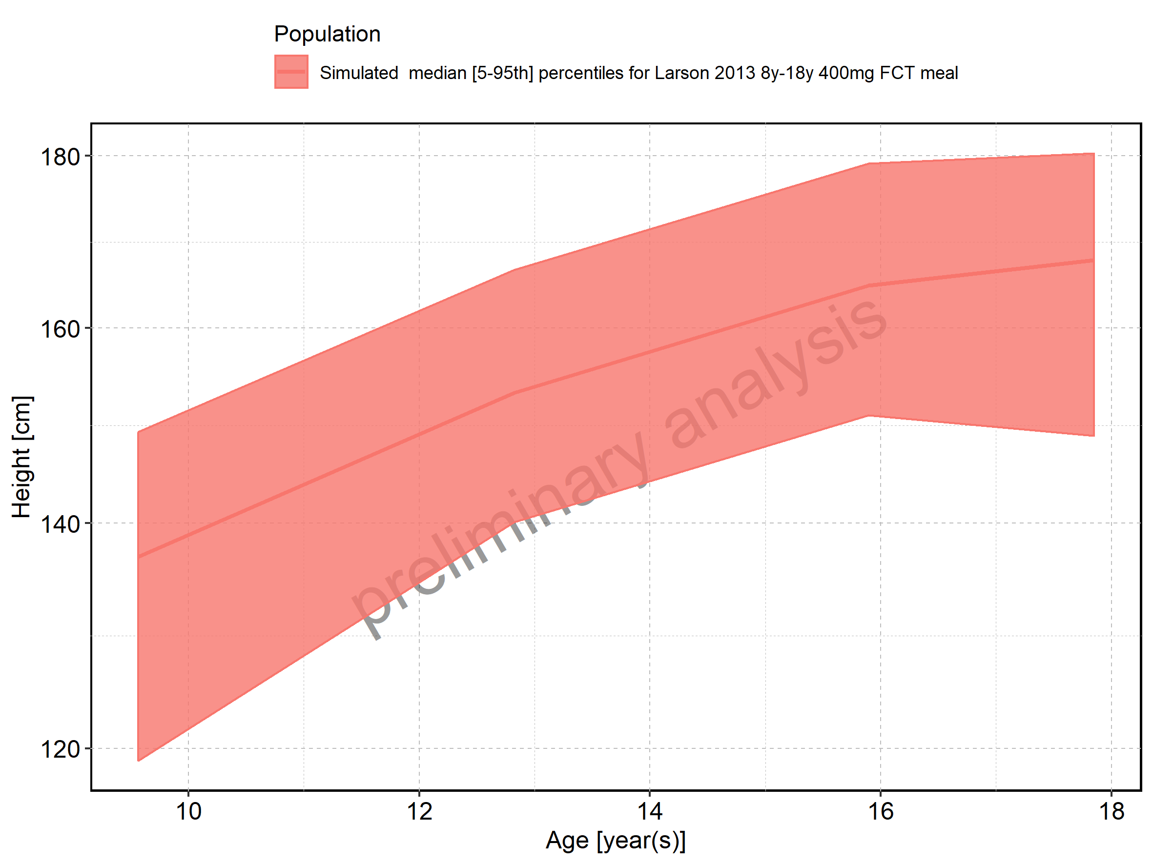

Figure 371: Age-dependence of Height for Filmcoated_tablet_400mg_sd. Profiles are plotted in a linear scale.

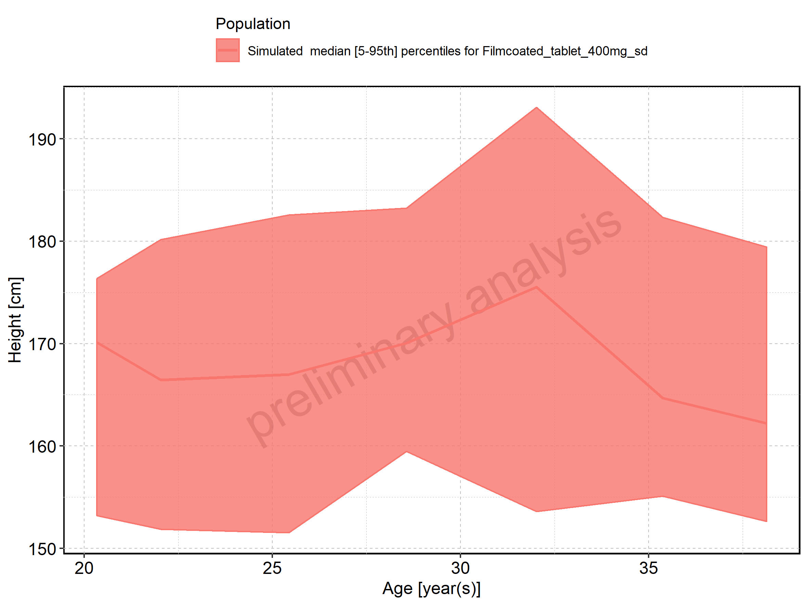

Figure 372: Age-dependence of Height for Filmcoated_tablet_400mg_sd. Profiles are plotted in a logarithmic scale.

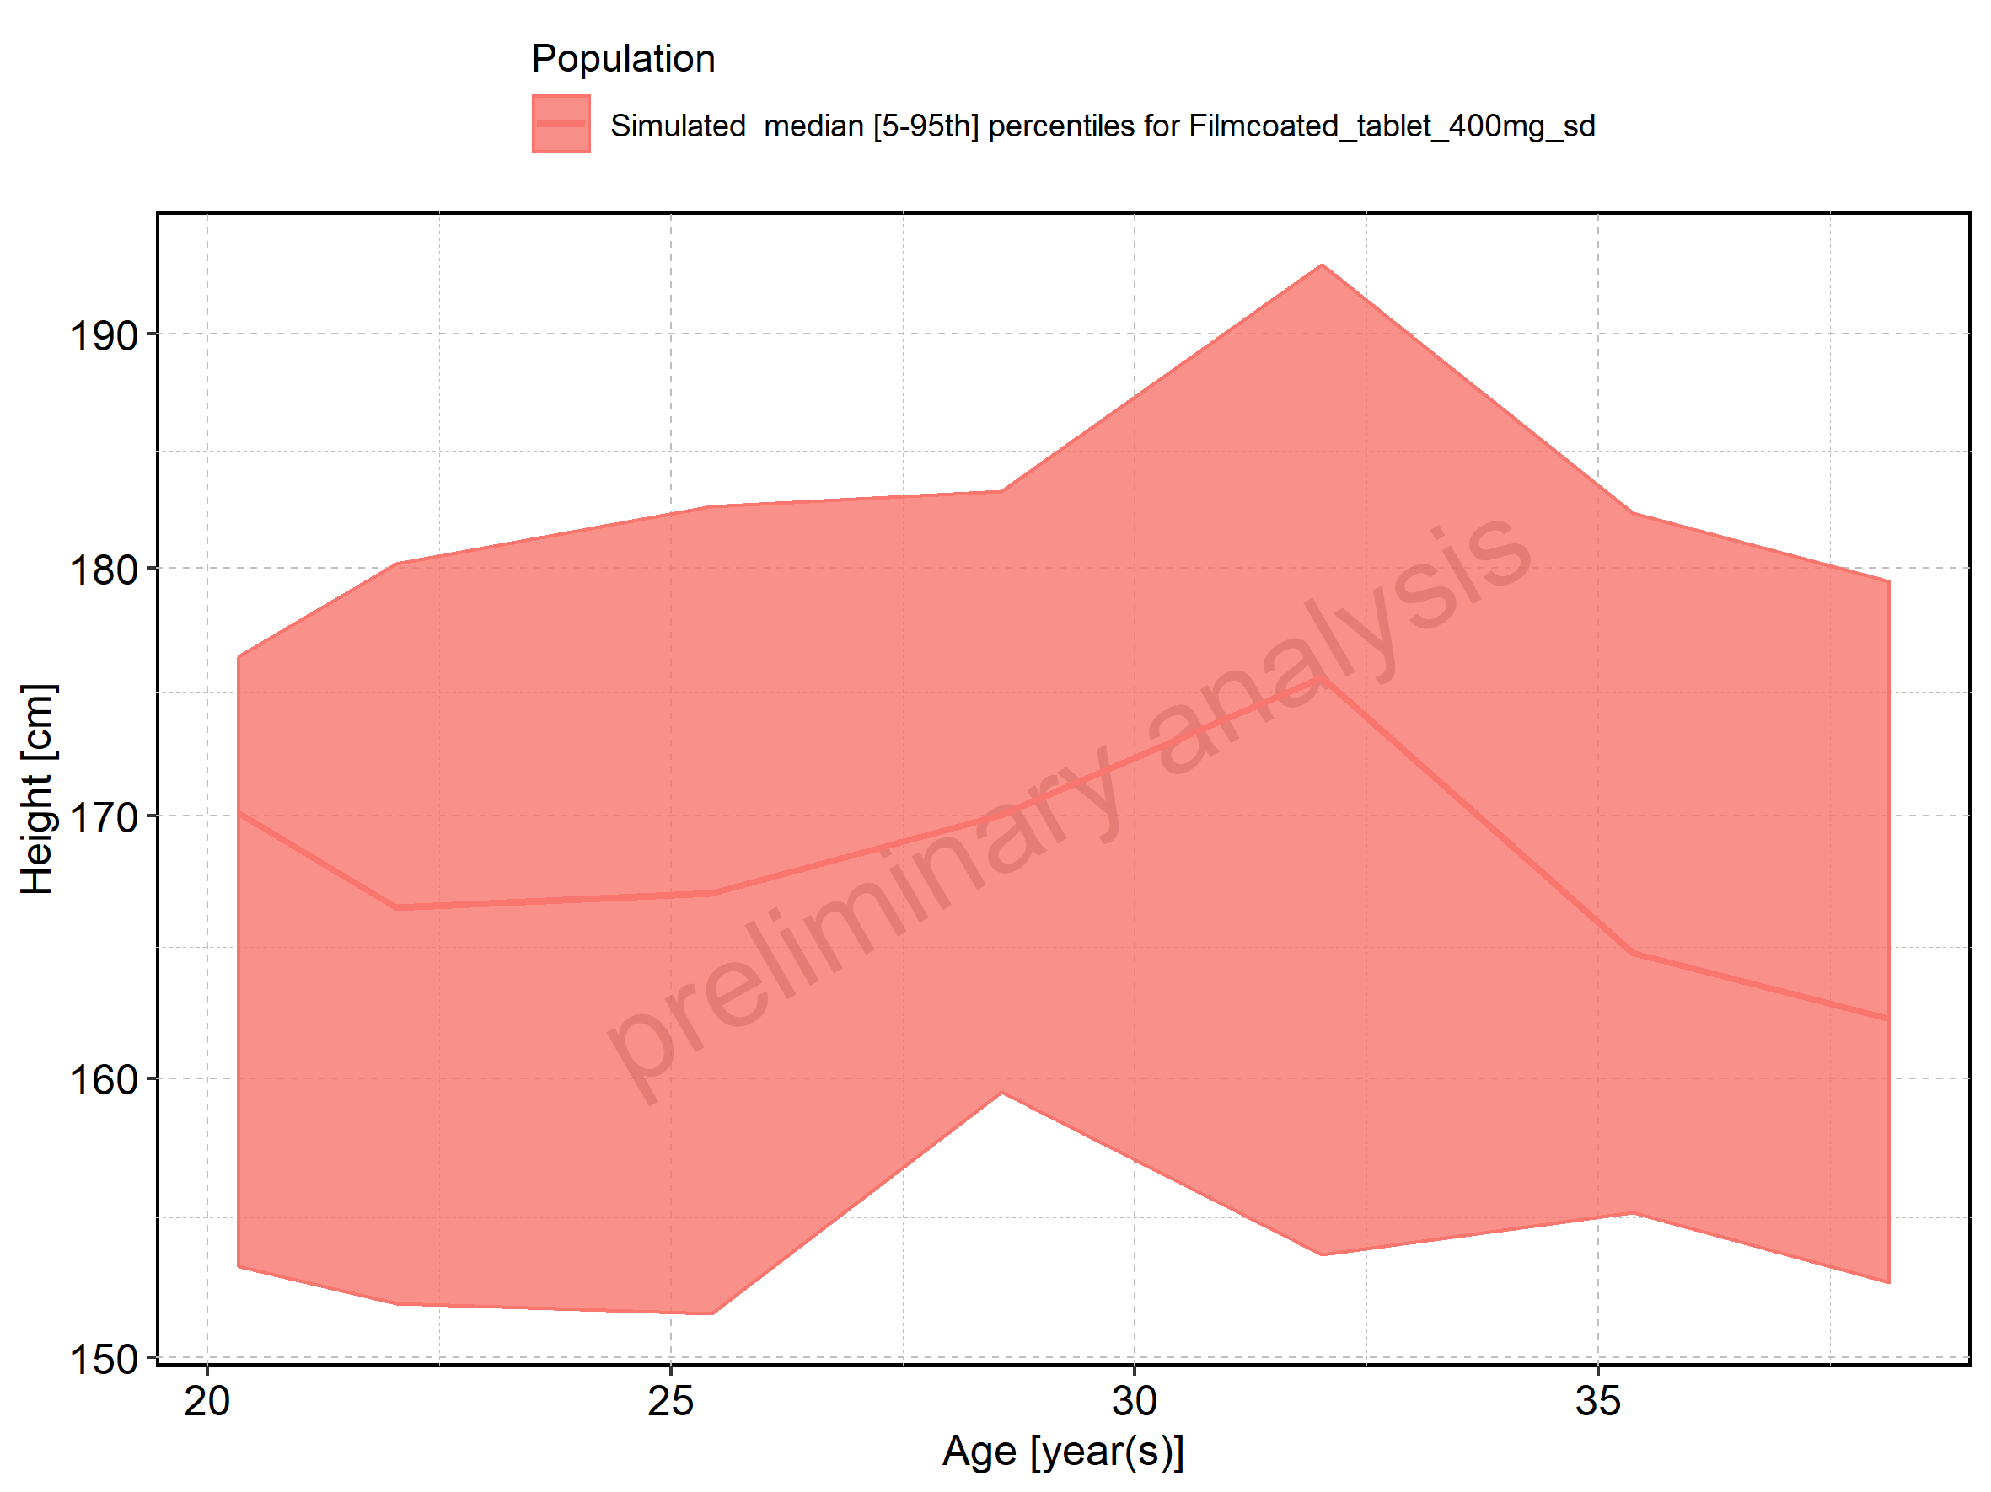

Figure 373: Age-dependence of Weight for Larson 2013 8y-18y 400mg FCT meal in comparison to Filmcoated_tablet_400mg_sd. Profiles are plotted in a linear scale.

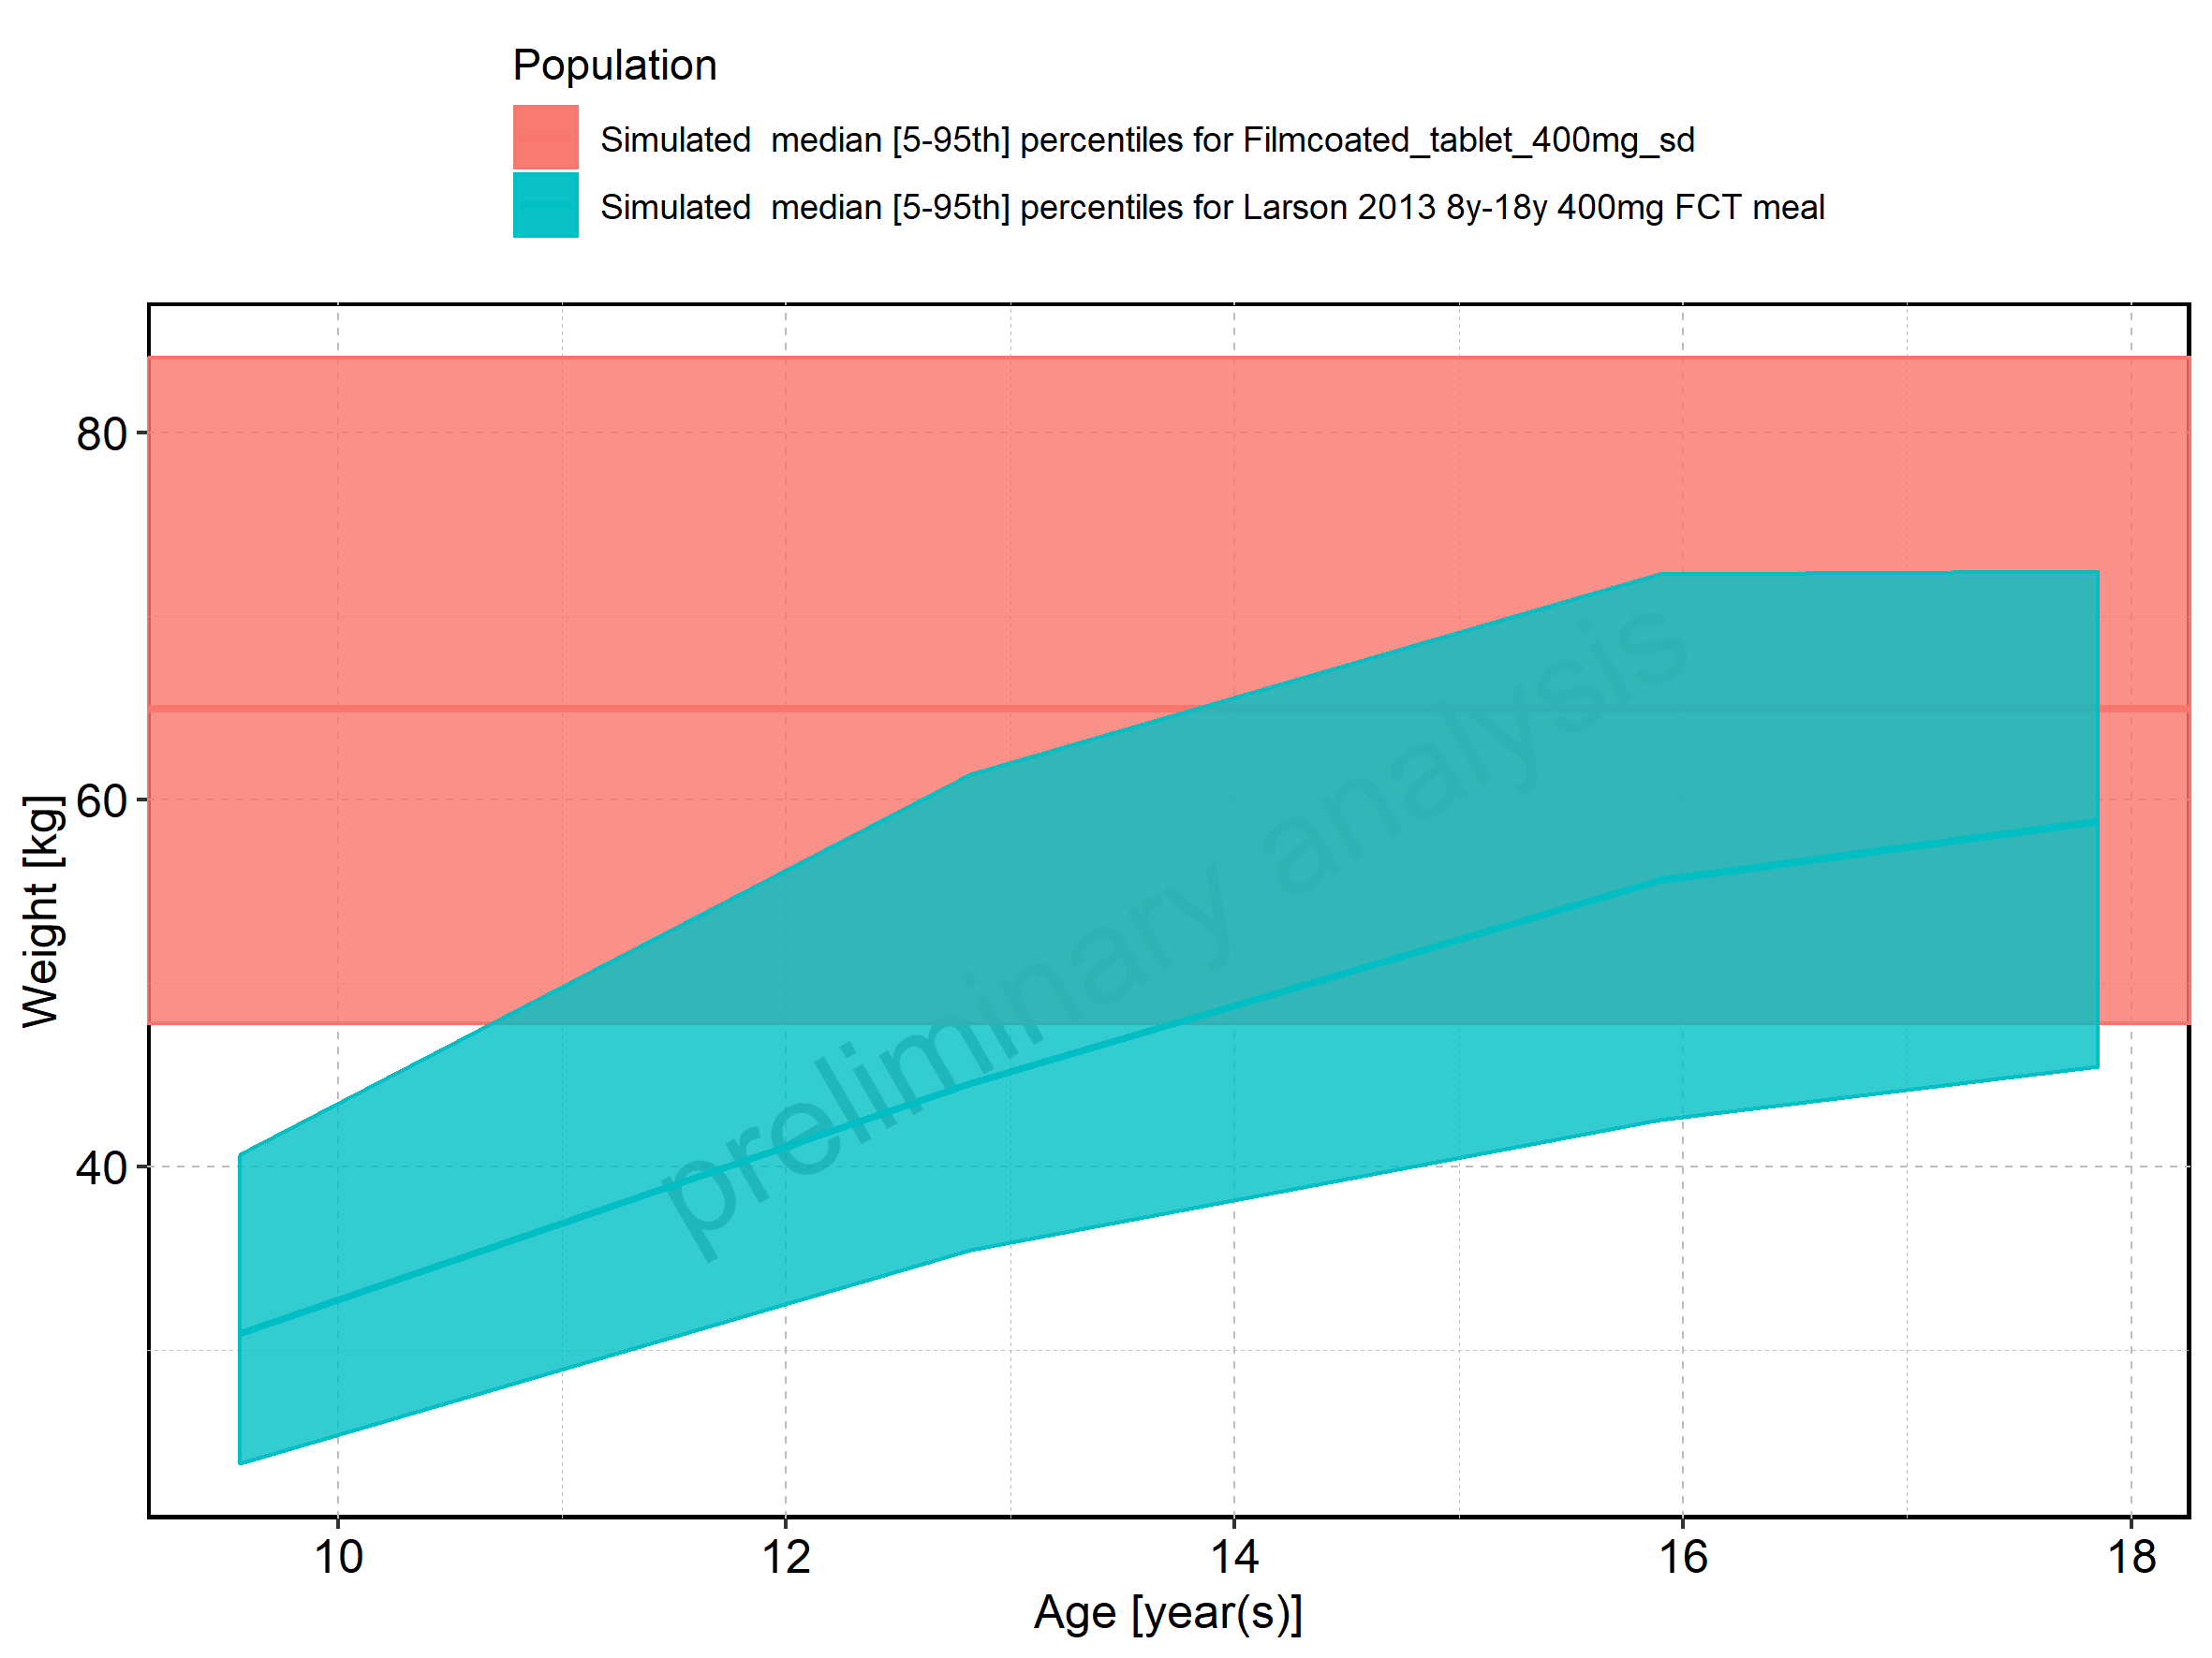

Figure 374: Age-dependence of Weight for Larson 2013 8y-18y 400mg FCT meal in comparison to Filmcoated_tablet_400mg_sd. Profiles are plotted in a logarithmic scale.

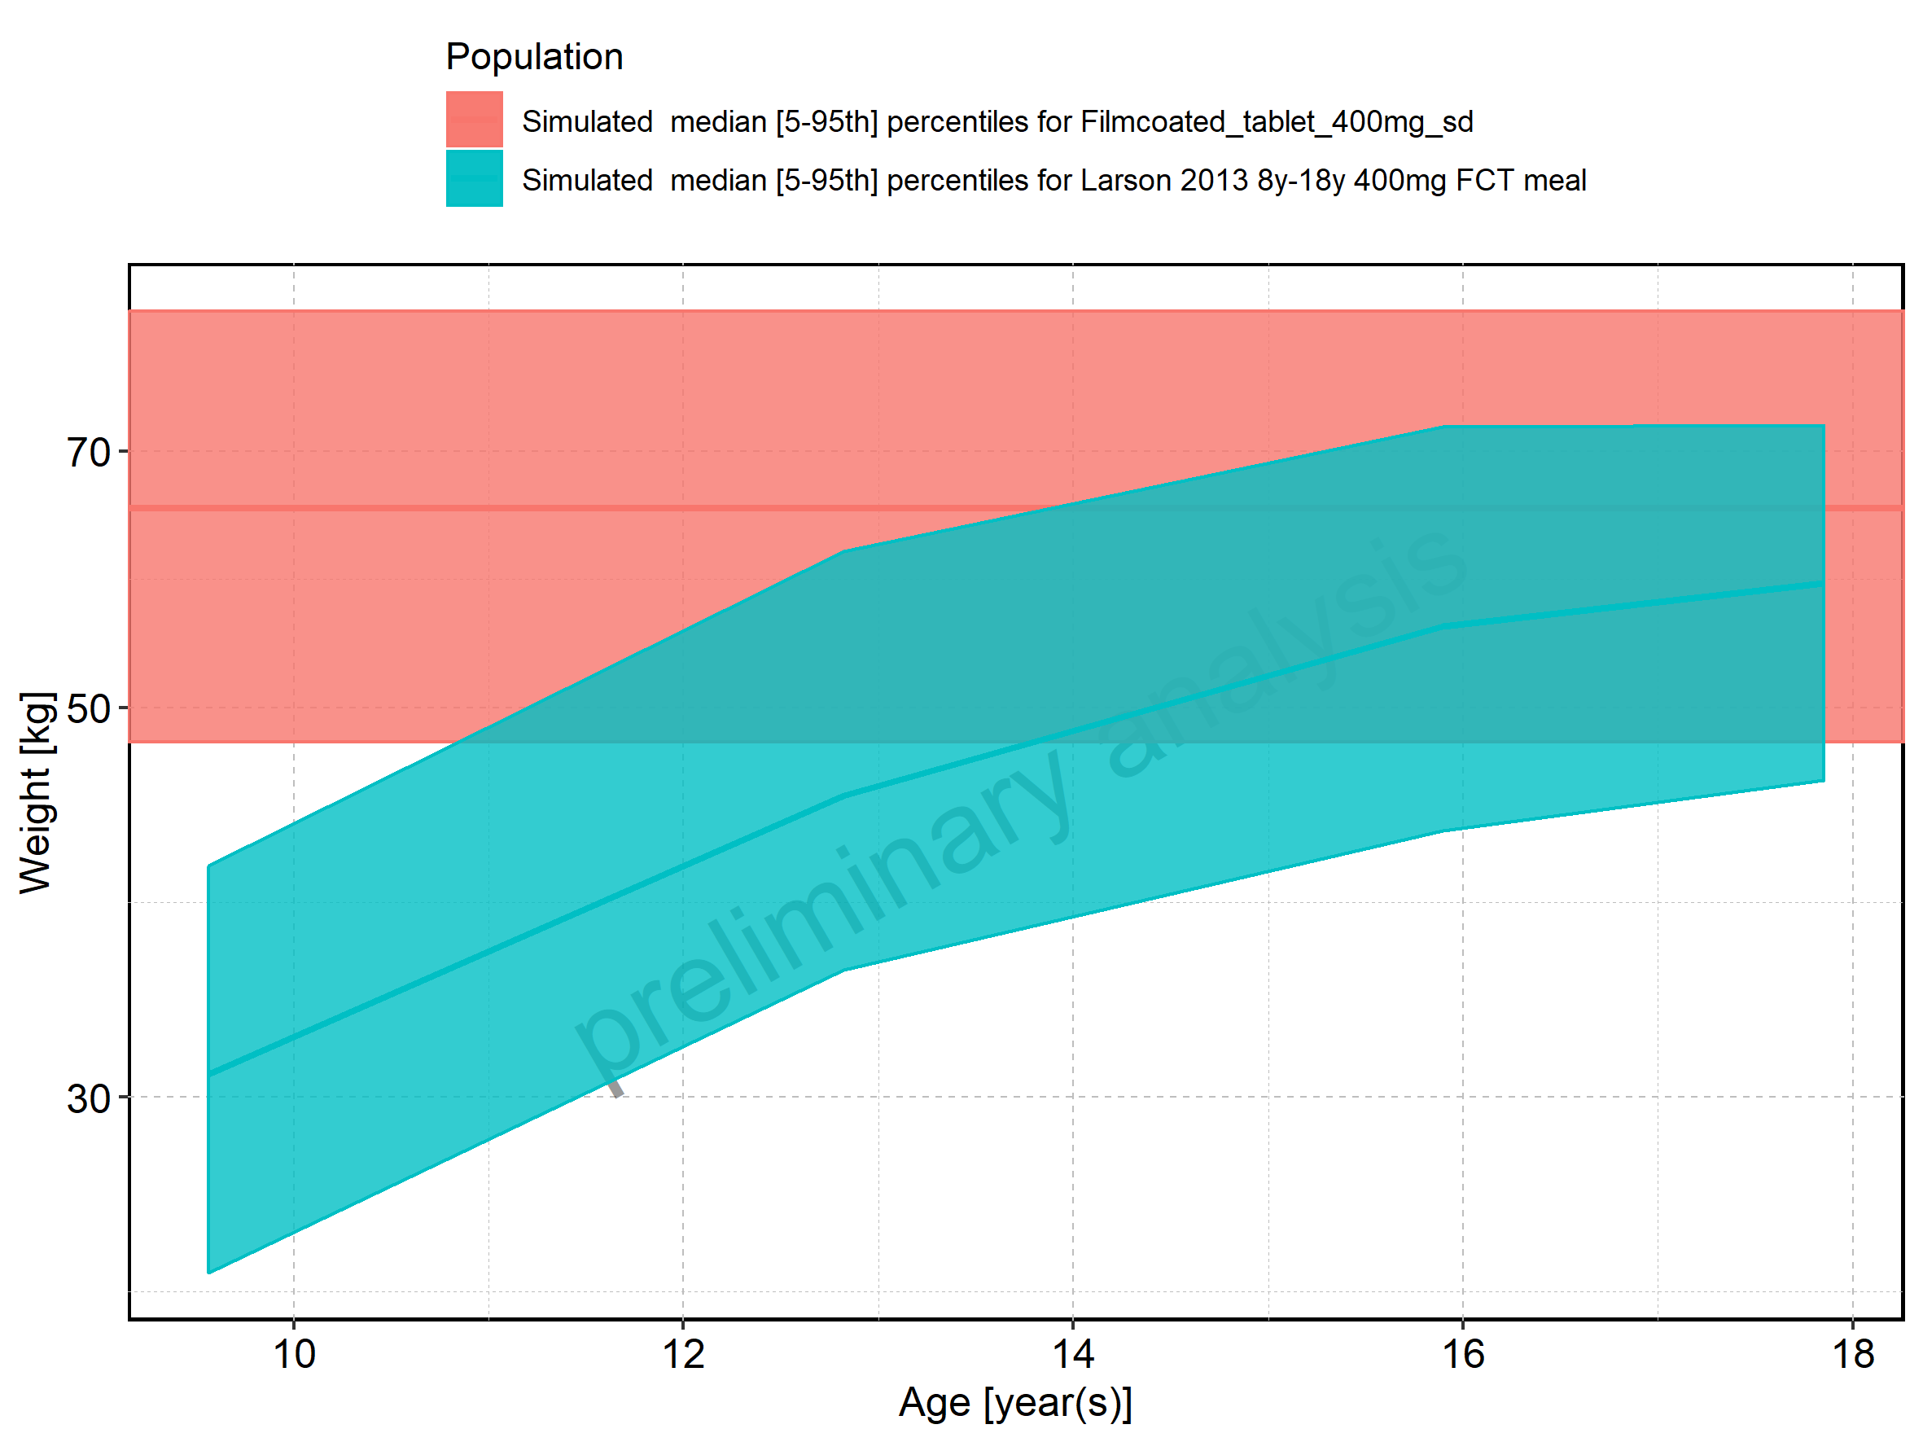

Figure 375: Age-dependence of Weight for Larson 2013 8y-18y 400mg FCT meal. Profiles are plotted in a linear scale.

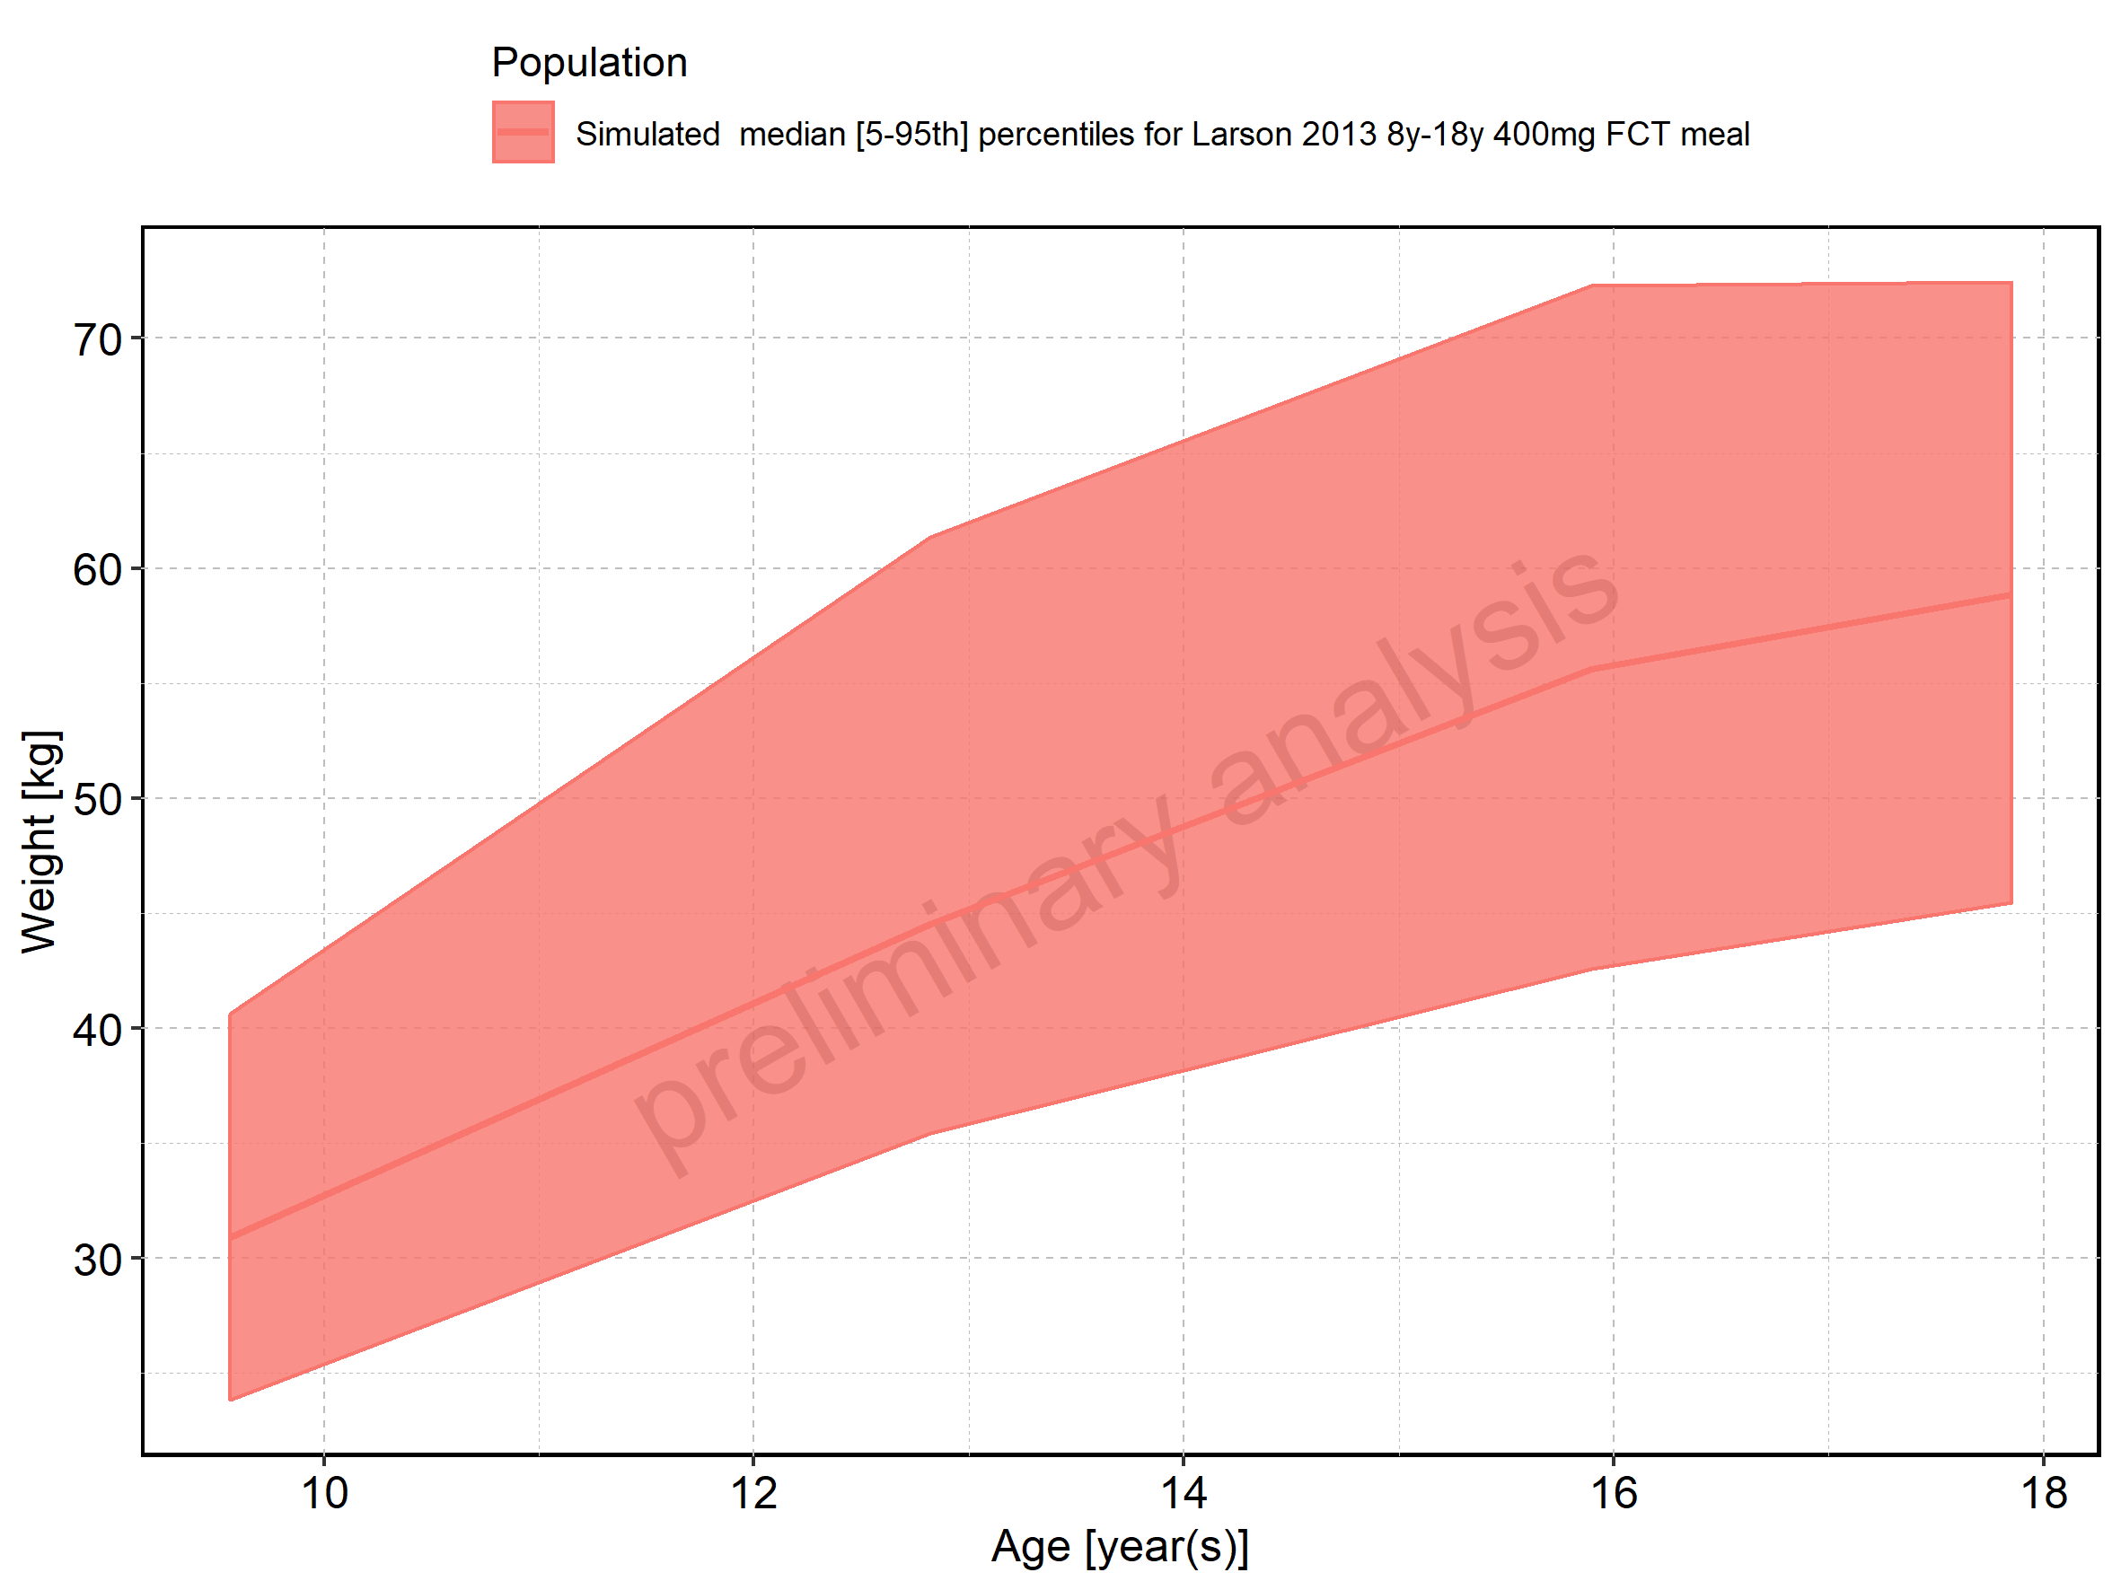

Figure 376: Age-dependence of Weight for Larson 2013 8y-18y 400mg FCT meal. Profiles are plotted in a logarithmic scale.

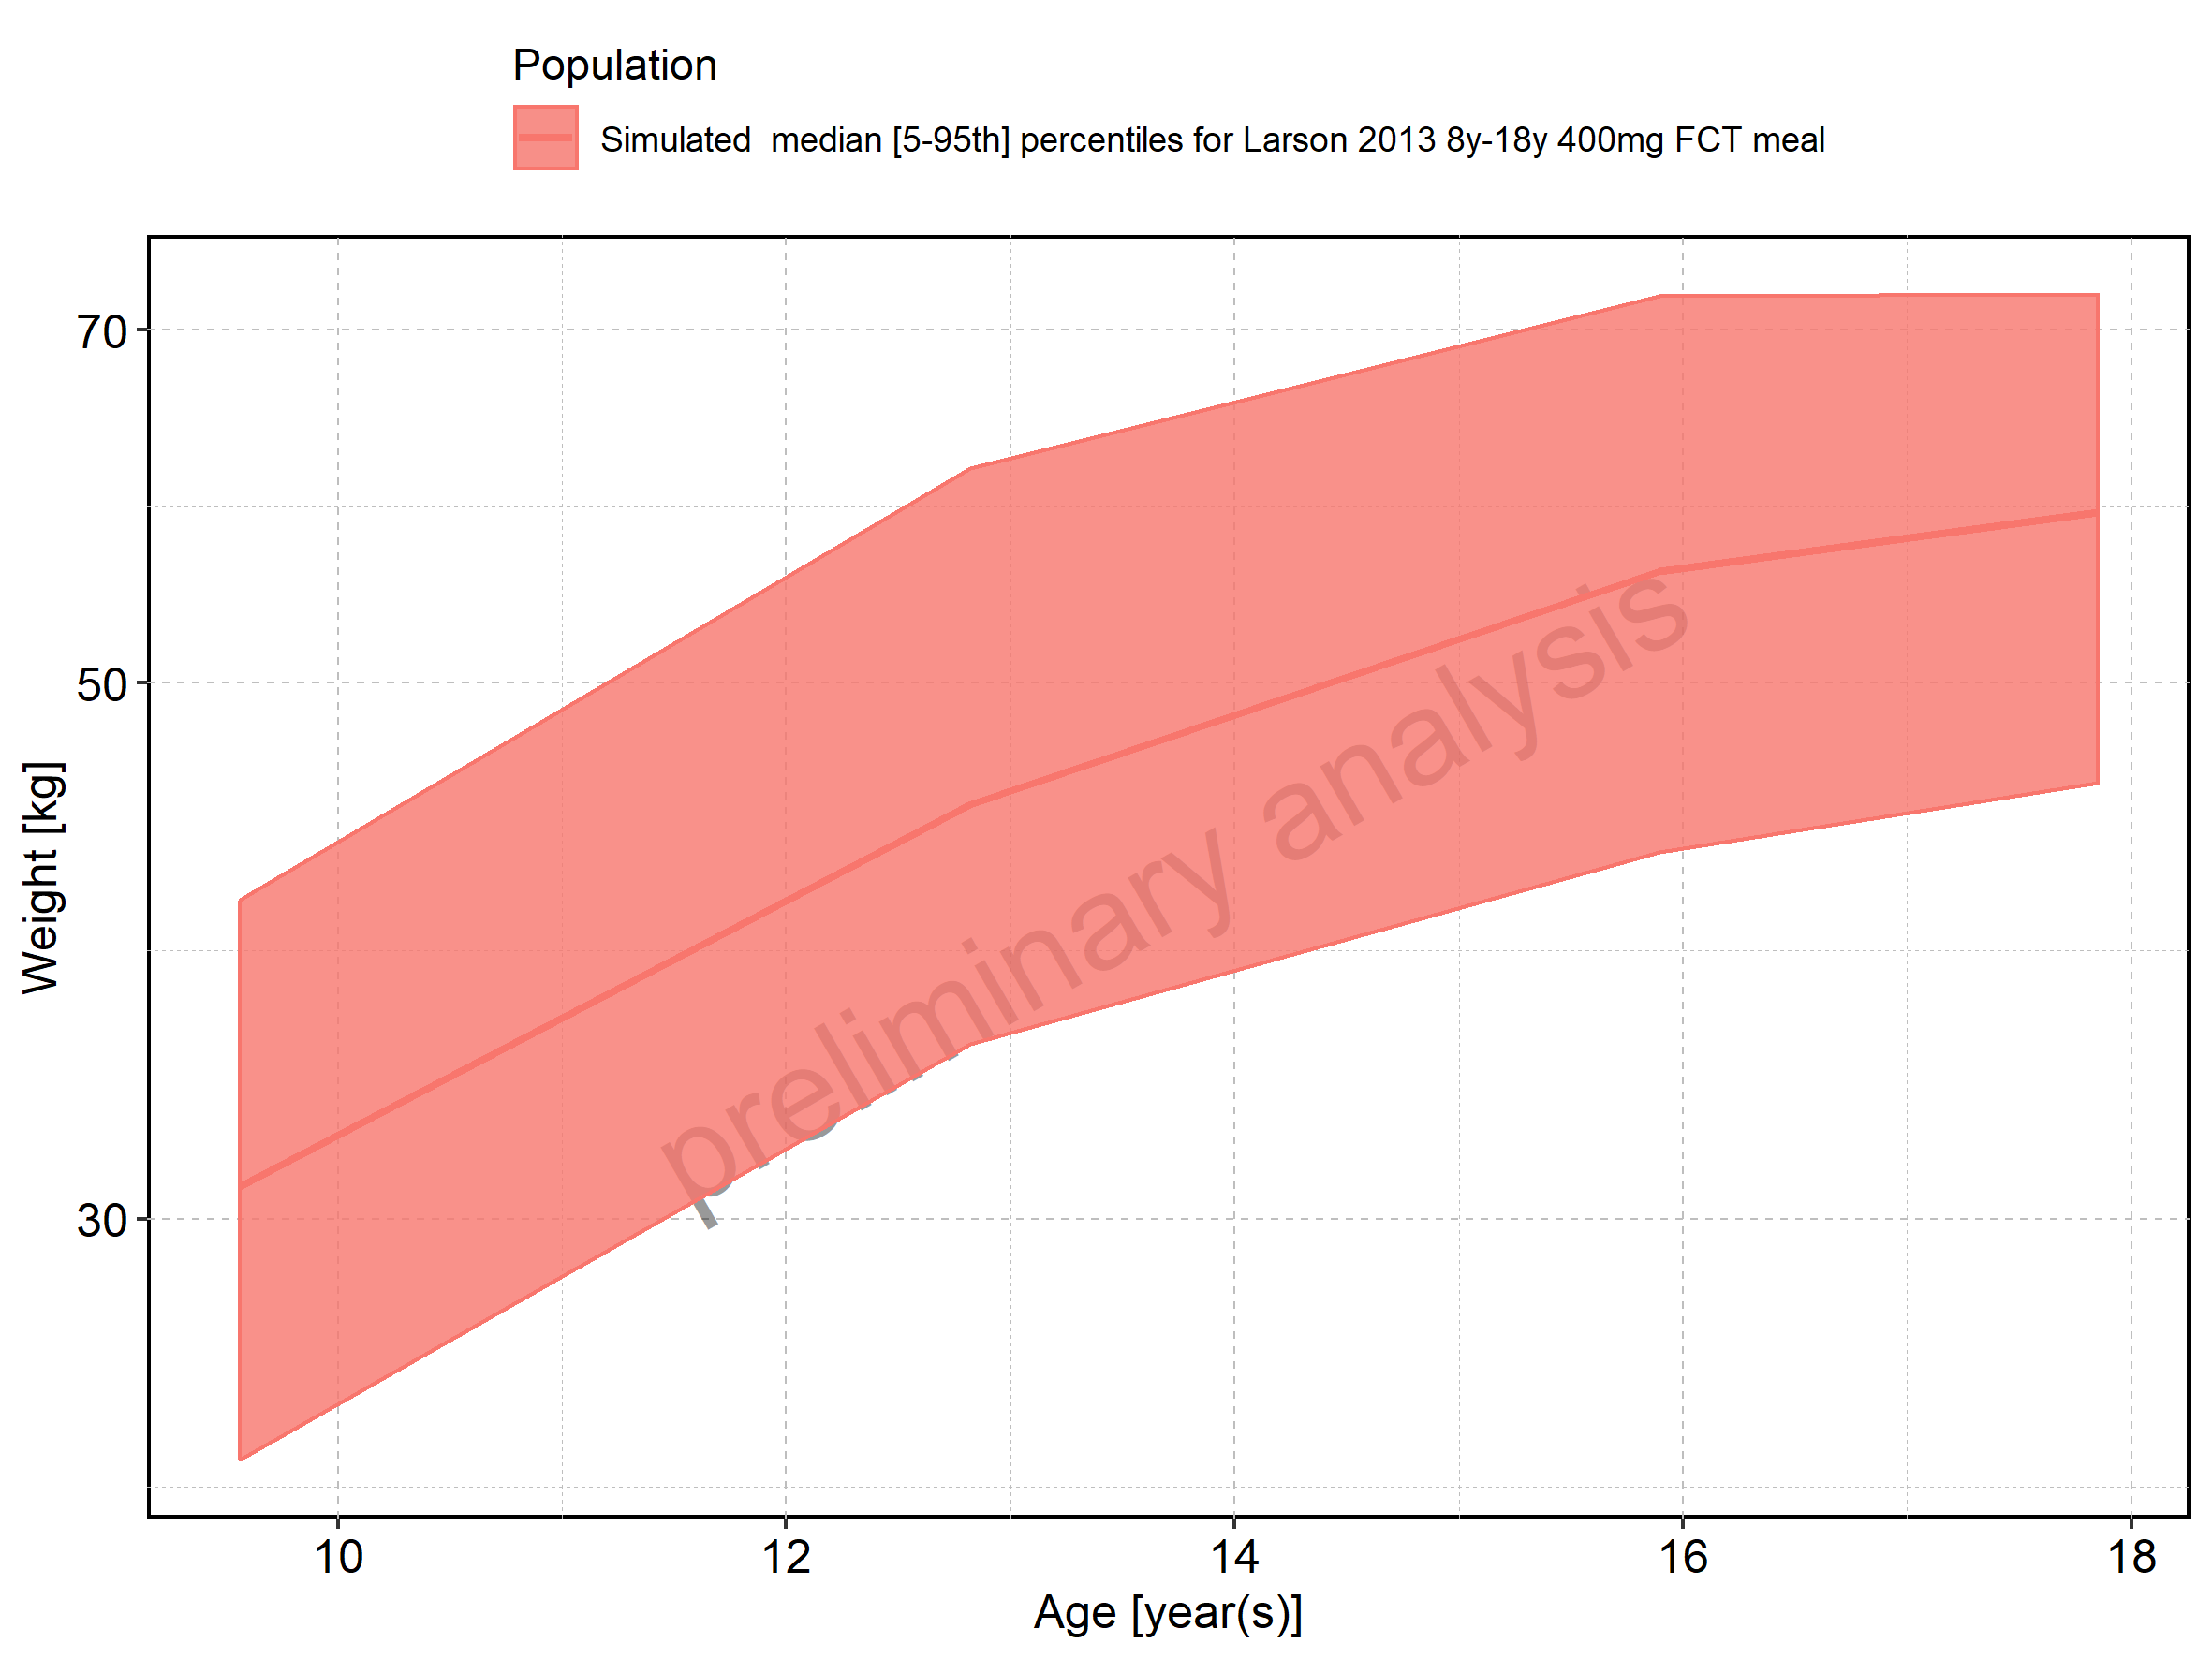

Figure 377: Age-dependence of Weight for Filmcoated_tablet_400mg_sd. Profiles are plotted in a linear scale.

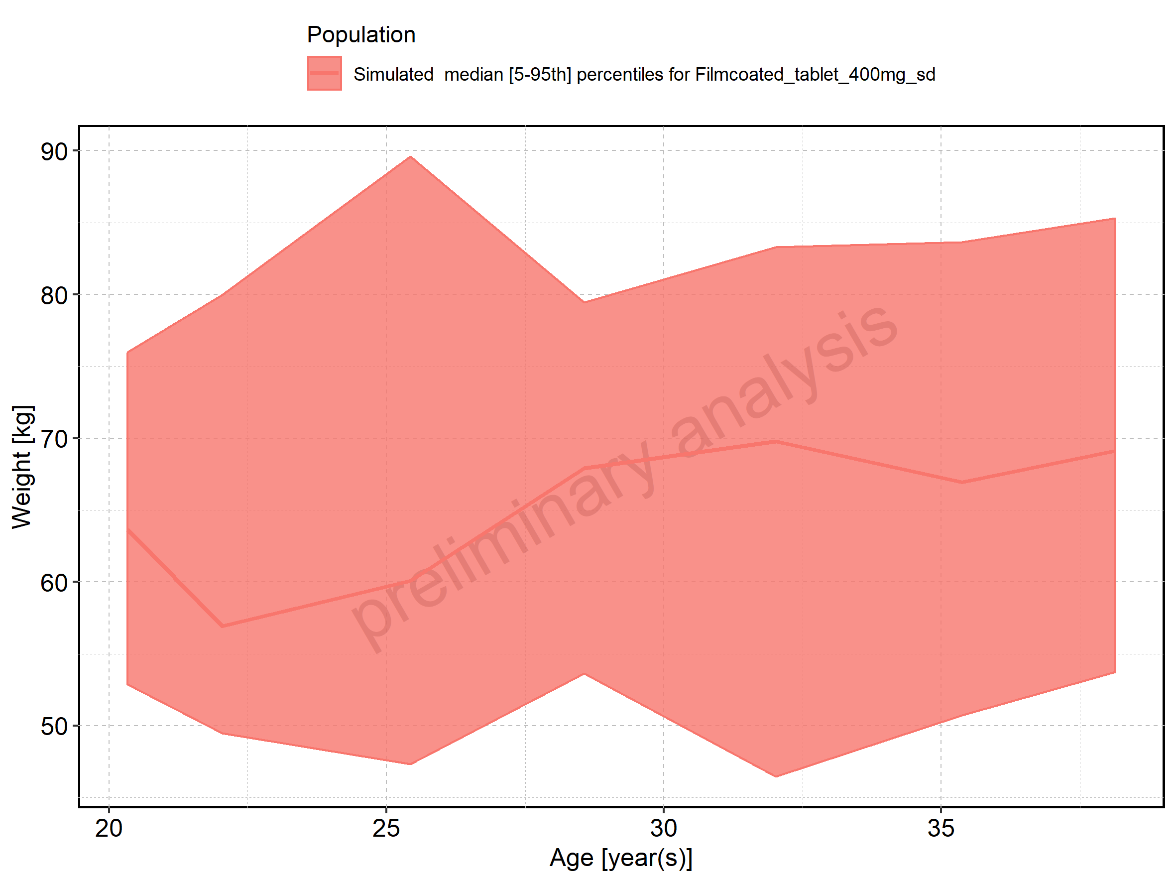

Figure 378: Age-dependence of Weight for Filmcoated_tablet_400mg_sd. Profiles are plotted in a logarithmic scale.

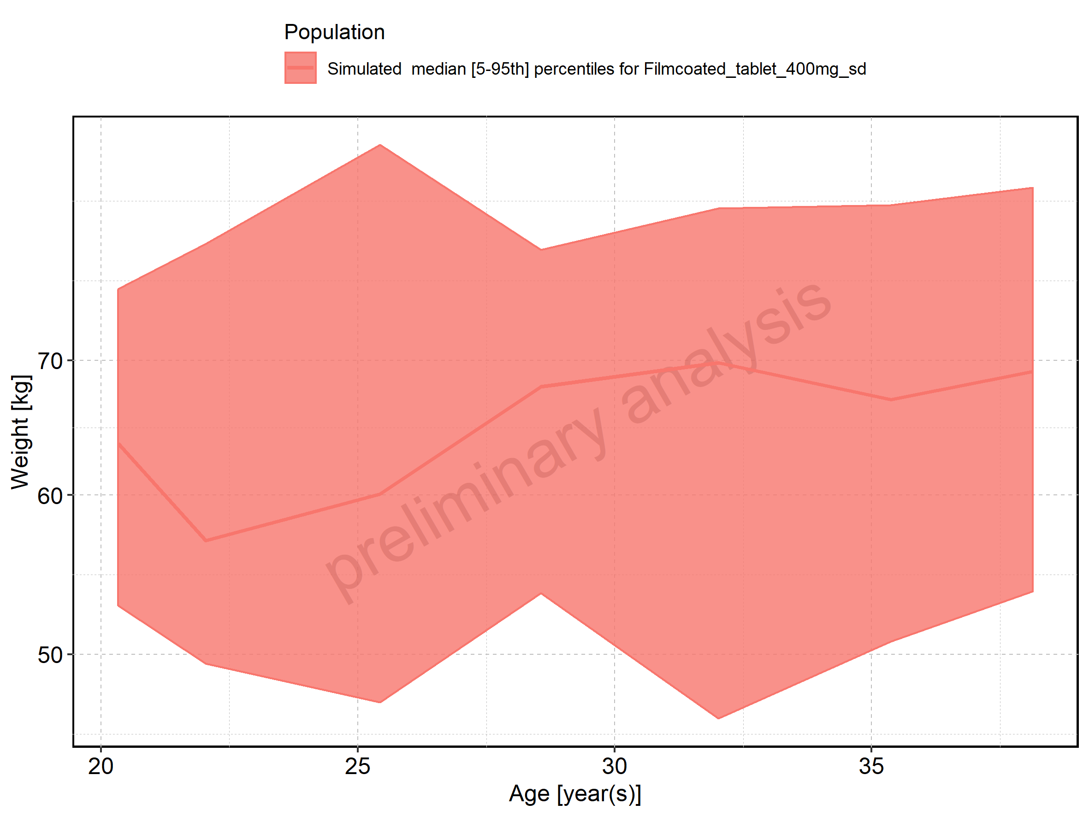

Figure 379: Age-dependence of BMI for Larson 2013 8y-18y 400mg FCT meal in comparison to Filmcoated_tablet_400mg_sd. Profiles are plotted in a linear scale.

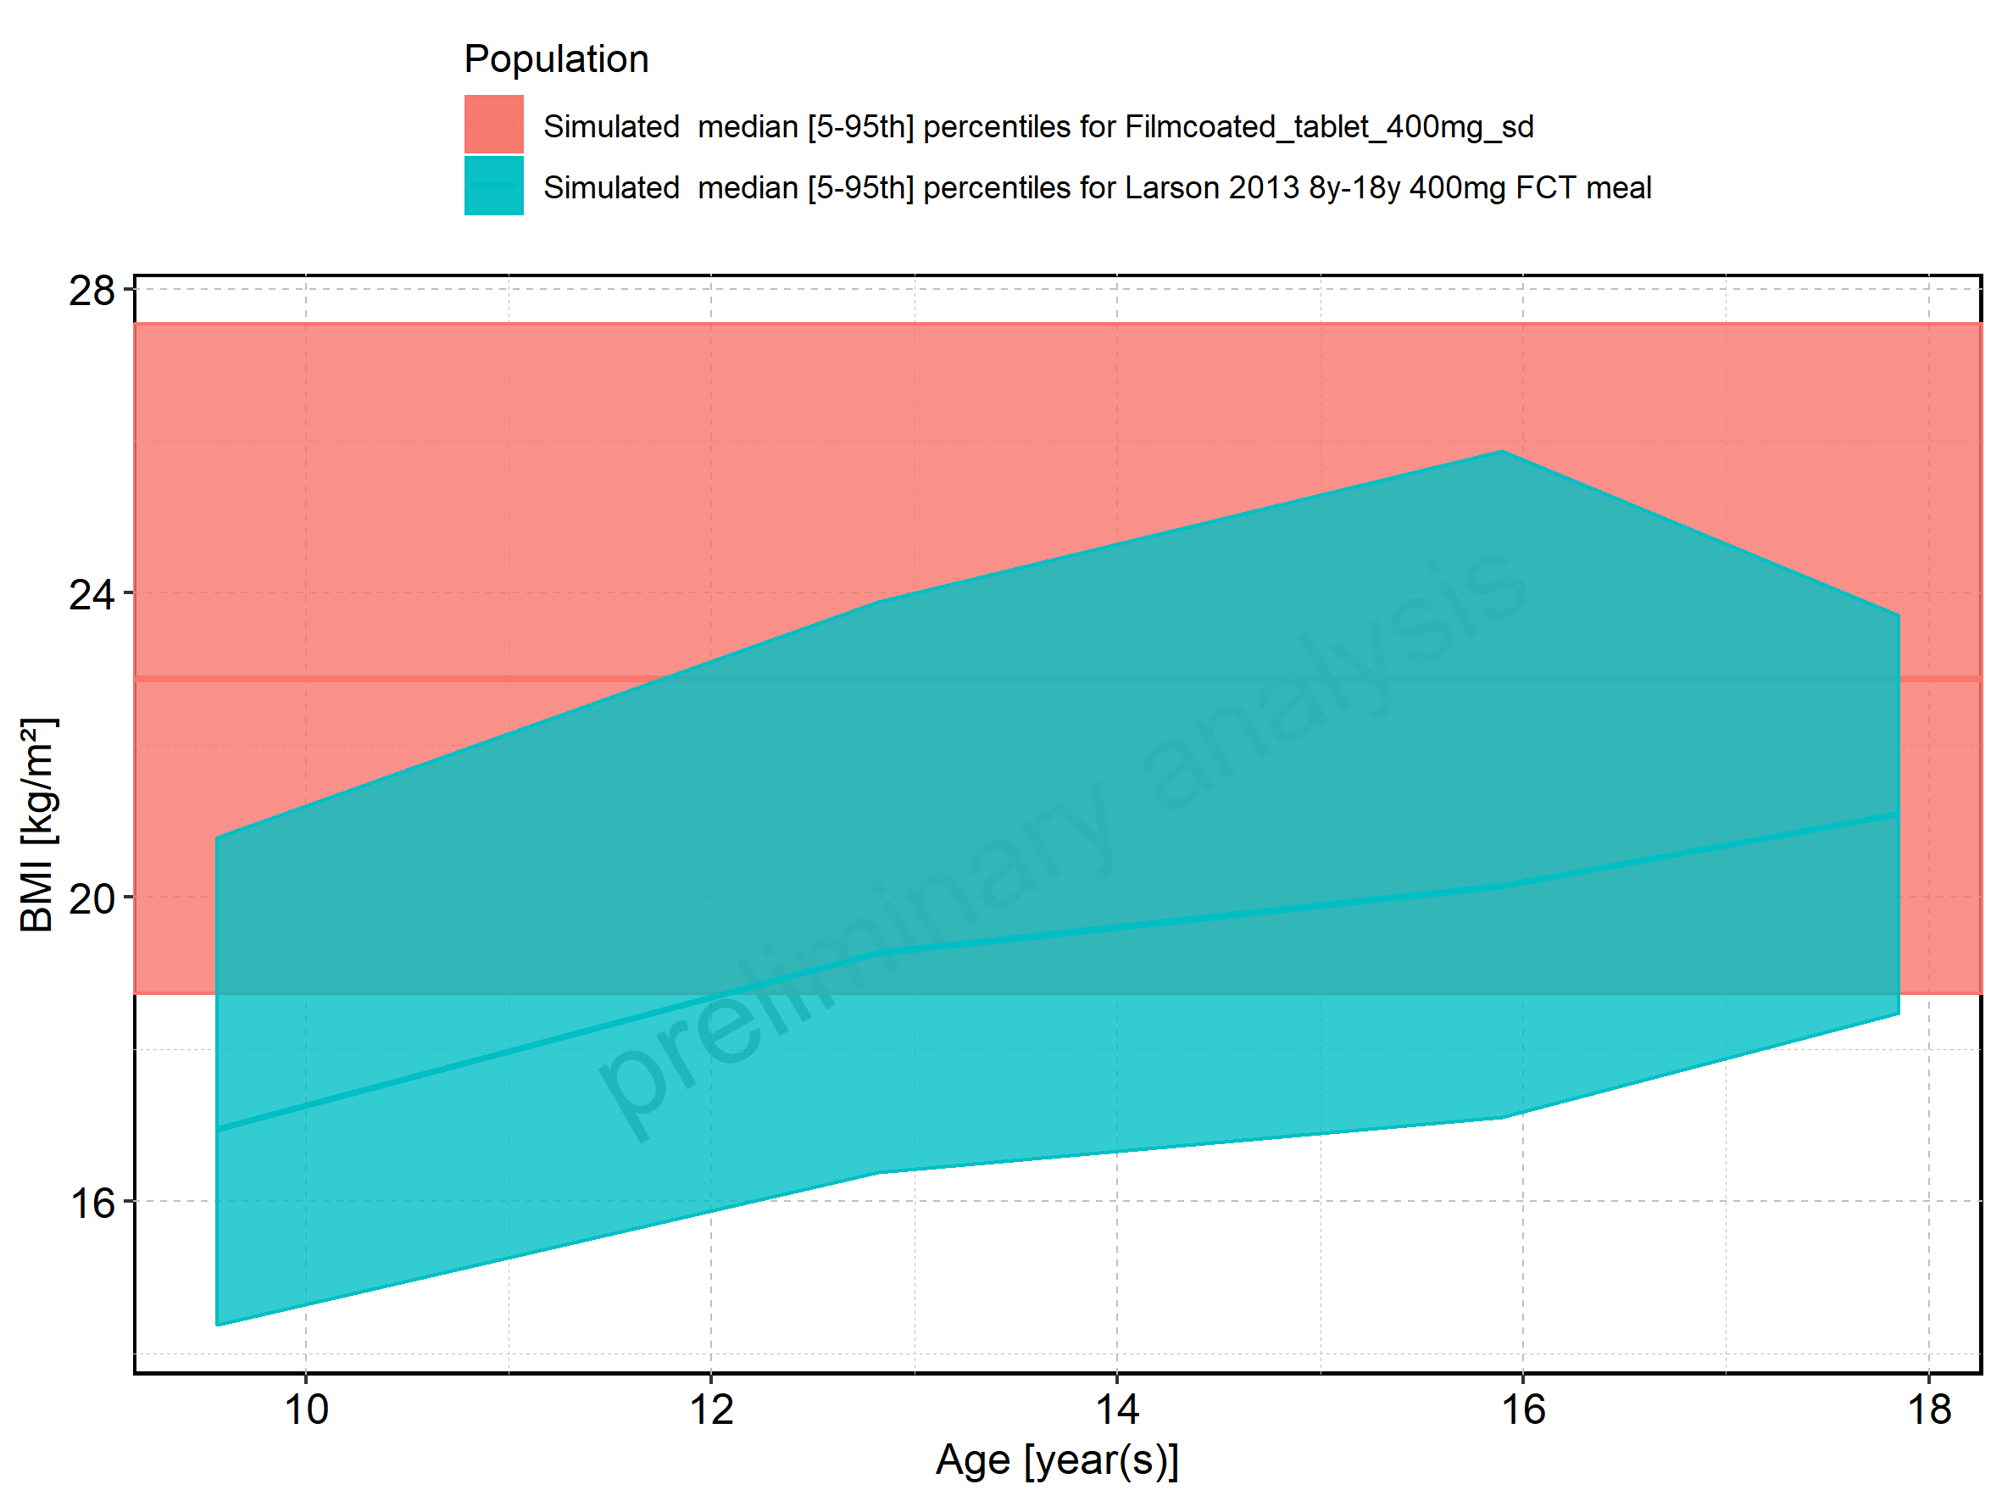

Figure 380: Age-dependence of BMI for Larson 2013 8y-18y 400mg FCT meal in comparison to Filmcoated_tablet_400mg_sd. Profiles are plotted in a logarithmic scale.

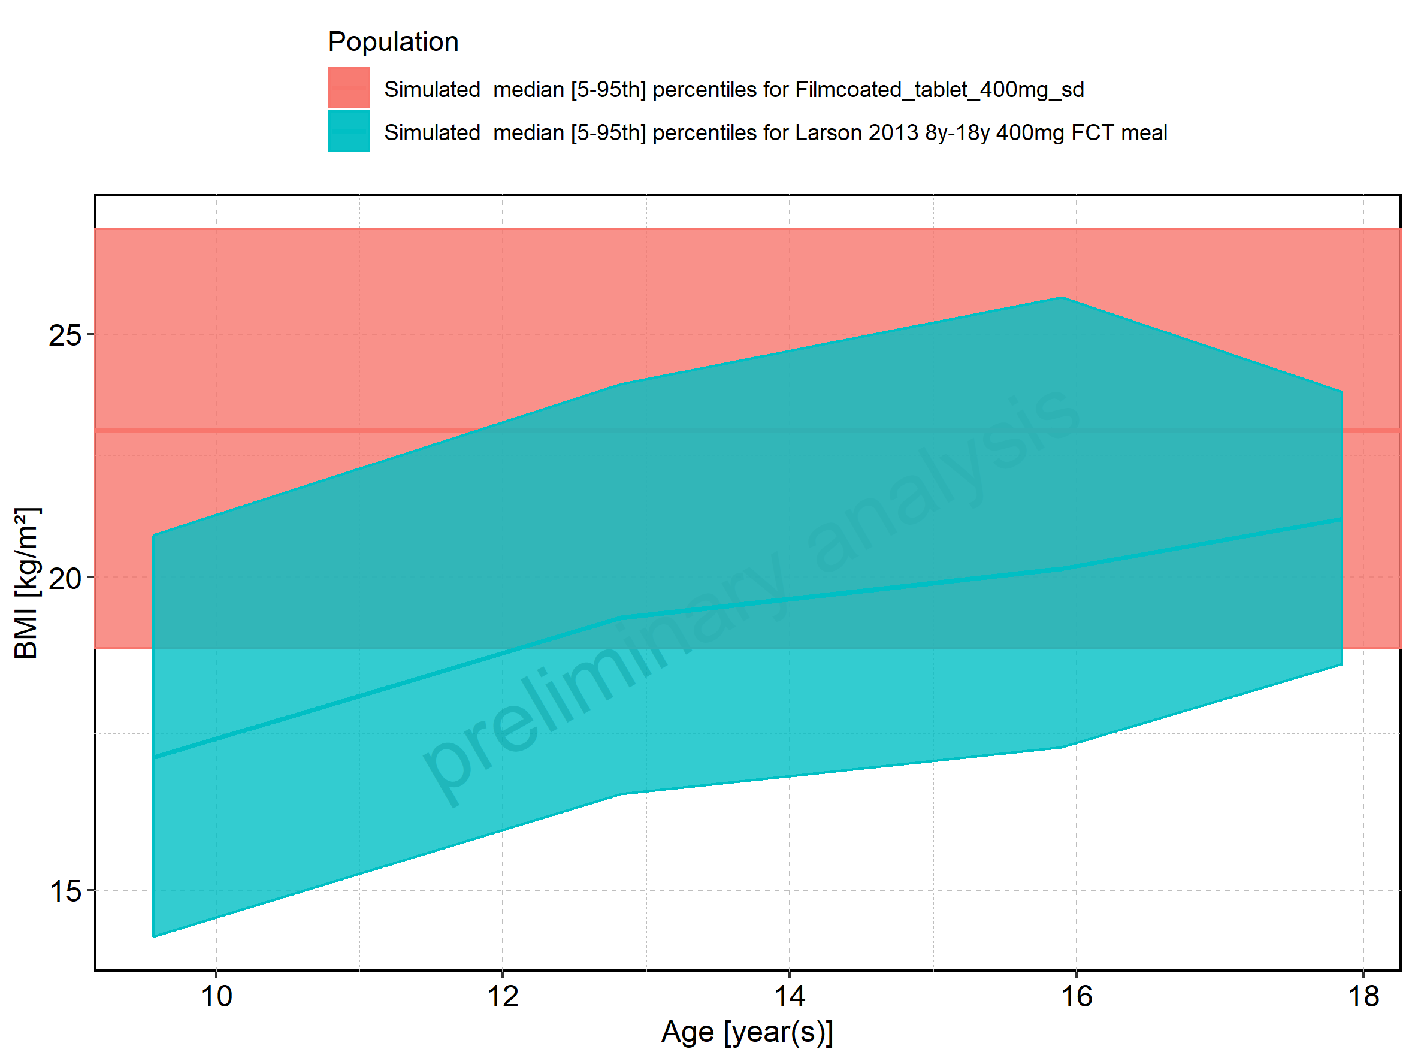

Figure 381: Age-dependence of BMI for Larson 2013 8y-18y 400mg FCT meal. Profiles are plotted in a linear scale.

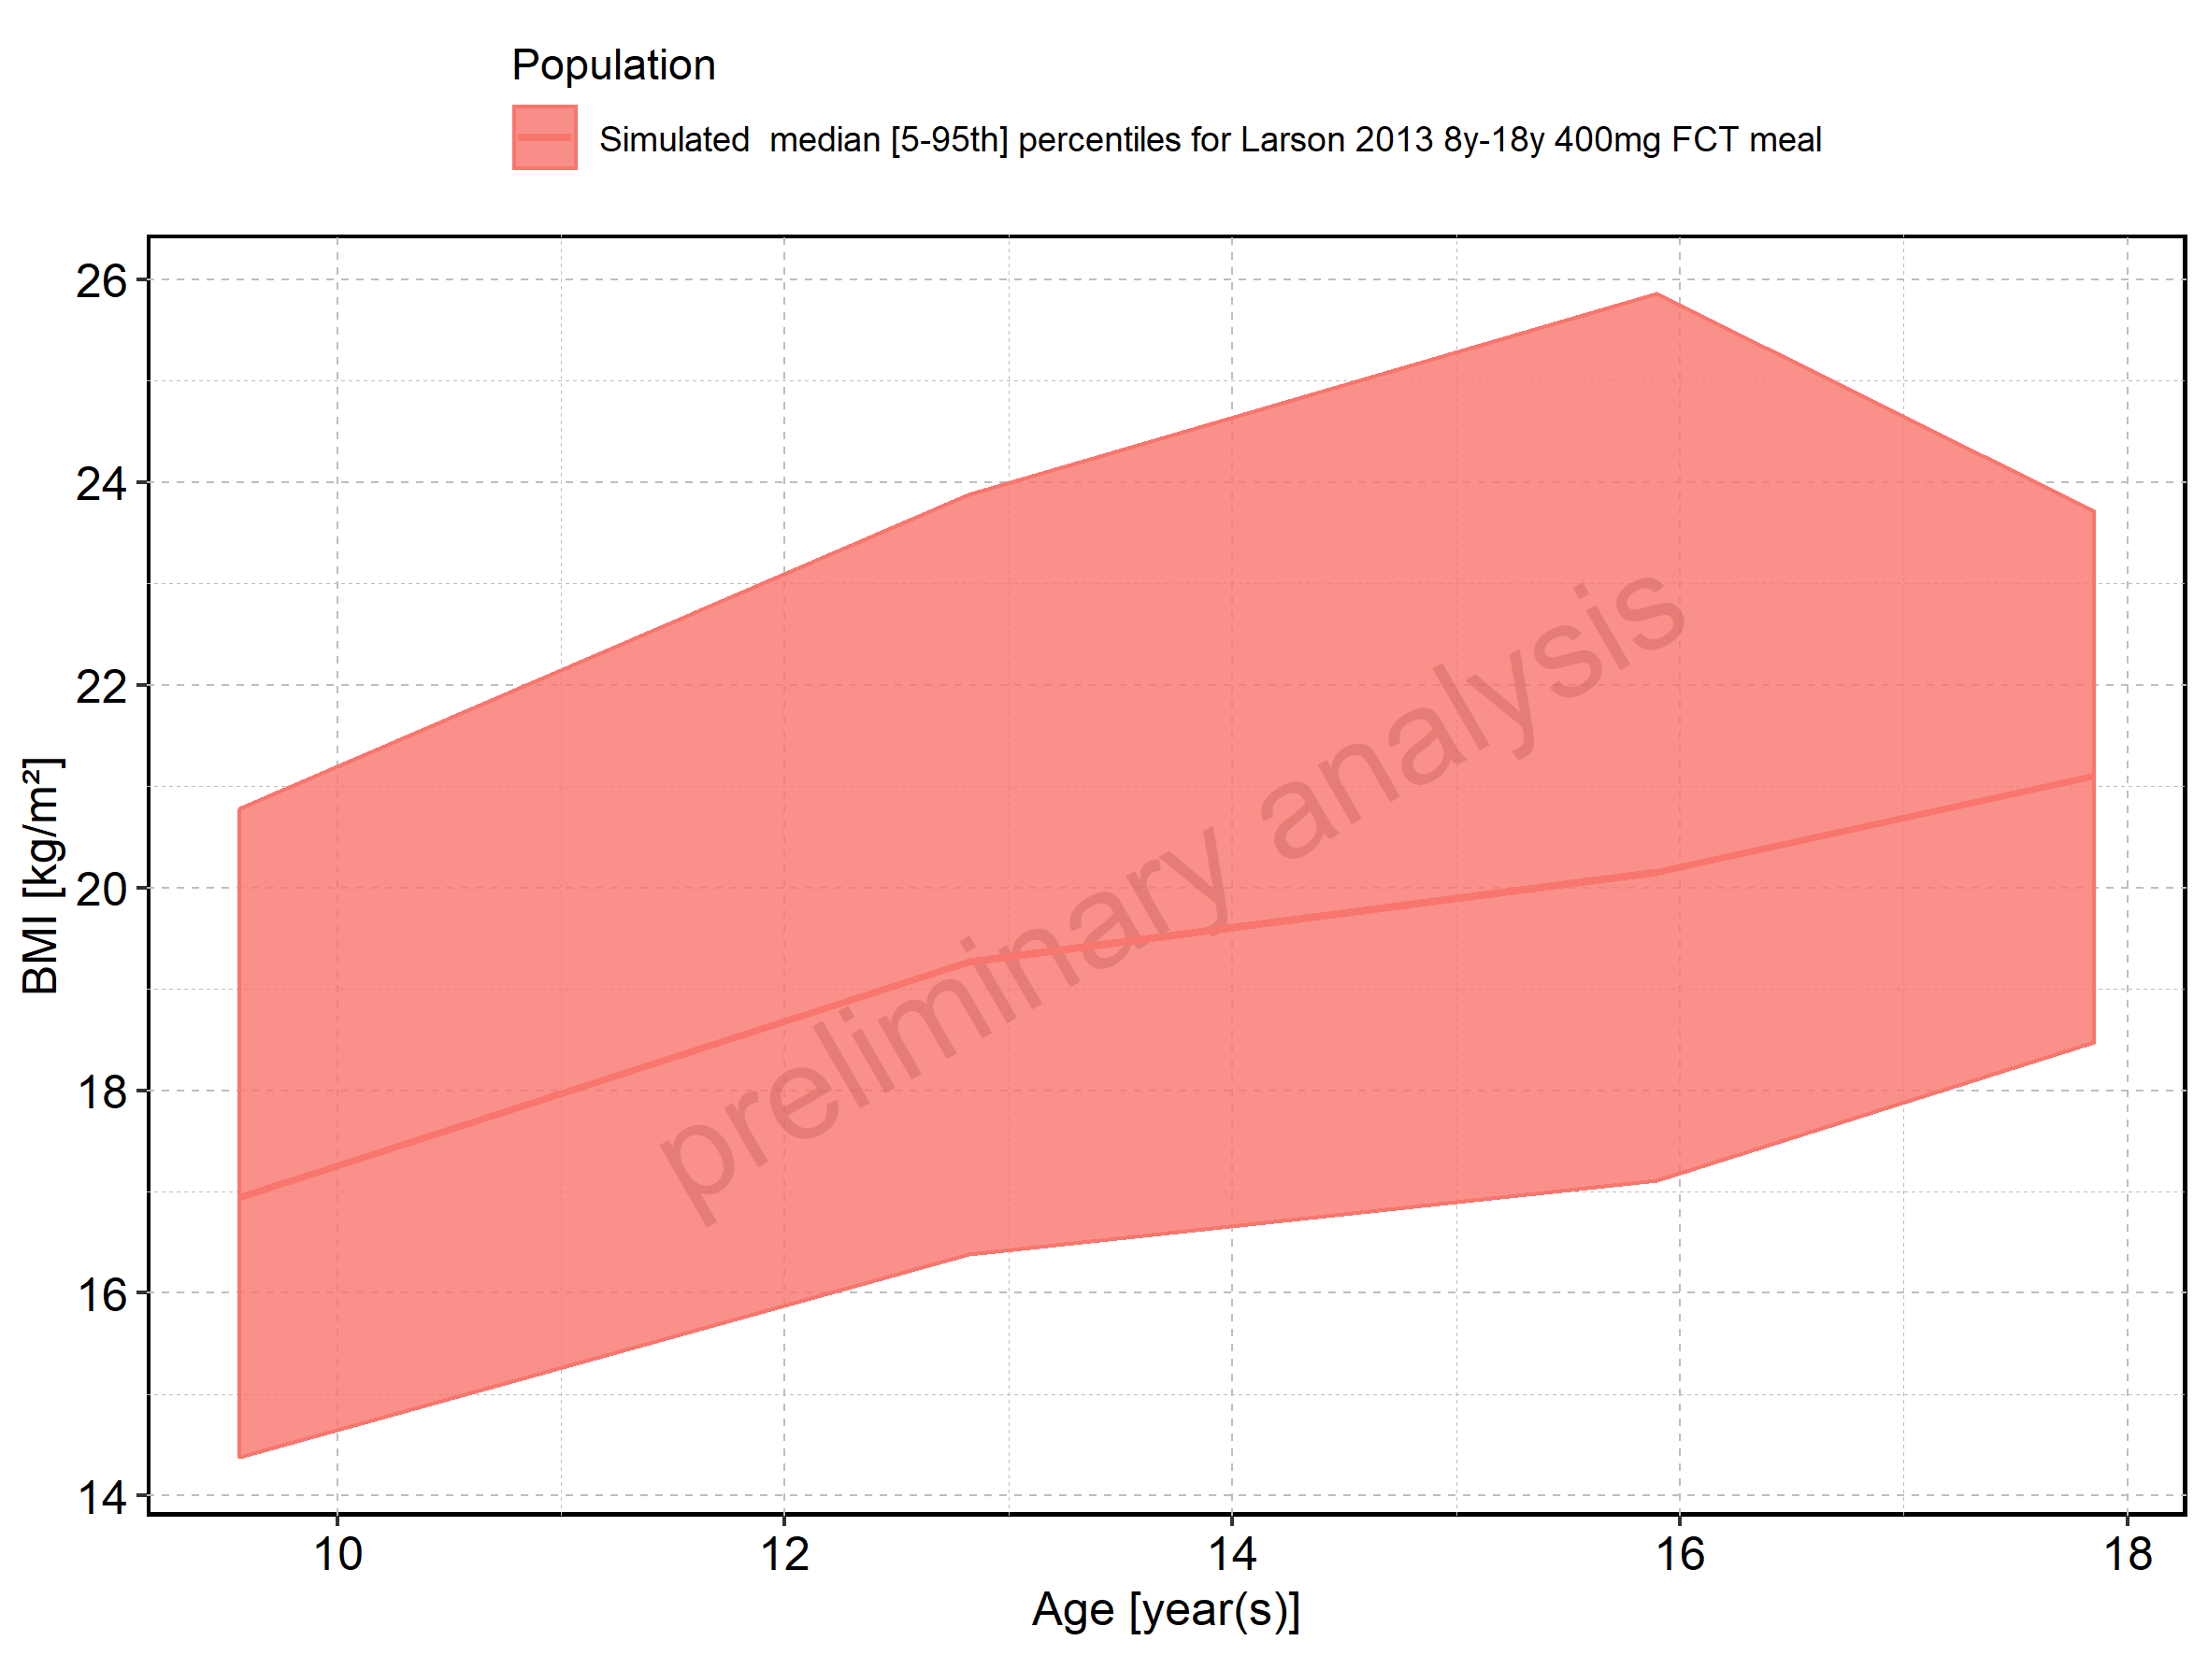

Figure 382: Age-dependence of BMI for Larson 2013 8y-18y 400mg FCT meal. Profiles are plotted in a logarithmic scale.

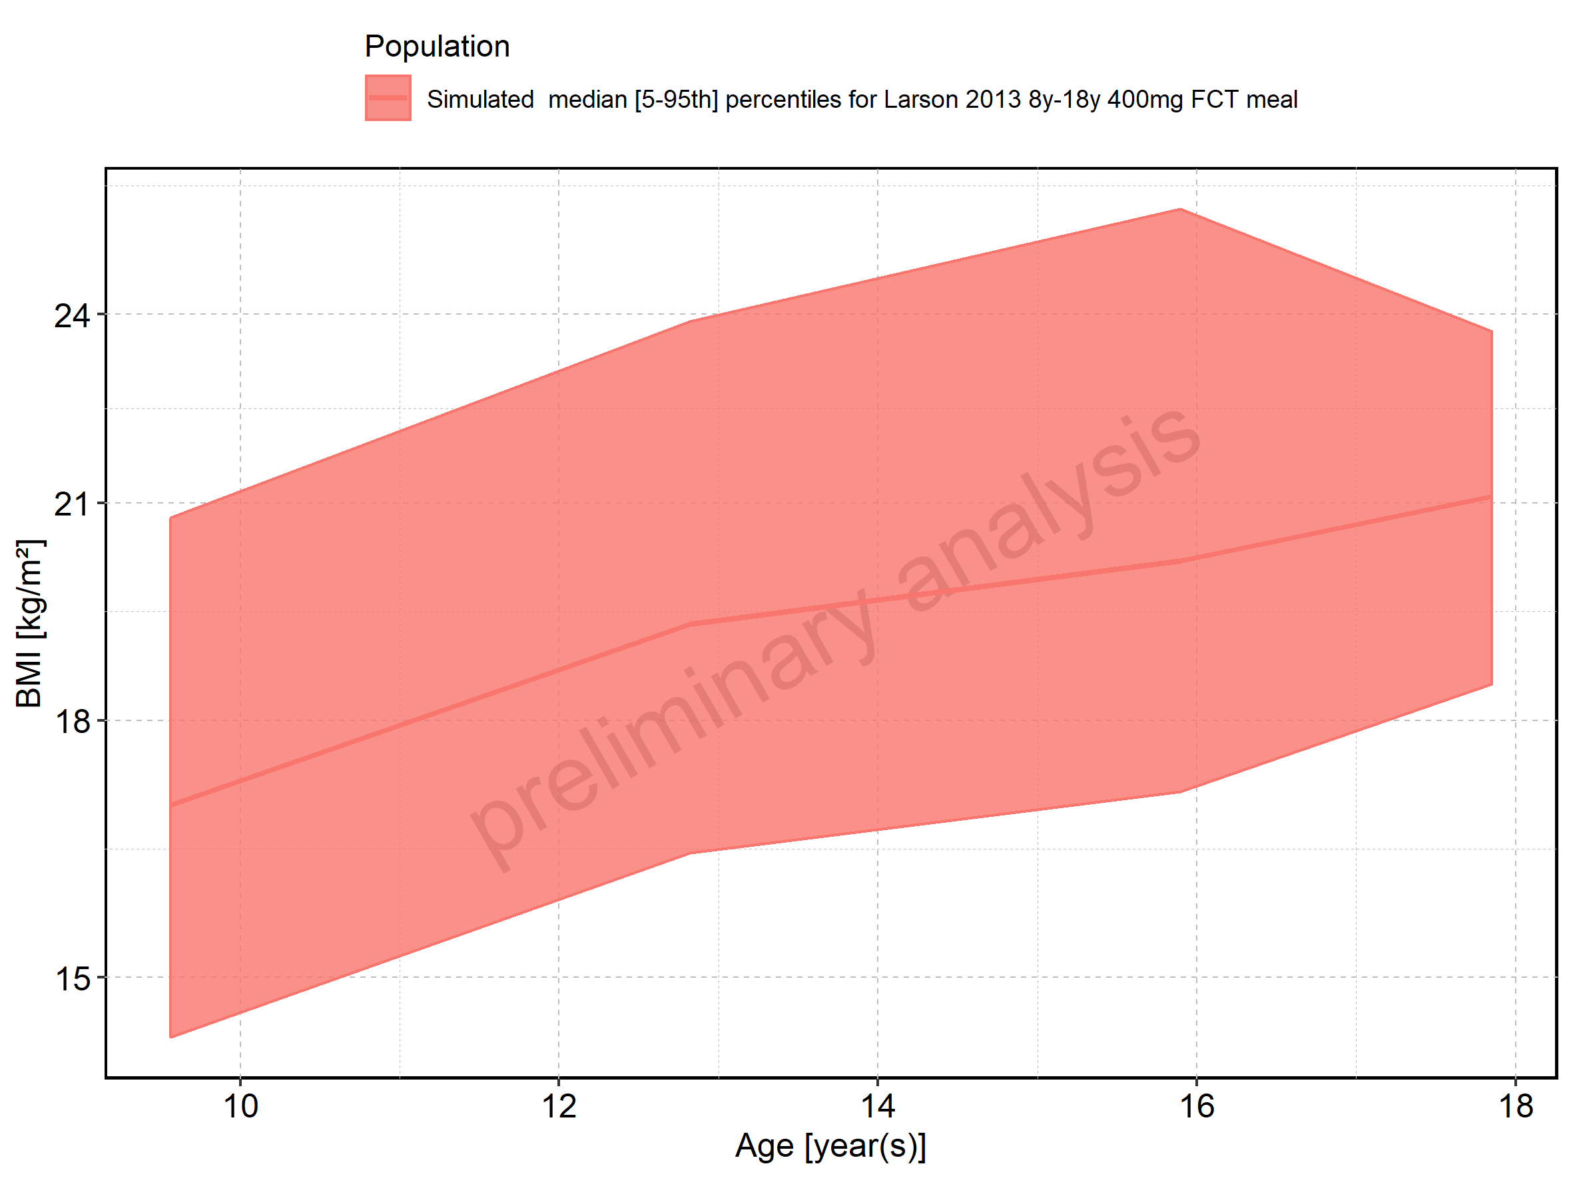

Figure 383: Age-dependence of BMI for Filmcoated_tablet_400mg_sd. Profiles are plotted in a linear scale.

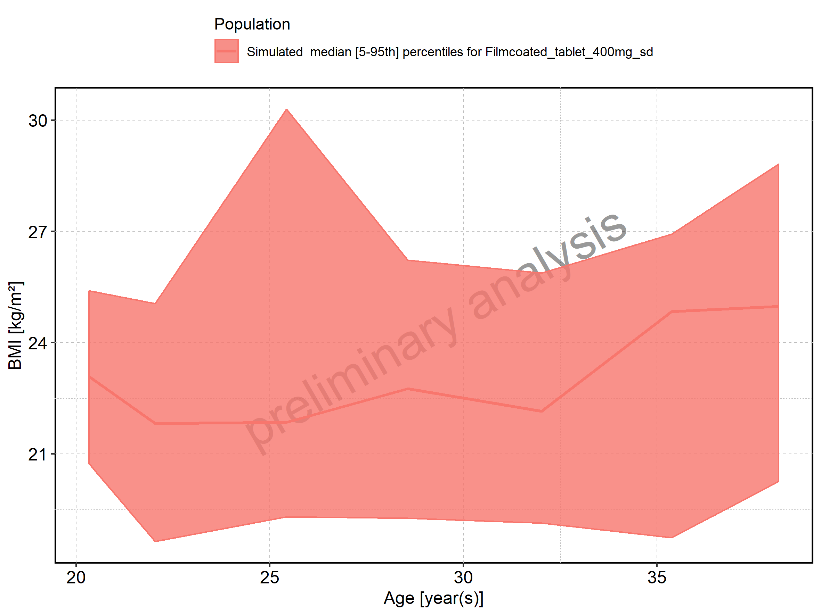

Figure 384: Age-dependence of BMI for Filmcoated_tablet_400mg_sd. Profiles are plotted in a logarithmic scale.

